Design testing and evaluation report
The original problem to tackle was to conceptualise three prototype variants in response to our earlier research findings on one of eight instrumental activities of daily living, identified by designingwithpeople.rca.ac.uk. I decided to research into digital communication as an activity and more specifically a health and wellbeing app to be used on your smartphone for any age range to aid them with any health problem, physical impediment/disability. Now that I have created 3 prototypes from my findings I will be using various testing methods and evaluating my findings from the tests. I believe the final outcome of the results of the testing will be that it’s basic idea is good but as an app it’s trying to do a little bit too much and may need to focus on a couple of the categories created within the three prototypes. However I do believe that the testing will show that the visuals of the app are well thought out and been used in the correct manner throughout each screen.
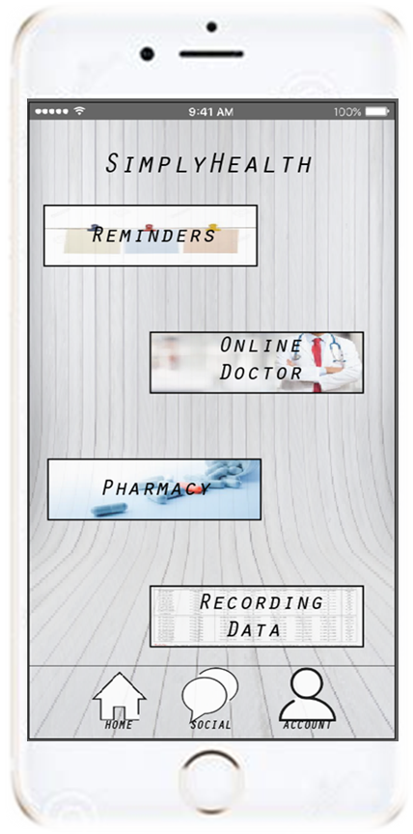
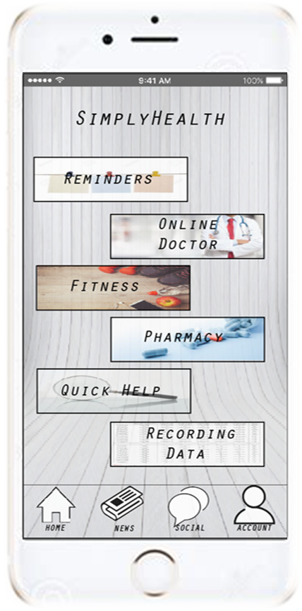
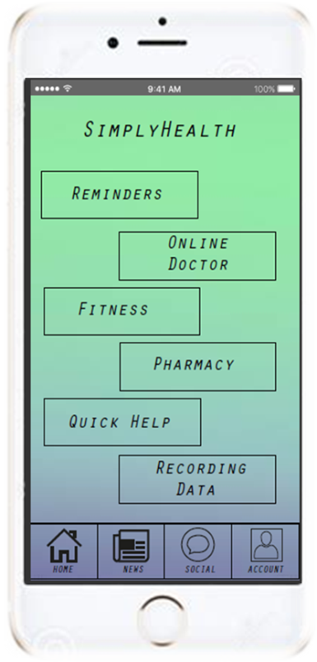
Below I have a few images of my 3 prototypes created from my research evaluation.
Although quite similar to each other there are a few distinct changes between the three prototypes. Prototype 1 was the first one I created and once finished I looked at the possible changes that could be made to the other prototypes to make them different/better to use. In prototype 2 I focused on looking at the possible changes I would be able to make to the imagery, backgrounds icons and text styles. By adding more imagery more distinct icons and a brighter background it has made the app itself stand out more than in the first. In the third prototype I solely looked at the content of the app, looking at possible ways of refining the amount of functions that the app does would mean less hassle for the user, ease of use rises and suddenly becomes less cluttered to the naked eye.
Once doing the original research I then used my own opinion to decide on what I thought would be needed as far as content , imagery colours etc, once I made the first prototype I was able to identify possible flaws and what could be done to make the app more user friendly and just better in general. However as the brief states and Kevin McDonagh, chief executive of Novoda (http://www.telegraph.co.uk/connect/better-business/top-tips-for-creating-a-successful-app/) says you should test your app on real users to gain a better understanding and have another point of view of possible changes/flaws and learn what areas are good about your app. “There’s only so much you can do in a lab, so testing with real users before launch is vital.” I’ve decided to use the same character profiles that I used in my initial research for this project. Below are the character profiles identities to remind you.
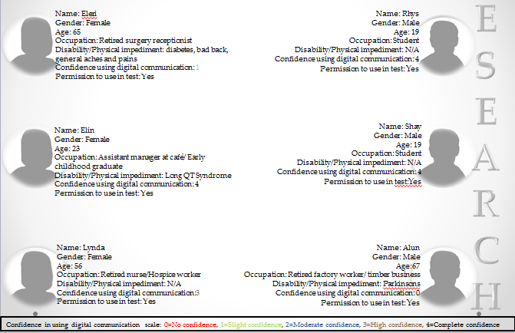
There are very few ways to actually test an app especially unless it has been made to a high standard and is ready to be placed on the market (app store) for many test subjects to then try it and see if every aspect works, also if it is made to work there could be tests for bugs within the coding of the app. However seen as I have only made the premise of the app, so each screens visuals and show how each screen links to each other then I am limited to the testing I am able to do. With the 6 test subjects/ character profiles I will give them a series of set questions to answer with some in the form of a Likert scale to easily gain evidence of what this wide range of profiles think of my app. I will also use two of the Ideo cards which I used in the initial research for this particular task simultaneously to garner a better perspective of what the users think of the app on a broader spectrum.
Below are the two Ideo cards I believe will aid me in understanding what the users think of the app first hand.

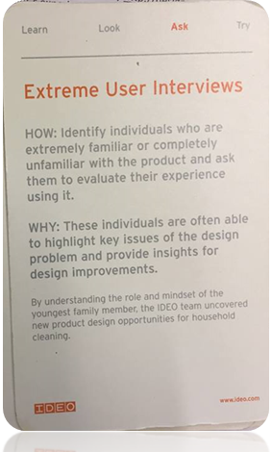
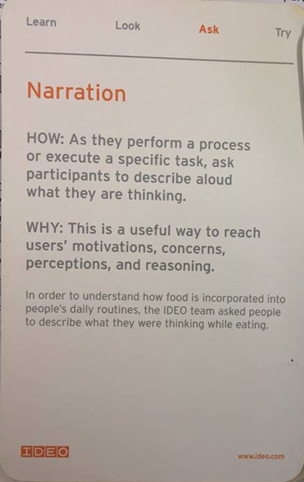
These two methods are quite similar as they both intend on you as the designer to ask your test subjects questions and watch them use a product and get a response, which is the reason why both can be used simultaneously to gather feedback from the users.

Narration will be a useful testing tool to use on these prototypes as I will be able to find out first-hand what they think of every aspect of the app such as how each screen link with each other and how they think the notifications and pop out icons work, which I may not have been able to find out by just handing them a questionnaire and answer a broader range of questions.
I will be using two character profiles who are at opposite ends of the market as far as confidence using digital communication as a whole The first being Rhys who is very confident in using digital communication and secondly Eleri who is a lot less confident in using digital communication. Eleri who also has diabetes will be able to give me a better overview of the app as one of its main purposes is to aid members of the public with health problems, physical impediments/disabilities. (She will be able to give me a more definitive answer into whether the prototypes are a success by seeing if it could actually help her with her diabetes in some form.

Now I have decided on what testing methods to use I will now need to create examples of these tests to give to my character profiles.

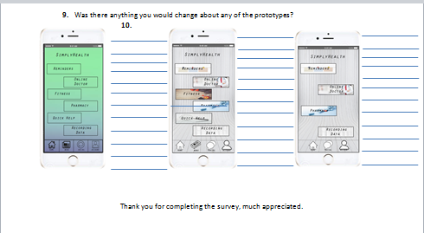
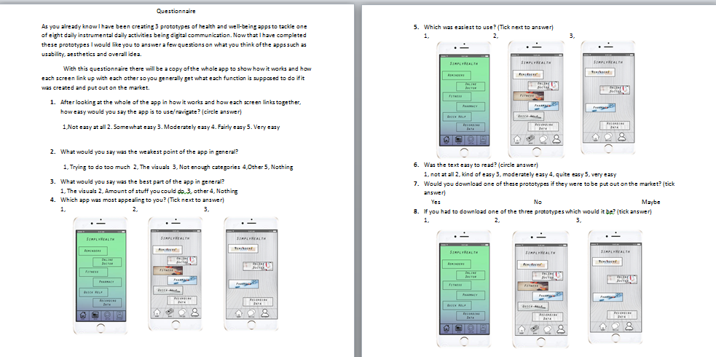
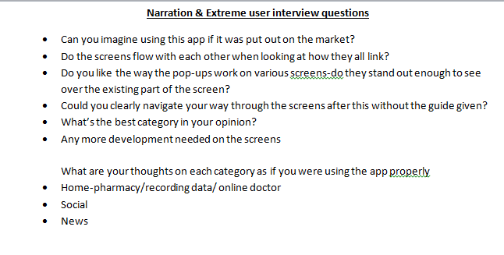
Before going to sit with and speak to Rhys and Eleri I felt I needed to have some form of plan to have an idea of what sort questions/statements I should be asking the two profiles. I will be able to use the top 6 bullet points to use as a guide for the interviews and the last 3 bullet points for narration of them using the main areas of the app.
The Likert scale can be seen in use on questions, 1 and 6
There will be a guide that will go with the questionnaire showing the character profiles how the app works in principle, (the guide being the 1st prototype displayed in my PowerPoint)
Questionnaire contains 9 different questions with only one question not with fixed answers to choose from.

Results of above testing methods
Below are some of the results from the questionnaire and the narration and extreme user interview that I feel will aid me in coming up with a conclusion of results.

Here we can see that the younger generation of the character profiles were able to use the app easily enough scoring a 4 and 2x5 in ease of use. The older end of the test subjects struggled a bit more scoring a 3 and less for the ease of use.

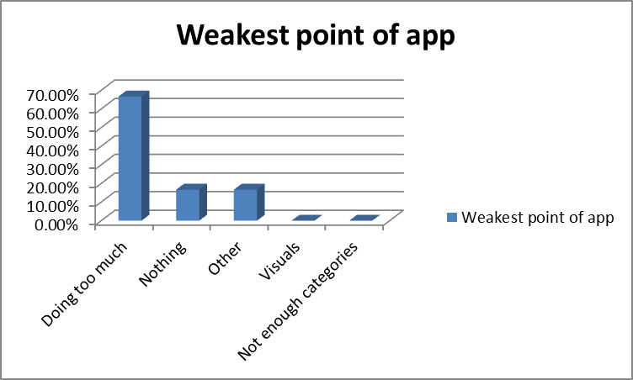
I asked my character profiles to choose what area was weakest in the app, coming out well on top here with 66.67% was that the app was trying to do too much. As suspected no one found the visuals to be the weak point of the app.

In this question I decided to ask the test subjects which prototype was most appealing to them in general. 5 of the 6 participants thought that the 3rd prototype was most appealing with only Alun thinking otherwise as he felt prototype 1 was best.

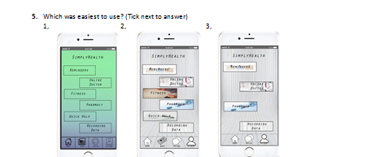
In question 5 I asked the participants to decide on which prototype they felt was the easiest to use. Staggeringly all the participants felt that option 3 was the easiest to use with 83.33% of the votes, with option 2 getting 0% and option 1 with 16.67%. However option 3 did come with less content which does make the app look less cluttered. (All three prototypes used the same basic screens and how they link with each other; it was only ever the content, imagery and other visuals that made a drastic change.

Question 8 asked the participants to choose which of the 3 prototypes they would download if put out on the market. I had a more mixed response for this 1 participant choosing option 1, 3 people opting for option 2 and finally two participants saying they would download option 3. So although we saw above that the majority felt that prototype 3 is the easiest to use it does not necessarily mean that it would be the prototype of choice to download as option 2 was considered favourite to download which has the equal most amount of content to use in the app.
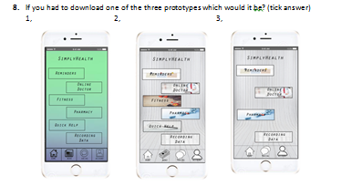

Here are some of the more interesting responses I got from my extreme user interviews and narration testing on Eleri and Rhys:
If I ever had a health problem I felt like I needed checking I would definitely use this app-especially like the look of the online doctor category, being able to video call a doctor without the hassle of going in for a check-up is brilliant.-Rhys on using the app if released.
Pop up’s work well, can clearly see what each one says and the main screen does not pull your vision away from them. -Eleri on pop up’s.

Navigation was pretty easy throughout the screens of the app, would have probably been easier again if actual creation of app was made to see the links happening.-Rhys on navigating the apps screens.
Favourite category has to be reminders, especially as I have to take insulin every day to regulate my diabetes-I also like the pharmacy category as it would save me a trip of going to the nearest surgery to get tablets I may need.-Eleri on favoured category in-app.

Narration
Eleri: online doctor-With the big icons to decide on what area of online doctor you want to use she said it was perfect for anyone with sight loss/blurred vision. She said although she would normally like to speak to a doctor face to face she could see the huge benefit of having an option of video calling especially for the busier user who maybe work a lot of the day and not have time to get advice if needed.
News screen- Not a big reader of news but with the choice of being able to choose what sort of health and fitness was coming on your news feed she could read what she wnted without having search for ages through the unwanted articles.
Rhys: Pharmacy-He thought visually in the pharmacy category especially in the 2nd and 3rd prototypes were excellent and instantly made purchasing tablets more interesting.
Social- As he is a young lad he straight away liked the idea of being able to talk to a wide range of people from across the world, without the embarrassment of putting it on his main social media fronts for advice.
Conclusion of results
Throughout the task set I’ve needed to create a portfolio of research and design development whilst interacting with a ‘product’ during one of eight instrumental activities of daily living identified by designingwithpeople.rca. With a handful of test subjects I have also had to test and evaluate my development prototypes. I have learnt what the majority of the public use digital communication for and what they expect from an app. There are many avenues an app designer could choose from to create an app and then identify specific problems/changes needed to that category can be quite challenging. The added challenge of the ‘product’ to be used by all ages and physical condition, meant it was very time consuming and extremely hard to create 3 prototypes that would be up to a high standard to go out on to the market. I identified health + well-being as an area which could be developed further.
Now that I have created the three prototypes and tested them with a focus group I can see people expect different aspects to suit them specifically, so to try and choose one small area specifically is perhaps not the best way to go but to have a broader amount of areas for the customer to use in the app is best (but still being mindful of keeping a happy medium). From the test subjects opinions and my own personal opinion I can honestly say that ‘less is more’ and the third prototype with a change in content and quality visuals (imagery etc.) Is the better of the three prototypes. By not over filling the app means it’s a lot easier to navigate through the number of screens available and by there being less content, the visuals really stand out well to catch the public’s eye and entice them to use the app. However I still believe that there are areas that could be improved on in the third prototype and I believe the best way forward to tackle these problems would be to create the app in its entirety on a website such as InVision.

Bibliography
Sources for digital communication
Design with people page- http://designingwithpeople.rca.ac.uk/activities/digital-communication
https://www.spotless.co.uk/insights/ethnography-when-and-how/
https://hbr.org/2015/04/a-process-for-empathetic-product-design
challenges of d.c- http://www.watsonhelsby.co.uk/assets/files/Digital-Communications-Social%20Media-The-Challenges-facing-the-PR-industry.pdf
ideo cards- http://www.gillianhayes.com/Inf231F12/wp-content/uploads/2012/10/IDEOMethodCards.pdf
Facts and figures- https://www.ofcom.org.uk/about-ofcom/latest/media/media-releases/2015/cmr-uk-2015
https://www.ofcom.org.uk/about-ofcom/latest/media/facts
how to create a successful app- http://www.telegraph.co.uk/connect/better-business/top-tips-for-creating-a-successful-app/
https://www.entrepreneur.com/article/224013
https://www.forbes.com/sites/avidlarizadeh/2013/07/19/eight-tips-for-a-successful-app/#1aed019753e5
Physical impairment/disability in detail- https://www.nhs.uk/conditions/parkinsons-disease/
https://www.ucbpharma.co.uk/presscenter/Therapy-Areas/Parkinson/Fast-Facts
https://www.parkinsons.org.uk/information-and-support/tremor
https://www.parkinsons.org.uk/information-and-support/types-parkinsons
https://www.diabetes.org.uk/diabetes-the-basics
https://www.diabetes.org.uk/professionals/position-statements-reports/statistics
Existing products on the market- https://itunes.apple.com/gb/app/doctor-on-demand/id591981144?mt=8
https://itunes.apple.com/gb/app/first-derm-online-dermatology/id564481892?mt=8
https://itunes.apple.com/us/app/mychart/id382952264?mt=8
http://wholeheartedlylaura.com/2016/04/best-apps-health-wellbeing.html
https://itunes.apple.com/us/app/balanced/id990154592?mt=8

Possible changes for the app
https://timesofindia.indiatimes.com/life-style/health-fitness/de-stress/7-relaxing-colors-and-how-they-affect-your-mood/articleshow/46946305.cms

www.getselfhelp.co.uk/colour.htm

https://envato.com/blog/8-color-scheme-trends-mobile-app-design/
http://altered-states.net/barry/newsletter220/
http://digitalskratch.com/color-psychology
https://medium.com/@Adoriasoft_Com/mobile-app-design-14-trendy-color-schemes-2669b5bb77d3
https://www.smashingmagazine.com/2017/01/underestimated-power-color-mobile-app-design/

