Critical Thinking
Today I present to you a poster on ‘Critical Thinking’.
What is critical thinking?
Well I asked myself that question on many occasions during this assessment. I had to do some extensive research to enable me to find a definition that I could comprehend and apply when presented with the article “Teaching assistants experiences of inclusive education” by Suzanne Mackenzie.
Firstly, I needed to reflect;
This involves questioning what it is you’re being told.
- What does it mean?
- What is happening?
- How do I make sense of this?

Secondly, I needed to recognise;

Evidence is needed to back up any points made.

- What claims are being made?
- How credible is that claim?
- How strong are those arguments?
Lastly, I needed to resolve;

By forming a view, I could come to my own opinion.
- What do I believe?
- What conclusions can I draw from this?

To think critically I needed to analyse the text and draw out the relevant information. I needed the ability to recognise assumptions and interpret the claims being made in the article. It is essential to be open-minded and have a fair and balanced view of others’ work and opinions.

Critical thinking is an applied learning process developed through practise. I found this quote on Skillsyouneed.com which enabled me to understand fully;

“It’s not something you can learn once and use in that form forever, such as the nine times table you learn in school”.
Skillsyouneed.com (2017)

This quote really helped me to understand what critical thinking is by highlighting the fact that critical thinking draws on the different opinions of people, unlike the times tables where we would have the same answer. Another way that helped me was this exercise;

Think of something a friend may have told you recently,

- Was it about someone you know?
- Were you told all the facts?
- Did they only tell you what they thought you wanted to hear?
- Was it a secret?
- Does it affect you? How?
- Did they tell you for a valid reason?
- Was there any malice or indifference?

This quote from Martin Luther King Jr is relevant to this;
“Nothing in all the world is more dangerous than sincere ignorance and conscientious stupidity”.
(Martin Luther King Jr).

When you apply this to any situation you can become a master of critical thinking.

To think critically, you must question what you are being told, what you are reading and what you are hearing. This will help you to educate yourself.
The News is broadcast daily, on television and in tabloids. Do you believe everything you hear on TV and read in the papers? Are you that gullible? Editors and production teams broadcast what they believe the public wants, we need to read between the lines and think critically to discover what is really happening. Quoting Pauline Baynes;

“Believe what you like, but don’t believe everything you read without questioning it”.
(Pauline Baynes).

Critical thinking is now becoming a major part in education in all subjects in school particularly English and History. Teachers encourage pupils to analyse the source Who wrote it? What is said? Where did it come from?
Critical thinking is used in their enquiries and research to define the facts from fiction, is it the truth or is it propaganda?
In English lessons, you use critical thinking to understand a writers’ purpose. You need to find the point, back it up with evidence and give an explanation for your opinion. Critical thinking in education is necessary to enable you to enhance your academic performance.

Through this assessment I have been forced to critically think about everything, I did struggle with the concept at first as I had believed that I was naturally a critical person. To put it into practise, is so much harder than I had anticipated. I now believe I have the ability to think critically.

References
2011-2018, (. (2018). Skills You Need - Helping You Develop Life Skills. [online] Skillsyouneed.com. Available at: https://www.skillsyouneed.com/ [Accessed 26 Oct. 2018].
Baynes, P. (n.d.). .
Luther King Jr, M. (n.d.). .

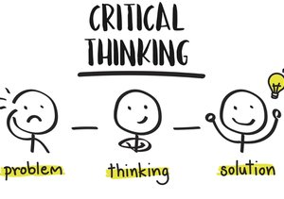
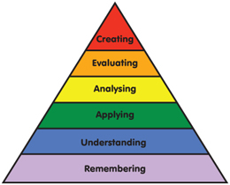
Forming a view
“Nothing in all the world is more
dangerous than sincere ignorance and conscientous stupidity”.

(Martin Luther King Jr)

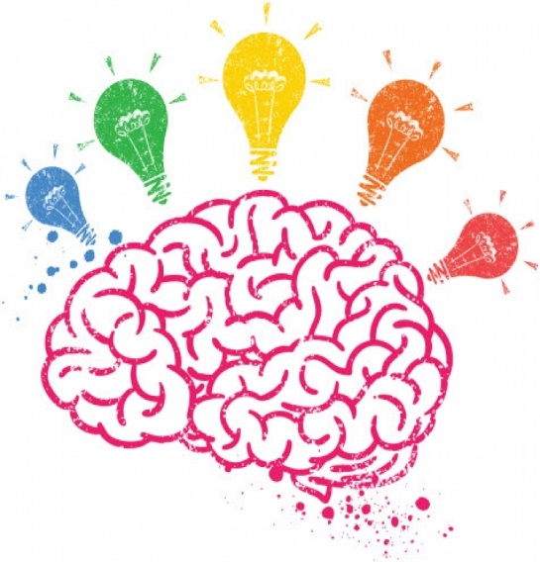
“Believe what you like,
but don’t believe everything you read
Evidence!
without questioning it”.
(Pauline Baynes)


Resolve
Recognise

Knowledge.
Questioning?
Keep Calm
And Think
Critically
Reflect

