Appendix I

PARE/PASE Reflective Framework Guide
The PARE/PASE Reflective Framework, developed in 2022 by student-researcher, voice teacher, and opera singer Zulimar López-Hernández, is a tool designed to support voice students during their solitary practice sessions (SPS). Grounded in theories such as Reflective Practice, Deliberate Practice (DP), Experiential Learning (EL), and Student-Centered Learning (SCL), the framework aims to bridge the gap between in-lesson learning and SPS, fostering self-efficacy and autonomy in learners.

Founding Theories
Reflective Practice:
Reflective practice, rooted in the works of John Dewey and Donald Schön, emphasizes the importance of learning through intentional reflection. Dewey (1910) described reflection as the “active, persistent, and careful consideration of any belief,” motivated by problem-solving needs. He viewed uncertainty and doubt as catalysts for reflection, leading to new understanding and solutions. Schön (1983) introduced the concept of reflective practice in professional and educational contexts, focusing on two types:
- Reflection-in-action: Occurs during an activity, relying on intuitive and implicit knowledge.
- Reflection-on-action: Happens after an event, involving deliberate analysis to improve future performance.
Both models advocate for critical thinking and observation to navigate complex or uncertain situations, fostering adaptability and deeper understanding.
Deliberate Practice (DP):
Coined by Ericsson et al. (1993), deliberate practice is a structured process aimed at enhancing performance through effortful, goal-oriented activities. Key elements include:
- Monitored Practice: Guided by instructors or coaches to ensure effective learning strategies.
- Individualized Feedback: Tailored to the learner's needs to refine skills.
- Recovery and Avoiding Burnout: Practicing at sustainable levels to prevent overuse injuries and ensure long-term progress.
DP emphasizes the importance of designing activities that motivate learners, incorporate prior knowledge, and provide immediate feedback. This structured approach helps students develop expertise while maintaining their well-being.
Experiential and Student-Centered Learning (EL and SCL):
Kolb’s Experiential Learning (1984) highlights the transformation of experiences into knowledge through active participation in the process of Do, Reflect, Think, and Apply. This hands-on approach integrates cognitive, emotional, and behavioral elements to enhance problem-solving and real-world application.
Student-Centered Learning (SCL), based on Vygotsky’s constructivist theory, emphasizes active student involvement, where learners reflect on their experiences to construct knowledge. Teachers act as facilitators, guiding learners to explore, analyze, and build upon their understanding. Writing and reflection support this process by enhancing retention, memory, and motivation.
Together, EL and SCL foster critical thinking, collaboration, and problem-solving by encouraging students to take ownership of their learning while applying it meaningfully.

How It Came to Be
The PARE/PASE "Stop or Go" approach was developed in Spanish in 2022, following the researcher’s master's program module work on reflective practice. It centers on two distinct scenarios.
- Scenario One: Students expressed satisfaction and motivation during voice lessons but frustration when unable to replicate these results during SPS, where music students typically work solo (Lehmann and Anders Ericsson, 1996). This disparity caused inconsistency and lack of motivation during SPS.
- Scenario Two: During a lesson, a student achieved remarkable results in a vocal exercise. When asked about his approach, he replied, “I thought,” and elaborated. The teacher-researcher (T/R) wrote a "P" for Pensamiento (thought) and documented his description, followed by an "A" for Acción (action). After repeating the exercise, the student evaluated the sensation and result (R/S) as "great and comfortable." Finally, the T/R wrote "E" for Experiencia (experience), creating the acronym PARE/PASE
In 2023, the framework was tested. Participants reported that using the in-lesson template helped them focus during SPS, better understand how to work on specific skills, and recreate the voice lesson process. Students reported increased motivation and consistency in their SPS. A sense of achievement developed as students felt they "knew what [they] were doing," which motivated continued practice. While some study limitations, such as not knowing if students could sustain its usage throughout a semester, were identified, future initiatives such as the incorporation of the vocal practice buddy systems as a peer learning strategy in combination with the framework aim to enhance the framework’s development and assess its impact on self-efficacy, autonomy, and motivation in vocal learning.

Framework Overview
CT: Concepto a Trabajar (Concept to Work)
This section documents the primary focus of the session, such as vocal exercises (e.g., warm-ups, technical work, cooldowns), objectives, goals, or repertoire work.

Pensamiento (Thought) / Preparation
Reflection-for-action moment: "The planning of the activity" (Cowan, 2016, p.68).
"P" represents a STOP moment for reflection before singing. It involves planning and preparation, focusing on:
- Awareness of procedures and sensations.
- Mental rehearsal (e.g., audiating the note, connecting with the body).
- Reviewing goals and required steps for success.
Guide Questions (GQ):
- What did you think before singing?
- What happened before you sang?
- How did you breathe?
- Did you prepare the vowel and audit the note?
- What image or gesture helped you before singing?
Examples:
- "Inhale calmly."
- "Relax posture."
- "Sing the note in my brain."

Acción (Action)
Reflection-in-action moment: "Thinking while doing" or singing.
(Schön, 1983; Warwick, 2007; Finlay, 2008, p.3)
"A" represents a GO moment where the focus shifts to execution. It involves:
- Awareness of what is being done.
- Execution of the plan prepared during Pensamiento.
- Input-to-output relationships (sensation and result).
GQ:
- What action did you execute?
- What image or gesture accompanied the singing?
- Where was your attention during the activity?

Examples:
- "Looking at the mirror."
- "Moving while singing."
- "Pirate arm movement."
- "Dead face."

Sensación / Resultado (Sensation / Result)
Reflection-on-action moment: "After the event" (Schön, 1983; Finlay, 2008, p.3).
"S/R" represents a STOP moment for reflection after singing. It emphasizes:
- Evaluating the effect or result of the action.
- Determining whether the sensation or outcome matches expectations.
- Identifying areas for improvement.
GQ:
- How did the action feel?
- What was the result of the singing?
- If unsatisfactory, what adjustments could be made?
Examples:
- "I really liked it."
- "It was comfortable."
- "It felt bright as the sun."
- "It felt really open."

Experiencia (Experience)
Reflection-on-action moment: Contemplation on what happened to learn from experience (Kolb, 1984; Kong, 2021).
"E" allows students to:
- Consider their overall experience.
- Assess emotions and motivation.
- Connect the session outcomes with future practice goals.
Examples:
- "I felt like I knew what I was doing, and that motivated me to continue."
- "I need to practice slower."
- "I can do it 100%."
- "No rushing."
GQ:
- How did the experience make you feel?
- What did you learn from this session?
- What will you do differently next time?
An Exemplar:
An exemplar of the PARE/PASE used by "Raffy" back in 2022 when the framework was tested:
- CT: Goals: memorization and performance mode ("not stopping for a mistake").
- P: "Do not stop."
- A: "I'll catch it later."
- R/S: "I was still confused but did not stop" and "felt satisfied."
- E"I flowed."
Raffy's final reflection-on-action was that since he had the technical foundation before the repertoire work, he felt "more secure and comfortable" and was unconcerned with the mistake (Schön, 1983).

The Stop and Go Moments
Go Moment (GM)
A Go Moment represents a "green light" phase where the student is ready to engage in singing and practice following preparation (P) or after a Stop Moment (SM). The emphasis is on mindful repetition and real-time assessment of results.
Stop Moment (SM)
A Stop Moment is a deliberate pause during vocal practice or lessons where students reflect on their actions to improve learning and performance. It serves as an opportunity to evaluate outcomes, identify challenges, and devise strategies for improvement.

Expanded Key Aspects of SM:
- Pausing to Reflect:
SMs encourage intentional breaks to analyze actions, fostering self-awareness and learning consolidation.
- Wakeful Rest:
Incorporates short breaks (seconds to 15 minutes) to enhance memory retention and prevent vocal fatigue. Research highlights how rest aids brain consolidation of skills (Martini et al., 2020; Buch et al., 2021).
- Mental Practice:
During SMs, students mentally rehearse actions to reinforce positive outcomes and address challenges.

Benefits of SM:
- Improves information retention by linking in-lesson learning to practice sessions.
- Prevents vocal overuse and fatigue.
- Enhances critical thinking and problem-solving skills through reflective evaluation.
- Builds confidence in identifying strengths and improving weaknesses.

Teacher’s Role
The teacher acts as a facilitator, guiding students through reflective practice using inquiry-based learning. By modeling the PARE/PASE framework, they enable students to:
- Develop self-awareness during voice lessons.
- Connect in-lesson content to SPS.
- Build autonomy and confidence.

🟢 🟡 🔴 PARE/PASE Template 🟢 🟡 🔴
Name: __________________________ Date: _____________ Time: __________ ☐ SPS ☐ VPBS ________________________________________________
Practice Tools: ☐ Recording device ☐ Cork ☐ SOVT devices ☐ Water ☐ Piano ☐ Mirror ☐ Other: ____________________
Conceptos a Trabajar | Pensamiento 🔴 | Acción 🟢 | Sensación/Resultado 🔴 | Experiencia (emoción) 🔴
Technical Work, Repertoire Work, Goals or Objectives | What did you think to accomplish that action? What happened before you sang? | What action did you execute? How did you do that? | What was the sensation? How or what was the result? What happened? | Describe your experience. How did that make you feel as a student/singer?
Additional Reflections/ Doubts 🟡 / Stop Moments (SM) 🔴 (to be discussed with teacher or “buddy”)
____________________________________________________________________________________________________________________________________________________________________________________________________________________________________________________________________

Appendix II: Pre-study Questionnaire

Research Project Title: How can the vocal practice experience of undergraduate voice students be supported and motivated by the integration of a vocal practice buddy system (VPBS) alongside the deliberate and reflective practice approach of the PARE/PASE framework?
Pre-study questionnaire responses
I. Participation in study
- How do you feel about participating in this study? (e.g., What are you excited about? what are your worries or concerns?)
Paige: I feel excited to get to participate in this study because I think it will help me learn more about vocal techniques and improve the way I practice. I'm also happy to help my professor with her study, since she has helped me so much as her student.
Sara: I am very excited and also nervous to participate in this study. I'm thrilled to be part of it again and help the teacher with her research. Nervous because now it will not be the teacher and me, but I working with a colleague and then the teacher helps us if she sees it necessary. My concern are that I may not understand or grasp the skills or instructions given to me and therefore not be able to do a good job. Another concern is that the other person is unable to fulfil the investigation partially or entirely.
Ryan: I am excited to have been selected for this study. I am excited to be able to learn and contribute to future systems of practice and the evolution of the development of vocal technique

Jade: I’m really excited. I want to see how consistently working with a partner can affect my personal growth and how I see practice.
Jay: I feel honored to be a part of this study. I wouldn't say I'm worried, more like very excited to contribute to this investigation and get to see a glimpse of the personal and collective results.
Chloe: I'm excited to be working with Jade and to hopefully stop fearing or start fearing making mistakes in front of others a lot less (essentially to build some immunity to that fear, in a way). I worry that I'll mentally block myself in the process, as it's really hard for me to overcome the block if/when it happens.

- What do you think is going to happen?
Paige: I think this study will push me out of my comfort zone because I'm used to practicing by myself. I think this will be good because it will help me practice teamwork and be a better listener.
Sara: I always have the best and the worst outcome in mind. We may do an excellent job, learn from each other, and further develop even more as singers. We may also fail to understand each other and not be able to do a good job. Essentially, I think my partner and I will do a good job and, as we have worked together before, we will learn from each other and continue to develop as singers.
Ryan: I am going to acquire new knowledge and discover new ways to do a deliberate and fun practice with my buddy
Jade: I think that our perspectives on singing and vocal practice are going to change thanks to the different points of view and the influence we’ll have in one another.
Jay: I think that peer learning will increase the results of studying sessions on a very positive way due to the fact that we are not just receiving our own feedback.
Chloe: I'm not sure, but I hope I'll build a healthier relationship with the practice room. I admit I've grown some animosity towards practicing my vocal technique, because, in the same way that there's always something to LEARN :), there's also ALWAYS something to learn :/ . What I mean is that it's hard for me to track my progress, because I feel like the process I never ending and I end up unsatisfied, because I feel like it's never enough.

- Have you ever participated in a VPBS? (e.g., voluntarily, assigned)

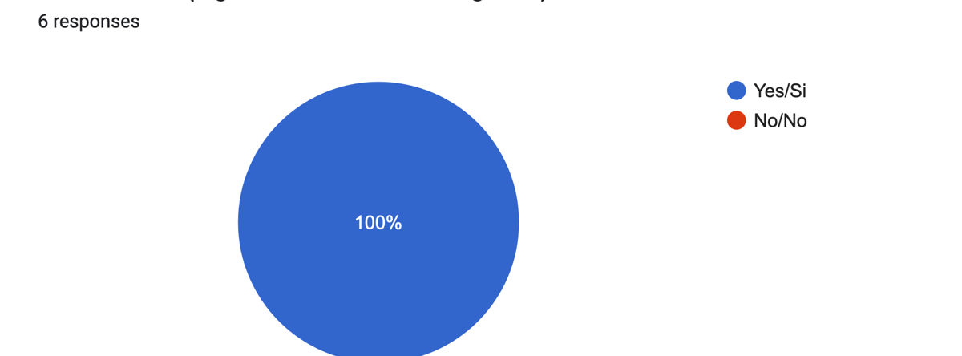

- If so, do you enjoy the process? (Share your likes and dislikes) * If you haven’t participated, kindly disregard this question.
Paige: I've done vocal exercises with my classmates, and most of the time we give each other some tips or words of encouragement. I enjoy the process because a lot of times my classmates say some of the same things that my professor has said to me before during class, so they serve as confirmations and reminders of the things I should keep in mind and work on. I also like helping other people in any way I can, and I think it's important to have a person listen to you from an outside perspective.
Sara: I enjoy the process of participating in this system because it allows me to see how the other person works and see if I benefit from any skill that that person uses, to help the other individual if he has any doubts, to experiment with the person exercises and to see if it benefits us both and in general to be able to get feedback on my work as a singing student.
Ryan: I had the opportunity to participate in the previous research on PARE/PASE. I have no complaints; I enjoyed the experience and feel that I made a significant contribution to the research.
Jade: I do enjoy it because it allows me to see that I’m not alone when feeling certain emotions and helps me overcome them through methods others use or even understand myself better and find a solution that works for me. I can also help my partner whenever they’re struggling and give them suggestions of what has helped me before. The encouragement of a fellow singer helps with seeing what we’ve never noticed before or felt insecure of.
Jay: I really do enjoy the process because the other person takes into account things that maybe, in the moment of practice, I forget or not take into consideration as much as I should. Biopsychosocial thing for example.
Chloe: For the most part, I find it uncomfortable in the same way as gynecologist appointments or going to the gym. Uncomfortable, but necessary and ultimately beneficial in the long run. Plus, the discomfort becomes slightly more bearable with the active in-the-moment feedback I can get from a buddy, not too dissimilar to the feedback I could get from my vocal professor. When I'm by myself, sure, I can record myself, but I won't be able to listen to myself until after I've repeated the exercise a few times, so it's slightly more tedious.

II. Practice Habits

- What is your usual attitude when entering your vocal practice sessions?
(Please select all that apply)
Paige: Let’s explore and play
Sara:I walk with specific goals ;I don’t know what to do; Other; The options I chose vary between practice sessions.
Ryan: Let’s explore and play; I walk with specific goals; I don’t know what to do
Jade: Let’s explore and play; I walk with specific goals; I have doubts about what to do
Jay:I walk with specific goals; Other: When I do explore, it's mainly to check how my instrument is doing on the day.
Chloe: I walk with specific goals; I have doubts about what to do; I don’t know what to do; Other: A lot of the times I'm not too excited, because I think about it too much as "this is for a class so I MUST do it" instead of "I like singing and I want to get better at it, so I WANT TO do it".

Coding: Practice as a chore, responsibility, obligatory; teacher assuming student knows what to do during SPS (idea: take time in lesson to discuss what to do in SPS or teach back strategy)

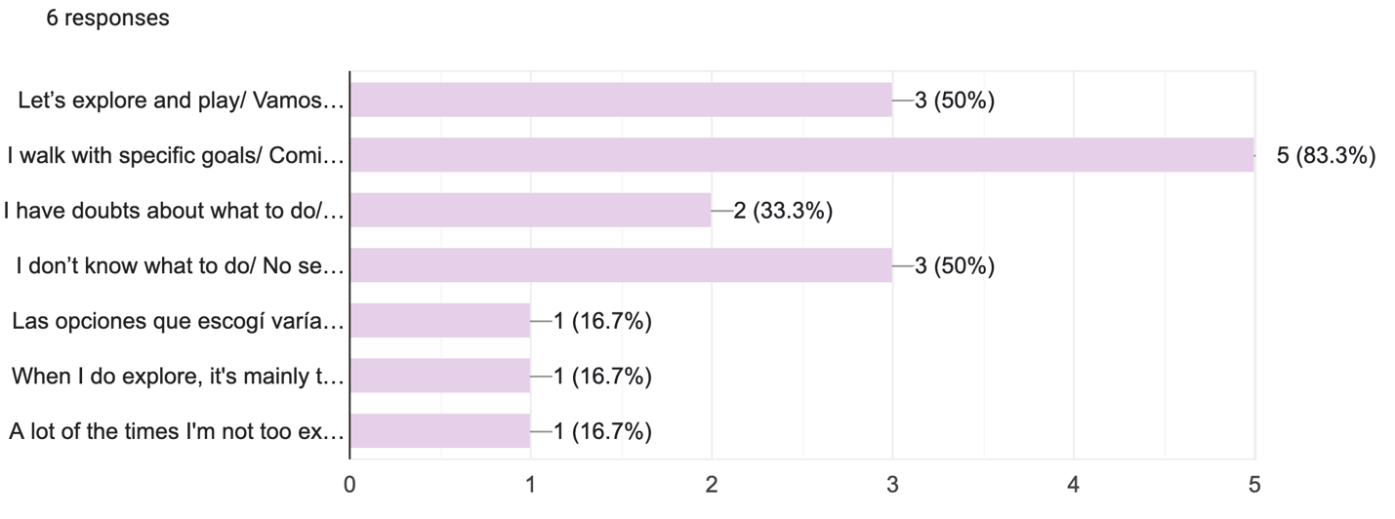

- What do you care most about when it comes to your practice? (Please select all that apply)
Paige: The quality of the practice sessions
Sara: The quality of the practice sessions; The tasks and work I did; Other: Feeling I’ve improved every week.
Ryan: The quality of the practice sessions
Jade: The number of weekly vocal practice sessions; The quality of the practice sessions
Jay: The number of weekly vocal practice sessions; The quality of the practice sessions
Chloe: The number of weekly vocal practice sessions; The duration of your practice sessions; The quality of the practice sessions; The tasks and work I did; Other: Feeling like I'm actually progressing in some shape, way, or form.

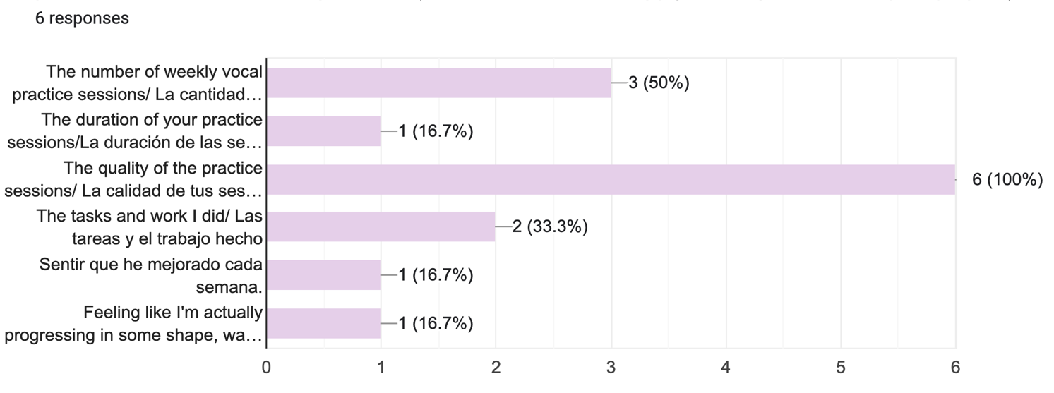

- How motivated are you when it comes to practicing? (1=Never, 5= Always)
Paige: 3 | Sara: 3 | Ryan: 1 | Jade: 3 | Jay: 4 | Chloe: 3

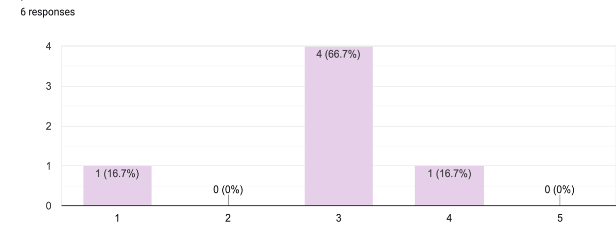

- Do you ever struggle with being consistent with your daily practice? (1=Never, 5= Always)

Paige: 5 | Sara: 4 | Ryan: 5 | Jade: 4 | Jay: 3 | Chloe: 5

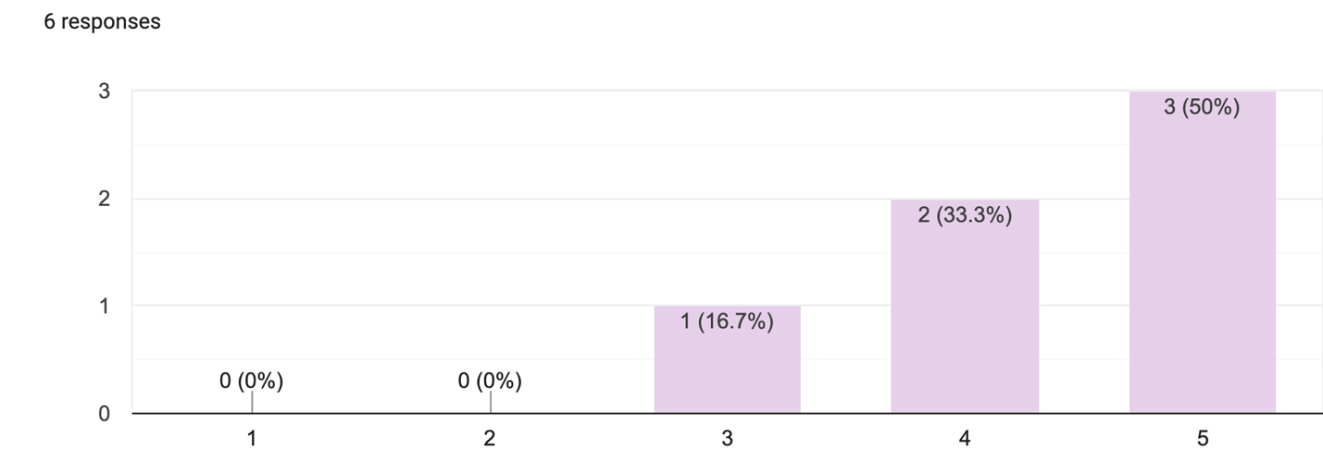

- How does the above factors (motivation and consistency) impact your vocal practice?

Paige: Most of the time, I feel like my motivation isn't linear (it feels like a rollercoaster), so this affects my consistency. Sometimes I'm really motivated and sometimes I'm not at all, depending on the circumstances in my day-to-day life or my workload.
Sara: If I'm not motivated, I probably don't do a good job or I already have in mind that that day's practice won't work out well because I am unmotivated. As for consistency, at least for me the more I do the same every day (the same being a certain activity), it will either become a habit and I will not be "forcing" myself to do the activity if I do not have motivation because I have already programmed it in my mind as an activity I have to do.
Ryan: I do not have consistency because of lack of motivation and/or distractions that occur around me.
Jade: Losing the consistency makes it hard to connect with the work done and feelings I had in the previous practice sessions, which can create stress because “I don’t feel the same way” or I forgot how I got there before. Due to that stress, practice becomes a heavy chore that I want to leave for later, affecting motivation, and therefore the consistency.
Jay: Sometimes I practice under pressure and stress. It makes me rush study sessions or extend them unnecessarily.
Chloe: I feel like the motivation I feel towards practicing comes more from thinking about the potential outcomes and not the exploration that can occur in the practice room, so I tend to end up kind of unsatisfied, which leaves me less motivated and obstructs my consistency. The problem is that I struggle with shifting my mentality towards "play :)" and "fun :)" and "exploration :)". I end up having to gaslight myself into liking the process, even though, I promise, I genuinely do love singing (I know this makes it sound like I hate it, but it's just... complicated). I think I'm just scared of making mistakes. Conversely, the lack of consistency only fuels the lack of motivation. It's a vicious cycle that I constantly have to overcome to get any work done.

Now, here's the kicker, 25 minutes in the practice room feels like an eternity, but I could spend several hours in a day singing and not feel that same pressure. Where I'm going with this is that the problem isn't the vocal load, it's my mentality towards practicing.

- Please describe in detail your vocal practice process and habits. (e.g., warmup, technical work, repertoire work, use of piano, mirror work, attention to hydration, recordings, etc.)
Paige: Usually, my vocal practice starts by me sitting in front of the piano and taking a few deep breaths to get in the right headspace to sing. Then, I do some lip trills while looking at my reflection to check that I'm maintaining the right expressions to improve my vocal space and that I'm breathing correctly. Then, I do some type of vocal exercise with syllables or vowels depending on the kind of repertoire I'm going to be practicing at that time. Then, I work on my repertoire, whether that means learning new music or practicing repertoire that I already know, or that I have memorized. Finally, I drink a bottle of water (I try to have it in room temperature). Most times, I record the audio of some parts of the practice sessions and then listen to them when I finish.
Sara: I always start by stretching the area of the face, neck, shoulders and head. Then I do semi-occlusive vocalization exercises and when I feel warmed up, I switch to vocal exercising. I always do the exercises in front of a piano, sometimes sitting and sometimes standing. After vocalizing and being warmed up, if I have allocated repertoire, I work the pieces first focusing on the rhythm, then the lyrics, then notes and then I combine everything. When I know the repertoire/music, I implement the skills learned in the voice lesson with the teacher and practice of them. I work for 25 minutes and take 5 minutes of rest. I have my bottle of water with me to hydrate myself during the practice session. I don't look in the mirror, nor do I deliberately film myself.
Ryan: Depending on my daily schedule I start with stretches and warmup exercises and then I practice the repertoire either auditing if I have a lot of vocal load in the day or if I am more relaxed and have the time I practice more thoroughly the repertory.
Jade: First, mental preparation (getting in the headspace for singing) and/or breathing exercises, then stretching, followed by warm ups with a piano, spacing out the vocal exercises to meditate on them. Use of mirrors and recording devices is as needed, and tiny water breaks while analyzing what needs work or corrections. During repertoire work, I divide the song in different sections and try to do the technical work best needed for each section one at a time before connecting everything, always trying to write down the key points for the next session and practice. Although I take sips of water during practice, I also try to be properly hydrated before starting a session to keep it to a minimum and also not feel bloated. Something I always use is a timer to keep track of how long I’ve been practicing, and the lengths of the breaks.
Jay: First, I stretch my body and breathe deeply to scan my body and my mind. Then I do pre-warmups if I haven't done any during the day. Next, I warmup doing a variation of exercises that align with the goals I have for that day and the music I'm going to study. Lastly, I study the piece I'm trying to master and follow up with some cooldown exercises.

Chloe: I always start out whining about my day and about my feelings (in other words, I fill out the biopsychosocial factors that are affecting me in that given day in the practice diary form), which usually takes no more than 5 minutes, but sometimes I'm particularly affected by something and might take longer. Then, I stretch my neck, shoulders, intercostals, back, and hips (they're usually very stiff with tension), and that generally takes me about 5-7 minutes. After that, I'll do 1-3-ish warm up exercises, which usually consist of triads, scales, or 5181 in lip trills, tongue trills, or on vowels like /i/ and /a/. This takes about 10 minutes or so, but I want to point out that I always try to be mindful about my warm-ups, so they sort of bleed into my tech work if you don't think too deeply into it. Around this point, I'll be done with the first session of the day and will be mentally exhausted, but proud that I actually survived. Sometimes, I'll end my misery there and move unto the fun stuff (repertoire!! yay!!), but other times I'll actually go through the discomfort of doing weird things in the name of "exploration" (particularly tech work I've already done in the safety of the classroom with my very wonderful vocal professor. Yes, I use the PARE/PASE framework during my vocal practice sessions. First, I write the concept to work, either to vocalize or to work with my repertoire. Afterwards, I write what I think before I start singing to keep in mind how I want to practice it and how obtain it. After singing, I write down the actions I did to perform the exercise. In the end, I write about how it felt and how it helps me become a better singer). Either way, by the time I get into the assigned repertoire, my energies and mood will improve (even if I don't like the piece) and will sing and be happy. The end :)

- How satisfied are you typically with your vocal practice sessions? (1=Never, 5= Always)

Pau:4 | Sof: 4 | Ran: 3 | Jess: 3 | Jul: 3 | Cam: 3

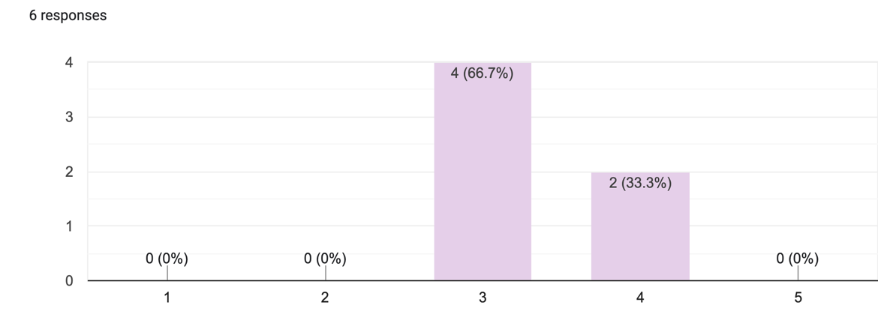

- Question for dual singers (voice students and choral singers): Do you practice your choral repertoire in the same way as your solo repertoire? (e.g., technical work, repertoire work *Please skip the question if you are not a dual singer.

Paige: Yes | Sara: Yes | Ryan: No | Jade: N/A | Jay: No | Chloe: Yes

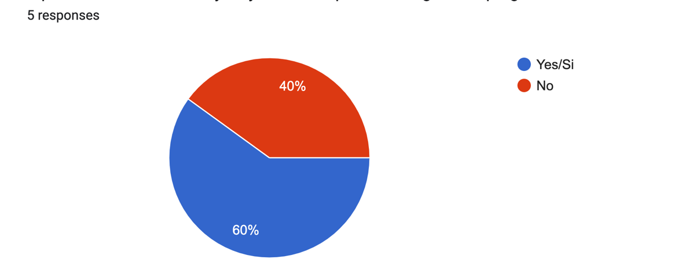
III. PARE/PASE

- During your vocal practice sessions, do you use the PARE/PASE framework? If yes, kindly explain how, if no, kindly explain why.

Paige: I did use it at one point, but now instead of using the template I use elements or ideas from it. For example, during the practice session I ask myself questions like: What did you think about? How did it feel? What movements did you use? etc., and sometimes I write those answers down to remember. That question-and-answer strategy has helped me a lot and I learned it from the PARE/PASE framework.
Sara: Yes, I use the PARE/PASE framework during my vocal practice sessions. First, I write the concept to work, either to vocalize or to work with my repertoire. Afterwards, I write what I think before I start singing to keep in mind how I want to practice it and how obtain it. After singing, I write down the actions I did to perform the exercise. In the end, I write about how it felt and how it helps me become a better singer.
Ryan: I don’t always use it unless I go with a clear goal and with the process that I’m going to work on, other times I feel like playing and doing exercises to work goals that I am going to set myself in the process.
Jade: Yes. I use it to organize my thought process better by setting a limited number of exercises to do, or what to focus on, preventing me from being all over the place. I try to keep track of what’s going through my mind or how I’m feeling throughout the session to keep repeating it and improving it with time. Also, so I can go back and analyze what may have helped me or stopped me from achieving the results I wanted. It’s pretty simple and clear, so just following the template is a good start whenever I may feel lost or doubtful.
Jay:Yes, I do use the PARE/PASE framework so that I can organize my practice and keep myself in check. It also helps me clear up my goals so that I don't go to a practice session aimlessly.
Chloe: Since I associate vocal practice sessions with the class and the PARE/PASE framework is part of it, I always use it. I don't quite find the practice session legitimate if I don't.

- If you could change anything about the PARE/PASE template and/or its use, what would it be and why?

Paige: Sometimes I get confused while trying to understand the difference between the "Sensación/Resultado" and the "Experiencia" columns. I would put the "Resultado" and "Experiencia" together and leave the "Sensación" by itself because I think the results and overall experience go more hand in hand, whereas the sensations deserve a column of their own. Other than that, I find that it's a very helpful and innovative tool for singers.
Sara: I don't really have a reason to change anything about the PARE/PASE framework. The template allows me to write what I will do or what I did and has enough space to be able to draw, if necessary, whatever to represent what I will do/did.
Ryan: I wouldn’t change anything
Jade: Maybe adding an option to mark whether you have a partner or not during the session, since that could help you identify why there may have been a certain improvement or change on your work and results that day. Also marking if you have any other instrument, like a cork or a straw.
Jay: I don't think I would change anything but to add a space so that we can write or put into words the times we reach a grey are on our sessions. Something like a yellow light so that we can write that doubt or curiosity of that specific practice session so we can bring it to the professor.
Chloe: It's just a nitpick, and maybe it's because I find that the result and the sensations I might be feeling while doing the exercise to be intrinsically tied to my experience (I do the exercise well=I feel well), but, in my case, I find that having both R/S AND E to be somewhat redundant. If it were up to me, I'd stop at the third letter, but I also understand that PAR/PAS is not as catchy and has no meaning in Spanish, unlike PARE/PASE (STOP/GO). Furthermore, I can totally understand that there's a legitimate difference between the result of an exercise and how I feel about it (sometimes I'll try out a new exercise and feel super weird regardless of the result, but also, that can technically also describe, not my experience, but also how it feels, which is to say the sensations I felt).

- If you were given the opportunity to describe your ideal vocal practice session, what would it look like?

Paige: My ideal vocal practice session would be in a place where I feel comfortable with no distractions, a piano, my music, and water, ideally feeling free of stress and motivated to improve, with sufficient time to dedicate to my goals and to also have little breaks in between.
Sara: Basically, in my ideal vocal practice session, I would be able to see, feel, and do exactly what the teacher tells me to do to achieve the desired result. My larynx would be down all the time, I would sing and feel the space in my soft palate, and all my vowels would be in the same space all the time. I would maintain motivation throughout the entire process. I wouldn't feel awful if I made a mistake or couldn't achieve or understand something the teacher told me. I wouldn't put so much pressure on myself to do everything right all the time, and I would accept if I made a mistake (I'm improving with the passing of practices and presentations).

Ryan: This would involve being in a space designed for my mental comfort, understanding that it is a work environment and providing me with peace to focus on myself and my instrument. As a result, I would establish goals and carry out the practice along the path aimed at the goals.

Jade: One where I get there knowing exactly what I want to work in, my mind is completely focused and my body in tune. Everything is clicking, I have my piano and mirror, complete silence (no interruptions), it’s just me and the music with no extra thoughts but the work I’m doing.
Jay: A completely ready mindset with a very well rested and conditioned body. A session where I can be completely conscious of the things I am doing and how they are responding, where I can be daring and confident of the limits I'm pushing and not letting bad habits or loss of focus get in the middle of the process. If I could describe it, I would see it as consciously leveling up.
Chloe: This might be an unhelpful answer, but I'm honestly not 100% sure. Here's what I mean. Writing out the BPS factors and stretching and all that is not singing plus it takes too long (at least in comparison to what I feel like it should take, which is 5 minutes tops to do everything), but I feel unprepared if I don't do it. Therefore, I feel like less prep should be more time-efficient, but I also acknowledge how beneficial it is to the rest of my practice session. Also, I'm often unsure as to what counts as a warm-up and what counts as tech work and at this point I'm too embarrassed to ask (until now), so it's difficult to quantify how long should be long enough for each one. Although, I will say that I really really enjoy treating phrases that are particularly difficult to execute from my repertoire as tech work, so my ideal vocal practice session would use the assigned repertoire (which is fun) in other to practice and continue developing my singing technique (making the process fun-er).

Appendix III

Participant’s Practice Profiles (from Pre-study Questionnaire)

Chloe’s Pres-Study Practice Profile
Emotion coding: (excitement, worries, hopes, frustration, difficulty, dissatisfaction, rushing)
Chloe is excited about collaborating with Jade and hopes this VPBS process helps her to overcome fearing making mistakes in front of others or "build some immunity to that fear." Her statement suggests that her primary concerns center around the possibility of “mental blocking,” which could impede her ability to practice effectively. This appears to be a situation she has encountered previously. Regarding her expectations from the study, she aims to foster a healthier relationship with her practice process. She acknowledges that in the past, she experienced frustration and animosity toward her current practice routine due to the overwhelming, continuous, and unending learning process, which made it difficult for her to track her progress and achieve satisfaction. Based on her words, I can infer that she believes progress is a finite phenomenon. She states, "There's also ALWAYS something to learn," and “I feel like the process is never ending,” which contributes to her feelings of dissatisfaction because she feels “it's never enough.” This could suggest that her focus on achieving results in a certain amount of time has led her to overlook the importance of the process itself, which is the one teaching her
She has participated in VPBS before and describes the process like "going to the gym," uncomfortable but "necessary and beneficial in the long run." Receiving immediate feedback from a practice partner alleviates these uncomfortable feelings, aligning with her professor's recommendations. However, she perceives the SPS as "slightly more tedious" due to its lack of immediate feedback.
Regarding her attitude towards practice, she alternates between exploring/playing and setting specific goals but often experiences a lack of excitement, perceiving practice as a chore or something “I MUST do” rather than something she “wants to do”. Among her priorities she regards the quality of her sessions and “feeling like I'm actually progressing in some shape, way, or form.
Regarding motivation and consistency to practice, between a one (never motivated) and a five (always motivated) she stated bien a three (middle), and she struggles always (a five) being consistent with her complying with her SPS. Her motivation is tied to potential outcomes rather than the process itself, leading to dissatisfaction and reduced consistency. Chloe finds it difficult to approach practice with a playful, exploratory mindset and instead feels a need to “gaslight” themselves into enjoying the process which creates a cyclical process were low motivation fuels inconsistency, further decreasing motivation. She states that “I genuinely do love singing, is just complicated, …I think I’m just scared of making mistakes”

Practice Process and Habits (she is organized and methodical. Her favorite part is transitioning to her repertoire work)

She begins with addressing her biopsychosocial (BPS) factors (appendix of “reflective diary”), followed by stretching her body, warm-up exercises, followed by technical work and repertoire practice, often incorporating feedback from prior voice lessons. She regards the process as mentally exhausting at first but eventually becomes enjoyable when transitioning to repertoire work. Sometimes, “in the name of exploration” she does “weird things”, which particularly is tech work she’s does in her voice lesson. Additionally, she uses the PARE/PASE framework and at “the end, I write about how it felt and how it helps me become a better singer” She states that her mood improves as the practice session goes along due to transitioning to repertoire work, which is her favorite section She also divides her practice sessions in 30-minute time slots. Her vocal practice satisfaction is moderate, reflecting a need for improvement in their approach or mindset.
PARE/PASE:
Chloe uses the framework consistently, viewing it as integral to legitimizing their practice sessions. Possible modifications to it would be either simplifying the framework by merging redundant components, such as "results and sensations," as they find these intrinsically linked to overall experience but she also claims that in some cases they need to be distinct.

What is your ideal vocal Practice Session:
Her ideal session would integrate phrases of her repertoire into technical exercises to make the process more enjoyable (great idea and it is her need) as well as efficient use of time with balanced preparation and execution phases.
Current Challenges:
Current preparation feels time-consuming, but she acknowledges is necessary, causing inefficiency (BPS assessment, but if she doesn’t do it, she feels unprepared)
Struggling to distinguish between warm-ups and technical work, leading to confusion about session structure (although she mentioned that she is always mindful when doing her warmup exercises and always taking into consideration her technical needs).

Jade’s pre-study practice profile

Feelings About Participating in the Study

Excitement: Jade is enthusiastic about the potential personal growth and exploring how working with a partner influences her practice and perspective on singing.
Concerns: non so far

Expectations from the Study
Jade anticipates that collaboration will lead to shifts in perspectives on singing and vocal practice and believes that engaging with different viewpoints and mutual influence will bring positive changes.

Experience with VPBS and Enjoyment of the Process
- Jade has participated in VPBS previously.
-She finds the process valuable for emotional validation and learning effective techniques from others:
“it allows me to see that I’m not alone when feeling certain emotions and helps me overcome them through methods others use”
Appreciates the opportunity to provide support and encouragement to partner with “suggestions of what has helped me before”.
Jade, values peer encouragement for addressing insecurities and discovering overlooked areas.

Attitude Toward Vocal Practice
- A mix of exploration, sets specific goals, and occasional uncertainty regarding “what to do”.

Priorities in Practice
- Quality of the practice sessions.
- The amount of weekly sessions

Motivation and Consistency

Motivation: (3 out of 5)
Regarding motivation and consistency to practice, between a 1 (never motivated) and a 5 (always motivated) she selected a 3 (in the middle)
Consistency: (4 out of 5 (always)
Jade struggles with consistency in her daily practice, which causes her stress as she disconnects from the content and outcomes of previous sessions. This stress leads to her practice becoming a burdensome chore, which in turn decreases her motivation and further affects consistency.
(cycle or loop regarding consistency and motivation)
Triangulation Chloe + Jade: Practice feeling like a chore due to lack of motivation or consistency.

Practice Process and Habits
Begins with mental preparation, “getting in the headspace for singing” or breathing exercises and stretching. She follows with warm-ups and technical exercises being mindful “spacing out the vocal exercises to meditate”. Regarding strategies for practicing her repertoire, she divides them into manageable sections, applying the technical work needed, “always trying to write down the key points”. She uses tools like mirrors, recordings, and timers, focuses on hydration (before and during sessions) and structured breaks to maintain energy (timer).
Chloe and Jade seem very organized and structured in her practice processes

Satisfaction with Vocal Practice (3 out of a 5) (5 being always)
Moderate which leaves room for improvement

PARE/PASE Framework
Jade regularly utilizes the framework to organize sessions, monitor thoughts and emotions, and maintain focus on a "specific number of exercises." She finds it helpful for identifying improvements and obstacles, as well as analyzing results. The PARE/PASE framework appears to be beneficial for her struggles with consistency and motivation, as she notes that it is "pretty simple and clear, so just following the template is a good start whenever I may feel lost or doubtful," a feeling that, as she has previously stated, leads to stress.
Add-on suggestions:
SPS or VPBS additional tools like corks or straws. (VPBS, tools)

Ideal Vocal Practice Session (satisfaction)
- A focused and distraction-free environment with clear goals (structured)
- Full alignment of mind and body (mindful approach)
- Efficient use of time with necessary tools like a piano and mirror.

Key Insights
1. Peer Support: The participant finds value in working with partners for emotional validation, learning, and encouragement.
2. Framework Utility: The PARE/PASE framework is beneficial but could be improved with more specific customization.
3. Barriers to Consistency: Stress and disconnection from previous progress undermine consistent practice.

Jay’s pre-study practice profile

Feelings About Participating in the Study
-Jay feels honored and excited to participate and possibly contribute to the study as well as observe the personal and collective results.
- No concerns mentioned, only anticipation to engage in the process.

Expectations from the Study
Jay views the collaborative approach of peer learning as highly beneficial, as he anticipates that it will enhance study session results by providing and sharing feedback beyond self-assessment (external and internal feedback, as well as immediate feedback to enhance practice sessions outcomes).

Experience with VPBS
-Yes, he has participated in a VPBS before.
- Enjoyment: The participant values their partner's ability to notice aspects they might overlook, such as biopsychosocial factors. (Jay, with his numerous academic, choral, and extracurricular responsibilities, often overcommits, which in the past has led to detrimental effects on his vocal health, as he acknowledges in his interview.)

Usual Attitude Toward Vocal Practice
Usually walks with specific goals and when he explores and plays is to assess their instrument's condition for the day (variaty of approaches, BPS is important to him)

Priorities in Practice
Quality and number of practice sessions

Motivation and Consistency
- Motivation: 4 (almost always).
- Consistency: 3 (middle).
Impact: Practicing under stress or pressure sometimes leads to rushed or unnecessarily extended sessions (Practice Challenges: Stress and pressure impact session structure and quality. The source of stress could be related to his overcommitments mentioned previously, he also had his junior recital this semester and was prepping for it during this study process)

Vocal Practice Process and Habits
Begins with stretching and deep breathing to assess physical and mental readiness (mind and body connection, mental prep first). He does pre-warm-up and warm-ups aligned with daily goals and repertoire needs. Then “I study the piece I'm trying to master and follow up with some cooldown exercises (structured practice in terms of content aligned with goals)

Satisfaction with Practice
- Satisfaction: 3 (middle).

Dual singers
(Jay does not practice his choral repertoire like his solo repertoire.)

PARE/PASE Framework and Suggestions
-Consistently employs PARE/PASE to facilitate session organization, preserve focus, and clarify goals.
- Appreciates its efficacy in preventing lack of direction during practice.
Suggestions:
- Suggests adding a section to record "grey areas" (doubts or curiosities) during practice (this section exists already and it is called “reflections or stop moments)
- Proposes a "yellow light" section to highlight areas to discuss with the professor (done)

Ideal Vocal Practice Session (success of practice)

A “completely ready mindset and a well-rested and conditioned body.”. Full awareness and confidence in the limits he tries to push and explore without falling into bad habits. Having a sense of progress akin to "consciously leveling up."

Paige’s pre-study practice profile

Feelings About Participating in the Study
Excitement:
Paige is enthusiastic about participating in the study, seeing it as an opportunity to improve her vocal techniques and practice habits. She also feels “happy to help professor” work, as a way to give back for the guidance she’s received as a student. (so grateful)
Concerns: non so far

Expectations from the Study
Paige expects the study to push them out of their comfort zone since they are accustomed to practicing alone and she views it as a chance to practice teamwork and improve listening skills. (she started teaching voice this semester, so this could help as a training tool for that)

Experience with VPBS and Enjoyment of the Process
-Paige has participated in a VPBS before.
She values collaborating with classmates, giving and receiving “tips or words of encouragement” as well as the perspective of an outside listener and appreciates the opportunity to help others. She enjoys the process, as it reinforces feedback received from their professor and serves as reminders “to keep in mind” of areas to focus on. (Ideal conditions: a supportive environment is critical for best practice outcomes, which could improve on motivation and consistency)
(Collaboration Benefits: The participant values feedback and teamwork as tools for reinforcement and growth.)

Attitude Toward Vocal Practice
-A mix of exploring/playing and setting specific goals. (not very structured, depending on how she feels)
Priorities in Practice
- The quality of practice sessions.

Motivation and Consistency
Motivation: (3 out of 5) middle/moderate
- Fluctuates significantly, described as a "rollercoaster."
Consistency: (5, always)
- Inconsistency is tied to daily circumstances and workload.
Since Paige’s motivation “isn’t linear,” this affects her consistency with daily practice, which makes it challenging to maintain a steady rhythm. (cycle loop between motivation and consistency)

Practice Process and Habits

She begins by sitting in front of the piano and taking deep breaths to “get in the right headspace to sing.” She then does lip trills while observing in a mirror to ensure proper expressions, “vocal space,” and breathing coordination. She then does technical exercises, “syllables or vowels,” centering on the demands of the repertoire she will practice. She then continues her repertoire work, whether it is “learning new music,” refining known pieces, or memorizing material. She drinks water during or after practice, and “most times” she records certain parts of the session and listens afterward for review.
(mental preparation as a starter, just like Jade),

Satisfaction with Vocal Practice (4 out of 5) (5 being always satisfied)

Seems good, but motivation fluctuations impact satisfaction with sessions.

Dual singers
Paige states, she practices her choral repertoire the same way she does her solo repertoire.

PARE/PASE Framework
At this point, she no longer uses the full template during her SPS, but instead incorporates elements from it, such as reflective questions like "What did you think about?" or "How did it feel?" Sometimes, she writes the answers to help her remember them. She finds this reflective strategy, which she learned from using the PARE/PASE during her voice lessons, helpful in improving her practice.
Suggestions - merging "Resultado" (Result) and "Experiencia" (Experience) into one column and separating "Sensación" (Sensation), as she feesl results and experiences are more interconnected. (framework simplication could improve usability)

Ideal Vocal Practice Session
- A stress and distraction-free environment with a piano, music, and water.
- Adequate time for focused work with breaks in between.
- Feeling “motivated to improved” and a comfortable atmosphere to achieve goals.

Ryan’s pre-study practice profile

Feelings About Participating in the Study
Ryan feels excited to have been selected for this study as he is eager to learn and contribute to future practice systems and the evolution of vocal technique development.

Expectations from the Study
He expects to gain new knowledge and discover new ways to make deliberate and enjoyable practice with their buddy. (values learning opportunities and collaboration)

Experience with VPBS and Enjoyment of the Process (Ryan misunderstood the question, he thought I was asking about having experience with the PARE/PASE framework)
Ryan was one of the participants “in my module 3 when I tested the PARE/PASE framework”, therefore, he has plenty of experience with it and he appreciated his participation in that study and felt he made a meaningful contribution.
Attitude in Practice:
Ryan enjoys exploring and playing, setting specific goals, but sometimes feels doubt about what to do during practice.
Priorities in Practice
The quality of practice sessions

Motivation and Consistency
Motivation:
- Rated: 1 (never).
Consistency:
- Rated: 5 (always).
Impact: (challenges)
- Inconsistent motivation and environmental distractions significantly affect practice routines; “lack of motivation” impacts his consistency to practice. (Motivation and consistency loop)
Vocal Practice Process and Habits
- Begins with stretching and warm-ups depending on the daily schedule.
- Practices repertoire by “auditing” (mental practice) if under a heavy “vocal load” or delves deeper into his repertoire if relaxed or has the time.
Satisfaction with Practice
-Satisfaction rated: 3 (middle).
Motivational fluctuations affect satisfaction levels. (This semester, Ryan got sick a couple of times, and he had a very busy singing schedule. Therefore (as expressed in his interview) he had to be careful and take things easy)
Dual singer
No, he doesn’t practice his choral repertoire the same way as his solo rep.
PARE/PASE Framework and Suggestions
Ryan uses PARE/PASE selectively, focusing on specific goals and the process when needed. Other times “I feel like playing” and explores with exercises based on in-the-moment goals I will establish while practicing. He would not change anything on the framework
(This can demonstrate flexibility in their practice approach but based on his interview expressions it can also mean lack of structure during his SPS. Aligned with his lack of motivation and consistency towards practice)
Ideal Vocal Practice Session
- A peaceful, distraction-free environment designed for “mental comfort.”.
- A workspace that fosters focus “on myself and my instrument” and allows for a structure centered around goal establishment, which would lead the process to attain them.

Sara’s pre-study practice profile

Feelings About Participating in the Study
Sara feels both excited and nervous about participating in this study. She is excited to assist her professor’s research. Her concerns center around the possibility of misinterpreting her practice partner's instructions, which could lead to "not being able to do a good job," as well as the commitment of her assigned partner to the study.
(Sara was one of the three participants in the module who tested the PARE/PASE framework.)

Expectations from the Study (values collaborative learning)
Sara expects both best and worst outcomes but remains optimistic:
Good: “further develop as singers”, “learn from each other”, “my partner and I will do a good job as we have worked together before”
Worst:”fail to understand each other” , “not do a good job”
Anticipates: mutual learning and further vocal development through collaboration.

Experience with VPBS and Enjoyment of the Process
- Has prior experience with VPBS and enjoyed the process.
- Values observing others’ techniques “skills/strategies”, experimenting together, and receiving feedback on progress, “helping others”

Attitude Toward Vocal Practice
-Exploring and playing, and occasional doubt “ I don’t know what to do”
-This approach varies between sessions.
Priorities in Practice
- Focuses on session quality, completed tasks, and weekly improvement, “feeling I’ve improved”

Motivation and Consistency
Motivation:
- Rated: 3 (middle).
Consistency:
- Rated: 4 (Moderate to high) (5 is always)
Impact: (motivation-consistency loop)
- Motivation and consistency directly influence session effectiveness and quality. When not motivated “I already have in mind that that day's practice won't work out well” (motivation)
- Daily repetition of “a certain actitvity”(practicing) help her establish habits, reducing reliance on motivation alone and helping her be more consistent: “I have already programmed it in my mind as an activity I have to do.”

Vocal Practice Process and Habits
- Starts with stretching face, neck, shoulders, and head.
- Progresses from semi-occluded vocalization exercises (for warming up) then transitions to vowel work.
- Practices repertoire by focusing on rhythm, lyrics, notes, “when I know the repertoire/music, I implement (practice) the skills learned in the voice lesson with the teacher” (stepwise approach to practice)
- Works for 25 minutes with 5-minute breaks and hydrates throughout.
- Avoids using mirrors or deliberate recordings. (feedback strategies are not incorporated) as stated in the FG (1:08:06) "I know it helps me. It's just a matter of doing it, period. Oh my God, because I don't like it?"

Satisfaction with Practice
- Satisfaction: 4 (Almost always).
- Motivational fluctuations impact satisfaction levels.

Dual singers
Sara practices her choral and solo repertoire in the same manner.
PARE/PASE Framework and Suggestions (she values structured guidance)
- Actively uses the framework to structure practice sessions: Starts with writing her CT, followed by her P: “I write what I think before I start singing to keep in mind how I want to practice it and how obtain it” (she writes her P before starting the vocal exercise, which helps her be focused and aware)
- Finds it effective for tracking progress and implementing techniques: “helps me become a better singer”
Suggestions:
- Prefers no changes to the framework, appreciating its design and flexibility and space to write or draw.
Ideal Vocal Practice Session
Sara envisions a session with clear, tangible instructions and progress: “I would be able to see, feel, and do exactly what the teacher tells me to do to achieve the desired result." Sara seems to place significant importance on receiving external guidance and feedback, while she tends to doubt her own internal feedback. I believe through her VPBS process with her buddy, she's beginning to learn that she already knows how to self-monitor her practice and progress between lessons, and she should take more ownership of the knowledge she has acquired over the years as an advanced 4th-year voice student.
Sara seeks consistent motivation and less self-imposed pressure for perfection. She would be more accepting of what she frames as mistakes, as they are part of her learning process (“I wouldn’t feel awful if I made a mistake... and I would accept if I made a mistake”), while maintaining focus and positivity. She states, "I'm improving with the passing of practices and presentations."
Her ideal practice session combines motivation, clarity of processes, and a relaxed and accepting approach to mistakes.
Throughout all her data, Sara highlights the importance of “feeling I’ve improved” and “I would be able to see, feel, and do” what has been asked of her during lessons; this apparently gives a sense of satisfaction, mental comfort, and focus for success.

Appendix IV
Reflective Observations
Chloe and Jade 1st VPBS session (August 27th, 2024, 10am)
Purpose: to clear doubts and get accustomed to having the T/R present during the sessions, provide suggestions if needed (planning content of sessions, strategies for practice such as taking turns, etc.,)

- J: “We are being fair in this partnership”
- T/R: What do you mean fair?”
- J: “tu empiezas un dia, la otra empieza el otro”, (taking turns strategy)
- C: “la última vez, empezó Jade”
- J: “ahora te toca a ti”

- C + J are writing in their reflexive practice diary (BPS)
- (appendix- keep further developing it”)
- T/R: “que estas hacienda o que estas escribiendo?”

- C: (Bio)Chloe states her arms and shoulder hurt (choral direction class and tension).
- (psicho) She says she is also nervous…
- T/R: “¿Que te preocupa más?”
- Jade: “¿Lo puedo decir en palabras sucias?”
- T/R: “Claro”
- J: “cagarla”
- C: “si, si, gracias Jade” (she makes heart gesture to Jade)

- T/R: miren, básicamente yo estoy aquí de “eavesdropper”, de presentá, a ver qué ustedes hacen Y entonces de alguna forma u otra aprender de ese proceso y ver si las puedo ayudar”
- C: “why don’t you warm up with me”?.. (she means stretching her body)
- Jade tells her that when she was talking, she stretched.
- Chloe continues stretching and Jade joins her (for a bit)
- Chloe decides to do boxed breathing “or i have a feeling I won’t be able to pick it up” (Jade counts the beats)..
- Chloe does masseter massage…and shares that every time she stretches her neck and shoulders that she feels really tight…
- T/R: “are you sleeping well”
- C: “not really”
- we all talk about possibly doing stretches before going to bed, or adjusting the pillows she is using, meditation…
- C: starts to do some humming
- T/R: inquiries about Jade, she didn’t eat well in the morning….. she shares about being stressed due to her morning classes…
- They are both taking their time to stretch and assess, Jade does autolaryngeal massage and both write (on their notebooks)
- Jade shows Chloe a vocal exercise and she freaks out because it’s a bit high…
- Jade is sitting in the piano…..and Chloe shows her where she usually starts on the piano….
- They both warm up together (1—2-4-3-5-4-2-1 LT)
- Jade is using her VPBS to master her piano skills…..
- Chloe states that her F4 broke and she needs to be more aware “I’m clenching my jaw” so she’s putting her fingers to create a remember the space….
- C: “vas a seguir subiendo loca?”
- SPA moment (17:55): “ahora voy a interrumpir voy aquí como que ayudarlas. Okay so me gusta el approach de ustedes de hacerlo a la vez pero si una de ustedes tiene o quiere subir más o quiere subir más lo puede seguir, ok. Ahora, esto siempre me trae la pregunta, ¿ustedes saben cuánto subir y cuánto bajar en ese primer ejercicio SOVT?
- C: llego hasta donde no le estoy poniendo “extra effort” si me empiezan a salir “gallitos” comienzo a bajar
- J: states the same approach…..si le tengo que dar mucho, comienzo a bajar
- SPA: me gusta, es un approach de libertad y que lo entiendo.

General reflection: This was a session to get the lay of the land and see what they do together during a VPBS. Jade and Chloe have great camaraderie amongst themselves, they laugh and understand each other when the other one is nervous and most of the time the other person says they feel the same way. They stated, “we are being fair in this partnership”, regarding taking turns in who is in the piano and who is. Standing.They were very nervous that I was present, seeming like they wanted to do it right and feared making mistakes in front of me, but they seemed very comfortable in front of each other (they get along great together). I am glad I was there because it helped me a chance to clear any doubts they had regarding vocal processes such as how high to do lip trills in that first vocal warm up exercise, talk and open the conversation to understand their thinking and validate their ways of making sense and how they handle what they encounter while practicing, which I think allowed them to calm down a bit more to get in the flow of things for their VPBS session. They keep each other accountable and support each other through their difficulties (Chloe to Jade “you are doing great” (when she was playing the piano). They also challenge each other while making it fun (teasing: “fair is fair”, “I’m going to take my revenge”) while laughing. When they take turns, and one is singing the other listens and then gives feedback. They both brought their PARE/PASE templates (iPad and paper respectively) and after the exercise and discussion they took their time to write. They also did a session prior to this first session.
Note: They kind of started to “blend” or imitate their sounds or maybe model their processes and imitate their sounds in a way.

Suggestions for next VPBS sessions:
- Plan what they want to work on, maybe 2 vocal exercises and a little bit of repertoire.
- In the face of ordinary difficulties, do a SM (change of vowels /i/ - /a/, passaggio coming up) which when I suggested it they laughed amongst themselves (I don’t think they like to stop). Why is it hard to stop in the face of difficulties? Maybe because I was present, and they didn’t wanted me to judge them.

Chloe and Jade 2nd VPBS session (09/03/2024, 10am)

Walking into this session, thoughts that come to my mind is how this investigation could help me as a teacher (or other teachers) to better the relationship voice students have with their DP sessions. How can we as voice teachers impact that very important process for our students taking into consideration the demands of the singing journey in terms of collaboration, support, motivation, asking for help and feedback, establishing an environment of safety, respect and professionalism that also allows for play and build the social skills for camaraderie. An environment that is open for dialogue where teacher and students are equal learners (Helding, 2020 “partners in training”).

As a result, is not about creating or inventing something new altogether, is about avoid perpetuating the same systems that have many gaps (such as not knowing how to go about practicing) or students walking into practice sessions just to comply with a chore, which impacts their vocal learning process overall (parallels, perpetuating “not reflecting in how to support processes” as equal as perpetuating “warming up and learning my music and just not transcending to actual vocal learning, or troubleshooting problems or uncertainties of practice, creating a moving vocal development loop that transcends the voice lesson and continues with students SPS and/or VPBS sessions with real strategies designed to support the vocal motor learning process through reflection, exploration, play, creativity

How can we better support and shape the practice process of our voice students?

This session started with a discussion regarding “cognitive dissonance” when the teacher/researcher recalls telling Chloe to sing like she should not like she chooses to sing it. To this Jade states this is similar to when she listens to herself while singing instead of “feeling her singing and technique”, therefore establishing a comparable parallel experience. Chloe states she is not singing it like she choosing she is “ singing it “como pienso que quieren que lo cante” /” as I think they want me to sing it”. T/R says: “how can we fix that dissonance” “how can you know you are doingf it the right way?”
Chloe: “keep practicing”….
T/R and Jade: No, because you are perpetuating the same doubt”, “you are just repeating something”
T/R: When you are with a buddy it is easier because of their feedback….“When you are alone how do you know?
Chloe: “when I have the balls to record myself and listen to it” or “I look at the mirror”
T/R: “and when you don’t have that external feedback?”
Chloe: “well, when it feels comfortable, I know it is right” (S/R)
There are time she doesn’t allow herself to go by sensation because she is not motivated therefore seeing practice like a chore or something that she must check of her list, which leaves her feeling “not great” or unsatisfied with her practice session.

Strategy for her: when feeling low and not motivated to do vocal exercises, do repertoire work in a technical manner (something she discussed in her pre study questionnaire) that many times vocal exercises make her feeling frustrated.

Warming up the voice is the process of transitioning the voice from its spoken use to its singing use.
Practice strategies: “chunking” (Chloe) and working in a stepwise manner layer by layer, learning the whole piece before doing the technical work (Jade). Two very different styles of working.

“Swampy lowlands” moment: Chloe shares that they both talked and because the teacher is presents in the VPBS sessions (SPA) they feel like they are in performance mode and that makes them anxious of making mistakes. They know they are “allowed” since practice is “messy” and T/R wants to see “messy” but they do not feel very convinced they can make mistakes”.
Jade: “that’s precisely right, I don’t want it to be messy in front of you” (Chloe agrees)

T/R explains her role as learner and as possible equal in this formula, so she inquires “How can i make it better for you guys to feel more comfortable”, I just want to understand your language and experience to help you guys where you want to go and better your practice experience.
Jade: “she is here and she’s going to see you fuck it up”
This is not about making mistakes, its about a process so:
T/R strategy: How about I practice for 5 minutes so you guys can see me in my process. T/R shares how she feels “not great” scratchy allergies, tired because she did not sleep well”, she nebulized beforehand but hasn’t warmed up her voice. She starts doing LT and stretching and moving while singing and varying the sequencing of her notes (5,4,3,2,1/ 5,4,3,2,1,3,5,3,1/ 5,4,3,2,1,3,5,8,5,3,1), she stands up, gets her SOVT bottle, stretcher her neck again. T/R did feel a bit exposed but she wanted to be in her participants position and experience the feeling they are expressing. She inquired regarding feedback or comments about what she was doing:

Jade (emotional), “you feel human”, like a singing type of partner not like the voice teacher”
Chloe (with a smile) “shes just like me, that’s crazy”

T/R: “remember that I am your teacher and most of the stuff you know I have taught you”. She does a second exercise (5,5,5,5,5,3,1: /i/i/i/i/i/a/i) with SM and as she shares why she is stopping and what she has been focusing this past week about her vowel changes between /i/ and /a/….she inquires again regarding feedback or comments:

Chloe: “we do the same” regarding exploring vowel shapes, different inputs and R/S.
T/R reassures her that’s what practice is, exploring, solving problems, dealing with what we find that day…
Jade: “This is not something I have to do because I am a novice or student, this is what professionals do to”

T/R: Does this helped establish a more comfortable even ground amongst us?
Chloe and Jade: Yes
T/R: “Thank you for allowing me the opportunity”

During this session, Chloe was in charge of the piano while Jade was standing in front of it.
After this Chloe and Jade’s session flew so much better, they looked like they trusted the process more and their level of comfort with each other improved. They seemed more present with their instruments, taking their time, repeating when needing, not just practicing together but doing the exercises with each other, stopping when needing, changing tempis that favored what they were exploring in their warmup exercises. At time Chloe alternated with humming and “blowfish” (SOVT) while Jade stayed during humming. They listen to each other, many times just a looked and the other person knew they needed to repeat and explore a bit more and at times they were so in sync that they reached for their water bottles at the same time. During this session they had their templates individually (Ipad and paper) and after the exercises, they shared their difficulties and how the fixed them and what they thought regarding them;
Chloe: “the same thing happened to us” (they both laughed), “the first note great and the 5th too thin”.

PARE/PASE: Chloe usually reviews her previous templates before each SPS or VPBS to remember her “mistakes/tendencies” so she can keep an eye on them. Those she circles in “red or dark pink” which is her “angriest” color designated so she can recall faster and remember.
Jade: remembering that not every day is the same and what worked one day doesn’t necessarily will work the next time “ if it doesn’t work don’t stress about it and find another solution but at the same time, I want it to work like it worked before” “it’s like a fight with myself”…..

They continue unto a second warm up exercise since they don’t feel “fully warmed up”. They vary from the first exercise, adding more notes in humming. As repetitions passed, they grew in comfort and independency of processes, stopping where needed and repeating and suggesting strategies.
Chloe was looking for “more gliddy” and Jade for “more connected”, they were in sync, not requiring much explanation.
T/R inquired regarding asking for feedback or help from the buddy, they both stated wanting to explore first by themselves before asking for help…
SPA: teacher suggest Jade thinks a bit more deliberately about her inner space and that she uses the mirror to help me in her inner assessment.
Chloe suggests she does a SM before her high note (exercise is 1,5,8,5,1) so she is more engaged and less thin in her sound “less mousy” (which is something that she stated happening to her previously).

SPA: went to the front to try and help Jade as she was having a bit of difficulty during an exercise. Chloe suggested doing “sirens” although she was feeling “phlegmy” (Chloe). As they both keep finding their flow and rhythm together, Chloe inquires, “how did it feel and what did you change?” (PARE/PASE framework) and when Jade had doubt Chloe reassured Jade that she knew what to do and to do what she wanted.
Jade switch from humming to LT and she found her groove back, understanding where she needed to be more connected in her exercise, then she switched between LT and humming (change of strategy).
Suggestions or encouragements for VPBS: keep planning before sessions, working repertoire once they already know the music well to practice performance and get that feedback from someone else other than the teacher (peer) and if something doesn’t work that “it’s not a humming kind of day” then switch to another exercise that feels better and informs you and try to avoid on insisting (to Jade as she remarked this).

Chloe and Jade 3rd VPBS session (09/10/2024, 10am)

Based on Jade and Chloe's feedback from the previous session, they felt that their teacher's presence during their VBPBS sessions required them to be in a "performance mode." This heightened their anxiety and self-awareness about making mistakes in her presence. Therefore, for the remaining sessions, the T/R decided not to be present during the VPBS sessions and just record them. Based on this, she will be making non-participant observations. The T/R made this decision to help Jade and Chloe feel calmer and less anxious while also attempting to capture the true essence of a VPBS session. T/R will also apply this strategy to the other VPBS teams, aiming to utilize the initial two sessions for SPA, provide recommendations, and then provide them with independence in the subsequent sessions. She did remark that if the participants needed her assistance, she would be available.

3rd VPBS:
During this session the T/R gave Chloe and Jade the option to use the board (just like they do in their lessons to fill out their PARE/PASE. They seemed to enjoy that option:
Chloe: “ah, so cool”
The first thing T/R noticed after leaving the room was that Chloe and Jade seemed to come alive with their true personalities as well. They automatically started talking and sharing how they were feeling while doing their BPS assessment in a very natural way, stating if they were physically tired, how their weekends went, how early they had to wake up that day, commenting on being aware that the recording was on “my YouTube channel” and “vlogging” comments while laughing. Basically, feeling comfortable to be relaxed and equals in the practice space without having someone else’s eyes on them waiting for them to practice or do whatever they do while practicing.
They started stretching their body, masseter, doing free lip trills, openly kept sharing, laughing and making jokes, which I think established an environment of togetherness, safety and comfort, equals and peers getting ready to work on their voice, technique and music. Jade prepped the board with the PARE/PASE template and instead of CT (concept to work/ concepto a trabajar) she put OBJ (objective). Chloe suggested a structure for the session regarding around 15-20 mins of warmups and “possibly” 1 technical exercise so they could move on to repertoire work like the T/R suggested them.
This took Jade a bit by surprise because she forgot and did not prep for that, but Chloe did and was ready for it. Jade laughed and stated that she likes to “refresh” before doing this type of work either for her voice lessons or VPBS sessions. They both laughed as Jade acknowledge (in front of the recording) that she actually forgot, which for the T/R means that they are so comfortable with each other (not having the T/R present during their VPBS) that almost forgot there was a recording going on. After 12-13 mins of sharing what to do, stretching and assessing their BPS they started warming up with SOVT (1/3/5/3/5/3/1) Jade was doing LT and Chloe alternated with LT, blowfish, humming and raspberries.
In this session Jade started in the piano and Chloe was standing up. When Chloe felt it was too high for herself, she stopped and had a drink of water while Jade kept going warming up her high range. Chloe was surprised how high Jade was going, and she said to Jade: “very nice” while moving closer to the piano. Later Chloe joined in when it was lower in register and as Jade continued going low in her register Chloe stated again “Jesus Christ Jade, that register” (so surprise and laughing) while moving closer to the piano again to see how low she was singing. Jade replied that in their voice lessons the teacher stretches them at the beginning, so she does it the same way if she feels comfortable but also stating that every day is different.

T/R: At this point is good to see that although they are practicing together, they are taking into consideration their individual needs and know how to be independent within the collaborative environment. Also, Jade was getting more comfortable at playing the vocal exercises in the piano and i don’t think she felt so judge if she made a mistake at the piano (which was one of her goals for the VPBS).
Jade mentioned what time it was and how much time they had left and although Chloe had suggested around 20 mins of warmups, she said she still needed another exercise as she didn’t feel “warmed up enough”. They moved on to doing arpeggios on SOVT’s and they did not write at the board yet. When Chloe again gets surprised by how high Jade is going, Jade challenges her and say, “can’t you go up to a high F#6?” to which Chloe replies “I don’t know”, and Jade says “do it”. Chloe does it and she seems happy and surprised: Chloe: “damn it, I cannot believe it and I have a witness” (pointing at the computer that is recoring), she also remarked “it felt so great” and I didn’t “overthink it” and it felt “slay”. She seemed surprised and quite motivated with her outcome on Jade’s challenge as she shares this. This challenge brought Chloe to reflect that she probably should try to warm up higher in her SPS and VPBS sessions.
During this exercise Jade mentioned that her voice has been feeling “raspy” for the past days which Chloe asked if she was hydrating enough. (Her buddy helping her keep a check on her vocal hygiene routine).
Reflection time (PARE/PASE): After this they move to the board to fill up the PARE/PASE template based on what they have done so far. During this process they start describing and explaining what happened, what their goals were, clearing doubts regarding what could be considered and action (A), making sense of their processes and strategies while singing and exploring.
Chloe: “can this be considered an A, releasing the tension in my jaw?”
Jade: “yes, I understand you, that’s an A”
Chloe remarks she “hates humming” and she is “scared of them” because they are “too similar as I sound fully singing them”, therefore she states she must do more humming exercises as to learn from that difficulty. Jade states that she usually starts her warm-ups not too mindful and then when she gets into a difficulty she thinks “where am I?”, remembering that she should have always prep (P) better.
T/R: Here she is being very open and honest with her buddy about her fears and their tendencies.
Chloe: “its almost as the A leads you to the R/S” (they laugh )
Jade: “we have 20 mins left, one hour is not enough for us”
Chloe: “To be honest, this feels really chaotic, but it's like a healthy chaos.”
T/R: I remember in the first sessions I was present; I told them practice is messy, and I wanted to see messy. They felt too self-conscious about that mess and making mistakes in front of their teacher. For the T/R to witness that messiness or that “chaos” I needed to step away from the room. When Chloe remarked “chaos” as a word for describing their making sense process and regards it as “healthy chaos” make me think that, they are engaging in the qualitative deliberate practice work that is challenging and effortful and simultaneously, that it is good to have help from a peer that gets us and understands you, so you don’t feel so overwhelmed during the practice process. They are building a support system to continue developing their organization and planning skills as well as handle the difficulties of practice, where challenging each other (desirable difficulties), laughing (play as motivation), working and focusing while getting stuff done, getting immediate feedback: Jade: “did it sound ok?” (when her voice was feeling “raspy”), and even amongst their differences they understand each other: Chloe “to me it was jiggly” (regarding it was moving), Jade: “too me it was smooth sailing, peaceful, relaxed but engaged” and “I didn’t stress because it wasn’t working, I was exploring and working”.
They later moved unto repertoire work where Chloe needed some assistance regarding breath management and phrasing of a long phrase. Jade helped her with breathing in a different, more energetic manner and taking breath according to the text and it helped Chloe with find a solution for the moment. Jade stated to Chloe “you need to make the piece yours”. Jade worked on a phrase of her aria and she remarked “my brain is empty” which made Chloe to reply “do you need a Stop?”, which concluded the hour session. While Jade was walking to open the door, she sang the phrase while walking and she was able to sing it like she wanted it, which surprised her and she laughed.
4th VPBS (October 1st, 2024, 10am- they started late because Chloe had an exam)
This lateness caused Jade to be concerned about time during their last VPBS session. This session started with both practice partners hugging each other and checking in with the other one regarding the exam Chloe had. Then they did one warmup exercise and afterwards they stretched and talked about how they were feeling. Jade seemed tired or low in energy, “bodily wise” she wasn’t feeling great. During this session, Chloe was in the piano, Jade was standing and singing while Chloe listened. Jade asked Chloe to not intervene and let her figure out if something was not working. Chloe did as Jade ask, but then Jade asked “what’s going on?”, which Chloe replied, “you told me not to talk”, to which Jade said “but your face is very questionable”.
This brought a feedback session that was helped by reflective questioning.
Chloe: “ i feel you are singing to yourself and I want to hear you as well as the professor” (signaling the camera).
Jade: “I want to listen to myself first”, “why do you look at me like that?”
Chloe: “I can’t look at you?”
Jade: “not with that face” …
Chloe: “what are you afraid of?”
Jade makes a comment about, collapsing, which brought Chloe to bring her a chair to sit. Jade said it was that she felt her voice was about to collapse a bit. Either way, Chloe encouraged her to sit and relax. They did a couple of breathing exercises to focus, calm and continued working.
1/3/5/31/3/5/3/1/3/5/3/1/ (i/i/a/a/i/i/a/a/i) with cork work both of them
At the beginning it was only Jade singing and Chloe listened and then they switched. This allowed for each other to really listened to one another and figure out how to give the other one feedback while helping each other with the difficulties they were experiencing. Chloe suggests to Jade to do the exercise without stopping in the middle. This strategy rendered a positive outcome for Jade and Chloe got for the improvement she was achieving. Afterwards, Jade started experimenting another challenge and Chloe decided to use the PARE/PASE framework to understand Jade’s experience “help me understand”:
Chloe: “that /a/ is very pretty and clear, what are you thinking? (as she goes to the board)
Jade: “empty thought”
Chloe: “ok, and that works for you? …. are you sure you are not thinking anything?”
Jade: “same space” (as she goes to the board)
They reflected a bit, but she was rushing through the process concerned about time. Since this session started 20 minutes later, I think it made Jade feel guilty if she was stalling to much doing this vocal exercise. Then Chloe started doing the exercise to then try to move unto repertoire work because it was still early, and she didn’t feel ready to sing repertoire yet. In this instance Jade helped her and reminded Chloe to “prep the space, feel the space”. Chloe stated to Jade “I can always trust on your sincerity” as they laughed. Jade blew a kiss and applauded in approval of what Chloe was doing. When Chloe finished the exercise she said, “that was very weird, and ugly” to which Jade replied “that sounded amazing”.
T/R: Talk about cognitive dissonance, but then Chloe went to the board to document what she experienced in the PARE/PASE board and when she drew the sun on her E, she was very surprised. Afterwards Jade did a couple of segments from her Verdi aria and Chloe helped her on the piano and suggested to her to sing the entire phrase while pointing several spots that were beautiful and other that could be more clean or freer.
T/R: Because they were taking turns to either sing the exercise and write on the PARE/PASE board, it felt like they were taking turns and peer tutoring one another. They were very specific with what they were listening and how they were explaining it. This type of work allowed them the chance to work on their listening and giving feedback skills.
Jay and Paige's first VPBS session (August 29th, 2024, 4:30 p.m.)
Purpose: to clear doubts and get accustomed to having the T/R present during the sessions, provide suggestions if needed (planning content of sessions, strategies for practice such as taking turns, etc.),

Paige and Jay were paired together because they are in the same semester and year of studies, and they were prepping and doing a recital together in the following months. Therefore, the T/R thought they would pair well together to create collaborative work from their practice sessions. Paige is a soprano, and Jay is a tenor. During their first session, Jay brought his PARE/PASE template (paper) and was already writing it (possibly prepping it). Conversely, Paula did not use her PARE/PASE template during the session. She stated at the beginning that they are both “very different”; he is very “structured.” The T/R said that it was great that they were so different. Afterwards, they began to stretch their bodies, and Jay assumed a leadership role in this interaction, consistently checking in with Paige to see if she was comfortable or needed anything. Both of them expressed nervousness, which was evident in their interactions. They are not accustomed to working together in this manner. Jay is accustomed to doing VPBS with other peers but not with Paige, and she is usually accustomed to practicing by herself (as stated in her pre-study questionnaire).
They start doing their first warm-up exercise (LT 5/4/3/2/1/2/3/4/5/4/3/2/1), and Jay goes to the piano but asks Paige if she wants to take the lead. She likes to stretch her mouth and jaw before LT. She lets him get to the piano, and she stands; they both sing together the exercise. Jay stops and switches octaves when he reaches high C5, and Paige goes up to an Eb6 (T/R guides Jay in how high to take Paige), then she starts going down her register. He flips octaves again and joins her down. They go as low as her F3 (his F2) when he tells her, “Wow, woman, you are incredible,” as he is surprised by her high and low extensions, and they high-five each other. This shows motivation and surprise for what Jay is witnessing in his buddy.
T/R: Takes the moment to do some SPA regarding the soprano register as far as stretching her voice up to Paige’s extension for future session reference as well as the tenor register.
For the second exercise, they switch places; Paige is at the piano, and Jay is standing by her. Without a mirror, Paige uses the piano's reflection to reflect herself as she starts the exercise. He wanted to do raspberries (SOVT), but she finds it difficult, so they decided to work on it in future sessions. Paige decides to do a technical exercise: 1/3/5/3/1 (vi-vi-vo-vo-vi), based on what she has been working on in her voice lesson (she explains to him). As they start singing, Jay writes something to his PARE/PASE (paper). Then, he stands where he was previously. During the exercise, Jay stops, which makes Paige stop and inquire.
T/R: “Why did you stop?”
Jay: "I wanted to watch Paige, but I lost connection."
T/R: (SPA) encourages Jay to share with Paige about the skill he has been working on regarding getting “disconnected.” He explains that his tendency to switch to his falsetto in the choir, which he describes as a "not authentic voice," to blend with the rest of his section hinders his vocal development. He expresses frustration when this happens. Paige responds, "Yes, but it's not a smooth transition." As he explains, Paige states the importance of her learning that this is something that usually happens to the tenor voice as they go up in their high tessitura because she just started teaching voice that semester, and she could learn how to help her students better if they encounter this situation.
T/R: Therefore, this VPBS dynamic can help Paige learn about vocal tendencies, behaviors, and comparisons between the male and female voices.
Jay intends to troubleshoot his difficulty by observing Paige perform the exercise, and then he will follow along. Paige sings, and he follows. T/R intervenes and says, “Paige, look at him and help him, as I think this will help you as a voice student and teacher.” It will also help Jays notice what is going on. The T/R encourages Paige to take him up to his high register, and as he goes up, Jay gestures, and Paige asks, “What happened? What are you thinking? Jay thinks, and he asks to continue singing to try to keep exploring; afterward, he flips to falsetto. Although he was a bit frustrated, Paige noticed the flip this time, and the T/R asked her, “What would you tell him?”
"I think he is too much in his head," Paige says, eliciting laughter from everyone, including Jay, who shares this feedback frequently. Paige states he was showing signs in his face that he was a bit stressed out about going higher: “You had a predisposition in your face and shoulders.” Jay responds, "Yes, I was panicking a little."
T/R suggests remarks to engage with each other during their sessions, be open to listening and interacting with one another, and not just sing together. Use yourselves as resources, as mirrors of one another. Also, plan sessions for yourself, not what you think the T/R wants, and base your work on your lessons or vocal ensembles.
SPA: T/R encourages Paige to bring Jay down and monitor his concern, which is singing his vocal phrase even instead of singing certain pitches more loudly or heavier.

Jay expresses his nervousness, and Paige agrees, emphasizing that her nervousness stems from not being as proficient at the piano as Jay is. As they do this, Paige is more alert, attentive, and proactive towards Jay’s concerns; she suggests doing it slower, which is more challenging for Jay, and he states, “I need to do it faster; if not, I keep being too much in my head.” He sings it well, as it reaches his high register, and he does not resort to falsetto.
Paige says, “It sounds much, much better.”
Jay: “Really?”
Paige: “Yes! What did you do differently?” (use of PARE/PASE reflective questions)
Jay: “Connecting more with my air and trying to keep it free.”
Paige inquires if previously he was thinking of volume instead of “seamless, which he thinks he was. They start going down, keeping in mind “seamless” or “even” instead of bigger in volume (which is something he has been working on in his lessons). When they finish, Paige applauds him, and she remarks that when he was going up, his “eyebrows and shoulders” were going up, and when they started going down, she noticed how he relaxed his shoulders and face (constructive visual feedback).
Jay says, “So the effort and worry are visible or too exaggerated.”
Paige: “That could be a reflex of your fear when going high in your register.”
Paige suggests he use a mirror to keep those things in check (strategy).
She also remarks that he did something “really well” that is challenging for her, freeing his jaw and engaging more of the lips in vowel work (positive feedback).

When they finish, Jay continues to complete his PARE/PASE template, and Paige expresses that she also needs to complete it. Typically, Paige records herself and listens to it, or she sees the PARE/PASE of her lesson but doesn't write in it during her practice sessions. However, the T/R reminds her that it's crucial to observe how she uses it for this study. During the VPBS session, she used reflective questioning techniques such as "What did you think?" and "What did you do differently?" "What did you think?" (P) and "What did you do differently?" (A). When Paige saw Jay writing, and they both began reflecting on their actions, she said, "I like taking the time to reflect at the end."

T/R suggests: “How are we making the most out of this partnership” or collaborative work?”. She encouraged them to claim that time as theirs, not the T/R, to use a mirror or recorder, to use the PARE/PASE on the board if that is more practical or easier, to plan and be flexible, to divide the session 50/50 so time spent is equal amongst buddies, to work on repertoire, etc.

Lastly, Paige asked Jay what he was observing while she was singing. He said, "How were you so flawless?" Paige responded, "I was thinking about keeping my jaw from articulating too much and using more of my lips," which was her goal and objective. The T/R said this kept her distracted, but Jay felt very relaxed and calm. The T/R advised Jay to adopt Paige's focus strategy, which could involve using a mirror, to increase his attentiveness to his actions during singing, thereby reducing his tendency to get lost in his thoughts. (Having a goal and monitoring it)

Jay and Paige's second VPBS session (September 5, 2024, 4:30 pm)
The T/R arrived a few minutes late for this session, but by then, Paige and Jay had already engaged in some LT exercises together. Paige remarked Jay sang a D5 and was more relaxed than in their first session, to which the T/R responded, “You are getting more accustomed to working with each other.” They also shared their BPS assessment for the day. They appeared more at ease and in a state of flow with each other. For the second exercise, Jay took the lead on the piano and suggested an exercise where Paige would take turns doing LT or SOVTs, to which she agreed. As he tells her not to be shy and she worries about slobbering all over him, he asks if Paige would instead do LT rather than raspberries, which she had mentioned being difficult in the first session. Jay challenged her to work through them and “try the raspberries” (a challenge for working on a difficulty). Due to her vulnerability, Paige got nervous, but they laughed and did it.
Jay: “Zumba, Dale.” “Hit it; go for it.” (He seems motivated to help her.)
Paige: “Ok, you will see how I do them.” (nervous)
As she begins, Jay observes her closely, and Paige responds, "Don't laugh," appearing apprehensive about revealing a skill that she considers a weakness.
Jay: “You are doing well; keep going.”
Paige: “He is looking at me like this” (she imitates him and laughs).
SPA: The T/R explains that he is just trying to watch her and see how he can help her, and Jay agrees with the T/R.
Jay: “Yes, I was watching and thinking about that.”
Paige: “Thank you.”
Jay: “I am not laughing at you.”

They continue the exercise, and Jay cues Paige: “Keep exhaling,” and he sings it and demonstrates it to her, which allows Paige to see how he does it, and she says, “Oh, you don’t stick your tongue that much.” This prompts Jay to pause and reflect; he glances at the T/R but then shifts his attention back to Paige. He repeats the exercise to ponder and connect with her, explaining his raspberry exercise process (reflection on action).
Jay: "As you noticed, when I stick my tongue out, I feel the vibration in my chest and thoracic cavity." He shares his process and strategy as we reflect on the action while he performs it and recalls its sensations and results (R/S). He then asks her, “How do you feel?”
Paige: "I don't like it because I can't do it, and I want it to work."
Jay: “How do you want it to work?”
Paige clarifies, "I want the vibration to remain constant and not break or interrupt."
Jay proceeds to repeat his raspberries, seeming to connect to what Paige mentioned about the fluidity of the exercise, and tries to recreate what happens to her to see if he can figure out what is that happens to Paige. He recalls language the teacher has used in class for working on lip trills. “Do you remember when the professor says to do the LT more relaxed or with more pressure on the lips?” “Could you possibly add more pressure to the lips?”
Paige tried the strategy Jay suggested (without pitches), and it worked:
Paige: “I think that was better.” (surprised and laughing)
Jay: “There you go.”
T/R: "Wow." She also suggests that she should distance herself from Jay to alleviate her concerns about excessive slobbering.

They continue with the exercise, and it's working much better than at the beginning. Jay cues Paige, “Keep going.“ It’s coming out better,” and he tells her to please not worry so much about slobbering and to concentrate on adding a bit more “lip pressure,” as he thinks “it is causing some type of positive audible result at least.” Paige responds, "Yes, I also feel the difference."
Jay: “What do you feel?”
Paige: “In the lips, I feel the vibration” (pointing at her lips).

Jay encourages her to focus on her body as much as possible, using this strategy to see if she receives different feedback during the exercise.
Paige: "I felt the movement of my breath and my abdomen."
Jay: “Ok, we keep exploring.”

Paige seems less self-conscious and more trusting of the process, and her buddy Jay is helping her. As they both get specific about giving and receiving feedback based on their awareness of processes, actions (A), thoughts (P), and how they feel (R/S), Jay remarks, “So, that’s your cue?”. This statement took aback Paige, as she appeared unsure of what Jay was referring to. “What cue?” Paige asks.
Jay stands up and models/demonstrates that every time Paige is going to sing a repetition, he takes a step to the front: “I am just getting to know you in your private moment,” and he explains that’s her “action move.” They both laugh, and she jokes that it is like she’s about to run when she does that.

T/R: This interaction was so exciting and emotional to witness. Paige had a clear goal for what she wanted her raspberries (SOVTs) to be. This required him to work vulnerably on a desirable difficulty because to achieve this, she knew she needed to step away from her comfort zone and be highly vulnerable. “I don’t want to be slobbering all over.” She also wanted to stop because although her raspberries were getting better, they were not as fluid as she wanted them to be. Doing this type of work in front of someone she’s getting to know in this private practice context while they get accustomed to working together was challenging. During this, Jay respectfully stated that he was also “getting to know her” in her “private moment” or process. Jay was closely observing her, attempting to assist while also encouraging her to "keep going," "explore," "don't stop," and "it's getting better." They were getting acquainted with their tendencies, gestures, and quirks and bringing them to the attention of the person's conscience as feedback to work from. As a SPA encouragement for both, the T/R mentioned, “Practice is vulnerable.” If Paige hadn’t embraced the vulnerability of the difficulties brought by her attempt to work on her raspberries and Jay hadn’t challenged her to work through them by stopping and exploring with “applying more pressure into the lips,” she wouldn’t have stated afterward, “It is better,” “I feel the difference in the lips vibration,” and “I feel my breath and abdomen engaged.” So, stopping, describing, listening, trying things out, reflecting, analyzing what someone does, explaining it to see if it helps the other person, and giving and receiving feedback to work out practice problems were beneficial ways to improve and practice singing.

Observing the positive outcomes in their second session was emotionally charged for the T/R. Following this interaction, she briefly left the room, leaving the recording device running to allow the participants to continue their work.

Jay: “We are here to help each other.”
He also encourages her to keep her tongue active and not so relaxed.
Paige: “With a little arch?”
Jay: “Yes.”
They continue going down her register, and she states, "It is tough to keep the tongue engaged."
(SPA) T/R tells them that the articulator has improved and may need rest after exploring something new. She asks Jay what he would recommend to her after her raspberry work. He tells Paige, “Take a few seconds to yourself and rest.” Paige closes her eyes and takes a wakeful rest to consolidate the processes. T/R discusses the benefits of wakeful rest after working on motor learning skills.
As they switch places (Jay standing to sing and Paige at the piano), Jay recommends to Paige that the next time she tries to practice her raspberries, she think about what worked, and he shares, “When I am practicing sometimes, I fail at that; I’m a bit stubborn with that” (they both laugh).

T/R inquires if they are recording the session; they are not, so she encourages them to use the board for the PARE/PASE to avoid forgetting what worked for Paige and because she is not accustomed to doing the template while practicing. We decide to send the participants a link to the sessions so they can complete their templates.
While Paige writes on the board, she acknowledges what worked: “Oh yes, that helped me a lot” (pressure on lips) and wrote “satisfied” on her E (experiencia) because she achieved her goal as we all reflect together. Jay realizes everything they worked on is based on Paige’s template entries.
T/R suggests always planning what they want to do and being flexible with what they can attain during sessions.
Paige shares that when doing SPS, she avoids doing raspberries because “they are hard, and I end up frustrated,” to which Jay shares the following:
“I have noticed that I am more willing to try certain things when I am with a buddy (practice partner) than when I am alone” (Jay is accustomed to studying and practicing with peers and friends). He shares that he’s more open to exploring and experimenting with different or complex things in comparison to doing them alone. He has noticed that "I will convince myself" or "I will look for a reason not to motivate myself to do it."
Paige: “The buddy pushes you.”
Jay: “Yes.”. He notes a similar observation he's made with other peers: "How do you think you will improve if you don't do it just because it's hard?"
While Paige continues, T/R reminds them both that the PARE/PASE is for good or negative outcomes; if something feels tight or uncomfortable, document it.

Jay seems motivated to participate in the study as we reflect during the VPBS session, saying, "This is cool."
Now it is Jay's turn to do the exercise, and he establishes his goal based on what Paige pointed out: while he does raspberries, he doesn’t stick out his tongue that much. He tells her where he would like to start (pitch-wise), and they do the same exercise (rasp. 1-3-5-5-5-3-1). After a couple of repetitions, Jay shares that, indeed, it feels (S/R) different, “It’s deeper in my body,” and he feels more feedback from the tongue trying to recruit in the back of his pharyngeal space because the tongue is more out as his current goal. Paige tells him he is also stepping forward like she does, or the “action move” he told her, and they both laugh at that similarity.
Before proceeding with the exercise, Paige suggests a possible connection between his deepness and tongue-sticking change: "Possibly; let's do it." They continue with his repetitions. He says, “Yes, more space,” and thinks (P) that.
T/R (SPA) asks, "Did you notice you are not in falsetto?"
Jay: “Oh, how cool!” (laughing and surprised, as he wasn’t paying attention to that.)
Paige mentioned she noticed the difference in sound and pointed out that he was moving with both arms. Jay explains that movement has helped him stay coordinated and connected with his breath management and oral cavity space configuration. Paige expressed, "It's impressive how one gesture can organize so many things." In this instance, Jay recalls his past peers and how they used movement and gestures, which helped them throughout their singing. When Jay shares this anecdote, he reminds the T/R that the PARE/PASE already existed in my mind and way of teaching in an intrinsic or “first phase.” He used to make sense of and reflect on how his more advanced peers used these actions (A) (gestures or images) and how they impacted their results (R/S).
T/R suggests that he document the meaning of his gestures for future reference and to keep building on them.
The SPA dimension has become a very organic reflection loop between participants, students, teachers, and researchers (at least in my opinion), and they are ready to work independently for the following sessions. They keep sharing how their use of gestures has assisted them during past performances in navigating specific difficulties, therefore transitioning them to practice toward the artistic side (performance). Jay replies, “How cool!” (and smiles). They seemed motivated and positive as they listened, shared, and smiled.
They check on time, and Jay continues to try to go up to his high register again; he is specific about how low and high he wants to go. Because Paige hears and intently watches him do a fantastic job, she keeps challenging him to go higher; in the last one, he replies, “It felt great, but I don’t want to get greedy,” and they both laugh and start going lower. He seems surprised and says, “Wow, it feels good; we continue” (laughing and smiling) as he experiences the changes in sensation due to the changes in his P+A (sticking his tongue out more and more in inner space). As they continue, they both stop. He says, “Did you notice something?” He asks, "Did you notice something?" Paige responds, "Yes," pointing out that his last note was becoming unsteady. He admits that the novelty of "how good I feel" and the new sensations distract him, as evidenced by his mind-blowing gestures and sounds. Paige suggests a new gesture to keep the action, and T/R suggests extending the gesture. He already has to check he is not losing his coordination before finishing the phrase. He persists, and his coordination improves; Paige instructs him to gauge his progress, and she pushes him to extend his range. She pays close attention to him, just as he did when she was singing, and the T/R confirms that they are both doing the same thing, as they all laugh and agree. They both high-five at the end of the session, and Jay says again, “How cool,” while finishing their second VPBS session.

T/R: Since Paige is usually accustomed to practicing by herself and not writing in her template while doing so, Jay is very much accustomed to that; this pairing will possibly benefit from each other's contrasts and differences and bring variety to their practice routines. Also, since Jay tends to be very organized and strict, and Paige is more complimentary, that will help Jay be more flexible with their practice plans.

Jay and Paige's 3rd VPBS session (September 12th, 2024, 4:30 pm)
Paige shares that during her SPS, she practiced her raspberries, and she took a video of it: “It was horrible” (regarding watching the video), but “I feel I got better.” They both high-five and laugh. Jay expresses that he also dislikes watching or listening to himself.
Paige: “I see improvement.”
Jay: “That’s what it’s all about: practice makes progress. Perfection is not that it doesn’t exist; it’s that for us mere mortals….” (they laugh).
They begin stretching as Jay says, “Today, I need to.”.
During this session, Jay retakes the lead regarding decisions and what to do, as Paige doesn’t seem to have planned a lot in terms of what vocal exercises to do. Jay always asks her what she wants to do (LT or Raspberry exercises). He asks her if she wants to do raspberries, and she chooses not to this time around. During their first exercise, Jay stopped to mention that he might have reflux symptoms, and we all talked a bit about prevention and going to the doctor. They continue with their warmup exercise, and at the end, he states, “I’m ready to move on to repertoire work, but do you want to do another exercise before? Paige responds, "Well, based on the time we have, let's move on to repertoire." He again asks her what she wants to sing and if she wants to go first, but she tells him to go first; he replies, “Are you sure? I might take the entire half-hour” (while laughing). He states, “I’m just going to sing and not get frustrated, right brain?” (He’s been working during the week and getting frustrated, and that’s the reason he’s working on the stuff he chose that day).
He begins by outlining his objectives in his German text at a steady tempo while also providing Paige with the piece's context, a synopsis of the opera, and details about the character traits. Paige seems intrigued by this show (Die Zauberflöte).
T/R: When working or practicing with a buddy on repertoire, each singer gets an opportunity to learn different repertoire besides their own, therefore expanding their knowledge of repertoire and composers.
Jay sings his piece, and Paige tells him that “the text is good” while applauding him. He does it a bit faster, and it seems more challenging. Previously, he stood, Paige sat on the piano bench, and Jay read from a distance. They later get a music stand (which the T/R mentions is theirs) to be more comfortable. Now Paige stands by him to read with him while he sings. Paige says, “That last tempo was good; keep practicing that way but work on memory. It’s sounding well.” She also gives him some suggestions about character work based on his words and the context he explained.
Jay moves on to his second song. Here, his goals were expressiveness and interpretation. He starts singing the beginning with “blowfish” because he forgot his straw (which he used in his voice lesson, and “it worked” for breath management purposes). Paige tells him, “Make it yours.” During this session, they talked a lot between exercises and singing repertoire, which can help them get to know each other since they are working on recital repertoire.
He starts singing his second song and running out of air. “I don’t know why I’m running out of air,” “Are you tense?” "Are you tense?" Paige asks. Jay responds, "I'm trying to find a focus." He shares that this strategy has worked for him in his drama class. Paige suggests he speaks the text with the intention without the rhythm “instead of doing everything together and then transferring that to the music.” He shares he has tried to do this in his lessons. After struggling, he says, “I have to do it with the rhythm,” and he does.
SPA-T/R: says to Paige, “Challenge him, He says it's hard, so challenge him (from the previous session: "How will you improve if you don't practice!").
Paige says, “Well, I had to work on the raspberries in the last session, so…” She also suggests he writes the text on paper and then reads it so he doesn’t look at the pitches and rhythms. He starts writing, and since that is taking some time, T/R asks Page if she’s going to sing something, and she replies, “I am terrified,” and Jay tells her, “Go for it” (probably because the teacher is present).
For this session, they haven’t written in their PARE/PASE templates, but they have asked, What are you thinking? (P) Or how does it feel? (R/S). She mentions this to both of them, who seem to have forgotten it. She reminds them to fill it out with the recording she will later send them.
Jay starts reading the text, and when he finishes, Paige says, “Do you know what you are saying?” As he tries to explain, although not very clearly, I think this process of explaining to his buddy what the song is about is helping him make sense of it, and she is helping him by saying, “Can you pinpoint the feelings behind the character?” “It helps me to write those feelings” (like a coding strategy she uses for working in interpretation). Jay smiles at her suggestion. He repeats, now singing and trying to focus on the “feelings of the character.” When he finishes, Paige says, “At the beginning, I noted those feelings, but then you got in your head” (just like in his past VPBS session). Jay started having breath management difficulties and running out of air at the end of phrases.
SPA/TR: T/R informs Jay that while his objective is to focus on interpretation and expressiveness, he appears to be rushing through the technical aspects of the song's breath management, with the intention of focusing on interpretation later. She also tells him that he can think about emotions, but he should prioritize the coordination of breath management first. As he finishes, he asks Paige what she wants to sing. In this session, Paige seems nervous to sing, as she stated previously, “I am really scared,” and it also feels like she didn’t plan what she wanted to practice, “I don’t know which one” (as she gets out two songs). This uncertainty makes Jay check her scores and tell her, “Ok, we are going to work on those coloraturas” (he was in her lesson auditing), to which Paige replies nervously, “Ok, yes,” and also says, “I was suffering in my lesson,” to which Jay says, “You did well.” Paige inquires, "From the beginning," to which T/R intervenes and responds, "From wherever you pick, Paige, it's your song and your practice." She continues to think and decide; Jay asks her, “What pitch do you need?” (on the piano), and she says, “Ok, let’s just go from the beginning.” As she breathes, she says, “Why am I so nervous?”.
T/R: “Remember that emotions are emotions, and the important thing is how we engage with them” (which we have discussed in her lessons).
Jay high-fives her (supporting her).
As she finally starts singing (nervous and insecure), she stops and shares that she is about to get her period and that she has been feeling really emotionally and vocally vulnerable because although she has been taking care of her vocal hygiene, she is experiencing premenstrual vocal symptoms: “I feel a bit hoarse, and for a couple of days I felt it tired,” or “I feel like I have a ball in my throat.”.
T/R asks her if she wants to practice the coloraturas with any SOVT exercise, and Paige replies, "I have my bottle" (the doctor's vox bottle). (SPA intervention)
Jay says, “Yeah, this is not something I would know what to say” (laughing nervously).
SPA: We take a moment to talk about what happens to the vocal fold tissue when most women are going through their period, and Jay says, “He understands that females retain water and the vocal folds swell.” During this time, we emphasize the importance of talking about stuff like this because if Jay wants to teach female singers in the future, he may encounter a situation like this, and he now has an experience to recall and reference.
As Paige continues to sing with the bottle, Jay exclaims, "Brava!" and inquires, "How are you feeling?" She replies, “I feel so much better with the bottle.” Jay responds, "If using the bottle gives you the confidence to work on this, then go ahead." Paige thanks him. T/R told her to use the resources she has (since she’s practicing with somebody, it is essential to develop communication skills, and maybe it was challenging for her since he is a guy and not a female singer). Also, we talk about how using the doctor's VOX bottle or doing SOVT can lower the vocal effort.
After she finishes practicing her aria, she seems more calm, and she openly expresses, “I need more confidence.” Jay reminds her to consider how she was feeling that day and finishes telling her, “Try not to be harsh on yourself; you are doing great,” to which Paige replies, smiling, “Thank you.”
Besides her PMS vocal symptoms, she felt insecure about a couple of pitches. Jay reassured her she’s got them, and the T/R suggested she focus on cleaning those spots that make her feel insecure so she could be more confident while singing them (build the confidence by working on what makes you feel unsure).
It was a wonderful privilege to be there when the conversation about Paige’s hormonal changes and period vocal symptoms happened, and it was wonderful witnessing the sensitivity and support Jay showed his practice buddy and seeing Paige be open and communicate what was happening to her. I think this was a memorable learning experience for them. She was surprised by how supportive he was with her, as she expressed in her one-on-one interview. Paige later reflected, “It was embarrassing at first to admit I wasn’t at my best”, but having the T/R and Jay’s support reminded her “that it’s okay to take care of myself while still trying.”
She also gained firsthand knowledge of how vulnerable a fellow female singer can feel when experiencing these types of symptoms, and he learned a strategy for providing support in this regard.
T/R reminded them to plan what they want to work on in their VPBS sessions, have clear goals and objectives, fill out their PARE/PASE during their sessions, and at least have their music learned when working with a buddy.

Jay and Paige's 4th VPBS session (September 26th, 2024, 4:30 pm)

For this session, the T/R was intentionally absent (she will make non-participant observations); she placed the video recorder and left but stated that if the participants needed her assistance, she would be available by text message or call, and she would come to the room. This is made with an attempt to create a comparison between sessions when the T/R is present and when she is not and to capture the true nature of the VPBS interaction with the participants, as well as see how they prepare, follow suggestions, and use the PARE/PASE framework.
Although they seemed nervous to be by themselves, once the T/R was gone, they started laughing and went for it: “Hola,” (said Jay), to which Paige replied, “Hola” (high-pitched). Jay asked Paige what her goals were for the repertoire where she would sing, and he thought about two exercises to achieve them and help her. They seemed prepared; they had their music out, and when Jay asked Paige her goals for that VPBS session, she stated, “the diction and clarity of her vowels and the intention of the text when singing” (regarding her expressiveness and interpretation). They prepared the board with the PARE/PASE template and employed a consistent filling strategy throughout the entire session. Each time they completed an exercise or worked on their repertoire, they both wrote on the template. Afterwards, they took a picture, which they later shared with each other, and they proceeded to fill out their respective templates. In the first exercise, they wrote their process and experience together and erased it to prepare for the next task. This way, the template was empty and ready to go. When one wrote, the other paid attention, and if they had trouble describing any of the parameters (P/A/R/S or E), they talked. This also worked if one of them forgot a detail; the other thought was critical to their process.
They started with their warmup exercise, and Paige was willing to do her raspberries, stating, “I can try them; I’m getting better at them.” Jay replied, “I trust in that,” and he also reminded her of something from the session she was working on with them: “Try not to think if it's working or not, but instead think about what you are feeling,” and she said, “Let’s see how they go. They went on and did the exercise; they barely stopped except for a moment when Paige was slobbering (which bothers her), and she went to get a piece of paper towel for the rest of the exercise. “That was a great warm-up,” Paige said jokingly when returning from the bathroom running (they both laughed). During this session, they seemed relaxed, calm, and focused on themselves and their goals. Jay retook the lead during the session in choosing the vocal exercises for them to do but always asked Paige if there was a specific exercise she wanted to do. This dynamic among them seemed like the norm, and it even appeared to be calming to Paige that someone else was in charge.
Jay chose the second exercise, which was new to her. It was an arpeggio exercise that alternated with a text in Spanish, “Súbete al palo’e mango,” and one in English, “You are a pain in the ass.” They both laughed and played a bit during the exercise but seemed focused on the task at hand and barely stopped during the whole exercise (go mode). In the end, they both seemed accomplished and laughed, and Paige said, “I liked it,” explaining that she focused on being specific and clear with her vowels and treating them “equally.” They high-five, smiling.
They were open with each other.
T/R: The collaborative aspect of filling out the framework helps as a reminder or prevention of forgetting the process and experiencing details. It supports the process of making sense of their practice experience. Paige said, "I take a little longer writing because putting into words what I was thinking while singing is difficult.” Jay replies, “Maybe giving yourself a reminder while you sing will help; it happens to me, too.” Based on Paige’s pre-study questionnaire, she used the framework template during her lessons but did not write in her SPS; she only used the type of questions to reflect during her SPS. In Jay’s case, he is very accustomed to using the template in his lessons and his SPS, and when he remembers something during an exercise (voice lesson or practice), he writes it down in the template.
Jay asked her if she noticed anything like "hitting certain pitches harder than others" or "explosive." Paige replied, "To be honest, because the exercise was so new to me, I was focused on how it was feeling, but I didn’t notice anything "explosive," to which Jay high-fived her because that was the advice he gave her previously in her raspberry work, and she used that strategy in this other exercise." As in previous sessions, they used gestures while singing and explained their meanings, comparing and contrasting them. Jay also shared that because he was at the piano and had too many things in his mind (objectives), he needed to “simplify,” but “I felt good,” to which Paige replied, “That’s what’s important.” This advice of simplifying their goals and keeping maybe one or two instead of “forty things” is something they advise each other continuously throughout their sessions, rendering positive outcomes in their VPBS sessions.
They move on to repertoire work, and while Jay erases the board's template, she starts writing under CT (concept to work) what she has planned to work on. Jay took the first turn in the previous session when they got to repertoire work; for this session, Paige started. She exhibits clarity and confidence in her goals, which positively impacts the efficiency of their sessions. Additionally, she effectively communicates these goals to her buddy, enabling him to track her progress and assist her. Before she begins, they discuss her goals, specifically the "vowels and intention of the text." Additionally, they discuss their upcoming studio recital. This VPBS session allows them to perform in front of someone and receive feedback in preparation for the performance. Paige shares the context of the piece and the character. During her repertoire work, she seemed confident and secure (which contrasts with their previous session, where she said she needed more “confidence”).
TR: The difference for this session lies in her planning based on her voice lesson content. Also, she shared with Jay that although she had been feeling a bit under the weather for the past couple of days, she related to how her voice was feeling and was working during the warmup, and she felt “surprised” that it was “comfortable.” He said, “Was it an obstacle?” Paige responded, "It was just mental, not physical." This reflective process enabled her to continue working on her repertoire without overly worrying about her voice hurting due to the demanding nature of the song.
During her repertoire work, they worked on breath markings; he challenged her to aim for the longer phrases (breath management) and be more into her character. Regarding her goals about the character's intention, Jay said, “I believed you,” and musically, he helped her fine-tune certain musical aspects of her song by playing the notes on the piano so she could clean the pitches. Paige demonstrated her willingness to take risks by laughing and affirming her accomplishments. After this, she seemed clear and in charge of her practice regarding if she wanted to repeat something: “Let’s start in this spot because it is always difficult” (acknowledging the need to work on her difficulties together). Jay suggests only doing “text and rhythm” before adding the pitches so she can concentrate on that before adding on (strategies of practice).
Jay prompts her to write and go to the board. During her PARE/PASE template process, she did state that while singing, she was fighting with the voices in her head, trying to focus on too many things in her head beyond her objectives, and recalling Jay reminding her “not forty things at the same time” (possibly clearing doubts of certain pitches or stopping to get translations of her song to understand her character truly), which made her feel unsure at moments, triggering thoughts of “anxiety,” like she wrote under her E (in the template), “for all the things that I was thinking that were not positive” and “I start thinking about everything at the same time.” Jay tells her the same thing happens to him: “It happens; it’s part of practice,” but to him, the key is “knowing how to navigate it.” Talking about the daily occurrences of practice seems to validate both of their feelings and help them feel understood while making sense of the experience. Finally, Jay asks her how she feels about her goals. “I felt that in times I was telling the story,” as she photographed the board. Paige also shared “I thought about how I felt at the end of the session, I realized I was more connected to the piece emotionally than ever before.”
Now, it is Jay’s turn for repertoire work, and he has two songs he wants to work on. Paige's repertoire work consumed a lot of the session, and when the T/R walked in to check on them, she gave them ten more minutes so he could work on his music. In the previous session, he took more time, so in a way, they seemed ok with this dynamic (fairness). He warms up his voice quickly and begins his song in Blowfish. Based on his feelings and experiences, he moves to the board and jots down specific details to continue singing. His goals are” to connect to the piece, stay in control, and sing the phrases.” As he attempts to understand the text through analysis, he realizes that simple word-to-word translations are insufficient; a deeper understanding of the text's meaning is necessary.
As he starts singing, he runs out of air, and Paige tells him, “But you finished; it's like what happened to me.” As this keeps happening to him, she reminds him to “inhale calmly.” She also tells him to “get distracted with the goals you have set for yourself—a good distraction—so he can get out of his head and breathe more ‘automatically” and less worried. Jay replies, “Ok, let’s do it.” He starts and says, “I am not feeling myself” (like he cannot read his sensations and feedback). As he says this, Paige goes to check Jay's music, and after seeing all his markings, she says, “You should trust that you can do this with the breath markings you have here” (this is not new repertoire for him), and she adds, “With all the progress you have made since you last sang this, focus on your goals, but maybe just choose one.” After he does it again, Paige says, “It sounded great, and you looked confident; it showed in your posture.” He seems surprised and says he can’t wait to watch the session video; he smiles and laughs, looking satisfied with what just happened.
He goes to the board to write, and the T/R enters while he is writing; Paige asks him about something he is writing, “What does that mean?” He wrote “something new.” As he explains, she says, “I also have to do that.” She also reminded her of similar strategies he suggested, like attention to dynamics in the music to aid in his breath energy and management.
T/T/R: As they both learn to establish realistic goals for their SPS or VPBS sessions, Jay, just as in his previous session, wanted to work on interpretation but needed to solidify his breath management strategy and honestly know what he was saying; in this session, Paige wanted to work on the intention of the character but had doubts about the meaning of the song text, which required her to look at her translation and make sense of things. Singers work on their repertoire daily to take ownership of their music and prepare for performances, and discussing the meaning of the text with Jay helps them improve their text and analysis skills.
Jay and Paige sessions:
When Jay and Paige are alone, you truly witness what practice is about. It involves everyday tasks such as working on music, refining pitches and rhythms, analyzing text, and fostering understanding in areas with doubts or uncertainty about breath markings or interpretative/performance choices. The only difference is that you have someone to bounce your ideas and practice difficulties off of—the good, the bad, and the ugly—who goes through the same thing: comparing and contrasting, finding similarities in experiences, and having the opportunity to talk about different strategies of studying, memorizing, and learning music, as well as building a support system among the vulnerabilities of students learning to perform.
It was beneficial to compare the last session when the T/R was present, where Paige was struggling with her period and her indecision on what to work on during their VPBS session, to her now with so much confidence in what she wants to work on and communicating it freely to Jay. Having somebody you trust (like a peer) listen to you while practicing helps create an objective comparison between how the singer feels they are singing versus how it sounds to the outside ears, which consequently can help establish a consonance to the cognitive dissonance singers undergo. The feedback process also supports the development of the singer’s communication skills to give and receive feedback in a clear, specific, and sensible way. The collaborative art of singing as a career revolves around feedback communication, whether a voice teacher, vocal coach, conductor, or stage director, among other departments or individuals.

Sara and Ryans' first VPBS session (September 1st, 2024, 4p.m.)
Purpose of the first meeting:
Clear doubts and get accustomed to having the T/R present during the sessions, as well as provide suggestions if needed (planning content of sessions, strategies for practice such as taking turns, etc.).
Ryan and Sara are accustomed to working together, as they did a recital the previous semester and worked together during rehearsals and practicing. Sara and Ryan were both participants in the T/R module 3 investigation when the PARE/PASE reflective framework was being tested for the first times. Therefore, they are very acquainted with its creation and development. They were paired because they were in the same year of studies (4 years of advanced voice studies). Additionally, Sara's structure and her proficiency in sight-reading music can benefit Ryan, who tends to be more instinctive. One of Ryan’s strengths is being very instinctual and free when it comes to the performing aspect of singing, which can help Sara, who tends to be too much in her mind and overthink processes. They start this session by laughing and playing the piano together, establishing a sense of play and comfort. They did a VPBS session the day before where they discussed how the sessions would go in terms of time distribution, strategies, and taking turns. Ryan began speaking in Italian because he had just started taking the language, while Sara had already completed a year. Jokingly, he said, "I need a buddy system for my Italian class," referencing Sara's offer to assist the rest of the voice studio with their Italian language skills. Sara sits on the piano for this first session, and Ryan starts his first warm-up exercise. Sara decides that the first exercise is "not as crazy as the one you gave me yesterday" (while laughing), and he establishes a tempo that works for him while she keeps an eye on him. She cues him on his alignments: “Watch out for your head! ” as he was bringing it too low, almost hunchbacked, and “Do not lean” because he was doing so on the piano. While he sings, he moves his hands, one movement for inhaling and another one for singing, and he also touches his chest. It seems as if he is trying to connect with the sensations and vibrations of his body (intrinsic feedback). Sara asks him, “How did you feel in your high register?” “I felt good,” he replies. Sara reminds him that his "air should be more active." They move on to the second exercise, and after asking him what he wants to do, she says, "This is what you are going to do." She says, “You said you do not like the vowel /i/, right? He responds, "It's not that I don't like it; it just gets harder when I reach my high register," and he laughs, glancing at the T/R and the camera. For this, Sara builds a vocal exercise (5, 3, 1, 3, 2, 4, 3, 5, 4, 2, 1: vi/i/vi/i/va/a/vi/i/va/a/vi), he stretches his back, and they start. Before he begins singing, Sara reminds him to "breathe calmly and prepare the vowel in his tongue." Sara instructed him to prepare the foundation, adding that the exercise is being performed slowly due to the /i/ sound. Ryan starts to sing, closing his eyes and continuing to use movement and gestures; Sara stops and asks him, “How are those vowels?”? He says, “Falling and uneven,” while laughing. "Do what we were doing yesterday; think about that," Sara instructs him. Ryan appears more focused, his eyes opening as if he is seeing an image. Sara notices an improvement and smiles, cueing him with "/i/" after a couple of repetitions. If she detects a change in his singing, she pauses and informs him, to which he typically responds, "Ah, okay." The cure she gives him seems to create more awareness of his processes. She tells him, "It sounds muffled" (during the shift to the /va,a/), and she instructs him to repeat the action. Every time she stops him, he takes longer to prepare or cue himself with gestures that seem to connect them to their sensations; he replies, “It is out from all sides” (meaning it’s uneven) while looking at T/R and laughing. Sara replies, "Put everything on the table, sing where you should, and if it doesn't work in one, try again in the next repetitions." He then changes the exercise to focus on vowel changes, his hardest part, and covers his nose (they don't have a mirror). At the end, Sara mentioned that he had changed the exercise, but she dismissed it as unimportant. The T/R asked if he had noticed the change, to which he replied, "Yes." T/R: When Sara uses her PARE/PASE, she typically fills in the letter P first as a reminder to maintain focus. So far, they haven’t used their PARE/PASE template (board, paper, or iPad) but have used its questions to assess how the first exercise worked for Ryan and for the cue/reminder Sara just gave Ryan. It appears that the planning of this session is influenced by their previous session from the day before. Since they are accustomed to working together, this dynamic seems very natural and efficient for them (advanced class/4 yrs). Ryan can get distracted easily, and Sara’s structured and monitoring skills help him stay on track. This can be seen as he looks at the camera quite a bit for the first part of the session. T/R asks, “How are you using the PARE/PASE? ” "Besides the reflective questioning, Ryan gets his iPad out and seems to start writing on the template. Ryan says, ‘Trying to sing in the /a/ space (his goal), Sara asks, “What did you do to achieve that? ”, he says, “Wait, I’m prepping this” (his iPad/PARE/PASE template). Ryan states, “I was trying to put it in different resonators.” Sara asks, "Okay, but what did you do to put it in the same space? ” R: “It never got there.” S: “Well, that’s not what I heard out here; it got there in one moment.” Ryan laughs, surprised. T/R: She mentions he was exploring and that he also covered his nose, to which Sara says she noticed that and the sound changed. Sara asks, “How did that feel? ” R: “Damn, this is where I am because everything changed when I covered my nose,” then “I tried adjusting” (to the oral cavity instead of the nasal cavity, which is what he found when he covered his nose), to which he replied to Sara that “it felt easier,” then Sara stands up to check what he is writing. After this they move on to his repertoire work. He picks a piece they are singing together, but he will sing in the opening part solo. He has doubts about the rhythm, and he worked that into his lesson earlier today in his voice lesson. Sara gets her music, and he jokingly says to her, “Get your music teacher,” and she sits on the piano to help him. Since he mentioned having doubts about the rhythm (the piece's rhythm is challenging for him), Sara suggests that before singing it, he should just focus on text and rhythm. As they do this work, Sara subdivides the rhythm to help him build a solid sense of where and how he could understand the sections he is doubtful about. She challenges him with adding a couple of written ornaments, but to do it slowly, and since he is still having doubts, she proposes using her metronome. It’s important for Ryan to learn this well, as the vocal ensemble is just a quartet of voices, and they won’t have a conductor. When he finishes his repertoire work, the T/R suggests he marks the parts he still has doubt about. Sara’s sight-reading skills are very solid, which can help Ryan a lot in terms of the strategies she suggests. At the same time, since Sara wants to be a teacher, this exercise helps her slow down her approach to help her peer. She does this when she says, “I do it with you,” and also to slow him down, “Wait for me; we will do it together,” since we can see Ryan tends to rush this type of work, which also highlights this might be the reason why he has doubts about his music. Because this is hard, he tends to rush, and Sara, as his buddy, is trying to slow him down, which is a challenge for him. T/R reminds Ryan to also help with the strategies they have done in his lessons to see if she can use them as well to help him. She wants to challenge again by doing it faster, but he still has doubts, to which he says, “Ok, let’s just do the rhythm faster,” which the T/R agrees to. At this time, I believe Sara was concerned she was not going to have enough time to practice herself, which possibly is the reason why she wanted him to do it faster and with all the elements. When he finishes, Sara says, I think we should stop to start my turn.”". Given the hour-long sessions and the presence of two workers, this type of scenario can present challenges. After Ryan finishes marking his music and his template, it is Sara’s turn to practice. Sara did two exercises that Ryan built for her after she stated she hadn’t sung during the day, and she just did humming during the day. He did ask her what she wanted to do, but she said to him, “What am I doing? ”. She could choose between lip trills or raspberries in (1, 3, 2, 4, 3, 5, 4, 2, 1); she stretches her upper body and starts. She also makes use of the movement of her arms as Ryan keeps reaching her high register (Sara is a mezzo). Sara stops and starts laughing and getting nervous. “Dame un break,” Ryan replies, “You were the one that started; I’m following you,” and Sara says, “I’m following you.” “You are the one doing the exercise,” while she continues to nervously laugh. T/R says, “Who is doing the exercise? ” As Sara explains that although she is singing the exercise, he plays, and she does what he plays, T/R says, “Exactly.”. T/R tells her that now is her turn to share with Ryan what she is working on in her voice lessons. She’s working on her higher register as she tends to reach her G5 and then go down and doesn’t explore what is higher than that, to which she states, “I don’t like singing high notes, so I reach a G5, and I go down”. “They are not difficult, though.”. Ryan says, “You are scared of them,” as Sara explains what she has been doing and thinking in class to achieve those notes. Ryan makes gestures to try to understand the pharyngeal space configuration she is trying to achieve (her pharyngeal space awareness), not just “the top of the soft palate” but also “behind the molars and down.”. Sara states, “You kept going so high, I got scared.” Ryan says, “Not at all.” Sara says, “Ok, I am not even going to ask” (regarding how high she was). She starts again and stops while laughing, and Ryan says, “It will come out when you get out of your head.” T/R: (to Ryan) share your strategy, “Mr. I set the table before starting; maybe it will help Sara. Ryan says, “Look, I don’t think of the high notes going up; I visualize them going forward,” like a car that moves forward. Ryan continues, “Stop thinking about everything, the support, the air,” as if they were the parts of a car. “If everything is too mechanical, then the sound is going to come out mechanical”. “You have to trust that your body knows what it has to do. You’ve been teaching it what to do for four years, and the body will guide you.” T/R: “Ryan is serving” (sharing his wisdom). Laughing, Sara says, “Literally.” “Ok, I am going to try not to think too much,” Ryan says. “Don’t overthink.” As Sara repeats the exercise, she seems focused, and after that she doesn’t stop, while Ryan is very attentive while watching and listening to her. Sara: “It’s not that I didn’t think as much as I didn’t overthink that much; I also thought about notes moving forward.” Ryan states he noticed too because she didn’t get as distracted as the first time if he would go down by half or whole steps. T/R agrees with Ryan to stop thinking about the “parts of the car” and about her studying for four years”. She also says, “This is great.” Sara: “Thank you for telling me to get out of my head.” Sara starts her second exercise: “You tell me what I will do” (I believe they agreed to this when it was their turn). Ryan chooses (1, 3, 5, 3, 1: vi/vi/va/va/vi), and Sara starts. She stops to “swallow,” but then she says, “I am doing the same you were doing earlier” (rushing her preparation). T/R: Although they seem in their own flow and routine, they are very aware that the teacher is there and the camera as well. Sara gets nervous and laughs, and sometimes she tells Ryan things in a low volume for just him. While she is singing, she starts pausing or slowing down, and Ryan tells her, “You are getting scared,” as Sara laughs, agreeing with him. Ryan models or imitates what she did, and they both laugh. T/R: “I knew you guys worked together, but I didn’t know how it was” (the interaction and camaraderie) while laughing. She states they have the trust and confidence to laugh and play but also to be really focused and tell each other what is happening, give and receive feedback, and say, “How cool, I’m so happy,” to witness their process but, of course, understanding that they know she is present. Ryan suggests going again from her middle voice and then going up. As Sara starts, her arm movement is to the front, and Ryan is doing it with her while paying attention to her. As they go higher than the previous time, she stops and laughs, but this time she seems surprised his strategy is working well. Ryan says, “It was only an F#5; Sara keeps laughing nervously and says, ‘I’m sorry”. T/R recommends going down 2 tones and doing it again and also tells Sara to use the image that Ryan told her (which brings her new information) and “add it to what you already use and know.”. Ryan tells her, “Sing like a diva.” Sara replies, laughing, “Oh God,” and afterwards she continues as she sings a full A5. T/R asks them, “What can you do in terms of the PARE/PASE? Where do you need help? Sara, “in the VA? ” T/R: “What does the PARE/PASE give us to work on difficulties? R: “the stop moment” (SM) Ryan highlighted that he already hears a change happening in her singing and also tells her when she was sounding fine and comfortable where she “panicked” and didn’t follow through. As she gears up to do the stop moment before the /VA/, the T/R says, “Do the SM like a diva.” Sara continues with the SM and “like a diva” strategy and again starts laughing. Ryan says, “You went to your head,” and T/R says to her, “It feels that uncomfortable with the stop moments? ”, Sara replies, “no,” T/R replies, “Then why do you stop? ” “Truly use the SM, audit the note, and follow that” (to avoid being automatic or unaware of the process). Ryan cues her one more time, “like a diva,” when she goes down, and Sara finishes the exercise. Ryan says, “That was a Bb5.” (Sara smiles as she knows she was keeping track of how high she was.) T/R: “I really like how you guys work together.”. Do keep exploring. Sara’s structure helps Ryan's free spirit and intuitiveness, which also helps Sara be less structured or more adventurous with her risk-taking. They both challenge each other in different terms; she brings the metronome and slows him down when he wants to rush through difficult passages, and he pushes her to take higher risks and explore. Suggestions to them are to use the PARE/PASE template more actively or deliberately, to keep planning their sessions, and to use a mirror for external feedback.
Sara and Ryans’ 2nd VPBS session (September 11th, 2024, 4p.m.)
For this session, they were in a different room, and the piano faced a wall, which made the logistics of playing and monitoring the singer more challenging. Since Ryan sang during the first session, this time Sara began the session while Ryan accompanied her on the piano and decided on exercises based on her vocal condition that day (whether warmed up or not). Sara had her voice lesson earlier in the day, so Ryan decided to start with a Lip Trill (LT) exercise: (1,3,2,4,3,5,4,2,1). While preparing, Sara set up the board with the PARE/PASE template, dividing it into two sections (top for her, bottom for Ryan) to keep their practice organized. Their usual strategy involves a 50-50 time distribution, allowing for thirty minutes of practice each.
As Sara began, she used arm gestures and movement during her lip trills. Throughout the exercise, she appeared confident and didn’t stop, although she was easily distracted if Ryan made mistakes on the piano. Most of the time, Ryan focused on the piano, but he occasionally looked at Sara, especially when she reached her higher register. After they finished, Sara asked, “What was the chord at the top?” wanting to identify the highest note she sang during the exercise. Ryan noted it was either a B or Bb, and she responded that she didn’t feel nervous or stressed about those notes like in the previous session, adding, “because I can sing those notes.” Ryan applauded her mindset and celebrated her achievement, reflecting progress in her confidence with her high register. As Sara wrote in her PARE/PASE template, Ryan cheered, “Supergirl,” continuing to celebrate her.
Sara, accustomed to using the template in her lessons and SPS in a structured way (as stated in her pre-study questionnaire), explained her strategy of drawing an arrow from the "P" column to the "A" column to avoid repeating information. She said, “I write it in CAPS, so I remember it.” Ryan admitted, “Oh, I’ve never used that strategy,” and Sara replied, “See what you can learn when working with other people?” T/R encouraged Ryan to adopt the strategy, highlighting the collaborative benefits of the VPBS sessions.
When Ryan asked what Sara wanted for her second exercise, they decided together. The T/R reminded them to align with Sara’s voice lesson goals. Sara requested an agility and vowel-focused exercise “not too fast or too slow.” They agreed on a sequence: (1,2,3,4,5,4,3,2,1,2,3,4,5,4,3,2,1,2,3,4,5,6,7,8,9,8,7,6,5,4,3,2,1), using vowels (vi/e/a/i). As Sara started, Ryan noticed she was rushing and said, “Take your air.” She laughed, replying, “I’m sorry.” Midway, Sara stopped and, looking at the T/R, said, “I don’t like it.”
The T/R encouraged troubleshooting, saying, “I’m not here; troubleshoot.” While Sara struggled to maintain a consistent rhythm, Ryan was paying more attention to the piano than to Sara’s singing, leading to instability. Ryan asked Sara, “Why?” She explained that agility exercises were difficult for her because it was hard to keep a consistent beat, which frustrated her. The T/R suggested they switch positions, allowing Ryan to monitor her directly and focus on maintaining a steady rhythm while accompanying. The T/R also intervened with a rhythmic strategy to simplify the accompaniment, saying, “If you start fussing too much with the beat, she’ll get unstable.”
Once they resumed, Sara appeared steadier, and Ryan focused on monitoring her. After stopping, Sara asked, “What did I do?” Ryan replied, “Are you tense?” Sara asked, “I don’t know; do I look tense?” Ryan modeled the tension he observed, pointing out how she moved her head and pulled her jaw back. To the T/R, Sara appeared nervous and vulnerable while working on a challenging skill. The T/R moved chairs to give Sara more space, allowing her to feel looser. Meanwhile, Ryan softly sang along, a strategy to help Sara by connecting through his own intrinsic feedback.
Sara admitted, “I feel I’m not doing it right.” Ryan asked, “What are you not doing right?” Sara revealed, “I don’t want the crack” (referring to the transition between chest and head voice). Ryan suggested she was thinking about too many things, and the T/R encouraged her to try again. Sara asked Ryan, “What do you do to not overthink?” Ryan explained, “I trust the progress and the work I’ve done in my body. I let my body respond, and based on that, I keep going.” He emphasized trusting intrinsic feedback and saving successful settings for repetition. The T/R and Ryan encouraged Sara to trust her body, focus on actions, and sing to elicit a response.
Sara appeared more at ease after Ryan shared his strategies. He told her, “React to what your body tells you instead of what your mind is saying.” The T/R emphasized the importance of singing to create input and output (A = R/S), a concept Ryan reiterated by saying, “If you don’t sing, you can’t feel what the body is telling you.”
As the session continued, Ryan offered cues such as, “Keep going like you’re running.” When Sara slowed down, he noted, “You’re getting stuck,” and asked, “What did your body tell you?” Sara reflected, “I need to exhale and not hold the air.” Ryan signaled a “STOP MOMENT” for her to write in the template, reinforcing the reflective process.
To address Sara’s frustration with the transition between registers, Ryan suggested a more active gesture to signify airflow continuity. This adjustment, alongside cues like “Take it easy” and “Don’t change the last vowel,” helped Sara stabilize. She acknowledged when she felt unsteady, prompting Ryan to challenge her critical thoughts and encourage troubleshooting in real-time. The T/R emphasized Sara’s growth in taking ownership of her learning process, building confidence through reflection and action.
At the end of Sara’s turn, she noted improvements in her high register but acknowledged changes in accessing her lower register. The T/R reminded her of the successful "yawn" strategy from her voice lessons. As Sara prepared for Ryan’s turn, he noticed the time and said, “It’s almost 5 p.m.” Sara hadn’t realized she took the entire hour. Ryan agreed to dedicate the next session to his practice.
T/R Reflection:
This session highlighted the emotional intensity of Sara’s practice as she faced her frustrations. The feedback exchange was impactful, and Ryan balanced humor with constructive suggestions. He shared his own strategies, encouraging Sara to experiment and trust her body. Although Sara felt vulnerable, she demonstrated a willingness to inquire, adapt, and implement Ryan’s advice. Through this process, the PARE/PASE template became a valuable tool, helping Sara consolidate her discoveries and experiences. By addressing her difficulties, Sara grew in confidence, resilience, and autonomy, embodying the collaborative and reflective nature of VPBS.

Sara and Ryans' 3rd VPBS session (September 18th, 2024, 4p.m.)
This session was dedicated entirely to Ryan, as Sara had taken the whole hour in their previous session, an arrangement they both agreed upon. The PARE/PASE template was already prepared on the board. Ryan mentioned to Sara that he was warmed up since he had a voice lesson earlier in the day and had just finished jazz ensemble. He expressed his desire to work directly on repertoire, and they proceeded accordingly.
Both Ryan and Sara are part of the university's Baroque chamber orchestra and are preparing an SATB quartet piece for an upcoming performance. Ryan, singing the tenor part, wanted to focus on this piece, which he had begun working on during his first VPBS session. Sara, with her strong choral background and excellent sight-reading skills, suggested maintaining their usual approach: starting with text and rhythm before moving to singing and using a metronome. She also proposed that if Ryan identified a recurring pattern, he could subdivide the metric to align his beats with the rest of the ensemble. The challenge of this piece lies in its conductor less format, with one singer per voice, requiring the quartet to balance blending as an ensemble while maintaining soloistic independence.
As they began, Sara commented, "Good job," noting the progress Ryan had made since their first session. After ensuring he was ready, they transitioned to singing with the notes. Ryan, who tends to rush and start at a fast tempo, was reminded by Sara, "Don’t lean on the piano." He performed well, and Sara affirmed, "Good," prompting a smile from Ryan. He appeared focused and undistracted, a significant improvement, as he had noted in his pre-study questionnaire that he often struggled with distraction when practicing alone. Sara joined him in the exercise but became momentarily confused while attempting to follow both her and his lines. Laughing, she said, "Okay, let’s do it again." Ryan then asked to try the exercise without the metronome, admitting that he wasn’t accustomed to its strict and fixed nature. While Sara agreed, she also suggested they later increase the tempo to challenge him.
The T/R and Sara explained the importance of learning music slowly to ensure accuracy before increasing the speed. This highlighted the differences in their approaches: Sara is structured and methodical, while Ryan is more spirited and spontaneous.
T/R asked Ryan, "Is working slowly like this a new strategy for you? Be honest."
Ryan replied, "Yes, it’s just that I get bored if I’m doing it alone." Sara laughed at this.
T/R responded, "But did you notice that you’re improving? You’re finally getting it!"
For Ryan, tackling difficulties with a practice partner seemed more manageable than working alone. The T/R reminded him to complete his PARE/PASE template.
Sara added, "If you practice too fast, you risk learning it wrong. When it’s time to sing with the group, you might get confused since everyone is singing something different."
The T/R emphasized the importance of building strong ensemble skills, especially since Ryan aspires to be an opera singer, a context that often requires independent yet collaborative singing. Ryan filled in the template, writing "boring" under his "E" (experience), which made Sara laugh. Despite the humor, Ryan was honest about his feelings. He admitted that while reading music, he didn’t actively engage his "P" (thoughts). Sara asked, "Okay, you can read your music, but what about singing?" Ryan explained that he focused on technical aspects during singing, to which Sara replied, "Then that’s your 'P,' but at least that’s something."
Later, Sara gave Ryan a thumbs-up for a well-done exercise, though he mentioned, "I almost ran out of air." The T/R interjected, "Sara, he almost ran out of air. Could it be that while working on music, breathing might need to be part of his 'P'?" Ryan laughed, and Sara affirmed, "Exactly, see?"
When they attempted a faster tempo, Ryan performed well with minor errors. To address these, Sara suggested marking spots of uncertainty and identifying any incorrect rhythms for later correction, emphasizing, "If not, it’s going to be harder to fix later." As they moved to the second movement, the T/R reminded them of the importance of wakeful rests to consolidate progress. Sara acknowledged this, saying, "Oh, right."
The T/R briefly discussed voice blending, crucial for this repertoire. Each singer must be mindful of volume and dynamics to avoid overpowering others. Ryan inquired whether his difficulty blending in choirs might stem from his lack of practice strategy for choral repertoire, as noted in his pre-study questionnaire. The T/R agreed this could be a factor, emphasizing the need to approach choral repertoire with the same care as solo repertoire. Sara shared that she had faced similar challenges and found stability by treating her choral repertoire with equal importance.
The T/R asked Ryan how he integrated lessons from his voice studio while working on music. "You’re singing too," she reminded him. Ryan acknowledged this and reflected on how to build technical awareness during music practice. Sara suggested ensuring his voice functioned as a whole across both solo and choral contexts, reiterating the importance of preparation ("P"). Ryan admitted he felt off that day, referencing "the mouse in his head being on vacation" to describe his lack of focus. Despite this, he pushed through.
Sara encouraged Ryan by sharing her own nervousness about the no-conductor scenario and explaining how solid preparation helped her build confidence. She urged Ryan to alternate between metronome use and free practice, assuring him, "We’re going to get it." Ryan seemed to regain focus, incorporating gestures for space and airflow as he sang.
As the session progressed, fatigue set in. Ryan repeatedly made mistakes, prompting the T/R to advise a break. He drank water while Sara asked, "Do you want me to write something on your template?" Under "A" (action), she wrote "1, 2, 3," while Ryan noted "tiring" under "S/R" (sensation/result). The T/R inquired about Ryan’s "mouse in his head," prompting laughter as Ryan explained it referred to his lack of conscious engagement in the process. Sara, the opposite of Ryan with her tendency to overthink, asked, "But how do you think?" Ryan, feeling frustrated, remarked, "Today I sound horrible." Sara countered, "Are you kidding me? That doesn’t sound horrible."
The T/R reminded Ryan that perceived poor performance might stem from insufficient preparation ("P"), a point Sara echoed. She highlighted how much Ryan had helped her in the previous session by advising her to connect with her body’s feedback rather than her mind’s negative narrative. This advice had significantly impacted Sara, leading her to take ownership of her process and trust her feedback. Now, Sara encouraged Ryan to apply his own advice.
Reflecting on the session, the T/R reminded Ryan of the importance of preparation, saying, "Beautiful requires a strategy: P + A = R/S." Sara drew a "+" sign on the board between "P" and "A," prompting Ryan to joke before concluding, "The foundation must be ready." The T/R emphasized that building this foundation requires daily effort. Sara reassured Ryan, reminding him they weren’t starting from scratch.
As the session ended, Ryan completed his template, writing, "Practice is boring, but I see the results," which made Sara laugh. The T/R concluded with an essential reminder: "As a professional singer, if I don’t practice and work on my foundations daily, it will feel like I don’t have it either."
T/R Reflection:
The past two sessions have been challenging for both Sara and Ryan. Despite their frustrations, they have supported each other in addressing difficulties, validating each other's experiences, and finding solutions together. Both singers have demonstrated resilience and motivation to improve, choosing to confront their challenges rather than shy away from them. Their ability to provide and receive constructive feedback has strengthened their partnership. In the next session, the singers will work independently, without T/R supervision, to capture the essence of their collaboration.

Sara and Ryans' 4th VPBS session (October 9th, 2024, 4p.m.)
Both participants seemed very comfortable with each other. Sara prepared the PARE/PASE board while asking Ryan how he was feeling that day (BPS). He shared details about his day and mentioned still recovering from being sick the previous week. As Sara asked about what he had been working on in his voice lessons, she wrote under his CT parameter and said, “Your thing was having the table ready” (regarding his preparation) and “the mouse.” Ryan replied, “The mouse is on vacation,” and Sara responded, “The problem is letting the mouse control you—put him to work,” and they both laughed. He also said, “I have goals for repertoire work.” With a studio recital approaching, both participants planned to use this session to focus on their repertoire for the performance. Sara also wrote her goals on the bottom half of the board.
For this session, Ryan began singing while Sara accompanied him on the piano, monitored, and provided feedback. He noted that he had been resting his voice due to illness and allergies the previous night, and as a result, he was not yet warmed up. Ryan wrote the warm-up exercise they would do (LT: 1, 2, 3, 4, 5, 4, 3, 2, 1, 2, 3, 4, 5, 4, 3, 2, 1). Sara noticed he was swaying and brought it up. Ryan acknowledged, “I wasn’t aware I was doing that,” and Sara mentioned that she was just thinking about his posture and alignment. He continued without swaying, and she reminded him of his preparation (P), urging him to have it in mind. During this exercise, Ryan seemed focused and relaxed (which was also his preparation goal). He monitored himself by placing his hands on his back. At the end, Sara commented, “Everything sounds open and in the same place,” and added, “I think you set the table.” Ryan went to the board to write, agreeing with her feedback, and shared that his preparation was “relaxing and natural.”
Afterward, Sara asked Ryan which vowel he always gets right, to which he replied, “Right now, none, so pick whichever.” Sara then constructed the next exercise (vi/i/e/e/a/a/i/i/e/e/a/a/e/e/i: 1, 3, 2, 4, 3, 5, 4, 6, 5, 3, 4, 2, 3, 2, etc.), a new sequence for him. She suggested that even if he made a mistake, he should keep going. After a few repetitions, she stopped him to work on vowels, noticing that he was altering the last and first notes, both of which were /i/ vowels. Sara shared what she had been working on in her lessons regarding vowel work. Together, they slowly spoke the vowel sequence, and before continuing, she reminded him, “Remember that” referring to his spoken vowel practice. Ryan resumed the exercise and used gestures that seemed to reflect his connection to vowel shaping and airflow. As he continued, Sara offered feedback such as “Good” and “Support it.” Ryan did not rush his preparation and trusted Sara’s feedback, which improved his vowel clarity. Sara observed that his sound was changing in volume, becoming more pronounced. She noted, “Now I hear it more open and even,” and mentioned it was louder. When Ryan asked, “Was it nasal?” Sara replied, “Maybe a little.” Ryan explained that he had been “playing more” while “changing the back space.” Sara continued encouraging him to shape his vowels, cueing him with “/i/.” At the end of the exercise, she said, “What you are doing now is more resonant but requires less effort,” and added, “It sounds better,” which reassured him and reinforced his trust in the process. After a few faster repetitions, Sara told him, “Shape your vowels,” and remarked that his sound was “more seamless and connected.” Ryan then rested briefly while Sara wrote on the board, and she said, “Okay, song,” referring to his repertoire work.
Repertoire work was straightforward. Ryan sang his song but prefaced it by saying he was working on double consonants (Italian) and clear entrances. Sara encouraged him to write these points on the board. He sang almost continuously, stopping only once. His piece was memorized, and Sara highlighted, “I love how you sing this song,” applauding him as he smiled. She offered feedback, such as “Don’t push your high notes” to keep them even with the rest of the phrase and corrected a few Italian pronunciation errors. Ryan revisited a section with a high note to address her comments. After repeating the phrase, Sara said, “Yes, much better.”
Next, it was Sara’s turn to practice. She went to the board and decided on an exercise (LT: 5, 4, 3, 2, 1). Sara began singing while Ryan paid more attention to the piano than to her. Without stopping, Sara shook her head as a strategy for finding movement and freedom in her high register. Afterward, she wrote on the board. Although it was her turn, she asked Ryan if he wanted her to do another exercise. Ryan asked, “How do you feel?” Sara replied, “I’m fine, but…” Ryan asked if she wanted to do another exercise before moving to repertoire, and she agreed, saying, “Something with vowels,” specifically triads. Ryan created the following exercise (va/ve/vi/vo/vu in triads with five repetitions). Sara remained focused and concentrated on her task, aligning with what she had been working on in previous sessions. Even when Ryan varied the sequence (alternating between half steps, whole steps, and third intervals), Sara continued. Toward the end, Ryan instructed, “A bit faster now,” and Sara flowed with determination. Afterward, she remarked, “My belly is working,” prompting laughter from both of them. She then asked Ryan for feedback:
Ryan: “Very good. You seemed present, active, and engaged the whole time and kept going.”
Sara replied, “Keep going, I don’t stop,” indicating her growing confidence and reduced overthinking compared to earlier sessions. Although she did not write on her PARE/PASE template for this exercise, this was acceptable since all participants were required to watch video recordings of their VPBS sessions and submit completed templates later.
Sara then sang her German song (Brahms), which she had memorized, but became distracted when Ryan tried to read and play the notes on the piano. She restarted and made a small mistake in the last phrase, commenting, “Still that last phrase,” indicating lingering insecurity. Ryan asked her to repeat the section and discuss breath strategies and markings. As she continued, he gestured for her to extend the last note and add a decrescendo. Afterward, Ryan said, “Much better,” and encouraged her to repeat it. Sara remarked, “It’s still lacking something.” Ryan asked, “Like what?” Sara replied, “Maybe I need more support.” She seemed unsure and asked, “Does it sound like it’s lacking something?” Ryan replied, “No,” but suggested starting the song from the beginning. After she sang the first part, Ryan stopped her, asking, “Do you know the text?” Sara confirmed, and he suggested adding more “emotion.” Sara laughed, feeling this was a challenge, and asked, “Does it sound like I’m doing nothing?” Ryan replied, “No, but I think what you feel is lacking is more drama, and you’ll get it.” Sara responded, “So, be more dramatic?” Ryan agreed, “Yes, tell the story.” When Sara resumed singing, Ryan gestured along with her phrasing and emotion, and she followed his lead. The last phrase remained challenging, and Ryan encouraged her with gestures for a longer note and decrescendo. She succeeded and acknowledged that the phrase required more attention compared to the rest of the piece, which was already solid.
Final Reflection of the VPBS with Ryan and Sara:
Their VPBS practice strategy of dividing the hour into thirty-minute slots—where one person sings during the first half while the other accompanies on the piano, monitors, provides feedback, helps the singer reflect while they write on their PARE/PASE template, as well as reminds them of the cues and details that worked—seems highly efficient. This approach effectively maintains their attention, focuses on goals, and targets specific skills based on their voice lessons and insights from previous sessions. Your text is mostly clear, but here’s a refined version for improved grammar and flow:
Another aspect of how Sara and Ryan work together the combination of Sara’s organization and structure with Ryan’s goal-oriented approach is. Before they begin working on an exercise or repertoire, they discuss and write their goals in their PARE/PASE template (CT). They divide the board in top and bottom part so they can both use the template. This strategy helps the singer focus on their objectives before starting and allows them to add new discoveries as they arise during singing and practice. This VPBS strategy models the voice lesson format where the teacher supervises and guides the student.

With Ryan and Sara, we observe a dichotomy: Sara tends to direct her voice while singing, often overthinking and being too focused on preparation (/P/), which mutes her intrinsic feedback and frustrates her. This often leaves her sounding "too mechanical," as Ryan pointed out during their second session. On the other hand, Ryan leans toward letting his body and voice guide him while singing, a tendency that activates his intrinsic feedback (/A/) but frequently causes him to skip the preparation (/P/) phase, leaving him vocally tired, doubtful, or frustrated. During one session, Sara remarked, “We can't let the mouse win; we need to put him to work,” referring to his tendency to let his brain “go on vacation.” Their pairing demonstrates a complementary dynamic, as each of their strengths helps the other to thrive. They challenge each other and build trust, evident in their openness to ask questions about each other's methods, give and receive feedback, and engage in play, exploration, and fun while working toward their goals and objectives.

T/R:
The reflective observations of Sara and Ryan’s VPBS sessions provide a rich tapestry of themes that highlight the interplay between emotional support, learning strategies, practice habits, cognitive dissonance, and collaboration. Their partnership demonstrates the value of complementary dynamics in vocal practice, where differences in approach can serve as opportunities for mutual growth. By engaging in reflective practices and supporting each other through challenges, Sara and Ryan exemplify the transformative potential of collaborative learning. Their experiences underscore the importance of trust, adaptability, and motivation in achieving personal and shared goals, offering valuable insights for vocal pedagogy and the broader context of deliberate practice.

Appendix V
VPBS PARE/PASE Participant’s Templates
- Chloe
- Jade
- Jay
- Paige
- Ryan
- Sara
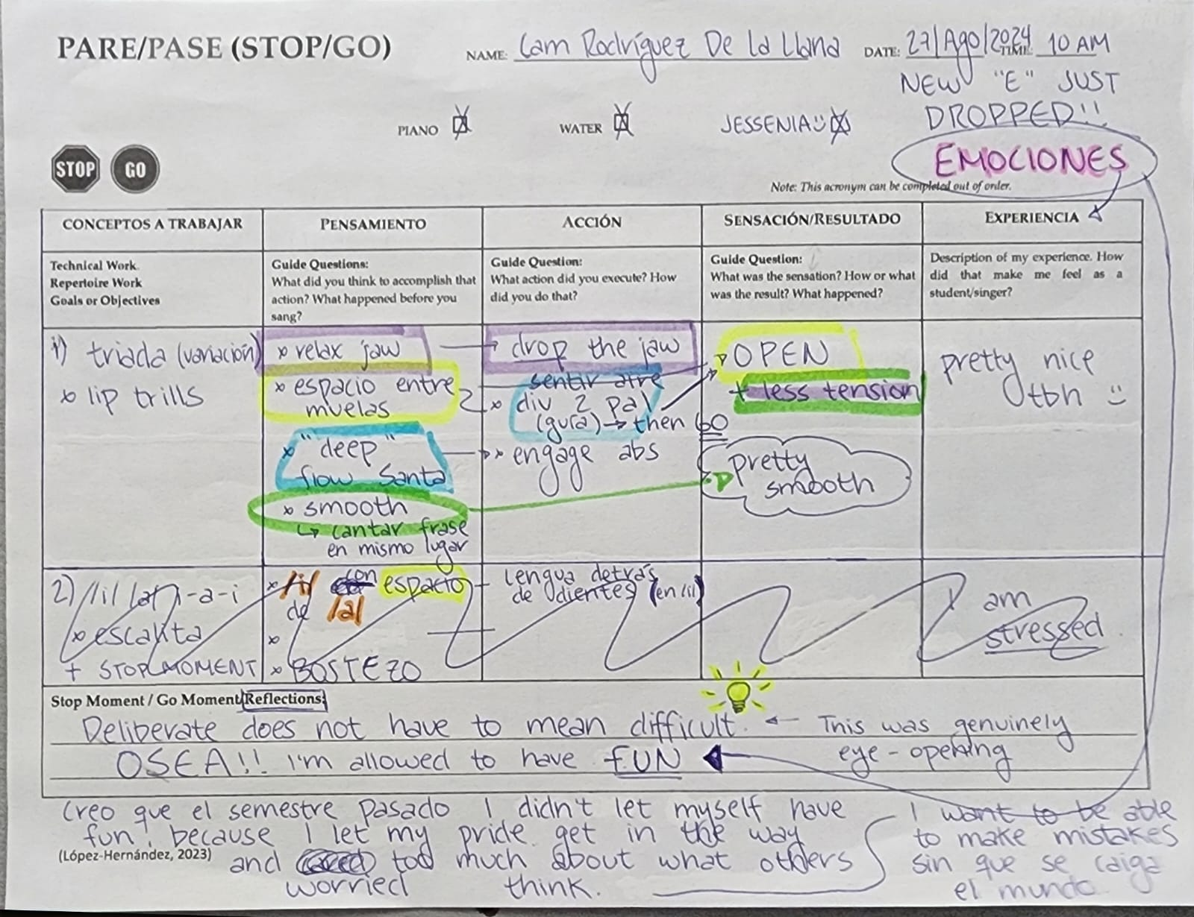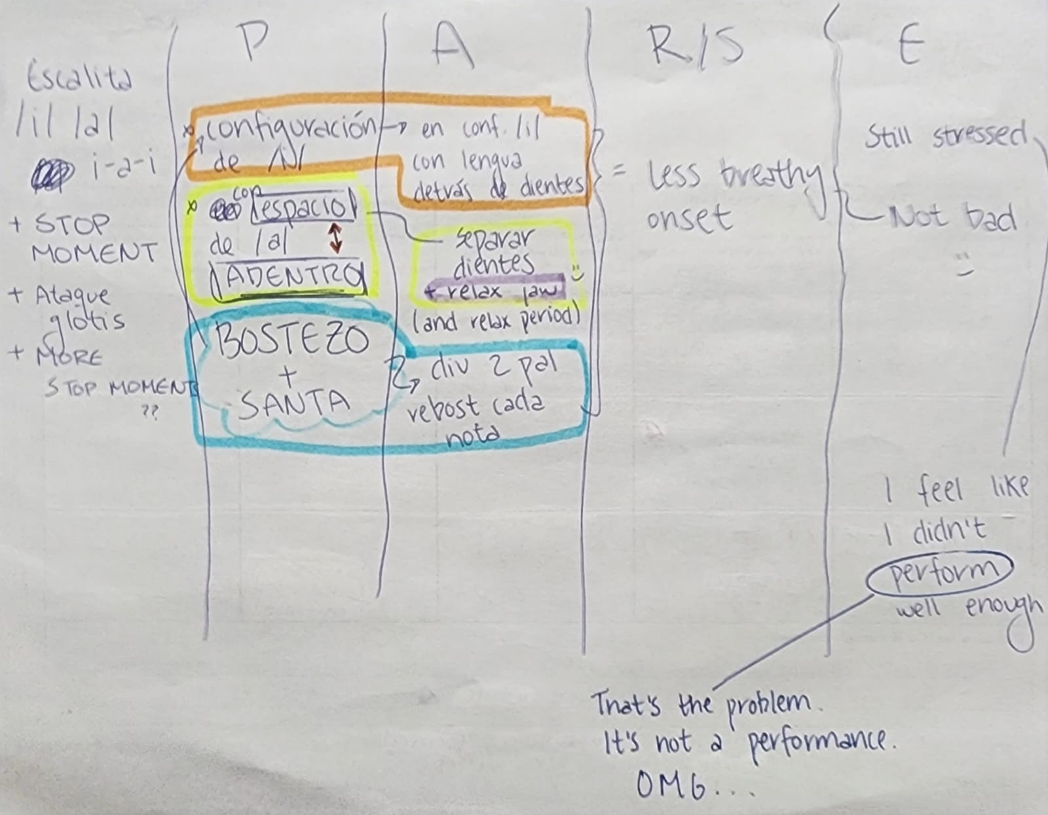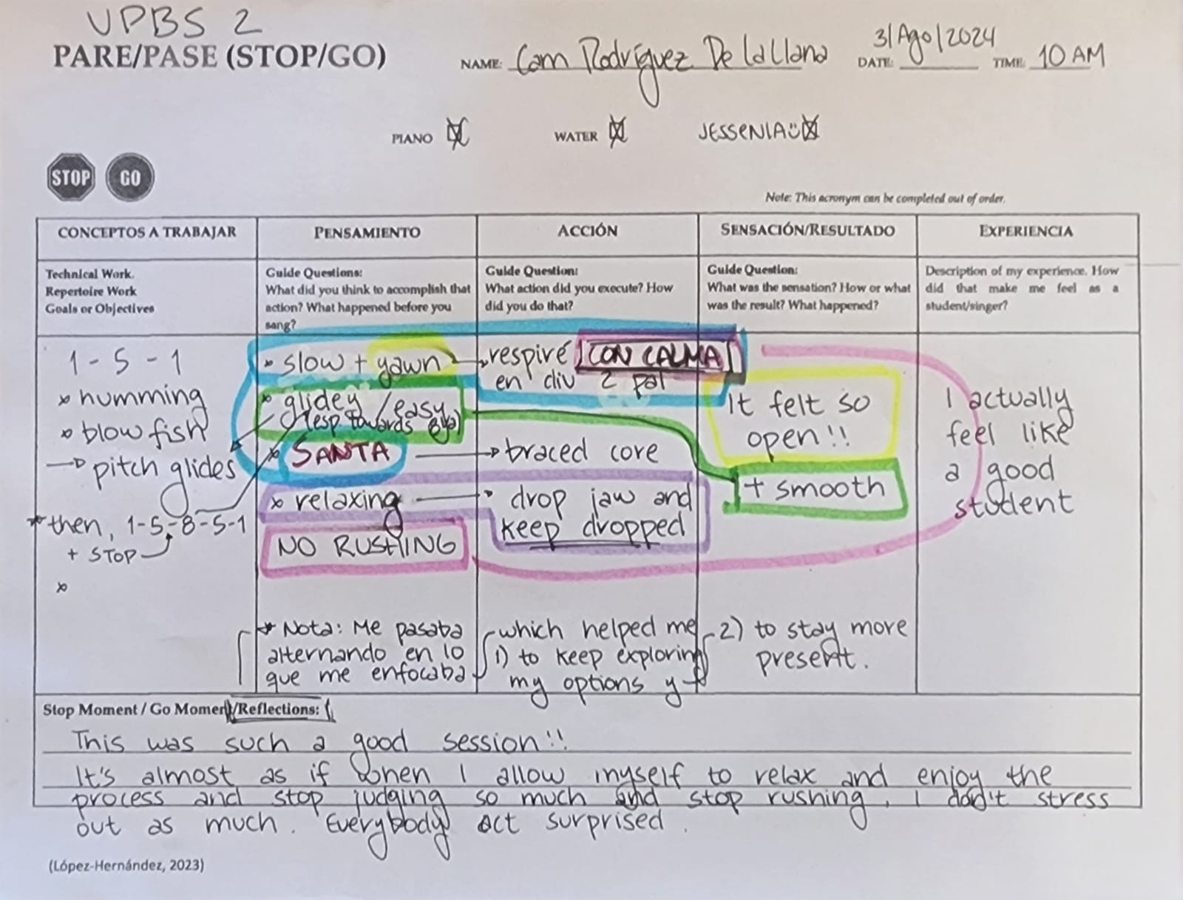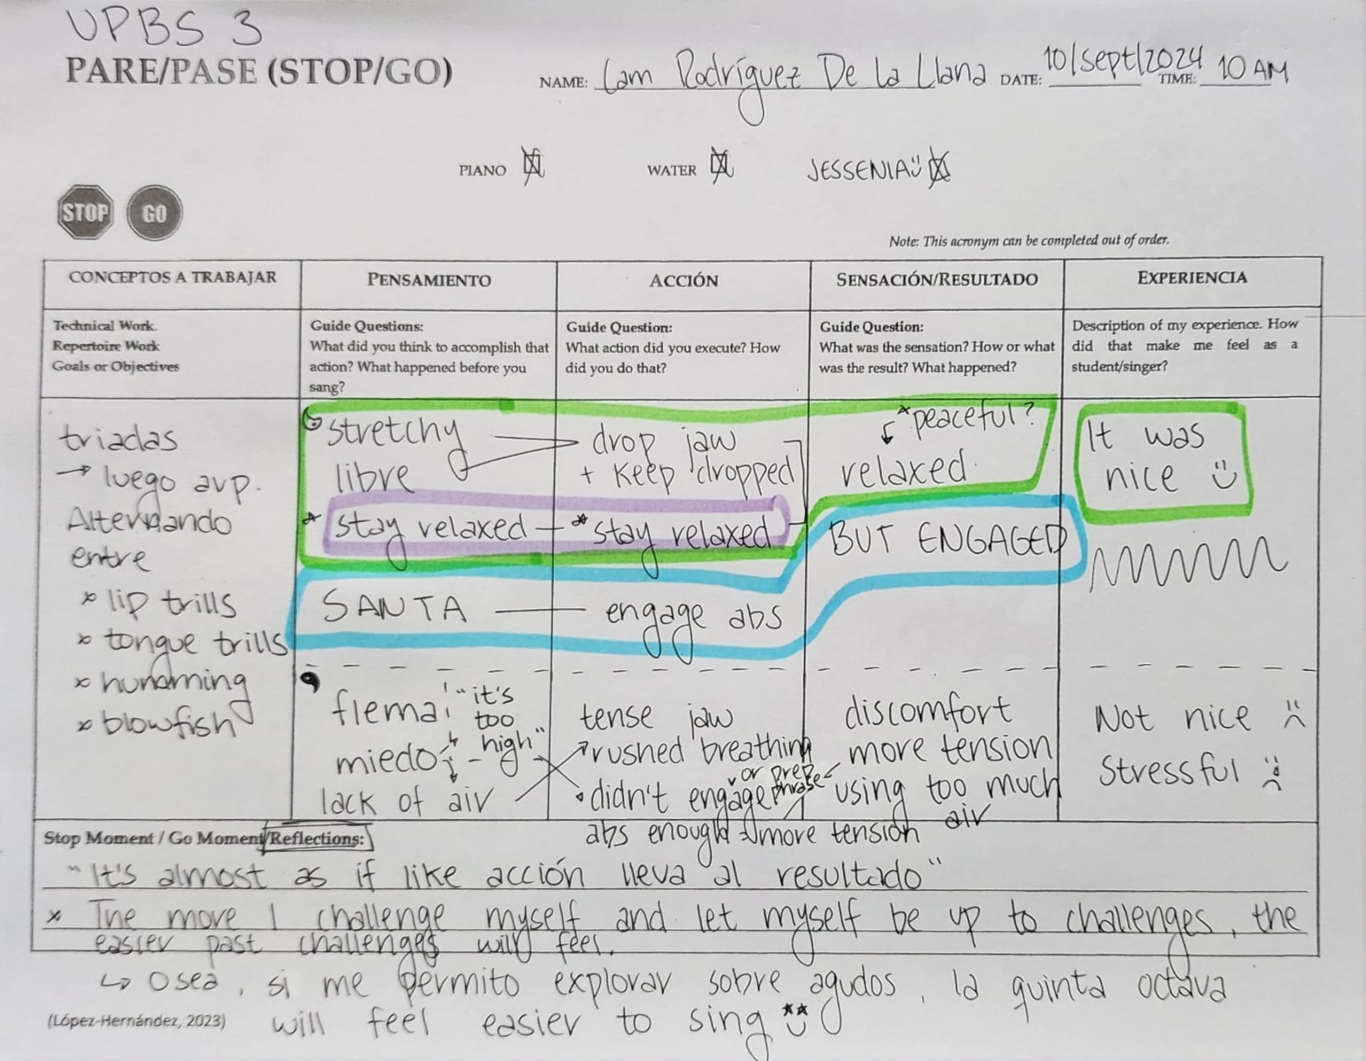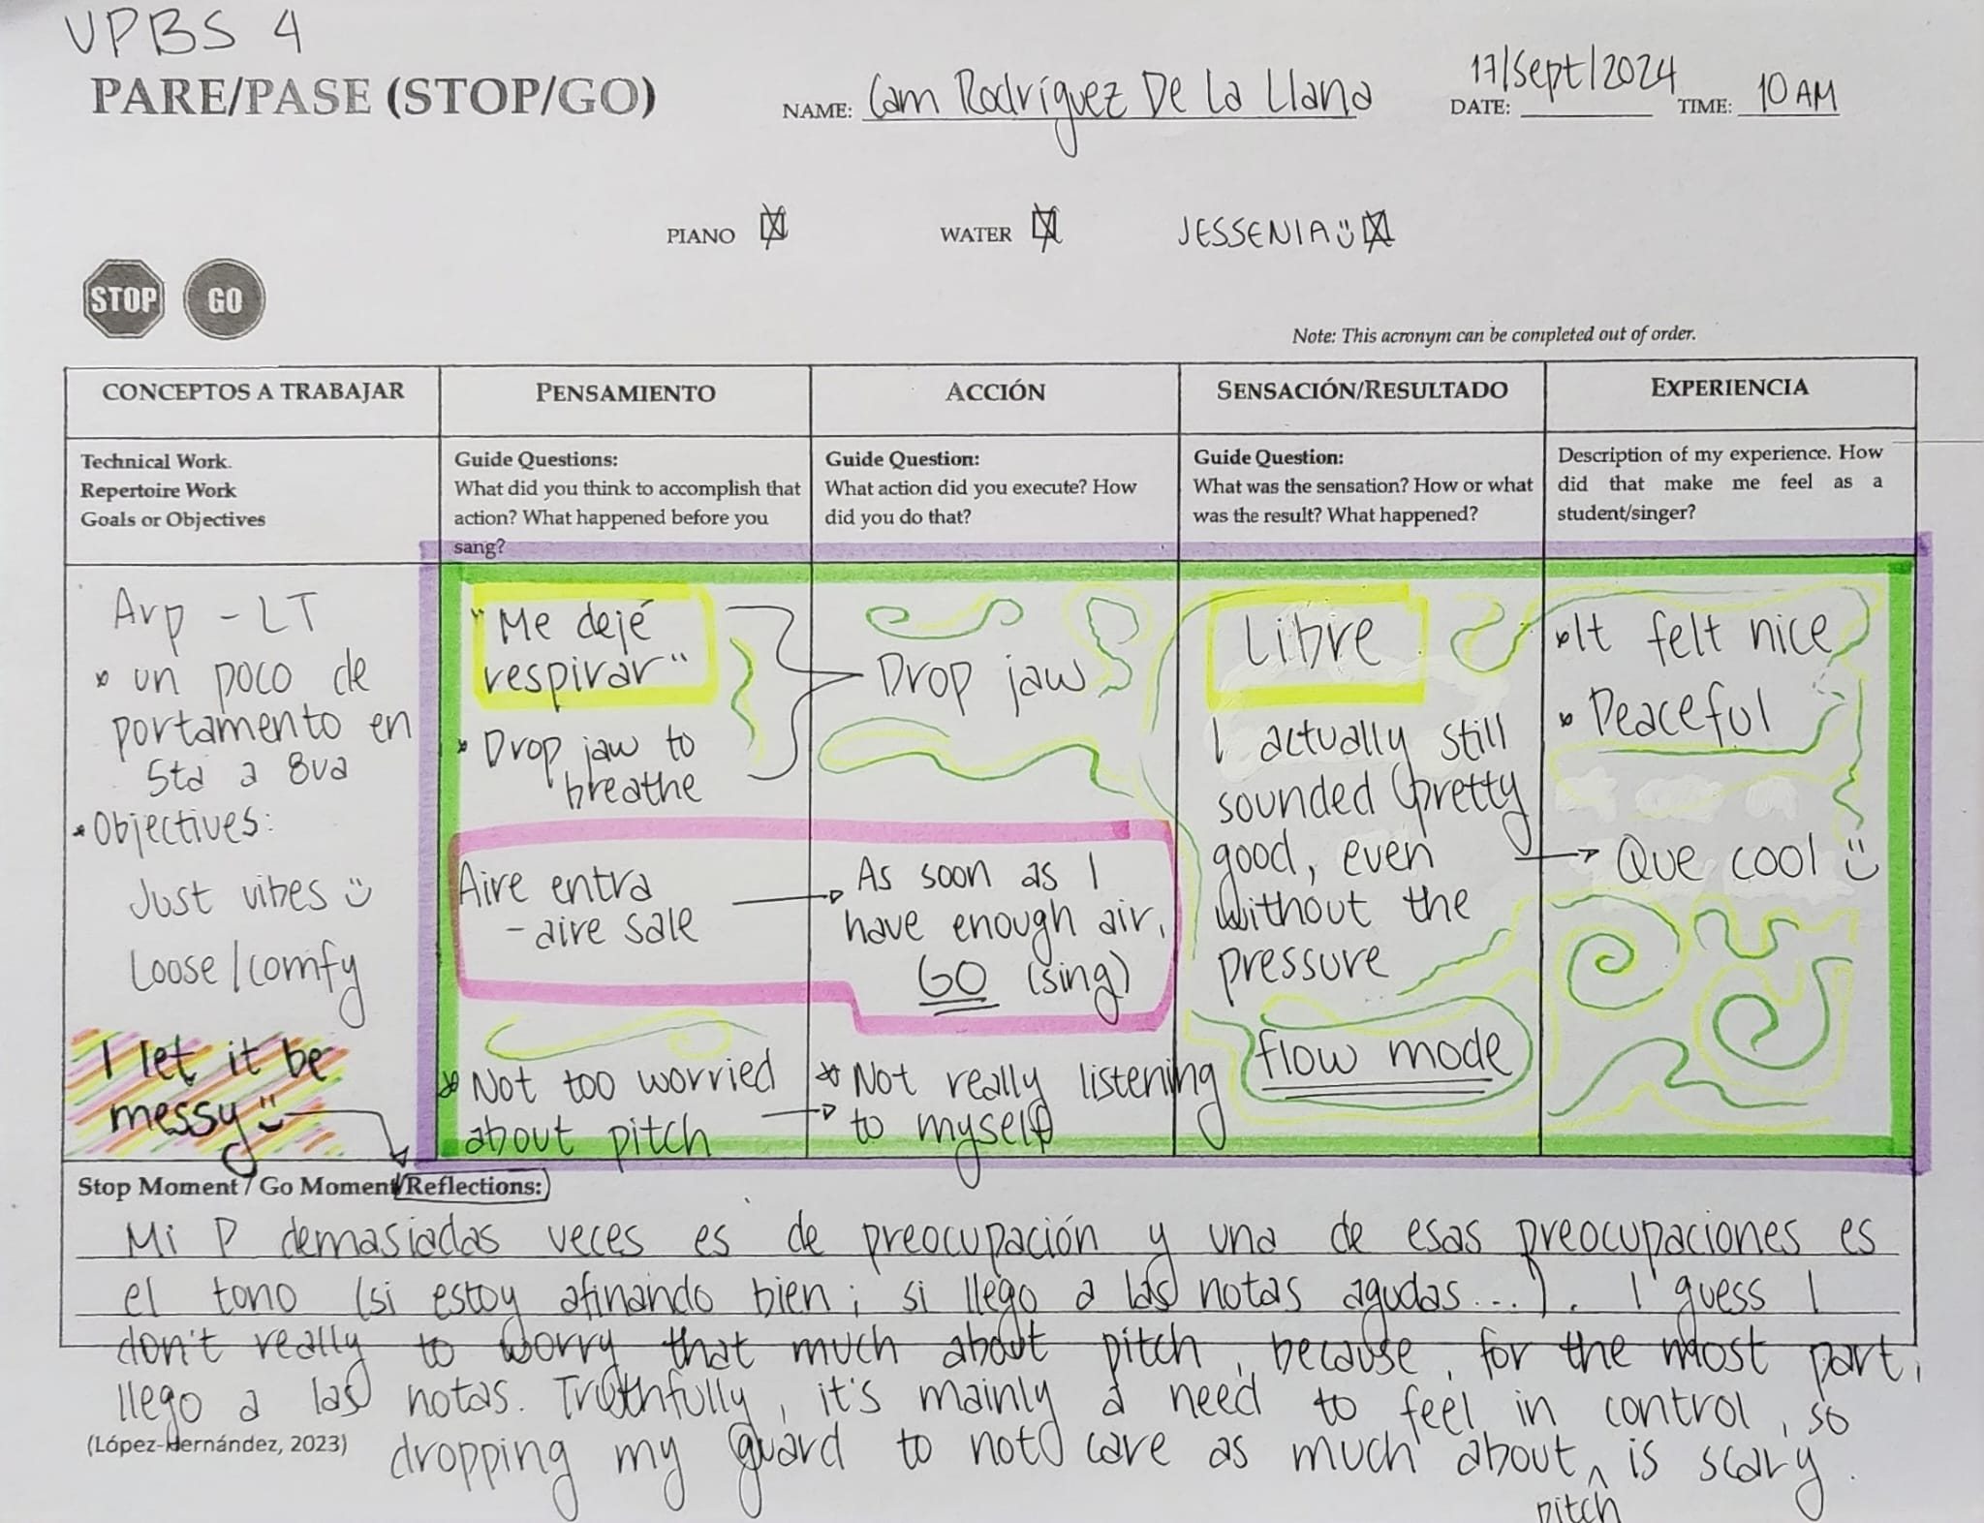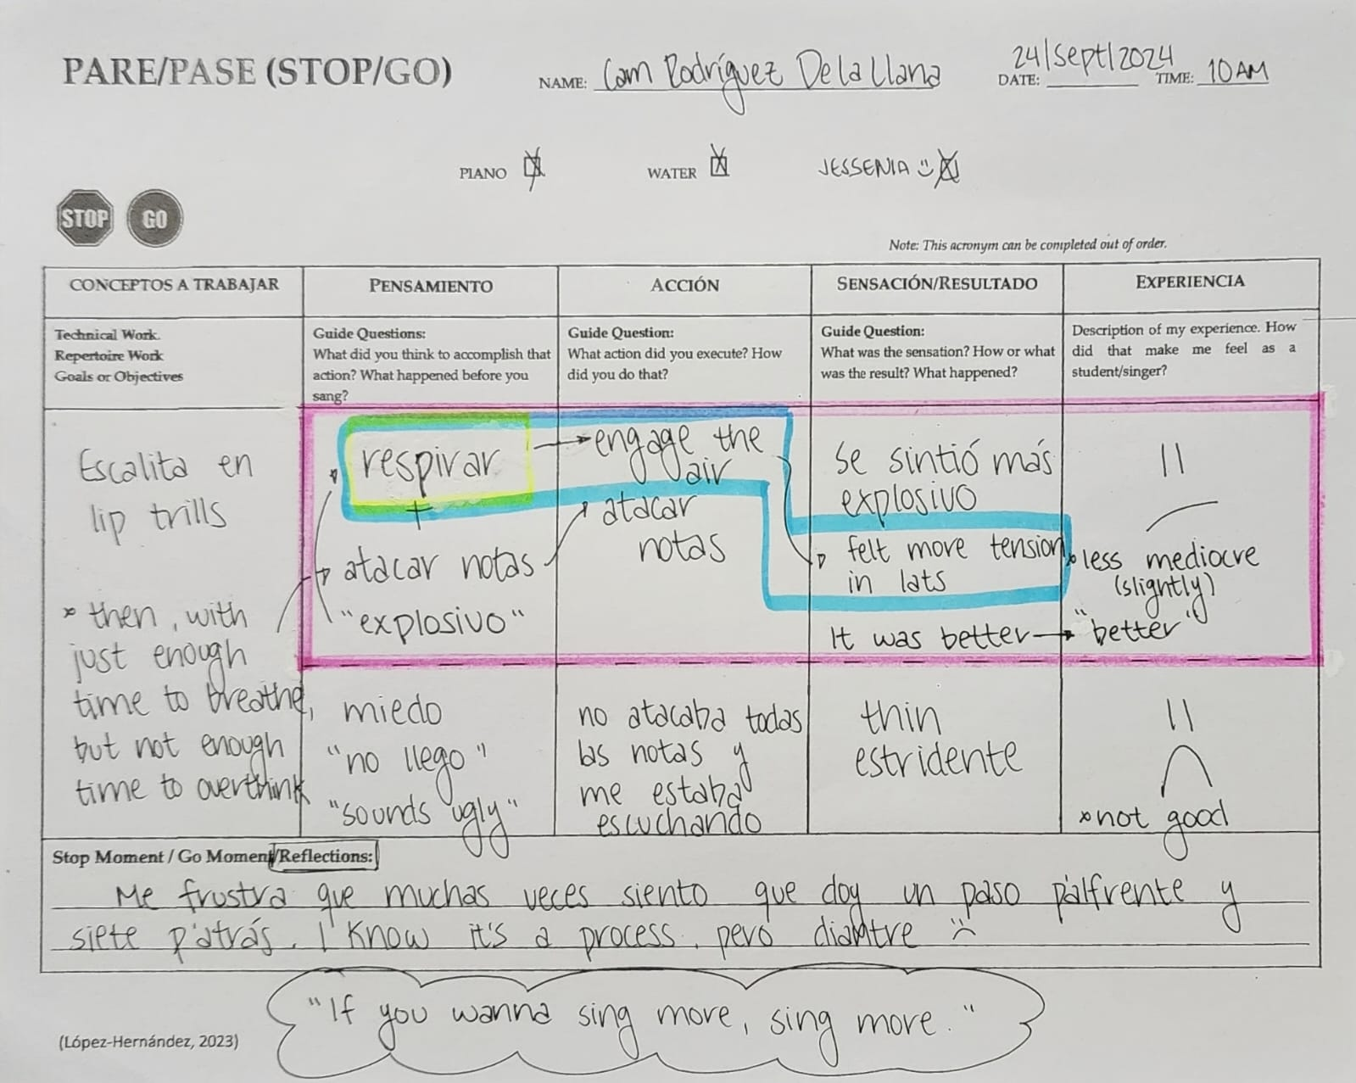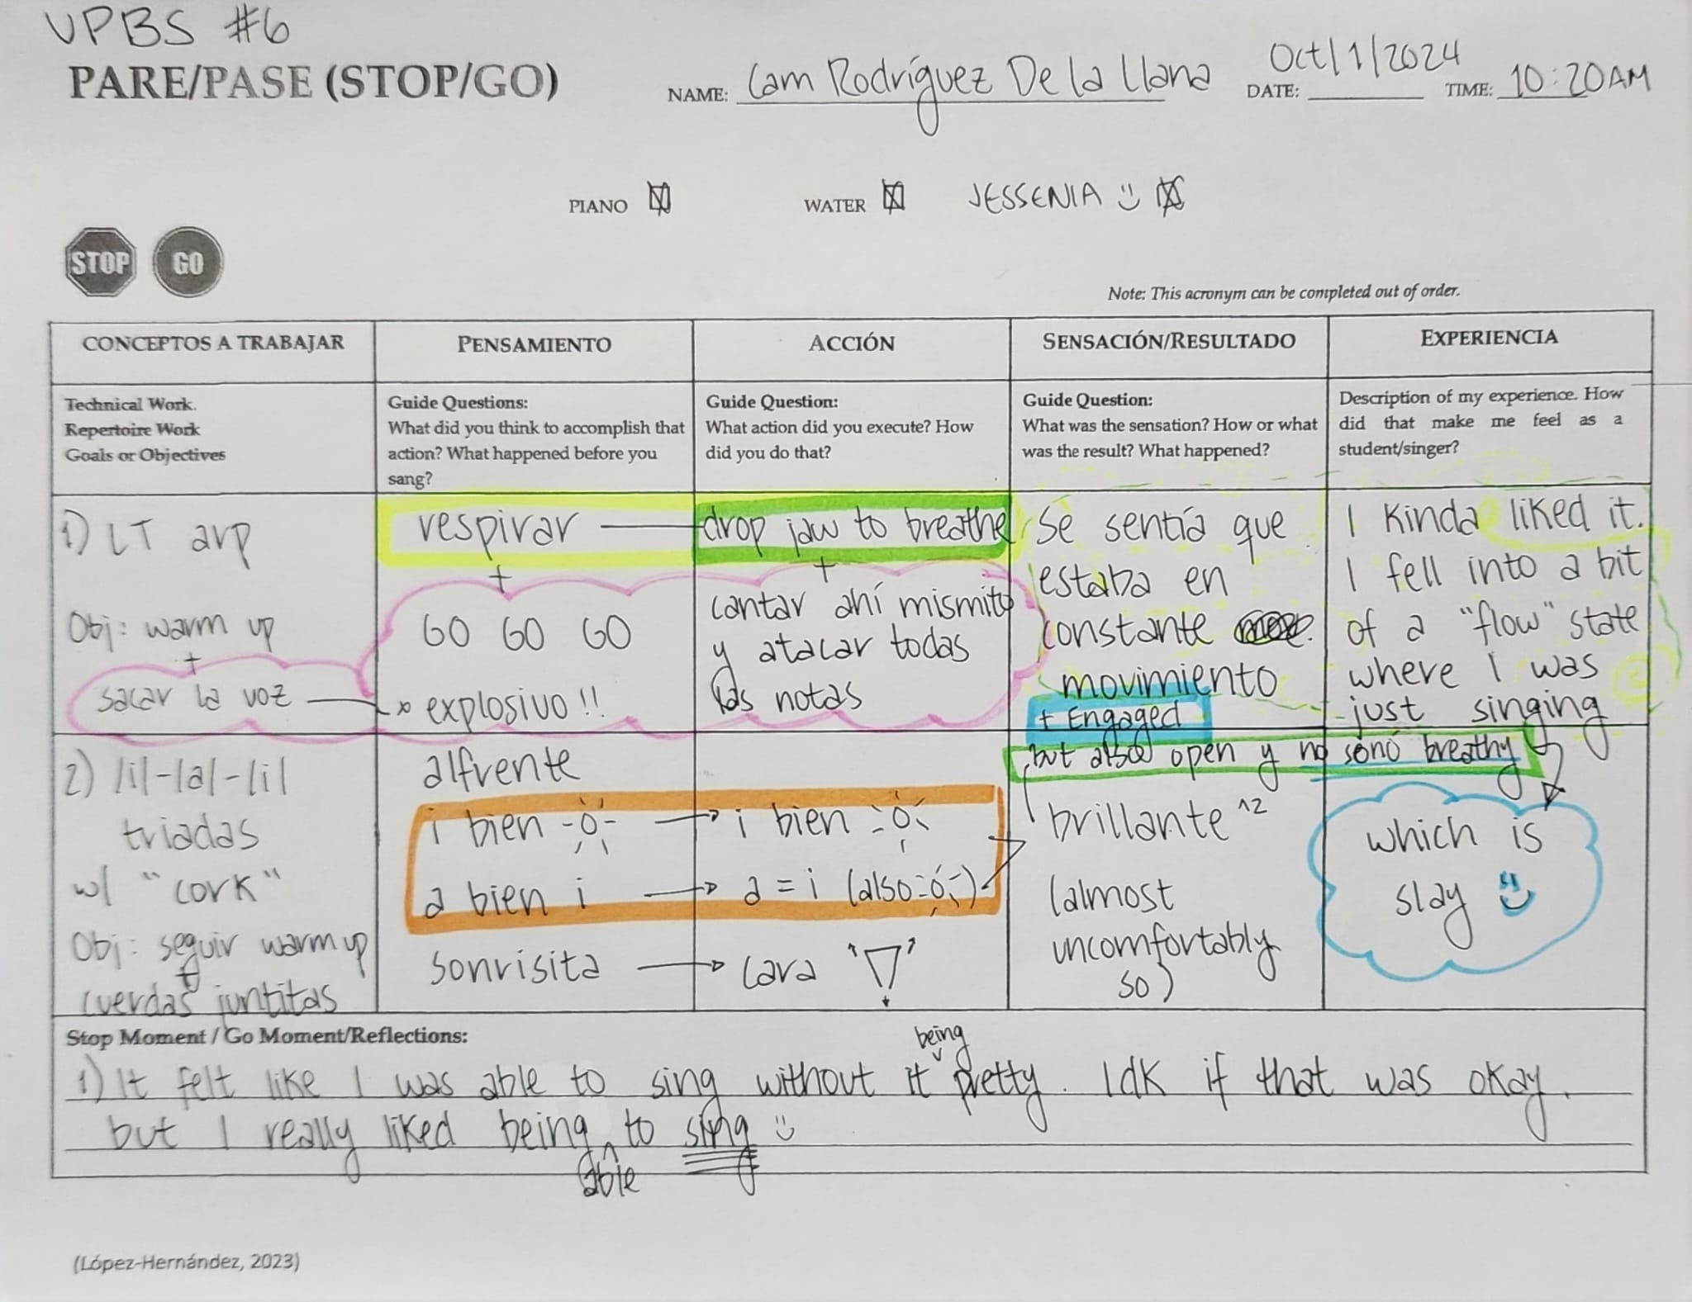
VPBS 1

“Jade”
“Chloe”
“Jade”

“Chloe”
“Jade”

“Chloe”
“Jade”

“Chloe”

VPBS 5
“Jade”

“Chloe”

“Jade”

“Chloe”

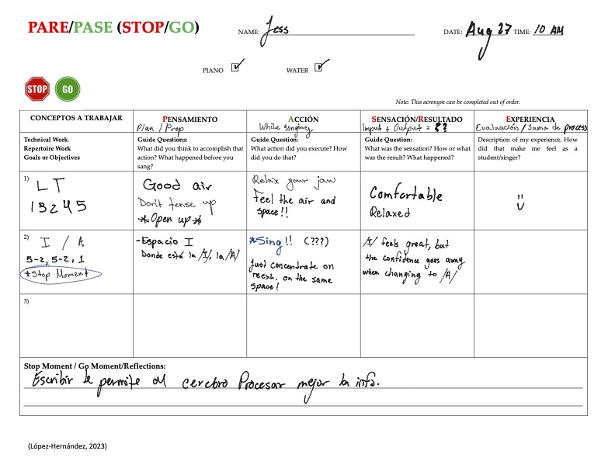
VPBS 1
“Jade”
VPBS 2

“Jade”

VPBS 3

“Jade”

VPBS 4
“Jade”

VPBS 5
“Jade”

VPBS 6
“Jade”

VPBS 1
Jay
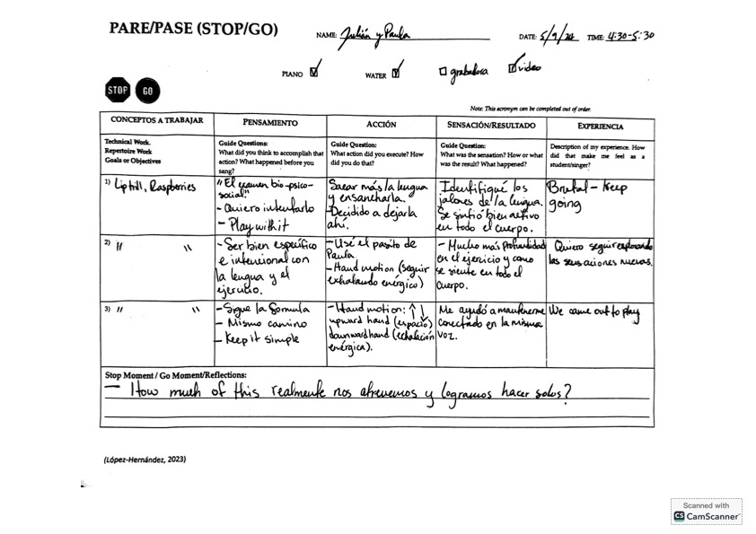
VPBS 2
Jay

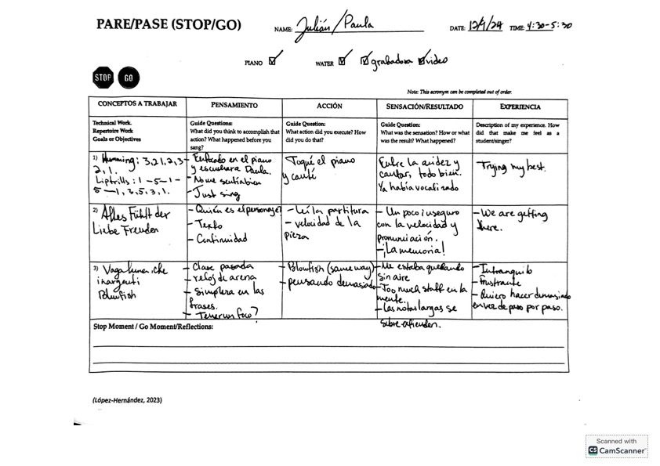

VPBS 3

Jay

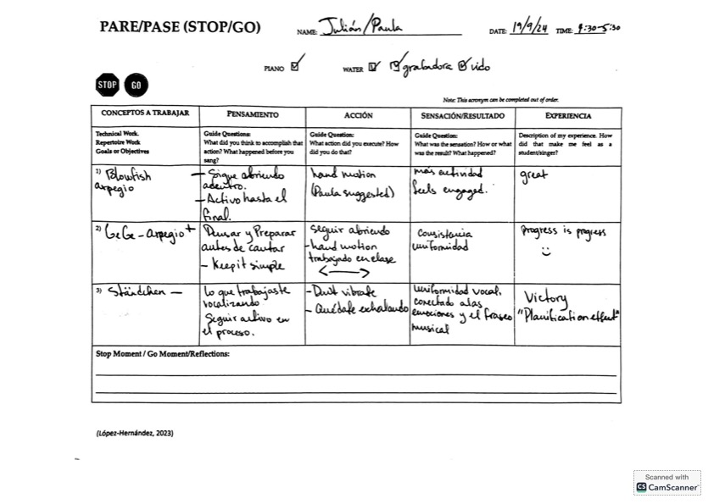

VPBS 4

Jay

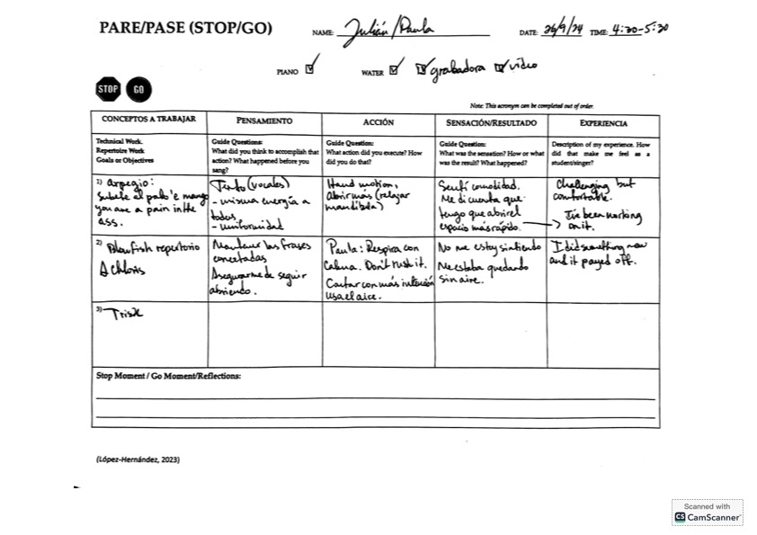

VPBS 5

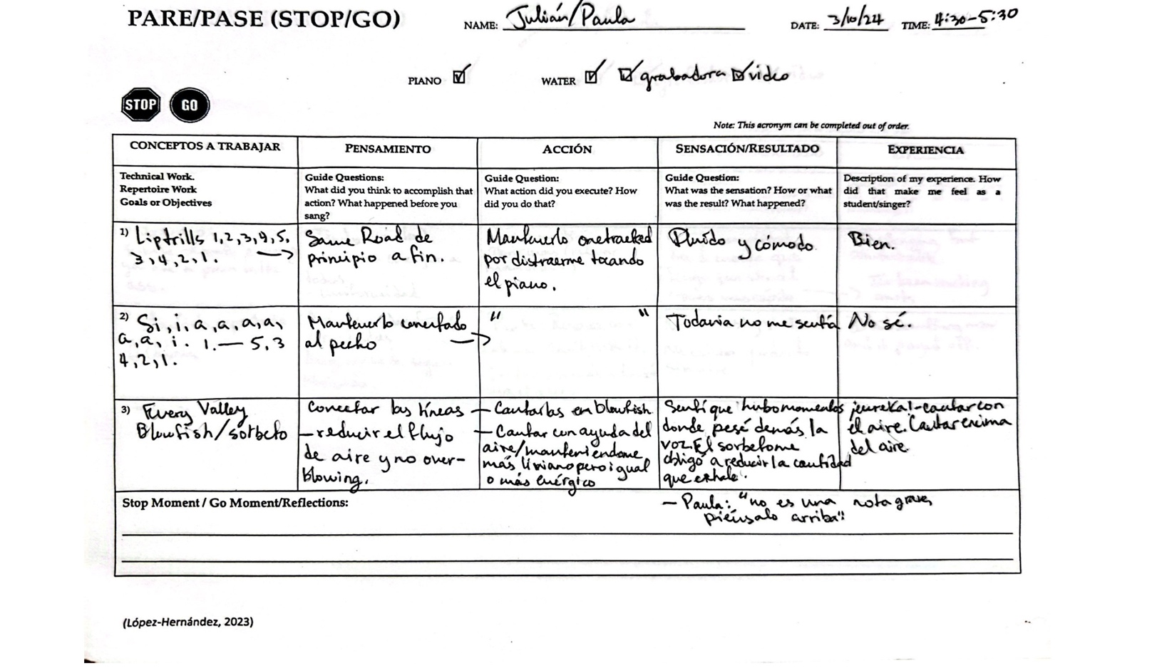
Jay

VPBS 1
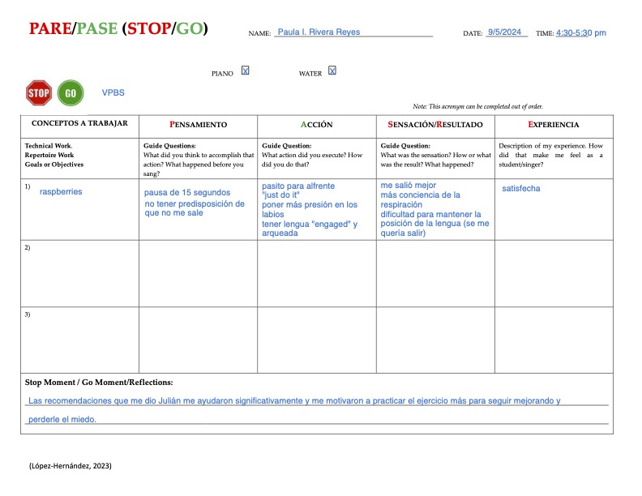
Paige

VPBS 2
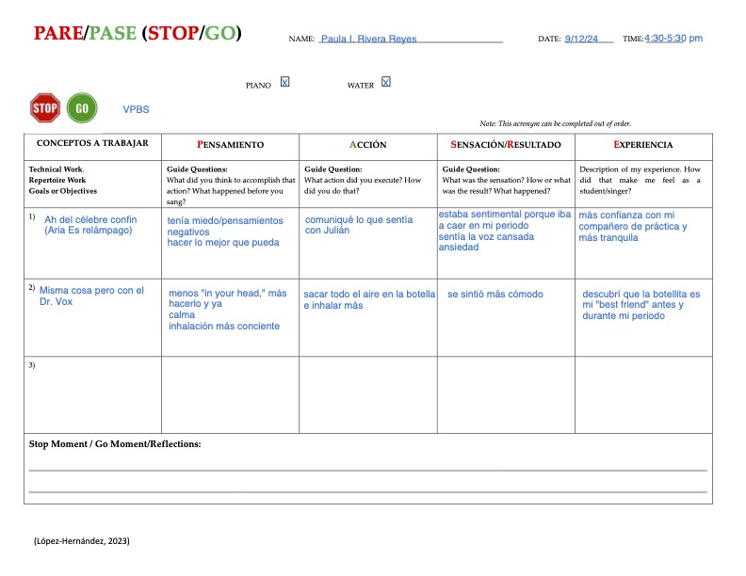
Paige

VPBS 3
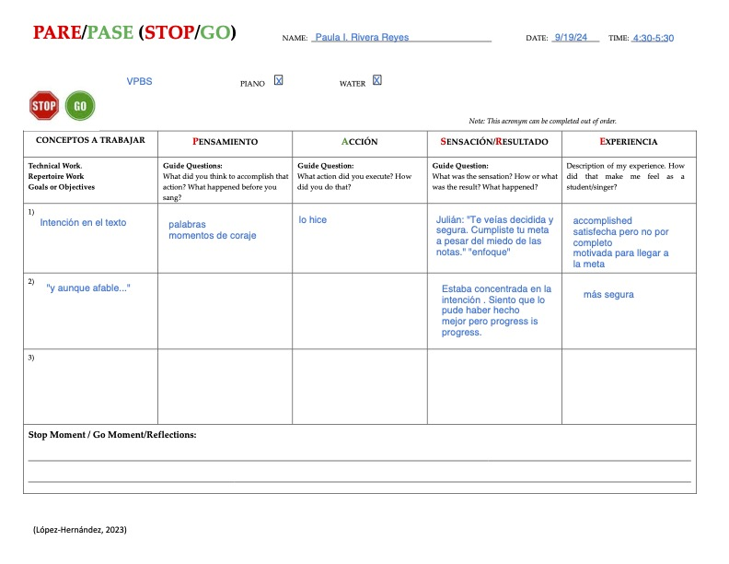
Paige

VPBS 4
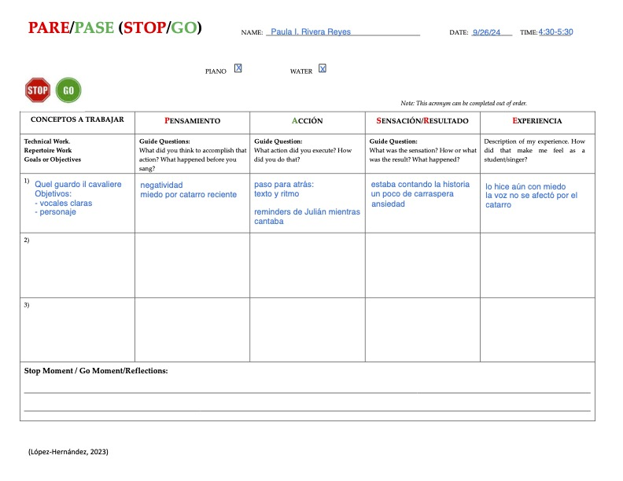
Paige

VPBS 5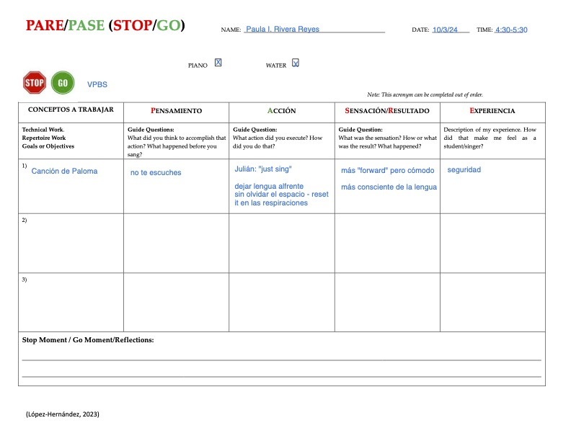
Paige

VPBS 1
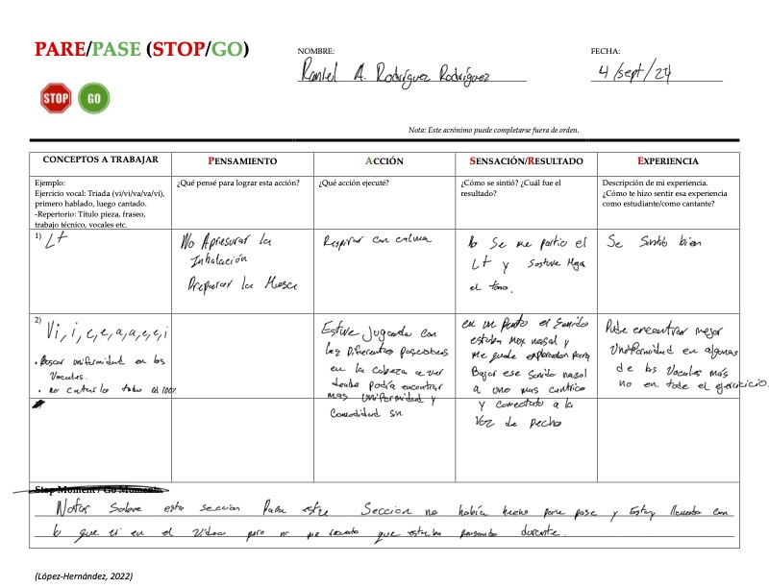
Ryan

VPBS 2
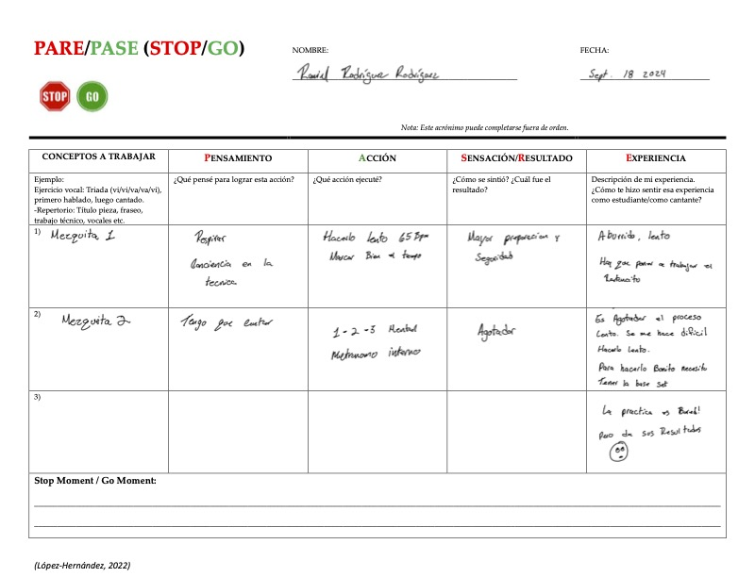
Ryan

VPBS 3

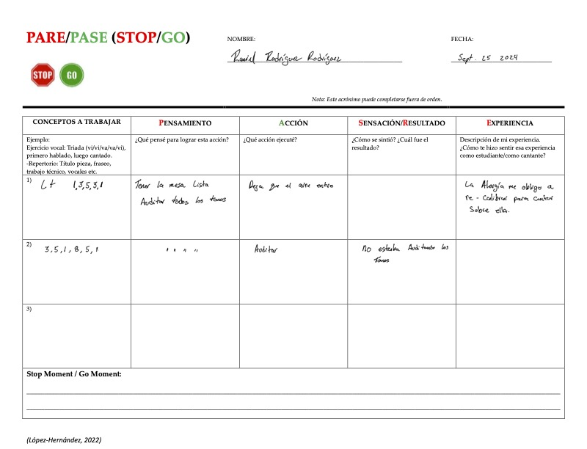
Ryan

VPBS 4
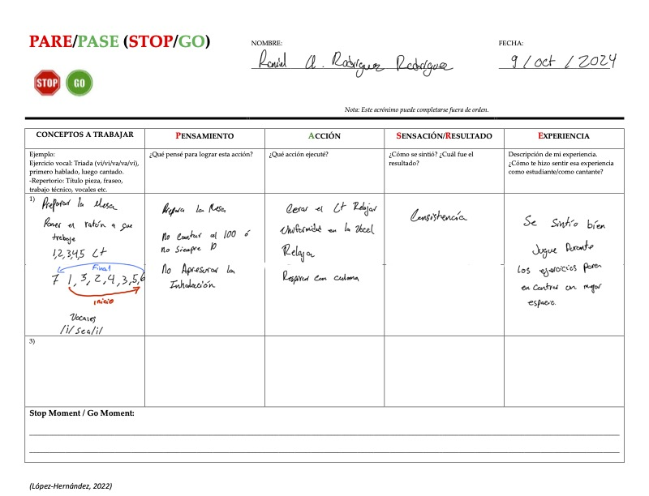
Ryan

VPBS 1
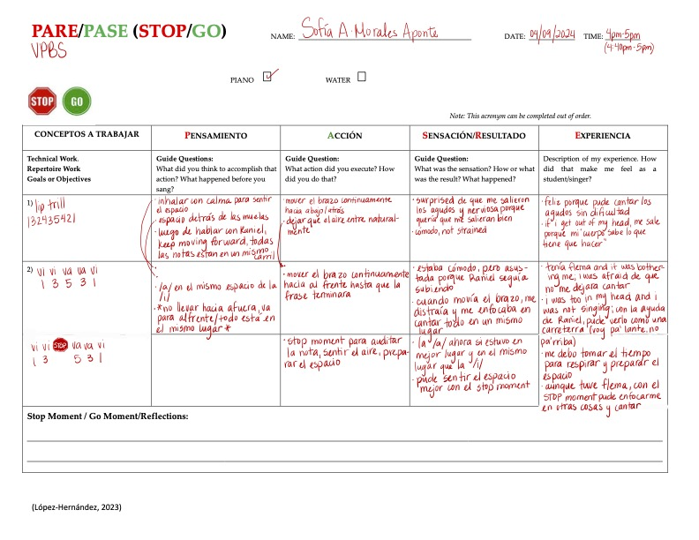
Sara

VPBS 2
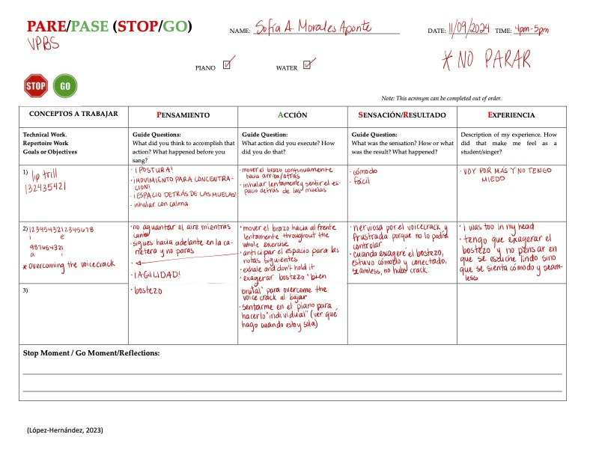
Sara

VPBS 3

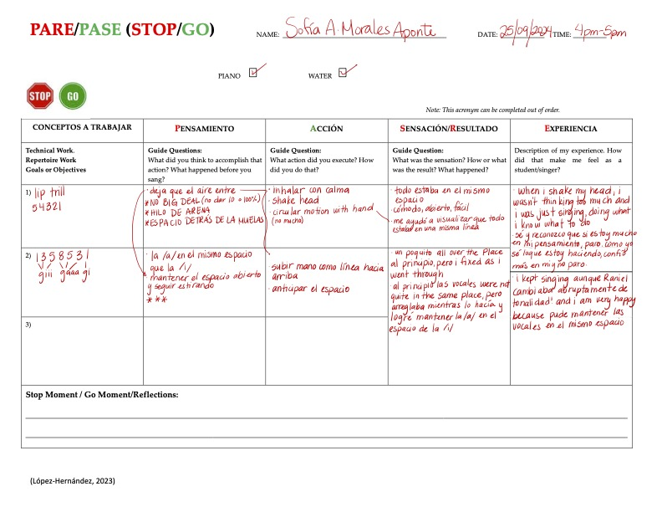
Sara

VPBS 4
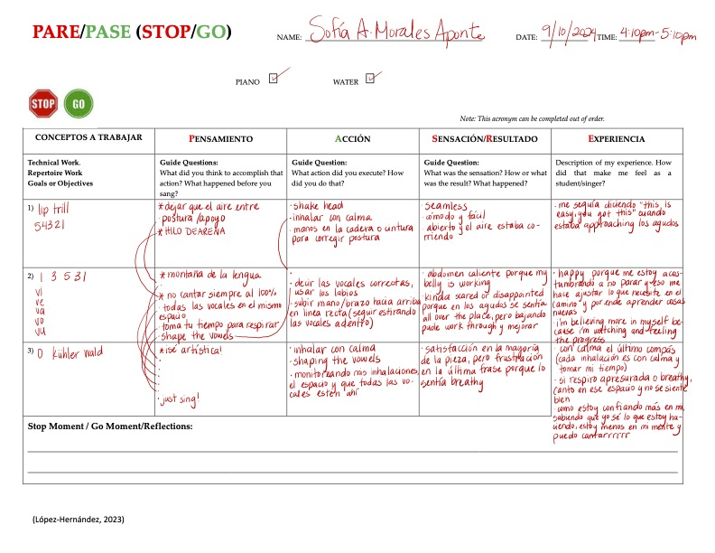
Sara

Appendix VI: Interview and Focus Group Questions
Vocal Practice (SPS and VPBS)
Pending: (change order of questions, deeper questions to the end)
- What were the most enjoyable aspects of the experience? / ¿Cuáles fueron los aspectos más que disfrutaste de esta experiencia?
- Which aspects of the VPBS sessions have proven to be particularly challenging, and why? (These aspects could include SPA, recording, singing in front of an audience, and the fear of making mistakes.) / ¿Qué aspectos de las sesiones del VPBS te resultaron más retantes y por qué? (Estos aspectos podrían incluir el SPA, la grabación, tener un plan, cantar ante un público y el miedo a cometer errores, tiempo limitado).
- Did these difficulties/challenges vary, or did they stay the same throughout the sessions? / ¿Esas dificultades variaron a lo largo de las sesiones, o se mantuvieron iguales?
- How did having your teacher present during some of the VPBS sessions make you feel? Please be completely honest; remember this is not personal; it's just data. ¿Cómo te hizo sentir la presencia de tu profesora durante algunas de las sesiones del VPBS? Por favor, sea completamente sincero; recuerde que esto no es personal; son sólo datos. (nervios, preocupaciones, "performing or trying to hard to do things right").
- Have you encountered any benefits in having a practice partner? (Julian expressed his willingness to take on tasks with a partner that he would not find motivation or willingness to do alone.) / ¿Has encontrado algún beneficio en tener un compañero de prácticas? ¿Cuáles? (Julian expresó su disposición a asumir tareas con un compañero que no encontraría motivación o voluntad para hacer solo).
- Has practicing with a partner impacted your motivation to practice? How? / ¿Cómo ha impactado tu motivación para la práctica el tener un compañero de práctica?
- In terms of maintaining consistency in practice, which of the two motivates you the most, SPS or VPBS? / En términos de mantener la consistencia en la práctica, ¿cuál de los dos te motiva más, SPS o VPBS?
- What are the main differences you notice in your vocal practice when working with a practice partner(s) versus practicing alone? (bored, motivated, being prepared, organized) / ¿Cuáles son las principales diferencias que aprecias entre practicar con un compañero(s) y practicar solo? (aburrimiento, motivación, preparación, organización)
- Has having a practice partner (VPBS) impacted your individual practice (SPS)? How? / ¿Tener un compañero de práctica ha influido en tu práctica individual (SPS)? ¿Como?
- What have you learned from working with your partner? Any strategies or tools? / ¿Qué has aprendido trabajando con su compañero de práctica? ¿Alguna estrategia o herramienta para tu SPS y desarrollo individual?
- Did you develop a strategy for organizing the VPBS sessions? Did you coordinate all your sessions with your friend? (Talk with your buddy about goals before sessions and what you wanted to work on, who plays the piano, taking turns, etc.) / ¿Desarrollaste una estrategia para organizar las sesiones del VPBS? ¿Coordinaste todas las sesiones con tu amigo? (Hablaste con tu compañero sobre los objetivos antes de las sesiones y sobre lo que querías trabajar, quién toca el piano, turnos, etc.)
- What insights have you gained from this experience overall? (about yourself? /¿Qué enseñanzas has obtenido de esta experiencia en general? (¿Sobre ti mismo?
- Have you been meeting with your assigned buddy or another buddy during these six weeks to practice, in addition to the sessions scheduled for the study? / ¿Durante estas seis semanas te has reunido con tu compañero asignado o con otros compañeros para tener sesiones de VPBS además de las sesiones programadas para el estudio?
- Will you continue to engage in any sort of practice partner system? Please explain. (Paula, your pre-study questionnaire indicated that you were used to practicing individually. What have you learned from collaborating with a partner, and do you plan to maintain this strategy going forward? / ¿Continuarás practicando en algún tipo de esquema de compañeros de prácticas? Favor de explicar, por qué. (Paula, tu cuestionario previo al estudio indicaba que estabas acostumbrada a practicar sola siempre).
- Could you draw a comparison and contrast between the VPBS sessions you attended with clearly defined goals and those you did not? How were the outcomes different? (Wasted time during sessions figuring out what to do, feeling anxious and nervous about it.) / ¿Podrías comparar y contrastar las sesiones del VPBS a las que asististe con objetivos claramente definidos y aquellas a las que no? ¿En qué se diferenciaron los resultados? (Pérdida de tiempo durante las sesiones pensando qué hacer, sensación de ansiedad y nerviosismo al respecto, resultado

PARE/PASE

- Could you describe the PARE/PASE framework in your own words? / ¿Podrías describir que es el esquema PARE/PASE en tus propias palabras?
- How does it contribute to your vocal development process? / ¿Cómo contribuye al proceso de tu desarrollo vocal?
- How did you use the framework in your VPBS sessions? (Guide questions for reflective inquiry, iPad, paper, board) / ¿Cómo utilizaste el esquema en tus sesiones de VPBS? (Preguntas guía para la reflexión, iPad, papel, pizarra)

- Do you employ the PARE/PASE framework in a different manner during your SPS than you do in your voice lessons? / ¿Utilizas el esquema PARE/PASE de manera diferente durante tus SPS que en tus clases de canto?
- How do you integrate your voice lesson template content into your SPS? (Organization of your practice sessions, goal and objective establishment, bringing awareness to processes) / ¿Cómo integras el contenido del template (PARE/PASE) de tus clases de canto en tus SPS? (Organización de tus sesiones de práctica, establecimiento de metas y objetivos, concienciación de los procesos).
- Has it impacted your motivation to practice and the results you achieve during it? / ¿Ha impactado en tu motivación para practicar y en los resultados que obtienes durante la misma?

Focus Group Questions
Time length: 1:30hrs approx.
Materials: Board, Chalk
Activities: Possible creation of Mind Maps
  - What is deliberate practice to you? / ¿Qué es la PRACTICA deliberada para ustedes? (prompts will come from 1-1 interviews) / (MM)
  - What is the PARE/PASE for you? What does it offer or provide you? / ¿Qué es el PARE/PASE para ustedes? Que les brinda o proporciona? / What is the PARE/PASE for you? (MM)
  - How would you describe the VPBS and what has it given you? / ¿Cómo describirían el VPBS y que te ha ofrecido? / (MM)
  - What strategies can we identify as necessary for a successful VPBS session? (e.g., organization and planning of what they want to work on, board for PARE/PASE, mirror, water, recording device) / ¿Qué estrategias podemos identificar como necesarias para el éxito de una sesión de VPBS? (e.g., organización y planificación de lo que desean trabajar, pizara para PARE/PASE, espejo, agua, recording device).

Compare and Contrast
  - ¿Cuáles son las diferencias principales entre la practica en solitario (SPS) y en buddy system (VPBS)? / What are the main differences between solo practice (SPS) and buddy system practice (VPBS)?

Additional Questions
  - What were the most enjoyable aspects of the experience? / ¿Cuáles fueron los aspectos más que disfrutaste de esta experiencia?
  - What have you learned from practicing with your buddy? / ¿Qué has aprendido de colaborar con un compañero? /
  - In what ways do you believe the VPBS has impacted your SPS? / ¿De qué manera cree que esta experiencia ha impactado tu desarrollo vocal? (desarrollo vocal/vocal development)
  - How long should the VPBS sessions last, and why? For example, should the sessions last 1 hour, 1.5 hours, or 2 hours?Si pudieran escoger cuanto podrían durar las sesiones de VPBS (1hr, 1.5hrs, 2hrs)

PARE/PASE
  - How would you describe a SM? / ¿Cómo describirían un Stop Moment? (MM)
  - How would you describe a GM? / ¿Como describirían un Go Moment? / (MM)
  - Is stopping during practice (SM) challenging? If so, could you explain why? / ¿Es un reto parar durante la práctica? En caso afirmativo, ¿podrías explicar la razón?
  - If you could change anything about the current PARE/PASE template, what would it be and why? (e.g., changes, add-ons, non-table format, additional meanings to the PARE/PASE paraments) / Si pudieras cambiar algo del template del PARE/PASE actual, ¿qué sería y por qué? (e.g.cambios, añadidos, formato parrafo (non-table), significados adicionales de los parámetros PARE/PASE)

Appendix VII: Interview Transcripts
- Chloe
- Jade
- Jay
- Paige
- Ryan
- Sara

Chloe’s Interview Transcript

T/R: Cool. You had the opportunity to listen to the Voice and it kind of brings your mind super.
00:00:08
Chloe: (gestures yes)
00:00:08
T/R: Super, well let's get started then. First, have you enjoyed the experience of practicing with your buddy?
00:00:17
Chloe: Generally speaking, yes,
00:00:18
T/R: Yes? Uh, what have you found challenging about the experience?
00:00:28
Chloe: Uh, I mean, it's, uh... I guess, ok. Because before this, Jade and I. I mean, We were friends and all that. But we weren't that close and it didn't force like we have to be comfortable enough to say things to each other, right to each other's faces and so it was making that adjustment. And so a bit challenging and also this, really having someone persistently, I mean, not having someone, but having someone other than you persistently telling me, okay, look, you're doing this. I was doing such a thing, I mean, changing such a thing and so, uh-huh, I guess it's just being vulnerable to taking that.
00:01:23
T/R: And taking that that feedback, right?
00:01:27
Chloe: Mhm.
00:01:27
T/R: All right. Wow. I mean, that vulnerability, huh? How do you feel the time management went?
00:01:36
Chloe: Eh? Not great. Huh? Maybe, uh, eh, right? Me. I kept thinking. Because this was something that I was constantly thinking about after that session, eh? And it was something that I had to adjust my expectation a little bit, because I uh starting out I had a certain expectation that we were going to do more things when the reality is that we didn't have time to do that much. We had to be in many moments having to stop and reassess and see how to, I mean, yes, change things. But how are those changes, eh? So basically that's time management.
00:02:36
T/R: We are going to go into that a little bit more in depth now, but I love what you just told me, because you are talking about expectations, ok? And we are going to talk about expectations in the focus group, ok? What was the expectation we had before and what happened and what is your conclusion now? Okay. Because obviously this is not an experience that ends here. If I'm not going to be evaluating them all the time. And I'm going to sit there and watch them practice all the time. It gives me though. It's taught me a lot, but at the same time, huh? Now you're free. I've maybe to keep doing with that person or explore with someone else. Let's go to the next one. Let's talk a little bit more about this. How did it make you feel to have your singing teacher/researcher present at most of the sessions? And can you be totally honest, because this is data
00:03:27
Chloe: at first, it was a bit strange because it felt like singing class 2.0 But then I had. I mean. And that's when I realized that I didn't really have the healthy relationship or the healthy mindset in my singing lessons, because I had this expectation that it was Performance mode when it's literally not.
00:03:56
T/R: mhm (nods)
00:03:56
Chloe: So. I mean, in the beginning. It was a bit weird. But particularly, I think it was in the second ones. In the second session that you were there. What right? You demonstrated how you practiced. I thought that was really really cool. Because I guess that showed us, that you're human so that's crazy. I don't know why, but a lot of times we glorify so much, these people that obviously have a lot of years of experience, Eh? And no. I mean, sometimes we don't think, you know these people also went through these processes...
00:04:39
T/R: and it happens
00:04:39
Chloe: So, it's like wow, actually, it's not that I'm so bad, it's just that it's not all performance and this. Right But already after that So I guess I like it allowed me to relax a little bit.
00:05:05
T/R: You told me earlier that your mindset sometimes in singing lessons kind of isn't the most ...I don't want to say correct because I don't remember the word you used and you kind of realized that you that you said that I felt a little bit like that singing lesson 2.0 then and then you say I guess I realized that my mindset in singing lessons...?
00:05:27
Chloe: Uh, that it was "unhealthy".... I mean it was unhealthy the mindset that I had uh of my singing lessons.
00:05:38
T/R: Mhm.
00:05:39
Chloe: And because of those buddy sessions I was able to allow myself that for me it still felt like singing class 2.o, just because I'm not on my own, eh? I mean, it's not for nothing. I'm not going to. I'm not going to react the same way if I'm with Jade or with Ryan or with Jay, who have a lot to say. This one is a little hard for me to sing the same way I do. So how I would sing at home is for me. Throughout it all it still felt like singing class 2.0.
00:06:25
T/R: I already
00:06:25
Chloe: But after I realized the mentality I had, I worked to change it a little bit, to work on that mentality. And that also helped me a little bit, eh? How I thought about my singing lessons. And there it was. I realized that in truth I also have things from previous semesters. I mean, and we go back to this thing about expectations that I realized, that sometimes I feel that since I've been doing this for a couple of semesters now, well, it's just. I mean, I feel that I have to set myself to an extremely high standard that is sometimes a little unrealistic, unrealistic.
00:07:22
T/R: unrealistic, yes All right are you feel like this is it? Do you feel like right now you said that the uh practicing with the buddy helped you a little bit to work on that mentality? I mean it was like you said the impact of the buddy system, maybe it's been the lowering of these high expectations a little bit and then maybe allowing you to relax a little bit on that.
00:07:55
Chloe: (Chloe nods with gesture-visual cue) At first, it felt like being judged... but then I realized the sessions weren’t about being perfect. They were about learning.
00:07:56
T/R: Super. How did you feel already when the teacher was not present? Any difference? I kept doing singing lessons, 2.0?
00:08:12
Chloe: Now it was like singing class 3.0. hahahaha
00:08:15
T/R: hahahaha
00:08:18
Chloe: Never. I mean, after that, when it was just me and Jade and me, eh. I mean you weren't there "it took the edge off". But every once in a while I would remember. Okay. Yeah, she's not here in person, but she's still there via the computer.
00:08:44
T/R: hahahaha
00:08:46
Chloe: Yeah, it's like sometimes I would forget, but then I would remember that at the end of the day, technically she's still there. So whether I would have been in the room or not, I don't feel like it would have made too much of a difference, honestly.
00:09:04
T/R: mhm
00:09:04
Chloe: Because, I mean, anyway it's not like you were positioned in a place where you were right in front of where we were and not you. I was almost always more east towards a corner, just observing. No, I didn't feel a big difference.
00:09:29
T/R: Super, if you could change anything about the experience. And here I'm talking more about the design, right? We were meeting with your buddy once a week. Uh, an hour. That's what you've had to do so far. If you could change anything, what would it be?
00:09:51
Chloe: Uh? It might be things that it wasn't necessarily in the session, but in preparation for.
00:10:00
T/R: Yes, perfect, yes.
00:10:01
Chloe: Yes. Okay. Because I. This one. Me. At first I felt a little bit of this pressure that, Okay, ya, ya, ya. I'm in a couple of days, and we have to have this set from the weekend. I like to have my stuff set as early as possible. Me, huh? I'm anti. Like doing things at the last minute, huh? It gives me a lot of stress.
00:10:34
T/R: of course
00:10:35
Chloe: But then my buddy is not necessarily that way. My buddy is a very flowing person. I mean, she goes with her instinct and is very intuitive. That's right. I mean, it's really cool to see how for her it's genuinely intuitive. She just thinks I'm going to sing, okay? I'm going to sing, I mean, singing equals singing. It's not like, okay, I think I want to sing, and then I have to do all these other things. It's this whole process of singing. It's like just singing equals singing. And then to her. For her it wasn't extremely necessary to have plan A. Plan B, Plan C, like for me it was.... (aside) sorry about all the airplanes is that I live in Carolina.
00:11:24
T/R: No, no, don't worry about it.
00:11:27
Chloe: Ok, East. Well, it's not necessarily that I would change anything. I mean, so I would change Este that I would have liked to be like upfront about that from the beginning and have a dialogue about that from the beginning.
00:11:49
T/R: With her?
00:11:49
Chloe: I mean, one to manage my own expectations and two to see how we could find a happy medium that maybe we're not planning this since Friday, but also not, uh, five minutes before the session, right, maybe, a day of or something like that for and at the end if we were doing it that way and at no time I talked about it with her, but it was something that more or less started to flow little by little. This one because I, I mean, there came a point, I think around the third or fourth session that I said okay, look really. I have to stop trying to control the situation and I have to I t. I have to stop trying to control the situation and I have to let myself flow. I'm me. I'm not going to be texting Jade since the weekend. I'm going to let her be me and see if she has an idea and when she tells me her idea, then I'll share mine. And coincidentally there was one of the sessions that we planned this, I mean the first time I let her try to confide, well that was literal, something like five minutes before, but the next time it was like ok, I think we ended up planning it Sunday night and that worked for both parties, because then I didn't feel like I was doing things at the last minute, but then we had like enough time to think about other things and things that were going on in our private practices that like, hey, look, I need this, not just trying to think, okay, well I think I'm going to need this in a week. Let me plan for that in a week, if this happens. Are we going to do that?
00:13:39
T/R: Yeah, so, I think in terms of how organized you and you are and how fluid she is, well then you kind of left yourself a little bit. You tried to use her mirror and her lens of being more fluid in some things...interesting...I think. Because that's one of the things that's going to happen when you do this kind of teamwork. You know what I mean? You are going to find these two worlds and each person comes in with a set of paradigms or beliefs or things should be this way. And then the two of you started to build, I think, a little bit the world that was going to work for you in that practice, which I think is always interesting because they can be challenges, but I think that sometimes even from the challenges you can really do it. When you are practicing with another person you are practicing with that world, with that culture, with those beliefs, with that way of being. And sometimes it can be challenging, but sometimes it's also like mmm. But look how calm she already walks through life and look at me. hahahahahaha Cool, I understand super, six have had an impact? How has it impacted in terms of your practice and your vocal growth, having a practice partner?
00:15:02
Chloe: Eh? For me the biggest thing, the most obvious thing, is that a lot of times if I'm doing something in my private practice and I'm getting really frustrated and something isn't coming out, I can have that option of texting Jade look, listen to me or what do I know, her. There was one of the times that she just called me and that's when this came up. It came up a completely random practice which is not something that I am used to. but I am also trying to really let myself flow a little bit.
00:15:45
T/R: Jade is rubbingon you
00:15:51
Chloe: And it's really cool that I can, I mean, I feel like I can have that option of this what do I know. I mean, listen to me. I mean, listen to me. What? What do you think could be better? Do you like the way I'm doing that? Then I give you maybe several options like this and I describe it a little bit and that's it. Maybe I can help myself.
00:16:16
T/R: Mhm.
00:16:17
Chloe: Eh. I wish you did the same with me? He hasn't done it once. But, well
00:16:24
T/R: Have you thought about talking about this because it's right from the previous question of what would you do differently until now that you bring it up again? At some point did you think that if this is this peer learning, you're not just learning from your teacher and you're learning from your community, from your peers, right? At some point I ask you, you thought let me tell them, let me ask them. Look, whenever you want, you can also do the same like and tell them. If you thought about it, you did it. Did you keep the thought?
00:17:01
Chloe: No, I haven't told him. He's been told on several occasions. Okay, now, now, now, now. Okay... coqui.
00:17:08
T/R: Ha, ha, ha, ha, ha, ha, ha, ha, ha, got it, super.
00:17:12
Chloe: But this one I don't know why also because once I put it on I got to thinking like that from before, because he doesn't call me for these things anymore, because he doesn't tell me, he doesn't give me options. And I think it boils down to. She is extremely intuitive. She just flows and maybe one maybe for her it's not necessary, but two maybe the way she has her private practices it's something that just happens in the moment and that's it. I mean, I don't know, I try to maybe think of it that way and I'm just there for her when she needs me, but if she understands that she doesn't need me, well, that's fine too.
00:18:07
T/R: I would love for this to be a longitudinal project, not to have a whole semester or a whole year for a real one. To be able to appreciate the context of peer practice in an extremely natural context where it's not already. Oh my God! I'm here executing performing in front of the teacher, but like, what are we going to do today? We've already planned it out and you get into that thing, that flow where you know each other well enough to tell each other the truth, even though I saw you tell each other the truth many times. And I loved that. It's like "all right' very well, that's correct and a little bit like invisibilizing the teacher or the researcher or that person who is not necessarily in this natural context....Ok. But I like what you say about I really like what you have said in all, but especially when you are in your private practice, which is one of the questions that comes when you are in your private practice and a doubt comes and a difficulty comes, is to know that you have the option to call this person and say I need your feedback urgently and to know that that exists as an option seems super interesting to me. How this impacts your motivation to practice based on the study, right? Did you do this study? You know you have the option of being able to practice with a person? How does that impact you in terms of motivating yourself to, let's get into it. Let's practice?
00:19:56
Chloe: Huh? I don't know, maybe because I had more. Opportunities to practice, because then now it's not just what I'm doing in the classroom, not just what I'm doing on my own or in choir or whatever, too. So I have this opportunity to practice with Jade.... I kind of lost her. I started to lose a little bit of fear of practicing because I realized that it's something that I just get to. We're in the cubicles. We are going to practice and. I mean, it doesn't haveto be a big deal.
00:20:41
T/R: Did you guys meet in additional sessions apart from the studio? ..... Well, yes, because you told me that when sometimes you practiced and I called her, you met in separate sessions.
00:20:48
Chloe: (Chloe makes affirmative-cue visual gesture)
00:20:49
T/R: Super. That's cool. (Chloe makes a visual affirmative-cue gesture) Very cool.
00:20:50
Chloe: No, no, a lot. I think just two or three, huh? Two, one and one unofficial, but yes. I mean, it was cool. Mmm, I really liked it a lot.
00:21:12
T/R: Okay, so you already told me a little bit about it from the studio. Have you noticed any change in how you sing and how you practice?
00:21:25
Chloe: Eh? Yes. Ok. Uh, it's a little bit of a nuance. Because the truth is that I compare myself to what I have from last semester and previous semesters.
00:21:43
T/R: Right
00:21:45
Chloe: Eh? And right. The first semester particularly, but also going to the second semester. I had like it was something. I tried to make it something very rigorous. I mean, this is like practicing every day or almost every day, let's do it this way. This one I was very quantitative, I mean, okay, I have to practice at least half an hour and all that. Last semester I got like this burnout that it wasn't that I hated practicing, but really when I practiced it was a half-hearted thing and compared to last semester. And I understand that a lot of that had to do with Jade, because I really lost a little bit of the kind of overwhelm that I felt when I practiced. I do see a difference in that, that is, in that mentality that I have now, which is not that now there are sunshines and Rainbows, but in comparison to that I understand that what I have right now is something at least a little more sustainable than what I had last semester and maybe even at the beginning of the semester.
00:23:17
T/R: Sustainable in the sense that if you can define to me what that sustainable would be for you, because it's individual, it's based on what in that burn out, right, so we see that burn out as obviously something that wasn't sustainable. So, now what is sustainable?
00:23:35
Chloe: For me it's sustainable me being able to practice during the week and during the weekends and all that and that it's not. It's not that it's not a big deal, because for me practicing will always be a big deal. Because that's, I mean, it's the building blocks of you lose a building block and it falls, but I mean, it's a little bit, I guess. It's a little bit, I guess .... that I'm starting to flow a little bit. I've noticed that I've been at least, right? And I hear it in my singing lessons as well, which is not that in all of them. obviously I've had a. I've gotten a lot of rocks in. But yeah, I'm trying to, by the way, I'm trying to flow a little bit more. I'm trying to dare a little bit more to sing this Work in progress, but in progress is still progress.
00:24:39
T/R: Yes progress is progress, but I really like that you're letting yourself flow. You are. You know? You're getting more daring. That I can see as this ability of I'm going to take the risk. I'm going to take risks. Not everything has to be, you know, there can be rough edges...there can be, you know, little corner.
00:25:03
Chloe: And I particularly noticed that on the last one. Two classes with you. I don't know if you noticed it, but I. I mean, I was there on purpose for me, which would be making a lot of mistakes and just not giving so many explanations, just because I'm going to try something and if I didn't get it right and so obviously I change it.
00:25:28
T/R: So, the relationship with mistakes has changed...how do you frame them...how do you see them?
00:25:34
Chloe: mhm,,,, (nods) Just hey, let me try something and if I don't get it right? Well it didn't come out so what am I going to do?
00:25:42
T/R: I tried it, right...But exactly, when you go to explore and if you think that option is a mistake, you won't want to try it, it's like you don't know, you have to explore them or you become a little bit of an investigator of those ideas, eh? But they are ideas, they are not mistakes. But how cool that what you thought maybe before could be a mistake or crazy, now it is an exploration hahahahaha. Very good. You already talked a little bit about this. If you could compare, because in the beginning we started. And based on those first sessions with everybody, I told them to plan a little bit, not to get to the space without having an idea of what they wanted to do. So, if you were to compare those first sessions where they came in a little bit more, let's see what happens. The ones where they were already going with a plan, huh? What were the results like for you? How did everything flow when you were, when they were planned versus, of course, the quality of the practice, the results, time management.
00:26:53
Chloe: Eh? to my surprise, in terms of what we ended up doing, it's not that I ended up doing the same thing, but I realized that many times, uh, we planned things and they didn't really happen. And it's not that it didn't happen, it's just that sometimes we would just practice...... Me. I'm a fan of over planning. You do this one in plan A, B, C and just in case D, you never get this one out. So what if we finish five minutes early so we don't get bored? But I realized that in many occasions, naturally, we were going to spend more time on that first exercise or those first two exercises that many times, a third one was like redundant. I mean, we're already, we're already struggling. All this is much better sometimes to have two super good exercises, to focus on that, to focus on that, to be as specific as possible, before trying to do three and four exercises, because I found that and particularly because there are already two of us in an hour. Actually at the beginning it was like what are we going to do in an hour, how much are we going to do in an hour?
00:28:28
T/R: aha
00:28:28
Chloe: But usually it didn't give time, one hour and this was something that I constantly talked about with Jade one hour and it doesn't feel like enough, but it's because one hour maybe wasn't enough to do everything that we were planning to do. But then a lot of times we would say what do I know. Jade would say one exercise and I would say another and that was. all we needed yeah, if we actually finished, what do I know, finishing a little bit earlier, we worked on repertoire....
00:29:02
T/R: Yeah, if it had been instead of an hour, an hour and a half what would have been different?
00:29:10
Chloe: Look, teacher, honestly. Honestly, I feel like it wouldn't have made a big difference.
00:29:19
T/R: hahahaha
00:29:19
Chloe: Genuinely, me. I know me. And I know Jade. We wouldn't have trusted that we had too much time and we still would have ended up doing two exercises and be careful, a little bit of repertoire.
00:29:35
T/R: It was not convenient for them that it was one hour, because if it had been three hours, they would have gone to ....... Very good. Yes. What have you learned from your partner?
00:30:05
Chloe: To flow .... good synthesis.
00:30:07
T/R: To flow in lowering expectations like you told me for an hour?
00:30:10
Chloe: Mostly lower expectations because uh. I mean, mmm because when I talk about expectations I am talking about many different types of expectations, that is, expectations, logistics, practice, expectations, of, of, of singing as such, uh, expectation, that is, exactly how the process of a certain cause and effect that I had in my mind is going to happen. Ok, this is what is going to happen and not necessarily, so de Jade . Anyway, I am learning because it is not that I have learned, that is something that is learned and I am already learning how to flow.
00:30:58
T/R: very well, very well, and that counts I think also you know that even though it is flowing, flowing counts as much as making plan A, B, C, D you know, all the plans in life. Ok.
00:31:13
Chloe: (aside Sorry, it's just that this one is thundering around here and my little dog is that.
00:31:21
T/R: And so ..... let me see her...ah you'vegot a baby....
00:31:30
Chloe: yeah, she's my baby
00:31:36
T/R: yeah, all the way down. Thank God for that. Cause here she gets hysterical too. (aside over) Let's move on. What benefits do you find in practicing with someone else? It doesn't necessarily have to be your partner, but what benefits do you find from the experience of practicing with another person?
00:32:00
Chloe: That what I think is going on, what I think, I mean, how I think I excuse myself, is not how I really excuse myself and is not how other people hear me. What I've seen that I'm seeing is not necessarily what I'm really seeing, because a lot of times I start singing and at first I'm seeing myself and then I go on a trip and I forget to keep seeing myself. But then Jade is looking at me and that's when I understand, Okay, look, I have to adjust such and such.
00:32:32
T/R: So, a little bit. If you. If we were talking. Because I think you're talking to me about what the singer's cognitive dissonance is. I think this is the right thing to do. And all of a sudden the other person. Oh, okay. I think what I think I hear and what I feel is not necessarily what this person is right. Well, super, super, super valid.
00:32:52
Chloe: I also found it really interesting because the same way it happens to me, the same way it happens to her. It happens to him. And it happened to Jade that this Jade many times wanted, I don't know, maybe he wanted a particular sound, but he wasn't, he wasn't singing, nothing was coming out and he was so afraid of sounding, he was so afraid of sounding, he was just like, "Explaining". But that's what frankly helped him,
00:33:21
T/R: I remember that day ....
00:33:21
Chloe: eh? And it wasn't only in that session, that was something that kept happening and that's when, I mean, after that one I understood. "Jade mas esplayao' ".
00:33:36
T/R: That's right and I think it worked both ways, you know for Caguas or for San Juan because it happened to you and then she was afraid of that concept, but what she thought was that concept was what actually corrected her. Wow, let me write the word explayao'...., because I remember that session at least when the concept started. so I can compare
00:34:00
Chloe: hahahahaha, the origins of esplayao'.
00:34:02
T/R: Oh hellow, I want shirts...hahahahahahaha.
00:34:03
Chloe: hahahahaha
00:34:05
T/R: yeah, yeah. Sara has a shirt. You're going to get another one. hahahahaha Eh....., this is it. What have you learned from this experience? You? Other than, I mean, other than flow.
00:34:42
Chloe: I mean, other than flowing.... I mean, I understand that. I mean. I have learned one. Maybe not to be so panicky about practicing this and so panicky about singing because anyway, if I want to dedicate myself to this, well, like, because it would be weird for me to be a singer, that you panic to sing.
00:35:11
T/R: Weird, because there is the concept of what is music performance anxiety (MPA) and that has a lot to do with the context that classical music, more than other contexts bring. Jazz sometimes brings a little bit because jazz, you know, has to know all these, this theoretical concept. But there's a lot written about what this is. I love to sing, Singing is what I love to do and it makes me feel, but it puts me in front of somebody and "Jesus Christ" no, no, I don't, I don't know how to handle it. And one of the things that I wrote in my proposal for this research is that I often believe that even if it's singing to one person a week, it makes a huge difference, because little by little you start to regulate yourself, to say it's all right, even if it's one person, even if it's practice, "you are performing in front of that person. And it is necessary that it is varied, that it is not always the teacher, because the teacher will always be. In this traditional model, the only expert that you are saying a little bit is this aspect of performance performing in front of somebody? I mean, singing in front of someone else if I can do it in front of them and everything is fine, so therefore, three people, a rehearsal, a recital, 20,000 people can do it. I'm really glad that was part of the things that you are starting to learn, but.... This has to do with it. You mentioned it just now and I have to say that in the findings of other interviews I didn't even think it was going to happen this way and I have been surprised. In your private practice, what has changed from practicing with one person? hahahaha, she laughs (before answering)
00:37:25
Chloe: I have to laugh, eh? Not always, but many times the vowel /A/ I'm noticing, eh? More and more, because that's the thing. If Jade had mentioned it to me once, no, but it was there. I think almost every session telling me that. And something that you've mentioned to me many times, what I think is /A/ is not /A/ And the funny thing is that then this one. I would listen to Jade and she had a super, super open, super bright, super. And I would listen to that. And it's like, wow, that follows an /A/ , but then I was afraid of it because, but heck, that sounds really open and that /a/ is really bright. Yeah, but that's just really cool sometimes. I mean. Eh?
00:38:21
T/R: So, when you're in your private practice, you remember those moments when I was already saying the A to the A.
00:38:29
Chloe: And recording also helps, although it still makes me feel bad, I don't know, I don't know if at some point I'm really going to get used to recording myself or not recording myself, to listen to myself, eh? But yes, many times what I do is that while I am, what do I know, doing some exercise, I give myself different options and what do I do (Chloe makes 3 types of sounds for her vowel /A/) and. I mean, basically playing with what feels more comfortable and how I'm feeling all that? And then I record myself and then I listen to myself like it doesn't really sound like that. That doesn't sound drawn out. That sounds good, cool, that sounds clear, that sounds clear that one, /a/. So the Jade I have learned, well, and I am learning how to say una, una /a/, that sounds like /A/.
00:39:36
T/R: Yeah, but also when you tell me about recording yourself and all of this, I think like when you're with your voice and you have that feedback The class has that feedback. I think what you're trying to tell me is that when you're alone you're creating your own feedback, even if it costs you to have to listen to yourself. You're remembering or you're establishing that a strategy that you've learned from the buddy system is that you have the immediate feedback. When you are alone, you are creating that feedback yourself and you are looking for it and you are exploring it. My job is to analyze. So it is better to do it now, because most probably later, when I see the interview, I will see other things, but I already have some things in mind that I am looking for and I always like to surprise, because you told me that when you had a doubt you had the option to call your buddy and tell him this is happening to me, listen to me to see if I am listening to butterfly versus listening to doggy to butterfly. What I'm seeing, you know, you get to establish that through feedback. You're looking for that feedback, huh? You managed to resolve that dissonance that or that difficulty or doubt that comes up in practice when you're alone, yet you're still reflecting. One of the things you're doing is reflecting. Oh, Wonder, this will be good. Let me do three. Do different ones. Okay? And if it's by seeking that feedback, whether it's from the outside person, whether it's from the one you're creating, you're trying to resolve, you're trying to explore, you're trying to reflect, and you're trying to resolve that dissonance.
00:41:30
Chloe: And also, uh, now that I think about it, that I hadn't thought of it as an effect of. But now that I think about it, I do understand that it has to do with, uh? Well, what do I know. Jade, Usually except on Tuesdays and Thursdays when she has lyric workshop. She usually leaves, what do I know, around 02:30, three or so on Mondays and Wednesdays, sometimes I leave work early because I have to practice or I want to practice, I have something else and I have realized that when I don't have Jade, many times I go to where I go, Lola or Clara, I go? Maybe even from other people and I ask her look, can she hear me?
00:42:12
T/R: wow
00:42:12
Chloe: this one. There was one time when there was no one else and I found Mary,,, the one from first, second semester. Uh-huh. This one I ran into her down the hallway and I said Look, can you hear me, huh? And she, even though she kept insisting, insisting Look, it's really me. I mean, I don't know much about this, but she could give me feedback and she could give me valuable feedback.
00:42:39
T/R: Wow, now that is surprising....So. Good. Thanks for remembering that. Because. Right? I mean, practicing with a person. Oh, it's normal. Let me hear me out. All right. Good for you. Good for you. Bravo! Makes me really happy. If you were given a choice in terms of motivation to practice. Let's try to think of motivation to practice. If you were given a choice. Which one would you choose? Solo practice or buddy system.
00:43:16
Chloe: It depends on the context, teach.
00:43:18
T/R: Right, I know .... Well, it depends on the context. Explain it to me.
00:43:24
Chloe: Okay,
00:43:26
T/R: why, did you choose solitary practice?
00:43:31
Chloe: There are times when, uh. Maybe I want to. Maybe I want to. I'm starting to learn something that is, I mean, it's too raw for me to start teaching it to somebody else. And in that case I'd like to first go little by little to learn things well, but then if I have any doubts or maybe, I don't know, I'd like you to listen to me to give me your opinion, maybe something that I could change or maybe this of a specific piece. I don't have to change anything because I am. I mean, maybe if I have to change something, but not something significant, it's more like I'd rather keep messing with it, so I'd rather, VPBS.
00:44:25
T/R: Fair enough.... I would continue practicing with a partner, you know? Already finishing the study?
00:44:33
Chloe: Yes, I would. If I asked you. If you could describe to me what deliberate practice is for you. You talked a little bit just now about what practice was. You said the practice was the Building Blocks. Okay. Anything else? Huh? I mean. That's really it. I mean, it's the Building Blocks. I mean, I understand. I don't know if the question is how to get to that or what can you, explain the question to me?
00:45:12
T/R: Which for you is maybe I'm talking about the value of deliberate practice for you.
00:45:19
Chloe: Already.
00:45:20
T/R: I can see from what you said that you have a very high ethic in relation to the practice in terms... in terms, for you it is, what I can see from what you said about the practice, the Building blocks, that's where everything went. And also what happened to you last semester that you got burned because you went a little more quantitative. I have to practice 15 times a week because if this does not happen, you know, it is very important for you to dedicate time to it and this is showing me a rigor and an ethic. To the work, to the value, to the process.
00:45:57
Chloe: Well, yes, because, uh, I mean, it is important to me. I do, in theory. I want to dedicate myself to this for the rest of my life. Well, I want to start now.
00:46:06
T/R: Right, right, right.
00:46:07
Chloe: Huh? Oh, shit. When I started to explain myself. An idea came to me and I completely lost it.
00:46:18
T/R: Well, what I did was a recap, a little moment of. For you it is that rigor, isn't it? You went through a burnout. I remember last semester when you told me Here I am trying to practice. I think you gave me a high number, my goodness, that's absurd...what are you doing, girl?
00:46:34
Chloe: Oh, shoot.
00:46:36
T/R: But it's okay, because those. I mean, the students are not experts. They're learning. And they're not just learning to sing. They're learning how to train. They're learning. You have to mess up. You have to over do things. No, no, that's not the campaign I'm going to say out there. Vote for me. I want you to go hoarse. I want you to learn. You know, like, because that many times that excess is what makes a person do (pause or STOP gesture) that says, hell I'm doing...I have to stop for a moment. Ah, hell, I didn't sleep. It's just that I skipped lunch, it's just that I've been singing from 08:00 am until 10:00 pm ok?.... so "building blocks" for what? For what you want to do.
00:47:26
Chloe: I mean, yes, but also for the kind of singer I want to be. Ok. And what I mean by that. I mean something very particular eh? I understand that it's very cool, that there are people who are just born having a great voice and knowing things and reading them first hand and reading them very brutally. And that is very cool, it is very cool that there are people who can do it intuitively and in a certain way. I have been able to, maybe, things that I have already done many times, I have realized that it comes a little bit more natural to me, in quotation marks. Now it comes out a little more intuitive, but I will always prefer to practice. And it's because it's something that gives me confidence eh, eh? And that's what I was going to mention just now. For me to practice something that i, i mean builds, builds, confidence, because I'm proving to myself that I can do it. Maybe I don't do it perfectly, maybe I don't do it in a particular way, but I am showing myself what minimum I am willing to put in the effort to do such and such a thing, to sing such and such a piece, to reach such and such a goal that I have, eh? For me it is very important to do things, because it is something that I care about. That matters to me,
00:49:17
T/R: yeah
00:49:17
Chloe: So. That's why for me it's the deliberate practice. What it is for me are the Building Blocks. But why is it important to me? Because it really gives me the confidence that little by little, right? Following maybe an X process, that first I learn this one first I read it rhythmically and I solfege it, then I go to the piano. Tin, tin, tin, tin, tin. And then, right? Little by little I go. I always like to practice in chunks, because I don't, I don't love to follow it around if I don't have this part that I really know and it's something that I know quite well. Obviously it's never going to be perfect and I'm going to be frustrated that it's not going to be perfect, but at least it's something that. That it shows that I've worked for it, of course.
00:50:29
T/R: I agree a 100 percent, and I applaud you for working for chunks, because I have the Insider View of what you bring to singing class, you are. at the top of music prep.
00:50:46
Chloe: That's very kind.
00:50:48
T/R: You are, because you're thinking it. Two people are on top. Okay. And I think there are times when if we're giving feedback, it's very important to emphasize what I see and what the literature talks about as efficient, chunking is always good...mass It's not efficient. Okay so, BRAVA, because all the repertoire that you have had to learn this semester is to run away many times, so, I applaud you. So, for you. If you were to describe briefly, what is the PARE/PASE?
00:51:33
Chloe: It is the cause and effect of how you arrive at a certain thing. I mean. For example. Uh, if you will. And this is not only. It is not only a question of the exercise, but of the specific objective of that exercise. If you want all /i/ to sound the same, what do I know, think, think /i/ and think that /i/, it's not like any /i/ is an /i/ that has to have space, that is, it can't be a small space. The one that if you think division of the two palates, think yawn...ok, THOUGHT, Ok, what did you do with that? ACTION, so it is literal. For me it is cause and effects, because then FEELING/ RESULT is still an effect of and EXPERIENCE that an effect of the MATCH/PASS is, for me it is a cause and effect as far as I can see. I thought exactly that and did exactly such other thing. And that led me to such and such other things.
00:52:50
T/R: Right. And that's one way of describing it. If it didn't exist. How would you feel already knowing it existed? If it didn't exist?
00:53:08
Chloe: Well, I don't know. Because if it didn't exist, I wouldn't know.
00:53:13
T/R: You wouldn't know what? You would have the recording of the class. Or what would you do with that recording? When you're practicing?
00:53:27
Chloe: Well, for me. And also because you introduced me to PARE/PASE, not from the first class.
00:53:35
T/R: correct
00:53:36
Chloe: But it was from those first classes, and. I think I was maybe one of your. "guinea pigs", obviously Ryan is Like where it started, Where that Ryan originated was the birth of PARE/PASE....
00:53:56
T/R: Well, he was the one that made me stand up from the piano and ah, I said let's go to the board". But already what reminded me of this process that had been going on for years.
00:54:08
Chloe: This one. But when you told me. And at first no, it wasn't that you told me ok, STOP/PASS fill in all these lines. what did you think and what did you do?
00:54:24
T/R: yeah
00:54:24
Chloe: I mean, we started with P. A. What did you think you did? And little by little, as we elaborated on that, for me it was something that felt like. Ok, this is full scientific method.
00:54:40
T/R: hahaha
00:54:40
Chloe: We did such-and-such and it did such-and-such. So, what I'm going with that is that if it didn't exist, I feel that somehow or another, even if it wasn't maybe with the acronym STOP/PASS, it was something that would have been created, maybe not with me specifically and not necessarily with that acronym, but knowing the kind of person I am, eh? I really like things to have a procedure. I feel that somehow or other in your class, and you are also a very methodical person, I feel that somehow or other it would have come up. I don't feel that in some other universoreally you wouldn't have come up the case eventually.
00:55:46
T/R: Hahaha, that's my shirt. That's really funny, but that is true. That is true. Because you don't realize these things. You guys who see me every day and who wear ones that have been around longer than otherwise. As long as I remember, it was about five years ago when we were in a seminar. Me. How do you remember that? Eh? I ask you how you use the PAIR/PASS in your practice sessions, either alone or with a partner?
00:56:21
Chloe: It depends. If it's something that's more like I want to go over it from class. I don't, I don't create a new PARE/PASE for that session, as long as I don't have to add new information. If I do add new information, then I just add it directly to that original PARE/PASE, if I'm doing maybe something else. I'm embellishing some exercise there or in a different one as a different thing. I really like to experiment with modes of scales "because I find that fun" , eh? Especially, I don't know, dominants with sevenths or I don't know this kind of jazzy stuff. huh? And I just go little by little as the exercise goes on. Maybe I make up other things, well, that's cool. I create another PARE/PASE, but it's not something that I'm using and by that I mean that I'm not creating a new PARE/PASE for each of my sessions. One because I like it to be true on paper and this one.... I don't know, sometimes you have to save the trees. I don't do it most of the time, but I really do this one as much as possible. I try not to use up all the paper, even if it's just adding to it. I a lot of times what I do is I have an original PAIR/PASS and maybe it looks pretty simple in keep building on that looks like w mess.
00:58:14
T/R: that's your mess, and you get it....
00:58:16
Chloe: I really do.
00:58:17
T/R: Yes, yes. But I like the idea because it's different. Like you go with the one in the class and within the week I see you already exploring and adding to it because you're working those concepts. But if you're going to do something totally new and you want to kind of explore, you do one because you want to document that experience. Okay, so it's basically. If it was, clarify it for me if it's different or if I misunderstood you. If during the week you took your class, you put it on Monday and you went to practice Tuesday on what you worked on in Monday's class. You follow Adding One and that is the pass that is tied to the singing class. And if it was the STOP/PASS from the Buddy System sessions and you're using things you're working on from the singing class. Would you put it right there?
00:59:07
Chloe: No, but it's because many times in the buddy system it's not that something completely different happens, nothing to do, but in that particular case I like to create it from scratch, because, I mean, when I'm doing it, I'm usually also with the recording, it's not that I'm all the time with the recording, because that also gives me something, because I'm listening to myself here. Then I'm also listening to myself here, I'm listening to myself too much. It's like
00:59:43
T/R: Too much feedback, too much dissonance (VPBS recording session and internal feedback).
00:59:48
Chloe: Yeah, yeah. But yeah, I'm, uh. Particularly if I'm in the lounge, like for example in the choir room, or I'm in one of the cubicles that almost all have mirrors. This one. What I have are these markers. Since I literally put it there and nothing and then erase it with toilet paper before someone comes in (what a GREAT idea, just like in the lesson...CREATE a to go erasable PARE/PASE template).
01:00:19
T/R: Yes, yes, yes, yes, ya, ya I can understand why It works for you, because.
01:00:26
Chloe: But also because I am a very visual person. I mean, I like, I like to be able to see it.
01:00:39
T/R: Yes, that helps you when you go to practice because you like it. You like to be visual, but visual in the sense that this is what I'm doing. I want to write it down. Mhm. What do you write it about? You want to kind of read it and analyze it?
01:01:01
Chloe: Yeah, yeah, but also then I read it and analyze it. Smooth. But I mean, it also depends on how much time I have. If I have about five minutes left, it's not like I'm going to follow this one, I'm going to keep working on it, but if I have a little more time, it's great. I write and then I keep on doing it, because many times maybe in the moment I was thinking something and in the moment it worked for me and then I went to repeat the exercise and it's like I don't know anymore, it's not like "I don't know" and maybe I would like to add something else and nothing, and I add it. Nothing happens (in subsequent practices see what I change and go editing and changing if necessary).
01:01:46
T/R: Right, speaking of your vocal growth and development, what role does the PAIR/PASS play?
01:01:54
Chloe: What error?
01:01:55
T/R: What role?
01:01:57
Chloe: What role? I mean, I said role huh? I don't know if. Well, I mean, a form of documentary. And I, uh. Although yes, obviously I use it to make it happen as such, but something I like about it, if I abuse it a little bit, I do. I abuse quite a bit the sessions section, the reflections section, because I love it, I love to talk and I spend a lot of time there writing, blah blah blah blah blah blah blah.
01:02:41
T/R: Yes, but it's cool because you are documenting it and writing helps a lot to analyze and reflect .... anything else you want to add?
01:02:51
Chloe: E..., going off of that, that also helps me not too much, but it also helps me to see some kind of. Oh, gosh,
01:03:05
T/R: Similarity, comparison?
01:03:10
Chloe: Progress.
01:03:11
T/R: Oh, right,
01:03:12
Chloe: especially in Mindset. Because what I write in reflections, huh. For example, last semester. If you of my STOP/PASS reflections on many occasions tend to be negative, eh? Or not? Not completely, but there's always this angle that I'm like deeply unsatisfied with what I'm doing. And now, well there's still, there's still that little taste that I don't love it, but there's also that little taste that at least I'm trying.
01:04:10
T/R: Aha...
01:04:10
Chloe: Oh my God, it's been an hour. It's felt like that...
01:04:15
T/R: Well, because you're doing something you love...hopefully ....O on your day that you don't have class. Thank you. Very very much, Camila, for your generosity, ok. And for your honesty. This has been a pleasure. It always is to talk to you. And you know and pick your mind.
01:04:55
Chloe: See you teach, bye!

Jade’s Interview Transcript

00:00:01
T/R: At any time. If you want to stop. You've had enough. You can do it in confidence. You saw the question I more or less sent you yesterday, more or less, thinking a little bit.
00:00:12
Jade: If
00:00:12
T/R: It's just kind of to bring back the memory of the experience, okey dokey here number one. Have you enjoyed practicing with your body?
00:00:24
Jade: Yes,
00:00:26
T/R: Why? What did you enjoy?
00:00:28
Jade: Having a company that understands the whole process that I go through especially, I mean, we're under the same teacher, same technique, right? And I decide that these problems that work for me. I mean, these solutions that work for me for this problem, the mutual sharing and then like, since we have our super good harmony, we synchronize everything and we understand each other. Okay, I am in doubt, but I understand you. I am kind of processing, but I understand what you mean, ok, this works like that synchrony between us much easier. And we understand each other and we can deal with it because we don't know, we kind of warn each other and say, it's going too fast, right, did you think about what you're doing? Oh, I forgot. Imagine
00:01:18
T/R: like the dialogue you're having with having the dialogue in practice with another person who understands you and knows you.
00:01:25
Jade: if
00:01:25
T/R: The aspect of him knowing you, of you knowing each other helps.... Maybe think about if you had been touched by someone you don't trust as much?
00:01:33
Jade: I really mean how do you look at the way we carry it out in the session?
00:01:38
T/R: in the session?
00:01:39
Jade: Because it's not necessarily that Chloe and I are best friends.... for example, talk, but when we started this and we started practicing we realize, "Look, this happens to me, and I say to me too. And it was an aspect that now we kind of don't understand and we don't know at a certain point that we say it works because I understand what's going on compared to if we were completely different people, polar opposites. Now, it's seeing from my perspective, what I wouldn't do to see what would work for you ...now. Okay, here's what I do. Try it...Ok, it worked for me. Okay. If it didn't work for me, we can look for an alternative. But we understand each other well in that aspect and we know that tendency. And then it is much easier because that, that synergy is very "easy" .......
00:02:21
T/R: How cool......how nice that this happened between you....what have you found challenging in the experience of working, practicing, having a practice partner?
00:02:36
Jade: Specifically with this, with this study really because we have a humanly set time, because we don't have the ability to just go unlimited. So when we want to meet a certain time, I know that my process a little bit slower and I know that the process is slow. So when we know that naturally, let's say one hour we have, we would need two to deal with it.
00:02:59
T/R: amazing
00:02:59
Jade: And that rush has been quite kind of challenging. Challenging because you just want to get things done and deliver, but at the same time I also want to work and finish this process right and either I sing what I need to sing or I cut it in half because I have to move on. That is one thing. And secondly, that also has to do a lot with that issue. It's like, like a pressure to do things okay, because I am here with a partner, I feel that I have to solve it faster, I can't leave it complete, I have to let him know that he is helping me and that his help is helping me to solve this, because for me if I feel like if I don't finish helping my partner in something, I mean okay, I must have given him a good "tip", that is good, maybe I didn't say something that works for him and that "self-blame" from where I want it to be. I do wrong, more, but at the end of the day. No, it is not that it is necessary
00:04:01
T/R: right
00:04:02
Jade: But when I think about my daily practice, I can leave it in the middle of the century, that tomorrow is a day, but when I am in another person I say I want to help to solve this now so that the process feels finished.
00:04:13
T/R: I mean, a sense that you are also helping your partner, not just yourself, but others as well.
00:04:19
Jade: Look, I don't want to make her think that she didn't help me finish the process, but if for another day I would have said look, tomorrow, tomorrow I'll try again (if it was SPS vs VPBS practice).
00:04:27
T/R: Right, that would be like maybe like kind of the difference between the solo practice and the body system. Super Jade. Following up on these questions that can sometimes be difficult, the pressure, to resolve; how did it make you feel to have your teacher, the researcher present at most of your sessions?
00:04:56
Jade: It's going to sound a little bit like the extra word for the context is like being judged, because the teacher is the professional who knows. And now we, the teacher's students are here among us and so I'm thinking, I'm going to say this, but I don't want the teacher to think that it's better to do this and this. And I know knowing you, you're not going to say ok, this is bad, You're going to say Ok, we're going to look for a different alternative. But at the moment one says, if I say this suggestion is possible, the teacher thinks but why this thing they are saying? If we can use this and these ways? And like that thinking or that they are judging me on the side, I have the judge of "the voice" there watching me, but if we are going to continue in front and when we started that she still hadn't given us that, that free proof of what can enter her class, her daily practice, well, sometimes the teacher is the professional, she goes and sings and the contract and you are like, I don't want her to catch me. Why? But then you, you put the session; well look, this is me in my practice. ...and you, she's a singer too, she's a student too.
00:06:07
T/R: Do you feel that helped you?
00:06:09
Jade: I mean, from now on. I was not only the teacher who teaches me, but she is a singer. A student that
00:06:20
T/R: helped you maybe to feel like we all went through the same thing in some way.
00:06:24
Jade: Yes, a little bit after that you can also get into the mentality of the teacher. She's here, but she's a support tool. She's not. She's not going to stop, interrupt. And like what? Force them to make a photocopier out of her. Look, this is what I want I would do. Make you guys and him think. Well she wouldn't not interrupt to force us to make her. We are not Zuly 2.0. She wants us to explore the process. And so the other thing that the teacher is not forcing me to be like her but now it's like heck I'm supposed to do this in the time that we set up just because.
00:07:00
T/R: Yes, yes. I agree with you too. What. And good thing you bring it. Because I suspected that time management was one of the biggest challenges, because it's two people in an hour and honestly I know that maybe when you guys practice I've seen them too. Sometimes you're here and Camila is on her lunch break at work and they zoom in, they don't necessarily have to be here, but they're practicing together and most likely they're more free with time and being able to play with that. Super thanks, Jade, Uh... how do you compare to the sessions that I wasn't present, that the researcher wasn't there, that the teacher wasn't there.
00:07:39
Jade: We would start from the beginning, it was much more informal, because it's like the environment or the atmosphere, so to speak, or that the teacher is watching us and as much as I forget that she is there, also in my mind is the part of the " the teacher's there, we are going to do a good job". But now it's like I'm with Chloe . Now I have Chloe. I know what's coming, I'm going to get scolded. But it's Chloe. I get out of there and the teacher doesn't have to know about it. They're being recorded, but they don't know anything about what's going on here.
00:08:14
T/R: Like it's buddy and you don't feel like maybe anymore? Help me get this straight. With the teacher it's like the professional and with your buddy it's like one of the same.
00:08:25
Jade: Exactly, like the reflection of my process in my body.
00:08:29
T/R: Sure, you see her more like a mirror. Super. Thank you. That's nice. Good. There you go. Next question I'm going to ask you. They're based a lot on your pre-study questionnaire. The things that you said and you were always very generous and you know I always appreciate that so much. Keeping in mind that you're working with a person and you already went through like that experience in the studio. How did that impact your perspective on vocal practice and your vocal growth?
00:09:05
Jade: Is it permissible to make mistakes and not know how to work it out?
00:09:10
T/R: Even when you're with that person, right?
00:09:12
Jade: Yes, because it's just that when you practice that, you know. Chloe and I once in a while, but it was like "random little moments"; it was very few times, when she was already practicing something and obviously I would see her and I would see that she was already a little frustrated and I would start helping her and I would say "look"... in the studio, or outside the studio, or outside of the studio.
00:09:30
T/R: In the studio, or outside the studio?
00:09:32
Jade: Outside....before you organized it....
00:09:34
T/R: ah, before
00:09:34
Jade: I was already practicing a piece and I would sit at the piano and I would say to me Chloe, this works for me because I see that you are very stressed, but then we get there and I am seeing "there's struggle" but eh, in practice, now what is it, I mean, it's more, I don't know what term to use because now it's like more direct. Now if I am with Chloe and no, I am in a random practice moment of the day and since now it is a process to follow from the beginning, but now it is a whole study, a very casual day, well now we are going to practice seriously. I mean, ok, now I have to expose my learning process, my practice process with hers and kind of put it together, but put it together because I mean, when I gave my daily practice nobody was watching me. It's me, it's me, I'm frustrated with something, I find a way to solve it on my own. Now they are going to see me making mistakes, they are going to see my process and now I feel, I thought that I am doing this wrong, that this is not "non sense" as they are looking at me.
00:10:39
T/R: Yes.
00:10:40
Jade: It's not just that, they're looking at me and that puts a level of pressure of okay, I have to do this right so that, so that it doesn't look like I'm "which is nonsense" Because everyone is different, but at the moment what you want to be told is "ah, what a nice study process like that look at the little dog "with a treat". And the process helped a lot, a lot, to see that I am not the only one that even with my "self-doubt" of , I will be doing well. This or that I am not feeling well is not working for me or what is going on now? I am not the only person who "struggles" that has a problem in practice. Everyone who sits down to do it is going to have it at some point (struggles). And to see Chloe say, this doesn't work for me, and to see things that maybe I've had, that I saw with ,,,, I realize that it's true that everyone is fighting their own monster and I'm not the only one sitting here, sitting at the piano saying "what am I doing, I don't want to do anything".
00:11:47
T/R: Wow.... like if you could see like you could look at yourself and see yourself reflected and projected onto someone else. And that maybe helped you feel validated.
00:11:58
Jade: I'm not the only one...
00:11:58
T/R: yeah, "im not the only one" , That's good, that's good. From this study, have you noticed any difference in how you sing or how you practice?
00:12:11
Jade: Less fear of making mistakes or stop moments, much less fear of stop moments instead of forcing myself to keep going. Now I think, okay, maybe today is not the day that this is going to work for me, maybe the strategy is going to change. Another thing completely different or remember the things that Chloe used to say to me "look explayao'....
00:12:30
T/R: .hahahahahaha
00:12:31
Jade: and it's like everything, all the expressions from memory, because there are times when you are doing something and you imagine how he is going to look at you, with what face and especially afterwards, the sessions. You imagine, I imagine Chloe's face, of I hope she's doing what I think we're supposed to be doing. I say Okay. If I was with her, if I had a studio path that I would be doing right now. If it's not. I'm not the only one. This is a process that there is. Maybe not tomorrow. Maybe it will be different or it will change as the method changes, because also this is not this what works yesterday is not the same as today. And that thing when she mentions certain phrases like look, don't try to get today what you got yesterday, maybe today is different. Then me insisting and she says but wasn't it you who told me maybe today is not the same as yesterday. And me.
00:13:27
T/R: So what you are telling me is that when you are in your SPS, in your solitary practice, eh? Sometimes you imagine. Think a lot about the strategies you developed with Chloe, huh? Sometimes you imagine how she would tell you things for your , maybe navigate, what you encounter in your practice.
00:13:47
Jade: As I would also remember. What good does it do me to get frustrated at something if I know this is what is working? So "move on", for the next one. But there's a lot less pressure that, okay, my work has to be perfect today so that tomorrow is another day of perfect and another day of perfect, especially because Chloe and I, I mean, in several sessions we came in, and "like, we weren't in the best place." It's like, I mean there, I mean, uh, if normal to come to practice and be vulnerable . It's like I arrive and I'm Okay little soldier, we're ready for everything, we're already warmed up. I mean, it's good that there are times, for example the "midterm" that we don't have the motivation to do anything. That's ok. Is it tiring to feel bad? No, not going into practice, already, set, like taking a break. These are little things that make me think, it is not a perfect process because we are not doing the practice because it is perfect, but because we need to perfect something and how can it not be perfect when you are still perfecting it?
00:14:56
T/R: Those moments when the two of them were like with the stress of the classes, what comes after this session and all that and they weren't, you know, like you say, in the best place. They still managed to work things out, they managed to make it a little thing in one session. Did you find them positive in that meeting?
00:15:14
Jade: Yes, because maybe it wasn't a concrete like.....final, so to speak, or that we wanted to achieve these exercises. We achieved it or not, but maybe in that exercise I managed to find a way that maybe in the next one it will work for me or maybe I didn't manage to do the whole exercise. I got stuck on a couple of notes, but I remember that this exercise helped me with these "cues' like next time, when I have to do this exercise, I will think about how I was singing. What little things I saw that weren't working for me "like, put them aside"...What is it that I did, like I didn't always get to the end, but that process I can take it to the next time and say ok, what was working for me at that moment. If not, I didn't get to my end. Like I don't get to my explanation of how it felt. I felt "amazing"...., yes, but I remember. I felt pretty much where I was supposed to start. Compared to this, it didn't work for me. No, my time is not going to be wasted. I mean, I remember that start and this is what I want or I remember what she told me maybe it's not working for this and this reason, and maybe I'm better today. I go through and I say let me see what she was telling me and she kind of reacts the same way. Okay, I'm getting it, I'm processing her this information better today than a new and completely different day.
00:16:40
T/R: Sure,
00:16:41
Jade: it still works better than just thinking "ah, it doesn't work at all". Nothing I did nothing in this practice....
00:16:51
T/R: Super, In terms of the motivation to get you to practice. What appeals to you more? Practicing alone or practicing with a partner?
00:17:01
Jade: Honestly, for me practicing with a partner is easier because. I mean, this is like for me. Even working out, doing homework, working things out.
00:17:16
T/R: Yes (the accountability partner thing)
00:17:17
Jade: And when I'm with someone else, even though I'm doing my own process, to have that "desto" that at some point maybe I have a doubt and there are times that. Well, I have my own doubt that what they are doing is right and I can't confirm with myself if that is what I want. And even though I'm practicing alone, I mean look, listen to this and see how this is and then I go back to my thing. Yeah, but when I'm by myself, I have to ask myself and I have to say this works, if we're going to try this, it's a little bit more difficult, because for me the validation of someone else. And if it's really important, even if it's just for a question and keep running it, it kind of tells me ok, here I confirmed. I follow him the rest of the way. It helps me get less lost, less, eh? I don't remember the word, but no, no, I don't get too much. I don't overload.
00:18:24
T/R: With an overload partner because it doesn't overload you.
00:18:28
Jade: Ah, because I'm not thinking. I think if I do this. As far as I know now, they gave me an option. maybe it didn't work for me. But I'm not mega crazy.
00:18:37
T/R: yes
00:18:37
Jade: and I can't figure out what to do. And I'm doing it wrong because it's not working for me. It's like with this it's not working for you. Try something else and a lot of times Chloe. says Ok, let's change the strategy and I'm not thinking about it and I'm flowing a little bit better because I'm not in my mind by myself, this, this, this and esyoy and there's not as much self-judgment.
00:18:58
T/R: It's like more flexible, not self-judgment, or less. If I could compare those first sessions where you were maybe coming in, not with set goals versus those sessions where I was telling you to try to plan what you were going to do. Things change. But if you could compare the practices that came in more prepared, planned versus those that didn't come in planned. How? How can you make that comparison in terms of maybe the goals that were coming in? How that affected time management, time. Time management.
00:19:48
Jade: Well. The actual studio time between the two of us. It was pretty early. Because I don't get up at 05:00 to warm up to be ready. I mean, I kind of manage my time to do things exactly. Well, if I get up at a certain time I go to bed at a certain time. I have everything prepared for the night and when I get up at 06:00 to come, I do not warm up, I move quickly to finish doing things and end up leaving.
00:20:19
T/R: of course
00:20:19
Jade: So usually when I get up I don't do a vocal practice or a vocal warmup and then I get to the studio right now. At that time I arrive without warming up, I'm practically completely cold, I don't speak in class. Professor Alonso, the one who talks is me. I'm there quietly and when I get there I start talking and "vocalize and warmup" and it's one of the hardest things of all, because let's say, it would have been later, I would have yelled and jumped and warmed up a lot more.
00:20:50
T/R: Yes.
00:20:51
Jade: But the days that I found myself to say Look, this weekend I did have time to talk to Chloe and say Look, I want to kind of do this exercise. And we more or less discussed how we wanted to do it and then we looked for a common exercise. Let's say that this one could work and we would work out what we both wanted to do and we would get to practice, those days, it was safer, huh? Starting indirect because we kind of already know compared to the exercise days.
00:21:25
T/R: Uh-huh.
00:21:25
Jade: But also thinking about this like there are those five minutes of thinking what exercise one talks about is very different there to have them and say take those five minutes, these five minutes that we could set up an exercise. This is what I want to think or talk about as we are, because we already know what we want to do. We discuss. We start a little bit more direct than sometimes. I think the question is how do we warm up the boardroom at the same time? We don't have to put that in, which is kind of a waste when we have to use that time alone.
00:21:57
T/R: So you find it beneficial. Plan a little bit,
00:22:00
Jade: yeah, because, you start straight away and it's less waste. I feel less anxious about Okay, look, we're wasting time because look, we have 50 minutes left and it's more, since it's more direct, we start fast and we start and literally we start fast, (she hums a vocal exercise) warm up (she hums a vocal exercise) and then we transition to what would be the next exercise. We weren't able to do a lot of repertoire, but I really appreciated the exercises.
00:22:35
T/R: I think that the process in general, because you more or less have one that is like the beginning of what could be to continue with a strategy like practicing with a person. So. Going back, something I didn't ask you directly because you answered it in other questions. If you could change something about the experience. I know that at 10:00am So that was one of the challenges,
00:22:55
Jade: if
00:22:55
T/R: right? By. To the. What you're telling me about you have classes in the morning, then you have to. You have no chance. As who says sing and have the hottest voice to get to a practice session with a person. Time also tells me that if I could do two hours or past the hour, it's more, it's a lot.
00:23:15
Jade: Because honestly, if this studio, for example, were. This semester started out pretty heavy from the beginning, so let's say this study would have been up to last semester. For example, in last semester's routine and a different time, the time would have run much more differently than my first perspective. It's not that one would want to stop, because if it were up to us we would have continued as necessary, but obviously we would see the teacher playing and we would say "noo time's up".
00:23:49
T/R: I know "we are just starting".
00:23:51
Jade: For me that time goes fast. I'm not thinking about time until I see her again and I say yeah, this is a time study, because one time Chloe called me and we lasted an hour or two hours on the call and we were also seeing her and we lasted like an hour, two hours on the call and this and that. We weren't checking time because it was our independent time.
00:24:08
T/R: I mean, I wonder based on that information if, if I had not come in saying that the time was up, we would have been there, I would have continued.
00:24:17
Jade: Possibly, because at that time we both had available, Well, she had class with you, but let's say,
00:24:23
T/R: if she hadn't had class...
00:24:24
Jade: Of course if we would have continued, from my perspective, we would have continued and.
00:24:28
T/R: Good, well, I'm going to ask her the same thing, I'm not going to tell her anything, but it's interesting to see because then how would you describe that feeling, that feeling that we're going to continue, we're going to continue because.
00:24:38
Jade: it working but I am not overdoing it...Because she always pauses and she actually Chloe, she was always well "comprehensive" do you want me to go on it or what? All right, give it perfect...
00:24:51
T/R: So taking turns...
00:24:52
Jade: There were times that we ended up that maybe I am overloading in your own mind, let me do it so you take a break, look at me and think what do you hear, what do you feel you could do and not just me. I have to arrange. Me, me, me, me, me. If there is not a team it is still two people working together. Although it's the same exercise and it helps a lot to make a shift from I need to fix this. Okay? No, wait. I also have to help Camila. And now when I say wait, I just told her this. How about I like that ....
00:25:26
T/R: hahahahahaha ( I apply it to myself )
00:25:30
Jade: What if you.
00:25:31
T/R: So you dress in that look? Right when you were working with a person, uh, you're automatically suggesting something to them, but you're learning because we're kind of the same way. Wow! Jade! brilliant, brilliant, brilliant, brilliant, brilliant. So. What have you accomplished? If you can somehow convince him that you've learned from your partner?
00:26:00
Jade: That she's just like me.
00:26:03
T/R: In what way? That we are the same. In what way?
00:26:05
Jade: Because it's, uh. I see. I mean, I see Chloe, a little bit more like. Like, I can follow her lead because. I think about things a lot. I mean, I say what I'm going to say I'll be saying it right, but Chloe's like, "okay, let's see, I'm getting it, okay," but it's like she gets the information and she works it out. Meanwhile, I always feel like I'm thinking will it or won't it, will it or won't it. But "other than that" a lot of times I say something and I get it right quick and even if we don't understand me, let's see, let's apply. Do you give me an example or do I give you an example? We have already been there. We both arrived. Okay, this is what is happening to me. I'm fine, I'm tired. I understand. I have to do. I understand. This is happening to me. I understand you. I get to this place and no, I'm not going to get here without understanding because when we have those breakdowns I understand you. The moments of anxiety that I don't know what I want to do with my life. I get it. The exhaustion. I get it. When you're sick. I got sick two days ago. I understand you too, it's always from ok, we did the same thing pretty much
00:27:23
T/R: we went through the same things a little bit working with that person, maybe you, because sometimes when we practice alone, I don't know if it happens to you. It's like this only happens to me, this only happens to me, this only happens to me. When I work with another person. It's like .... you too?
00:27:37
Jade: Ah, I see.
00:27:38
T/R: bo I'm crazy in this world. we find that validation, so contrast, a little bit of that validation that your processes are normal, that it's normal what's happening to you. So. Okay, very good, very good.
00:27:53
Jade: When they tell me to take it easy. Why don't you do this better..., oh my God.
00:28:00
T/R: Interesting
00:28:02
Jade: Why do I go on, because I'm in a hurry and she says, you got me thinking, give me we're on a break. Okay. But she looks at me with the face she looks at me with, and I say don't judge me, don't be judging me now, don't look at me like that. I kind of expose myself when I see the look on her face that she's telling me: you know what you're supposed to be doing and I'm over here.
00:28:23
T/R: So in terms of your learning that you have found in that validation with her, in that validation of practicing with a person. You just mentioned to me now. Things like I'm not the only one. I've learned to be a little more flexible with myself to not judge myself that it's okay to make mistakes. So something more than that. What have you learned from this experience? How to formalize the experience? What it's like to sit down with this person and practice
00:28:59
Jade: not that full on the process of practicing is a process of perfecting some process, like it's not that I get here, I'm perfect at this. The idea is that in case I'm making mistakes...like fix them, and find out more or less what's going on and the next time I come, well that's as smart as possible, because no, I'm not going to get 100% here. Even if I get to 50, the idea is to make a little staircase and get to a 100
00:29:29
T/R: a process.
00:29:31
Jade: And it's not no, I arrive, I sat down and I'm ready.
00:29:34
T/R: perfect!!!
00:29:35
Jade: and I know this piece, as I am going to be practicing and a learning process and I know things. So, no, it is not logical and it is a process. The idea is that it takes time with effort and it's not perfect by any means impossible.
00:29:51
T/R: Yes.
00:29:52
Jade: And that's that initial arrival of why I want it to be perfect.....
00:29:59
T/R: you found yourself in that dialogue. "'cause I want it to be perfect" yes. I see that I've been told a lot of benefits of practicing with a person and I think if it were to capitalize. I think you are not alone in the sense that you see yourself validated with the other person. So it's not just me, I think you're also clearer now, maybe of what the practice really is, because you can see it also reflected in another person who feels that the online practice is. It goes up and down, up and down?
00:30:48
Jade: Definitely, wave, after wave, after wave, after wave.....
00:30:51
T/R: But it also tells me in terms of which one motivates you more to get into practice. I understand you told me that with your buddy, with your partner it makes it easier for you, huh? When? So the strategies that you're telling me that you've kind of developed based on working with one person? Well maybe being more flexible with yourself, huh? If there's something that doesn't work for you when you're alone, "move on" leave it for a little while, come back later, imagine that your partner is there, maybe in your mind. What would your partner do in this moment? What would your partner say to you? I think these are some of the tools or strategies that you have developed in this process. Always ask yourself what would your partner say to you? Super Thinking about the PARE/PASE, what is the PARE/PASE for you...we use it in class regularly. Practice. And you used it with your buddy?
00:31:53
Jade: Yeah, it's. It helps me a lot to organize things.
00:31:58
T/R: It helps you analyze.
00:31:59
Jade: Organize, organize myself. Because for me, even though. I mean, I'm kind of disorganized, but I don't like to be disorganized. Ok, I come back crazy, but when I find the template. I know, I know, I know my life, I know where to go and then I start to go for it. I like to do the things I don't know how to do, because I like to know what it does before I do it. And in this case, obviously, I'm not going to get there knowing how to sing, but I have the template of what steps to follow to make the process of singing easier, to make it more comfortable, to make it sound good, to make it feel good. That everything is right. Follow it. It's a guide, a guide. It's a guide. I mean, for me right now it's super important because it's a breakdown of. many times I forget that STOP is one of the options. Not only is it not a pass, it's not like it happens all the time, it goes on, you don't give it throttle, no, no brake, it's not like a STOP/PASS, but at least I can identify that this was working for me lately. So how do I put colors. He says I put color here and there. I say you have to use colors...
00:33:29
T/R: Strategy you've picked up from Chloe... use colors when you're....
00:33:39
Jade: And smiley faces. Still. I'm still working on what is the STOP, because it's hard, to deal with yourself and say well you should do this today. And the little voice in the back, but who told you that you have to do this today? And that fight is still there. But it gives me the option to think about what I've been doing. Something that I was actually consciously doing, or am I doing it for the sake of doing it? I put in the "desto" of us objective and like Chloe said something about she didn't see it as objective, she saw it as something else. And sometimes that I say my goal now is to go through this exercise, but maybe I want this and that. A lot of times I don't write down the goal, but with the exercise I associate it with what it is that I want to accomplish with that desire.
00:34:26
T/R: Right, right.
00:34:27
Jade: And there are times when I what I put instead of TC as such a goal, but obviously that when.
00:34:34
T/R: I do feel that the concept to work on can be the exercise, can be the goal. The goal can be something that after you find out you wow, I was working such a thing.
00:34:44
Jade: Because when I put a VI-A I know that what I want to work on is my connection to the I and the A or how I want to sing it, the space, the outdoors, everything that I've been working on during the semester,
00:34:55
T/R: Of course
00:34:56
Jade: well I associate it with that, so I don't think ah, well this, this, this, this, but when the preparation starts is that I say okay, I prepared this, this and this, but the PARE/PASE honestly, even if I graduate and I'm 50 years old, the PARE/PASE is still going to be on my iPad or on my tablet, because it's really, it's really very necessary or too necessary for my daily life? Honestly, I would say it's one of the best tools that you honestly came up with.
00:35:29
T/R: "When I'm 50 years old." I thank you very much for those words.... There you answered me a lot the next one that in help when you are going to practice the STOP/PASS because you told me about the organization? How does it impact you. Does your rush or anxiety help you? Does writing help you process? You told me something that helps you organize and helps you analyze that process of analyzing, of organizing. It's something that goes hand in hand with calmness.
00:36:15
Jade: When I'm in the mental space for that yes, because there are times when you have to be honest when you feel like you're writing for the sake of writing, so I want to solve this equation and get the "1+2+3+4 =" But when, ok, let me write down what I'm doing and then think about what I want to do. That's what I wanted to feel. When there really isn't that rush of I want to do this exercise like this. So I'm writing to write to write to see what I'm doing wrong, instead of sitting down and saying This is what I did. Let's think and analyze why I was doing this. I realized I was doing something. Let me record. repeat. Re-do the whole beginning and say what is working for me or what is not working for me? What do I feel like I'm doing right and what do I feel like isn't working for me? "fix it up a little bit" .... helps a lot. Like no, like I don't like doing the thing that I don't know how to do.
00:37:18
T/R: That's what I was going to ask you because I understand that the STOP/PASS for you, in your way of knowing what and how you're going to do it.
00:37:26
Jade: And it's one thing to sit down and I wrote things out of my mind, because it wasn't how I really know now. No, not that I know. It's not that I'm the master of the process, but right now I know what I want to do Okay, so let me go back to the step again.
00:37:40
T/R: To the class... Basically to remember the class.
00:37:43
Jade: With all those STOP/PASS like let me take you back to step and see what I was doing right now, in this little square that I was doing here before I go back again and follow it forward.
00:37:55
T/R: Right, okay.
00:37:56
Jade: And that So ....................sé what I'm doing, so quiet instead of what I'm doing? No, this is what I'm doing, what I want to do.
00:38:12
T/R: all right, so when you remember what you have to do is looking at the PAR/PASE of the classes and then that's like this is the map?.
00:38:22
Jade: uh, yeah, that I was doing when I went to do this exercise, that's what I was thinking about. right, so in some way or another, maybe it helps us remember and it helps us remember that there's way that you can remember what you do in class, like listening to the recordings. But sometimes, you know. Reading I remember myself what I was thinking,
00:38:42
T/R: Great, reading you remember what you were doing and what you were thinking and how you described it at the time. Very good, Jade.... Anything else you would like to add? No. What role does PARE/PASE play in your vocal growth and development? I think you kind of said it, because it's important for you to know what you want to do, not only to know it, but also how I do it. I want to work on this because I worked on it in class, how do I do it? That reminds you a little bit of your process, of what I was doing in P. Dame un momentito (someone knocks at the door) ,
00:39:13
Jade: what I was doing in A and kind of how it felt? There was a lot of that question that you said, that when you write you remember how it felt, what it was that you did? Why? Thank you Jade, just a big thank you to you.

Jay’s Interview Transcript

00:00:00
Jay: You.
00:00:02
T/R: Forgive me.
00:00:03
Jay: You hear me well. I hear you.
00:00:05
T/R: I hear you.
00:00:06
Jay: I hear you. No. Okay. Okay.
00:00:10
T/R: No, you hear me fine.
00:00:12
Jay: Yes. Yes.
00:00:14
T/R: Okay, Jay. Let's get started. Have you enjoyed the experience of practicing with your practice partner?
00:00:24
Jay: Yes. Yes. Because aside from the fact that you're a person who hadn't usually studied. I mean, you don't usually study with her, huh? Well, one, it helped me to get to know her a little bit better in that environment and two, to see what things I could adopt for my practice process, especially when I am alone, but also when I do some kind of analysis, which I usually do from time to time, when I see partners that I can study with them.
00:01:14
T/R: What have you found challenging about the experience of practicing with another person?
00:01:20
Jay: Well. To practice with another person.
00:01:27
T/R: From practicing with your partner or from this particular study I'm referring to the particular study, but what have I found challenging about this experience of working with your partner.
00:01:40
Jay: Well, from the studio of working with my partner it wasn't much. I mean, beyond adapting to understand how she works and how I work and how we could be more efficient, so that within the time frame that we have the time frame, we can work on the things that we have to pay attention to. I think that the difficulty is not the challenge, it is not her, it is not the partner, but the context in which we are basing this study, right? Because maybe if there is no academic process, we would not be doing this study, because they are a little bit more disorganized, a little bit more back and maybe less efficient or well, depending on the circumstances, but definitely. More like putting myself in the mindset, in that mental space of I'm going to do this in this time with my partner and we can both take advantage of it, take advantage of that space.
00:03:13
T/R: Okay. In terms of challenges, the most I can highlight that you say is how much it can take you to adapt and get to know this person so that in the time allotted for the sessions you can be as effective and be able to work. So I think what you are trying to tell me because I am trying based on your description, remember that I am going to evaluate your experience, not the experience in general. That's why I do these 1-on-1 interviews, because when we go to the focus group we will get the consensus of the group. But here I think what you are trying to say is that one of the most challenging things was that we have one hour to practice, how in one hour we can solve what you want and what I want and how we can achieve those goals or that work that you are used to do. But in the formality of we have one hour and something else there that goes, that maybe you say like yes and also this or it's okay with that interpretation that I gave it.
00:04:18
Jay: Eh? It was also this step further, but not the challenges. It was also getting organized and working on what was what we have. This is what we're going to do and we're not going to do any more or less than we can weekend tackles both and come out with what we set out to do in this time. Paige’s freer approach taught me to let go of , of overplanning my practices and be more in the process and moment.
00:04:52
T/R: Super. How did it make you feel to have your teacher? Slash researcher present for most of the sessions?
00:05:04
Jay: It made me feel super good. But I feel like that was kind of part of it because obviously we're doing research, but we're studying a body system and obviously when we're studying outside of that context, we don't have the teacher. So maybe there are more stumbles, Maybe there are no stumbles because we go through a lot of things unnoticed this one or we just parrot practice like we're used to, which I understand that what we want to do is find a much more efficient way to study, avoid burn out and and and really work on mindfulness. This one with the little things we have to study. Week after week it felt like we were doing a little bit of cheating because maybe the road was going straight and then we took a curve and then teacher Einstein Track Mhm. Obviously not like that, but it was a big help and it helped us to organize ourselves, it helped us to be more focused when we were doing these practices, especially when we were alone, we already had the idea of this is what we are going to do because we have already seen in the previous sections, so it was very beneficial. It is the little help.
00:06:53
T/R: Did you feel at some point that you had to execute, to perform?
00:07:02
Jay: Well yes, because as I was not used to or had not studied with my partner Ever, well, first, there is always that fear of opening up, of the person being inside that space that is usually intimate, at least for me, and seeing me in that process. For me that is something that is Byron, if I have not faced it, that is not the word, if not. If I don't put myself in that situation where I have to be half defensive because this person is going to know beyond what I've allowed him. Mhm. Well. I guess that's where it escapes me. The point is that some person I'm giving the space to know a lot more about me, especially on the academic but personal side. Yes, yes. And in that, in that space, well first I'm going to be like ah! This is me and. But in reality it is to allow me. For me this, uh, to work, to feel vulnerable, that the other person can understand me and get to know me more and really work together.
00:08:31
T/R: Would you do that as a challenge of the experience of working with a person? Would you categorize that as a challenge? Having to open up in a space that is kind of more vulnerable and more intimate or more personal. And also seeing the teacher there, because when I'm still there I'm basically like in the same question, how did it make you feel to have your teacher there? The researcher present in the session tells me that it helped you, but you felt like you were cheating, because in any case of help, the teacher can help. But I'm also kind of supervising that context. So I say, maybe by having the teacher there you feel like you have to do things right. Did you feel that as a pressure factor? I can see that it was a challenge for you. I can infer, based on what you have told me, that it was a challenge to dare to practice in front of a person you don't know. In that context, so far.
00:09:34
Jay: Yes, in fact, maybe with the teacher always. Although we have already worked on this dynamic in class and I feel more comfortable because it is not new to me. In my case I had not taught a class of my partner, my teacher, my partner had not edited a class of mine, this was something completely new and it was definitely something in which I could find a little bit of difficulty, but not so much, because a person I have known for a long time and we have taken many classes together and there is a certain level of chemistry that makes me feel calm, even so, it was like I had to perform instead of explore or practicing. Yeah, yeah, it happened at least in the beginning, in the first two, two sections that then I realize. Look, okay, this one we're studying. There is a process, there is a context here, but we are studying and we don't have to go much further than that.
00:11:04
T/R: How did you feel when the teacher and researcher were not present? Any difference?
00:11:14
Jay: Well, uh, as you mentioned just now. The teacher is when she wasn't present she had already left informed us to work in a way that we can make the most of the time and be efficient and work on what is really important in the context of that week's classes and what we are doing during the semester, right? Especially with the recital work. Eh, it's true that we felt a little bit more exposed afterwards and we had to improvise a little bit when the teacher was there or when the teacher was in the room.
00:12:04
T/R: The teacher was there or when the teacher was not there.
00:12:08
Jay: When the teacher was not there.
00:12:11
T/R: This is more exposed when the teacher was not there.
00:12:17
Jay: Yes, more like that, more like that. Ah! When I talk about exposed, exposed is to stay in the mold, eh, that the teacher had already kind of established. To spoil certain attentions or to take directions that were not necessarily what we were working on. But I consider that even when the teacher was not there. As a precedent, she had already left a mold because we were able to work very well and take advantage of the time. It was taking advantage of the time and being efficient and quite intentional with what we were going to do and work on.
00:13:16
T/R: Good. If you could change anything about the experience, what would it be.
00:13:29
Jay: Uh, maybe. Well, we can't do anything about the space, but.
00:13:38
T/R: Yeah, but the question I'll ask you again. If you could change anything about the experience, what would it be?
00:13:48
Jay: Well, yes, maybe the space in the circumstances in which we were, because there were certain difficulties of time, of health.
00:14:01
T/R: Of time. In what sense would you like it to be you, your life, to say your name? Would you like it to have been less time? Would you have liked it to be longer?
00:14:19
Jay: Given how the experience was going and how much we were exploring new things. More time might have been more interesting, but we also had to keep in mind not to overuse our instrument, especially when we have other responsibilities. Write after this and other things we have to take into consideration during the week and during the semester.
00:14:48
T/R: Ok, let's go little by little, let's go little by little, let's go little by little. Try to stay focused on the question because it's stopping into something really good? Okay, you just said because you said there are a few things that you would change about the time if it was an hour and a half? If it was two hours. Or sessions between you guys that lasted like an hour and four. Okay, if that had been extended to an hour and a half, you would have been right now at an hour and four. You wanted to finish, you wanted to continue.
00:15:23
Jay: I never did. At least I speak for myself. I never felt that ah, I want to go the other way. I felt that I don't want to continue. We're going to keep exploring this. We are going to keep doing it. What a cool thing we are doing. No way, we faced the need to stop, it was a matter of time.
00:15:44
T/R: Of course, because that's part of the design. That's why I'm trying to keep it right. There's about 20-something questions or we're going to get to what you want, but let me if possible keep the focus on the question and on your experience and not on what you think would be ideal. Don't answer me the right things, go to hands. I would have liked to. You just told me about the vocal load of the week. How then that you would have done differently based on the fact that you have one? That was coming up next. You had a two-hour rehearsal. So, maybe you're telling me again. I'm filling in blanks. Based on what you're telling me that you would have liked the session to be after choir on a day that you didn't have choir, That it's hard to square both people's schedules to come to an agreement that everybody can be present at those times. Do you see that there we see more design difficulties than in an ideal world? I would like to do this, but on a day where I'm not tired it's not 17:00 in the afternoon. Okay, so we are longer and if they would have let you stay longer. As I was saying we are already in the next hour, the vocal load. What was your concern about that? Based on experience?
00:17:08
Jay: Well, uh. From the mouth I was worried about getting to the end of the week, not Friday. And I felt that at the moment, everything I did in the week fell. It fell on me. Obviously you have to.
00:17:24
T/R: Put in the other day. And your sessions were Thursday. Yes, okay, you see there we are. I'm going well into your experience. Okay. The sessions fell on Thursday at a time that you'd already had a day's academic load. The next day, the next few hours, you had rehearsal. The next day was your singing class. Okay. What was it about that context that worried you?
00:17:53
Jay: I was worried about. My vocal health. The overuse of this one. Wasn't it? Because as mentioned, there was the section on Thursday afternoon after all day. Then came the rehearsal. And then after that rehearsal came another rehearsal. And then Friday, my class. And then after Friday. Saturday I had another rehearsal. This one plus the time I take out to study in Between All of That. This one. That's oral health. Not over doing it. This is keeping myself in good condition, which is what.
00:18:44
T/R: Just happened that your major concern here is how to maintain your oral hygiene and oral health. What would you have changed about the Practice Buddy System experience?
00:19:03
Jay: I think so. Okay. Maybe from the experience I would have changed if I had followed it for the whole hour instead of breaking it down by time. Like 20 minutes, 25 minutes and using the pomodoro and a little bit more in between to avoid some kind of fatigue or to avoid things that are going to affect vocal health. This one. The other thing is. Although the design was. It was supposed to be an hour ago and sometimes we extended and we never, we never wanted to stop as such. So maybe if we would have worked in a way. If our body had worked a little bit more in a more collected way, more divided by segments within the same amount of time that we have, it wouldn't have been a concern about vocal health. Of course, I never felt in danger, I never felt like oh, no, I shouldn't do this. Eh? Adding it all up, it's inevitable to feel tired. Then you can't cover the sun with a finger.
00:20:44
T/R: Ok.
00:20:45
Jay: I'm going to come back to this right now because you're going to realize, because your concern is in the mouth load or in the planning of how those sessions are conducted, causing maybe there was an imbalance in who sings the most in the sessions. Okay, but remember this because I'm going to you're going to be able to. I think we were going to be able to tie it all together, huh? How has it impacted what you think, what your perspective is on vocal practice and your vocal growth, huh? Having a practice partner I'm going to tell you again. How has having a practice partner impacted your perspective on your practice and your vocal growth?
00:21:31
T/R: Well, it has impacted me greatly. It has served as a reminder and a reminder to keep me on the edge of what I can and can't do while I'm studying, while I'm practicing. It is something that I have been working on for quite a long time, uh, since I started studying vocal technique and with friends who helped me study and explained to me more or less what the body system was at that time, uh? But eh, I am a person that tends to not take my spaces or my moments of rest and something that helped me a lot was to cut and segment my. My stages in the study to avoid stress, meaningless repetitions and end up tired or frustrated. And in that it was a great help to have a study partner, because also by seeing what my partner was doing and how she was doing it, I could infer and think ok, this I think I can apply that to my study, I think I should take it more calmly and study in a lesser way. Uh, Sabotaje. I don't know how to say that in Spanish.
00:23:24
Jay: Self-sabotage
00:23:25
T/R: Self sabotage.
00:23:30
Jay: That's in terms of the practice. Super In terms of your vocal growth. Like working with a person. Did that vocal growth impact you?
00:23:42
T/R: Well. I don't know how to answer this question because.
00:23:53
Jay: Yeah, I usually string it along with what you just told me. Right you've learned a little bit based on the mirror that you see in her, to segment your practices, make them shorter, create that awareness. This is what you can do. Focus on that. How that kind of strategy that you've started to validate has impacted your vocal performance.
00:24:24
T/R: Well if anything super positive, because. I've seen the things that we've worked on in class and in the body system this, that have given me work and that we know that we've continued to work on that, that little by little they're being achieved or at least I see a hint of those things that we've worked on emerging because obviously they've been studied and I feel much more comfortable. I feel. Eh, freer and at the same time much more interested in continuing to explore these things that are emerging.
00:25:06
Jay: Mhm.
00:25:07
Jay: When it comes to singing I feel much more aware of what I can and should do and what. Paige’s feedback helped me see areas I hadn’t considered before. I'm achieving. Uh, there's a lot of things that we worked on in the VPBS that I also took to class that translated quite well into singing. And in these rehearsals that I've had recently with the pianist and in the recitals that we've had, I've seen that growth. There is more room and there is always room for improvement. But yes.
00:26:02
Jay: Like this. Practice system with your partner. Has it impacted your motivation to practice?
00:26:14
T/R: Eh, quite a lot, Quite high, because even though I always used to study. It's never felt like an obligation because I like to study. But uh, maybe in the way I was studying before, I ended up frustrated or I didn't do what I was supposed to do. How did this impact me in my area of study? Well, it was definitely a matter of getting out of my mind and avoiding repetitions that could tire me out and stress me out and consequently impede my progress within my study space.
00:27:09
Jay: Mhm.
00:27:10
T/R: This all, we all face difficulties when studying, but as she impacted me, she made me see and understand that I don't have to do a lot of things all the time when studying and that if I am going to study, apart from measuring myself with time that something that I have also worked on, eh? Better the intention and and working on one thing than wanting to do 80,000. No matter how many goals I have and prepare and organize whatever it is I'm going to do in that hour of study. Because when I try to work on many factors at once or I say I want to work on one factor but I'm thinking 80,000, well it doesn't accomplish any of them, instead of really sticking to one lane.
00:28:22
Jay: Super! Super. Have you noticed any changes in the way you sing and how you practice from the studio? I guess I want to refer here to when you're on your own. What changes have you noticed?
00:28:54
T/R: When I'm alone. I definitely choose, or at least I try to choose. Most of the time, just one thing. Work. And by time. If I'm going to study several times during the day, maybe I work on one thing first and then the second time I work on something else, uh, that has helped me a lot and when it comes to singing this one I'm noticing it. Things that maybe I couldn't do before. They are starting to come out a little more often. Or that used to come out sporadically, but now I'm achieving a certain kind of consistency.
00:29:42
Jay: Mhm.
00:29:43
T/R: Eh? I mean, when I sing. When I study alone. So that's it, huh?
00:29:50
Jay: So you can focus on one thing. No? Like you said in the previous question, 80,000 things and all of a sudden you didn't get 83,000 versus I'm going to focus on one and I think that helps you organize yourself better. Super, super. I could compare the sessions this you remember right now I told you there was going to be a question that was going to help you connect the previous one. You could compare the sessions that you came to with pre-established goals versus the sessions that I came to. See what happened and how things flowed? Yes.
00:30:26
T/R: Uh, definitely. The sections, the sessions. Sorry that. I came prepared.
00:30:35
Jay: Mhm.
00:30:36
T/R: We accomplished a lot more than we came organized. We did much more with little. I mean, working on one thing. And at least those times when we worked that way, everything else managed to fall into place. And I didn't have to worry about so many things, because I was only thinking about one thing. And when it came to singing or studying with my partner. MHM, it felt so much more satisfying and rewarding. This is the same feedback I was getting from myself. Unlike the times when I would arrive not as prepared or organized, at least. It's not that I didn't arrive unprepared or organized, but I wanted to do 80 things, eh? Instead of simplifying the process, it turned out to be disorganized because I wanted to do 80 and I planned to do 80 and the ones that are done all at once and none of them happened. And obviously it was the intervention of Mira, you know I tried to do one and after I did one I dropped the other one, if not then you keep working on it eh? Anyway it was possible to work, but definitely the times that we achieved much more and got much more out of it. Those were the times that we said ok, I'm going to do this thing today and I'm going to focus on that and I want that to translate to everything that I'm doing.
00:32:21
Jay: Right, right.
00:32:23
T/R: I would say that's the biggest strategy that you've been able to adopt from your partner, to focus not on all things, but on one. And so I think that's a very clear strategy that you've laid out in several responses. So how cool that you were able to absorb that strategy from her. The quality of your practice I think is increasing and then you are being able to apply that strategy which is that skill that you are working on little by little you can add it like salt and pepper to all the other things that you are doing, because you are clear on how to execute that little thing. Okay, super. So, you already said this, but I understand that's what you've learned the most from it. To focus on one thing recognizing that you tend to be a lot of women. And I understand because sometimes the intention is great, we have a lot of things to do and we want to do them all at once, but I think you established that that way you made them a little bit less efficient or a little bit poorer versus doing one. I think there is something else that you learned from her that you can say and from her as well. There is.
00:33:32
Jay: Huh? I also learned to enjoy the process of the practice more, because I want to be very organized and very rigid and everything. But from my partner I learned that she likes to be a little bit freer in her time, in her time of practicing and enjoys being more real, more in the process, because it doesn't have to be so tedious. This one. That's what I learned to enjoy myself the most. To simplify my my study and. That I should always drink a matcha before, supposedly.
00:34:28
T/R: Ha ha ha ha ha ha ha ha ha ha.
00:34:33
Jay: So wow! That means to me that rigidity and organization doesn't have to be a tedious process. You can within that establish that balance and that equilibrium and that balance and and laughing helps and just maybe take a little bit of that pressure off. Okay, but how nice! If you were to talk to another colleague in the department or another musician colleague of yours about the benefits of practicing with a person already having so much experience practicing in this studio, but also with other people. What benefits would you tell that person about the benefits of practicing with someone else versus practicing alone? Well.
00:35:20
T/R: It's practicing with someone else first, right? That it is a person that you feel comfortable with and that it is not going to be a practice that becomes a competition or a jury. So the benefits of working with a person that you feel comfortable with are astronomically great, because that person can watch over your process of knowing when you need to take it easy or you know try something else or take a break because I don't want you to get frustrated or I don't want you to get burned out. Huh? It's like that. That little touch. That, uh, too. Right? The person can help you organize your practice instead of wanting to do 80,000 things. Just work on one thing first and then take your break and work on something else. Mhm. Or help you or see you practicing. What things that person does that I can learn and what things that person could learn from me. Uh, it's. It's like a little help. Well, that's why it's Body System, huh? But I think the most important thing. It's more about how comfortable you feel with the person coming to see me to monitor or to be in my practice or to practice together.
00:37:06
Jay: Yeah, yeah.
00:37:09
T/R: It's definitely important, because you wouldn't practice with one person, with one you feel trust, it would become something else, whether it's a person who maybe has more experience. There's a kind of peer learning, but it's. That I think that can also happen. But in this case I wanted to, you know, establish pairs, very similar levels that I know get along well. That is very important because what we want is to strengthen the learning process, not to detract from it. And if there is already what you say, that environment of competition or that I'm judging you, that I'm passing judgment on you, it becomes something else, something else that is not necessarily a system of partner practice, okay. So singing in front of a person, getting that feedback. I think that's what you're telling me the most about realizing what you're doing in terms of the processes. This reminding you I think you have to maybe stop or take a break or you know, getting that feedback from another person who is just like you. I think that's what you're saying to me in relation to that check in check in. I also liked very much what you said about wellness, because when you are practicing and you have a lot of things in your mind, sometimes it is very difficult. I think one of the things that you also told me right now was that sometimes now you put time in the practice, ok to try to like stream linear process one thing and the buzzer went off, we have to stop, we take a requirement and I come back. So I think this practice some person can help you a lot to regulate and monitor. Because you in particular are very concerned about maintaining your oral hygiene because you've said it over and over and over and over. Okay, and I think having another person is like the mirror of you've been going for two hours, you've been going for an hour, you're getting off. I mean, it's like the help in this aspect of your concerns is not just your concern anymore. It's your partner's worry as well. If you are not carrying this worry by yourself, nor you, nor your teacher always telling you some things, but if I forget, I always have someone in the corner who can help me.
00:39:37
Jay: And that's it.
00:39:42
T/R: That's the thing that nobody tells us as a student.
00:39:48
Jay: Your teacher.
00:39:50
T/R: Exactly.
00:39:51
Jay: And there are teachers who don't necessarily do that. Who pretend that the student. Study.
00:40:01
T/R: Practice. But how?
00:40:03
Jay: Exactly.
00:40:05
T/R: One of the driving forces of these three years of mine has been exactly that. That's where I started. Musicians are told. All musicians are told to practice, practice, practice. But we are not told how. It's hard enough to quantify the strategy, but it's easier to go into qualitative, qualitative aspects. Still, giving people the strategies, motivation is affected.
00:40:30
Jay: Con.
00:40:30
T/R: What can we do within that that can help. No, I'm not alone. That happens to you too. Wow. I don't feel so lost. You know, those things do. At least I've seen in these past few. In these past two months. I've seen. With this things that are very emotional for me. But at the same time. Like this has to be done. Ok. I am extremely grateful to you. I think you have learned a lot from this experience and I'm glad. I've also learned a tremendous amount from watching you guys, which was the next question, but I don't think we have to ask it because I think it's a summary of what you've told me in the previous. Let's go to the next one. Your private practice. This also a little bit we touched on, it has changed from working with this particular person and I think that's what it is right? Efficiency.
00:41:26
Jay: Yes. There are times during the week when given all the things I'm doing wrong and I don't get the time I would like.
00:41:35
T/R: Mhm.
00:41:36
Jay: But that time I do have. I already have a strategy that I learned with my partner and this studio on how to use it to the fullest and to try not to go through things unnoticed or unnoticed. If I'm going to do, if I'm going to work on something, if I'm going to practice, choose a way like what am I going to practice, what am I going to do in that moment and really stay in that this one and try to carry it over to all the other things that I'm doing, huh? It's also that. Because of this, if I monitor myself more on how I'm using my voice, thing that I know I'm into 40,800 things, but. I believe that I should be able to preserve my vocal health and perform and fulfill the responsibilities to which I committed myself, which is something that I can also take away from the study of this space that we did. Well, if I had continued studying as I studied before, without taking into consideration time and all the things I want to accomplish in X or Y amount of time. Rather focusing on the quantitative part, of course, than the qualitative part, because I saw myself, I would not have achieved it, I saw myself, I would not have been able to, I saw myself. No, I am fine, I am sure that no, that I was complaining about some pain or tiredness, I would not be able to fulfill my responsibilities and so on.
00:43:32
T/R: Because it had already happened to you. Are you comparing with past experiences? Yes. Super. In terms of the motivation to practice. What else appeals to you? Practicing alone or practicing with a partner?
00:44:11
Jay: I'm more interested in practicing with a partner, because when I practice alone I practice because I have to practice and because I need to practice. I am liking more to practice alone after this experiment because I saw myself. As mentioned in one of the sections. Maybe when we are alone we don't dare to do things or we get to work on things that we really should focus on and we want to do other things and we end up super exploited. The difference when I am with a partner is that if I dare, if I have a person who is guiding me, who is helping me to stay on the same path and work more efficiently.
00:45:08
T/R: Mhm. Yes.
00:45:15
Jay: And you told me that you are more motivated now. You're more motivated to practice just because you kind of know how.
00:45:24
T/R: Yeah, I'm still. Obviously I'm still exploring and discovering things for my practice when I'm alone, but I'm definitely motivated when I go to study with someone because there's already a predisposition. This one is also that. Like I'm going to choose the person I want to study with.
00:45:47
Jay: Right.
00:45:48
T/R: Well, I feel comfortable and since I feel comfortable, maybe I'll try more things. Maybe I have prepared myself mentally in a very different way when I am alone.
00:46:01
Jay: Sure.
00:46:14
T/R: After this study, I would continue to practice with your partner.
00:46:20
Jay: Yes, definitely.
00:46:27
T/R: In short you could tell me what deliberate practice is for you.
00:46:34
Jay: Deliberate practice is practice that is done with a clear intention of what we are going to do and that is a practice in which one is aware that the time one has should be used in the most efficient way. But not by doing a lot of things, but by really working on one aspect. That I can give you that feedback that you can work on and that you feel that okay, I am going to achieve this and when I achieve it or I feel that I am achieving it or I am managing it the way I want to, I am going to continue there. It's a practice with intention, concrete intention.
00:47:38
T/R: Concrete. What is the pass for you?
00:47:51
Jay: The pass for me is the reflection of. Of how I felt while I was studying. Can this also mean my working plane? Or that is this as an outline. But as I'm filling it in as I'm studying, as I'm practicing. It's a reflection of what I did and how I felt as I was practicing. And as I'm completely honest when I'm using the pass after checking it, so I can. Okay, I felt this way. Or is it true this or that?
00:48:43
T/R: Super.
00:48:45
Jay: Super. You told me that so in your practices you fill it in as you're practicing. That's great. Anything else you do in particular? For example? Eh? You go in with some goals or while you are practicing, you fill it out and then you go back, you fill it out in order.
00:49:10
T/R: I always try to fill it out in order, huh? I always have the three things I want to do. Although that's changed a little bit now, huh? I always go with Ok, I'm going to do this exercise. I'm going to do this vowel exercise and I'm going to work this piece or these pieces with certain goals in mind, huh? But as I go pigeonholed by pigeonholed. Well, I'm adapting. Actually I'm adapting to how it felt and how.
00:49:50
Jay: So it's flexible.
00:49:52
T/R: Exactly. What do I want to achieve in the end?
00:49:56
Jay: You know that you can come up with some goals but you have allowed yourself that space of Ok, let's go somewhere else, so we are going to be super. When you plan those goals, do those goals come from the singing class or do they come from a rehearsal you had? Where does it come from?
00:50:24
T/R: I'm going to do.
00:50:25
Jay: This and this, and this, and this? Where does that planning come from.
00:50:28
T/R: That planning? A lot of the time it comes from my singing class.
00:50:34
Jay: Mhm.
00:50:35
T/R: Eh. But there are also times that I think about my singing class and how I'm adapting it to the rehearsals that I'm having with the choirs and so on, so that I can stay on track in both contexts. And that I don't. If I realize that I went this way instead of staying here, which is something that also helps me to stay more conscious, more aware of what I'm doing when I'm in another context, with my technique class.

00:51:13
Jay: Mhm Mhm.
00:51:20
T/R: How does it help you to practice? Before you didn't use it and practice. I'm thinking pre stop, pass like now. The pass helps you practice. How does that process support you?
00:51:38
Jay: Huh? The PARE/PASE forces me to stay more focused it is a game-changer for staying focused, and simplify the things I want to do when I practice. Also, since it's something that I do for a period of time, it helps me to keep, uh, away from that fatigue or those frustrations. Although they always exist, they always happen for little or less than before, but they happen, eh? Unlike, I mean, I prepared a pass. I didn't think about this. I thought that a good practice section was to study for an hour or more than an hour and to work on everything that I had to work on in every possible way and to do a lot of exercises that I thought were the right way and that can give you a rather disorganized way. Not at all conscious of myself, my performance and how I was going to end up at the end of the practice. In the vast majority of the time I would end up either confused or frustrated. Instead of OK, I was able to achieve this and sent this. Because it is a result of the pass to pass pair, it has helped me to simplify and see what I did and what I accomplished, what I didn't accomplish or how I felt. What can I do next time? Super!
00:53:24
T/R: It allows you to plan for the future Long term. If yes, what role does the base parent play in your vocal growth?
00:53:44
Jay: I would say since I've been using it and using it more often because I think I adopted it and started using it quite frequently in the summer. I'd like to think that it's been quite protagonist, but obviously there's my teacher and my classmates as well. That the sum of all of that, which has really put me on. I've learned that little star of Bethlehem that I have to follow. But that has also been quite protagonist, because I have seen and I have reflected on it, in that I write as I feel when I do things in. There is also a very important document that has helped me, which is the biopsychosocial exam, which. Taking that into consideration, doing that before I start studying is how it reflects. Ah, in me, in my study, when I'm practicing and what I write in my base. And obviously after reflecting on the base pair, well I say ah, because I felt this way or as long as it happens.
00:55:11
T/R: Exactly.
00:55:12
Jay: At the moment I'm not feeling good or I'm getting too frustrated or I'm not getting this note or this exercise. Ah, because I was feeling this way or this thing happened to me or I didn't rest, etc. These two things go hand in hand.
00:55:30
T/R: Yes, yes.
00:55:30
Jay: Yes, yes, I understand you. I understand you. The reason why I know. Days together was because of that. Because a lot of times we think that when the practice doesn't go the way we want it to, it's like. Ah, I just don't know how to do it. It has to do with my vocal development, with my vocal growth, but it doesn't have to do because a person like you has too many things in the tray and the tray you get tired and you can fall. So it's easier to start from the premise of I feel like this, I feel like this, I feel like this. Let's practice. If something feels weird here I go backwards. You go to your reflection on action on how you feel biologically, psychologically or socially and see how that impacts that. You use that BPS as maybe a monitor for you. Okay, interesting because I think it's important. In terms of the results. Anything else you want to add from the experience design study?
00:56:39
T/R: I liked this one a lot. Obviously I contemplated contemplating doing it twice a week, but as the semester picked up full force, well I said I'm well crazy and I think.
00:56:53
Jay: That.
00:56:54
T/R: This is definitely something I want to continue to do and implement.
00:57:02
Jay: Yes.
00:57:03
T/R: Yes, implement it to my study routine, preparation before my class or the semester, because I have taken many benefits and learned many things. This one.
00:57:20
Jay: Well.
00:57:22
T/R: Yeah, I'm curious, I'm curious and this I was going to ask you because this was very targeted. Based on your pre-study questionnaire when going to your choral repertoire. Now you're practicing it just if that changes. Ya. Have you noticed change with that in your performance when you're in the choir vocally to staying on the same track.
00:57:54
Jay: Eh?
00:57:55
T/R: I've noticed in phrasing issues that maybe I was breaking because I didn't have the air or the support on this one. They feel more accessible now to be able to do that. This the way I'm singing that I think I've been able to stay a lot more within what I'm working on in class.
00:58:21
Jay: Mhm.
00:58:22
T/R: Still keeping in mind that I'm in a choir and that mixing. But something that I have also wanted to implement in at least in Coral, since it is a choir that demands a lot from me this question of let's mix, let's listen to others, eh? It is to tell my colleagues to sing with their voice. Y. After you can sing freely with your voice, we work on the mixing aspect, because we saw each other and we are thinking. Blend, blend, blend, blend, blend. All the time, our authentic voice disappears and creates another one. Eh? Instead of having one sound.
00:59:17
Jay: Yes, and.
00:59:19
T/R: I mean, reflect. And it's been happening to me for years.
00:59:24
Jay: Years.
00:59:24
T/R: Semester year from that questionnaire. Maybe I know that after I saw the answer, I Ok. And so I think in terms of seeing a positive correlation, that instability that you felt in the choral context maybe it was because if you were practicing your solo repertoire, but the Chorale you weren't paying the same attention to it in the vocal approach, not the musical, which is the if I had time, well that would be the next study, because I know that's where moralists tend to fail, practice the notes and the rhythms and they learn the notes, but they don't practice the vocal aspect.
01:00:03
Jay: Yes, singing.
01:00:04
T/R: But that you were able to, uh implement it because I think in the future it depends on what you want to do, because I think you're going to be able to pass on the right information to the people that you're working with, if what you want to do is choral conducting. Very well, Jay, thank you very much for your generosity.
01:00:20
Jay: Thank you.

Paige’s Interview Transcript

00:00:01
T/R: So you had a chance to listen to the overview of the questions I sent you there?
00:00:09
Paige: Yes.
00:00:10
T/R: Cool. Super. That's just to refresh your memory, because it's been a while since the last time we did the session. So, did you enjoy the experience of practicing with a partner first?
00:00:22
Paige: Yes. At first I was very nervous because it was something new and they were recording me, so that adds a little bit of pressure,
00:00:32
T/R: hahahaha
00:00:32
Paige: but in the end I got used to it and I liked it a lot.
00:00:36
T/R: What did you like?
00:00:39
Paige: The fact that I was able to discover new things about myself that I didn't know. The fact that I could learn a lot just by watching how this other person practices and works.
00:01:01
T/R: yes
00:01:01
Paige: And I also liked being able to receive and give feedback like that in a setting, just as a friend.
00:01:10
T/R: Sure. What did you find, challenging. From the experience of working with a partner?
00:01:24
Paige: Mmm. I think the most challenging thing was to plan what we were going to do, because sometimes we could plan and then during the process things changed or we didn't have the normal time.
00:01:40
T/R: time.
00:01:41
Paige: So that and also the nerves that I was getting at the time. I don't know why I was so nervous.
00:01:53
T/R: About that cool. Let me write it down over here, because you're not the only one. You're not the only one. And it's important. Let me give Safe something. Okay. But that's important for the focus group. Because you're not the only one who felt that, as you say. Pressure or nerve? So, uh, the planning would be like who's to say, the planning. And then when you get to the real context, it's like oh my God, everything changed, but that's normal. Many times in singing lessons I plan that I'm going to do these exercises during the day and suddenly you come with reflections of what happened in such and such rehearsal or in such and such practice and suddenly I hear some things in the voice and the plan is gone.... I take the same plan and I kind of adapt it or I have to change it all the way through..... But you who are teaching I think it's going to help you a lot. And also the feedback thing.
00:02:47
Paige: yes, it happens to me a lot
00:02:47
T/R: I'm glad, I'm glad, huh? How did it make you feel that your teacher was most of the time in the sections?
00:03:01
Paige: It was weird at first. It was a little bit awkward because they didn't, they didn't say much of anything. At the beginning having you felt being observed in a performance but then you would say little things to help us out here and there. But it was mostly watching. And we were like ok, what do we do?
00:03:21
T/R: hahahahaha Because I was used to someone....(correct them and guide them).
00:03:23
Paige: Yes, exactly. But I also liked it because in the moments when we were really, really blocked or something was happening that maybe, you could help us. You just kind of jumped in and said some comment, one or the other, and then we could go on, hahahaha, so I liked it. I liked it a lot.
00:03:57
T/R: How cool! I also liked watching them a lot because I think more needs to be done. It's watching the students, either individually or together, but watching them practice because you want to know how they are applying and if they are applying correctly. I think my purpose behind doing what I called the SPA, which is the supervise, Supervision of Practice Approach uh, is because I think you don't do enough. And so a student It's not that one doesn't trust you, but it's really like trying to see what you wrote on paper and see how you execute it. And then me also knowing the language how you think and do things helps us get into a very particular groove when we're on our own. But it reinforces, it reinforces all the doubts, it tends to reinforce them. That's what I like. I also really enjoyed being there.
00:04:48
Paige: Yes, and it kind of pushed us to do it. It didn't force us to have to. Like figuring out how to do it amongst ourselves.
00:05:02
T/R: How to figure it out, beautiful.
00:05:04
Paige: Yes.
00:05:07
T/R: Hey. How did you feel when the teacher already. The teacher wasn't there? Any difference?
00:05:15
Paige: Mmm. I think. At first it was more challenging. And then it got easier. And we kind of knew what we had to do. Huh? Yeah, it relieved a little bit of the pressure and the nerves. I feel like when you were leaving the room it kind of went away a little bit. But it wasn't. No, I don't know. I feel like it wasn't such a drastic change. You being there versus you not being there. I don't know what Jay will say. I want to know, hahaha.
00:06:13
T/R: That's why, You know he's going to have a lot to say. But. But that's why it's important to take feedback from individual, because I too. There are things that are going to be said in private, that are private and all of a sudden in the focus group it's like I forgot to say that. That happened to me and I had never thought about it. And all these group things are also going to come out. But that contrast of the one-on-one, the one-on-one versus the east, this privacy, versus then a collective, I think it's going to bring out different kinds of data. Super. If you could change anything about the experience, what would it be?
00:06:54
Paige: Mmm. Oh, my gosh. I didn't think this through. If I could change anything. ...
00:07:07
T/R: It could be more sessions. Fewer sessions. Make it a longer session. Not an hour?
00:07:16
Paige: Yes, I think more. More time. Because sometimes I found myself with. We were both challenged by that. Okay, how much time did we spend on what and who? Because a lot of times I felt like Jay wanted to see a lot of things. I wanted, I wanted to see many, many pieces of him. And then I would say in my mind, like but we're not going to have time. And I would look and it was like well, I'll see it. But then next session, then it's my turn to kind of do more (the challenge of one party taking or monopolizing the time and at the same time Paige's opportunity to take control and restore the balance).
00:07:58
T/R: Aha, so, a little bit towards that "counterbalance". And now you put 45 minutes into it. Next time get ready, because that 45. Exactly. That's the mentality. Of balance and you feel like it's flowing?
00:08:15
Paige: Yes, yes.
00:08:17
T/R: I mean I had the awareness that it took up a lot of time. And that for the next session. So let's (balancing gesture).
00:08:23
Paige: Yes, yes. And I let him know. I let him know. Uh.
00:08:27
T/R: I was going to ask.
00:08:29
Paige: What for the next time that I had more time.
00:08:33
T/R: Yeah, that when they planned it, well, you let him know. That's good. Why did you take that initiative? And that's important. How has it impacted what vocal practice and vocal growth means to you? Practicing with a person?
00:09:13
Paige: Wow! I think that's the thing that impacted me the most. This one. I've found myself practicing more, more times, more time in the week and also taking into consideration the things that he was doing and kind of by nature of the things that he does in his practice. Many of them I've been able to apply in my own way. Jay’s focus motivated me to show up even on days when I felt like slacking off.
00:09:46
T/R: Yes
00:09:47
Paige: and the exercises. He also brought new exercises that I had never done and I also wanted to implement them, to do them from time to time. Me. And the raspberries helped me a lot hahaha......From the first session. I think that's what we worked on and I've seen a significant change.
00:10:16
T/R: that well, I would say that for what you were doing before, you add what he does. And now, when you go to practice you have more tools?
00:10:29
Paige: if
00:10:29
T/R: to practice because you have been able to, uh, see what he does and then adjust them to what you already do as well.
00:10:38
Paige: Yes,
00:10:39
T/R: very good. wow, cool,
00:10:42
Paige: yes, because I realized that in practice it's like in practice it's like in the past and he gives himself, he gives himself the break to stop, to analyze and then he kind of follows and sometimes I do it in practice. I am a little bit more. I don't know if I should say disorganized, but it's like I don't give myself. I just want to do things and that's it. And that, seeing him helped me to implement that, to stop, to take a break if I need a break. And also that he uses the STOP/PASS all the time.
00:11:31
T/R: Mhm.
00:11:32
Paige: That's another thing.
00:11:53
T/R: Right. Like this. This study has impacted the motivation that you have to sit down and practice.
00:12:07
Paige: that, Yeah, that goes along with the other question. Yes. That that has motivated me to practice more. Y. I don't know, to look at it from a different perspective. Like more serious. Like. More. More serious?
00:12:41
T/R: More serious, maybe more formal.
00:12:44
Paige: Yeah, I kind of take it more, more like more professional. I'm doing this for my college career and for what I want to do in the future. Jay’s discipline inspired me to take my practice more seriously,”
Like every practice is that. It's not just practicing for the sake of practicing, because I have to learn the pieces and that's it.
00:13:07
T/R: Right, right, right. Bello, that's the difference of regular practice and deliberate practice. So I'm glad that the study has helped you a little bit to enhance the purpose and the different adjustments that one can make within what is the scheme of practice, which is broad. This one from this study. Ah, you already said this. Which is that you have noticed a change in how you practice. But have you noticed any difference in how you sing in your vocal development?
00:13:51
Paige: Yes. Well specific. I think I'm more aware of my breathing. Y. The emotions that I feel when I sing. Because like I had a lot of moments during the practices with Jay, where I felt good, anxious or I was going through something, like when I was menstruating or about to fall I felt good, anxious and I felt like I had a plug in my throat. But I learned that it’s okay to take care of myself while still trying.
00:14:40
T/R: Yes, yes
00:14:41
Paige: Well now I am like more aware of all those things and the tools that I can use, like for example the little bottle that I was told (during the SPA practice) that it is going to be my best friend. (SOVT bottle )
00:14:56
T/R: It already is, ...
00:14:57
Paige: Yes. Well yes, those things I have noticed change.
00:15:06
T/R: Just a moment. Paige..., don't go away. Okay, okay, okay. Shall we continue? Super! Paige. It tells me that you've noticed a change in that one. In that awareness or that awareness of when I breathe. The emotions that are fluctuating, the things that you can do a little bit to intervene, right? And kind of refocus. This is a way that you use like to. Like you. Based on that, you can monitor your progress. Or how do you monitor your vocal progress? Do you feel that you've progressed vocally in these three months that you're in recital preparation, that has coincided with practice, with your recital partner, who has also been your practice partner? Or how do you feel this has impacted your vocal progress?
00:16:13
Paige: Eh, I think it has impacted him a lot and the fact that he is practicing more also has an influence, eh?
00:16:26
T/R: How do you notice that vocal progress? Because you know you've progressed more. I think that many people can tell you, I can tell you or I can tell you and I can tell you because it's important that you feel it too. Ok? But because you know that you have progressed, you compare with something past, with past semesters, with past experience.
00:16:48
Paige: I feel, I feel freer, I feel that I have been able to, uh, to overcome little things that at the beginning were not so difficult for me and now it is like something that I don't even think about.
00:17:07
T/R: It is more automatic. Right.
00:17:09
Paige: Exactly, it is automatic. A lot of things that are already automatic and the internship with Jay reinforced that for me. Mmm. I don't know what else...
00:17:29
T/R: that's super... really. To reinforce that that's really important because it's a way to reinforce or validate. Okay, I'm doing good, you know, that validation is important.
00:17:50
Paige: Yes. Another thing I also wanted to mention is when I met with Chloe and Jade to see the "I feel pretty".
00:18:02
T/R: Yes
00:18:02
Paige: I felt a little bit more confident to, to, to, like, kind of take them to her and kind of help them. And I think that's because of the buddy system, because since I had the experience of helping Jay so much, of course, and understanding someone who is at the same level as me, so helping them. It was quite, quite easy for me.
00:18:38
T/R: Well, it's not that it's hard for me not to think that you are teaching and that's important in a teacher. Those skills of receiving feedback, giving feedback, knowing if that feedback is efficient or not. I am not helping, I am looking for alternative ways because that is something that we as teachers always have to be reflecting on. The teacher is always the one. I think it is one of the professions where we reflect the most, because we are teachers and we cannot start from the premise that we know everything. Yes, many times we know what we are bad at, so it is as if we often think more negatively than positively. But it is important to know that you can recognize that you have learned to take charge, to take control and let's do this. And maybe you are a person who is a little bit more shy, but all of a sudden now it doesn't give me, it doesn't cause me so much anxiety or so much fear. This is what we're going to do and help someone else guide them.
00:19:41
Paige: mhmmm...Yeah, because I think about Paige, last semester, the semester before, and she wouldn't have dared to do that, like take her to the little room and tell her Look, this is what I want to be done and so on and so forth.
00:20:00
T/R: Okay, uh, if you could compare the sessions that you came in with a plan versus the sessions where they came in, like there were more of them in the beginning, what were those results like? The ones that you came in planned versus the ones that you didn't come in planned? How did those sessions flow that had a plan versus those that didn't?
00:20:27
Paige: It's funny because I think both. They were both going pretty much the same.
00:20:32
T/R: Why was that?
00:20:33
Paige: Because we always ended up with something different than what we had planned. Something always happened.
00:20:44
T/R: yes
00:20:44
Paige: or we didn't have time or at the moment we didn't have something like mine, the one with the period when I had to use the bottle, when I got sentimental, all those things, so they changed our plans.
00:20:59
T/R: Aha.
00:21:01
Paige: Uh, yes, maybe at the beginning, in the days when we arrived without a plan, well, we were like that. Okay. What do we do? Do you want to do this? Okay. (chuckles) If not, uh, that kind of thing. But, uh.
00:21:17
T/R: did that take time?
00:21:18
Paige: I think so. Yeah, it did. We did. It cost us more time when we didn't come prepared and a lot of times Jay was the one that would say okay, we're going to do this exercise.
00:21:34
T/R: He would take the initiative?
00:21:34
Paige: Yes, he took the initiative.
00:21:45
T/R: What did you learn from your partner?
00:21:51
Paige: Mmm, I think what I said right now about being more, more paused, taking more STOPS in the practices, being more aware of the STOP/PASS, using it. Eh? Ah, he noticed a little thing that I was doing physically that I didn't know before. I was doing it automatically and I didn't realize I was doing it like the little step forward, like getting ready to hit that first note, that sort of thing. So it taught me to be more aware of the things that I do physically. Hey, there was one other little thing. ...( try to remember?0
00:22:48
T/R: Take more pause. Stop awareness of using the practice pass. The movements.
00:22:56
Paige: Yes, the giving. Take little steps backwards in and not literally. As if at the moment something appears on the way that we have to fix. What happened to him? I'm sorry, what happened to him? What happened to him? What was it, huh? I think it was the breathing thing. In one of the pieces. He was having a hard time, he didn't have them well marked and learned. So he wanted to move on to other things without checking that first.
00:23:36
T/R: Of course he did.
00:23:37
Paige: And so he learned it. And seeing that, it helped me. Okay, well, I also have to do those things.
00:23:46
T/R: Sometimes seeing him going backwards in his preparation, I can't go forward before I clean this up.
00:23:52
Paige: Exactly, yes it would also be paying attention to all of them. All the aspects during practice, all the aspects that go into preparing a piece in super detail.
00:24:10
T/R: Yes, what it would be in English. The stepwise approach, that is, one thing first and the other after. No skipping steps.
00:24:17
Paige: Exactly and if you have to take steps backwards, there's no shame in that.
00:24:25
T/R: Of course, not share, because it's like they say. I believe that the STOP/PASS is that. For me one of the things that you have to stop in order to continue you have to stop. And one evaluates. We look backwards, we are always looking backwards. It is very rare that in the moment in action, which is the A we can, what we are basically doing is an observation, but the most you can see in real time in real time. But we are always mmm I'm I can do it a little bit better or I really don't know what word I'm saying here or all those musical issues don't jump to the step of preparation. Super. What benefits do you find in practicing with one, with another person, with a peer, a couple?
00:25:14
Paige: A lot of benefits, because you can practice alone and even record yourself, but it doesn't compare to having a person there watching you, listening to you and being able to tell you things that maybe you, you didn't, you didn't feel that they were happening.
00:25:36
T/R: Of course,
00:25:39
Paige: and you always tell us don't listen, don't listen to each other. So this is having someone to listen to us. So then it helps to let go of that. The really, really not listening to you. Because a person who is taking care of that and that's it.
00:26:00
T/R: yayyyy...super What have you learned from this experience? Not necessarily from the buddy system, but from the process of being with another person you have to evaluate a little bit of yourself and the experience with you that you've learned.
00:26:36
Paige: I have learned to let go a little bit of that fear of being heard. That fear of. Making mistakes with people present.
00:26:57
T/R: yes, super
00:26:58
Paige: And receiving too, huh? Feedback or criticism. Whatever in a kind of a calm, kind of like
00:27:11
T/R: objective
00:27:11
Paige: Yes, exactly, yes. And it has helped me a lot as a singer, in all aspects, in practice, in performance. Also I started thinking in terms of how todays practice would set me up for next week of next month.
00:27:28
T/R: And it's interesting because I think it's important to talk about feedback, because in this career you will always be receiving feedback. That is, that is what we learn with the teacher, with the coach, with the stage director, the assistant stage director, the teacher who is going to direct you and then there are three people in the audience who are going to give you feedback. It is also important to choose who is going to give you feedback among those people who are also essential. You know, in that process, as you continue to grow, also say wait, this far, because a lot of feedback can be a lot of feedback. Okay, that's always knowing that if it's a peer that you part and you feel confident also to receive it and to give it and to work and to create that what is that learning in partnership or collaborative learning, which is what I think peer learning or learning with peers helps a lot. I'm very happy for you that you were able to get to that and that you were able to experience that.
00:28:32
Paige: Mhm...and...
00:28:33
T/R: Yeah, tell me, tell me.
00:28:35
Paige: Yes, sorry. Recently my sister, who is a pianist, she sat down to practice and she gave me the score. And she gave me the score and she said Listen to me. I'm going to try to do the whole piece from memory because she's also preparing for her recital. So I thought, Hey, this is like a buddy system.
00:28:57
T/R: Yeah, it is. It is.
00:28:59
Paige: So I was already there with the score. And at the end, when she finished, I was able to give her feedback. Although I'm not a pianist,
00:29:06
T/R: of course, but you can help her, you understand her anyway.
00:29:09
Paige: Tell her look at such and such, little things here and there. And she is my sister. She complained to me. She complained to me 20 times because she gave me, the confidence, but I liked that I was able to pay attention to those details, that I also paid attention to when I was with Jay.
00:29:34
T/R: That was nice.
00:29:34
Paige: Yeah, even if it was a different instrument.
00:29:57
T/R: Wow...... Super, thinking about your solo practice that has changed from the studio, Just now you told me that. Well when you're in practice you use strategies that you learned from your buddy, from your partner. Anything else?
00:30:22
Paige: I think it pushed me a little bit to learn more about the piano, besides the fact that obviously I'm a teacher and I have to play the piano all the time. But seeing Jay so quietly playing the piano while he was singing and doing all the exercises and stuff kind of pushed me to, hey, I have to get into piano because.
00:30:51
T/R: Did it motivate you to that pushed you?
00:30:52
Paige: Yes. Yes. Because it's going to help me a lot. I have to. I have to get to know the piano. Okay. [Laughs]
00:31:00
T/R: Yeah, yeah, yeah, yeah. It's definitely a. It's a tool that we need.
00:31:04
Paige: Yes. If you were given a choice. Enter. Thinking about what motivates you to sit down and practice. If you were given a choice which would you choose private practice or practice with a partner? Oh, my God!
00:31:19
T/R: Today's terms of motivation.
00:31:25
Paige: Mmm. Gosh, it's both. I feel they are so different. Mhm, in what way? I think that. Okay, the difference. It's that they have too much, too many things.
00:31:46
T/R: And I'm asking because you said in your questionnaire that you were always used to practicing alone. Yes. Yes. Mmm. I think most of the time I would choose however I wanted to practice alone. But I do recognize that there are many benefits to practicing with a person. And also one of them that I hadn't mentioned before, is that it kind of pushes you to kind of know your music well because if you don't know your music well it kind of. It slows you down, it slows down the practice this and. And it doesn't look like it doesn't feel right. Like there are certain things that when you go to work in the context of the partner's, eh? They already have to be a little bit ready to then test you in front of this person. I understand, you're using it more as a test in terms of repertoire, but if it was practice vocalizing and working on technique... I think so.
00:33:01
Paige: For that, I think so. I would prefer a buddy.
00:33:05
T/R: For technique and for repertoire. After you know it, it's cool, but for the technical stuff, you like him too, right? But overall if we were thinking repertoire and technical. Which one would you prefer?
00:33:24
Paige: mhm
00:33:24
T/R: Because I understand what you are telling me about the repertoire for the question of learning notes and rhythms and stuff. You prefer to do it privately. Why do you prefer to do it privately?
00:33:38
Paige: Because I feel that I learn better that way, me.
00:33:42
T/R: Right, right. Yes. I understand you.
00:33:45
Paige: Yeah... because...
00:33:46
T/R: Is there something you're afraid the other person will see?.
00:33:51
Paige: Well, yes, I think everybody has, like, their own little things that are more difficult. And for me, that reading, that reading at first sight.
00:34:02
T/R: Of course, I understand you perfectly. You know, and I tell you this because there are other people who have expressed something very similar. I tell you this so that you don't feel alone. There are some things that one prefers to do on their own and when we feel more stable. But it will come because already having the option or the motivation perhaps to practice with a person as you say, pushes you to have that aspect of the music ready, to be able to take it and transcend it to another level. And that is interesting because one system supports the other.
00:34:35
Paige: Exactly.
00:34:36
T/R: Okay. How cool that we do these things without knowing haha. I mean me ...hehe after this study you would continue to practice with a partner?
00:34:49
Paige: Yes, yes, from time to time I would. Yeah, yeah.
00:34:57
T/R: Super. If you were to define what deliberate practice is for you, what is it?
00:35:05
Paige: A practice. Conscious of everything. How you feel that day of. Uh, everything. Everything, all aspects. A practice like well, well done using the template, eh? Or if not the template, just writing down, just writing down the things you feel, the things you did, eh? And a practice that also has moments of pause in between to be able to consolidate the information and also take that break that you need, you need physically and mentally.
00:35:59
T/R: And then what is the deliberate practice that deliberate practice uses in you to cause deliberate practice in you?
00:36:09
Paige: To make you more efficient. More eh? That it helps me to learn the pieces better. Mhm. Eh. Then coming to class ready. It is also to know. I know very well what the character in the piece wants to say. That's also part of the practice
00:36:50
T/R: the character study
00:36:50
Paige: and for me it's analyzing the lyrics, everything.
00:37:02
T/R: Is it important to you?
00:37:05
Paige: What is important to you?
00:37:07
T/R: To practice?
00:37:09
Paige: Yes, it is the most important thing. I think it comes before everything else.
00:37:22
T/R: I feel that with studying. Or you feel that. Do you feel that with this particular study the practice is still the same as it was before for you? I you answered it before, but ....
00:37:38
Paige: No, it's not the same.
00:37:48
T/R: Super, let's talk a little bit about PARE/PASE and we're already on the other side to define what PARE/PASE is for you. What is it?
00:37:57
Paige: Father Pace is a very good tool. It helps me to organize EVERYTHING
00:38:07
T/R: hahahaha
00:38:07
Paige: . Organize what I did in terms of repertoire or. Or the or the vocal exercise.
00:38:18
T/R: Aha.
00:38:19
Paige: Of the things that I feel physically. The things I can improve. And the emotions and the overall . Like everything that I felt. And it helps me also when you look at them side by side, you see them super clearly the things that I could improve or that you've put aside. You've forgotten. It's good, it's a very visual tool and I like that a lot.
00:38:59
T/R: Super. How do you use it in your sessions, either alone or with one person or with a buddy?
00:39:12
Paige: Well, I use it more or less the same. What it does what we did in the buddy system, eh? But I feel like I don't put in as much stuff when I'm alone, when I'm like when I was with Jay or when I'm with you in the class, well I put in more stuff because you notice things that you don't notice.
00:39:37
T/R: Right, right. Yes, yes, that's what happens with what is called the "loop" of dialogue, you know, it's like what for? To gradually encourage self, self-questioning, self-reflection, when we are alone, we are like I think I did and I am doing Oh, wow. That's cool. What did I do before? It's kind of like formatting the way you practice, the thing that you learned it with someone else when you're alone. So you know maybe when you're alone you don't write as much. But that doesn't mean anything in terms of good or bad, you just are like that and I think the more you get used to it you will know what is important for you to write, because you say when you see them side by side, it's clear. Ah, look, I haven't done this for a long time and they are telling me now and since I haven't done it this week, I realize that one plus one equals okay, eh? But it's important to just uh, know how you use it and the role it takes and. And also to know that if something happens along the way and it can help you, well you can pick it up, maybe in a different way. It was different than how you used it, how your buddy used it?
00:40:54
Paige: Yes, yes, because he filled it at the moment. I mean, he would pass a little thing quickly for him to pass. Eh? It was well, the STOP/PASS was very present in his practice and in the buddy system. From the first day he took. Yeah, he carried the copies and everything.
00:41:19
T/R: Mhm.
00:41:20
Paige: This I I almost didn't use it. And if he did use it it was like. More Me. I think I put it in the Google Form that we wrote that I used it like I was more mental in the sense that I thought ok, what am I, what am I feeling, what sense I felt this, it was more like I saw the template in my head, I remembered the little things and so on, but I didn't write it down and so uh, that was one of the first things that I realized that were completely different between Jay and me. And now I'm more aware of it. The template and I can fill it out and I have it on the computer and I'm a little bit more organized there.
00:42:17
T/R: is the thing. .... And again this is different for everybody, not because of one person or another. I have to go to the board and. And because you, you get when you are working with a person, there is a level of intimacy that you develop and you start to get to know characteristics and traits that a person has and you can recognize. This person is doing it for this, but I'm doing it for that. But also along the way you realize it. I like that strategy. I'm going to incorporate that for myself because I realize this can help me. Maybe not at the time, but in the future maybe you're trying to navigate some difficulty and you say ...... Wait, I've seen this before. Let me see if that strategy helps me. And maybe things will start to change. I think there's room to continue to grow with what can help us, how it can help us. We have two left.
00:43:14
Paige: Mhm.
00:43:15
T/R: Eh? I almost have one left because you almost answered this one, for example ...... How does the step pair help you when you go to practice? And here I put in parentheses as a prompt from singing class to private practice. Ok, how do you take that PAIR/PASS that is filled in class or those things that are talked about in class how do you take that map and apply it, apply it to you?
00:43:42
Paige: Ok, well, we always take pictures of it.
00:43:47
T/R: yes
00:43:47
Paige: this one and we take it with us, I put it here on the piano.
00:43:54
T/R: Yes, exactly. Aha.
00:43:56
Paige: I put it there, next to whatever I'm doing and especially in the vocalization. I'm very aware of the things he's saying there. And I try to do what he says or to be aware, eh? Of maybe the things, the bad things, because sometimes in the STOP/PASS you don't, you don't always put the positive things. You also put the things that felt strange or new or nothing. So then those things, see them and verify what I can do here now by myself to change that.
00:44:43
T/R: Right, so you feel that it uh, it supports you, it helps you, it helps you focus on what you have to do, what you have to do "the what" and what you are going to do "like the how".
00:44:59
Paige: mhm
00:44:59
T/R: You feel it plays a super role. I'm really glad. When the focus group comes I think we are all going to be more confident about something I think I want to do. East. There are some little things called, I think they are bubble Maps (mind Maps) that you can put as a concept and then everyone starts to say what that concept is for them and suddenly it comes out as this graph, but they are like little bubbles or they can also be called word maps, which are like smaller words. But if three people said that the practice is a challenge, then we have to make the challenge a little bit bigger. And if one person said but for me it's a relaxation, then we put a small relaxation, but it's still valid. Ok? I think that when we are in the focus group I hope we get to have a little bit more fun. I hope we can enjoy a little bit of that, that this is for you and that everybody can. And what things we could. What is it for you to stop pause and do maybe a strategy diagram. Another one of the services that strategies can give us, et cetera et cetera et cetera. Last one huh? If we were to talk about your vocal growth and development, what role has PARE/PASE played in those two aspects?
00:46:26
Paige: Ok, I think it has helped me a lot because since I started taking classes with you it is the PARE/PASE, it has been one, I mean, one of the key tools for everyone's growth.
00:46:44
T/R: mhm
00:46:44
Paige: . I think, and it's something that I had never been taught before. Y. I think it added to it. More. Eh? I mean, it's a tool. It's a tool that helped me a lot to organize my practice. Because sometimes I would go to practice and I would do some vocalization exercise and then I would start singing the piece and that's it. And I didn't have a structure. So the father was definitely added structure for me.
00:47:39
T/R: And that structure has had an impact. So you realize that that structure maybe has impacted how your vocal development has been flowing.
00:47:47
Paige: Yes. Yes. I feel like this one has been more. It could have been faster. Versus if I didn't have it. If I had never learned how. How to practice with that organization.
00:48:04
T/R: Vocal development has like a correlation with organization.
00:48:12
Paige: mhm
00:48:12
T/R: and structure. And so, maybe, according to. Notice, because it's interesting when you talk about your partner like he, it's like uh, he comes up with I want to do this and this and this and this. Do you think your partner has progressed vocally in these three months that you have worked so much with him?
00:48:34
Paige: I think so. I think so, I think he has been able to loosen up a lot, especially in the last sessions.
00:48:42
T/R: Mhm.
00:48:43
Paige: Mhm. Because we were able to develop confidence. And yes, I saw it. Like sometimes in the last sessions he already knew exactly what I was going to tell him or what I was going to tell him.
00:49:05
T/R: Right, they already know each other.
00:49:06
Paige: Exactly.
00:49:08
T/R: That's good.
00:49:08
Paige: Yeah, I've heard a very, very good change and I've seen it.
00:49:13
T/R: You, you feel like you've made progress.
00:49:15
Paige: Yes. Yes, I feel more confident.
00:49:25
T/R: Anything else you want to share with me?
00:49:30
Paige: I don't think so.
00:49:34
T/R: Thank you so much for your generosity, Paige.
00:49:37
Paige: Of course, of course.

Ryan’s Interview Transcript

00:00:00
T/R: Record on the computer. Okay, let's get started. Have you enjoyed practicing with your buddy this experience?
00:00:12
Ryan : Yes, practicing with my buddy has been fun, we've laughed a lot. It has been a very good experience.
00:00:24
T/R: What have you found challenging about the experience of working with another person? Practicing with another person?
00:00:34
Ryan : Well, I think that at the beginning what was a little bit challenging was that it was programmed, I mean, he knows how to say look, I want to work on this, let's do this and the other person could then guide me, do that.
00:00:59
T/R: And the experience in general?
00:01:02
Ryan : From the experience in general, I think that Sara and I work very well with the buddy system; I'm not complaining, this one.
00:01:12
T/R: For example, if she asked you about time for an hour, do you feel that hour was a challenge? Would you have liked to have more time, less time?
00:01:21
Ryan : I think one hour is enough. Like if we distribute like 30 minutes and 30 minutes, it gives us time for each one of us to see certain vocalization exercises and have a different approach, which is where you have more technique, that is, you are more aware of the technique at that moment.
00:01:46
T/R: Of course.
00:01:47
Ryan : This one and I think it's an intense 30 minutes with an approach of look this one you left what you're doing. Let's go back. Uh...
00:01:58
T/R: ah, I understand you
00:01:58
Ryan : uh, uh. They are well worked
00:02:06
T/R: super
00:02:06
Ryan : At other times we also divided our time, if it was my turn today, then the next time we would take the whole hour, and I think that is also a very good way to work on it. Like because then we focus on the technical parts as well as the technical parts. Well look, I also need help in this part of the repertoire, because then I had that approach.
00:02:30
T/R: Yes, but I understand about the hour, that you were going to work on the two techniques, you think it is better 30 minutes and 30 minutes, you stay more efficient (more concentrated or attentive) like more maybe to the process, but if they are working more than that hour, maybe it can cause you some kind of...well you lose efficiency or you lose attention. But then also the strategy that you, I think it happened organically, the truth is that one day we kind of worked and it was already past the hour. But it was because you worked on several things. Now I think that if what you tell me is that the challenge many times is to plan in advance what is going to be done, what I need and also to reach an agreement. You guys from okay, well I'm going to try to help along this path.
00:03:16
Ryan : Mhm.
00:03:16
T/R: That's great! How did it make you feel to have your teacher/researcher present in most of the sessions?
00:03:27
Ryan : (Jokingly) like someone was grading me even though I knew it wasn’t a test but, it gave us a good, very good approach and an approve. Because there are times when, let's say, I wanted to... yes I wanted to say something to my buddy, but I didn't know if it was right, so I have someone who could kind of see if I agree, that's happening, it just gave us good feedback that I wasn't saying the wrong thing to my buddy and also, well.... It was a resource, I mean, it wasn't something that was always used, but it was a resource that helped a lot in certain moments of the buddy meetings. (feedback)
00:04:17
T/R: In terms of feeling that validation of what you were asking your buddy was the right thing to do?
00:04:23
Ryan : Yes, yes.
00:04:25
T/R: Then I ask you the opposite. In the sessions where the teacher and the researcher was not present, how did you feel? What were the differences?
00:04:36
Ryan : East. Well, I think so.
00:04:40
T/R: Because I know that you two are used to working together.
00:04:44
Ryan : Yes, at least the two of us. Well, we have pretty good chemistry. We have already worked together, we did the recital, we don't feel like telling each other things a little bit, which sometimes sounds a little bit rough, but we understand each other and we know that we are saying it with love and respect and in all the right way hahahaha, and so. Well, I feel that the dynamics did flow when you were not there, but. Este no, it was not something.....the dynamic, it flowed, it was not something that we necessarily wanted to have it there
00:05:36
T/R: right.
00:05:38
Ryan : But when we were there, it was a super resource and well, we were also a lot of jajajajajaja
00:05:46
T/R: hahahaha
00:05:46
Ryan : You can see in the videos that are a little bit longer hahahahahaha, because the distraction would take us out and then we would come back hahahahahahaha
00:05:59
T/R: So, then he tells me that then he saw it as a resource, but when he was absent. Well, maybe this one I think they enjoyed it, there was more play inside what I was doing.
00:06:12
Ryan : Yes.
00:06:15
T/R: And I think that has a lot to do with the fact that you have worked together before. And you know, you understand that it can work. Five, super. If you had to change anything about the experience, I mean, anything about how the studio has been run so far, what would it be?
00:06:46
Ryan : Well, I. I think the study went very well. It worked out very well. Well, maybe it was a little bit more the communication between Sara and I, that sometimes we already took for granted that we were going to meet this day and then I would forget or something would always happen that I would miss several times, so maybe it was more on my part, on my organization (VPBS requires organization and responsibility but maybe to establish a reminder system for the day's practice).
00:07:28
T/R: How would you work that out? as far as what you might have needed from your buddy, if she already knows that maybe it's like you have a lot going on in college or you were leaving or you could get lost, what then would you have done differently with her? Maybe establish a set of rules at the beginning. Look, you know how I am. So. Remind me on the days I have a meeting. Send me a little text or I don't know like ......
00:07:56
Ryan : Like, say, confirm or in the morning or the day before.
00:08:00
T/R: Maybe that strategy between you guys?
00:08:02
Ryan : If there was. because sometimes, let's say. It happened to me one day when I was already on my way home almost,
00:08:09
T/R: I remember
00:08:09
Ryan : and I. Yes, yes, yes, yes, yes, yes, yes, yes and Sara calls me... "where are you?" and I'm "on my way home", but today we have a meeting and I said "what? but today we have a meeting and I'm like "what?"
00:08:20
T/R: wow, okay, uh. In terms of if we think about the impact of your vocal practice and growth.
00:08:31
Ryan : Mhm.
00:08:31
T/R: How has it? How has having a buddy impacted your perspective on vocal practice and growth?
00:08:43
Ryan : Okay. Having a buddy. It has impacted my practice and my process in a way. The fact that you can practice alone sometimes is kind of harder, at least for me, because I either get bored in the process or I get distracted. I mean, it's hard for me to know if the approach I'm taking is the right one from an outside perspective. And then having the buddy helps or gives you "support, I mean, look if you are going well" or you tell me look, this one is going down the line, but check, touch these parts, these things...
00:09:34
T/R: he would give you those reminders
00:09:37
Ryan : If then I already had someone who was more aware of maybe what was going on externally. Because sometimes it was like I was going very mechanical thinking about what was happening internally, so, I was very here and back here it was open, but the front was closed and no, no and I didn't see it because in the room I wasn't looking at myself (reference to technical issues that require the use of the mirror).
00:10:08
T/R: aha...
00:10:12
Ryan : well then it helped me...
00:10:16
T/R: so, it helps you to create that awareness in moments when sometimes we go on automatic, it helps you when you are with a person it's hard to get bored, isn't it? It helps you a little bit more attention, it helps you to validate the doubts, those doubts of practice. Am I doing it right? I'm not doing it right, huh? And it gives you that external feedback that you have in the singing class. Well, now you have it, at least with that one, with that practice partner. Super. Good. In terms of motivation to practice, how did having a practice partner motivate you?
00:11:05
Ryan : In my individual practice or with?
00:11:08
T/R: Yes (in your individual practice)
00:11:11
Ryan : Well, with my individual practice, the process has been complicated (laughs) But yes, it was like having that resource there, like they were telling me what hand, I have to practice to have a better improve or to have a better approach, in practice, with the buddy. But I think my problem has always been the practice and that's where ..... is.
00:11:57
T/R: So, do you feel that having a buddy has impacted your practice? That's, that's that statement that you're making now. My problem has always been practice.
T/RIn what way? In what do I do?
Ryan: In being consistent or what am I going to do when I'm going to sit down and practice? Maybe in the consistency of the practice, maybe in the desire that I have to practice. That is if we think that I have come from four or five weeks of working with one person and right now I am going to ask you the question of comparing which of those contexts you would prefer in terms of that, my problem is practice. Why do you think your problem is practice? Based on what you tell me? Sometimes you get bored. You don't know if what you are doing is the right thing.
00:12:48
Ryan : And it's also a matter of I know I have, let's say, the classes and the goals that are stipulated in the class and that. But it came time for practice and it's like no. No, no, I don't feel that. I don't feel like doing that now,
00:13:08
T/R: the motivation, the desire
00:13:08
Ryan : si.......then the practice exercises, well I usually have one SOVT, I do some vocalization exercises and "well I vocalized"....and I see the repertoire and that's it, but that practice that recently, that is, I feel like I "click" that I have to work more on the foundation of the basics.
00:13:36
T/R: of the basics
00:13:36
Ryan : of the basis of that practice. I would say that as of today I still haven't been able to complete it....
00:13:48
T/R: I think it's a learning process. You know, I think it is a learning process, because I think also in the last few years we have been, we have to solve this, you know, we have to try to find or create systems or ideas or to be able to little by little attack this situation that is not you, there are many, there are a lot. And what happens with you, just like what happened with your ODI, that are people that, that, that, that have served me as a sample, as a test of participants for me to be able to attack or address a situation that is real in a population.
00:14:30
Ryan : Mhm.
00:14:31
T/R: It is not only you. That's why it's so important that's ok. My problem is practice. Everybody has different situations within that problem. My problem is this, that and the other. Super! We are still addressing seven, which is that question I asked you, but I think with the other questions you will be able to. Maybe we can come back to it.
00:14:56
Ryan : mhm
00:14:57
T/R: So, next, from this study, have you noticed from your you know, from the experience of those four or five weeks with your buddy, have you noticed any changes in how you sing and how you practice?
00:15:14
Ryan : Yeah.
00:15:15
T/R: Have you?
00:15:16
Ryan : Yes there has been ....?
00:15:19
T/R: Or you pay attention to some things that you didn't pay attention to before, what changes have you noticed?
00:15:24
Ryan : Yes. I'm a little bit more attentive to certain details.....
00:15:29
T/R: aha.....
00:15:29
Ryan : that maybe before I didn't..... let's say like having a little bit more consistency in the vowels and certain other things that maybe before I didn't, it's that no, I wasn't so attentive, but having that buddy proposal that basically is my work and it already gives hints, I managed to access it and it's like ok, let me verify that it's there, so I think that and....
00:16:14
T/R: Have you noticed vocal progress?
00:16:18
Ryan : Well, that's a......(chuckles)
00:16:20
T/R: That's okay. Remember that I'm more of a researcher and a student here than your teacher. But it's important to know that you've felt one.
00:16:31
Ryan : Is it a double-edged one? I would say in a way no, but it's a matter of in the semester I haven't felt a, a big growth.
00:16:48
T/R: mhm Have you noticed growth in the way you approach practice because of having that buddy? Because I think in the previous question you touched a little bit on that, I've noticed that I'm more aware of the things I need to pay attention to. Why is that? Because your buddy, what your buddy is asking you, what your partner is asking you, is similar to what is being asked of you. Maybe in singing class or in rehearsals?
00:17:19
Ryan : Yes
00:17:21
T/R: So, you're seeing like wait, this person is telling me this and this person is also telling me this I have to wear.
00:17:28
Ryan : You have to keep an eye on that.
00:17:31
T/R: Okay, okay, right.
00:17:36
Ryan : This one. But yeah, overall, that question comes back to partly whether there's been progress. Progress. Because. We're a little bit more aware of certain things. Eh? But in the last few months, when I haven't felt a lot of vocal progress, but I've felt like I've gone a little bit more backwards. But it is not direct with the .......
00:18:09
T/R: What can you attribute that to? What is the reason for not feeling that progress?
00:18:20
Ryan : I feel that I have to establish more of a routine. A fixed practice routine. And for him. The fixed routine of daily practice and. After that. Mmm.
00:18:47
T/R: Do you feel you have the tools to establish that routine?
00:18:51
Ryan : If I do, I haven't done it.
00:18:55
T/R: And therein then lies the motivation. Unless it's that this particular semester things are happening that another semester weren't happening or there's not some motivation as an end goal. For example, last semester you had a recital and that's a pretty obvious goal, right?
00:19:15
Ryan : mhm
00:19:15
T/R: Suddenly now you no longer have that recital. So you are at least one person, and if this were a longitudinal study that I could take at the bottom of the study and take all the data in between and join the last semester to this semester. That really is a longitudinal exercise, because that's almost over a year, year and a half. I would say look at you, I saw a peak here
00:19:39
Ryan : and here a decline
00:19:41
T/R: That pick was seen because it was seen because why? Because you had a recital. So you started to find like, Wow, I have to tighten the screws here because next semester I have a recital. You did recital and all of a sudden I felt like something low. But I don't think it's because if you're a well-driven, goal-driven person. But I also think that this semester maybe there are things that have changed in your daily routine, that maybe have affected that motivation or you feel like I just don't have a goal as big as a recital as big as maybe, I don't know, things that fall on that same spectrum. It's like a recital, an audition is a major concert?
00:20:27
Ryan : Well I say yes. This semester has been quite, quite different from the other semesters. A lot has happened this month. I've also been sick, a lot.
00:20:42
T/R: Yes, health
00:20:42
Ryan : And yes. So this one, I got sick a lot. And then between, that's like coming back is like coming back again from zero, going to (vocal) care, giving it little by little until I get to like 100% recovery. So this semester it has been like ok, I recovered 50%, boom I got sick 50%, something happened so it has been like I have not been able to get back to my 100%.
00:21:17
T/R: aha
00:21:18
Ryan : Well, yes, sometimes I get a little bit paranoid.
00:21:25
T/R: of course
00:21:26
Ryan : And that's why I went to all ENT, and what do I know. And since I talked to him he's been kind of more aware a little bit of how I'm feeling vocally.
00:21:37
T/R: mhm
00:21:37
Ryan : Well, part of what my initial assumptions were. I'm getting tired of this, I'm getting tired of that, I'm getting tired of that, well, I've been working on them. Well yes, I have been able to work on them over time and no longer, I don't feel that this is the problem. If I have to look for the recommendation that the means to verify that little tension that was happening in the throat, that also has me, it gives me a little bit of.... I'm not going to be doing something wrong? What am I doing wrong? Am I not realizing it? What am I doing that pressure?
00:22:23
T/R: What do you feel you've done wrong? or what do you feel you've done inefficiently? .... To not put it wrong. You know. But if you don't it's like you recover and you fall. You recover and you recover. And you know what's going on when you're going to sing. It's not what you're used to.
00:22:41
Ryan : mhm and still, ..... I've had the concerts and I have a concert, today I have rehearsal in the evening as well. So it's still not over until December. So I'm full.
00:22:57
T/R: And what has happened?...apart from the fact that obviously you got a, you know, an illness that takes a long time to recover from. But I think the ENT is not the only person here who can enable you in terms of vocal health and that quickly people go to the laryngologist and say look, I don't see anything there, but you have to check the technique.
00:23:20
Ryan : mhm
00:23:20
T/R: I've always seen, and this I wrote about in my previous research, that vocal care is as important as deliberate practice. And it's so hard to implement in terms of motivation to practice. Basically, the motivation that a person has to have to take care of the voice, to rest, to do cooldowns, to do warmups, to do a practice routine, as you say, like a little bit more systematic, where half an hour is a lot or let's leave it at half an hour. But as far as I know I'm misting, drinking water, resting the voice, resting, resting the body, all those things. That full spectrum is as hard as going a "practice room" to a practice room to sit down, to practice.
00:24:08
Ryan : mhm
00:24:08
T/R: And I think here it has impacted a little bit that, reflect on this, on this point of that difficulty, because remember I think a lot in the difficulties we always find the light after reflection. If we leave the difficulty without stopping and reflecting and back, but this semester, now that you say it, I thought about this, I remembered that, I remembered the other, remember that for the focus group?
00:24:36
Ryan : mhm
00:24:36
T/R: Because I think it's important, because I think we're all going to be able to learn from a reflection on this semester. It has been difficult, but it has been difficult because of this and this and this and this. And here was maybe where I had to stop and say we have to do things differently and also share with the group what you had to do differently and what you think you can continue to do differently to be able to at some point get to 100.
00:25:00
Ryan : mhm
00:25:00
T/R: Okay, but I think we can get a lot more emphasis out of what vocal health is, other than clinical care in clinical care, if we're under the biopsychosocial spectrum. Okay. Biologically you are. You've been sick and I've been sick. And I've had to go to the doctor. How many times have you been to the doctor in three months?
00:25:24
Ryan : Well, a lot.
00:25:26
T/R: That's right. That's right. That's right. Something tells me that if you're past the clinical part. What about the psychological and social ones that are having an impact? That's where we realize it's not just a spectrum. They are just. Remember that for the focus group. And if ideas come to you, write them down. If you're in rehearsals and you realize, or you catch yourself as a brother, shut your mouth. Is that what I was doing? Write, I think we're all, we're all going to be able to learn. Because remember this. You're not the only one. The good thing about having a buddy is that you have someone to talk to. And there, all of a sudden, you. You too. Wow. And sometimes you get so lonely. This only happens to me. Okay, Super. Let's move on. If you could compare those first sessions that you came to unorganized versus the ones that you came to as a plan. How were the results?
00:26:26
Ryan : There was more progress because obviously we went with established goals and exercises in mind. Things were clearer and we went straight to work on what we were going to do or we were done. Okay, now it's your turn. Let's see what you want to do, what are your goals? We work and that's it.
00:26:51
T/R: And in the ones that you don't?
00:26:51
Ryan : and in the ones that didn't, it was like "What are we going to do, and now this, and what if we do this? Me? Well, yes."
00:26:59
T/R: So. How did that affect time management?
00:27:04
Ryan : It affected time, two, no, it was not so, so intentional. All because we are spending more of the time thinking about what we were going to do, what exercises we were going to do, how we were going to execute the process and so. We always try to "time ourselves" to the time, to the 30 minutes so we can maximize everything. This one. So this one does. If you're more organized, it definitely flows a lot better.
00:27:46
T/R: Super, very good. I'm really struck by that because when you said that you said that it wasn't intentional. There are different types of practice and deliberate practice is one of them, which is that practice that you come to with well established goals. That's what I'm working on this week. I've got this gig, in class, I'm working this, that, that. That's where the deliberate aspect comes in. Let's work on this. This is not easy for me. I need your feedback versus another kind of practice that is much more like more loose, more playing at the same time and exploring. I think there can be a balance between deliberate and play, but I think you hit the nail on the head between it wasn't as intentional, it was a type of practice, but it wasn't very intentional and it caused us to maybe waste a little bit of time versus the other one tells me that they maximize. They had more clarity, they were straightforward. Let's go to work when you were organized? Okay, we're going to go that way. Next. What have you learned from your practice partner?
00:29:01
Ryan : I've learned a lot from Sara. Well, with Sara it's been like, at first it was this. Okay. Like I say, I feel like the word is challenging, but challenging in the way that I challenged her in one way and helped her and vice versa. She gave me the challenge during the.....
00:29:53
T/R: the sessions?
00:29:55
Ryan : Yes, well, we challenged each other. We had a good time during that and there was work done. A lot of work. I forgot what the question was.
00:30:08
T/R: What have you learned from your partner?
00:30:11
Ryan : Well, from Sofía I learned perseverance. She is always very perseverant and goes with her established goals and works straight ahead. And in each session she always had and went with a new goal and had already achieved her objective for the week, which was to implement those things that she had in practice that week, that progress.
00:30:43
T/R: You learned that from her. And it's something that maybe you would like?
00:30:46
Ryan : Sure.
00:30:47
T/R: As a strategy. That strategy of hers tells me that she's learned them, so it's something that you might want to absorb from her?
00:30:55
Ryan : Yes. Yes, like one week she was already telling me I'm going to work, this is giving me problems, I don't remember in the first section it was "there, I'm afraid to upload this or that". Look, "try this, this" and then a week later I was going up as if it was nothing. .... "viste"....
00:31:15
T/R: right.....
00:31:16
Ryan : And I, you saw....., I got that in. In that, kind of dealing with that and going on and working. And I saw a lot of growth in it. In, with the buddys.
00:31:33
T/R: What benefit? If you were to talk to a partner and say Hand, this. The benefits of practicing with someone are. What benefits do you find in practicing with a partner?
00:31:46
Ryan : Well, the practice will be more dynamic. This one. It can be either intentional or unintentional, because there are moments that. That maybe if we go with a focus, then we don't get distracted much. But once we go with focus that person understands it, we're going to work on it. It's brutal because you're going to work on it. They learn from a different perspective than you or your teacher. They use some other vocabulary that maybe works better for you or gives you a new point of view, which gives you a bigger picture. So working with a buddy is great.
00:32:50
T/R: Would you recommend it to the buddy who comes to you and says, "Hey, you guys are always doing this and that and the other thing. Would you recommend it?
00:32:58
Ryan : Yes. Yes.
00:33:18
T/R: You practice......This. A little bit. We play this. You're going to. You're going to see that it touches on what we talked about above your practice, your SPS. Your solo practice has changed from the sessions of practicing with a partner. In one you answered me yes, because you're like she said this to me. Stop paying attention to it. How has your SPS changed?
00:33:44
Ryan : Well, I have tried to be more aware of things. So, there has been a little more awareness and I think that's the biggest change, because the other thing is consistency, that's why it's not
00:34:11
T/R: hahahaha that's something else. What have you learned from this experience? It tells me that it's something to practice with a buddy, it's something with a partner, it's something that you would recommend to people but that you have learned from this experience. Maybe you as a singer, you as a music student.
00:34:32
Ryan : Well look, having a person with whom I have a commitment, an appointment for practice, it forces me to be there, to do it, as I am bound to have to get there and do the practice so it helps me to be consistent. At least I know that day I had my 30 minutes of practice, this secured, this intentional. Those practices were more intentional. You worked a lot on this one? What else?
00:35:15
T/R: That's great. That's great. Because most likely, when we're in the focus group somebody says something and you say, "Me too. You know, that's good what you are telling me now. Because it's 1 to 1 you and me, which are things that sometimes you say differently than when you're in front of another person. They are. Feel completely confident in what you're saying to me. I'm not just going to, you know, tell him or anybody else. So next. If we're talking about the motivation to practice what do you prefer to practice alone or practice with a buddy?
00:35:54
Ryan : With a buddy
00:35:59
T/R: with a buddy?
00:36:01
Ryan : I prefer with a buddy. Also, having a buddy helped me stay focused. When I practice alone, I would get bored or distracted, but with Sara, I had someone to keep me on track.

00:36:01
T/R: 100?..
00:36:03
Ryan : Yes.
00:36:03
T/R: hahaha, super!
00:36:07
Ryan : I think from a certain perspective. Maybe this one can be said as a kind of crutch, but really it's that I join, it forces me like I have an appointment with the body, I have to go and get there and practice the commitment.
00:36:21
T/R: The commitment forces you.
00:36:23
Ryan : And then another thing is that. When I, when the dynamic changes, I don't have to be like playing the piano, doing my exercises, torturing myself and doing it. So this me. It flows a little bit more. I have to sit at the piano, do my exercises,
00:36:46
T/R: Yeah, like it's not all your responsibility, like it's a shared responsibility?
00:36:52
Ryan : If I get help, I feel more comfortable this way. I feel more comfortable like this. Like that. If I can keep doing it.
00:37:02
T/R: Uh-huh. Uh-huh. So if I were to tell you guys. Okay, five times 20. But you have to be like a buddy. Do you feel like you could get more done with your practice if it was always with a buddy?
00:37:13
Ryan : Yes. Likewise, this one could, like I'm telling you, change, intersperse buddy, maybe for maybe different perspectives of ......
00:37:30
T/R: So, that maybe we could, if we were talking about what one would change about the experience. That was question number five. Would you have liked to? Maybe like to have different buddies?
00:37:40
Ryan : Yeah, to have different points of view, different perspectives from .....
00:37:47
T/R: So, you liked that about having different points of view, right? Like the feedback?
00:37:52
Ryan : Yeah.
00:38:00
T/R: That answer I'm going to add that answer I'm going to add to the one that I think about having different buddies. I think I would have if I had, if we had had like three months or that's been a month like a month with another person and in the end you choose who you want to be with.
00:38:15
Ryan : hahahaha
00:38:17
T/R: Well, after this study I already suspect what you're going to answer, but after this study would you continue to practice with a partner?
00:38:26
Ryan : Yes. Yes, yes.
00:38:33
T/R: If I were to ask you what deliberate practice is for you, what is deliberate practice for you?
00:38:41
Ryan : A planned and intentional practice in which you go directly to work on objectives, meeting stipulated objectives.
00:39:07
T/R: And in that deliberate practice you are going to put the time to achieve objectives that you would maintain, you know you are looking at your needs. Would it be one hour 45 minutes, half an hour, several sessions?
00:39:29
Ryan : Well, I think that there I think you could take out several subtopics, because if we say it is a goal. To meet weekly goals. So, if I meet. 30 45 minutes a week. Maybe it is not the most efficient for me in a daily goal. So maybe 30 minutes. Let's be conscious and then yes.
00:40:04
T/R: I mean, a daily goal. I mean, you're talking about maybe long-term, weekly goals versus short-term goals. Okay, today's goal is this versus the week's goal.
00:40:16
Ryan : Mhm.
00:40:25
T/R: We're almost done. In terms of the STOP/PASS. Okay. Let's go over there, what is the STOP/PASS for you?
00:40:41
Ryan : The PARE/PASE for me is a guide to structure and to reflect on the process of, of practice. This one. Sometimes it gives me a little bit of, it weighs on me to fill it out, it weighs on me a lot to fill it out like that.
00:41:05
T/R: Does it weigh you down in class or does it weigh you down in practice?
00:41:10
Ryan : I think it weighs more on me in practice or when I don't fill it out or when I don't fill it out at the moment. Or having to reanalyze everything and sit down. Maybe that's what weighs me down the most, like the last phase ....
00:41:29
T/R: When you were in the sessions with your buddy. Did it weigh on you to fill it up in that moment or was it more like when you're in singing class you have someone who can allow you to get into the reflective dialogue, that
00:41:42
Ryan : Yeah, with the body it was a lot easier. I think with with, with, with, with a person there that, that gives me. Let's say. We have worked on this. So that person is pending and can give me a refresher on what I just did? Maybe. Well, I can reflect a little bit better, to sit and listen that I am left like that, thinking to see what it was, what I was doing, what was the right thing to do, so maybe it is something you have to do.
00:42:14
T/R: Well, maybe it is something that you have to fill at the moment, because if you let time go by, you prove the theory that the human being forgets and the attention runs out. You kind of have to. You kind of have to recharge the battery again. So I like what you're saying is a guide to structure yourself to reflect. You have a hard time filling it when you're alone in your solo practice, but when you're in a buddy system or with someone else, like in singing class. You know, it's easier not to forget. How you use it in your practice sessions. For example, if you filled out a couple of passes in your singing class, how do you use that content in your practice sessions alone or with your body, with your partner?
00:43:04
Ryan : Well, I do the goal, which is the same. Generally, I work in the class that is the points with bullets in the steps to my PARE/PASE and based on that I go then working and reflecting on the process....
00:43:24
T/R: super
00:43:24
Ryan : so, I use it as a guide.....when I use it hahahaha
00:43:31
T/R: hahaha thanks for that. Thanks for the honesty. Do you notice when you stop using it in your performance, in your progress?
00:43:49
Ryan : I notice. I think I notice more when it's not the moment, but in the long run. When I see I am here, this here "stoquiao" what do I do, I have been here for a semester here for a semester stoquiao.
00:44:02
T/R: And that, maybe you have realized that your PARE/PASE has also been a little bit unstable.
00:44:08
Ryan : Yeah, yeah.
00:44:09
T/R: Okay, so that's one thing. In terms of if we were to do a graph. I've stopped using the PARE/PASE my practice has been going down as well. That when you're well into it, I think your practice goes up as well. Okay, let me write this....so if we were to put like a graph. We have the STOP/PASS on one side and then we have your deliberate practice on the other side. And when the PARE/PASE is at minus in terms of the practice, then here it gets a little bit inconsistent. And in semesters where you've been, well STOP/PASS, STOP/PASS, STOP/PASS, STOP/PASS all the time, do you feel like your progress has been increasing or has been more stable?
00:45:18
Ryan : Good progress, it is more stable and increasing. Last semester I think it was also the pressure of the recital. That is to say that it had me active, that I didn't have,
00:45:30
T/R: of course, the goal
00:45:31
Ryan : but yes, but in the same way it was not my goal for this semester. It was like going downhill. Like that.
00:45:41
T/R: Of course.
00:45:42
Ryan : Next semester, when I had my graduation recital. I kind of have a list of things that I would like to do. I mean, I would like it to be something much bigger, with many more things and, well, to be able to fulfill it, to take them little by little so that they can be and not have to take all this out in one semester.
00:46:03
T/R: Exactly, exactly, but you can never do it. In other words, it always allows those processes that we are sometimes reading as low, to inform you because here we have just created light on something that I had not seen in that way, that this inconsistency that I was experiencing was also being reflected in the use of the PARE/PASE. And you say that the STOP/PASS is something that I help you to organize, to structure, to focus, because what's here that's what I'm going to practice. But you get to practice and I kind of don't know what to do anymore. I'm alone, I get distracted. The STOP/PASS is helping you to sustain your attention a little bit. If it were another study maybe one could see the implications of this in people who have maybe some kind of attention deficit, but that is not what we are measuring right now, because I know it is hard for you to fill it alone, but then we can use the buddy system variable, to have someone who tells you, I am here with you, but also what did you do, what did you think, what was the result or anything that has to do with maintaining that attention and not letting things fall asleep and forget. We have two little questions left and we're wrapping up now. When you go to practice thinking from singing class to private practice or buddy system, how does that help you already? You said it, it basically helps you structure yourself, what else? Set your goals.
00:47:33
Ryan : What was it?
00:47:35
T/R: How does the...
00:47:37
Ryan : buddy system?
00:47:37
T/R: No, the PAIR/PASS.
00:47:43
Ryan : Ah, well, structurally, the practice was more organized, a little bit more deliberate and the consistency of, I mean, having a goal maybe not daily, but weekly. It helps me then to work on what would be the daily goal. For example, if this week is to work on the vowels, then one day I can work on /A/, another day on /E/, /i/, /o/ and little by little I go to .....
00:48:12
T/R: Last we come to the end. What role does the PARE/PASE play in your vocal growth and development?
00:48:25
Ryan : What role does the PARE/PASE play in my growth?
00:48:28
T/R: We already said it because when we set up the chart (or the graph).
00:48:30
Ryan : Yes, it has a very important role because it helps me to establish the daily or weekly work and goal and it impacts the way I practice with the intention and everything. it has a very important role ...
00:49:03
T/R: beautiful, something else?
00:49:03
Ryan : No.
00:49:05
T/R: What would you like to share from the Buddy System process. Something that you feel you have that is important to say, that is important to say, that ..... I don't know. No. Are we? We covered everything? yes. Super, so then what I'm going to ask you is if you have any ideas that you tend to be like more graphic or more visual. If there is anything that you think about the STOP/PASS that might change so that we can discuss it in the focus group, that would be interesting. I've always thought that the table helps because the table is like more visual and you kind of have these columns, but that's just me. There are people who maybe need more space to write and they need then the P and like that lines and the A and lines or if there's some visual way that they think that can be done to the PAIR/PASS or things that can be added to a standard template that I can choose. Because this is what I've been told. Ah, so we can put SPS or VPB can be put check..... I think in terms of water, mirror, piano, you can put a recorder on all those things, like so we know what we're using to look for that feedback whether it's external or internal, just if you feel like there's something about that that can be done, then that can be done as well. And then I also want to do. There is a thing called mind maps, where we are going to say that you think it is practice, well imagine a piece of paper and you put practice in the middle of the paper and these little bubbles start to come out, right?
00:50:46
Ryan : Uh-huh.
00:50:46
T/R: Where? Like this word was repeated a lot, so that word has to be bigger. And then if a person fills up, we are seeing that for that group it is the practice, depending on how many words, how many times that is repeated. We are going to do that with the practice, we are going to do it with other things that I have already set up on the iPad, but refresh, think a little bit about those things and I am always going to give them a small summary of what we are going to talk about more or less in the group. In the focus group we are going to do the PARE/PASE for you. Well, you told me that it is structure, organization, goals and all those things. Imagine that I put father pass and all those little bubbles start coming out of that. I thought about that and what I told you right now, that you should reflect on your problem, you call it that, right? What happened to you this semester, right? In terms of having. Look, I had to go to the doctor three times this semester and I got this and I didn't feel 100 percent so it's important to share that so you can see that you're not going to be alone. So you can see that everybody has had a semester like that or more than one semester like that.
00:52:04
Ryan : Mhm.
00:52:05
T/R: And also see what other people can do or what your peers can tell you. Like you say, someone else's perspective is cool because it allows you to strategize more. Ok? Super we are Ryan, thank you very much for your time.
00:52:18
Ryan : Thank you very much for your time. Good day.

Sara’s Interview Transcript

00:00:00
T/R: I speak Spanish. How are you? How are you doing?
00:00:06
Sara: I am fine.
00:00:07
T/R: I'm asking you about the study. Have you enjoyed the experience of practicing with another person?
00:00:14
Sara: Yes, but this time it felt a little bit more professional or more serious, because obviously I've already had casual buddy systems and it's with other people that we vocalize with each other. And if there is something that we want the other person to say or that we say to each other and so on. But this time it was like for the professional research of how serious it was and well for me it was a little bit difficult because it was like ok, I know what I want to do, I know what I want to work on, but how can I tell another person so that they understand what I want them to give me their feedback?
00:01:05
T/R: . Aha. What you were expecting from the "pairing" as well.
00:01:11
Sara: But I liked it and it felt good
00:01:12
T/R: And do you feel that you achieved, that goal of you in yourself, looking for what you needed from that practice session, were you able to articulate it with your partner?
00:01:24
Sara: Yes, yes. No, no, I don't think 100%, but more than 70%.
00:01:32
T/R: Do you feel that you achieve it with other people in that set and less formal or less serious?
00:01:36
Sara: No, no
00:01:38
T/R: So in that more organized and more structured setting do you feel you achieve it....
00:01:42
Sara: Yes
00:01:43
T/R: OK, if we were to think then in a semester and I'm assigning you to someone else again. You feel that because I'm assigning it to you, that pushes you or motivates you to have to figure out how to articulate what you need to do to make the session feel like it works.
00:02:02
Sara: If
00:02:03
T/R: When you're in a more casual setting it's like more play.
00:02:06
Sara: if
00:02:06
T/R: it's not as deliberate, okay, super. Next, what have you found challenging about this experience because you already told me something that was challenging, like articulating that. But what else? As far as it's been challenging, it may be maybe the time, an hour versus having more time.
00:02:31
Sara: So ..... (I can't say the names right?).
00:02:34
T/R: You can tell him, call him Ralphy for now, we don't know what's going to be done.
00:02:39
Sara: Well, in addition to me articulating, it was also to understand that the partner wanted to work because I asked him, I asked him and he was very general. He was not very specific. And I found it difficult at the time to know how to tell him in order to help him,
00:03:10
T/R: of course.
00:03:12
Sara: And at least, it was a little bit difficult because I was asking a world of questions, and especially again and in general and trying to ask more questions so that he would be more specific, to be able to understand well, well and to be able to help him in that specific case that I was obviously helping him from my point of view and from what has helped me.
00:03:32
T/R: Of course, of course
00:03:33
Sara: To see if it would help him, right? But, there were things that were again very general and I asked myself diache, how am I going to help him.
00:03:43
T/R: Uh-huh. And I managed somehow to help him. I felt that I was succeeding,
00:03:48
Sara: yes, yes
00:03:48
T/R: when that difficulty of practice came up. you feel that that difficulty of practice has some parallel, like when you practice alone. You know when we're practicing alone sometimes we're like I would be doing well. How do I resolve this? These practice difficulties. Do you feel that that difficulty has a parallel? Does it happen with other people? Is it that the person maybe doesn't know what they are looking for and it's very general?
00:04:15
Sara: No, at least not with the other people I have dealt with.
00:04:20
T/R: So, maybe that's the difference between these two pairings, these two people. How did it make you feel to have your singing teacher/researcher present at most of the sessions.
00:04:33
Sara: At first I felt like to be quite honest, hell you have to do it right, because there's the teacher.
00:04:44
T/R: hahahaha
00:04:44
Sara: There's the teacher, do everything right because she taught you everything and you know how to do it. And well, it put that pressure on me, but after that, because after the second one, I was like
00:04:59
T/R: yeah
00:05:00
Sara: Well, I told myself that she is there to help. It's not like she's giving us both a lesson, if we get confused or something, she helps us, but in reality I was more focused on my partner. And I said okay, he is the one who is going to listen to me, he is the one who is going to tell me, I am going to make a mental wall so I don't focus on the fact that the teacher was there, but also me. I mean, I felt good because if at some point we didn't know what was going on or we didn't know what to say or what to do, he would say it and read our minds.
00:05:45
T/R: hahahaha And how did you feel when she was not present, what differences did you notice?
00:05:50
Sara: it's funny, because then I said Ok, now she's not here, now what are we going to do?
00:05:59
T/R: hahahaha oh-oh
00:05:59
Sara: And I said what are we going to do? But obviously before our sessions without the teacher, well we would write to each other and set goals and objectives and what we wanted to do, whether it was vocalization exercises or direct singing repertoire things, or he would say look, I need help with this and I would help him like this and I would also tell him like we would make a sketch and we would make a sketch of what we were going to work on....
00:06:39
T/R: Super, so, I'm going to jump for a moment because that question that you're answering, uh, leads me to something that I noticed from the beginning of the session to the end And I could compare the sessions that you came to with goals set versus what you came to at the beginning, which was like how is this going to work? Or like you would do a "commpare and contrast" of the one's that maybe we didn't get to with goals to the one's that you led with your outline.
00:07:10
Sara: The ones that we didn't come up with good ones that we weren't prepared for or didn't know what we were going to do, well I felt a little bit lost because I was like Okay, I know we're going to sing, but what specifically are we going to do? And OK, we are going to vocalize, but what are we going to work on inside "like" inside the vocalization and what are the goals. And I felt a little bit lost. I really don't know if he felt the same way, but I also felt a little bit of stress because I didn't know what I wanted to work on, so it wasn't like ok, "do you want to do this?
00:07:54
T/R: hahahaha
00:07:54
Sara: But then, when I did prepare, it was straight to the point. And we knew what we wanted to do. And obviously, since one was there to give feedback to the other. And we were already ready for what that person wanted to do. And since we knew, well, since I knew what he wanted to work on. I was like ok, this is what he wants to work on. So you have to see or hear such and such and such like so and so, so then I would give him the feedback.
00:08:31
T/R: Yeah, yeah, yeah, yeah, yeah, so, by being prepared you feel that the results were maybe more efficient?
00:08:40
Sara: Yes.
00:08:50
T/R: Yeah. What if you could change anything about the experience. What would it be? How it was designed? How long is it? How many sessions were there? With the person you were working with. ....whatever...If you could change anything about your experience what would you have done differently. If you could design the research like so far in your sessions and all that stuff that you ...
00:09:25
Sara: I as I am more (makes square gesture).
00:09:28
T/R: Square.....organized?
00:09:32
Sara: Yes
00:09:32
T/R: What does that mean?
00:09:34
Sara: Yes, organized or structured, so to speak, Well, I think that at least for me, right, it was an hour long, but that's what took me out of concentration sometimes is how are we going to divide that hour? Because you're probably going to take longer than me. And that's not going to be an hour and a half or two, or we're going to take more than an hour and it's supposed to be an hour. But that was me being all picky.
00:10:08
T/R: Yeah, yeah. Right.
00:10:10
Sara: Oh, at least for me, it was like. Okay, you're going to be so many minutes and I'm going to be so many minutes, and I feel like that's how he's given the, I mean, the opportunity, the equal whether.
00:10:24
T/R: It's balanced.
00:10:25
Sara: That's why in the session, that I was late by myself and I saw that I took the whole hour, I was like "oh my gosh" And then Ryan had to do the whole hour and now he's like ...... And then
00:10:43
T/R: that was interesting, that that dynamic happened, because I think that also made them, That goes back to the previous question. In the planning of what we are going to do, maybe it can help us to be a little bit more efficient. And we already know that maybe one hour is a little bit, because it has been the consensus, the truth is that if I need more time now I will ask you based on that, on the fact that it is organized, that you have one hour. When the session was over, as you felt, you wanted to stop. You wanted to continue. I could go on.
00:11:12
Sara: At first I wanted to stop because I didn't know what we wanted to work on. And it was like really, like. I don't know what I'm supposed to do, that I want to stop, but then when we got organized? And I felt like I was doing well, right? When it was my turn, it was going well and when it was his turn, it was like, "I want to do something else, I'm going to go on and get into it, but in my head". I said to myself, it's an hour ...That too, this one.
00:11:52
T/R: But if I had had more time, if I had told him that they could stay a little longer, it would have been an obligation, it would have been "cool" comfortable, we are ...
00:12:02
Sara: From both of us. Because there were sessions at least that I, that I felt like okay, I really want to stop and I don't want to continue. But there were other sessions that I was tied up and I didn't know what to do, but there were other sessions that I felt good and I want to keep going. And when he was getting the truth of what he was, what he wanted to work on and what he was looking for, it was like, I want to keep helping him and if he wanted to stop. But my mind was also thinking that if we work with a lot of time and momentum, we're going to get frustrated and we're going to work frustrated....
00:12:49
T/R: Of course,
00:12:50
Sara: so....wasn't that I wanted to extend myself a lot of time, because I know that my brain was not going to do well....
00:13:00
T/R: Okay. So, to recap. You wanted to stop when you didn't know what to do. it kind of caused you a little bit of discomfort. But when I knew what I wanted to do, I could keep going. With the awareness that at some point we have to stop to maintain that efficiency.... (t/r is typing on her ipad) Thinking about your perspective on what the practice is and your vocal growth. How has having a practice partner or going through this studio impacted your vocal growth practice?
00:14:03
Sara: Well. I didn't practice before. I'm not going to say enough, but I didn't practice a lot because I might practice a day or 2 days a week, I didn't practice every day.
00:14:18
T/R: Maybe before, when we were doing the other thing? (reference to m3).
00:14:20
Sara: mhmmm So, when
00:14:21
T/R: a year ago? (Sara nods).
00:14:23
Sara: So, when I had, right, my partner. I felt like. Also, I don't, I don't know. No, not pressure, but like the support that he was helping me and he wanted to know. So I was doing and how he could help me and I felt that support. So when that gave me the motivation, right? When I got out of the buddy systems and had the results that we had, that gave me the motivation to try it on my own. So every time I went to practice by myself and it came out, I went to him.
00:15:05
T/R: ah (excited)
00:15:05
Sara: and I remember one time, it was in the office and he was "pa" (doing a high five gesture) and I know if he did it, but I did it then too. I'm not going to talk about me, that made me more aware of how I was singing in the other choirs, because I knew I was singing well.
00:15:31
T/R: Yeah,
00:15:31
Sara: But then now I had to focus on even more specific things.
00:15:36
T/R: What did you learn in the buddy system
00:15:39
Sara: Well I'm going to do in addition to my solo practice, also in my daily practice and also when I would come out I would say look, I came out with such and such, such and such and I would say, "oh yeah you know" and all that...., but I'm afraid that motivated me to practice alone, not only when I want to, when I'm motivated, but maybe you're also telling me that when you come out with something you always have to follow through.....
00:16:09
T/R: You are also telling me that you have to go tell your friend, you have to tell your buddy, that what happened to you and it motivates you (motivated) Wow, you just surprised me, these are things that you don't really think are going to happen, but that's cool, because I had asked a question about how your buddy system has impacted your solo practice, but I think that when we go there maybe if you remember something else, we can't touch, but I really like that. From this, from this study that has to do a little bit with that. Have you noticed any change in how you sing and practice?
00:16:48
Sara: Yes, yes, yes, yes, yes, yes (laughs, looking proud).
00:16:53
T/R: Aside from having that motivation to practice more and tell your partner, is there anything else that you've noticed?
00:17:01
Sara: Ok, like.... how do I say it in Spanish ?
00:17:04
T/R: say it in English while saying it in English. Right there he translates it.
00:17:15
Sara: "To show me that I can do it for me, myself" No, not to do it just to tell him, but "prove to myself" that I can do it then....
00:17:27
T/R: In your practice bone, like, I did it with my partner... I can do it.
00:17:32
Sara: "I can do it.
00:17:32
T/R: Like...I have the ability to be able to do it to prove to myself that I can do it.
00:17:38
Sara: I can do it......
00:17:41
T/R: so that has to do with your...., your autonomy, your security, that you can't do it alone, that you can do it
00:17:48
Sara: because before I often didn't want to practice because when I practiced I felt that it wasn't the same as in my singing class....
00:17:59
T/R: I know, I remember reading that
00:18:01
Sara: Yyo.....hay, how can I do?
00:18:03
T/R: I remember reading that exactly. In the first study we did you said... "it's just that when I do it alone it's not the same and that takes away my motivation, although it's great to have been able to ....full circle (Sara laughs pretending to look satisfied) Chevere.........In terms of the motivation to practice, which one calls your attention more, what motivates you to practice alone or to practice with a buddy. Are they the same or different?
00:18:47
Sara: They are good for me They are different because when I am practicing alone, I am with myself. And I'm very slow and I don't know how to say it in Spanish .... "I convince myself"...
00:19:06
T/R: me convenzo...
00:19:06
Sara: yes, I convince myself. If I convince myself that it's not coming out. No. I mean, I'm doing it wrong. I'm going to get frustrated. I'm going to want to stop. So, if I'm with the buddy and I feel like that, that I'm doing it wrong? The onesie can help me to be able to say "look it just doesn't sound like that or look like that." And even, he tells me like he told me many times, you have to stop thinking too much and focus on something else and that also helps me to get out of my head.
00:19:42
T/R: yes
00:19:42
Sara: and that seems to me that I see it differently, but in the sense of being able to do it, well it's the same thing, like I don't have a preference to do it, not to do it just because I know that in both I will do the same job, because no, at least if I think that as one over the other I will favor it more and I will want to do a better job in one than in the other ...., at least that's me.
00:20:14
T/R: Yes, yes, yes. Of course I do....Clearly. .. We established What have I learned from your partner strategies, how did you get it into your head. And when are you going to practice? now that it's in there, that voice, that, that "teletubby" that little doll, it's not "teletubby", it's others that don't, that get in your head the "power puffs" I was told by the students ...What have you learned from him?
00:20:52
Sara: That I've been doing this for so long that he doesn't know what he has to do, that I know what I'm doing and it's all going to come out automatically, and that also leads me to not thinking. And it's so much in my mind that's what he told me. When I'm thinking too much and I'm in my mind so much. And also one thing that he tells me that he told me and he still tells me is that all the notes are in one, they're, they're in a line towards the front.
00:21:34
T/R: yes, I remember
00:21:35
Sara: It's not that one is higher than the other and well, that's also very much in my mind, because at least I realized that if I think of them vertically, the one that is higher has more importance, so to speak, than the one below, versus when they are all in the same line, well, there is not one higher than the other. And I also got that
00:21:59
T/R: very well. I'm sorry, it's just that in your daily practice, in solitude and now maybe you enter with more than?
00:22:10
Sara: More security
00:22:13
T/R: With less what?.
00:22:19
Sara: ay I don't know (head scratching)
00:22:19
T/R: Think about before. Those times when maybe you had a hard time getting into the practice. Now you go in more confident and less than before?
00:22:33
Sara: Judgement (she whispers) (how do you say that in Spanish).
00:22:35
T/R: Judging me?
00:22:35
Sara: ok, so with less judgment.....jajajajaja
00:22:44
T/R: ok......with less judgment, self-judgment, self-criticism.
00:22:48
Sara: Yes,
00:22:51
T/R: Because you are going to find everything in practice, you are going to find everything in practice. I think the difference is that before, all those negative thoughts that you used to have would come in.
00:23:00
Sara: I would stop and leave
00:23:01
T/R: and now.
00:23:03
Sara: Now it's like, I get frustrated, but I say to myself, you can do it better, you know how to do it better, try it again, knowing what you know now and how you know how to do it now.
00:23:18
T/R: mhm
00:23:18
Sara: Before it was like I'm not getting it, I don't like it. I'm going to stop and now it's like, Okay, maybe, .... give me a break and let me know what the heck, what's going on? What am I doing? What is it that's not letting me feel what I'm supposed to feel, well, aha, that. And now, when I'm practicing by myself, well, I feel more confident in myself in terms of singing and if something happens to me that I don't want to happen to me, it's like, OK, we're going to get through. We're not going to stay there and go to another step so much on that and not... (gesture of insistence).
00:24:05
T/R: But to start judging you
00:24:07
Sara: that
00:24:07
T/R: and self flagellating. And you know, I don't work, you know that. So we start with that narrative of I can't, I can't. I've literally had sessions where I've had a lot of sessions where I can't.
00:24:15
Sara: I've literally had sessions where I'm like, what the heck am I doing? versus before I was like, oh, I'm really going to stop because no, I can't do it?
00:24:27
T/R: so it's harder to stop now
00:24:29
Sara: and now it's like what am I doing? like a little bit more like I'm singing?,
00:24:34
T/R: so, you have like a self-reflection...
00:24:37
Sara: that helps me to keep going and not to stop, that was another thing too, I used to stop a lot, now...
00:24:46
T/R: but I used to stop, I used to stop when you took off or stopped, when you are going to take a break and I'll be back in a few hours...
00:24:56
Sara: that I would take FULL time off Now it's like...ok?....
00:24:58
T/R: Wow, that's nice, Sara. ..you're going to make me cry (they both laugh ) Very nice. I mean, in terms of strategy, he tells me this one, you know, to get out of your head. Not to think too much. This one about the line. Something else that you've learned from your partner, what do I know in terms of, It might even be something that you've seen in him, that you've kind of recognized not, these things help. It should be more than you. Do you feel that he learned from you?
00:25:47
Sara: Okay, uh, better plan what he wants to work on or be able to...
00:25:56
T/R: so, organization, do you think he would benefit from saying, sit down for a moment and plan
00:26:02
Sara: yes, and also take it all one step at a time. Not all at the same time..... because I noticed he does that. I don't know if he does it with everything, but he does kind of take it all at the same time and I try to kind of
00:26:18
T/R: "stepwise."
00:26:21
Sara: Uh-huh, step by step by step, which is better.
00:26:25
T/R: That's good because basically the STOP/PASS, sometimes ...in the class we did this ok, well let's see how you involve the PARE/PASE (Sara raises her hand)
00:26:33
Sara: What about the phrase "sing like a diva" right? He tells me that, but I have also seen it in him, because when he starts singing, he is another person...ok well I have to do that, because that helps me not to think about unnecessary things.
00:27:03
T/R: That's something you learned from him.
00:27:08
Sara: Yeah, now I do the STOP/PASS thing.
00:27:08
T/R: And it's true. I knew we had something else left...so...let's go to the STOP/PASS. How do you feel your vocal progress? Is it the same as it was last semester from the beginning of class to now (Sara gestures no)
00:27:23
Sara: no
00:27:23
T/R: Why do you feel it has changed? Do you feel that the research has impacted that vocal progress.
00:27:31
Sara: Yes in addition to the individual class, with the teacher. But I feel that in less than three months I have progressed a lot, a lot, a lot, a lot, because last semester I felt. Last year ...I felt that I progressed more in three months or faster in three months than last year, because I know, I mean, I was talking to a classmate about how I was singing and I was like no, last semester I sang badly and I know that I sing well, but I'm not singing better yet because I...
00:28:17
T/R: how they measure them. Efficiency in feeling and you dare more to do things in vocal health like you know you are singing better now. (Sara nods)
00:28:29
Sara: It has a lot to do with the feeling that I feel inside. And I'm not going to say how it sounds because it's not that I'm listening to myself, but it's more the sensation of how it feels in the body ..... Because I know I sang well last semester. But if I compare it with these three months I am singing much better, much better and even my mom told me so. She told me I realized and I didn't know what I was doing.
00:29:06
T/R: and kisses you and motivates you...
00:29:12
Sara: well and it also shows that the work I'm doing, that I know now better what I'm supposed to do. I just don't know.... I don't know how to say it (she laughs)
00:29:25
T/R: I don't think it's not just knowing what you have to do, it's that...eh
00:29:30
Sara: it's...how to do it...yeah
00:29:32
T/R: it's more, because if you. If you know what you have to do, you're like in the P, but it's like I know how to execute it and when in doubt I can, " I can bypass" I can. Okay. Well, I know how to do this, I've done it before. That I think is Achievingassociating what I've done in the class, I've done it with my buddy, because I'm not going to be able to do it alone. I think that's where I think you've reinforced your process and "Im very proud of that".... Let's just go to the STOP/PASS and, we're just finishing up.
00:30:09
Sara: Ok, what is practice for you? Practice is the discipline and the habit. that one has to improve, because if one doesn't practice. Really, this is me, if you don't practice...how do you expect to improve, but because every time you practice you get better.
00:30:45
T/R: to get better.
00:30:46
Sara: Of course, it's like a habit is created. ...... (thinks)
00:30:53
T/R: Discipline and the habit that one has to improve as that tool or that strategy that one has to improve. But you have experienced in the course of that me a year. If I, despite having done a longitudinal study with your partner and you, I could demarcate. And as you started with the development of this framework, of this schema....Ahora and in an almost quantitative way, we could see the vocal progress in you, which has been different with focus. But you both did that research and you did that research now and you have encountered difficulties. But I think one of the things I can see the most in you is that you know there are going to be difficulties in practice. If it's the is the is the strategy to get better. But when you walk into that practice room you're going to find everything up and down. There's going to be motivation. So I think that when I created the body system, what I wanted was to empower that talent, to look for a support system within the difficulties that we know we are going to find in practice and also to understand that deliberate practice is different from not playing so cool. It's cool to balance it that way and a little bit to practice. With a buddy, if you get along with the person, it tends to be a little bit. It's like. Or that we're working seriously, like you said. But. But I'm going to. I'm gonna work. Really? Okay, now I'm going straight to the STOP/PASS... What is the STOP/PASS for you? How would you describe it?
00:32:47
Sara: Actually, for me, it helps me to organize myself some, but even more than I already am. Because I see it as checkboxes. So I know the thing I want to do. I pull out what I want to practice and every time I fill in a STOP/PASS part it's a checkbox done ✅ , done. That's how I see it. And if I don't it's not that I really don't, no matter how much all your writing or why that actually has to do with you. But for me, seeing that I wrote something there is like what I managed to do the P, I managed to do the A, I managed to have a feeling or a result. There were many times that I was like I'm going to put in the E. But I said I have to write something because, I mean, I need to feel that I complete it.
00:33:47
T/R: I need to feel that I complete it
00:33:48
Sara: exactly... I mean, if
00:33:51
T/R: gives you peace, what is it? What does your "check those boxes" cause you to do? .... What does it cause you to do? I got it done, done, complete.
00:34:03
Sara: Me. I feel more at peace in knowing that I can do it. Can I? Ay, ....voice my thoughts.....I don't know how to say it
00:34:17
T/R: in Spanish. Say it. Say it.
00:34:19
Sara: Voice my thoughts... You know what I can
00:34:21
T/R: If I put voice to your thoughts.
00:34:25
Sara: I can ...get what I'm thinking in my mind and put it into words and by writing it down, it also gives me that sense that I can do this, I know how to do this and it also motivates me to keep practicing.
00:35:03
T/R: You already answered this one with what you just told me. In what way does it help you when you go to practice, I think it has to do with what you are telling me about the organization? But if we go more to practice. When you leave here, you leave with a process that you did in class with one of the exercise concepts to work on and you have the process as a recipe. How does that help you to sit down and practice? You just said you know, it calms you down because you are more organized. Something else in addition. If I didn't have the STOP/PASS, what would happen? It's clear to me now.
00:35:42
Sara: If I didn't have the PARE/PASE as I did last year, I wouldn't know what to do to achieve what I want, so to speak...because, every time we leave the class and fill it out, I also have what helped me to achieve that thing and I can try it again to see if the results are the same or changed.
00:36:16
T/R: In the past you used to tape the classes that didn't have STOP/PASS. How was that practice?
00:36:22
Sara: For me it was.
00:36:23
T/R: Did you play the recording to listen to?
00:36:27
Sara: I would play the recording and do the same exercise at the same time with the recording. And what I was looking for was OK I felt the same as I felt in the class and to see how .....como listened to me a lot, so I tried to make it sound the same and I tried to make it sound the same.
00:36:45
T/R: aja
00:36:45
Sara: Here obviously I listen to the recording, but since I have it written down I don't have to go back to the recording. Of course, I go and read it and I, although I can tell you with this that I did such an action, but now I am going to try that same action but with another exercise.
00:37:01
T/R: Exactly, you can use like that pool of preparations or actions to investigate in a sentence or investigate
00:37:09
Sara: and know the how I have it written. Know what it is that I have to think about specifically so that it's clear what your ingredients are.
00:37:18
T/R: clear what your ingredients are. Right, right. You've already said that, but if we think about your vocal growth and development, what role does PARE/PASE play? No, it's not buddy system. But PARE/PASE....como ty vocal growth vocal growth and development. Started to. Change or impact. From. I have now a system. The. Original question is What role does the father play in your vocal growth and development? Because before you say I would listen to the recordings and try to imitate the sound of the exercise. You felt there vocal progress and development.
00:38:21
Sara: not so much ......
00:38:22
T/R: You felt but you didn't feel as much,
00:38:24
Sara: but not so much because
00:38:24
T/R: the clarity of the process
00:38:26
Sara: was like I have it written down and like truth every time at least there are times that I practice and I do it like that for my
00:38:37
T/R: for your practice
00:38:40
Sara: and so everything. I can compare at least the sensations and experiences and there I can see that besides feeling the progress I can also read it and that also gives me a feedback of how I was before and the development that I have had until now and I can compare and say, well this is better than this, but also this in the old ones, that something helps me in
00:39:15
T/R: Right, imagine that you. This would be a job, right... to look at like the STOP/PASES from a year ago and make like a chart. When you say Sara, you can put this semester and choose the P that helped you plus the A that helped you plus the results and feelings. That would be cool and the E and be able to see this is your thinking pool, this is your thinking pool or preparation or planning. You are the one that whenever you start a STOP/PASS at least in practice, you always put a P, because it works for you. There are other people that we have to read it, kind of do the exercise. I that I thought about this specifically in preparation, but to you it helps because you really like organization. For you organization is peace of mind. What is it that I was able to codify a little bit for you, organization, the check in box is it. I am calm because it gives me that security that I know how to do this. There may be other things in the P that add to you in the class. A lot of times that happens, you already know what you are thinking, but all of a sudden I tell you Sara, this, that and you say "that's right I forgot this". This
00:40:32
Sara: and also, since you are doing it individually and you are filling it out individually, its your own feedback...like you don't have to. Depend on someone else to tell you, but you yourself can see what you yourself found and what you yourself . did and what is
00:40:56
T/R: right for me. It is very important that you develop like that autonomy. You know that if the teacher is not there, you can go on. If the teacher is always needed to touch base. I have this doubt, this doubt that came to me one day and you write it down and bring it home and it is a process, or you write it down and work on it with a buddy. You don't understand what I have to do because we are going to wait for the teacher to arrive, but there is a way to handle the contexts in an autonomous way? I'm thinking four years from now another teacher is not going to be with you. Maybe this other teacher, or maybe you'll be, what do I know, making a stew here, cooking with this ..... to see if the teacher is somewhere else and you have to do the important things, you know. Anything else you would like to comment on? Regarding the study, the PARE/PASE, the experience of working with a person who sits down, that we didn't cover in the questions. Something that I think leaves me with something important in terms of when you write it allows you to put voice to your thoughts in that process of writing. It's the importance of reflection, right? Because when writing is different than just having a conversation, But I think that the process of couple has allowed you in the solitary practice of yours, to allow yourself that self-dialogue, in English it's called "self inquiry"..... I'm not going to say "self inquiry" because I'm making up the word, but this self-questioning, I'll be doing it right. You are not lying down as you say, that I am not getting it, I am going to take it off, the teacher is on a trip, she is not going to find out, I was practicing a week before and suddenly I am worse than before. I think that has opened the gap to yourself, to question yourself when it is time to question yourself, when it is time to be in your mind. I think they also help you a little bit to create that balance between the P and the A in your life. Thank you, darling. Thank you, thank you.

Appendix VIII: Focus Group Transcription

00:00:00
T/R: Let's go. Turn up the volume. It's the same rules. They apply. If you guys don't want to answer a question, you're free not to. We're going to play a little bit with the board, writing and all that. So I'm also going to put the phone in Airplane Mode and we're not going to disturb. How are you guys doing?
00:00:21
Participants-Together: We're fine.
00:00:22
T/R: You guys good? Okay. As you saw the questions, I sent you that to refresh your memory. What do you think for you? What is deliberate practice? And there. So. Sofia. You can put me on the board in the middle .... That is deliberate practice (creation of the Mind Map of DP). Then, depending on your answer, we are going to look for keywords, key words and we are going to write. So, what is deliberate practice for you? You want to talk (Q, answer)
00:00:50
Paige: For me deliberate practice is a practice with clear intention and goals,
00:00:57
T/R: Well, there it is, you can draw lines, intention, clear goals... ( T/R dictates to Sara, while she writes on the board the Mind Map )
00:01:05
Ryan : Organization
00:01:07
T/R: An organized practice. Very good.
00:01:12
Jay: Conscious, a conscious practice
00:01:16
T/R: Super Sara. So. Little by little, if possible. Forgive me because I didn't help you here (T/R stops and goes to the board to help Sara make the mind map) ...Try to throw me intention. Clear goals, Ok organization, instead of putting it all in one little paragraph... exactly (as she sits down). Intention, goals, but organized to say on the other side.
00:01:42
Ryan : Ah, because after that more subgroups are going to come out?
00:01:45
T/R: Maybe, that's right.
00:01:45
Ryan : So that's why we have to leave space, Sara (group laughs because Ryan is Sara's buddy and he is giving her directions 😊 )
00:01:52
Paige: It's just that they are "buddies".... (😂)
00:01:57
T/R: You've seen how they complement each other. Hahaha. Organization delete then is the organized practice part because you already threw it away.
00:02:06
Sara: I don't know what he said... (T/R goes to the board to clarify doubts to Sara)
00:02:07
T/R: What he means is that we keep little by little close to the center, because from this we can get topics and subtopics, but only that. Anybody else we have there? Organization, consciousness of one.
00:02:25
Jay: a practice with awareness of ....
00:02:28
T/R: of what we are doing...Right? (T/R interrupts and finishes what Jay is saying)
00:02:30
Jay: How I feel. ...
00:02:32
T/R: So, you mean you think practice and voice warming are the same thing?
00:02:36
Jay: No,
00:02:37
T/R: no?
00:02:38
Ryan : Yes, it is,
00:02:38
T/R: Why yes? All, all, all questions are welcome.
00:02:48
Ryan : I think so, because you work on vocalization exercises with awareness, with organization, with clear goals.
00:02:56
T/R: But, vocalization exercises as a vocal warm-up or as a deliberate practice.
00:03:02
Ryan : As practice.
00:03:03
T/R: As practice. So, I go back to vocal warm-up, is that the same as practice? (Jade shakes her head no and T/R asks) Because you say no (to Jade).
00:03:12
Jade: I see it more as I am preparing to transition my voice from a speaking voice, nothing else I have done all day but speak to a voice that I am going to sing and use the muscle, the vocal cords, stretch them, make sure that my whole being is in the necessary zone to sing.
00:03:29
T/R: Perfect. So when you warm up the voice, you use consciousness?
00:03:35
Jade: Yes, I do,
00:03:36
T/R: Do you use intention?
00:03:37
Jade: hmmm (yes)
00:03:37
T/R: So, we could say that part of the deliberate practice maybe is to warm up the voice?.
00:03:42
Ryan : Yes
00:03:43
T/R: Yes? what were you going to say? (Chloé, raised her hand to answer).
00:03:47
Chloe: Basically that, that this all vocalization should be deliberate, but not all deliberate practice is obviously a deliberate vocalization.
00:03:55
Jade: a vocalization .... (Jade finishes Chloé's thought, they are buddies)
00:03:57
Chloe: Vocalize....exactly (thast exactly what you said basically)....
00:04:00
T/R: Yup, but in your words it's always going to be better. I'm trying to, as it were, fish your words out and take it as an analysis. Ok, it's all valid,
00:04:11
Chloe: Under intention, what is "clear goals" ....(says to Sara)
00:04:14
Sara: Ah,
00:04:16
Chloe: No worries.
00:04:16
T/R: We have intention, clear goal, to warm up the voice. Not all deliberate practice is warming up, but warming up the voice is deliberate practice. Anything else we have missed? Anything else we can?
00:04:36
Jay: What is deliberate practice? I mean, I take back my answer from hour to yes because, vocalization is part of deliberate practice, and it is deliberate practice too, because like an athlete needs to stretch and warm up his body, he does it with awareness and in preparation for what he is going to do.
00:04:56
T/R: Right.
00:04:57
Jay: If I am going to vocalize and I am going to warm up my muscles and stretch and all that conscious of what I am going to do, there is a question of technicality that I have to have already prepared, that is, to think about them beforehand before going to practice.
00:05:19
T/R: (T/R makes an analysis of what has been said so far) So, we agree that since we are warming up the voice, we are already in a process that is deliberate. Now, if we remove the deliberate that is to practice for you, then now make a circle to practice (addressing Sara in the pizzarra). And then from there we start to pull out ... So, what is practice, what is practice for?
00:05:47
Ryan : I think progress.... ( T/R restores the rules of group conversation) "one at a time". Exactly. Try to raise your little hand. Right.
00:05:54
Paige: (Paige asks Ryan: Progress?.
00:05:55
T/R: Progress. Progress. But that practice is for progress?.
00:06:00
Paige: Ah, no, no. It's just that's what he said (referring to Ryan).
00:06:03
Ryan : I said it... Progress
00:06:05
Paige: For me it is the work one does to achieve a result.
00:06:13
T/R: Mmm. Mmm. What else is involved?
00:06:20
Ryan : Consistency?
00:06:23
Paige: hmmm (nods)
00:06:23
T/R: Yes, but you're telling me single words. Practice is consistency. So you're describing to me that practice must be consistent in order for it to be deliberate.
00:06:36
Sara: I would say, at least I would, it's a habit. A habit? Very good.
00:06:47
T/R: Something else we forget.
00:06:49
Sara: I see it as a process of perfecting something.
00:06:52
Jade: perfect process of perfecting.
00:06:56
T/R: The literature sometimes says that practice is a kind of rehearsal? True, so we can look at rehearsals, maybe CORALS as a type of practice, but it's in collective. (Jay snorts and gestures that he's thinking and wants to contribute something but he's trying to leverage)..... Here's someone who. It kind of, it kind of feels like something is missing, right? What's missing you think? (some laugh because they understand his expression).
00:07:23
Jay: .... put into words
00:07:24
T/R: Look at the board. Look at the board, now I say. Yes, practice is creating a habit. Yes, practice. It is a process of improvement, it brings progress. It can also bring stagnation. It can also bring stagnation (analysis). How? Practice can. ....Aja (Chloé nods....)
00:07:46
Chloe: It can. It can end the, the question, is.
00:07:50
T/R: I'm trying to bring prompts. Ok. Because it can bring progress. Yes. There are some factors that are already written on the board. But there are some factors that are not written. What I promote is the same. That in progress we see it as something that moves to the right. That, "its buidling up", isn't it? ...Sara
00:08:15
Sara: This one I also see it as a bit like navigation. It is said if navigation of obstacles,
00:08:28
T/R: of difficulties..,
00:08:29
Sara: of difficulty, because when you are practicing you find yourself, right? With, as I said, obstacles. And while you are practicing you also find out how to face those obstacles and be able to continue ...
00:08:45
T/R: So you said, a navigation of difficulties, obstacle. (T/R turns to Jay), you're going to answer the question that I asked a little while ago and that's because it was your word, right? So. How practice promotes progress and how practice can promote stagnation. Oh, uh, the Spanish expression. Because you can practice the right thing as well as you can practice the wrong thing and however you record it. So, that the expression of practice promotes perfection? Yes, it promotes perfection of anything. You are going to perfect, flex one more muscle or you are going to perfect, flex one more muscle? Well, what then is that going to promote progress?
00:09:31
Jay: OK, "I want to address" two things first, uh... (all laugh, including Jay).
00:09:40
T/R: We already know who his partner is. Ha, ha, ha, ha.
00:09:42
Jay: Ha, ha, ha, ha, ha. Practice. It's a space where it's us with ourselves. It's a moment where we come structured or unstructured to explore. This is a playground, like a laboratory or a "Rubik's Cube" or a "Jenga" that has a lot of pieces and needs a structure.
00:10:12
T/R: Of course
00:10:13
Ryan : What? (Ryan makes a doubtful gesture)
00:10:15
T/R: Is, do you know what a Rubik's Cube is?
00:10:16
Ryan : Yes,
00:10:19
T/R: You don't know what Jenga is either.
00:10:21
Ryan : Yes
00:10:21
T/R: Okay, well, if you try to raise your hand so as not to interrupt your partner and have the recording taken by a person ...continue (they laugh in agreement).
00:10:30
Jay: How do we provoke progress in our practice? We have to. We have to.... have a little bit of conflict because progress can be positive, which we aspire to be positive. Many times. But if we are practicing something in the wrong way or not, for example, not following the guidelines of our vocal technique teacher or whatever we are instructed to do, and we record something that is not going in that direction, then there is also progress there, not in the direction we want.
00:11:10
T/R: Sure, but whatever.
00:11:12
Jay: Eh?
00:11:13
T/R: You are creating a habit.
00:11:15
Jay: We get to progress within the practice. When we are consistent in something, when we have an idea, a thought, a goal and we work on it in a way that we want to achieve it.
00:11:36
T/R: Mhm.
00:11:36
Jay: So, there is a question of consistency, discipline and dedication.
00:11:40
T/R: There it is. Write over there (he says to Sara and the participants make a "recap" of what has not been written on the board while Ryan was talking).
00:11:42
Chloe: And he also mentioned that. That it's an exploration.
00:11:48
T/R: Thank you.
00:11:51
Jay: And a playground.
00:11:54
Paige: That's where I'm going.
00:11:56
T/R: Let's give Sara a break to...(write on the board) Okay. (T/R, gives Sara directions to write the Mind Map) Here all those things have to go alone.
00:12:03
Sara: Eah diache
00:12:03
T/R: Ha, ha, ha, ha, ha, ha, ha, ha, ha, ha, ha, ha, ha, ha, ha. Right. That's why I tell you to pull for more the middle, because you're pulling for the edge of the board.
00:12:11
Paige: It looks like a neuron (referring to the slate map).
00:12:14
T/R: Ok, you already put, consistency, discipline, dedication, exploration. And the playing field? Ok, but it's interesting because you said. Who was next? You were next, right?
00:12:30
Paige: No, no, but he already said what I was going to say. That he was going to say about experimentation and play.
00:12:36
T/R: That's right. Experimentation and the right game. So you talk about I'm in practice and I'm solving difficulties, I'm exploring. But what is it that you are already writing on the board? What promotes progress. If I practice without awareness what do I promote.
00:12:57
Jay: What I mentioned.
00:12:59
T/R: That it stays the same. And that is the stagnation. That's what I wanted to go horita. If that link is missing, I would say to make a big circle, with consciousness, because within the sphere, whether it is practice or deliberate practice, if you notice, look at everything that comes out of practice alone and what comes out of deliberate. And now if you look at if in deliberate practice there is no consistency in repetition, there is no discipline to uh, if you don't create a habit that that has to do with consistency, we get stuck a little bit. Okay, anything else that we have to highlight to say, that we have left.
00:13:42
Jay: In deliberate practice there is efficiency.
00:13:45
T/R: Right.
00:13:46
Jay: And yes, deliberate practice. I think one is conscious about how many things I'm going to work on or "I'm going to tackle."
00:13:59
T/R: Like goals.
00:14:00
Jay: Exactly. Simplifying doesn't mean I'm doing less clear. I'm doing more, focusing on one.
00:14:10
T/R: Efficiency. Very good. Okay, let's take a picture of that and let's move on to the next one. Which we're going to do this exact same exercise. Anything else you want to add? Let's go. Super good. Super. You can go ahead and delete. And we're going to move then to the STOP/PASS. Okay, let's go through the same exercise. (turns to Sara) When you put me here STOP/PASS try to start close. And then? Then you go outside (they laugh because Sara wanted to write clusters and not a midn map, but here the T/R is responsible for not explaining it to Sara in advance) To this board.
00:14:44
Jade: But I want to say something that is still out there. But I don't know what it would be. I don't see as in the practice of other students, now that the PARE/PASE because it is already included in as such the dynamics of my practice.
00:14:57
T/R: Aha.
00:14:58
Jade: Now I imagine it would be like I would be taking a technique class without the father, since she's used to the system like "its so weird".
00:15:06
T/R: Wow! Because tell me, let's go that way. Why?
00:15:11
Jade: What is it?
00:15:13
T/R: What is it for you and what does it give you in your practice? What is it that gives you
00:15:19
Jade: much more order than Well, I alone
00:15:22
T/R: order, (indication to Sara who is writing on the blackboard)
00:15:22
Jade: because when I started I was like after what am I supposed to do, oh, what am I going to do?
00:15:29
T/R: Aha,
00:15:30
Jade: I'm supposed to work, I don't remember what I did in my other internship, so it's a form of
00:15:33
T/R: so it's a way to remember, (for Sara, "remember").
00:15:36
Jade: You can remember so many things. Not just a class from last week. It can be a class from two years ago, a session from. Any time that I say I'm going through there. I mean, wait for it...
00:15:47
T/R: It's also like an archive, a documentation (you can put documenting and from documenting go to archiving).
00:15:54
Jade: It's not just the objectives. But I'm putting, I'm writing and I don't remember the word, but I'm kind of "recording it", recording that memory that I'm whatever I'm thinking at the moment, how I'm feeling, the result that it gave me and I have a map.
00:16:13
T/R: map (for Sara)
00:16:14
Jade: I have a pretty clear map of what I was doing at the moment that maybe did not work for me that day, but I say ok, this helps me to remember a little bit what was happening at that moment compared to when let's say I don't have it, I am like what am I doing right now, I have nothing in my mind, I don't remember what I am doing, what is my intention and I get lost because I don't have that clear reference of where I am, where I want to go. Where did I start from? Like that order helped me a lot more.
00:16:42
T/R: So, it organizes you, she talked about organization. And she also talked about (there's more chalk), maybe. What you said about her losing you versus not losing you. I think that's important because it gives you direction or prevents you from getting lost. We've all been there when you start practicing and you don't know where you're going. We're going to give our partner here in this one a bit of a struggle. Direction.
00:17:13
Paige: This is for me a very visual tool, because sometimes we have a lot of thoughts.
00:17:22
T/R: Visual tool (for S.)
00:17:23
Paige: This one, during the practice
00:17:27
T/R: (laughs because T/R tells S. to stand up)
00:17:27
Paige: like for example. At the moment I don't get the eh, it gives me work to open and have the right space, then I have that in my mind, but if I don't write it, if I don't see it later I continue with the practice and I forget it or whatever.
00:17:45
T/R: They both said write, they both said write. Writing allows you to write literally. It allows you to describe. And if we see the something that I am proposing with the PARE/PASE, which is also a phenomenological framework, Ok. And when we talk about this, phenomenology and interpretive one describes and then analyzes what it is that we are doing. You are writing and the same process are going to analysis. Writing what you do in the P, in the A and in the R/S is a lot of description, especially the P and the A. And when you go to the S and the R. How did it feel? Well, comfortable, uncomfortable, neutral. When they go to the E, that's where they have to do the most analysis,
00:18:31
Paige: mhmm
00:18:31
T/R: Because that's where they have to go backwards. That's why we stayed. We talked about reflection. I'm going backwards. On what I did. Okay. So. But through writing you can describe even the most basic things. Sometimes you tell me Teacher, this is going to be like crazy, but I'm seeing sunshine or butterfly or strawberry. But your brain works that way and everything is valid. Everything is valid. I like it very much. Tell me (P. raises his hand to add something else)
00:18:59
Paige: it's also like a visual tool
00:19:02
T/R: visual tool you put it? perfect (to S.), thank you.
00:19:04
Paige: You can see the amount of things that you did, because sometimes you are practicing and you get involved and at the moment you do much more than you actually had to do or less. So that helps you visually. Today I did all these things, "maybe", for the next one I don't have to do so many.
00:19:23
T/R: Right. That allows you to regulate and monitor yourself a little bit.
00:19:32
Jay: It resonated so much with what Paula says, because at least I'm a person who comes in with her PARE/PASS more or less structured.
00:19:40
T/R: Aha.
00:19:41
Jay: And at one point I decided to cut the structure to allow me to focus on more specific things and play around that. I realized that the times or most of the times I came in wanting to do a lot of things, uh, no, none of them happened. Or if it did happen, it was very minimal, but it wasn't consistent. I felt the need to simplify,
00:20:19
T/R: simplify
00:20:21
Jay: to be able to progress, to feel the satisfaction of a good practice for you.
00:20:30
T/R: So, for you, you had to simplify to feel satisfied,
00:20:36
Jay: Satisfied. For me the STOP/PASS is...... (T/R interrupts)
00:20:41
T/R: Simplify and take a dash, a twig to simplify and satisfaction.
00:20:47
Jay: Is it a guide? Exactly, It's a guide, but at the same time it's a BIG WARNING for me. at least how it works for me.
00:21:01
T/R: Yes, yes, yes, yes. Ok, I find it very interesting what you are saying (how do you say "warning in Spanish?")
00:21:09
Jade: Warning
00:21:13
T/R: As a warning strategy. Warning strategy for the person who can do too much.
00:21:20
Jade: Yes, exactly. Which is why it resonates a lot with what Paulo was saying. Because we want to do 1 million things or.
00:21:28
T/R: And when you're writing you realize everything you've done and you see how it allows you. If we go then towards another visual tool. But when you see it it's like wow, look at everything I've done.
00:21:38
Jay: Because otherwise, I block and I almost don't do anything, which also happens.
00:21:42
Paige: It helps you also to take care of your mental health, I mean vocal.
00:21:47
Jay: well, mental too.
00:21:51
Paige: But. Vocal. Because yes, yes. At the moment you're doing a lot of things, it can give you a rest. Vocal health. That way you can take it out on the other side. ...(laughs) Super. Something else over here that's the STOP/PASS for you guys, No, if you've already said it (looking at Chloe and Ryan),
00:22:23
Chloe: they've already said it all
00:22:24
T/R: with that you resonate with, where in the documenting, remember the order structure of take me out in the order You already wrote order structure, take me out a little dash that says word structure.... Ah, right, perfect, right. And look what a thing, we didn't plan it. But of course, they connect. Connect order and structure, please, make a little circle there, you read my mind, you know what order is. You know, I play like a little doll (laughs) but you see, I didn't see it like that, she made it more interesting like that,
00:23:04
Sara: so I connect the two that are the same,
00:23:07
T/R: there you go, the two that are the same. Very good output. Anything else?
00:23:12
Chloe: I think this is in another question, so (looking at his phone where he has written down the possible questions to cover in the FG).
00:23:16
T/R: Don't you want to go ahead? You can say it, you can say it. I'm not necessarily going to follow this whole booklet and remember that I don't forget me. Is there anything else you want to say?
00:23:26
Chloe: Well, uh. Something that. It's just that I've been exploring it too much, but, uh. I dealt with it in one or another of the sessions with Jade, and I dealt with it at home one or another time too, uh. And that, uh. When Jay was mentioning about a warning strategy, it reminded me. Oh, what, one time or another that I kind of, I parti....
00:23:59
T/R: Uh-huh, not that, but okay,
00:24:02
Chloe: the STOP/PASS in two, basically that at the top is what works. So what I thought and how I did it. And all of that when it works? And then when it didn't really work, that I was thinking that I was thinking about tuning, that I was thinking about I'm afraid, that I was thinking about what thing and what did that action lead me to that doesn't open enough, that whatever. And that's also another way to kind of like "record" a negative progress, so to speak.
00:24:34
T/R: Mhm.
00:24:35
Chloe: But that
00:24:38
Jay: actually... (did not raise hand) Sorry,
00:24:40
Chloe: no dale.
00:24:43
Jay: There are times when I see it as a diary. Because there are sections that I'm going to have of studies that are not necessarily going to be entirely positive. And it's going to be documented because that was that practice, I felt this way and I didn't do this, I got frustrated by this. When I come to analyze what happened I didn't do such a thing or, or I did other things very well.
00:25:08
T/R: So I think where you are saying diary and you are saying uh, write the positive as well as the negative. I think we are talking about it being customizable. If it really is customizable (also in how students use it in practice) and how I feel at that moment. That we don't necessarily talk about it a little bit in the process, I documented the positive, as well as the negative, because it is also a way to regulate yourself, to be able to monitor, to be able to realize if you are doing a lot of things and that doesn't contribute to the positive as the negative is customizable, (for S.) that word, I know it is correct, how do you write it? Cus-to-mi-... I think it is "z".
00:25:56
Jade: it is with Z
00:25:57
T/R: is that Spanish is much more efficient. Customizable
00:26:01
Jade: It's that con is very "uy".
00:26:02
T/R: Ah from the famous confin, hahahaha.
00:26:07
Paige: Yes, I was going to say the same thing that just came out, but the example eh, of the E of the PARE/PASE that you told me that Chloe added in that section, in that Emoción, the word emoción. And that helped me a lot, because many times I didn't even know what to put.
00:26:30
T/R: Right, right.
00:26:33
Paige: So being able to put emotions for me was like it changed me a lot, it was brutal, because I knew what to put in there.
00:26:43
T/R: Right, right. And I got there and I'm going to go with you now (addressing Chloe) because most of you, whether it's here, whether it's in classes with other students, that's where you, a lot of times, I don't know if you've noticed, you find the satisfaction or you find the next motivation, but that's the last thing that you write when you finish that exercise or that process. And it's like sometimes I get a happy face, sometimes I get a sad face or it puts me on "question mark", or it tells me "I'm pompeao" "I know I can do it" and that obviously has to do with the emotional factor.
00:27:21
Chloe: It's just that. I mean, I thought of it that way because for me there was no clear distinction between what it is, i.e. sensation, result, experience. For me it's all one and the same thing, because as I am feeling something, this is my experience, how I felt something. But when I can say ah, this made me feel happy, then it felt really cool, like for me that has to do with an emotion, it's something a little bit clearer than, uh, what do I know. This felt in such a way in the sense that it opened up, it felt open, that's what it is. I don't know, it's just that I ...
00:28:08
T/R: I understand you perfectly. And the good thing about getting to the emotion is that the emotion is going to help you learn from the experience. Because if you tell me that's what it felt like. I feel super happy. I am going to tell you why. And there, in that why is the experiential learning, it is there because that emotion means something and there you are learning from that process. The first two questions I put in the E were; how does it make you feel as a student or as a singer? Many times they tell me satisfied, excited, I have to work harder and that is a very strong reflection. Ok, when one has to admit that I have to work differently or I'm not doing it right, that has to make you feel good or lost or bad and that's an emotion. I thank you because to arrive at the analysis of the experience we realized that there was, that there was, that emotion, emotion allows you because it makes you feel happy, because it makes you feel pompiao'. Because it made you feel "pompia" that you could do it. What did that inform you? ( addressing Sara )
00:29:19
Sara: Well, you know I could do it. Y
00:29:23
T/R: that's a big word.
00:29:25
Sara: I mean, like. What is the realization? I don't know if it's an anglicism, but we don't use it. But that realization. Realizing that. Okay, I can do this.
00:29:43
T/R: Because you just wrote it. You did it.
00:29:45
Sara: So they trust what I did more.
00:29:48
T/R: they realize. How do they get there? How a person can, by describing step by step what you are doing, you can get to safety, to confidence, (turning to S to write it on the board(...realization, from realization, that you can get to safety, from safety It can lead me to confidence and you throw me one that says emotion because through emotion it allows us to get to learning from experience. Ok,
00:30:17
Paige: teacher. Forgive me for interrupting. You can't see the camera very well. I don't know if you have to see yourself.
00:30:23
T/R: It's not necessary, I saw myself at the beginning, but that.
00:30:29
Jay: Professor, I have a question and it concerns another document. I don't know if it is going to be touched.
00:30:36
T/R: That one right now and we can add the one from the journal. Which one?
00:30:41
Jay: Is it the biopsychosocial exam?
00:30:44
T/R: That's in the diary. Okay. Remember that's the first step in the diary that we can visualize it well when we go there. There we go. Okay. Super. There will be something missing. I know this one was intense, but I can tell you like it. I thank you very much, but I feel so lost in these three years. But in this process I have to also thank one of the sessions that I was with this pair that is here (pointing to Jay and Paige), because you (Jay) reminded me that before the PAIR/PASS existed, it existed here in my head. When this was years ago and we were in a seminar and I was asking the student some things and others and I was saying wow, like this Thought Action Parameter, how did that feel like it already existed. Ok, so nothing, I thank you. .... You guys helped me flesh that out, ok.....Anything missing? We took pictures of it.
00:31:41
Jade: How long have we been doing this...well, actually, with the document since 2022 it was concretized in this room. Right, mate? (referring to Ray) right?
00:31:53
Paige: I've always used it with you.
00:31:55
Jay: But, the form, the structure, the prototype. The teacher has always had a way of operating and teaching the class.
00:32:06
Jade: I don't know if it is because the PARE/PASE she integrated it and it was super mega there yes. What I mean is that since I have the document. For me that sense that I have been with the document for the whole university ...
00:32:18
T/R: right, but look you're pre-pandemic and pandemic.
00:32:23
Jade: I know, I hate it....( she took a year of military basic enrollment)
00:32:24
T/R: and I didn't use the stop/pass, but you did. But it's interesting what you said, that when I brought the document in transition for you it was easy. And that. What's that? You guys. Well the head. Ok, you see, erase. Yes. Thank you. (for S. to erase the board) Thank you. Uh, this same exercise we can do with the buddy system. With the VPBS. Okay. How would you describe that kind of practice? Okay. Oh, VPBS. Now that, as you say, focus on that in the context of being working. With a person.
00:33:11
Sara: I don't know if you guys notice, but every time I make a different circle to have more peaks to draw lines from,
00:33:19
T/R: here you can see how the structure helps her. Here we have a first person. (Paige raises her hand) Yes. What is dance for you?
00:33:28
Paige: It's an opportunity to get an objective perspective on our practice.
00:33:35
T/R: (Paige raises her hand) Wow,
00:33:35
Jade: those are big girl words.) Hahahahahahahahahahaha. Crash it, crash it, crash it....
00:33:44
T/R: You're gonna high five (T/R makes a joke because Chloe raised her hand to talk) I'm gonna send you a video. I'm gonna tell you where this came from. My objective perspective of the practice... (asks Paige).
00:33:55
Paige: If
00:33:55
T/R: You can put it from practice, you can put the abbreviation on it. Don't worry, next (pointing to Chloe)....
00:34:02
Chloe: I already forgot.
00:34:03
T/R: No, no, ...(Chloe laughs). If you start to barbaric, it comes out. But when you remember, raise your hand quickly. We interrupted that. So, objective perspective of the practice. Why? What do you mean by an objective perspective? Not yours?
00:34:19
Paige: Exactly. Because if in the. In performances we have an objective perspective, always. Of course, there's always going to be an audience. But in practice that is very rare unless you look for it.
00:34:32
T/R: Performance (for S.) So performance, eh? It's something that comes out of there. (to S.) Thank you.
00:34:39
Paige: It's a very unique opportunity and you have to take advantage of it.
00:34:45
T/R: unique. From there, from an objective perspective, you get performance and from there you give me a unique perspective. Wow, that's good, isn't it? But that's where they stay. Don't you remember (to Chloe)?
00:35:09
Chloe: Yes, I mean, something that I understand is important from that objective perspective that instantaneous. I mean, the audience waits for you at the end to give you the applause. If you didn't do it, well, .... you will know (hahaha) But in the moment Jade can tell me open your mouth or anything else she wants to tell me.
00:35:36
T/R: Instant. Can you? Take it out. Get it out from underneath. Get it out of there. Good. Okay. (reminds Chloe about not mentioning names or using the word "my buddy")
00:35:44
Jade: (reminds Chloe about not mentioning names or using the word "my buddy".... Instead of mentioning names, mention the buddy. No more. One at a time. Let's not confuse the two of us. But you have to talk to me. That's not what this is about right now. You said I was in the bathroom. Oh, right. Oh, okay. Yes. It was a reiteration of the rules doesn't produce instant feedback. But Ryan said feedback. Yes. He keeps us a check. Check we're on. Yeah, but you're absolutely right. It's an E. We're at. We're not waiting to get to where the master. We're not waiting to have a performance. You can automatically have a person who is telling you Are you doing this or yes? Yes. No. That's nice because you write and you remember, right? (Chloe went to get a notebook to write so she woulnt forget) Anything else?
00:36:48
T/R: I think it's a vulnerable moment and also vulnerable. Take it out of VPBS Ok, it doesn't go down, down, down, down, down.
00:36:58
Ryan : He's already got the line out.
00:37:00
T/R: If not, but get it out of there you don't have to keep taking it up. You have right, left, down. That's right. Try to avoid going to the outside too soon, because then you're not going to have a way to open. That's right. Vulnerability. That's not right. Because. Because you're there. Why? Because you have a person there.
00:37:19
Paige: Because you have a person there. Specifically with the task of watching every detail of when he vocalizes and sings. Repertoire. Repertoire. So it's like you're out there in the open, waiting for the person to tell you anything. Right, right. Right on. And you have to be willing to take negative and positive things.
00:37:52
Sara: That's really hard. Yes.
00:37:54
T/R: Willing to receive. Positive or negative? That can come out of feedback. Can you draw from that? Willingness to receive, either positive or negative. Feedback. You tell us. And then? No, no, no, no, no.
00:38:12
Chloe: As far as that vulnerability that Paige mentions, that creates confidence precisely because of the performance. Or you can pretend that the quote A creates confidence and then that little arrow creates the performance. ....... (they laugh because S. has been writing on the board for a long time).... I thank you. Research is a process that is difficult, but when you open the conversation it is more than that. Create confidence in the performance. Bravo! Bravo! Jade (raises hand)
00:38:51
Jade: It's like not so much to put it into words. But since my Spanish is on the floor....it's like a little ball of understanding, because I'm with this person that we may be on completely different levels, because we have so many years here or we are in another kind of vocal work, but we are students of the same environment, it helps so much like okay, I'm exposing myself, I'm being very free this person, but I know that this person understands me and maybe because he understands me I can also get out of this pond in which all this stagnation, whatever, because there is someone that I can see eye to eye, face to face and it is possible that this level in which I am I can say ok, this is what works for me, you try it. And that helps me a lot with trust, performance .
00:39:42
Jay: understanding and empathy
00:39:43
T/R: right...I love it. I see. The little ball, pellet or bubble of understanding. I think it's important to take a little line over here to the right that what you just said understanding, support.
00:40:01
Jay: Empathy within a body. I think it is very important.
00:40:08
T/R: Give me a break, forgive me, forgive me, forgive me. Understanding and support should come out of the ball of understanding. Is it correct? That's right. Is it that you were writing it twice? Is that correct? Understanding and support. Thank you. Tell me Jay, tell me how is the issue of being empathetic this with the other person we are doing this with?
00:40:29
Jay: They are also important because. Well for many things, the person may not feel quite willing or quite right or asked me for the help because they really need someone to supervise or monitor them. But rather to keep in check and that the other person also has the tact, or that of that space of confidence or trust of yourself you put down of entrepreneurship or took out a scratch? Trust and tact to build trust. Tact, then tact. Look for it in the mind.
00:41:20
Paige: With that same one I was saying this one that I will never forget when I was about to fall into menstruation. And J's empathy for me was so important, because I felt so good, because I was so anxious and at the moment I let go. I said I don't feel good, I feel like the voice is like I felt normal,
00:41:47
T/R: I felt good (for S.) So it's like there was no Eh?
00:41:54
Sara: Where do I put it?
00:41:55
T/R: Bubble ball of understanding. Draw a line. Down. Down. Pull the stop. Exactly. Well, it "felt good to me.
00:42:12
Paige: And it was .... for me it felt brutal. That being such a super fast man, he could understand me. He said to me It's okay. And you told me to do it with the little bottle (SPA moment). And that's when I found out.
00:42:24
T/R: Right, that. "It felt good." And you're going to throw me a line at "anxiety management". Right there. Down, down, down, down, down. Do you remember or. No. Anything else?
00:42:44
Sara: I at least see it as less pressure. Because I. I'm a much lower pressure person.
00:42:57
T/R: "less pressure"..... Get him out of here. Get him out of here! Get him out from under here! Sara. You have half a board (indicating to S. that she can use more board space) You get something out there and we'll get you going. Because I.
00:43:13
Sara: I'm a person who puts a lot of pressure on myself when I'm doing something, because the other person is already looking at me. And obviously when I'm with a teacher it's like my mind is saying okay, try to do it like I told you, exactly I'm going to do it, but I don't know when I'm in this, I have less pressure. I still have a little bit of pressure because I'm in performance and all that, but it's like I feel, I feel also that, what's the word pressure and this Eh? It's like, Okay, I eat it. The other person is not a teacher, so to speak.
00:43:59
T/R: Right.
00:43:59
Sara: I feel like calmer
00:44:02
T/R: it's a couple
00:44:03
Sara: make mistakes and that it kind of doesn't
00:44:07
Jade: feel more forgivable, less sinful.
00:44:12
T/R: aha,
00:44:12
Sara: put it this way (hahaha) less pressure to make mistakes and you dare to make one less
00:44:16
T/R: draw one less line.
00:44:18
Jay: That goes with what I mentioned in one of the Session sections. Mhm. This one. And I remembered what I was going to say. Mhm. When we are in VPBS. At least for me, there has always, always been this one. One dares to be more or less afraid of things. As long as you feel comfortable with the person you are studying with.
00:44:45
T/R: Give me a break, Sara. That goes where we are going. Less pressure, making mistakes. You're going to take two stripes off the bottom?
00:44:52
Jay: Wow, Sara's got to be...
00:44:55
T/R: She's got the brains. "You dare more?"
00:45:01
Jay: Yeah, yeah, " more daring" Unlike when we're on our own, which obviously you get more frustrated or you don't stop doing things when we go to class. Like the thing that I'm with the teacher. The teacher is the one that pushes us to get to that place and we don't do it. This one, well decidedly this one. But when we are with our with our partner, uh, there is a question of motivation, of wanting to do more motivation.
00:45:39
T/R: Daring more draws a stripe of daring, more motivation from.
00:45:43
Jay: Trying new things, daring. Mhm, let's give Sara a little breakecito s Sara
00:45:56
T/R: "New things (referring to what Jay just said). For me. I mean, the one that for me was a complete world changer. When this moment I saw. I know I'm not going to write anything down. And we talked. Paige pointing. Let's play. Let's play! STOP, STOP And it was super Game Changing. Definitely. But that's interesting because then, by stopping writing, you allowed yourself to play.
00:46:30
Jay: Yeah, because I stepped out of my comfort zone. Or rather what I thought was my comfort zone. I entered another one as comfort that allowed me to do more.
00:46:46
Paige: What he was writing about on the spot. Every time he noticed a little thing, he would write. Uh-huh. So maybe that kind of distracted you.
00:46:57
Jay: It broke up the process.
00:46:57
Paige: Uh-huh. Yes.
00:46:59
T/R: Wow. Oh, yeah. Is there anything else?
00:47:05
Paige: Jade wanted to say something and then I wanted to say something. What do you mean?
00:47:06
Jade: That when Jay said it. Well, when you're lonely in comparison. That I'm alone. I say my own opinion is not reliable, I needs somebody. Yeah, I'm with the teacher, okay, Does the teacher know what she's saying? Well I'm going to trust what the teacher is saying. I'm going back to my practice. Okay. The teacher's not here with me. So I have to rely on myself. I don't think. Well, I have to rely on myself, but I don't feel that what I'm saying is true. I'm with my onesie and I say stand up, but I'm helping him. What I say for real has a weight, it has a value. It's true that I can trust my own opinion, not just what they say to me is like okay, put that little voice aside and think that if your own opinion helps your buddy, it means that you can help yourself, but you have to listen to yourself.
00:47:51
T/R: Ok. Confidence in my abilities. If I can help one person, I can help myself. Okay. So confidence, confidence in my abilities. And there you're going to be an okay or self-confidence. But I think confidence in my abilities is important because through helping a person you realize that you can help yourself. And I think that's one of the keys of a musician or a musician learns to teach himself. Okay, so confidence in my abilities, take a line from what you just wrote. Mhm. Ehh. Can I help myself?
00:48:34
Jade: (sings I believe I can fly tune)....
00:48:45
T/R: All right Paige, you were going to say. Anything else?
00:48:47
Paige: Yeah, I have two little things. One is that for me personally it helped me a lot to not get distracted, because when I'm in a practice by myself, to stay focused. I tend to get distracted from the middle to the side. And I was recently diagnosed with ADHD. This one. Now I realize all the little things that I was doing as a little girl, that I now
00:49:13
T/R: clicks
00:49:13
Paige: Aha, I used to say this is normal, but no, it is not normal. So there are a lot of musicians that during the buddy system practice I was able to have a person there, it helps you to have a path to follow and I didn't get distracted.
00:49:37
T/R: but you put me in parentheses. Okay.
00:49:42
Paige: So. The second thing is I'm teaching singing lessons now. So it helped me so much that because I was helping you (jay) And I I was putting myself in the mindset that my little hat kind of teacher. But at the same time you're a person that's on the same level. So being able to help you that you're here helped me a lot to help the students.
00:50:15
T/R: OK, I'm going to get a left line at the bottom. This is exactly what you can put in English, teachers in training.
00:50:29
Jay: That also reminds me of what we did with the Raspberry.
00:50:33
T/R: Oh, yeah? Well, if you put me in parentheses this, uh, practicum. It's a good strategy of maybe if you're trying to teach the teacher who is an accurate teacher to put it with their peers and see, uh. And then a practicum.
00:51:00
Jay: Is the teacher going to reform the pedagogy department?
00:51:03
Jade: I mean no, that's going to sound very ugly, because obviously using the term pedestal, but also not necessarily so. its so funny, to me, and well funny that I have my own tendencies that I have like I tend to put this little person on a pedestal, for example for me. Jay Well, everybody here, but I'm like for example, Jay is singing Chloe is singing pre buddy system, I'm like wow! My God, these people have to have been singing for like ten years, OMG, the first time when I first heard Sara. And then when you're in this buddy system, what do you feel. You have to talk to the teacher, you don't say, I go through these processes with Jay or with any buddies? I'm with my buddy and I'm like, it's still up there, but I'm playing with and it's really cool because I feel like I'm putting someone on a pedestal. But then I listen to it. It's like there's people who also put their buddy on a pedestal, of wow, I look up to you, what you're doing a magnificent process and it's a lot of resonance from them. We're, we're all the same person.
00:52:11
T/R: Okay, you're going to pull something out of me that says admiration down? Sara, Always down. Now admiration. You can put quotation marks around the pedestal. Very big one I have there. Validation. So, in parentheses, we're equals.
00:52:44
Jade: Thank you for saying that, because I thought in class the other days, basically. And I look at all of you and think and put you all the same way. And those of you that have come before, that I've come and audited two seminars since before the professor taught me and it was like, I mean, seeing the ones that are probably the prototypes of this and they don't know it. This going through these processes and me seeing their process, how they express themselves, how they talk about the concepts that we learn with the teacher and it's definitely inevitable to put them, put them up there (up/pedestal) and admire them and appreciate them and learn from them and from each one of us. Because I mean we are peers. And we are all trying to understand what the teacher is teaching us so, we are basically going through the same thing, each in our own process.
00:53:51
Sara: I want to say something and because I'm writing I can't speak almost (this was my bad, but now I know for next time to designate several people or do it myslef) but what, you want to speak first? (Chloe raised her hand)
00:54:01
Chloe: no, that for next time I in next time I can write.
00:54:04
T/R: Okay, you exchange, let's switch now so she can take a break.....Exactly, thank you, Chloe. Thank you very much (now Chloe is at the blackboard).
00:54:15
Sara: I mean, this one, practicing as a person made me realize that I have to do it on my own.
00:54:29
T/R: And that's where we're going to go soon. On to the compare and contrast part. Let's go there. Hey, hey. But remember what you mean, because that's really important. Okay? So. Something else about the buddy system VPBS. Something, yeah, you had to say something else?
00:54:48
Paige: Yes. I think for me, the most motivating way to practice,
00:54:52
T/R: right that motivation, was over there, right there, on the right. You can't see it, but don't fall if it's there, okay? So, look what we're going to do. You're going to make me like a little motivational circle.
00:55:06
Paige: And if it's to practice more by myself Okay, so, SPS. Exactly. So people are coming for this and this. And that goes along with what I was going to say (paige asks for permission to eat a snack).
00:55:21
T/R: Yes, yes, yes, yes, yes, yes, please, please, anything. Sara That you were going to say
00:55:27
Sara: that Jade and Jay's line that sounds like they look at people and they look at her. And that I can also say like ah, whether it's this one, whether it's my buddy, he gets it or it helps him such a thing, well I'm going to try or I'm going to try that so then see if that helps me, because there are times that you do things, you didn't even realize that it helped you, or there are times that you don't do things because he doesn't want to do them.
00:55:57
T/R: Uh-huh,
00:55:58
Sara: and you don't know that they're going to help you.
00:56:02
T/R: ok
00:56:02
Sara: That's why I learned a lot.
00:56:05
T/R: You made me dare to do things that I could do. Uh-huh, like that. I mean, like I'm going to try this to see if it helps me.
00:56:15
Chloe: I left that idea on the chair for you. I swear I wrote it. When? When?
00:56:23
T/R: Well you say it too, Chloe, how did you think of it? Because the thoughts are obviously going to line up because we're revolving around the same idea. But there's more to it than that. Don't worry about daring more. You get a little line out of me that's like daring to use your buddy's strategies or daring to do the things that you hate.
00:56:52
Sara: Yeah I already put that up there. We also talked about vulnerability, because at least for me, if it happens again, the better for me was me. I felt vulnerable, I stepped out of what I was for me. I felt it was comfortable and I was already used to it because I always have in my head. Ah, but if it goes wrong for me. Right. Super. Daring to step out of the comfort zone.
00:57:20
Jay: From what happened and actually what I was doing. Paige I said right then and there I'm going to do it too. Thank you.
00:57:30
Chloe: Sorry. (because she is being graphical on the board)
00:57:31
T/R: No, scratch me
00:57:37
Chloe: The teacher knows that my STOP/PASS is like this. Right.
00:57:40
Jay: At the same instant I said. I'm going to do it too. And I started acting on that by having the image and the example before me. It was completely unbelievable. That session that VPBS
00:57:59
T/R: Very good.... you're trying there.
00:58:02
Chloe: I mean, what is it. What is the neuron? Ok, Ok, I'm going to read it here, maybe it's "algaro" (slang for messy) I put this other solutions exclamation point and dash to things we wouldn't think it sounds good and stuff. I have a particular example in mind and maybe sharing it with you can help me. When I was in VPBS with my buddy, my buddy had a particular goal and it wasn't working out. And I gave him a suggestion. I told him this right, he was already trying to sing and so he was trying to sing like this in this space, in this (small) space. And I said ok, well now I spread it out (spread it out, over opened) in some little thing like this. But the moment I sang it spread it out it opened, that was good. Brilliant. Yo Wow, how cool is it to sing that (everyone laughs at his anecdote and nods).
00:59:12
T/R: I mean, draw a line with a quaotation mark that says "how cool it is to sing" that sings of stepping out of the comfort zone. Give me a dash that you just wrote. Exactly.
00:59:30
Jade: If I could say that there are in my person founding moment type Christopher Columbus or whatever. The explayado that's always in my head too.
00:59:43
T/R: Instant feedback. That's right. What changes me. Very good. Okay, so look what you're going to do on. What's singing? There's a smiley face here.
00:59:59
Chloe: Ah beautiful, beautiful Once that's done.
01:00:04
T/R: And to make it specific. So give me the after because it's. Great Guys. Okay. Something else So then take your picture. And we're moving. So now the next thing is going to flow a little bit more. Because he's thinking a lot about writing something else. It's 5:05pm
01:00:27
Paige: The importance of sometimes you take the step back and sometimes you don't,
01:00:32
T/R: and that comes from there. VPBS makes you kind of go backwards?
01:00:36
Paige: For me it did. And with Jay too, for both of us.
01:00:40
T/R: You can take it from right here. Kind of an awareness of going backwards what's right backwards.
01:00:48
Paige: it's okay to go backwards.
01:00:51
T/R: It's okay.
01:00:53
Paige: It happened to me a lot, I went through a lot this summer because you just, you just keep going and what do I know. And the body can help you to say but you want to do these things here, but this is not ready yet. Mhm.
01:01:11
T/R: Wow,
01:01:12
Paige: You have to go. Yeah, yeah.
01:01:15
Jay: And I remember your look and everything like that.
01:01:17
T/R: And that. And in quotes, you put "its ok."
01:01:23
Jay: (Piage and Jade laugh) Yeah, yeah, it was, like a "safe word" for both of us, "stop."
01:01:31
T/R: stop, wait, we got to the stop, super, cool, thanks, I thought that didn't happen. All right, thank you. Let's take a picture of this.
01:01:40
Jade: Thank you. Thank you, thank you. There were times when Chloe's face was like. Don't look at me there. No (thinking of the times they didn't want to stop to correct).
01:01:45
T/R: Go ahead and erase, Chloe.
01:01:48
Chloe: I don't have to say so much because I say ( addressing Jade)
01:01:54
T/R: Okay, let's see this we say this so that just if you want to do now like a listing. But we don't have to, you know, make a map or anything like that. Okay, we go a little bit at a time over there and that runs a little bit more, faster. If we think of VPBS as a strategy, really practice, huh? What does it take to make a Body System session successful? Let's make a list. S
01:02:21
Sara: You know what you want to work on so much that it makes it into the planner. Because at least speaking from experience, me and my buddy had a few at the beginning, obviously because we didn't know what we were going to do. And we came in like ok, let's vocalize everything, let's work And then we realized that it was very accomplished and at least talking about me, I felt like when we came in organized the progress uh, it was greater, like I felt like I was so much more compared to the times when we didn't have anything planned I say.
01:03:05
T/R: Wow, very good. And that, that was. It was equal to better result right there you can put me is equal, better result (for Chloe).
01:03:12
Sara: And that also helped us to think ok, if my buddy wants to work on this, what can I think or what can I do to make it easier for him to work on it and get results.
01:03:25
T/R: Troubleshooting strategies.
01:03:30
Jade: Yes, be open because anything can happen on that day, at that moment, in that session, right? Well, you can't expect that when you come in it's going to be specifically this, this, this, this, this, this and this has to be open, because you can be super good this day and when your buddy comes in and maybe it doesn't feel so good, it's like adapting to the circumstances of the moment knowing that if we have an order, we know what we want to do, let's change this here, this here is here and let's work with that, but knowing that I came in with the mindset that anything can happen, let's run with what we can from here.
01:04:09
T/R: Super. Anything else?
01:04:11
Paige: That's what I was going to say, that the plan serves as a guide, but we're not necessarily going to do exactly that. It's being open to change.
01:04:21
T/R: Open to change. Super. Exactly. Yeah, yeah. I think that would be great here, because you can arrive well structured, but no matter how structured you are, the rules are always made to be modified. Very good.
01:04:35
Sara: May I say something?
01:04:35
T/R: Of course, it is okay to talk here,
01:04:41
Sara: but we arrived, at least talking about me. I arrived planned, but then being in the buddy system we kind of did that and I was waiting for my buddy to tell me what I had to do next. And when I realized that I wasn't going to do it there I said eah ray,,, I have to do it myself, and then that put me in the spot, like you're the one who has to tell him like I'm going to do this because of course.
01:05:14
T/R: Because it's a session together, but you know what you want to practice. And he knows what he wants to practice. And you support each other. But he's not going to tell you because he doesn't know what you're practicing or what you're working on.
01:05:29
Sara: So, it was very funny because I would say Okay, let's do this exercise and since I'm used to if I get something somewhere in the exercise, stop thinking about it, write it down and he would follow it down, and when I was done, I would say Okay, we're going to do this exercise and I'm used to that. Me. Okay. Now what, I don't know what to do?
01:05:52
T/R: So, exactly. Exactly. I think that's important. Again you're going to go to the thing of coming in planned, of knowing what you're going to do because "yes" you're going to practice 50-50 with this person. But this person is not in charge.
01:06:06
Sara: Exactly.
01:06:07
T/R: It's a shared session. It's nothing out there, even though it doesn't have much to do with.
01:06:13
Sara: Im sorry, I'm writing here at the drop of a hat.
01:06:15
T/R: No, no, that's fine. They gave me a lot of freedom. Next to initiatives take me out autonomy. Because it is important to have a record of the lines of your past, to have initiative, autonomy, put me,. This is a buddy system is this. That has to go in the other, but it's a fifty fifty. Fifty, fifty,,, tell me Paige?
01:06:46
Paige: Have enough time. Take out enough time to be calm, focused.
01:06:52
T/R: Yes, that's going to go right now with the one. How long do you think the session should last? That's important. Cool. Anything else in terms of strategies needed for a successful VPBS session?
01:07:08
Jay: Arriving prepared, but not in the sense of being planned, but in the sense of taking advantage of the time when we were already there to sing or arrive.
01:07:22
T/R: Arriving warmed up?
01:07:23
Jay: If we had already done a study section, that could translate perfectly from the class or the study session to the body system section.
01:07:36
T/R: Aha, you say that you had already had contact with either warming up the voice or refreshing the music, so that the buddy system session was not a let me learn this or let me learn that session. Okay.
01:07:52
Paige: Know the music.
01:07:52
T/R: Wow, that music, I hadn't thought of that. Okay so you agree that maybe having a mirror recording device and all that stuff helps?
01:08:03
Paige: Yeah, yeah, the piano.
01:08:06
Sara: So I know it helps me. It's just a matter of doing it, period. My God, why don't I like it.
01:08:13
Jay: Because we've all been there (referring to the piano).
01:08:15
T/R: the mirror, piano (dictating to Chloe). Thank you for putting it that way. Having an SPS first and because it's important to make contact with getting hot. But I also kind of want to work this section. Tell me Ryan
01:08:32
Ryan : I think part of trust with your buddy like you have to know that you're going to get into a safe space and stop being vulnerable with him.
01:08:40
T/R: So out of two you're going to take me out. We ended up doing almost a mind map of the 2 saca.
01:08:49
Ryan : a subline you put the 2.a
01:08:50
T/R: that's right, organizational strategies are good....Exacto. And there you put me this one. The thing about what Ryan just said, which is that it's a safe space because it's a safe space and you're going to trust the work that you're going to do with your body. That's important. I think that's important to learn. You have to feel that the space is safe because ....." if you feel threatened". That doesn't allow things to stick to us or not all the time you're nervous or anxious.
01:09:27
Jay: There is a part. Sorry.
01:09:30
Paige: It's short....have respect and empathy.
01:09:36
Jay: In the case of Paige and me. Me.
01:09:45
Sara: We're already on names.
01:09:47
T/R: a while ago. Don't worry, I edit them into the transcript.
01:09:56
Jay: I was really scared because it's not like I'm used to working with this person. I know I get along very well, we took many classes together. Mhm. But when I arrive at the first session, obviously, even if I don't want to, I know that I am on the defensive because I am putting myself in a position in front of a person who has not seen me in this environment.
01:10:18
T/R: It's vulnerability and vulnerability right now.
01:10:25
Paige: I didn't know that.
01:10:28
Jay: But after the second session onwards I really said, we're going to work and obviously the process was much more bearable, it was much easier to learn, it was much easier to connect with her and her with me and help each other. It0.
01:10:56
T/R: But it's linked to what Daniel just said, to have respect and trust that it's a safe space and everything is going to be okay. And this person, just like I want good for me, this person also wants good for me. Okay. Very good. Anything else? We'll move on to the next one. Okay. Leave it there. Leave it there. I took it. Four as a four under VPBS strategies to the side. Give me four. That's for me. That's not for me. Okay, cool. So if we do it now, I'm going to erase it. I'm going to erase it. I think we make a comparison. Let's try not to write there. It helps me a lot that you guys write. We don't know, huh? Thank you Chloe. Now let's do a compare and contrast. Ok? What are the main differences between a solo practice session and a buddy system?
01:11:55
Ryan : of what?
01:11:55
Chloe: Let's make a chart
01:11:57
T/R: no, we can't make a chart. Mind you, we can kind of put SPS on the side and VPBS. What are the main differences between solitary practice and practice with a body. You can put it on one side of SPS It needs a relay.
01:12:17
Chloe: No, im good
01:12:17
Ryan : I want to talk, so practice with a buddy
01:12:23
T/R: One person at a time is easier for me is. Okay, Ryan.
01:12:32
Ryan : Practicing with a buddy is a little more bearable. Make the sessions more dynamic, more entertaining. More dynamic, it gives you instant feedback, because it helps you make the external changes from a different perspective than you already have. Because many times, let's say you see or you feel that you are doing well, but then they tell you look, it is not a way, but keep an eye on this or check that.
01:13:02
T/R: You do not have to imitate it (hahaha).
01:13:06
Ryan : And then they practice it alone, because you are alone and so on. I am bored. Is it ok or not? Well, yes.
01:13:22
T/R: It's important because in this study we are trying to see if VPBS can help the motivation to practice. Yeah, that's always important to me as a researcher, going back to the question. I'm answering my question that what.
01:13:39
Ryan : put it in captions, she felt it too.
01:13:41
T/R: Dynamic, take-away. It's faster instant feedback. Write me next to faster. Instantaneous feedback.
01:13:53
Sara: I was going to talk to the person because one person.
01:13:56
T/R: One at a time for Cam's brain and mine too.
01:13:59
Sara: Right. I mean, I'm going down that same line. Uh-huh, that since you're just practicing the. The feedback is yours and it's very subjective, that's what it says.
01:14:12
T/R: Exactly, that says intrinsic feedback.
01:14:15
Sara: is very subjective. Correct. And so you're more.....
01:14:21
T/R: That's why we don't record. They're more prone, they're more prone to. In the SPS.
01:14:31
Sara: You're more prone to give yourself a hard time and feel bad about doing it wrong, quote unquote. And when you're with the buddy, the feedback is objective, because I mean, that person is not you. That person is just looking at the work that you're doing.
01:14:54
T/R: So in the SPS they can judge you more negatively. Yeah, yeah. So in SPS Write to me. Can you put me on intrinsic feedback? Uh-huh. Feedback. Then I get a little line next to it that says this. Judge yourself negatively.
01:15:29
Paige: Because I've cried alone.
01:15:33
Jay: We're still comparing.
01:15:36
T/R: Negatively. And then this one draws a little line next to it that says frustration. Can you cross it? You can get it right.
01:15:48
Jay: There was something to.
01:15:49
T/R: Search. But one person at a time. One person at a time. Cross that same. And frustration because we see the line truth as a feedback can then turn into starting to play negatively. And we end up in frustration when you're going to tell me something? (Jay) Yes, you say.
01:16:12
Jay: Eh? Unlike the SPS, I was already looking forward to, I mean, I was excited about going to the buddy system and going to the buddy system. Wanting to do it several times during the week or longer motivated me to study all the sections after the buddy systems,
01:16:40
T/R: all areas huh?
01:16:44
Jay: Because I also did bad, maybe I did good, but the feedback that was given to me and how we worked mhm, It made me realize the things that I have to do and it motivated me to do it alone after realizing that I dare more when I am with me and I feel more comfortable exploring things that I don't do, that you know I will do it in private also because my buddy is helping me and my buddy is supporting me to do it by myself.
01:17:24
T/R: Cool, I have a question here that goes along with what you just said. I think we can put it in this space and join it to this question and it is how the buddy system has impacted or influenced the practice and the solitary practice. And I think what you are telling me is no, you gave me more motivation, Carita feliz there is the same or a little line or a little arrow, or better said a little arrow there. SPS Ok. Doing good has caused you to be motivated to practice on your own. Cool.
01:18:08
Chloe: That creates Independence,
01:18:11
T/R: And it's important to put it in there, it's really, it's really interesting to see how a context of two can help you create. I have it in my research as autonomy, ok? Because at the end of the day you're standing in front of an audience, you're alone and I'm not the teacher that's there. No, I have to let you guys screw up, figure it out along the way. I am sending you all positive vibes. Everything is fine. This and that is very, very important, because when you go to auditions, how many things still. Hey, look, I went to sing here to this cool place, you tell me about it and everything, but you have to learn to vocalize, you have to learn to learn music. You, you took the initiative in the concert to do some things and that's important. That creates independence and autonomy. Definitely. What else? Because now I know. Solo practice can be boring. It's less motivation. Feedback is subjective. We can end up in frustration. Anything else? I mean. No.
01:19:16
Sara: I just don't. I'm sorry I didn't raise my hand.
01:19:20
Paige: This one wanted to say something positive about SPS. The first thing is that it's necessary. I mean, you can't do all your practices with a buddy. Mhm. So. Uh-huh. It's necessary. And it also helps you to create discipline with yourself, because it's like saying I was homeschooled, I had to do things by myself. Mhm. And the school pushes you. The teacher tells you.
01:19:55
T/R: Sure, you always have somebody that's there for you. Uh-huh.
01:19:58
Paige: That itself creates a discipline to do things. You. Of course it does,
01:20:03
Chloe: I had already written something here and it slipped my mind. I'm sorry, I'm sorry.
01:20:06
T/R: Discipline? Not if I remember. Nothing is in the. It's in the video. The video's not going to catch that because that's too far. And that's when Paige was saying.
01:20:20
Jade: Yeah, there it is. That's why we need each other. We need to. It's necessary. Discipline. Discipline. Ok. Super! Sara that was super. Okay, let's get moving. Now, let's see how we speed up. Let's see how we accelerate. Okay. Okay, now. I can already to these questions if you can go fast, because you guys have already answered them. Okay. What were the aspects of the buddy system that you most enjoyed raising your hand? Uh-huh. Having a buddy (Jade and Chloe hug). Uh-huh. What else?
01:21:01
Paige: Uh, I have two little things. Tell me that I felt understood by my partner. And being able to break down my technique and repertoire with an objective perspective.
01:21:13
T/R: That's nice. Anything else?
01:21:16
Paige: I really liked the details that I could. We could bring out things that I didn't realize. He notices. So do you.
01:21:25
T/R: Literally, the same thing happened to me. Over here. Nothing else.
01:21:30
Jade: The trust that it generates,
01:21:31
T/R: trust that I know was built very well too.
01:21:37
Sara: I mean, at least for me, I do this a lot. But having the buddy and knowing what I was working on and how I felt, if it went well and how I felt if it went wrong, every time I went to my practice alone or went to a rehearsal where obviously he wasn't there to tell me what I could do or how he listened to me as one says, well, feeling that I did it, it gave me that feeling that look, I did what you told me to do and you told me later and that seemed to me like that.
01:22:13
T/R: You told me later and that's what I felt. I remember when the interviewee told me that and I thought it was really cool that you were in something that was in the office and you did high five. I know that they have learned to collaborate with one person.
01:22:30
Sara: That not everyone thinks.
01:22:33
T/R: Uh-huh, that. That they don't do what you do and that what helps you doesn't necessarily help them and vice versa. And vice versa. That maybe what he does can help you.
01:22:47
Ryan : I liked it, though, I know it was complicated. It was on my side. Sometimes it is very complicated to work with this person. But I do like working with someone.
01:23:03
T/R: Yes, I think we understood that at the beginning, when you said that it is dynamic, that it is easy, that you have immediate feedback and all that. But it is also important what Jade said, at one point, and I think the guys also said that it cannot replace the work that a person has to do individually. I think they go hand in hand.
01:23:25
Jade: Okay, already again we're back with you realize that everybody human is vulnerable and we're not machines or everybody is going to Have good days. Bad days. It's a moment that you have to be with that person and you realize
01:23:38
T/R: it's a much more real experience, right? And much more real, because many times you are alone and you think if the other world does well and here I am. When you practice with other people, we are the same.
01:23:51
Sara: Also, at least. Speaking truthfully about what happened to me. Like he put me up against the wall to look at me. Like you have to do this. What he's saying is true, because you know you have to work it. So you have to do such and such. And there's a lot of things he was telling me that I was like, "diache he's literally telling me that I don't want to do."
01:24:16
Participants-Together: uuuhhhhhhh
01:24:16
Sara: . So so. He basically put me like you have to do it. You have to. .... Aha.
01:24:27
T/R: That's what....in learning there's something called the desirable difficulties and what we don't want to do. That's what you have to do if you want to learn. If and because if not, you stay doing what you like, nothing else. And that's what stays with you.
01:24:38
Sara: Yes, that's why. That's why.
01:24:42
T/R: I'm not saying anything. I'm talking about something else.
01:24:47
Sara: There were things that he would say to me that also made me realize that like we were going to like Paige and I knew I did such a thing oh, I didn't know I did such a thing. Let me do it like that other way. And that's where it would leave me too. I mean, obviously it wasn't all negative.
01:25:13
T/R: Yes, but that experience seems to have left a mark on you.
01:25:16
Sara: Yes, it marked me, it marked me from the first, from the first buddy system.
01:25:23
T/R: Okay, if you could choose, if you could choose the ideal time that a Body System session should last, you would choose an hour, an hour and a half. Two hours?
01:25:42
Ryan : 30 each
01:25:42
T/R: One hour, 30 and 30 ...
01:25:43
Ryan : because after that. Well at least the sections of us had two sessions that were done in two hours.
01:25:50
T/R: Uh-huh.
01:25:50
Ryan : They were like I think we both got to the point where we got frustrated and got out of there.
01:25:56
Jay: An hour and an hour.
01:25:58
T/R: But let me tell you then this goes a little bit against what the pomodoro is, right? That says 25 five 25 five five six If you got to that result, there's learning there, okay? What happens is sometimes you lose track of time and that's why maybe you didn't do it. It's important to maybe have the strategies. You can put a clock, a timer to keep you going, eh? Paige has a very good application that she recommended to me. I hope that's something that was born somewhere in the world. Okay, so one hour you guys half fifty fifty, huh? We agree that an hour is fine. There might be some people who say an hour and a half,
01:26:38
Chloe: but the problem with that is something I mentioned to the teacher in the interview. For example, my buddy says I'm not going to name names, right? He mentions that it will be between 2 to 3 hours. The detail with that is that in the same way that we take an hour and. No, no, no, no, it's not enough. We're going to take two hours and it's not going to be enough. It's never going to be enough.
01:27:07
T/R: For some people it's not enough. Exactly. It's different. Okay. And I understand that too.
01:27:16
Chloe: That it's an hour and not hour in another hour or whatever. They're also forcing us. Yeah, to make it more specific. It's possible that it's like ok, there's this and only this.
01:27:30
T/R: yes
01:27:30
Chloe: Right and and try to. I mean, no, it doesn't have to be a rigid obligation, but it does have to be a planning that look Ok, well under ideal circumstances it can be like that. Obviously also have the flexibility and the confidence in your buddy, which is like look, really if it didn't go the way we wanted it to, well like Paige said, that one can have an idea of what it's going to be but flexible and realistic. Super so it can be an hour or an hour and a half, two hours. Paige?
01:28:02
Paige: Uh, I was going to tell you like thinking about the class schedule an hour and 20 minutes. Most classes are like that. I, I, I, I would take that an hour and 20 minutes.
01:28:13
T/R: Yeah, because we're kind of like we're very used to hour and 20 and 50 mins.
01:28:19
Paige: And besides that, we've seen like a little bit, most of the time we were extended more than an hour and you guys too, with 30 and 30.
01:28:27
T/R: you too, with 30 and 30. You both agree with that. Okay.
01:28:32
Paige: Yes. And, uh, we. Right? By. In an ideal world, No, I'd be distracted or we wouldn't talk as much. But you have to make room for that as well.
01:28:44
T/R: That's part of the practice. Finding a partner. You know, a little bit of play inside of the of the important situation and all that stuff. It's important because sometimes we are very rigorous. I think if anything you can learn a little bit of the buddy system. When we go to practice alone, which we can take from this, we can create a practice that is a little more dynamic. If something like that happens to you, I can tell you, I mean, if you are very frustrated, what is the stop stop stop. Okay, but I don't want to move. Dale Jay, huh?
01:29:23
Jay: I agree with my partner, I consider that 45 and 45 mhm that adds up to an hour and a half. Sure, this one is super good and leaves you at the point that well, I already want it to be the other section to continue exploring.
01:29:41
T/R: Yeah, yeah,
01:29:41
Jay: because as Paige buddy system, we saw many times of that, we were so dedicated, exploring things and playing and discovering that time was getting short, of course, but it is not that we are going to be super busy and we are not going to fulfill other responsibilities that I wanted to emphasize what Chloe mentioned right now, that is why we arrived planned to be efficient and work with one thing and if possible to have contact with him before. If it is good to minimize the time that maybe could be wasted doing other things.
01:30:26
T/R: Mhm,
01:30:27
Jay: huh? And leave the buddy space to work efficiently on what we want to accomplish, both individually and to play and explore with my partner, with my foot. If I'm going to.
01:30:42
T/R: Make a strategy list, but I really liked what you said that I would put as a recommendation. It's important. I think buddy system planning can come from a solo practice session, like that or watching the class pass pair, touching bases. And today I'm going to do this, I'm going to do this, I'm going to do this. I think it helps, if you have to go Ryan you can go...
01:31:07
Jade: I at least when I do it.
01:31:13
T/R: We're walking, we're finishing up or finishing up.
01:31:16
Jade: At least with my buddy I, fast that before we started our session Well what I was doing, I was reviewing, this was what I worked on with the class this week with the teacher, that I want to play again, she was saying ah well I worked on something similar, let's do such and such exercise and we kind of figured out what we wanted to work on or what things we had touched on, that maybe we wanted to go a little bit more into and in that way we kind of decided what we were going to do during this new session.
01:31:42
T/R: Super. In relation to the STOP/PASS that for you (you don't have to write Chloe) what is the stop moment for you?
01:31:53
Sara: I stop in a moment of analysis and it's a moment of analysis and recapitulation, because I can be doing something if I am and I feel like I'm doing it wrong, but I keep doing it and I feel like I'm not getting better. It's like ok, I need a break, think about what I'm doing.
01:32:22
T/R: It's like ok, I need a break, think about what I'm doing.
01:32:23
Sara: to know what it is that I'm doing and then say, ok let me try this...
01:32:27
T/R: Yeah, exactly. Stop, see what you're doing. Like to reflect.
01:32:33
Sara: And also like Like. The configuration Yes you can say like this.
01:32:38
T/R: Yes,
01:32:38
Sara: because. Right, I'm talking about doing something stop and do it again. But if we do it within an exercise, like we usually do it to verify the configuration that we already have so then we understand that there's....
01:32:55
T/R: Right you're talking about two stop moments there's the one when we're singing outside, that we go inside to sing and go over. Okay, here it says space or we sing the note in the mind. That is the process of singing overtly outside and inside covertly, either feeling the air space or singing the note and that is when we are repeating I don't know what's going on, I have to see what I'm doing, very good, there are two moments something else you want to add about the stop moments?
01:33:27
Jay: Yes, this is also the moment that you don't take to decide what you want to do. In other words, wipe the slate clean and focus on one thing. This is a moment to touch base, a moment to breathe and concentrate or to know if you can really go on or not.
01:33:56
T/R: Exactly, Recalculate the route.
01:34:00
Jay: Recalculate was looking to Restructure, Not Calculate.
01:34:07
T/R: Very good. Anything else?
01:34:10
Paige: When you tell us OK. I closed my eyes for 15 seconds. Consolidation. Exactly. That's where the scientific part comes in, which is the consolidation of information for the brain, which is super important. How would you describe the go go moment?
01:34:34
Jade: A green light. Literally. Everything is fine. The traffic laws have been respected. Did you take your moment?
01:34:44
T/R: Of course I did.
01:34:45
Paige: You know you've got the gas you need. You're not going to run around in circles. And they're part of an express car. I don't know.
01:34:52
T/R: That would be like parrot practice.
01:34:56
Jade: Make sure the car is ready before you start before you go. Lest you accelerate, at that green light that you think is green, and the car falls apart. And when you went to check, it wasn't even green. I think I have to stop.
01:35:09
Jay: Teacher. The Go Moment I mean, it's time for let's play. Yeah, I already did this my stop moment and I recalculated and I restructured. I erased with whatever. This is the moment when we're going to start working. But it's the most exciting moment because you get there. It doesn't work. Stop Buddy helped you to calculate and there's a whole different mindset, a whole different intention. And a lot of things happen. What makes it so exciting?
01:35:52
T/R: Now you're talking to me then about a moment that is triggered by the buddy?
01:36:00
Jay: When you're .... Alone.
01:36:02
T/R: This was me. The only one who saw this title.
01:36:05
Sara: No, me. I saw it too.
01:36:07
T/R: I think it's magic.
01:36:11
Non Participant : Hello. Hello.
01:36:11
T/R: Hello.
01:36:12
Non Participant : You guys are staying here, right?
01:36:13
T/R: Yeah. Yeah, we are. We're leaving now?
01:36:15
Non Participant : I'll take the key.
01:36:16
T/R: Yes. Please, don't worry. But there's no one else. Oh, good. It's not us.
01:36:29
Jay: Eh? At the same time. It's the same thing. Bodysuit or no bodysuit.
01:36:40
T/R: That's right. Then you recalculate if it goes up or down. Whatever.
01:36:45
Jay: In fact, maybe the go moment. No, not necessarily. It has to be in the same session. Mhm. It's happened to me in my SPS, that Stop Moment, is that then everything Ok. It's over. After a new session, let's go to work.
01:37:03
T/R: Mhm.
01:37:04
Jay: Already.
01:37:08
Jade: EL. just do it the Nike
01:37:12
T/R: Before reminding the teacher, I was saying to myself. I mean, something just go, Yeah, exactly. Okay. And I see. I've always seen something like a moment where you're singing and we need to sing for the body to speak to us. And then paramo recalculated Go, go, go, go, go, go, go, go, go! It is another expression that I used to say Go, go, sing, sing, sing, sing, sing, sing, sing, sing, sing, sing, sing, sing, sing, sing, sing, sing, sing, sing, sing, sing, sing, sing, sing, sing, sing, sing, sing, sing, sing, sing. Stop talking a little bit. How super! Anything else you would like to add? Not there. Come on, let's go. Super, huh? It's hard for them to stop when they're practicing. I didn't want to look at you,(looking at Chloe) but she was the first person to look and she did. Record (
01:38:06
Chloe: Any similarity to reality is completely
01:38:09
T/R: It's a fluke. I have to take a picture of the board. Is it hard for you to stop?
01:38:16
Chloe: Yes. Yes. Why is that? Because I get desperate.
01:38:27
T/R: Is there a hurry?.
01:38:28
Chloe: Yes,
01:38:28
Jade: Desperation
01:38:34
Sara: I got a little lost.
01:38:35
T/R: It's hard for them to make a stop movement when they're in practice.
01:38:40
Sara: I thought it was a different kind of stop... Because the stopping that I do is stopping when something goes wrong.
01:38:51
T/R: Uh-huh.
01:38:53
Sara: And I don't consider that a stop moment. And I thought the one you were using that for was that one.
01:39:00
T/R: Well, it's that you described to me right now. Two ones where something's not going right for you and then you're stopping. What the heck am I doing that for? But you also talked about the one where it's when you're singing.
01:39:10
Sara: Yeah, me. I'm talking about the one where I have to do something and I'm doing it wrong, so I stop and start again.
01:39:16
T/R: Uh-huh.
01:39:17
Sara: That's the one I'm talking about, but it's hard for me to stop too because I don't like to think about what I might be doing wrong.
01:39:28
T/R: Right. Uh.
01:39:30
Sara: That's why it's hard for me.
01:39:32
T/R: Because they don't want to look the beast in the eye. Does it make sense what was going on with Ryan? That your buddy. He was telling you what to do. And you think that's exactly what I don't want to do. And that's why you don't want to stop now. Because when. Stop. You have to recognize what you have to do. Slow down and slow down. Clean up, record yourself and listen. I think recording yourself and listening is a way to stop.
01:40:01
Paige: Julian was about to say something. The First one raised his hand, Well, first than me.
01:40:04
Jay: Well, me. If we ask my May self.
01:40:10
T/R: mhm
01:40:12
Jay: and June and July is going to say yes, but lately I've found it so satisfying and easy to stop in my SPS and That's when I know I'm on my way to getting frustrated When I'm on my way to getting frustrated, no.
01:40:31
T/R: You've already learned to recognize it.
01:40:33
Jay: Yes. Yes.
01:40:34
T/R: And it's been done. Work in progress. Right?
01:40:37
Jay: Because I'm relearning how to study.
01:40:43
T/R: the hammer is on the chair
01:40:45
Jay: Being aware of how I feel. What am I going to do that I don't want to do? It's me.
01:40:55
T/R: You've found like a lot of satisfaction and in stopping
01:40:59
Jay: and ease
01:41:00
T/R: a validation. Yes.
01:41:02
Jay: Validation is the best. This one because there are times where I don't want to stop and it kind of gives me, but let's do it and recalibrate and let's go that way.
01:41:12
T/R: Thats Okay, But in the same 25-minute section. 30 minutes, I've known to go three times. Okay, that's fine.
01:41:24
Paige: Or, although I do it more now, I've learned to do it. Stopping when it's going wrong, I don't like it most of the time. Just like Sofia. For the same reason as Camila, that it makes me desperate, that it frustrates me and I want to keep going and I want things to go fast. But when I do things well I love to stop to consolidate. When I do it right it's like ah, ok. Now I don't like it when they do that because they have found the strategy. You know, it's the work, you know, the rest, the work for learning. Believe me, if you've been frustrated for a while, you stopped learning. Yes, and I think that's one of the things that our society doesn't teach us. But the reality is that when you stop and take a walk, the brain is never idle, so that's where all the ideas start flowing. Jade?
01:42:27
Jade: For the same train of thought....for example, a desperate one. And they go on and on and on. And I really forget that stopping is an option, because I'm used to it. Until you don't finish and reach, what you're going to do. It's not going to stop.
01:42:40
T/R: That's why I say society.
01:42:41
Jade: And it's up to that moment where you say, it's a stop or pass, literally, or you stop. pass If you're not passing, what do you have to do? Well you have to stop for a moment to analyze well and say what am I doing right now? Am I forcing myself to push the car without gas or am I taking a moment to recover the energy I just lost and get back to doing it right from the beginning or stop here and come back tomorrow refreshed or whatever it is. Comparison to I'm going to keep going, I'm going to keep going and I'm not because I'm spending all my energy and recording a completely negative process.
01:43:21
T/R: If only process consolidation is important as well. A lot of times you don't have to look the beast in the eye, I think. A lot of times it's just stopping, taking a walk. The solution is going to come to the brain, but it's that we have to disconnect from the mode that is active. A lot of times we're singing and we're inactive. It's like we're wondering. And that's where we fall a little bit into the parrot. Okay, but the problem is that you're singing and you can get tired, but a lot of times if you're frustrated what you have to do is get up, walk away and go for a walk. You are going to see how the brain works the answer and then you come to the practice room and you say Ah, the solution was waiting for me here because it is a way that the brain has that the moment you stand up you remember a lot of things, I assure you. They send me messages. And that happened. Last we have arrived. If you could change something in the STOP/PASS temperament that I put here, change things or add something to it instead of it being a table. Make it paragraph. Different meaning. Thank you. We already have the E for emotions there.
01:44:35
Jade: I would say space because I write and I feel like I don't get the space. I don't know what, I don't know how, but I don't know how to try, but with myself.
01:44:43
T/R: And that you write on a tablet that you can do and still.
01:44:47
Jade: I say well, I have to take the other part of it.
01:44:49
Sara: at least that for me. Although if I think the same as her also having a limited space helps me to be more specific with what I want to say and not to be loitering or over.
01:45:02
T/R: That difficulty as an advantage for analyzing you.
01:45:06
Sara: Like getting straight to the point and not lingering.
01:45:09
Paige: Writing complex sentences
01:45:11
T/R: is also at the bottom that not everyone fills in. There is a colleague who makes me make things nice. But she uses that section and sometimes, we can kind of throw little arrows and use that section also as things that you can think of that you can also bring to the teacher. Yes, the reflections as well. I think we can say take it to the teacher, add that one that is not just a reflection, a comment, but a comment for the teacher or a comment for my buddy.
01:45:41
Jay: I consider that adding check box is this.
01:45:45
T/R: It has checkboxes at the top, yes, but which checkbox of you are you referring to?
01:45:53
Jay: recording, have water, piano.
01:45:55
Jade: That one is already there, t Have water and piano and buddy
01:46:06
T/R: You have to add the buddy. What?
01:46:10
Jay: The body thing. That's this super I would add the mirror and the recording.
01:46:23
T/R: Yes, i agree
01:46:23
Jay: To those two well brutal, because as I'm not always going to be with buddy, well yes, but.
01:46:29
T/R: It's true, you're right, because if we at least see it as a written option, it reminds us that when we stop we can just let me record myself to see what the recording tells me, and seeing it as an option is like at the discretion of whether you want to do it or not, but seeing it written is like an option.
01:46:48
Jay: I am going to do it
01:46:48
T/R: it is an option
01:46:48
Jade: Well, I recorded this day, let me see what I did this day that worked for me.
01:46:52
T/R: Guys, thank you. I thank you for being so generous with your time. Thank you. With the process. I know that now the hard work begins for me. If you don't see me at times it's because I'm locked up, I thank you so much for your generosity. Thank you.

Appendix IX: Permit Letters

- Zulimar López-Hernández Voice Studio
- University of Puerto Rico

May 15th, 2024

Dear UWTSD,

RE: Exploring the practice experience of undergraduate voice students using the PARE/PASE reflective framework (López-Hernández, 2022) as a peer-learning vocal practice strategy for enhancing performance and motivation.

I confirm that I approve of the research proposed into the PARE/PASE framework in the voice studio and practice sessions to be conducted by voice instructor Zulimar López- Hernández of the University of Puerto Rico and Zulimar López’s Voice Studio with the company during the period of 7/3/2024–01/27/2025.
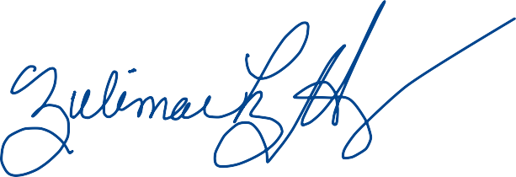
Kind Regards,
Zulimar López-Hernández

May 14th, 2024

From: Zulimar López-Hernández Professor
Departamento de Música Facultad de Humanidades Universidad de Puerto Rico Recinto de Rio Piedras

I hereby request permission to undertake a work-based research study with several of my university students as part of my Master of Arts degree in Voice Pedagogy at the Voice Study Center of the University of Wales Trinity Saint David in the United Kingdom. The proposed title for the investigation is Exploring the practice experience of undergraduate voice students using the PARE/PASE reflective framework (López-Hernández, 2022) as a peer-learning vocal practice strategy for enhancing performance and motivation. The aim of this research is to explore the PARE/PASE framework in a supervised practice setting with a peer-learning strategy that could allow the researcher to better understand students' practice habits and challenges and develop additional systems to help them.

The research will involve the participation of about ten students from my voice studio. Questionnaires, interviews, and observations of practice will be part of the methods for data analysis. Finally, we may conduct a focus group to gather general student feedback, analyze the impact and general impressions, identify study gaps, and suggest future recommendations, among other things. Recognizing my positionality as an inside researcher, I will take a purposive sample of participants, ensure voluntary participation, and inform each student of the study's aim and objectives. The study will adhere to the ethical and moral standards of the University of Puerto Rico, the Wales Academy for Professional Practice and Applied Research, and the University of Wales Trinity Saint David.

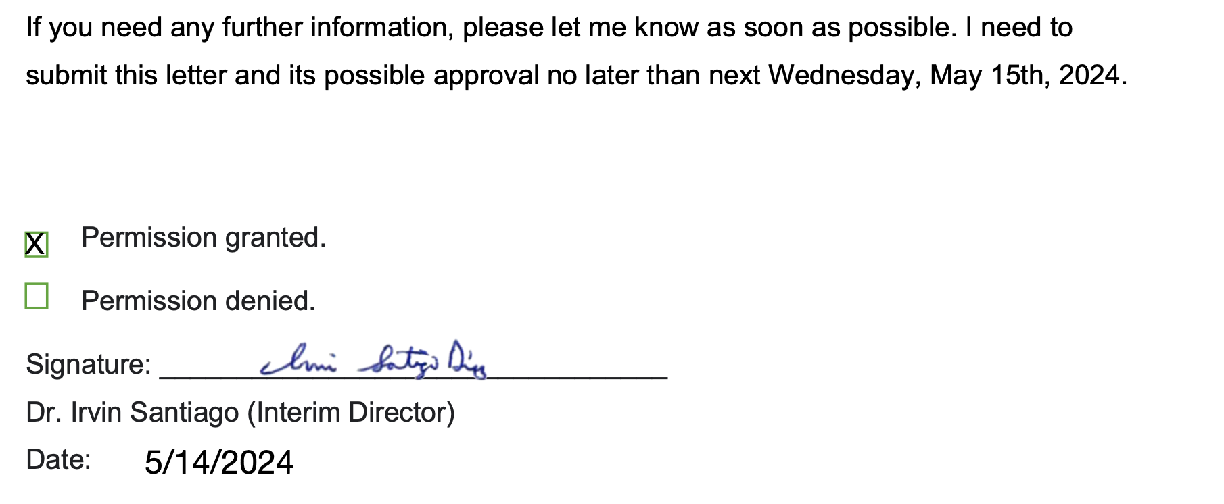

Appendix X: Participant’s Information Sheets (Signed)
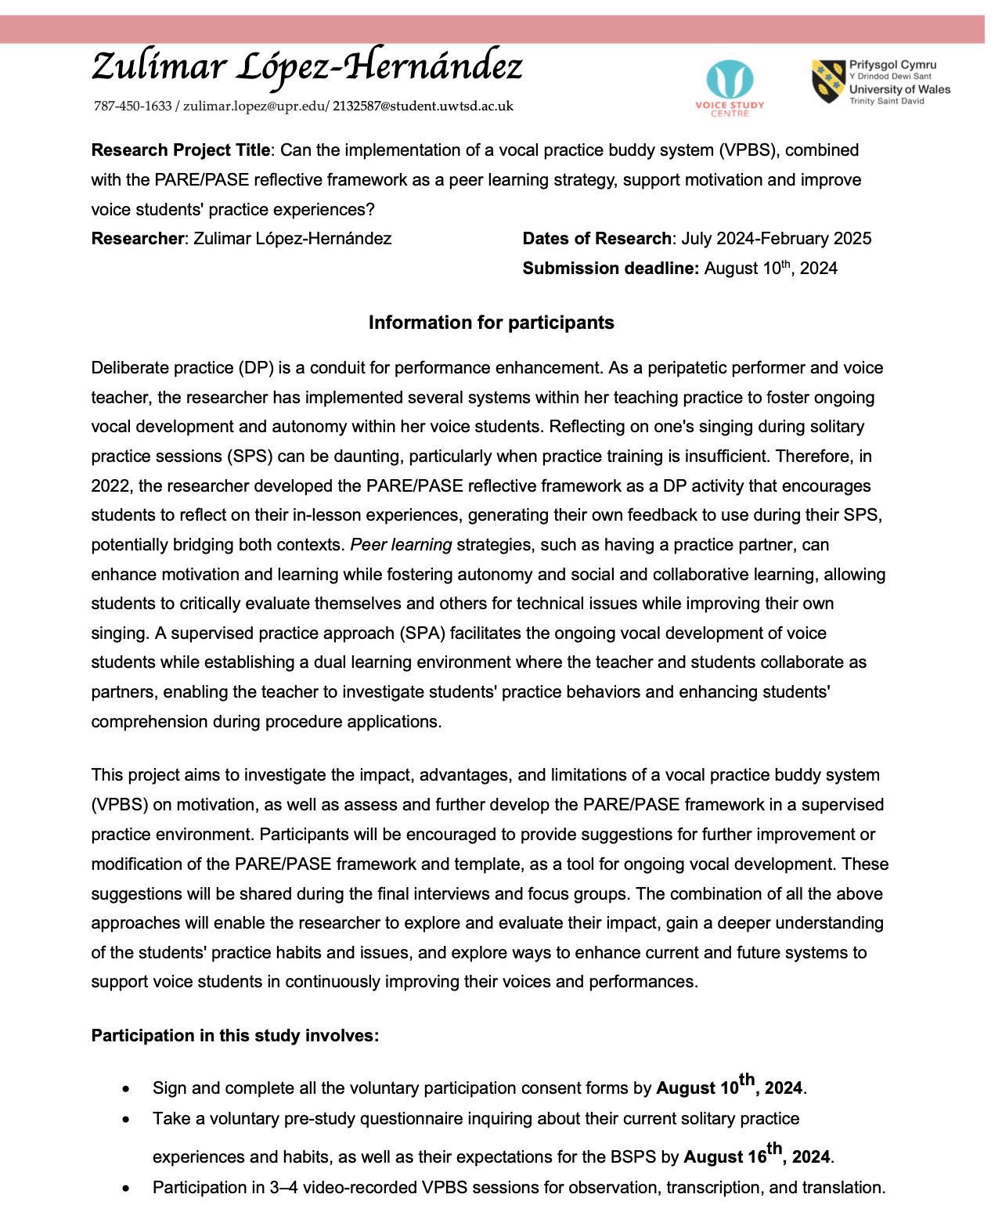
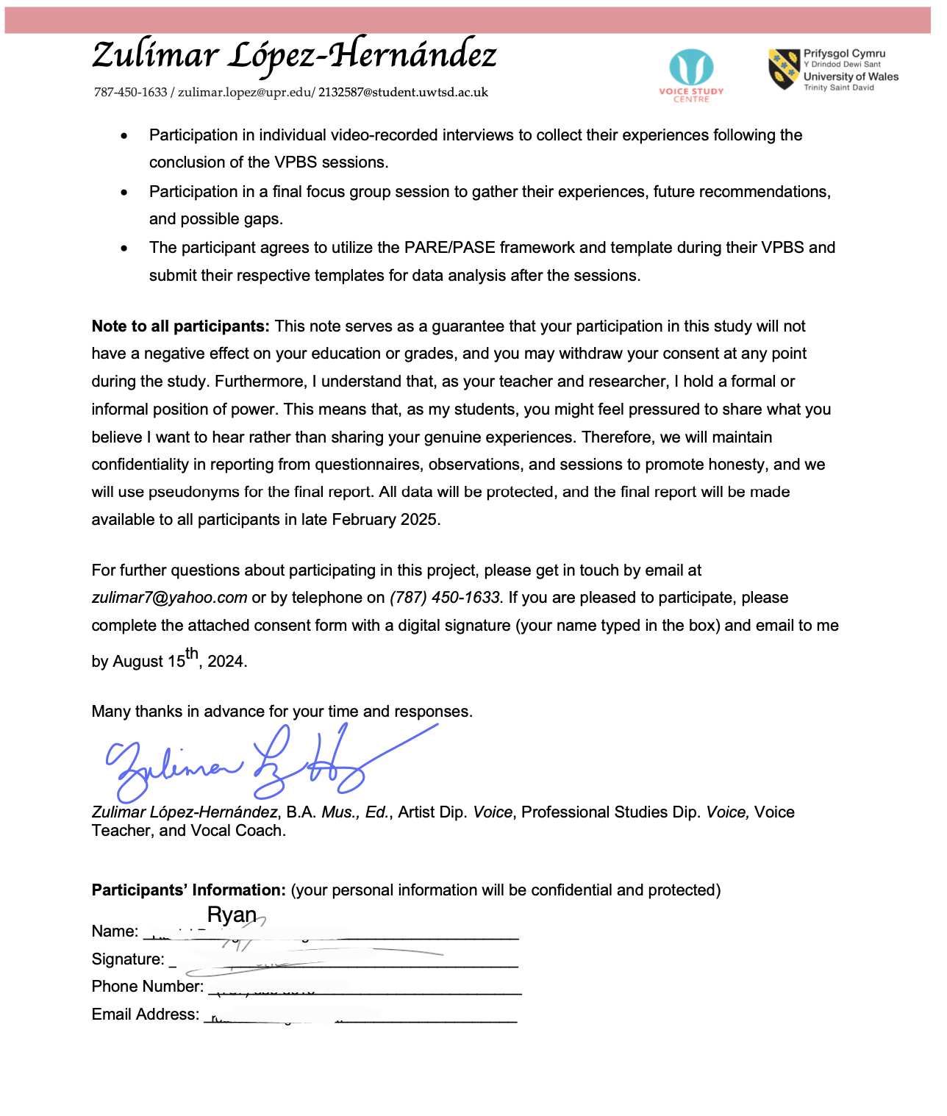

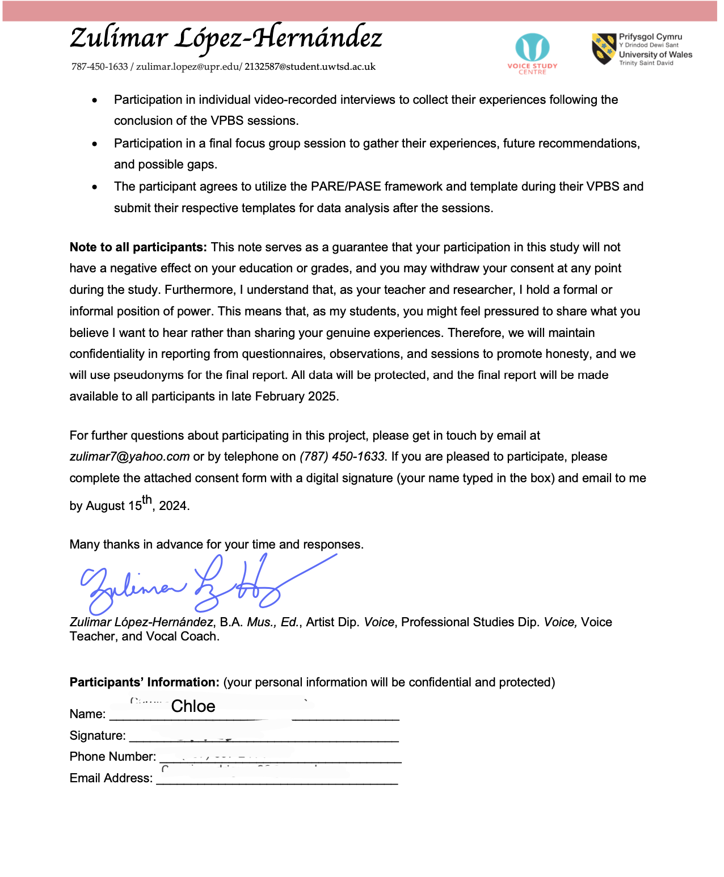

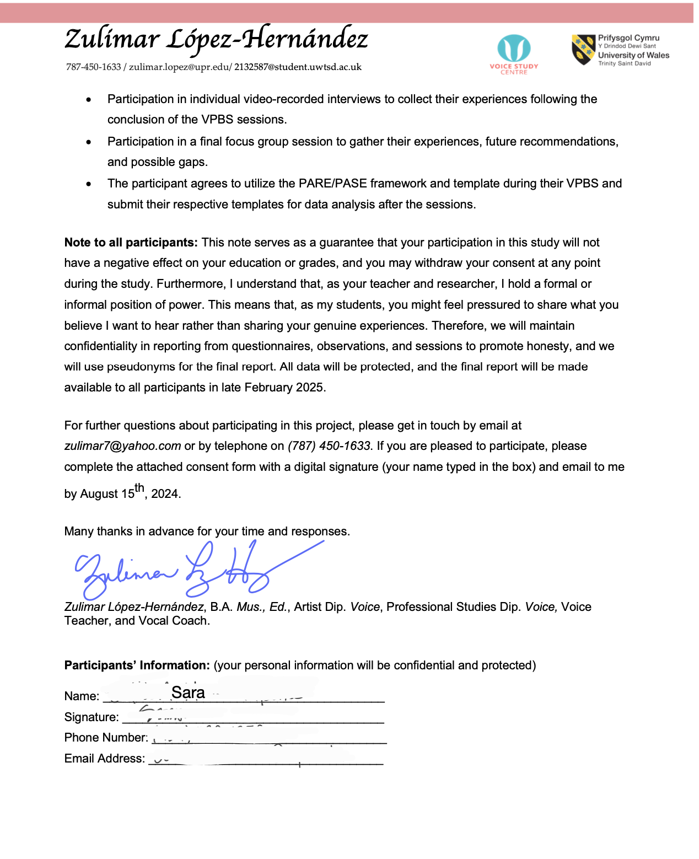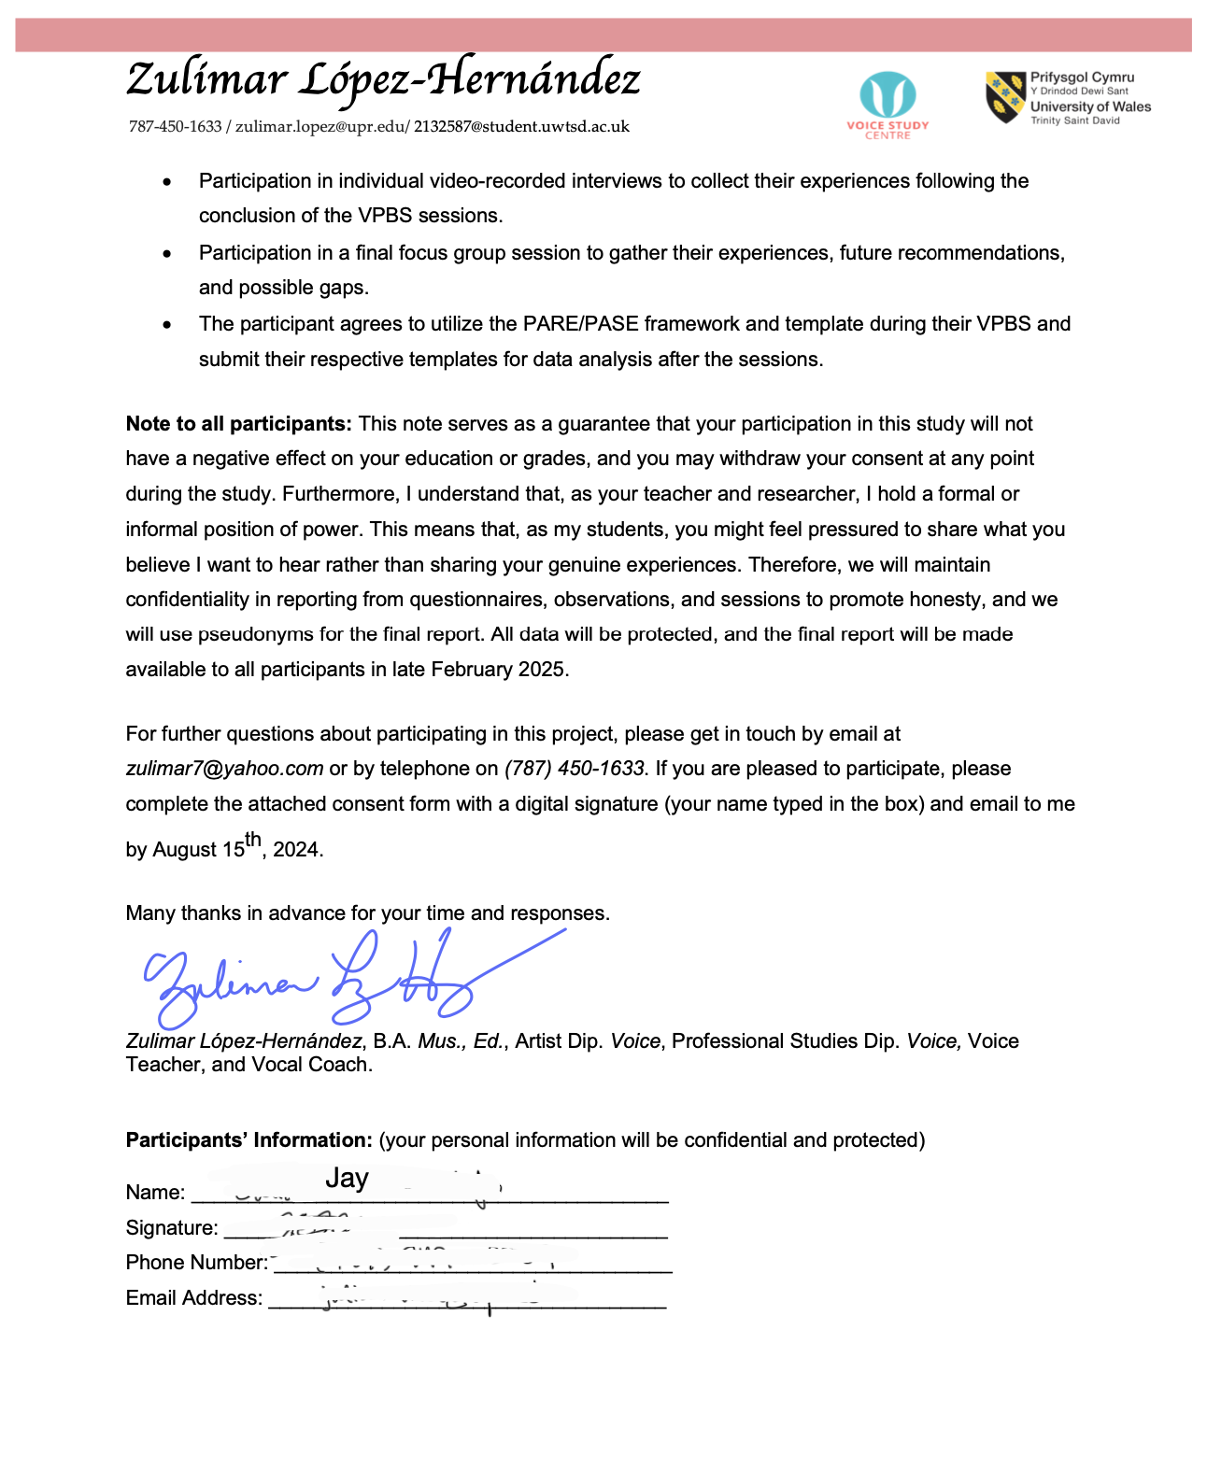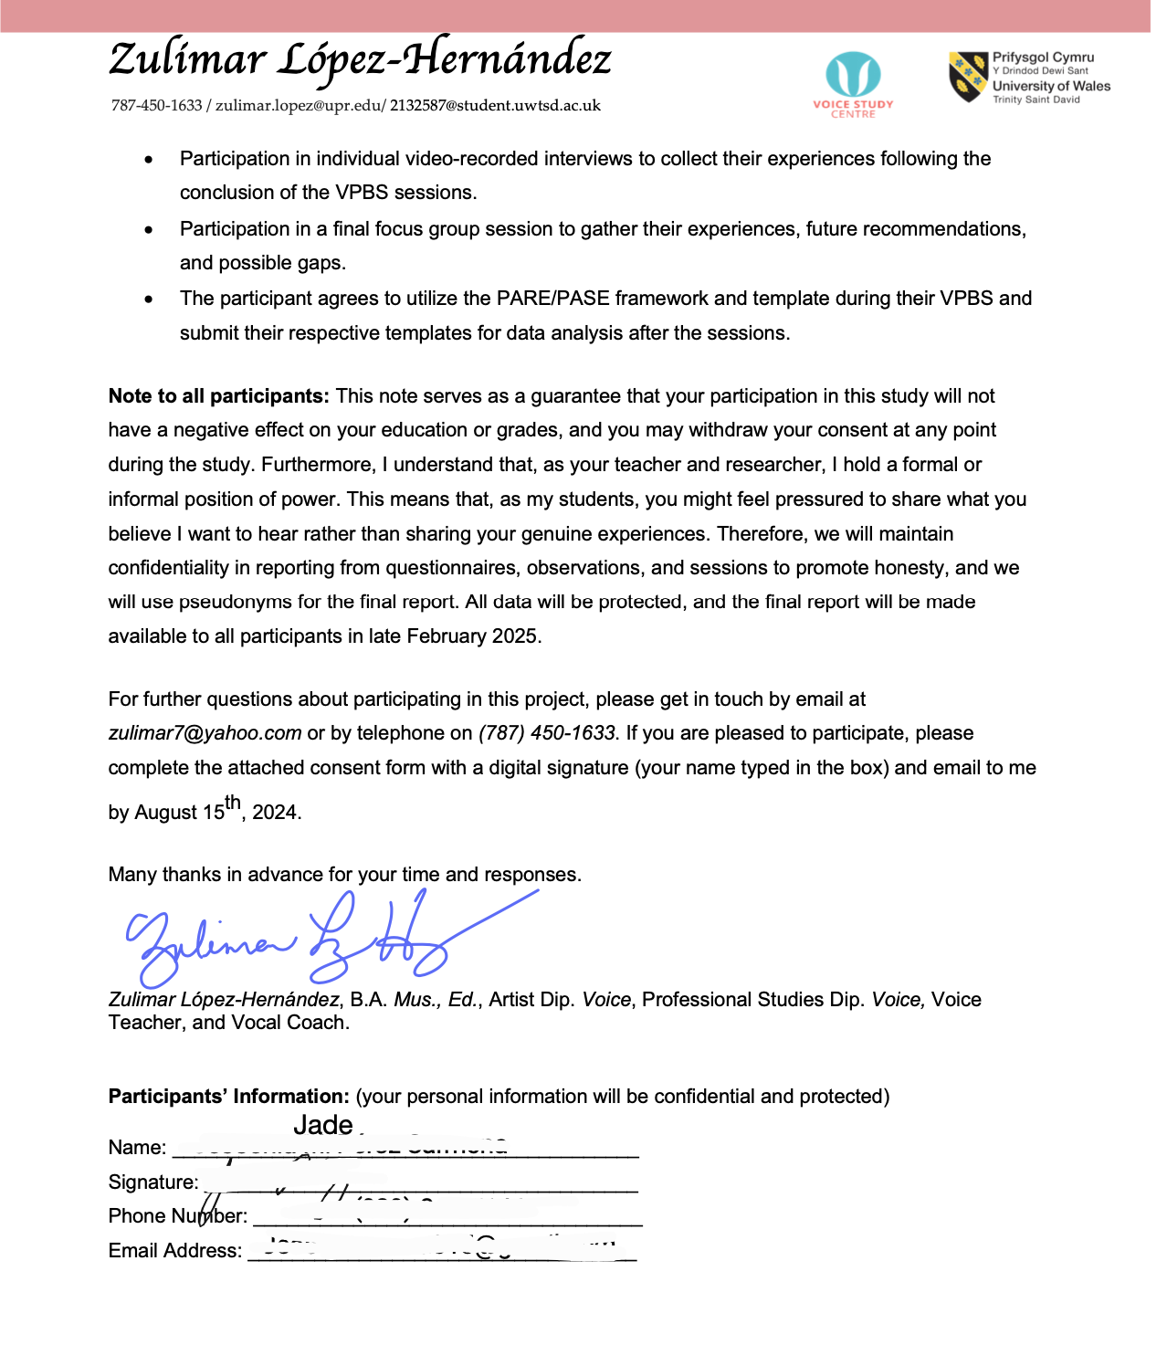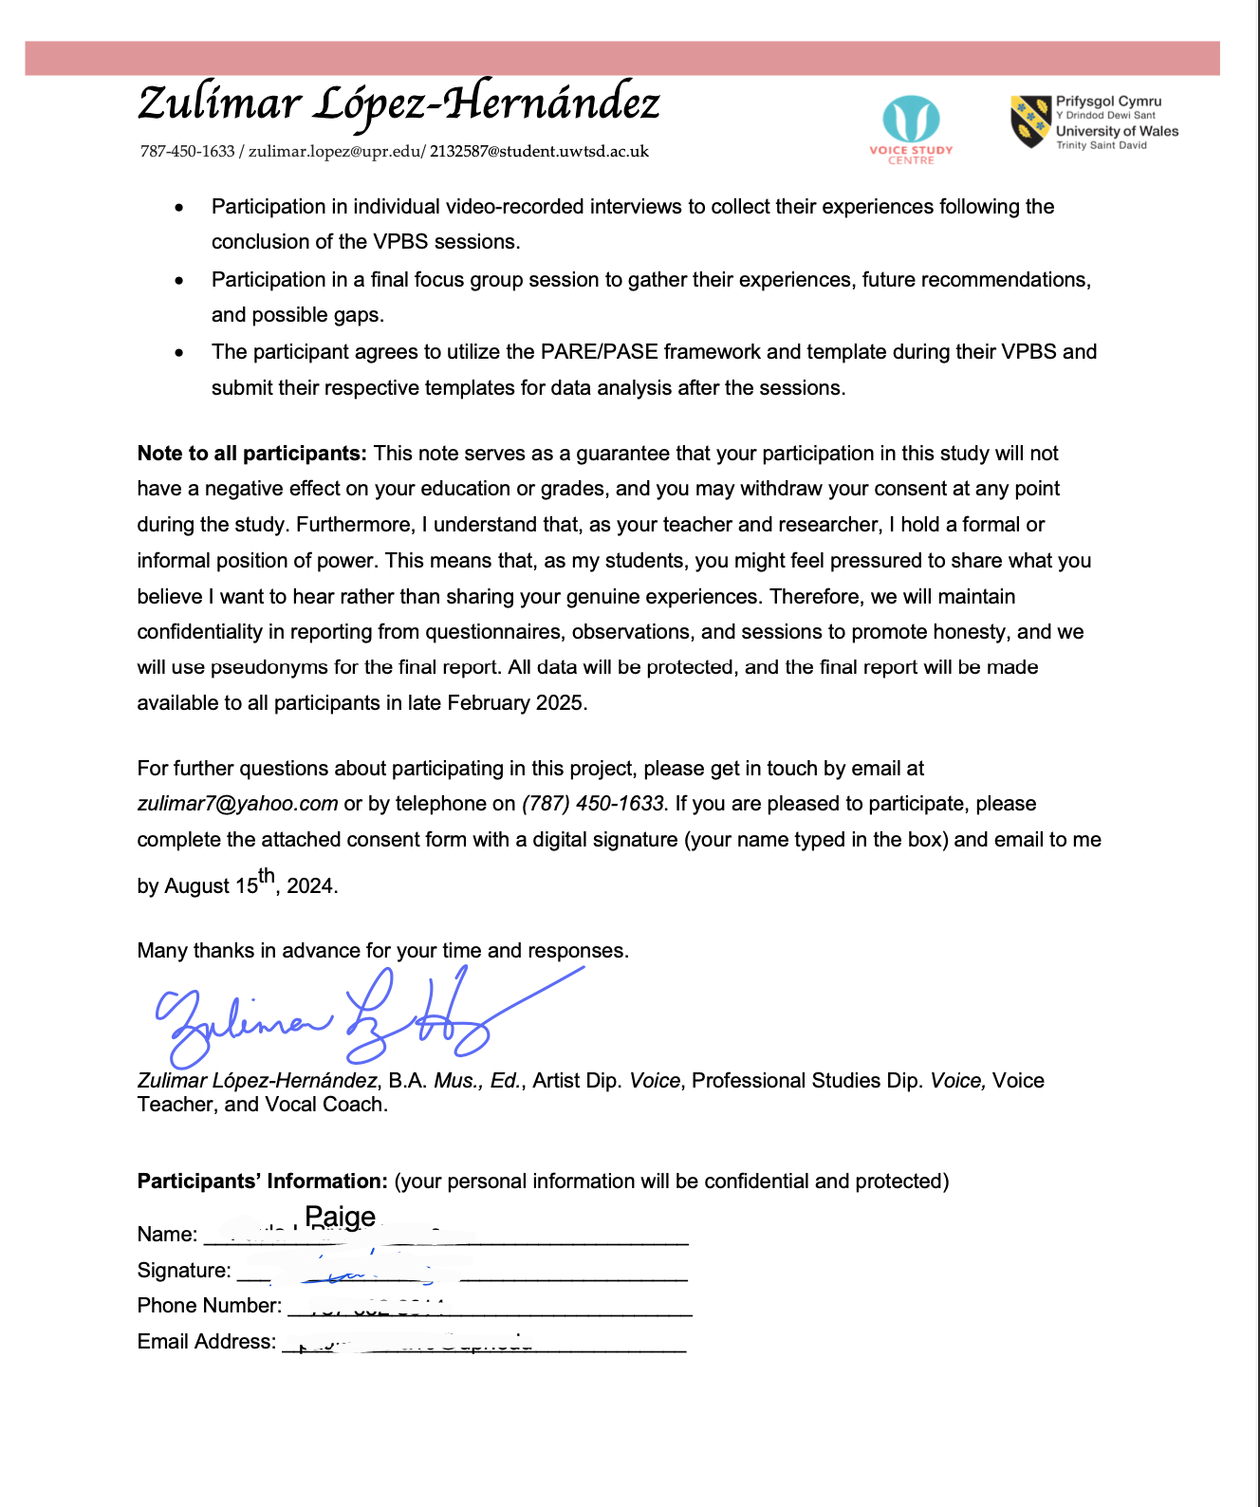

Appendix XI: Participant’s Consent Forms (Signed)
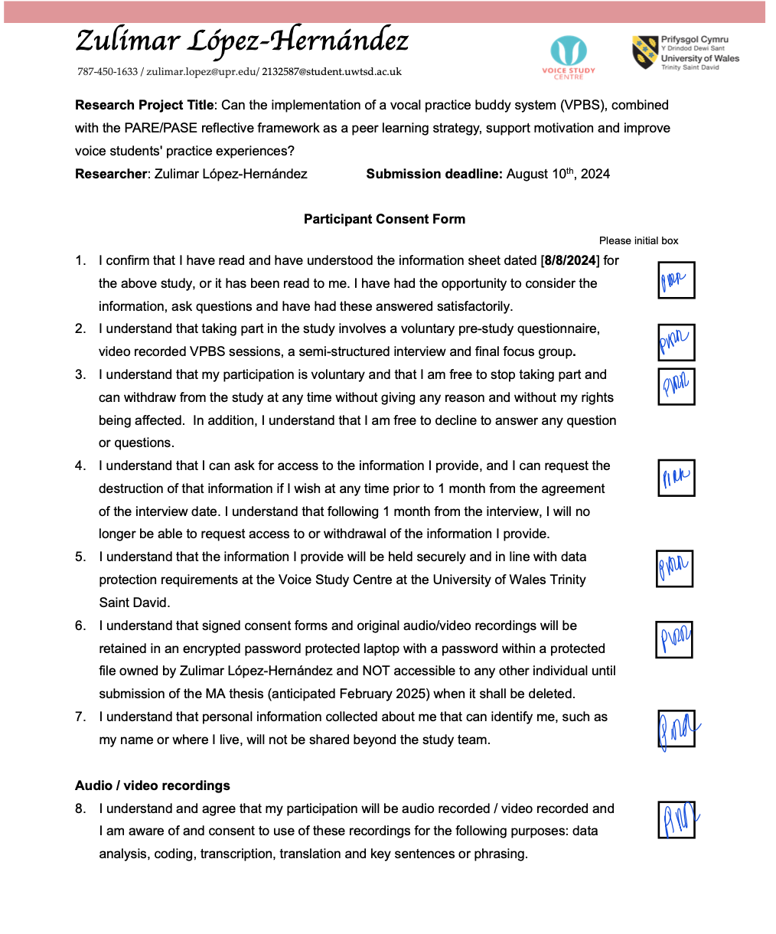

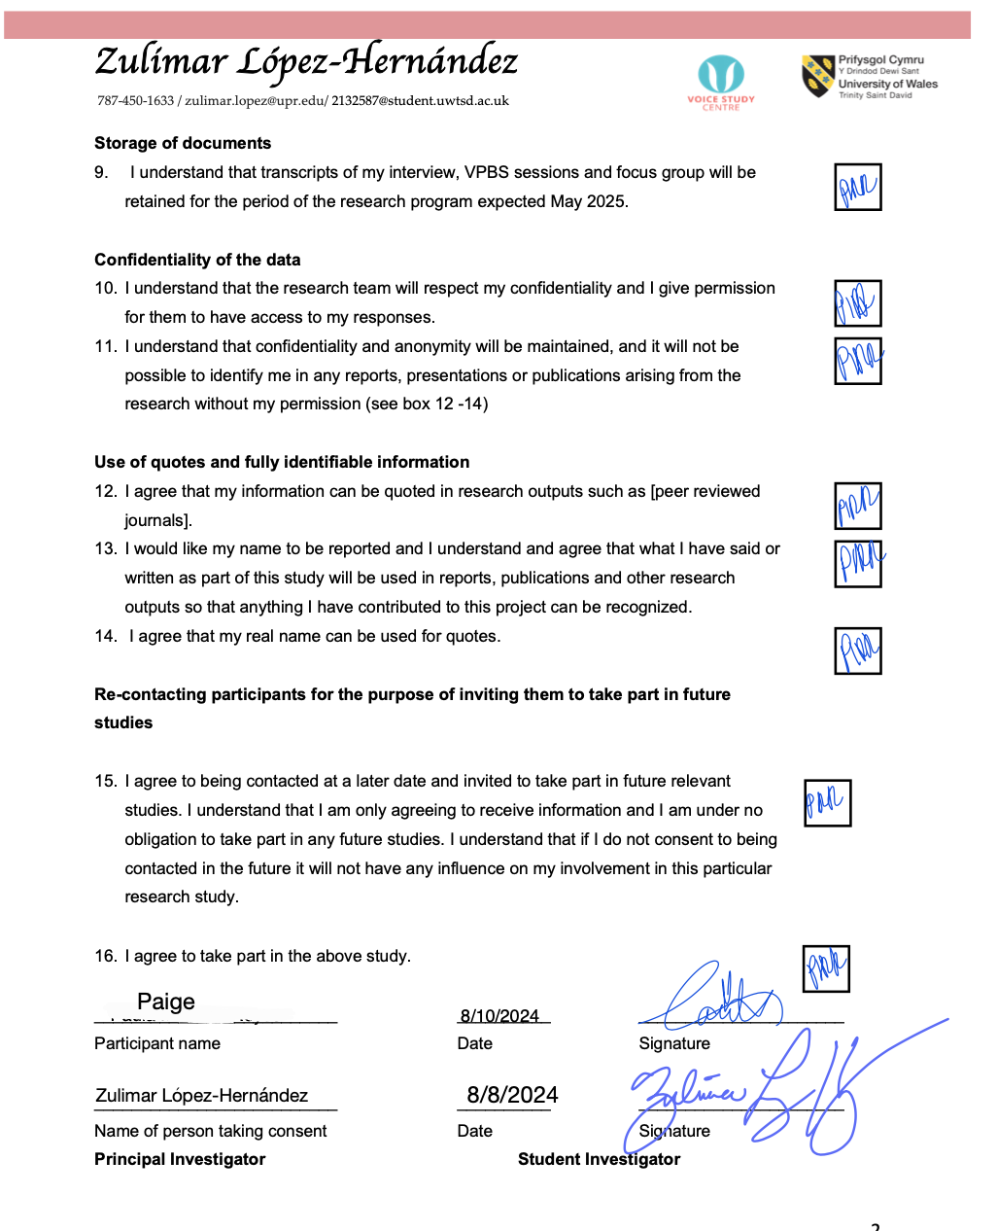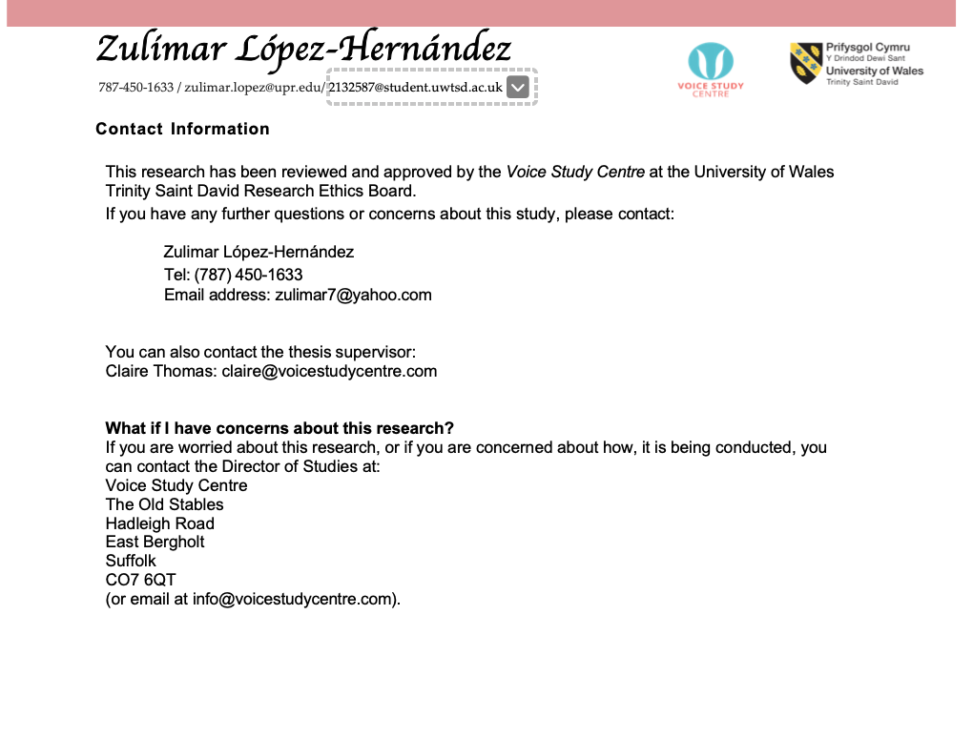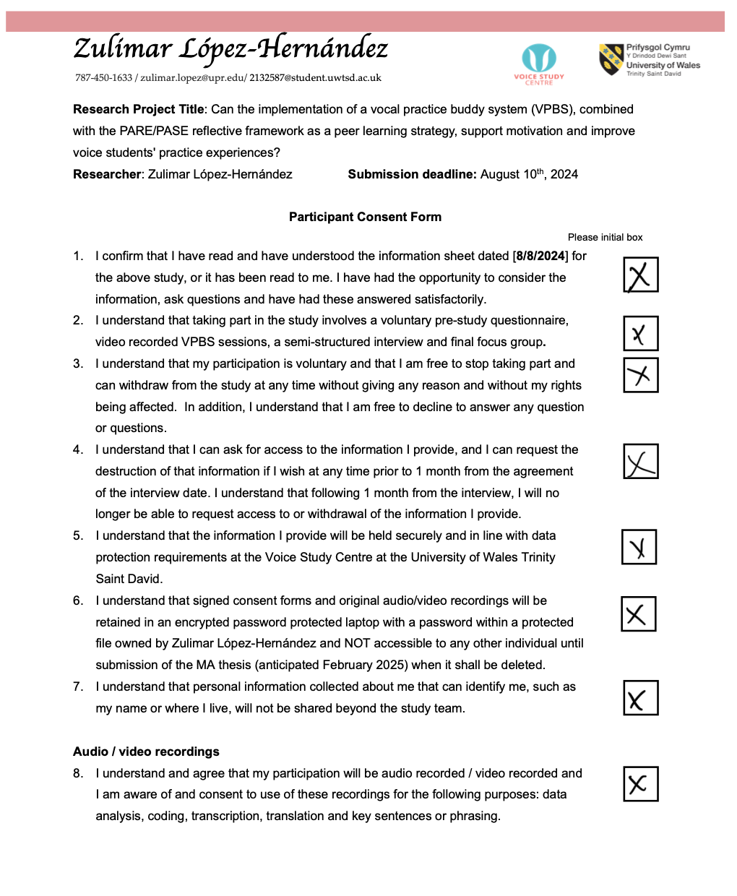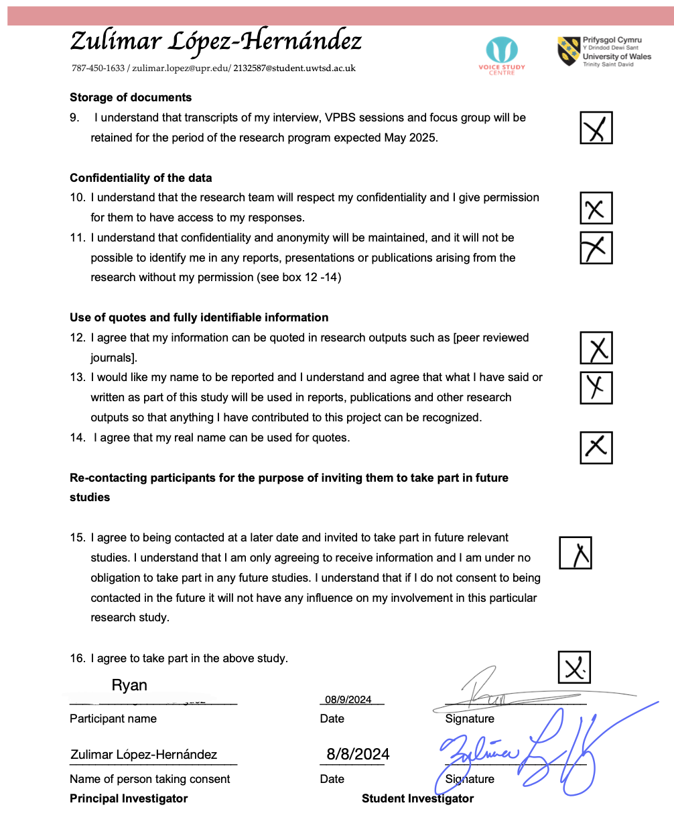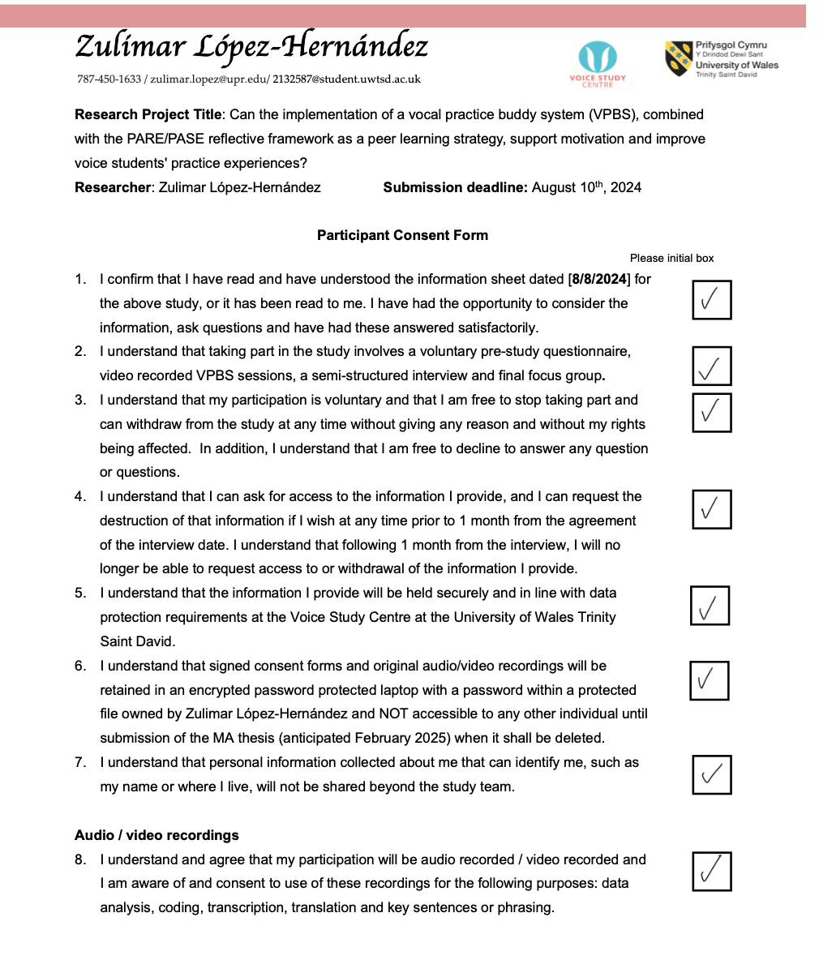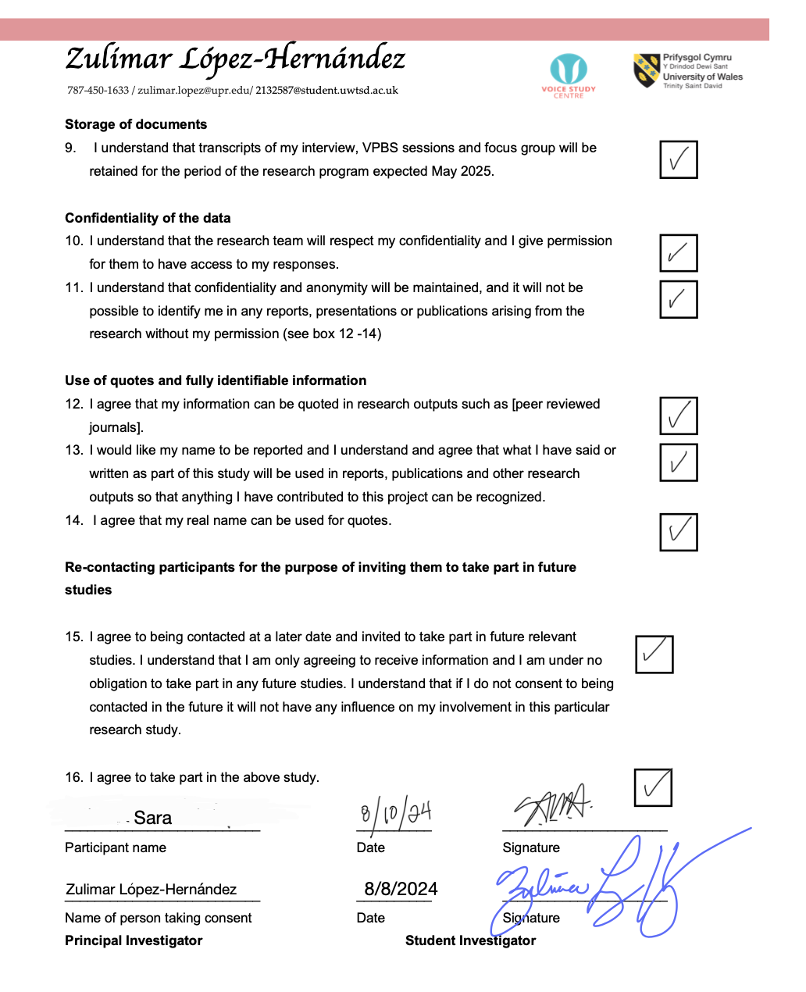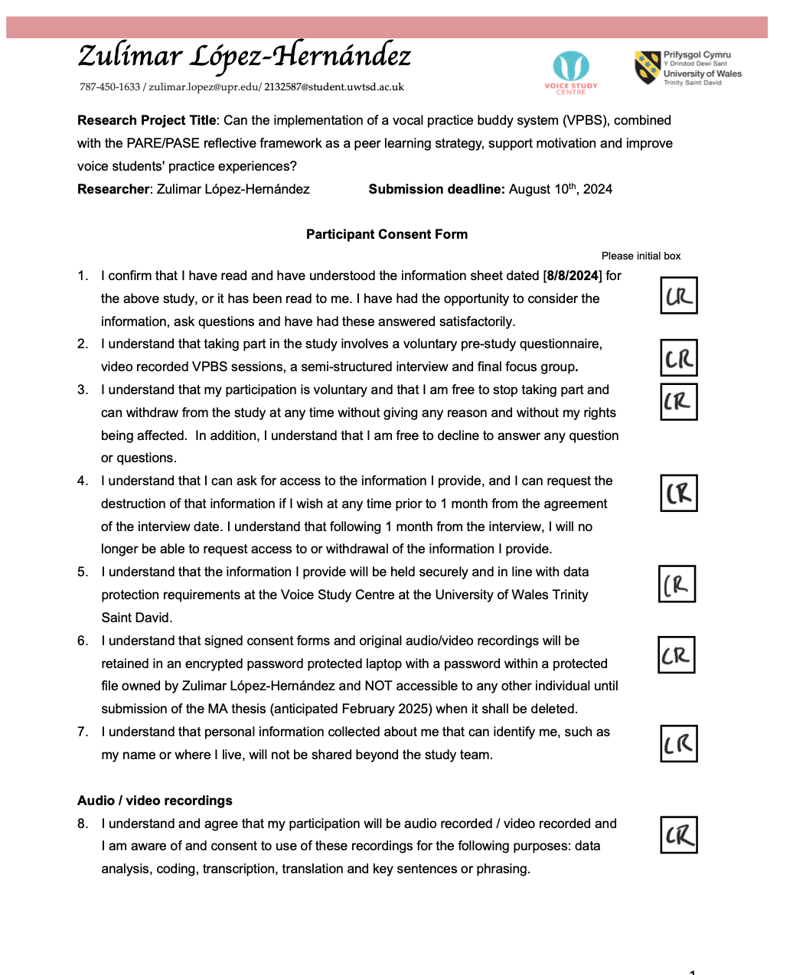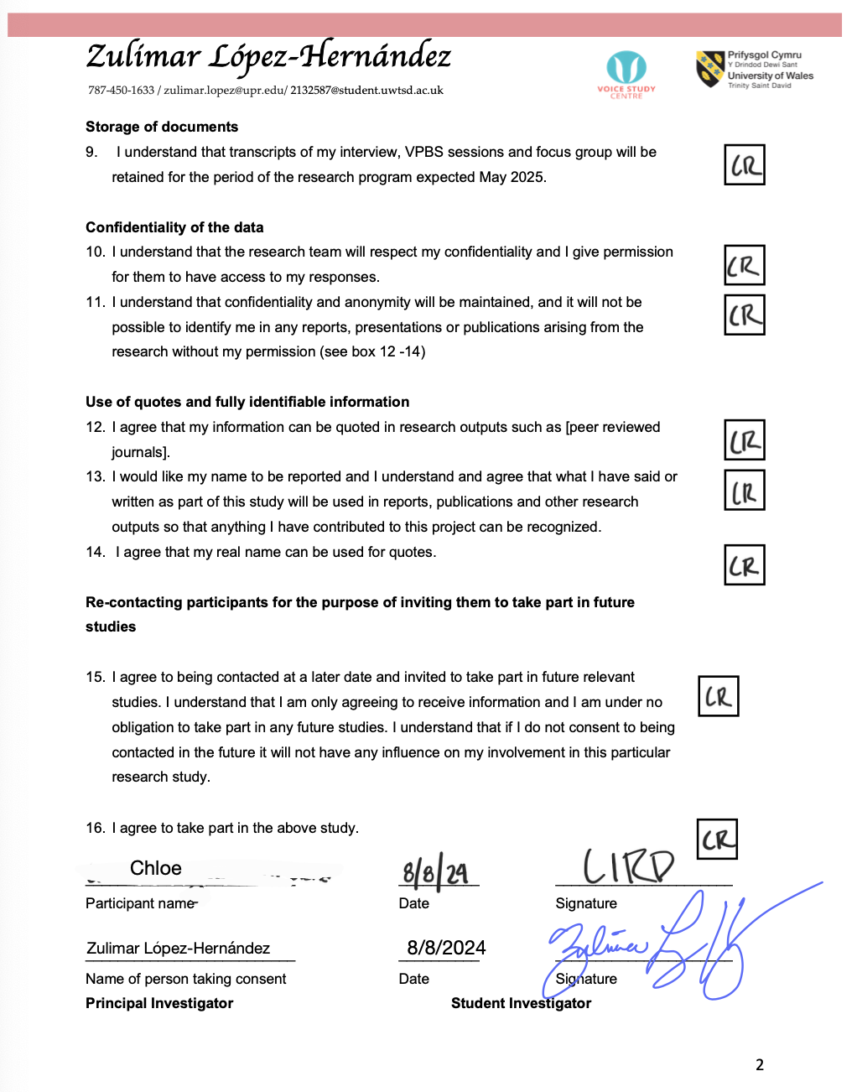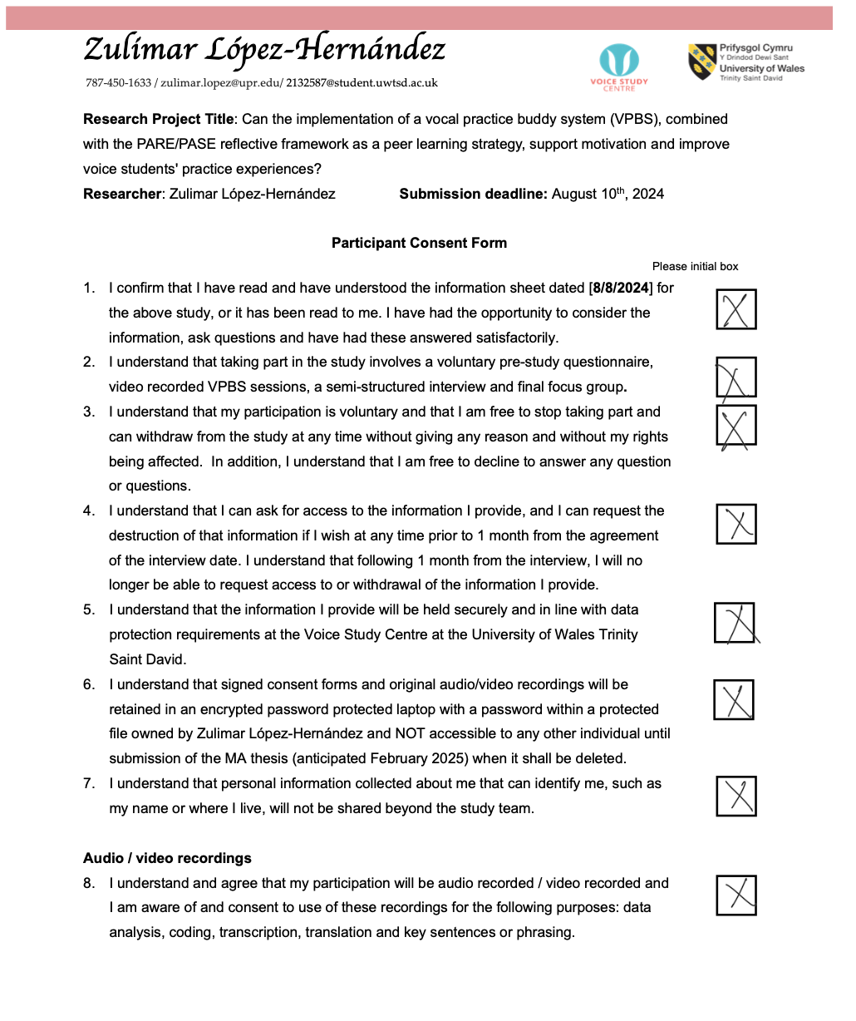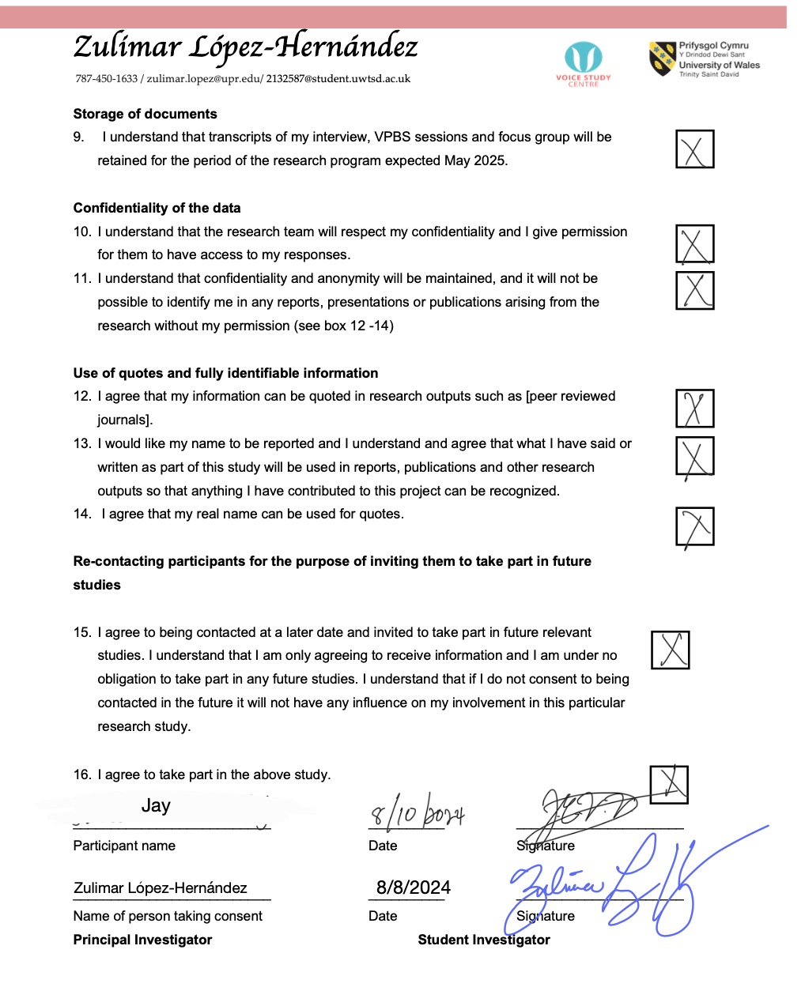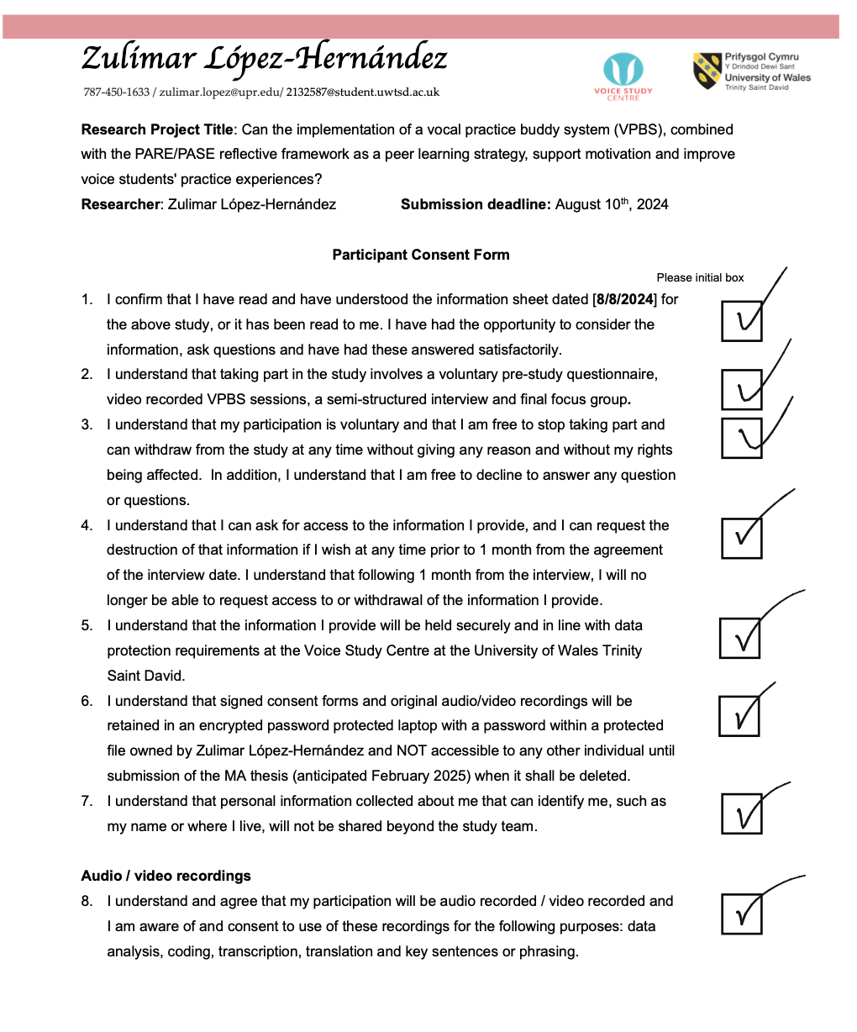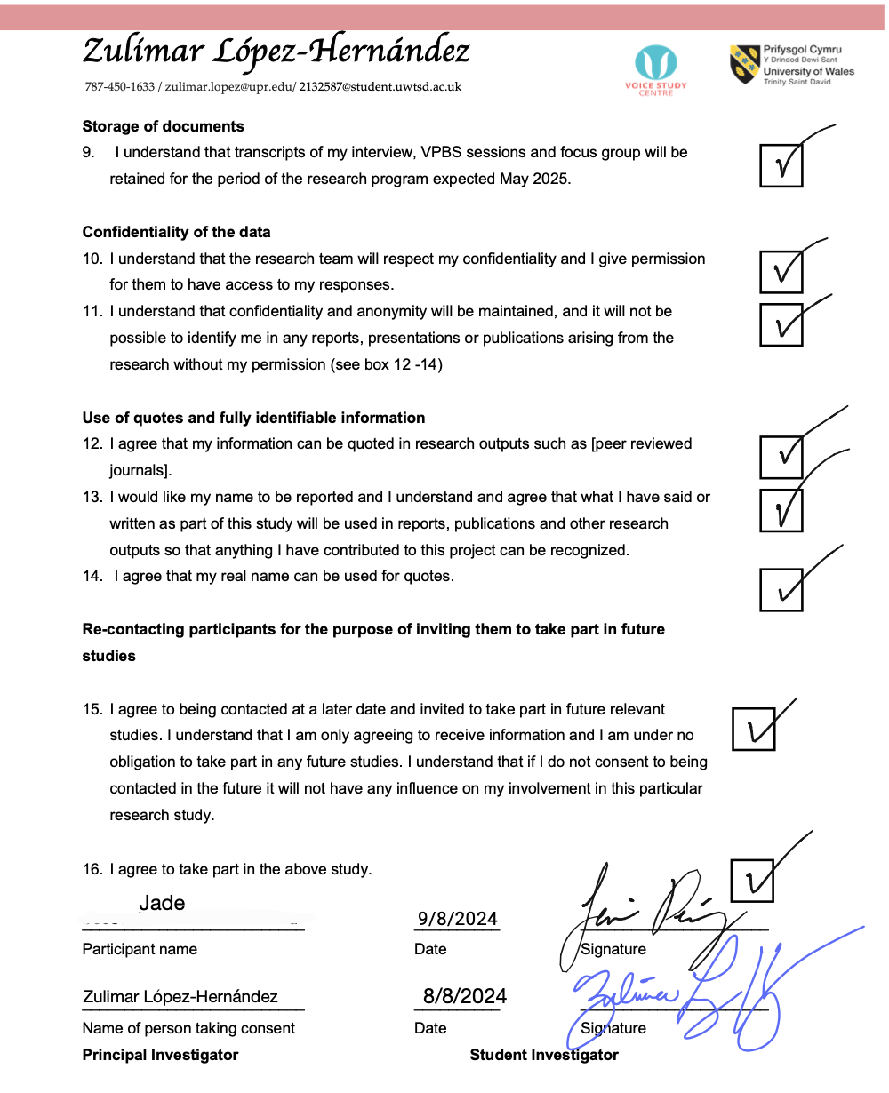

Appendix XII: Focus Group Ground Rules Agreement (Signed)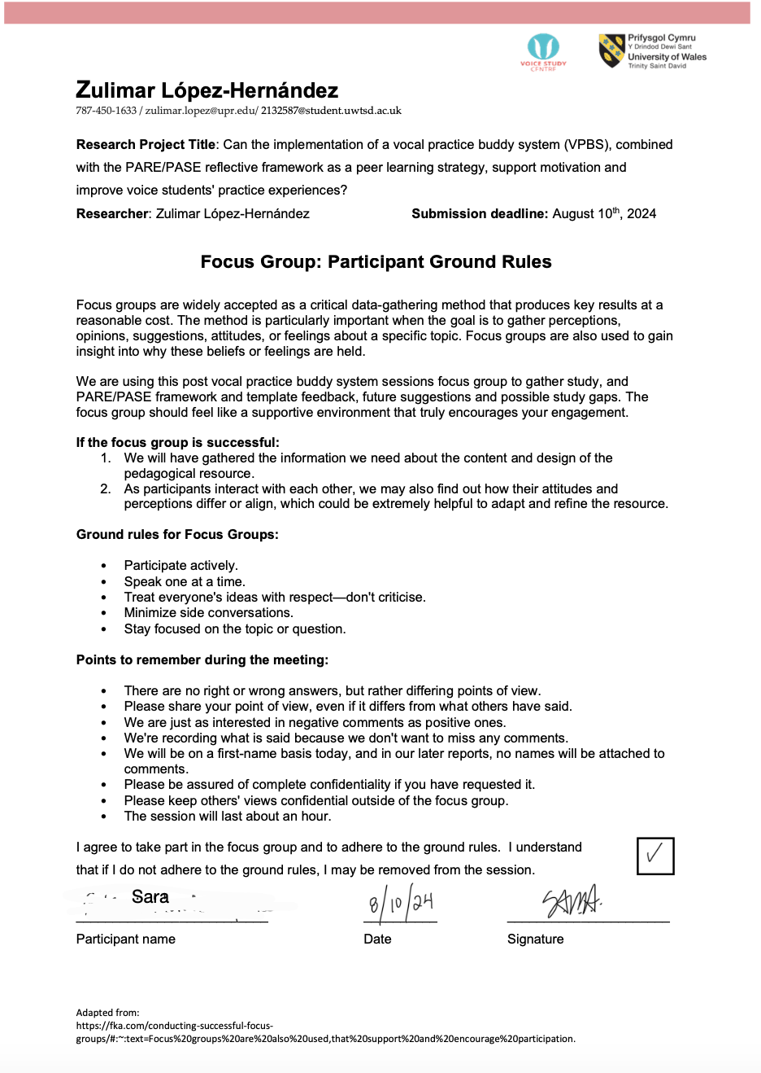
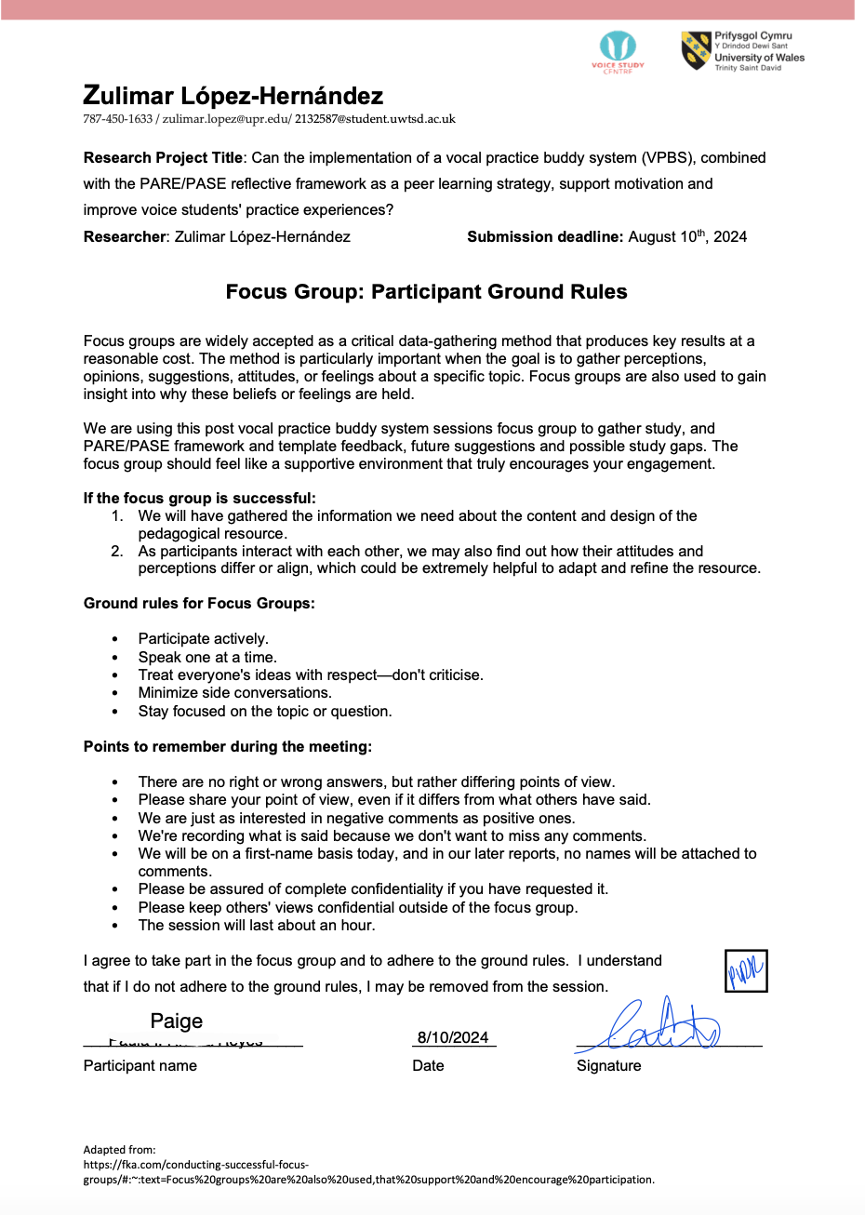 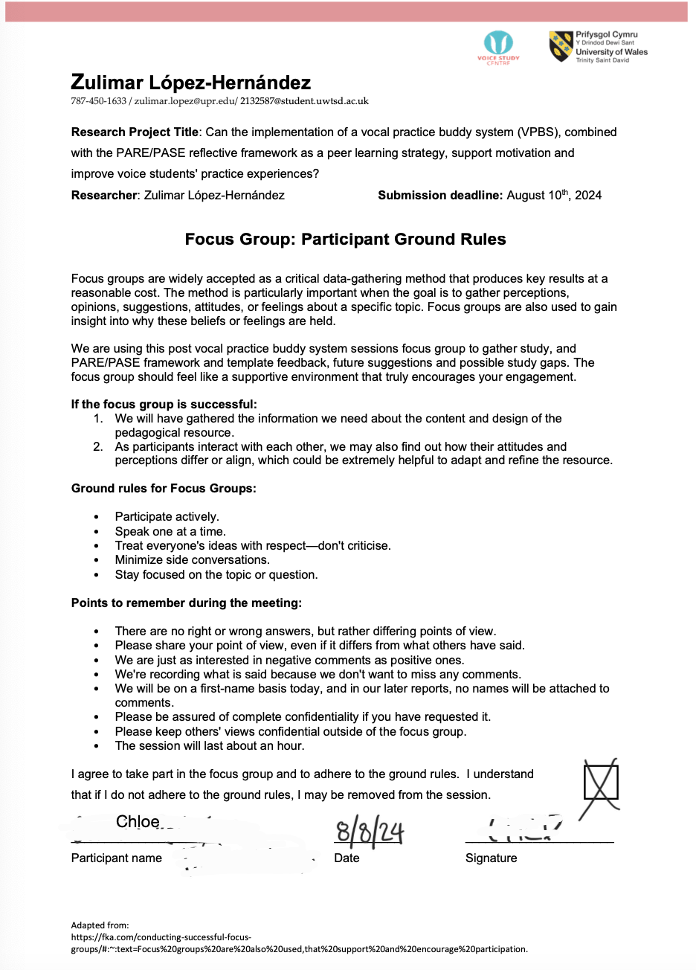 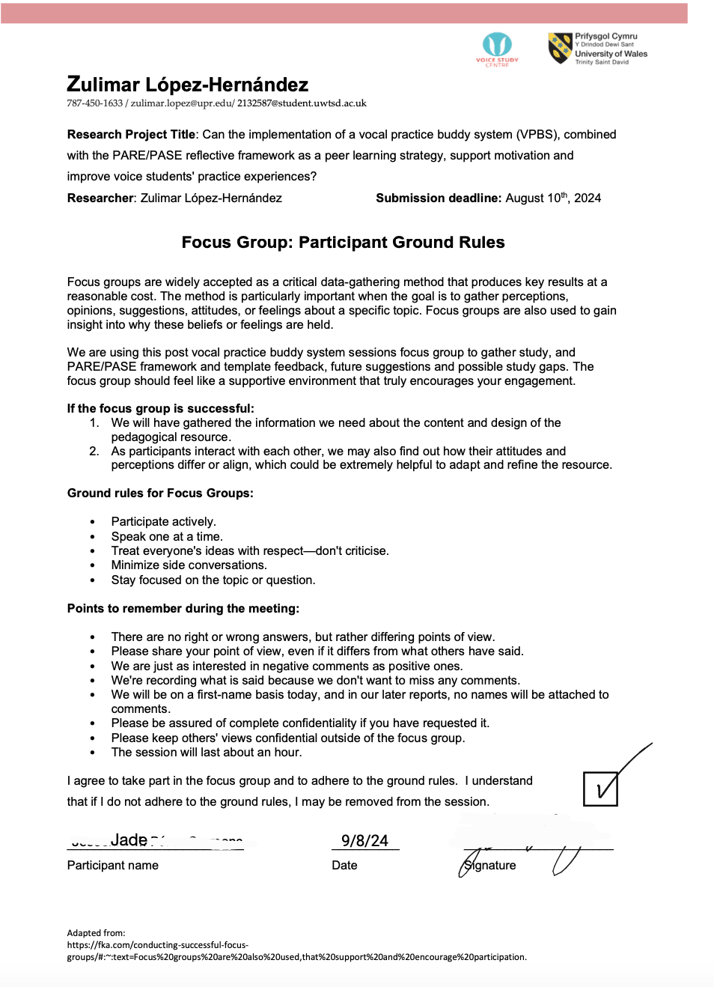 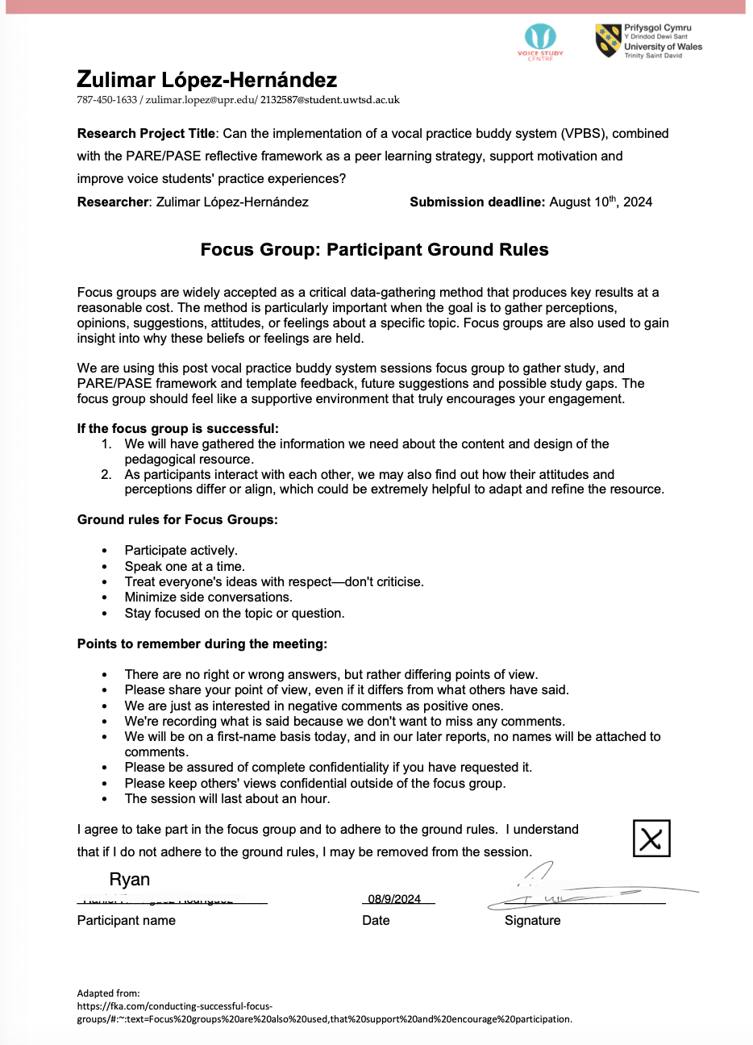 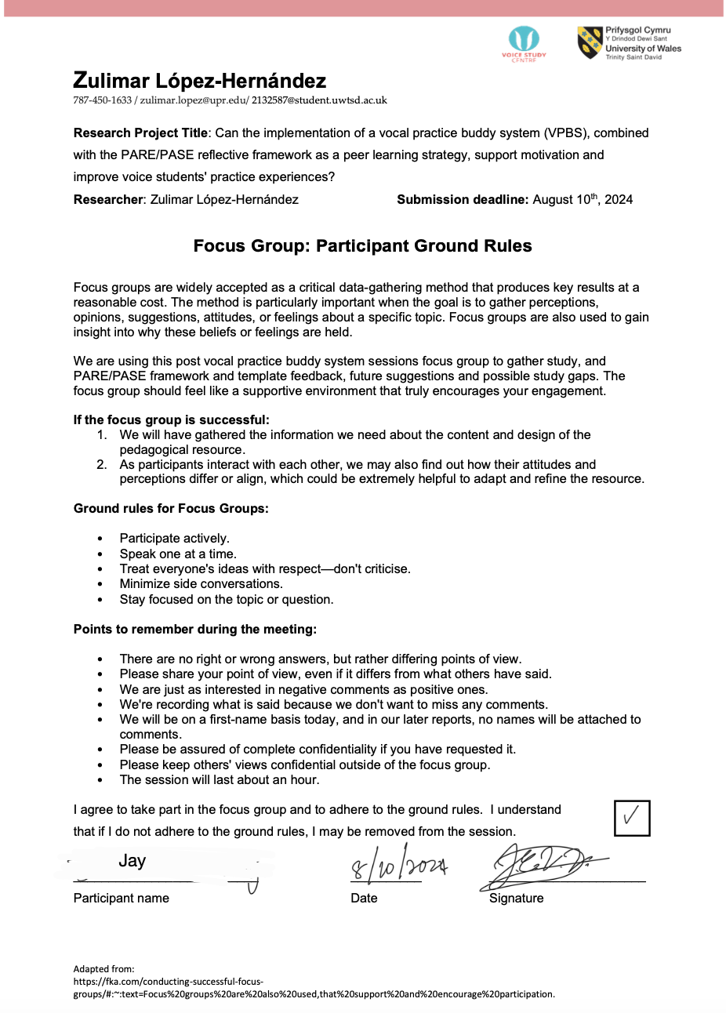Appendix XIII: Approved Ethics Form
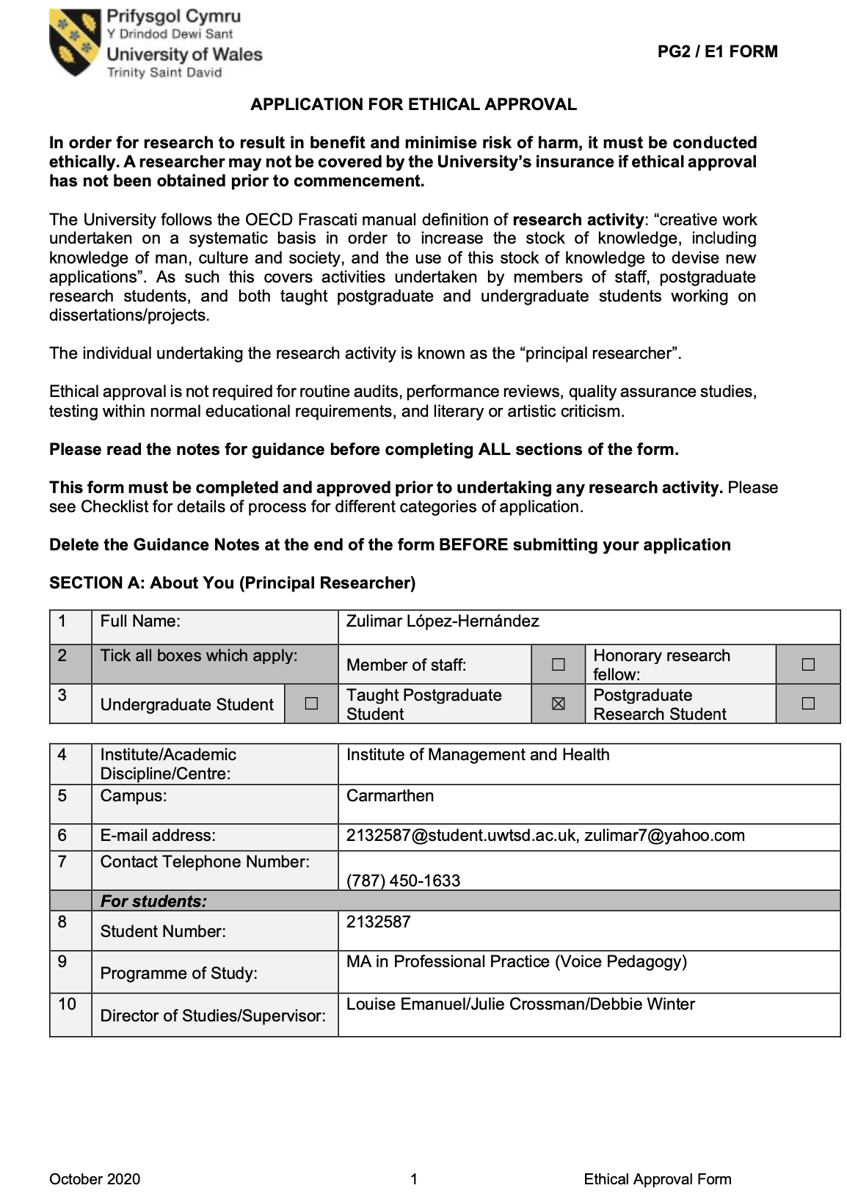

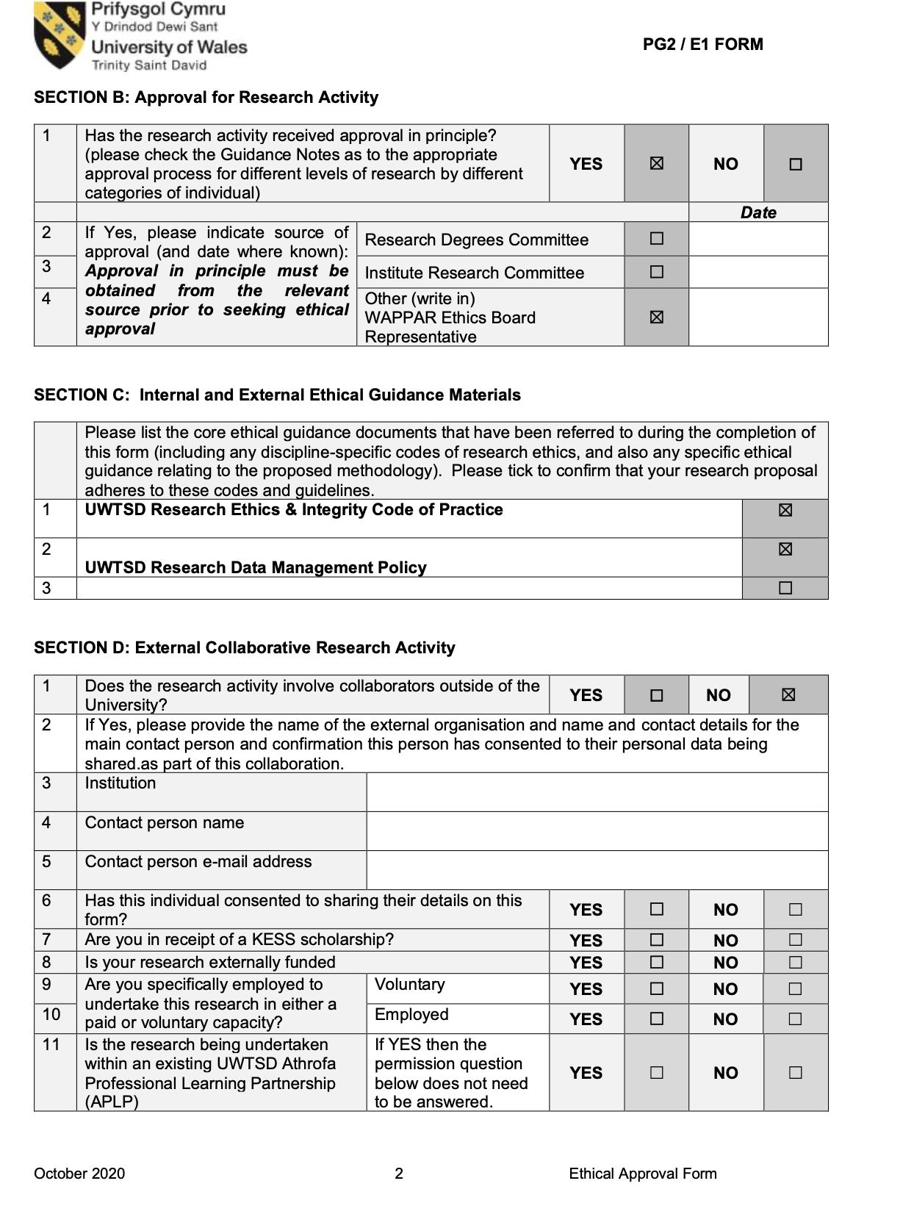 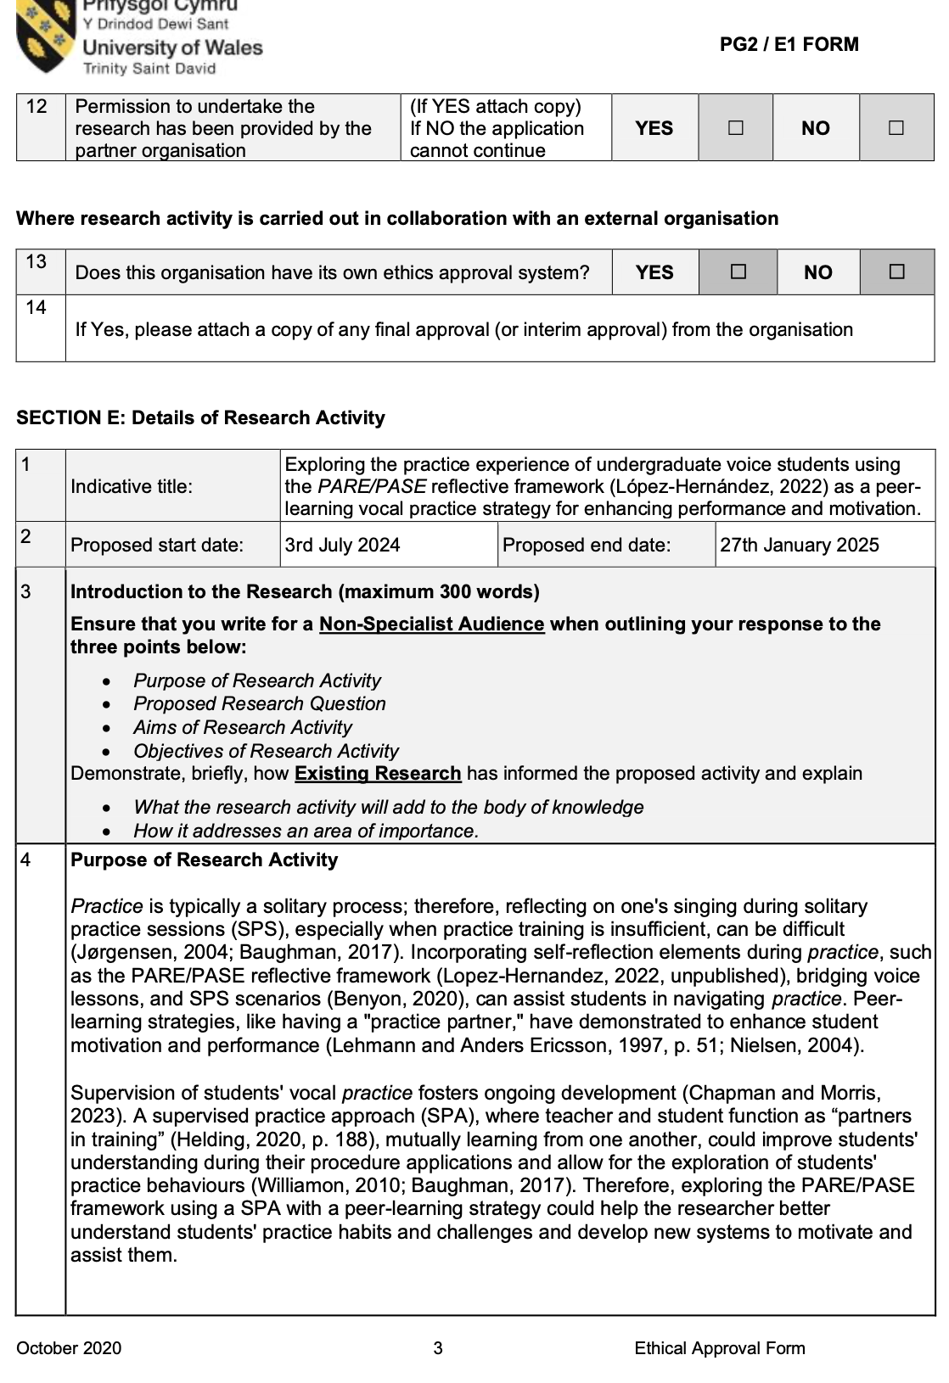 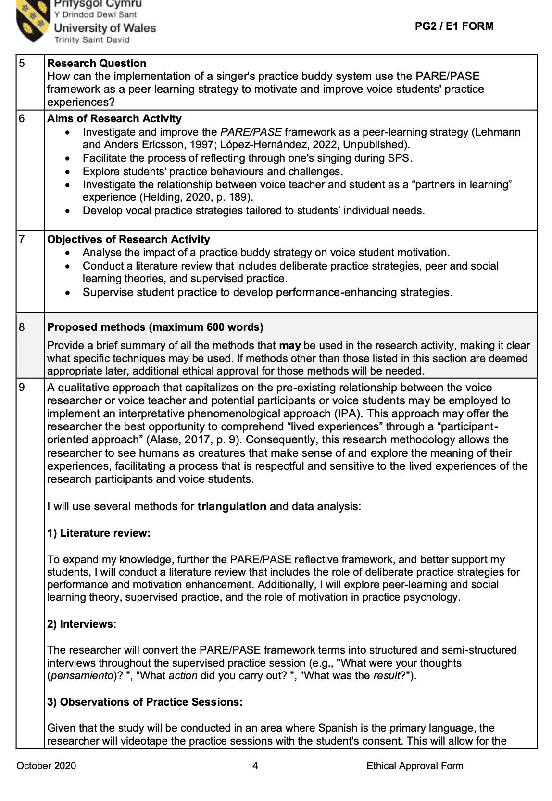 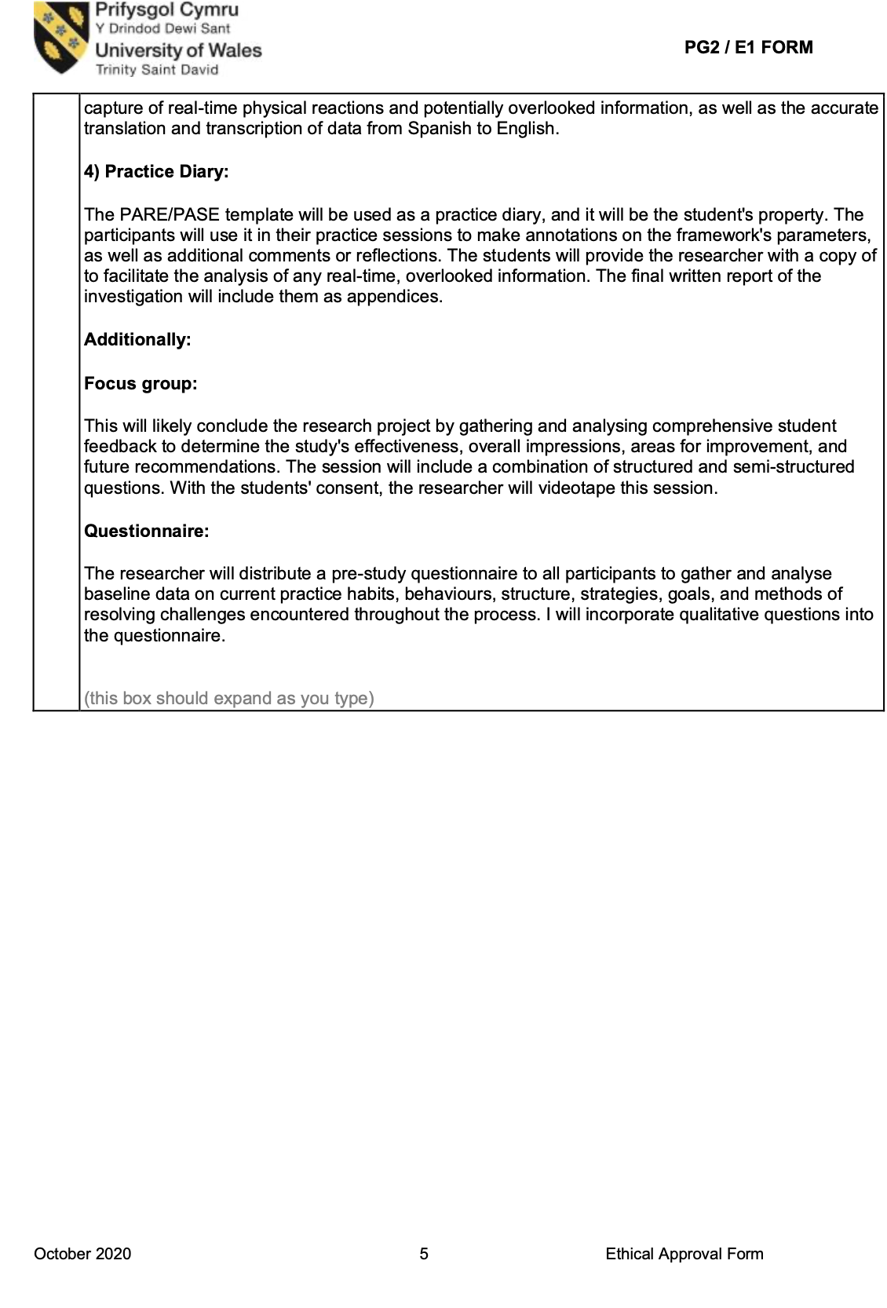 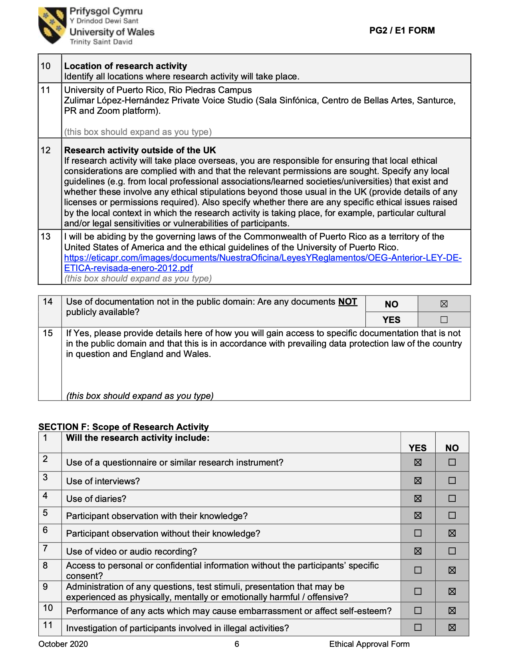 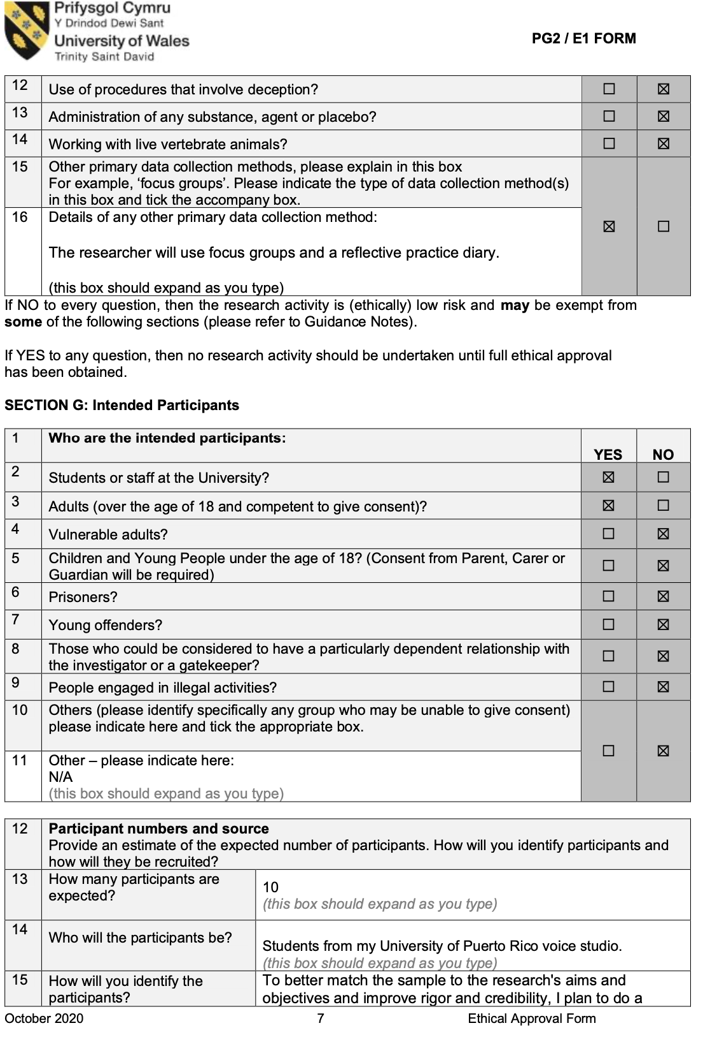 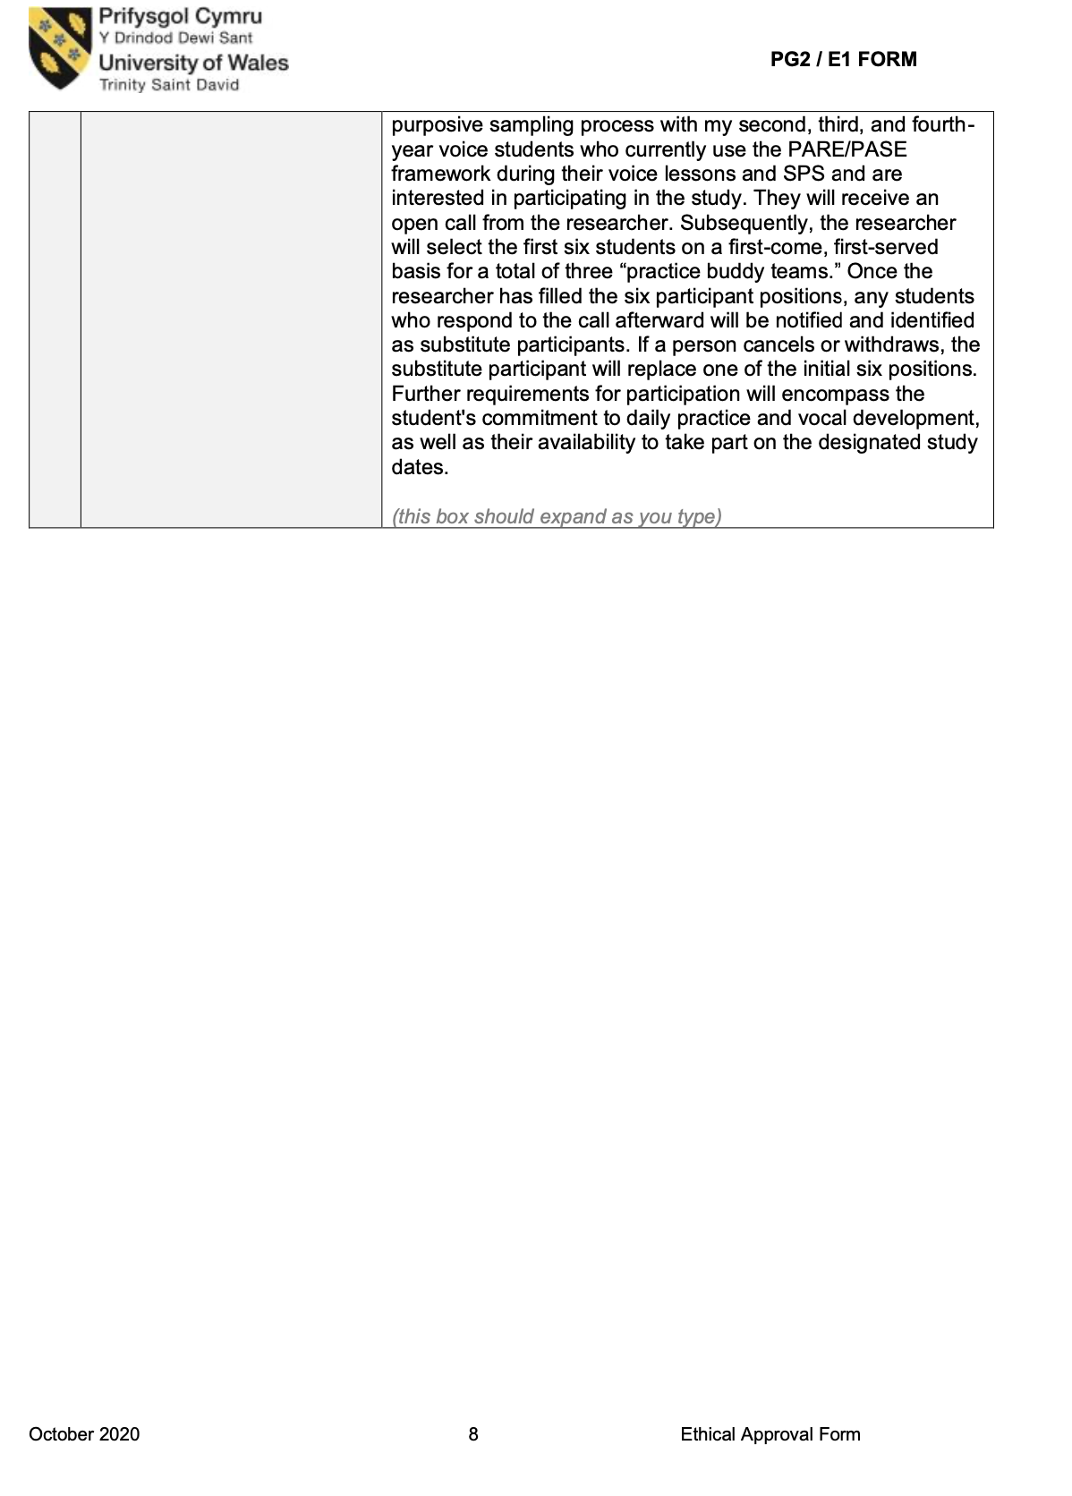 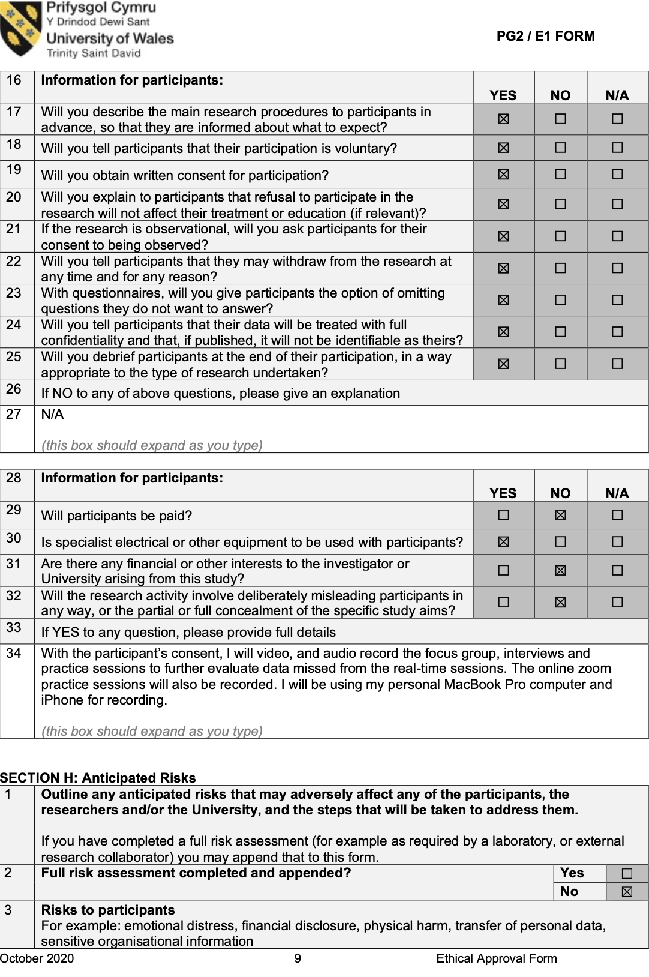 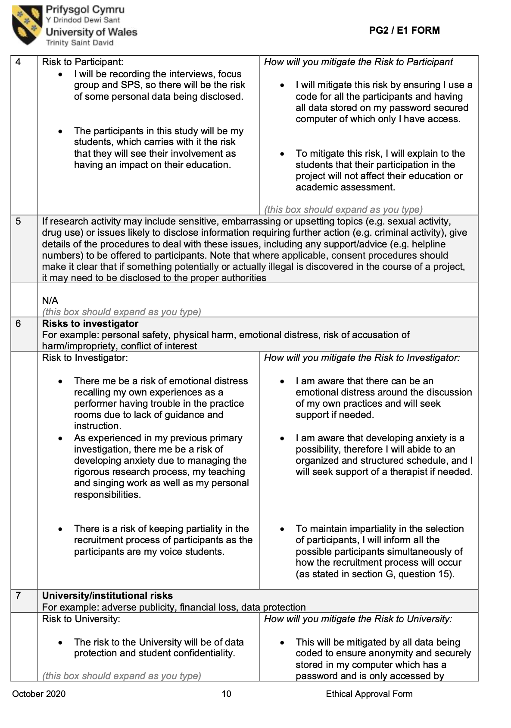 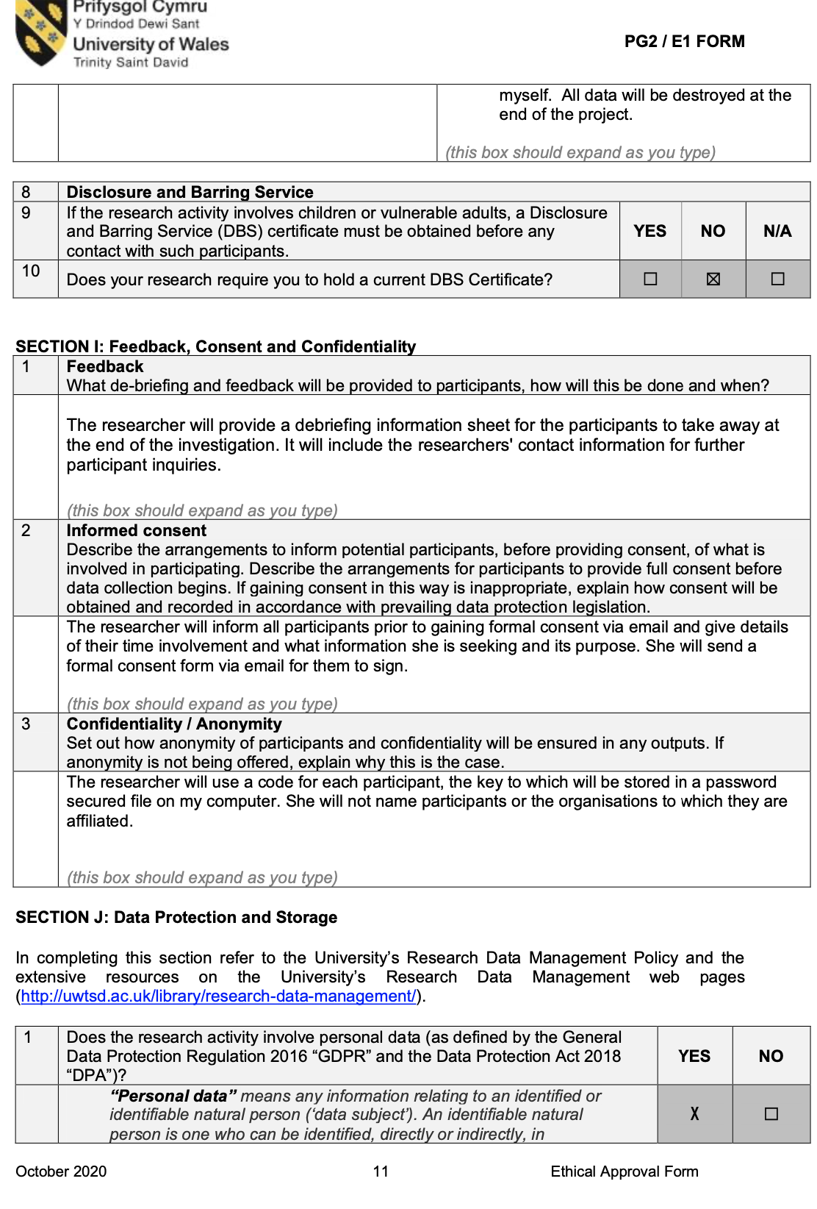 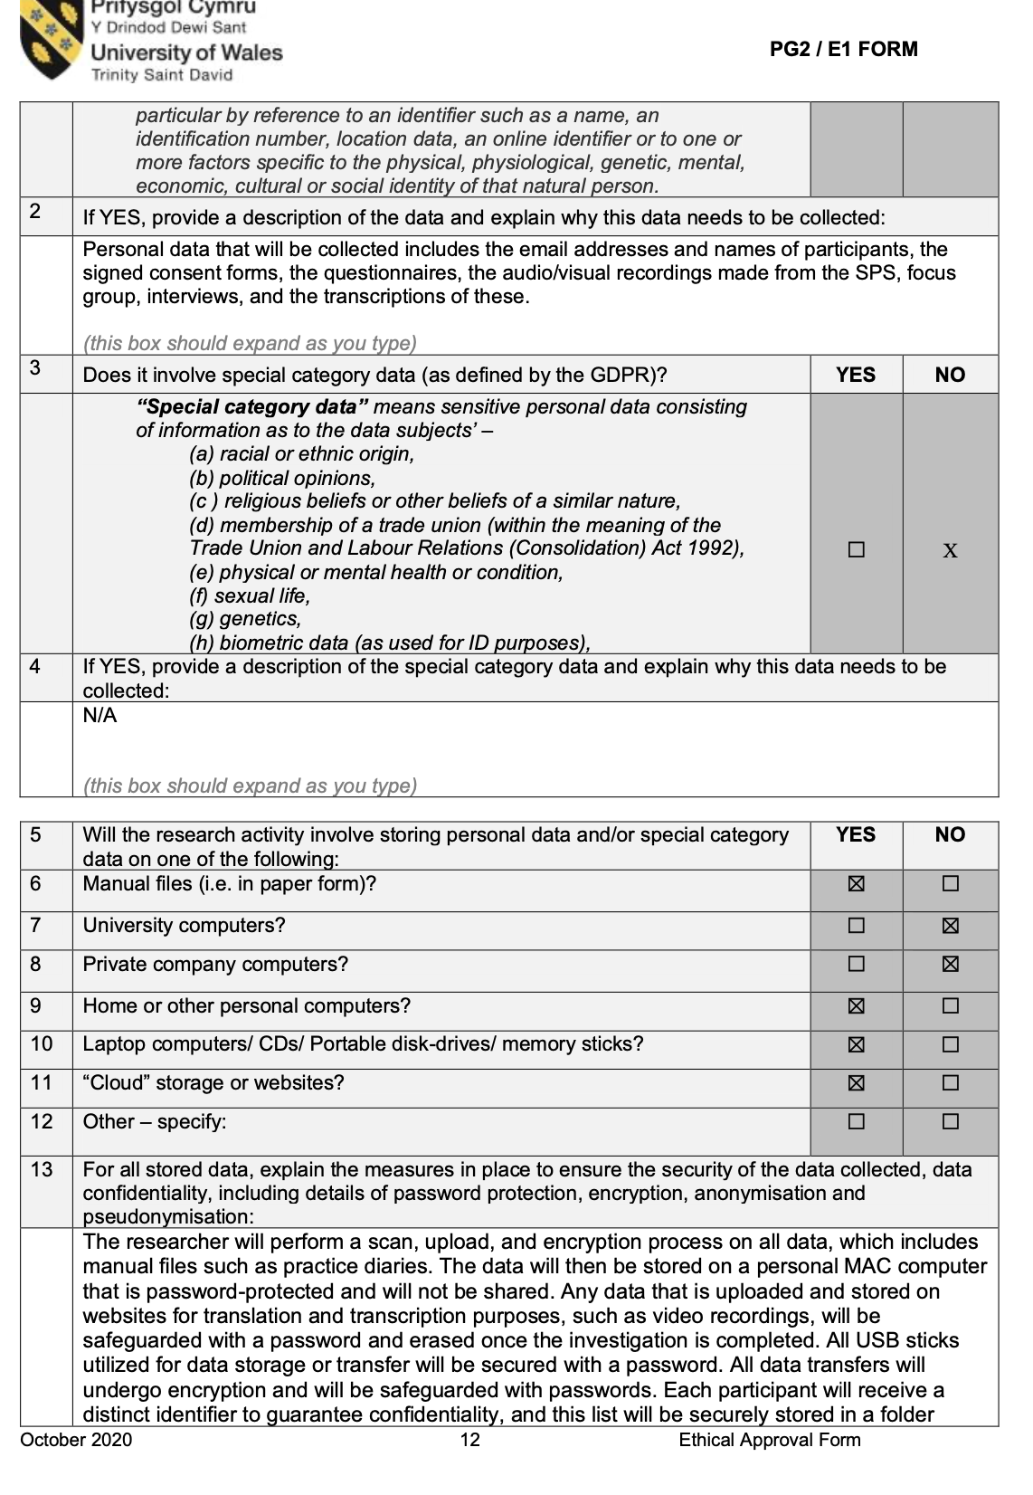 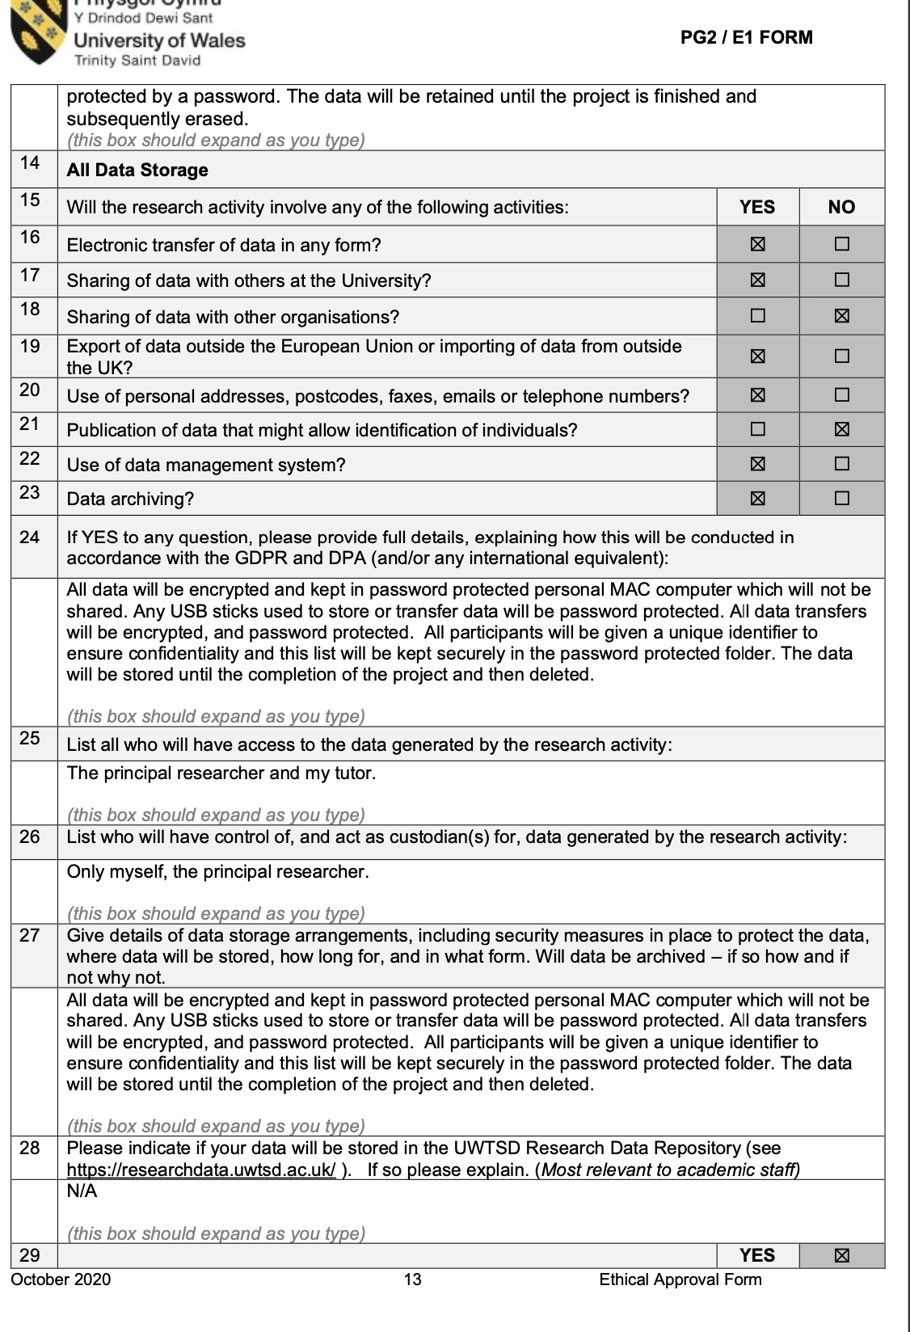 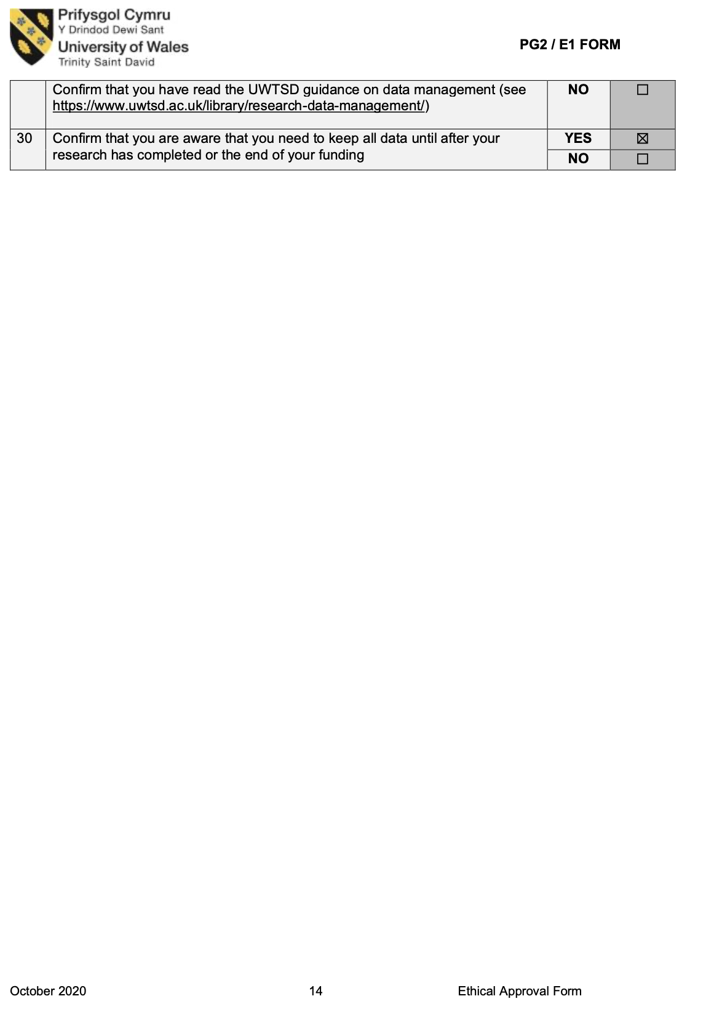 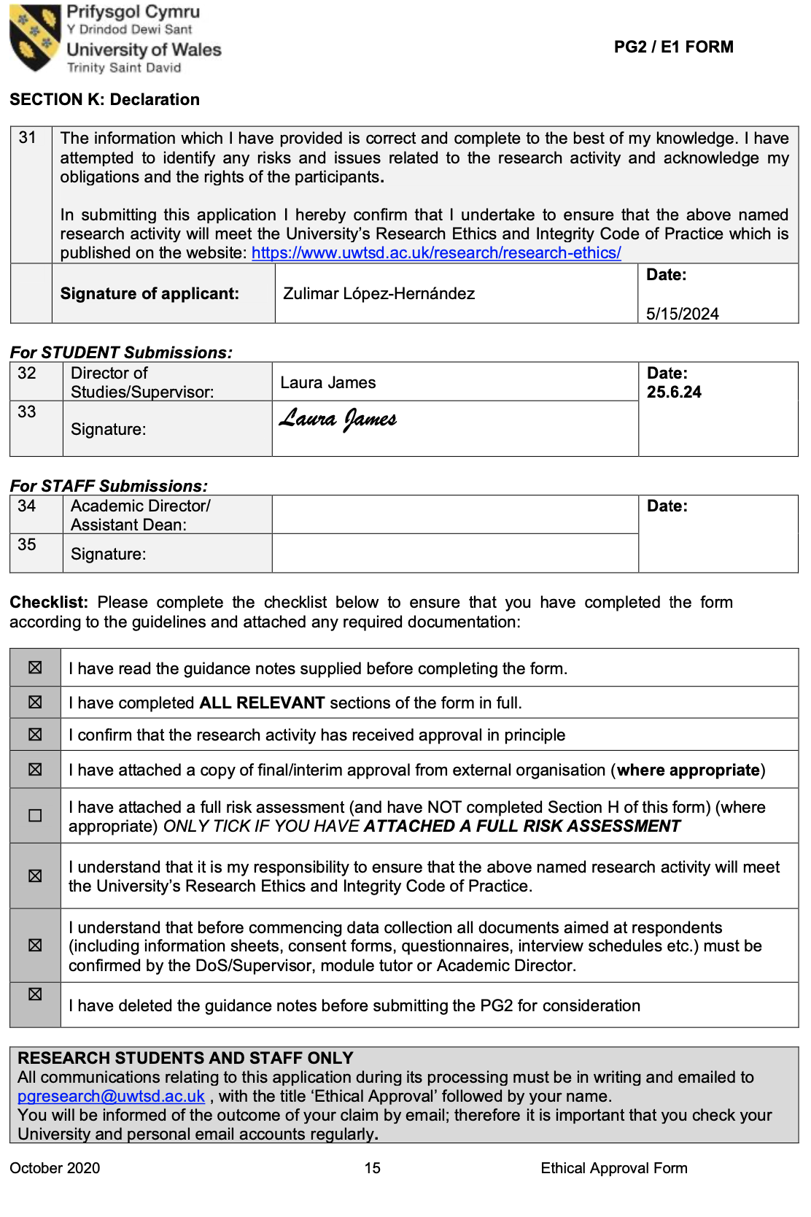 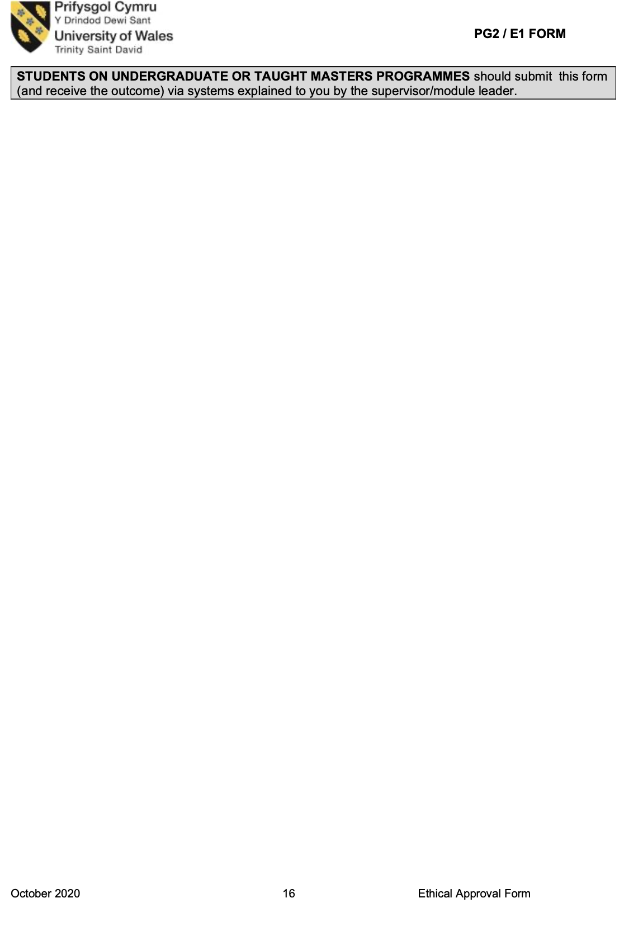Appendix XIII: Thematic Coding

The thematic coding of the Findings section was conducted through an Interpretative Phenomenological Analysis (IPA) framework, identifying emergent themes across the three VPBS teams. The analysis followed an iterative, multi-stage process involving verbatim transcription, initial coding, thematic clustering, and cross-case analysis (Smith, Flowers, & Larkin, 2009; Crawford, 2019). These themes were further refined into specific subthemes, including peer scaffolding, reflective adaptation, feedback processing, and artistic independence, as detailed below:

Primary Themes and Subthemes
- Building Trust and Challenging Boundaries
  - Overcoming initial hesitations and fear of judgment
  - Expanding vocal and technical boundaries through peer encouragement
  - Developing confidence through shared risk-taking
- Navigating Emotional Responses
  - Performance anxiety in supervised settings
  - The role of vulnerability in vocal and reflective growth
  - Teacher/researcher as a learning partner in reducing hierarchical barriers
- Motivation and Peer Encouragement
  - External accountability sustaining engagement
  - Peer scaffolding as a strategy for resilience
  - Self-determined motivation emerging through structured peer collaboration
- Creative Adaptation in Challenging Situations
  - Adjusting practice strategies in response to technical difficulties
  - Flexibility in applying structured reflection tools
  - Balancing structure and spontaneity in practice
- Technical and Artistic Development Through Feedback
  - Immediate vs. delayed feedback in peer learning
  - The impact of structured reflection on refining technique
  - Collaborative exploration of artistic expression
- Reflection and Meaning-Making with the PARE/PASE Framework
  - Cognitive and physical awareness in self-regulated practice
  - The framework as a metacognitive tool for refining strategies
  - Linking immediate reflection to broader artistic and technical goals
- Reconciling Cognitive Dissonance in Learning
  - Tensions between external validation and self-guided artistry
  - Reframing mistakes as learning tools
  - Developing artistic independence through reflective adaptation

Cross-Case Analysis and Thematic Clustering
The coding process also identified converging and diverging patterns across the three VPBS teams:
- All teams demonstrated the role of peer collaboration in fostering motivation and structured reflection in refining technique.
- Chloe and Jade emphasized overcoming perfectionism and performance anxiety, showcasing the impact of peer trust and risk-taking.
- Jay and Paige highlighted the interplay between structured practice and adaptability, reinforcing how peer collaboration enhances motivation and problem-solving.
- Sara and Ryan focused on artistic autonomy and interpretative independence, illustrating how peer engagement fosters expressive growth.
The findings underscore the interdependence of technical, cognitive, and emotional learning dimensions, affirming VPBS and the PARE/PASE framework’s role in structuring and sustaining self-regulated learning (McPherson & Renwick, 2001; Nielsen et al., 2018; Hanken, 2016).

VPBS Teams Summary of Themes
Chloe and Jade's VPBS Sessions

Collaboration, emotional responses, identity in learning, cognitive dissonance, coping with anxiety, and self-regulation strategies.
- Collaboration and Peer Support:
Chloe and Jade established a balanced partnership characterized by fairness, mutual accountability, and emotional support. Their shared feedback and encouragement fostered a safe and motivating learning environment, allowing them to engage in playful challenges and constructive critique.
- Emotional Responses and Performance Anxiety:
The presence of the teacher/researcher (T/R) initially heightened their performance anxiety, causing discomfort in making mistakes. However, when the T/R modeled vulnerability and later transitioned to a non-observational role, Chloe and Jade became more relaxed and authentic in their practice.
- Motivation and Peer Encouragement:
Peer support acted as a catalyst for motivation. Challenges and encouragement between Chloe and Jade helped them push beyond their comfort zones, boosting self-confidence and fostering a growth mindset.
- Identity in Learning and Cognitive Dissonance:
Both students grappled with cognitive dissonance between performing for approval and expressing authentic artistry. Reflecting on these tensions helped them navigate their learning identities and adopt strategies that aligned with their vocal goals.
- Reflection and Meaning-Making through PARE/PASE Framework:
The use of PARE/PASE templates enabled them to critically reflect on their practice. Chloe’s strategic color-coding and their collaborative reflections deepened their self-awareness, supporting adaptive learning strategies and deliberate practice.
Chloe and Jade’s evolving partnership, marked by emotional support, peer motivation, and reflective practice, created a safe space for growth and exploration. Their journey highlights the importance of fostering collaborative and supportive environments in vocal learning.
Jay’s VPBS Sessions
Jay and Paige are two voice students in the same year if voice studies who are preparing for an upcoming recital. This analysis revealed several key themes that shaped their learning experience and personal growth throughout the sessions.
1. Navigating Differences in Practice Styles
Jay’s structured and organized practice style contrasted with Paige’s more flexible and spontaneous approach. This dynamic encouraged both to adapt and learn from each other, fostering a balance between structure and creativity in their practice routines.
2. Mutual Support and Constructive Feedback
Jay and Paige developed a supportive partnership by providing each other with constructive feedback. Their reflective questioning (e.g., "What did you do differently?" and "How did it feel?") facilitated self-awareness and deeper learning. Jay’s encouragement helped Paige overcome her insecurities, while Paige’s observations helped Jay address technical issues.
3. Resilience Through Emotional Support
Emotional support was a cornerstone of their collaborative work. Jay's sensitive response to Paige's vocal vulnerabilities, particularly regarding her premenstrual vocal symptoms, highlighted the importance of empathy. Paige, in turn, recognized Jay’s nervousness and offered encouragement, creating a psychologically safe environment for growth.
4. Reflective Practice with the PARE/PASE Framework
The integration of the PARE/PASE framework, both through written documentation and reflective questioning, promoted mindful practice. Initially, Paige was hesitant to use the template, but observing Jay’s consistent use encouraged her to engage with it, enhancing their self-assessment and goal-setting processes. Paige “ I like taking the time to reflect at the end”.
5. Motivation Through Collaborative Effort
Motivation was a recurring theme as both participants challenged and supported each other. Jay motivated Paige to confront difficult exercises like the raspberries, and Paige reciprocated by pushing Jay to focus on breath management and interpretation. Their shared motivation fostered persistence and resilience.
6. Development of Teaching and Learning Strategies
Paige’s budding role as a voice teacher was enhanced by observing and assisting Jay with vocal challenges typical of tenors. Similarly, Jay gained insights into supporting female singers, recognizing the need for sensitivity to vocal health issues related to hormonal changes. This exchange enriched their pedagogical strategies.
The VPBS sessions between Jay and Paige illustrated how collaborative practice can nurture personal and professional growth. Their journey through mutual support, reflective practice, and emotional resilience demonstrates the transformative power of peer learning. This analysis underscores the significance of empathy, communication, and adaptability in fostering a productive and motivating learning environment.

Ryan and Sara
The reflective observations from Sara and Ryan’s Vocal Practice Buddy System (VPBS) sessions provide a detailed account of their collaborative practice, with themes emerging around emotional support, vulnerability, strategies for learning music, practice habits, and motivation. This analysis delves into their experiences, emphasizing their interactions, learning dynamics, and the ways in which their differences complement and challenge each other.

1: Emotional Support and Vulnerability
A recurring theme in Sara and Ryan’s sessions is the role of emotional support in navigating vulnerability. Both participants encounter moments of self-doubt and frustration, which are mitigated by their ability to support and validate each other. Sara, for instance, experiences apprehension around singing high notes and agility exercises, expressing concerns about cracking or instability. These moments of vulnerability reveal Sara’s tendency to overthink and focus on potential failures, which sometimes undermines her confidence.
Ryan provides emotional support by sharing his own strategies and encouraging Sara to trust her body’s intrinsic feedback. During one session, he suggests she focus on forward-moving imagery, likening singing to a car in motion, rather than getting caught up in the mechanics. This metaphor resonates with Sara, helping her shift from a critical mindset to a more embodied approach. His lighthearted encouragement, such as calling her “Supergirl” or reminding her to “sing like a diva,” brings levity to the sessions and helps Sara build confidence.
Conversely, Ryan also faces moments of doubt, particularly when his preparation or execution feels insufficient. His admission of feeling “off” or perceiving his singing as “horrible” underscores his vulnerability. Sara, drawing from her own experiences, reassures him by highlighting his strengths and acknowledging the challenges of the practice context. Their mutual vulnerability fosters a safe space where both participants feel comfortable exploring their limitations and taking risks.

2: Strategies for Learning Music
Sara and Ryan’s contrasting approaches to learning music reveal their distinct personalities and strengths. Sara’s structured and methodical approach, characterized by her reliance on the PARE/PASE template, is instrumental in keeping Ryan on track. Her ability to sight-read and subdivide rhythms offers Ryan practical strategies for overcoming his tendency to rush through challenging passages. For example, during their repertoire work, she introduces a metronome and suggests writing beats in each bar to help Ryan navigate complex rhythms. These strategies highlight Sara’s role as a mentor-like figure, guiding Ryan toward more disciplined practice habits.
Ryan, on the other hand, brings a spontaneous and intuitive energy to their sessions. His approach to learning music is less structured, often driven by experimentation and a reliance on intrinsic feedback. This is evident when he describes his process of “trusting the progress and work” his body has internalized. While this approach allows him to remain present and responsive, it occasionally leads to gaps in preparation, as noted during his choral repertoire work.
Their collaborative dynamic enables them to learn from each other’s strengths. Sara adopts some of Ryan’s intuitive methods, such as focusing on actions rather than overthinking, while Ryan benefits from Sara’s structured strategies, which help him address his tendency to rush. This mutual exchange enriches their learning experiences and enhances their ability to tackle musical challenges.

3: Practice Habits and Motivation
The VPBS sessions reveal insights into Sara and Ryan’s practice habits and their sources of motivation. Sara’s practice is characterized by a strong reliance on external tools, such as the PARE/PASE template, and a focus on meeting specific goals. Her detailed reflections, including drawing arrows between columns and using capitalization to emphasize key points, demonstrate her commitment to deliberate practice. This structured approach is closely tied to her motivation to improve and her aspirations to become a teacher.
Ryan, by contrast, approaches practice with a sense of play and exploration. He admits that working slowly and methodically is a new and sometimes “boring” strategy for him, but he acknowledges its effectiveness in producing results. His preference for collaborative practice, rather than working alone, highlights the motivational role of social interaction in his learning process. This is evident in his willingness to engage in reflective discussions and adapt Sara’s suggestions, even when they challenge his usual habits.
The dynamic between Sara and Ryan reflects the benefits of their complementary practice habits. While Sara’s structure helps Ryan stay focused and disciplined, Ryan’s spontaneity encourages Sara to take risks and embrace the unpredictable aspects of learning. Their shared motivation to support each other and achieve their goals fosters a sense of accountability and mutual growth.

4: Navigating Cognitive Dissonance
A key challenge for both Sara and Ryan is navigating the cognitive dissonance that arises from conflicting internal feedback and external evaluations. For Sara, this manifests as a disconnect between her perception of her singing and the feedback she receives from Ryan or the T/R. She often expresses concerns about sounding “bad” or “horrible,” even when her singing is praised. This dissonance reflects her tendency to focus on negative narratives, which can hinder her ability to trust her progress.
Ryan, on the other hand, experiences dissonance when his intuitive approach conflicts with the structured demands of choral repertoire. His preference for relying on intrinsic feedback sometimes leads to gaps in preparation, which become evident in ensemble contexts. This dissonance highlights the need for a balanced approach that integrates both intuition and structure.
The reflective process facilitated by the PARE/PASE template plays a crucial role in addressing this dissonance. By encouraging Sara and Ryan to articulate their thoughts, actions, and sensations, the template helps them reconcile their internal experiences with external feedback. This process not only enhances their self-awareness but also fosters a greater sense of ownership over their learning.

5: Building Trust and Collaboration
The trust and collaboration between Sara and Ryan are central to the success of their VPBS sessions. Their shared history of working together, including previous recitals and module investigations, provides a strong foundation for their partnership. This trust is evident in their willingness to share vulnerabilities, give and receive feedback, and experiment with new strategies.
Their complementary strengths further enhance their collaboration. Sara’s ability to slow Ryan down and introduce structured strategies balances his tendency to rush, while Ryan’s encouragement and intuitive insights help Sara embrace risk-taking and spontaneity. This dynamic creates a sense of mutual respect and accountability, which motivates both participants to engage fully in the practice process.
The playful and supportive atmosphere of their sessions also contributes to their collaborative success. Moments of humor, such as Ryan calling Sara “Supergirl” or encouraging her to “sing like a diva,” lighten the emotional intensity of the practice, making it easier for both participants to navigate challenges. This balance of seriousness and play fosters a positive and productive learning environment.

Thematic Analysis of Focus Group Discussion on Deliberate Practice and the Buddy System
The focus group session explored the concept of deliberate practice among vocalists, focusing on the integration of the Vocal Practice Buddy System (VPBS) and reflective tools like the PARE/PASE framework. Participants engaged in collaborative activities, such as a whiteboard mind map, to articulate their definitions and experiences with deliberate practice. This analysis examines emergent themes, personal insights, and collective reflections to understand the impact of structured and collaborative practice methods.

Themes
1. Defining Deliberate Practice: A Shared Understanding
- Core Attributes: Participants consistently identified deliberate practice as involving intention, organization, clear goals, and conscious effort. These elements were visualized during the session using a whiteboard mind map, highlighting their shared understanding.
- Warm-ups vs. Practice: A significant debate emerged regarding whether vocal warm-ups constituted deliberate practice. While some viewed warm-ups as preparatory, others argued they could be deliberate when executed with intention and awareness.
T/R Reflection: Deliberate practice requires mindfulness and intentionality, with participants acknowledging the distinction between merely performing tasks and engaging with purpose.
2. Challenges in Practice: Stagnation vs. Growth
- Navigating Obstacles: Participants discussed the potential for practice to perpetuate bad habits if not approached critically. They emphasized the importance of addressing challenges constructively to foster growth.
- Perfect Practice Makes Perfect: This concept resonated with participants, who acknowledged that unreflective repetition could hinder progress.
T/R Reflection: Effective practice involves recognizing and overcoming difficulties, emphasizing the need for reflective and adaptive approaches.
3. The Buddy System: Collaborative Learning and Emotional Support
- Motivational Impact: Practicing with a partner enhanced enthusiasm, accountability, and the ability to provide and receive immediate feedback.
- Emotional Dynamics: The presence of a buddy fostered a supportive environment, reducing self-criticism and encouraging constructive critique.
- Peer Insights: Participants valued the opportunity to learn from their partner’s perspectives and techniques, leveraging collaborative learning to refine their skills.
T/R Reflection: The buddy system provided both practical and emotional benefits, creating a dynamic and empathetic practice environment.
4. Reflection as a Practice Tool
- Structured Reflection: The PARE/PASE framework was integral in helping participants break down their practice into manageable steps, fostering introspection and focused improvement.
- Stop Moments: Participants highlighted the importance of pausing to recalibrate and reflect, preventing unproductive repetition and reinforcing intentionality.
T/R Reflection: Reflection enabled participants to identify and address weaknesses, enhancing the effectiveness of their practice sessions.
5. Solo vs. Collaborative Practice: A Comparative Analysis
- Solo Practice: Participants acknowledged the value of solo practice for fostering independence and discipline but noted its potential to lead to frustration or lack of objectivity.
- Collaborative Practice: Practicing with a buddy encouraged accountability, shared learning, and emotional engagement, making sessions more effective and enjoyable.
T/R Reflection: The complementary benefits of solo and collaborative practice highlighted the need for balance, with participants advocating for structured and intentional collaboration.

6. Emotional and Psychological Dimensions of Practice
- Vulnerability and Empathy: Participants emphasized the importance of acknowledging vulnerabilities and fostering mutual growth within the buddy system.
- Emotional Awareness: The discussions underscored the role of emotional intelligence in navigating practice challenges and supporting peers.
T/R Reflection: Emotional engagement and empathy were critical in creating a safe and productive practice space.
7. Proposed Enhancements to Practice Frameworks
- Customization of Tools: Participants suggested enhancing the PARE/PASE framework to include more flexible formats, such as checkboxes for preparation items and progress tracking.
- Recording Practices: Incorporating recordings was recommended as a means to analyze progress and refine techniques more effectively.
T/R Reflection: Practical improvements to existing frameworks could further support reflective and goal-oriented practice.
The focus group discussion illuminated the intricate benefits of deliberate practice and the VPBS in fostering technical, emotional, and collaborative growth. The integration of structured reflection through the PARE/PASE framework and the motivational dynamics of the buddy system emerged as key factors in enhancing the effectiveness of vocal practice. By balancing solo and collaborative efforts, participants demonstrated a nuanced understanding of how deliberate practice can address challenges, build resilience, and cultivate a supportive learning environment.

