Taylor Dawn Hodges
2008862@uwtsd.student.ac.uk
BSc Computing (Software Engineering)
Lecturer: M Dacey and T Bashford
DD: 20/1/22
ADVANCED SOFTWARE DEVELOPMENT (ACCB5011)
Maze Pathfinding implementation

Contents
Table of Figures 2
Abbreviations Table/Key 2
Introduction 3
Task 1 - Path Finding Algorithms 3
Dijkstra's Algorithm 3
A* Algorithm 4
Comparison 6
Task 2 – Reflection 7
Development Process 7
First Iteration 7
Second Iteration 7
Dijkstra’s/A* Algorithm 8
Features 8
Code Snippets 10
Set Node List 10
Calculate Distance 11
Dijkstra’s Algorithm 11
Set Shortest Path 12
Make Manoeuvre 13
Conclusion and Results Obtained 15
Appendix 16
Node.h 16
Node.cpp 17
GridNavigatorAutomatic.h 18
GridNavigatorAutomatic.cpp 19

Table of Figures
Table 1: Shortest path table from A to C. the highlighted rows show the shortest route. Crossed out routes are not the shortest route to that node. 3
Table 2: Shortest path table from A to J. the highlighted rows show the shortest route. 4

Figure 1: Nodes A-E and their distance [1] 3
Figure 2: Nodes A-J, their distance, and their remaining distance [3] 4

Diagram 1: All identified Nodes on this iteration of the maze. 8
Diagram 2: The determined shortest route via selected Nodes on this iteration of the maze. 8

Screenshot 1: A list of identified Nodes, as printed by the ‘PrintAvailableNodes()’ function. 7
Screenshot 2: A list of selected Nodes as the shortest path, in addition to their distance from Origin, as printed by the ‘PrintSelectedNodes()’ function. 8
Screenshot 4: Set Nodes List function, part 1 9
Screenshot 5: Set Nodes List function, part 2 9
Screenshot 6: Calculate Distance function 10
Screenshot 7:Dijkstra’s Algorithm function 10
Screenshot 8: Set Shortest Path function 11
Screenshot 9: Make Manoeuvre function part 1 12
Screenshot 10: Make Manoeuvre function part 2 13
Screenshot 3: Results from the benchmarking mode. 14

Abbreviations Table/Key
G cost | Distance from the starting node
H cost | Heuristic distance from the end node
F cost | G cost + H cost
Node | A point in a diagram with pathways.  e.g starting point A/the Origin.

Introduction
Shortest pathfinding algorithms come in many shapes and forms. In this report, the concept of Dijkstra’s algorithm and A* algorithm will be explored and explained with examples, then implemented in C++ into a random maze generator program.

Task 1 - Path Finding Algorithms
Pathfinding algorithms are used to find the shortest and quickest route from start to end.
All algorithms know:
- Where they started, and where the end is
- Where they are
- Where they’ve been
- Where they could go next
The only difference is if the algorithm knows how to look for a practical next step. Different algorithms have different methods of this:
- uninformed search algorithms – the algorithm doesn’t have any more information to suggest where to go next [1]. A good example of this is a near-sighted person attempting to navigate an unfamiliar location, they can only access information right in front of them.
- informed search algorithms – has information to help direct towards the goal, this score may not be exact, just an approximation to indicate the correct direction.

Dijkstra's Algorithm
Dijkstra's Algorithm is an uninformed pathfinding algorithm, it works by sorting through the shortest paths to find the best path from A to B. Each route between nodes holds a value, this is the distance as is used to calculate a node’s G cost:
$$G cost = distance from the starting node$$
Equation 1: G cost calculation.
Dijkstra's Algorithm works as:
- From the starting point, note the G cost of the adjacent nodes.
- Order the priority queue by the shortest G cost, then explore the new options from the next node, without re-visiting paths. Update any new shortest G cost routes and repeat step 2 until the endpoint has reached the top of the priority queue. All nodes need to be explored to fully consider all options.
- Finally backtrack to find the shortest route.
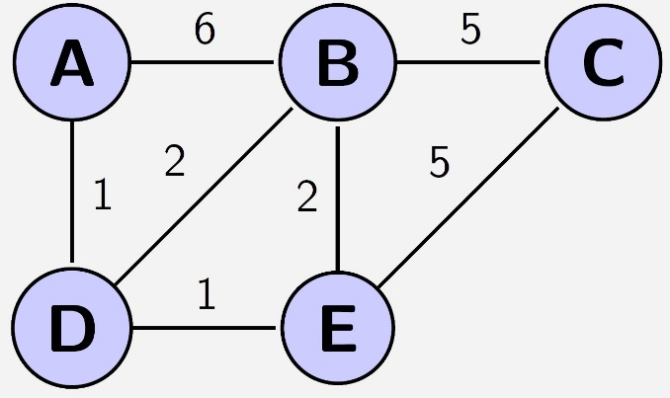
Figure 1: Nodes A-E and their distance [1]

Step | Node | G cost | Previous Node
 | A | 0
1 | D | 1 | A
1 | B | 6 | A
2 | E | 2 | D
2 | B | 3 | D
3 | C | 8 | B
3 | E | 5 | B
4 | C | 7 | E
Table 1: Shortest path table from A to C. the highlighted rows show the shortest route. Crossed out routes are not the shortest route to that node.
The shortest route from A to C is $7 = [A, D,E,C]$.
The main drawback of Dijkstra's Algorithm is the lack of direction; it prioritises the shortest route which could be in the wrong direction before the desired direction is the shortest path. A* algorithm was designed to tackle this issue.

A* Algorithm
A* Algorithm is an extension of Dijkstra's Algorithm; this informed search algorithm holds an additional heuristic, H cost, how far the nodes are away from the endpoint ‘as the crow flies, or Euclidean distance [2].
$$H cost (heuristic)= distance form the end node$$
Equation 2: H cost calculation.
With the use of H cost, the algorithm can calculate how far it has travelled in combination with approximately how far it has left, called combined distance, F cost:$$F cost =G cost +H cost$$
Equation 3: F cost calculation.
F cost is used to sort priority queue lowest to highest, therefore, this helps to locate the shortest route in the target direction as they are weighted less by remaining distance and prioritised. If two nodes have the same F cost, they are next prioritised by H cost.
A* Algorithm works as:
- From the starting point, note the G, H and F costs of the adjacent nodes.
- Ordering the priority queue by the shortest F cost, then H cost, explore the new options from the next node, without re-visiting paths. Repeat step 2 until the endpoint has been reached. Not all nodes need to be explored.
- Finally backtrack to find the shortest route.

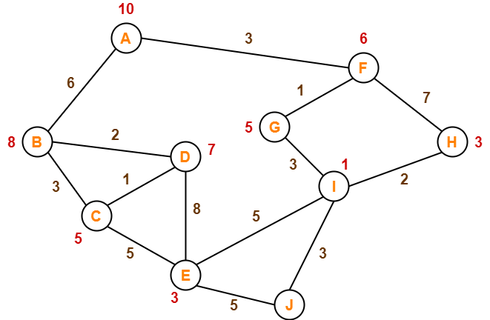
Figure 2: Nodes A-J, their distance, and their remaining distance [3]
Step | Node | G cost | H cost | F cost | Previous Node
 | A | 0 | 10 | 10
1 | F | 3 | 6 | 9 | A
1 | B | 6 | 8 | 14 | A
2 | G | 4 | 5 | 9 | F
2 | H | 10 | 3 | 13 | F
3 | I | 7 | 1 | 8 | G
4 | J | 10 |  | 10 | I
Table 2: Shortest path table from A to J. the highlighted rows show the shortest route.
The shortest route from A to J is $10 = [A, F,G,I,J]$.

Comparison
A* algorithm is more efficient and faster than Dijkstra’s algorithm as it does not have to check every node including those in the wrong direction. Furthermore, it is less loadbearing on the memory as it does not have to store data on all nodes, only on nodes that are possibly required to reach the end node.
A* does not just consider the shortest path, but also the most direct path. As seen in the examples, Dijkstra’s algorithm is not taking what could be considered as a quick detour but explores further away than necessary.
While Heuristics are only an estimate, they are enough indication to prevent the A* algorithm from exploring away from the goal. The weighting of the cost by using distance from the heuristics goal is an ingenious way for the algorithm to prioritise exploring in the direction of the goal. Therefore, A* is ‘pruning’ nodes that aren’t relevant to the shortest route from start to end, which Dijkstra’s algorithm would still explore.
In conclusion, the A* algorithm has been developed out of the weaknesses of Dijkstra’s algorithm, and doing so has created a more efficient and effective method to find the shortest path.

Task 2 – Reflection

Development Process

First Iteration
During the development of this code, the first basic algorithm idea depicted a loop:
- transverse through the maze up until next to a wall
- move right until the player can go up again
  - if the player cannot go right anymore, go left instead.
- Repeat steps 1-2 until the player has found the target.
Unfortunately, this technique would mean the player searches left/right more than necessary, therefore this was not an effective shortest path algorithm.
The next iteration would consider the entire grid before moving.

Second Iteration
On second evaluation, the program would:
- get the grid
- search each row starting at the top,
  - identify all ‘Nodes’
  - pick the closet Node to the previous node
- repeat step 2 until the entire grid has been searched
- mauver the grid through the Nodes identified
While this edition contained a ‘Node’ class with attributes on ‘X’, ‘Y’, and ‘previous node’, it did not hold information on distance from origin or distance to the target.
The biggest flaw in this algorithm is it would not consider that the closest node may be longer than an alternative node, therefore this was not an effective shortest path algorithm.
The next iteration would consider all Nodes before selecting any.

Dijkstra’s/A* Algorithm
After some careful planning, the Node class was expanded to hold attributes on ID and ‘Distance from origin’, as well as new attributes in the ‘Grid navigator automatic’ class to hold vectors for ‘Node list’ and ‘shortest path.’ This latest iteration of the program briefly does the following:
- Get grid and assign it to a 2D array
- Identify all necessary nodes (touching walls on left or right, and only where the player can move horizontally on the next row [See more below])
  - Enter these Nodes into the ‘Node list’ vector
- Assess all nodes in Dijkstra’s Algorithm:
  - Calculate distance between node A and node B
  - update each node with the shortest distance from the origin and previous node
  - repeat steps 3a-b to calculate the distance between node A and each Node with the same Y coordinate as Node B. During this assessment, paths cannot include two Nodes on the same row.
- repeat step 3 for all nodes.
- Select the shortest path by travelling in reversed order from target to player using each Node’s ‘previous Node’ attribute, like a single linked list.
  - Add each of these nodes into the ‘shortest path’ vector
- Manoeuvre through the maze using Nodes on the ‘shortest path’ vector

Features
All identified Nodes are touching a wall on the left or right, this is so the player moves around ‘hugging the wall.’
All nodes are also positioned where the player can move horizontally after moving up one, this is to create some consistency in moving. When the player moves, they always move up one first, before moving left/right to line up with the next node before moving up again to meet it [See Screenshot 1 and Diagram 1].
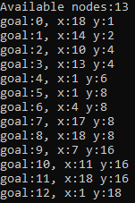
Screenshot 1: A list of identified Nodes, as printed by the ‘PrintAvailableNodes()’ function.
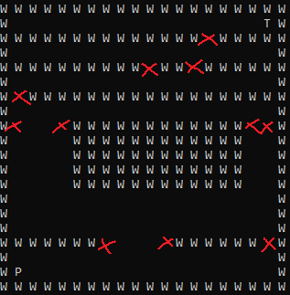
Diagram 1: All identified Nodes on this iteration of the maze.
As the program does not assess distances between any nodes on the same row, and always travels up towards the target, it may be argued that the Y coordinate is used as ‘distance from the target’, therefore the program can also be considered as an A* algorithm.
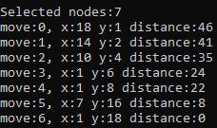
Screenshot 2: A list of selected Nodes as the shortest path, in addition to their distance from Origin, as printed by the ‘PrintSelectedNodes()’ function.
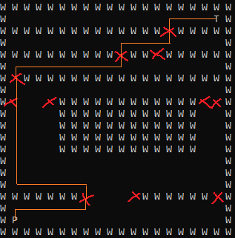
Diagram 2: The determined shortest route via selected Nodes on this iteration of the maze.

Code Snippets

Set Node List
The following code checks through the 2D grid array (already assigned with Get Grid Array function) and searches through it for the target, the player, and Nodes under certain conditions:
- Nodes must be touching a wall on the left or right.
- Nodes must not be directly above or below another node. This is done by using the Matches previous row function to not check any rows that are the same as the last.
All results are stored in the node list vector for later with a count integer as their unique ID.
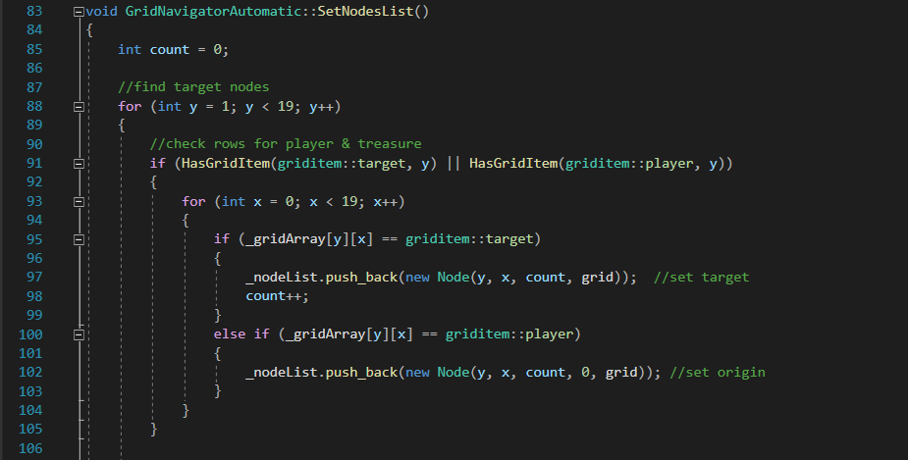
Screenshot 4: Set Nodes List function, part 1
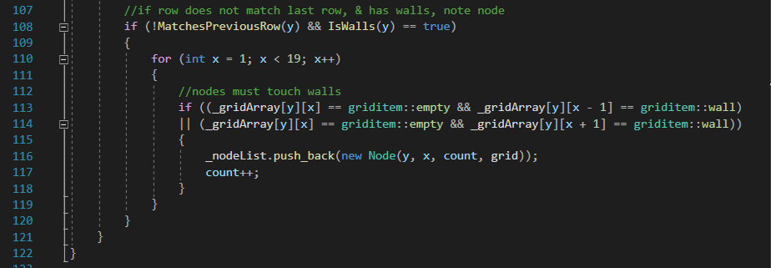
Screenshot 5: Set Nodes List function, part 2

Calculate Distance
The following function calculates the distance between two nodes and returns the running total for distance. The results are squared and rooted to obtain a positive integer before x and y are added, this calculation is then added to the first node’s distance.
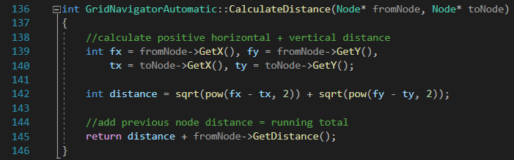
Screenshot 6: Calculate Distance function

Dijkstra’s Algorithm
The following function sets the distance and previous node attributes for all found nodes. It does this by scanning through nodes from origin to destination, whilst the ‘nested for loop’ scans from the current node to destination, searching for each node with the Y coordinate after the current node Y coordinate. These nodes have their distance from the origin calculated, if this is lower than their current distance (constructor set to 1000 as a placeholder), then the distance and previous node are updated.
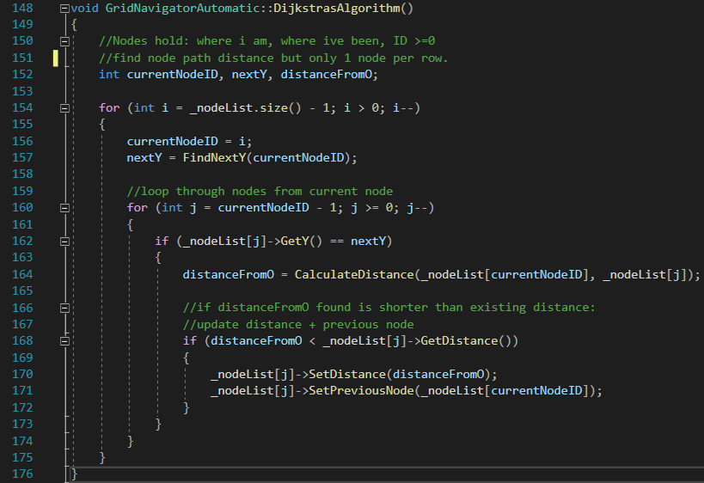
Screenshot 7:Dijkstra’s Algorithm function

Set Shortest Path
The following code tracks backwards through the nodes from destination to origin using the previous node attribute to identify the previous node in the path. Each found node is added to the shortest path vector.
The nodes list is then cleared as it will not be used again.
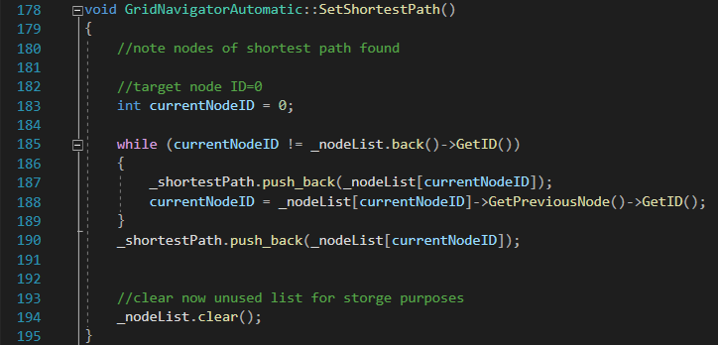
Screenshot 8: Set Shortest Path function

Make Manoeuvre
The following function moved the player through the shortest path from origin to destination. It starts by saving the players location to variables, then removing the start location from the shortest path vector.
While the grid has not been completed, firstly, the next target node coordinates are set to variables. Then the player starts by moving up (as we know there is a wall either left and/or right of the node) then left or right till the player X matches the target X, finally, up until the player Y matches the target Y.
If this has been successful, the player will be at the target node, and therefore this target is removed from the vector.
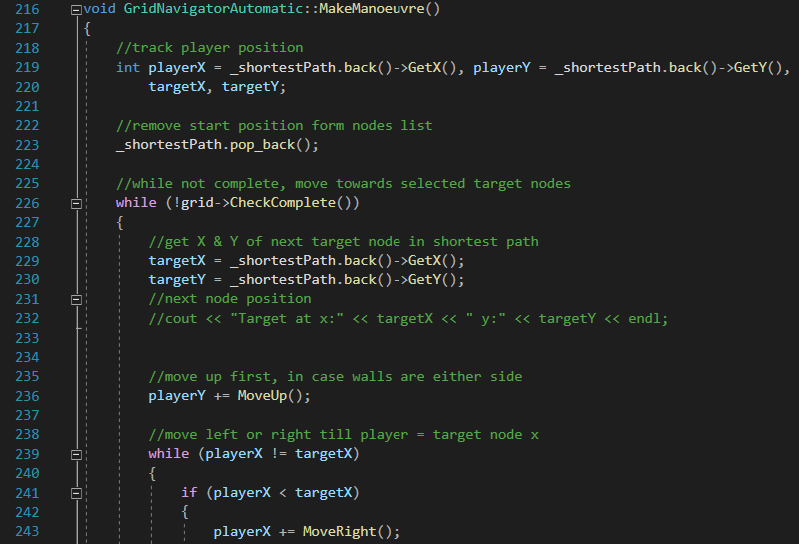
Screenshot 9: Make Manoeuvre function part 1
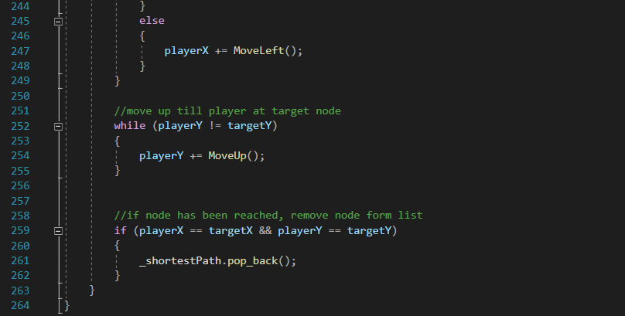
Screenshot 10: Make Manoeuvre function part 2

Conclusion and Results Obtained
The following screenshot shows the results of the benchmarking mode.
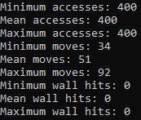
Screenshot 3: Results from the benchmarking mode.
You can see as standard, the grid is imported once, accumulating 400 access points. Zero walls are hit in any run of the program, this is due to good design. On average, the maze is completed in 51 moves, with a minimum of 34, and a maximum of 92 due to different iterations of the randomly generated maze.
This would be considered as a good result as the program takes the maze data, makes a local copy, and considers all the facts on the board before choosing a route to the target.
The code also considers the maze to be mostly vertical, requiring moving left to right to continue up, therefore it can be justified as an A* algorithm as the Node’s Y coordinate indicates how far away it is from the destination, ergo the program always considers a closer node next.
Overall, this code is far better at finding the shortest path than either of the earlier iterations. The use of the Dijkstra’s/A* algorithm picks an efficient route before the player starts moving, resulting in a far shorter route.

Appendix

Node.h
#pragma once
#include "Grid.h"
#include "GridNavigator.h"

class Node
{
private:
int _shortestDistanceFromO, _x, _y, _ID;
Node* _previousNode;

public:
Node(int x, int y, int ID, Grid* grid);
Node(int x, int y, int ID, int shortestDistanceFromO, Grid* grid);

int GetX();
int GetY();
int GetID();
int GetDistance(); //O = Origin
Node* GetPreviousNode();

void SetPreviousNode(Node* previousNode);
void SetDistance(int distance);
};

Node.cpp
#include "Node.h"
#include <math.h>

Node::Node(int y, int x, int ID, Grid* grid)
{
_x = x;
_y = y;
_ID = ID;
_shortestDistanceFromO = 1000; //to check it is unassigned
}

Node::Node(int y, int x, int ID, int shortestDistanceFromO, Grid* grid)
{
_x = x;
_y = y;
_ID = ID;
_shortestDistanceFromO = shortestDistanceFromO;
}

int Node::GetX()
{
return _x;
}

int Node::GetY()
{
return _y;
}

int Node::GetID()
{
return _ID;
}

int Node::GetDistance()
{
return _shortestDistanceFromO;
}

Node* Node::GetPreviousNode()
{
return _previousNode;
}

void Node::SetPreviousNode(Node* previousNode)
{
_previousNode = previousNode;
}

void Node::SetDistance(int distance)
{
_shortestDistanceFromO = distance;
}

GridNavigatorAutomatic.h
#pragma once
#include "GridNavigator.h"
#include "Node.h"
class GridNavigatorAutomatic : public GridNavigator
{
private:
vector<Node*> _nodeList, _shortestPath;
griditem _gridArray[20][20];

public:
GridNavigatorAutomatic();

void GetGridArray();

void PrintAvailableNodes();
void PrintSelectedNodes();

bool IsWalls(int y);
bool MatchesPreviousRow(int y);
bool HasGridItem(griditem item, int y);

void SetNodesList();
int FindNextY(int currentNodeID);
int CalculateDistance(Node* fromNode, Node* toNode);

void DijkstrasAlgorithm();
void SetShortestPath();

int MoveUp();
int MoveLeft();
int MoveRight();
void MakeManoeuvre();

void Navigate();
};

GridNavigatorAutomatic.cpp
#include "GridNavigatorAutomatic.h"
#include "Node.h"
#include <math.h>
#include <stdio.h>
#include <string>
#include <iostream>

GridNavigatorAutomatic::GridNavigatorAutomatic() : GridNavigator()
{
}

void GridNavigatorAutomatic::GetGridArray()
{
for (int y = 0; y < 20; y++)
{
for (int x = 0; x < 20; x++)
{
_gridArray[y][x] = grid->GetGridSquare(x, y);
}
}
}

void GridNavigatorAutomatic::PrintAvailableNodes()
{
int numOfNodes = _nodeList.size();
cout << endl << "Available nodes:" << numOfNodes << endl;
for (int i = 0; i < numOfNodes; i++)
{
cout << "goal:" << i << ", x:" << _nodeList[i]->GetX()
<< " y:" << _nodeList[i]->GetY() << endl;
}
}

void GridNavigatorAutomatic::PrintSelectedNodes()
{
int numOfNodes = _shortestPath.size();
cout << endl << "Selected nodes:" << numOfNodes << endl;
for (int i = 0; i < numOfNodes; i++)
{
cout << "move:" << i << ", x:" << _shortestPath[i]->GetX()
<< " y:" << _shortestPath[i]->GetY()
<< " distance:" << _shortestPath[i]->GetDistance() << endl;
}
}

bool GridNavigatorAutomatic::IsWalls(int y)
{
for (int x = 1; x < 19; x++)
{
if (_gridArray[y][x] == griditem::wall)
{
return true;
}
}
return false;
}

bool GridNavigatorAutomatic::MatchesPreviousRow(int y)
{
for (int x = 1; x < 19; x++)
{
if (_gridArray[y][x] != _gridArray[y - 1][x])
{
return false;
}
}
return true;
}

bool GridNavigatorAutomatic::HasGridItem(griditem item, int y)
{
for (int x = 1; x < 19; x++)
{
if (_gridArray[y][x] == item)
{
return true;
}
}
return false;
}

void GridNavigatorAutomatic::SetNodesList()
{
int count = 0;

//find target nodes
for (int y = 1; y < 19; y++)
{
//check rows for player & treasure
if (HasGridItem(griditem::target, y) || HasGridItem(griditem::player, y))
{
for (int x = 0; x < 19; x++)
{
if (_gridArray[y][x] == griditem::target)
{
_nodeList.push_back(new Node(y, x, count, grid)); //set target
count++;
}
else if (_gridArray[y][x] == griditem::player)
{
_nodeList.push_back(new Node(y, x, count, 0, grid)); //set origin
}
}
}

//if row does not match last row, & has walls, note node
if (!MatchesPreviousRow(y) && IsWalls(y) == true)
{
for (int x = 1; x < 19; x++)
{
//nodes must touch walls
if ((_gridArray[y][x] == griditem::empty && _gridArray[y][x - 1] == griditem::wall)
|| (_gridArray[y][x] == griditem::empty && _gridArray[y][x + 1] == griditem::wall))
{
_nodeList.push_back(new Node(y, x, count, grid));
count++;
}
}
}
}
}

int GridNavigatorAutomatic::FindNextY(int currentNodeID)
{
//loop until next Y is found
while (_nodeList[currentNodeID]->GetY() == _nodeList[currentNodeID - 1]->GetY())
{
currentNodeID++;
}
return _nodeList[currentNodeID - 1]->GetY();
}

int GridNavigatorAutomatic::CalculateDistance(Node* fromNode, Node* toNode)
{
//calculate positive horizontal + vertical distance
int fx = fromNode->GetX(), fy = fromNode->GetY(),
tx = toNode->GetX(), ty = toNode->GetY();

int distance = sqrt(pow(fx - tx, 2)) + sqrt(pow(fy - ty, 2));

//add previous node distance = running total
return distance + fromNode->GetDistance();
}

void GridNavigatorAutomatic::DijkstrasAlgorithm()
{
//Nodes hold: where i am, where ive been, ID >=0
//find node path distance but only 1 node per row.
int currentNodeID, nextY, distanceFromO;

for (int i = _nodeList.size() - 1; i > 0; i--)
{
currentNodeID = i;
nextY = FindNextY(currentNodeID);

//loop through nodes from current node
for (int j = currentNodeID - 1; j >= 0; j--)
{
if (_nodeList[j]->GetY() == nextY)
{
distanceFromO = CalculateDistance(_nodeList[currentNodeID], _nodeList[j]);

//if distanceFromO found is shorter than existing distance:
//update distance + previous node
if (distanceFromO < _nodeList[j]->GetDistance())
{
_nodeList[j]->SetDistance(distanceFromO);
_nodeList[j]->SetPreviousNode(_nodeList[currentNodeID]);
}
}
}
}
}

void GridNavigatorAutomatic::SetShortestPath()
{
//note nodes of shortest path found

//target node ID=0
int currentNodeID = 0;

while (currentNodeID != _nodeList.back()->GetID())
{
_shortestPath.push_back(_nodeList[currentNodeID]);
currentNodeID = _nodeList[currentNodeID]->GetPreviousNode()->GetID();
}
_shortestPath.push_back(_nodeList[currentNodeID]);

//clear now unused list for storge purposes
_nodeList.clear();
}

int GridNavigatorAutomatic::MoveUp()
{
grid->MovePlayer(movedirection::up);
return -1;
}

int GridNavigatorAutomatic::MoveLeft()
{
grid->MovePlayer(movedirection::left);
return -1;
}

int GridNavigatorAutomatic::MoveRight()
{
grid->MovePlayer(movedirection::right);
return 1;
}

void GridNavigatorAutomatic::MakeManoeuvre()
{
//track player position
int playerX = _shortestPath.back()->GetX(), playerY = _shortestPath.back()->GetY(),
targetX, targetY;

//remove start position form nodes list
_shortestPath.pop_back();

//while not complete, move towards selected target nodes
while (!grid->CheckComplete())
{
//get X & Y of next target node in shortest path
targetX = _shortestPath.back()->GetX();
targetY = _shortestPath.back()->GetY();
//next node position
//cout << "Target at x:" << targetX << " y:" << targetY << endl;

//move up first, in case walls are either side
playerY += MoveUp();

//move left or right till player = target node x
while (playerX != targetX)
{
if (playerX < targetX)
{
playerX += MoveRight();
}
else
{
playerX += MoveLeft();
}
}

//move up till player at target node
while (playerY != targetY)
{
playerY += MoveUp();
}

//if node has been reached, remove node form list
if (playerX == targetX && playerY == targetY)
{
_shortestPath.pop_back();
}
}
}

void GridNavigatorAutomatic::Navigate() //does not work
{
//grid->PrintGrid(); //show grid

GetGridArray();
SetNodesList(); //list of all nodes
//PrintAvailableNodes();

DijkstrasAlgorithm();
SetShortestPath(); //find shortest path through nodes
//PrintSelectedNodes();

MakeManoeuvre(); //transverse through shortest path
}

