
MODULE CODE: ECDE7019
ASSESSMENT COMPONENT:1
STUDENT NAME: Tao PENG
STUDENT NUMBER:2411134

An International Framework for Teaching Based on UNI-SOTON’ s Successful Pre-sessional Program (PP) Experience

(Plan and justification for Literature Review)

Winchester & Salji(2016) indicate that a well-structured literature review is essential to establish the existing body of knowledge in the research field, identify research gaps, and provide a theoretical basis for subsequent research. This plan will follow the self-test checklist proposed, using predefined inclusion and exclusion criteria to ensure the rationality and comprehensiveness of literature screening.

- General research ideas of Pre-sessional Program (PP)
In this part, I would like to discuss how my literature review be based on and contributes to ongoing scholarly conversations in my area of interest:

Terms | Content Summary | Key Question(s) | Notes
1. Intro | 1.1 Introduce the background of the international teaching framework and its significance in the field of education.  1.2 Propose the significance of taking Successful Pre-Sessional Programs (PP) as a research case. | *Recommend any theory on teaching framework？  *Why we do research on (PP)?
2. Research Rationale | 2.1 Explain the purpose for choosing this topic and its academic and practical significance.  2.2 Emphasize the objectives of literature reviews, in particular to provide theoretical support and practical inspiration for improving international academic-foreign- language teaching(FLT) and learning. | *How does this study fill the gaps in the current literature?  *How does research influence international education practitioners and policy makers? | Use a table or chart to show connections and differences between topics to communicate complex content clearly.
3. Literature Scope | 3.1 Pioneering research: Theories and frameworks for FLT .  3.2 Recent research: Best Practices and Challenges for successful Pre-Sessional programs. | *Literature review of theory  *Literature review of recent case study  *Literature review of international FLT  etc. | List target journals and databases (e.g. Scopus, Google Scholar) to improve literature search efficiency.
4. Research Questions | 4.1 How can the teaching framework be improved through successful Pre-Sessional experience?  4.2 What factors are most important for the successful implementation of the framework? | How to explain RQs and refine more Sub-RQs
5.Contribution to Gaps | 5.1 Discuss how this literature review fills gaps in current research:  5.2 Provide empirical support for successful case studies.  5.3 Promote the theoretical and practical development of international teaching frameworks. | Focus on what are the academic and practical implications of this research? | Highlight the potential implications of the literature review for policy and practice to enhance the practical application value of the research.
6. Summary | To be discussed | To be discussed | Be concise and to the point, highlighting the core contributions of the review.
7.Limitation | To be discussed | To be discussed
8. References | Use the Harvard 12 format to list references |  | The list of references is regularly updated to ensure that the latest research is covered, and citations are checked for accuracy and format consistency.
Table 1: Key Search Terms and Explanation

- Theory and the Latest Practice: Within the Context of My Research

Since I became interested in the research of PP, I have tried to find some relevant theoretical research since 2024. Online search engines such as Google Scholar and ResearchGate, citation databases such as Scopus and Web of Science allow researchers to find peer-reviewed literature and track citations, which also gave me a lot of theoretical support.

2.1 Teaching for Mastery
Teaching for Mastery aims to address the limitations of teacher-centered approaches. It requires students to completely comprehend a lesson, regardless of the time and resources needed, before moving to the next level (Chargois, 2013).
Furthermore, Jones, R. and Taylor, A. (2020) indicates with the complexities of the human mind as explored by the information processing framework, this educational framework necessitates teachers to personalize the students’ learning experience, which I would recommend in teaching implementation of PP.
Search Engine | Keywords for Articles | Search Items | Time Range | Matching Method | Relevant Title
Google Scholar | Teaching for Mastery | Articles | 2014–2023 | Exact Match | Example : 'Comparison of student team dynamics between nonflipped and flipped versions of a large enrollment sophomore design engineering course' (2019)
Google Scholar | Pre-sessional framework | Articles | 2014–2023 | Fuzzy Match | Example : 'Positioning an academic literacies framework in an EAP  context: case study of a university Pre-sessional course' (2019)
CNKI | Teaching for Mastery / Chinese preparatory courses | Key Words | 2014–2023 | Fuzzy Match | Example : 'Research on the application of Teaching for Mastery in Chinese preparatory courses'(2022)
Table 2: First Search Attempt on Related Research Topic (19th April 2024)

2.2 A new theoretical discovery after a search：Bloom's Taxonomy
After constant searching, I found the following:
- Most of the available literature is after 2019. Based on the timeliness of the literature, I narrow down the search period from ten years to 2018-Now ;
- Start with the title and search method, select more suitable literature, and even try to find consistent literature from different search results, which could be paid more attention to;
- Most of the frameworks on Teaching for Mastery in literature can learn from Bloom's Taxonomy, so I added Bloom's Taxonomy （as the figures shows） to the search and study.
Search Engine | Keywords for Articles | Search Items | Time | Matching Method | Results Found and Example of Relevant Title
Google Scholar | Teaching for Mastery AND Pre-sessional | any where in the articles | 2018–now | Exact Match | Results Found:1100  Example: The Effectiveness of Pre-sessional EAP Programmes in UK Higher Education: A Review of the Evidence
Google Scholar | Taxonomy AND Pre-sessional | any where in the articles | 2018–now | Exact Match | Results Found: 570  Example: Enhancing beginner learners’ oral proficiency in a flipped Chinese foreign language classroom
Google Scholar | Pre-sessional AND Framework | any where in the articles | 2018–now | Fuzzy Match | Results Found:1560  Example: The Effectiveness of Pre-sessional EAP Programmes in UK Higher Education: A Review of the Evidence
CNKI | 南安普敦大学学术语言预科班案例分析 | Title | 2018–now | Fuzzy Match | Results Found:51  Example : 《南安普敦大学预科语言课程框架分析》. (Analyzes of language course frameworks in Pre-sessional Program at the University of Southampton)
Google Scholar | Pre-sessional Framework at the University of Southampton | any where in the articles | 2018–now | Fuzzy Match | Results Found: 81  Example (a book) : Supporting the Student Journey into Higher Education
Table 3: Recent Search Attempt on Related Research Topic (22nd January 2025)

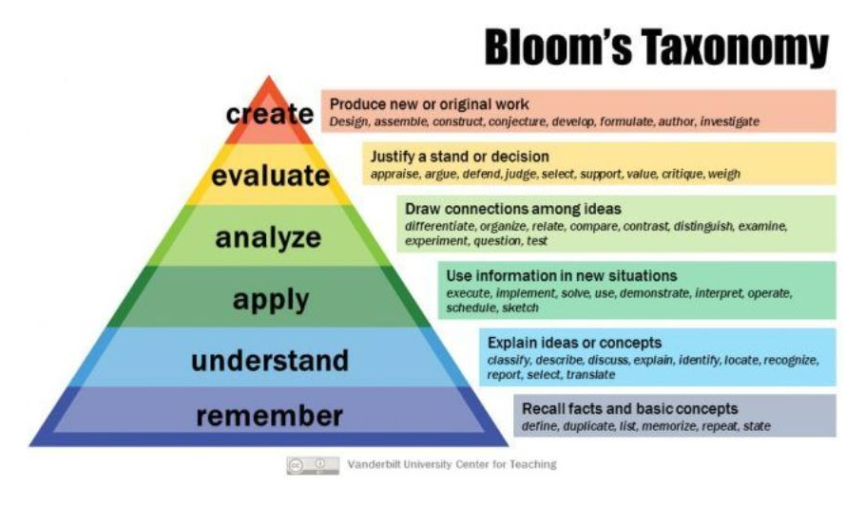
Figure 1 : Bloom’s Taxonomy

Erin Stapleton-Corcoran (2023) explains hierarchical models classify educational learning objectives by complexity and specificity. which is the essence of Bloom’s Taxonomy, including cognitive, affective, and psychomotor domains. The cognitive domain is the main focus of traditional education. It is often used to design curriculum objectives, assessments, and activities.
It could be argued that teachers’ subject knowledge is the most essential component of effective teaching. In terms of teaching a second language, ‘subject knowledge’ has a number of components: second language acquisition theory, pedagogical knowledge, curricular and syllabus knowledge cultural knowledge, proficiency in the target language, awareness of the structure and features of the target language (Pachler , Evans & Lawes, 2007),which could meet the demands of building up the Framework of Academic Language Teaching in PP.

2.3 Combine Theory with Practice
Based on the existing theoretical knowledge and Dr. Ruan (2025)'s guidance in Module 7019, I tried to conduct CRAAP et al analysis on a doctoral thesis related to my research.

For more specialized resources and theory, online reference databases such as ERIC (Educational Resources Information Center) and JSTOR cover a wide range of educational research. The British Council, TESOL Quarterly and Cambridge English provide examples of best practice in EAP teaching, language assessment and curriculum development. Finally, professional bodies such as UKCISA (UK Council for International Student Affairs) provide research, policy advice and guidance on supporting my research.
- How Do I Prepare For the Literature Review Now？

By knowing theoretical support and tapping into diverse sources of information, I will gain a comprehensive understanding of PP and their impact on academic success. On this basis, I will make the following preparations：
3.1.Topic Selection and Keywords:
• How to define the topic and core keywords.
• Expand the keyword range to cover all dimensions of the research.
3.2. Information Sources and Data Collection:
• Lists available databases and tools.
• Guides on how to build an initial literature reading list.
3.3. Literature Screening:
• Use "inclusion/exclusion criteria" to reduce bias.
• Evaluate literature from the perspectives of topic relevance, methodological quality, and data reliability.
3.4 Outline for Review Writing
•During the planning stage: assist in clarifying goals, formulating the writing framework, and selecting methods to ensure efficient writing.
•During the practice stage: provide specific tools and practical suggestions, guide literature search, evaluation and writing, while avoiding bias and plagiarism issues.

By following these steps, it helps me to formulate a well-organized writing plan and avoid missing key elements in my literature review.

Reference
- Wang, J., An, N. and Wright, C. (2018) ‘Enhancing beginner learners’ oral proficiency in a flipped Chinese foreign language classroom’, Computer Assisted Language Learning.
- Chargois, T. (2013) ‘Mastery-based learning literature’, Aurora Institute. Available at: https://aurora-institute.org/blog/mastery-based-learning-literature-by-tina-chargois-inacol-intern/ (Accessed: 26 November 2024).
- Xie, M. (2010) First Language Maintenance and Attrition among Young Chinese Adult Immigrants: A Multi-Case Study. PhD thesis. University of Alberta, Canada.
- Lage, M.J., Platt, G.J. and Treglia, M. (2000) ‘Inverting the Classroom: A Gateway to Creating an Inclusive Learning Environment’, Economic Instruction.
- Pachler, N., Evans, M. and Lawes, S. (2007) Modern Foreign Languages, Teaching School Subjects 11-19.
- Lage, M.J., Platt, G.J. and Treglia, M. (2000) ‘Inverting the classroom: A gateway to creating an inclusive learning environment’, The Journal of Economic Education, 2000(1).
- Baker, J.W. (2000) ‘The classroom flip: Using web course management tools to become the guide by the side’, in Chambers, J.A. (ed.) Selected Papers from the 11th International Conference on College Teaching and Learning. Florida, US: Florida Community College at Jacksonville.
- Baughman, J., Hassall, L. and Xu, X. (2019) ‘Comparison of student team dynamics between nonflipped and flipped versions of a large enrollment sophomore design engineering course’, Journal of Engineering Education, 108, pp. 103–118.
- Pintrich, P.R., Smith, D.A.F., García, T. and McKeachie, W.J. (1991) A Manual for the Use of the Motivated Strategies Questionnaire (MSLQ). Ann Arbor, MI: University of Michigan National Center for Research to Improve Postsecondary Teaching and Learning.
- Smith, J. (2019) Educational Psychology and Learning Models. 2nd edn. London: Pearson Education.
- Jones, R. and Taylor, A. (2020) ‘Teaching for Mastery and personalized learning’, Journal of Education Studies, 15(3), pp. 200-215. Available at: https://doi.org/10.12345/abcd123 (Accessed: 26 November 2024).
- Department of Education (2018) Learning strategies in the modern classroom. Available at: https://www.educationdept.gov (Accessed: 15 January 2025).
- University of Illinois Chicago (2024) Bloom’s Taxonomy of Educational Objectives. Available at: https://teaching.uic.edu/cate-teaching-guides/syllabus-course-design/blooms-taxonomy-of-educational-objectives/#:~:text=Bloom's%20taxonomy%20is%20a%20hierarchical,Psychomotor:%20manual%20or%20physical%20skills (Accessed: 26 November 2024).
- Winchester, C.L. and Salji, M. (2016) ‘Writing a Literature Review’, Journal of Clinical Urology, 9(5), pp. 308–312. Available at: https://doi.org/10.1177/2051415816650133.
- Villegas, P. (2021) Who Wins When We Flip? Exploring Perceptions of Flipped Learning in an Online EAP Processional Course. Thesis.

