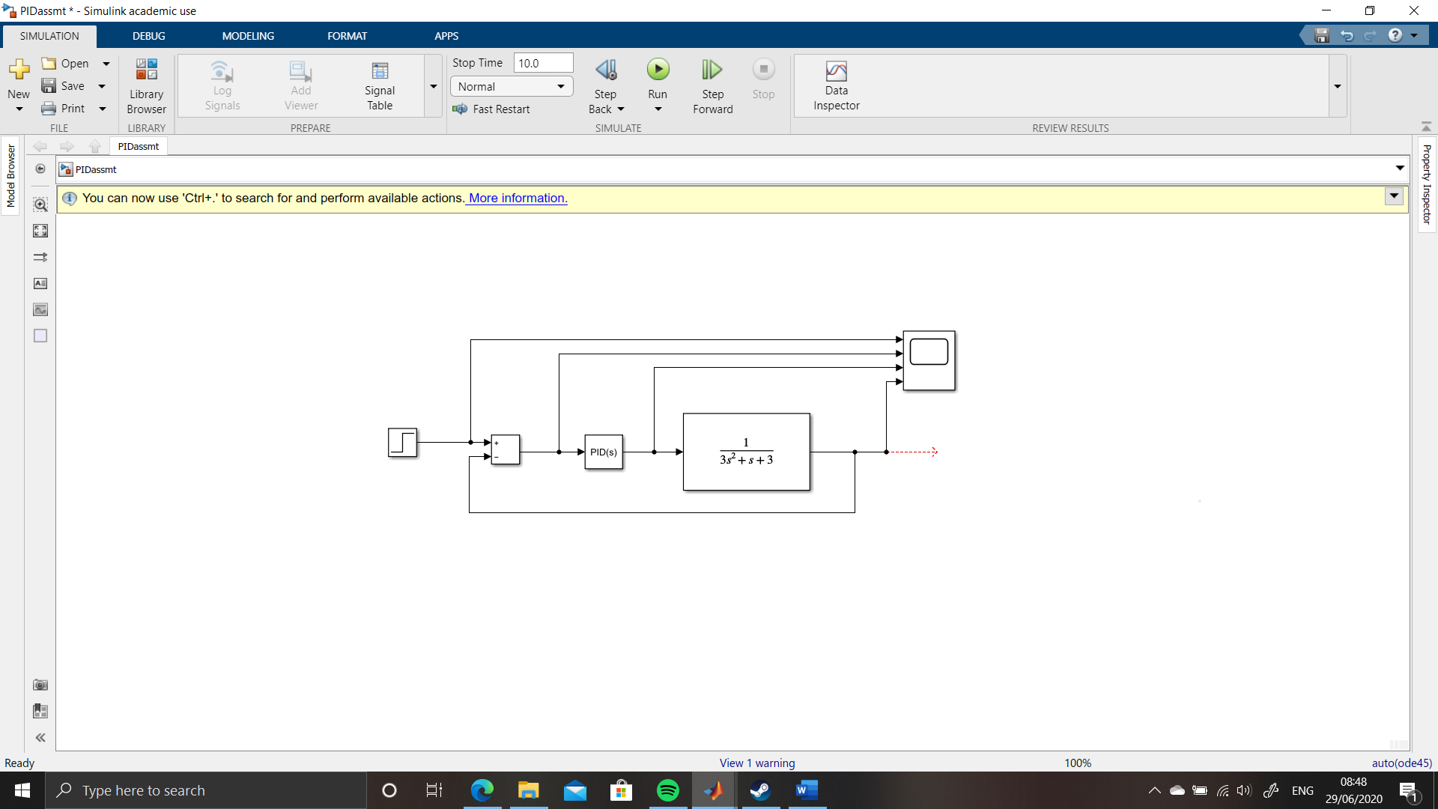

Control System Design

Alexander Dand - 1810440 | OME Instrumentation and Control ACDA5011 | July 2020

Abstract
This report deals with the design and analysis of a modelled PID controlled closed loop process within MATLAB. The controller is tuned to give a specified response and converted into an open loop process.
Data is then drawn from the response of the two systems, analysed and discussed.
Recommendations for future study are included.


Table of Contents
Abstract 0
Introduction 2
Task Description 2
Control System Definition 2
Transfer Function Definition 2
PID Control Theory 2
P Controller 3
I Controller 3
D Controller 4
Uses of PID Control 4
Equipment 5
Method 5
Results 9
Discussion 14
System Response 14
Pole-Zero analysis 14
Nyquist Diagram analysis 15
Root Locus Analysis 15
Conclusion 16
Table of Figures 17
References 18
Appendix 20
Example calculations for Transfer Functions 20

Introduction

Task Description
The author has been tasked with designing a control system within MATLAB and Simulink using an industrial process with a given transfer function. The expectation is that the system will be controlled within two seconds and have an overshoot of less than 5%. From there, the closed loop transfer function should be found, and simulated as a single block process. The results of the two processes should then be compared.

Control System Definition
‘A control system consists of subsystems and processes (or plants) assembled for the purpose of obtaining a desired output with desired performance, given a specific input.’ [1]
Open Loop systems are those where there is no effect of the output signal on the input. Closed Loop systems are those where a form of feedback is incorporated to the input signal based on the output [2]

Transfer Function Definition
‘A transfer function represents the relationship between the output signal of a control system and the input signal for all possible input values.’ [3]

PID Control Theory
PID (Proportional-Integral-Derivative) control is an algorithm most widely used worldwide in industry [4]. It is used to control processes with a potentially high precision and accuracy. It is versatile and can tune the controller to obtain a desired set of characteristics within the process. The basis behind the theory is that of three controllers combined, each producing output calculated in different ways based on input from an error detector fed by a feedback loop in the process. A simple ON-OFF controller only gives two possible states to a system, and as a direct result, has very limited control due to the natural oscillation between those two states [5]. (276)

P Controller
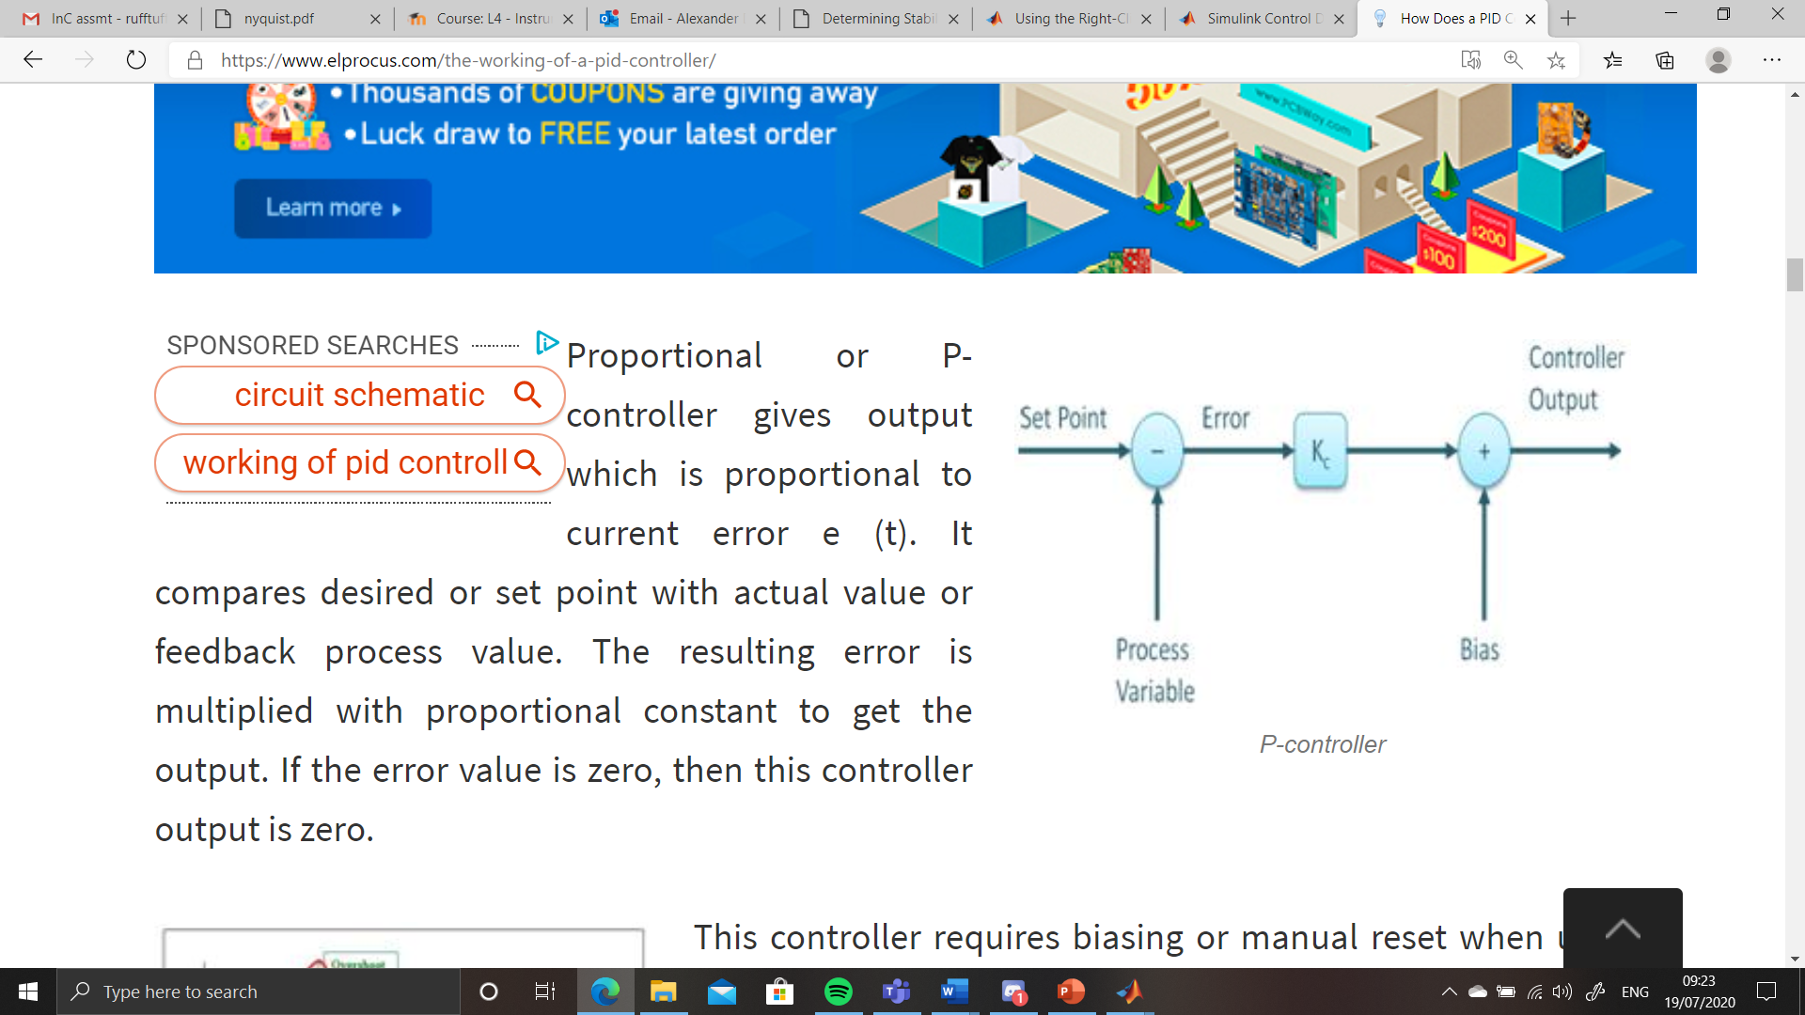
Figure 1 - P Controller [5]
With Proportional control, the process is as follows:
- Set point for process changed from zero (input step, process variable such as temperature, flow rate, pressure)
- Controller output set to 100% effort
- Process value increases rapidly to meet output demand proportionally based on the difference between the set point and the process value
- As the output is gradually lessened proportional to this difference, the process value will never reach the set point
- If the proportional gain is increased, the speed of the response increases, although if this value is too large, the process value will oscillate around the set point and potentially become unstable (103)

I Controller
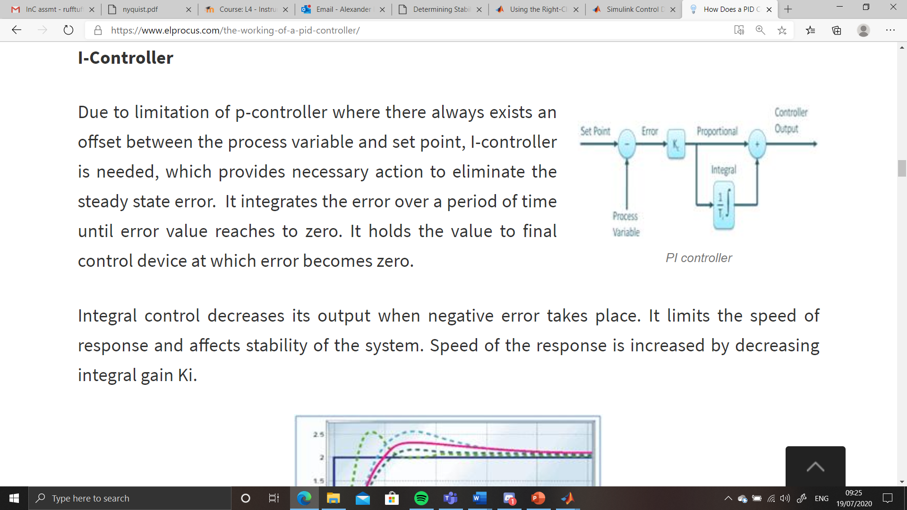
Figure 2 - PI Controller [5]
With Integral control, the process is as follows:
- As shown in Figure 2, both P and I controllers are used to contribute to control of the process
- Where the P controller will never allow the system to reach the set point, the I controller integrates the sums of the error values over time and compensates for the steady state error caused by the P control
- As this integral gets closer to zero, it slows the output, but will constantly drive the signal of the error towards a value of zero
- If the integral gain is decreased, the speed of the response is increased. If the I controller output is too high, Integral Windup [6] can occur where too large an error signal can cause the integral to increase even when an error state of zero has been reached (138)

D Controller
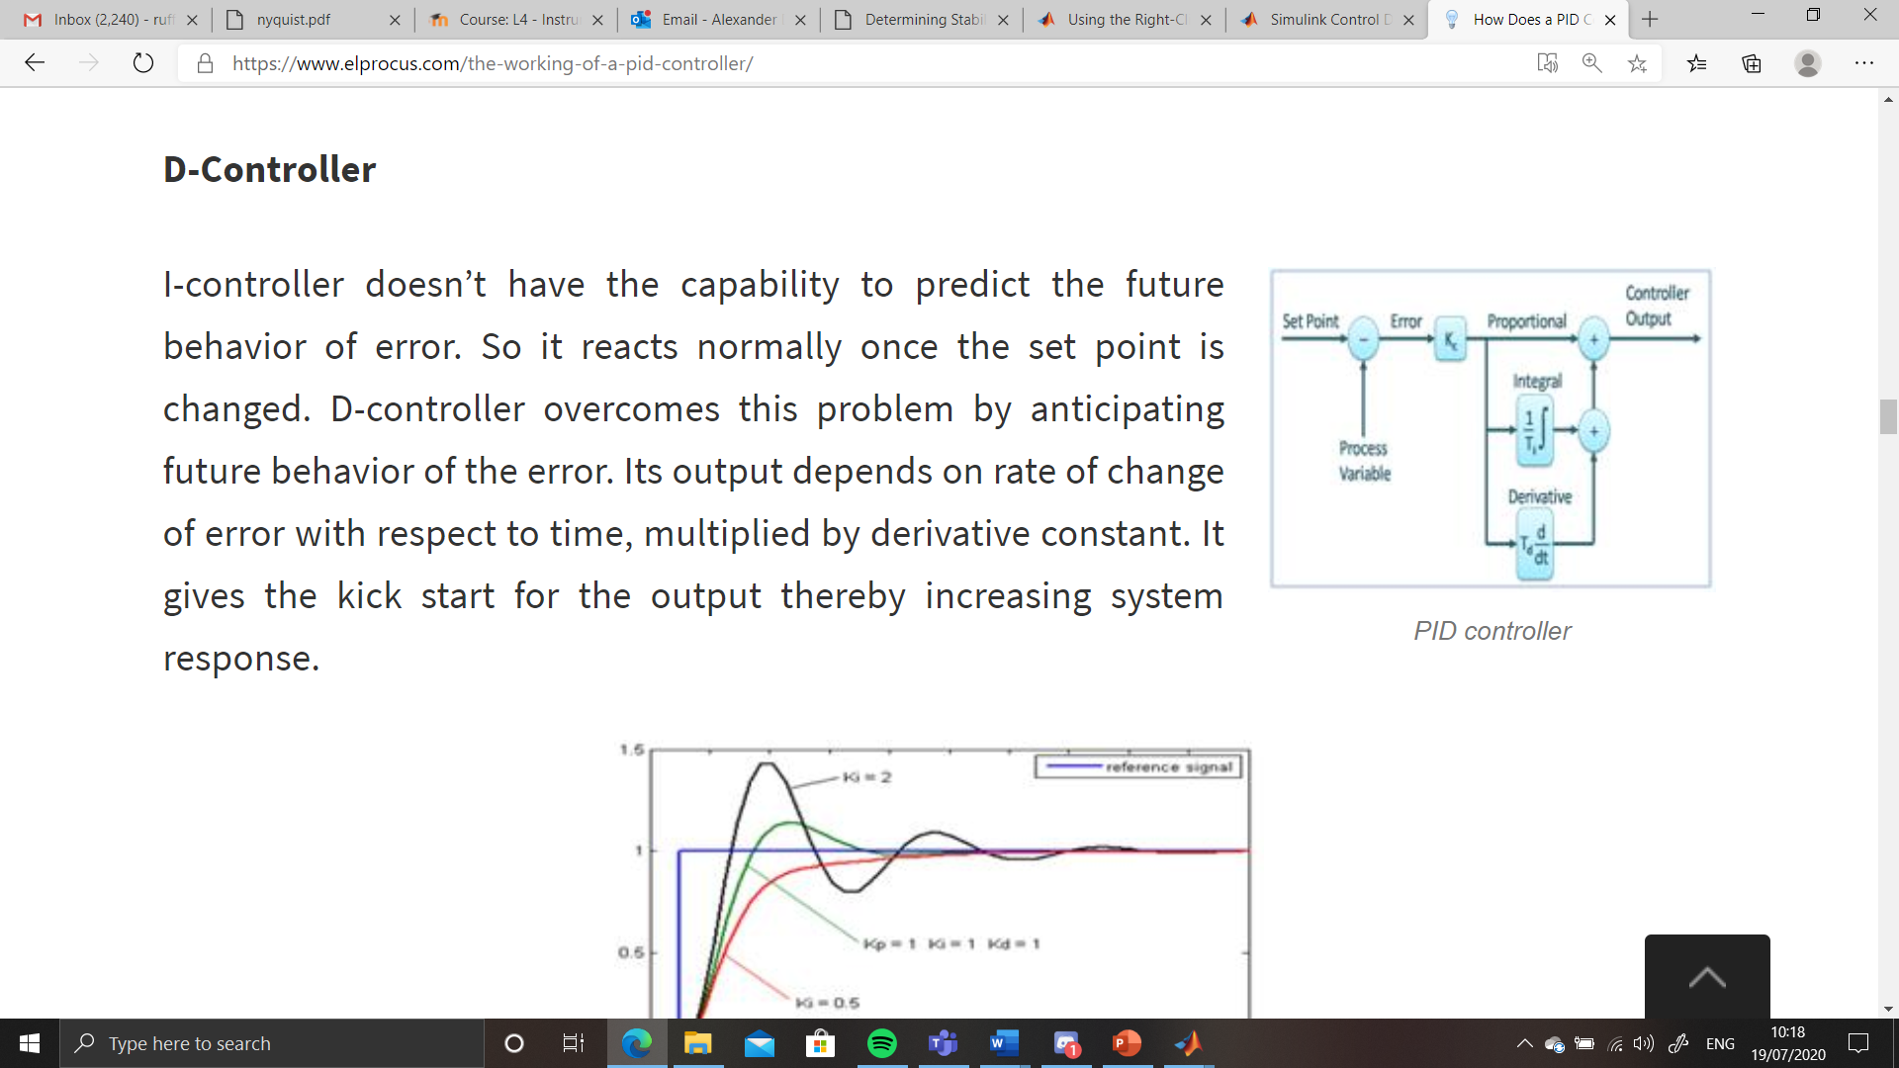
Figure 3 - PID Controller [5]
Including Derivative control give us the above control system and the process changes as follows:
- D control anticipates the future behavior of the controller by controlling output based on a derivative constant obtained from the sum of past errors with respect to time; the rate of change of errors rather than the actual current error
- This increases stability of the system as it considers possible future errors and mitigates against overshoot of the set point and oscillation

Uses of PID Control
As stated, PID controllers are used in many systems, from heating in the home to controlling the flow rate of a liquid in an industrial process [7] to the guidance control of a guided missile [8].

Equipment
For this task, the author will use MATLAB and the Simulink add on.

Method
The transfer function values that the author was given gave the following transfer function:
$$\frac{1}{{3s}^{2}+s+3}$$
This gave the following closed loop system: (154)
Figure 4 - Subject Control system
Which when run gave the following responses: (7)
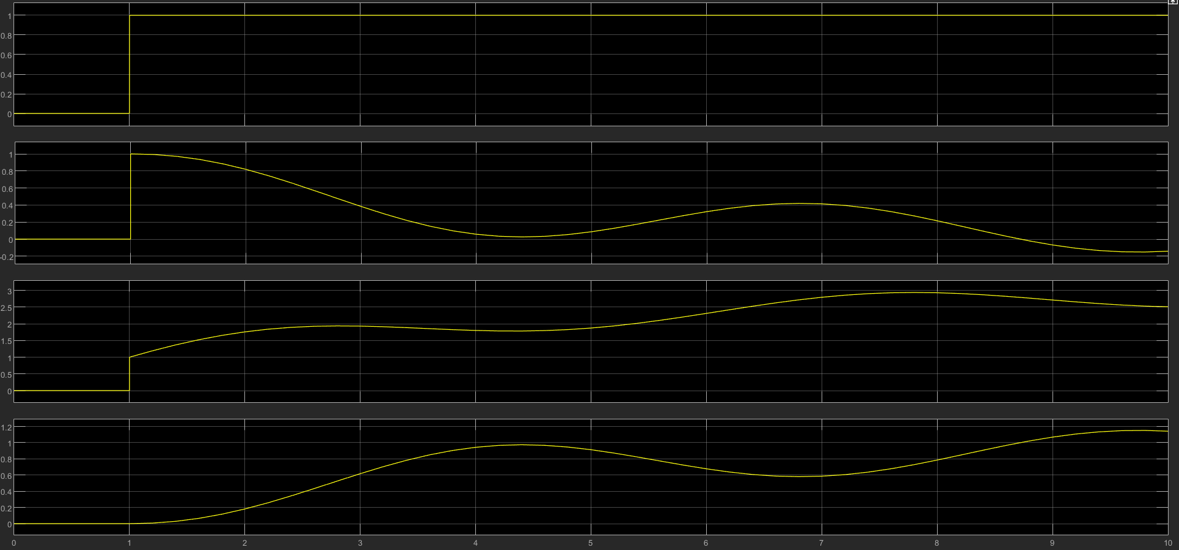
Figure 5 - System response graphs
The PID control block was then interrogated for overshoot and settling time and showed the following: (16)
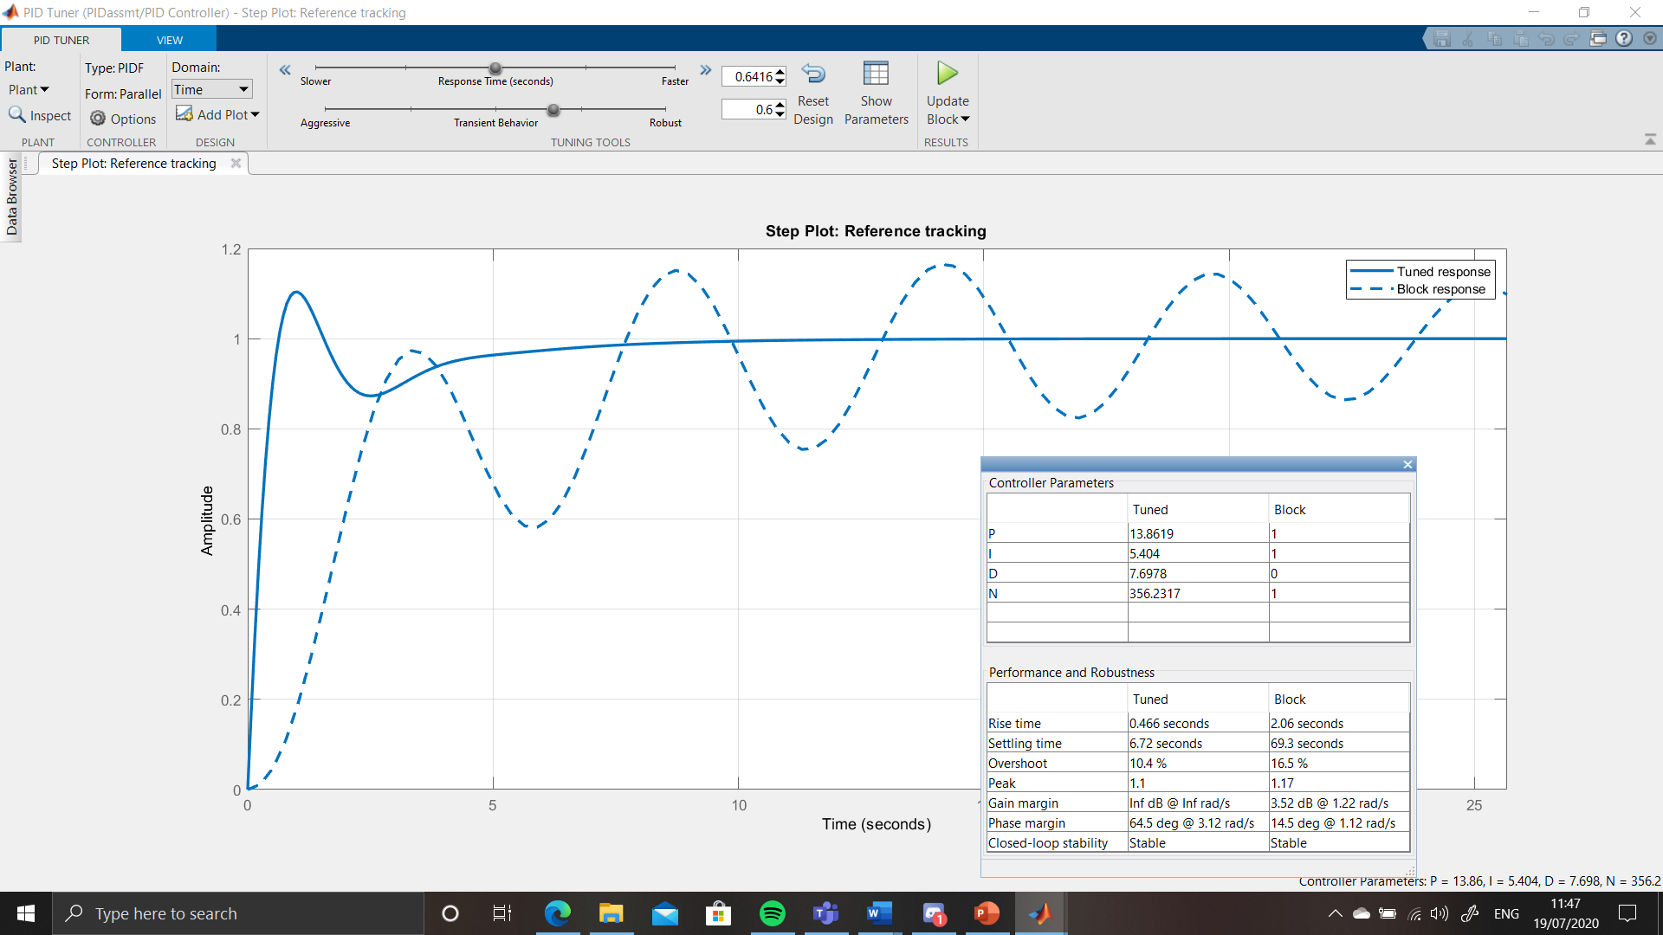
Figure 6 - PID control block tuner
In order to tune the system to the parameters given, initially the response time was adjusted to obtain a suitable settling time (<2s). The response time of 0.0842s was selected for a settling time of 0.522s. As this gave an unacceptable overshoot, the robustness of the process was increased gradually to obtain a figure of 0.864 which gave a final set of acceptable figures (settling time of 0.471s and a process overshoot of 3.52%) as shown below: (77)
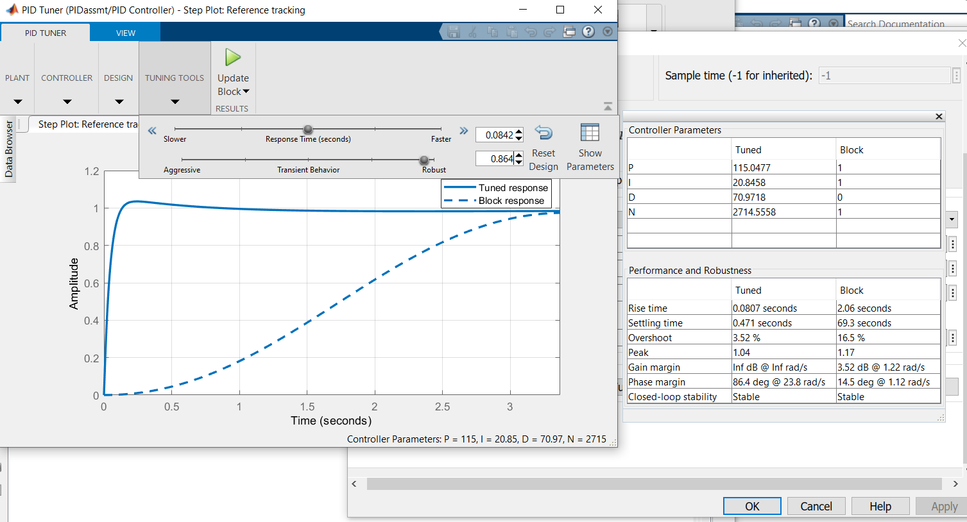
Figure 7 - PID control block – Tuned
As can be seen, the tuned vales for P, I, D and N are shown in the controller parameters. These figures can be used for the compensator formula to find the transfer function of the controller (denoted as ‘C’, with the transfer function of the process as ‘G’):
$$K_{p}+K_{i}\frac{1}{s}+K_{d}\frac{N}{1+N\frac{1}{s}}$$
To find the transfer function of the whole system, and in order to remove the feedback loop, the transfer function of the PID controller should be multiplied by the transfer function of the process with the feedback loop (H) to be considered as 1. Considering the closed loop forward transfer function of the whole system is the following:
$$TF=\frac{C×G}{1+(C×G)H}$$
Entering these values into MATLAB gives the following: (116)
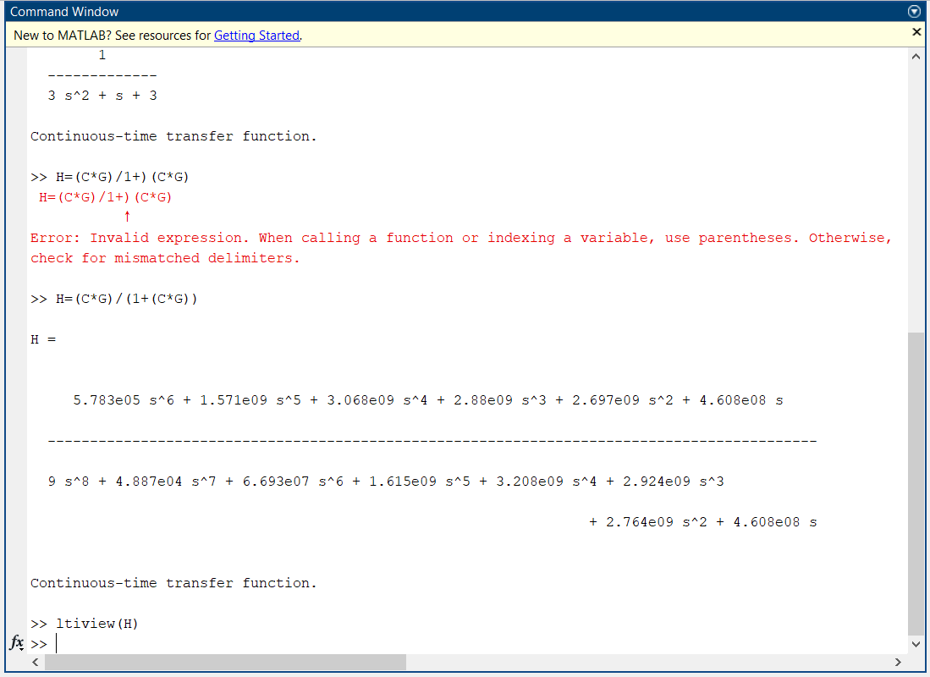
Figure 8 - Closed Loop transfer function of whole system
Using the Linear System Analyser, several views are used to analyse the response of the system; Step Response, Pole Zero Map and Nyquist Diagram. A Root Locus Plot was also obtained.
The system is then re-modelled in Simulink using only a Transfer Function block and utilising the above figures as shown below. (52)
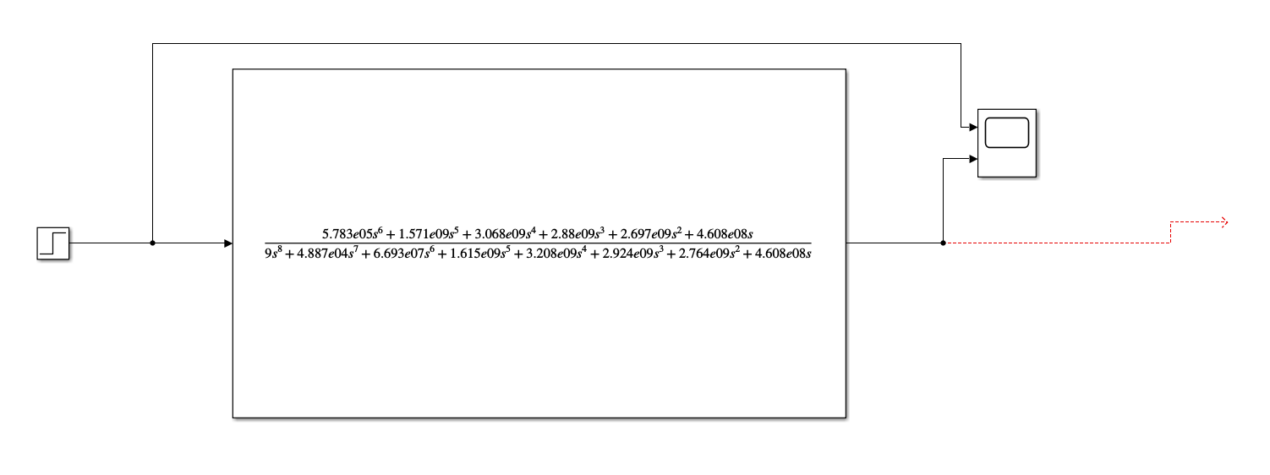
Figure 9 - Single Block Process
The process was run and the response graph for this single block system was generated. (15)

Results
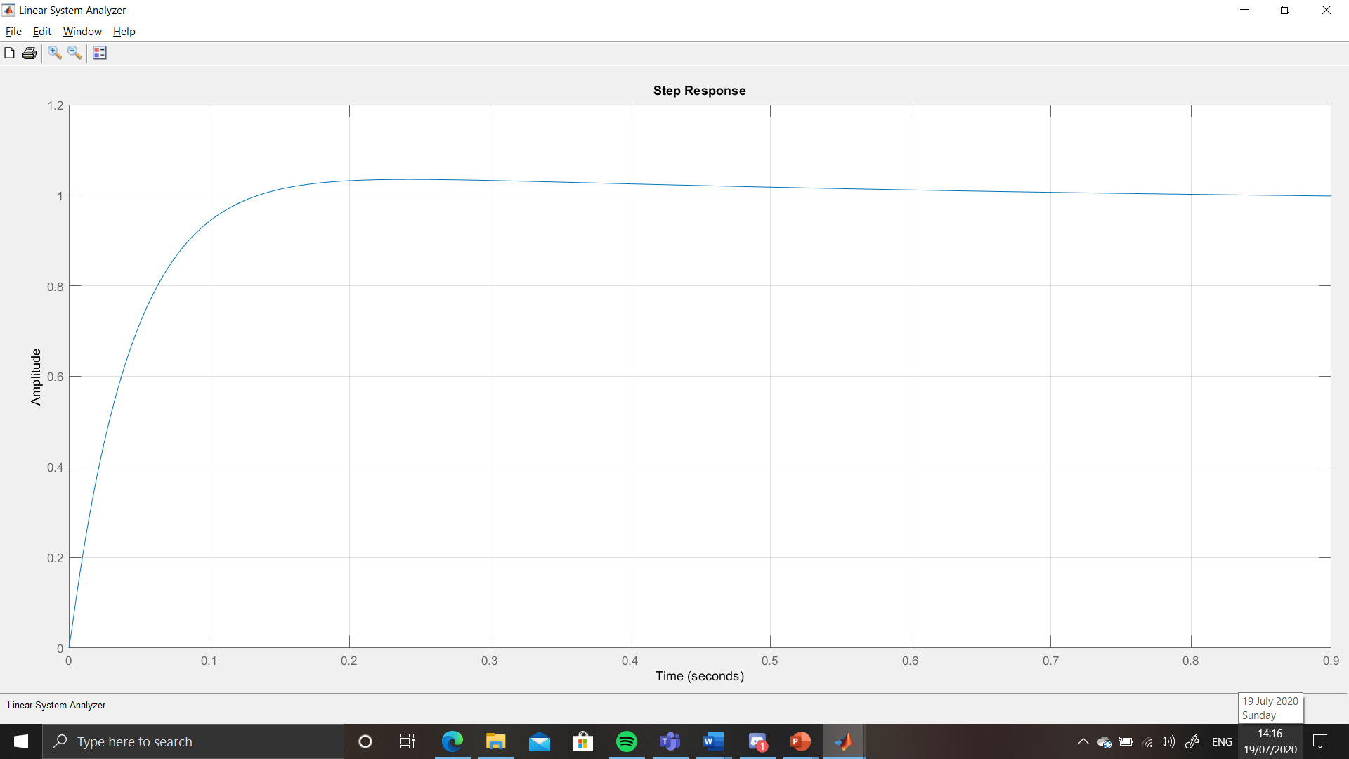
Figure 10 - Step Response graph - Single Block Process
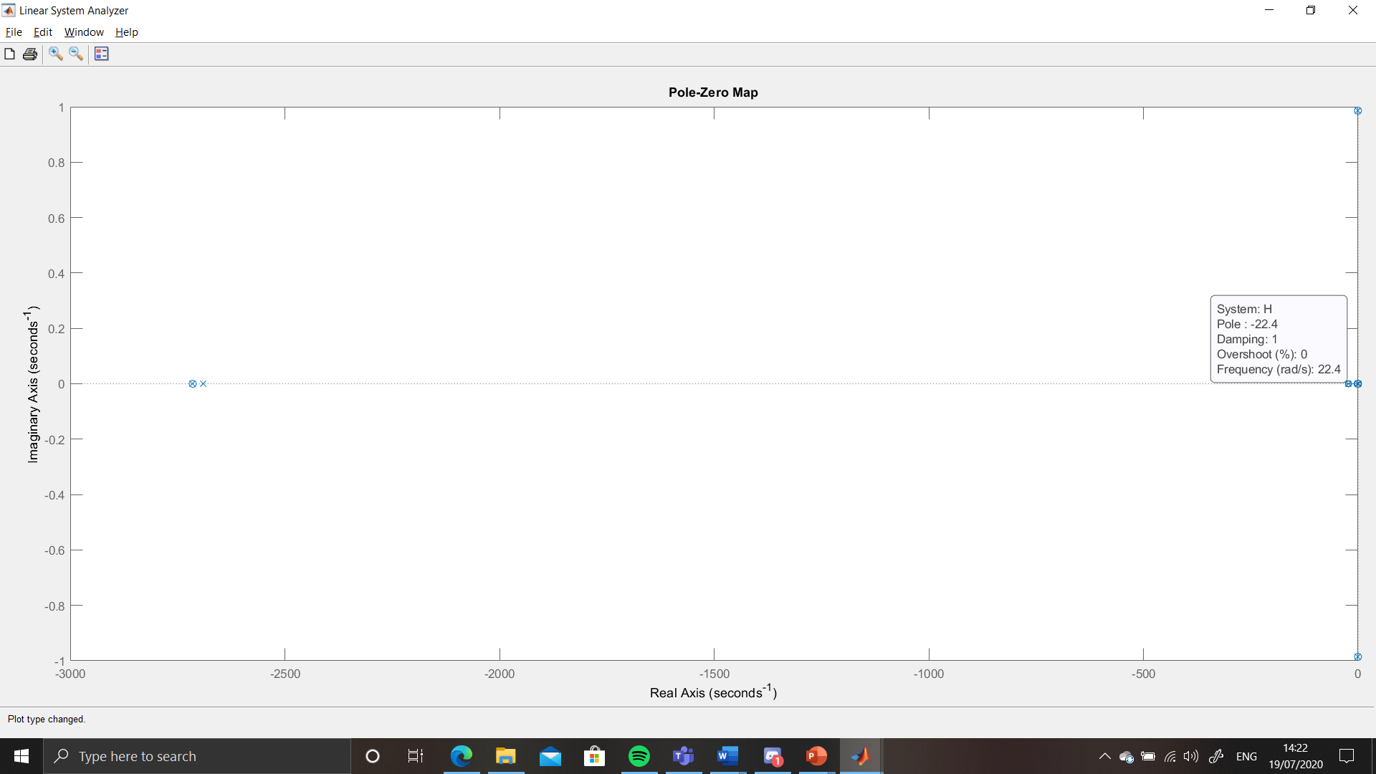
Figure 11 - Pole Zero Map - Single Block Process
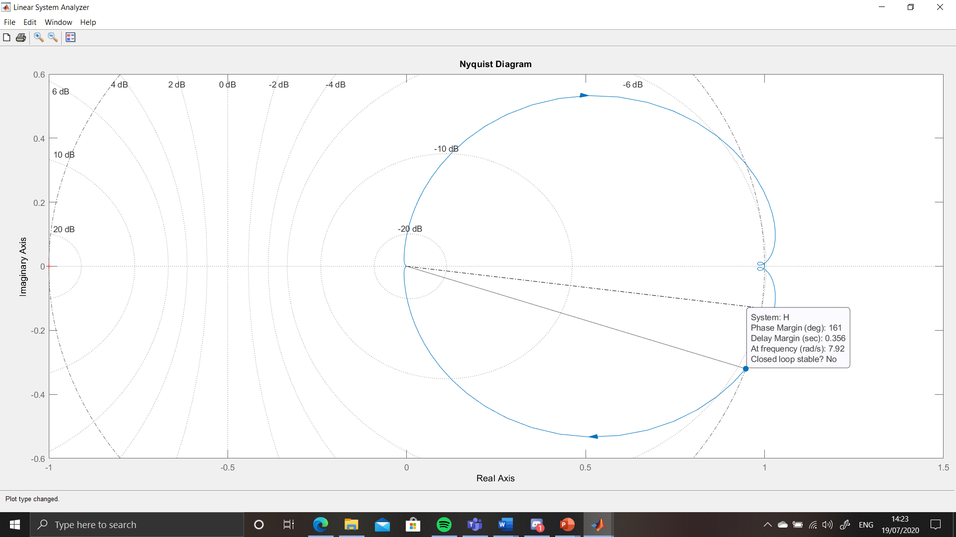
Figure 12 - Nyquist Diagram showing Phase Margin - Single Block Process
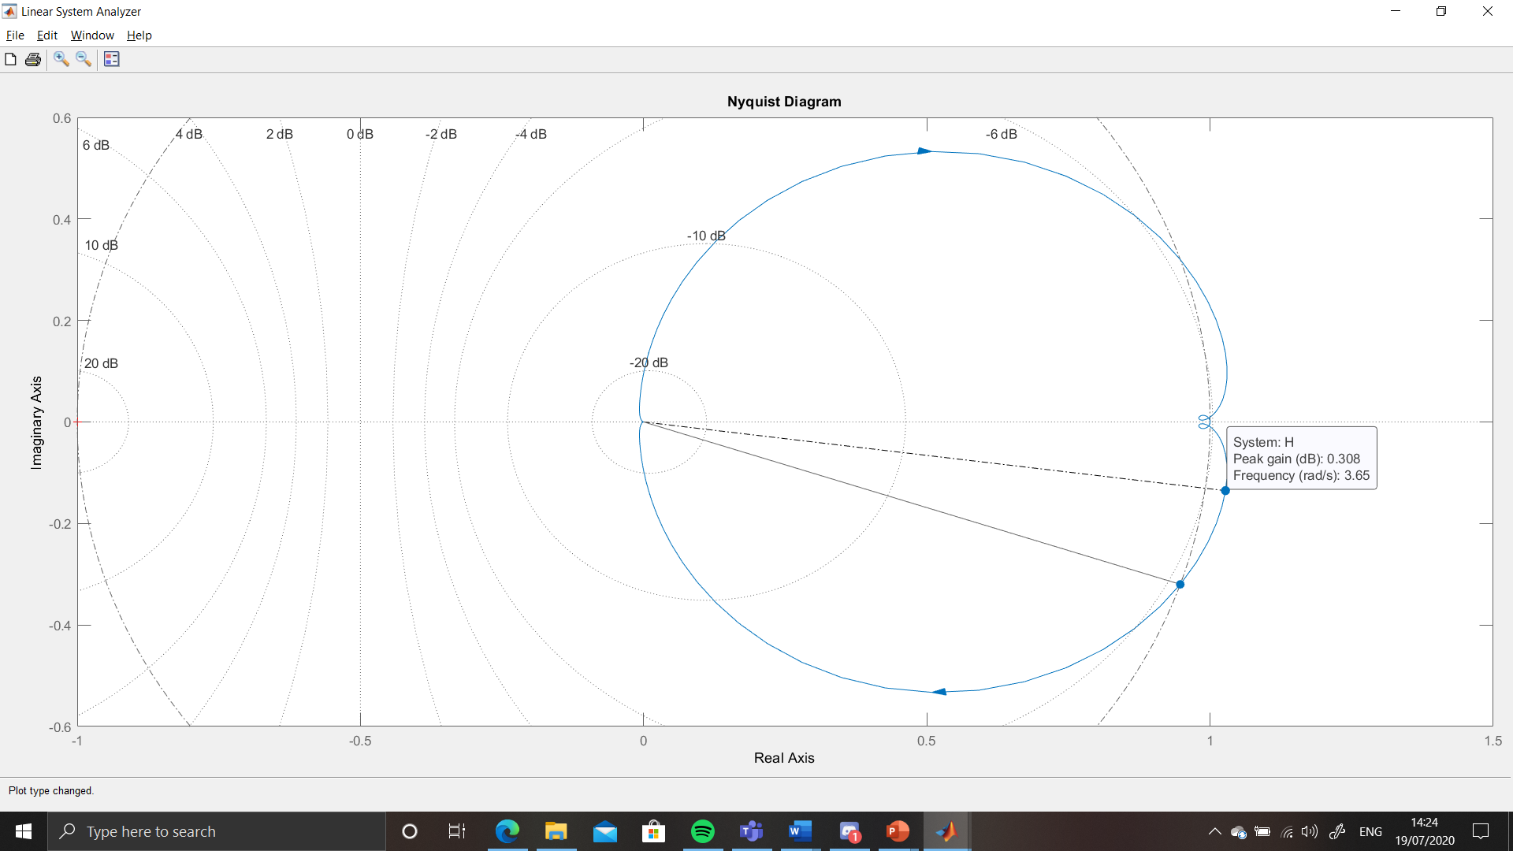
Figure 13 - Nyquist Diagram showing Peak Response - Single Block Process
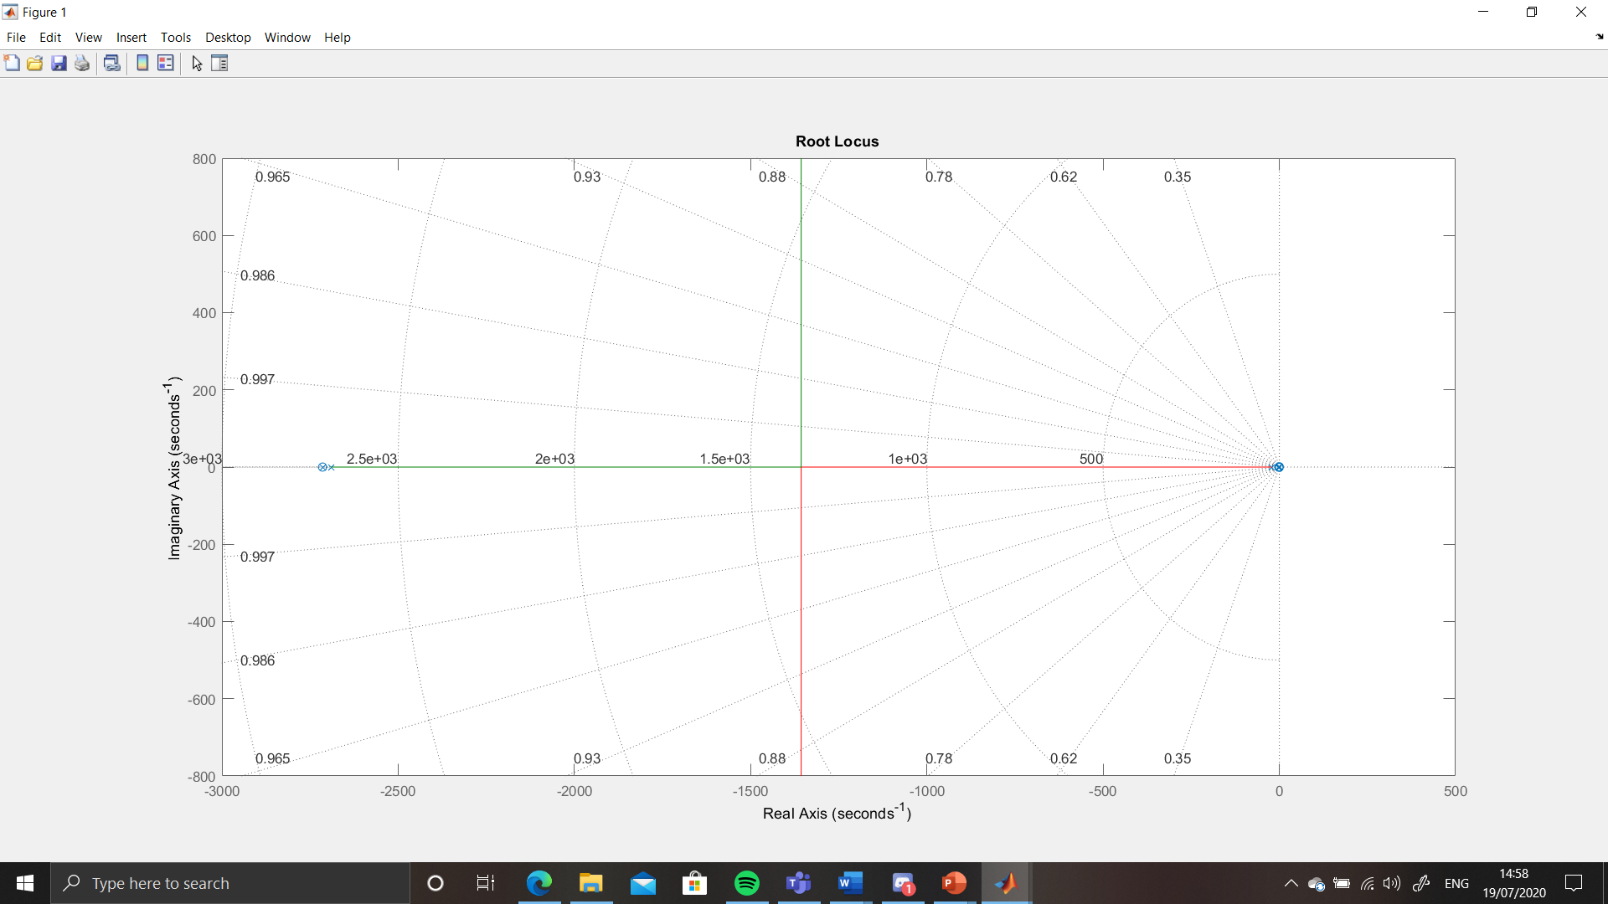
Figure 14 - Root Locus - Single Block Process
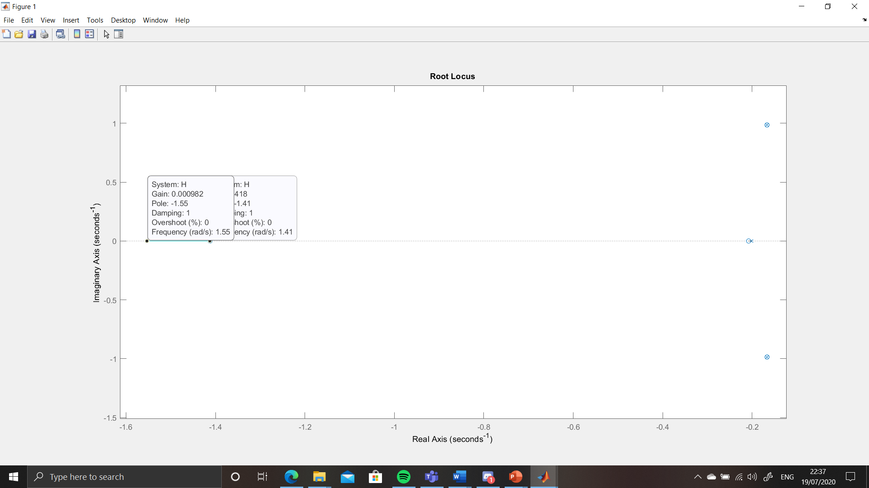
Figure 15 – Over-damped response (1)
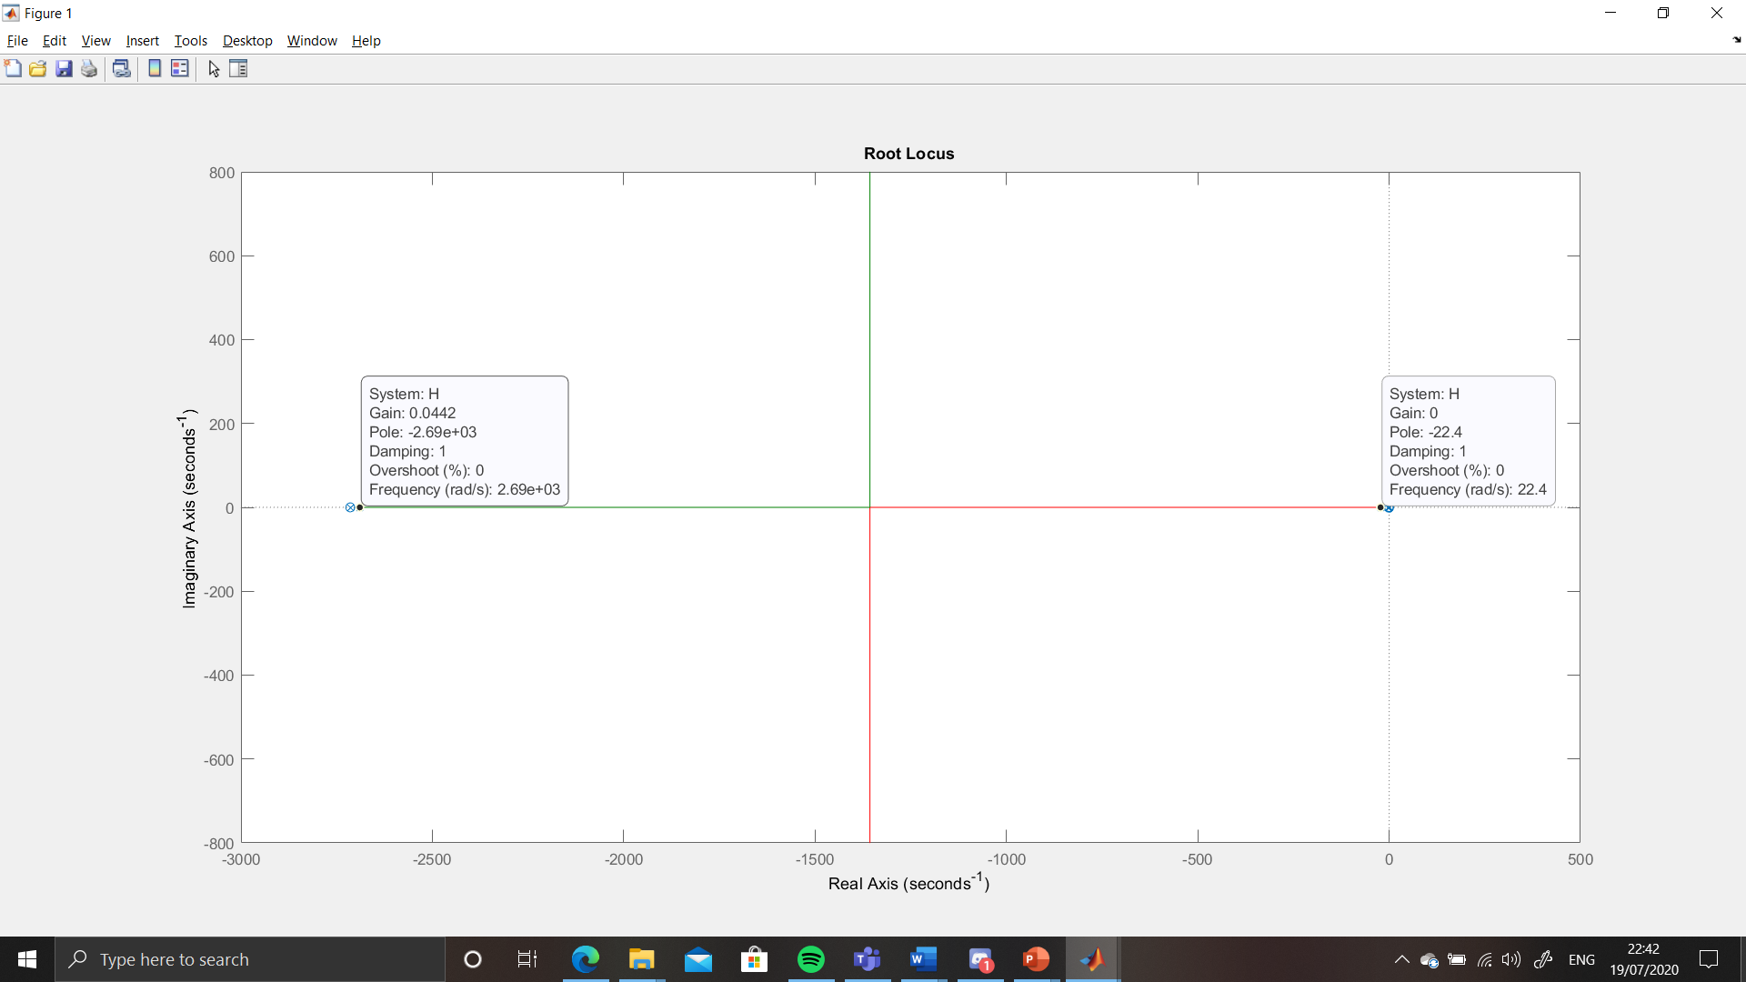
Figure 16 – Over-damped response (2)
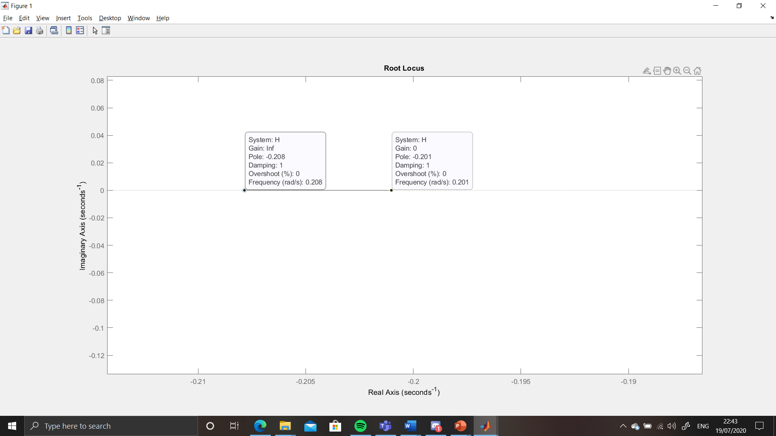
Figure 17 – Over-damped response (3)
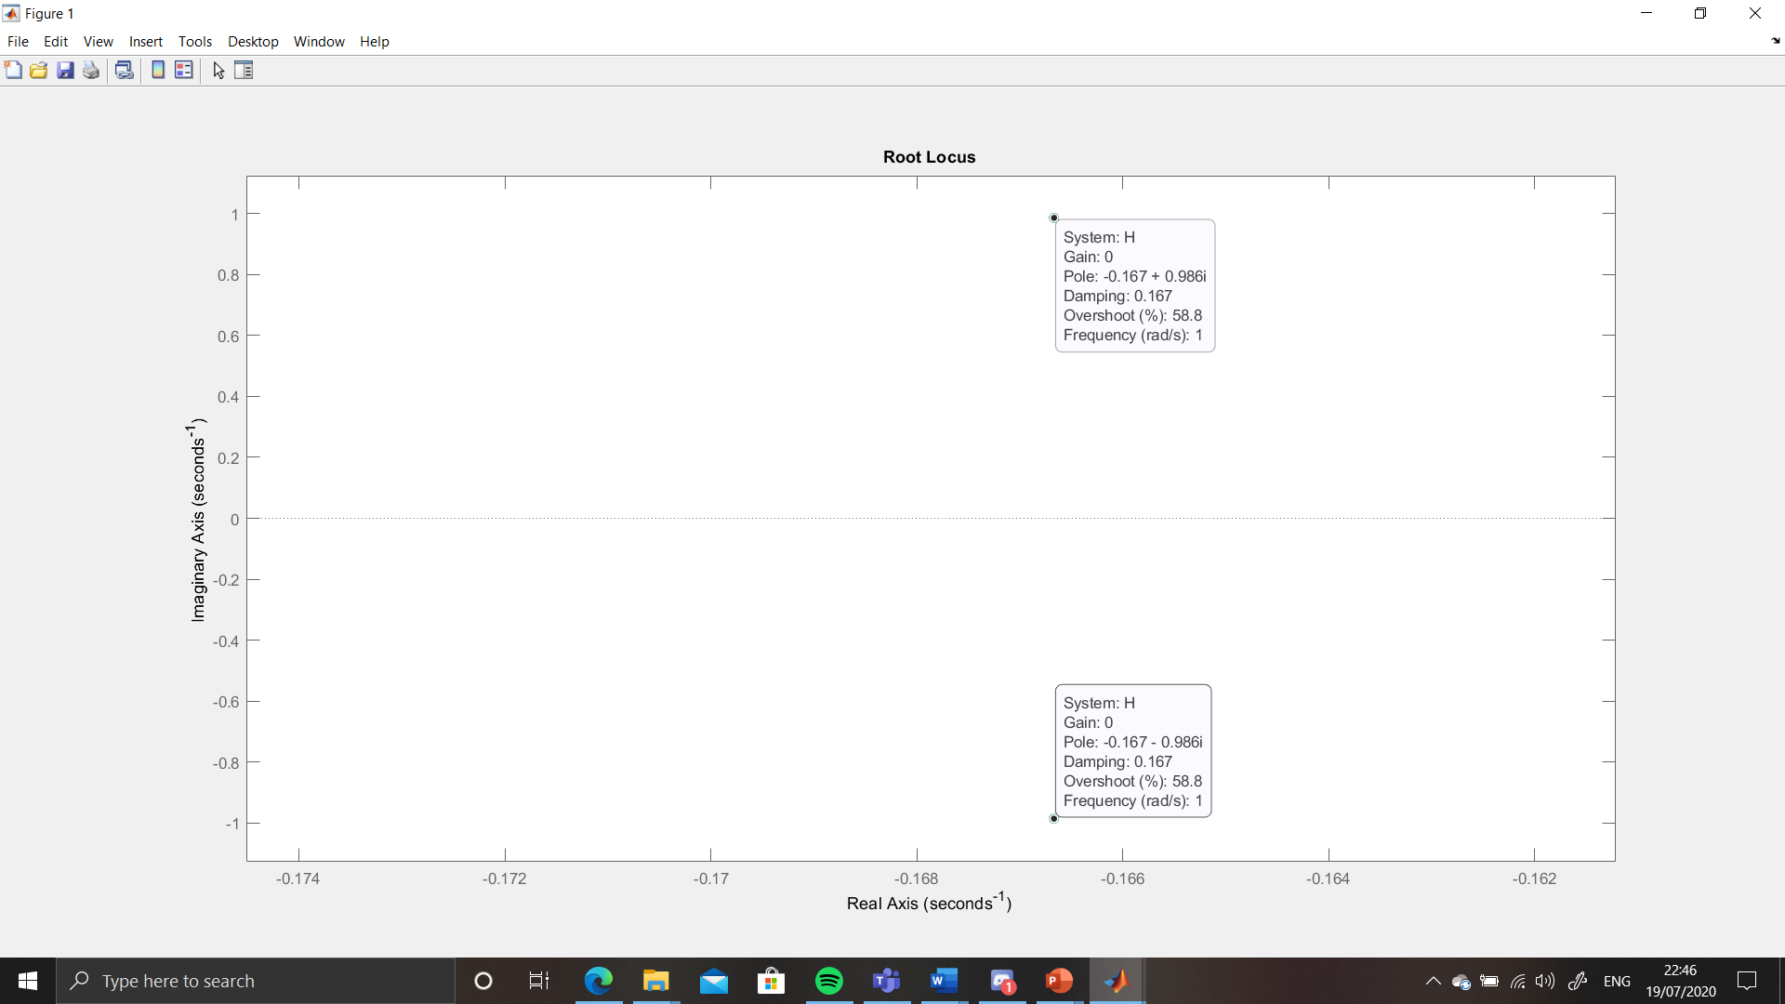
Figure 18 - Under-damped response

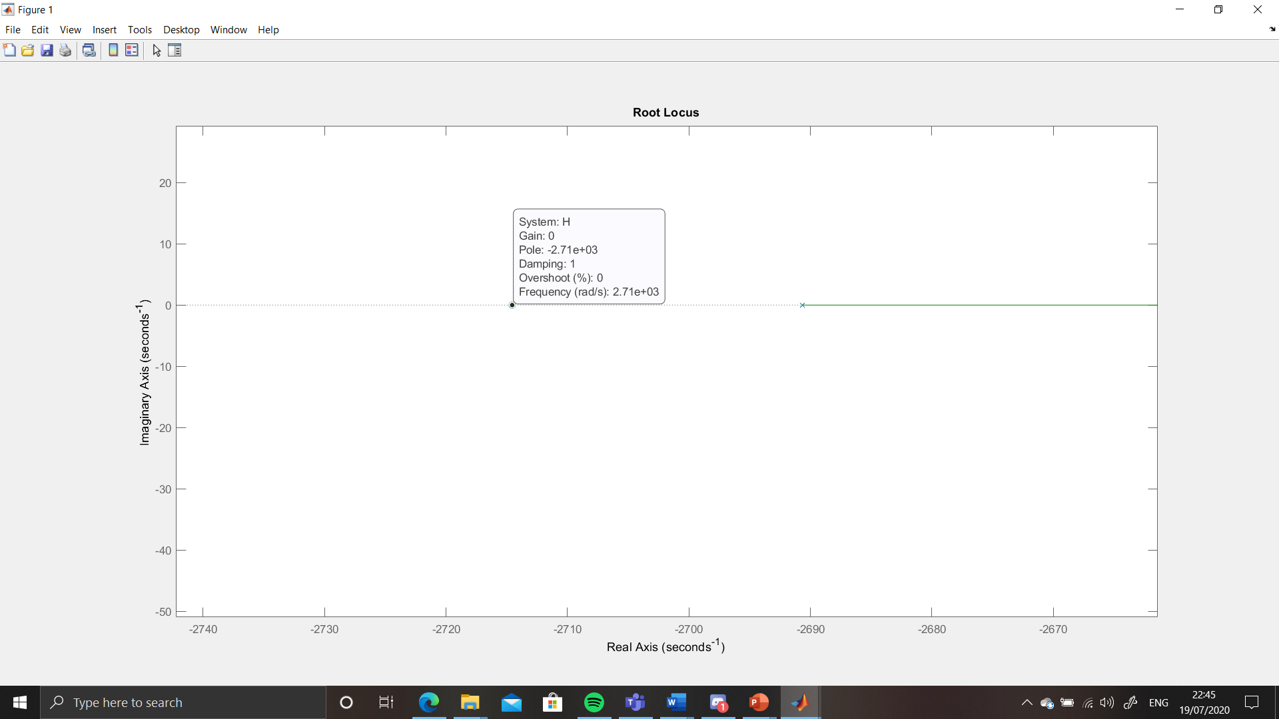
Figure 19 - Critically Damped response

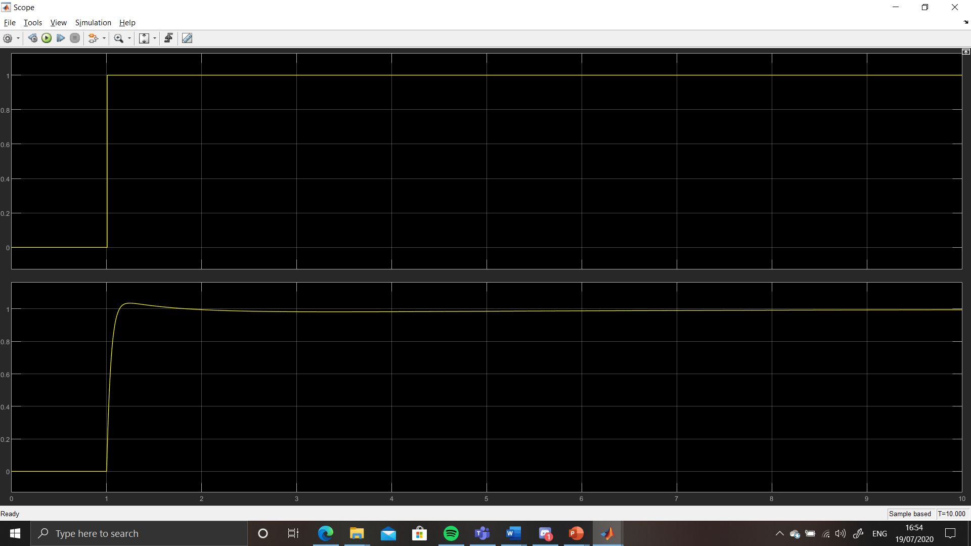
Figure 20 - Response graph - Single Block Process

Discussion

System Response
This study has shown that a closed loop process with feedback can be converted into an open loop process with the correct formula applied. This simplifies the system, reducing cost and complexity within the process.
From the graphs, several pieces of information can be obtained about the process that has been designed. The Step Response Graph (Figure 10) follows the shape of the graph given by the tuned initial system design (Figure 7), which indicates the figure have followed through correctly and gives greater confidence that the other information obtained is accurate.

Pole-Zero analysis
Referring to the Pole Zero Graph shown in Figure 11, the following information can be extracted [9]:
- There is at least one pole on the negative real axis (P_{i}=-22.4), which indicates exponential decay of the response towards a steady state. As this is relatively close to the origin, it indicates that the decay will be quite slow.
- The Complex conjugate pair at (-0.167±0.986j) indicate that there will be a decaying sinusoid in the system behaviour as it oscillates towards the steady state and will not increase its instability as the process continues. This sinusoid can be shown by the equation: $A_{0}e^{-σt}sin\left(ωt+φ\right)$, where A₀ is the initial amplitude of the system and φ is the initial phase shift. In this case, the equation can be expressed as:
$$A_{0}e^{-0.167t}sin\left(0.986t+φ\right)$$
- The fact that the real number for this pair is in the negative side of the graph indicates the system is currently stable

Nyquist Diagram analysis
From the Nyquist Diagram (Figure 12), the following can be ascertained [10]:
- That the Phase Margin for this system is 161 degrees. This means that the system can undergo open-loop phase shift of 161 degrees at unity gain (input and output are the same) before it becomes unstable. This give us an idea of the robustness of the system.
- From Figure 13, the information obtained is the Peak gain of the system (0.308dB), which indicates that there is an acceptable open-loop gain change of the same amount allowed if the system was at 180̊ out of phase before the system becomes unstable (Gain Margin). When determining the stability of a system, the larger the gain margin, the more stable the system. This small figure indicates that the system is only just stable.
- Further evidence of the stability of the system is given by the fact that the plot does not loop over the (-1, 0) point.

Root Locus Analysis
Following analysis of the Root Locus diagram, the following is learned:
- There are multiple points of interest on this diagram, with each figure 14-19 indicating the movement of the poles as the gain is changed. These movements relate to a different aspect of system ‘damping’, which is the effect of an external stimulus on the oscillations of a system [1]. This effect is dimensionless and is denoted by ‘ζ’.
- There are several types of damping visible in these figures; Figures 15-17 show over-damping, where ζ is greater than 1. In this situation, the behaviour of the response is that it does not oscillate around the set-point/steady state, but instead rises slowly and gradually to the set-point.
- In Figure 18, it shows an under-damped response, where ζ is more than 0, but less than 1. The behaviour of this response is that of an exponentially decaying signal. The signal oscillates around the set-point/steady state, and the length of time to reach this point is directly proportional to the under-damping value (more under-damping means more oscillations means greater time to reach a steady state).
- Figure 19 shows a response that has been critically damped. This is the point where ζ is exactly equal to 1 and is the point on the negative real axis where a pole and a zero appear simultaneously. It is this response point where the system reaches the steady state most quickly. Ideally there should be no oscillation around the steady state. [11] (643)

Conclusion
With the evidence supplied from the graphs, this system is stable, but only just. It is able to withstand more phase shift (power factor of the signal can be changed [12]), but the gain only has a very limited range before the system destabilises. Looking at the Step Response, the system seems to be under-damped, as it is oscillating (evidenced by the overshoot) around the set point. If this was a physical system, damping could occur mechanically (through friction, viscosity, inertia) or additional impedance in an electrical system. However, the manner of damping is unimportant, as long as the rate of energy dissipation is correctly calculated with respect to frequency [13].
Likewise, with the change from a three block closed loop system into a single block open loop system, we can find the required feedback information from the various mathematical tools available whilst reducing the complexity of the system. In real terms, this will reduce cost, and also reduce the potential for error introduced by increasing complexity. With additional physical steps come additional links in the process chain with more scope for mistakes to be made, more damping factors and a reduction in efficiency. If the system is pared down, it becomes more efficient. The issue then becomes one of accuracy. With the maths expressed within MATLAB, if it were done ‘pen and paper’ it would become very cumbersome and time-consuming. It would also need to be re-done every time there was a change to the process and may become prohibitively expensive and may impact on the current drive towards highly efficient yet brittle manufacturing and logistics processes. Please see Appendix for example calculations. The calculations shown were worked out on a calculator, but the question of accuracy comes in as there are only so many character spaces on a calculator, and there may be a reduction of accuracy due to rounding errors.
If this study were to be redone, the author has some recommendations with regard to the outcome. When initially tuning the PID controller, the method used could have been more efficient. There are several methods that can be used to tune a PID controller [5] such as ‘Trial and Error’ method, ‘Process Reaction Curve’ technique (open loop technique so unsuitable for tuning the initial closed loop process, but may be used to tune the single block process once it has been converted and with data supplied by the mathematical tools) or the Ziegler-Nichols method (closed loop method so better suited to initial tuning).
Further work could include a study of a physical system controlled with a PID controller and investigate the system output compared against the same controller modelled in ideal conditions.

Table of Figures
Figure 1 - P Controller [5] 2
Figure 2 - PI Controller [5] 3
Figure 3 - PID Controller [5] 4
Figure 4 - Subject Control system 5
Figure 5 - System response graphs 5
Figure 6 - PID control block tuner 6
Figure 7 - PID control block – Tuned 6
Figure 8 - Closed Loop transfer function of whole system 7
Figure 9 - Single Block Process 8
Figure 10 - Step Response graph - Single Block Process 8
Figure 11 - Pole Zero Map - Single Block Process 9
Figure 12 - Nyquist Diagram showing Phase Margin - Single Block Process 9
Figure 13 - Nyquist Diagram showing Peak Response - Single Block Process 10
Figure 14 - Root Locus - Single Block Process 10
Figure 15 – Over-damped response (1) 11
Figure 16 – Over-damped response (2) 11
Figure 17 – Over-damped response (3) 12
Figure 18 - Under-damped response 12
Figure 19 - Critically Damped response 13
Figure 20 - Response graph - Single Block Process 13

References

[1] | N. Nise, Control Systems Engineering - Seventh Edition, New Jersey: Wiley, 2015.
[2] | Electronics Tutorials, “Closed-loop Systems,” Electronics Tutorials, [Online]. Available: https://www.electronics-tutorials.ws/systems/closed-loop-system.html. [Accessed 19 07 2020].
[3] | Electrical4U, “Transfer Function of a Control System,” Electrical4U, 08 06 2019. [Online]. Available: https://www.electrical4u.com/transfer-function/. [Accessed 19 07 2020].
[4] | National Instruments, “PID Theory Explained,” National Instruments, 17 03 2020. [Online]. Available: https://www.ni.com/en-gb/innovations/white-papers/06/pid-theory-explained.html. [Accessed 16 07 2020].
[5] | ElProCus, “The Working Principle of a PID Controller for Beginners,” ElProCus, [Online]. Available: https://www.elprocus.com/the-working-of-a-pid-controller/. [Accessed 18 07 2020].
[6] | D. Cooper, “Integral (Reset) Windup, Jacketing Logic and the Velocity PI Form,” Control Guru, 07 04 2015. [Online]. Available: https://controlguru.com/integral-reset-windup-jacketing-logic-and-the-velocity-pi-form/. [Accessed 19 07 2020].
[7] | L. Payne, “The Modern Industrial Workhorse: PID Controllers,” Tech Briefs, 01 07 2014. [Online]. Available: https://www.techbriefs.com/component/content/article/tb/pub/features/articles/20013. [Accessed 19 07 2020].
[8] | Bureau of Naval Personnel, Principles of Guided Missiles and Nuclear Weapons, Washington: Bureau of Naval Personnel, 1966.
[9] | R. e. a. Baraniuk, “Signals and Systems,” 29 10 2015. [Online]. Available: https://cnx.org/contents/d2CEAGW5@15.4:OS2148xF@5/Poles-and-Zeros-in-the-S-Plane. [Accessed 19 07 2020].
[10] | E. Cheever, “Determining Stability using the Nyquist Plot,” Swarthmore College, Swarthmore, 2020.
[11] | MIT OpenCourseWare, “Under, Over and Critical Damping,” MIT OpenCourseWare, Massachusetts, 2011.
[12] | Electronics Tutorials, “Phase Difference and Phase Shift,” Electronics Tutorials, [Online]. Available: https://www.electronics-tutorials.ws/accircuits/phase-difference.html. [Accessed 19 07 2020].
[13] | F. Axisa, Modelling of Mechanical Systems - Volume 1, Discrete Systems, Guildford: Hermes Science, 2004.

Appendix

Example calculations for Transfer Functions
$$G\left(s\right)=\frac{1}{{3s}^{2}+s+3}$$
K_{p} = 115.0477
K_{i} = 20.8458
K_{d} = 70.9718
Transfer function of PID cont:
$$\frac{{70.9718s}^{2}+115.0477s+20.8458}{s}$$
Forward path xfer function = controller xfer func multiplied by xfer func of process
$$\frac{{70.9718s}^{2}+115.0477s+20.8458}{s}×\frac{1}{{3s}^{2}+s+3}$$
$$\frac{{70.9718s}^{2}+115.0477s+20.8458}{{3s}^{3}+s^{2}+3s}$$
Transfer function of the process:
$$TF=\frac{G}{1+GH}$$
H=1
$$TF=\frac{\frac{{70.9718s}^{2}+115.0477s+20.8458}{{3s}^{3}+s^{2}+3s}}{\frac{{3s}^{3}+s^{2}+3s}{{3s}^{3}+s^{2}+3s}+\frac{{70.9718s}^{2}+115.0477s+20.8458}{{3s}^{3}+s^{2}+3s}}$$
$$TF=\frac{\frac{{70.9718s}^{2}+115.0477s+20.8458}{{3s}^{3}+s^{2}+3s}}{\frac{{{3s}^{3}+71.9718s}^{2}+118.0477s+20.8458}{{3s}^{3}+s^{2}+3s}}$$
$$TF=\frac{{70.9718s}^{2}+115.0477s+20.8458}{{3s}^{3}+s^{2}+3s}×\frac{{3s}^{3}+s^{2}+3s}{{{3s}^{3}+71.9718s}^{2}+118.0477s+20.8458}$$
$$TF=\frac{({70.9718s}^{2}+115.0477s+20.8458)({3s}^{3}+s^{2}+3s)}{({3s}^{3}+s^{2}+3s)({{3s}^{3}+71.9718s}^{2}+118.0477s+20.8458)}$$
$$TF=\frac{{212.9154s}^{5}+{70.9718s}^{4}+{212.9154s}^{3}+{345.1431s}^{4}+{115.0477s}^{3}+{345.1431s}^{2}+{62.5347s}^{3}+{20.8458s}^{2}+62.5347s}{{9s}^{6}+{215.9154s}^{5}+{354.1431s}^{4}+{62.5374s}^{3}+{3s}^{5}+{71.9718s}^{4}+{118.0477s}^{3}+{20.8458s}^{2}+{9s}^{4}+{215.9154s}^{3}+{354.1431s}^{2}+62.5374s}$$
Like terms together:
$$TF=\frac{{212.9154s}^{5}+{416.1149s}^{4}+{390.4978s}^{3}+{365.9889s}^{2}+62.5347s}{{9s}^{6}+{218.9154s}^{5}+{435.1149s}^{4}+{396.5005s}^{3}+{374.9889s}^{2}+62.5374s}$$

Controller xfer function (C)
$$K_{p}+K_{i}\frac{1}{s}+K_{d}\frac{s}{\frac{1}{N}s+1}$$
Function of process (G)
$$\frac{1}{{3s}^{2}+s+3}$$
K_{p} = 115.0477
K_{i} = 20.8458
K_{d} = 70.9718
N = 2714.5558
$$\left(115.0477+\frac{20.8458}{s}+70.9718\frac{s}{\frac{s}{2714.5558}+1}\right)×\left(\frac{1}{{3s}^{2}+s+3}\right)$$
$$\left(115.0477+\frac{20.8458}{s}+70.9718\frac{s}{\frac{s+2714.5558}{2714.5558}}\right)×\left(\frac{1}{{3s}^{2}+s+3}\right)$$
$$\left(115.0477+\frac{20.8458}{s}+70.9718\left(s\left(\frac{2714.5558}{s+2714.5558}\right)\right)\right)×\left(\frac{1}{{3s}^{2}+s+3}\right)$$
$$\left(115.0477+\frac{20.8458}{s}+70.9718\left(\frac{2714.5558s}{s+2714.5558}\right)\right)×\left(\frac{1}{{3s}^{2}+s+3}\right)$$
$$\left(115.0477+\frac{20.8458}{s}+\frac{192656.91132644s}{s+2714.5558}\right)×\left(\frac{1}{{3s}^{2}+s+3}\right)$$
$$\left(\frac{\left(\left(s\left(s+2714.5558\right)\right)×115.0477\right)+20.8458\left(s+2714.5558\right)+{192656.91132644s}^{2}}{\left(s\left(s+2714.5558\right)\right)}\right)$$
$$\frac{{115.0477s}^{2}+312303.40131166+20.8458s+56587.08729564+{192656.91132644s}^{2}}{s^{2}+2714.5558s}$$
$$\frac{{192771.95902644s}^{2}+20.8458s+368890.4886073}{s^{2}+2714.5558s}$$
$$\left(\frac{{192771.95902644s}^{2}+20.8458s+368890.4886073}{s^{2}+2714.5558s}\right)×\left(\frac{1}{{3s}^{2}+s+3}\right)$$
$$\frac{{192771.95902644s}^{2}+20.8458s+368890.4886073}{\left(s^{2}+2714.5558s\right)\left({3s}^{2}+s+3\right)}$$
$$\frac{{192771.95902644s}^{2}+20.8458s+368890.4886073}{{3s}^{4}+s^{3}+{3s}^{2}+{8143.6674s}^{3}+{2714.5558s}^{2}+8143.6674s}$$
$$\frac{{192771.95902644s}^{2}+20.8458s+368890.4886073}{{3s}^{4}+{8144.6674s}^{3}+{2717.5558s}^{2}+8143.6674s}$$

Transfer function of system as whole (H=1)
$$TF=\frac{G}{1+GH}$$
$$\frac{\frac{{192771.95902644s}^{2}+20.8458s+368890.4886073}{{3s}^{4}+{8144.6674s}^{3}+{2717.5558s}^{2}+8143.6674s}}{1+\frac{{192771.95902644s}^{2}+20.8458s+368890.4886073}{{3s}^{4}+{8144.6674s}^{3}+{2717.5558s}^{2}+8143.6674s}×1}$$
$$\frac{\frac{{192771.95902644s}^{2}+20.8458s+368890.4886073}{{3s}^{4}+{8144.6674s}^{3}+{2717.5558s}^{2}+8143.6674s}}{\frac{{3s}^{4}+{8144.6674s}^{3}+{2717.5558s}^{2}+8143.6674s}{{3s}^{4}+{8144.6674s}^{3}+{2717.5558s}^{2}+8143.6674s}+\frac{{192771.95902644s}^{2}+20.8458s+368890.4886073}{{3s}^{4}+{8144.6674s}^{3}+{2717.5558s}^{2}+8143.6674s}}$$
$$\frac{\frac{{192771.95902644s}^{2}+20.8458s+368890.4886073}{{3s}^{4}+{8144.6674s}^{3}+{2717.5558s}^{2}+8143.6674s}}{\frac{{{3s}^{4}+{8144.6674s}^{3}+195489.51482644s}^{2}+8164.5132s+368890.4886073}{{3s}^{4}+{8144.6674s}^{3}+{2717.5558s}^{2}+8143.6674s}}$$
$$\frac{{192771.95902644s}^{2}+20.8458s+368890.4886073}{{3s}^{4}+{8144.6674s}^{3}+{2717.5558s}^{2}+8143.6674s}×\frac{{3s}^{4}+{8144.6674s}^{3}+{2717.5558s}^{2}+8143.6674s}{{{3s}^{4}+{8144.6674s}^{3}+195489.51482644s}^{2}+8164.5132s+368890.4886073}$$

$$\frac{{578315.87707932s}^{6}+{1570063490.316782s}^{5}+{523868555.3296644s}^{4}+{1569870718.357755s}^{3}+{62.5374s}^{5}+}{{9s}^{8}+{24434.0022}^{7}+{586468.54447932s}^{6}+{24493.5396s}^{5}+{1106671.4658219s}^{4}+{24434.0022s}^{7}+{66335607.05662276s}^{6}+}$$
$$\frac{+{169782.10768692s}^{4}+{56649.62469564s}^{3}+{169761.26188692s}^{2}+{1106671.4658219}^{4}+{3004490336.729948s}^{3}+}{+{1592197078.448723s}^{5}+{66497244.49690968}^{4}+{3004490336.729948}^{3}+{8152.6674s}^{6}+{22133588.13194092s}^{5}+}$$
$$\frac{+{1002480486.879602s}^{2}+}{+{531253664.855778s}^{4}+{22187520.20083656s}^{3}+{1002480486.879602}^{2}+{24431.0022}^{5}+{66327462.38922276}^{4}+}$$
$$\frac{+3004121446.24134s}{{1592001588.933986s}^{3}+{66489079.98370968s}^{2}+3004121446.24134s}$$

$$\frac{{578315.87707932s}^{6}+{1570063552.854182s}^{5}+{525145008.9031732s}^{4}+{4574417704.712399s}^{3}+{1002650248.141489s}^{2}+}{{9s}^{8}+{48868.0044s}^{7}+{66930228.26850208s}^{6}+{1614379591.122464s}^{5}+{665185043.2077323s}^{4}+{4618679445.864771s}^{3}+}$$
$$\frac{+3004121446.24134s}{{1068969566.863312s}^{2}+3004121446.24134s}$$

