Student name: Ruxandra Laczko 2107521
Module title: Sustainable Hospitality and Tourism Management
Module code: BMIH5006
Lecturer name: Ruth Taylor-Davies
Title: Beijing, China.

Contents
Executive Summary 3
Sustainable tourism plan for Beijing Tourism. 4
About China economic development and sustainable performance. 5
Environmental factors 8
Social and Community Impact: 10
Conclusion. 11
Reference: 12

Executive Summary:
China's State Council presents a tourism development plan for a stable modern system by 2025 and a tourism powerhouse by 2035, prioritizing high-quality goods, supply-side changes, and industry integration.
Air pollution is a major environmental issue, and Beijing is investing in scientific breakthroughs to reduce emissions. Domestic tourists can make changes to their habits to reduce their environmental footprint, and Doxey's Irridex model suggests linking city-based tourism research with urban planning.
Chinese government implements low-carbon strategies to attract tourists, but trade should shift to cleaner energy sources. Green innovation and renewable energy are crucial for environmental performance and economic development. Pandemic control policies can mitigate impact.
Businesses welcome tourism in Shi Cha Hai Hutong, Beijing, but residents are ambiguous. Doxey's Irridex model suggests time increases tourism tolerance. Linking city-based tourism research with urban planning and incorporating urban gentrification into the Butler model can help.
Domestic tourists can reduce their environmental footprint by booking sustainable travel options, choosing sustainable transport modes, reducing food and packaging waste, and shopping with a sustainability mindset.
Transport providers should switch to clean fuel and renewable energy, waste sorting facilities should be onsite, and financial mechanisms should support sustainability projects.
China's abolished one-child policy in 2015 influenced aging, health, and education. Chinese people contribute to climate change through low-cost local co-benefits.

Sustainable tourism plan for Beijing Tourism.
China sets out 5-year path for tourism (www.gov.cn)
The State Council presented a development plan for China's tourism sector for the period covered by the 14th Five-Year Plan (2021-2025). By 2025, China aims to have a more stable modern system with integrated cultural development and barrier-free surroundings. By 2035, it aspires to become a tourism powerhouse with a variety of hotspots. Modern tourism demands high-quality goods, systemic supply-side change, and industry integration. The notices advocate adding tourism from the Silk Road and national cultural parks in regional plans and coordinated development. Also emphasises how important it is to promote travel and leisure as fundamental urban activities and to develop world-class tourism destinations like Guilin. To coexist with nature, it promotes the establishment of national cultural parks and the preservation of historical treasures. Describing the cultural parks unique beauty with Chinese culture. The plan promotes domestic and international travel, which were prioritised during the COVID-19 outbreak, and makes it less difficult for cruise ships and self-driving excursions to pass through customs.
According to the management plan for Beijing it aims to protect resources and natural resources, while having contactless tourism and consumption.
A good example of the plan would be the winter Olympics taken place in Beijing.
The Beijing 2022 Sustainability Plan focuses on maximizing venue use, building sustainable facilities, strengthening regional cooperation, tackling climate change, implementing sustainable sourcing, improving public infrastructure, developing winter sports and tourism industries, promoting technological achievements, improving living conditions, and promoting winter sports and Chinese culture. It aims to foster economic growth, improve living conditions, and promote a positive society in Beijing and Zhangjiakou.
Beijing 2022 releases Sustainability Plan (paralympic.org).

About China economic development and sustainable performance.
According to Tesone (2010) sustainable tourism-based organisations strategies can be used to temporarily place expatriate managers from home nations into positions at host country locations, allowing them to assimilate into the host nation's culture. Hotel managers should examine the host country's external environment to ascertain how diverse groups of people are statistically represented by factors such as ethnicity, age, sex, race, and national origin. According to Butler (2018. Pg. 921-922) the geography has changed visible in the past years and has made researchers to put importance on tourism destinations. The World Economic Forum (2019) shows that China is leading the world in sustainable development making a responsible choice from quantity to quality economic growth.
Tourism plays an important role in developing countries, and the tourism destination geographically are described on different scales, depending on region, country or attraction which can be visited by overstayed visitors, then can be managed, planned and marketed by governments. There are elements such as place landscape, accessibility that may drive tourists to visit a destination (Cooper, C. and Hall, C.M. 2019). A lack of tourism-related publications in geographical journals is a result of geography being impacted by universities' emphasis on commerce (Crouch, D. 2012).
According to Hall, C.M. (2008) the economic driver on tourism planning become focused on social and environmental aspects to create sustainable form which develop “economic approaches, industry approaches, physical approaches, community oriented and sustainable tourism approaches.”

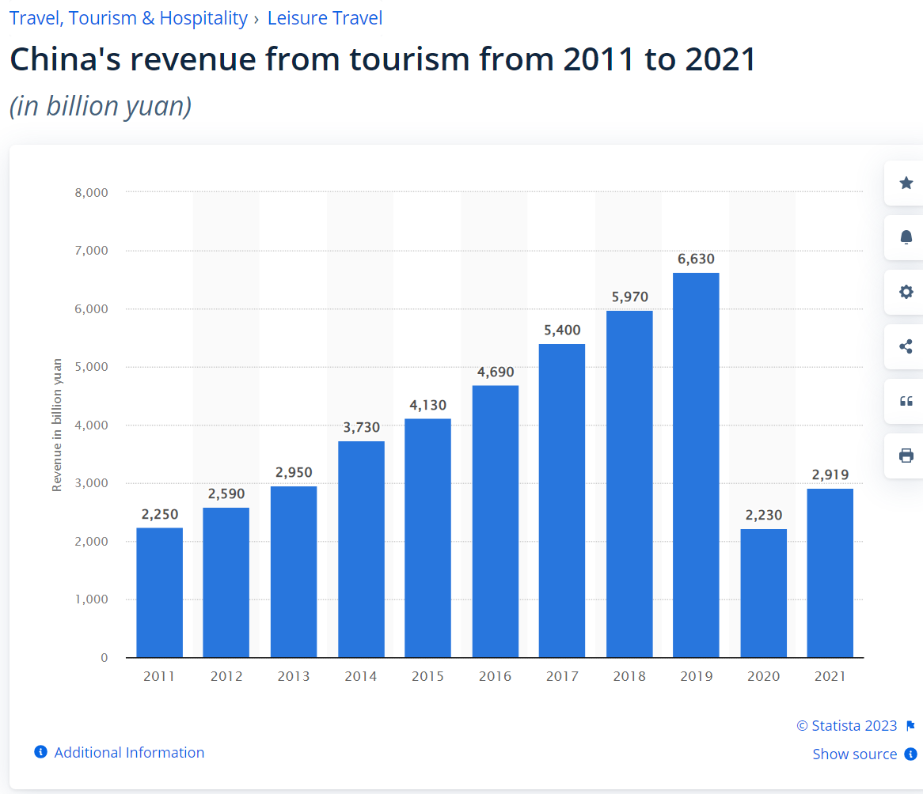Statista 2023.
In 2021, China's tourist industry generated about 2.92 trillion yuan in revenue. Since there has been no inbound tourism since February 2020 because of severe travel restrictions, revenues for 2020 and 2021 are expected to be almost entirely produced domestically.
Beijing is part of the World Tourism Organisation and declared the tourism sector such as a fast-growing socio-economic sector, providing economic growth, creating employment, contributing to development at least developed regions helping eradicating poverty (Beijing Declaration on Sustainable Tourism as a driver of Development and Peace (e-unwto.org) ).
Beijing's Pinggu district maps out plan for green and sustainable development, which outlines the development path of the district over the 14th Five-Year Plan Period (2021-25). Pinggu is now a pilot zone for ecological construction and green development, and the government will improve the ecological space protection system, strengthen spatial and land resource management, defend the "red line" for ecological protection, improve air quality, soil protection, implement compulsory household garbage classification, control plastic pollution, and promote environmentally friendly and energy saving construction projects( Beijing's Pinggu district maps out plans for green and sustainable development- China.org.cn. ).
The post-2020 development scenario will present China with new opportunities and challenges. Three major areas will be its main attention: People and Prosperity, Planet, and Partnerships. Over the next five years, all the UN System's activities in and with China will be built on these priority areas, which will also help China achieve high-quality development.(Sustainable Development Goals | United Nations in China.).
According to Smart Cities Dive that Beijing would include tourism development into its comprehensive planning scheme. Researcher believes that urban planning has not given enough attention to tourism development. Data from the Beijing Tourism Commission shows that in 2012 Beijing's total tourism income was 362.6 billion RMB, and its tourism industry accounted for 7.5% of GDP and 10.5% of the city's total investment in fixed assets (Beijing Includes Tourism Development in City's Comprehensive Planning | Smart Cities Dive ).
The 2019 Beijing International Horticultural Expo has enabled Yanqing to form a full-fledged tourism industrial chain of food, accommodation, transportation, sightseeing, shopping and entertainment. It was suggested building Yanqing into a place of horticulture suitable for different age groups, while others suggested tailoring plans to the different demands of investors and consumers. The focus should be on both high-end and lower-income consumer demand ( Experts explore sustainable development of Beijing Expo- China.org.cn. ). Innovation is the primary engine of development, promoting technological progress and reducing resource waste and environmental pollution. Coordination, green development, openness, and sharing are the ultimate goals of development according to research ( Sustainability | Free Full-Text | Can Implementing the New Development Concept Reduce Carbon Emissions? An Empirical Study from China (mdpi.com) ).
Measures such as green hotel programs and green technology innovation have been implemented to reduce pollution in China. Chinese government can reduce emissions by using renewable sources and eco-friendly vehicles.
The Chinese government is using low sustainable carbon and pollution-intensive strategies to entertain tourists, but trade should transform traditional industries to utilize cleaner energy sources. Green innovation and renewable energy are essential for improving environmental performance and economic development. The government must implement strategies to help develop a sustainable tourism and trade sector, including energy-saving vehicles, pollution tax, green innovation technology, and research and development. This should help reduce the severity of pollution in China, which requires government commitment and solemnity (Zhu et al., 2022). Tourism-related environmental problems, such as noise, air quality, water pollution, and biodiversity loss, negatively affect the image of tourist destinations and the sustainable development of the local tourism industry (Zhong et al., 2011). According to research because of Covid 19 pandemic the results showed that without a pandemic control policy, employment, and tourism would decrease. However, the prevention and control policy reducing the impact of COVID-19, with an increase in unemployment, and reduction in domestic tourism demand (Wang, C. et. al. 2022).
Studies examined the spatial distribution characteristics of tourism villages in the Beijing-Tianjin-Hebei region. Results showed significant differences in the actual spatial distribution, aggregation, multi-core clusters, and positive influences from economic factors, population, transportation, and tourism resources (Zhao, W. 2021).
Environmental factors.
Environmental quality in China is a major issue due to rapid industrial development and economic growth. As of 2021, China ranked fourth among countries with the most natural disasters worldwide. Air pollution is the most prominent environmental issue, with carbon dioxide emissions reaching nearly 11.5 billion metric tons. To reduce emissions, the government has introduced specific reduction targets in the national five-year plans and monitored their implementation. As of 2022, over 80 percent of the surface water sampled across China was categorized as Grade III or above, which was almost drinkable quality. An industry has developed around environmental protection, and air quality has been improving, with 87% of days having a good or above quality in 2021(Environmental quality in China - statistics & facts | Statista 2022). “An environmental protection legal system has been established, with environmental protection law as the core, and pollution prevention and control laws for water, gas, soil waste, noise, nuclear and radiation as the mainstay” according to the Environmental Social and Governance Laws 2023 in China (Environmental, Social, & Governance Laws and Regulations Report 2023 China (iclg.com) ). Beijing is placing its strategic bet on attaining state-directed and supported scientific breakthroughs to enable a domestic green transformation and worldwide tech leadership in all areas, from renewable energy to environmental protection technology “Greening” China: An analysis of Beijing’s sustainable development strategies | Merics.
Tourism generated 800 Mt of CO2e in 2019, accounting for 6%-8% of overall emissions in China.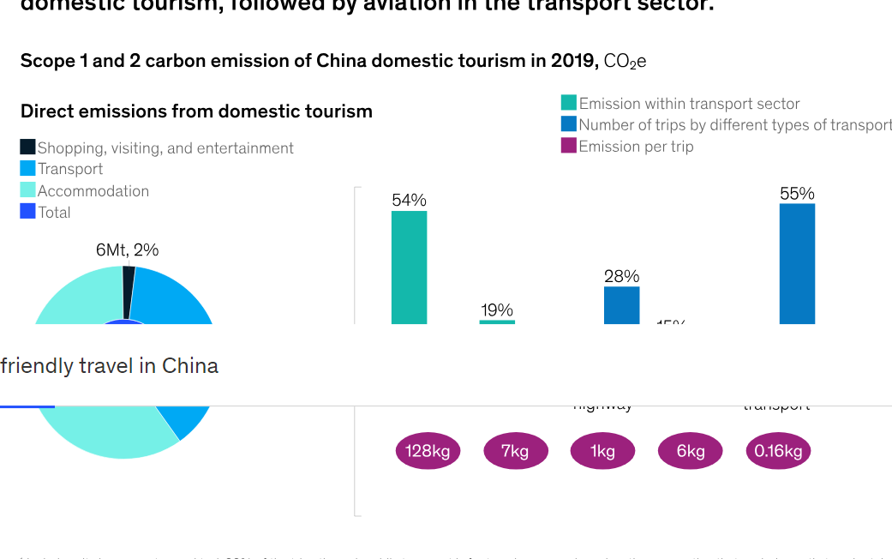
Domestic tourists in mainland China consume 7-8 billion cubic meters of water and generate 12-14Mt of solid waste annually. A three-day round trip by air between Beijing and Shanghai uses and discards single-use consumables, showers, towels, bedsheets, meals, and disposable plastic packaging. The total direct emissions from this trip add up to 330kg CO2e and 1,200 litres of water consumption. Chinese travellers are aware of sustainability, but not willing to pay for it. Governments and tourism providers must work together to support sustainable tourism. Domestic tourists can make changes to their habits to reduce their environmental footprint. They can book sustainable travel options with certified service providers, choose more sustainable transport modes, reduce food and packaging waste, and shop with a sustainability mindset. These choices can help reduce carbon emissions and enrich the experience of the trip accordingly to in a future scenario, all activities and facilities are geared towards reducing emissions. Transport providers could switch to clean fuel and install renewable energy. Waste sorting facilities could be onsite in locations with high food and material consumption, and financial mechanisms could support sustainability projects. All buildings would be designed to be non-intrusive and take environmental consequences into account Sustainable travel in China | McKinsey.
Shangri-La Group partners with local leaders and indigenous communities to create economic opportunities and lasting value for the community.

Social and Community Impact:
The Shangri-La Group works to improve the lives of individuals and communities while protecting the environment and balancing the needs of its various stakeholders Welcome: Shangri-La Group.
Research (Ryan, C., & Gu, H. 2013) suggests the results from comparative studies of residents and businesses in Shi Cha Hai Hutong, Beijing, for 2006 and 2008. Results show that businesses welcome tourism, but residents are more ambiguous in their response patterns. Doxey's Irridex model suggests that the passing of time brings greater tolerance of tourism. Two key suggestions are to link city-based tourism research with urban planning and incorporate processes of urban gentrification into the Butler model of destination evolution.
China abolished the one-child policy in October 2015, allowing couples in urban areas to have two children. The National Strategic Plan considers ageing and health, focusing on home and neighbourhood importance. Research suggests strategies to reduce environmental pressure, recreate place identity, and promote independence in old age. Aging involves reshaping space, creating belonging, and controlling routine, self-identity, social capital, biography, and experience. Filial piety, a traditional Confucian virtue, has been influenced by modernization, urbanization, and the one-child policy, Western theories on aging, place, and health are not suitable for China's case, as cultural values shape positive aging experiences (Yu, J. and Rosenberg, M.W. 2017). Sociodemographic shifts create a diverse labour force, with education being a key indicator. Disadvantaged groups include low-wage workers and limited human capital, with temporary low-income college graduates emerging. Research suggests that job supply and demand in Chinese cities are out of sync due to economic and sociodemographic changes (Hu, L., Fan, Y. and Sun, T. 2017). According to Löschel, A. et al. (2021) studies reveals that Chinese people contribute to reducing CO2 emissions through low-cost local co-benefits, indicating an additional incentive to combat climate change. China, a major emitter of CO2, faces environmental issues like local air pollution, making it recommended to implement co-benefits to reduce emissions.

Conclusion.
Based on the information above and research suggestion, Beijing as a destination can be sustainable choice. However, it is a long road ahead of the region to develop a sustainable environment and more research needs to be done to sustain the development of tourism sector.

Reference:

“Greening” China: An analysis of Beijing’s sustainable development strategies | Merics. (Accessed at: 2023).
Beijing 2022 releases Sustainability Plan (paralympic.org.) (Accessed at: 2023).
Beijing Declaration on Sustainable Tourism as a driver of Development and Peace (e-unwto.org). (Accessed at: 2023).
Beijing Includes Tourism Development in City's Comprehensive Planning | Smart Cities Dive. (Accessed at: 2023).
Beijing's Pinggu district maps out plans for green and sustainable development- China.org.cn. (Accessed at: 2023).
Butler, R.W. (2018) ‘Thoughts of a lapsed (?) geographer’, Tourism geographies, 20(5), pp. 921–922. Available at: https://doi.org/10.1080/14616688.2018.1477174.
C.Textor. 2022: Environmental quality in China - statistics & facts. Environmental quality in China - statistics & facts | Statista. (Accessed at: 2023).
China sets out 5-year path for tourism (www.gov.cn).
China: tourism industry revenue 2021 | Statista. (Accessed at: 2023).
Cooper, C. and Hall, C.M. (2019) Contemporary tourism: an international approach. Fourth edition. Oxford: Goodfellow Publishers.
Crouch, D. (2012) ‘The Routledge handbook of tourism geographies’, Anatolia. Taylor & Francis Group, pp. 446–448. Available at: https://doi.org/10.1080/13032917.2012.731359.
Environmental, Social, & Governance Laws and Regulations Report 2023 China (iclg.com). (Accessed at: 2023).
Experts explore sustainable development of Beijing Expo- China.org.cn. (Accessed at: 2023).
Hall, C.M. (2008) Tourism planning: policies, processes and relationships. 2nd ed. Harlow: Prentice Hall.
How is China showing the rest of the world how sustainable development is done? | World Economic Forum (weforum.org). (Accessed at: 06.06.2023).
https://en.ndrc.gov.cn/policies/202105/P020210527785800103339.pdf.
Hu, L., Fan, Y. and Sun, T. (2017) ‘Spatial or socioeconomic inequality? Job accessibility changes for low- and high-education population in Beijing, China’, Cities, 66, pp. 23–33. Available at: https://doi.org/10.1016/j.cities.2017.03.003.
Löschel, A. et al. (2021) ‘The Demand for Global and Local Environmental Protection: Experimental Evidence from Climate Change Mitigation in Beijing’, Land economics, 97(1), pp. 137–154. Available at: https://doi.org/10.3368/WPLE.97.1.061219-0076R1.
Ryan, C., & Gu, H. (2013). The Social Impacts of Tourism in a Beijing Hutong—A Case of Environmental Change.
Sustainability | Free Full-Text | Can Implementing the New Development Concept Reduce Carbon Emissions? An Empirical Study from China (mdpi.com). (Accessed at: 2023).
Sustainable Development Goals | United Nations in China. (Accessed at: 2023).
Tesone, D.V. (2010) Principles of management for the hospitality industry. Oxford: Butterworth-Heinemann.
The path toward eco-friendly travel in China (March 14, 2023). Report; Sustainable travel in China | McKinsey. (Accessed at:2023).
Wang, C., Meng, X., Siriwardana, M., & Pham, T. (2022). The impact of COVID-19 on the Chinese tourism industry. Tourism Economics, 28(1), 131–152. https://doi.org/10.1177/13548166211041209.
Welcome: Shangri-La Group. (Accessed at: 2023).
Yu, J. and Rosenberg, M.W. (2017) ‘“No place like home”: Aging in post-reform Beijing’, Health & place, 46, pp. 192–200. Available at: https://doi.org/10.1016/j.healthplace.2017.05.015.
Zhao, W. RETRACTED ARTICLE: Rural tourism and spatial development in Beijing-Tianjin-Hebei region under the revitalization strategy. Arab J Geosci 14, 1856 (2021). https://doi.org/10.1007/s12517-021-07971-x.

Zhong, L., Deng, J., Song, Z. and Ding, P. (2011) 'Research on environmental impacts of tourism in China: Progress and prospect', Journal of environmental management, 92(11), pp. 2972-2983. doi: 10.1016/j.jenvman.2011.07.011 https://www.sciencedirect.com/science/article/pii/S0301479711002763.
Zhu, S., Luo, Y., Aziz, N., Jamal, A. and Zhang, Q. (2022) 'Environmental impact of the tourism industry in China: analyses based on multiple environmental factors using novel Quantile Autoregressive Distributed Lag model', Economic Research-Ekonomska Istraživanja, 35(1), pp. 3663-3689. doi: 10.1080/1331677X.2021.2002707 https://doi.org/10.1080/1331677X.2021.2002707.

