Module Title: Hospitality and Guest Service Management

Module code: BMIH4003
Assignment Title: The importance of effectively monitoring guest service approaches
Student name: Ioana Neagu
Student ID:2245342

Executive Summary
This report has delved into the pivotal aspect of guest service approaches within the hospitality industry that has emphasized the critical roles of reputation Management Service culture and brand consistency. Using case studies from industry leaders such as Kimpton, Marriott, and Hilton, the report has outlined challenges experienced which includes fake reviews and Technology disruptions and has offered strategic recommendations as well. The potential recommendations include harnessing advanced sentiment analysis tools personalisation through Data Analytics and balancing automation with the human touch. Embracing these strategies the hotels would be able to proactively monitor guest service approaches that would ensure authenticity enhance guest satisfaction and foster enduring brand loyalty.

Table of Contents
Introduction 3
The importance of effectively monitoring guest service approaches 3
Reputation Management in the Context of Monitoring Guest Service Approaches 3
Service Culture in the Context of Monitoring Guest Service Approaches 5
Brand Consistency in the Context of Monitoring Guest Service Approaches 6
Conclusion 7
Recommendations 7
Reference list 8

Introduction
In the current fiercely competitive hospitality industry ensuring exception and guest experience has become a significant aspect of the success of hotels. This report will delve into the critical context of guest service approaches that would mainly focus on the indispensable necessity for effective monitoring. With an in-depth analysis of the two pivotal components such as service culture and reputation management, the report has aimed at exploding the key to maintaining and enhancing the standing of a hotel in the market. Furthermore, this report will explore the nuances of brand consistency that would emphasise their potential impact on guest satisfaction and loyalty. With the help of a comprehensive examination, this report would illuminate the strategies essential for strategies to not only meet but exceed gas expectations that would secure their reputation, help them foster a positive service culture and ensure long-term success in the competitive hospitality landscape.

The importance of effectively monitoring guest service approaches

Reputation Management in the Context of Monitoring Guest Service Approaches
In the current digital age, deputation management has been acting as the linchpin of the success of a hotel. Guests have often relied on online reviews and ratings while making decisions that have made it imperative for the hospitality industry especially for proactively managing their online image (Heppell, 2015). A pertinent case study in Kimpton Hotels which has been identified as a renowned hotel for its exceptional guest experiences and one of their surveys with customers has showcased that 78% of guests have been considering online reviews to be crucial while making any booking decision (Buhalis and Moldavska, 2022). The proactive approach of Kimpton to reputational management has been involved with responses to online reviews and addressing concerns swiftly and this approach has significantly helped the company in bolstering its image. Such efforts have not only enhanced customer satisfaction but it has also acted as powerful marketing tools that have enabled the company to foster positive word of mouth and repeat business (Ihgplc, 2023). However significant challenges have also been observed experienced by the market players especially while managing reputation. The industrial players have been grappling with the rise of fake reviews that have made it essential for hotels to invest in advanced tools for sentiment analysis and authenticity verification. Additionally, the trend of customer-centric culture has become a potential threat for this in the tree that has initiated the market players and hotels to balance their responses effectively while addressing concerns without exerting the situation at the same time (Baek et al. 2020).
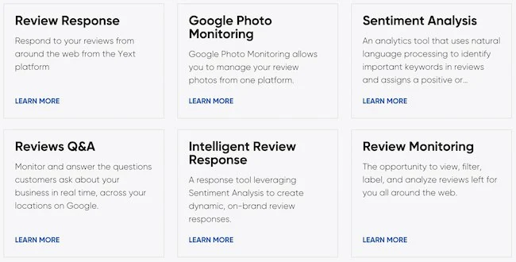
Figure 1: Reputation Management Approaches
(Source: Jeaheng et al. 2019)
In light of the challenges, it has become crucial for the hospitality industry to increase investment in staff training programs that have mainly emphasised the importance of guest interactions and reviews (Wood, 2015). Collaborations with reputable review platforms would be able to provide hotels with valuable insight into customer sentiments that would enable them to tailor their services more effectively as highlighted in Figure 1. Furthermore, the adoption of blockchain Technology for review would be beneficial for enhancing transparency and mitigating issues associated with fake feedback that would ensure the authenticity of online reputations (Teng, 2019). With the objective of staying ahead and gaining a competitive advantage in the hospitality industry, the market players and hotels need to focus on the market Trends as well. Personalisation has been gaining traction due to which guests have been experiencing bespoke experiences from hotels. Utilising Data Analytics would help hotels in tailoring services that would enhance guest satisfaction and consequently online reputation (Rabiul et al. 2022). Moreover, collaborating with influencers and leveraging social media platforms would help the hotels in amplifying positive narratives that would shape public perception and help in mitigating negative feedback impact as well.

Service Culture in the Context of Monitoring Guest Service Approaches
Service culture has been regarded as the embodiment of the values and commitment of a hotel towards guest satisfaction and it has been playing a significant role in shaping the guest experience (Rossanty et al. 2019). The Kimpton Hotels has been standing as a prime example for its celebration of exceptional service culture. With the help of a combination of personalised interactions and anticipatory service Kimpton has not only earned customer loyalty but has successfully gained reviews that have reflected in their impressive customer satisfaction rating of 88% which has been significantly higher than the industry average (Cntraveler, 2023). With the objective of adapting to the evolving market change the hotels need to focus on fostering a service culture that would not only be guest-centric but would be Agile as well. Hoteliers need to focus on employing guest Data Analytics that has been identified to be similar to the leading players like Hilton and Marriott have been executing especially for anticipating guest preferences and customising their services. For example, the mobile request feature of Marriott has enabled the case to make specific requests that have enhanced their experience (Wu et al. 2020).
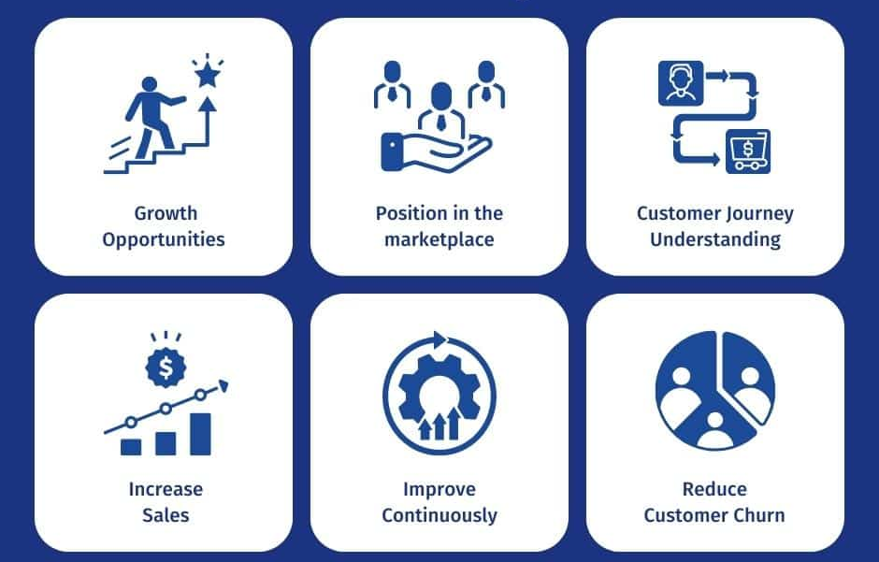
Figure 2: Benefits of Adopting Service Culture
(Source: Wang et al. 2021)
However, the industry has been experiencing significant struggles such as high staff turnover rates. Consistent service culture has been observed to be disrupted when a constant influx of new staff has been introduced into the organisation. To tackle these obstacles, hotels need to invest in comprehensive training programs that train every staff member who embodies the service ethos of the organisation. Additionally, the rise of contactless Technology has been altered in the guest Expectations as well. While automation has been offering efficiency it needs to complement not fully replace human interaction (Djajasinga et al. 2021). Therefore the hotels need to focus on creating a distinct balance as demonstrated by tech-savvy brands such as Aloft hotels as finding these write balances can be regarded to be significant for hotels in the current world. Aloft Hotels has been utilising robots for mundane tasks that have allowed staff to focus more on personalised guest interactions (Olimovich et al. 2020). Furthermore, hotels also need to focus on embracing sustainable practices. The increasing concern of guests towards Eco-conscious choices has initiated hotels and other businesses to take eco-conscious initiatives. With the help of initiatives such as energy efficiency and waste reduction, the hotels have not only been contributing to the environment but it has also been enhancing their service culture. For example, the EarthCare program of Kimpton has not only reduced environmental impact but has also helped the company resonate positively with Eco-conscious guests (Tsao, 2018).

Brand Consistency in the Context of Monitoring Guest Service Approaches
Brand consistency has been regarded as the most significant aspect of cash loyalty and a positive reputation. Kimpton has been identified as a stabilizer in this aspect which has been maintaining a cohesive brand identity across its diverse portfolio. Unique boutique experience is the company has not only differentiated itself but has also achieved remarkable brand consistency throughout the years (Ihg, 2023). Their brand loyalty statistics has reflected this with the high percentage of repeat case that has showcased the power of a consistent brand image. According to Mehta et al. (2023), in the competitive hospitality landscape maintaining brand consistency has been regarded to be a challenging aspect. One major talent experience by the industry players has been regarded as the necessity to balance Global standards with local preferences. Tracking this balance has been associated with a nuanced approach as exemplified by Marriott International which has adopted its offerings to align with local cultures while upholding a consistent Global brand standard (Buhalis and Moldavska, 2022). For navigating this challenge hotels need to invest in comprehensive staff training programs. Staff members have been serving as brand ambassadors and they have been ensuring that the brand ethos has been well reflected in every guest interaction.

Conclusion
In the evolving hospitality landscape monitoring guest service approaches has been observed to be no longer a choice for hotels but it has become a necessity for enduring success. Reputation Management Service culture and grand consistency as exemplified by industrial leaders such as Marriott and Kimpton have been regarded as significant components of customer satisfaction and loyalty. Overcoming challenges such as fake news and adapting to market shifts have been associated with strategy responses that have involved collaboration with review platforms and the adoption of cutting-edge technologies such as blockchain. By seamlessly integrating these strategies Hotel should not only ensure guest contentment but it is also help them cultivate unwavering trust and loyalty which has been regarded as Essential elements for thriving in the fiercely competitive hospitality Arena.

Recommendations
- Embracing advanced sentiment analysis tools and authenticity verification methods coupled with blockchain technology for review validation would help the hotels counter the challenges posed by fake news and ensure a genuine online reputation.
- In cultivating an exceptional service culture hotels need to invest in continuous staff training that would emphasize the significance of Hotel introduction.
- Hotels need to harmonize global standards with local differences as exemplified by Marriott International that would ensure a cohesive brand identity.

Reference list
Baek, J., Choe, Y. and Ok, C.M., 2020. Determinants of hotel guests’ service experiences: an examination of differences between lifestyle and traditional hotels. Journal of Hospitality Marketing & Management, 29(1), pp.88-105.
Buhalis, D. and Moldavska, I., 2022. Voice assistants in hospitality: using artificial intelligence for customer service. Journal of Hospitality and Tourism Technology, 13(3), pp.386-403.
Cntraveler, 2023. Overview of Kimpton Hotels & Restaurants [online]. Available at: https://www.cntraveler.com/hotels/new-orleans/kimpton-hotel-fontenot [Accessed on: 12/10/2023]
Djajasinga, N.D., Sulastri, L., Sudirman, A., Sari, A.L. and Rihardi, E.L., 2021, June. Practices in Human Resources and Employee Turnover in the Hospitality Industry. In 2nd Annual Conference on blended learning, educational technology and Innovation (ACBLETI 2020) (pp. 113-117). Atlantis Press.
Guillet, B.D., 2020. Online upselling: Moving beyond offline upselling in the hotel industry. International Journal of Hospitality Management, 84, p.102322.
Heppell, M., 2015. Five Star Service: How to deliver exceptional customer service. Pearson UK.
Ihg, 2023. Overview of Kimpton Hotels & Restaurants [online]. Available at: https://www.ihg.com/kimptonhotels/content/us/en/press/kimpton-history [Accessed on: 12/10/2023]
Ihgplc, 2023. Overview of Kimpton Hotels & Restaurants [online]. Available at: https://www.ihgplc.com/en/our-brands/kimpton [Accessed on: 12/10/2023]
Jeaheng, Y., Al-Ansi, A. and Han, H., 2019. Halal-friendly hotels: Impact of halal-friendly attributes on guest purchase behaviors in the hotel industry. Journal of Travel & Tourism Marketing, 36(6), pp.729-746.
Mehta, M.P., Kumar, G. and Ramkumar, M., 2023. Customer expectations in the hotel industry during the COVID-19 pandemic: a global perspective using sentiment analysis. Tourism Recreation Research, 48(1), pp.110-127.
Olimovich, D.I., Bakhtiyorovich, T.M. and Salimovna, N.G., 2020. Improving of personnel training in hotel bussines. Academy, (2 (53)), pp.18-19.
Rabiul, M.K., Promsivapallop, P., Al Karim, R., Islam, M.A. and Patwary, A.K., 2022. Fostering quality customer service during Covid-19: The role of managers’ oral language, employee work engagement, and employee resilience. Journal of Hospitality and Tourism Management, 53, pp.50-60.
Rossanty, Y., Nasution, M.D.T.P. and Irawan, I., 2019. Communication and Customer Relations Strategy in Improving Hotel Guests’ Satisfaction. International Journal of Management (IJM), 10(6).
Teng, H.Y., 2019. Job crafting and customer service behaviors in the hospitality industry: Mediating effect of job passion. International Journal of Hospitality Management, 81, pp.34-42.
Tsao, W.C., 2018. Star power: the effect of star rating on service recovery in the hotel industry. International Journal of Contemporary Hospitality Management, 30(2), pp.1092-1111.
Wang, K.Y., Ma, M.L. and Yu, J., 2021. Understanding the perceived satisfaction and revisiting intentions of lodgers in a restricted service scenario: evidence from the hotel industry in quarantine. Service Business, 15(2), pp.335-368.
Wood, R.C. ed., 2015. Hospitality management: a brief introduction. Sage.
Wu, L.Z., Ye, Y., Cheng, X.M., Kwan, H.K. and Lyu, Y., 2020. Fuel the service fire: The effect of leader humor on frontline hospitality employees’ service performance and proactive customer service performance. International Journal of Contemporary Hospitality Management, 32(5), pp.1755-1773.

