A Report focussing on

Construction Systems and

Resource Programming

By:

Nathan Morgan

Table of Contents

- Introduction
- Findings
  - Foundations
  - Basement Construction
  - Superstructure
  - External Walls
  - Roof Construction
- On-Site Construction
- Resources
- Gantt Chart
- References

- Introduction

For this assignment I will be examining the appropriate construction systems for the commercial building that has been proposed by the client. This report will also contain a Gantt chart which will give details on how the works programme has been completed. The report will also show how the resources have been calculated and how they are monitored throughout the scheme.

- Findings
  - Foundations

For this project a raft foundation has been chosen due the nature of the ground being quite poor as it contains a mix of sand, lime and clay. Also, the ground conditions have had a major impact on the choice of construction for all other elements of the scheme. (Designing Buildings 2017). To calculate the duration of most of these tasks I used the ‘Spons Architects and Builders Price Book 2015’.

I have shown an example below on how long it would take for each block to be completed by ‘blinding’. After reading SPONS, it indicated that it takes around 1.7 hours per m³. So with the volume required for each block being around 75m³ (500m² x 0.15m). By using 1 labourer it would take roughly 16 days to complete if working 8 hours per day. So in order to reduce the duration I introduced more labourers to get the job done quicker. So the equation would be:

75 x 1.7 = 2 days
8

  - Basement Construction

The basement construction will consist of a piling system. The piles will have to set at a suitable depth to ensure the adequate load transfer from the superstructure. The piles will also need to provide support against any lateral pressure from the external soil. This will also provide the client with useable basement space for future use. (Anon A). As the basement construction will consist of piling, the method which will need to used would be secant piling. This method consists of walls formed by constructing intersecting reinforced concrete piles. The piles itself would be reinforced with steel and would be constructed by drilling under the mud. The main advantages of secant piling are:

- Increased wall stiffness compared to sheet piling.
- Can be installed when ground is difficult.
- Noise levels are kept to a minimum.
- No need for timber lagging.

  - Superstructure

The superstore of this proposed commercial block will consist of a steel frame. This will satisfy the needs for a modern open plan construction. One advantage of using steel is that all the elements will be prefabricated off site and therefore will minimise disruption on site whilst other works are being carried out. Once the steel is delivered onto site, works can then be carried out in a timely manner to reduce any potential delays. (Steel Superstructure 2017)

  - External Walls

The external covering for this project will consist of glazing which will allow sufficient lighting into the building whilst also making the commercial block stand out. This curtain walling system will act as non-structural cladding for the building and will also provide a water tight structure. (Anon B)

  - Roof Construction

The roof construction for this commercial will consist of reinforced concrete which will match within the surrounding. After the roof construction is complete a covering will be applied to stop the roof from any water getting into the structure. This method will provide high durability to the roof. (Harrison, H.W.(2009).

- On-Site Construction

The construction stage has been planned to allow multiple tasks carry on at once. This will maximise the time allocated on site for the workers. The first step will be to make sure all site offices and facilities are up and running before any work is to start on site. Once site offices and facilities are completed, works can then start on the earthworks and removing any contaminated material.

Following site clearance works, foundations and drainage works can begin. Works will begin by installing all drainage and utility works before any piling work can start. All these works have been split into 4 different sub block to allow other works to be carried out. This will reduced the amount of time required on site. As soon as the basement and foundation works are completed, construction can then begin on the steel frame structure which comprise of the main framework to the building. The floor construction will also being at the same time to make sure all delays are avoided on the project. Lastly, once the steel frame is completed the roof can then be completed and the external glazing can be added to create a water tight structure. This will allow for all internal works to begin.

Resource Calculation

The following gives clarification on how the duration of tasks have been calculated;

Duration = Work Load X Labour Hours
No. of Gangs

Task | Duration | Labourers
Excavation works | 207 days  2 gangs 5 labourers  = 20.7 days  =21 days | 2 gangs of 5 labourers  10 labourers overall
Basement excavation | 740 days  3 gangs 5 labourers  =16 days | 3 gangs of 5 labourers  15 labourers overall

- Resources

The information below is relating to the resources allocated to this project. This information will be monitored throughout the project to ensure the tasks can be completed efficiently and also ensuring adequate resources for this development.

Name | Start | Finish | Remaining Work
Steelworkers | Mon 29/01/18 | Wed 03/10/18 | 1,750 hrs
Crane operative | Tue 13/02/18 | Wed 03/10/18 | 1,825 hrs
Excavator operative | Thu 25/01/18 | Tue 27/03/18 | 72 hrs
Groundworkers | Fri 01/12/17 | Tue 27/03/18 | 245 hrs
Roofers | Fri 07/09/18 | Fri 14/09/18 | 42 hrs
Carpenters | Thu 05/07/18 | Mon 16/07/18 | 66 hrs
Concrete gang | Mon 12/02/18 | Mon 30/07/18 | 66 hrs
Glazed wall specialist | Thu 19/04/18 | Wed 26/12/18 | 1,436 hrs
Piling contractor | Tue 09/01/18 | Fri 23/03/18 | 378 hrs
Concrete flooring specialist | Tue 13/02/18 | Wed 04/07/18 | 478 hrs

Some changes need to be amended in the below Gantt chart. The first change needs to be the duration of the earthworks. From looking over the Gantt chart I realised that the duration shown was too short. After spotting this mistake I then recalculated it and the duration should have been 21 days instead of 11 as shown. When calculating the basement excavation the Gantt chart shows only 2 days but this also needed to be recalculated as this duration was also too short. After recalculating it would take 3 gangs of 5 labourers a total of 16 days to complete the basement excavation. The foundation phase also needed to be amended. Below I have shown the calculations for the amended durations and hours. All of the below labour hours were taken for SPONS. (RICS 2018)

Foundations (500m² per sub-block)

- Blinding
- Labour hour = 1.71m²
- Volume required = 500 x 0.13 = 75m³
- 75 x 1.71 = 128.25 hours

- Drainage & Utilities
- 2 days per sub-block (8 days in total)

- Steelwork for raft foundation
- Steel mesh and reinforcement = 0.08m²
- 500m² x 0.08m² = 40 hours

- Concrete pour for foundations
- Labour hour = 1.02m³
- Depth = 450mm
- Volume = 500 x 0.45 = 225m³
- 225 x 1.02 = 229.5 hours

- Curing period
- Allow 14 days for curing period

After calculating all durations, the table below shows the amount of days needed and labourers required to complete the foundation phase.

Foundations (per block A.B.C.D)
Blinding | 16 days = 2 days  8 labourers
Drainage & Utilities | = 2 days
Steel work for raft | 5 days = 1.7 days  3 labourers
Concrete pour | 28 days = 2.8 days  10 labourers
Curing period | = 14 days

Repeat the above process for each sub-block.

- Gantt Chart

- References

Anon A. (2017). Piling. Available: https://www.concretecentre.com/Building-Elements/Foundations/Piling.aspx. Last accessed December 2017.
Steel Construction. (2017). Steel Superstructure. Available: https://www.steelconstruction.info/Construction. Last accessed December 2017.
Harrison, H.W., 2009. Roofs and roofing: performance, diagnosis, maintenance, repair and the avoidance of defects, Garston, Watford: BRE Press.

Anon B., 2017 Planning Planet. Curtain Walling | Project Controls - planning, scheduling, cost management and forensic analysis (Planning Planet). Available at: http://www.planningplanet.com/wiki/422545/curtain-walling [Accessed November 05, 2017].

Design Building. (2017). Raft Foundation. Available: https://www.designingbuildings.co.uk/wiki/Piled_raft_foundation. Last accessed December 2017

GemTech. (2018). Piling. Available: http://www.gemech.co.uk/contiguous_secant.html. Last accessed January 2018.
RICS. (2018). Spons. Available: http://www.rics.org/uk/shop/Spons-Architects-and-Builders-Price-Book-2018-20683.aspx. Last accessed January 2018.

A Report focussing on

Site Layout

Assignment 2

By:

Nathan Morgan

Table of Contents

- Introduction
- General Information on Site Logistics
- Site Planning
- Appendix 1
- Appendix 2 (phase 1)
- Appendix 3 (phase 2)
- Appendix 4
- References

- Introduction

For this assignment I have been asked to write a report describing the site logistics for the construction of the commercial block as stated in previous reports. I will begin to discuss how to plan a site layout including all relevant facilities including:
- Site offices
- Welfare facilities
- Canteen
- Storage area
- Car parks
- Crane location
I will also be describing the resources needed for each stage of the construction project and how the site will change along the duration of the project. I will be including drawings to improve your understanding of my chosen solutions.
- General Information on Site Logistics

Site logistics in construction is vital for any constriction project as it can give huge advantages in proficiency and profitability that fundamentally reduces the general cost of the project. There’s nothing more disappointing than having a workforce not being able to carry on with the work as they are waiting on delivery of materials. This can have a big impact on other workers involved in the project, yet with some arranging these materials can be delivered so each phase of the development can proceed without any delays (aec business). The main contractor should have a plan well in advanced, with a full stock of what materials and plant will be required at each stage. Having the capacity to successfully deal with the flow of materials from source to site enables a number of advantages:
- Substantial savings and decrease of waste. Preparation allows materials to be on site when needed so the construction team can work with no needing to stop.
- On site arranging implies that all materials are put away properly and are anything but difficult to find. Again this quickens up the process, and enhances effectiveness.
- A clean site is a safe site. Good planning avoids all kinds of clutter and is better when sorted out. This also helps health and safety.
- Site Planning

The most important task of site management within every construction project is making sure the site layout planning is correct. Poor site planning can lead to a lot of problems. An effective site plan should allow all personnel, site equipment and plant deliveries to work together from start to finish of the project. A detailed plan of the site showing all facilities will enable the management to make any improvements when necessary, this will improve the projects time and improve the workers by creating a better and safer environment. (Get Mapping 2018)

The site planning can be an aspect of the project than can potentially be neglected and therefore tends to be developed as the project develops. Labour costs on large projects take around 50 to 60% of the total project cost. Substantial saving can be achieved if the labour force moved freely and quickly within the site. A good site layout plan will lead to the following:
1) Increase productivity and safety.
2) A reduction in areas needed for temporary construction.
3) Maximizing useof the space available.

Preparation is key for a successful site layout plan. The following have been considered through the development of this project:

- Site accessibility- The site layout has been prepared to allow accessibility for equipment and vehicles to be safe, and also minimize the chance of accidents, and save time in maneuvering to arrive at and leave the site. The site layout has also provided internal road to facilitate any traffic during the project. The route has been designed as a one way system to mitigate any turning movements within the site boundary. Also included in the plans is separate walkway for site personnel and visitors. Parking facilities have also been provided for the site management, trade personnel and visitors to site. These have been located near the site entrance, to allow all personnel to monitored at entrance gate. At the exit of site there will be a wheel wash system which will ensure that no site debris will carried out onto the public highway.

- Site Safety- Construction safety on site is the most vital part of site planning from start to finish. PPE will be provided to all workers which will include safety boots, hard hats, gloves, goggles and these must be worn at all times during the workers time on site. The perimeter of the site will be closed off the timber panel fencing with windows cut into the timber to allow people to see what’s going on at the site. According the Highways Act 1980 “A close boarded fence hoarding is required to be erected prior to the beginning of building operations if such operations are adjacent to a public footpath or highway”.

- Traffic Signs- Traffic signs have been provided on the plan to provide assistance in guiding the traffic on the site and to avoid any accidents that may occur. This will help to eliminate any disputes between labour and management. An emergency escape route will also be displayed on each floor as required.

- Material Storage and Waste Management- As the plans show, there is a storage area where all the materials will be stored and a waste plan showing where all the waste material will go. Both of these areas have been situated near the access to the site as this will allow for easy access and avoid any delays. A variety of skips will be on site to quickly and effectively get rid of all materials. (Anon 2018)

- Security- A manned personnel will be at the entrance of the site during the site hours to ensure the site has no security issues and so that all deliveries coming into the site are on time so no work is disrupted.

- Crane- The crane that’s been chosen to operate on this site will be a single crane which will be able to accommodate for the whole site. By only having one crane, this will be a big saving over the total cost of the project. The crane will also be able to manage all deliveries. The crane plan on Appendix 4 shows how a single crane will be able accommodate the whole site.

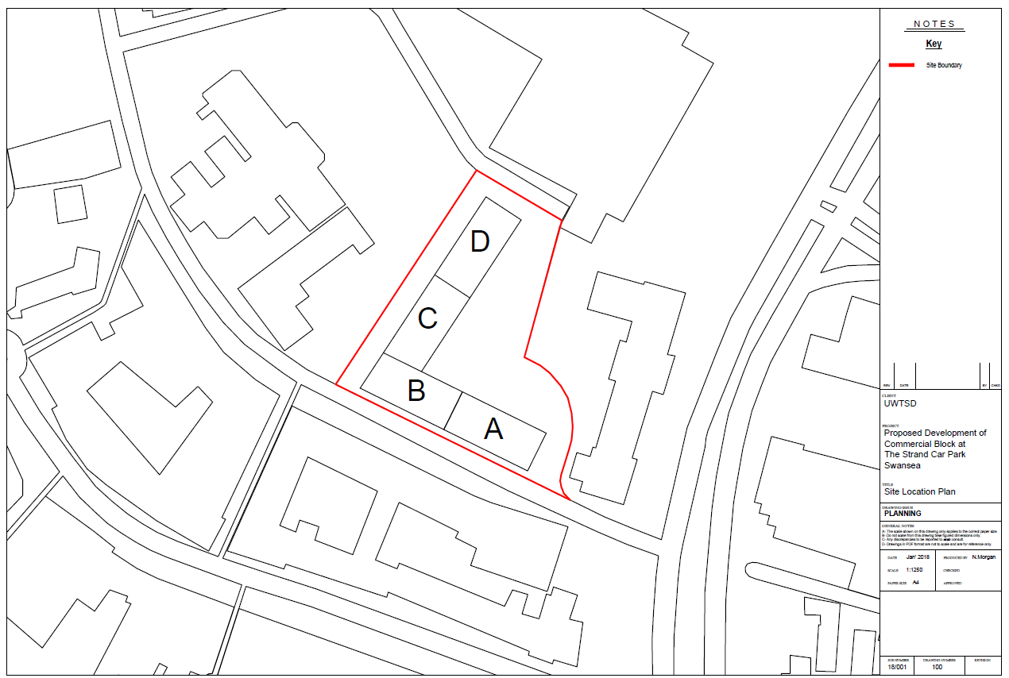
- Appendix 1- Site Location Plan

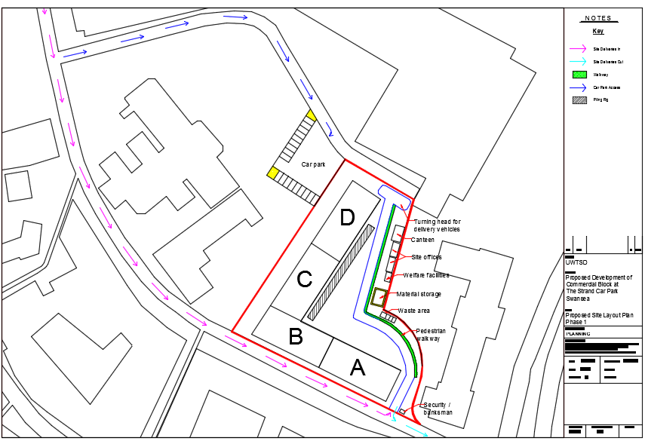
- Appendix 2- Site Layout Plan (phase 1)

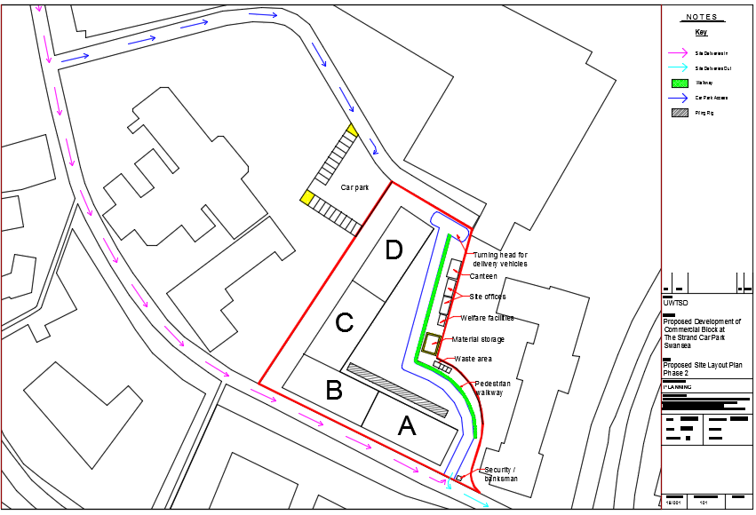
- Appendix 3- Site Layout Plan (phase 2)
- Appendix 4
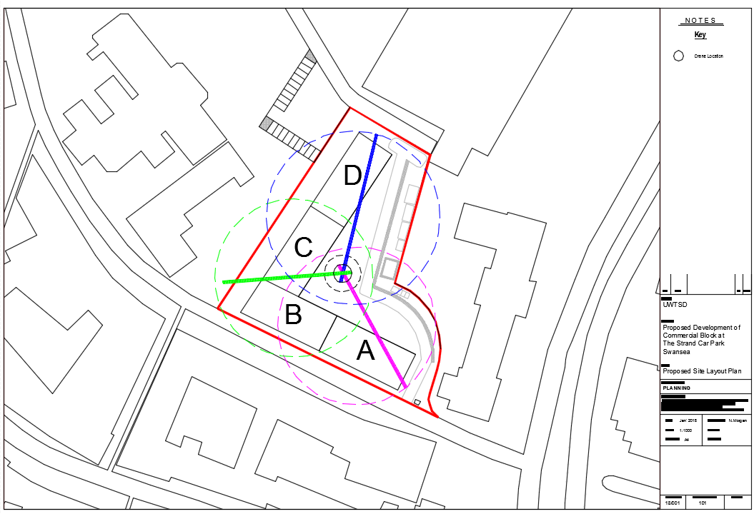

- References

AEC Business. (2018). Site Logistics. Available: https://aec-business.com/logistics-key-construction-site/. Last accessed January 2018.
Get Mapping. (2018). Site Location Plan. Available: http://www.getmapping.com/support/planning-maps/what-difference-between-site-plan-and-location-plan. Last accessed January 2018.
Tower Crane image 1. Available: http://www.falconcranes.co.uk/shares/sitefile_20580.pdf
HSE 2018. (2018). Traffic Management. Available: http://www.hse.gov.uk/construction/safetytopics/vehiclestrafficmanagement.htm. Last accessed January 2018.
Tower Crane image 2. Available: http://www.falconcranes.co.uk/shares/sitefile_20580.pdf
Anon, Traffic management on site. Construction - Traffic management on construction sites. Available at: http://www.hse.gov.uk/construction/safetytopics/vehiclestrafficmanagement.htm [Accessed January 22, 2018]
Dr Emad Elbeltagi. (2018). Site Layout. Available: http://drahmedelyamany.weebly.com/uploads/7/0/1/0/7010103/site-layout_dremad.pdf. Last accessed January 2018

