Ieuan Morgan Davies
Programme : HNC process operations engineering
Module : Process Engineering practice
Assignment title : Operations of practice

Table of Contents
Task 1 (LO4) 3
Operation 3
The Dissolved air floatation (DAF) Tanks 3
the operation of the DAF tank 5
circular design 5
top scraper 5
bottom scraper 6
Weir plate and ‘V’ shaped weir 6
Clean water tank 6
Failure 6
Mechanical failure 6
Process failure 7
Eliminate the risk 7
Task 2 LO3 8
Tank Farm 8
Crude unit 8
Crude column principle 9
Trays 10
Bibliography 11

Task 1 (LO4)

For task four you are required to demonstrate an ability to describe process equipment operation and an awareness of physical hazards present at a facility.

A key item of process equipment at your facility (e.g. column, compressor, turbine, pump, heat exchanger).

Your report should include the following detail for the equipment chosen;

- The technology and theory associated with the equipment.

- The principle of operation of the equipment in service.

- The conditions that could lead to failure for the chosen equipment including process, physical, mechanical and operational abnormalities and hazards. (pressure, temperature, flow, contamination, vibration, deterioration mechanisms and indication of deterioration, abnormal combustion conditions and operational conditions.

- The attempt to eliminate the risk posed by the hazards identified through application of the current HSE framework.

Operation

The Dissolved air floatation (DAF) Tanks
For task I will be looking at the Waste Water Treatment plant (WWTP). The Dissolved air floatation (DAF) Tanks are used to remove oil and solid particles from the influent (water). Influent is raw water which needs to be treated and effluent is treated water which is suitable to be discharged to the haven. It is located downstream of the API bays.
(K.lloyd, 2018)
The AIP bays have an average of two hours retention time, this allows oil to settle out on top of the water and the sludge or solid particles to fall to the bottom of the bay due to the difference in density. Next, the influent will pass through a weir only allowing the water to flow through and stopping the oil. this is where a large amount of oil and solids will be removed. From there It will flow though the Secondary Diversion Box (SDB), here two chemicals will be mixed in with the water, these are polymer and coagulant. These will chemically bond to solid partials and hydrocarbons, these will increase the surface are of the solid or hydrocarbon and therefore lower the density of the solid or hydrocarbon. This process is called flocculation.
(K.lloyd, 2013)

Flocculation is where fine particles are bonded together to make ‘clumps’ the clumps will increase the surface area of the clump, and this will decrease the overall density of the club and therefore, the clamp will float on water. However, if the clamp gets too big the density can increase and therefore it will then sink in water due to the density being heavier, this will then fall to the bottom of the tank and form a sludge.
(Baraniak, 2003)

The chemicals for flocculation used at Pembroke’s WWTP are coagulant and polymer. Coagulant is the primary chemical for bonding to the solid particles and hydrocarbons, then the secondly chemical is the polymer which joins the little clumps of coagulant and solids/hydrocarbons together. This means the clumps will either float on the water or they will sink.

Next, there will be compress air added into the line upstream of the DAF tank, this will be pressurised using plant utility air which goes through a compressor, powered by a set of pumps.

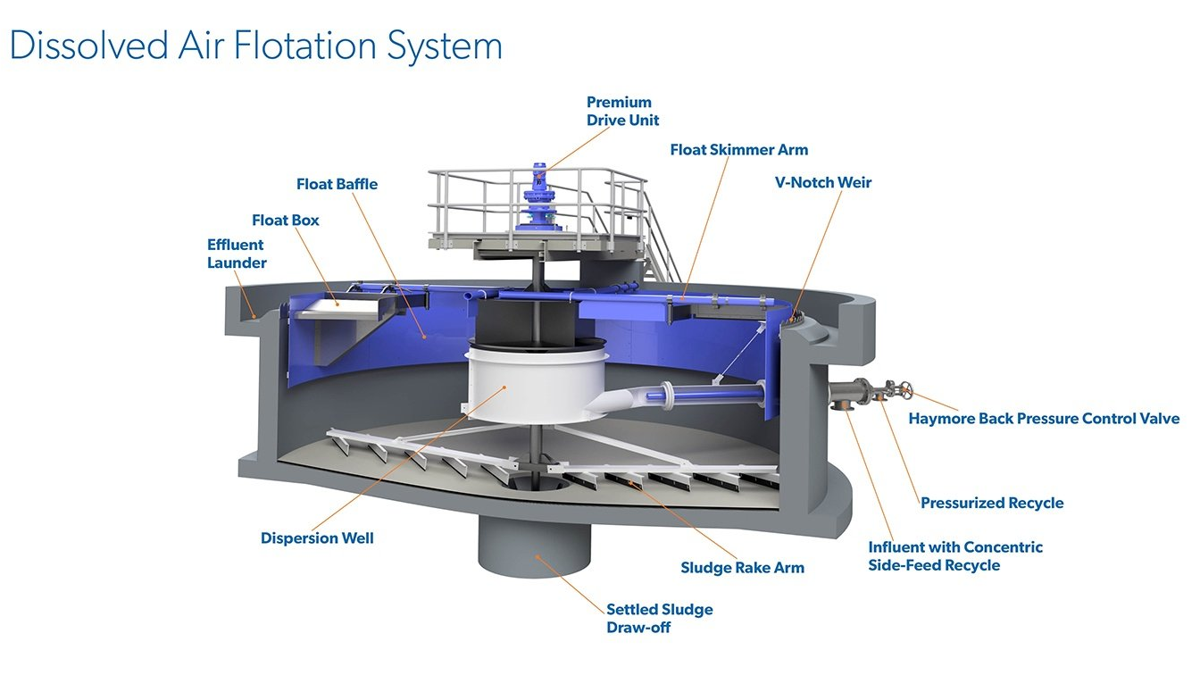
Figure 1 - DAF tank

the operation of the DAF tank
The influent will enter the tank though the centre, from there the influent will disperse. The pressurised air will crease bubbles in the water, these will then push the solids and hydrocarbons to the surface of the DAF tank.

circular design
the tank has a circular design to allow the two scrapers to rotate and cover as much surface area as possible. the bridge moves in a clockwise motion, this will run constantly without stopping. Additionally, having a circular design means no sludge will be able to build up due to all areas of the tank being covered with a scraper.

top scraper
the top scraper is connected to the bridge and will rotate in a clockwise motion, moving constantly. The scraper is approximately 6 inches long, and partly submerged in the water and the other half will be on the surface. This Is to capture all the solid partials which are being pushed to the surface. The scraper is submerged in the water to capture any large amounts of carry over which can create a build up on the surface of the DAF tank.

bottom scraper
the bottom scraper works in the same way as the top scraper however, it is located at the bottom of the tank and will ensure there is no sludge build up on the bottom of the tank. It will scape the sludge into a common sludge pot on the side of the tank, this will be pumped into a slop tank.

Weir plate and ‘V’ shaped weir
There will be a weir which will be about 15 inches high, it will be placed above and belove the surface of the water. This is to ensure that solid particles are forced to stay on the surface of the water and the water with no contaminates will flow under the weir. Next, there is another weir with ‘V’ shaped notches cut out which allows the water to pass though, these are designed to catch any dirt or debris.

Clean water tank
The clean water which passes over the ‘V’ shaped weir, will flow into the clear water tank. From here it will have two routes, these are to the upstream and downstream of the DAF tank. This is to allow the influent to flow though the DAF tank and to remove the highest amount of solid particles and hydrocarbons as possible, and therefore make the process as efficient as possible. The other influent will leave the clear water tank by a different rout, this will be to the flume and will continue to make its way though the waste water plant.

Failure
The DAF tanks there is a number of things which can go wrong, these are:

Mechanical failure
Mechanical failure, this can be the motor which turns the two scrapers, the pump which removes sludge from the sludge pot or the pumps which helps supply the air for the pressured air.

If the two scrapers stop rotating, them all solid particles and sludge will not be removed from the tank and therefore it will have a build-up.

If the pump on the sludge pot fails the level in the pot will build up and will overflow, therefore creating hazardous conditions on the plant and should be checked regularly.

If the pumps for the pressurised air there will be no pressurised air to the DAF and therefor the process will be less effective.

Additionally, the pumps which pump the polymer or coagulant can also fail resulting in no chemicals being added to the process

Process failure
Finally, the last failure can be wrong flow rate thought the DAF tanks, the lower the flow rate means the DAF has more time to separate the influent and solids, however if the flowrate is increase the retention time will be decreased. Furthermore, if there is increased amounts of oil or hydrocars then the DAF is designed for, then it will not be efficient at removing them.

Eliminate the risk
When working around the DAF or Above , ensure all required PPE is worn at all times. Additional PPE will be a facemask to ensure you do not inhale any small particles. All risk assessments and procedures should be followed when carrying out work.

Task 2 LO3
For task two you are required to demonstrate a knowledge and understanding of the units that make up an industrial process. With this in mind, you should include a description of the main process units at your facility. You should consider the chemical and physical transformation processes occurring in at least one unit at your facility.

Tank Farm
Crude oil is imported into crude storage tanks located in the tank farm. The tanks will be left to settle for a minimum of six hours, however the longer they are left the better. The tank is left to settle before the density difference between oil and water means the crude oil will float on the water and therefore the water will settle out on the bottom of the tank. This allows any water to be water drawn and removed from the tank, as much water should be removed as possible. From there it will be but onto the feed system which feeds the crude unit. It will go through a ‘crude blender’ this will control the ratio between the different crude oil. Different crude oil has different mixtures; therefore some crude oil is heavy and some has more light ends. The ratio will change depending on how the crude unit needs to react and depending on if the company wants more light or heavy products.

Crude unit
Next, the crude oil will enter the crude units battery limits. From there it will flow through a set of cheat exchangers, these warm the crude oil using heat from hydrocarbons which are flowing out of the crude column, this heat is transferred to the raw crude oil which will the. Flow to the desalters. The purpose of the desalter is to remove traces of water which are left in the crude, this will be to reduce water, salt, sodium and magnesium chloride. the water which is left in the crude oil is normally mixed in resulting in an emollition being formed. The emollition is removed by using electronic grids which use high voltage and low amps. this will separate the oil and the water. The water will be routed to the Wastewater treatment plant (WWTP). Next, the crude oil will flow to the pre-flash drum, this will lower the pressure allowing the light ends to vaporise, and these will be routed directly to the crude column. All other crude will be preheated using heat exchanged, the oil which heats this will be the bottoms which are leaving the crude unit and are on feed to the Vacuum Distillation Unit (VDU), next it will flow through a set of fired heaters, these will increase the temperature of the crude oil before it goes into the crude column. (Carey, 2015)

Crude column principle
The Crude works on the principle that the lighter the product is, the less energy it takes to turn into a gas and the heavier the product the more energy required to turn it into a gas. Light products have less hydrocarbons in the chain, and heavier products will have a longer chain. (Mingasov, 219)

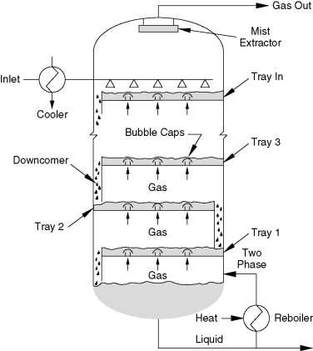
Figure 2 - Crude column
Using that principle, the lighter the products will rise up the column and the heavier ones will descend down the column. Products found in the crude column will be naphtha, kerosene light diesel, heavy diesel, atmospheric reside. (K.stone, 2018)

Trays
Diving the crude column up will be tray. These trays help the separation of the different products, they allow gasses to pass up though the bubble caps and will hold a level of product on the tray, as shown in figure 2 and 3. (Mingasov, 219)
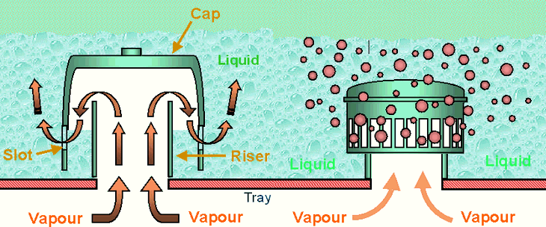
Figure 3 - Trays in crude column
The products will settle out on the trays as required; this is due to the lower temperature as products make the way higher up the column. This is due to the re-boiler being at the bottom and all heat is kept at the bottom of the column due to the heavy products being circulated at the bottom. (Mingasov, 219)

The pressure is controlled using the overhead system which controls the level in the overhead drum, if the pressure starts to increase in the main crude column the level in the overhead drum can lowered by increasing the flowrate. Additionally, fin fans can be used to control pressure, this will be done by reducing the temperature of the products and therefore the pressure will decrease.

Once all products have been separated out, they leave the tray and flow to another unit to be refined even more and get a product which is pure. Depending on what unit the product will be going to, some products are cooled using fin fans and heat exchangers. Heat exchangers are often used to cool products due to heat transfer from a hot product to a cold product, resulting in no additional energy required for heat transfer to occur.

Bibliography
Baraniak, B., 2003. Sciencedirect. [Online]
Available at: https://www.sciencedirect.com/topics/biochemistry-genetics-and-molecular-biology/flocculation
[Accessed 20 4 2021].
Carey, D., 2015. Plant operator - Crude Distilation Unit , s.l.: valero.
K.lloyd, 2013. WWTP monitor and control, s.l.: Valero.
K.lloyd, 2018. PLANT OPERATOR - WASTE WATER TREATMENT PLANT, Pembroke: Valero.
K.stone, 2018. PLANT OPERATOR CRUDE DISTILLATION UNIT , s.l.: Valero.
Mingasov, S.-B. A. /. R. R., 219. Crude Distilation Unit. [Online]
Available at: https://www.intechopen.com/online-first/crude-distillation-unit-cdu
[Accessed 21 4 2021].

Figure 1 (DAF tank) - https://www.westech-inc.com/products/dissolved-air-flotation-clarifiers-and-thickeners
Figure 2 (Crude Column) – https://www.sciencedirect.com/topics/engineering/fractionation-towers
Figure 3 (Trays in crude Column) - http://www.wermac.org/equipment/distillation_part2.html

