All About me and my ADHD.

A teaching resource for girls with ADHD.

By Ffion Weston

Contents:

- Overview, aims and intended outcomes of project: 2
- Evidence of the need for the work: 3
- Information pack for teachers: 5
- Disclaimer: 9
- Workshop 1: Understanding ADHD: 10
- Workshop 2: Exploring our struggles: 13
- Workshop 3: Stress and anxiety: 18
- Workshop 4: Being yourself and confidence building: 21
- Workshop 5: Focusing: 25
- Workshop 6: Emotional regulation: 28
- Workshop 7: Creating our toolbox: 31
- Workshop 8: Celebrating connections: 33
- Appendix: 36
- Risk assessment: 38
- Ethical considerations: 40
- Handouts: 41
- Bibliography: 43

Title: All about me and my ADHD

Overview

This resource is designed for teachers who are working with girls who have ADHD. The workshops have been crafted to work on the common struggles that girls who have ADHD go through, teaching them healthy coping mechanisms and building resilience.
This teaching pack also gives teachers advice for working with girls with this learning difference, while aiding them in building understanding about ADHD as a whole.

Aims

The main aims for the resource are as follows:
- To teach girls with ADHD healthy coping mechanisms to deal with the struggles of ADHD
- To bring more awareness to ADHD and how it presents in girls.
- To build understanding of the struggles of ADHD
- To build resilience in girls who have ADHD

Objectives

The aims will be achieved by:
- Creating an information pack for the teachers about ADHD, how it presents in girls and the struggles a girl goes through while growing up with ADHD, this is to be accompanied by videos and tasks to aid in the learning process
- Creating a series of workshops with the topics of different struggles girls with ADHD experience and how to deal with these difficulties.

Intended outcomes

By the end of the project, the participants would have learned how to cope with their ADHD and the challenges that accompany it. They will also have built resilience and learned healthy coping mechanisms through participating in these workshops.
The teacher will also have more understanding of ADHD in girls and will learn how to best support their students who have this learning difference.

Evidence of need for the work

Through research I have found there are many theatre companies who create performance with and for people who have disabilities, one of which is the Taking Flight theatre company based in Cardiff. The Taking Flight company website states that, “At Taking Flight we make bold, unusual theatre productions with D/deaf, disabled and non-disabled performers” (Taking Flight, 2020). Taking flight creates theatre and tours around Wales with a mission to break down barriers of participating theatre and strives for a more inclusive view of performance.

Another inclusive theatre company is Hijinx theatre based in Cardiff’s Wales Millennium Centre. Hijinx work with autistic individuals and those with learning disabilities as they believe “our understanding of humanity is enriched when we view the world from a different perspective” (Hijinx, 2020). Although Hijinx are based in Cardiff, the company works with people from all over Wales with their academies and their Hijinx Pawb community projects.

Both these companies are advocates for the important work of inclusive theatre, but neither of these bodies work with individuals to help them cope with the struggles of disabilities. Whilst there are schools that aim to help students with learning differences gain the skills they need to be independent in life, I have been unable to find any programmes in the South Wales area which use drama to aid girls with learning difficulties to create healthy coping mechanisms. As girls with ADHD present symptoms differently to boys, there are complex struggles that need to be addressed which need healthy coping mechanisms rather than self-destructive ones, such as self-harm.
Evidence supports that there is an increased level of girls who have ADHD who use self-harm as a coping mechanism. Stephen P. Hinshaw, Ph.D. conducted a study “Self-Harm as a Developmental Outcome in Girls with ADHD: Clinical Significance and Underlying Mechanisms” (Hinshaw, 2015).

In this study it states that peer victimization had an intense impact on the reason for which adolescent girls with ADHD were using non-suicidal self-injury (NSSI) as a coping mechanism.
Hinshaw states that,

“Through ten years of prospective follow up, indicate the clinical reality of significant self-harm in girls with ADHD as they emerge into early adulthood. Rates of both attempted suicide and engagement in NSSI were particularly high in the originally diagnosed group with the combined form of ADHD”.

(Hinshaw, 2020)

Hinshaw further goes on to report that females that were highly impulsive in childhood begin to create “self-destructive behaviour patterns” (Hinshaw, 2020).
This study shows that without adequate support, many young women with ADHD begin to suffer with mental health issues. This is the reasoning behind why I believe a project such as mine, which aids students who have this learning difference, to create healthy coping mechanisms, would be important to implement into schools who have female students who have been recognised as having ADHD.

Information pack for teachers:

Understanding ADHD - spotting ADHD in students, masking and comorbidity

Definitions

Comorbidity: Refers to the presence of more than one disorder in the same person.

Masking: Masking is when a person hides their social difficulties to the point where it makes it hard to diagnose a disorder.

ADHD: Attention Deficit Hyperactivity Disorder.

What is ADHD?
ADHD stands for Attention Deficit Hyperactivity Disorder and can affect people of all ages and genders. ADHD is not something that people ‘grow out of’ but instead have to learn to manage as they grow older.

Symptoms of ADHD
According to the NHS website, symptoms in children and teenagers include;
- Inattentiveness
- Hyperactivity and impulsiveness

In teenagers however, ADHD symptoms can also include;
- Anxiety Disorder
- Depression
- Oppositional Defiant Disorder
- Sleeping problems
- Eating Disorders

ADHD and School

Having ADHD can greatly affect how a student performs in school and the quality of their education, this can happen if they are not taught how to manage their symptoms or allowances are not made to accommodate their difficulties.

A child who has ADHD may also have other comorbid disorders or learning difficulties such as:
- Dyslexia
- Dyspraxia
- Dysgraphia
- Autism
- Anxiety disorders
- Depression
- Bipolar disorder
- Schizophrenia

(AADD-UK, 2020)

But how does ADHD actually affect a student’s school life?

A child may:

- Have trouble concentrating or staying focussed on a task, getting distracted extremely easily.
- Have trouble remembering what they have just read
- Have difficulty copying from the whiteboard or screen
- Be unable to sit for prolonged periods of time
- Have trouble completing homework tasks
- Have poor organizational skills,they may also struggle to organize thoughts, their desks and/or projects.
- Have poor time management skills, often arriving late to class or school.

How can I tell if a student has ADHD?
It is not always possible to spot if a child or student has ADHD, although the symptoms of ADHD can cause the following results, if educational services are not put in place.

- Lowered marks in tests and examinations
- Increased stress and anxiety
- Increased difficulty in study skills
- Strong dislike of school and schoolwork
- Constant loss of focus and increased distractibility

ADHD in girls

It was thought previously that girls were less likely to have ADHD, as it presents differently in girls than it does in boys, this is untrue. Boys tend to be disruptive in class or show stereotypical signs of ADHD, while girls tend to be less disruptive but struggle more with concentration, constant daydreaming in class and are not as hyperactive as boys with ADHD. As these girls do not fit the preconceived personality of a typical person with this learning difference, many go unnoticed and undiagnosed until later on in life.
Girls tend to work hard to overcome difficulties and therefore become extremely good at hiding their symptoms of ADHD and this is called masking. Masking makes it extremely difficult to diagnose girls with ADHD and causes many girls who have this learning difference to go through education without the help that they need.

Girls who have ADHD are also much more likely to suffer from depression, anxiety and eating disorders in comparison to girls who do not have ADHD (Childs Mind Institute, 2020).
Additionally, girls tend to blame themselves and internalise their difficulties causing mental health issues.

Test Time!

Please fill out the worksheets below to record your understanding of the key information which have been discussed previously.
Task 1 - Fill in the blanks

- ADHD stands for _____________________________________________________.

- Girls who have ADHD are more likely to develop ___________________________ than girls without ADHD.

- People who have ADHD often have other learning difficulties such as: (give three examples)

______________________________________________________________

__________________________________

- Girls with ADHD often work harder to overcome difficulties and hide their struggles.

This is called _____________________.

Task 2-True or False.

Girls are less likely to have ADHD:

ADHD can affect time management:

Girls with ADHD are typically less hyperactive than boys with this learning difference:

If a person has ADHD it means they also have autism:

Task 3 - Journaling time!

Write a short paragraph reflecting on how you can create a better learning environment for your students with ADHD.

Top tip!
Maybe think about your teaching plans and how you could change them to be more interactive or visually stimulating!

All about me and my ADHD: Workshops and exercises.
Many of the exercises included in this resource pack have come from different drama practitioners. My research has led me to believe that the exercises which have been put together in these unique workshops, have the potential to create a positive change in the lives of young girls with ADHD. Please see the bibliography and resources section for further information on these practitioners.
This teaching resource will aid you in creating a positive environment for students with ADHD to learn and each workshop is designed to last for approximately 1 hour each.

Workshop 1: Understanding ADHD
Check in: 10 minutes
Begin by introducing yourself and explain that these workshops have been created to aid in helping girls with ADHD to create healthy coping mechanisms
Icebreaker: Go around the circle and ask everyone to say their name (if they feel comfortable enough) and then say a number from 1-10 to describe how they feel.

Warm up game: 5 minutes.
Zip Zap Boing
- To play Zip Zap Boing, the group must stand in a circle
- The leader will tell the group that to pass a ‘Zip’ around the circle, they must clap their hands towards the person on their right.
- Once the ‘Zip’ comes back to the leader, they will then tell the group that they can pass a ‘Zip’ across the circle. They must do this by making eye contact with the person they want to send the ‘Zip’ to and clap their hands towards that player and say the word ‘Zap’ and the game continues around the circle.
- The leader will then also tell the group they can deny a “Zip” by saying the word ‘Boing’ they cannot do this when sent a ‘Zap’ from across the circle, only when someone has passed this to them from their side.
If a player breaks the rules or makes an error, they must do a lap of the circle and get back to their place as fast as possible.

Exercise 1: Circle of images: 5 mins
Ask the participants to stand in a circle and create their own still images using their bodies, as a response to the questions they will be asked. Explain to the group that a still image is a frozen picture that will be produced as a form of visual communication, to give an insight into how they may view their ADHD.

Ask these questions and analyse a few images with the group.
· How does ADHD look to you?
· How does ADHD make you feel?
· Describe a struggle that ADHD causes?
· Describe a positive aspect of having ADHD?
How to analyse an image
Here are some helpful tips for analysing images with a group.
· Ask the group what they see in the image
· Ask the group to describe what the person is doing in the image
· Ask the group how they think the person in this image is feeling
· Ask how does the body language demonstrate your thoughts regarding emotional content.

Exercise 2: 20 minutes
Role-play
Show the group one of the scenes listed below
· A scene where the girl with ADHD is in trouble for not paying attention and gets held back after class
· A scene where a parent does not understand why they are acting so moody, the girl with ADHD snaps at them because she has had a bad day at school but does not tell the parent, so she gets in trouble for being rude.
· A scene where the girl with ADHD is repeatedly late to class and she gets in trouble, but neither the teacher nor the student understands why they are constantly late. This results in the teacher getting angry and gives the girl detention.

Show the scene
De-role (come out of character) and then discuss the scene.
Aim: The aim of this exercise is to get the girls thinking of ways they could change their behaviour in real life, if this were to happen to them and bring about a better outcome.
Ask the girls what they think the main character could have done differently to prevent the outcome? If the girls feel at ease, role-play this section and see how this can also be completed.
Ask the girls how they would handle the situation? If the girls feel at ease, role -play this section and see how it turns out this can also be completed.
Ask the girls if they have ever experienced this and what they did? How did that turn out?
If the participants choose the role-play option, allow for an extra 5-10 minutes on this section.

Final exercise: 5 minutes.
End with a de-stressing game that will shake off any negative energy the group may have.
Eye spy touch
This game begins by saying the words, “Eye spy with my little eye something beginning with …” except with eye spy touch, everyone must run and touch something in the room beginning with the letter that is selected.
For example, “Eye spy with my little eye something beginning with P” everyone would run to touch a pencil case, a phone or something else which starts with the letter P.
No one must have the same item and the last person who touches something, has the next turn.

Final check in: 5 minutes.
Gather the group into a circle and check in once more, ask how everyone is feeling on a scale of 1-10. Explain that next week we will look at individual struggles that we go through and give each participant handout 1, which is a list of common struggles that girls with ADHD experience. Ask the participants to tick one box which they would like to look at next week.

Workshop 2: Exploring our struggles
Check in: 5 minutes
Begin with a check in and ask how everyone is feeling on a scale of 1-10. Ask if anyone would like to share anything that’s happened to them over the week.
Recap from the previous week
There will be a series of exercises for each struggle that the participants have picked. Choose one of these exercises for each topic. If no one has picked one of the tasks, you can select an extra game from another section which the group would like to explore.

Warm up: 5 minutes.
Zip Zap Boing
The rules for this game can be found in workshop 1.
Exercises about motivation
For this part of the workshop, you will need the following for each participant:
- 1 piece of A4 paper
- a pen
Ritual role-play: 10 minutes
Ask each participant to think about what activity they struggle to motivate themselves to accomplish, writing this down on a piece of paper.
Next, ask the group to close their eyes and visualize what steps need to be done to do that activity and to write down those steps once they have visualized every step. This will show the participants that once a task is broken down into steps, the workload seems less intimidating and more achievable.
Looking at their list of steps they need to do to complete the activity, ask the participants to role-play how they could create a better environment to do the task.
For example, if someone is struggling to do their schoolwork, they could create the following ritual:
- Making a cup of tea.
- Clearing their desk of anything that is not useful to complete their work.
- Gather the materials they need to do their work.
- Finally, sitting down to do their work.
This task creates a structure for the participants to follow when they need to complete a task, therefore creating a mindset which is ready and focused.

Exercises about body image
Different perspectives: 5 minutes
- Ask a pair to come into the middle of the circle and create a pose.
- Ask the group to describe what they see but without interpreting what the image means. For example if two people are shaking hands someone in front who can see this would say, “two bodies reaching their left arms out” whereas someone standing behind one of the posing participants would say, “ a body with one arm by it’s side and one arm outreached.” This is called viewing a situation objectively rather than subjectively, viewing the situation as whole rather than from one individual perspective.
- Do this several times with different poses.
Aim: As many girls with ADHD struggle with body image, this exercise can be used to help the participants depersonalise and look at their situations from another point of view. The aim of this exercise is so that the group can visualise the situation from another perspective, therefore, they will be able to take a step back during a real-life interaction and not read too much into someone’s actions.
Mirroring: 5 minutes
Ask the participants to partner up and label themselves A and B. They will then mirror partner A’s actions slowly, changing over when the drama leader feels that partner B has been fully engaged. Repeat for partner A.
Aim: This exercise is to enforce the fact that people are directed by the task and focus on actions not people’s appearance, therefore, building the belief that looks do not overtake the importance of actions. This also encourages the importance of teamwork and limits anxiety around self-consciousness.

Exercises about bullying
Role-play scenes: 15 minutes
- Have a discussion about bullying scenarios as a class.
- Split the participants into groups and ask each team to create scenes in which an incident occurs between a bully and a victim and demonstrate to the class.
- Discuss how we can avoid these situations or make them better when we are in those scenarios.
- Re-create the scenes with the solutions added in to achieve a better outcome.

Power imbalance walk: 5 minutes
- Split the group into partners and ask them to label themselves A and B.
- A will be the bully in this scenario and B will be the victim.
- The pair will begin in a natural distance between each other and over a progression of time A will slowly become more aggressive, this leads to greater intimidation towards B. B will naturally back away, this will clarify the roles played by victim and bully within A and B.
- Through walking, the pair will then switch regarding dominant roles, as B will develop their confidence and begin to feel strength through their physical movement.
Aim: The aim of this exercise is to show the participants that they do not have to feel insufficient due to a bully and they can take back control of the situation.

Exercises about Homework
Continuum of distractions: 5 minutes.
Lay a piece of string on the floor and ask the group to place themselves on the line, depending on how much the object distracts them. One side will be “I get very distracted”, the middle will be “neutral” the other side will be “doesn't distract me at all”.
Distractions will include:
- Phone or tablet
- TV
- Games console
- Friends
- Family

Obstacle of distractions game: 5 minutes
Set up the room as an obstacle course with items representing distractions. These items could be chairs, tables or images of the distractions.
Ask the group to stand in a line holding hands and you will guide them through the obstacle course as one.
At each obstacle, ask the group how we could overcome this problem so it will no longer distract us. For example, if the TV is distracting when trying to do homework, ask the group how we could deal with this? A participant may say that instead of working in the living room, they could move into a different room without a TV.
Travel around the obstacle course asking the participants how they could overcome each distraction until the course has been completed.
This will show the participants that they have control over their distractions and how they can eliminate them.

Final exercise: 5 minutes.
As a final ending game play eye spy touch to shake off any negative energy the group may have developed
Eye spy touch
This game begins as any ‘eye spy’ game starts.
“Eye spy with my little eye something beginning with …” except with eye spy touch, everyone must run and touch something in the room beginning with the letter.
For example, “Eye spy with my little eye something beginning with P” everyone would run to touch a pencil case, a phone or something else which starts with the letter P.
No one must have the same item and the last person who touches something, has the next turn.
Final check in: 5 minutes
Check in with the group once again and recap the contents of this session, discussing how we can use it in our everyday lives.
Workshop 3: Stress and anxiety
Check in: 5 minutes.
Begin with a check in and ask how everyone is feeling on a scale of 1-10. Ask if anyone would like to share anything that has happened to them over the week.

Warm up game: 10 minutes.
The royal ball with emotions.
- Ask each participant to create a character with a profession that they are to portray.
- Tell them that everyone had been invited to a ball at the palace.
- You will set up the door and each character will be announced as they enter by the drama leader, who is playing as a waiter who will hand each person a drink.
- Everyone meets and mingles as their character until it is announced that the waiter has spiked the drinks with a magical spell which makes the waiter have control over the guests’ emotions.
- The waiter will announce an emotion and the guests must act as though they are experiencing the emotion as their character.
Emotions to announce:
- Excited
- Nervous
- Distraught
- Angry
- Joy
- Stress
- Anxiety
- Neutral (this must be the last one said)
Once this is complete, the waiter will then announce that dinner is served which is the magical saying which serves as the antidote to the spell.
Each guest will make their way back through the door in which they entered, ending the game.

Role-Play: 15 minutes
Have a short discussion as a class of situations where people may feel stressed, writing these down on a piece of A3 paper.
Have another short discussion of situations where people may feel anxious, writing these down on a different piece of A3 paper.
Split the participants into groups and ask them to create a short scene of a situation which has been written down, 1 scene for stress and 1 scene for anxiety.
Ask the groups to present to the class and discuss what could have been done to avoid stress and anxiety in each of these scenarios.
Role-play the scene again, adding in the solutions they have discussed as a class.
Hot seating: 15 minutes.
As the drama leader, set up the scene and tell the group that they will be able to ask the emotion anxiety questions.
Discuss what questions they could ask beforehand, so they do not feel overwhelmed when they must ask you questions.
You will then act as the emotion anxiety and the participants will be able to ask you questions about overcoming anxiety, what causes it and how they can avoid it.
Repeat this process as the character stress.
Final exercise: 10 minutes
5-minute meditation.
As a final ending exercise, ask the participants to lay on the floor and conduct a five-minute meditation, with a focus on the breath and visualising how they may use these toolboxes in their everyday lives.
5-minute beginners’ yoga.
Conduct a simple, beginners 5-minute yoga stretching exercise after the meditation to re-awaken the participants.
Before the creation of this resource, a survey was conducted to inform the author of how women with ADHD coped with their symptoms. It was discovered that one woman found yoga to be extremely helpful in grounding her senses, it also aided in readying her for the rest of her day. This is the reasoning behind including yoga in this workshop.
Final check in: 5 minutes.
Check in and ask how everyone is doing and is there anything that they may try out when they get stressed or anxious.
Give each person Handout 2 for them to take home as a reminder of how to ease anxiety and stress.

Workshop 4: Being yourself and confidence building!

For this workshop you will need:
- The diary entry printed out and stuck into a diary/ book
- 1 A3 piece of paper
- A marker pen
Check in: 5 minutes.
Begin with a check in and ask how everyone is feeling on a scale of 1-10. Ask if anyone would like to share anything that has happened to them over the week.

Warm up game: 10 minutes
Seeing from different perspectives
- Ask a pair to come into the middle of the circle and create a pose.
- Ask the group to describe what they see but without interpreting what the image means. For example if two people are shaking hands someone in front who can see this would say, “two bodies reaching their left arms out” whereas someone standing behind one of the posing participants would say, “a body with one arm by it’s side and one arm outreached.” This is called viewing a situation objectively rather than subjectively, viewing the situation as whole rather than from one individual perspective.
- Do this several times with different poses.
Aim: As many girls with ADHD with body image, this exercise can be used to help the participants depersonalise and look at their situations from another point of view. The aim of this exercise is so that the group can visualise the situation from another perspective, therefore, they will be able to take a step back during a real-life interaction and not read too much into someone’s actions.
Exercise 1: 5 minutes
Setting the scene
Role-play a scene where you have found a diary in an abandoned bag. Read the diary entry to the class.
Diary entry (found in appendix 1)
Exercise 2: 10 minutes:
Build the character
The next step in this process is to build the character using the image below which you will copy on to a piece of A3 paper and write the information.
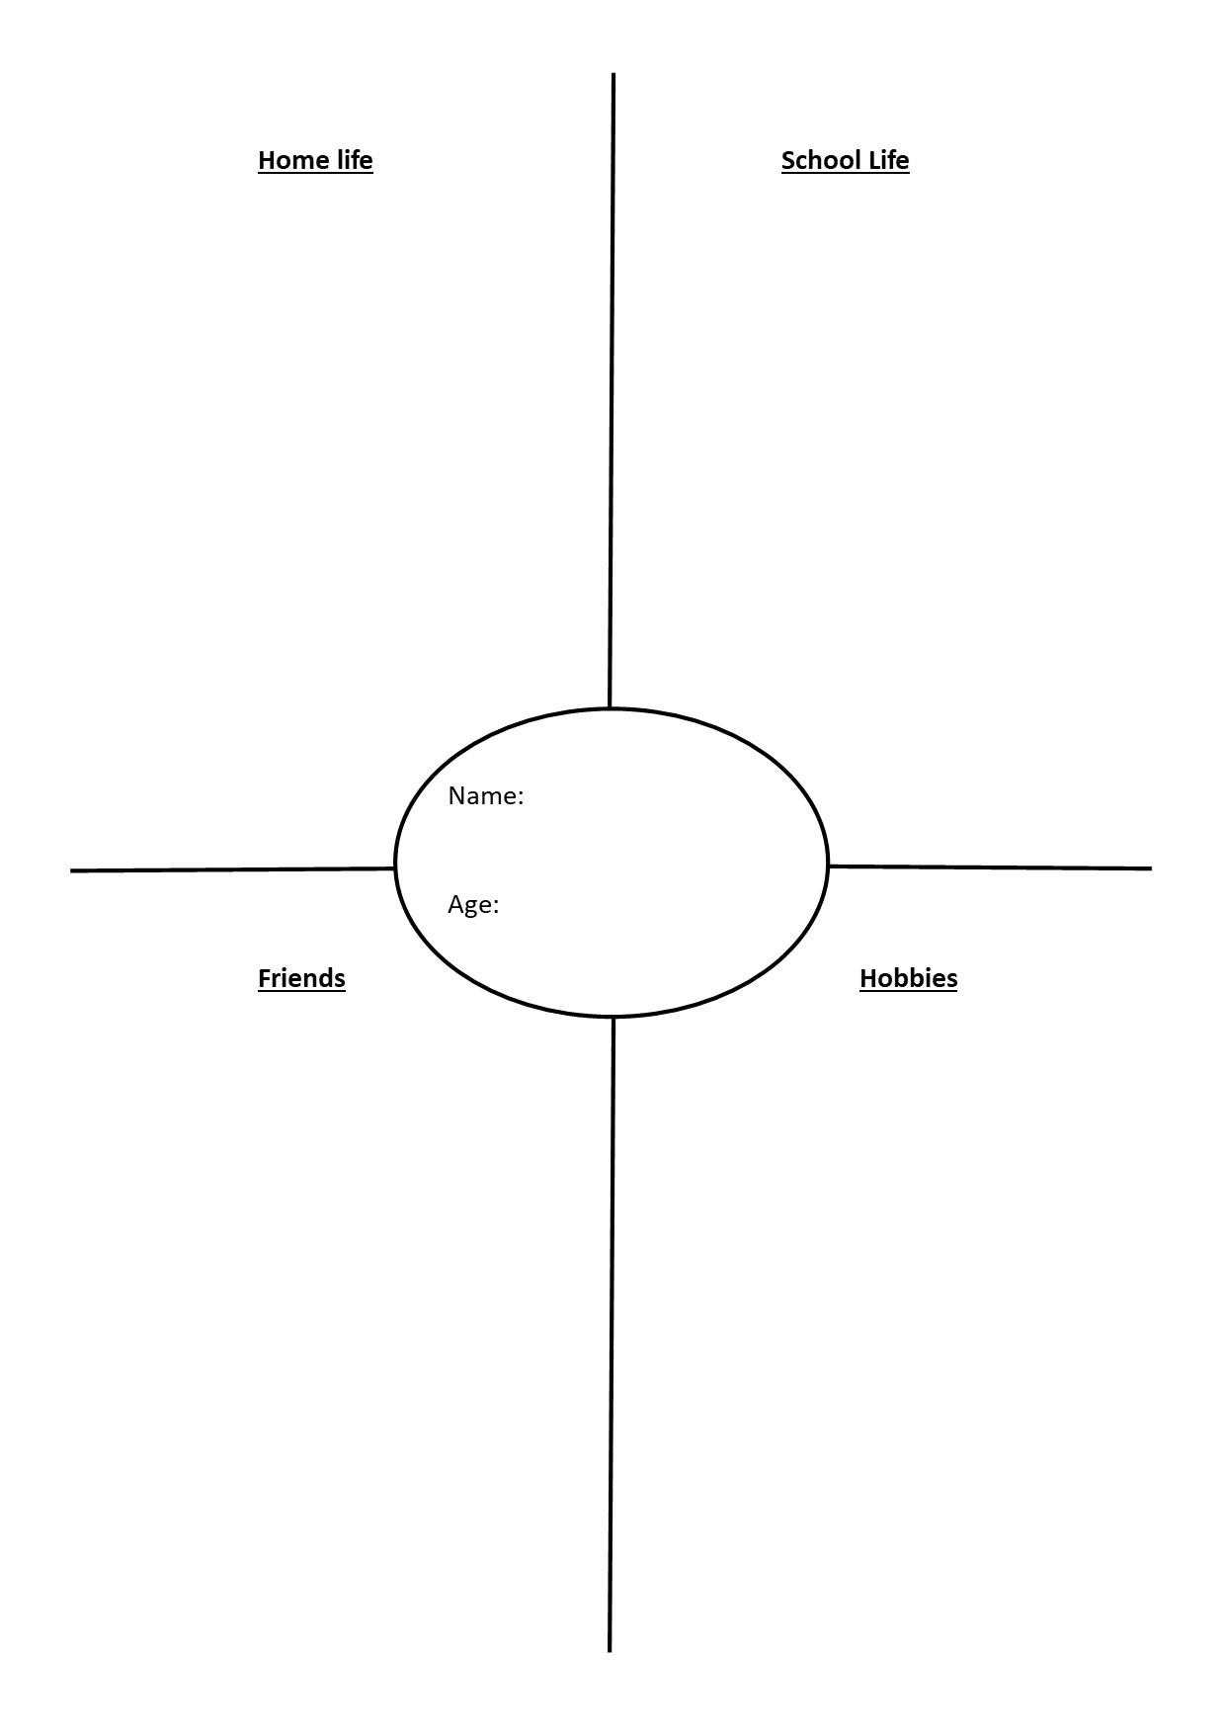
Ask the class to build this character, inserting the pieces of information that we know of them and creating the rest using their imagination.
Below is an example of a completed version.
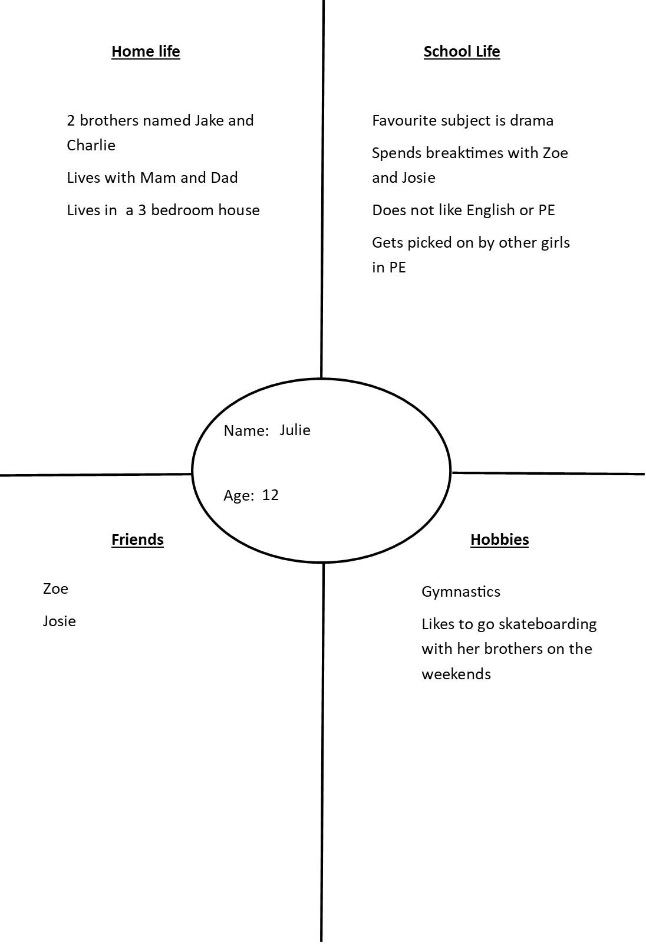

Exercise 3: 15 minutes
Meet characters and hot seat
The aim of this exercise is to find out if there is anything that the diarist can do to build their self-confidence by asking the writer. This will then allow the participants to analyse the problem, consider the options available and develop solutions as to what they can do to build their own self confidence.
As a group discuss the actions the character would need to put in place to feel better. Develop this further by using role-play.
Final exercise: 10 minutes.
Mirroring
Ask the participants to partner up and label themselves A and B. They will then mirror partner A’s actions slowly changing over when the drama leader feels that partner B has been fully engaged. Repeat for partner A.
This exercise is to enforce the fact that people focus on actions not how people look, therefore building the belief that looks do not overtake the importance of actions.
Final check in: 5 minutes.
Gather the group into a circle and check in once more, ask how everyone is feeling on a scale of 1-10. Ask if anyone would like to share their thoughts on today’s session.

Workshop 5: Focusing
For this workshop you will need the following for each participant:
- A pack of sticky notes
- A pen
You will also need:
- 1 A3 sheet of paper
- 1 marker pen
Ensure you set up the room so that there is a pack of sticky notes and a pen for each person placed around the outside of the room. This is to avoid any risk of trip hazards during the workshop.

Check in: 5 minutes.
Begin with a check in and ask how everyone is feeling on a scale of 1-10. Ask if anyone would like to share anything that’s happened to them over the week.
Warm up game: 5 minutes.
Slow-motion race
Explain to the participants that as this race is a slow-motion race, the last person to cross the finish line wins. The rules are that you must only have one foot on the ground at a time and you must never stop moving.
Aim: The aim of the slow-motion race is to engage the participants with movement and begin to focus them to mentally prepare for the workshop.
Exercise 1: 10 minutes
Ask the group to get into a circle and explain that this game is based on how fast you can respond and return to your original place. The drama leader will say ‘run’ and the participants will make their way to an individual designated spot where there will be a pack of sticky notes and a pen. The drama leader (you) will then ask a question and the participants will have to write a response to that question, as quickly as possible and get back to the circle. This game is based on first responses, quick thinking and concentration.

Questions you will ask the group:
- What do you prefer, ice cream or chocolate? (use this as a warmup to ensure the group know how to play)
- What is your favourite subject in school?
- What is your favourite hobby?
- Where do you want to go on holiday?
- What is your favourite game we have played so far?
- What do you want to be when you are older?
Ask the group to come back into the circle and if they would like to share their answers they can do so then.

Exercise 2: 20 minutes
Images and role-play
Explain that some people who have ADHD work best under pressure as it motivates them to work quickly, however this can elevate the chances of mistakes being made. For example, leaving an assignment until the last minute can lead to not completing the assignment to their best ability.
Discuss examples of times the participants have felt pressure and it has led to mistakes being made, writing these situations down on the A3 paper with a marker.
Ask the participants to create an image of one of these situations in groups. Show the class and then discuss how we could improve the outcome.
Bring the images to life, using role-play to create an effective solution which has been previously discussed, to ensure that mistakes are not made.

Final exercise: 10 minutes.
To end the session, play a game of Columbian Hypnosis as it enables the participant to move and therefore engage the mind so the group can focus more efficiently.
How to play Columbian Hypnosis.
- Each participant must have a partner and label themselves A and B.
- A will raise their arm out in front of them, so that it is two fists away from B’s face.
- B must focus on A’s hand, keeping the same distance between their face and the hand which is guiding them.
- The pairs can move around the room ensuring they do not come into contact with any other pairs.
- Repeat so that each partner has a chance to guide.

Developing the game: 5 minutes.
To develop this game, you could make two pairs join together so that one person is leading two people, while the extra participant also guides their own person.
It can sometimes help if there is some meditative music playing when using this activity, but it is not essential.
Final check in: 5 minutes.
Gather the group into a circle and check in once more, ask how everyone is feeling on a scale of 1-10. Ask if anyone would like to share their thoughts on today’s session.

Workshop 6: Emotional regulation
Check in: 5 minutes
Begin with a check in and ask how everyone is feeling on a scale of 1-10. Ask if anyone would like to share anything that has happened to them over the week.
Warm up game: 5 minutes.
Relying on others
- Ask each participant to partner up and ask them to sit back to back.
- Tell them they have to try to get up only using the support of the other person. No hands allowed.
- The pair will struggle to begin with but by using both their own and their partner's weight, they will rise to stand together.
- Next, ask the partners to turn around and face each other, ask them to try to rise by using teamwork as a cantilever to pull themselves up together.
Aim: The aim of this exercise is to show the group that opening up and relying on others is okay and can make life easier to cope with.

Exercise 1: 10 minutes
A day in the life
Create a character who has ADHD using the character creation method previously used in workshop 4.
As a class, plan out the characters day, writing the order of her day on a piece of A3.

Exercise 2: 15 minutes
Images
In groups of 3, ask the participants to choose one part of the character’s day, which they will create a still image from.
Once the previous step has been completed, using the still images the groups have created, discuss as a class where in her day her emotions might get the better of her. For example, she could get picked on and therefore get anxious as a result or get into a fight with her mother after school because she does not want to talk about school.
Role-play these scenarios, bringing them to life from the still images and show the class.

Exercise 3: 10 minutes.
Angel and the devil
Choose one scene as an example and show the group how to do this exercise.
Choose one person to be the angel and one person to be the devil and the main character stays the same.
The angel will stand on one side of the main character and give her good advice to create a better outcome for the character, while arguing with the devil to stop giving the character bad advice. The devil on the other hand, will give bad advice, trying to encourage the worst outcome to happen while arguing with the angel.
Aim: The aim of this exercise is to show the participants that they can take time to analyse the situation and make good decisions. The group will also be giving themselves advice which further shows that they can do this when they are on their own in real life situations.

Final exercise: 10 minutes.
Walk means run.
- Ask the group to begin walking around the space.
- Tell the participants that when you say jump they are to jump, when you say walk they are to walk, when you say to clap they are to clap and when you say stop they are to stop.
- Give them a few tries to get used to the actions and once they are familiar with them you can then move on to the next step.
- Tell the group that now when you say walk, they are to jump and when you say to jump, they are to walk. This will confuse them for a while, but they will soon get the hang of it.
- Now tell the participants that when you say clap they are to stop and when you say stop, they are to clap.
- Again, this will confuse them for a while but they will soon get the hang of it.
- When you feel everyone has accomplished this you can end the game.
Aim: The aim of this exercise is to show the participants that they can change their behaviours and if they take time to think before they act, they can create a better outcome. This game works on the basis of proactive interference, this is when previously retained information gets in the way of current instructions. This exercise will work on breaking down those barriers, so that the participants can re-learn ways to deal with situations.

Final check in: 5 minutes.
Gather the group into a circle and check in once more, ask how everyone is feeling on a scale of 1-10. Ask if anyone would like to share their thoughts on today’s session.

Workshop 7: Creating our toolbox
For this workshop you will need the following for each participant:
- A pack of sticky notes
- A pen
- 5 envelopes labeled ‘open when I’: need to focus, am stressed, am anxious, need help processing my emotions, feel self-conscious, need a little pick me up.
You could also give each participant a small box to keep these envelopes safe if you wanted, however this is not essential to the workshop.
You will also need:
- 1 A3 sheet of paper
- 1 marker pen

Ensure you set up the room so that there is a pack of sticky notes and a pen for each person placed around the outside of the room. This is to avoid any trip hazard during the workshop
Check in: 5 mins
Begin in a circle with a check in and ask how everyone is feeling on a scale of 1-10. Ask if anyone would like to share anything that’s happened to them over the week.
Explain that today will be about reflecting on the last few weeks and creating our toolboxes to help us when life gets a little too much.

Warm up game: 10 minutes
Eye spy touch
Rules for this game can be found in workshop 1.
Storytime: 10 minutes.
The story you will read here is found in appendix 2
You will tell the participants that they will hear a story of a day in the life of a young tiger princess who has ADHD.
Once you have told the story, recap the main points of the story where the Tiger princess struggled because of her ADHD, writing these down on a piece of A3 paper.

Images: 20 minutes.
Each group will create an image for each key point in the story where the Tiger Princess’ ADHD affected her and then show the class one at a time.
While each group is doing this, the rest of the class will consider solutions and write them down on their sticky note pads.
Once every group has shown their images, the class will feedback what solutions or coping mechanisms could the Tiger Princess put in place to:
- Help her focus
- Help her when she gets stressed
- Help her when she gets anxious
- Help processing her emotions
- Help her feel less self-conscious
- Help her feel better when she is down
The participants will write these on their sticky note pads and place them in their own envelopes, so they can look back on these toolboxes when they need help with these problems.

Final Exercises: 10 minutes.
5-minute meditation.
As a final ending exercise, ask the participants to lay on the floor and conduct a five-minute meditation, with a focus on the breath and visualising how they may use these toolboxes in their everyday lives.
5-minute beginners’ yoga.
Conduct a simple, beginners 5-minute yoga stretching exercise after the meditation to re-awaken the participants.
Final check in: 5 minutes.
Gather the group into a circle and check in once more, ask how everyone is feeling on a scale of 1-10. Ask if anyone would like to share their thoughts on today’s session.
Workshop 8: Celebrating connections.

For this workshop you will need the following for each participant:
- A black marker
- 3x A3 paper taped together so that it is big enough to outline the participant.

Check in: 5 minutes.
Begin with a check in and ask how everyone is feeling on a scale of 1-10. Ask if anyone would like to share anything that’s happened to them over the week.
Warm up: 5 minutes.
Visualisation.
Conduct a 5-minute visualisation of a calming place with a focus on breathing.
Outlining us: 10 minutes.
Give each person a black marker and the big piece of paper and ask to draw an outline of themselves.
Ask the participants to write information that many people know about them on the outside of their sketch, using the outline as a visual barrier.
Then write internalized information that many people do not know, however would like people to know. This information will act as a connection with others to celebrate qualities that are often missed from an outsider's perspective.
For example, music taste could be information that could bring people together as a way in which the participants could connect.
Aim: The aim of this exercise is to show the group other ways in which they can bond other than their ADHD, finding similarities in each other that they previously did not know existed.
Present the outlines to the class and have a discussion about similarities and differences between the information in the sketches.

Creating images: 5 mins
Ask the participants to pair up and create images portraying the differences and similarities between their outlines.
1 image portraying a similarity between the pairs and 1 image portraying a difference.

Telling stories: 10 mins
Split the participants into different pairs and ask them to tell their partners one story where they have experienced friendship.
Explain that neither must interrupt their partner and must ensure they listen intently as they will be asked to tell their partner’s stories to the group. They are allowed to ask questions but only once their partner has finished telling their story.
Share stories to the group.
Once the stories about friendship have been shared, ask the pairs to tell their partner a story where they have experienced a connection.
The same rules from the previous story sharing will apply.
Share stories to the group.

Creating the stories: 10 mins
- Split the participants into groups and ask them to choose one story to re-create.
- The person who told the story originally will be the storyteller.
- The other group members will act out the story behind the storyteller as it is being told.
- Give the participants ten minutes to work on this and then ask them to show the rest of the class.

Final exercise: 10 minutes.
Balloon is an extension of the body
To play this game you will need six balloons.
The group will begin in a circle and the drama leader will slowly introduce the balloons sending them into the paths of the participants, one by one.
The participants will have to work as a team to keep the balloons in the air.
The balloons must be touched very gently, as if the balloon is an extension of their own body. The participants should try to use other body parts to keep the balloons in the air, as well as their hands.
The drama leader will slowly take the balloons away again until there are no balloons left and the game ends.
Final check in :5 mins
Gather the group into a circle and check in once more, to ask how everyone is feeling on a scale of 1-10. Ask if anyone would like to share their thoughts on today’s session.

Appendix
Appendix 1
Dear diary,
Today has been the worst day ever! I don't understand how Zoe and Josie find it so easy. They are pretty, popular and they are amazing at gymnastics. That is why they have so many friends at school and at gymnastics!
Today was awful because in gymnastics class we were asked to show our somersaults and I was called on to go first! I was so nervous and because of that I messed up and everyone laughed, even Zoe and Josie laughed and they are supposed to be my best friends! I was so embarrassed because I am one of the oldest in the class so I should have done it perfectly like everyone else.
No one would talk to me for the rest of class because I messed up and I walked home crying because I am such a failure. Why can’t I be like the other girls? Why can’t I be like Zoe and Josie? They’re so perfect and I am just… me. I wish I could be perfect like them.
I know! Tomorrow I will ask my mom to take me shopping, I will buy new clothes and buy makeup with my birthday money so I can be just like Zoe and Josie! Everyone will definitely like me then and who knows, maybe I’ll even get a boyfriend like they have!

Appendix 2
Once upon a time, there was a beautiful Tiger Princess although if you were to tell her she was beautiful, she would not believe you. The Tiger Princess’ mother and father ruled over all the tigers in the kingdom, their family was very important, and they had a lot of responsibility. Unfortunately, the Tiger Princess struggled with this and felt that she did not fit in with her family. You see, her mother was always on time and always seemed to keep calm, even when times were stressful. Her father was always so strong in times of trouble and he always knew exactly the right words to say to make things better.
One day, the Tiger Princess awoke from her slumber and shook out her fur, she put on her favourite cape and walked out of her bedroom.
“Princess you are running late again! Where is your tiara? Why are you wearing your evening cape? It’s only afternoon!” The Tiger Queen bellowed.
“Oh, my tiara, I forgot! But mother why can’t I wear this cape? It's so much better than my afternoon one!”
The Tiger Queen disagreed and made her change her cape, “You are a princess and you need to act more like it! Now come, we need to make sure you get to your tutor early so we can get you ready for the ball tonight.”
Later in her tutoring session, the Tiger Princess was bored of the schoolwork and decided to draw instead.
“Princess I must urge you to stop drawing at once!” Her teacher snapped. “You will never become a good Queen if you cannot pay attention.”
“But it’s boring! I don’t want to do it!” She huffed “I can't concentrate on it!”
“Unfortunately, you have to by the order of your mother.”
For the remainder of the class the Tiger Princess tried to stay focused on the tasks her teacher had set, but nothing worked, and she was told to complete it as homework.
When her mother came to collect her, the teacher told the Queen how the Princess was not paying attention. “Why can’t you be like your brother the Tiger Prince? He always got the best marks in his schoolwork, he always knew how to present himself when out in public and he was never ever in trouble.”
This made the Princess angry and she screamed, “I hate this class and I hate you. I never asked to be a princess! I can’t be perfect like the rest of you royals!”
This made the Queen very angry and she told the Princess that she was not to attend her best friend’s ball tonight. This made the princess very upset as she had been looking forward to this all week.
That night the Tiger Princess sat in her room and cried, “Why can’t I be like the other royals?” she sobbed, “All of my friends will be at the ball talking about how I wasn’t allowed to go and now they won’t be friends with me anymore because they will think I am a big baby!”

Risk Assessment
Below is an example of a risk assessment, along with some ideas of what to include and some handy tips for filling it out!

Workshop/Performance Risk Assessment
Name of group/ session: | The name of the project goes here!
Location of event: | Where is the workshop taking place?
Date of first risk assessment: | Ensure you complete the risk assessment before the workshop and write the date here!
Name and signed: | Final step! Just sign your name here.

What is the hazard? | Who is at risk from this hazard? | What are you already doing to reduce the risk? | Do you need to do anything else to manage the risk? | Actions by whom? | Actions by when?
Slips,Trips and Falls hazard.  What could cause a person to trip? Include all causes! | Will you as the facilitator be at risk, the participants or both? | How are you preventing the hazard from happening? | What will you do if this hazard occurs? | Will you be taking action?  Are there any other actions that may be taken as precautionary? | Will actions be taken before the workshop? Throughout? Or after?
Emotional stress. What could cause the participants to experience emotional stress? | Will you as the facilitator be at risk, the participants or both? | How are you preventing the hazard from happening? | What will you do if this hazard occurs? | Will you be taking action?  Are there any other actions that may be taken as precautionary? | Will actions be taken before the workshop? Throughout? Or after?
Fire and emergency procedures. How will you ensure the participants will know the fire and emergency procedures? | Will you as the facilitator be at risk, the participants or both? | How will you let the participants know the emergency procedures?  How are you preventing the cause of a fire or emergency? | What will you do if this hazard occurs? | Will you be taking action?  Are there any other actions that may be taken as precautionary? | Will actions be taken before the workshop? Throughout? Or after?

If there are any other hazards specific to your location which you feel need to be included, ensure you do this!

Ethical considerations
Choice
To ensure choice during these workshops, you should allow the participants to choose how much involvement they want to contribute during the workshops. Reassure the group that they are welcome to step out if they do not feel comfortable and can re-join at any time during the workshop, without judgement.
Equality
To ensure equality during these workshops, you should explain to the group that everyone has the right to express their views/opinions and these will be respected at all times. Another way to guarantee equality in the workshops is to reinforce the idea that the group have the right to participate, or to not participate and to look for anyone who is struggling during the workshops, aiding them as best you can.
Respect
When facilitating this kind of work, respect is vital. To guarantee respect you should listen to the participants intently and validate their responses, along with allowing the participants to step out of exercises without judgement.
Safety
To ensure safety you will complete a risk assessment before any workshop takes place. You will also take suitable precautions before, during and after the workshop to protect the participants and yourself.
Competence
You should try to complete all workshops to the best of your abilities, ensuring that you achieve the intended outcomes of aiding the participants to create healthy coping mechanisms which are specific to their needs, as a girl with ADHD.

Handouts
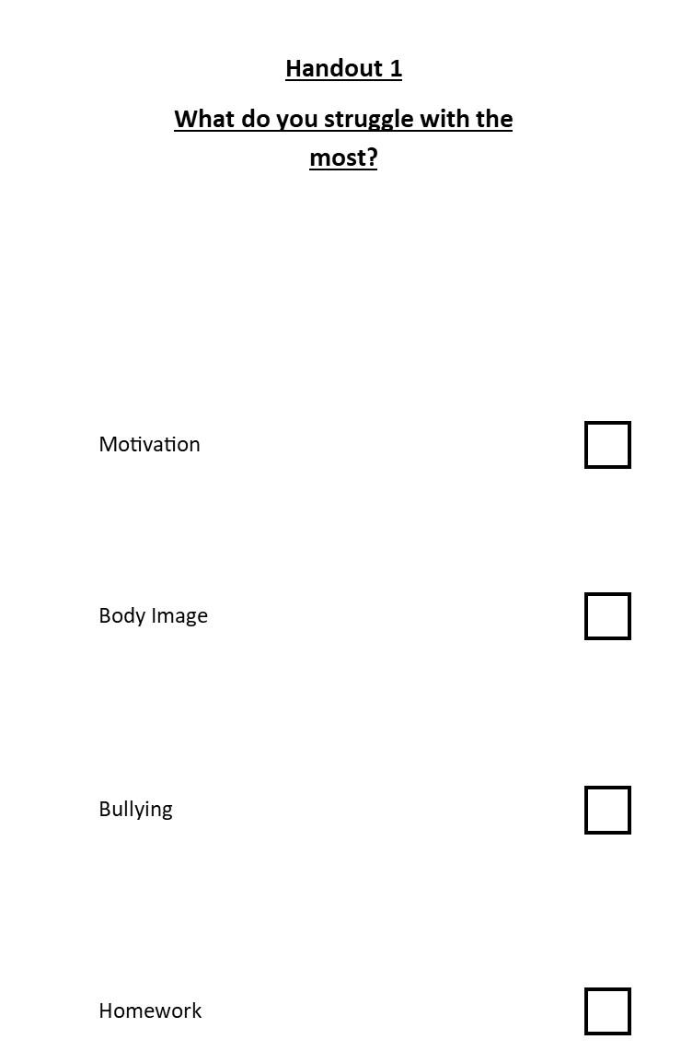
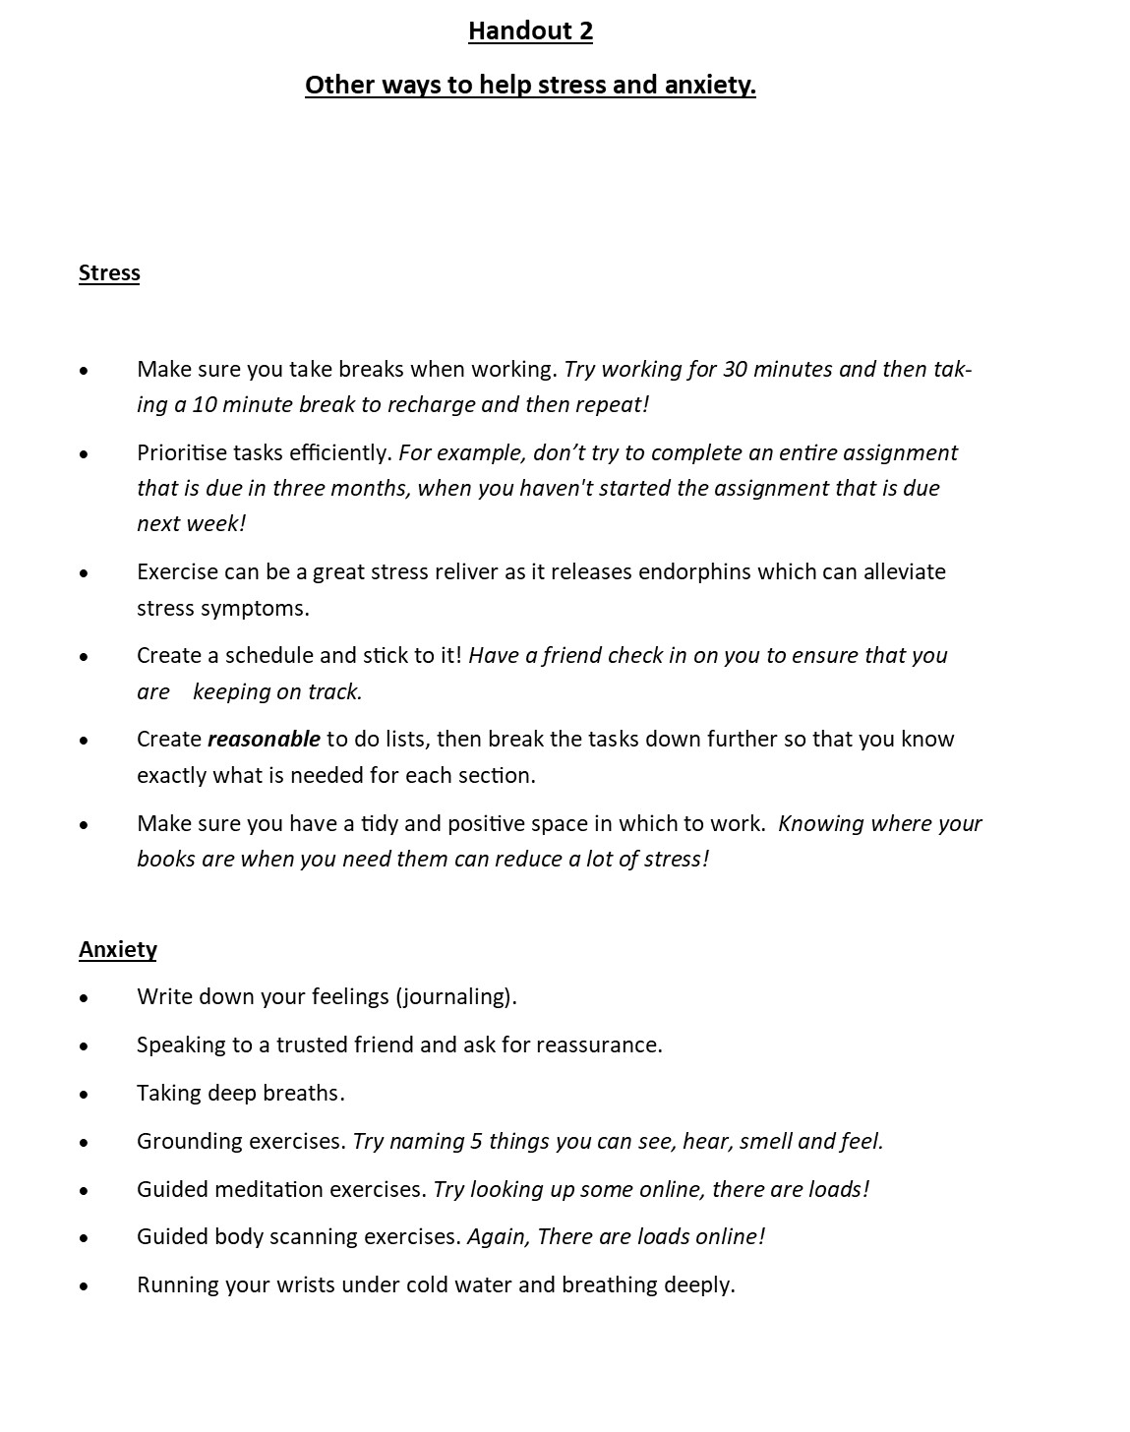
Bibliography
ADHD Europe (2020) Comorbid Disorders and Coexisting Difficulties. Available at: https://www.adhdeurope.eu/information/articles/comorbid-disorders-and-coexisting-difficulties/ (Accessed: 13th March 2020)
AADD-UK (2017) Comorbidities. Available at: https://aadduk.org/symptoms-diagnosis-treatment/comorbidities/ (Accessed: 13th March 2020)
Alexander, T. (2004) Dance, Drama and Performance and Attention Deficit Hyperactivity Disorder (ADHD). Available at: https://scips.worc.ac.uk/subjects-and-disabilities/dance-ddp_adhd/ (Accessed: 4th April 2020)
Archer, T and Kostrzewa, R. M. (2011) Physical Exercise Alleviates ADHD Symptoms: Regional Deficits and Development Trajectory. Neurotoxicity Research [online]. 21(2), pp.195-209. Available from: https://doi.org/10.1007/s12640-011-9260-0 [Accessed: 28th April 2020]
Baim, C., Brookes, S. and Mountford, A. (Eds.) (2002) The Geese Theatre Handbook: Drama with Offenders and People at Risk. Hook: Waterside Press.
Bauermeister, J.J., Shrout. P.E., Chávez, L., Rubio-Stipec, M., Ramírez, R., Padilla, L., Anderson, A., García, P and Canino, G. (2007) ‘ADHD and gender: are risks and sequela of ADHD the same for boys and girls?’, The Journal of Child Psychology and Psychiatry, 48(8),pp. 831–839. DOI:10.1111/j.1469-7610.2007.01750.x
Boal, A. (1992) Games for actors and non actors. London, New York:Routledge.
Chang, W. (2006) ‘A Study of the Application of the Drama Therapy on ADHD Students’ Social Abilities at the Resource Class of the Elementary School’ International Journal of Arts Education, pp.36-64. Available at:https://ed.arte.gov.tw/uploadfile/periodical/1518_arts_education42_00360064.pdf (Accessed: 26th April 2020)
Gersie, A, King, N. (1990) Storymaking in education and therapy. London: Jessica Kingsley Publishers LTD, Sweden: Stockholm institute of educational press.
Gould.J and Smith.J.A. (2017) Missed or Mis-diagnosis...Girls and Women on the autism spectrum. Available at: https://network.autism.org.uk/sites/default/files/ckfinder/files/Missed%20or%20misdiagnosis%2C%20girls%20and%20women%20on%20the%20autism%20spectrum%2C%20diagnosis%2C%20education%20and%20support_%20Dr%20Judith%20Gould%20and%20Jacqui%20Ashton%20Smith.pdf (Accessed: 20th April 2020)
Gould.J. (2017) ‘Towards understanding the under-recognition of girls and women on the autism spectrum’, Autism. 21(6), pp. 703-705. DOI: https://doi.org/10.1177/1362361317706174

Healey, D. M. and Rucklidge, J. J. (2008) ‘The relationship between ADHD and creativity’, The ADHD Report. 16(3), pp.1-6. DOI: 10.1521/adhd.2008.16.3.1.
Hinshaw, S.P. (2015) Self-Harm as a Developmental Outcome in Girls with ADHD: Clinical Significance and Underlying Mechanisms. The ADHD Report [online]. 23(6) pp.1-6. Available from: https://guilfordjournals.com/doi/pdf/10.1521/adhd.2015.23.6.1 (Accessed 18th April 2020)
Hijinx. (2020) About Us. Hijinx [online]. Available from: http://www.hijinx.org.uk/about-us/ [Accessed:18th April 2020]
Jacobson, R. (2020) How Girls with ADHD are different. Available at: https://childmind.org/article/how-girls-with-adhd-are-different/ (Accessed: 13th March 2020)

Jacobson, R. (2020) How to help girls with ADHD. Available at: https://childmind.org/article/how-to-help-girls-with-adhd/ (Accessed: 13th March 2020)
Kejani, M. and Raeisi, Z. (2020) ‘The effect of drama therapy on working memory and its components in primary school children with ADHD’, Current Psychology. pp.1-10. DOI:https://doi.org/10.1007/s12144-019-00564-8
Leitner, Y. (2014) ‘The Co-Occurrence of Autism and Attention Deficit Hyperactivity Disorder in Children – What Do We Know?’ Frontiers in Human Neuroscience, 8, pp.268 DOI:10.3389/fnhum.2014.00268
Monika, S. (2011) A social competence intervention program using drama therapy and how it can improve peer relations among children with Attention-Deficit Hyperactivity Disorder. Unpublished Graduate Projects (non-thesis). Canada: Concordia University. Available at: https://spectrum.library.concordia.ca/35800/ (Accessed: 28th April 2020)
Neelands, J. (1990) Structuring Drama Work. Cambridge: Cambridge University Press.
NHS (2018) Attention Deficit Hyperactivity Disorder (ADHD). Available at: https://www.nhs.uk/conditions/attention-deficit-hyperactivity-disorder-adhd/ (Accessed: 13th March 2020)
Quinn, P.O (2005) ‘Treating adolescent girls and women with ADHD: Gender-specific issues’, Current psychology, 61(5), pp.579-586. DOI:10.1002/jclp.20121
Taking flight. (2020) What We Do. Taking Flight [online]. Available at: https://www.takingflighttheatre.org.uk/what-we-do/ (Accessed: 18th April 2020)
Understood.org (2020) ADHD in girls: What you need to know. Available at: https://www.understood.org/en/learning-thinking-differences/child-learning-disabilities/add-adhd/adhd-in-girls (Accessed: 15th April 2020)
Van Der Water, M., McAvoy, M. and Hunt, K.(2015) Drama & Education: Performative Methodologies for Teaching and Learning. London: Routledge
Oxfordshire County Council. (n.d) Oxfordshire protocol for the identification and assessment of pupils with Attention Deficit and Hyperactivity Disorder (ADHD): Attention Deficit and Hyperactivity Disorder (ADHD) Strategies for teachers in schools (KS3/KS4). Available at: http://schools.oxfordshire.gov.uk/cms/sites/schools/files/folders/folders/documents/SEN/guidance/ADHD/StrategiesforSchools%28KeyStage3_4%29.pdf (Accessed:28th April 2020)

The exercises in these workshops have been taken from or inspired by the resources below.
Baim, C., Brookes, S. and Mountford, A. (Eds.) (2002) The Geese Theatre Handbook: Drama with Offenders and People at Risk. Hook: Waterside Press.
Boal, A.(1992) Games for actors and non actors. London, New York: Routledge.

Gersie, A, King, N. (1990) Storymaking in education and therapy. London: Jessica Kingsley Publishers LTD, Sweden: Stockholm institute of educational press.
Neelands, J. (1990) Structuring Drama Work. Cambridge: Cambridge University Press.
Both ‘The Tiger Princess’ story and the diary entry was written by the author of the workshop.

