

INFORMATION BOOKLET
Dementia as a Long-Term Condition in UK Health and Social Care
A critical examination of management, policy and person-centred care
Programme: MSc Public Health and Social Care in Practice
Module: Community Care and Management of Longer-term Conditions
Module Code: LCHS7003
Assignment Title: Component 1 – Information Booklet of Long-term Condition Management
Lecturer: Muhammad Khan
Student Name: [Noaman Sidat]
Student Number: [2536192]
Target Audience: Health and social care professionals and commissioners in the UK
Word Count: 3000
Submission Date: 17TH July 2026

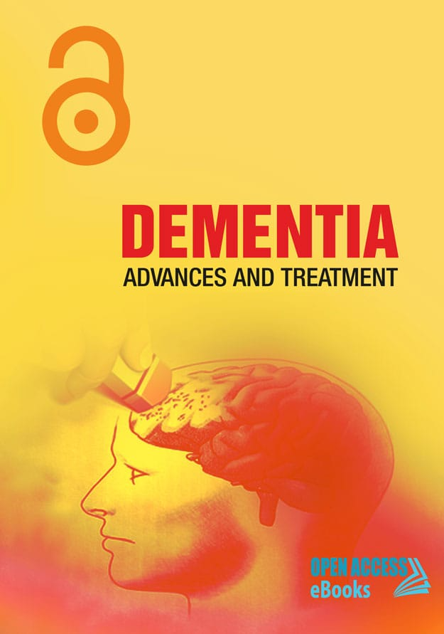

Table of Contents
1. Introduction 4
2. Condition Overview 4
2.1 Defining Dementia: Biomedical and Biopsychosocial Tensions 4
2.2 Prevalence and Epidemiology 4
2.3 Risk Factors and Aetiology 5
3. Impact Analysis 6
3.1 Physical Impact 6
3.2 Psychological Impact 6
3.3 Social Impact 7
3.4 Impact on Family and Unpaid Carers 7
4. NHS Treatment and Care Provision 7
4.1 Pharmacological Treatment 7
4.2 Non-Pharmacological Treatment 8
4.3 Inequality in Access 8
5. Models and Frameworks 8
5.1 The NHS Long Term Plan (UK model) 8
5.2 The Chronic Care Model (international model) 9
6. Policy Analysis 10
6.1 National Policy 10
6.2 Local and Regional Delivery 10
6.3 Political and Financial Constraints 10
7. Recommendations 11
7.1 Embed Kitwood’s Person-Centred Care Consistently 11
7.2 Expand Self-Management Support Realistically 11
7.3 Address Digital Exclusion Before Expanding Digital Health 11
7.4 Fund Workforce Retention, Not Only Recruitment 11
7.5 Strengthen Early Referral to Palliative and End-of-Life Care 12
7.6 Close the Health and Social Care Funding Divide 12
8. Conclusion 12
Reference List 13

1. Introduction
This booklet is written for health and social care professionals in the UK. Chronic conditions, also called long-term conditions (LTCs), are medical conditions that affect people for many years, are not curable, and account for approximately 71% of all deaths worldwide (World Health Organization, 2024). In England, over 15 million people live with at least one LTC (NHS England, 2024a), and this number rises with age. Dementia is a progressive neurological condition that impairs mental function and independence and requires continuous support from systems designed around acute care (The King’s Fund, 2023), unlike many physical LTCs. Dementia exposes systemic failings, including a structural reliance on unpaid family carers, that stem from the separation of free NHS healthcare from means-tested social care. Alzheimer’s Society (2024a) estimates that nearly one million people are affected by dementia in the UK, with 76,894 deaths recorded in 2024 (Alzheimer’s Research UK, 2025a).

2. Condition Overview

2.1 Defining Dementia: Biomedical and Biopsychosocial Tensions
Dementia is an umbrella term used to describe a group of neurological conditions that involve a gradual loss of cognitive functioning (particularly memory loss), thinking, behaviour and functioning in everyday life (NICE, 2018, updated 2025; WHO, 2023). The biomedical definition is a good basis for diagnosis and treatment but it has been criticized as ignoring the psychological, social and environmental factors that contribute to the lived experience of dementia. A biopsychosocial approach thus provides a more holistic approach as it sees the effects of dementia as being shaped by the neurological changes as well as influence from relationships; social inclusion; access to support; and the wider setting in which care is carried out (Kontos et al., 2017).

2.2 Prevalence and Epidemiology
The population ageing means that the number of people living with dementia is estimated to rise to 1.4 million in 2040, from an estimated 982,000 in 2024 (Alzheimer's Society, 2024a). Dementia is one of the major causes of disability and dependency in older people, and demands significant levels of health and social care services. In 2024, the total cost of dementia in the UK is estimated to be £42 billion, of which around 77% comes from unpaid family and social care, not NHS healthcare, rather than paid family/social care (Alzheimer's Society, 2024b; Dementia Carers Count, 2024).
The World Health Organization estimates that 57 million people suffered from dementia in the world in 2021. This is projected to grow to 78 million in 2030 and 139 million in 2050, mostly due to population ageing. The economic burden of dementia is already costing about US £1.3 trillion globally every year, and about 60% of people with dementia are living in low- and middle-income countries (LMICs), where there are often not enough resources in healthcare systems to provide the growing care needs (World Health Organization, 2023).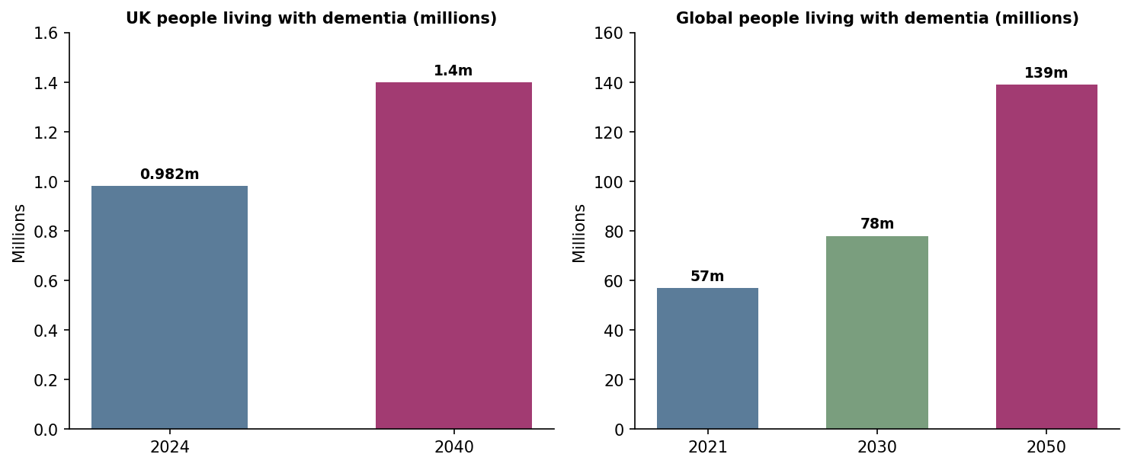
Figure 1: Projected growth in dementia prevalence, UK and worldwide
Source: (Alzheimer’s Society, 2024a; World Health Organization, 2023).
The overall figures are likely to be underestimated. In England as at December 2024, there were only 483,000 people over the age of 65 who had received a formal diagnosis of dementia in Primary Care (GOV.UK, 2025), suggesting that many people are not diagnosed with dementia. In addition there is a socioeconomic deprivation and ethnic based influence on diagnosis rates and access to care. Findings have indicated accentuated inequalities in diagnosis and additional barriers to accessing dementia care and support for individuals from minority ethnic communities from more deprived areas (Robinson et al., 2024; Giebel et al., 2023). The disparities reflect deep-rooted health inequalities in England.

2.3 Risk Factors and Aetiology
The principal risk factor for dementia is age: the risk is estimated to double every five years after the age of 65 (Alzheimer’s Society, 2024a). However, this emphasis on age masks the large proportion of risk that is modifiable. The Lancet Commission (Livingston et al., 2024) reframes dementia as partly preventable, identifying fourteen modifiable risk factors that, it estimates, could prevent or delay up to 45% of cases. These risks are also socially patterned by the broader determinants of poverty, education and environment (Dahlgren and Whitehead, 1991). Behaviours such as smoking and inactivity are therefore not purely individual choices but are structurally shaped. Yet government policy remains focused on individual behaviour and fails to address structural inequalities, which itself constitutes a form of structural neglect (Office for Health Improvement and Disparities, 2022).
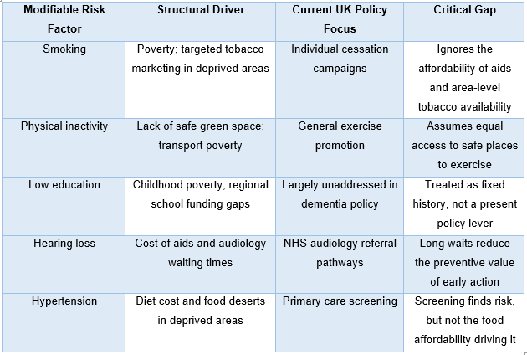
Table 1: Modifiable dementia risk factors and the structural conditions that drive them, contrasted with the dominant UK policy response.
The point of interest is the gap column rather than the risk factors themselves, as UK policy targets the wrong layer of the Dahlgren and Whitehead (1991) model for almost all the risk factors listed.

3. Impact Analysis

3.1 Physical Impact
Clinical guidance on dementia is directed mainly at the physical deterioration of mobility, the risk of falls, and susceptibility to other conditions such as diabetes (NICE, 2018, updated 2025). Dementia gradually affects a person's physical abilities as the disease progresses. In the early stages, many individuals remain independent, but over time they may experience difficulties with balance, walking, coordination, and performing everyday activities such as dressing, bathing, or preparing meals. Memory loss can also lead to forgetting to eat, drink enough water, or take prescribed medication, increasing the risk of malnutrition, dehydration, and poor management of long-term conditions such as diabetes or hypertension.
People living with dementia are also more likely to experience falls because of poor judgement, reduced balance, and impaired spatial awareness. Falls may result in fractures, hospital admission, reduced mobility, and loss of independence. As dementia advances, swallowing difficulties (dysphagia) may develop, increasing the risk of choking and chest infections such as aspiration pneumonia.

3.2 Psychological Impact
The psychological effects of dementia can be as significant as the physical symptoms. Many people experience anxiety, depression, frustration, and fear, particularly after receiving a diagnosis or when they become aware of their declining memory. Confusion and difficulty recognising familiar people or places may lead to emotional distress, while changes in behaviour can affect self-esteem and confidence.
Some individuals develop agitation, mood swings, hallucinations, or paranoia as the condition progresses. Feelings of loneliness and social withdrawal are also common, especially when communication becomes more difficult or when people fear being judged because of their symptoms. Without appropriate emotional support, these psychological challenges may reduce quality of life and increase caregiver stress.The emotional impact of dementia is substantial. According to the Alzheimer’s Society (2025) survey, 73% of people with dementia reported feeling anxious about their symptoms, and 42% said they felt embarrassed or stigmatised by them. The most helpful model here is a biopsychosocial model, which is Engel's (1977) model of illness, the biopsychosocial model, which focuses on biological, psychological, and social factors, and where psychological factors affect the severity of illness. Despite this, NHS pathways in England remain focused mainly on pharmacological rather than psychological approaches to dementia (NICE, 2018, updated 2025), and psychological support is neither consistently provided nor routinely sought by patients (Health and Social Care Committee, 2022). Psychological support is not missing from the care pathway, it's that the pathway is based on the wrong priority.

3.3 Social Impact
Stigma may lead to isolation and people may be reluctant to access support services for fear or embarrassment (Alzheimer's Society, 2025). The social model of disability holds that disability arises less from impairment itself than from society’s failure to adapt to it (Oliver, 2013). When a person with dementia is excluded from a bank, a shop, a bus or a train, the barrier lies in the environment, not the disease

3.4 Impact on Family and Unpaid Carers
In the UK, unpaid carers are the main source of support for people living with dementia. Approximately 700,000 unpaid carers provide this support, many of whom provided more than 100 hours of care per week during the pandemic (Health and Social Care Committee, 2022). More broadly, around 5.2 million people in England provide informal care, a considerable proportion of the population (House of Commons Library, 2025; King’s Fund, 2024). Collectively, they contribute economic value of more than £180 billion per year, covering roughly half the total cost of dementia care (Dementia Carers Count, 2024). Nevertheless, carers are under extreme strain, with the vast majority reaching crisis point and experiencing a decline in their own health. This exposes a system that is structurally reliant on informal care and is, as a result, inherently fragile (Dementia Carers Count, 2024).

4. NHS Treatment and Care Provision

4.1 Pharmacological Treatment
NICE recommends pharmacological treatment in guidance updated in 2025 and identifies two main classes of medicine: cholinesterase inhibitors and memantine. Neither directly affects the underlying disease process; both are used primarily for symptom management (NICE, 2018, updated 2025; Alzheimer’s Society, 2025). They can temporarily slow cognitive decline but do not address the underlying neurodegeneration, exposing the limits of the biomedical model’s curative promise. The MHRA approved lecanemab and donanemab in 2024, finding modest benefits in slowing early-stage Alzheimer’s disease. However, NICE rejected routine NHS adoption on cost-effectiveness grounds, and the reasons for this rejection remain unclear (Alzheimer’s Society, 2025). This illustrates an underlying conflict: the availability of treatment is determined not only by clinical need but by budgetary constraints. Despite the scientific validity of treatments, they may not be available, and the biggest problem with dementia care is the cost of the care system, not the biomedical ability.

4.2 Non-Pharmacological Treatment
The evidence for the measurable cognitive and quality-of-life benefits of cognitive stimulation therapy, reminiscence work and social prescribing is strong, and NICE recommends these interventions (NICE, 2018, updated 2025). The issue is not evidence but delivery: only twenty-nine per cent of care workers in England have received any dementia-specific training, even though residents with dementia account for around seventy per cent of the residential care population (Age UK, 2025; Alzheimer’s Society, 2025). This is not a knowledge gap but a workforce investment gap, and there is a structural explanation for it: non-pharmacological care is labour-intensive and unglamorous, and despite having strong evidence behind it, it is the first area to be squeezed when budgets are cut.

4.3 Inequality in Access
There is considerable variation in diagnosis rates between Integrated Care Board areas, a pattern Alzheimer’s Society (2024d) describes as a ‘postcode lottery’. The national dementia diagnosis target, which aimed to ensure that everyone with dementia in England received a recorded diagnosis, was removed entirely from the 2025/26 NHS Priorities and Operational Planning Guidance and was not referenced anywhere in the document (Journal of Dementia Care, 2025). Withdrawing the one national accountability measure at precisely the moment when regional differences are widening suggests that a universal NHS does not automatically deliver equal outcomes; universality can coexist with inequality. Removing the measure does not close the gap, it simply hides it.

5. Models and Frameworks
As per the brief's request, this section focuses on a model from the United Kingdom (the NHS Long Term Plan) and a clinical model from the United States (the Chronic Care Model).

5.1 House of Care (UK model)
The House of Care Model is a person centred way of managing long term conditions in the NHS – and is highly transferable to dementia and care. Not just the NHS's role in the model – the intention is to pull health, social and voluntary providers together to arrange co-ordinated services, negotiate joint decision making and support service users in self-management (NHS England, 2016). This is because it takes into consideration that dementia does not only affect a person's mind, but their psychological wellbeing, social support needs and the needs of family carers as well.

The model is built upon the four integrated, inter-dependent elements of engaged and informed public and carers, positive mindset of health professionals towards partnership working, systems within the organization to enable co-ordinated working, and commissioning processes to ensure the right services are commissioned. All of these aim to promote continuity and improve communication between primary care, memory assessment, community teams/social care providers.

The House of care Model is a successful blueprint for integrated care across England, but is not always being successfully implemented. While workforce is still a limiting factor in coordinated care, the need for services has also increased, and geographic variations in service commissioning have also become a constraint. Skills for Care (2025) have estimated that there were 111,000 adult social care jobs in England, this meant that the available social care staff was limited to provide individual and sustained care. Consequently, good practice is linked to the model and how effectively the outcomes of the services are delivered will depend on satisfactory levels of funding, staffing and good partnership working between health and social care services.

5.2 The Chronic Care Model (international model)
The Chronic Care Model (CCM) (Wagner et al., 1996) is an American model developed at the MacColl Institute, which is centred on proactive treatment and patient self-management rather than crisis treatment. The model assumes, however, that there is enough and consistent self-management capacity. Dementia is a progressive condition, meaning that this capacity actively decreases over time. This is a disadvantage of the model, because it places increasing demands on family carers as the condition worsens (Coleman et al., 2009). Thus, a dementia challenges the very premise of the model, namely, the capacity it employs is the very thing it's destroying.
5.3 Comparative Critique

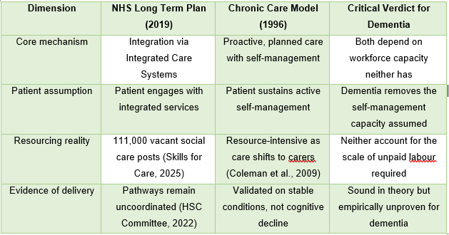
Table 2: Critical comparison of the NHS Long Term Plan and the Chronic Care Model against the specific demands of dementia care.
Model success in dementia care is therefore a resourcing problem, not a design problem.

6. Policy Analysis

6.1 National Policy
Three national policies underpin the provision of care for people with dementia in England: the NHS Long Term Plan (NHS England, 2019); the Care Act 2014, which has a statutory duty on local government to carry out reviews and make provision for eligible social care needs (Care Act 2014); and NICE guidance NG97, which was updated in 2025 (NICE, 2018, updated 2025). The problem is that there's a difference between free NHS care and means-tested social care. Day-to-day, dementia is largely a social care condition: most families need help with washing and supervision, and this support is means-tested rather than free (Health and Social Care Committee, 2022). The Care Act 2014 brought in the need assessment but did not resolve the issue of funding split. This therefore has a positive effect on the standards of clinical care, but a negative impact on the working out of the payment system when a need is identified, impacting on the financial hardship of families.
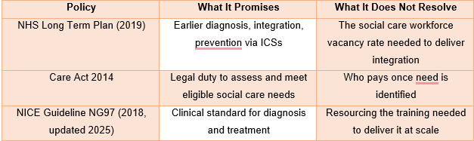
Table 3: The three core national dementia policies, what each promises, and the structural gap each leaves unresolved.

6.2 Local and Regional Delivery
Since July 2022 forty-two Integrated Care Systems (ICSs) have acted in England to make health and social care choices for their areas (Alzheimer’s Society, 2024d). Local flexibility allows systems to respond to local needs, but it also produces the regional inequality discussed in Section 4.3, since priorities vary between systems and there is no longer a national diagnosis floor to anchor them. Devolving responsibility without devolving funding amounts to a transfer of blame rather than power: a postcode lottery is the likely outcome whenever local systems are asked to deliver national ambitions from local budgets that vary widely.

6.3 Political and Financial Constraints
Although funding for social care rose by £8.5 billion over the last ten years, a £6.1 billion gap remained, filled instead by unmet need and unpaid carers (Health and Social Care Committee, 2022). There is demand for greater respite provision and a fully funded National Carers Strategy, according to Carers UK (2025). Demand has been rising due to an ageing population and a lack of funding, while successive governments have published strategies without making any change to the underlying funding settlement (Health and Social Care Committee, 2022). The funding settlement needed to deliver the policy has never matched the level of ambition.

7. Recommendations
The recommendations below are not neutral or cost-free. Each carries an implementation cost or trade-off that is not normally acknowledged in policy documents. In line with the brief, they are organised around promoting person-centred care, self-management, and end-of-life care.

7.1 Embed Kitwood’s Person-Centred Care Consistently
Kitwood’s (1997) framework of person-centred care must be embedded across the training of NHS and social care professionals, not confined to dementia-specific training within memory services alone, given that only twenty-nine per cent of care workers have received any dementia-specific training at all (Age UK, 2025). This means there is a trade-off to be made: there is a need to invest in the training and this will create more of a time pressure on an industry already suffering from a seven percent vacancy rate (Skills for Care, 2025). It will only be a reality if it is funded, not just mandated.

7.2 Expand Self-Management Support Realistically
Self-management programmes are based on self-efficacy theory (Bandura, 1977) but in dementia there is a definite limit to this, as self-management ability diminishes over time. Support should be designed to be career co-managed; self-directed is inadequate. This shifts resources to the careers, which is important in its natural course but may leave the view that the family, and not the State, is required to meet the growing care needs as they increase.

7.3 Address Digital Exclusion Before Expanding Digital Health
Digital tools are playing an increasing role in provision of care, but older people and people with a cognitive impairment are more digitally excluded. Funded low-tech alternatives should be provided to support digital expansion, to ensure that digital convenience does not create a new barrier. This will be in contradiction to the current NHS digital first approach and will probably be resisted, just because of the extra cost of operating parallel provision that isn't digital.

7.4 Fund Workforce Retention, Not Only Recruitment
The adult social care sector has approximately 111,000 unfilled roles (Skills for Care, 2025), and recruitment alone will not close this gap. Retention, not only recruitment, must be addressed through a funded workforce strategy that focuses on pay, progression and mandatory dementia training. Section 6.3 demonstrates that long-term funding for social care is needed, a commitment that has been repeatedly absent from the UK social care funding landscape.

7.5 Strengthen Early Referral to Palliative and End-of-Life Care
Dementia is a terminal disease, but palliative referral often occurs late, partly because its slow and unpredictable course makes it harder to identify an end-of-life stage than is the case with cancer (Health and Social Care Committee, 2022). Embedding palliative principles earlier into routine review would better serve the person and their family, but this requires a cultural change as much as a procedural one: current practice and training do not equip clinicians to initiate difficult conversations early enough for families to prepare.

7.6 Close the Health and Social Care Funding Divide
The most basic adjustment that needs to be made is structural; separating care for the most acute from care for the most personal and social, which is referred to as social care. Most people with dementia do not require urgent NHS care, but do require personal and social support, which is often provided by social care and is means-tested. The booklet in this paper makes the case that the split isn't incidental, but a load-bearing element of the system. Better integration alone will not resolve it; the divide itself needs to be dismantled, since every other recommendation above operates within a funding system that is not designed to cover a condition that is as much social as it is long-term. This is also the least likely recommendation to be implemented, as it is the most expensive, and it has been raised for resolution by successive parliamentary inquiries without being resolved (Health and Social Care Committee, 2022). Evidence-based policy has its limits in times of fiscal constraint.

8. Conclusion
Dementia is the UK’s leading cause of death and is growing at an alarming rate, yet the system for tackling it remains structurally weak. Despite strong policy and clinical guidance, treatment remains largely symptomatic, workforce capacity is limited, and cost continues to restrict access to new treatments. Unpaid careers, already under serious strain, remain essential to the care system, while the gap between free NHS healthcare and means-tested social care persists. This gap is a structural funding mechanism which requires systemic change, rather than gradual and incremental policy change.

Reference List
Age UK (2025) Parliamentary Briefing: Dementia Care, June 2025. https://www.ageuk.org.uk/siteassets/documents/reports-and-publications/reports-and-briefings/age-uk-parliamentary-briefing---dementia-care-june-2025.pdf
Alzheimer’s Research UK (2025a) ‘Dementia is still UK’s biggest killer – where do we go from here?’ https://www.alzheimersresearchuk.org/news/dementia-is-still-uks-biggest-killer-where-do-we-go-from-here/
Alzheimer’s Society (2024a) ‘How many people have dementia in the UK?’ https://www.alzheimers.org.uk/blog/how-many-people-have-dementia-uk
Alzheimer’s Society (2024b) ‘Facts for the media about dementia.’ https://www.alzheimers.org.uk/what-we-do/news-and-media/facts-media
Alzheimer’s Society (2024c) ‘Understanding and supporting a person with dementia.’ https://www.alzheimers.org.uk/get-support/help-dementia-care/understanding-supporting-person-dementia
Alzheimer’s Society (2024d) ‘Local dementia statistics.’ https://www.alzheimers.org.uk/what-we-do/policy-and-influencing/local-dementia-statistics
Alzheimer’s Society (2025) Survey report: Lived experiences of dementia 2025. https://www.alzheimers.org.uk/about-us/policy-and-influencing/reports/survey-lived-experiences-dementia
Bandura, A. (1977) ‘Self-efficacy: toward a unifying theory of behavioral change’, Psychological Review, 84(2), pp. 191–215. https://doi.org/10.1037/0033-295X.84.2.191
Care Act 2014, c.23. London: The Stationery Office. https://www.legislation.gov.uk/ukpga/2014/23/contents
Carers UK (2025) State of Caring 2025: The Cost of Caring. https://www.carersuk.org/media/upzd0h2y/state-of-caring-2025-cost-of-caring-report_v2.pdf
Coleman, K., Austin, B.T., Brach, C. and Wagner, E.H. (2009) ‘Evidence on the Chronic Care Model in the new millennium’, Health Affairs, 28(1), pp. 75–85. https://doi.org/10.1377/hlthaff.28.1.75
Dahlgren, G. and Whitehead, M. (1991) Policies and Strategies to Promote Social Equity in Health. Stockholm: Institute for Futures Studies. https://files01.core.ac.uk/download/pdf/6472456.pdf
Dementia Carers Count (2024) ‘Dementia care statistics.’ https://dementiacarers.org.uk/what-we-do/campaigning/dementia-care-statistics/
Engel, G.L. (1977) ‘The need for a new medical model: a challenge for biomedicine’, Science, 196(4286), pp. 129–136. https://doi.org/10.1126/science.847460
Giebel, C. et al. (2023) ‘A 3-UK-nation survey on dementia and the cost of living crisis’, Aging & Mental Health. https://www.tandfonline.com/doi/full/10.1080/13607863.2023.2197845
GOV.UK (2025) Dementia Profile: Prevalence and Supporting Well Topics Statistical Commentary, March 2025. https://www.gov.uk/government/statistics/dementia-profile-march-2025-update/dementia-profile-prevalence-and-supporting-well-topics-statistical-commentary-march-2025
Health and Social Care Committee (2022) Supporting People with Dementia and their Carers. London: House of Commons. https://publications.parliament.uk/pa/cm5802/cmselect/cmhealth/96/report.html
House of Commons Library (2025) Inequalities Faced by Unpaid Carers. https://commonslibrary.parliament.uk/research-briefings/cdp-2025-0213/
Journal of Dementia Care (2025) ‘Dementia diagnosis rate target removed from NHS 2025/26 Priorities and Operational Planning Guidance.’ https://journalofdementiacare.co.uk/dementia-diagnosis-rate-target-removed-from-nhs-2025-26-priorities-and-operational-planning-guidance
King’s Fund (2023) What is Social Care? London: The King’s Fund. https://www.kingsfund.org.uk/insight-and-analysis/long-reads/social-care-explained
King’s Fund (2024) ‘Who are unpaid carers and who do they provide care for?’ https://www.kingsfund.org.uk/insight-and-analysis/data-and-charts/unpaid-carers-nutshell
Kitwood, T. (1997) Dementia Reconsidered: The Person Comes First. Buckingham: Open University Press. https://books.google.com/books/about/Dementia_Reconsidered.html?id=BxxsAAAAMAAJ
Kontos, P., Miller, K.L. and Kontos, A.P. (2017) ‘Relational citizenship: supporting embodied selfhood and relationality in dementia care’, Sociology of Health & Illness, 39(2), pp. 182–198. https://doi.org/10.1111/1467-9566.12453
Livingston, G. et al. (2024) ‘Dementia prevention, intervention, and care: 2024 report of the Lancet Standing Commission’, The Lancet, 404(10452), pp. 572–628. https://doi.org/10.1016/S0140-6736(24)01296-0
NHS England (2019) The NHS Long Term Plan. London: NHS England. https://www.longtermplan.nhs.uk/
NHS England (2024a) ‘Long term conditions and multimorbidity.’ https://www.england.nhs.uk/ourwork/clinical-policy/ltc/
NICE (2018, updated 2025) Dementia: Assessment, Management and Support (NG97). London: NICE. https://www.nice.org.uk/guidance/ng97
Office for Health Improvement and Disparities (2022) ‘Dementia: applying All Our Health.’ https://www.gov.uk/government/publications/dementia-applying-all-our-health/dementia-applying-all-our-health
Oliver, M. (2013) ‘The social model of disability: thirty years on’, Disability & Society, 28(7), pp. 1024–1026. https://doi.org/10.1080/09687599.2013.818773
Robinson, L. et al. (2024) ‘Estimating the prevalence of diagnosed Alzheimer disease in England across deprivation groups using electronic health records’, PMC. https://pmc.ncbi.nlm.nih.gov/articles/PMC10603427/
Skills for Care (2025) The State of the Adult Social Care Sector and Workforce in England. https://www.skillsforcare.org.uk/Adult-Social-Care-Workforce-Data/Workforce-intelligence/publications/national-information/The-state-of-the-adult-social-care-sector-and-workforce.aspx
Wagner, E.H., Austin, B.T. and Von Korff, M. (1996) ‘Organizing care for patients with chronic illness’, The Milbank Quarterly, 74(4), pp. 511–544. https://doi.org/10.2307/3350391
World Health Organization (2023) Dementia Fact Sheet. https://www.who.int/news-room/fact-sheets/detail/dementia
World Health Organization (2024) Noncommunicable Diseases Fact Sheet. https://www.who.int/news-room/fact-sheets/detail/noncommunicable-diseases

