

LOCATION: Swansea | LLEOLIAD: abertawe
LEVEL 7 | LEFEL 7
EXAMINATION PERIOD | CYFNOD ARHOLIADAU
JAN 2025 | Ionawr 2025
MODULE CODE: ACCA7026
ARTIFICIAL INTELLIGENCE
TIME: 2 HOURS

answer two out of three QUESTIONS FROM section a
AND aLL FROM SECTION B

Equipment or materials required. Please select from the following:
Adnoddau neu ddefnyddiau sydd eu hangen.

Cyfrifiannell/Calculator
x
Llyfr Agored/Open Book

Arall/Other Nodwch/Please Note ……………………….

Section A: [ 40 Marks]

This section contains THREE questions; Answer any TWO questions from this section.

Question 1: [20 Marks]

Artificial Intelligence (AI) is finding widespread application in the field of Autonomous Vehicles (AVs), which are developing at a rapid pace. Perception, prediction, planning, and control are the key AI functions in major AV systems.

  - Describe how weak AI facilitates perception, prediction, planning, and control functions in AVs. Your answer must include the definition of each function, the role of Weak AI in each area, and discuss the specific technologies used. Use the template given in Table 1 to provide the answers in your answer booklet.
[4x3=12 Marks]
Table 1: Key AI functions in AVs
Function | Definition | Role of Weak AI | Technology
Perception
Prediction
Planning
Control

  - Imagine a self-driving car powered by Strong AI. How would its capabilities differ from those of current Weak AI systems? [4 Marks]

  - Provide examples of complex driving situations where Strong AI would offer significant advantages. [4 Marks]

Question 2: [20 marks]
Reinforcement Learning provides powerful methods for vehicle control in autonomous driving by enabling Autonomous Vehicles to learn from their environment through direct interaction.
2.1 Discuss the basic principles of reinforcement learning that makes it suitable for vehicle control in autonomous driving? [6 Marks]

2.2 Explain, how does the exploration-exploitation trade-off reflect in Reinforcement Learning for autonomous vehicles, and discuss the strategies that can be used to balance this trade-off effectively? [4 Marks]
2.3. Describe the key elements of reinforcement learning and explain how these elements interact to ensure effective and adaptive driving in autonomous vehicles.
[10 Marks]

Question 3: [20 Marks]
A company wants to implement an automated customer service system that can efficiently address the most common queries from customers. The system should be able to understand customer questions, provide accurate answers, and if necessary, forward more complex queries to human agents if necessary.
3.1 Why is Natural Language Processing (NLP) considered an effective approach for developing automated customer service systems? Discuss how NLP handles specific aspects of customer service such as understanding customer queries and generating responses. Provide examples to justify your answer. [4 Marks]

3.2 Several NLP methods such as named entity recognition, sentiment analysis and language translation play a significant role in enhancing interaction and service quality in a customer service system. Explain the functionalities of these three methods and give an example of the application of these methods in a customer service system.
[9 Marks]
3.3 Explain the main advantages of NLP applications in customer-focused industries.
[5 Marks]
3.4 Explain how ensemble learning can be beneficial for improving Natural Language Processing (NLP) tasks in customer service systems. Provide a basic example to support your answer. [2 Marks]

Section B [35 Marks]

Question 4: [35 Marks]

You are tasked with developing a CNN for classifying objects captured by an autonomous vehicle’s front camera. In real time, the CNN must correctly identify and classify a wide range of objects, including cars, people, traffic signs, and obstructions. For the network to be deployed in a setting with resource constraints, your design must guarantee that it is reliable and effective.

4.1 Figure 1 shows an example of a CNN architecture for image classification. Explain the key five building blocks of CNN. [10 Marks]

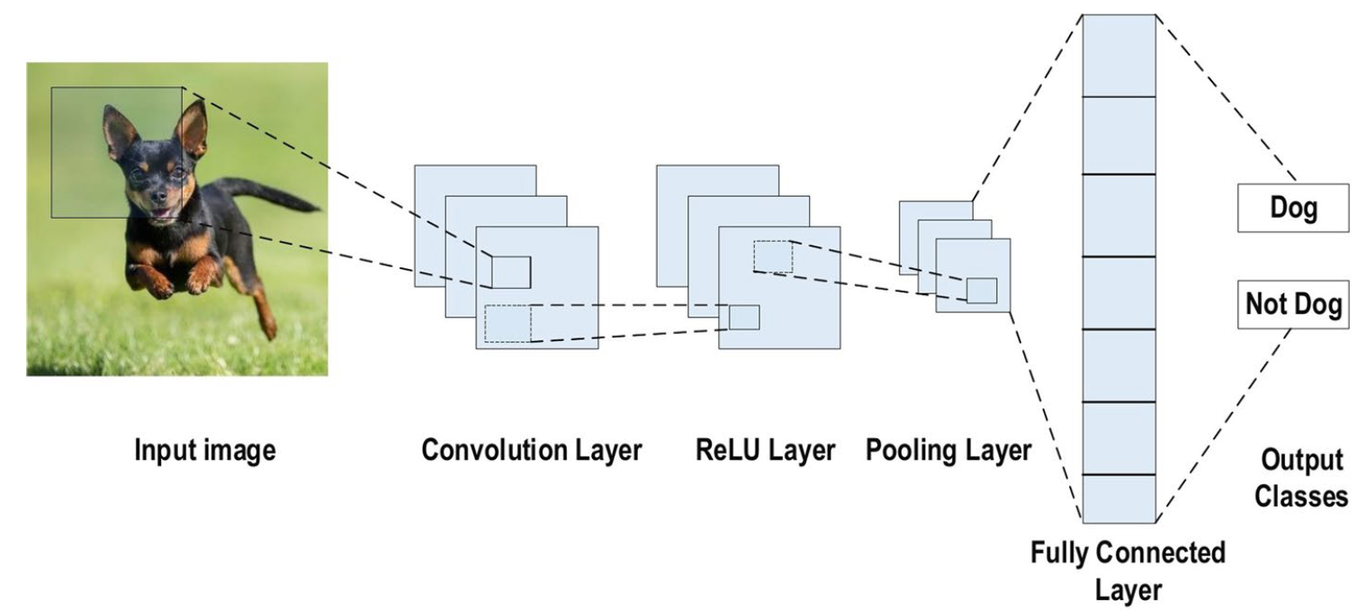
Figure 1. Example of CNN architecture (Source: Alzubaidi et al., 2021)

4.2 Calculate the output dimension of an input image of size, 128 X 128 x 3 with a convolutional layer parameter of 32 filters of size 3, strides 1 and padding of 1.
[5 Marks]

4.3 In the context of autonomous vehicles, discuss the functional benefits and practical advantages of pooling layers in terms of dimensionality reduction and translation invariance. [6 Marks]

4.4 Explain the roles of depth, stride, and padding in CNNs and how these parameters specifically influence the performance and behaviour of CNN-based perception systems in AVs. [9 Marks]
4.5 In the domain of motion planning for Autonomous Vehicles (AVs), traditional optimization models such as Dijkstra's algorithm or A* have been extensively used to compute paths that satisfy certain constraints. However, recent advancements in Convolutional Neural Networks (CNNs) have demonstrated their superiority in handling more complex and dynamic scenarios in motion planning.
Give specific examples of how CNNs perform better than traditional approaches in real-world AV scenarios such as managing real time processing and adapting to dynamic surroundings, to illustrate the benefits of utilizing CNNs for motion planning in AVS. [5 Marks]

Diwedd/End

