

Module Name: Marketing Management
Module Code: LCMB7024

Marketing Environmental Analysis for Pioneers (Tesla) and Followers (BYD)
Lecturer’s Name: Laila Maazouz

Student Name: Vishal Sapkal
Student ID: 2521152

Table of Contents
1. Introduction 2
2. Task 1: Critical Analysis of the Macro Marketing Environment 3
2.1 Macro Marketing Environment 3
2.2 Analysis of Macro Factor 1 (Technological factor) 6
2.2.1 Impact on the Pioneer Organisation (Tesla) 6
2.2.2 Impact on the Follower Organisation (BYD) 7
2.3 Analysis of Macro Factor 2 (Environmental factor) 7
2.3.1 Impact on the Pioneer Organisation (Tesla) 7
2.3.2 Impact on the Follower Organisation (BYD) 8
3. Task 2: Strategic Responses of Pioneering and Follower Organisations 8
3.1 Pioneering Organisation’s Strategic Responses (Tesla) 8
3.2 Follower Organisation’s Strategic Responses (BYD) 10
4. Conclusion 12
5. References 13
6. Appendices 17
Appendix 1: Electric care sales 2016 to 2023 17

1. Introduction
The electric vehicle (EV) sector has become one of the radical parts of the global transport industry due to technological changes and ecological needs. Over the past era, EVs have come into faster adoption, reflecting sales of almost 14 million units of EVs in 2023 globally, which is almost 18% of the total car sales (IEA, 2024). This accelerated growth is an indicator of the desire of consumers to have sustainable mobility as well as the regulatory pressure against carbon emissions. Amidst this dynamic environment, firms also take on different strategic positions, especially as pioneers and followers. Tesla has established itself as a pioneer, relying on the first mover advantage in battery innovation, autonomous driving and charging infrastructure. Conversely, BYD has positioned itself as a follower, concentrating on low cost of entry, mass-production and incremental innovation so as to capture world market at a rapid pace.
Under strategic marketing management, the macro-marketing environment is an important element to study in order to determine the forces influencing organisational competitiveness in the external environment. In this report, PESTEL has been used to discuss two macro environmental factors, technological and environmental factors and how they affect Tesla and BYD. Technological and environmental factors have turned out particularly important in the EV industry, as they have a direct implication on product innovation, consumer adoption, and government-executive market expansion. Drawing upon these factors, the report critically evaluates how both organisations react strategically to the external pressures with regard to appropriate marketing paradigms. It involves two tasks followed by Task 1, which is a critical analysis of the macro environment and Task 2, which is a strategic responses assessment. The scope of the report also indirectly points to the strategic role of environmental scanning as well as the significance of marketing strategies that are flexible enough to keep a business competitive.

2. Task 1: Critical Analysis of the Macro Marketing Environment

2.1 Macro Marketing Environment
PESTLE framework
Factor | Key findings | Strategic Impact
Political | - Adoption of EVs is driven by government policies (IEA, 2021).  - Electrification has been enhanced by NEV policy in China and Fit-for-55 package in the EU (Pan et al., 2026). | Political support, the decline of consumer prices, and on-going stimulation of R&D made the growth of EV adoption possible. Nevertheless, the issue of policy instability, when China reduced its subsidies in 2019, stunned the producers and revealed the danger of excessive dependence on governmental incentives.
Economic | - EV represents 18% of the total car sales globally, with the sales amounting to 14 million in 2023 (IEA, 2024).  - In the U.S., the Inflation Reduction Act of 2022 provides tax credits of $ 7500 per EV (U.S. Department of Energy, 2022).  - By 2023, the cost of the battery packs fell to 139/kWh, down to 176/kWh in 2018 (BloombergNEF, 2023). | The low costs of batteries have enhanced cost-effectiveness and strengthened EVs as a new mainstream category of vehicles.
Social | - Globally, 46 % of consumers prefer sustainability while buying (Deloitte, 2023)  - In Europe and Asia, younger populations were more willing to use EVs.  - The increasing fuel cost and urbanisation support EV adoption (Kiss, Árpád and Kocsis, 2025). | The acceptance of EVs has increased as a result of social acceptability, especially among conscious consumers. However, the current fears about charging infrastructure put limitations on entering consumer markets.
Technological | - Advanced battery performance, self-driving, and charging system  - Globally, over 2.7 million charging points were deployed in 2023 (IEA, 2023) | The technological innovation has become the major differentiator in the EV industry. Increasing adoption of technology sets scale opportunities but also subjects the high-tech firm to erosion.
Legal | - The EU announced an outlaw on ICE cars by 2035 (Raymunt and Torsoli, 2025).  - Autonomous driving safety litigation risk has developed; Tesla was under investigation in 2022 | Laws have exerted pressure on car manufacturers to hasten EVs and conformity. Although these regulations increase costs, they offer long-term competitiveness.
Environmental | - The EU Green Deal provided tighter emission goals by 2050 (European Commission, 2019).  - EVs are placed at the centre of the production of transport emissions that constitute 20% of global CO2 (Aslam et al., 2025). | The environmental imperatives have opened opportunities in terms of branding ESG and consumer belief. Reputational risks are, however, persistent when the sustainability claims are compromised by the supply chain problems.
Table 1: PESTLE analysis
Justification
The PESTLE analysis points out that although various macro-environmental forces affect the EV industry, technological and environmental factors are seen to emerge strategic. The choice of these two factors is both empirically and theoretically justified.
Technological innovation represents the main source of competitive differentiation in the EV market. Unlike traditional car manufacturing, where the incremental optimisation is the primary metric, EVs are mainly competitive in terms of battery performance and software integration (Albatayneh, 2024). Between the years 2018 and 2025, the continuous improvements in battery density and reduction in cost have also greatly transformed accessible markets, which allow firms to scale efforts as well as breach into mass markets.
Besides, Environmental factors remain the core demand factor supporting the whole EV industry. According to the research conducted by Shibayama and Laa (2024), sustainable mobility is not merely the movement supported by the end user but also a requirement of the regulatory and even societal levels. Decarbonised transport has been further reinforced by international commitments to go carbon-neutral. Consequently, EVs are increasingly becoming policy-based, with subsidies. Taxation policies and emissions regulations also have a direct effect on market growth.
Explanation of the strategic significance
The strategic importance of these factors lies in the asymmetric consequences on pioneering and follower organisations. Technological change poses the first mover advantages, enabling the early entrants to lead the way in innovation, brand recognition and control of the infrastructure (Zaino et al., 2024). It, however, is very uncertain, consumes a lot of capital and has a high risk of being rendered obsolete. The environmental factor, though, is more likely to favour follower organisations in the long term, as regulatory settings become more transparent and market demand rates improve.
Critically, the interplay between the technological and environmental forces serves as a facilitator in increasing their strategic importance. Technological advancements have enabled firms to comply with increasingly stringent environmental regulations, whereas environmental policies have accelerated the rate of technological innovation. This interdependence results in a dynamic competitive environment within which firms need to constantly change their strategies in order to retain their relevance. For pioneers such as Tesla, technology is a key to differentiation, and environmental branding is a key to sustaining premium equity. For followers such as BYD, technological adjustment and environmental applicability are the drivers of affordability and scale. Thus, these two macro factors offer the most critical lenses to assess strategic marketing management in the EV industry.

2.2 Analysis of Macro Factor 1 (Technological factor)

2.2.1 Impact on the Pioneer Organisation (Tesla)
In the case of Tesla, technological innovation is a major opportunity as well as a potential threat. As per data, Tesla heavily involved in research and development and had expenses amounting to 3.97 billion in 2023 (Tesla, 2023). By 2026, the company will have the opportunity to capitalise on its 4680 battery cell innovations to increase battery capacity and build a Supercharger network worldwide (Reuters, 2024). These innovations would contribute to the competitive advantage of Tesla by solidifying its high-end perception and system-lock effect. However, risks rest in the rate of penetration of technologies across the industry (Suvarna, 2024). Other companies (BYD and CATL) are closing the gap in innovation, and Tesla will not escape losses due to a lack of innovation paying off. The implication for Tesla, therefore, is that although technology leadership maintains its differentiation, the rate of imitation by its followers jeopardises its dominance in the end.

2.2.2 Impact on the Follower Organisation (BYD)
In the case of BYD, the opportunities of technology are in the field of adaptation and cost-effective innovation. Introduction of Blade Battery in 2020 allowed BYD to increase its sales more significantly, resulting in more than 3 million EV sales in 2023 (BYD, 2025). This flexibility enables BYD to control volume markets, especially in China, where infrastructure is funded by the state, making it easy to adopt. Nevertheless, there are still threats such as weak brand perception in high-end markets and low awareness of radical innovation (Chanaron, 2020). The strength of BYD is thereby illustrated as affordable and scalable, whereas the weakness includes vulnerability in markets where buyers aim to have high-tech devices rather than affordable ones. The implication for BYD, therefore, is that although the follower strategy will provide a dominant position in the mass market, the prestige-based competitive advantage is not enough to compete with Tesla.

2.3 Analysis of Macro Factor 2 (Environmental factor)

2.3.1 Impact on the Pioneer Organisation (Tesla)
Environmental imperatives offer Tesla both a strong opportunity and a reputational threat. The global carbon neutrality goals, including the net-zero goal by the 2050 EU and the Inflation Reduction Act (IRA) by the United States Legal (2022), offer an opportunity related to EV adoption via tax incentives and infrastructure financing (Climate Action, 2024). As a sustainability leader, Tesla has set its mission of hastening the shift to clean energy. This synchronisation allows Tesla to enjoy larger margins, and the average gross profit per vehicle is 8000 dollars in 2023 (Tesla, 2021). Nevertheless, it faces threats of scrutiny regarding supply chain activities, in particular, lithium and cobalt mining. In 2022, Tesla was criticised as cobalt sourcing emissions to cast its ESG statements in a negative light (Johnson, 2023). The implication, consequently, is that although Tesla has an environmental positioning that advantages brand equity, reputational risk can undermine its competitive strategy.

2.3.2 Impact on the Follower Organisation (BYD)

In the case of BYD, the environmental forces bring opportunities due to the adherence to the aggressive green policies in China. In China, over 60 % of the total EV sales were evident in 2023 (IEA, 2024). BYD have the opportunity to sell more vehicles in this market with the alignment of the state-oriented requirements. Nevertheless, sustainability is a threat to rigorous regulations, especially in Europe, where recycling and ESG disclosure norms are getting tougher. The comparative flexibility of BYD also concerns the vertical integration, which gives it a practical ability to manage its supply chain emissions more efficiently than other competitors (Qu, 2023). However, its weakness seems to be visible in its premium markets, where consumers require affordability, as well as exhibiting leadership in sustainability. This implies that the environmental compliance of BYD ensures mass-market growth, whereas reputation risks can limit its competence with Tesla in more environmentally mind-full premium niche markets.

3. Task 2: Strategic Responses of Pioneering and Follower Organisations

3.1 Pioneering Organisation’s Strategic Responses (Tesla)
The impact of the external pressures and opportunities on Tesla is critically analysed here with the help of Ansoff Growth Matrix, including four growth strategies: market penetration, product development, market development, and diversification.
- Market Penetration
Tesla has solidified its presence by establishing a continuously expanding chain of Superchargers, consisting of over 6,000 throughout the globe (Kane, 2024). This architecture assists in strengthening loyalty of the customer since it ensures repeat purchase and ecosystem lock-in. As an illustration, Tesla's charging network in the U.S. has been a binding element in preserving its market share amidst increasing rivalry with Ford and GM.
- Product Development
Tesla has continuously introduced new technologies in the current markets. In 2020, Tesla announced its 4680 battery cells, based on higher energy density and a lower price, expanding its Full Self-Driving (FSD) software (Tesla, 2021). The company has also shown its determination to develop innovations. For example, in 2023, it announced that more than 300,000 cars were fitted with FSD Beta (Kolodny, 2023). Other companies, including Volkswagen Group and Ford Motor Company, have progressed with EV platforms and software ecosystems faster, reducing the technological gap in Tesla. This shows the decreasing sustainability of first-mover advantage in a high-paced industry.
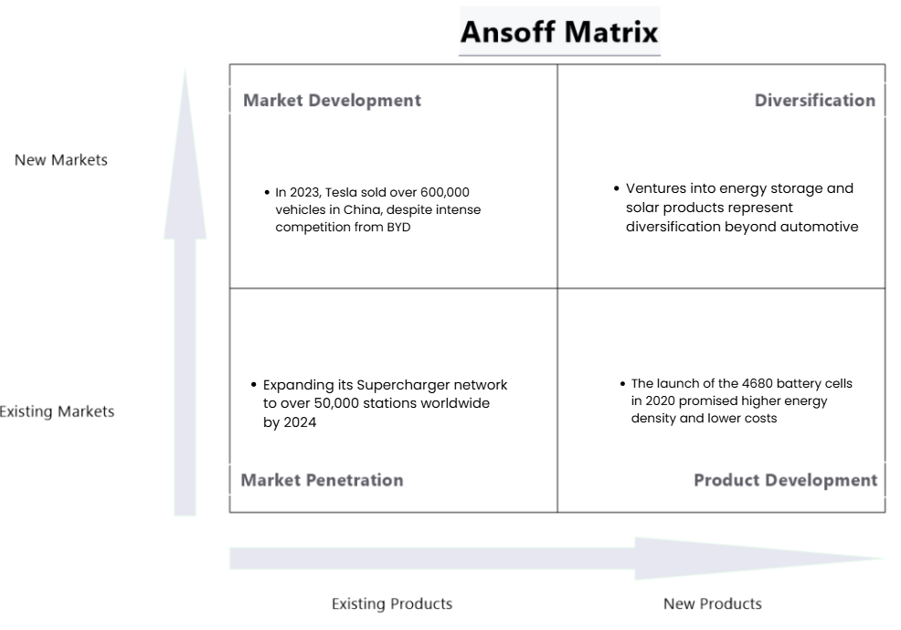
Figure 1: Ansoff Matrix
(Source: Author)
- Market Development
Tesla has ventured aggressively into new geographical markets, especially China and Europe. As of 2023, Tesla sold more than 600,000 vehicles in China, even though the competition between Tesla, BYD and NIO is fierce (Reuters, 2025). This growth shows that Tesla can use brand prestige and environmental positioning to enter highly competitive markets.
- Diversification
The diversification of Tesla beyond the automotive industry is through its operations in energy storage and solar products. Its products, Powerwall and Solar Roof, match the requirements of environmentalism and complement the ESG story of Tesla, establishing a linkage between clean energy and mobility.
However, the multi-pronged growth strategy by Tesla within the framework of Ansoff shows proactive reactions to the pressures of technology and environment, which underpins its leadership quality. The use of differentiation places Tesla at the premium position; however, it makes it vulnerable to fluctuations.

3.2 Follower Organisation’s Strategic Responses (BYD)
Porter's Generic Strategy, based on cost leadership, differentiation, and focus, are implied here to analyse the strategic responses of BYD.
- Cost Leadership
The business model of BYD is vertically integrated, which inspires the firm to adopt a cost leadership strategy (EVBoosters, 2025). Unlike most of its competitors, BYD manufactures its batteries, semiconductors, and major parts, which enhances production at a much lower cost. This feature was especially beneficial in the recent global semiconductor shortage (2020-2022) when the production of most automakers, including Toyota Motor Corporation, was interrupted. BYD, conversely, experienced quite stable production, which allowed it to increase its market share.
- Differentiation
Although affordability is the core strength of BYD, they have sought incremental differentiation with battery-swapping technology and hybrid EVs. As an illustration, the BYD Qin Plus DM-i hybrid sedan was among the best-selling vehicles in China in 2022, as consumers who are price-sensitive rely on convenience to make the decision (SEDA, 2024). Nevertheless, the differentiation of BYD is minimal about the radical innovations that Tesla achieved, limiting its competition in high-quality markets.
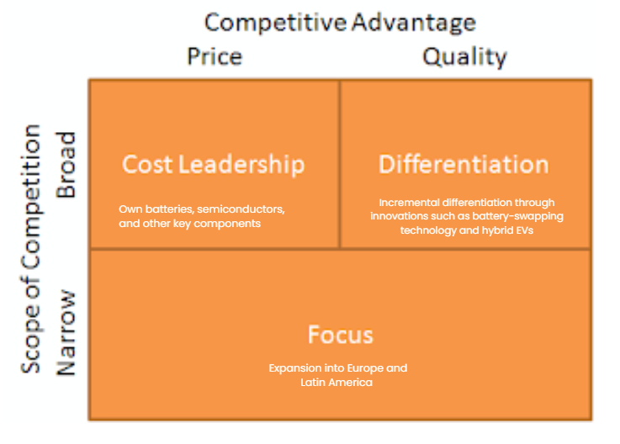
Figure 2: Porter's Generic Strategy
(Source: Author)
- Focus Strategy
BYD has focused on domestic dominance and emerging economies within China, where the government subsidies and mandates are highly favourable to EV adoption. Its move to Europe and Latin America shows its focus on those markets in which price matters. As an example, in 2022, BYD launched the Atto 3 SUV in Europe, at a much lower price than the Model Y, which aimed at middle-income buyers (Zhou and Wongsamuth, 2023).
On the whole, the strategic responses of BYD based on Porter's framework reflect flexibility and scalability. Cost leadership in BYD provides durability in the price-sensitive markets, yet restricts brand equity in the value segments.

4. Conclusion
This report has critically examined the influence of macro factors on pioneer and follower organizations in the EV industry particularly Tesla and BYD. The discussion showed that the first mover benefits the pioneer to a high degree due to the innovation and brand differentiation. Additionally, the environmental conditions remain more favourable to follower organisations, where the transparency of regulations and facilitation of policies contribute to scaling at low cost and market expansion. In terms of ensure long-term competitive leadership in the rapidly evolving EV market, companies thereby need to seek dynamic marketing strategies, which should be aligned to the evolving technological and regulatory climate.

5. References
Albatayneh, A. (2024). The electric cars era transforming the car repairs and services landscape. Advances in Mechanical Engineering, 16(7). doi:https://doi.org/10.1177/16878132241266536.
Aslam, B., Zhantian, B., Amjad, M.A. and Zhang, G. (2025). Decarbonizing transport: EV production versus conventional vehicles. Transport Policy, [online] 174, p.103821. doi:https://doi.org/10.1016/j.tranpol.2025.103821.
BloombergNEF (2023). Lithium-Ion Battery Pack Prices Hit Record Low of $139/kWh - BloombergNEF. [online] BloombergNEF. Available at: https://about.bnef.com/insights/clean-energy/lithium-ion-battery-pack-prices-hit-record-low-of-139-kwh/ [Accessed 25 Mar. 2026].
BYD (2025). ‘blade battery’. [online] Technological Innovations for a Better Life | BYD USA. Available at: https://en.byd.com/page/6/?s=blade+battery [Accessed 25 Mar. 2026].
Chanaron, J.-J. (2020). Challenges to radical innovation winning technology for the car of the future? Part two. Megatrend revija, 17(3), pp.1–30. doi:https://doi.org/10.5937/megrev2003001c.
Climate Action (2024). Policies & action. [online] Climateactiontracker.org. Available at: https://climateactiontracker.org/countries/usa/2022-08-16/policies-action/ [Accessed 25 Mar. 2026].
Deloitte (2023). Green products come of age. [online] Deloitte Insights. Available at: https://www.deloitte.com/us/en/insights/industry/retail-distribution/consumer-behavior-trends-state-of-the-consumer-tracker/sustainable-products-customer-expectations.html [Accessed 25 Mar. 2026].
European Commission (2019). The European Green Deal. [online] European Commission. Available at: https://commission.europa.eu/strategy-and-policy/priorities-2019-2024/european-green-deal_en [Accessed 25 Mar. 2026].
EVBoosters (2025). The blueprint of an EV empire: how BYD built global dominance through vertical integration. [online] EVBoosters. Available at: https://evboosters.com/ev-charging-news/the-blueprint-of-an-ev-empire-how-byd-built-global-dominance-through-vertical-integration/ [Accessed 25 Mar. 2026].
IEA (2021). Policies to Promote Electric Vehicle Deployment. [online] IEA. Available at: https://www.iea.org/reports/global-ev-outlook-2021/policies-to-promote-electric-vehicle-deployment [Accessed 25 Mar. 2026].
IEA (2023). Trends in Charging Infrastructure – Global EV Outlook 2023 – Analysis. [online] IEA. Available at: https://www.iea.org/reports/global-ev-outlook-2023/trends-in-charging-infrastructure [Accessed 25 Mar. 2026].
IEA (2024). Electric vehicles. [online] IEA. Available at: https://www.iea.org/energy-system/transport/electric-vehicles [Accessed 25 Mar. 2026].
Johnson, W. (2023). Tesla doubles down on ethical sourcing with cobalt mining risk analysis. [online] TESLARATI. Available at: https://www.teslarati.com/tesla-ethical-sourcing-cobalt-mining-impact-report/ [Accessed 25 Mar. 2026].
Kane, M. (2024). Tesla Expanded Its Supercharging Network To Roughly 6,000 Stations. [online] InsideEVs. Available at: https://insideevs.com/news/705972/tesla-supercharging-network-roughly-6000-stations/ [Accessed 25 Mar. 2026].
Kiss, J.T., Árpád, I.W. and Kocsis, D. (2025). Influence of human capital, urbanization, fuel imports and other macroeconomic factors on electric vehicle adoption. Heliyon, pp.e42661–e42661. doi:https://doi.org/10.1016/j.heliyon.2025.e42661.
Kolodny, L. (2023). Tesla recalls 362,758 vehicles, says Full Self-Driving Beta software may cause crashes. [online] CNBC. Available at: https://www.cnbc.com/2023/02/16/tesla-recalls-362758-vehicles-says-full-self-driving-beta-software-may-cause-crashes.html [Accessed 25 Mar. 2026].
Pan, S., Xu, Y., Li, Z., Fulton, L.M. and Gao, H.O. (2026). Future changes in CO2 emissions in the shift to electric mobility in countries with varied levels of zero-emission vehicle policies. Resources, Environment and Sustainability, 24, p.100316. doi:https://doi.org/10.1016/j.resenv.2026.100316.
Qu, Y. (2023). The Advantages of Supply Chain Integration in Electric-vehicle Industry: Evidence from BYD. Highlights in Business, Economics and Management, 7, pp.179–185. doi:https://doi.org/10.54097/hbem.v7i.6940.
Raymunt, M. and Torsoli, A. (2025). Automakers See Future for Fuel-Burning Cars With EU Ban in Doubt. [online] Bloomberg.com. Available at: https://www.bloomberg.com/news/articles/2025-12-10/automakers-see-future-for-fuel-burning-cars-with-eu-ban-in-doubt [Accessed 25 Mar. 2026].
Reuters (2024). Tesla plans four new batteries in 2026, including for robotaxi, The Information reports. [online] Reuters. Available at: https://www.reuters.com/technology/tesla-plans-four-new-batteries-2026-including-robotaxi-information-reports-2024-10-03/ [Accessed 25 Mar. 2026].
Reuters (2025). Tesla’s China sales rise to record high in 2024, bucking global decline. Reuters. [online] 3 Jan. Available at: https://www.reuters.com/business/autos-transportation/teslas-china-sales-rise-record-high-83000-december-2025-01-03/ [Accessed 25 Mar. 2026].
SEDA (2024). BYD Qin family sales exceeded 2 million and Qin L DM-i was popular. - HS SAIDA International Trading Co., Ltd. [online] BYD Qin family sales exceeded 2 million, and Qin L DM-i was popular. - SEDA. Available at: https://www.hsseda.com/news/byd-qin-family-sales-exceeded-2-million-and-qin-l-dm-i-was-popular/ [Accessed 25 Mar. 2026].
Shibayama, T. and Laa, B. (2024). The Sustainable Mobility Guarantee: developing the concept from a transport planning perspective. Transport Policy, 155, pp.287–299. doi:https://doi.org/10.1016/j.tranpol.2024.07.003.
Suvarna, D.S. (2024). A Strategic Examination of the Electric Vehicle (EV) Industry: Unveiling Opportunities and Challenges for... [online] ResearchGate. Available at: https://www.researchgate.net/publication/381160803_A_Strategic_Examination_of_the_Electric_Vehicle_EV_Industry_Unveiling_Opportunities_and_Challenges_for_Tesla.
Tesla (2021). Impact Report 2021. [online] Available at: https://www.tesla.com/ns_videos/2021-tesla-impact-report.pdf [Accessed 25 Mar. 2026].
Tesla (2023). Annual Report. [online] Available at: https://ir.tesla.com/_flysystem/s3/sec/000162828024002390/tsla-20231231-gen.pdf [Accessed 25 Mar. 2026].
U.S. Department of Energy (2022). Alternative Fuels Data Center: Qualified Plug-In Electric Vehicle (PEV) Tax Credit. [online] afdc.energy.gov. Available at: https://afdc.energy.gov/laws/409 [Accessed 25 Mar. 2026].
Zaino, R., Ahmed, V., Alhammadi, A.M. and Alghoush, M. (2024). Electric Vehicle Adoption: A Comprehensive Systematic Review of Technological, Environmental, Organizational and Policy Impacts. World Electric Vehicle Journal, [online] 15(8), p.375. doi:https://doi.org/10.3390/wevj15080375.
Zhou, V. and Wongsamuth, N. (2023). BYD conquered China’s EV market. Europe and the U.S. will be a lot tougher. [online] Rest of World. Available at: https://restofworld.org/2023/byd-evs-global-rollout-tesla/ [Accessed 25 Mar. 2026].

6. Appendices

Appendix 1: Electric car sales 2016 to 2023

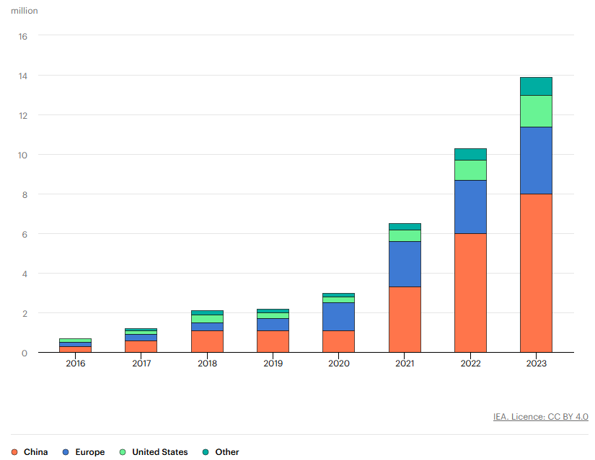
(Source: IEA, 2024)

