Introduction

Industry Background
According to the United Nations Conference on Trade and Development (UNCTAD), the tourism sector suffers approximately US$4 trillion loss due to the COVID-19 (UNCTAD 2021). Referring to figure-1, source from UNCTAD, points to the fact that the GDP loss percentage from tourism sector for Hong Kong is just behind that of United States of America ranked No. 15 in the world. Based on estimates from the Hong Kong Special Administrative Region government, Hong Kong's GDP declined 8.9% during the first quarter of 2020 (www.hk-lawyer.org). Hong Kong's tourism industry is one of the main pillar industries that contribute heavily to the economy and employment. Tourism accounted for 4.5% of the GDP and 6.6% of employment in 2018 as compared to 2.4% and 3.6% in 2020 (HKMA 2021).
Figure 1 – Financial Loss in GDP in Tourism Sector
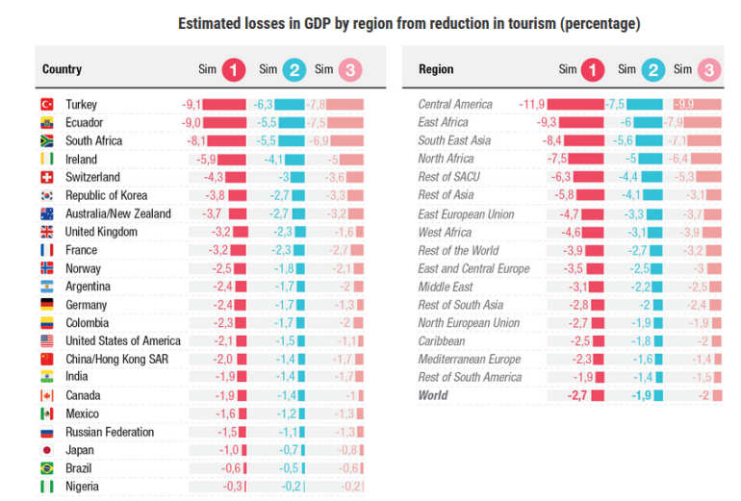
Source: unctad.org Jun 2021

Hong Kong hotels are known around the world for their excellent performance. Data collected from Hong Kong Hotels Associations, amongst 104 members hotel, hotel occupancy rate reached 90% on a yearly basis in 2019. According to the Hong Kong Tourism Board (HKTB) reports, total number of visitor arrivals in 2020 is 3.5 million, down by 93.6 percent when compare to 2019 (www.discoverhongkong.com). The majority of the annual total was accounted for by arrivals in January 2020 alone (Figure 2) (www.discoverhongkong.com). A worldwide pandemic Covid-19 hits Hong Kong on January 23, 2020 with the first COVID-19 case (Cheung 2020). After the COVID-19 outbreak spreading worldwide in February 2021, Hong Kong enacted strict quarantine measures and restricted access to foreign visitors in mid-March. Hong Kong Hotel practitioners are experienced to overcome various crisis in the past including global crisis like the Gulf War in 1991, the Asian Financial crisis in 1997, the Severe Acute Respiratory Syndrome (SARS) outbreak in 2003 (The Edge Market 2020), and the Swine Flu outbreak in 2009. The industry is struggling to survive in the face of unforeseen challenges running from profitability to survival.
Figure 2 – HKHA Members Hotel Room Occupancy, Average Rate and Yield for Jun 2021
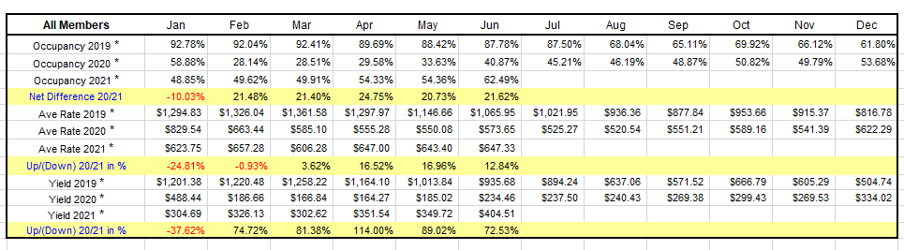
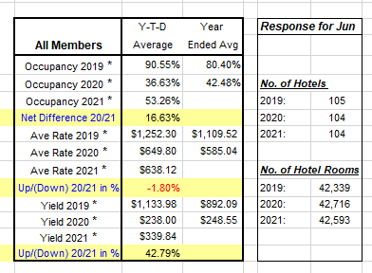Source: Hong Kong Hotels Association (Jun 2021)
Hotel Classifications
Classifications of hotels are designed to meet the expectations of guests and hotel properties. There are different ratings available around the world or on different platforms. In North America, a diamond rating system is used and is managed by the American Automobile Association (AAA) founded in 1902. The symbol of world-class luxury went from five diamonds to one diamond by meeting the industry-leading standards of AAA inspections (www.aaa.com). In Europe, hotels are rated by stars and categorized under the services provided. Five-star hotels offer hotels with a 24/7 reception desk staffed by hotel stars union, and one-star hotels offer only daily room cleaning (www.hotelstars.eu). In Hong Kong, the Hong Kong Tourism Board oversees the classifications of hotels and latest update in 2018. Hong Kong Hotel Classification System will grade hotels under five major components –facilities, location, staff-to-room ratio, average achieved room rate and business mix. Hotel classifications then represent by High Tariff A, High Tariff B and Medium Tariff Hotel (Appendix 1) based on the composite scores. Ratings based on stars are more widely accepted by the public, as well as in China which is managed by the China National Tourism Association.
Brand hotels
Hotel chains including international names are available in Hong Kong. Four out of the ten largest hotel groups operate in Hong Kong (Figure 3) and Marriott is the top amongst the list. Hotel owners usually hire management companies to manage their properties and pay them a substantial management fee. Brand-name hotels are said to have competitive advantage as they have a stronger brand reputation against competition. Service excellence is often upheld by a higher staff-to-room ration. In most cases, hotel groups are supervised by head/corporate offices. According to Kaplan and Morton (2004), companies run by corporate offices starts with a deficit on their balance sheet. Other words, the costs are higher and resources are tighter, under COVID-19 pandemic, when comparing to other operations. Moreover, management companies and hotel owners sometimes convey conflicting messages, and with multiple layers of managers are remarkable to study, along with the level of strategic barriers posed by the COVID-19 pandemic.

Figure 3 – Top 10 Hotel Groups in the World
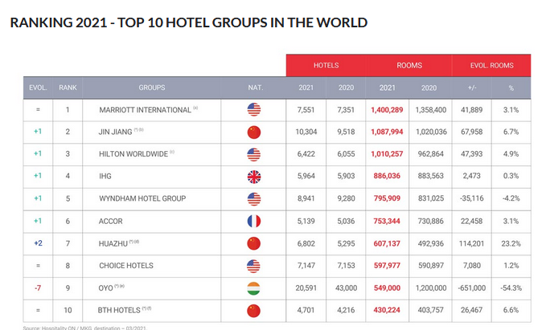
Source: Hospitality ON. (Apr 2021).

Lean Service Hotel
The industry has been moving towards lean service hotels in recent years because of the rising costs (Erwin et.al 2015). Due to generational differences in travel, Millennials, Generation X, and Generation Z are looking for different experiences in comparison to boomers. Lean service hotels aim to maximize customer satisfaction, provide high quality service to all customers by minimize resource use, maximize productivity, and increase efficiency (Rauch et. al 2016). In general, these hotels are run without star ratings and are usually classified as boutique or selected service hotels. Hotels with familiar brand names, such as Best Western, Holiday Inn Express, and Ibis are under this classification. These hotels operate on a lean model or with fewer resources and at a lower operation cost. Theoretically, these types of hotels may survive a disruptive business environment better than traditional or top-brand hotels under cost differentiation. Moreover, a leaner staff-to-room ratio with fewer management layers, will there be fewer barriers for strategy implementation? This study will look into this aspect with insights.

Quarantine Hotel
For protection against the COVID-19 virus, the Hong Kong Special Administrative Region government implemented a restriction prohibiting arrivals from selected areas and requiring them to stay in government selected quarantine hotels starting from December 2020. At present, 36 hotels are available for visitors, providing 10,000 rooms (www.coronavirus.gov.hk). The hotel operators opted to collaborate with the government and to comply with the relevant government requirements. During COVID-19 period, this is considered a new business model that has been undisturbed. Several hotel groups including top brand names such as Sheraton, Marriott and Mandarin Oriental Groups have chosen to be a designated quarantine hotel. It is possible that staff members will resist the idea of implementing such a strategy owing to mistrust or opposition. An examination of how strategic barriers impact the implementation of a strategy for this specific type of hotel is of particular interest to this study.

Problem Statement
Theoretically, strategy management is about building strength on performances. In the past, the industry has encountered challenges such as financial crises or travel restrictions imposed by the World Health Organization in 2003 influenced by SARS and 2009 under the threat of Swine Flu outbreaks. Hotels in Hong Kong have learned their lessons and the impact the travel ban had on competing environment. Historically, there is a short-term effect on Hong Kong Hotels from such incidents, or some academies studied the period under crisis management, and the business bounce back is strong. The tourism and travel industry are one of the most threatened industries under COVID-19 pandemic and business disruptions still persist over 20 months from January 2020. Massive drops in global demand resulting from travel restrictions and international borders are closings (UNWTO 2020). The hospitality industry, as part of the tourism and travel industry, suffers from the same problems. As mentioned previously, Hong Kong hotel practitioners may have insight into the challenges due to a travel ban from previous solid experience. Worldwide studies have been published on the COVID-19 period, however, there have been no studies that examine the hospitality industry specifically with regards to strategic management, in the context of the strategy gap, in Hong Kong.
Strategy formulation is based on accessing the competitive environment (Porter 1985) and internal resources and capabilities (Barney 1991). Based on Porter's Five Forces model, a firm's competitive advantage is based on making strategic choices to defend or manipulate the force to maintain its advantage against its competition (Porter 1985). An effective hotel management involves leveraging resources and capabilities in order to maximize profitability. The resources include both tangible and intangible assets, from furniture to skills such as the management skills possessed by the pool of employment. Intangible assets make up more than 75% of the market value of an average company (Kaplan and Morton 2004). Companies, especially in the hospitality industry, manage assets they cannot see or measure. Most strategic initiatives fail between 70 and 90 percent (Kaplan and Morton 2004), and strategic choices can differ from one to another. There are apparently different approaches to managing a business portfolio at different environment. Depending on strategies, it will be interesting to see who survives, who struggles, who fails, and who succeeds after COVID-19 (Chuck 2021). This study will only evaluate barriers to implementing the chosen strategy, not the reasons for choosing the strategy.

Research Questions
By addressing the above problem statement, this study attempts to provide an answer by examining the types of strategic barriers and how do strategic barriers influence strategy execution during COVID-19 pandemic period? Strategic barriers are identified by Kaplan & Norton (2001) as vision, people, management, and resources. In other research, strategic barriers can result from other aspects such as culture, leaderships, communications, time, cost cutting, trust, goals and many more. This study will use Kaplan and Morton (2001) as our grounding theory and code the other factors into themes under the four principal barriers. Tt is crucial to examine what is affecting implementation, especially during unfavourable periods, when performance must be maximized.

Different categories of hotels will control different levels of resources, as is evident, in the aspect of tangible and intangible. Staff levels may differ in between types of hotel. Moreover, operating facilities will also be different. For example, a five-star hotel is required to operate with a spa, a swimming pool and at least five restaurants. When profit centres such as restaurants and spas are forced to close during regulations of government under COVID-19, strategic decisions are more difficult to make when comparing to a lean service hotel business model. It is imperative to understand what are the key barriers for hoteliers to successfully implement their strategies during Covid-19? What are the differences and similarities among the barriers encountered in different types and categories of hotels?

Relevance and Importance of the Research
A strategy gap analysis is essential for ensuring the implementation of business strategy. Knowing strategic barriers can help companies to optimize available resources during strategy implementation in order to avoid abusing resources and making mistakes. In the period of COVID-19 pandemic, business conditions are unfavourable, risks are high and the window of opportunity is limited. It is the purpose of this study to provide hotel practitioners with insight into overcoming challenges over this specific period. Study participants will be interviewed regarding the challenges faced by the types of hotel they operate and the strategy gaps they experience.
There are several reasons why this study is significant:
- It is intended to serve as a record for Hong Kong Hotel practitioners during the covid-19 outbreak.
- To get a better understanding of the hospitality industry from hotel leaders and the different hotel classes.
- To identify the key strategic barriers that influence hotel practitioners in strategy execution during covid-19.
- To discuss how these barriers may vary between different types/classifications of hotels.

Literature review

Key Concepts, Theories and Studies
Strategic management is one of the most cited topics with over 4 million times at google scholar. Influential studies and theories are introduced by academies in the past decades. Professor Peter Drucker published his book of strategic management in 1964 describes and illustrates how to manage discontinuities by repeating and changing processes (Maciariello 2018). In 1985, Professor Michael Porter presented his book Competitive Advantage, introduced Porter's five forces (Porter 1985), a framework mostly used in analysing business competition. The Resource Base View, presented in 1991 by Professor Jay Barney, complements the external forces by focusing on a firm’s internal resources (Barney 1991). The balance scorecard was introduced by Kaplan and Norton in 2001 as a tool for strategic management. Research and theories are concentrating on analysis, formulation, and implementation of strategies.
Sustaining competitive advantage is the key to strategic management and will competitive advantage last even at COVID-19 pandemic period? A generic strategy, according to Porter (1985), is either cost differentiation, product differentiation or focus strategy. If strategy is properly implemented, a company with a competitive advantage will be able to outperform its competitors. Over the years Professor Michael Porter published numerous books and articles on competitive advantage. Through his work, Professor Porter has explored the bases of competitive advantage and its sustainability through the lens of conceptualizing a firm’s resources and capabilities. In recent years, Professor Porter takes a broader concept of competitive advantage and apply it to nations, from industries to political and geographic units implying that competitive advantage is more than just a theory.
Professor Jay Barney studies a firm's internal sources of sustained competitive advantage (Barney 1991), theories for how a firm creates strategic value focused on gathering resources from multiple stakeholders. Resources alone do not enable a firm to form and implement strategies. A firm’s skills and abilities allow them to compete more effectively with other players in the industry. A firm can achieve greater organizational performance, explicit value creation mostly in terms of profit, only when internal resources and capabilities are utilized efficiently and effectively (Barney 1991). The concept of a firm's resources mainly refers to tangible and intangible assets. Intangible resources are resources without any physical appearance owned and controlled by a firm. Brand reputation, human resources, trademarks, intellectual property, trust, leadership and teamwork are group as intangible resources. Different from physical resources, intangible resources, for example, brand reputation to some degree cannot be traded on the market, costly to duplicate, and takes a long time to build. Intangible resources are more sustainable in nature, as a source of competitive advantage for a firm.
Most of these studies examine strategy under a stable environment on performance and growth. Theoretically, companies should maintain business performance during challenging times if they have a competitive advantage over their competitors. When faced with the unexpected changes and challenges of a COVID-19 pandemic, will a firm with a competitive advantage survive? Will strategies be able to sustain in a disrupted environment? Top-brand hotels have a better reputation, as competitive advantage, do top-brand hotels have a higher chance of surviving than independent hotels during COVID-19 period?
Strategy is about choice (Porter 1985), a firm's choice based on its assessment on competing environment. A company may need to make strategic decisions due to changes in the business environment. Implementations of strategic plans and measurements are well defined and analysed in a balanced scorecard (Kaplan and Morton 2001). The balance scorecard gives managers four perspectives, including financial, customer, internal, innovation and learning. Looking at the goals and measures in connection with the four perspectives, managers can examine below (Kaplan and Morton 1992):
- Is a firm well-received by customers? (customer perspective)
- In what areas is a firm good at? (internal perspective)
- Is a firm creating value through improvement? (innovation and learning perspective)
- What is a firm’s approach to shareholders? (financial perspective)

Key Debates and Gaps in Existing Knowledges
Professor McGrath of Columbia Business School pointed out strategy in most literature is evaluated on a stable and undisrupted environment (Bell 2013). Professor McGrath argues that sustainable competitive advantage does not exist (HBR 2013). It is more important for a company to focus on capturing opportunities as soon as identified rather than focusing on establishing a sustainable competitive advantage as part of strategy (HBR 2013). In fact, there is an essential need for a strategy to make a difference in a volatile and unsettled environment. A variety of frameworks like SWOT, Porter's Five Forces, Resource-Based View, and Balanced Score-Card are commonly used to evaluate strategy formulations and implementations. Unofficial research indicates approximately 20 to 50 strategy frameworks from various scholars are available. Using the strategy frameworks described above, a solid blueprint of a business should have been built. What are the chances a company will survive in these tough economic times if they follow these blueprints? In order to successfully implement strategy, there will always be challenges. Study on the strategy gap or strategic barriers, or the gap between profitability objectives and actual profitability levels, is lacking.
The purpose of this study is to bridge a research gap that is seldomly investigated. In light of the COVID-19 outbreak, it is critical to understand the challenges on strategy implementation. In limited study by Kaplan and Norton (2001), nine out of ten companies failed to successfully implement strategy. A people barrier, or human resource barrier, stands out to be a strong barrier. The same study, Figure 3, cites management, vision, and resources are also barriers to strategy implementation (Kaplan and Norton 2001). This analysis reveals the following:
- Only 5 percent of the workforce understands the company's strategy. In other words, 95 percent of the workforce lacks vision.
- In 25 percent of cases, managers will align incentives with their strategies. In 75 percent of cases, there are no incentives for staff to execute strategy.
- Almost 85% of executive teams meet less than one hour a month discussing strategy.
- In 60% of organizations, budgets and strategies are not linked.

Figure 3 – Strategic Barriers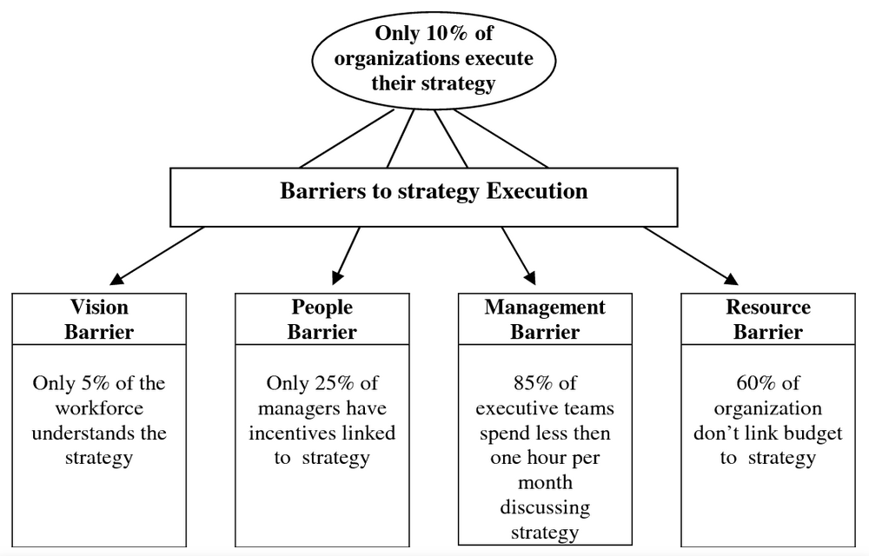
Source: Ahmad and Rajuddin (2006)

Research design and methods

Research design
A qualitative method and exploratory nature are chosen for this study. Method is chosen due to the complexity of hotel industry which is also known as people industry (O'Gorman & MacIntosh 2014). Intangible resources are the most valuable part of this industry, owing to the nature, it is hard to measure scientifically. This research is aim at looking for insights which can be shared from the research unit. In addition, research units are chosen in specific to look at cases and representation for the period of Covid-19 pandemic in Hong Kong. The aim of this study is to identify the key strategic barriers that influence Hong Kong hotel practitioners in strategy execution during COVID-19 pandemic. Moreover, this study will measure if these barriers differ among various classes of hotels within the defined research unit.
This study is designed to collect primary data from semi-structured interviews with head of hotels, the department heads or assistant department heads of the research unit. The interviewee is invited to share their experience as a leader, leading through unexpected dynamic business environment, overcoming challenges and strategic barriers in operating a hotel. Interviews are ideal to be conducted face-to-face, by zoom or other digital platforms. On the other hand, telephone interviews will also be considered if chosen by interviewees. All interviews are planned to be recorded. Researcher will prepare a written transcript for each interview, and will be passed along to interviewee for validation in order to ensure all data collected is accurate and unbiased. Snowball sampling will also be considered to recruit more data due to interviewees are relatively rare and difficult to find within the research unit.
In addition, secondary sources data will also be analysed, including trade journals, trade magazines, and association reports. Research findings from hotel internal reports and hotel inspection tours are planned if approved by study participants.
This study may expect the following findings (F):
- F1: Hotels are experiencing some level of strategic barriers under the impact of covid-19.
- F2: Different classes of hotels will experience different level of barriers.
- F3: Hotel practitioners can learn to overcome with insights share.

Methods and Sources

Research focus is constrained to the study period of January 1, 2020 to December 31, 2021. The research participants must be servicing the study unit within the define study period. Moreover, participants must be in current job position within the define study period. The participants should be leading and servicing the research unit during this defined study period. This particular study period was described as an unexpected and dynamic business environment. As a result of such conditions, participants will be interviewed to obtain the insights on relevant research objectives of this study.
Research Unit
The secondary aim of this study is to measure if these barriers differ among various classes of hotels within the defined research unit. As such, one representation of each of the following classes of hotels will be invited:
- Hotels owned or managed by international brands. Brands such as Hyatt, Four Seasons Hotel, Accor, Marriott International, InterContinental Hotel, Peninsula, etc.
- 5-star or 4-star rating Hotels which hotel properties are running with accommodations and food & beverage outlets and other revenue units including spas, etc.
- Selected service hotels which hotel runs only accommodations with least hotel services and usually less staff.
- The research unit which is the one of 36 quarantine hotels that reacted to COVID-19 and worked with government and provided accommodations and meals for 14 to 21 days during quarantine.
Semi-structured Interview
Researchers will invite hotel leaders to share their experiences in order to achieve the research goal, as such, head of hotels, general managers, department heads or assistant department heads of study unit will be invited. To acquire primary data, semi-structured interviews are prepared (Appendix 2). An overview will be provided by the researcher before the interview begins to provide participants with a brief concept. Participants will also be encouraged to share examples, stories, and experiences with the researcher. When answers do not match variables or themes of strategy barriers, researcher will probe for additional questions. After the interviews, validate the content with the participants to confirm that the interpretation is correct. Variables will be coded and aligned based on theoretical concepts. In addition, data from the interviews will be analyzed using thematic analysis. Data on a nominal scale for some of the responses from the interviews.

Limitations of Study and Considerations
Similar to many other studies there are challenges and expected limitations on this research. Firstly, a qualitative research method is used in this study, which could result in interpreter bias and the subjectivity of results. Primary data of this study is collected from semi-structure interviews with head of hotels and leaders of departments. Then, the data collected will be themed and content coded. Despite the best effort, possibility of subjectivity cannot be disregarded. Furthermore, if data collected from interviews, such as conversation and stories, are not objective, then this can indicate defective risks related to the period and incident. An interview transcript will be prepared at the end of the interview for the participant to validate and minimize bias impacts on data collection. Secondly, the sample size is relatively small. As per Hong Kong Hotel Association, there is only 104 member hotels in Hong Kong. One sample hotel of a defined class, out of 104 hotels, is picked to represent a research unit may address the limitation on research generalization. Therefore, this research used one representation of different hotel classifications, allowing for a less generalized analysis. Thirdly, the study does not produce any scientific data and there is no validation for a broader population that could be generalized or applied worldwide. This research study is limited to Hong Kong Hotels only, and geographical representation is small. Thus, it is recommended that further research be conducted at different geographical locations to improve dependability of this stud. Lastly, this research period will target at least 20 interviews from sample research unit. However, due to time constraints, as well as the volume of data received from the interviews, a deeper analysis may not be possible within the limited resources.

Implications and contributions to knowledge

Practical Implications

The word strategy is a combination of two Greek words meaning utilise the forces and defeat the enemies. The paradox of strategy from The Art of War, by Sun Tzu, since 5th century B.C. In ancient times, strategy is always associated with unstable, uncertain and war. Since the 1960s, when strategy management became popular, many academics have studied strategy development, analysis methods, and strategy implementation measurement. Professor Porter emphasizes the five-force model and value chain analysis when analysing external factors. Professor Barney emphasizes the importance of resource base theory focusing on internal resources and capabilities of a firm. Kaplan and Morton introduce balanced scorecard as a strategy implementation framework. However, few academics investigate the obstacles to strategy implementation. The environment is stable and homogeneous in most strategic theories. However, this is not the case in reality. Because the business environment has altered as a result of COVID-19, creating a dynamic and unstable scenario, this study will be valuable in determining how strategy barriers will limit the success of strategy implementations. Knowing that the resources available at various hotel classes differ, strategy obstacles are expected to differ. Other practitioners will be able to make better strategic decisions as a result of the insights given by industry leaders. Furthermore, by identifying strategy implementation gaps, it is possible to improve strategy execution in order to ensure predictable results and add competitive advantages.
Previous research has focused on a stable environment, but the COVID-19 epidemic has created uncertainty in the corporate environment. Hoteliers in Hong Kong have learned from earlier SARS outbreaks in 2003 and the 2009 SWINE flu pandemic. In comparison to the COVID-19 pandemic, which has swept the globe, the impact on travel prohibition is massive. There is lack of research studies in this particular area for Hoteliers to learn from the impact. Researchers are focused on COVID-19 pandemic impact on industry overall; yet, not covering strategy in particular. This study will focus on strategy gap and intend to well cover on barriers of implementation. Looking into identifying barriers can minimize the gap and improve strategy execution, value creation and obtain competitive advantage. Identifying the barriers can improves process of execution. Minimize issues with performance or efficiency of hotel operations. The importance is to avoid failure, facilitate execution, improve value creation. This study aims to provide insights to hotel practitioners in Hong Kong and hoteliers facing this problem may implicate other hoteliers in other destination. These findings also provide insights to managers and factors that maybe useful in future when leading strategic changes, developing strategy and planning.

Theoretical Implications
The theoretical contribution on identifying strategy barriers, or gap analysis, is to examine root cause of challenges. Research by Kaplan and Morton reveals that only five percent of employees are aware of a company's vision. In other words, it is necessary to study 95 percent of the workforce and the causes of failures in communication with the workforce. By identifying the cause, this study is providing the opportunity to improve the situation in the future. Several studies have addressed the challenges faced by disruptive events in the past, this evaluation on strategy barriers is not commonly addressed in existing academic literature. The absence of foundational theories encourages further research. Though this is an exploratory study, the findings will help to strengthen the strategic barrier model and develop a stronger theory in this area for future research.

Appendix 1 – Hong Kong Hotels Classification System 2018 by Hong Kong Tourism Board
https://en.wikipedia.org/wiki/Strategy
https://en.wikipedia.org/wiki/The_Art_of_War

