- Module name: problem solving and decision making
- Module code: BMSW4004
- Module Lecturer: Chijioke Uba
- Student Name: Marian Viorel Matei
Student ID:2123249

Problem Solving and Decision Making
A case study of NHS: Issues related to lack of staff members
Table of Contents
Introduction 3
Nature and impact of the complex problem on employees and their organisations 3
Analysis of external factors 4
Cause and effect analysis of the case scenario 7
Evaluation of alternative solutions to staff shortage and Recommendations 8
Conclusion 9
Reference list 10

Introduction
Staff management is the subsection of human resource management. Staff management is the process that includes understanding the needs and desires of the staff members. Talent management is another area that determines the fate of the staff management for the organisations irrespective of the industry of operations (Temchenko et al., 2019). The study especially focuses on understanding the staffing challenges faced by various sections of NHS UK. It needs to be noted from the provided case scenario that the organisation is facing several issues regarding staffing and the lack of staff members also adversely affects the quality of care in the nation. The paper will further discuss the nature and impact of staffing issues on the part of organisations and employees. The external factors that are responsible for these issues will also be explained and pointed out. Various alternative solutions to the staffing issues faced by the NHS will be provided and one of them will be selected in this manner.

Nature and impact of the complex problem on employees and their organisations
Staffing issues are one of the nightmares that the management of organisations possesses. There are a number of staffing issues that can have an impact on organisations and employees. One of the most common staffing issues is turnover. Turnover can be high for a number of reasons, including low pay, poor working conditions, and a lack of opportunity for advancement. High turnover can be costly for organisations, as they must constantly train new employees. It can also be disruptive for employees, as they must work with new colleagues on a regular basis (Kaye et al., 2021). Another common staffing issue is a lack of qualified applicants. This can be due to a number of factors, including a lack of awareness of the organisation, a lack of interest in the organisation's mission, or a lack of skills required for the position. This can lead to a situation where the organisation is forced to lower its standards in order to fill a position. There are also issues with hiring new employees. Due to the high turnover rate, the organisation may hire someone who cannot keep up with the workload or comes in underqualified.
The complex problem of staffing issues creates a lot of impact on employees and their organisations. There are various reasons for this. The first reason is that it creates a lot of financial burden on the organisation (Bilan et al., 2020). The second reason is that it creates a lot of stress on the employees. The third reason is that it affects the productivity of the organisation. The fourth reason is that it affects the morale of the employees. The fifth reason is that it affects the image of the organisation. The process of recruiting and retaining employees is a continuous process and it involves the employer to keep on evaluating the employees regularly. The impacts of this evaluation process are positively affecting the image of the organisation, positively affecting productivity and positively affecting morale.
It is very important for all employees to be evaluated regularly on their performance so that they can be provided with the necessary guidance, motivation and resources to perform their duties. This will also help the organisation in motivating its employees by offering them incentives where appropriate or terminating them in case they fail to meet the desired standard. This evaluation helps the employee understand their roles within the organisation as well as guide them for better performance (Clohessy and Acton, 2019). It acts as a constructive feedback mechanism for both employers and employees too. Similarly, in the case of NHS UK, as the case study suggests, several issues related to external and internal factors staffing issues and the lack of quality staff arise. It is very important to note that the governing bodies of the UK also neglected the healthcare sector of the country for a long time. It is also understood that by 2030, the UK is going to face acute shortages of general physicians (parliament, 2022). The situation of the UK healthcare sector can further be understood that the government is reported to hire medical practitioners outside of the country to meet the huge shortages of doctors (Campbell, 2022).
Another pressing issue is the case of lack of staff in the NHS and the subsequent workloads of the employees. It is very easy to understand that the limited number of employees makes the situation for the management tricky as the workload tends to increase. It further devalues the level of motivation of the existing staff members which eventually led to the loss of additional staff in the organisation. As pointed out by Riaz (2022), a lack of staff members can initiate a destabilising impact on the workload distribution which further increases the chase of chaos in the organisational set-up. It also challenges the management with stability in the business prospects. However, Madigan and Flanagan (2021), presented another view and stated that the lack of employees further reduces the turnover of an organisation. It further limits the organisational capabilities to perform in market competition.

Analysis of external factors
This section of the study specifically tries to implement and explain the external factors. The PESTLE model is going to use in this area:
Elements of PESTLE | Factors associated | Impact
Political | - Brexit  - Political instability | Brexit is the public referendum passed with popular votes in 2016. Here, the Britishers voted for leaving the common market of the EU. It further invites several import and export duties to play their roles and visa restrictions come into action. It restricts and limits the stay of foreign medical practitioners. It reduces the scope of the healthcare industry to employ quality staff. It negatively impacts the industry overall and the NHS is no exception in this matter.  The political dilemma in the UK and the recent resignation of the British PM, Liz Truss further add positive catalysts to this situation (Nevett and Whannel, 2022). It reduces the scope of the parliament to pass any financial relief packages for the healthcare sector of the country. It additionally negatively impacts the industry as well as the NHS which separately needs funds to employ staff.
Economic | - Inflation rate  - GDP growth | The inflation rate of the UK as of September 2022, is 13.2% as per CPIH estimation (ons, 2022). It eventually increases the price level of goods and services. It negatively impacts organisations in the healthcare industry like the NHS. It binds the management to raise the wages of the existing staff members as well as increase operating costs.  The GDP growth rate is the estimation of the economic activities of a nation. As of 2022, the GDP growth rate of the country was at 3.9% (statista, 2022). It positively influences the prospect of the healthcare sector. Similarly, the NHS can also rely on higher GDP growth which opens up new frontiers to attract donations and investments.
Social | - Internet Penetration Rate  - Literacy rate | As of 2022, the internet penetration rate of the UK is 93% (statista, 2022). It helped the healthcare sector to provide quality care to distant care receivers through the use of internet-of-things. Similarly, the NHS can apply such techniques and overcome the disadvantages because of the lack of staff members.  The literacy rate in the UK is 99%. It positively influences the healthcare industry. Similarly, the NHS also captivates the opportunity and employs quality and educated staff members from the country.
Technological | - Innovation | Innovation is the process that serves as the vital living force for any industry to grow and sustain with the change in time. The UK stands fifth in the innovation index 2019 among the G-20 countries (gov, 2022). It positively impacts the healthcare industry as it can innovate the caregiving process and include technological interventions to monitor the quality. Similarly, in the case of the NHS, the factor can help the organisation to hire employees with innovative ideas.
Legal | - The “Health and Safety at Work, 1974”  - The “National Minimum Wages Act, 1998” | It is the act that defines safety in the workplace within the legislation of the UK. It stated that the safety of the employees is the responsibility of the employers (hse, 2022). It adversely impacts the healthcare sector as well as the NHS as it needs to apply the proper framework to ensure safety. It eventually increases the operational cost in financially formidable times.  The act, on the other hand, ensures that all the employees on the land should get a minimum wage from the employers (legislation, 2022). It adversely influences the operations capability of the healthcare sector as well as the NHS as it raises the inflation rate considerably.
Environmental | - The “Environmental Protection Act, 1990” | The act is the principal legislation enacted to protect the environment from pollution. It stated that the management of any organisation operating in the UK should develop an effective framework to control pollution from their end (legislation, 2022). It negatively impacts the prospect of the healthcare industry along with the NHS as it effectively raises operational costs.
Table 1: PESTLE analysis
(Source: Created by the learner)

Cause and effect analysis of the case scenario
This section of the study explained the causes and effects of the issues faced by the NHS. The Fishbone model is going to be used in order to explain the factors and effects on the issues to identify the root cause(s):
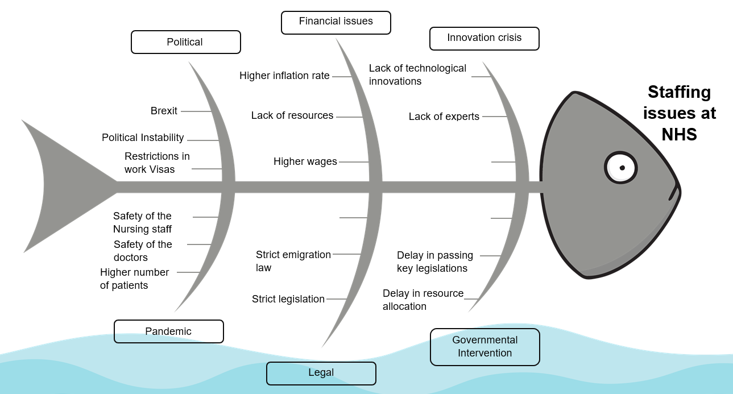
Figure 1: Fishbone analysis for cause and effect analysis
(Source: Created by the learner)
The above figure shows that there are many factors and causes that have the ability to destabilise the operational capabilities of the healthcare industry. The figure indicates that among the political issues faced by the healthcare industry, Brexit and political instability play their role along with the impact of restrictions on the work visas granted to other nationals. It also puts the management in hot soup as they fail to employ quality staff for a longer period with foreign nationality. The financial challenges have also been explained and the cruises have been identified effectively. The pandemic issues and the higher number of care receivers are also noted as challenges to the stability of the healthcare industry. The strict emigration laws also adversely impact the business prospects of the healthcare industry.

Evaluation of alternative solutions to staff shortage and Recommendations
The implications that can be implemented for mitigating the issues and challenges related to the shortage of staff need to be assessed for maintaining the transparency and adherence of the organisation. The shortage of staff can be adequately managed by fostering work-life balance and mentorship programmes in terms of focusing on the enhancement of the professional career of employees effectively. The work balance can be implemented by scheduling the operations of employees in terms of prioritising significant tasks earlier. By implementing working remotely for employees, the organisation can increase the flexibility and agility of staff so that they can possess high productivity and efficiency within their job roles. The examination of working ability needs to be done every day in terms of assessing their learning and development regarding the fostering of skills, knowledge and expertise progressively. The organisation can recruit effective leaders and managers grounded on their positive attributes for supporting and reinforcing the intrinsic drive of employees in order to function and perform virtuously enclosed by their workplace. The reconsideration of time management and sanctioning breaks between working can also help in the reduction of stress, anxiety and burden of work among employees that can lead to better proficiency regarding the completion of their tasks or projects significantly.

Conclusion
The study included the evaluation of the challenges faced by the NHS regarding staff shortages. The problems faced by organisations and other business establishments related to similar problems as well as their impact have also been described. External factors and their impacts have been shortlisted and tried to describe how it explains the prospects of the business. Further, the cause and effect analysis of the issues described in the case scenario has also been described. Possible solutions and the impact do the same have been summarised at the final stage.

Reference list
Kaye, A.D., Okeagu, C.N., Pham, A.D., Silva, R.A., Hurley, J.J., Arron, B.L., Sarfraz, N., Lee, H.N., Ghali, G.E., Gamble, J.W. and Liu, H., 2021. Economic impact of COVID-19 pandemic on healthcare facilities and systems: International perspectives. Best Practice & Research Clinical Anaesthesiology, 35(3), pp.293-306.
Bilan, Y., Mishchuk, H., Roshchyk, I. and Joshi, O., 2020. Hiring and retaining skilled employees in SMEs: problems in human resource practices and links with organizational success. Verslas: Teorija Ir Praktika/Business: Theory and Practice, 21(2), pp.780-791.
Clohessy, T. and Acton, T., 2019. Investigating the influence of organizational factors on blockchain adoption: An innovation theory perspective. Industrial Management & Data Systems.
Riaz, M.A., 2022. The Impact of Organisational Politics on Employee performance in UK Based Organisations (Doctoral dissertation, University of Wales Trinity Saint David (United Kingdom)).
Madigan, L. and Flanagan, J., 2021. Protecting Competition on Behalf of the People. Inequality and the Labor Market: The Case for Greater Competition, 107.
Nevett, J. and Whannel, K., 2022. Liz Truss resigns: PM's exit kicks off another Tory leadership race. [Online] Available at: <https://www.bbc.com/news/uk-politics-63332037> [Accessed on 25 October 2022]
ons, 2022. Consumer price inflation, UK: September 2022. [Online] Available at: <https://www.ons.gov.uk/economy/inflationandpriceindices/bulletins/consumerpriceinflation/september2022#:~:text=Download%20this%20chart,-Image%20.csv%20.xls&text=The%20CPIH%20goods%20annual%20inflation,%2C%20from%205.1%25%20in%20August.> [Accessed on 25 October 2022]
parliament, 2022. General Practitioners: Shortage. [Online] Available at: <https://hansard.parliament.uk/Lords/2022-07-12/debates/7ECAE111-16D9-4FD7-A4C3-AD525CB974BE/GeneralPractitionersShortage> [Accessed on 25 October 2022]
Campbell, D., 2022. General Practitioners: Shortage. [Online] Available at: <https://www.theguardian.com/society/2022/jun/08/nhs-hiring-more-doctors-from-outside-uk-and-eea-than-inside-for-first-time> [Accessed on 25 October 2022]
statista, 2022. GDP growth forecast for the UK 2000-2026. [Online] Available at: <https://www.statista.com/statistics/375195/gdp-growth-forecast-uk/> [Accessed on 25 October 2022]
statista, 2022. United Kingdom: online usage penetration rate 2018-2027. [Online] Available at: <https://www.statista.com/statistics/553589/predicted-internet-user-penetration-rate-in-the-united-kingdom-uk/> [Accessed on 25 October 2022]
gov, 2022. UK innovation. [Online] Available at: <https://www.great.gov.uk/international/content/investment/why-invest-in-the-uk/uk-innovation/> [Accessed on 25 October 2022]
hse, 2022. Health and Safety at Work etc Act 1974. [Online] Available at: <https://www.hse.gov.uk/legislation/hswa.htm> [Accessed on 25 October 2022]
legislation, 2022. National Minimum Wage Act 1998. [Online] Available at: <https://www.legislation.gov.uk/ukpga/1998/39/contents> [Accessed on 25 October 2022]
legislation, 2022. Environmental Protection Act 1990. [Online] Available at: <https://www.legislation.gov.uk/ukpga/1990/43/contents> [Accessed on 25 October 2022]
Temchenko, O., Shevchuk, N. and Morhun, T., 2019. Key problems of staff management at enterprises and their solutions ways. Scientific Journal of Polonia University, 32(1), pp.11-17.

