11/04/2024
Tyler Williamson (2237644)
BSc Data and Information Systems
L4 – Computer Architecture and Operating Systems (ACCA4022)
Title: Operating Systems
Table of Contents
1 Introduction 4
2 Key Functions of Universal OS 4
2.1 Process Scheduling 4
2.2 Memory Management 5
2.3 Security Management 5
2.4 File Management 6
2.5 User Interface 6
2.6 Booting 7
2.7 Computer Performance 7
2.8 Application job management 8
2.9 Network Management 8
3 Windows OS CLI Commands 9
3.1 Driverquery 9
3.2 Systeminfo 9
3.3 Tracert 10
3.4 Echo 10
3.5 Ipconfig 11
3.6 Assoc 11
3.7 Dir 11
3.8 Tree 12
3.9 Tasklist 12
3.10 Taskkill 13
4 Linux OS CLI Commands 13
4.1 Ls 13
4.2 Pwd 13
4.3 Cd 14
4.4 Echo 14
4.5 History 14
4.6 Mkdir 15
4.7 Rm 15
4.8 Touch 15
4.9 Clear 16
4.10 Chmod 16
5 Windows OS Scripts 16
5.1 File Backup 16
5.2 System Monitoring 17
5.3 User Management 18
5.4 Network Configuration 18
6 Linux OS Scripts 19
6.1 Case Statement 19
6.2 Function and User Input 20
6.3 For loop, Array and If Statement 20
6.4 Certificate of Course Completion 21
7 Conclusion 21
8 Appendices 22
8.1 OS Types from 22
8.1.1 Batch 22
8.1.2 Multi-Programming 22
8.1.3 Multi-Processing 22
8.1.4 Multi-Tasking 22
8.1.5 Distributed 23
8.1.6 Network 23
8.1.7 Real-Time 23
8.1.8 Mobile 23
8.2 Certified Course 23
8.2.1 Cisco course: Linux Unhatched 23
9 References 26

Figure 1 - View of Process Scheduling in Windows 4
Figure 2 - View of Memory Management in Windows 5
Figure 3 – View of Security Management in Windows 5
Figure 4 - View of File Management in Windows 6
Figure 5 - View of User Interface (Start Menu) 6
Figure 6 - View of User Interface (Notifications and Other Icons) 7
Figure 7 - View of the Restart Function 7
Figure 8 - View of Computer Performance 8
Figure 9 - View of Application Job Management 8
Figure 10 - View of Network Management 9
Figure 11 - Driverquery Command 9
Figure 12 - Systeminfo Command 10
Figure 13 - Tracert Command 10
Figure 14 - Echo Command 10
Figure 15 - Ipconfig Command 11
Figure 16 - Assoc Command 11
Figure 17 - Dir Command 12
Figure 18 - Tree Command 12
Figure 19 - Tasklist Command 13
Figure 20 - Taskkill Command 13
Figure 21 - ls Command 13
Figure 22 - pwd Command 14
Figure 23 - cd Command 14
Figure 24 - echo Command 14
Figure 25 - history Command 15
Figure 26 - mkdir Command 15
Figure 27 - rm Command 15
Figure 28 - touch Command 15
Figure 29 - clear Command 16
Figure 30 – Result of the Command 16
Figure 31 - chmod Command 16
Figure 32 - xcopy 17
Figure 33 - Get-Process 17
Figure 34 - Get-Service 17
Figure 35 - Get-WmiObject 18
Figure 36 – net 18
Figure 37 - Get-NetAdapter 19
Figure 38 - Get-NetIPAddress 19
Figure 39 - Get-NetRoute 19
Figure 40 – Case Statement 20
Figure 41- Function and User Input 20
Figure 42 – For loop, Array and If Statement 21
Figure 43 - Completed Course 21
Figure 44 - Linux Unhatched (1) 24
Figure 45 - Linux Unhatched (2) 24
Figure 46 - Linux Unhatched (3) 24
Figure 47 - Linux Unhatched (4) 25
Figure 48 - Linux Unhatched (5) 25
Figure 49 - Linux Unhatched (6) 25
Figure 50 - Linux Unhatched (7) 26
Figure 51 - Linux Unhatched (8) 26
Figure 52 - Linux Unhatched (9) 26

Introduction
The report aims to examine the key functions of operating systems, focusing on Windows PowerShell and Linux Bash. It explores general-purpose operating system functions, command-line interface commands (also known as CLI) and scripts developed and utilised in the terminals. By analysing these, it provides insights into various operating system capabilities, especially in command-line interfaces. Through Windows PowerShell and Linux Bash exploration, readers will gain a comprehensive understanding of the CLI environment’s modern significance.

Key Functions of Universal OS
Popular general-purpose Operating Systems effectively manage various aspects of computer functionality. The foremost key functions for the management of computer operational facilities consist of process scheduling, memory management, device management, security management, file management, user interface, booting, computer performance, application job management, error information management, network management, management of communications between various applications and processes [1].

Process Scheduling
Process scheduling involves determining the order in which processes are executed and managing processor utilisation. The operating systems allocates CPU resources efficiently, optimising system performance. Demonstrated in Figure 1 below, you can view Process Scheduling in the task manager’s details tab, which will give you details of the processes as well as CPU and memory usage.

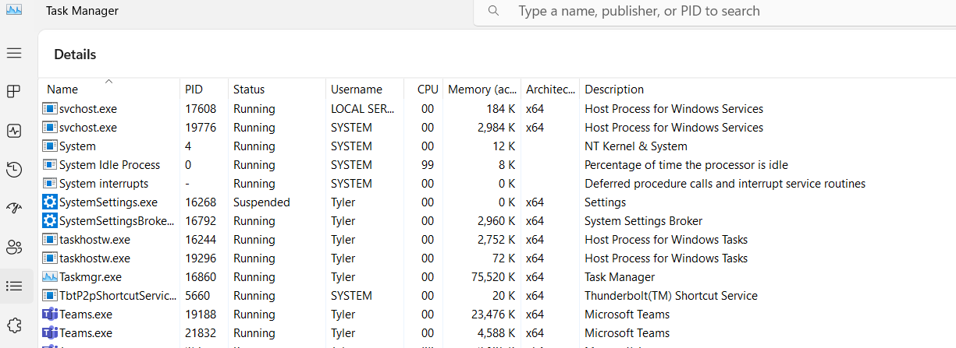
Figure 1 - View of Process Scheduling in Windows

Memory Management
Memory Management controls the allocation and deallocation of Primary and Main memory resources. The Operating System ensures adequate memory allocation for processes, enhancing system performance and preventing memory associated issues. As shown in Figure 2, memory management information can be found in task manager’s performance tab.

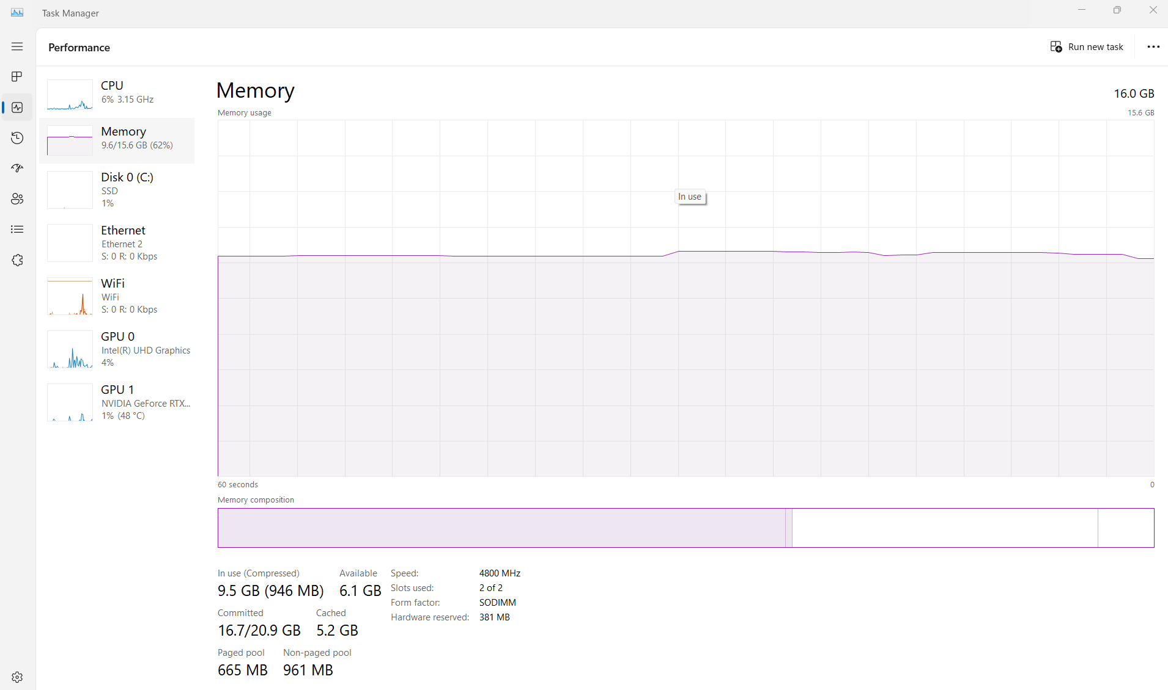
Figure 2 - View of Memory Management in Windows

Security Management
Security management is vital for protecting data and systems from unauthorised access and malicious attacks The operating system implements security measures such as user authentication, encryption, and access control to safeguard sensitive data. These features can be accessed in the Windows Security section as demonstrated in Figure 3.

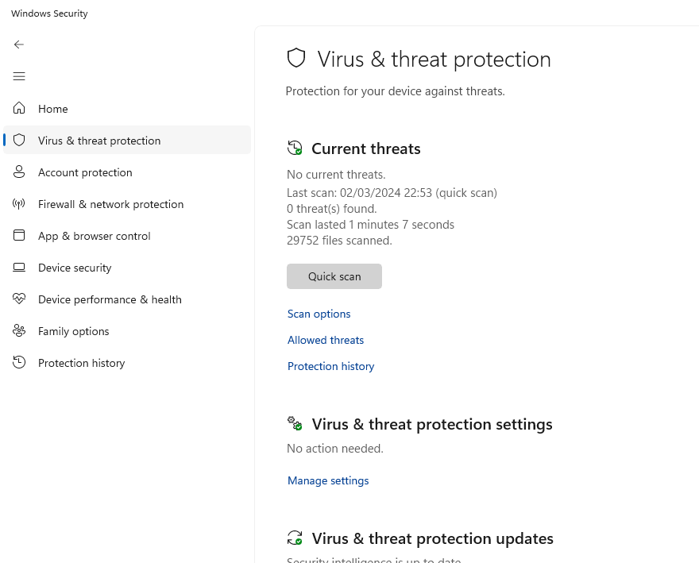
Figure 3 – View of Security Management in Windows

File Management
File management involves organising, accessing, and manipulating files stored on the system. The operating system tracks file modifications, manages file permissions, and ensures data integrity within the file system. File explorer in Windows is an example of this, as shown below in Figure 4.

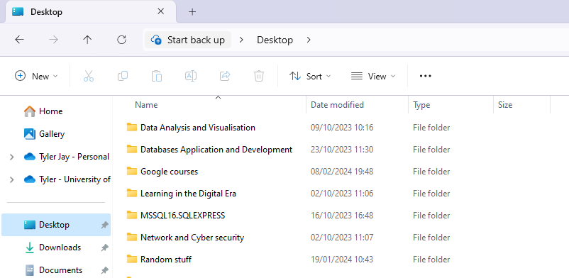
Figure 4 - View of File Management in Windows

User Interface
The operating system imparts a user-friendly interface for interacting with computer hardware and software. Graphical user interfaces (GUIs) allow users to navigate the system, launch applications, and access system settings easily. Some examples of easy access to system settings, and applications are demonstrated in Figures 5 and 6.

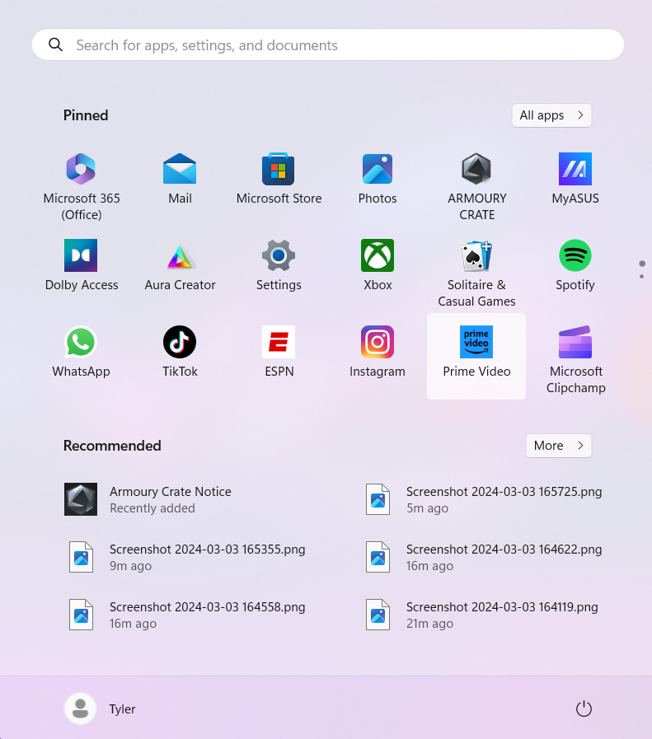
Figure 5 - View of User Interface (Start Menu)

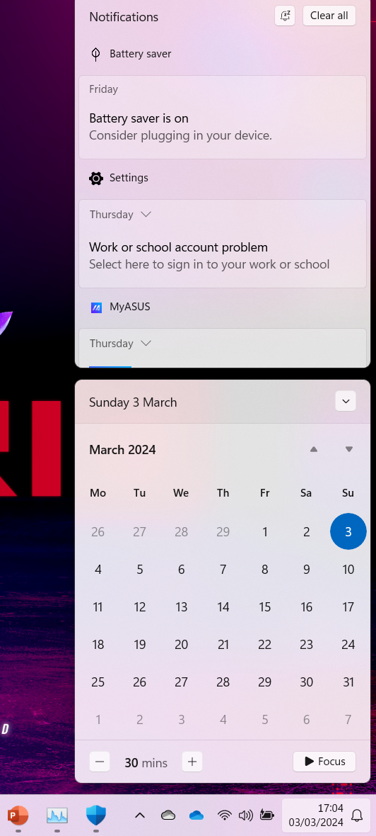
Figure 6 - View of User Interface (Notifications and Other Icons)

Booting
Booting is the process of starting up the computer’s operating system, especially during a restart process, also known as warm rebooting. The operating system manages the boot order, priming hardware components, and loading the required system files to launch the operating system successfully, bringing the system back to a useable state following the booting process. Shown in Figure 7 below, is the restart function that uses this booting procedure.

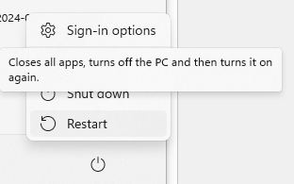
Figure 7 - View of the Restart Function

Computer Performance
The operating system monitors and controls system resources to optimise the computer performance. It allocates Central Processing Unit resources effectively, regulates memory usage, and prevents resource conflicts to ensure smooth operations of multiple tasks. Figure 8 shows in task manager, where a user can view the computers performance.

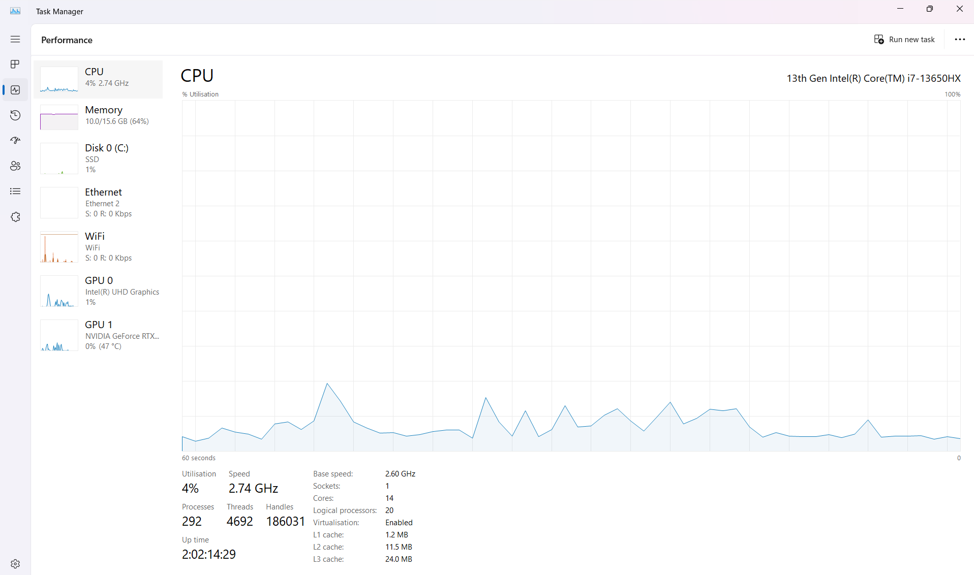
Figure 8 - View of Computer Performance

Application job management
The operating system manages the execution of application processes, assigning Central Processing Unit time and memory resources as needed. It tracks process states, schedules job tasks, and maintains system stability during multitasking. Displayed below in Figure 9, is a view of where a user can view application jobs as well as manage them if required.

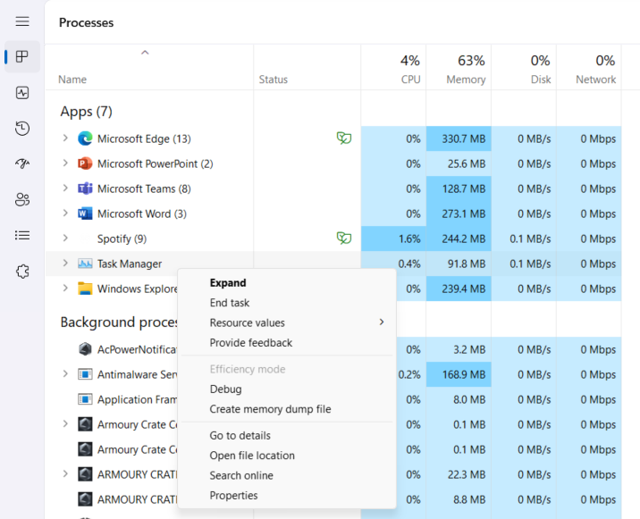
Figure 9 - View of Application Job Management

Network Management
Network management involves managing communication between computers and monitoring network performance. The operating system configures network settings, manages data transmission, and implements security protocols to ensure reliable network connectivity. As shown in Figure 10, the user can view network settings in the Network and Internet Section of Settings in Windows.

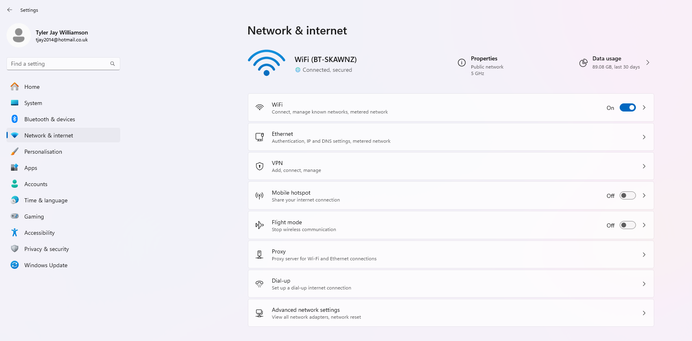
Figure 10 - View of Network Management

Windows OS CLI Commands

Driverquery
The Driverquery command in Windows PowerShell provides a complete list of installed device drivers on the system. This includes drivers for various hardware components such as display adapters, network adapters, storage controllers, and more. Each entry in the list displays the driver’s name, display name, type, and the path to its associated files.

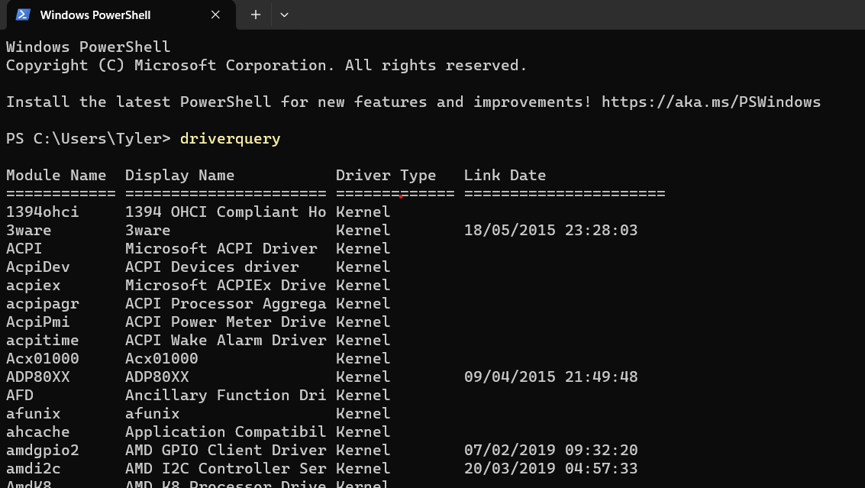
Figure 11 - Driverquery Command

Systeminfo
The Systeminfo command provides lots of information about the system’s hardware and software configuration. This includes key details such as the operating system version, system manufacturer, processor type and speed, RAM, and system uptime. Additionally, the command displays information about installed network adapters, and system boot time.

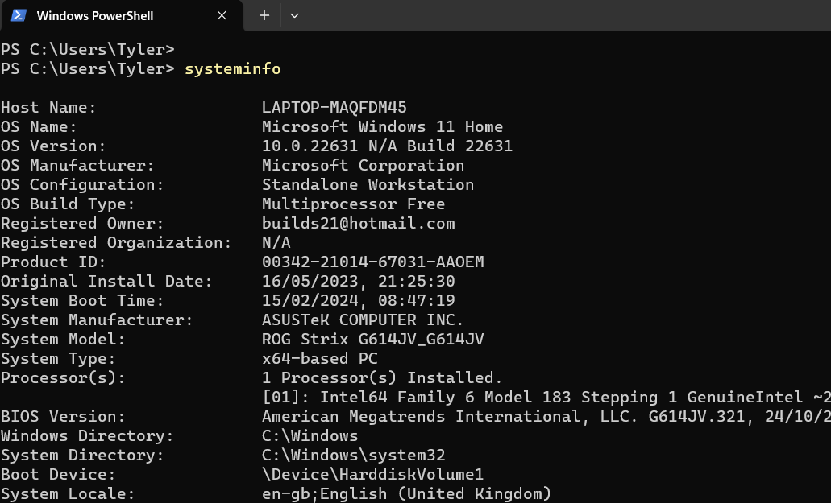
Figure 12 - Systeminfo Command

Tracert
The functionality of tracert command is that it serves as a diagnostic tool used to demonstrate the pathway route to a URL from the operating system being used by sending Internet Control Message Protocol messages or requests to the host.

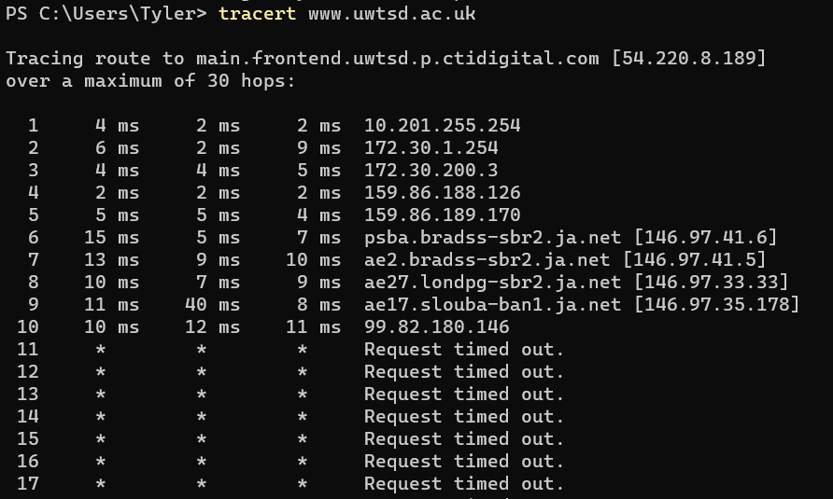
Figure 13 - Tracert Command

Echo
The echo command is used to display text in the Command Prompt or PowerShell. Shown below is an example of this command used to display the output text “Hello Tyler” to the window.

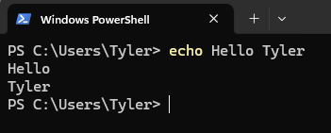
Figure 14 - Echo Command

Ipconfig
The command Ipconfig is a network diagnostic tool, and it is solely used for the purpose of identifying current and relevant details of the system’s network configuration settings and values.

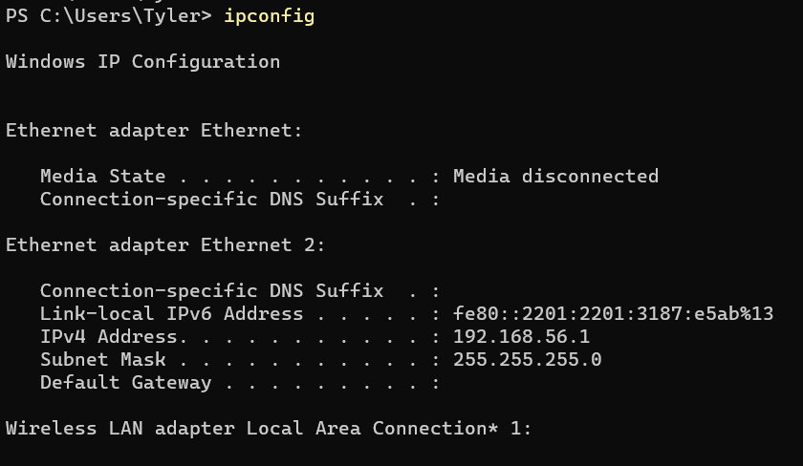
Figure 15 - Ipconfig Command

Assoc
This command ‘cmd /c assoc’ displays the file name extension associations. This will then allow further modifications to be made to the file name extension associations via the command prompt.

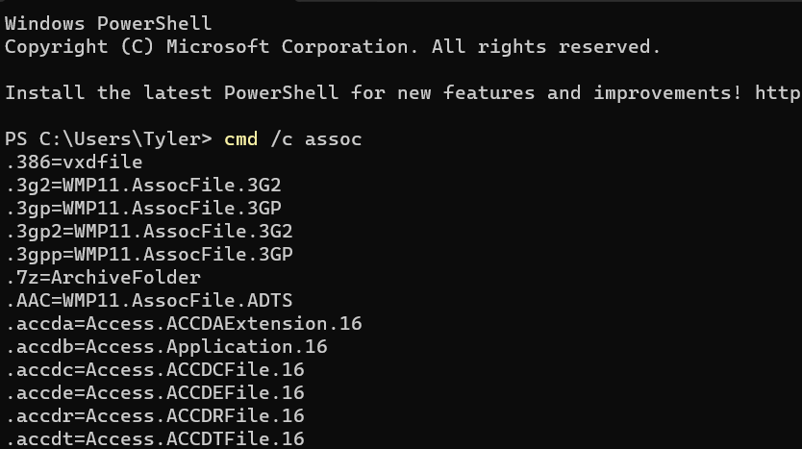
Figure 16 - Assoc Command

Dir
The DIR command displays a list of files within a directory, including subdirectories, it provides details of the files such as file names, sizes, and timestamps. Below is a screenshot showing the command being executed in Windows PowerShell and the results of the output.

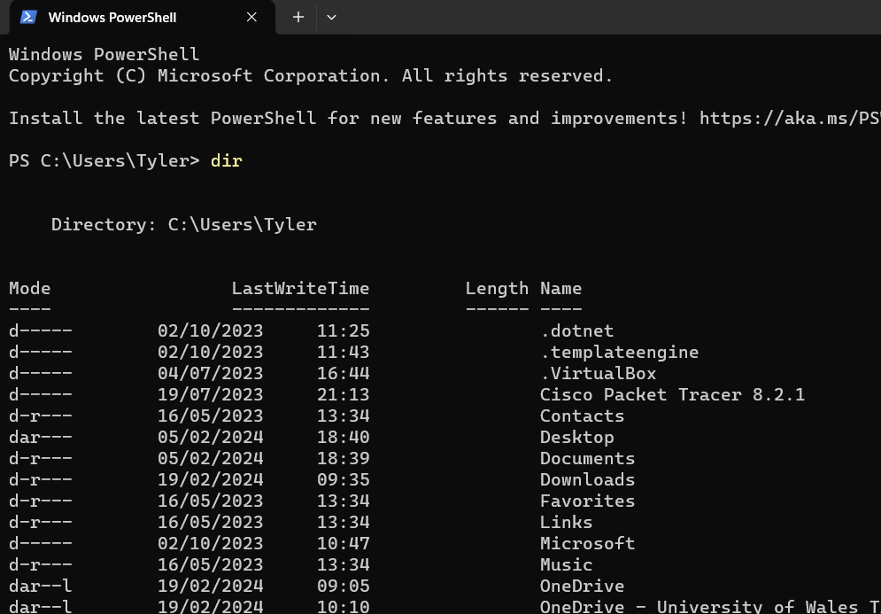
Figure 17 - Dir Command

Tree
The tree command is used to display the folder structure of a directory and all its subdirectories in a tree-like format in the command prompt or Windows PowerShell.

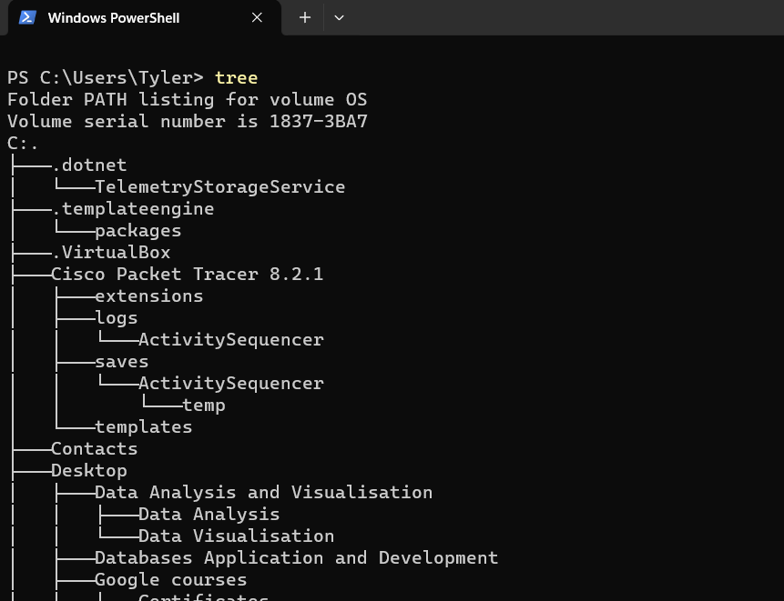
Figure 18 - Tree Command

Tasklist
The tasklist function identifies and displays the system processes that are running or active within the Windows operating system, providing detailed information about these processes.

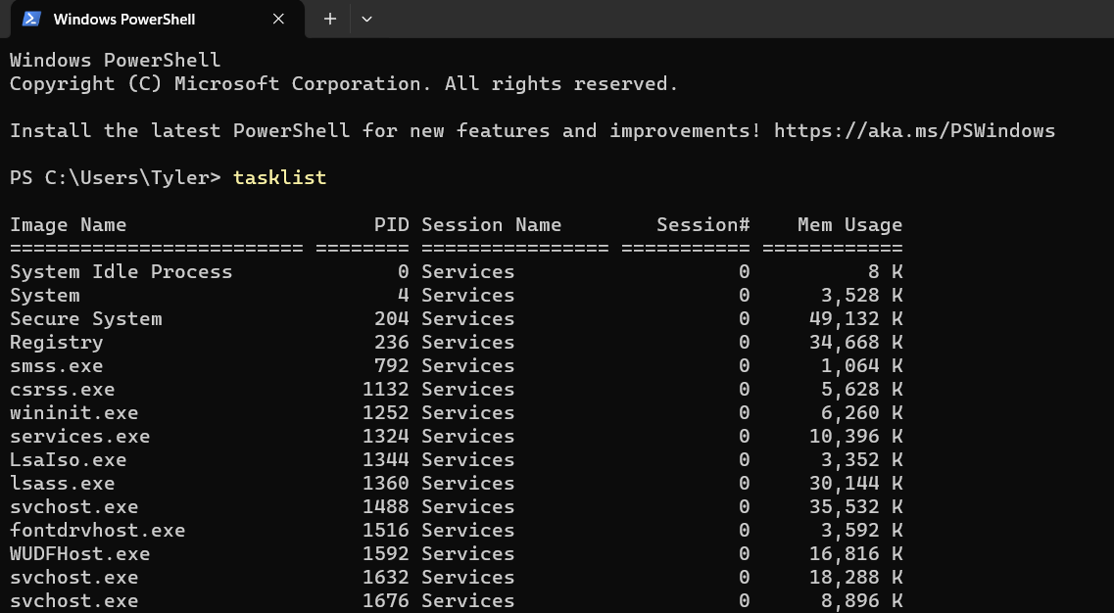
Figure 19 - Tasklist Command

Taskkill
In simple terms, the function called Task Kill executes the termination of a running process by ending the job task.

Figure 20 - Taskkill Command

Linux OS CLI Commands

Ls
As displayed in Figure 21, this Linux OS command lists files within the directory. It is a very commonly used command and can be customised to display lists based on scripted conditions.

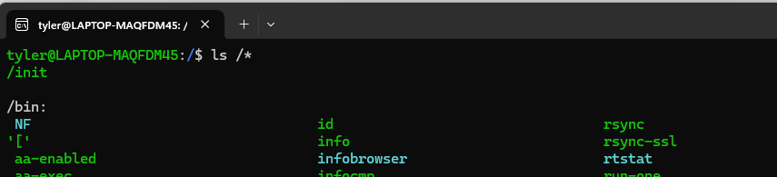
Figure 21 - ls Command

Pwd
In Figure 22, the utilisation of the ‘pwd’ command is illustrated, showcasing how the users can use it to identify their current directory and to understand the file system hierarchy.

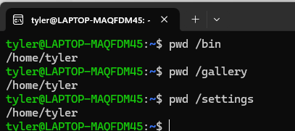
Figure 22 - pwd Command

Cd
In Figure 23, illustrates the user’s ability to navigate between directories using the Bash terminal. This command allows users to switch their current working directory to another location within the file system.

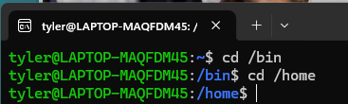
Figure 23 - cd Command

Echo
Figure 24 as depicted below, shows the execution of the ‘echo’ command within the Bash terminal. This command is a fundamental tool, to display text, variables, and formatting output in the terminal.
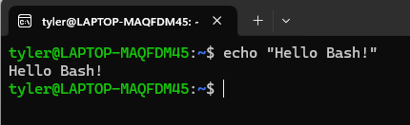
Figure 24 - echo Command

History
The ‘history’ command, showcased in Figure 25, serves the function of displaying a comprehensive list all previously executed commands within the Bash terminal. This command assists with facilitating tasks such as troubleshooting, repeating commands, or recalling specific actions performed during sessions previously.

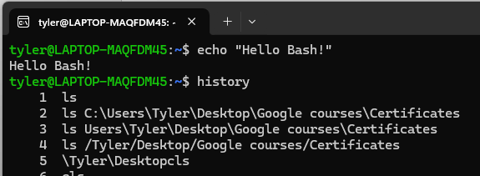
Figure 25 - history Command

Mkdir
Displayed in Figure 26, the command ‘mkdir’ is applied directly in the Bash terminal for specifically creating new directories within the user’s operating system. Creation of directories is an important task in file management, enabling users to organise their files and data systematically.

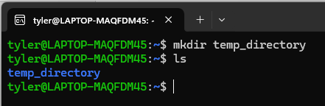
Figure 26 - mkdir Command

Rm
The ‘rm’ command in Bash is used for deleting files and directories from the file management system. When ‘-d’ is invoked, it instructs the system to remove a directory, requiring the user to input the directory location within the file system’s hierarchy as illustrated in Figure 27 below.

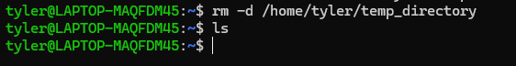
Figure 27 - rm Command

Touch
Demonstrated below in Figure 28 is the ‘touch’ command, used to create empty files directly from within the terminal.

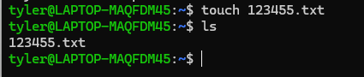
Figure 28 - touch Command

Clear
The ‘clear’ command simply removes all previous command logs and output from the terminal. In Figures 29 and 30, the command is demonstrated, showing how it resets the terminal.

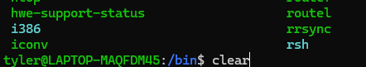
Figure 29 - clear Command

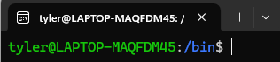
Figure 30 – Result of the Command

Chmod
As illustrated in Figure 31, the ‘chmod’ command is primarily used to modify file permissions. The ‘chmod 600’ command assigns readable permissions exclusively to the file owner. Likewise, the ‘chmod o+rx’ command grants read and execute permissions to others.

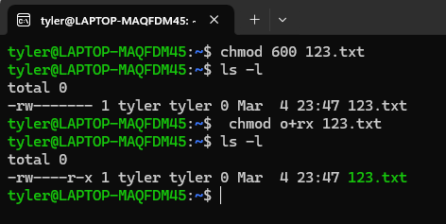
Figure 31 - chmod Command

Windows OS Scripts

File Backup
Shown below in Figure 32, is an effective tool for automating the file backup process with efficiency and reliability. It employs the xcopy command to seamlessly copy files from a defined source directory to a specified backup destination, ensuring the preservation of essential data [2]. By scheduling this script to execute at regular intervals, users can establish a logical and proactive approach to maintaining backups. This ensures that backups are consistently updated from the source files. As a result, this reinforces data security, and enhancing recovery capabilities against the risk of unexpected data loss.

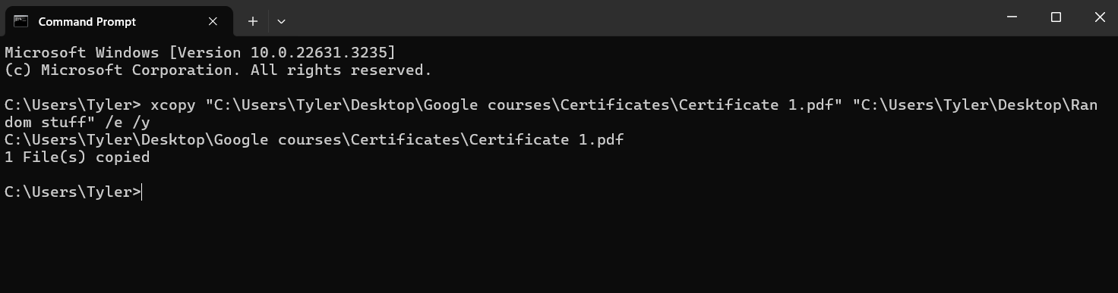
Figure 32 - xcopy

System Monitoring
As demonstrated in Figures 33, 34 and 35, are system monitoring capabilities utilising the Get-Process, Get-Service, and Get-WmiObject cmdlets [3]. They retrieve comprehensive data on running processes, system services, and hardware components. Presenting this data in a structured format facilitates efficient monitoring of system health and performance. Users can identify processes that are consuming larger quantities of resources and troubleshoot any performance issues more efficiently. Providing these useful insights enable users to proactively manage and optimise functionality of computer systems through detailed process monitoring.

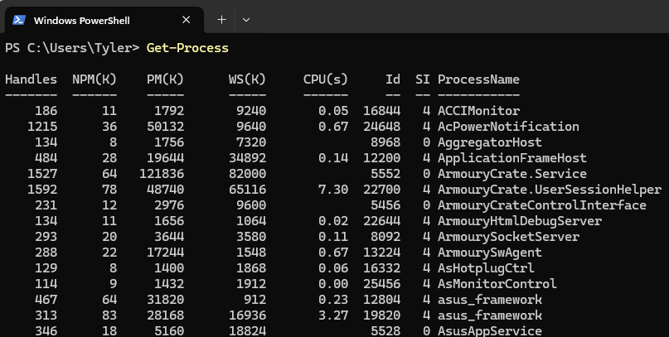
Figure 33 - Get-Process
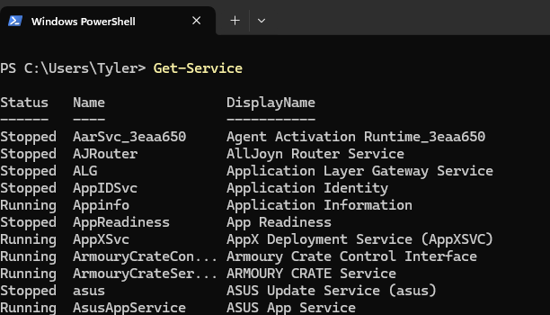
Figure 34 - Get-Service

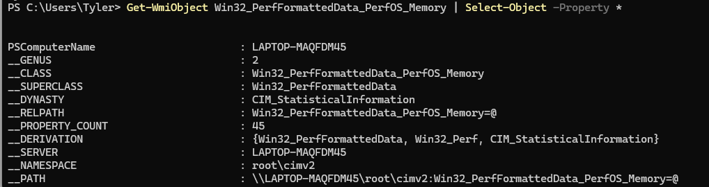
Figure 35 - Get-WmiObject

User Management
Illustrated in Figure 36, the ‘net’ command provides a complete overview of user account details for the specific computer or operating system it runs on. It showcases the capability to effectively manage user accounts, offering functions to create, modify, and delete both user accounts and groups. Through automation, administrators can streamline user management tasks, such as updating user profiles, adjusting access controls, and performing maintenance processes. This automation not only enhances operational efficiency but strengthens security measures by regulating user management practices across the system. Providing administrators with the ability to maintain strong and secure user conditions.

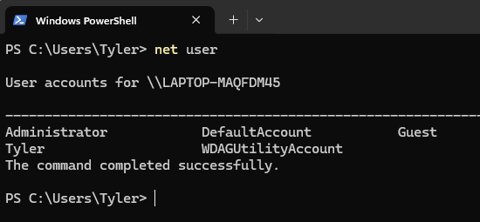
Figure 36 – net

Network Configuration
Figures 37, 38 and 39 shows the extensive capabilities for network configuration. They employ cmdlets such as Get-NetAdapter, Get-NetIPAddress, and Get-NetRoute to efficiently retrieve and configure network adapter settings, IP addresses, and routing tables [4. 5. 6]. By scripting network configuration tasks, administrators can automate various aspects of network provisioning. This automation also enables administrators to promptly troubleshoot connectivity issues by accessing and modifying network settings. Furthermore, the scripts facilitate the optimisation of network performance effectively by allowing administrators to adjust network configurations based on specific requirements.

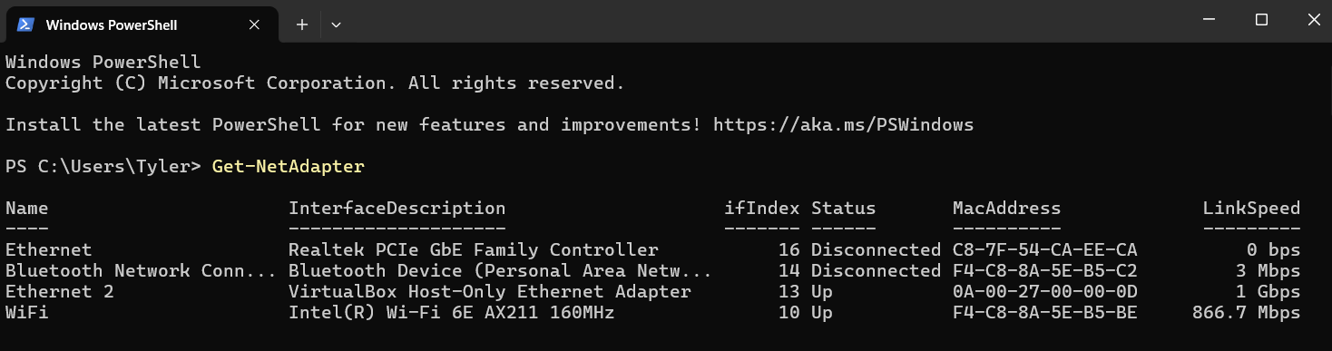
Figure 37 - Get-NetAdapter

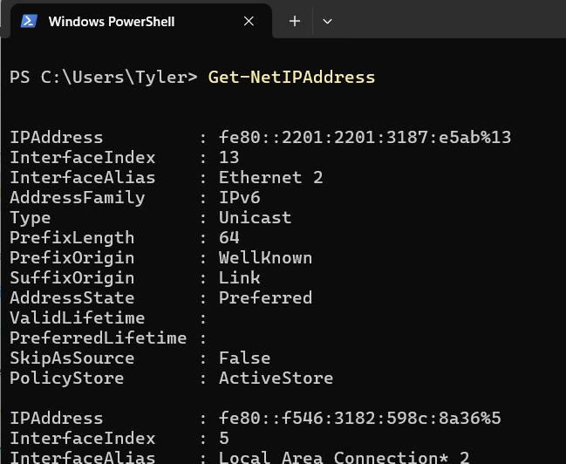
Figure 38 - Get-NetIPAddress

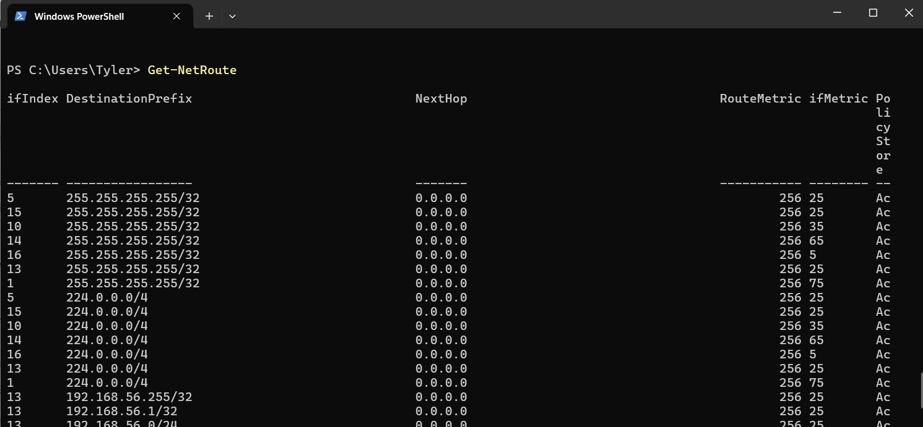
Figure 39 - Get-NetRoute

Linux OS Scripts

Case Statement
The case statement and user input script, as illustrated in Figure 36 and developed on a Linux operating system, employ multiple commands to generate an interactive question with user input answers [7]. Some commands include the ‘echo’ command and the ‘read’ command [8]. Firstly, the ‘echo’ command is used to display a message at the beginning of the script, prompting the user to input their answer. Subsequently, the ‘read’ command, along with a variable, is utilized to enable the user to enter their answer. Finally, the case statement uses the ‘Answer’ variable to find the subsequent message that should be displayed. This will then allow the ‘echo’ command to display the corresponding message, which matches the condition. This script exhibits interaction with users, generating output based on case statement conditions.

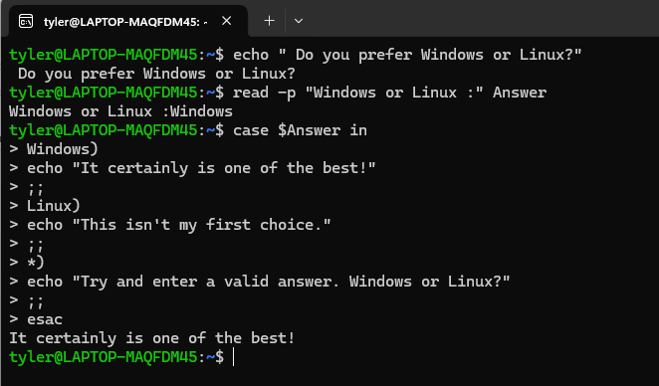
Figure 40 – Case Statement

Function and User Input
This script engages the user by prompting them to input numerical values for arithmetic operations. As shown in Figure 37, it highlights the versatility of the terminal in facilitating mathematical computations, demonstrating its capabilities. The calculation process involves utilising variables, particularly $sum, to store the result of adding the values in num1 and num2 [9]. This not only exhibits the inherent arithmetic capabilities of bash scripting but also highlights its flexibility and power in handling complex calculations. Upon completion of the calculation, the script employs the ‘echo’ command to present the computed sum to the user. This highlights the effectiveness of creating a function using user input, variable handling, and output generation to enhance the user experience in the terminal.
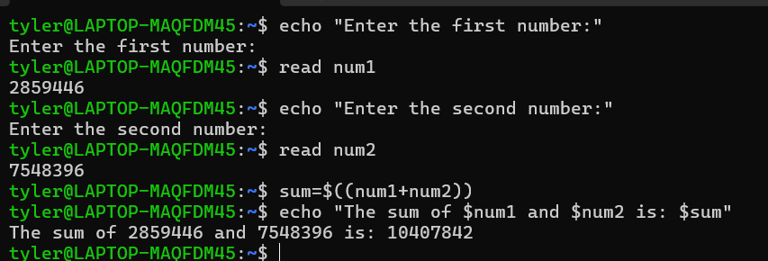
Figure 41- Function and User Input

For loop, Array and If Statement
Demonstrated in Figure 38, the bash script showcases the automation capabilities of the for loop in the terminal, enabling users to input a numerical value as the set limit for the loop [10]. It involves creating a variable with an empty array, which will eventually store even numbers generated in the following loop [11]. The loop then iterates through numbers up to the limit, applying the ‘if’ statement to check for even numbers using the operator modulo and adding them to the variable’s array. Finally, the script echoes the list of even numbers within the specified limit for readability.

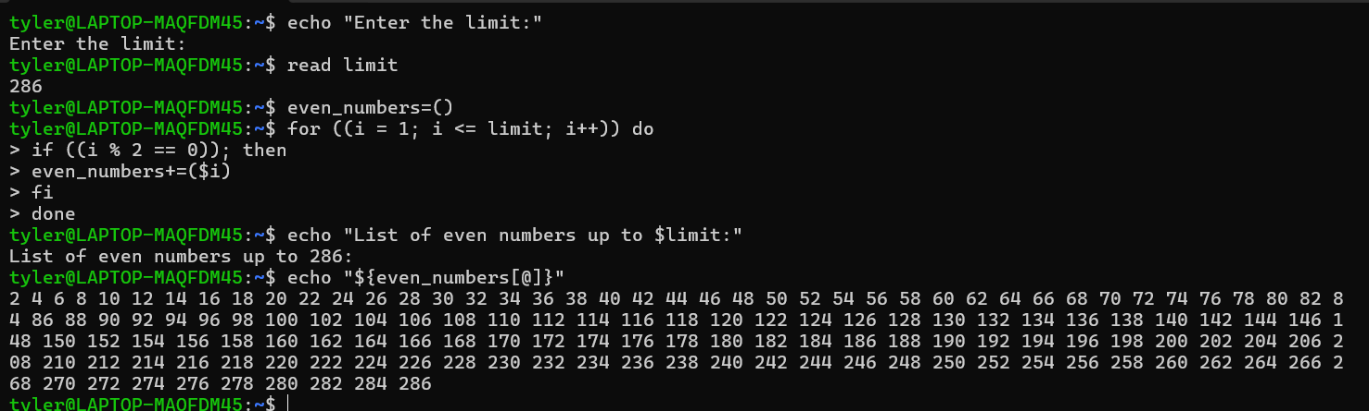
Figure 42 – For loop, Array and If Statement

Certificate of Course Completion


Figure 43 - Completed Course

Conclusion
In conclusion, this report has studied the key functions of operating systems, focusing on major players such as PowerShell and Bash. It has explored the fundamental functionalities of universal operating systems, observed various CLI commands, and provided samples of scripts that can be employed within the terminals.
Throughout the report, we have identified and analysed these components to offer insights into the essential functionalities and capabilities of operating systems, particularly in the context of command-line interaction.
Overall, this report highlights the significance of CLI in facilitating efficient and versatile interactions with operating systems, enabling users to perform a wide range of tasks and operations. As technology continues to advance, understanding and harnessing the capabilities of CLI will remain crucial for effectively managing and employing operating systems in diverse computing environments.

Appendices

OS Types from
There are numerous types of Operating Systems commonly used today that have evolved over time to meet the growing demands of technological advancements. Examples of these types of Operating Systems include Batch, Multi-Programming, Multi-Processing, Multi-Tasking, Time-Sharing, Distributed, Network, Real-Time, and Mobile Operating Systems [12].

Batch
Batch Operating Systems organise tasks by grouping them based on similarity in job requirements necessary for execution. Such Operating systems typically predict the duration of a job when it enters the queue awaiting execution.

Multi-Programming
Multi-Programming Operating Systems enable the simultaneous execution of multiple programs, enhancing performance and ensuring efficient responsiveness.

Multi-Processing
Multi-Processing Operating Systems allow for the simultaneous execution of multiple Central Processing Units also known as CPUs, efficiently managing various programming resources.

Multi-Tasking
Multi-Tasking Operating Systems utilize algorithms that enable the simultaneous execution of multiple programs. They share similarities with Time-Sharing Operating Systems in their handling of processes. Primarily, Time-Sharing Operating Systems allocate time among different processes or tasks, which functions like Multi-Tasking Operating Systems. Both Operating Systems distribute time to individual tasks to make their performances more efficient.

Distributed
Distributed Operating Systems facilitate communication between linked computers through shared communication networks.

Network
Network Operating Systems operate on servers to manage networking functions. They provide clear outlines of the configurations for network operating systems to all users, which is a fundamental feature ensuring that networks are efficient.

Real-Time
Real-Time Operating Systems offer services for systems or programmes with defined operating times and intervals requirements, where it is vital to strictly adhere to the settings. They impose strict acceptability boundaries for job execution, making them essential in settings such as the military, where precise timings are critical for operations and lives. There are many more settings that require the utilisation of this type of operating system.

Mobile
Mobile Operating systems are constructed with the purpose of operating various smart technological gadgets such as smartphones, tables, watches, and other smart devices. Some examples of well-known mobile operating systems include iOS and Android.

Certified Course

Cisco course: Linux Unhatched

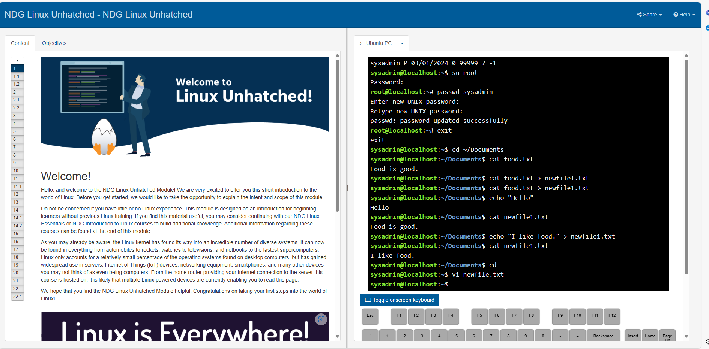
Figure 44 - Linux Unhatched (1)

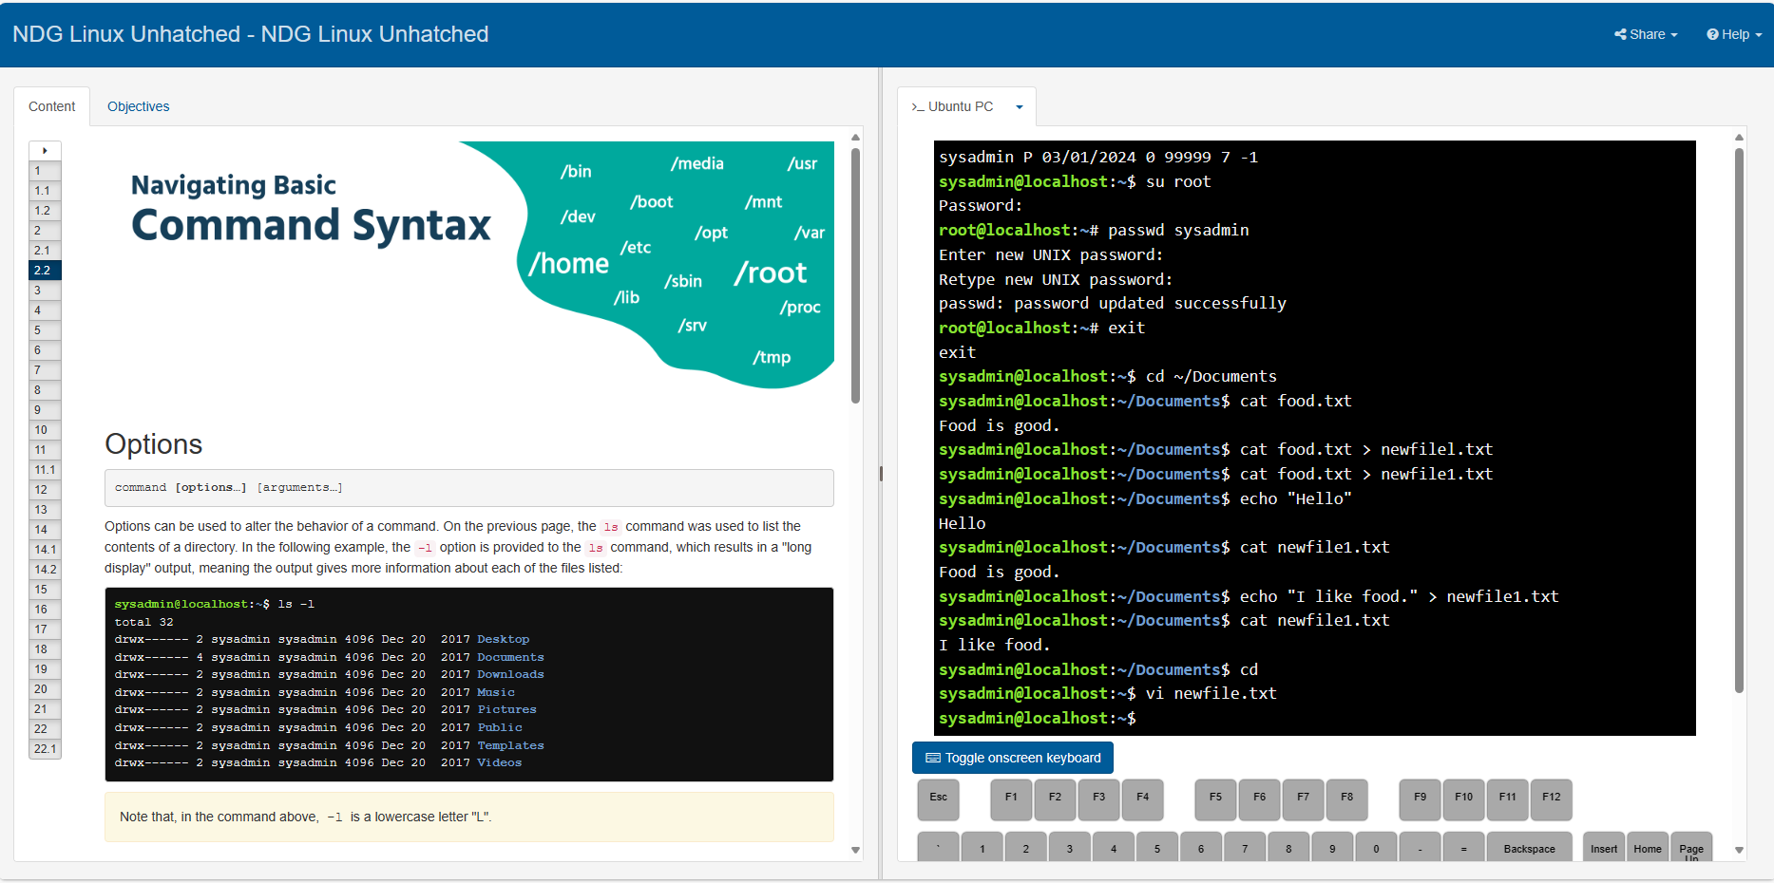
Figure 45 - Linux Unhatched (2)

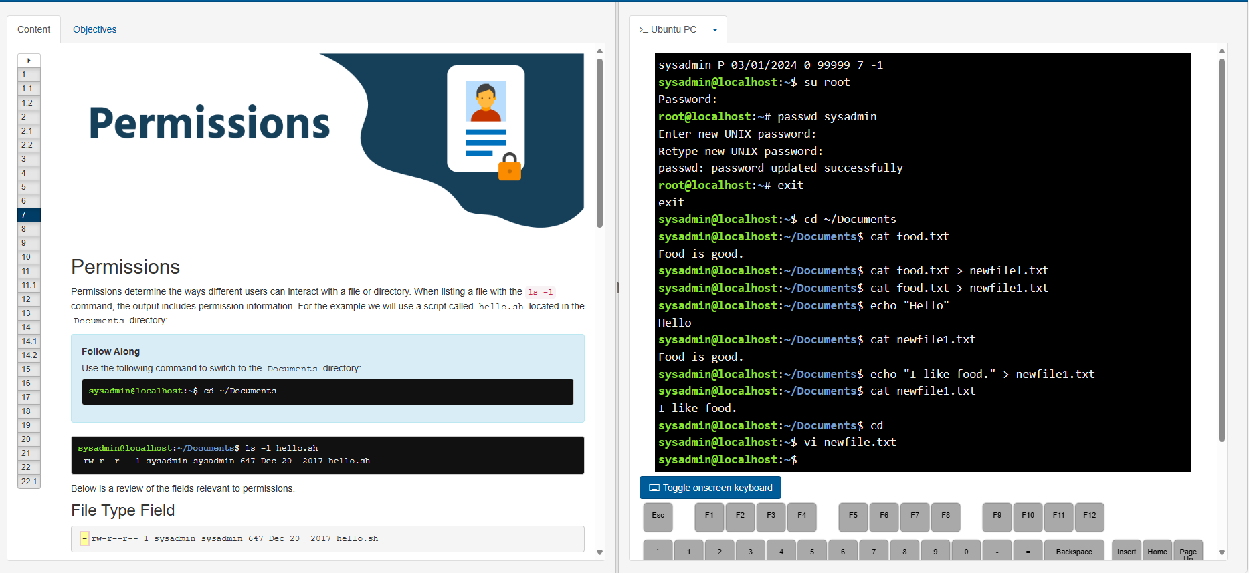
Figure 46 - Linux Unhatched (3)
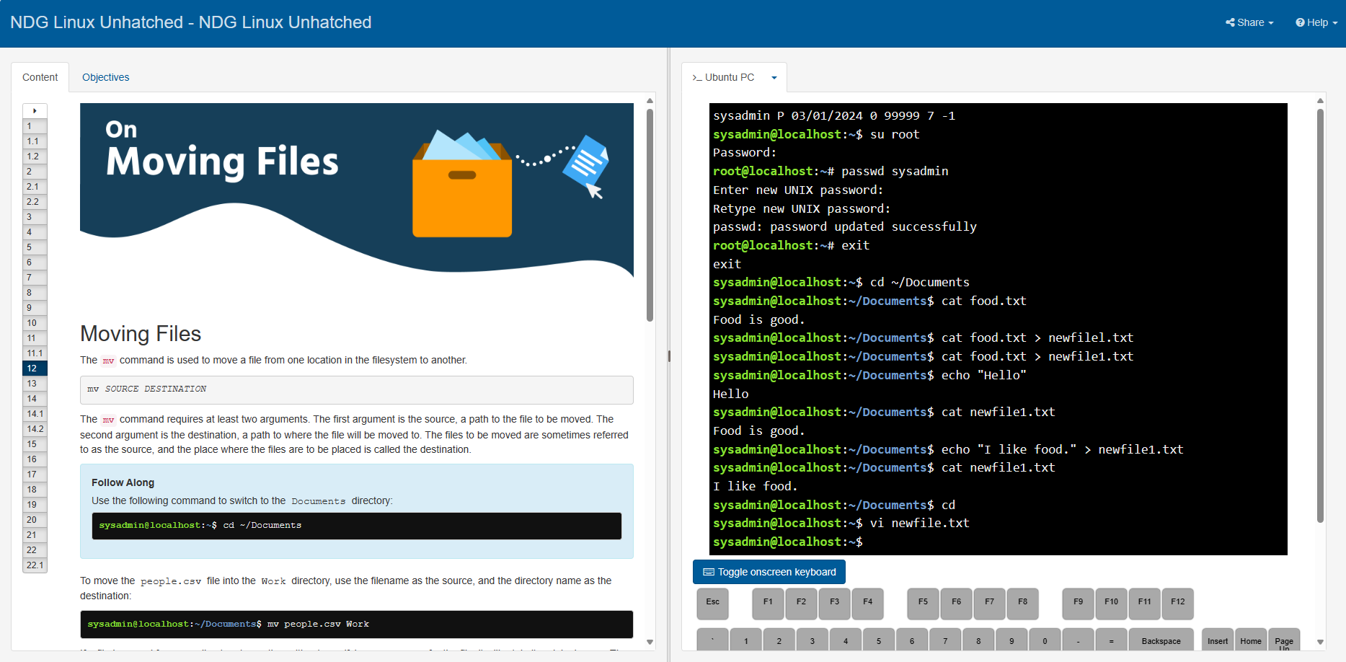
Figure 47 - Linux Unhatched (4)

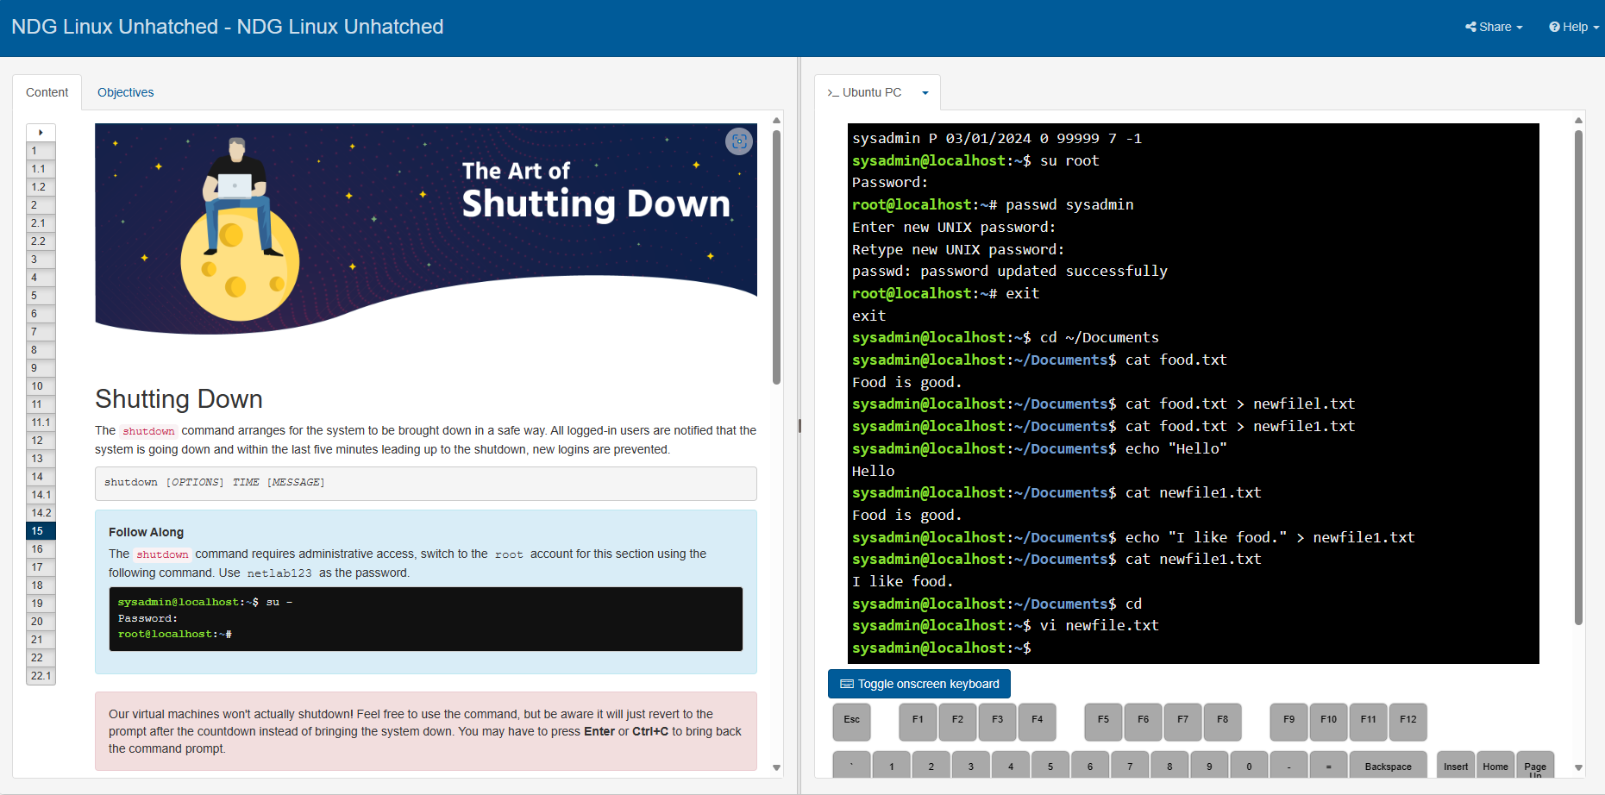
Figure 48 - Linux Unhatched (5)

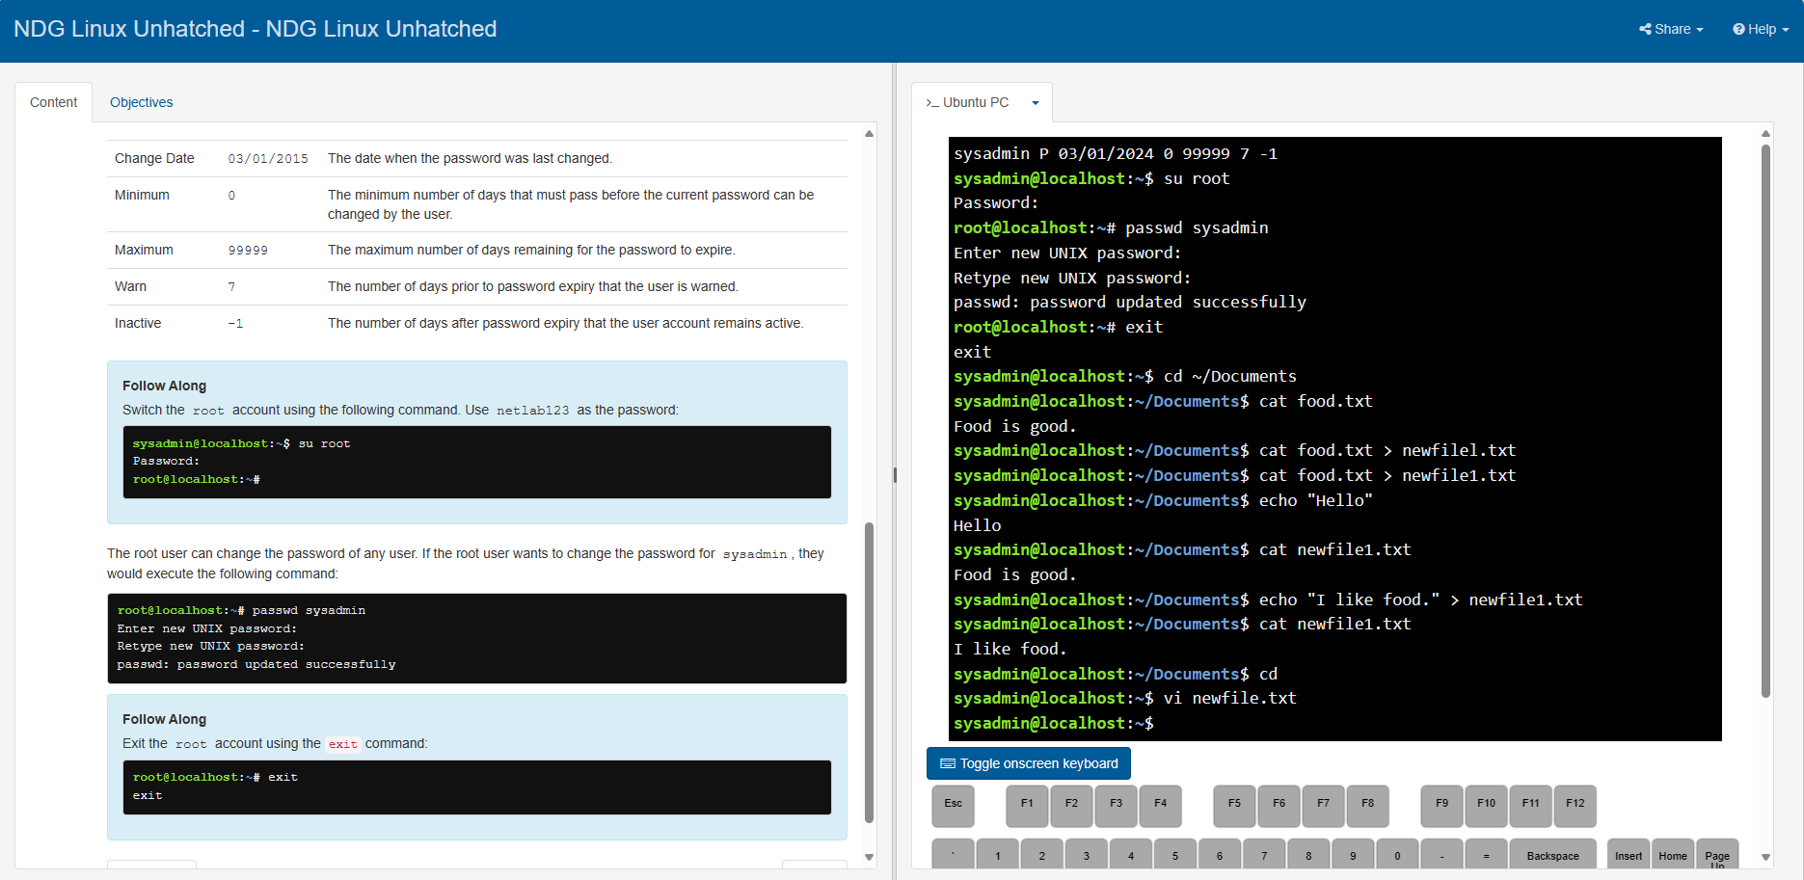
Figure 49 - Linux Unhatched (6)

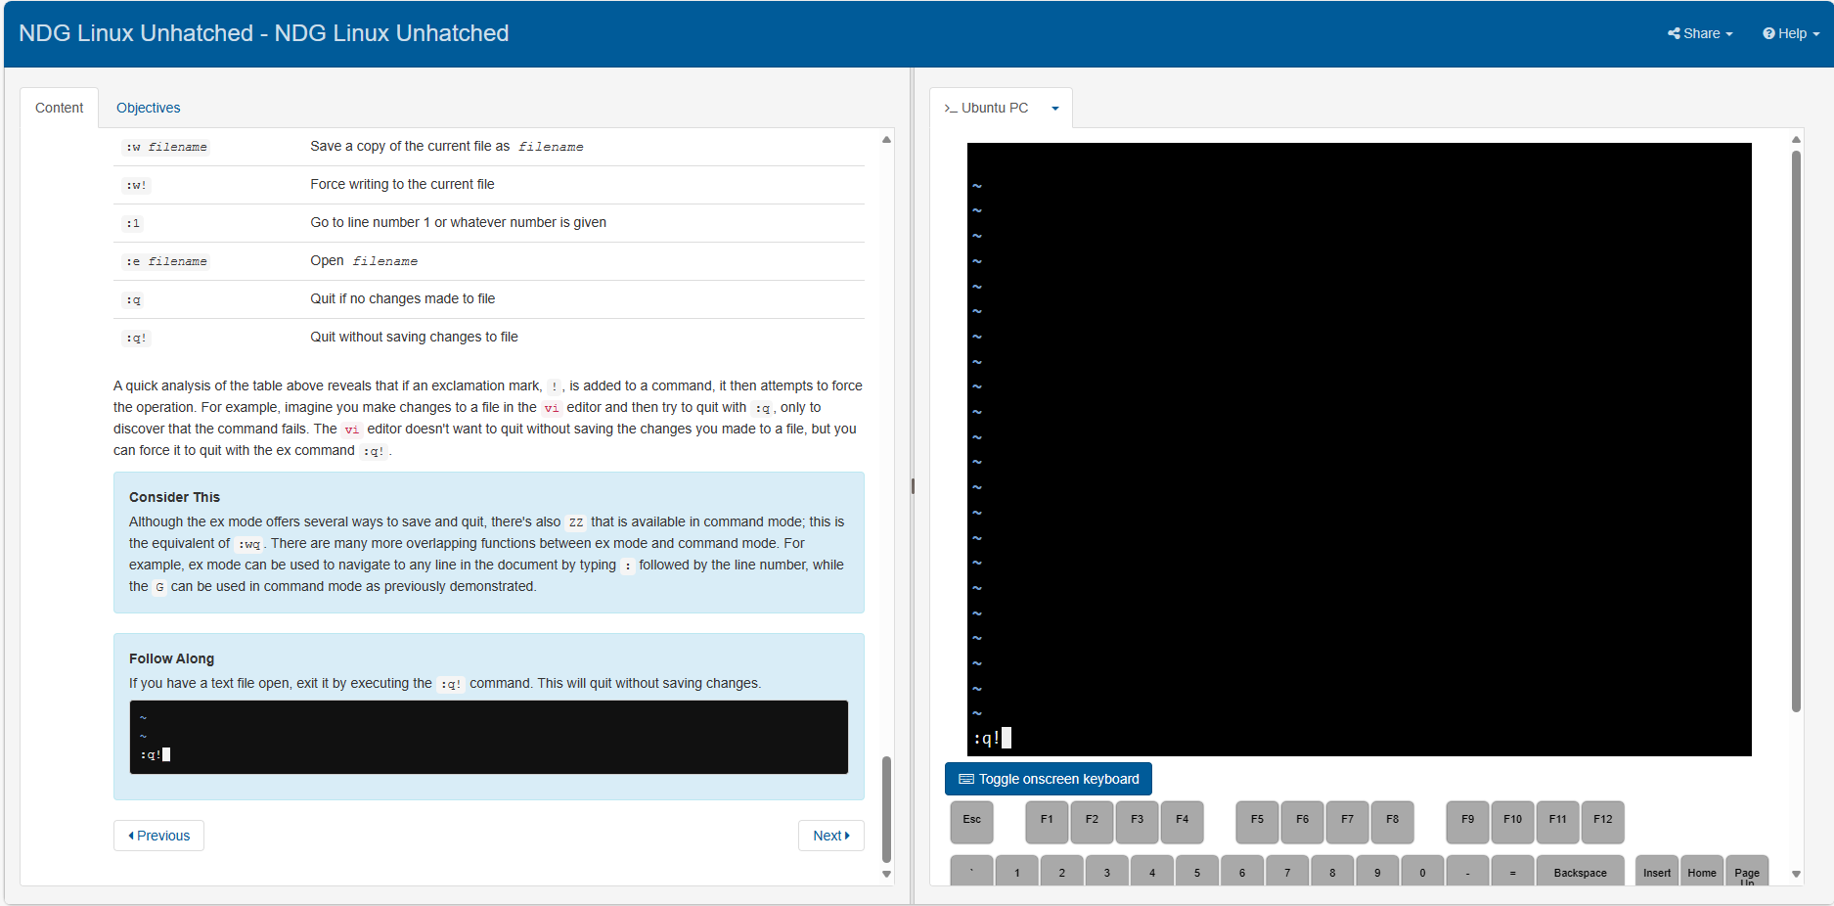
Figure 50 - Linux Unhatched (7)

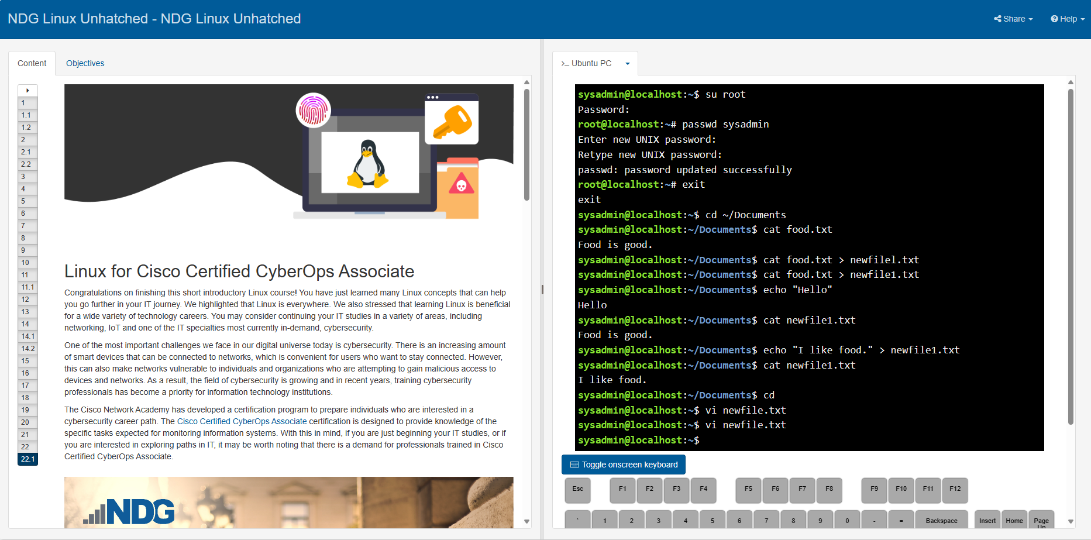
Figure 51 - Linux Unhatched (8)

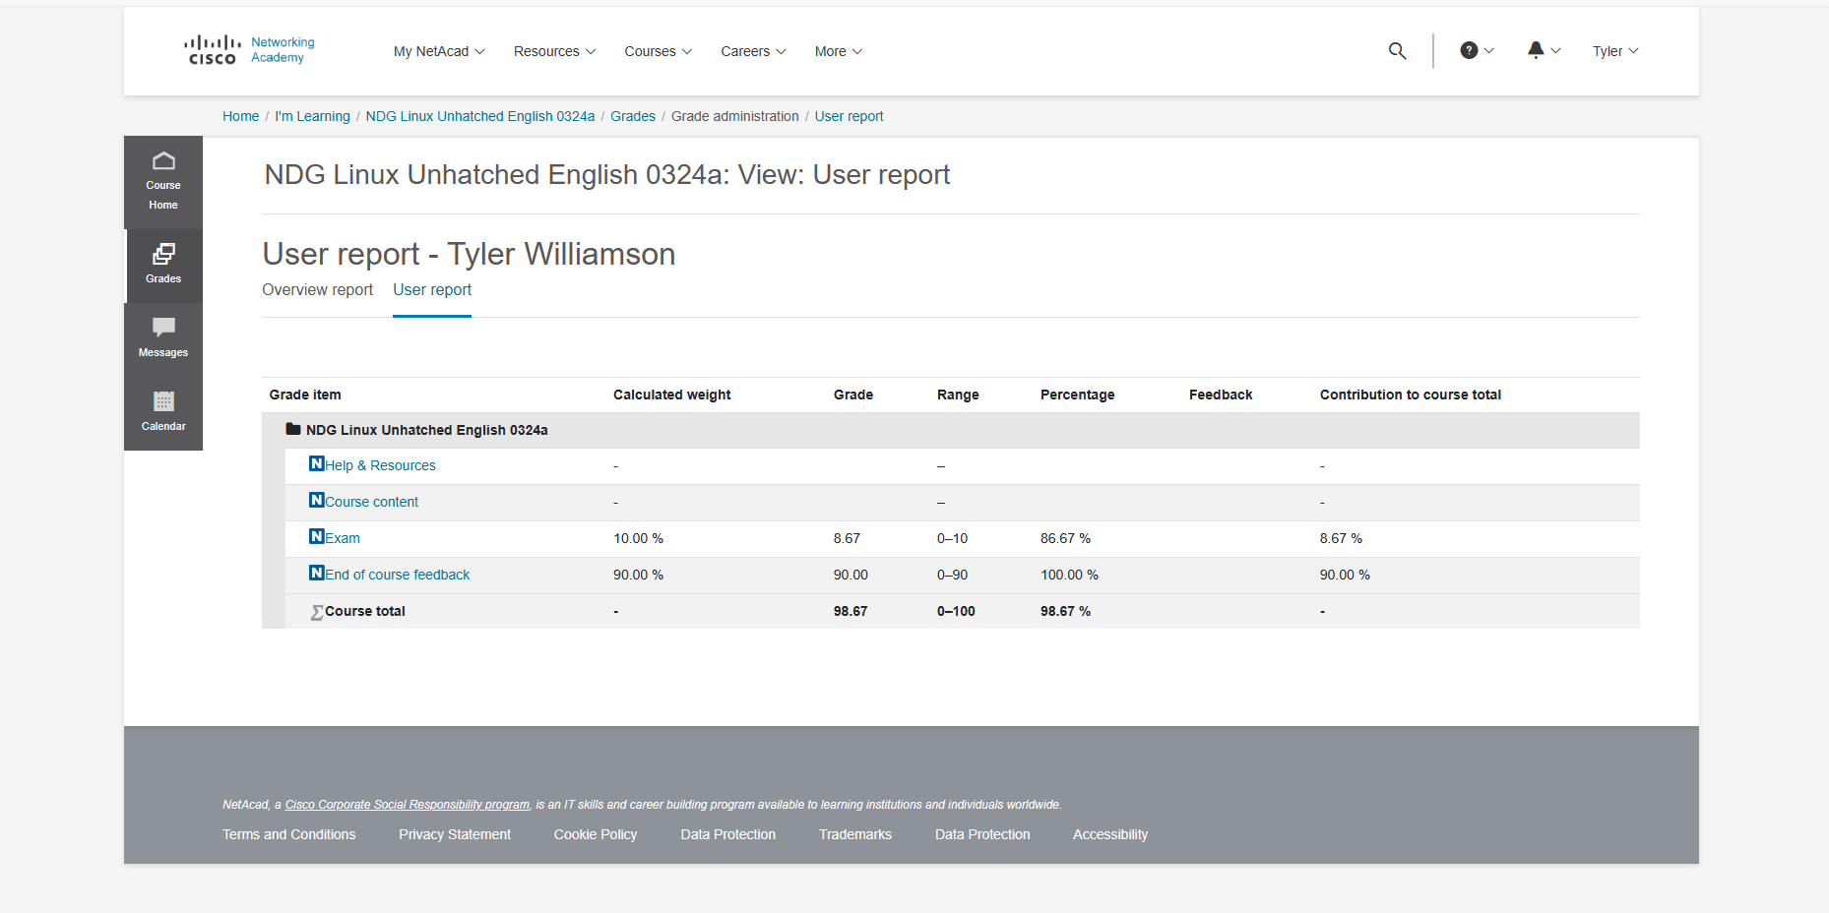
Figure 52 - Linux Unhatched (9)

References
[1] Geeks for Geeks. "Functions Of Operating System." https://www.geeksforgeeks.org/functions-of-operating-system/ (accessed Feb 26,).
[2] Microsoft Office. "Working with files and folders." https://learn.microsoft.com/en-us/powershell/scripting/samples/working-with-files-and-folders?view=powershell-7.4#copying-files-and-folders (accessed March 03,).
[3] Microsoft Office. "Microsoft.PowerShell.Management." https://learn.microsoft.com/en-us/powershell/module/microsoft.powershell.management/?view=powershell-7.4 (accessed March 03,).
[4] Microsoft Office. "Get-NetRoute." https://learn.microsoft.com/en-us/powershell/module/nettcpip/get-netroute?view=windowsserver2022-ps (accessed March 03,).
[5] Microsoft Office. "Get-NetIPAddress." https://learn.microsoft.com/en-us/powershell/module/nettcpip/get-netipaddress?view=windowsserver2022-ps (accessed March 03,).
[6] Microsoft Offce. "Get-NetAdapter." https://learn.microsoft.com/en-us/powershell/module/netadapter/get-netadapter?view=windowsserver2022-ps (accessed March 03,).
[7] Geeks for Geeks. "Bash Scripting – Case Statement." https://www.geeksforgeeks.org/bash-scripting-case-statement/
[8] Geeks for Geeks. "Bash Script – Read User Input." https://www.geeksforgeeks.org/bash-script-read-user-input/ (accessed Mar 05,).
[9] Geeks for Geeks. "Bash Script – Arithmetic Operators." https://www.geeksforgeeks.org/bash-script-arithmetic-operators/?ref=ml_lbp (accessed Mar 05,).
[10] Geeks for Geeks. "Bash Scripting – For Loop." https://www.geeksforgeeks.org/bash-scripting-for-loop/?ref=ml_lbp (accessed Mar 05,).
[11] Geeks for Geeks. "Bash Scripting – Array." https://www.geeksforgeeks.org/bash-scripting-array/?ref=ml_lbp (accessed Mar 05,).
[12] Geeks for Geeks. "Types of Operating Systems ." https://www.geeksforgeeks.org/types-of-operating-systems/ (accessed Mar 08,).

