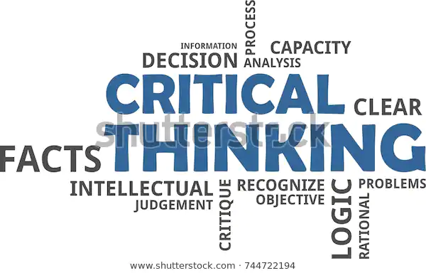
Mohammed Farooq
1715168
BMSK5001 – Developing workplace critical thinking
Due date – 26/03/20
Lecturer – Ernest Ovia

Contents
Introduction……………………………………………………………………………………………3
How beliefs impact me as an individual
How attitudes impact me as an individual……………….………………………………………...4
How do the values impact me?
The impact on Sainsbury’s organizational core values and beliefs…………………………….5
Bureaucratic management theory by Max Weber
Bureaucratic management theory by Max Weber continued……………………………………6
Bureaucratic management theory by Max Weber continued……………………………………7
The evaluation of Sainsburys modern day working environment
The value systems and beliefs at Sainsburys…………………………………………………….8
References……………………………………………………………………………………………9
References continued………………………………………………………………………………10

How an individuals’ beliefs, attitudes and values impact on workplace behavior

Introduction
The purpose of this assignment is based on a theory that I will be using towards a critical thinking model relevant towards the criteria set out for me. The model will be used for the negative impact of the different beliefs of an individual in the retail workplace specifically Sainsburys which is the business I have chosen to relate this theory on. Also, the attitude and value systems will also be discussed which negatively impact the individual within the working environment which is related towards their behavior in the workplace. The purpose of this task is also explaining in detail how and why an individual is affected by the different value systems, beliefs and attitudes in the workplace. The importance of attitudes and values will be communicated in much more detail to further explain the potential affects the individual may also experience whilst performing their job role whether it is a customer service advisor or a manager within the business of Sainsburys. Furthermore, to this report a management theory will be discussed which will be according to the Max Weber theory that is called the bureaucratic management model. The bureaucratic management model relates to 6 different principles like the hierarchical management structure for instance, the divisions of labor, the formal selection processes and careers orientations and impersonality as well. Next, I will use the relevant critical thinking models such as the Max Weber theory for instance and then I will be doing an evaluation on the modern-day workplace being relevant as well as the weakness of the management model undertaken by Max Weber. Lastly, an appropriate critical thinking strategy will be used where it’s going to help to develop a suitable argument which could be for or against the economic environment and how it can affect the resident business or not as well as an explanation as to why this is using prime examples to relate as evidence that will support such claims that I am going to be making.
How beliefs impact me as an individual
The beliefs according to a individual are personal to them and whether something is correct or incorrect or whether something is existent or non-existent so putting within the working place culture it is said that the reason why beliefs may have an effect on the type of culture within the working environment is totally depending on the individuals who have their beliefs towards their own religions for instance and having this in the working environment of people with different beliefs sometimes doesn’t work well and results to causing conflict within the workplace where a lot of negativity such as racism, judgements of gender, sexuality etc.. are then made causing disbanding groups within the workplace and causes negative impacts on the workplace culture. The research which I have undertaken stated that a person’s value systems and their beliefs have an effect on the person’s performance of work. All of the workplace relations a person may have and that is because it depends on what yourself as a person to believe what you would experience so, a person would have an important part of an identity which relates to religion, cultures and morals. Beliefs can be personal and important to a person having said this is because it can reflect who we are as a person and the way that we live according to (Personal values, belief and attitudes - Personal values, belief and attitudes, 2009). This is how the beliefs would be impacting me as an individual within the working environment and if I was discriminated against within the working environment for my beliefs and my religion it will impact my behavior negatively and will decrease my performance within the workplace as well as have a huge impact on my emotions as well. Most requests which are considered in many workplaces with beliefs are usually towards clothing, appearance and jewelry and this is said because it relates wearing for example, when a person is wearing a headscarf, where a turban and wearing a kippah. It can also relate to beards, wear a cross around your neck and to wear a crucifix. People can be discriminated against these within the workplace which a part of an individual’s appearance and related to their religion too according to (Religion or belief in the workplace, 2020).
How attitudes impact me as an individual
The way that attitude impacts me as an individual is whether my behavior is good or bad. Myself being as an employee if I am effected by the beliefs in the workplace where I have been discriminated against for example because I am wearing jewelry that is related to my religion being a Muslim and I am being discriminated against it within the workplace would really change the way my attitude would be on a normal working day without any problems at work and this is because it would make me very angry that it is allowed to take place at a working environment with nothing being done about it, it would also cause me a lot of stress and will negatively affect my performance of my job role as I may not be concentrated on my objectives and might lack in completing the daily tasks I would have been provided to do on a daily basis and this would make me feel discomfort being in a working environment like that where the behavior of an individual is very poor and is treating me with no respect what so ever I wouldn’t be comfortable at a workplace like this and I believe that if this is continuous within the working environment will sooner or later lead to disbanding groups where people are going their own ways due to workplace problems. There are many reasons why there are disbanding groups which relate to attitude and the reasons are mostly related to a charter, being unaware of what requirements are needed for team effort, lacking accountability, not having the correct resources, not being effective with leadership, not being able to plan and bad management which will lead to deal with conflict which will shortly take place and the reason to this is individuals are not happy with one another’s attitude, behavior and effort of teamworking which results to this according to (Witt, 2010). The positive or negative attitude is based on the affect of how the workers in the workplace look at their job roles as well as the emotions and attitudes that is bad on the other workers. Generally, a good emotion and attitude would then create good impression for the business for productivity whilst the previous statement is correct too according to (Joseph, 2020).
How do the values impact me?
The workplace culture really helps me to reach any improvements that I feel would need to be made especially towards the employee engagement within the working environment of Sainsburys. It is stated that the engagement in between all employees is a workplace counter relating itself to correct policies for all of the staff in the business to do the best as agreed within their contract on a daily basis and stay committed to this as it is part of the business goals which help to remain motivated all of the time and pay more attention to the success of the business having sense of a person’s well-being according to (Why is it important - Engage for Success, 2019). The core values being impacted in the working environment are negative but can also be positive as well which then relate to various of different qualities at the workplace which the managers/team leaders in the workplace will gather maybe up to standard being more impressive. Most of the core values relate to a negative effect in the workplace culture nowadays has different names like having passion/honesty due to the nature of not being passionate about your job and would then lead to the individual to not perform as they should be and who isn’t paying any attention towards the purpose of the job role/targets that would need to be completed without having to put the business in to a negative situation. My personal core values which I find important are the fundamental beliefs which I have and relate to in the business environment too which in my opinion dictate behavior and help me to understand the difference between the right and wrong doings and some of the core values which I find important are dependability, reliability, loyalty, commitment and open-mindedness. Other core values which are important and related to the workplace culture are being honest, efficiency and having consistency according to (Examples of Core Values, 2020). Not being able to judge what is right and wrong would have a huge negative impact on me as an individual and having said this is because I wont be able to reach a decision on anything and not being able to make decisions by myself would result to having another individual to then be able to make such decisions for me in some cases which I find negative and would like to be able to make the decisions for myself instead of having to cause myself issues in the future and wont look good within a working environment also as I believe I wouldn’t last very long being a worker for Sainsburys for instance not being able to make decisions for myself would result to a lot of work related stress for me for sure and may have a negative impact on behavior and health as well as my performance at work.
The impact on Sainsbury’s organizational core values and beliefs
Sainsburys organizational beliefs and core values relate to their vision statement which they have produced that advises them being the most trusted retailer across the UK. This is impacted when people like the customers don’t feel this way and don’t feel like they have been put first which gives Sainsburys a negative impact on their business and customers don’t feel loved to work and shop at Sainsburys if they feel they have not been treated fairly and equally. A recent research towards the type of service that Sainsburys provides is a website well known as Trust Pilot that provides up to date accurate information from customers reviews and how they feel. Some of the studies have stated that there have been times the elderly customers have complained numerous times that they have a high risk letter from the NHS where they are required to have services which Sainsburys have stated that they provide to the elderly which involve personal shoppers and delivery drivers who kindly help the elderly have their shopping put away in their home safely for them. However, my argument is against this as I have studied the Trust Pilot service who provides reviews from customers directly where elderly people have stated that they have not been recognized as one of Sainsburys elderly customers and are very sorry they haven’t been able to identify the customer as disabled according to (J Sainsbury is rated "Poor" with 2.0 / 5 on Trustpilot, 2020) which is pretty bad service and this is what impacts Sainsburys organizational core values and leads to their beliefs not being true as they have clearly stated in their vision statement that they have been mostly trusted as a retailer, and people have loved working in their stores. Sainsburys has said by putting their customers before anything they do and making invests within their stores, their members of staff and the channels which will help to provide the best shopping experiences according to (Our vision, 2020). According to the reviews being taken into consideration at the Trust Pilot website there is true evidence to support my claim that the customer attention would need to be improved by Sainsburys in order to avoid such problems in the nearby future.
Bureaucratic management model by Max Weber
According to the Bureaucratic management theory by Max Weber it is known that this is a management theory for the systematic formation for an organization which has been created to secure the efficiency also the economic effectiveness. This management theory is an ideal model that can be used towards management as well as administration which will bring the businesses power structure forward and usable according to (Mulder, 2020). An advantage of the Bureaucratic management theory is that it’s simplified for managers/team leaders to keep their control at all times and then adjust if it’s necessary.

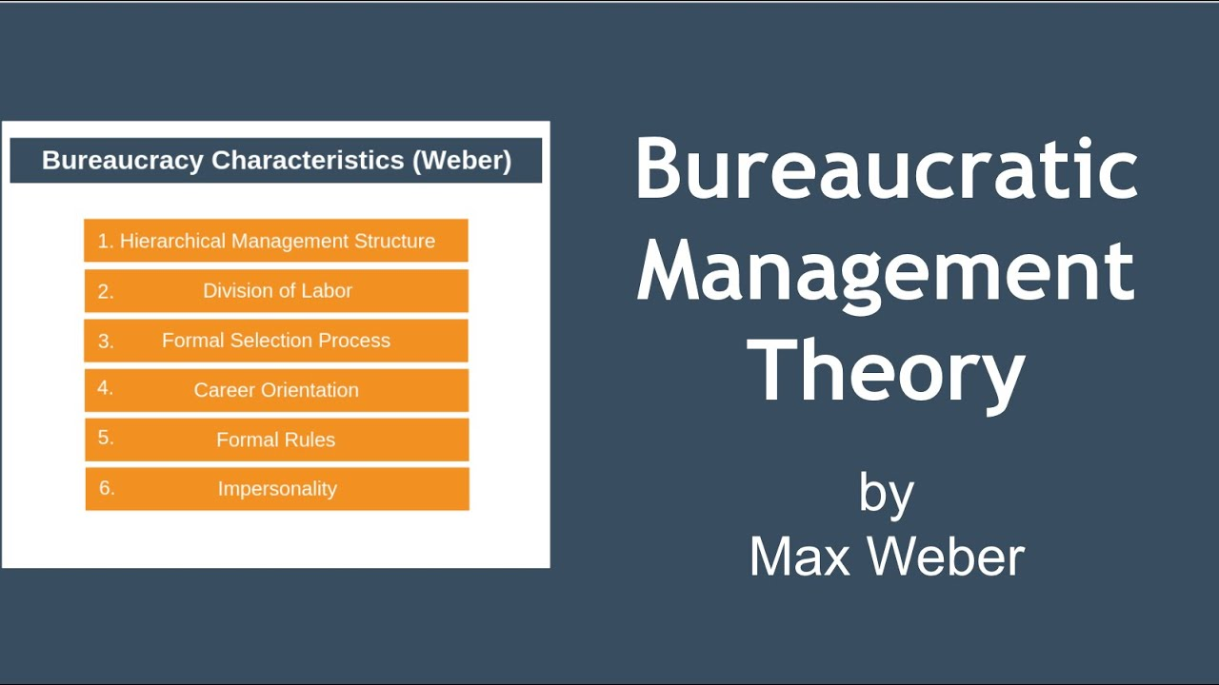
Bureaucratic does have negative impacts which can then be associated towards the larger businesses/organizations and the government agencies. Also, there is benefits of bureaucracies which are related to the organizations that have hierarchical layers which are then structured to use effectively. The established rules along with the established procedures allow more efficiency that is a consistent piece of work conducted by the employees in the business.
The hierarchical management structure that has been produced, the formal process for selection, the career orientation, the impersonality and the formal rules are all a part of the management theory which was introduced by Max Weber. The management theory by Max Weber has some disadvantages as well where bureaucracy has been characterized by desks, more paperwork, the different office culture and very slow communication because of its hierarchical layers and it’s systems have disadvantages relating to a bureaucratic business which is very unfortunate for workers as they are distanced apart from one another as well as the business which makes them feel like they are less more loyal. It’s a well-known fact that bureaucracy can be dependent on regulatory compliances as well as the policies compliances which stops its workers to then come to their own conclusive ideas that will make the employee feel as if they are a number and not a valuable individual. A research had showed that workers are appreciating more attention so therefore would appreciate having their own voices to be able to reach a decision.
The division of labor as invented by Max Webber had a purpose related to specialization which should be fixed within the working environment and there shouldn’t be a balance in the middle of responsibilities and power. The chain of command or as it is well referred to as organizational hierarchy has the ability to construct in such a way that information then becomes relative and can be used to make decisions which can then be used more effectively. Having separated personal and official property suggests that owners as well as business assets become divorced which are then treated equally which is by the owner or by the business itself. A recent research that was conducted (Bureaucratic Management Theory by Max Weber, 2020) the application of consistent and complete rules is related to proper rules and regulations within the organization which is for managing the organization efficiently. These rules are to be followed from step to step of the organization and they should be equally applicable towards every member of the business. The selection and promotion based on qualifications is the selection and promotion towards the employees which are based on equalization such as skills, age and experiences and should not be influenced by the personal relations and benefits. This also includes the training for the job role requirements and skills which has a difference between the management and the other parts of an organization as well as training to improve skills of management which is very important and relevant towards the modern-day working environment. There are many features of a bureaucratic organization which involve the key principles such as a high degree of the division of labor as well as specialization, a well-defined chain of command, the principle follows rationality, consistency and objectively, the relationships amongst the members of the organization are formal and impersonal relationships which are based on the different positions and not personalities. The rules and regulations are also well defined which indicate towards the duties and the rights of an employee which would apply to everybody within the business whether its from the bottom of the organization which should still be followed strictly. The selection and promotion are also based towards the technical qualifications and only the bureaucratic or the legal power is given the importance.
Max Weber himself was born in 1864 and was born in Germany and spent majority of his time within the industrialization sector to transform government, business and the society. Weber has had an interest in the industrial capitalism towards an economic system where the industry was privately controlled which led to operating profit. Weber’s goal was to gain the reason why industrial capitalism had been successful in some of the countries and why some of the countries hadn’t been successful. Weber had believed that the large-scale organizations such as the factories and the government departments was a characteristic of capitalist economies according to (Bureaucratic Management | Principles of Management, 2020).
Max Weber had visited the United States in the year 1904 which was to study the United Stated economy. Upon visiting the US he had the observed the spirit of capitalism which only then he noted that capitalism within the United States had encouraged competition and innovation which had then made Weber realize that majority of the businesses had been managed efficiently by professional managers which he had then gathered were linked to each other through an economic relationship. Weber’s proposed bureaucracy as the optimum form of an organization had contrasted with capitalistic practices based in Germany where he had a small group of powerful people that controlled the economy. People had then been given positions of an authority based towards their social standing as well as connections and the businesses had then been linked by families and the social relationships.
The evaluation of Sainsburys modern day working environment
After reviewing the working environment of Sainsburys I have gathered that they have reviewed an important action plan for their business which relates towards their focus on their customers more as well as their employees. To keep up to date with the latest modern day business such as Lidl, Asda and Tesco who are Sainsburys competitors, Sainsburys has stated that their employees would be taught new skills where they are required and needed to then be able to support and give motivation to so that there is more opportunities for their employees to proceed with a career progression and this is one of the reasons why Sainsburys have offered their colleagues accredited training externally and also provide an internal career progression that will have the ability to open doors for apprenticeships options for people and they have spent a lot of their time and investments to create these opportunities and training programmer and developments for their colleagues for progression to show that they are also creating more opportunities internally and externally for the community, employees and management. Sainsburys has also been aiming towards providing new and existing workers a good competitive salary and some good benefits such as employee discount and an increase of wages on a yearly basis along with a free union for employees to join which is good for employees who have problems at work and some reviews state that working in Sainsburys atmosphere was good meeting different people all the time on a daily basis providing them good customer service experiences which left many customers happy and they felt motivated by the competitive salary and benefit packages according to (Plc., 2020). According to Sainsburys themselves they have used strategic highlights to improve sales, marketing, more customer and improvement on their profit Margin by having a positive momentum in the grocery market shares and sales performances, launching a 123 new value brand product in Sainsburys, provide customer satisfaction scores of having an increase of 3% year on year and a smartshop handheld self-scanning technology now in over 350 supermarkets according to (Results, Reports and Presentations, 2020). According to shoppers based within the United kingdom in the year 2015 Sainsburys has performed very well ever since with a percentage of 76% of their shoppers evaluating the product quality as a four or a five to accumulate a total rating of 76% overall for their product availability according to (Sainsbury's performance: customer evaluation UK 2015 | Statista, 2015).
The value systems and beliefs at Sainsburys
Based at Sainsburys the value systems are important to them because Sainsburys are able to give their customers and their employees a much healthier lifestyle for the products that the business is providing to their customers. Sainsburys believe that it is important to have respect not only for their employees and customers but the environment too and this is said because Sainsburys have stated that they would like to pay attention more to the public too as they find that information useful and important to consider to make the environment a better place and not have a negative impact on their employees as well and they want to take every opportunity to make the environment a better place for everybody. Sainsburys themselves have stated that their business strategy since they have first opened their doors in the year 1869, they have done everything they could possibly do to help their customers live a healthier lifestyle for less and has always been their goal from the very start. Sainsburys have also stated that it’s the lifeblood of their business to undertake this business strategy and to help shape their strategy which would deliver value towards their customers and their shareholders too according to (Our business strategy, 2020). Sainsburys does a lot for the environment to reduce the impact on the environment where they respect the environment as one of their core values and they believe it is about doing the right thing and Sainsburys aims to be the United Kingdom’s greenest grocer which is good for the environment as well as the business but it gives both the environment and the business an equal advantage according to (What do you do to minimize your impact on the environment? | Sainsbury's, 2019)

References
iEduNote.com. 2020. Bureaucratic Management Theory by Max Weber. [online] Available at: <https://www.iedunote.com/bureaucratic-management-theory-max-weber> [Accessed 23 March 2020].
Courses.lumenlearning.com. 2020. Bureaucratic Management | Principles of Management. [online] Available at: <https://courses.lumenlearning.com/wm-principlesofmanagement/chapter/reading-bureaucratic-management/> [Accessed 24 March 2020].
Your Dictionary. 2020. Examples of Core Values. [online] Available at: <https://examples.yourdictionary.com/examples-of-core-values.html> [Accessed 17 March 2020].
Trustpilot. 2020. J Sainsbury Is Rated "Poor" With 2.0 / 5 On Trustpilot. [online] Available at: <https://uk.trustpilot.com/review/www.j-sainsbury.co.uk> [Accessed 22 March 2020].
Joseph, C., 2020. The Effects Attitude Has on Workplace Productivity. [online] Smallbusiness.chron.com. Available at: <https://smallbusiness.chron.com/effects-attitude-workplace-productivity-11777.html> [Accessed 16 March 2020].
Mulder, P., 2020. What Is Max Weber Bureaucracy Theory? Definition & Examples | Tools hero. [online] tools hero. Available at: <https://www.toolshero.com/management/bureaucratic-theory-weber/> [Accessed 23 March 2020].
About.sainsburys.co.uk. 2020. Our Business Strategy. [online] Available at: <https://www.about.sainsburys.co.uk/about-us/our-business-strategy> [Accessed 25 March 2020].
About.sainsburys.co.uk. 2020. Our Vision. [online] Available at: <https://www.about.sainsburys.co.uk/about-us/our-vision> [Accessed 21 March 2020].
Sielearning.tafensw.edu.au. 2009. Personal Values, Belief and Attitudes - Personal Values, Belief and Attitudes. [online] Available at: <https://sielearning.tafensw.edu.au/MCS/CHCAOD402A/chcaod402a_csw/knowledge/values/values.htm> [Accessed 14 March 2020].
Plc., J., 2020. Working at J Sainsbury Plc.: 8,566 Reviews | Indeed.Co.Uk. [online] Indeed.co.uk. Available at: <https://www.indeed.co.uk/cmp/J-Sainsbury-Plc./reviews> [Accessed 18 March 2020].
Staffs.ac.uk. 2020. Religion or Belief in The Workplace. [online] Available at: <https://www.staffs.ac.uk/assets/religion_or_belief_in_the_workplace_a_guide_for_employers_tcm44-61920.pdf> [Accessed 14 March 2020].
About.sainsburys.co.uk. 2020. Results, Reports and Presentations. [online] Available at: <https://www.about.sainsburys.co.uk/investors/results-reports-and-presentations> [Accessed 19 March 2020].
Help.sainsburys.co.uk. 2019. What Do You Do to Minimise Your Impact on The Environment? | Sainsbury's. [online] Available at: <https://help.sainsburys.co.uk/help/terms-and-conditions/environment-impact> [Accessed 25 March 2020].
Statista. 2015. Sainsbury's Performance: Customer Evaluation UK 2015 | Statista. [online] Available at: <https://www.statista.com/statistics/534508/uk-sainsburys-supermarket-performances-customer-evaluation/> [Accessed 20 March 2020].
Engage for Success. 2019. Why Is It Important - Engage for Success. [online] Available at: <https://engageforsuccess.org/why-is-it-important> [Accessed 16 March 2020].
Witt, D., 2010. Why Teams Fail: 10 Causes and Cures. [online] Blanchard Leader Chat. Available at: <https://leaderchat.org/2010/11/22/why-teams-fail-10-causes-and-cures/> [Accessed 15 March 2020].

