Assignment Title: Engineering Design Project

Name: Duke Asamoah

Role: Research on Power Generation and Storage

Student ID number: 1706143

Module code: M4X01160

Table of Contents
Power generation and storage 3
Electric motor selection 3
Energy storage and delivery 4
Sources 4

Table of Figures

Figure 1 DC Motor 3
Figure 2 Micro switch 4
Figure 3 D sized cabled battery 4

Power generation and storage
This task involved researching products available on the market that could be utilised within the project. The team met every Tuesday to discuss ideas and developments, on the tools and methods necessary to design a pipe climber.
Investigation through various websites revealed motors are increasingly varied. To select a motor for the project an investigation into available motors was essential. It was important to match the type of motor and its specification to the task. In this regard, investigation was undertaken as to what the torque and speed requirements for the motor are. The maximum weight of our vehicle has been assessed at 400g and the weight of the chain is approximately 300g. Assuming a wheel radius of 40mm and the motor directly driving the wheel.
The motor is required to provide sufficient torque in order to raise the machine via rotating a wheel. A quick estimation of the torque that will need to be applied required shown below.
$$T=F*d$$
This gives a required torque of roughly 2800gcm without using any gearing or mechanical advantage type systems.
It was discovered that brushless DC motors were superior versions to brushed versions, they produce less noise, and they are lighter, more durable and create fewer sparks.
In one of the meetings, it was agreed by the team that it might be better to use a brushless motor for this project for a better performance during testing. However, it is also necessary to use brushed motors if similar results are found to brushless motors but they are cheaper. It was agreed that the torque needed to be higher than the RPM of the motor, so when the pipe climber mechanism is going up the cylinder it has an adequate traction on the pipe even with the additional weight of the chain (3mm x 2m, 302g) but also climbing at a reasonable speed. The battery can be changed between the rounds as specified in the regulations. However, this must be quick and easy to do if it is required as you have a 2-minute window after being called to be prepared and in position to start a race. For this reason, it may be sensible to use existing components such as battery holders which allow the user to snap in and out any battery.
It was discussed that the price of the motor that will be used will no higher than £5.00. Research was carried out to find the attributes of what was required from using the most dependable brushless motor necessary:

Electric motor selection
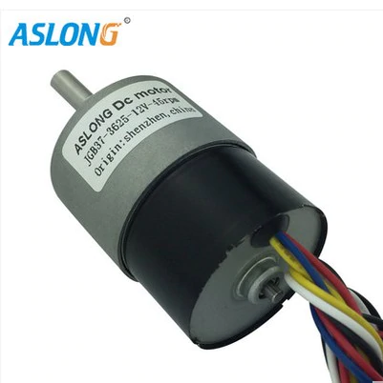
- Type of the motor: DC motor
- Configuration: Brushless motor is better for use; however, the cost is significantly more, it is acknowledged that a brushed motor may be the only option for this project.
- Voltage: V12
- Power Outlet: Battery
- RPM: 300 or slightly higher
- Torque: Maximum efficiency at around 400 g-cm or higher, torque needs to be calculated to include the components and weight of the chain.
Figure 1 Brushless DC Motor
- Weight: Below 100g
- Size (Dimensions): At approximately around 12cm x 8cm x 4cm, a small DC.
- Cost: £2.49 to £5.00
- Availability: eBay, Amazon, RS component
- Mounting: Could use wheel like the Atoplee 20pcs 3x12x4mm High Carbon steel Wire U Groove Pulley, must be 15mm groove to fit over pipe.
- Compatibility: Bracket that could be attached to the motor.
- Service life: The device needs to last for a trial run and a minimum of three heats.
- Reliability: Brushless motor will be dependable since it doesn’t ignite sparks, is much lighter, has a longer life than its brushed counterpart.
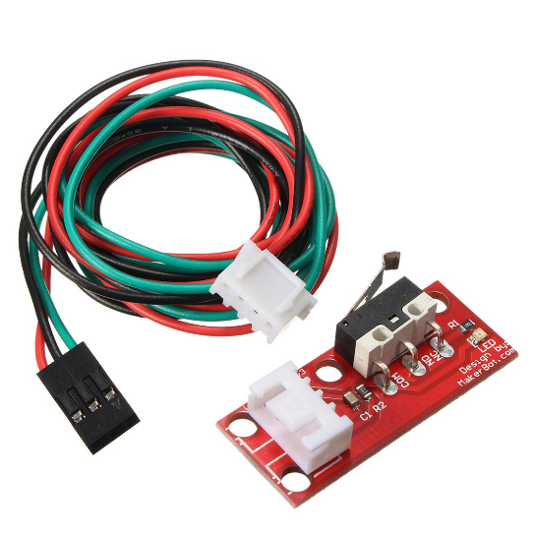
As listed above, some research was carried out to see what attributes were needed to potentially make the motor adequate for the competition. The team leader explained that the motor will need a remote controller connected to it. Also, it was discussed at the meeting what type of switch the motor will use, for example a type of micro switch like the TOOGOO(R) 6pcs Endstop Limit Mechanical End Stop Switch W/ Cable for CNC 3D Printer RAMPS (Amazon,2018) that will toggle once the motor touches the bottom of the (diameter) 150mm rigid stop piece when it reaches the top of the pipe and turn the motor off entirely. The group discussed putting something soft but light (like a sponge) at the bottom of the pipe climber contraption so when falling at a high velocity towards the ground it will be able to withstand the fall impact, and therefore nothing gets detached or broken.
Figure 2 Micro switch

Energy storage and delivery
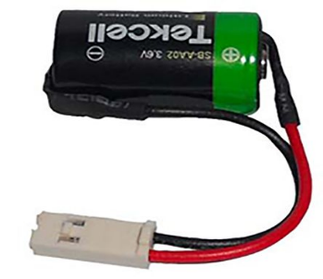
- System requirements: Siemens Battery for use with S5-90U Series, SIMATIC S7-300 Series (RS component, 2018).
- Voltage: 3.6V/min
- Amp hours: 0.8Ah
- Weight: 12g
- Size: A size D
- Service: This is a lithium battery type, so this is rechargeable.
Figure 3 D sized cabled battery

Sources
https://uk.rs-online.com/web/p/plc-accessories/0628888/
https://www.amazon.co.uk/TOOGOO-Endstop-Mechanical-Switch-Printer-red/dp/B073CRPJR7/ref=sr_1_1?s=electronics&ie=UTF8&qid=1544204317&sr=1-1&keywords=TOOGOO%28R%29+6pcs+Endstop+Limit+Mechanical+End+Stop+Switch+W%2F+Cable+for+CNC+3D+Printer+RAMPS
https://www.ebay.com/itm/12V-DC-Speed-Reduction-DC-Brushless-Gear-Motor-Gearbox-Motor-7-960RPM-NEW-/332839812413

