Construction Technology
Mohammad Nadeem
Student ID
2231309

Option 1:
- Describe the different elements of a building and their respective functional requirements.
- Choose one of the building elements and explain in detail the differences between modern and traditional construction.
Introduction
The building construction requires a significant financial investment, it is critical to have a thorough awareness of the various building processes and components before making any decisions. It is vital to thoroughly describe the many architectural components and procedures utilized in constructing both traditional and modern buildings (Beiranvand, 2020). The primary goal of this study is to grasp of the building processes employed in constructing traditional and contemporary dwellings. Furthermore, the study will concentrate on the distinctions between the two building methodologies and the benefits and drawbacks connected with each option separately.
Elements of a Building and their Requirements
A building comprises various components that, when combined, form a structure that serves a purpose. The following are the functional requirements connected with each component:
Foundation
The foundation of a building is the lowest section of the structure that bears the weight of the structure and distributes it uniformly over the ground (Beiranvand, 2020). The foundation of the building offers stability to the structure and keeps it from sinking or collapsing in. The strength of a structure's foundation directly proportions to its durability and safety.

Walls
The walls define the building's structural boundaries and divide the inner areas. They insulate and calm the surroundings and provide structural support for the roof and higher levels. Climate, budgetary restraints, and convenience of access are all variables that influence wall material choices.
Roof
The structure's roof protects the contents from the weather but also shelters the contents from the elements (Budd, 2019). The structure's purpose and surroundings influence the roof's design. The roof's pitch, the material it has built of, and even the color it has painted may all impact how well it performs and appears.
Doors and windows
Doors and windows allow people to enter and exit a building while providing ventilation, insulation, and illumination (Majhi, 2019). When choosing doors and windows, it is critical to consider how simple they are to maintain, how energy efficient, and how safe they are.
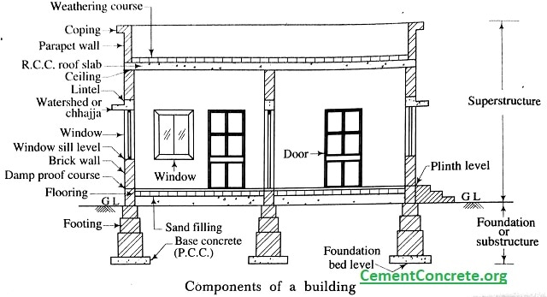
Flooring and Ceilings
The floors and ceilings provide a good walking surface and a support system for the weight of furniture and other equipment items. Also, they aid with soundproofing and insulation. When choosing materials for the flooring and ceiling, consider their endurance, the amount of upkeep required, and their visual appeal.
Mechanical Systems
Heating, ventilation, and air conditioning (HVAC) systems, for example, manage the structure's temperature, humidity, and air quality. Pipes, elevators, and fire prevention and suppression systems are further examples of mechanical systems (Morris, 2019). When selecting mechanical systems, it is critical to consider the demands for energy economy, safety, and maintenance.
Electrical Systems
The cabling, outlets, and fixtures in a structure responsible for delivering electricity to its various electronic devices, such as lights and appliances, are called "electrical systems." While choosing electrical systems, consider the energy efficiency, safety, and maintenance requirements.
Plumbing Systems
Plumbing systems deliver water into a building and remove used water and waste from the facility. When choosing plumbing systems, consider how long they will last, how effectively they utilize water, and how much maintenance they require.
Modern and Traditional Construction Methods
Construction methods have evolved through time, and current building methods often incorporate newly discovered technology and established production practices to increase output while decreasing costs. Traditional building techniques, on the other hand, often employ locally obtained materials and depend significantly on expert craftsmanship (Morris, 2019). This section thoroughly examines the contrasts and parallels between contemporary and traditional construction processes.
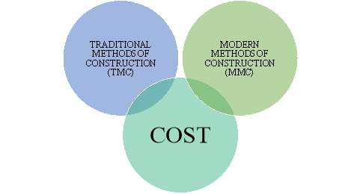
Modern Construction Methods
Prefabricated panels and large machinery are frequent components of modern building procedures. Panels are constructed off-site to exact specifications, delivered to the building site, and erected using heavy gear. This method enables using materials with greater strength and durability than typical building materials, such as steel or concrete. While adopting this strategy, the building process may also be finished more rapidly, with higher precision, and more consistently (Budd, 2019). In order to reduce the influence of the structure on the surrounding environment, modern construction methods usually incorporate sustainable design concepts, such as the use of energy-efficient materials and technologies. This is done to lessen the building's environmental imprint. Nevertheless, because prefabricated panels are standardized, current building methods may have drawbacks, such as a lack of design freedom. Also, using large machinery may raise the noise and disruption in the surrounding area.
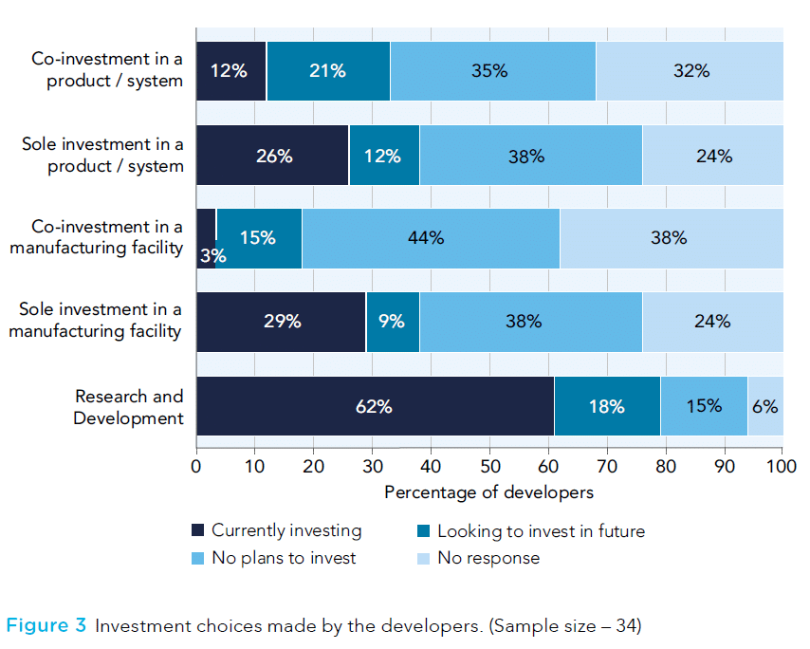
Traditional Construction Methods
Traditional building methods typically make use of locally obtained resources as well as expert craftsmanship. Construction entails installing these components on-site with traditional methods like masonry or wood framing. This is only one stage in the process. Materials such as wood, stone, or adobe are typically used in buildings (Amran, 2019). Classical construction methods can produce structures that are both distinctive and visually appealing. This is because elaborate patterns and features are often produced with exceptional craftsmanship. On the other hand, older construction methods may need much more time and work to finish than more contemporary methods, resulting in higher prices. Because older materials are more brittle and less resistant to harm than modern materials, they may need more effort to maintain and may have shorter lifespans overall.
Current and ancient construction processes take quite diverse approaches to materials and procedures. Materials are procured locally, and specialized labor is used in older ways, although prefabricated panels and large machines are typically used in modern methods. The use of modern technology enables quicker building times, greater precision and uniformity, and the use of materials engineered to last for extended periods. Traditional technologies provide several potential advantages, including their potential for sustainability, originality, beauty in design, and historical or cultural relevance. Numerous additional criteria, such as cost, viability, aesthetics, and the structure's cultural or historical value, all play a part in determining which building method to choose. While investing in real estate, it is essential to examine these factors to pick the most appropriate construction technique.
Different Wall Construction Techniques
Wall construction is essential because it defines interior and exterior zones, provides structural support, and insulates the building from the elements. This section will compare and contrast the differences between building walls utilizing modern technology and traditional methods. Constructing Modern Walls, It is usual to employ prefabricated panels composed of steel, concrete, or insulating boards when constructing modern walls (Kumar, 2017). These panels are manufactured off-site to exact specifications before being delivered to the building site and installed. When it comes to modern wall building, employing prefabricated panels has several significant advantages.
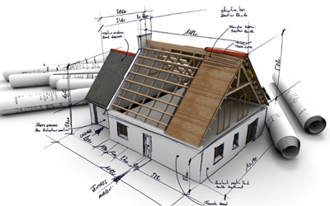
To begin, the time necessary to build the building may be decreased since the panels may be quickly erected with the help of heavy equipment. Second, the fact that the panels are built to precise specifications improves the precision and dependability of the building process. Employing unusual materials, such as concrete or steel, might result in a weaker and less long-lasting construction than one built with standard materials. However, there are significant drawbacks to employing current wall-building technologies. Using prefabricated panels in specific sizes and forms may limit the design's versatility. This is because the sizes and forms of the panels are predetermined. Also, using large machinery may raise the noise and disruption in the surrounding area.
Traditional wall construction methods sometimes include using locally produced materials such as bricks, stones, or adobe and skilled labor to assemble the materials on-site using time-honored techniques such as masonry or timber framing (Hagan, 2019). These procedures are regarded as the standards. Employing technologies that have been around for a long time to build walls has several advantages (Morris, 2019). Using locally sourced materials may be more ecologically responsible and sustainable because it requires less energy for manufacture and distribution. Second, ancient building methods typically incorporated expert craftsmanship, resulting in unique and aesthetically beautiful constructions, not to mention the likelihood that older buildings have cultural or historical importance that more modern structures do not. Nevertheless, using traditional methods for wall construction has a few drawbacks. The increased time and effort required compared to more current procedures may be more expensive. Because older materials are more brittle and less resistant to harm than modern materials, they may need more effort to maintain and may have shorter lifespans overall.
The components utilized, the techniques followed during assembly, and the qualities of the result are the fundamental distinctions between contemporary and old ways of creating walls. Traditional methods employ locally available bricks and stones. However, modern methods typically use prefabricated panels composed of steel or concrete (Beiranvand, 2020). Modern wall-building techniques have various advantages, including faster construction periods, better precision and uniformity, and materials designed to last long. Traditional wall-building techniques provide a variety of potential advantages, including sustainability, distinct and appealing patterns, and historical or cultural importance. Many variables influence the construction of walls, including cost, viability, beauty, and the value of the wall's placement in a cultural or historical context. It is critical to evaluate all of these elements before deciding on a way of wall building that will achieve the desired results.
Advantages and Disadvantages of Traditional and Modern Construction
Using traditional or modern building procedures in construction may have beneficial and harmful consequences on the end output. In this section, we will look at the benefits and drawbacks of more conventional and modern approaches to building construction.

Traditional Construction Methods
Traditional construction methods have several advantages, including the use of locally available materials, the creation of unique and appealing structures as a consequence of excellent craftsmanship, and the possibility of historical or cultural importance. Traditional building materials such as wood, bricks, and stones can be more energy efficient and ecologically friendly since they require less transportation and manufacturing procedures that waste much energy. These materials may be utilized to create houses and other structures. Modern buildings may lack the appeal and charisma inherent in classic structures (Hagan, 2019). However, there are significant drawbacks to adopting traditional building methods. The increased time and effort required compared to more current procedures may be more expensive. Because older materials are more brittle and less resistant to harm than modern materials, they may need more effort to maintain and may have shorter lifespans overall. Updating or altering previous building processes to fit newly discovered demands might take more work.
Modern Construction Methods
Modern building techniques result in reduced construction timeframes, enhanced precision and uniformity throughout the construction process, and the use of materials meant to last for a long time. If prefabricated panels or modular building techniques are employed, construction may be finished more rapidly and at a lower cost (Zhong, 2020). Moreover, using materials such as steel or concrete can provide greater strength and longevity than traditional materials. Nevertheless, some things could be improved to using modern construction technologies. Using prefabricated panels in specific sizes and forms may limit the design's versatility (Hagan, 2019). This is because the sizes and forms of the panels are predetermined. Also, using large machinery may raise the noise and disruption in the surrounding area. Furthermore, modern structures cannot have the same charm and character as antique structures.
Traditional and modern construction methods are distinguished principally by the components utilized, the procedure followed during assembly, and the features of the end product created. Traditional methods often use locally obtained resources and skilled labor, as opposed to modern procedures, which commonly use prefabricated components and large machinery. While deciding between conventional and contemporary building techniques, consider cost, lifespan, aesthetics, and the structure's cultural or historical value (Amran, 2019). Traditional construction techniques may be more relevant on a cultural and environmental level, even though contemporary building techniques might decrease the time it takes to build a structure and enhance its durability. Both traditional and contemporary building processes have advantages and downsides. While selecting a building style, evaluating the project's objectives, aims, and potential effects on the surrounding community and the environment are critical.
Conclusion
In conclusion, building a structure requires several diverse components, each of which must fulfill its own unique functional criteria. Both modern and traditional building processes employ a wide range of diverse materials and procedures, none of which are remotely comparable to the other. While contemporary methods often use heavy machinery and prefabricated panels, traditional methods use locally accessible resources and expert labor. Several variables influence the building methods used, including cost, viability, aesthetics, and the cultural or historical relevance of the project. In order to make educated judgments while investing in real estate, it is critical to understand the distinctions between contemporary and old building processes.
References
Amran, Y. M., & Rafiq, M. I. (2019). Sustainability assessment of traditional construction techniques in Malaysia. Journal of Cleaner Production, 219, 174-184.
Beiranvand, Pour, A., & Azar Eini, A. (2020). Advantages and disadvantages of modern construction methods in urban housing. International Journal of Architectural Engineering and Urban Planning, 30(1), 43-50.
Budd, G., & Curran, J. (2019). Building materials and sustainability. Routledge.
Hagan, E. (2019). Sustainable construction materials: Recycled materials for sustainable construction. Routledge.
Kumar, M. S., Suresh, S. R., & Goh, T. N. (2017). A review of the advantages and disadvantages of modern and traditional construction methods. International Journal of Engineering and Technology, 9(1), 27-32.
Majhi, S., Biswas, A., & Banerjee, P. (2019). A comparative study of traditional and modern construction materials. International Journal of Engineering Research and Technology, 12(6), 891-895.
Morris, P. (2019). Sustainable construction and building materials: Selecting sustainable materials for use in construction. Routledge.
Zhong, X., Huang, Y., Xue, L., & Wang, S. (2020). Advantages and disadvantages of traditional and modern building materials in rural areas. Journal of Cleaner Production, 246, 119002.

