

Business Report - Comparison of Two Hospitality Organisations

Student Name: LOREDANA LEONTE
Student ID: 2234509

Module Title: Financial Management for the Hotel Industry

Module Code: BMIH5007

Lecturer: Tristan Hawkins
Date: 10.05.2024

1. Executive Summary:
This report will undertake a comparative analysis of the financial strategies employed by two established hotel chains: Shangri-La Hotels and Travelodge Hotels, with a focus on their key financial factors, business practices and management strategies.
Key Findings:
Market Positioning: Shangri-La targets luxury travellers with exceptional experiences, while Travelodge focuses on budget-conscious travellers seeking affordability.
Financial Performance: Both companies show steady revenue growth. Shangri-La benefits from global expansion, while Travelodge leverages strong domestic demand.
Growth Strategies: Shangri-La's growth lies in market expansion, brand extension, and innovation. Travelodge can grow through diversification, technology integration, and international expansion.
Corporate Social Responsibility: Both companies prioritise CSR with investments in sustainability, community engagement, and employee well-being.
2. Table of Contents:
- Executive Summary
- Table of Contents:
- Introduction
- Report 4.1. Comparison of Revenue 4.2 Market Position 4.3 Growth Potential 4.4 Financial Commitment to CSR
- Conclusion
- Recommendations 6.1 Recommendation for Shangri-La Hotels 6.2 Recommendation for Travelodge Hotels
- References
3. Introduction
Operating in a dynamic and competitive environment which the hospitality industry has become, Shangri-La Hotels and Travelodge Hotels stand out as prominent players, situated on the opposite sides of the business plan axis. Their contrasting approach to the concept of hospitality, and, indeed, to financial management, prompts a critical analysis of their respective financial strategies and practices. This will help to investigate their revenue generation, market positioning, growth potential, and commitment to corporate social responsibility (CSR).
Through a comprehensive analysis, this report will offer recommendations for each organisation to enhance their financial performance and sustainability.
4. Report
4.1. Comparison of Revenue
4.1.1 Shangri-La Hotels
Shangri-La Hotels is a hospitality brand positioning itself in the luxury hotel segment, with about 100 hotels in Africa, Asia – Mainly China –, Europe, North America, and the Middle East (Jones & Comfort, 2019), and is renowned for premium services and exquisite accommodations. This can offer the invaluable position of accessing large amounts of revenue.
In recent years, the revenue of Shangri-La Hotels has shown a steady growth trend. The 2021 annual financial report shows a strong recovery from the previous year (pandemic year) from 824.55 million £ (1,033.4 million USD) to 990.19 million £ (1,241.0 million USD) (2021 Financial Report), the next year’s report shows an increase in Consolidated Revenue of 17.8%, to 1166.61 million £ (1,462.1 million USD) (2022 Financial Report), while the 2023’s annual report boasts with an even greater increase, of 46.5%, the total figure rising to 1708.94 million £ (2,141.8 million USD) (2023 Financial Report). This was driven primarily by the company’s expanding global presence, the reopening of the borders in early 2023 for Mainland China and Hong Kong, and its continuous focus on delivering exceptional guest experiences. The main sources of revenue for Shangri-La Hotels through the 3 years mentioned include: hotel operations – main source of revenue for the period, hotel properties, hotel management and related services, investment properties, and property development for sale.
4.1.2 Travelodge Hotels UK
Travelodge is perceived as one of the largest budget hotel chains in the UK, boasting over 22 million guests annually, accommodated in almost 600 hotels across UK. The location for their hotels is crucial in ensuring a constant guest flow: in major cities, towns, and holiday hotspots, by airports and key business hubs (Travelodge, 2024).
The prominent hotel chain has shown remarkable revenue growth over the years. In 2021, the total revenue was £559.8 million (Travelodge 2021 Financial Report), with a 23.1% decrease from 2019 due to COVID-19 restrictions. However, in 2022, revenue surged to £909.9 million (Travelodge 2022 Financial Report), driven by strong domestic leisure demand and effective cost management. The positive trend continued in 2023, with revenue reaching over £1 billion (Travelodge 2023 Financial Report), reflecting a 13.7% increase attributed to diverse business demand and enhanced customer experience. Sources of revenue include room bookings, food and beverage sales, and management fees. Key revenue drivers include the brand's value proposition, efficient operating model, and expansion of the hotel network. Despite inflationary pressures, Travelodge's focus on cost control and supplier relationships has led to improved revenue performance. The company's resilience in the face of challenges and strategic growth initiatives have positioned it as a leader in the hospitality industry.
4.2 Market Position
4.2.1 Shangri-La Hotels
Shangri-La Hotels, with its luxury market interest, reflects a focus on high margins and exceptional customer service. This strategy involves selective property development, higher-differentiation agglomeration by diversifying service levels of hotels (Woo & Moon, 2020), premium amenities, and offers the opportunity of developing luxurious hotel properties for rent and a hotel management franchise. The company has actively acted on geographic expansion. This suggests a strategy of capitalising on growing tourism markets, however China remains its main revenue area, so even though the expansion doesn’t limit to Asia, it’s mainly focused there. Moreover, there is a continuous struggle between global standardisation and orientation towards a local trend, which in luxury hospitality area, a hybrid approach seems more efficient, as the values and priorities of very wealthy people are similar (Aeberhard et al, 2020), but a more in-depth analysis is needed, using indices like Data Envelopment Analysis (DEA), which is a method of analysis that employ multiple performance measures to estimate operational efficiency (Kim, Kim & Lee, 2022).
Shangri-La Hotels emphasises sustainability practices in their operations. This suggests a financial strategy that includes long-term cost savings through resource management and potentially attracting environmentally conscious customers. (Shangri-La, 2024)
Based on Bowman's Strategy Clock, Shangri-La Hotels' market position aligns closely with the high-price, high-value added, and differentiation strategies (Jones & Comfort). By providing luxury experiences and personalised services to wealthy travellers, they position themselves as a leading brand in the luxury industry. This focus on delivering exceptional value at premium prices has helped Shangri-La Hotels maintain a strong competitive position in the luxury hotel market.
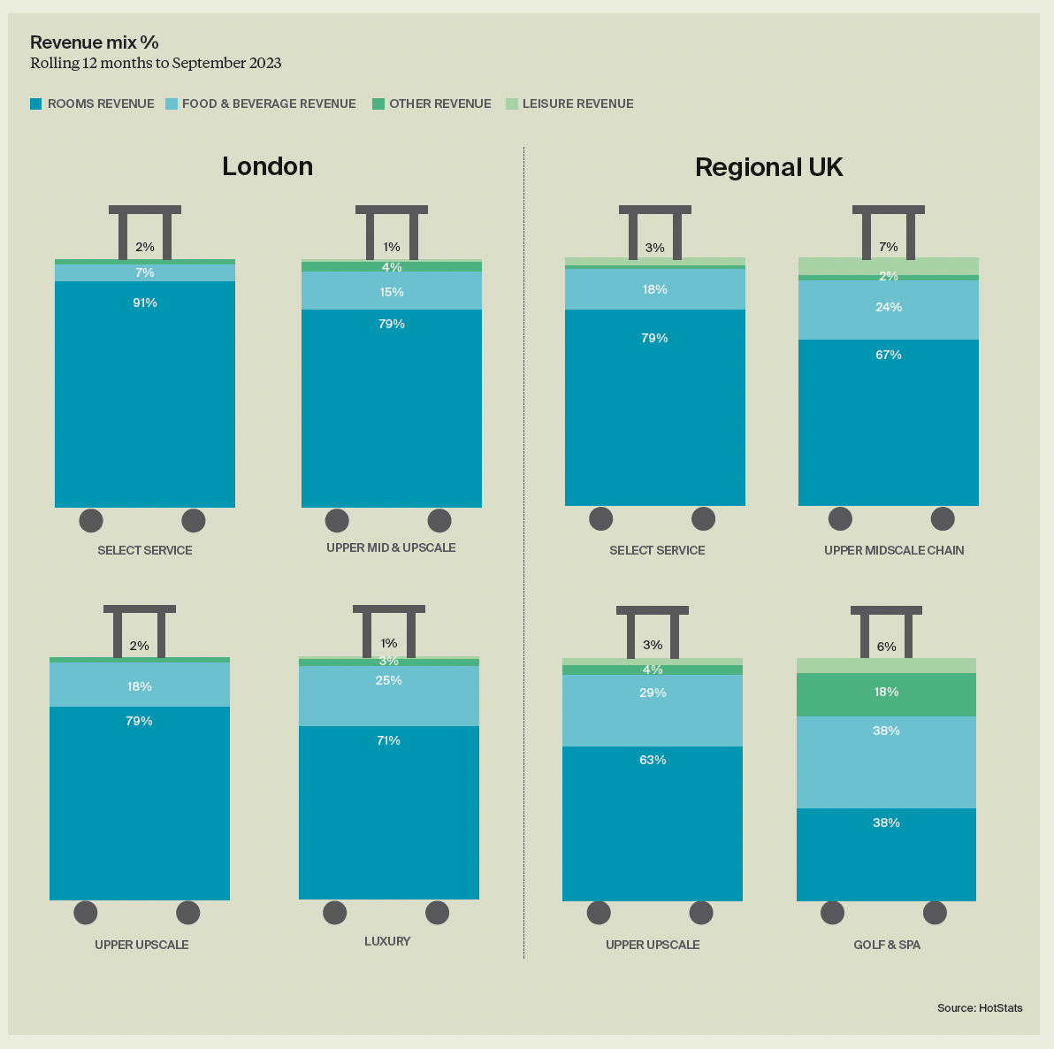
An interesting fact: Budget hotels (Select Service) tend to obtain more than 90% of their revenue from room occupancy, whereas almost a quarter of luxury hotels (Luxury) revenue comes from food & beverage (Knight Frank)

4.2.2 Travelodge Hotels UK
Travelodge UK primarily target budget-conscious travellers seeking affordable accommodations. The company’s messaging emphasises convenience, comfort, and value for money, often highlighting features like comfortable beds and central locations. Showcasing modern, minimalist room designs, the company targets demographics that include both leisure and business travellers, with a focus on families, couples, and individual travellers looking for cost-effective options. (Travelodge, 2024)
Reports on the UK hotel market segmentation (Mintel, 2022, KniteFrank, 2023), indicate a significant market share for budget hotel chains like Travelodge UK. Customer preferences in the budget segment often revolve around affordability and convenient locations, that align with Travelodge's value proposition. While luxury hotels cater to a specific niche, budget accommodations appeal to a broader demographic. Consumer reviews of Travelodge UK highlight the brand's consistency in providing clean, comfortable rooms at competitive prices. Positive reviews often mention the convenience of Travelodge's locations, ease of booking, and the overall value for money. Negative reviews touch upon issues with room maintenance, noise levels, or customer service, which brings the overall rating to 2.3 stars out of 5 (Trustpilot, 2024).
Based on Bowman's Strategy Clock, Travelodge UK's market position aligns closely with the low-price, moderate added value, and hybrid strategies (Echchakoui, 2018). They aim to provide affordable accommodations with a reasonable level of perceived value, catering to budget-conscious travellers without compromising too much on quality. This positioning has allowed them to carve out a significant share of the budget hotel market in the UK while maintaining competitiveness in terms of pricing and value.
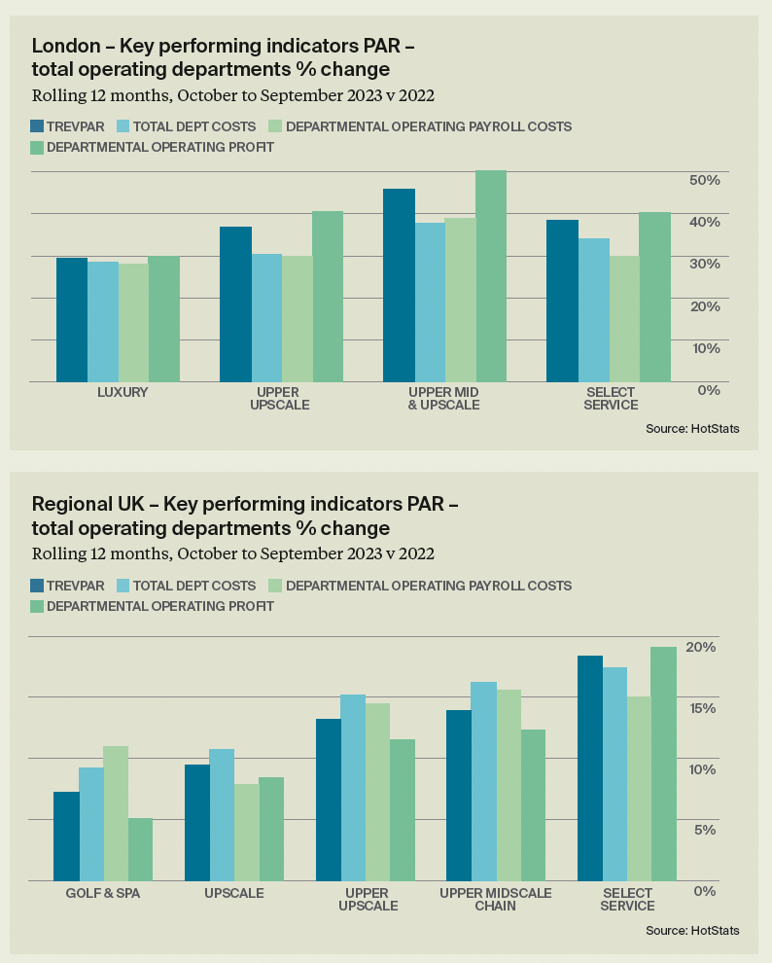
Budget and luxury hotels in London show an almost equal year-on-year increase, between 30% and 40%, but with a smaller percentage change for budget hotels, of around 10%, and luxury hotels of about 20%, for Regional UK (Knight Frank)

4.3 Growth Potential
4.3.1 Shangri-La Hotels
Based on Shangri-La Hotels' market position, an assessment of its growth potential can be explained based on 5 principles:
1. Market Expansion: Shangri-La Hotels’ potential to expand its market presence is by entering new regions or markets where demand for luxury is growing. Emerging markets with a rising affluent class are opportunities for Shangri-La to establish new properties and capture market share.
2. Brand Extension: Shangri-La Hotels can use its strong brand, healthy image perception, and reputation to continue its business offerings that go beyond traditional hotel accommodations, such as the related areas of luxury and branded residences, catering to the preferences of its wealthy clientele. This is brand positioning by product class or category (Diasz, 2017). Investing in unique amenities, exclusive partnerships, and immersive experiences can help attract new customers and retain existing ones.
3. Partnerships and Alliances: Forming strategic partnerships and alliances with other luxury providers like airlines, travel agencies, or luxury lifestyle brands can open new distribution opportunities for Shangri-La Hotels and enhance brand visibility, attracting wealthy travellers who seek integrated luxury experiences.
4. Focus on Customer Experience: Exceptional customer service and personalised experiences further differentiates Shangri-La Hotels from competitors, driving growth through positive word-of-mouth and repeat business.
5. Sustainable Growth Practices: Initiatives that integrate sustainability into its operations can appeal to environmentally conscious travellers, positioning Shangri-La Hotels as a responsible luxury brand. Reducing carbon footprint can enhance brand reputation and attract socially conscious consumers.
4.3.2 Travelodge Hotels UK
Following the same structure, an assessment of Travelodge Hotels UK’ growth potential can be ventured based on 5 principles:
1. Market Expansion: Travelodge UK has the potential to expand its market presence by targeting new regions or underserved markets within the UK. Opportunities exist to establish new properties in high-demand locations such as city centres, airports, and popular tourist destinations to capture the low-budget market share.
2. Product Diversification and Technology Integration: Travelodge UK can explore opportunities for diversifying its offers by expanding beyond traditional budget accommodations and investing in technology solutions and digital innovations. Introducing new hotel formats, such as boutique or themed hotels, and implementing mobile check-in/check-out, smart room features, and personalised guest services through mobile apps can attract a broader range of customers and drive revenue growth.
3. Partnerships and Collaborations: Forming strategic partnerships with travel agencies, online booking platforms, or corporate clients can help Travelodge UK expand its customer base and increase occupancy rates.
4. Brand Refresh and Differentiation: Travelodge UK can consider refreshing its brand and differentiating itself from competitors in the budget hotel segment. Emphasising unique selling points such as community engagement programs or themed room designs can enhance brand perception and attract new customers seeking value beyond just affordability.
5. International Expansion: Exploring opportunities for international expansion in markets with similar demand characteristics and infrastructure as the UK can fuel growth for Travelodge UK. Targeting markets with a growing middle-class segment and increasing inbound tourism can provide avenues for establishing new properties and diversifying revenue streams.
4.4 Financial Commitment to CSR
4.4.1 Shangri-La Hotels
Shangri-La Hotels exemplifies a robust commitment to Corporate Social Responsibility (CSR) through substantial financial initiatives, such as investments in energy-efficient technologies, water conservation measures, waste management systems, and renewable energy sources to minimise environmental impact and promote sustainable practices. Significant investment goes into community engagement programs like disaster relief efforts to benefit local communities (Backhouse, 2023), and into employee welfare and development, materialised in health and wellness initiatives and diversity and inclusion programs. Additionally, Shangri-La collaborates with NGOs and non-profits, ensuring ethical supply chain management practices, and maintains transparency through comprehensive reporting on CSR efforts.
4.4.2 Travelodge Hotels UK
Travelodge UK demonstrates its financial commitment to Corporate Social Responsibility (CSR) through various initiatives, including sustainability efforts such as investments in energy-efficient technologies, water conservation measures, and waste management systems. They also engage in community outreach by providing financial support for local projects in areas such as education (Careers, Travelodge, 2024), healthcare, and disaster relief. Additionally, the company partners with non-profit organisations to address social and environmental issues, while also maintaining ethical supply chain practices to uphold fair labour standards and responsible sourcing. These financial commitments underscore Travelodge UK's dedication to CSR, aiming to promote positive social and environmental impacts while ensuring long-term business sustainability.
5. Conclusion
In summary, both Shangri-La Hotels and Travelodge Hotels UK possess unique strengths and opportunities for growth. By strategically leveraging their market positions, investing in innovation, and maintaining a strong commitment to CSR, both organisations can continue to thrive in the ever-evolving hospitality landscape.
6. Recommendations
6.1 Shangri-La Hotels
Explore opportunities for further brand extension into luxury single residences like apartments, either by creating its own brand, or by collaborating with established brands, such as Air B&B.
6.2 Travelodge
Consider product diversification by introducing new hotel formats or integrating additional services, while investing in new technology solutions like mobile check-in and smart room features to enhance guest experience.
References:
- https://www.shangri-la.com/group/sustainability/
- Kim, J., Kim, S.I., and Lee, M., “What to Sell and How to Sell Matters: Focusing on Luxury Hotel Properties’ Business Performance and Efficiency”, Cornell Hospitality Quarterly, 2022 63:1, 78-95, https://doi.org/10.1177/19389655211020254
- Jones, P., Comfort, D., Sustainable Development Goals and the World’s Leading Hotel Groups, Athens Journal of Tourism, 2019, 6:1, 1-14 https://doi.org/10.30958/ajt.6-1-1
- Aeberhard, M., Corigliano, M. A., Bricchi, S., Kinsman, J., Kirihara, K., “Marketing Management of Luxury Providers”, in Conrady, R., Ruetz, D., Aeberhard, M., (eds), Luxury Tourism. Market Trends, Changing Paradigms, and Best Practices, 2020, Cham, Springer
- Echchakoui, S., An analytical model that links customer-perceived value and competitive strategies. Journal Market Analysis 6, 138–149 (2018). https://doi.org/10.1057/s41270-018-0043-9
- Linda Woo, Sung Gyun Mun, Types of agglomeration effects and location choices of international hotels in an emerging market, Tourism Management, Volume 77, 2020, 104034
- Diasz, J., Marketing and Business Strategy, 2017, Colombo, Softwave Printing & Packaging, p. 224
- Knight Frank, UK Hotel Trading Performance Review 2023, knightfrank.com/research
- Amazing value prices, https://www.travelodge.co.uk/about/amazing-value-prices/
- Company Overview, Travelodge, https://travelodge.co.uk/our-business/about-us/company-overview
- UK Hotels Market Report 2022, Mintel, https://store.mintel.com/report/uk-hotels-market-report-2022
- Travelodge review page, https://uk.trustpilot.com/review/www.travelodge.co.uk
- Forget Uni and debt - earn while you learn at Travelodge, https://www.travelodge.co.uk/careers/graduate_scheme/
- Backhouse, I.A.S., “Shangri-La Group offers a helping hand to aid earthquake-stricken communities in Turkey”, 2023, https://theglassmagazine.com/shangri-la-group-offers-a-helping-hand-to-aid-earthquake-stricken-communities-in-turkey/
- Shangri-La Asia Limited 2021 Annual Results
- Shangri-La Asia Limited 2022 Final Results Announcement
- Shangri-La Asia Limited 2023 Final Results Announcement
- Thame And London Limited Annual Report and Financial Statements for the Year Ended 31 December 2021
- Thame And London Limited Annual Report and Financial Statements for the Year Ended 31 December 2022
- Thame And London Limited Annual Report and Financial Statements for the Year Ended 31 December 2023
- Sustainability, https://www.shangri-la.com/group/sustainability/

