​
​
​
​
​
​
​
​
​
​
​
Design for X
ACMA5002

James Wybron​
​
​
​
​

​
​​

Contents
Task 1 - Abstract. 3
Task 1 – Concept design Appraisal. 4
Manufacturing process proposal. 5
DFA. 5
Manual Handling Analysis in Lucas DFA 6
Manual Fitting Analysis in Lucas DFA 6
Manufacturing process proposal. 7
Manufacturing process improvement proposal. 8
Standardising of metric off the shelf components. 8
Plastic die molding on a large scale. 9
Pre building of smaller components. 9
FMEA Table. 12
QFD. 12
Task 1 Conclusion. 14
Task 2. Abstract. 15
Project specification 16
Current market components. 16
Additive manufacturing. 18
Verdict for construction method. 20
Topology optomisation. 22
Generative design tools. 23
Cost and environmental factors. 25
Conclusion. 27
Bibliography 28

Table of figures.

Figure 1 - Spreadsheet showing the Lucas DFA handling index 6
Figure 2 - Lucas DFA Manual fitting index scoring spreadsheet 6
Figure 3- Flow chart showing the importance of work flow optomisation to increase efficiency. Creation of sub assembly 7
Figure 4 - Image of staked blank for water jett cutting to increase efficiency and reduce wasted material. 8
Figure 5 - Robotic gripper assembly broken down into 4 key stages to improve ,construction and build efficency 9
Figure 6 - Original gripper assembly with multiple fixing points on arms 9
Figure 7- Gripper arm re-designed with snap on fit and less fixing points. 10
Figure 8- Robotic gripper drawing showing what components could be standardised and removed to ease construction. 10
Figure 9 - FMEA Table showing high scoring components 11
Figure 10 - Completed QFD of gripper components 12
Figure 11 - both images showing typical valve tags options and what is currently installed on plant. 16
Figure 12 - Image showing the small size of RFID chip and its versatility due to its size. 17
Figure 13 - SIL scoring matrix industry standard 17
Figure 14 - Example of the 3d printing method. 18
Figure 15 - Example diagram of VAT Photopolymerisation 19
Figure 16 - Example diagram of power bed fusion technology 20
Figure 17 - Showing finite element analysis of a typical component and the fatigue sections 21
Figure 18 - Image showing rub damage from wear through outer sheathing on cable 21
Figure 19 - Hand sketches of protype ideas for new RFID tags 21
Figure 20 - Hand drawing of potential mounting points to prevent movement 22
Figure 21- Finsihed CAD models of tags suited to each area with both RFID chip and QR code 23
Figure 22 - Typical DSEAR zoning standard for equipment in explosive areas 24
Figure 23 - Image of materials and components to generate costing 25
Figure 24 - Calculation to work out total labour cost for project creation not implementation 25

Task 1 - Abstract.

The ever-constant development and enhancement of manufacturing systems has transformed the landscape of industrial production, however there are limiting factors such as manufacturing resources levels and escalating cost. The ability to automate in house and apply the resource is far outside the remit for smaller less global businesses, who are trying to fill their escalating demand.
As industries strive to meet growing demands and competitive pressures, the development and optimisation of robotic grippers have become critical to achieving higher throughput and minimizing production time. Traditional gripper designs, while effective, often faced limitations in handling a wide variety of tools and different sized components.
To address this challenge, re-engineering efforts have focused on enhancing the adaptability, speed, and precision of grippers production using internationally recognised tools and methodologies.
This shift not only optimizes resource utilization but also drives manufacturing processes toward greater scalability and flexibility, positioning industries to meet the future's dynamic production needs.

Task 1 – Concept design Appraisal.

The success of re-engineering efforts must extend beyond technical improvements and consideration of customer expectations, end user needs, public perception, and aesthetics. To meet these multidimensional requirements, the development process can benefit from methodologies like Quality Function Deployment (QFD), which systematically integrates customer feedback into design specifications.
QFD allows for a structured approach to translating what the customer wants and needs into functional and performance requirements for the robotic gripper. End users, typically manufacturers, demand grippers that can handle diverse products with precision and efficiency, while being adaptable to various production environments. At the same time, customer expectations increasingly focus on sustainability, ease of use, and safety maintenance and reliability.
By incorporating these factors into the the design of robotic grippers we can move beyond functionality alone to deliver solutions that meet both the needs of the customer and manufacturer.

Manufacturing process proposal.

The re-development of robotic grippers in the context of industrial automation requires careful alignment with both technical and business considerations to maximize product volume, minimise manufacturing time. Beyond the immediate functional improvements, companies must address their own operational needs, cost drivers, and the economic viability of mass production. For any small business the key drivers include maximizing throughput, minimizing downtime, ensuring product quality, and maintaining flexibility to accommodate a wide range of tasks. Consequently, a well-designed robotic gripper not only needs to meet these demands but also operate within budget constraints any organisation can increase output by throwing time and money at this. This option isn’t the correct nor viable one and the smaller the organisation typically tighter the budget constraint.
Processes such as injection molding, die casting, or additive manufacturing may be chosen depending on the material composition and complexity of the gripper components. For example injection molding is widely used for mass production of plastic parts due to its ability to produce large quantities at low per-unit cost, making it ideal for producing high-volume, precision parts like gripper fingers or housing. In contrast, additive manufacturing could be employed during prototyping or when dealing with highly complex geometries or low-batch production, offering flexibility but at a higher per-unit cost.
The re-engineering process must also focus on cost drivers such as raw material usage, production cycle time, labor, and tooling costs. These factors along can drastically improve efficiency and throughput.

DFA.

The Lucas Design for Assembly (DFA) method is a approach used to improve the method and ease of product assembly. It makes a keen focus on reducing complexity, cost, and errors during assembly. It evaluates product designs with respect to how easily and efficiently they can be assembled.
This methodology is particularly helpful in manual handling and manual fitting analysis, where human interaction with components during the assembly process is critical this is shown by Wiberg, A., Persson, J. and Ölvander, J in their journal paper from 2019 illustrating the effectiveness of the methods (Wiberg, 2019).

Manual Handling Analysis in Lucas DFA

Manual handling analysis looks at in detail how easily a part can be manipulated by a worker during the assembly process. The key factors include but are not limited to part orientation, size and weight, symmetry of parts, ease of grasping and are tooling required. The Lucas DFA method design for Assembly method was introduced by G. R. Lucas in the early 1980s and is used by multiple organisations in many different sectors (Ezpeleta, 2019) .

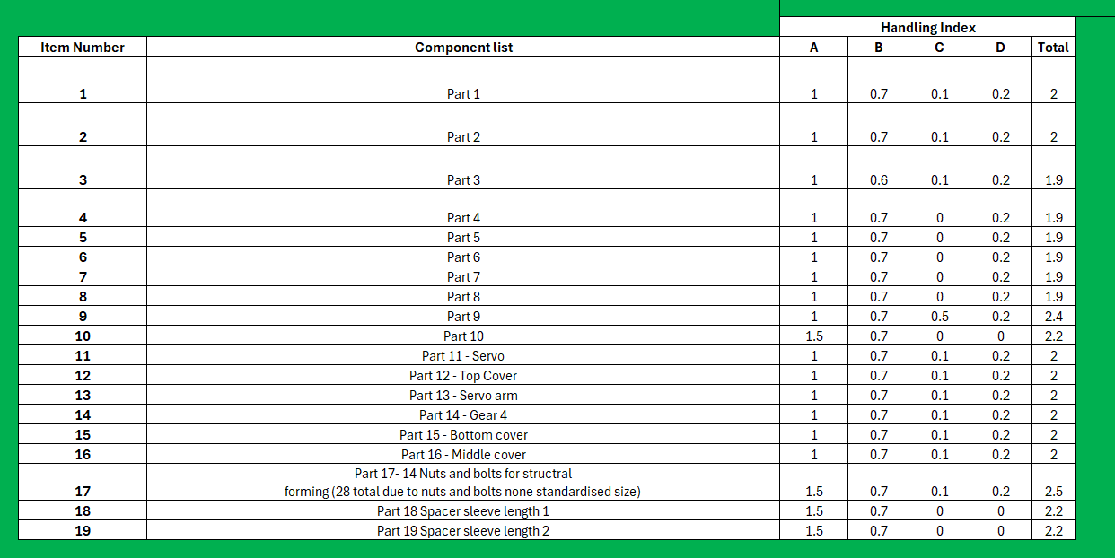
Figure 1 - Spreadsheet showing the Lucas DFA handling index

Manual Fitting Analysis in Lucas DFA
Manual fitting analysis focuses on the difficulty of inserting or attaching a part during the assembly process.
There might be a long time for an employee picking up and moving the part to suit its nesting point. This could be reduced by having the component ready in the correct orientation for install. How long does it take to install the component along with what is the time frame for also securing that part. There is also a potential for error as well that the employee may install it correctly if not unambiguously marked. These all seem like small factors but then compound over and over again on multiple assemblies the time frame and cost can gown exponentially (Ezpeleta, 2019).

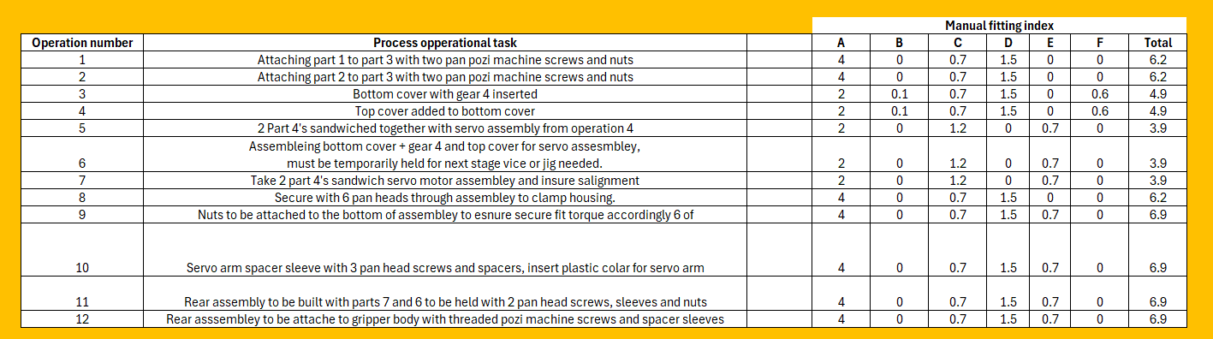
Figure 2 - Lucas DFA Manual fitting index scoring spreadsheet
The goal of Lucas DFA is to minimize the number of assembly steps and handling complexity. After analyzing both manual handling and fitting, engineers can make adjustments to the product's design to improve assembly.

Manufacturing process proposal.

As can be seen from the previous dfa and qfds there has been dramatic increase in both the scoring of process and the number of steps taken to build the robotic gripper. These steps alone do not streamline the process of production especially upon a mass scale.
A clear example of efficiency improvement is that of Mr Henry Ford implementing one of the first moving assembly systems. The focus here is not to make one person the specialist in all aspects of robotic grip construction but to specialise in specific steps of assembly.
Please see the flow chart and subsidiary inputs that would dramatically improve work flow efficiency.

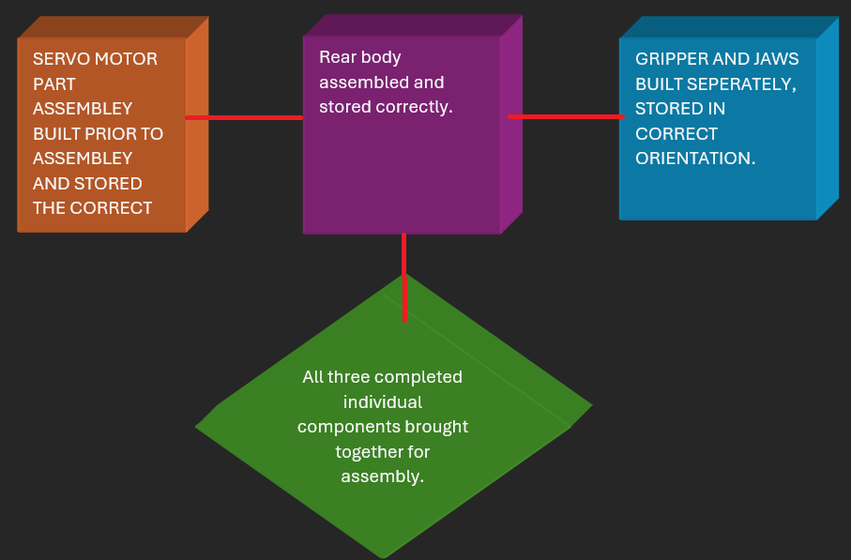
Figure 3- Flow chart showing the importance of work flow optomisation to increase efficiency. Creation of sub assembly

Manufacturing process improvement proposal.

The objective is to enhance the efficiency, reduce the amount of waste, build time and improve the quality of the current manufacturing process.
First recommendation improvement would be ensuring that the flat profile components could be set to the same thickness. However, this could take some re-engineering and drawing. Utilising all components to same spec material and thickness would mean that cutting out of a steel die could be done in mass. The image below is of a different component, but the principle would be the same. Ensuring that all components are laid out to utilise as much material as possible and reduce scrap.

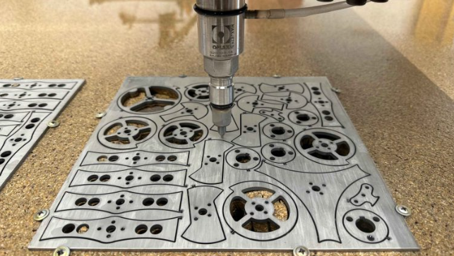
Figure 4 - Image of staked blank for water jett cutting to increase efficiency and reduce wasted material.

Why water jet cutting is ideal for cutting titanium materials - MRC Industries

Water jut cutting is a versatile and precise manufacturing process that uses a high pressure water jet mixed with abrasive particles to cut through various materials such as metal, stone glass and other composites.
Water jet cutting works by using a very high-pressure stream of water typically between 30,000psi and 90,000psi to erode and cut through metal.

Standardising of metric off the shelf components.

Standardising nuts and bolts in a production line is crucial step in optimising efficiency, reducing waste, improving quality control and lowering overall costs. It allows for short lead times on components due to them being common and readily available. There will also be in manufacture standard equipment for their installation like over-the-counter torque, Allen key, screwdriver and fastening.
There is time to be allocated in the initial design stage to allow the selection of fasteners that can be used in multiple stages of the product build.
Standardising nuts and bolts in the robot gripper build stage will significantly improve its efficiency, cost reduction and overall quality. By limiting the varying fasteners, the production process will be streamlined and improve overall quality. Production teams in turn will achieve faster production times, and fewer errors.

Plastic die molding on a large scale.

Plastic die molding also known as injection molding is one of the most common manufacturing processes for producing plastic parts. It involves injecting molten plastic into a predesigned mold known as a die. This is where it is allowed to cool and solidify into the final part. The process is highly efficient in the mass production of identical parts offering high precision, repeatability and the ability to create complex shapes.
There are 6 components from which would benefit greatly from mass production via injection molding.
Gear 4, Part 10, middle cover, bottom cover part 3 and top cover.
There would be an initial cost of creating a die with multiple components, but the mass production ability following from there would increase production.
The realistic success would be to potentially outsource the manufacture of components as far as reasonable practicable.

Pre building of smaller components.

There is a considerable bottle neck within this build process with un built components that are inter supported or in terms of DFA severely nest. Therefore splitting the assembly process where staff are utilised to pre assemble as many components as possible and box at different stages. You can then think of the final build as final assembly, where all larger scale components are built. Please see the images below which will further explain.

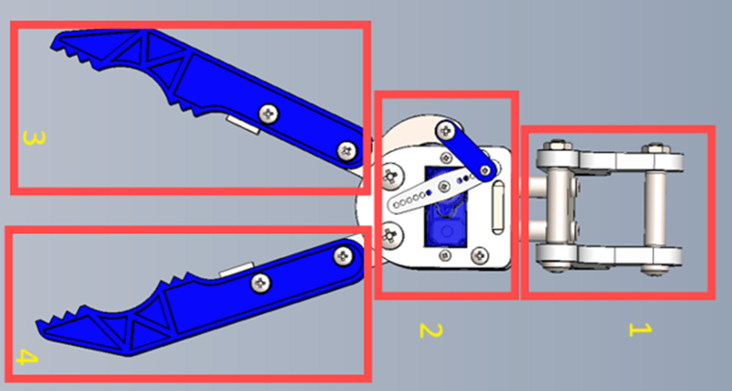

Figure 5 - Robotic gripper assembly broken down into 4 key stages to improve ,construction and build efficency

The build process due to its small scale doesn’t require large labour resource at the same time. The pre built parts reduces the requirements for the operator to be an overall specialist and allows for skills to be developed with independent less challenging stages. This was a concept that was implement by Mr Henry Ford.

Reduce and remove, the images below some of the alterations made to remove unrequired
materials and components that complicate the assembly.

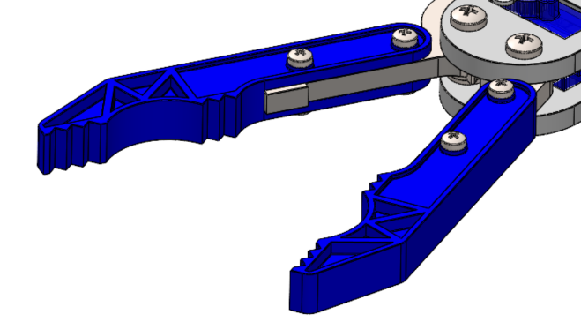

Figure 6 - Original gripper assembly with multiple fixing points on arms

There are eight components alone that are installed in the gripper arms, this does not include the griper arms themselves. By adapting this and installing a clip assembly the number of operations is reduced and materials required.

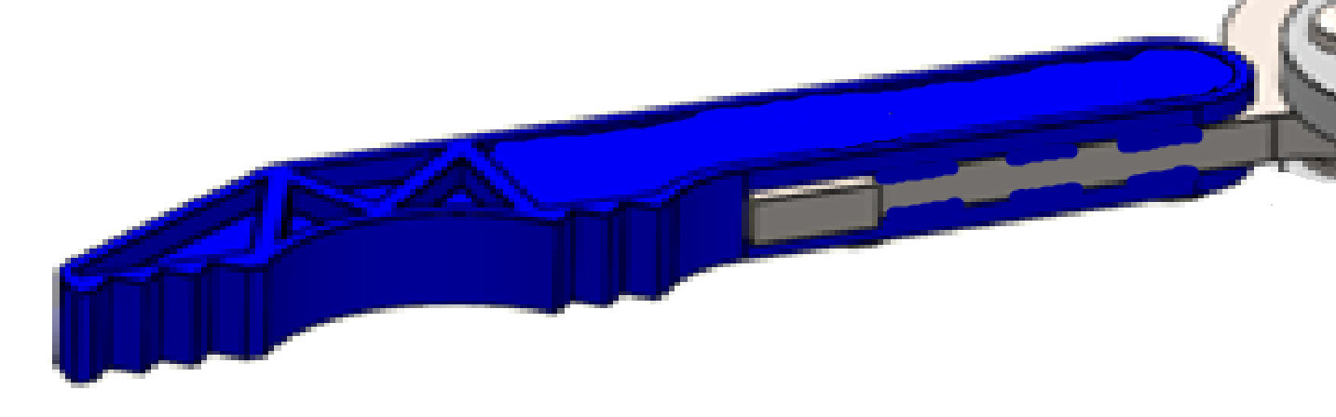

Figure 7- Gripper arm re-designed with snap on fit and less fixing points.

The redesign now has a snap assembly which also increases ease of maintenance and repair. This would be far more acceptable under the British retail consortium regulation as the arm is highly visible due to colour with less potential for cross contamination from loose parts.

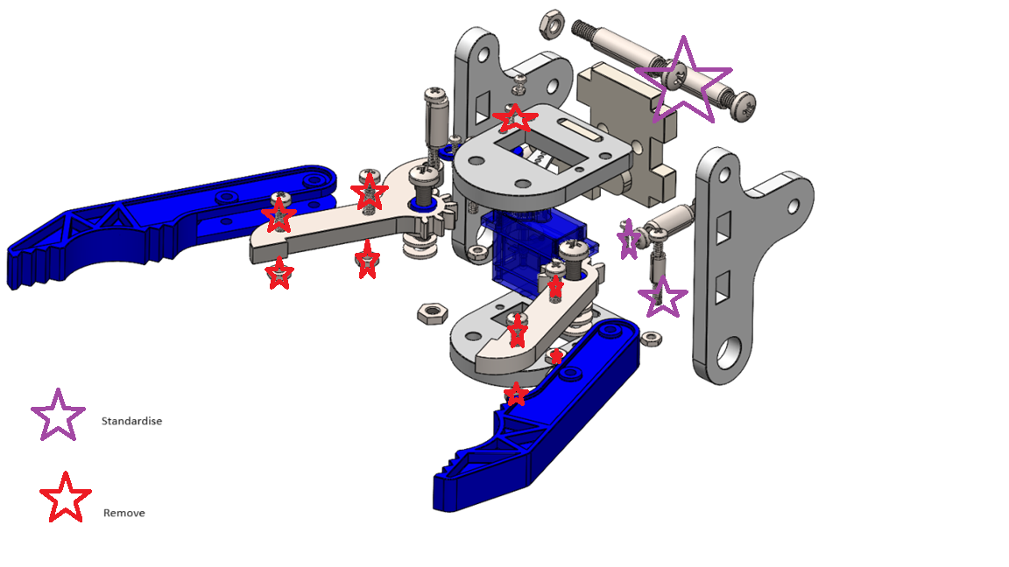

Figure 8- Robotic gripper drawing showing what components could be standardised and removed to ease construction.

The image above shows both the simplicity and power of substituting and removing items, just this image alone shows a reduction of thirteen components. All of which require tools on the handling index.

FMEA Table.

FMEA which is an abbreviation for failure mode effect analysis is a system-based approach to identify failure, with a process or product and the possible effects. Think of it as a risk assessment for a product. The goal is to identify the failures and highlight them.
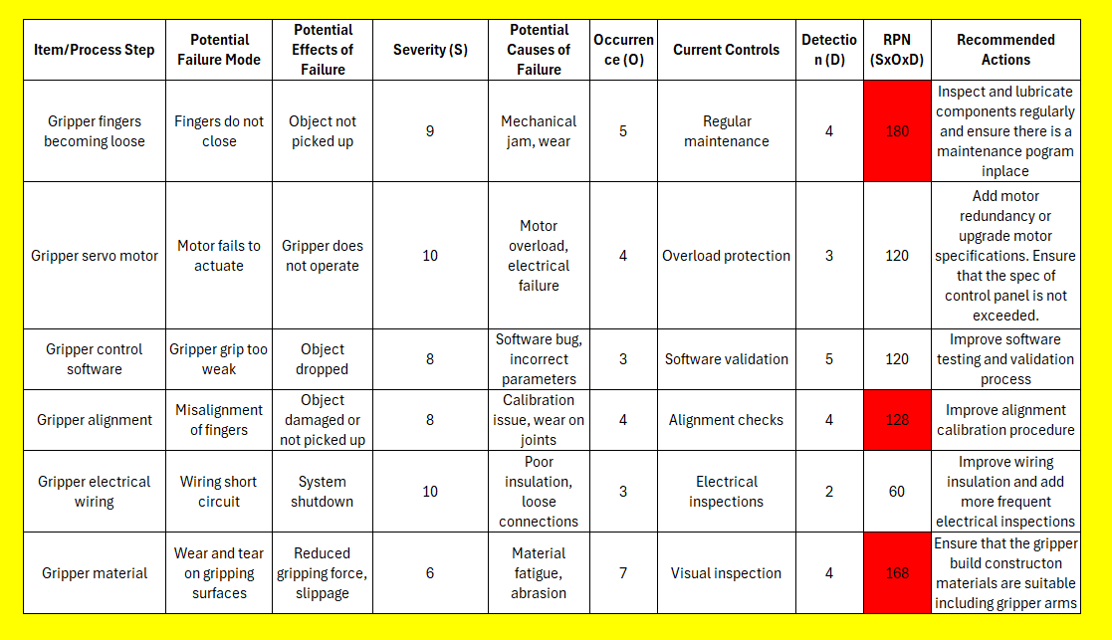
Figure 9 - FMEA Table showing high scoring components

The RPN risk priority number is calculated using the equation below.
RPN = Severity × Occurrence × Detection
There are three scores that came out higher than expected which are the gripper fingers becoming loose, gripper alignment and gripper manufactured material. This table has created focus to the redevelopment preventing going of in a tangent and re-inventing everything.

QFD.
The QFD is a quality function deployment and provides a structured way to prioritize technical features based on customer needs. The QFD table below is that of the robotic gripper looking at key attributes and features of the original product. It was the brain child of Dr Yogi Akao in the nineteen sixties from Japan.
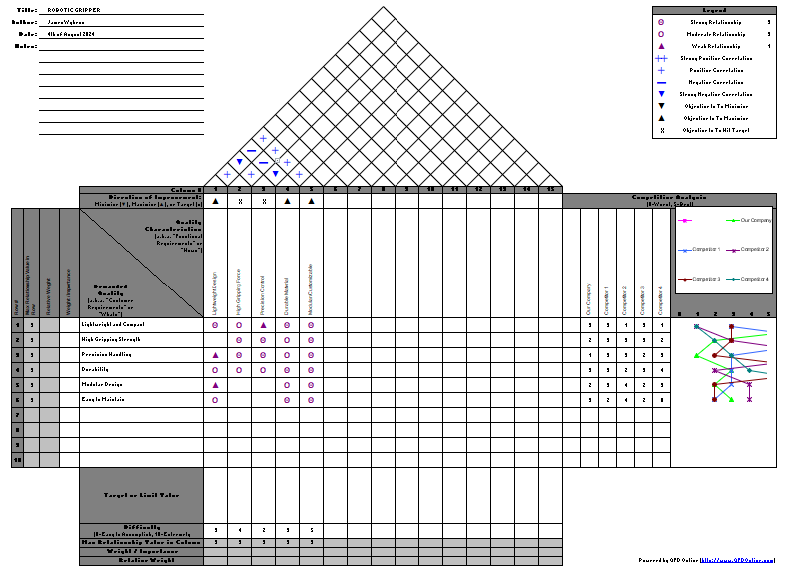
Figure 10 - Completed QFD of gripper components
SCAMPER.
Is a tool for problem solving used to generate and drive ideas it is an abbreviation for substitute, combine, adapt, modify, put to other use, eliminate and re arrange. The table below highlights the use of scamper through out this process. The systematic approach of these methodologies helps align focus to the project in hand, they all play a vital role in successfully redesigning a product for improvement.

Task 1 Conclusion.

In conclusion the development if a robotic gripper represents a significant advancement in automation and technology particularly due to its now simplified construction using such methods as failure mode effect analysis and Quality function deployment.
By leveraging modular designs, readily available standard materials, simplified control mechanisms an engineer can create efficient and effective grippers without exponential growing their resources and expertise. The implementation of the appropriate design philosophy can happy any organisation of any size develops and exceed the demand for their product with the correct approach. The accessibility not only lowers the barrier to entry for individuals and small companies venturing into this specific field of gripper build but accelerates the innovation and forward thinking in that field.
As a result the ease of the building the robotic grippers has improved with the resource available to the company by enhancing productivity with systematic tools and methodologies. No greater words are spoken by that of audi with “vorsprung durch Technik” translated to “progress through technology”, which is evident in the report.

Task 2. Abstract.

This research explores the development of pressure and flow transmitter interactive tags utlising additive manufacturing techniques specifically 3D printing to enhance functionality and integration with smart work systems such as work place tablets.
Pressure and flow transmitters are critical components in monitoring and providing closed loop control and real time live feedback in an industrial environment. As important as the feedback from the equipment is so its clear unambiguous identifications for tracking, compliance maintenance calibration and data acquisition purposes. Traditional methods of tagging these devices, such as labels and barcodes face imitations in harsh conditions and extreme environments.
The proposed solution leverages additive manufacturing to create robust, interactive RFID (Radio Frequency Identification) or NFC (Near Field Communication) tags that are directly clipped to the transmitter's structure. These tags are designed to withstand high pressures, extreme temperatures, and corrosive environments while providing real-time data access for industrial monitoring systems. By embedding tags directly onto the pressure/flow transmitter using advanced materials and tailored geometries, the project aims to improve durability, reduce human error in data retrieval, and streamline asset management.

The use of generative design tools in combination with 3D printing allows for the optimization of the tag’s geometry and material usage, ensuring minimal interference with the transmitter’s functionality while enhancing signal strength and durability. The result is an advanced, interactive pressure transmitter solution that integrates seamlessly into Industry 4.0 environments, enabling enhanced communication, traceability, and operational efficiency.

Project specification

Project specification for the improvement of pressure and flow transmitter tags on safety critical equipment. At present pressure transmitters are installed with serial id tags to distinguish its location and application. Its application could be to provide instant instrumentation loop feedback to pressure or flow of an individual process. The current tag system has been the same for may years. However, I feel this is a perfect opportunity to progress with technology along with the implementation of a digitalised sap maintenance system. The current tags only denote the millimeter water gauge, scale range and location and type. The proposed tags would allow a technician to scan and identify last calibrations, manufacturer specification and process mediums associated with the transmitter.

Current market components.

The current identification tags that are available are known as valve tags and are used to identify valves in relation to drawings. They are all purely visual indication based, the scope or design is only governed by the physical size of the tag and volume of text that can be applied. Even though the raw material and cost of the item is relatively small, there is a requirement to have bespoke machinery and skills to be able to develop the product from conception to completion. In some industries the number of components within a circuit can grow exponentially into the thousands. The tasks of creating this task can be costly and time consuming due to the shear quantity of what is required for that specific industry.

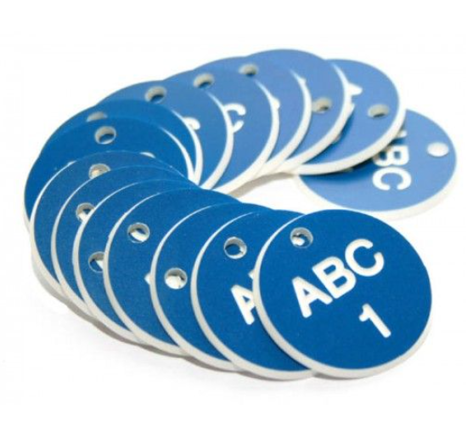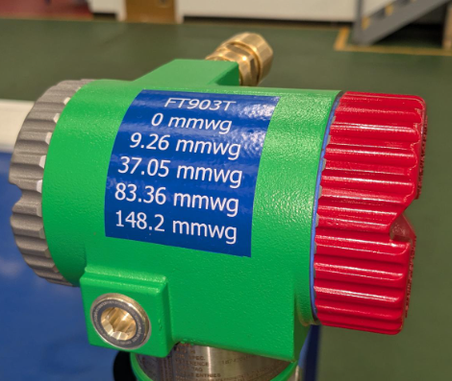
Figure 11 - both images showing typical valve tags options and what is currently installed on plant.
RFID Explained.
RFID which is an abbreviation for radio frequency identification is a means of technology that can track a multitude of applications from animals to industrial. It involves three main components a transponder, reader and an antenna. Its uses in industry are limitless, allowing employees or processes to be tracked along paths of its life from conception to completion. This has even been mentioned in academic papers by Meng Z showing its limitless use. (Meng, 2016)
There are three main types of tags passive tags having no power source and rely on the RFID reader to provide a power source through energy waves. These are the cheapest standard of tag.
Active tags that have their own internal power supply that are active and can be read up to hundreds of meters away.
Information stored that’s works on a two-packet communication methodology, the chip has information stored and is only accessible when the RFID reader has the correct serial number to allow two way communication. (Meng, 2016)
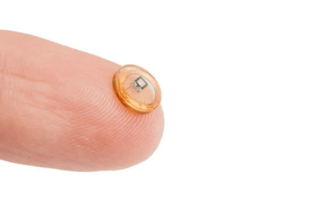
The sheer size of the RFID chip set is so small its application is endless. Image taken from (Marshall, 2017). David Marshall speaks of the endless possibilities of RFID chipsets.

Figure 12 - Image showing the small size of RFID chip and its versatility due to its size.
QR Code.
Mr T J soon speaks openly about the endless possibilities of QR coding in 2008 and sixteen years later the technology is still viable for use and application in industry (Soon, 2008).
QR is an abbreviation for (Quick Response code) is a two dimensional barcode that can store a variety of information, such as URLs, text, or other data. It consists of black squares arranged on a white background, which can be scanned by a smartphone or QR code reader to quickly retrieve the stored information.
There are three stages to QR code operation data encoding, scanning and encoding.
QR codes are widely used for easy data sharing, payments, marketing, and product tracking. They're faster and can store more data than traditional barcodes.
The benefits of bespoke tailored tags.
When a process safety system is based upon safety critical assets performing at their optimum there must be layers of protection in place. Not only are the components involved in the installation SIL Safety integrity level is a measure of its performance in terms of probability of failure while in operation. The figures are based numerically of probability as for example 1 in 100,000. Please refer to tables below. They even have their own IEC standards

- IEC 61508: Functional Safety of Electrical/Electronic/Programmable Electronic Safety-Related Systems
- IEC 61511: Safety Instrumented Systems for the Process Industry Sector

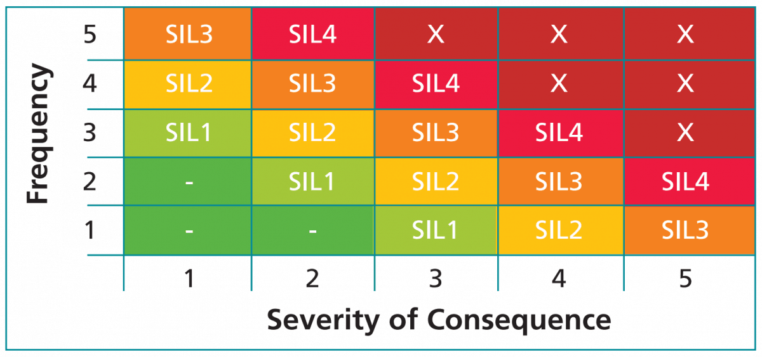
Figure 13 - SIL scoring matrix industry standard

Designing an installing is not enough it requires regular maintenance and testing from trained and component individuals. Therefore the introduction of interactive tagging would greatly reduce the factor of human error. There would be no noting of numbers and miss communication once created and installed instant access to all data and manufacturers spec would be available with the scan of a QR code or rfd or rfi chip.

Additive manufacturing.

Additive manufacturing is a process of adding material layer at a time to build a complete component. This technology is far newer than traditional manufacturing processes where they are subtractive. An example of this would be starting with a base material and removing section via, drilling, cutting, milling or molding a material to its desired form. The best example of this is 3d printing where manufacturing builds objects from the ground up by adding layers of material generated from a raw composite.

Material jetting - 3d Printing.
Material jetting 3D printing technology is a method of taken a medium in this case filament and through heat melting that medium and allowing the moving head to re position the medium to the desired location on the deck. This is how a 3d printer works and can allow up to several different colours, with a range of filaments offering different characteristics. The image below shows the operation of a 3d printer. The short cycle times from design to print is an excellent tool for prototyping.

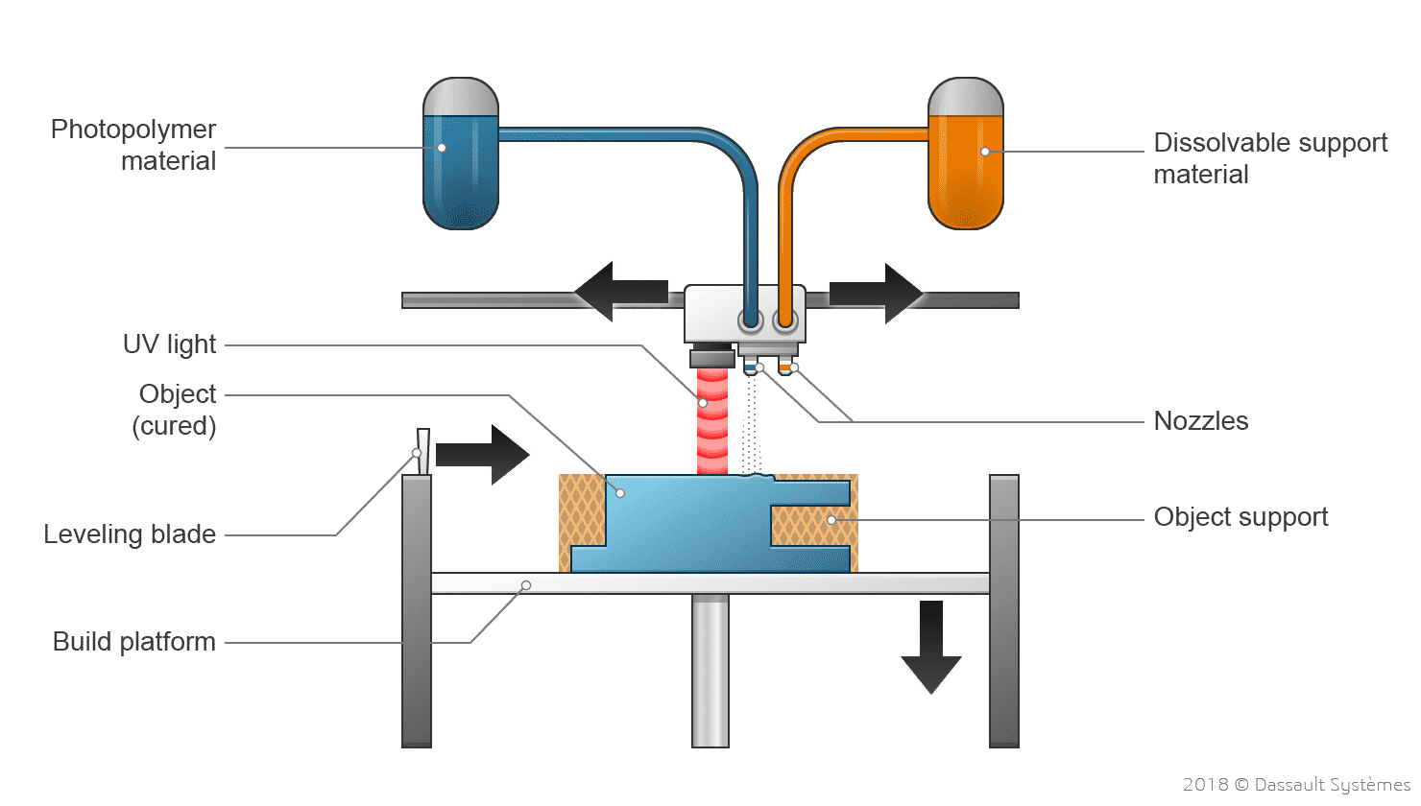
Figure 14 - Example of the 3d printing method.

VAT Photopolymerisation.

Vat polymerisation uses a tank of liquid photopolymer resin, then a model is built single layer by single layer. Vat photopolymerization is a category of additive manufacturing processes that create 3D objects through targeting a light source to activate and harden the liquid material to create a polymerisation.

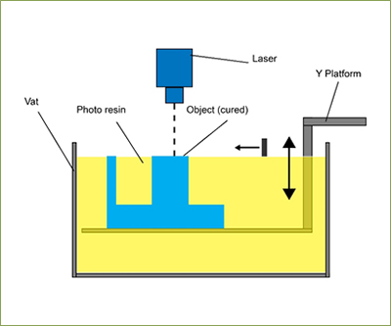
Figure 15 - Example diagram of VAT Photopolymerisation

Power bed fusion.

Power bed fusion is similar to 3d printing in terms of being an additive manufacturing process. However instead of passing filament through a heated head a laser does selective point heating where it causes the material to solidify to the desired shape, the left over material needs to be removed after printing during post processing.

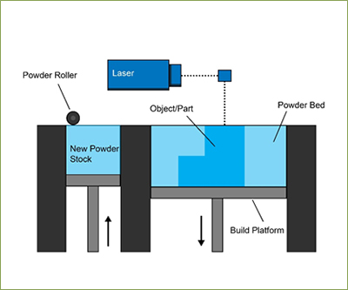

Figure 16 - Example diagram of power bed fusion technology

Verdict for construction method.
All of the above are viable and realistic options for the construction of the interactive identification tags, however there are constraints and cost implications.
DFAM Principles.
Finite element analysis (FEA)
Finite Element Analysis (FEA) is a computational technique used to simulate and analyse the behaviour of physical systems under various conditions. It breaks down a complex object or system into smaller, simpler parts called finite elements such as triangles or rectangles. These elements are then solved for individually to predict how the overall system will react to physical forces, vibrations, heat, fluid flow, or other real-world conditions. (Roylance, 2001)

An excellent example of this is the clip below showing the areas of higher fatigue and potential failure.
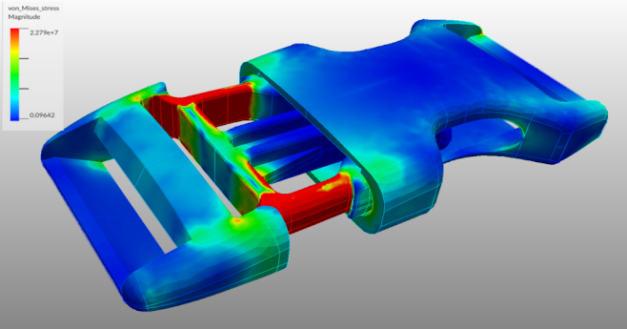
Figure 17 - Showing finite element analysis of a typical component and the fatigue sections
The only areas around the tag design that may be points of failure are the corners. Please see the sketch below.
Sharp angled edges would be a point of failure for both the tag and surrounding equipment, the long term effects of materials blowing in the wind eroding their environment. This would be an issue on thermally lagged equipment or fitted with trace heating. Please see below the image of exposed in cores from wear resulting in spark ignition potential or failure.
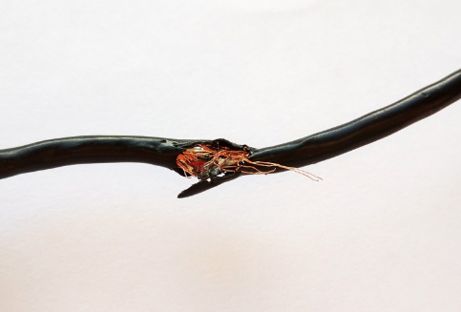
Figure 18 - Image showing rub damage from wear through outer sheathing on cable

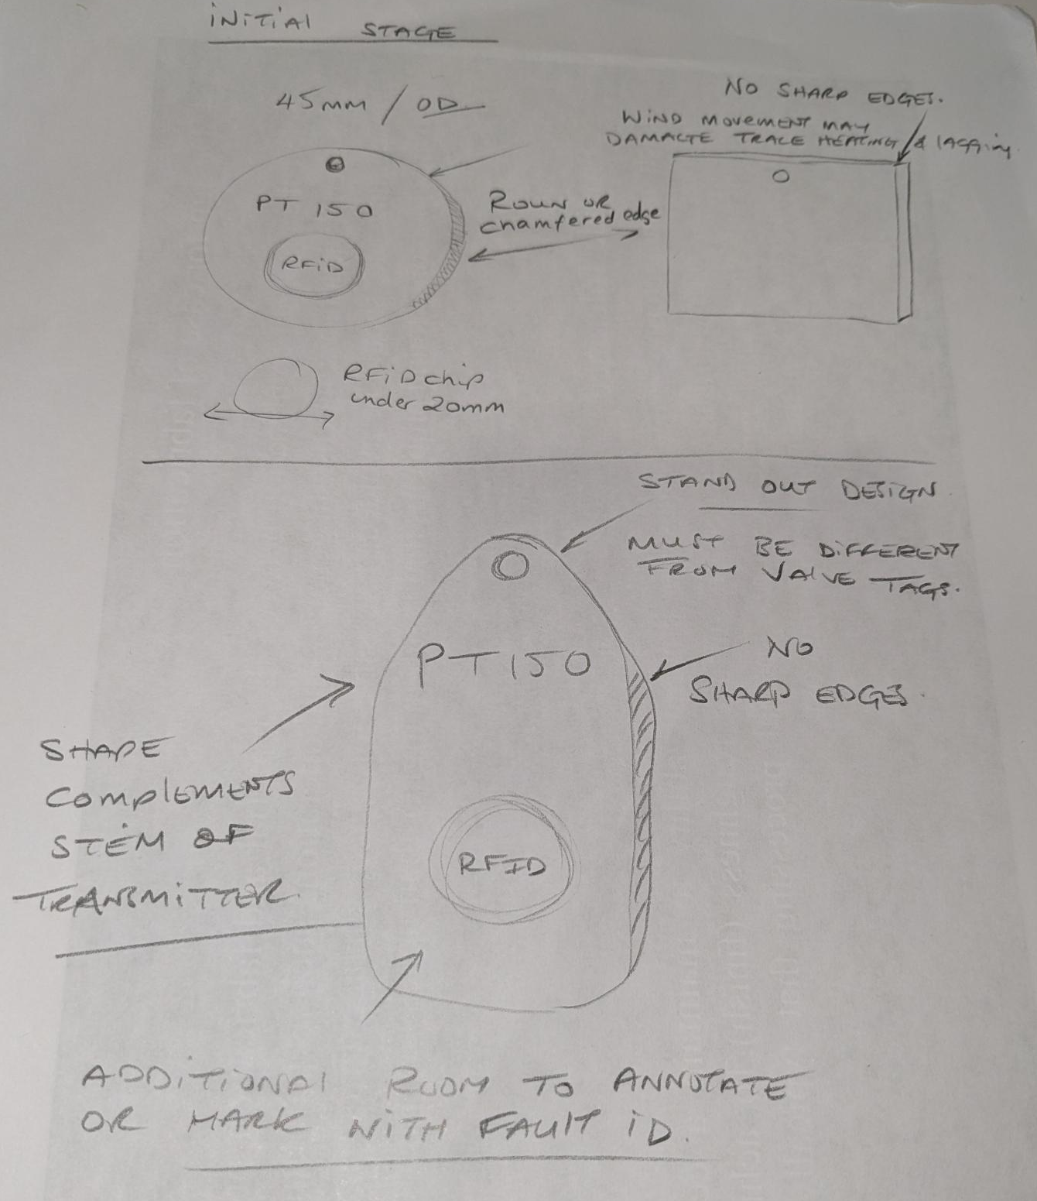
Figure 19 - Hand sketches of protype ideas for new RFID tags

Topology optomisation.
Topology is a branch of mathematics that studies the properties of spaces that are preserved under continuous deformations, such as stretching, twisting, or bending, but not tearing or gluing. It focuses on concepts like connectedness, continuity, and boundary rather than precise shapes and sizes. These can be replicated in software and highlight defects and faults before they go to manufacture. (Bendsoe, 2013). The id tag is not exposed to any supportive or stressful loading it is purely a means of identification. The material to be chosen will be suitable for harsh industrial environments where it is exposed to the weather and process variables.
Therefore the product was redesigned to ensure that there were both anchor points top and bottom of the tag to prevent wear and environmental movement.
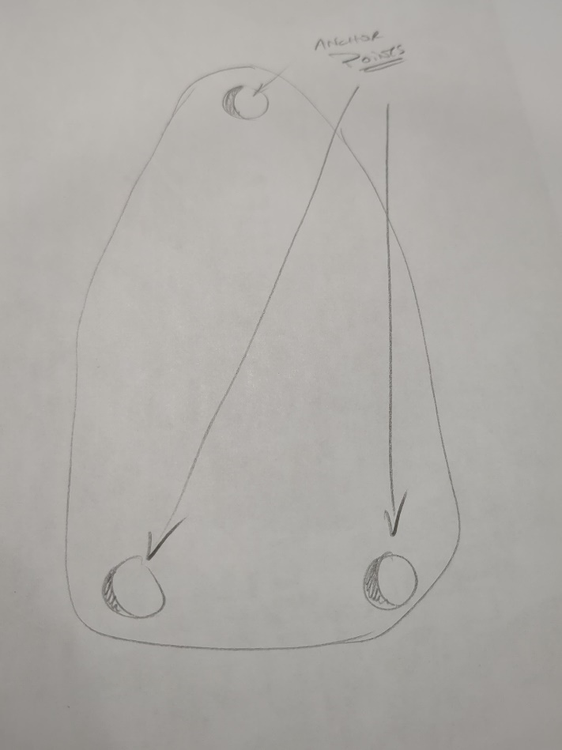

Figure 20 - Hand drawing of potential mounting points to prevent movement

Generative design tools.
Adaptive manufacturing and generative design refer to the process that can modify and optomise production methods in real time based on changes and demands, material changes, engineering efficiency. Generative design process that uses algorithms to optomise designs based on specified constraints and objectives. This is a far cry from the original traditional design process where engineers manually create solutions, generate designs which takes time and skill to create protypes. There is also a cost implication from trialing multiple prototypes and then developing improvements. Depending upon the material composition of item the cost of prototyping could grow exponentially until the desired result is achieved.
There are software applications that can explore thousands of possibilities and be trialed in real time on software that replicates real world conditions. A typical example of this would be application software such as Fusion 360. There is an initial cost for the purchase of the software and the resource of using a trained and competent person for the design, yet this yields a payback over time.

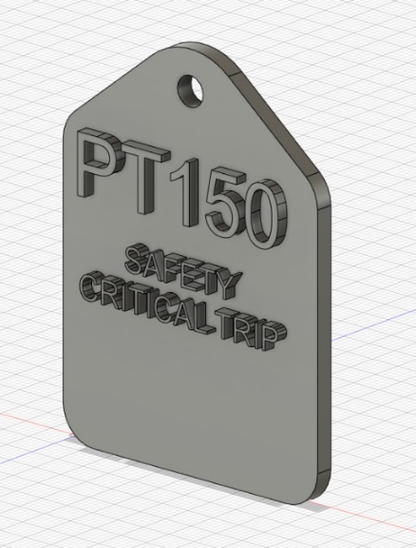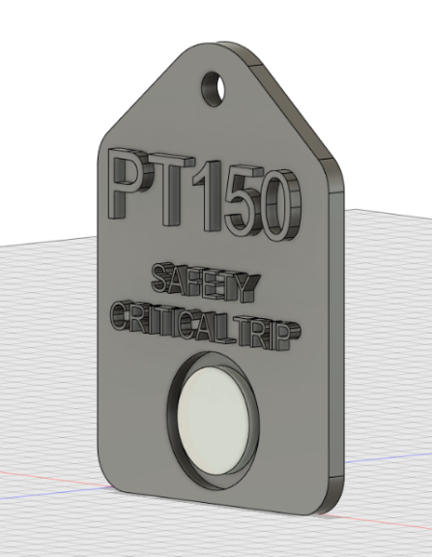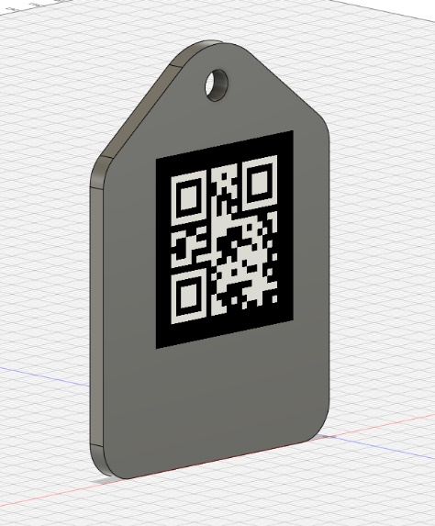
Figure 21- Finsihed CAD models of tags suited to each area with both RFID chip and QR code

Anisotropy and inhomogeneity.

Anisotropy is the official term that means a material has different properties depending on the direction you measure them. Like wood along its grain is stronger that across it. So in terms of 3d printing there could be planes stronger in certain areas than others as highlighted by Bandinelli, F., Scapin, M. and Peroni, L in their recent 2024 journal (Bandinelli, 2024).
Inhomogeneity means the materials properties are not the same throughout the object, so some parts are stronger that others.
Areas where material has been removed for holes, recessed for adding RFID chip and raised embossed text even though being the same polycarb material will have different structural properties.
Shrinkage, porosity and distortion.
These are all considerations to be taken into account when creating a new product as they may hinder its operation and in some cases can be a serious issue. For example, the shrinking of a gasket holding back a corrosive flammable substance during operation could have detrimental effects. These are not issues at this construction however we had to ensure that the material is environmentally suitable and dose not cause a spark.
Material and post processing considerations.
With the creation of any product there will be post processing and with the chosen medium 3d filament printing there will be support material removal, sanding, assembly and resin coating.
The outer body of the tag will need to be sanded and support material removed, there should be very little due to simple shape. The next stage would be in the fitting and securing of the RFID chip to the recessed body with adhesive and after curing resin coating to prevent damage. All of these processes need to be risk assessed and local exhaust ventilation installed to ensure that the assembler is not exposed to harmful chemicals or materials using the correct personal protective equipment.

Support structure requirements.

With the creation of many intricate 3d printed assemblies there are support structure requirements to ensure that the print dose not collapse during printing. As mentioned previously this will not be an issue with the simplicity of the design

Cost and environmental factors.
ne of the main driving forces will be the suitabliity for excuipment is DSEAR zones. DSEAR is the abbreviation for danger susbatances explosive atmospheres regulation, it ensures that equipment in a zone is suitable to prevent a spark or ignition source igniting presnt gas or flamable solids. Please see below the zonal classifiaction for DSEAR equipment.

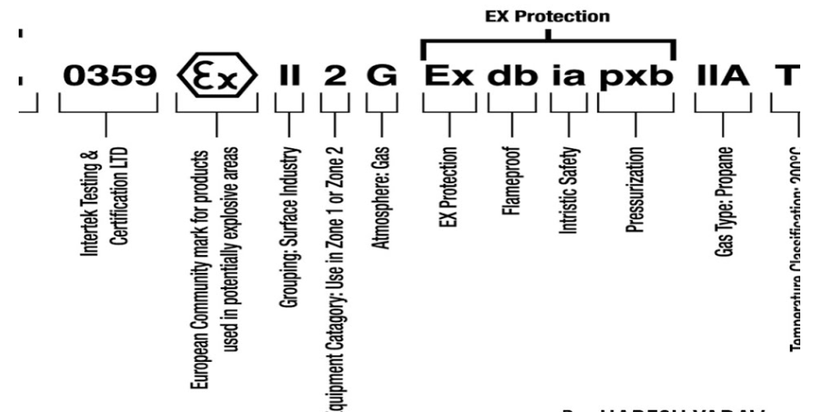
Figure 22 - Typical DSEAR zoning standard for equipment in explosive areas
The equipment that sits in zonal areas can not have an RFID chip, there I looked at the option of using QR codes. RFID chips (radio frequency identification) works by transmitting data, inside the tag is a small coil and antenna. This is a potential for wearing and coil damage and may not suit zone suitability. Therefore the QR code can be used inline with a DSEAR rated tablet (Ennis, 2006).
Due to the material having to be use outside and exposed to the enivormental elements the chosen material to be used is ez pc polycarbinate fillament which has great strength and impact resisitance. It has high thermal resiatnace also which would be good when sat on equipment that has trace heating or lagged and exposed to drirect sulight. It has been used in applications such as riot gear and
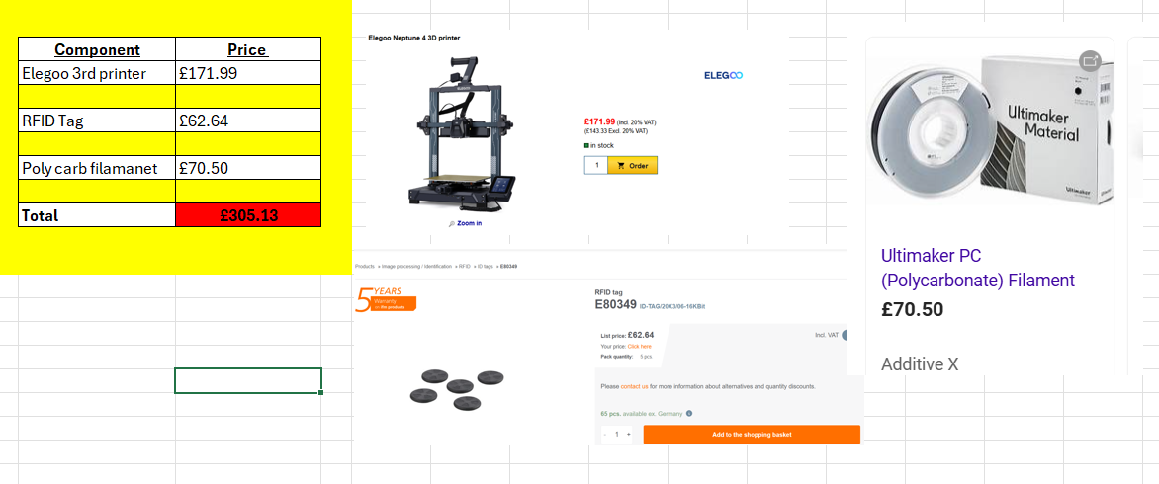

Figure 23 - Image of materials and components to generate costing

However the total initial cost to make is relatively low, however the total cost will grow immensely if using electrical technicians to complete this work.
I also feel that this is not a sustainable or useful cost effective method for their time allocation, this leans upon outsourcing the manufacture of the tags. Instrumentation loops and ID assets can be pulled from SAP and with a meeting with a manufacturer the scope and specification can be decided upon.
There are three thousand and eighty-six items across plant please see below the cost excluding materials in labor for building the tags. This does not include the fitting of RFID tags, coding and installing on site. This can be done against maintenance plans over a rolling period of twelve months. This number is the standard number to ensure that all components are checked within a twelve month period. Safety critical components are completed within a shorter time frame and far more frequent.

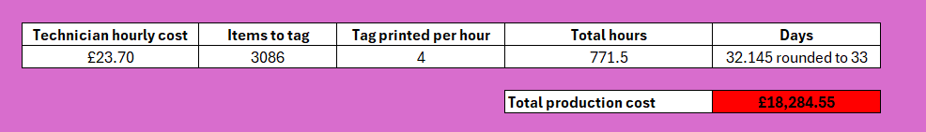
Figure 24 - Calculation to work out total labour cost for project creation not implementation

This total cost excluding material also creating a backlog in work from a dedicated technician being taken away form planned preventative maintenance. With my experience in industry the technicians would be asked to work overtime to reduce the backlog and the overall cost will skyrocket.
My decision would be to work closely with an external contractor and outsourcing the creating process allow tech time to code and fit tag system when working on dedicated equipment.

Conclusion.
Creating identification tags with RFID chips for industrial equipment using design for additive manufacturing principles, has allowed for a tailored and bespoke completed design suited to the specifications and needs of the company. It has in theory dramatically enhanced equipment tracking, maintenance and management. By incorporating the RFID technology, the id tags provide technicians with real time specific original equipment manufacturer documentation, equipment status, location and history. This would dramatically increase the operational efficiency of the technicians and supporting staff and engineers. Applying design for additive manufacturing principles ensures that the tags are designed to allow for optomisation being light weight, suited to environmental factors and material efficiency.
Using additive manufacturing, the RFID tags can be integrated seamlessly onto equipment parts or housing, reducing the need for additional fasteners or external attachments and not effecting OEM specification. This reduces production costs, improves durability, and minimizes interference with equipment operation. Furthermore, the customizability of 3D printing allows for the design of RFID housings that can withstand harsh industrial environments, protecting the chip while ensuring reliable signal transmission.

In conclusion, by combining RFID technology with DFAM principles, industrial ID tags can be produced in a way that enhances both functionality and manufacturability, resulting in cost-effective, durable, and efficient tracking solutions for industrial equipment management. This approach ultimately leads to better asset utilisation, reduced downtime, and streamlined operations.

Bibliography
Bandinelli, F. S. M. a. P. L., 2024. Effects of anisotropy and infill pattern on compression properties of 3D printed CFRP: mechanical analysis and elasto-plastic finite element modelling.. Rapid Prototyping Journal,, 1(30), pp. 142 - 158.
Bendsoe, M. a. S. O., 2013. Topology optimization: theory, methods, and applications.. 2nd ed. s.l.:Springer Science & Business Media..
Ennis, T., 2006. Experiences and issues in ATEX and DSEAR compliance. Hazards XIX: Process Safety and Environmental Protection:. what Do We Know? where are We Going?, -(-), p. 151.
Ezpeleta, I. J. D. B. U. a. Z. J., 2019. DFA method to improve the assembly during all the product development phases. Procedia CIRP, 25(1), pp. 673-679.
Marshall, M. D., 2017. https://immago.com. [Online]
Available at: https://immago.com/rfid-tags-how-why-should-be-using-them/
[Accessed 12th September 2024].
Meng, Z. a. L. Z., 2016. RFID tag as a sensor-a review on the innovative designs and applications.. Measurement science review, pp. 305 - 315.
Roylance, D., 2001. Roylance, D., 2001. Finite element analysis.. Finite element analysis. Department of Materials Science and Engineering, Massachusetts Institute of Technology.
Soon, T., 2008. QR Code. synthesis Journal, pp. 59-78.
Wiberg, A. P. J. a. Ö. J., 2019. Design for additive manufacturing–a review of available design methods and software.. Rapid Prototyping Journal, 25(6), pp. 1080-1094.

