UWTSD, BABM, LCBB4004, Assessment 2
Lecturer: Tushara Balendran
Student: Tonka Nikolova, 1914038, Term 2, Group 1

The role of marketing in creating value for customers and how stakeholders’ impact on the marketing activities of NESCAFE.

Content
Introduction………………………………………………………………………………………….3
Marketing and marketing concept…………………………………………………………………...3
Ansoff matrix………………………………………………………………………………………...6
Stakeholders…………………………………………………………………………………………10
Conclusion and recommendation…………………………………………………………………………………..…15
Reference list…………………………………………………………………………………………16

The role of marketing in creating value for customers and how stakeholders impact on the marketing activities of the organisation.
Introduction
Assess the development of marketing in creating value for customers.
In this essay, I will look at and make an analyst of the NESCAFE brand from the position of how the company's marketing adds value to its customers, and on the dribbling side I will look at the relationship between the company and the internal and external stakeholders by giving some examples to support the analyses presented. „Nescafe coffee is a drink that makes us all look forward to more of each day and that is the kind of impact a brand which is ‘here to stay’ makes on people.” (Indian Advertising Media & Marketing News – exchange4media, n.d.) “Mitra spoke about how a cup of Nescafe changes your mood from the very first sip, and that is the power of a brand that can drive passion among its users.” (Indian Advertising Media & Marketing News – exchange4media, n.d.)
Marketing and Marketing Concepts
Marketing is the activity, set of institutions and processes for creating, communicating, delivering and exchanging offerings that have value for customers, clients, partners, and society at large (American Marketing Association, n.d.).Marketing ad value to the consumers as informing and educated them. customer education is especially important for both parties: client, producer. Advertising of NESCAFE create a positive feeling and attitude of consumers to the brand, which leads to the purchase of the products.
Marketing concepts (Fig.1) can be defined as the marketing philosophies by which a firm's goal can be best achieved through identification and satisfaction of the customers' stated and unstated needs and wants (Essays, Research Papers and Articles on Business Management, 2019).
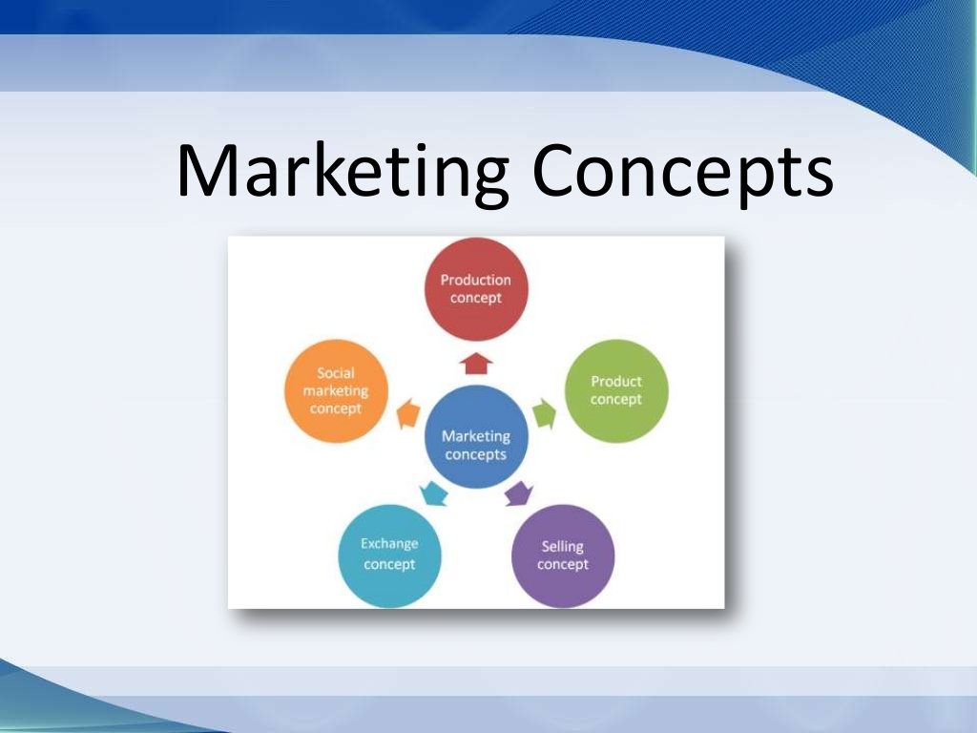
Fig.1 Source: https://www.slideshare.net/dankjohn/marketing-concepts-production-social-exchange-selling-product-and-holistic-marketing-concepts
The role of marketing to create value to the customers is to be informing and educating them. For clients with clearly defined needs, marketing provides a means of learning about new products and what they do. Marketing can also include more practical information to assist in making a purchase, such as addresses, phone numbers products release dates, store hours and Web addresses(https://www.nescafe.com/),( https://www.dolce-gusto.bg/),( https://www.nestle.com/brands/allbrands/nescafe). The way Nescafe educates its current and future users- customer education is especially important for both parties: client, producer. Their ads create a positive feeling and attitude of consumers to the brand, which leads to the purchase of the products.
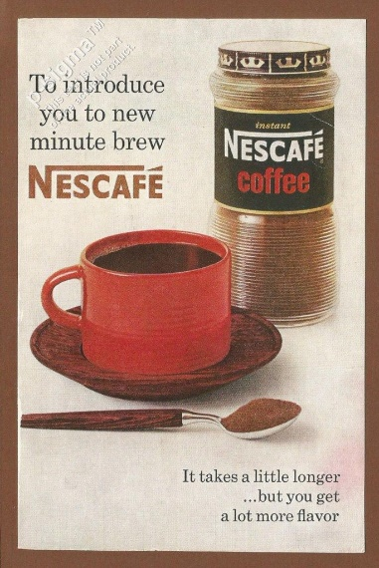
Source: https://www.ebay.com/itm/NESCAFE-coffee-1963-Vintage-Readers-Digest-Print-Ad-/112660163073
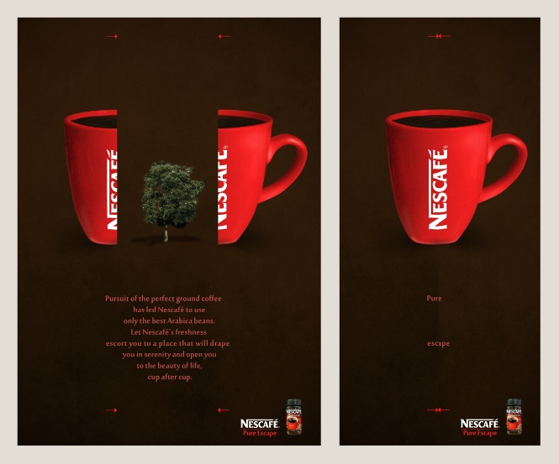
Source: http://2.bp.blogspot.com/-ZFqXxfAks7c/USONvqIe8II/AAAAAAAAAbM/5qKcUJL228U/s1600/nescafe_advertising_by_mrdinkleman-d3cnebs.jpg
The marketing concept rests on four pillars (www2.nau.edu, n.d):
Target Market. No company can operate in every market and serve every need. NESCAFE always strives to satisfy the needs of its customers. Its market targeting its consumers as give them instant and qualified coffee that stimulates body within a day. their rich assortment and different and autorotative packaging and sizes are able to satisfy even the most difficult requirements of their customers. Nescafe has covered all possible groups of customers, even thought about diabetics, people who consume coffee without sugar, without caffeine, etc.
Customer Needs. The marketing concept places the customer on top of every business. He is the pivot around which organisational activities revolve. Marketers should focus attention on customer needs and deliver desired satisfactions more effectively and more efficiently than competitors. Nescafe knows “Customers expect what they want, where they are, when they want it”. (Nestlé Professional, n.d.).And brand try successfully to satisfy their needs as for the convenience of its customers, the company has provided convenient access to its products through its distribution channels in order to make it even easier to shop for coffee lovers
Integrated Marketing. When all the company’s department’s work together to serve the customer’s interests, the result is integrated marketing. Integrated marketing takes on two levels. First, the various marketing functions-sales force, advertising, product management, marketing research, and so on – must work together. Second must be well coordi­nated with other company departments.
“Branding is the process of creating and disseminating a name, design or symbol that identifies and differentiates a company from its competitors. A good brand reflects the benefits of a product or service and builds recognition and loyalty in customers. However, branding is an expensive process and is difficult to undo if the company's direction changes”. ( https://bizfluent.com/info-8475523-advantages-disadvantages-branding.html) branding contributes customers designing a particular image that includes qualities and characteristics manufacturers and entrepreneurs want users to conceit their business, goods and services.(www.grin.com, n.d.)
As Nestle product Nescafe use Family Branding/Corporate Umbrella Branding- The company uses one brand name as the main identifier for the different variety of products produced.Branding can be created according goals and objectives of the company, its value, its promises, the positioning, The brand is identifying by its logo, a colour, advertising, communications, radio, magazines, mobile network etc.

Source: https://en.wikipedia.org/wiki/Nescafé#/media/File:Nescafé_logo.png
“In 2013 a Nestlé brand that started as an idea to solve the problem of what to do with unsold coffee celebrated its 75th anniversary and its position as one of the world’s favourite drinks” says Nestle in its website (Nestle.com, 2019). In the years since its inception, Nescafe has changed many types of packaging, created many different flavours and everything in order to be the most preferred and cause high demand and ever better quality. Also, in 2010 Nestle created a Nescafe plan to give agribusiness modern tools to improve quality and growth as well as protect the environment.” We have a responsibility to ensure great tasting coffee remains accessible to everyone today and in the future. The NESCAFÉ Plan is our global initiative positively impacting our coffee growing communities, whilst supporting farmers to produce sustainable coffee.” (Nestlé Professional, n.d.) Nescafe is the best coffee company. There are almost 170 different variants available worldwide. About 4,600 cups of Nescafe coffee are used every second in the world. Neskafe ranks 25th for the most used brands in the world.( https://www.forbes.com/companies/nescafe/#3f61d4b55854) Nescafe gives people great choices to drink coffee with energy and excellent taste. some other elements that contribute to the quality of the brand - the logo was created by a French advertising company and since nestle is a product of Nestle its name is made up of NESS/NESTLE and coffee.”It all starts with a NESCAFE” the brand lifts tonus and invigorates its clients. Through its ads, Nescafe creates value for its customers, as they have a wide and diverse range of customers belonging to different nationalities and cultural traditions. The company uses local agencies, with the help of which it complies with the requirements of its clients according to different regions and cultural traditions. In this way, he affirms his brand and reputation as a world leader, to meet the needs of its users.
Ansoff Matrix Nescafe:
’The Ansoff Matrix (Fig.2), also called the Product/Market Expansion Grid, is a tool used by firms to analyse and plan their strategies for growth. The matrix shows four strategies that can be used to help a firm grow and also analyzes the risk associated with each strategy. Learn more about business strategy in CFI’s Business Strategy Course.’ (Corporate Finance Institute, 2000).Тhe matrix was courted and implemented by H. Igor Ansoff-mathematician and businessman and published in the HBR, 1957.)
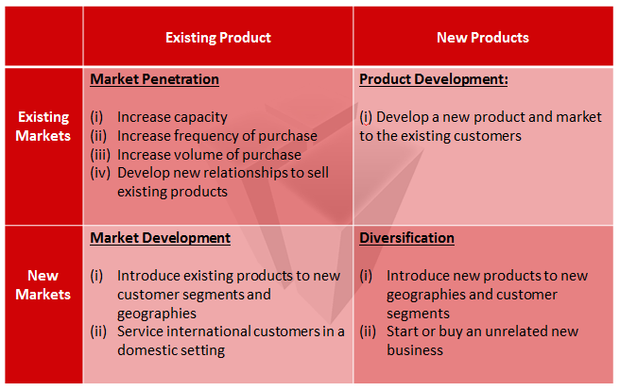
Fig.2 (Source: https://www.thepositiveeconomist.com/wp-content/uploads/2016/01/Ansoff_Matrix.png )

as a product of Nestle should be regarded as its division. In the case of Ansoff matrix is applicable to Nestle as a whole, but can still be noted typical of The Nessaffe applied.
Market penetration.
The priority objectives of NESCAFE strategy are to deliver high quality and sustainable products to its consumers. That’s how the company add value to its customers. For this purpose, the brand builds a strong brand equity using of aggressive promotions globally. Each region’s Nescafe create its own strategy to effectively educated its audience. is That’s why some variants are designed and marketed to satisfy to the needs of that particular segment of the market. It has been noted that that Nescafe as a brand is being an exclusive practical consumption product when it used to be only an instant coffee to turn more of a product with demand consumption when it started to create and sell different blends in different markets. All variants have their own specific characteristics to add value to the brand under the same name. The company aims at providing products to consumers wherever, whenever, and however is required.( https://www.ukessays.com/essays/marketing/the-global-promotion-strategies-of-nescafe-marketing-essay.php)
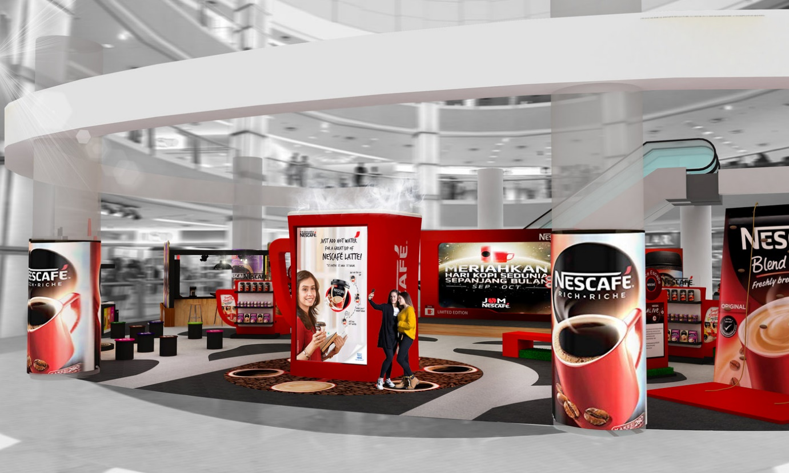
Source: https://s3images.coroflot.com/user_files/individual_files/large_471120_egnkxbs3lhcjvtxaezwd7tq5b.jpg
However, NESCAFE does not make compromises with the quality. Its products are guarantee a high standard, but the politic of the brand is to create relationship develop brand loyalty with the costumers. The direct distribution channels give easiest access to the consumers of the products.
Diversification.
NESCAFE follows the trend of new technologies and to put them into practice quite successfully.
Working in this direction NESTLE placed on the market coffee machines DOLCHE GUSTO specially designed by hardware specialists Arno, Krups and De'Longhi. That type of coffee machines are compatible with capsule system.
In the other side brand launch on the market Nescafe and Go Machine which is very compact and convenient for using of the customers. This coffee machine for businesses allows customers of NESCAFE to offer coffee and other hot drinks such as tea and hot chocolate even in small locations. Tats how the brand care for its clients to add value to them. NESCAFE is understanding the specialty of utilizing a client-driven approach to deal with their development as coffee gives new taste with modern packaging helps to meet the fluctuating requirements of them.
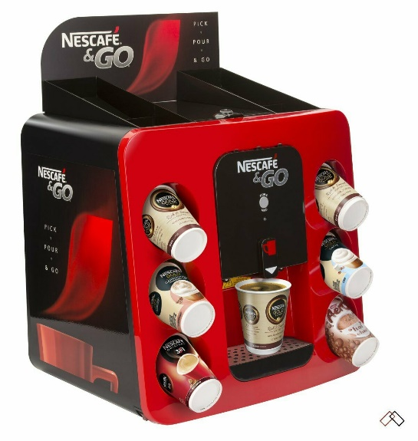
Source: https://www.ebay.co.uk/itm/Nescafe-and-Go-Machine/324237522860?hash=item4b7e0ff7ac:g:pLgAAOSweYhfGFFk

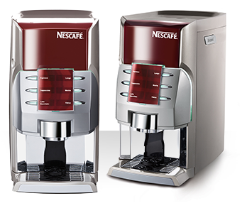
Source: https://aquaspresso.co.za/wp-content/uploads/2015/01/alegria-only1.png
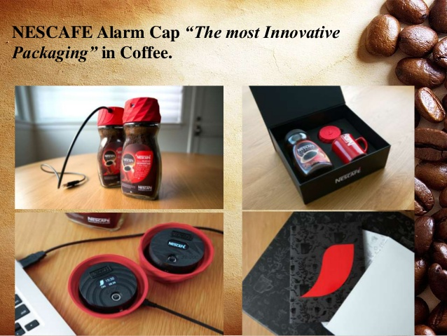
Source: https://image.slidesharecdn.com/nescafeclassicfinalppt-170715155109/95/nescafe-classic-brand-management-19-638.jpg?cb=1500133987
Relevant stakeholders and their impact on the marketing activities of the organisation.
Stakeholder (Fig.3)-a person such as an employee, customer, or citizen who is involved with an organization, society, etc. and therefore has responsibilities towards it and an interest in its success (https://dictionary.cambridge.org/dictionary/english/stakeholder)
Internal /External Stakeholders
Internal stakeholders are groups within a business or people who work directlywithin the business. Internal stakeholders include employees, board members, company owners, donors, and volunteers.
External stakeholders are groups outside a business or people who are not directly working within the business but are affected in some way from the decisions of the business, such as customers, suppliers, creditors, community, trade unions, and the government. ( hits:/ www.boundless.com/accounting/textbooks.boundle
-textbook/introduction-to-accounting- 1 /overview of-key-elements-of-the
business-19business:stakeholders-internal-and-external-117-6595/)
The role of internal/external stakeholders is especially important for each organization. (Fig.4)
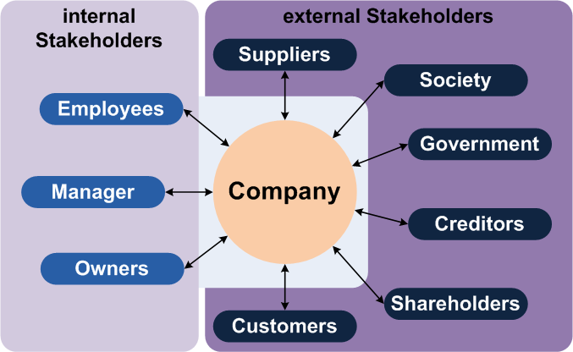
Fig.3 Source: https://courses.lumenlearning.com/boundless-accounting/chapter/overview-of-key-elements-of-the-business/
Now I will stop closer to NESCAFE internal stakeholders. As Nescafe is a division of Nestle and constitutes a separate unit of the company's hierarchical structure (Fig.5). Nestle is a division of Nestle and forms a separate unit of the hierarchical structure of the company, the Brand occupies a separate division of beverages. All groups of people involved in this chain are internal stakeholders. These are the employees(workers in the company for remuneration) who collect the coffee beans from the plantations, the paced, the quality-inspecting workers before transporting their ships to the stores with ovens machines, the operators of the baking machines, it takes years until they become baking experts.l who collect the coffee beans from the plantations, the paced, the quality-inspecting workers before transporting their ships to the ovens, the operators of the baking machines, it takes years until they become baking experts.(PBFY Flexible Packaging, 2016)
Internal stakeholders are managers, team leaders, supervisors, etc. Nestle has a BOARD OF DIRECTORS (control the company). EXECUTIVE BOARD, CHIEF EXECITIVE OFFICER: ZONE AMS(Americans) and ZONE AOA (Asia , Oceania and Sub-Saharan Africa),ZONE EMENA(EUROPE, MIIDDLE EAST, NORT AFRICA), CHIEF TECNOLOGY ,Strategic Business Unit, etc.
“Our Board is composed of highly-qualified leaders in business, technology, nutrition, fast-moving consumer goods and other relevant disciplines. Each Board member has proven experience, skills and current expertise aligned to our business goals. NESTLE said .(https://www.nestle.com/aboutus/management/boardofdirectors)It is really very important to be selected right ,educated and experienced person for each position.
“Engaging with stakeholders on important issues to tackle them together lies at the heart of how we do business. Even when we are making progress, we seek the advice of the best experts and advocates to develop and improve our corporate policies and commitments, strengthen our business and target our societal investments.” (www.nestle-cwa.com)
External stakeholders of NESTLE/NESCAFE. Suppliers (including farmers and smallholders) According to the Coffee Farmers Support Plan (2010), the company contributed to the beneficial development of the productivity and quality of Robusta coffee. Farmers passed on their experience to the next workers in the industry and by 2016 676 farmers had been trained. Here are some examples of Nestle's stakeholders:
Customers. We all know this sentence that customer is always right. Any company producing goods or services would not exist if there were no customers.to build love and trust of the consumers organization should keep strong relation between itself and its target customers . Providing products is just not enough, it's about building great ethical relationships to have excellent customer/brand communication. when asked its customers are satisfied with the goods on offer, the best way is to explore their opinion is via research using rating-based question and also through a section on the Website/contact NESCAFE there are several options to contact the customer by placing a question, a suggestion, if there is a complaint, and if there are positive sounds.( https://www.nescafe.com/gb/contact-us).Feedback from their customers shows that the company values and takes into account their opinion. feedback extracts information about future users and also improves quality and helps retain current customers, and mostly helps to make important organizational decisions (Startquestion, 2016)
Suppliers. The success of any organization lay on good relationship with suppliers and customers.” Each individual company sits in the middle of a chain of relationships formed with suppliers and customers, taking raw materials, products and services from one end, and adding value to generate profit out the other.” (Pay4, 2016) Сuppliers/organization are in a continuous relationship, so maintaining good relationships with each other is of paramount importance in order to ensure a quick resolution of problems encountered and find ways to improve, support their actions.” Did you know that we work with almost 165,000 direct suppliers and 695,000 individual farmers worldwide?
We’re committed to fostering responsible practices in our supply chain, while ensuring that our sourcing and supplier relationships deliver a competitive advantage.” NESTLE said in their website (https://www.nestle.com/aboutus/suppliers).The company has own “Nestlé Responsible Sourcing Standard”
As I mentioned above, NESCAFE has a plan(2010) to help farmers growing coffee. Collaborating with its partners help farmers with training them of how to manage their cost and business. Also, the company conducts pansful studies through special programs for new and improved coffee varieties of greater quality and yield for this purpose have a separate Plant Science department.
Competitors. The main competitors are Jacobs Douwe Egberts, Keurig.,Starbucks' Other important rivals are Starbucks, JM Smucker , Kraft Heinz (Maxwell House), Lavazza, Tchibo. To know and research its rivals is very important because that is help the company to understand its competitive advantage. However, building a communication plan to increase their advantages, to use their weaknesses as its capabilities. Nescafe wants to be sure that its products are better than their rivals. Brand print nutrition values and other health facts related to the products on the packet of the product. Company also provide contact number and mailing address for queries or any other facts.

Stakeholder and their Sources of Influence
Internal Stakeholders | External Stakeholders
- Hierarchy (formal power) e.g. authority, senior position | - Control of strategic resources e.g. materials, labour, money
- Influence (informal power) e.g. leadership style | - Involvement in strategy Implementation e.g. strategic partners in distribution channels
- Control of strategic resources e.g. responsibility for strategic products | - Possession of knowledge and skills e.g. cooperation partners, subcontractors
- Possession of knowledge and skills e.g. expert knowledge that forms the organisations core competence | - Through internal links e.g. networking
- Control of the environment e.g. negotiation & network of relationships to external stakeholders
- Involvement in strategy implementation e.g. as a change agent or responsibility for strategic projects

Fig.4 Source: https://www.tutor2u.net/business/blog/nestle-develops-the-coffee-market

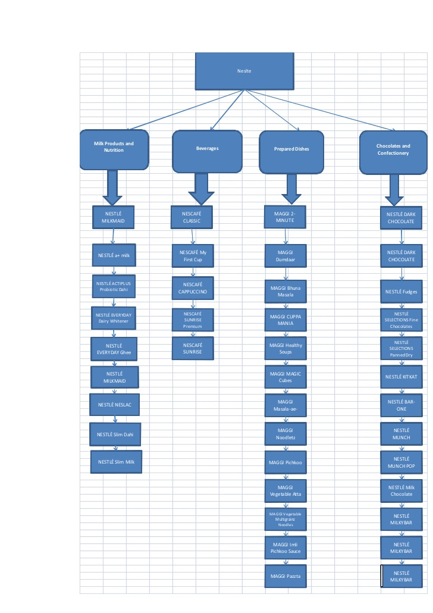
Fig.5 Source: https://image.slidesharecdn.com/theproducthierarchyofnestle-120404080444-phpapp02/95/the-product-hierarchy-of-nestle-5-728.jpg?cb=1333528924
Conclusion and recommendation.
In conclusion, the relationship marketing which company used help it to create strong valuable relation with its customers, based on the loyalty and trust. Nescafe is focused on long term customer engagement and its target is keep emotional connection with them. That is the way how NESCAFE marketing concept create value to its consumers. On the other hand, I drew attention to the importance and interaction between the organization and some of the major stakeholders - to show how it manages its business and what makes it so sustainable in the global marketplace.
Nessaffe could focus a little more on rural paradises with larger advertising and radio campaigns and more information about the benefits of drinking coffee to gain more trust and loyalty from their customers.They could expand and embrace more target groups, such as non-working hosts - as well as older people over 50.They could focus efforts on expanding the market in India. , this vast market by putting on their market coffee meeting Indian standards, e.g. decaf coffee. They could also reduce some of their prices because now , at this time of global crisis , this will increase the confidence of their customers. Also there are some problems with supplying and transportation, which is normal for such a huge company operating globally. For example, poor coordination of the quantities applied for and received, and sometimes inconsistencies with the requested number, and this corresponds to tension and stress. In order to avoid this problem, they could coordinate and anticipate the situation by directing more efforts or the creation of a tracking and response unit in time to keep the work going between the company and its suppliers .This will help to make an even stronger and stable connection between them.

References:
Ansoff, H. I. (1957). Strategies for Diversification. Harvard Business Review. (Vol. 35 Issue 5, Sep/Oct). p113-124.
American Marketing Association. (n.d.). Marketing Definitions Archives. [online] Available at: https://www.ama.org/topics/marketing-definition/ .
Corporate Finance Institute. (2000). Ansoff Matrix - Overview, Strategies and Practical Examples. [online] Available at: https://corporatefinanceinstitute.com/resources/knowledge/strategy/ansoff-matrix / .
CHERRY, K. (2011). Nescafé. A Marketing analysis. 2011th ed
DrHealthBenefits.com. (2018). What Are The Benefits of Drinking Nescafe That People Should Aware. [online] Available at: https://drhealthbenefits.com/food-bevarages/beverages/coffee/the-benefits-of-drinking-nescafe [Accessed 27 Aug. 2020].
Essays, Research Papers and Articles on Business Management. (2019). Marketing Concepts: 10+ Marketing Concepts. [online] Available at: https://www.businessmanagementideas.com/marketing/marketing-concepts/marketing-concepts-explained/18819 [Accessed 25 Aug. 2020].
Nestle.com. (2019). [online] Available at: https://www.nestle.com/aboutus/history/nestle-company-history/nescafe-75-years [Accessed 26 Aug. 2020].

Nestlé Professional. (n.d.). The future of coffee is in good hands. [online] Available at: https://www.nestleprofessional.com.au/training/future-coffee-good-hands [Accessed 28 Aug. 2020].
Nestlé Professional. (n.d.). Creating the Cup of Coffee That’s Right Up Their Street. [online] Available at: https://www.nestleprofessional.co.uk/news/insights/understanding-your-coffee-customers. [Accessed 28 Aug. 2020].

Indian Advertising Media & Marketing News – exchange4media. (n.d.). Nescafé, building the next generation of coffee lovers: Sunayan Mitra, VP - Marketing & Business Head - Exchange4media. [online] Available at: https://www.exchange4media.com/marketing-news/nescafe-building-the-next-generation-of-coffee-lovers-sunayan-mitra-vp-marketing-business-head-91152.html [Accessed 16 Aug. 2020].
from, D. (2019). What is relationship marketing? - Definition from WhatIs.com. [online] SearchCustomerExperience. Available at: https://searchcustomerexperience.techtarget.com/definition/relationship-marketing [Accessed 28 Aug. 2020].
Pay4. (2016). The importance of effective supplier relationship management. [online] Available at: https://www.pay4.com/supplier-relationship-management-important/#:~:text=But%20the%20supplier%20side%20is%20just%20as%20important [Accessed 30 Aug. 2020].
PBFY Flexible Packaging (2016). From Coffee Bean to Coffee Cup - Take a Coffee Journey with PBFY.com. YouTube. Available at: https://www.youtube.com/watch?v=6X-pErkPNhI&list=TLPQMjkwODIwMjAUFxRDV4ONFQ&index=2 [Accessed 30 Aug. 2020].
Schaefer Marketing Solutions: We Help Businesses {grow}. (2017). The 30 possible ways you can create customer value. [online] Available at: https://businessesgrow.com/2017/05/08/create-customer-value/ [Accessed 26 Aug. 2020].
Startquestion (2016). 7 Reasons Why Customer Feedback Is Important To Your Business. [online] The Official Startquestion Blog. Available at: https://blog.startquestion.com/7-reasons-why-customer-feedback-is-important-to-your-business-28e99c00eba7.
tutor2u(2020).Nescafe develops the coffee market. https://www.tutor2u.net/business/blog/nestle-develops-the-coffee-market [Accessed 25 Aug. 2020].
UKEssays.com. (n.d.). Stakeholders Mapping and Power/Interest Matrix. [online] Available at: https://www.ukessays.com/essays/education/stakeholders-into-primary-and-secondary.php [Accessed 30 Aug. 2020].
www.nescafe.com. (n.d.). Grown Respectfully | UK & IE. [online] Available at: https://www.nescafe.com/gb/grown-respectfully [Accessed 28 Aug. 2020].
www.grin.com. (n.d.). GRIN - Nescafé. A Marketing analysis. [online] Available at: https://www.grin.com/document/271463#:~:text=Nestle%20Nescafe%20has%20been%20able%20to%20satisfy%20its [Accessed 30 Aug. 2020].
www2.nau.edu. (n.d.). THE MARKETING CONCEPT. [online] Available at: http://www2.nau.edu/~rgm/ha400/class/professional/concept/Article-Mkt-Con.html?fbclid=IwAR3AU908w8wKskLLx2mY5n8vzbhiyNWRY10Cu0sQ4X7-nYAlBcM6s8R_TjY.

