Programme: BA International Hotel Management
Module: Managing Hotel Administration
Module code: BMIH6004
Assignment Title: Student Learning Log
Lecturer Name: Neil Dyer
Student Name: Hasna Jahan
Student ID: 2109022
Table of Contents
Introduction 1
A brief overview of the hotel’s administration operation 1
Learning objectives for the placement within the area 1
Reflection on Experience and critical analysis of situation and issues 2
Conclusion 4
References 6

Introduction
This portfolio aims to construct a reflective log of my experience managing hotel administration as a human resource manager at Clarion Hotel. It will demonstrate the work base, technical skill, and knowledge required for hotel administration within the HRM department, critically analysing problems faced by the HRM department in the uses like managing performance, managing people, and producing effective teamwork.
As a learner of this module, I engaged in a work placement within Clarion Hotel in the UK as the placement is a part of the module “Hotel Placement – Managing Hotel Administration”. Placement means improving practical knowledge and skills of working within a real-life business organisation by getting the opportunity to perform job roles and responsibilities within any organization for a specific timeline (Casao, 2012). So, I got placed within Clarion Hotel to perform the role and responsibility of a Human Resources Manager in the HRM department of Clarion Hotel.

A brief overview of the hotel’s administration operation
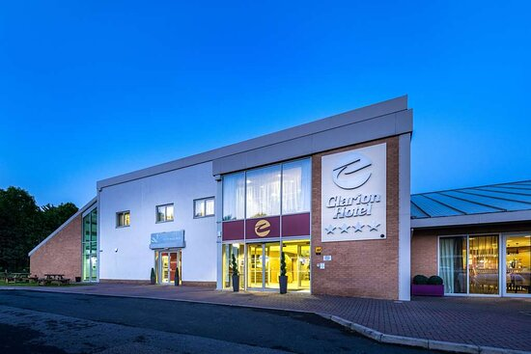
Figure 01: Clarion Hotel.
Source: (Hotelmix.co.uk, 2024).
Clarion Hotel is a British hotel chain. Founded in 1961, it has more than 279 hotels and operates in around 40 international markets (Hotelmix.co.uk, 2024). The hotel's administrative operation renders high-level service to the guests through effective operation management to stimulate business profit (Franchisehelp.com, 2024). Clarion Hotel administration operation manages employee and client records, manages office and facility equipment, oversees day-to-day activities for effective operation and guarantees a high level of guest service, tracks the progress of revenue, employee engagement, and management, staffing, resource deployment, technology utilisation, and meeting guest expectations (Tewan, 2009).

Learning objectives for the placement within the area
- To develop the skill of people management, including accusing, onboarding, developing, and motivating employees.
- To understand the workplace issues associated with the role of an HR manager and explore specific work-based skills and technological knowledge for encountering the issues.
- To understand strengths and areas of improvement associated with administrative tasks for understanding relevant theories and models for reinforcing personal and professional development.

Reflection on Experience and critical analysis of situation and issues
This reflection will apply Gibbs's reflective cycle in terms of reflecting on the overall job placement experience as an HR manager in the Human resource department for managing the hotel administration at Clarion Hotel (Casao, 2012). It also reflects the feeling and understanding of the work-based skill and technical knowledge critically and analyses organisational issues encountered as an HR manager while managing hotel administration for making a future action plan for personal and professional development.

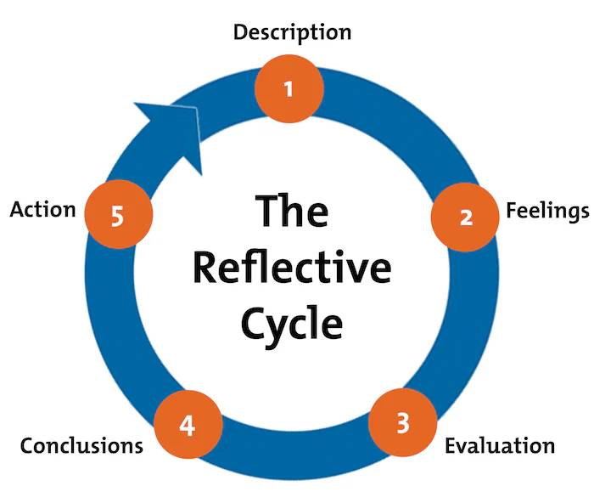
Figure 02: Gibbs Reflective Cycle.
Source: (Hagg, 2013).
Description: This section deals with describing the experience and personal development reflecting the experience. So, here, the experience of carrying out the role of HR manager in Clarion Hotel's human resources department will be explored (Fallon and Rutherford, 2010). For example, during the job placement at Clarion Hotel, I played the job role of Human Resource Manager, where I played the job role of conducting interviews after attracting target candidates through job descriptions and advertising, conflict resolution, developing workplace atmosphere, and improving policies. Also, recruiting new staff, giving skill development programs or training, formulating human resource policies and pragmas, motivating employees, and ensuring their quality performance to meet the guests’ expectations and demands (Tewan, 2009).
Feeling: Before the attainment of the module “managing hotel administration’ and the job placement experience, I did not understand the importance of the work- base and technical knowledge and skills for managing the guest service expectations as an HR manager. My previous industry experience and placement were not in the hospitality industry and not in such a supervisor role (Johnston, Clark, and Shulver, 2012). After attaining the module and experiencing the duty of an HR manager in Human resources, I immensely understood the significance of work-based skills like decision-making, communication, teamwork, leadership, organisation, and many more. That helped me to lead and motivate the employees to perform highly and meet the standard for managing the expectations of the guests with the customised and unique service offerings (QAA, 2018).
Evolution: This stage evaluates the effective and ineffective things that occurred during the situation or experience. For example, while working as an HR manager in the Clarion Hotel, I was able to attract mandatory talent by making the job decryption and placement and posting them in broadcasting and non-broadcasting mediums to reduce skill shortage (Rughubalan, 2009). So, I implemented the Two-Way communication model that helped me to communicate with departmental heads to ask for job vacancies and the skills and experience required to fill those vacancies (Tewan, 2009). I also took the interviews, trained, and educated to make employees able to do their job roles effectively. I also made different policies with changing times to meet employee expectations. For example, I inspired the departmental heads to implement Theory X and Theory Y where employees will get rewards for high productivity and will get penalties for their misbehaviour with guests and their colleagues (Vallen, Vallen, and Jerome, 2014). I applied a democratic leadership style while managing the team of the HRM department where I implemented a 360-degree feedback system that helped me to get the opinions of team members about the company policies and procedures and ideas to improve those policies and procedures which worked well (Zara, 2020). However, I also found that the employee's engagement and performance, although effective, failed to remain competitive during task administration (Tewan, 2009). The customer also demands digital services like consultancy and communication in social media, digital booking, and payment systems. So, I found their lack of technical knowledge and technological skill among the employees, which caused negative consequences in customer retention and a lack of competitiveness (Zara, 2020). This reduced the decline in performance and productivity, which made the business less competitive.
Analysis: Here, the analysis of the organisation’s available issues regarding the hotel administration operation is going to take place to identify their impact and suggest possible solutions (William, 2020). For instance, while managing the hotel administration, I found a lack of technological skill and knowledge among the employees, which affected their performance and productivity compared to the industry standard (Vallen, Vallen, and Jerome, 2014). So, I arranged a training program where the skilled employees practically showed unskilled employees how to effectively use technology to complete tasks quickly. I also found that employees have resistance to change; they ignore technological development and do not upgrade them due to their habits, fear of losing jobs, and fear of the unknown and unseen. As an HR manager, I implemented Lewin’s 3 Stages model of change which helped me to take insights from employees that helped me to solve the issues faced by employees to accept the digital transformation at the workplace (Wood, 2012).
Conclusion: The overall expire of my Job placement as an HR manager, I learned various work-based and technological knowledge and skills due to doing teamwork, communicating with professionals and employees, recruiting mandatory staff, analysing their performance, ensuring their growth, and keeping them motivated for performing high and meeting the guest demand and expectation (Zara, 2020). Nevertheless, I also found that I do not have better critical thinking and strategic management skills. I also need to keep myself updated with the digital transformation so that I can better lead and manage my teams and lead them by my example (Zara, 2020).
Action plan: In The experience I had as an HR manager regarding the administration operation in a hotel, I found I need to develop some of my work-based skills and technological knowledge in the future (William, 2020). For example, I have critical thinking skills, computer skills, data management, and analytical skills so that I have a clear understanding of the available skill gap between my subordinates and the digital medium I can use for education and skill development anytime, anywhere, saving time cost and effort (Tewan, 2009). It helps them manage their personal and professional lives and ensure professional growth as per industry standards.

Conclusion
The learning log identified for doing a supervisory job role in managing a hotel, like HR manager, work-based skills and technological knowledge are mandatory. But during work duty, various problems can arise, which can be resolved by using and developing proper work-based skills and technological knowledge in this present globalised and digitalised era.

References
ASET (2017). Good Practice Guide for Work-based and Placement Learning in Higher Education, ASET, Sheffield.
Bardi, J. (2010). Hotel Front Office Management, Wiley, London.
Casado, M. (2012). Housekeeping Management, Wiley, London.
Fallon, M. and Rutherford, D. (2010). Hotel Management and Operations, Wiley, London
Franchisehelp.com (2024). Clarion Hotel Franchise Cost & Opportunities 2024 | Franchise Help. www.franchisehelp.com. Available at: https://www.franchisehelp.com/franchises/clarion-hotel.
Hagg, E (2013). Internship Guide Eleven, The Hague.
Hotelmix.co.uk (2024). Hotel Clarion Hotel Park Avenue, New York, United States. Hotelmix.co.uk. Available at: https://clarion-hotel-park-avenue-new-york.hotelmix.co.uk/.
Johnston, R. Clark, G. Shulver, M. (2012). Service Operations Management, Pearson, London
QAA (2018). UK Quality Code, Advice and Guidance: Work-based Learning, QAA, London.
Rughubalan, G. (2009). Hotel Housekeeping: Operations and Management, Oxford Higher Education Press.
Tewan, J. (2009). Hotel Front Office: Operations and Management, Oxford Higher Ed Press.
Vallen, G.K. and Vallen, Jerome J. (2014). Check-in check-out: managing hotel operations. Ninth edition.; Pearson New International.
William, J. (2020). Introduction to Human Resource Management. 4th Ed. Kogan Page.
Wood, R. (2012). Key Concepts in Hospitality Management, Sage, London.
Zara (2020). Strategic human resource management: A role of the human resource manager in the process of strategy formation. Human Resource Management Review, 2(4), pp.299–315.

