Milena Petrova Valeva
Student Number: 1817469
MARKETING FUNDAMENTALS
MODULE CODE / LCBB4004
Marketing Fundamentals Analysis and Evaluation
Module Lecturer : Tushara Baladran

CONTENT

1.INTRODUCTION
2.THE MARKETING PROCESS AND THE ROLE OF THE MARKETING MIX
3.THE ROLE OF MARKETING IN CREATING VALUE FOR CONSUMERS
4.STAKEHOLDER ENGAGEMENT
5.REFLECTION ON TACTICAL COMMUNICATION TOOLS
6.CONCLUSION AND RECOMMENDATIONS
7.REFERENCES

1.Introduction
Lindt & Sprungli, also referred to as Lindt, is a Swiss-based chocolate and confectionary company. Based in Kilchberg, Lindt, founded in 1845, is world-renowned for its delicious, creamy chocolate, truffles and pralines that are a staple of festive seasons and celebrations (Annual Report). It is the no.1 premium chocolate maker in the world and 6th in the world. The global chocolate confectionary market is projected to grow by a CAGR of 4.2% from its current market size of US$139billion as of 2019, to $187billion by 2026 (Statista 2019). This paper looks at Lindt and its current challenges, opportunities and the role of marketing in its strategy.

2. The marketing process and the role of the marketing MIX
Marketing and the marketing process
Marketing has many definitions. Blythe (2014) for instance defined it as the engagement of customers and management of profitable customer relationships through value creation and exchange. Ferrell and Hartline (2011, p.8) defined it as the organizational function and set of processes used to create, communicate and deliver customer value and manage customer relationships in a way that benefits an organization and its stakeholders. Both definitions emphasize value creation, customer engagement and relationship building as being central to understanding what marketing is.
A broad way to understand how firms create, communicate and deliver customer value and manage customer relationships is illustrated in the figure below which demonstrates the marketing process.
Figure 1: The Marketing Process: Creating and Capturing Customer Value
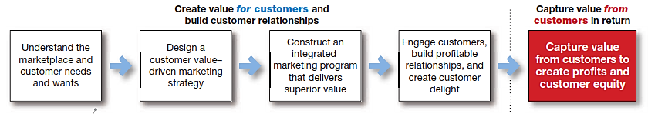
Kotler and Armstrong (2017) argued that the concept of the marketing process is a way to show the various steps organizations create and capture customer value. They categorised the marketing process into five stages as shown in figure 1above.
- The first stage is to first understand the marketplace and customer needs, wants and demands. Once market place needs are identified, a value-driven marketing strategy is then designed, outlining how to create value to meet those customer needs.
- The next phase is developing an integrated marketing program which consists of the marketing mix, that communicates and delivers the intended value to target customers.
- These three steps all lead up to the fourth and most vital step; engaging and building profitable customer relationships through customer relationship management.
- The last step in the marketing process is capturing value from customers in form of sales, market share or profits (Kotler and Armstrong 2017).
STP Model of Lindt
One way of identifying customer needs, wants and characteristics and creating value to serve them efficiently is to segment them. A common marketing framework used in segmentation is the STP model, which stands for segmentation, targeting and positioning.
Figure 2: The Segmentation, Targeting, and Positioning Model
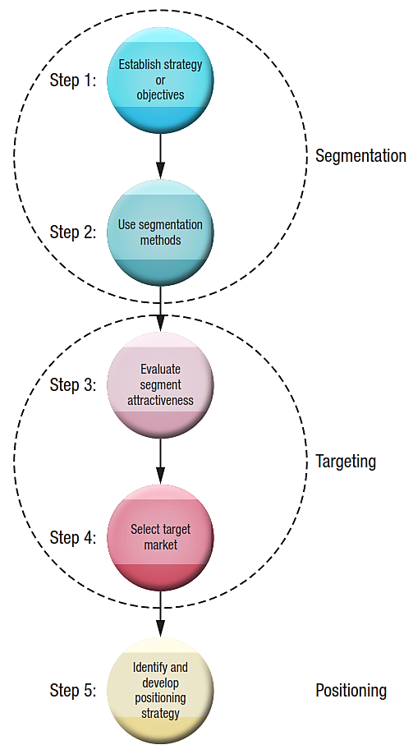
Source: Grewal and Levy (2016, p.171)

The following table shows the STP model of Lindt that identifies the needs, wants and characteristics of the various customer needs they serve.

Table 1: Lindt's STP Model
Segmentation type | Market segment served
Geography | Lindts key markets are segmented along 3 geographic markets; Europe, North America & Rest of world. Europe contributes 50% of sales, North America 40% and Rest of World 10%. | Primary segment
Psychographic | High achievers segmented along those who seek self-expression and are not afraid to indulge their tastes whatever the price. | Secondary segment
Demographics | Lindt segments its chocolate offerings along age (targets young consumers), income (targets affluent types with its premium positioning) and gender (females) | Primary segment
Benefits | Segmented along customers who seek to indulge in high quality confectionary beyond and above just utility. | Secondary segment
Behavioural | A crucial form of behavioural segmentation for Lindt is buying on occasion e.g. Christmas, Easter, Thanksgiving, Valentine’s day, birthdays & other festivals or gift giving occasions. | Primary segment
Targeting | Main target market is primarily composed of affluent consumers from its two biggest markets; Europe and North America, which together contribute 87% to group sales.
Positioning | Lindt has maintained its position as No. 1 in the premium segment, which is its core positioning in the global chocolate and confectionary industry.

The 4 Ps marketing mix strategies of Lindt
Once an organization has identified key segments for targeting with its value offer, the next step is to define the right marketing mix variables (4Ps) that will help consumers perceive its value offer as distinctive and unique compared to rivals’ offer (Grewal and Levy 2016). This is part of developing an integrated marketing program (which consists of the marketing mix), that communicates and delivers superior value to target customers.

Product
Lindt provides its customers with a range of premium chocolates manufactured from some of the highest quality ingredients, with great care, including hand detailing great taste and flair. The products are known for innovation, quality, and come with distinctive premium packaging. Its two bestselling global brands are; Excellence and Lindor.

Price
Organizations use price in the marketing mix as a strategic tool that ties in with the rest of corporate strategy. This means pricing strategy can be used to garner market share from competitors by either offering similar prices or lower prices (Kotler and Armstrong 2017). Lindt pursue a premium pricing strategy as a form of differentiation that highlights its market positioning and type of upscale customers it targets.

Place
Place refers to the activities of building extensive distribution networks that help deliver products and services to the end customer, expand sales locations and thus more revenue. For a physical product like Lindt, the chocolatier has placed the geographic markets of Europe and North America at the heart of its place marketing mix. It for instance runs more than 410 Lindt & Sprüngli owned retail shops worldwide, and 50 cafes across key markets as it battles for market share in competitive markets (Annual Report 2018). In 2018, it also opened new distribution centres in the US and Japan.

Promotion
Promotional efforts used by Lindt across the world include event sponsorship e. g. Lindt sponsors X Factor Italy, free sampling events through partners, food festival promotions, bunny hunt events, media promotions e.g. a TV commercial in France, TV shows, and social media campaigns. In North America, promotional effort included new marketing and distribution initiatives, such as selling through TV Shopping Channels.
Situational analysis of Lindt
Ferrell and Hartline (2011) define situation analysis as the overall process of collecting and interpreting internal, competitive, and environmental information- analysis focuses on the firm’s resources, strengths, and capabilities vis-a-vis competitive, customer, and environmental issues).
Mission statement of Lindt
To master chocolate making in order to deliver the ultimate quality and taste experience, creating the happiest chocolate lovers on the planet.
Company strategy, objectives
Corporate strategy helps an organization understand which industry and market it can best compete in (Grant 2016). Corporate strategy aids in decision making, helping an organization define how it can generate revenue by bringing together firm resources such as production, HRM, finance, or marketing to realise business goals and objective. The corporate strategy of Lindt is threefold currently; marketing excellence, increasing organic sales and drive operating efficiency (Lindt & Sprüngli 2017; Annual Report 2018).
These three are further subdivided into both short and long-term objectives to achieve including;
- Strengthening brand distinctiveness
- A focus on innovation
- Expansion of store networks and franchises
- Exploitation of new market opportunities
- Exploit ecommerce growth channels
- Increase supply chain integration to achieve cost efficiencies

Macro environment (PESTLE)
The global chocolate confectionary market is projected to grow by a CAGR of 4.2% from its current market size of US$139billion as of 2019, to $187billion by 2026 (Statista 2019). Despite this, average annual sales growth rate is forecast to decline (see figure below) due to a challenging international market environment that has impacted the industry.
Figure 3: Growth stalls in the global chocolate market
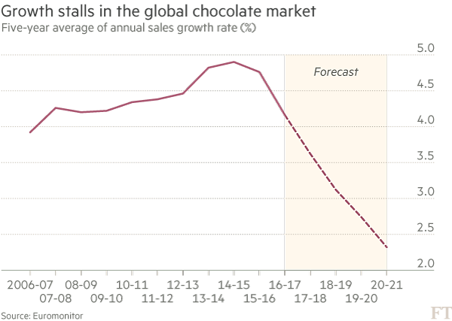
Source: Atkins 2017

Political environment
Lindt has already stated that a hard Brexit will negatively impact it and the entire chocolate confectionary industry by increasing production prices, supply chain interruptions and shortages (Selwood et al, 2019).

Economic environment
A new coca pricing method designed to alleviate poverty among farmers from Ghana and Ivory Coast, led to a sustained rise in cocoa prices since the beginning of 2018, an unfavorable trend that continues to hurt chocolate firms like Lindt (Wallace 2019). This was worsened by record market prices for vanilla due to poor crop yields (Annual Report 2018).
Nevertheless, strong growth in emerging markets such as India and China a favorable trend.

Social environment
The continued premiumization of food and drink continues to present opportunities for growth. Affluent and health conscious consumers are increasingly turning to premium chocolates that are handmade, organic or with added exotic flavorings, favorable news for premium brands like Lindt (Atkins 2017; Euromonitor 2019).
This is part of the mega trend towards healthier eating habits, driven by rising obesity and negativity surrounding salt, sugar and artificial additives. Nevertheless, firms marketing healthier chocolate options especially dark chocolate and sugar free options are seeing favorable growth (Gordon 2017).
Favorable country-of-origin branding that associates quality chocolate with Switzerland given chocolate is part of Switzerland’s reputation for good living gives Lindt a branding platform to expand to other markets (Atkins 2017).

Legal environment
The proliferation of sugar taxes and levies by governments fighting across the world in mature markets including Ireland, UK, and USA is a negative trend because it impacts chocolate companies’ revenue and profits.

Technological environment
New technological breakthroughs are also helping firms in the confectionary industry to reduce sugar in their products. Nestle came up with an innovative technique that allows it to reduce the amount of sugar in its chocolate bars by 40%, an innovation that allows reformulation of chocolates and biscuits with less sugar (Nestle 2018).

Environmental factors
With research showing it takes at least 1000 litres of water to manufacture a single bar of chocolate, firms like Lindt are under pressure to become more sustainable in their supply chain, an unfavourable trend.
Micro environment (Porters 5 forces)

Threat of entry (high)
The barriers to entry in the global chocolate industry are low due to low product differentiation and common access to commodity ingredients such as milk, cocoa etc

Threat of substitutes (high)
Substitutes to chocolate include snacks such as biscuits, energy bars, yoghurt etc. The increased focus on health and wellbeing is leading to a shift in power to healthier substitutes

Bargaining power of buyers (high)
Bargaining power of chocolates customers due to intense competition and availability of numerous substitute snacks

Bargaining power of suppliers (low)
Major suppliers include cocoa farmers in West Africa and dairy farmers, all with low bargaining power.

Competitive rivalry
The global chocolate industry leans towards being an oligopoly since the top 5-6 command more than 50% market share as shown below. Its very competitive with market share gains often coming at the expense of rivals.
Figure 5: Global market shares 2016-2017
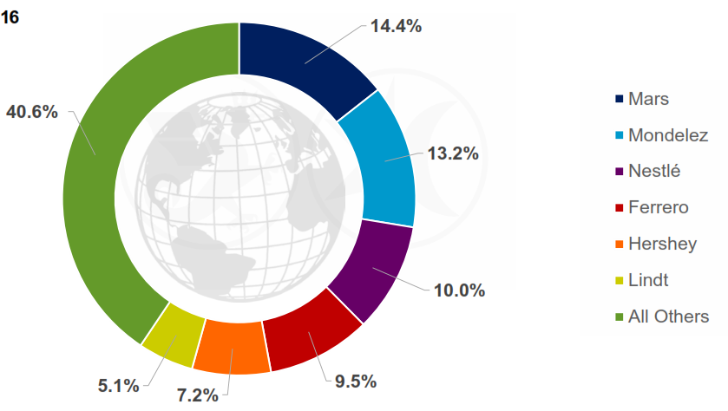
Source: Lindt & Sprüngli (2017)

Advantages and disadvantages of either pestle, porters or swot
Some of the advantages of the Pestle framework include ability to help organizations identify future opportunities and threats in the business environment likely to impact them, helping businesses plan better to mitigate risks or take advantage of opportunity. On the other, its disadvantages include oversimplification, relying often on assumptions. Today’s constantly changing environment makes forecasting trends using Pestle harder, a problem for organizations that rely on such frameworks for forecasting. According to Rastogi and Trivedi (2016), the framework should only be used in conjunction with other strategy tools such as SWOT if it’s to be effective.

3.The role of marketing in creating value for consumers
The societal marketing concept refers to the argument that business should take into account the needs, wants and desires of both their immediate customers but also the welfare, needs and interests of broader society and stakeholders such as employees, local communities and the environment. It’s a concept that’s akin to sustainable marketing in that both seek greater social, ethical and ecological responsibility from marketing beyond simply profit maximisation (Abratt and Sacks 1989).
As part of its branding and marketing, Lindt unapologetically sees its chocolates as indulgences, and does not even pretend they are healthy for its consumers (Atkins 2017). This contravenes the core principle of societal marketing of offering a pleasing product that brings about short-term satisfaction but ultimately may be contributing to rising obesity and health related issues across the western world, in other words causing harm to society in the long run.
The company’s chocolates are also not Fairtrade, meaning it makes profits at the expense of unfair unethical sourcing practices that disadvantage poor farmers. While the company is part of an effort to try and implement fair farmer remuneration practices as part of its Lindt & Sprüngli Farming Program, it still falls short since smallholder farmers in West Africa (where 80% of its cocoa is sourced), are still paid lowly (Pipitone 2018)
Branding strategy of Lindt
Branding can be defined as the manufacture of meaning, a process involving the creation of distinctive identities for products and services that consumers can recognize (Low and Fullerton 1994). In other words, branding is the link between a firm’s marketing efforts and the perception of its customers.
Advantages of good branding are many. Firstly, it can lead to creation of strong brand identity and equity, an intangible but potent asset that translates into customer loyalty, support, goodwill and favourable image in the marketplace (Holt 2006). The reputation and goodwill of an established brand on its be worth billions, an intangible but durable asset that consumers look up to as a mark of standard quality and service (Low and Fullerton 1994; Holt 2006). Brand building offers compelling reasons for consumers to buy products, a potent form of differentiation that allows firms to escape ‘commodity hell’, charge higher prices and increase margins (Ferrell and Hartline 2011). For consumers, branding eases the task of quality control for those firms whose brand image and values are positive.
Lindt’s core branding strategy is premium chocolates- seeing its chocolates as indulgences, rather than pretending they are healthy (Atkins 2017). The packaging and pricing of both chocolates also reflects this branding strategy. Lindor truffles for instance come wrapped in luxury packaging, are designed with many hand details and are priced highly to reflect a premium branding strategy as shown in fig below;
Table 2: Lindt branding strategy
Segmentation basis | Occasion | Health | Indulgence
Brand name | Lindt Gold Bunny   £3.8 | Excellence  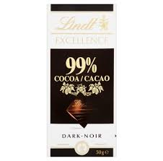  100g at £5 | Lindor truffles  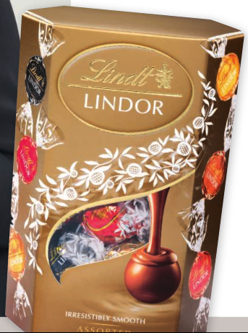  200g at £9.50
Brand values communicated | Only the highest-quality ingredients such as cocoa beans, premium packaging, constant innovation in product development & brand consistency. | Dark chocolate, highest concentration of cacao, healthy option, lower sugar content. | Sophistication, style & high quality e.g. packaging, detailed chocolate appearance with handmade texture, scented aroma, unapologetic indulgence.
Competitors | Ferrero Rocher Bunny    Pack at £3.8 | Ferrero Rondnoir  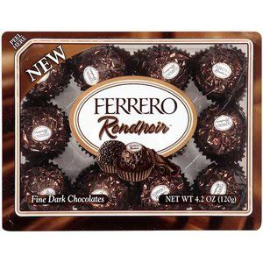  120g pack at £8 | 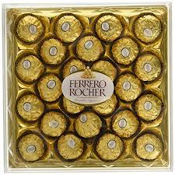  300g pack at £12.40
Positioning | Premium | Ultra-premium | Premium
Points of differentiation | Synonymous with Easter, celebrations and other festive occasions | Packaging, healthiest option, 70-90% dark cacao | Packaging, best taste, flavours and scents, exquisite hand detailing

Ansoff’s Matrix of Lindt
New Products
Existing Products
New Markets
Existing Markets

Product development- Lindt boasts more than 9,000 registered brands across 170 countries (Annual Report 2018). From an Ansoff’s matrix viewpoint, product development – which deals with creating new products for existing markets, 9,000 brands are enough value for existing markets.
Product diversification- Creating new products for new markets is expensive and is not necessary for Lindt whose core markets are already catered for by its vast current product portfolio. But with 500 R&D projects in the long-term pipeline around the world, Lindt wants to be well positioned to enter new markets with new products as core markets mature.
Market development- At the moment, Lindt is delivering more value to customers via market development geographically underdeveloped markets such as Japan, India and China where its already opening new chocolate cafes to boost distribution. From a demographic and product lifecycle standpoint, these markets offer new growth opportunities for Lindt.
Market penetration- This is about serving existing markets with existing products, a strategy Lindt that’s at the core of the company’s strategic focus on its two core markets in Europe and North America.
4. Stakeholder engagement
A stakeholder in business is anyone who can affect or be affected by its actions, objectives and policies. A business needs to recognise and engage with all stakeholders to ensure decisions have buy-in especially if they affect all stakeholders involved for good representation (Donaldson and Preston 1995). In essence, stakeholder theory rests on the premise that any business or project is an alliance of various interest groups where management’s role is to thus balance what is often conflicting interests.

External stakeholders | Communication
Customers | Communicates quality of ingredients used, image via packaging, price & brand values of sophistication, style & exclusiveness via advertising and company promotional efforts
Suppliers | Communicates quality margins & brand values via annual report & company memos
Stockists & distributors | Communicates quality margins & brand values via annual report & company memos
Farmers | Communicates collaboration and support in improving their welfare via foundation and trust activities
Internal stakeholders
Employees | Communicates teamwork, benefits, and brand values via annual report and internal communication
Shareholders & investors | Communicates stock prices, financial forecasts & company financial health indicators via annual report, board meetings and company presentations
Government | Communicates health and safety compliance, product quality and tax compliance via official filings

Stakeholder analysis: influence and importance matrix
External stakeholders | Importance to marketing (low=1, high=5) | Influence on marketing (low=1, high=5)
Customers | 5 | 5
Suppliers | 3 | 1
Stockists & distributors | 4 | 2
Farmers | 5 | 1
Internal stakeholders
Employees | 5 | 3
Shareholders & investors | 4 | 4
Government | 4 | 3

5. Reflection on tactical communication tools
Communication in marketing refers to the process of delivering a marketing message to a target audience using appropriate means and channels. Of more recent, organizations are incorporating Integrated Marketing Communication (IMC) defined as “a process which involves the management and organisation of all ‘agents’ in the analysis, planning, implementation and control of all marketing communications contacts, media, messages and promotional tools focused at selected target audiences in such a way as to derive the greatest enhancement and coherence of marketing communications effort in achieving predetermined product and corporate marketing communications objectives” (Pickton 2010).
There are many communication channels/models including advertising, sales promotions, digital marketing, personal sales, direct marketing, and public relations (Ferrell and Hartline 2011). The communication channels a company chooses to use will often be determined by various factors including the type of audience they are seeking to communicate to, chosen media reach, impact, as well as budgetary decisions (Hollensen 2011).
Figure 6: The IMC communication model
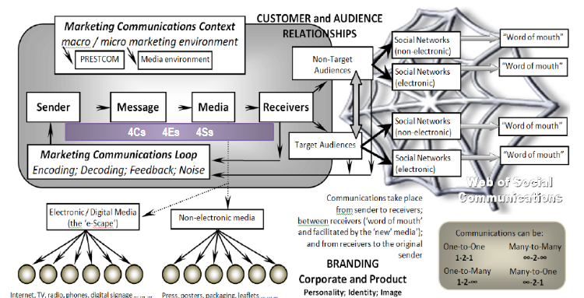
The main communication ways used by Lindt include
Broadcast media
This includes traditional advertising on TV, satellite etc
Social media and Press releases
Lindt publishes a lot of press releases and social media posts where it provides content to its followers on Facebook and Instagram about daily operations and whatever is going marketing wise that’s of interest. This includes posting contests and competitions for prizes.
Sponsorship and product placement
Sponsorship is whereby a company pays a fee to have its name associated with a particular event (e.g. World Cup), team or athletic association (Hollensen 2011). Lindt is the sponsor of X factor Italy. The main advantage of sponsorship is its ability to reach a global audience. While sponsorship is straightforward, product placement takes a more nuanced form often in the shape of brands or products being used in the context of a movie storyline, television shows or news programmes.

6.Conclusion & Recommendations
In conclusion, the marketing and situational analysis has shown that Lindt is currently faced with a number of challenges and risks it needs to mitigate if its to maintain market share and growth including unfavourable trends such as Brexit, growing sugar concerns, and market saturation in key markets. It needs to especially capitalise on opportunities like growing demand for healthier options to diversify its product portfolio by increasing the diversity of its healthier offer to already existing customers in core markets.
Crucially, Lindt needs to diversify away from mature core markets such as Europe and North America, on which it over-relies for almost 90% of its revenue. APAC nations especially present massive opportunities for growth due to fast urbanisation and middle-class growth.

7.References:
Abratt, Russell and Sacks, D. (1989) "Perceptions of the Societal Marketing Concept", European Journal of Marketing, 23(6), pp. 25–33
Annual Report (2018) “Lindt & Sprüngli: Annual Report 2018” [Online] at https://report.lindt-spruengli.com/18/ar/app/themes/lindtspruengli/dist/pdf/WEB_GB18_Gesamt_en.pdf
Atkins, Ralph (2017) “Swiss chocolate sees its magic melt” Financial Times [Online] at https://www.ft.com/content/1acfb746-1957-11e7-a53d-df09f373be87
Blythe, Jim. (2014), Principles and Practice of Marketing, 3rd edition, Sage
Clow, K., & Baack, D., (2013), Integrated Advertising, Promotion and Marketing Communications, 6th ed., Pearson Education
Donaldson, T &Preston, L. E (1995) “The stakeholder theory of the corporation: Concepts, evidence, and implications” Academy of Management Review, 20:65-91.
Euromonitor (2019) “Premiumization in Snacks” [Online] at https://go.euromonitor.com/event-content-packagedfood-2019-sweets_and_snacks_expo.html
Ferrell, O.C., & Hartline, M.D. (2011) “Marketing management strategies” 5th ed., Cengage Learning
Geraghty G., and Conway A.T. (2016) “The Study of Traditional and Non-traditional Marketing Communications: Target Marketing in the Events Sector” Paper presented at the 12th Annual Tourism and Hospitality Research in Ireland Conference, THRIC 2016, 16th and 17th June, Limerick Institute of Technology.
Grant, M. Robert (2016) “Contemporary Strategy Analysis: Text and cases edition” 9th ed., John Wiley & Sons.
Grewal, D., and Levy, M. (2016) “Marketing” 5th ed., McGraw-Hill.
Holt, D. (2006) “Toward a sociology of branding” Journal of Consumer Culture 6, pp. 299–302
Hollensen, Svend (2011). “Global Marketing: A Decision-Oriented Approach”, 5th ed., FT Prentice Hall
Kotler, P., Armstrong, G., Harris, L., & Piercy, N., (2017), Principles of Marketing, 17th Edition, Pearson Education.
Lindt & Sprüngli (2017) “Lindt & Sprüngli: Company Presentation” [Online] at https://www.lindt-spruengli.com/fileadmin/user_upload/corporate/user_upload/Investors/Presentations/Company_Presentation_2017.pdf
Low, G, and Fullerton, R. (1994), “Brands, Brand Management, and the Brand Manager System: A Critical-Historical Evaluation”, Journal of Marketing Research, Vol. 31 (May), pp. 173-190.
Nestle (2018) “Nestlé UK & Ireland cuts 2.6 billion teaspoons of sugar and more than 60 billion calories in just three years” [Online] at https://www.nestle.co.uk/en-gb/media/pressreleases/nestle-cuts-26-billion-teaspoons-of-sugar-and-more-than-60-billion-calories
Pickton, David (2010) “What is integrated marketing communications? Integrating ‘integrated marketing communications’ Research Gate [Online] at https://www.researchgate.net/publication/313361674_ What_is_integrated_marketing_communications_Integrating_'integrated_marketing_communications'3_Models_4Cs_4Es_4Ss_and_a_Profile
Pipitone, Laurent (2018) “Cocoa market still unethical, unfair despite 10 years of sustainability in the industry” Confectionary News [Online] at https://www.confectionerynews.com/Article/2018/11/13/Guest-article-Cocoa-market-still-unethical-unfair-despite-10-years-of-sustainability-in-the-industry
Rastogi, N. and Trivedi, M. (2016). PESTLE Technique – A Tool to Identify External Risks in Construction Projects. International Research Journal of Engineering and Technology, 03(01), pp.384-388. DOI: https://www.irjet.net/archives/V3/i1/IRJET-V3I165.pdf.
Selwood, D., Brown, N., & Weinbren, E. (2019) “The rise of dark, Brexit effects and the British chocolate boom: bumper confectionery category report 2019” The Grocer [Online] at https://www.thegrocer.co.uk/category-reports/the-rise-of-dark-brexit-effects-and-the-british-chocolate-boom-bumper-confectionery-category-report-2019/598003.article
Statista (2019) “Size of the chocolate confectionery market worldwide from 2017 to 2026” [Online] at https://www.statista.com/statistics/983554/global-chocolate-confectionery-market-size/
Wallace, Joe (2019) “New Cocoa-Pricing Method Makes for a Hot Commodity” Wall Street Journal [Online] at https://www.wsj.com/articles/west-african-poverty-alleviation-program-makes-cocoa-this-years-hot-commodity-11570622401

