

University of Wales Trinity Saint David
School of Engineering
BEng Manufacturing systems

DARRYL EVANS
1904051

GROUP PROJECT M5X00400
Group Project Assignment B

17/02/2020
Abstract
This assignment is a reflective essay about a problem that was encountered at my work.
The problem was with a dairy testing analysis instrument, which was first picked up in the final stages of quality control. What was not realised however, was that some instruments had already been shipped abroad and had been installed at the customers sites. This was when the problem escalated to corporate level and had to be resolved immediately to contain damage limitation.
This assignment looks back at how the issues were resolved. It shows how teamwork and good leadership skills, combined with the correct tools, contained the problem and eventually fixed it without damaging the company’s name or reputation.

Contents

Introduction 1
Overview of fault 2
Area layout 3
5s 3
Getting the team 4
Brainstorming 6
Smart Objectives 7
Clarifying the problem 8
Gantt chart 9
Leadership styles 10
Motivation 11
Critical Path Analysis 13
Root cause 14
Statistical Process Control 16
Reflective Thinking 17
Work Cited 18

Table of Figures

Fig. 1 Lactoscope Instrument 1
Fig. 2 Pump volume check 2
Fig. 3 Carry over test 2
Fig. 4 Lactoscope cell layout 3
Fig. 5 5S Examples 3
Fig. 6 The team chosen for the project 4
Fig. 7 Belbin team roles 5
Fig. 8 Fish diagram after brainstorming 6
Fig. 9 The smart objectives set out for the project. 7
Fig. 10 Clarifying the Problem 8
Fig. 11 Gantt chart for the timescale of the project 9
Fig. 12 Maslow Hierarchy 11
Fig. 13 Critical Path Analysis 13
Fig. 14 Breakdown of Inlet valve 14
Fig. 15 Pump manually tested and O ring split 14
Fig. 16 Swarf 15
Fig. 17 Cleaning the swarf 15
Fig. 18 SPC for Lactoscope 16
Fig. 19 Tuckman’s model...………………………………………………………………………………………………………………17

Introduction

I am an employee at PerkinElmer in the Llantrisant manufacturing site. PerkinElmer is an American owned worldwide corporation with 13000 employees.
PerkinElmer supplies instruments and services for the healthcare, pharmaceutical, environment and agricultural industries to enable scientists and researchers to look at issues affecting human health and the environment.
One of the analytical instruments manufactured in Llantrisant is a Lactoscope. The Lactoscope comes under the food section of the company. There is a Sales Inventory Operations Planning (SIOP) demand to produce eight of these instruments a week to be delivered straight to the customer.


Fig. 1 Lactoscope Instrument

Overview of fault

The Lactoscope primarily tests milk for its fat, protein and lactose content. To guarantee that every sample tested is not contaminated by the previous sample stringent tests and specs are used. When the pump is turned on to suck up a sample of milk it carries out 100 pump strokes and the spec for the amount pumped should be within 1% of 38ml for milk and within 1% of 35ml for cream.
Fig. 2 Pump volume check

If the pump is not set up correctly and the amount of liquid that is sucked up is not within specification, then the next sample will be out of limits as the correct amount will not have been taken. This is known as a carry over.
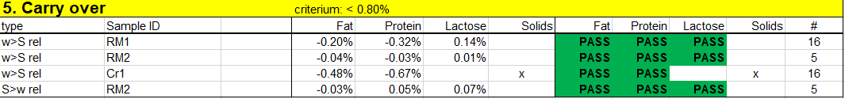
Fig. 3 Carry over test

It was discovered that a problem had occurred where the pump volumes have been adjusted correctly but the carry over was too high. Thus, resulting in instruments failing the final quality control testing and placing the Lactoscope instrument line on stop. This was a serious issue for Llantrisant and resulted in more staff attending the daily cell meetings which became more formal and minutes started to be taken.
The taking of minutes is essential for every important meeting. Those involved in the meeting will look back at the minutes for reminders of what was said and to look at the other attendees to determine any agreed tasks. Minutes can also act as traceability and can be checked and referred to when required in the future.
(Gutmann, 2016)

Area layout

The Lactoscope instrument is manufactured in Llantrisant and has its R&D department in the Netherlands. There are six dedicated technicians working on the Lactoscope cell. Sub-assemblies are manufactured in-house and are fed into the build area before they get the final quality control tests.
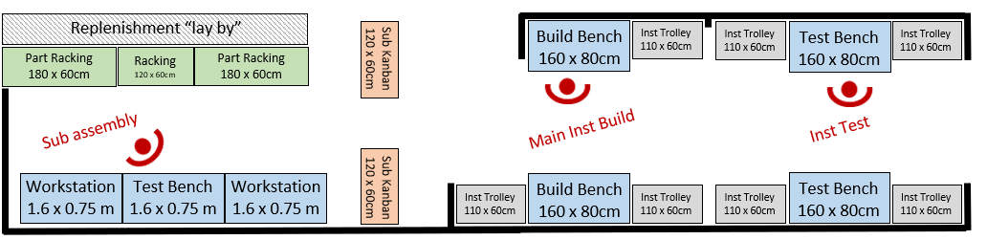
Fig. 4 Lactoscope cell layout

5s
The problem affected the outcome with targets not being met and this was highlighted on the many KPI boards that were present, not just on the manufacturing cell but the site itself. The team leader knew that the problem with production would increase the focus on the section so 5s was paramount to bringing order and organization.
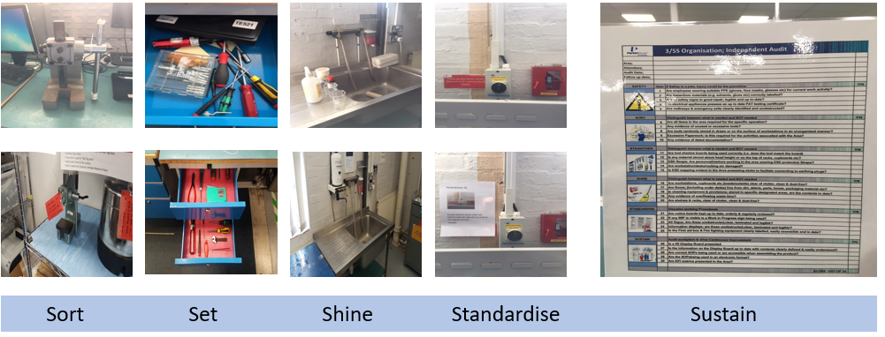
Fig. 5 5S Examples

5s is a tool used in six sigma which is invaluable for organising production areas. It helps people to do their tasks more safely with focus on productivity and quality attaining a higher standard.
(McFadden, 2020)

Getting the team

Working on a project can enables those in the team to reach their potential, which they may not be aware of. It allows team members to bounce new ideas off each other and to work on tasks which they may not have done before.
(Nieto-Rodriguez, 2019)

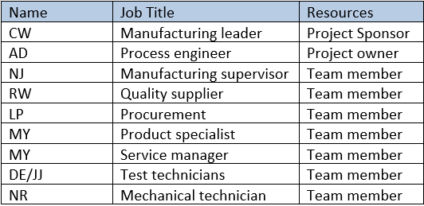

Fig. 6 The team chosen for the project

The Project Sponsor has the responsibility for keeping the project focussed and making sure the goals are achieved. The required resources and financial constraints are arranged with the project sponsor’s agreement with senior management.
(Young, 2016)
Although you are given the period of time for a project a start and an end date, what happens in that time is an unknown and this can be exciting and daunting before the project starts as you will be working with a team of people you have never worked with before.
(Nieto-Rodriguez, 2019)
The team members will inevitably look up to the Group Leader for advice and the feeling of belonging to the team. If the Team Leader sets a good example of honesty, then the team will move forward.
(Whitmore, 2009)
On this occasion, the team had been chosen for the project by the Senior Leadership Team and were a mixture of individuals from various departments. The team’s strengths and weakness would have been assessed to make sure the project team would be self-efficient and resolve problems amongst themselves.
Belbin’s theory shows that there are nine different ways people behave when working in a team. If all the types of behaviour characteristics are achieved it doesn’t matter how many members are in the team.
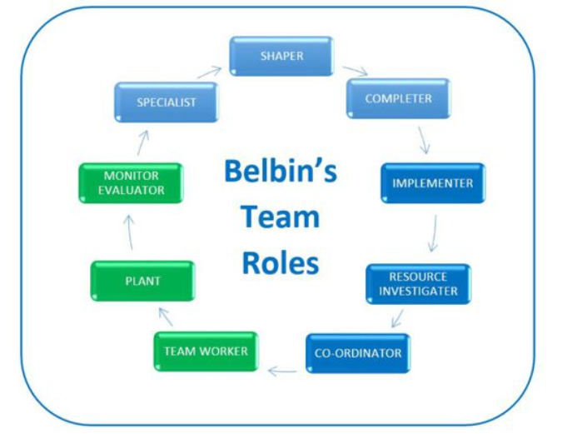
Fig. 7 Belbin team roles
(Candy, 2016)

Under Belbin’s theory, the team can be made up of the following roles and traits:
The Resource Investigator is outgoing and develops contacts but is known to lose interest and forget to follow up a lead.
Team Workers are co-operative and diplomatic but can be indecisive.
Co-ordinators are confident and clarify goals but are manipulative and over delegate.
Plants are creative and good problem solvers but could be absent minded.
Monitor Evaluators are strategic and judges accurately but lack drive and are critical.
Specialists are dedicated and single minded but will overload on information.
Shapers are dynamic and work well under pressure but can offend people and be aggressive.
Implementers are practical and organised but are slow to respond.
Completer Finishers are conscientious and perfectionists but tend to worry and don’t delegate.
(Belbin, 2010)

Brainstorming

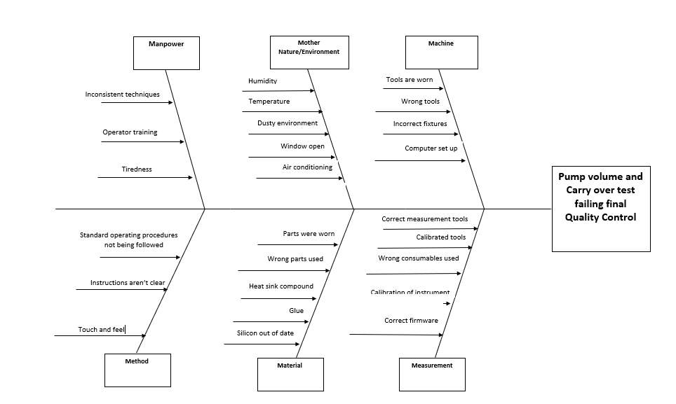

Fig. 8 Fish diagram after brainstorming
(Authors own, 2020)

Having brainstorming meetings with senior management and different department representatives was a new concept to the project team. The team leader wanted more employee involvement from the beginning to get the ideas from those close to the problem.
Management from companies get some of their employees committed to objectives and processes by employee involvement or employee participation. This gets the individuals involved with the projects and helps with any business decisions.
(Rayner & Adam-Smith, 2005)

Smart Objectives
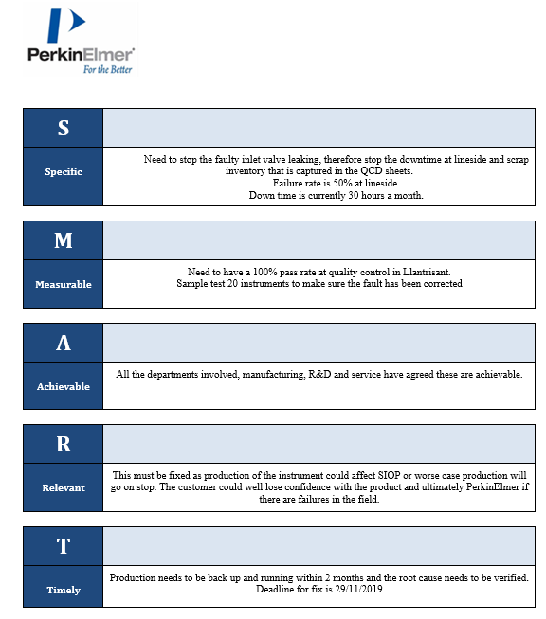

Fig. 9 The smart objectives set out for the project.
(Authors own, 2020)

Smart objectives are goals that are set to enable the team to focus and check the progress of the project. The goals are now easy to view and should be accomplished.
(Perrin, 2019)
The SMART objectives were then displayed on the Kanban board in the section.
The Kanban board is used as a graphical indication of what needs to be done at a glance to avoid any lengthy discussion. It also breaks down the work into progress into manageable tasks.
(Cole & Scotcher, 2016)

Clarifying the problem

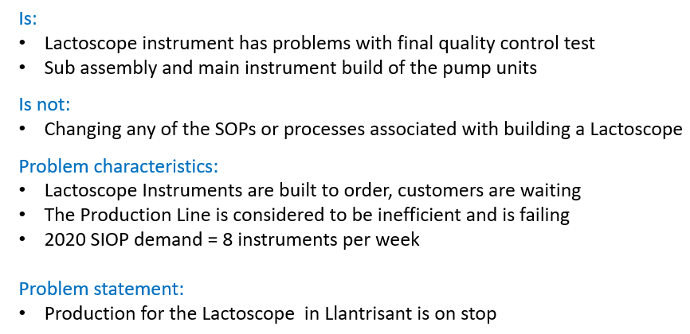
Fig. 10 Clarifying the Problem
(Authors own, 2020)

After the SMART objectives were set out and the problem was clarified the manufacturing leader called the team together and discussed the importance of time management for the project to be effective.
Time management is an essential trait for looking professional. It will encourage organisation and priority of work and stop any unnecessary tasks being undertaken.
(Mann, 2016)

Gantt chart

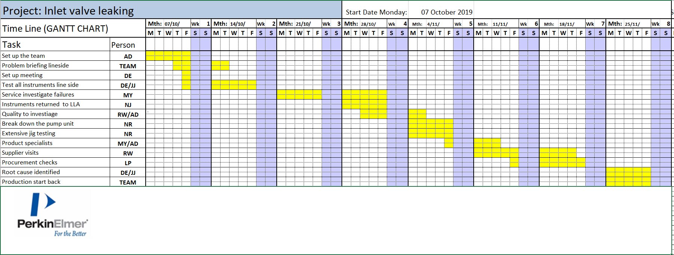
Fig. 11 Gantt chart for the timescale of the project
(Authors own, 2020)

Gantt charts are useful tools used in projects to easily show the course of the project. They help to visually communicate deadlines and show which departments carry out specific tasks and in which order they should be carried out for the maximum efficiency.
(Anderson, 2016)

Leadership styles

In a bid to resolve the problem there was a lot of involvement from the Llantrisant leadership team with leaders from all departments involved. The manufacturing team had their objectives, as did engineering and they often saw things from different angles. The quality team would also get their point across and this was usually at the expense of procurement and global purchasing. It was apparent from the start of the project that there were definitely different ways of communicating and leading or managing people. Being told what to do and not asked for their opinions made some members of the team not want to speak up or share information. In particular, the technicians in the team didn’t feel comfortable trying new ideas without being guided and the youngest member of the team took it very personally and became angry and would only work by himself which slowed tasks down.
However, the project owner could sense there were problems and was able to pull the team back together with team talks and praise for the team members that felt deflated. With a calming influence everyone was able to discuss the problems knowing that opinions did matter, and the team soon realised that different managers had different leadership styles.
There are many types of leadership styles. Some of the most successful leaders from all walks of life have had different styles to each other. There are four styles of leadership that can easily be related to the leaders who were involved in this project.
The manufacturing leader has the traits of a transactional leader, who doesn’t like change and is all for following rules and able to achieve short term goals.
(Jonathan, 2018)
The quality leader tended towards the transformational leader, someone who creates and shares a vision, inspires and encourages development.
(Rayner & Adam-Smith, 2005)
The continuous improvement leader was a democratic leader, someone who encourages everyone to share ideas and the team members feel committed and involved.
(Luenendonk, 2016)

The project owner was the adaptive leader, prepared to try different things for the results who has earned the teams respect through a culture of honesty.
(Gleeson, 2016)

Motivation

As the line had stopped production of finished instruments and complaints from the customer sites were being processed, morale in the department and the project team was at an all-time low. It felt as if there was no end to the problems. One thing that was apparent however, was that the longer the line wasn’t producing the visits from senior management were more frequent, adding to the stress of the team. The team leader always tried to pick the team up in the morning cell meetings. Any little milestone was often rewarded with a Reward and Recognition, these ranged from a breakfast token for the canteen, a meal out or just a mention in the senior management meetings. These small gestures showed how the team leader was focussed on the team and how he always provided support to motivate the team.
Human motivation is described by Maslow in his Hierarchy of needs theory. Maslow hierarchy is usually portrayed as pyramid.
(Cherry, 2019)
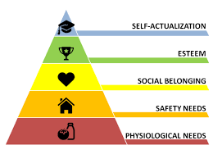
Fig. 12 Maslow Hierarchy

(Fremont, 2017)
The needs at the bottom of the pyramid should be satisfied before individuals try to attain the higher up needs
(McLeod, 2018)
- The Physiological needs are the needs that are vital for humans to survive. These include sleep, food and drink and clothing.
- The safety needs can also be described as security needs. People start to want to have control these needs can be getting employment to have a regular income and health care.
- The social needs are also known as emotional needs. These drive humans and are the needs to be loved or accepted. Family, friends and romance are important.
- The esteem needs are when individuals gain the respect from other people and know that they are valued. It is now that individuals are confident in themselves.
- The self-actualization needs are the highest of all the needs and are when humans are reaching their capabilities. People tend to be self-aware and focus on personal growth.
(Adair, 2016)

Critical Path Analysis
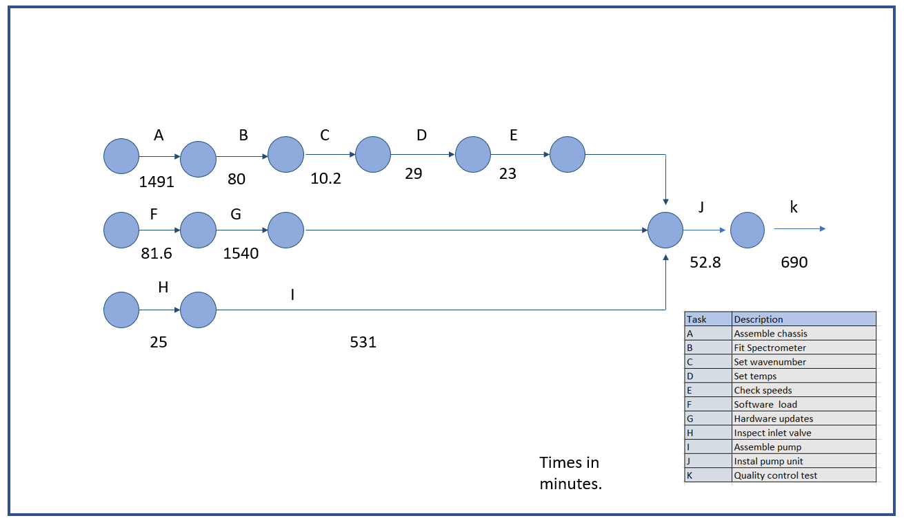
Fig. 13 Critical Path Analysis
(Authors own, 2020)

Although the focus from the team was to establish the fault, it was still necessary to keep the Lactoscope cell moving. The team used Critical Path Analysis to determine which activities if any, could be done that would help the backlog that was in front of us. The sub-assemblies and the main chassis were produced but the pump would be fitted at a later stage.
A Critical Path Analysis is a project management tool that visually shows all the activities in a process and which ones need to be carried out in a specific order to complete the project.
(Kenton, 2020)

Root cause

The team based in Llantrisant needed to use the expertise of R&D whose site was based in Holland. Luckily with technological advancements we didn’t have to rely on individuals travelling back and for. Skype was used and group discussions were set up through Microsoft teams. R&D were also able to remotely access the sites computers this saved a lot of time and electronic speeds and gains were ruled out. After extensive testing the team were able to isolate the fault to the inlet valve on the peristaltic pump, the mechanical biased team members then disassembled the inlet valve.

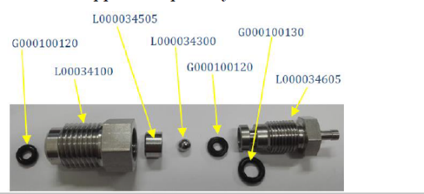
Fig. 14 Breakdown of Inlet valve

After the breakdown of 10 inlet valves from failed instruments, an ever so slight tear was found in the rubber washer.
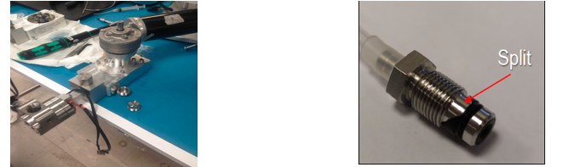
Fig. 15 Pump manually tested and O ring split

Procurement and quality had strong debates about the part being bought in from different suppliers and therefore not meeting the specification. The engineering and technical teams worked together and focussed on the pump itself and used an external measuring company.
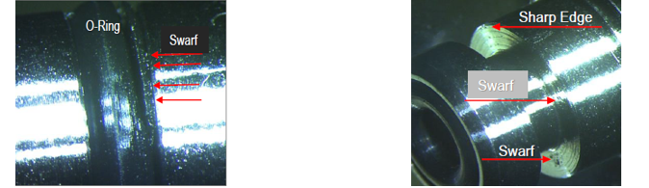
Fig. 16 Swarf
It was established that there was a lot of swarf on the recess of the inlet valve and over time this was tearing the inlet valves.

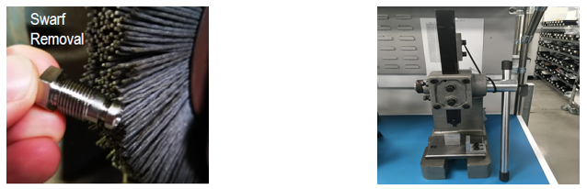
Fig. 17 Cleaning the swarf

Statistical Process Control

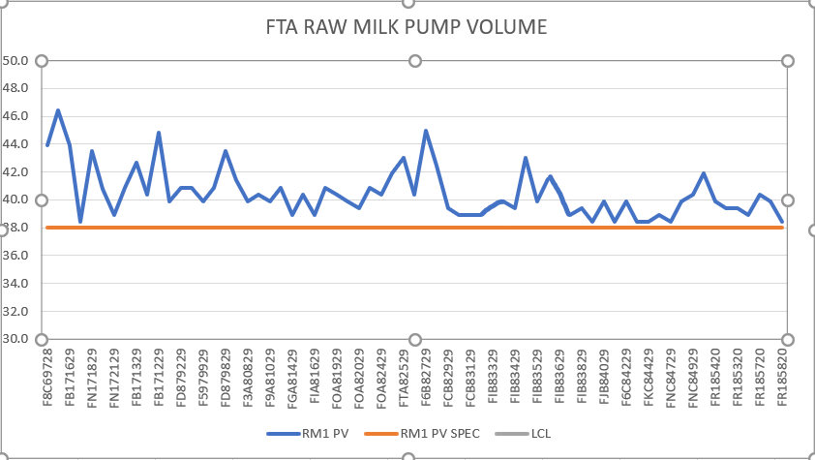
Fig. 18 SPC for Lactoscope

An extra test was added to the standard operational procedures, the data was then uploaded into an SPC chart to monitor if an instrument was out of specification.
Statistical Process Control is a tool used to measure and monitor a manufacturing method. The data is analysed, and control limits are set in place to monitor any variations.
(Berk & Berk, 2000)

Reflective Thinking

This group project was a massive learning curve both personally and professionally. In the company manufacturing technicians don’t normally get picked to be in project teams. I felt that this showed at the start as I lacked confidence to speak in meetings for fear of being shot down by senior members. It didn’t take me long to realise that my input was not only needed but was held in high regard, this was helped by the team leader making sure everyone was able to speak and put their points across.
During the lessons learnt with the project leader I was shown how my performance throughout compared to Tuckman’s theory. He also pointed out that the way the team worked was no different to other teams that he had experienced before.
(Tailor & Tailor, 2019)
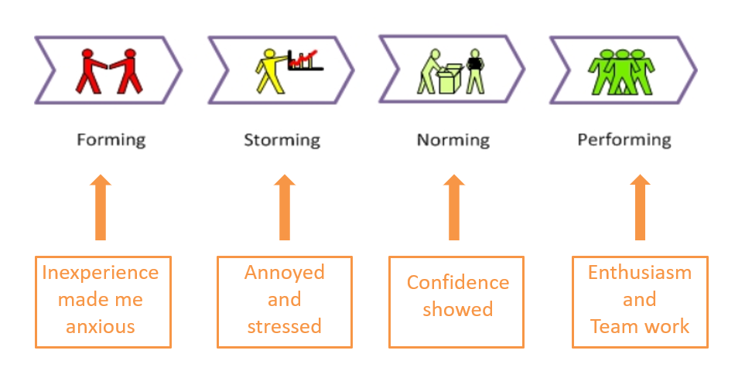
Fig. 19 Tuckman's model

(Tailor & Tailor, 2019)

Working closely with other departments helped me change my way of thinking. At first, I dismissed the project management tools that were being used, as a waste of time, but looking back it was my inexperience of using and understanding them. I now realise these are essential to leading a structured approach and to establish the exact objectives and criteria.

Time management was foremost in the project and the constant update of progress and comparing key milestones to the Gantt chart has shown the importance of using visual management tools.
I now look at the leaders who were involved in the project and compare them to what I researched on management styles to see which style they use. I don’t think the Transactional Leadership style worked for our project team as there was enough pressure already. Democratic Leadership style worked well as all individuals were asked for their points of views and this helped keep the teams morale up, I think it also helped the leader get a proper understanding of the whole project and which tasks everyone had to carry out.
The main conclusion that I have made from the group project was that the senior member doesn’t always make the best leader. The team leader heading our project took control and used great skills in motivating individuals as well as staying calm and taking criticism onboard whilst being under pressure from the leadership team.
I was unaware of how a team was chosen and which characteristics are needed, looking back and using Belbin’s theory I can see the importance of having the different character strengths to make the team successful and how some members could fit into more than one role. Since this experience, I have learnt so many new skills and now have the confidence to speak out and work with other departments and external suppliers that I will be putting myself forward for any further project work.

Work Cited

Adair, J., 2016. Effective Motivation. 2nd ed. London: Pan Books.
Anderson, B., 2016. successfulprojects. [Online]
Available at: https://successfulprojects.com.au/purpose-of-a-gantt-chart/
[Accessed 09 March 2020].
Belbin, M., 2010. Team roles at work. 2nd ed. London: Routledge.
Berk, J. & Berk, S., 2000. Quality Management for the Technology Sector. Oxford: Butterworth-Heinemann.
Candy, L., 2016. Belbin Team Roles. [Online]
Available at: https://www.educational-business-articles.com/belbin-team-roles/
[Accessed 23 March 2020].
Cherry, K., 2019. verywellmind. [Online]
Available at: https://www.verywellmind.com/what-is-maslows-hierarchy-of-needs-4136760
[Accessed 08 March 2020].
Cole, R. & Scotcher, E., 2016. Brilliant Agile Project Management. Harlow: Pearson.
Fremont, D., 2017. maslows-hierarchy-of-needs-for-software-developers. [Online]
Available at: https://damienfremont.com/2017/11/11/maslows-hierarchy-of-needs-for-software-developers/
[Accessed 04 March 2020].
Gleeson, B., 2016. Why Adaptive Leadership Is the Only Way to Get Results. [Online]
Available at: https://www.inc.com/brent-gleeson/why-adaptive-leadership-is-the-only-way-to-get-results.html
[Accessed 1 April 2020].
Gutmann, J., 2016. Taking minutes of meetings. 4th ed. London: Kogan Page.
Jonathan, S., 2018. Characteristics of Transactional Leaders. [Online]
Available at: https://careertrend.com/info-8083987-characteristics-transactional-leaders.html
[Accessed 1 April 2020].
Kenton, W., 2020. Critical Path Analysis (CPA). [Online]
Available at: https://www.investopedia.com/terms/c/critical-path-analysis.asp
[Accessed 18 March 2020].
Luenendonk, M., 2016. Democratic Leadership Guide. [Online]
Available at: https://www.cleverism.com/democratic-leadership-guide/
[Accessed 2020 April 2020].
Mann, S., 2016. Managing your boss in a week. London: Teach Yourself.
McFadden, B., 2020. Graphic product. [Online]
Available at: https://www.graphicproducts.com/articles/what-is-5s/
[Accessed 02 March 2020].
McLeod, S., 2018. simplypsychology. [Online]
Available at: https://www.simplypsychology.org/maslow.html
[Accessed 08 March 2020].
Nieto-Rodriguez, A., 2019. Lead Successful Projects. London: Penguin.
Perrin, M., 2019. The Importance of Setting SMART Goals. [Online]
Available at: https://www.hydratemarketing.com/blog/the-importance-of-setting-smart-goals
[Accessed 7 April 2020].
Rayner, C. & Adam-Smith, D., 2005. Managing and Leading People. London: Chartered Institute of Personnel Development.
Tailor, P. & Tailor, S., 2019. Group Formation Theory. [Online]
Available at: https://www.learnmanagement2.com/formingnormingstormingperformingbrucetuckman.html
[Accessed 1 May 2020].
Whitmore, J., 2009. Coaching for Performance. 4th ed. London: Nicholas Brealey.
Young, T. L., 2016. Successful Project Management. 5th ed. London: Kogan Page.

