University of Wales Trinity Saint David

Work-Based Group Project



BEng Group Project
Work-Based Group Project (ACDB5022)

Katie Byrne

2114211

2nd May 2024

Lecturer: Dave Holley

Contents
- Introduction
- Transport Safety
- Requirements
- Cratering Kits
- Existing Cratering Kits
- QFD
- QFD 1 Functional Importances
- Functional Means Analysis
- Feature Importances
- Control Factors
- Noise factors
- Non-electric Detonator & Auger Packaging
- Main Charge & Booster Packaging
- Transport Vehicle Land
- Transport Vehicle Air
- Transport Vehicle Sea
- Conclusion
- References

Introduction
The class was tasked to undertake the systems of engineering of the Demolition Rapid Crater Kit Mk2 which has been standard equipment for the Royal Engineers for many years. It has seen service across recent conflicts enabling forces to “dig in” a defensive position rapidly and safely. Research needed to be done to find existing processes that are currently used and how they could be made better. A list of customer requirements was given, and it was the groups job to come up with a new and improved design that met all of the customer requirements whilst the new design remained efficient and cost effective. Each team was split up into sections where each member was assigned a role. The roles ranged from Design, Manufacturing, Safety and Testing.
The roles we were put into include:
- Compare the performance of the new formulation with existing formulations.
- Obtain safety data.
- Propose a design for the cratering kit.
- Recommend a production route.
- Describe the Manufacturing to Disposal Sequence MTDS. Propose packaging.
- Propose a series of trials to prove the device meets the MTDS requirements.

The team first decided on a name and logo for the group before assigning duties and titles to each member in accordance with the questions posed in the brief. A team name of Explosive Solutions International (AESI) was established. Titles and functions that were assigned were:
- Research and Design Engineer
- Design Engineer
- Production and Manufacturer Lead
- Test and Evaluation Manager
- Safety Lead Engineer
- Transport Engineer
- Disposal Engineer

The role I took was transport Engineer which included obtaining transport and packaging data on the cratering kit. The group met up weekly to share background research. The reason for this is that if each member of the team did their own research into the available kits, it would give them a greater overall understanding of the subject that was outlined in the brief and ultimately help them comprehend their role to meet their individual requirements. This gives the group the best possible options with every individual opinion and coming to a mutual decision presented good teamwork. QFD’s, functional means analysis, feature importances, control factors and noise factors were done as a team getting each individual members opinion.

Transport Safety

Safety is very important when transporting explosives. There are a couple of key factors that are thought about while doing as such. These include guaranteeing that explosives are safely packaged in secure containers that are intended to endure transportation conditions is fundamental. This helps prevent accidental ignition or detonation. Following severe conventions for dealing with and it is essential when storing explosives. They ought to be stored far from start sources, heat, and contrary materials. Temperature control and adequate ventilation may also be required. Adhering to local, national, and international regulations regarding the transportation of explosives is a must. This includes obtaining the necessary permits, licenses, and certifications. Training and expertise is significant as only prepared work force ought to be engaged with the transportation of explosives. They should have a thorough understanding of safety procedures, emergency protocols, and the specific characteristics of the explosives being transported. Implementing robust security measures, such as vehicle tracking, tamper-evident seals, and background checks for personnel involved in transportation, helps prevent unauthorized access and potential theft. [1]

Requirements
The group met to discuss some of the most crucial requirements they wanted to fulfil for the new Crater Kit they were developing after roles and titles had been assigned. They recognized the Implicit Requirements are crucial for the plan. Understood implicit requirements are normally what are recently anticipated and don't require noting physically but these necessities must be followed all through the entire interaction. These included:
• Enhanced Safety
• Reduced Accidental Detonation
• Mission Flexibility
• Compliance with Regulations
• Operational Effectiveness
When the Implicit Requirements were settled the group recognized a few requirements that the client/client would need from the new planned Cavity Unit. As there is just one primary objective from the Cratering Pack. That implied that the key client necessities were generally to easy to meet. The customer requirements were:
• The Cratering Kit that the Cratering Kit is Insensitive Munition (IM) compliant
• The Cratering Kit must create a final crater diameter of anything larger than 4m and anything less than 10m
• The Cratering Kit must create a penetration depth of between 3m-7m deep

Cratering Kits
Military cratering kits are involved by the military to make explosive craters for multiple different purposes. These kits commonly incorporate explosives, detonators, and other fundamental instruments for controlled removal and destruction. They can be utilized to make obstructions, clear pathways, or disturb enemy infrastructure. The cratering kits are intended to give the military the capacity to rapidly and productively alter the landscape to suit their functional necessities. At last, they empower military units to make obstructions or modify landscape quickly in various operational scenarios.
Using cratering kits helps the military in more than one way. They give the military the capacity to adjust the landscape rapidly and decisively during activities. By making explosive craters, the military can make obstacles for enemy forces, block their developments, and disturb their framework. The army can adjust to changing battlefield conditions thanks to these kits, which make efficient excavation and demolition possible. In the end, the army's tactical capabilities are improved and their overall effectiveness in achieving their goals is increased by using crater kits. [2]
Furthermore, the production of craters can establish a dangerous and unpredictable climate for the enemy, making it harder for them to explore and organize their powers. Overall cratering units can be an integral asset in giving the military a high ground in battle circumstances. They can be used to make defensive positions, for example, trenches or barriers, that give cover to the military. These positions can be decisively positioned to improve the military's defence capacities and safeguard their forces. Cratering kits additionally take into consideration productive removal and destruction, empowering the military to adjust to changing circumstances on the war zone. This adaptability can be significant in powerful battle situations.
The explosive craters made by these kits would make the runways and framework inoperable, successfully impairing the airport and disturbing their air tasks. This would block the enemy's ability to convey airplane, transport supplies, and lead airborne attacks. It would likewise restrict their mobility and make it more difficult for them to answer rapidly to different circumstances. Thus, utilizing cratering kits on enemy air terminals can be an essential move to debilitate their air power and in general military capacities.

Existing Cratering Kits
There are various sorts of cratering kits available, and they come in various shapes and sizes. Crater kits come in a variety of forms and are used in many countries. These kits accompany the necessary devices in general and hardware to eventually make a hole in the ground to impede the enemy. They each accompany different dangerous arrangements as well as various method for detonation. The team’s research was firstly conducted with the reference of the 40lb Catering Charge used by the US Army.
- M112 Demolition Block packed with C-4 [4]
- M3 40lb Shaped Charge filled with Composition B (*)
- M19 Shock Tube Detonator lined with HMX
- 40lb Demolition Charge filled with Composition B (*)
- (Composition B is a mixture of RDX/TNT and a WAX) *

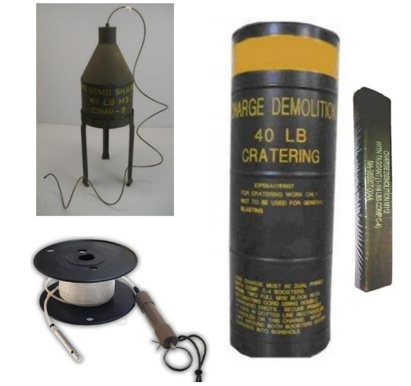

There then was some research done on NATO Rapid Crater Kit Mk 2. It was identified that within the kit NATO used:
- 2 x 15kg Hexagonal Charges filled with TNT/HMX
- 11kg MR50 Shaped Charge filled with RDX and TNT
- Primary Charge 28A filled with RDX
- M19 Shock Tube Detonator filled with HMX
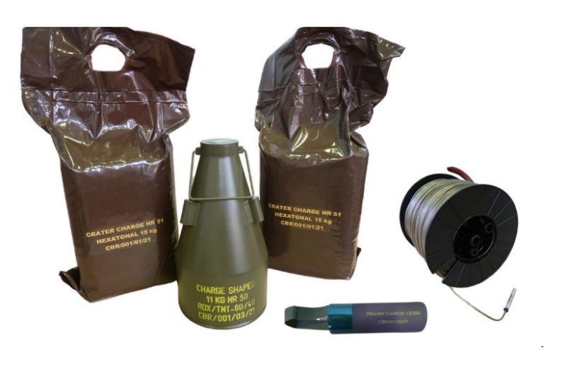

QFD
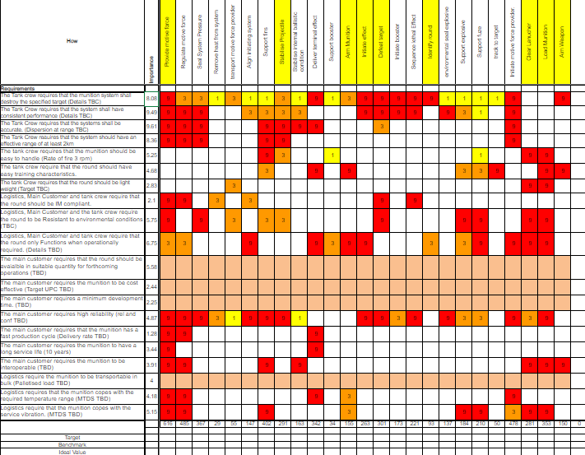
A QFD stands for Quality Function Deployment. It's a method used to translate customer requirements into design and production processes. It guarantees that items and administrations meet customers’ expectations. Involving QFD in product development has multiple advantages. It assists companies with better comprehension of the customers necessities and preferences, prompting the making of items that line up with customers assumptions. QFD additionally further develops correspondence and coordinated effort among various groups associated with the advancement cycle. By considering customers prerequisites from the get-go, QFD can assist with lessening plan cycles and expensive changes later. At last, it brings about higher consumer loyalty and increased market competitiveness. [4] The key steps in QFD include:

- Gathering customer requirements: This includes gathering and dissecting client input, reviews, and statistical surveying to grasp their requirements and assumptions.
- Identifying technical requirements: Make an interpretation of customer requirements into explicit specialized qualities that the item should have.
- Creating a relationship matrix: To identify the most essential design features, create a matrix that links customer requirements and technical requirements.
- Setting target values: Decide the ideal qualities and performance targets for every technical requirement.
- Designing the product: design the product plan and designing determinations considering the objective qualities and technical requirements.
- Checking and approving: Test and assess the item plan to guarantee it meets the customer requirements and technical specifications.
- Continual improvement: Screen customer feedback and make essential adjustments to further develop the item founded on the accumulated data.
These steps help ensure that customer needs are translated into actionable design and production processes.

QFD 1 Functional Importances
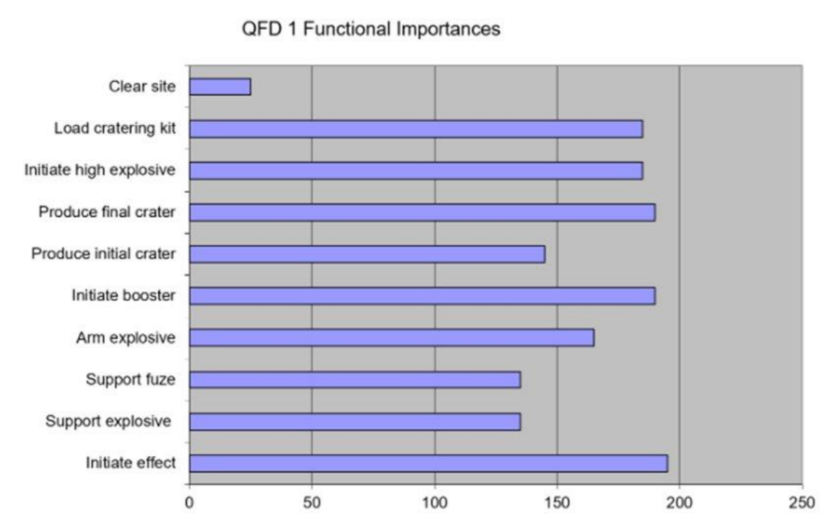

To create QFD 1, Functional Importance’s was done to determine which of the steps was most important in the process of using the Crater Kit. It was identified that initiating the effect of the Crater Kit was the most important functional step. This was closely followed by the production of the final crater. Each functional importance was high on the graph showing the importance and essentiality of majority of the steps. This means all must work for the cratering kit to work as planned.
Functional means analysis
A functional means analysis is a process used to distinguish the different ways or techniques to accomplish a particular capability or objective. It includes separating a capability into its constituent components and examining the various means or ways of achieving it. Understanding the various strategies or approaches that are available to achieve the desired result is made easier by this analysis. Leading a functional means analysis has a few advantages. It aids in the identification of alternative approaches to completing a particular task, which can result in increased effectiveness and efficiency. It likewise advances development and innovativeness by investigating various means to achieve an objective. Additionally, process optimization, decision-making, and problem-solving can all benefit from a functional means analysis. Overall, it makes it possible to have a deeper comprehension of the choices that are available and may result in improved outcomes. [5]
In order to complete the Functional Means Analysis, the functions from QFD 1 were put into a table and then discussed by the team and came to decisions on how each function could be completed. Once all of the different functional means had been identified for each function the team chose the best means to input into the data, these are highlighted in green. Less important but still reasonable ideas are highlighted in yellow.
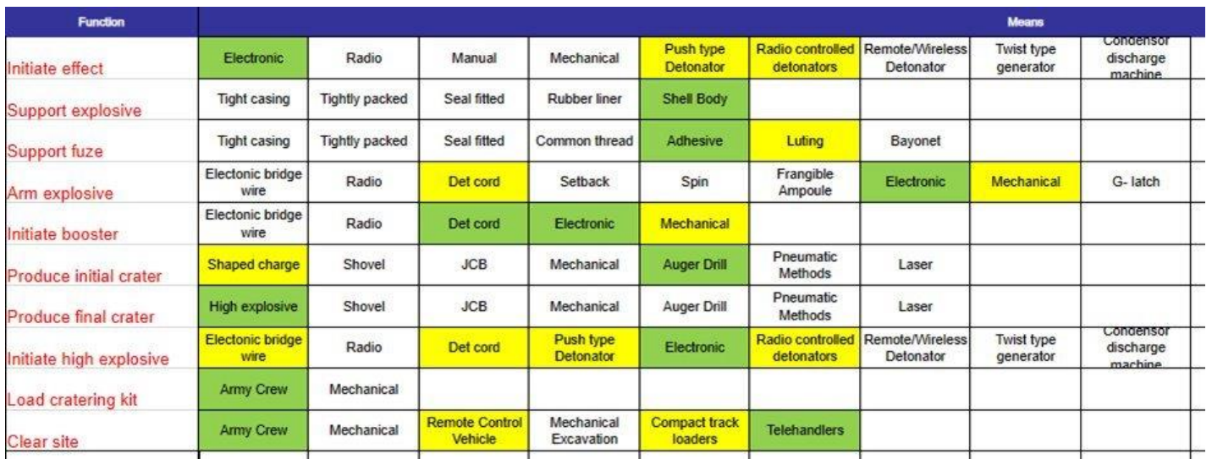

Feature Importances
Feature importance alludes to the importance or relevance of various elements or factors in a given setting or examination. It is a proportion of how much a specific component adds to the general result or execution of a framework, model, or cycle. Deciding feature importance can help in understanding which elements have the most impact and can direct navigation, prioritization, and asset assignment. It is normally utilized in different fields, for example, data analysis, machine learning and product development. [6]

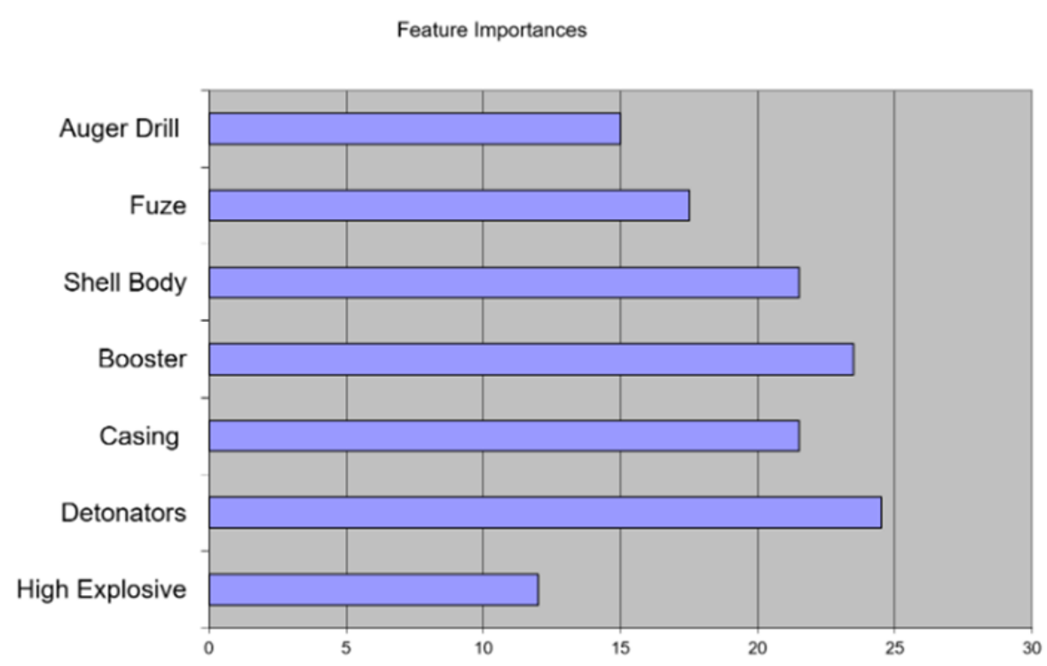

The detonator was identified as the most important feature of the cratering kit. This is crucial as it is what initiates the explosion and without the whole process would be pointless. The booster and shell body came next in line. These features are what should be prioritized over others in manufacturing.

Control Factors
In an experiment or study, control factors, also known as control variables, are variables that are kept the same or changed to isolate the effects of other variables. They are utilized to guarantee that any noticed changes or results are because of the independent variable being tried and not affected by different elements. Control factors assist specialists with laying out circumstances and logical results connections by limiting the effect of perplexing factors. By keeping control factors reliable, specialists can zero in on the impacts of the factors they are keen on examining. In information examination, control factors are utilized to represent the impact of specific factors that might frustrate the connection between the free and subordinate factors. By incorporating control factors in the examination, researchers can segregate the impacts of the autonomous variable of interest and better figure out its effect on the reliant variable.
To draw more accurate and reliable conclusions from the data, control factors ensure that any observed relationships are not caused by the influence of other factors. Control factors assist with limiting puzzling factors by holding specific factors consistent or controlling them. By doing so, researchers can separate the impacts of the free factor they are keen on contemplating. This guarantees that any noticed changes or results are not impacted by different elements, considering a clearer comprehension of the connection between the free and subordinate factors. Basically, control factors assist researchers separate the signal of interest from the noise of confounding variables, prompting more dependable and legitimate outcomes in data analysis. [7]

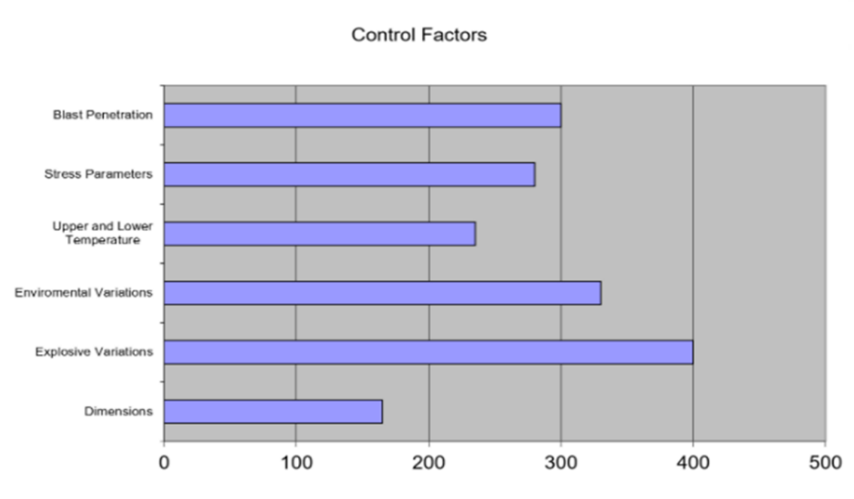

Controlling the type of explosive for the Cratering Kit was identified as the most important control factor. This will have the biggest effect on the kit if at fault. Without control of the explosives, it brings unnecessary risk. This would affect safety, transporting and packaging as well as other areas. Each explosive has been chosen specifically, packaged specifically and measurements have been made to create the desired crater.

Noise Factors
Noise factors, with regards to data analysis, allude to random or unessential factors that can bring inconstancy or error into the data. The true relationship between the independent and dependent variables may be obscured or distorted by these factors, which are unrelated to the variables of interest. Noise factors can emerge from different sources like measurement errors, natural circumstances, or individual contrasts. Limiting the effect of noise factors is significant in information examination to guarantee that the noticed examples or connections are not exclusively because of irregular variances or outer impacts.
A few common sources of noise factors in information examination incorporate sampling variability, environmental conditions, human error, and instrument limitations. Measurement blunders can happen because of mistakes in information assortment or recording. sampling variability alludes to the regular variety that can emerge while concentrating on a subset of a bigger populace. Environmental conditions mean factors like changes in temperature or lighting, can bring commotion into information. Noise can also be caused by human error, such as bias or inconsistent data entry. Also, limits in the instruments or apparatuses utilized for information assortment can present noise factors. It's critical to distinguish and represent these sources of noise to guarantee precise and reliable data analysis. [8]

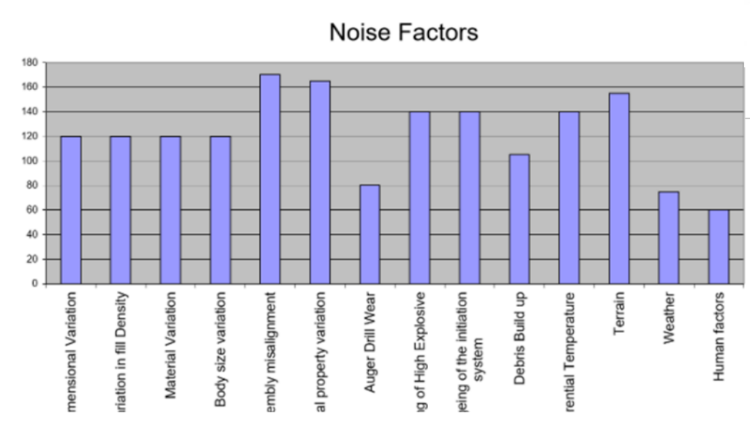

It was identified that the most important noise factor is the Assembly misalignment. There is little to no measures the team can put in place to control this showing a problem from the noise factor. The determined effect will not happen is the assembly is misaligned. This is a factor the group cannot help however so nothing can be done. The next in line is material property variation but after team discussions a suitable material for casing was aligned to allow the cratering kit to do its intended job.
Non-electric Detonator & Auger- Packaging
Shock Tubes, contain a primary explosive and therefore may not be transported in the same vehicle with other explosives, unless packed in wooden or fibreboard boxes. ​Therefore, these shock tubes will be transported in wooden boxes to meet the standard of regulations and make transporting these with other explosives possible. A shock tube with a detonator attached can be a max of a 320m reel. By working with the Test and Evaluation Manager, they came to the conclusion the maximum surface blast wave would be of an approximate safe distance of 193m. The Cratering kit is designed to have the explosives below the surface of the ground so will further minimise the blast wave effects, shortening the safe distance. Because of this it was agreed that we would use a 200m shock tube reel to oblige with safety regulations. Using the 320m reel would be a waste of time, resource, and money as 120m would go to waste every time. Working with the Research and Design Engineer and the Production and Manufacturer Lead it was decided to use a non-electric detonator instead of an electric. This makes following transportation and packaging regulations a lot easier
The shock tube initiators and Ground Auger are battery powered so will be in separate packaging in case of a short circuit via contact with other batteries. The battery in the shock tube initiator as well as metal objects or conductive surfaces. Therefore, they will be packaged in plastic containers wrapped with bubble wrap to provide extra protection against radio waves. The auger drill battery will similarly be wrapped with bubble wrap but also transported with the rest of the ground auger itself, in a plastic container. It is best to keep detonators and other explosives separate in all cases of transport. This is because any chance of increasing the likelihood of detonation is always condemned. This means all that will be transported in this one land transport vehicle at a time will be the shock tube detonator, shock tube initiator and ground auger drill. The main charges and booster will be transported in a separate land transport vehicle. This is only the case for land as sea and air have their own standards to mitigate the risk while transporting the whole cratering kit at once. [2]

Main Charge & Booster – PBX 9502 & Rowanex 3601- Packaging
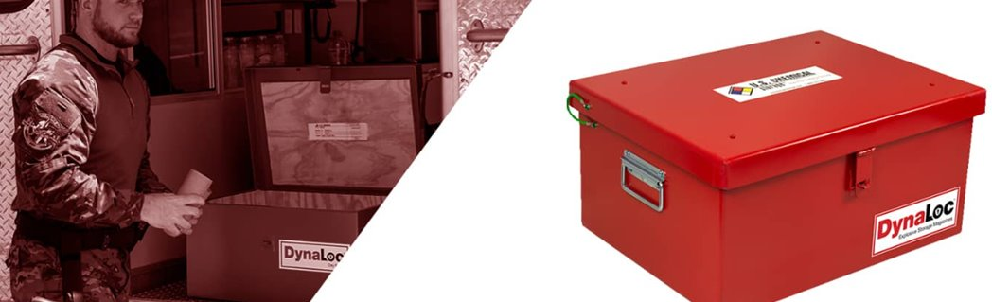
The Main charge and Booster will be transported in the same land transport vehicle in separate containers but the same type of packaging. These containers will be fit to different sizes for the different contents, but the same materials will be applied. Dynaloc transport explosives in securely Packaged in specialised containers designed to withstand the rigors of transportation to prevent​ 12-gauge steel lined with 1/2 inch of plywood​. It has non-sparking interior​, Fire-resistant construction​ and Weather-resistant construction​. For the booster the packaging will contain foam padding for a tight fit. [3]For the main charge there will be 3 charges per container with a 1/2 inch of plywood in between each charge. There will be foam padding in each section to provide extra support while transporting. Plywood Lining is shock absorbent which will minimise risk of accidental detonation. Insulation against temperature changes is also included so the explosives are not exposed to too hot or cold conditions preventing sensitivity and stop friction between explosives and walls. They are moisture protection to prevent a degrade in quality or stability of explosives.​ For Closed Cargo Transport Units a total net explosive mass is 250kg so a maximum of 11 boosters and 33 Main charges per land transport vehicle. The material on the outside of packing is Steel which is heavier than aluminium but favoured for its durability and resistance to corrosion. It can withstand harsher environments for when these cratering kits have reached their desired location.

Transport Vehicles Land
Explosive materials can be transported by Land when the following conditions are met:​
All Explosive Transport Vehicles must contain IME compartments.​ The IME container or compartment must provide for total enclosure of the contents.​ Some more security measures are in place. The vehicles must have installed GPS tracking systems and surveillance cameras to prevent theft or tampering. ​A suitable driver must be assigned; this individual will have to have completed the ADR course for transporting explosives in order for them to be assigned to driving the vehicle. Generally, vehicles are equipped with safety features such as reinforced construction, explosive proof compartments or fire suppression systems are used. ​Equip every motor vehicle used for transporting explosives with at least two 10-bc or higher rated fire extinguishers. Securely mount the extinguishers near the driver for immediate access.​ [2]
Mark or placard vehicles transporting explosives on both sides, front and rear. ​ When mixed loads are transported, display the placard for the most hazardous explosive. ​In this case 1.5D would be displayed. [12]Unless there is no practical alternative, a motor vehicle which contains hazardous materials must be operated over routes which do not go through or near heavily populated areas, places where crowds are assembled, tunnels, narrow streets, or alleys. [5]
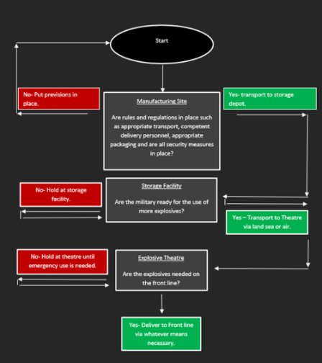
Here is a generalised process diagram made to refer to when making decisions on transportation of explosives.

Transport Vehicles Air
Explosive materials can be transported by aircraft when the following conditions are met:​
All explosives must be prepared and packaged under the supervision of a certified blaster and transported in undamaged original shipping containers. A shipper’s declaration for dangerous goods must be completed.​ High explosives must not be transported in the same container as detonators and must be separated from detonating materials. Detonating materials and explosives will be carried on different flights whenever possible and practical.​ Explosives and detonators transported in the aircraft or on external cargo racks must be stowed separately, secured by tie down straps, and be accessible for jettisoning whenever possible and practical. Detonators shall not be carried in helicopter sling loads. ​All explosives, ammunition, and detonating materials must be transported under the control or direction of a qualified or certified person.​ [14]
A Cargo Plane​ would be used for transporting by air. There is a maximum net explosive weight of 5000kg meaning 220 kits total could be transported by one plane. Only authorised personnel should be aboard the aircraft and no person other than required flight crewmember is allowed. There must always be an aviation safety inspector (FAA) aboard and explosives handling personnel will also be aboard. The owner of the aircraft must get advanced permission from all airports owners used in this air transportation.

Transport Vehicles Sea
Explosive materials can be transported by sea when the following conditions are met:​
Explosives must be placed upon a wooden platform. ​All detonators must be carried on deck as far forward as possible, in their original cartons, in a watertight, wood-lined, steel, portable cap magazine. However, in smaller vessels which experience severe bow impacts in rough waters, the detonator magazine should be carried abaft midship. If small boats are involved, carry the explosives on one, the detonators on the other. Or if transporting the explosives to a destination where they will be unloaded such as a barge, make one trip with the explosives, and a second trip carrying the detonator.​ Situate explosives away from loading booms or hoists, where they will not be exposed to falling objects. Keep them isolated from potential sources of static electricity, heat, and radio frequency energy. ​A boat carrying explosives must fly the “Bravo” flag at the bow, however, since this is not likely to be understood by many boaters, “EXPLOSIVES” signs should also be used in congested waters. [15]

Conclusion
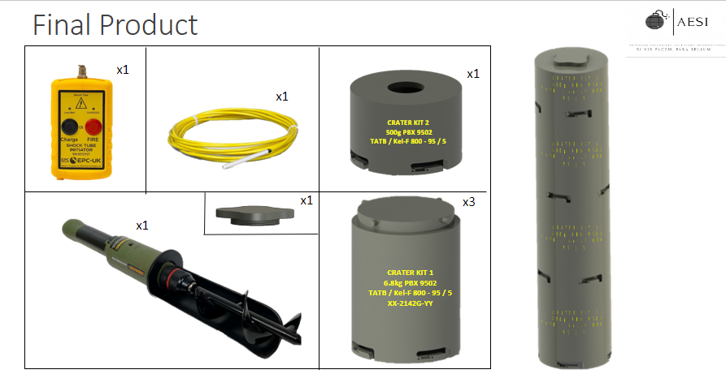
Above is the groups final product design. The group worked together through each stage of the cratering kit process as shown throughout this assignment. All customer requirements have been considered and completed.
In conclusion, both group and individual work came together to create a presentation as part of our module criteria. Feedback was taken into consideration to adjust any faults found. Transportation meets any regulations necessary as well as packaging regulations also. Weekly meetings benefitted the group to keep on top of each individual team members process.

References
HSE Books - Full catalogue
Type 2 Outdoor Magazine | U.S. Chemical Storage (uschemicalstorage.com)
Chapter 14 (publishing.service.gov.uk)
Chapter 4 (publishing.service.gov.uk)
The Control of Explosives Regulations 1991 (legislation.gov.uk)
FM 5-102: Countermobility - Chptr 6 Obstacles Other Than Minefields (globalsecurity.org)
https://www.burgehugheswalsh.co.uk/Uploaded/1/Documents/FMA-Tool-v1-1.pdf#:~:text=Function%20Means%20Analysis%20is%20a%20highly%20structured%20approach,criteria%20to%20help%20generate%20whole%20system%20concept%20solutions.
QFD: A Guide to Quality Function Deployment | SafetyCulture
https://machinelearningmastery.com/calculate-feature-importance-with-python/
https://sciencenotes.org/what-is-a-control-variable-definition-and-examples/
https://srs.ubc.ca/health-safety/occupational-hygiene/occupational-hazards/noise-hazards/
Class 1 Explosives - Shipping dangerous goods | DSV
How to Ship Explosives | Aviation Explosives | AETC (aesquibs.com)
IATA - What You Need To Know About The Transport Of Dangerous Goods By Air

