- ‘Fundamentalism’, 'Revolution' And Muslim Politics [GRB]

This section of the module seeks to introduce and explore the relationships between paradigms of 'fundamentalism', 'revolution', and Muslim Politics. These are terms that often come attached to underlying assumptions that - within an academic context - it is useful to consider, challenge and deconstruct if necessary. A key issue to consider is articulated by al-Azmeh:

“ ... in Islamic political thought, one has to confront the problematic status of political thought in Islam, and one must try to approach it in a way other than by analogy with modern political thought.”

Generalisations are problematic in any analysis of political thought, especially those elements espoused within an 'Islamic' context. Not only do specific cultural, historical, regional and linguistic elements have to be considered, but diverse political-religious factors contribute to any understanding of this subject area. Added to this must be the diverse academic approaches to this subject area, ranging from religious studies through to political science and anthropology. For the purposes of this module, the focus is on the 'religious' elements and influences, such as symbols, language, sources, and ideologues. However, it is also inter-disciplinary, in that it draws upon and filters studies from related subject areas, which contain useful analyses and information.

Clearly, within a module such as this, having delivered this warning, one must then proceed with some generalisations - which can then be refined as the reader progresses through the module. There are factors that may be shared, or affiliations and influences that transcend national boundaries. The introductory chapters contained in the module pack cover these factors in some detail, with practical examples.

One critical area in this type of study is how specific terms are applied. This is particularly relevant when researching and writing essays, where clarification of key terms (or at least awareness of diverse definitions) can assist in the critical interpretation of data. A good example of such methodological consideration would be related to the application of the term 'fundamentalism', which has a currency way beyond discourse about Islam and Muslim politics, especially within religious studies.
Tapper and Tapper, in a study of Islam and Muslims within a Turkish context, determined that fundamentalism was: “a datum which can be understood only in terms of its, often only implied, opposites.” They also make the point that the term was
“ ... a label used by outsiders, usually disparagingly, for phenomena which have little or nothing in common except the outsider’s wish to discredit them.” Tapper and Tapper make the point that the term has a firm linkage with understandings of Protestant Christianity, and that the term is eschatological, belief centred, and ahistorical in terms of its seeking of a return to traditional sources (in the context of Protestant Christianity, that being the Bible).

Within specific, Arabic-Islamic contexts there is no immediate equivalent term for 'fundamentalism', although the term 'usuliyya' has been coined (from usul - fundamentals, roots, principles) and may be appropriate within some analyses, although some feel that its Christian implications restrict or prohibit its use. In a Persian-Islamic context, the term 'bonyadegar' has been applied as a literal translation of ‘fundamentalist’, although it is not necessarily a mainstream term. It may be that the term has its equivalent in other 'Islamic languages', and it has certainly been applied within English-Islamic contexts to varying degrees.

So the key question is whether 'fundamentalism' can be a legitimate term for discussion, especially within the context of the study of Muslim politics, or whether it is simply shorthand for a number of different entities? What do we understand as a ‘fundamentalist’, when it is referred to in media, academic sources, and other sources? We may wish to ask whether (or how) a 'Muslim fundamentalist' can be ‘modern’ and ‘westernized’? How does this impact on approaches towards technology and innovation? Can science be Islamized? Can contemporary politics be 'Islamic'?

These are difficult questions. Bassam Tibi endeavoured to answer them, through the construction of various models, which contain specific political-religious elements: Tibi constructed an Enlightened Fundamentalist model (drawing upon a Hellenized tradition) and Militant Fundamentalist model (political, separating the qanun state law and the concepts surrounding the shari'ah, in the sense of the Divine Law of Islam). A Technological Fundamentalist model was also suggested, as an approach towards an Islamic (re-) possession of ‘technology’.

Are these appropriate terms? Is a ‘fundamentalist’ simply someone following the principles of their faith i.e. Qur’an, prayer, fasting, tax, unity of God, hajj? Some Muslims may define themselves as ‘fundamentalists’, if that is the criteria for the term? If they are operating within a political context, how should their politics be defined?

Some commentators apply the term ‘Islamism’, indicating a fusion of ‘fundamentalism’ with ‘Islam’ and ‘Islamic’ interpretation, or perhaps Islam with national-ism (and other -isms). The term can have liberation connotations, or association with resistance to authority and independence from ‘oppression’. Within the media, the term has implicit connotations associated with violence and extremism, which are well away from this model of principles (although individuals practising violence may also maintain Islamic practices of prayer, fasting, etc.).

In their editing of the Fundamentalism Project, which studied 'fundamentalisms' associated with diverse world views, Marty and Appleby indicated that Fundamentalism was a blanket term, “clustering” a variety of movements and individuals together, and suggesting a “global conspiracy”. So why study it?

“Fundamentalism seemed an appropriate subject of an interdisciplinary public policy study in part because it inspires the effort to create structures and institutions comprehending every aspect of human existence.”

Other terms may also be synonymous for some commentators and politicians, when discussing Islam and Muslim politics: the terms ‘extremist’, ‘theo-centric’, and ‘radical’ have a sustained history of careless application - often seen with the cipher of ‘secularist’ analyses. Careful application within the context of your research and essays for this MA module is significant (if not challenging). Demonstrating awareness of the limitations of language in exploring this subject area, and perhaps accommodating specific terms with explanations and reservations, can be helpful in expressing insight and providing a nuanced analysis within the field.

Moving away from the term ‘fundamentalist’, specific Muslim political-religious movements may be reactions to specific historical and cultural circumstances. These may be attributed (rightly or wrongly) to a variety of factors. It can be helpful to consider these (and perhaps devise your own) when studying Muslim politics in regional contexts. The writer would like to suggest the following criteria that may contribute to the establishment and maintenance of Muslim political movements in contemporary contexts, and the recruitment of support. These factors can be synthesised as follows:

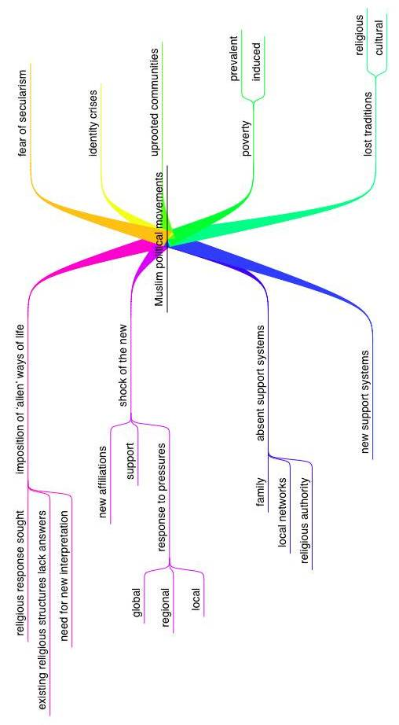

Diagram 1: Influences on creation and participation within Muslim political movements [Gary R. Bunt, ©copyright 2006]

In Islam, politics may be associated (by commentators and participants) with factors such as nationalism, religious symbols, religious activities, modern values, and secularism. This was recognised by one of the significant historical figures within Egyptian (and global) Muslim political discourse, Sayyid Qutb:

“Islamist political discourse is loath to specify the political system that the Islamic state would create and invigilate. It normally rests content with emphasizing the uniqueness of this society, it being one where God is the sole legislator. Beyond the legal order which re-enacts the primitivist utopia, nothing remains but a savage vitalism: the social order with ‘emerge vitally’ from doctrine, and doctrine becomes ‘the actual and active reality of the group.’”

Movements may provide comprehensive alternative structures, utilising religious language and political ideology. It is beyond the remit of this module to determine the ‘sincerity’ of practitioners, leaders and messages in their endeavours to gain mass audiences. Instead, it is useful here to discuss the phenomena associated with Muslim politics. The leadership may be charismatic, male, and authoritarian. The rhetoric may draw upon religious language, ideals, and an interpretation of belief systems (idealised, suiting an objective). Movements may be linked to regional concerns, nationalism, or universally identified with ‘religion’ (or an interpretation of religion). The language may evoke God and Prophet(s) within a supportive framework. Fundamentalisms may need ‘intermediaries’ to approach all powerful deities, the intermediaries Gellner described as “a hierarchical, specialized class of religious personnel.”

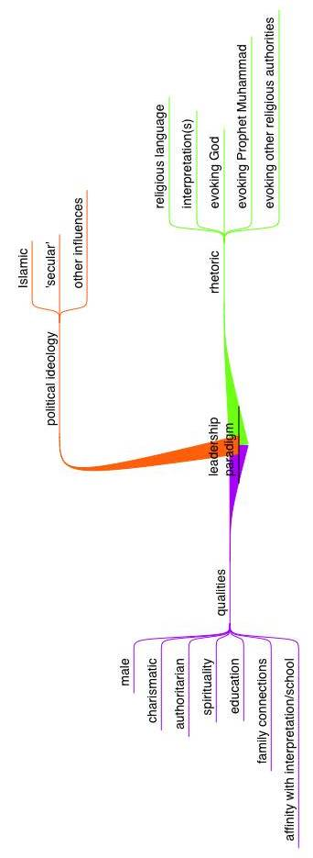

Diagram 2: an Islamic leadership paradigm
[Gary R. Bunt © copyright 2006]

Associating Islam with ‘Fundamentalism’ clearly raises difficulties, given the diversity of movements and individuals associated over a broad historical, political and geographical framework - and represents a generalisation that may not be useful within analyses. A unified ‘Islamic Fundamentalism’ does not exist. Instead, there are diverse movements, confined to regions or social classes (which may transcend barriers of social conditioning, language, religious practices, etc.). In truth, if the term has any applications at all, then it is when examining what John O. Voll describes as a “complex cluster of movements”:

“Islamic fundamentalism, then, will have to denote the reaffirmation of foundational principles and the effort to reshape society in terms of those reaffirmed fundamentals. This involves, in the words of Muslims who have described Islamic fundamentalism, the effort ‘to call Muslims back to the path of Islam,’ ‘an assertive surge of Islamic feeling’ which pervades the Islamic world, and ‘the reliance of Islamic fundamental principles to meet the needs and challenges of contemporary times.’”

This model could incorporate sub-Saharan African syncretic movements which combine aspects of animism with Islam [i.e. Nigeria], North African mystical/reform movements [i.e. Sanussi], Iranian Shi’i imamate movements, Saudi ‘Wahhabis’, the political reform Egyptian Muslim Brotherhood [ikhwan al-muslimiyya], and a host of other movements (operating on trans-national or localised lines) with different leaders and agendas, not mutually supportive of one another (and sometimes in conflict). Muslim political movements may be factionalist too, for example in the history of the Ikhwan.

Muslim political movements can also combine attributes of these entities:

“ ... [Hasan] al-Banna defined the [Muslim Brotherhood] movement as ‘a Salafiyya message, a Sunni way, a Sufi truth, a political organization, an athletic group, a cultural-education union, an economic company, and a social idea.’”

They may attempt to draw away from ‘traditions’, ‘innovations’, and ‘interpretations’, in an attempt to locate the ‘roots’ of religion.

“In another context, al-Banna emphasized the importance of the mission rather than the organization when he told the brothers, ‘you are not a benevolent organisation, nor a political party, nor a local association with strictly limited aims. Rather, you are a new spirit making its way into the heart of this nation and revivifying it through the Qur’an.’”

Diversity may arise in how this mission is approached, leading to different interpretations and angles [this is discussed in the later section on Pakistan, in relation to movements arising from the writings of Mawdudi]. ‘Tajdid’ in one Muslim context is not necessarily received warmly in other contexts. Esposito cites the example of the aftermath of the 1979 Revolution in Iran, which resulted in: Shi’a riots in Saudi Arabia’s Eastern Province; the seizure of the Grand mosque in Mecca by Iranian sympathisers (1979); the execution of Shi’a cleric Muhammad Baqr al-Sadr in Iraq (1980); a failed coup in Bahrain (1981).

In constructing model of Muslim political systems and movements, it is necessary to consider whether the rhetoric and policies include intentions of a ‘return to the past’ in terms of interpretative ideals and society norms, and whether that is feasible or realistic. Yvonne Haddad suggested that:

“Ideal time is past time, and the duty of the Muslim is to avoid new ideas, customs or interpretations since they are simply innovations which act as barriers and impediments to the realization of ideal society.”

However, much of the political-religiouis literature is future-centred, acknowledging what is stated in the Qur’an:

“ … Verily never will God change the condition of a people until they change it themselves (with their own souls).” Qur’an 13:12 (A)

This is indicative of the need for human endeavour, and responsibility of an Islamic society for forward thinking (islah) and ‘reform’ (tajdid, in the sense of renewal and revival).

How does one define whether a political entity or action is ‘Islamic’? Does it require the application of religious terminology, Qur’an-ic quotes, ideals – and as such is it social-political revolution? In history, the grafting of ‘political’ and ‘Islamic’ models has occurred. Consider the following examples:

- The fusion of socialism and Islam within Pakistan People’s Party of Zulfikar Bhutto in Pakistan.

- The integration of Iran-backed, anti-western rhetoric and a Shi’a message within Hizbullah in the Lebanon during the 1980s and 1990s, which opposed other Shi’a groups (such as Amal), but then adjusted within the political sphere in an attempt to draw in other religious perspectives (Christian and Muslim) from within Lebanon.

- The drawing together by ABIM of Malay-identity centred, religious propagation (dakwah) oriented concepts by a university educated elite promoting ‘reform’ and personal interpretation of primary sources (with ‘scholars’ status downgraded).

- The development of Darul Arqam in Malaysia, a messianic Sufi technology-centred movement, apolitical, with an emphasis on industry and education.

All of these entities could be described as representing ‘Muslim politics’ at some level, even those who claim to be ‘apolitical’ (which in itself is a statement). Within these and other paradigms are further, nuanced models of interpretation and political issues (for example, between local, regional and national levels). They might all be described as ‘fundamentalist’, in terms of adherence to their religious principles and political outlook.

When exploring such issues of interpretation and religious-political discourse, John Voll suggests a shift of emphasis, “... from ‘modernizing’ Islam to the Islamization of the modern experience.” One paradigm that might be applied links to that associated with the life of Muhammad (c.570-632), especially the practices and precedents established within Medinan society after the hijrah, and Meccan society following the city’s capitulation. The paradigm includes the idealised qualities of Muhammad as a pragmatic political leader, especially his decision making based on contextual Divine Revelation (Qur’an), and the example of sayings and actions. This formative period in Islam’s development presents a paradigm in which all facets of life are to be encompassed by Islamic practices and principles (ultimately) – including and integrating political ideals. This proto-community was relatively small (compared with the global Muslim population today!), and Islamic historical sources suggest that it was easier in some cases to introduce practices to loyal followers (despite warfare and

Cont/d … 26

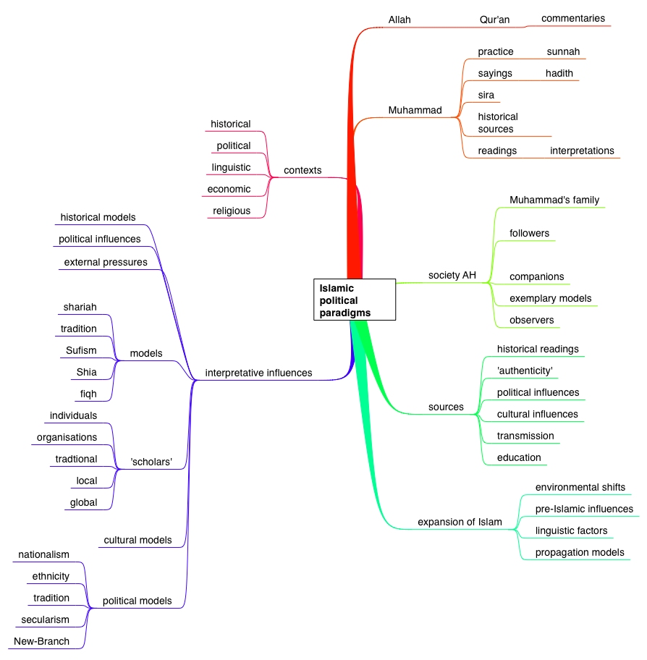

Diagram 3: Some Influences on Islamic Political Paradigms
[Gary R. Bunt © copyright 2006]

AH = Anno Hegirae, representing the Islamic Calendar
resistance). Critical to this adjustment was the notion of Arab identity, language and culture – together with the focus on an extraordinary individual. Following Muhammad’s death in 632, inevitably Muslim society divided, especially as Islam expands into different environments where expectations and cultural practices were different. The shift away from desert-urban society of the Arabian Peninsular towards Syria and Egypt, for example, encompasses the integration of other societies, languages and traditions which were drawn into an ‘Islamic’ or Muslim’ identity (however tokenistic or expedient for individuals/communities). Practices established in Medina, often based on pre-existing principles, could not necessarily easily be exported successfully to Syria, Egypt or eastern countries. What is suggested is the pragmatic aspect of Islam and the adaptability of religious-political systems (whilst following the ‘roots’ of religion), resulting in variations in interpretation and ultimately legal differences. Critics may suggest that the past can be (re-)interpreted, and that the ‘mythologization’ of history can be difficult to reconcile with the realities of the present. They may suggest that - whilst the Qur’an remains unchanged - fabrication and manipulation of interpretation, and scholarship associated with the strategic adjustment of the discourse (whether deliberate or not), makes an impact. Ideals of social unity have to be reconciled to ‘utopian’ ideologies, and the need to distinguish between romantic political arguments and specific programmes of action:

“The need to place Muslim politics into multiple and shifting contexts [thus] becomes apparent. Like power, symbolism and language - integral components of politics - ‘must be located within a nexus of social and cultural relationships.’ (Grillo 1989:21) This need for contextualization applies to all politics, and in this respect, Muslim politics is not unique. As we have argued, neither can it be said to be unique because of any singular determination of doctrine. The distinctiveness of Muslim politics may be said to lie in the specific, if evolving, values, symols, ideas, and traditions that constitute ‘Islam’. These include notions of social justice and communal solidarity that have been inspired by the founding texts of Islam such as the Qur’an and the sayings (hadiths) of the Prophet. They may also include a sense of obligation to authority that has been informed as much by social practice as by Qur’anic injunction, the practices of mystical orders (tariqas), and the established schools (madhhabs) of Islamic law. Such ideas and values, as expressed through symbols and language, constitute an image of the ideal Muslim society. Precisely because the symbolism and the language are inherently flexible and even ambigous, one Muslim’s image can be another’s “counter image”.”

With this in mind, one might consider that the term ‘fundamentalism’ may also be applied by political-religious platforms focused on concepts of the lesser jihad. This raises the issue of whether al-Qaeda (and its affiliates) represents a ‘political movement’ (in conjunction with its other elements?). This might be compared with the activities of Hamas (Harakat al-Muqawamah al-Islamiyyah) in Palestine, whose methods incorporated paramilitary activities and political action. This is an issue which you may wish to consider, as you proceed through the module, as clearly there would be a number of different approaches to this question.

The term ‘fundamentalism’ can be applied critically, for example by Aziz al-Azmeh, who uses it to criticise the Saudi regime, and its own ‘brand’ of Islamic interpretation. Aziz al-Azmeh suggests that ‘Saudi Wahhabis’ promote tribalism, homogenisation, and a pecking order for Saudi wealth re-distribution - promoted internationally and pervasively through funded networks and organisations:

“In short, Wahhabite fundamentalism puts forward a model whose task is to subject local societies with their customs, authorities, devotions, and other particularities to a general process of accultarisation which prepares them for membership in the commonwealth whose linchpin and exclusive raison d’être is the absolute dominance of the House of Sa‘ud.”

Within contemporary contexts, another critical factor has been how these diverse political messages were generated and spread. For example, sermons, study circles, texts commentaries, and media-expositions have all played a role in disseminating contemporary political discourse, via such media as the printing press, the internet, broadcast media (satellite television, analogue television, radio, internet media), digital media, video and audio tape. One prominent example of the effect of media on the distribution of a political-religious message was the dissemination of Ayatollah Khomeini’s sermons through audio-cassette tape, which were seem as significant to the Iranian Revolution in 1979. The evolution of distribution channels for information about Islam and Muslim politics does not disenfranchise traditional outlets such as sermons in mosques, or other ‘real time’ meetings, but it has had an impact as generations become increasingly media literate, and access to media improves. The permutations of Muslim politics have acquired a ready audience amongst those educated, recently urbanised (within a generation) people, especially in areas of hardship and depravation – where their expectations and qualifications have not been the key to economic or social security. John Esposito cites the archetypal politicised Sunni Muslim ‘radical’ as university educated, predominantly from a science, engineering, law or medicine background rather than from the study of religion or the humanities – this may subvert the stereotype of the archetypal marginalised, anti-modern or uneducated individual operating within ‘Muslim politics’. Technological developments have provided a new impetus for Muslim political dialogues, and enhanced the networking capabilities of movements (in terms of affiliation development, logistics, information provision and discussion). It should be noted that these dialogues take place in a multitude of languages, with English acting as one common language for discussion in international contexts.

Further Reading
Anthony H. Johns and Nelly Lahoud, ‘The world of Islam and the challenge of Islamism’, chapter in Nelly Lahoud and Anthony H. Johns (editors), Islam in World Politics (London: Routledge, 2005)

Other Reading

Jon Armajani, Modern Islamist Movements: History, Religion, and Politics (Chichester: Wiley-Blackwell, 2011)

Fred Halliday, ‘The Politics of the Umma: States and Community in Islamic Movements’ chapter in B.A. Roberson, Shaping the Current Islamic Revolution, (Portland & London: Frank Cass, 2003)

Peter Mandaville, Global Political Islam, (London & New York: Routledge, 2007). This is detailed in its scope. It would make useful background reading, and is an ideal theoretical reference resource for this module.

Bassam Tibi,. Islam in Global Politics, (London: Routledge, 2012)

. Aziz al-Azmeh, Islam and Modernities, (London & New York: Verso, 1993) p.89
. Richard Tapper & Nancy Tapper, “‘Thank God We’re Secular! Aspects of Fundamentalism in a Turkish Town’” chap. in Lionel Caplan, Ed. Studies in Religious Fundamentalism, (London: Macmillan Academic & Professional Ltd., 1987), p.52
. Tapper, p.52
. Tapper, p.54
. Bassam Tibi, The Worldview of Sunni Arab Fundamentalists: Attitudes towards Modern Science and Technology, chapter in Marty & Appleby, Fundamentalisms Observed, p.73. Also see - Imad-ad-Dean Ahmad, Review of Islamic Fundamentalism, Abdel Salam Sidahmed and Anoushiravan Ehteshami. Editors. Oxford: Westview Press, 1996, in Arab Studies Quarterly (ASQ), Spring, 1999
. Ervand Abrahamian, Khomeinism: Essays on the Islamic Republic (Berkeley: University of California Press, p.13
. Martin E. Marty & R. Scott Appleby, “Conclusion: An Interim Report on a Hypothetical Family”, in Mary and Appleby Eds. Fundamentalism Observed, p.815
. Marty & Appleby, Fundamentalism Observed, p.815.
. Marty & Appleby, Fundamentalism Observed, p.824 & passim.
. Sayyid Qutb, Ma‘alim fi‘t-tariq (Cairo & Beirut, 1981) pp.43-5 and Al-Mustaqbal li-hadha'l-din (Cairo, n.d., p.12) cited in Al-Azmeh, op.cit., p.28
. Gellner, p.134
. John O. Voll, “Fundamentalisms in the Sunni Arab World: Egypt and the Sudan”, in Fundamentalisms Observed, p.347
. Ibid.
. Richard P Mitchell, Society of Muslim Brothers, (London: OUP 1969), p.14 & Ishak Musa Husaini, Moslem Brethren, p.41 (Beirut: Khayat, 1956.) Cited in Voll, p.384
. Hasan M N al-Banna Shaheed, Five Tracts of Hasan al-Banna (1906-1949) trans. Charles Wendell, (Berkeley: University of California Press, 1978), pp.29-29
. John Esposito, ‘Trailblazers of the Islamic Resurgence’, in Haddad, Voll et al. p.44
. Yvonne Y. Haddad, ‘The Revivalist Literature and the literature on Revival.” in Yvonne Y. Haddad, John O. Voll, John L. Esposito with Kathleen Moore & David Sawan. The Contemporary Islamic Revival: A Critical Survey and Bibliography (Westport, CT: Greenwood Press, 1991), p.4
. Haddad, p.4 & passim.
. Esposito, in Haddad et al, p.46. Also see Amal Saad-Ghorayeb, Hizbu’llah: Politics and Religion, (London, Pluto Press, 2002)
. John O. Voll, ‘The Revivalist Heritage’, in Haddad, Voll et al. Op.cit. p.24
. Al-Azmeh, pp.70-71.
. Dale F. Eickelman and James Piscatori, Muslim Politics, (Princeton, New Jersey: Princeton University Press, 1996), pp.20-21, citing: Clive S. Kessler, ‘New Directions in the Study of Islam: Remarks on Some Trends and Prospects. Jurnal Antropologi Dan Sosiologi 18: 3-22. Ralph Grillo, ‘Anthropology, Languge, Politics.’ In Social Anthropology and the Politics of Language, Ed. Ralph Grilo, pp. 1-24. Sociological Review Monograph, no. 36, London: Routledge, 1989.
. Aziz al-Azmeh, op.cit., p.113
. Discussed in Eickelman & Piscatori.
Also see Gary R. Bunt, Islam in the Digital Age, (London: Pluto Press, 2003), Elizabeth Poole & John E. Richardson, Muslims and the News Media. London: IB Tauris, 2006).
. Haddad, p.10
. Esposito in Haddad et al, p.44

