Computer Architecture and Operating Systems

Name: Anesipo Sobekwa
Student number: 2308434
Q1. Key functions of general Operating Systems (page 2-3)
Q2. Use of Windows OS CLI commands (page 4-8)
Q3. Use of Linux OS CLI commands. (page 5-10)
Q4. Use of Windows OS scripts. (page 11-13)
Q5. Use of Linux OS scripts. (page 14-15)
REFERENCES.(page 15-18)

Introduction:

The purpose of this report is to explore different functions of general OS and how different environments such as Windows and Linux use these OS to optimise performance. It will also look different scripts such as Bash, Batch and PowerShell can be used to monitor and configure their respective environments.

An operating system is a software that runs on a computer or device and helps manage the device’s memory, processes and all its other software and hardware [2]. An operating system also allows the user to communicate with the device without knowing the device’s language [1]. An OS manages all the software and hardware on a computer. For the most part, a computer may be running several programs at the same and they all need access to the computer’s CPU, memory, and storage. The OS coordinates this to ensure each program gets what it needs.

The key functions of a modern OS are to manage software, hardware, and process management. An OS manages hardware such as keyboards, mouse, CPU, memory, and all input/output devices. The OS manages every process that the system hardware executes. General-purpose operating systems like Windows, macOS, and Linux are some of the fundamental software used in modern devices. These operating systems offer distinct user interfaces and tools that allow them to complete tasks with a great deal of efficiency. Key functions of the systems include system settings, file management, network settings, task manager, security, and privacy settings and software installation and management.

In windows, system settings can be accessed via the settings app or control panel. In macOS, system settings aid with configuring security, accessibility, and network settings. Linux system settings are dependent on the desktop being used. An example of this is with KDE distributions who use system setting modules whilst GNOME uses a system application that is similar to macOS. Linux is the most used and most popular OS. Like all operating systems, Linux manages all communication between software and hardware of a device and is the operating system for Android, one of the most popular platforms in the world.

File management is crucial for accessing, organising, manipulating, and controlling data stored on a device. Windows uses file explorer which is a great management tool that can be accessed through the start menu or task bar. This enables users to create, browse, modify, and delete files and folders [3]. In macOS, this is done by finder and in Linux, its done by several file mangers such as Dolphin and Nautilus.

Network settings are important for internet access and network resources. Windows users can configure these settings through the settings app or control panel. Here, users can modify VPN connections, WI-FI and ethernet connections. On macOS, network settings can be accessed via system preferences, and has the same functions previously listed. These settings can also be used to troubleshoot any network related issues. In Linux, all these settings can be accessed through network management tools like nmcli [9]. Users can also configure network interfaces and set DNS servers.

Q2.

Batch scripting has a vast number of commands that can be executed. Despite not being practiced or used a lot, its still one of the most powerful programming languages especially in a windows environment due to the sheer control and dominance it grants the user.

Below we can see the echo command in use for a series of arithmetic operations. The echo command in Bash is primarily used for printing texts and variables [4]. Its very simple but is still a powerful tool that can be manipulated in a number of different ways to enhance scripting.



When it comes to PowerShell scripting, few commands are more useful than the ‘get-command’. This is because this will display all commands that are available to use.
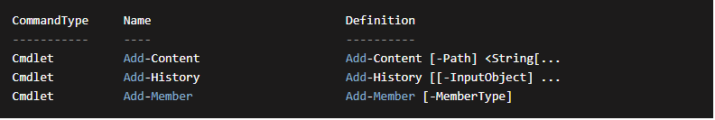

Similarly, the get-help command is essential because it allows users to quickly gain access to information needed to utilise all commands that are available.

Another useful command is the Get-Process command. This is useful because it allows the user to gain access to a list of all processes that are running.
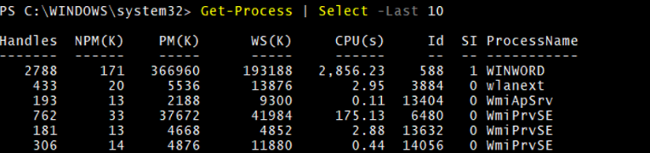

The format-table command is useful as it is used to format objects in a table. This command shows these processes with the same base priority. [5]
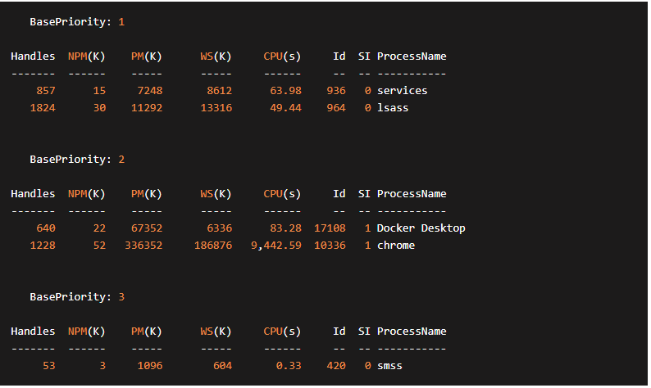

Another command that’s useful is the format-list command. This command enables users to format any output as a list, all on a new line.
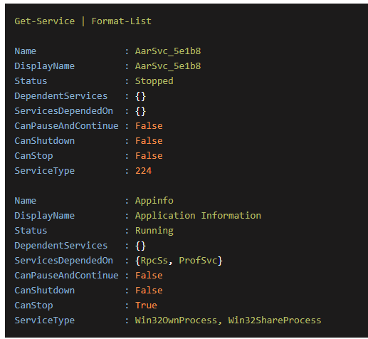

The where-object command is useful for filtering objects from a collection using a specific condition, allowing the user to select the items that meet the criteria. This is crucial for tasks such as data analysis.
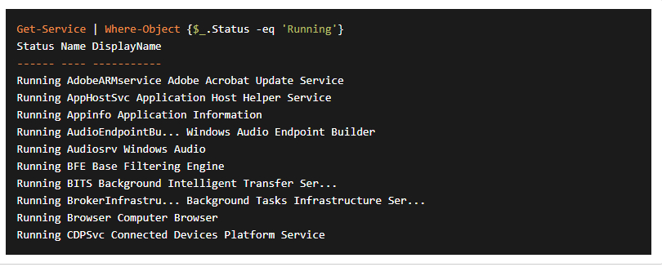

One of the most useful commands is the get-service command. This allows the user to access information about what services are installed on a device. This will list all services or filter based on a set criteria and can also be used to manipulate other operations related to managing services. [6]

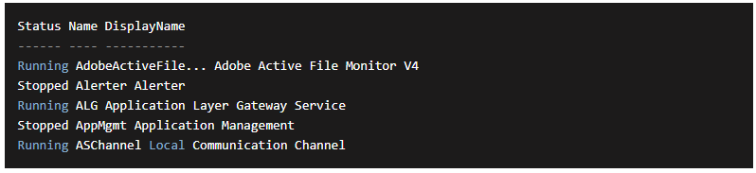

Q3.
The ‘ls’ command is used to list directory contents. It displays files and directories in the in the current directory.

The ‘cd’ command is generally used to change directories. The ‘cd <directory>’ to navigate to a specific directory.

‘PWD’ is used to print the current working directory path.

‘MKDIR’ is a command used to create a new directory. ’ Directories can be created simultaneously which can greatly speed up the process’.

The ’cp’ command is used to copy files or directories from a source to a destination.

All the above commands are crucial in bash as it makes manipulating and managing files and directories easier. They also make automating tasks simpler and more efficient. [13]

In conclusion, mastering the usage of essential Bash commands like ls, cd, pwd, mkdir, cp, mv, and rm empowers users to efficiently manage files and directories within the Unix/Linux command-line environment. These commands provide fundamental capabilities for navigating the file system, creating and deleting directories, copying and moving files, and identifying the current working directory. [11]
By understanding ls, users can quickly list the contents of a directory to view available files and directories. cd facilitates seamless navigation between directories, allowing users to switch locations within the file system effortlessly. pwd is essential for confirming the current working directory path, aiding in orientation within the directory structure.
Commands like mkdir enable the creation of new directories, while cp and mv facilitate file and directory manipulation by copying or moving them to specified locations. Finally, rm allows for the deletion of files or directories, helping to manage disk space and remove unwanted data. [13]
Together, these commands form the foundation for efficient file system management, enabling users to perform common tasks such as organizing files, making backups, and cleaning up unnecessary data. Mastery of these commands enhances productivity and proficiency in working with Unix/Linux systems, providing valuable skills for system administrators, developers, and power users alike. [12]

Q4.

The above PowerShell script is an example of a key Windows OS scripting language. When executed, this script displays all the processes currently running on the system, process name, ID, memory usage and CPU time. In order to do this, the ProcessInfo.ps1 will initially use the Get-Process command to gain an insight on all the processes running. It will then repeatedly use the ‘foreach’ loop in order to display the ID, memory usage and CPU time. [10]

This script is useful as it allows the user to view all processes running on their system and this comes in handy for monitoring and troubleshooting tasks.

The script above illustrates the file backup ability of PowerShell scripting. The first step is identifying the source and destination and then it ensures the source folder exists by using the 'Test-Path’ command. Once established, the ‘New-Item’ command creates a destination folder. The ‘Get-ChildItem’ transfers all the files from the source folder the destination folder using ‘Copy-Item’ command. This script clearly shows file manipulation ability of PowerShell and its ability to interact with different components within the system. [7]

This script demonstrates PowerShell scripting’s ability of event log monitoring. This is done by using a specific criteria to retrieve the event that fit into the given criteria. This done using the ‘Get-WinEvent’ which in turn displays the even details. [8]
Overall, PowerShell is a fundamental tool for Windows system admins due to its incredible adaptability in configuring and managing systems. It is also greatly efficient when it comes to automating tasks and interacting with the system as a whole.

Q5.
Bash scripting is a very useful and powerful tool that can be used to automate and manage tasks in Linux environments. The above scripts showcase a few key commands used in Bash scripting. The ‘system_info.sh’ script is used to obtain basic systematic information by using commands such as ‘free’ for memory usage, ‘df’ for disk space and ‘Iscpu’ for CPU details.
The ‘backup_files.sh’ scripts outline how Bash can be utilised for activities such as file management. It uses different variables, conditional directories and commands such as ‘tar’ in order to create compressed backups.
Bash scripting is crucial especially for admins in Linux environments because once mastered, it can simplify even some of the most complex processes and operation. This is key as it can help reduce errors, increase productivity, and make trouble shooting simple. [12]

In summary, these screenshots show Bash scripting is essential for automating tasks, system configuration and management, and customisation. Due to its simplicity and a vast number of powerful commands, it makes it easier for admins in a Linux environment to automate streamline system management. [11]

References:

[1]
GCFGlobal, “Computer Basics: Understanding Operating Systems,” GCFGlobal.org, 2016. https://edu.gcfglobal.org/en/computerbasics/understanding-operating-systems/1/
‌[2]
University of Wollongong, “Understanding operating systems - University of Wollongong – UOW,” www.uow.edu.au, 2022. https://www.uow.edu.au/student/learning-co-op/technology-and-software/operating-systems/
‌

[3]Prepbytes, “File Management in Operating System,” PrepBytes Blog, Jan. 31, 2023. https://www.prepbytes.com/blog/operating-system/file-management-in-operating-system/#:~:text=A%3A%20File%20management%20in%20an
‌

[4]
M. M. Gammerdinger Bob Freeman, Mary Piper, Radhika Khetani, Jihe Liu, Will, “Shell scripts and other related concepts,” Introduction to the command line interface (Shell), Oct. 01, 2021. https://hbctraining.github.io/Intro-to-shell-flipped/lessons/05_shell-scripts_variable.html
‌

[5]
“Format-Table - PowerShell Command | PDQ,” www.pdq.com. https://www.pdq.com/powershell/format-table/ (accessed Apr. 15, 2024).

[6]
sdwheeler, “Get-Service (Microsoft.PowerShell.Management) - PowerShell,” learn.microsoft.com. https://learn.microsoft.com/en-us/powershell/module/microsoft.powershell.management/get-service?view=powershell-7.4
‌

‌
[7]“Automate Backup Tasks Using PowerShell Scripts,” OpenClassrooms. https://openclassrooms.com/en/courses/7805656-schedule-your-tasks-with-powershell-scripts-on-windows-server/7973560-automate-backup-tasks-using-powershell-scripts
‌
[8]“How to monitor event log using powershell | Manageengine ADAudit Plus,” www.manageengine.com. https://www.manageengine.com/products/active-directory-audit/powershell/powershell-monitor-event-log.html#:~:text=Steps%20to%20monitor%20event%20log%20using%20PowerShell%3A&text=Compile%20the%20script. (accessed Apr. 19, 2024).

[9]“Configuring basic system settings Red Hat Enterprise Linux 8 | Red Hat Customer Portal,” access.redhat.com. https://access.redhat.com/documentation/en-us/red_hat_enterprise_linux/8/html-single/configuring_basic_system_settings/index

[10]sdwheeler, “Get-Process (Microsoft.PowerShell.Management) - PowerShell,” learn.microsoft.com. https://learn.microsoft.com/en-us/powershell/module/microsoft.powershell.management/get-process?view=powershell-7.4
[11]Z. Hira, “Bash Scripting Tutorial – Linux Shell Script and Command Line for Beginners,” freeCodeCamp.org, Mar. 20, 2023. https://www.freecodecamp.org/news/bash-scripting-tutorial-linux-shell-script-and-command-line-for-beginners/
‌
[12]“What is a Bash Script? - Bash Scripting Tutorial,” ryanstutorials.net. https://ryanstutorials.net/bash-scripting-tutorial/bash-script.php

[13]“Bash cheat sheet: Top 25 commands and creating custom commands,” Educative: Interactive Courses for Software Developers. https://www.educative.io/blog/bash-shell-command-cheat-sheet
‌

‌

‌

