

UNIVERSITY OF WALES TRINITY SAINT DAVID

Mechanical Engineering

2D Diffusion Equation model using the Explicit Finite Difference Method

Emyr Hunnam

2216571

BEng Mechanical and Manufacturing Engineering

January 2025

Computational Methods ACMA6012

Word Count: 3073

Table of Contents
Table of Contents 1
List of tables 3
List of Equations 3
List of Figures 3
1. Introduction 4
1.1 Aims and Objectives 4
2. The governing equation of the problem 5
3. A full description of the numerical method chosen to discretise the governing equation 7
3.1 Taylor Series 7
3.2 Derivation of the forward, backward and central difference 7
3.2.1 Forwards difference approximation 7
3.2.2 Backwards difference approximation 7
3.2.3 Central difference approximation to the first derivative 8
3.2.4 Central difference approximation to the second derivative 8
3.3 Explicit finite difference scheme 9
3.3.1 Discretising the spatial and temporal domains 9
3.3.3 Approximating the heat equation using explicit finite difference method 9
3.3.4 Define the stability criterion 10
4. The initial, boundary conditions and analytical solution 11
4.1 Initial and boundary conditions 11
4.2 Analytical Solution 12
5. Codes’ details and explanations 13
5.1 Workspace Management Commands 13
5.2 Defining Material Properties 13
5.3 User Inputs for Spatial Consideration 13
5.4 Compute Number of Rows and Columns 14
5.5 Temperature Matrix Initialisation 14
5.6 User Input for Temporal Consideration 15
5.7 Initialise Temperature Matrix T2 15
5.8 Convergence Criterion Threshold 15
5.9 Calculation of Temperature Distribution T2 16
5.10 Analytical Solution 16
5.11 Plotting Numerical and Analytical Solution 17
5.12 Calculate and Plot Error Map 17
5.13 Command Window Information Display 17
6. Validation of the code 19
7. Analysis of the code results 21
7.1 Grid spacing 21
7.2 Time step 22
7.3 Thermal equilibrium tolerance 23
7.4 Conclusion 24
8. Limitations of the model 26
8.1 Limitations due to numerical method 26
8.1.1 Round-off error 26
8.1.2 Truncation error 26
8.1.3 Complex Geometry 26
8.1.4 Stability 26
8.2 Limitations due to the coding 27
9. Suggested improvements to the model and future developments 28
9.1 ADI or Implicit Finite Difference Methods 28
9.2 Numerical Alternatives to the Finite Difference Method 28
9.2.1 Finite Element Method (FEM) 28
9.2.2 Finite Volume Method (FVM) 28
9.2.3 Boundary Element Method (BEM) 28
9.3 Robust Thermal Equilibrium Modelling 29
10. Conclusion 30
11. References 31
12. Appendix 33
12.1 MATLAB Code 33
12.2 Sensitivity analysis data 38

List of tables
Table 1 - Grid spacing influence on thermal equilibrium time 21
Table 2 - Time step influence on thermal equilibrium time 22
Table 3 - Tolerance influence on thermal equilibrium time 24

List of Equations
Equation 1 – Heat equation for conduction in solids (Thorsten and Boris, 2015) 5
Equation 2 - Thermal diffusivity (alpha) 5
Equation 3 – Simplified heat equation 5
Equation 4 - Taylors series equation (Math is Fun, 2017) 7
Equation 5 – Taylor Series equation simplified 7
Equation 6 – Forward difference approximation 7
Equation 7 - Backwards difference approximation 8
Equation 8 - Central difference approximation 8
Equation 9 - Central difference approximation to the second derivative 9
Equation 10 - Explicit finite difference approximation 10
Equation 11 - Stability criterion equation 10
Equation 12 - Analytical solution of the temperature at thermal equilibrium 12

List of Figures
Figure 1 - Workspace management commands 13
Figure 2 - Defining Material Properties 13
Figure 3 - User inputs for spatial consideration 14
Figure 4 - Number of rows and columns 14
Figure 5 - Temperature matrix initialisation 15
Figure 6 - User input for temporal consideration 15
Figure 7 - Initialise temperature matrix T2 15
Figure 8 - Convergence Criterion 15
Figure 9 - Calculation of temperature distribution T2 16
Figure 10 - Analytical solution 16
Figure 11 - Plotting the numerical and analytical solutions 17
Figure 12 - Calculate and plot error map 17
Figure 13 - Command window display information 18
Figure 14 - MATLAB Code output 19
Figure 16 - Grid spacing influence on thermal equilibrium time 22
Figure 17 - Time step influence on thermal equilibrium time 23
Figure 18 - Tolerance influence on thermal equilibrium time 24

Introduction
This report examines the temperature distribution in an aluminium plate using the heat equation, discussing its significance, two-dimensional mathematical definition, and terms. It covers the numerical method, including finite difference derivation, explicit discretisation, the Fourier number, and stability criteria. The report specifies initial, and boundary conditions, introduces the analytical solution, and provides detailed code explanations and validation. It critically analyses the effects of grid spacing, time step, and thermal equilibrium tolerance, and discusses limitations, suggests improvements, and concludes with a review of findings and objectives.

1.1 Aims and Objectives
The aim of the report is to develop and validate a computational model for calculating the temperature distribution within an aluminium plate over time using the Explicit Finite Difference Method.
Objectives:
- Explain the significance of the heat equation and present its two-dimensional form without heat sources.
- Describe the derivation of finite differences and the explicit finite difference scheme for discretisation.
- Specify initial and boundary conditions introduce the analytical solution for validation.
- Provide detailed explanations and snapshots of the code.
- Compare numerical results with the analytical solution.
- Examine the effects of grid spacing, time step, and thermal equilibrium tolerance on the model.
- Discuss limitations due to the numerical method and coding.
- Suggest alternatives to EFDM and robust methods to model thermal equilibrium.
- Summarise findings and review the aims and objectives.

The governing equation of the problem
The heat equation is a fundamental partial differential equation in thermodynamics and heat transfer, describing how heat diffuses through a given region over time. This understanding is crucial for various physical processes, including predicting temperature distribution and ensuring safety and efficiency in engineering applications. Mathematically, for a two-dimensional geometry with no internal heat sources, it is represented as:
$$\frac{∂^{2}T}{∂x^{2}}+\frac{∂^{2}T}{∂y^{2}}=\frac{ρ×C_{p}}{k}×\frac{∂T}{∂t}$$
Equation 1 – Heat equation for conduction in solids (Thorsten and Boris, 2015)

For an aluminium plate, the properties are defined as:
- Conductivity: k = 143 W/m.C
- Density: ρ = 2.8 × 10³ kg/m³
- Specific heat: c = 795 J/kg.C
Using these properties, the equation can be simplified by calculating the thermal diffusivity (alpha):
$$α=\frac{k}{ρ.c}=\frac{143}{2.8×{10}^{3}×795}=6.424×{10}^{-5}m^{2}/s$$
Equation 2 - Thermal diffusivity (alpha)
This leads to the simplified heat equation:
$$\frac{∂^{2}T}{∂x^{2}}+\frac{∂^{2}T}{∂y^{2}}=\frac{1}{α}×\frac{∂T}{∂t}$$
Equation 3 – Simplified heat equation
This equation is vital in engineering and physics, as it helps predict temperature distribution within materials. Accurate predictions are essential for designing thermal systems and ensuring safety and efficiency in various applications (Carslaw and Jaeger, 1952). Understanding the thermal behaviour of materials like aluminium allows engineers to design systems that effectively manage heat transfer, thus optimising performance and preventing overheating. The heat equation's applications extend to numerous fields, including electronics cooling, building insulation, and even climate modelling, highlighting its broad relevance and importance.

A full description of the numerical method chosen to discretise the governing equation

3.1 Taylor Series
The Taylor series approximates complex functions using polynomials by expressing a function as an infinite sum of its derivatives at a specific point, essential for deriving finite difference methods for numerical differentiation.
$$f\left(x\right)=f\left(x_{0}\right)+f^{'}\left(x_{0}\right).\frac{{(x-x_{0})}^{1}}{1!}+f^{''}\left(x_{0}\right).\frac{{(x-x_{0})}^{2}}{2!}+f^{'''}\left(x_{0}\right).\frac{{(x-x_{0})}^{3}}{3!}+…+…$$
Equation 4 - Taylors series equation (Math is Fun, 2017)
More compactly, it is expressed as:
$$f\left(x\right)=\sum_{n=0}^{∞}{f^{\left(n\right)}\left(x_{0}\right).\frac{{(x-x_{0})}^{n}}{n!}}$$
Equation 5 – Taylor Series equation simplified

3.2 Derivation of the forward, backward and central difference

3.2.1 Forwards difference approximation
The forwards difference approximation is generated to the first derivative by looking to the right of x0.
Taylor series of function 𝑓 𝑥 about point 𝑥 = 𝑥0 is
$$f\left(x\right)=f\left(x_{0}\right)+f^{'}\left(x_{0}\right).\frac{{\left(x-x_{0}\right)}^{1}}{1!}+f^{''}\left(x_{0}\right).\frac{{\left(x-x_{0}\right)}^{2}}{2!}+f^{'''}\left(x_{0}\right).\frac{{\left(x-x_{0}\right)}^{3}}{3!}+…+…$$
$$f\left(x_{0}+h\right)=f\left(x_{0}\right)+h.f^{'}\left(x_{0}\right)+\frac{h^{2}}{2!}f^{''}\left(x_{0}\right)+\frac{h^{3}}{3!}f^{(3)}\left(x_{0}\right)+\frac{h^{4}}{4!}f^{(4)}\left(x_{0}\right)+…$$
$$\frac{f\left(x_{0}+h\right)-f\left(x_{0}\right)}{h}=f^{'}\left(x_{0}\right)+\frac{h}{2!}f^{''}\left(x_{0}\right)+\frac{h^{2}}{3!}f^{(3)}\left(x_{0}\right)+…$$
$$f^{'}(x_{0})≈\frac{f(x_{0}+h)-f(x_{0})}{h}$$
Equation 6 – Forward difference approximation

3.2.2 Backwards difference approximation
Now to generate the backwards difference approximation by looking to the left of x0.
$$f\left(x_{0}-h\right)=f\left(x_{0}\right)-h.f^{'}\left(x_{0}\right)+\frac{h^{2}}{2!}f^{''}\left(x_{0}\right)-\frac{h^{3}}{3!}f^{\left(3\right)}\left(x_{0}\right)+…$$
Rearrange to make the first derivative the subject:
$$\frac{f\left(x_{0}-h\right)-f\left(x_{0}\right)}{h}={-f}^{'}\left(x_{0}\right)+\frac{h}{2!}f^{''}\left(x_{0}\right)-\frac{h^{2}}{3!}f^{(3)}\left(x_{0}\right)+…$$
So now the following backward difference approximation can be constructed:
$$f^{'}(x_{0})≈\frac{f\left(x_{0}\right)-f(x_{0}-h)}{h}$$
Equation 7 - Backwards difference approximation

3.2.3 Central difference approximation to the first derivative
To get an approximation that is more accurate the forwards and backwards difference approximations can be combined, by subtracting the backwards equation from the forwards.
$$\left(f\left(x_{0}+h\right)=f\left(x_{0}\right)+h.f^{'}\left(x_{0}\right)+\frac{h^{2}}{2!}f^{''}\left(x_{0}\right)+\frac{h^{3}}{3!}f^{\left(3\right)}\left(x_{0}\right)+…\right)-\left(f\left(x_{0}-h\right)=f\left(x_{0}\right)-h.f^{'}\left(x_{0}\right)+\frac{h^{2}}{2!}f^{''}\left(x_{0}\right)-\frac{h^{3}}{3!}f^{\left(3\right)}\left(x_{0}\right)+…\right)$$
To get:
$$f\left(x_{0}+h\right)-f\left(x_{0}-h\right)=2.\left(h.f^{'}\left(x_{0}\right)+\frac{h^{3}}{3!}f^{\left(3\right)}\left(x_{0}\right)+…\right)$$
Therefore:
$$\frac{f\left(x_{0}+h\right)-f\left(x_{0}-h\right)}{2.h}=f^{'}\left(x_{0}\right)+\frac{h^{2}}{3!}f^{\left(3\right)}\left(x_{0}\right)+…$$
Finally, the central difference approximation can be calculated
$$f^{'}(x_{0})≈\frac{f(x_{0}+h)-f(x_{0}-h)}{2h}$$
Equation 8 - Central difference approximation

3.2.4 Central difference approximation to the second derivative
Similarly, to derive higher order derivatives approximations the forwards and backwards approximations can be added.
$$\left(f\left(x_{0}+h\right)=f\left(x_{0}\right)+h.f^{'}\left(x_{0}\right)+\frac{h^{2}}{2!}f^{''}\left(x_{0}\right)+\frac{h^{3}}{3!}f^{\left(3\right)}\left(x_{0}\right)+…\right)-\left(f\left(x_{0}-h\right)=f\left(x_{0}\right)-h.f^{'}\left(x_{0}\right)+\frac{h^{2}}{2!}f^{''}\left(x_{0}\right)-\frac{h^{3}}{3!}f^{\left(3\right)}\left(x_{0}\right)+…\right)$$
To get:
$$f\left(x_{0}+h\right)-f\left(x_{0}-h\right)=2.\left(f\left(x_{0}\right)+\frac{h^{2}}{2!}f^{''}\left(x_{0}\right)+\frac{h^{4}}{4!}f^{(4)}\left(x_{0}\right)…\right)$$
Therefore:
$$\frac{f\left(x_{0}+h\right)-2.f\left(x_{0})+f(x_{0}-h\right)}{h^{2}}=f^{''}\left(x_{0}\right)+\frac{h^{2}}{12!}f^{\left(4\right)}\left(x_{0}\right)+…$$
Consequently, the central difference approximation to the second derivative can be calculated.
$$f^{''}(x_{0})≈\frac{f\left(x_{0}+h\right)-2.f\left(x_{0}\right)+f(x_{0}-h)}{h^{2}}$$
Equation 9 - Central difference approximation to the second derivative

3.3 Explicit finite difference scheme

3.3.1 Discretising the spatial and temporal domains
Discretising the spatial and temporal domains is critical for accurately modelling the temperature distribution within an aluminium plate. This process involves dividing the plate into a grid of discrete points (spatial discretisation) and the time into intervals (temporal discretisation). It transforms the continuous partial differential equations into solvable algebraic equations, capturing temperature variations across the plate over time. Discretisation is needed to apply numerical methods, ensuring stable and accurate simulations that reflect the physical dynamics of heat transfer, adhering to conditions like the Courant-Friedrichs-Lewy (CFL) criterion. This approach is essential for practical and computationally efficient thermal analysis.

3.3.3 Approximating the heat equation using explicit finite difference method
The explicit finite difference method replaces the derivative with approximations derived from the Taylor series. Using central difference for the second derivative and forward difference for the first derivative:
Central difference approximation at point P changes.
$$f^{''}(x_{0})≈\frac{f\left(x_{0}+h\right)-2.f\left(x_{0}\right)+f(x_{0}-h)}{h^{2}}$$
Function ‘f’ becomes the temperature. When deriving with respect to ‘x’ the temperatures are expressed at the east and west and when deriving with respect to ‘y’ the temperatures are expressed at the north and south.
$$T_{p}^{''}≈\frac{T_{E}-2.T_{p}+T_{W}}{h^{2}}$$
$$T_{p}^{''}≈\frac{T_{N}-2.T_{p}+T_{S}}{h^{2}}$$
Therefore, at point P:
$$\frac{∂^{2}T}{∂x^{2}}≈\frac{T_{E}^{t}-2.T_{p}^{t}+T_{W}^{t}}{h^{2}}$$
$$\frac{∂^{2}T}{∂y^{2}}≈\frac{T_{N}^{t}-2.T_{p}^{t}+T_{S}^{t}}{h^{2}}$$
$$\frac{∂T}{∂t}≈\frac{T_{p}^{t+∆t}-T_{p}^{t}}{∆t}$$
Substitute into the heat equation where $F_{0}=\frac{α.∆t}{h^{2}}$
$$T_{p}^{t+∆t}≈F_{0}(T_{E}^{t}+T_{W}^{t}+T_{N}^{t}+T_{S}^{t}-\left(4-\frac{1}{F_{0}}\right).T_{p}^{t})$$
Equation 10 - Explicit finite difference approximation

3.3.4 Define the stability criterion
This method is termed "explicit" because the unknown future temperature, $T_{p}^{t+∆t}$ can be directly calculated from known past temperatures. A significant limitation is that, once thermal diffusivity (alpha) and grid spacing (h) are set, the time step must be within a specific range to maintain stability, if the time step exceeds this criterion, the solution may become unstable. For two-dimensional geometry this is:
$$0<F_{0}≤\frac{1}{4}$$
Equation 11 - Stability criterion equation

The initial, boundary conditions and analytical solution

4.1 Initial and boundary conditions
In this analysis, the boundary conditions for the heat diffusion problem are rigorously defined with Dirichlet conditions applied to the north and south boundaries. The north boundary temperature ($T_{0}$) is specified by the user, while the south boundary is set to the negative temperature (${-T}_{0}$), creating an opposing temperature gradient. The east and west boundaries are characterized by zero heat flux, indicating perfect insulation, and are modelled using Neumann boundary conditions to ensure no heat transfer through these edges. By combining Dirichlet and Neumann boundary conditions, the model accurately reflects the physical constraints, providing a reliable framework for precise thermal analysis.
East boundary:
$$\frac{∂T(0,y,t)}{∂x}=0$$
West boundary:
$$\frac{∂T(x_{dim},y,t)}{∂x}=0$$
To implement the Neumann boundary conditions, the temperature derivative below can be approximated using the central difference approximation:
$$\frac{∂T}{∂x}=0$$
$$f^{'}(x_{0})≈\frac{f(x_{0}+h)-f(x_{0}-h)}{2h}$$
$$T_{p}^{'}≈\frac{T_{E}-T_{W}}{2h}=0$$
$$T_{E}-T_{W}=0.2h$$
$$T_{E}-T_{W}=0$$
This simplifies to:
$$T_{E}=T_{W}$$
This indicates that the temperature at the grid point on the boundary (east or west) is equal to the temperature at the adjacent grid point within the domain, reflecting the insulated nature of these boundaries.

Analytical Solution
The analytical solution for the temperature distribution within the domain combines a linear gradient in the y-direction with complex spatial variations described by an infinite series. The linear term represents a baseline temperature profile influenced by the boundary conditions, while the series incorporates Fourier terms and hyperbolic functions to capture periodic and exponential variations across the domain. The analytical solution for the temperature at thermal equilibrium is given by:
$$T\left(x,y\right)=-T_{0}+\frac{2.T_{0}}{Y_{dim}}.y+\sum_{k=1}^{∞}{(\frac{1}{{\left(100.k.π\right)}^{2}}.}[1-{\left(-1\right)}^{k}.\frac{\sin\left(\frac{k.π.y}{Y_{dim}}\right)}{\sinh\left(\frac{k.π.X}{Y_{dim}}\right)}.\left[\cosh\left(\frac{k.π.y}{Y_{dim}}\right)-cosh\left(\frac{k.π.(x-X_{dim}}{Y_{dim}}\right)\right])$$
Equation 12 - Analytical solution of the temperature at thermal equilibrium

This equation models the two-dimensional temperature distribution by combining a baseline linear gradient with more complex spatial variations. The terms involving Fourier series and hyperbolic functions allow the equation to account for periodic and exponential variations, which are essential for capturing the detailed temperature distribution influenced by both boundary conditions and internal spatial characteristics. By using these boundary conditions and analytical solutions, the numerical model can be validated against known solutions, ensuring its accuracy and reliability in predicting temperature distributions in similar thermal systems.

Codes’ details and explanations

5.1 Workspace Management Commands
The initial commands clc, clear, and close all clears the command Window, workspace, and closes all figures to start with a clean slate.
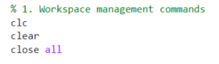
Figure 1 - Workspace management commands

5.2 Defining Material Properties
This section sets the thermal properties of the aluminium plate to specific values, so they are easier integrated into equations further down.
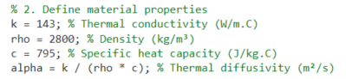
Figure 2 - Defining Material Properties

5.3 User Inputs for Spatial Consideration
This section prompts the user to input values for the plate dimensions and grid spacing. The while loop ensures that the dimensions are positive and that the grid spacing is a divisor of both the $X_{dim}$ and the $Y_{dim}$ without remainders.
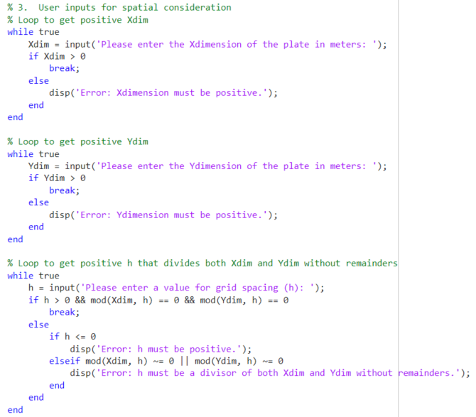
Figure 3 - User inputs for spatial consideration

5.4 Compute Number of Rows and Columns
This section calculates the number of grid points (Nx, Ny) based on the dimensions and grid spacing.
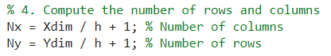
Figure 4 - Number of rows and columns

5.5 Temperature Matrix Initialisation
This section initialises the temperature matrix ($T_{1}$) with zeros sets the boundary conditions using user-defined temperature ($T_{0}$).
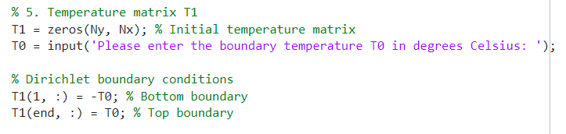
Figure 5 - Temperature matrix initialisation

5.6 User Input for Temporal Consideration
This section prompts the user to input a time step that satisfies the stability criterion, calculated using the maximum permissible dt value.
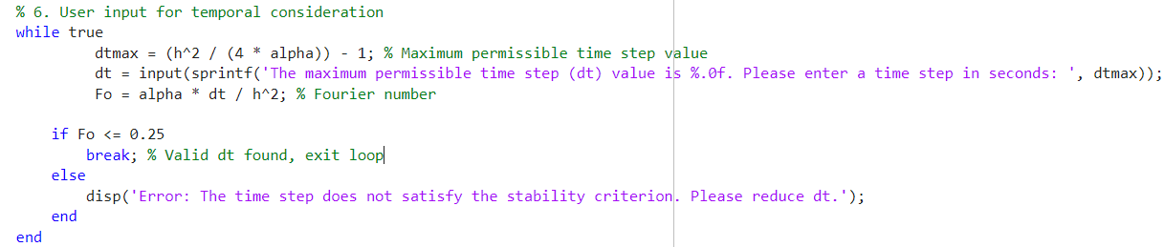
Figure 6 - User input for temporal consideration

5.7 Initialise Temperature Matrix T2
This section copies the initial temperature matrix (T1) to T2 for iterative updates.
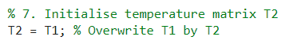
Figure 7 - Initialise temperature matrix T2

5.8 Convergence Criterion Threshold
This section sets the maximum allowable temperature difference (CC) for convergence.
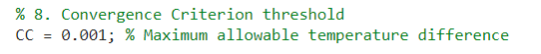
Figure 8 - Convergence Criterion

5.9 Calculation of Temperature Distribution T2
This section iteratively updates the temperature matrix (T2) using the Explicit Finite Difference Method until the maximum temperature difference between iterations is below the conversion criteria. This section of code also applies Neumann boundary conditions and counts the number of time steps and total time.
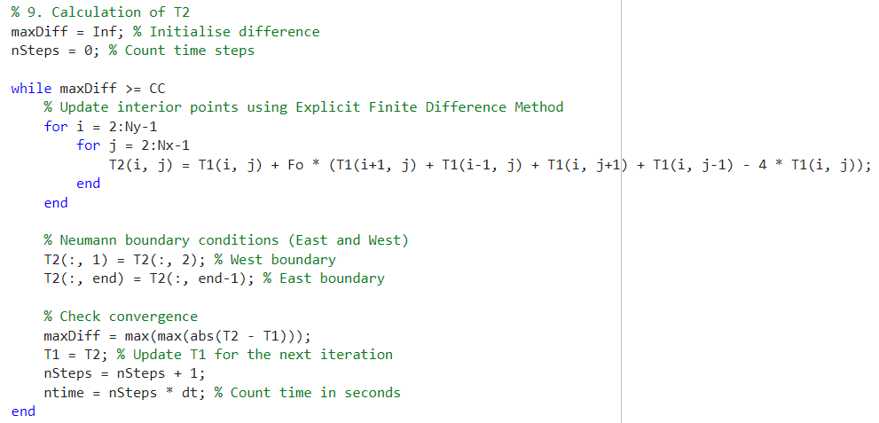
Figure 9 - Calculation of temperature distribution T2

5.10 Analytical Solution
This section computes the analytical temperature distribution based on the given boundary conditions. ‘J’ represents the number of columns and ‘i’ represents the number of rows.
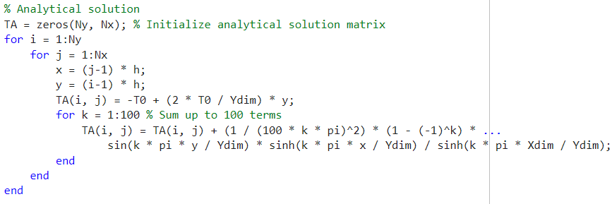
Figure 10 - Analytical solution

5.11 Plotting Numerical and Analytical Solution
This section plots the numerical and analytical temperature distribution using contour plots.
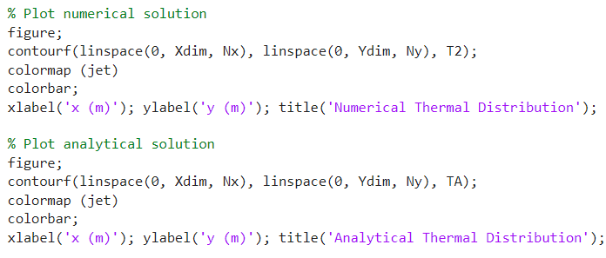
Figure 11 - Plotting the numerical and analytical solutions

5.12 Calculate and Plot Error Map
This section computes the error map representing the difference between the numerical and analytical solutions.
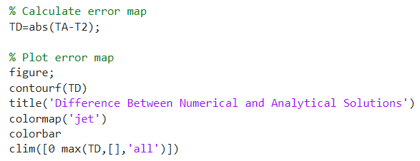
Figure 12 - Calculate and plot error map

5.13 Command Window Information Display
This section displays the thermal equilibrium time, numerical solution, analytical solution, and the error map in the Command Window.
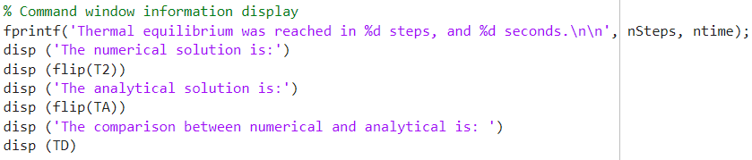
Figure 13 - Command window display information

Validation of the code
The validation of the MATLAB code involves comparing the numerical temperature map at thermal equilibrium with the analytical solution. For this analysis, the dimensions of the plate were set to 5 meters by 5 meters, the grid spacing (h) to 1 meter, the boundary temperature ($T_{0}$) to 50°C, and the time step (dt) to 3600 seconds. The numerical model reached thermal equilibrium after 25 steps, corresponding to 90,000 seconds.
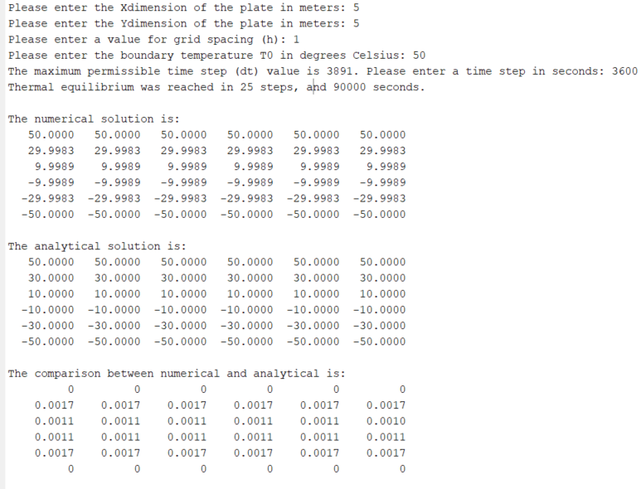
Figure 14 - MATLAB Code output

These results demonstrate that the numerical solution closely approximates the analytical solution, with the maximum discrepancy being only 0.0017°C. This level of accuracy indicates that the Explicit Finite Difference Method (EFDM) implemented in MATLAB is reliable for modelling heat diffusion in two-dimensional domains.
The minor discrepancies can be attributed to inherent numerical approximations and discretisation effects, which are expected in finite difference methods. These small errors are acceptable within the context of engineering and scientific applications, as they do not significantly impact the overall accuracy of the temperature distribution.
In conclusion, the validation process confirms the effectiveness of the MATLAB code in solving the heat diffusion problem. The close agreement between the numerical and analytical solutions highlights the reliability of the EFDM for thermal analysis. The code successfully simulates the temperature distribution within the aluminium plate, providing accurate results that can be trusted for further engineering and scientific studies.
This validation underscores the importance of carefully selecting numerical parameters such as grid spacing, time step, and tolerance to achieve optimal accuracy and computational efficiency. Future improvements could involve adopting more advanced numerical methods, such as implicit schemes or adaptive grid refinement, to further enhance the model's stability and accuracy.

Analysis of the code results

7.1 Grid spacing
The grid spacing (h) significantly impacts the thermal equilibrium time in numerical heat diffusion simulations. As observed in the data, larger grid spacings (4m) result in longer thermal equilibrium times (282,600 seconds), while finer grid spacings (0.2m) lead to shorter equilibrium times (251,700 seconds). This trend underscores the trade-off between computational efficiency and accuracy in finite difference methods.
Finer grid spacings provide a more detailed and accurate representation of the temperature distribution within the domain. However, they also increase the number of grid points, thereby escalating computational demands. For instance, reducing the grid spacing from 1m to 0.2m results in a slight decrease in thermal equilibrium time from 254,700 seconds to 251,700 seconds. This minimal change suggests that beyond a certain point, further reduction in grid spacing yields diminishing returns in terms of accuracy relative to the additional computational cost.
Interestingly, the thermal equilibrium time for a grid spacing of 2m (255,150 seconds) is slightly shorter than that for 1.5m (258,600 seconds). This anomaly can be attributed to fewer computational nodes in coarser grids, reducing the overall computational effort per iteration. Additionally, coarser grids exhibit higher numerical diffusion, which can artificially accelerate the diffusion process, leading to an earlier attainment of equilibrium (Holleman, Fringer and Stacey, 2013). Therefore, selecting an optimal grid spacing is crucial for balancing accuracy and computational efficiency in heat diffusion simulations.
Table 1 - Grid spacing influence on thermal equilibrium time
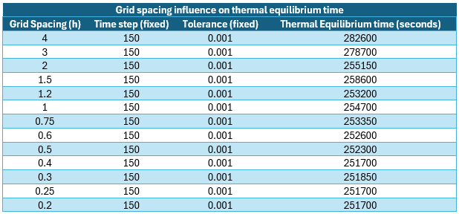

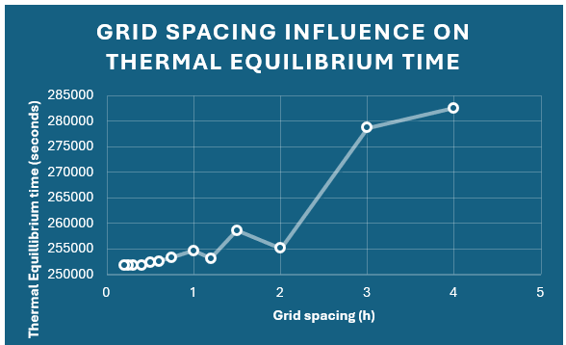
Figure 16 - Grid spacing influence on thermal equilibrium time

7.2 Time step
The choice of time step (dt) is critical for the stability and convergence of numerical solutions in explicit finite difference methods. The data shows that larger time steps result in longer thermal equilibrium times, while smaller time steps significantly reduce equilibrium times. For example, a time step of 2,000 seconds leads to a thermal equilibrium time of 528,000 seconds, whereas a time step of 25 seconds reduces the equilibrium time to 282,775 seconds.
Smaller time steps enhance stability and accuracy by adhering to the Courant-Friedrichs-Lewy (CFL) condition, essential for explicit methods (Caminha, 2024). This condition ensures that numerical solutions remain stable and accurate. However, smaller time steps also increase the number of iterations required, thereby extending computation time. Balancing the time step size to optimize stability and computational efficiency is vital for effective modelling (Kornhaas, Sternel and Schäfer, 2008).
Table 2 - Time step influence on thermal equilibrium time
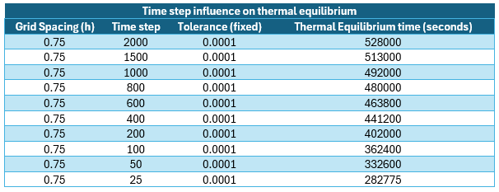
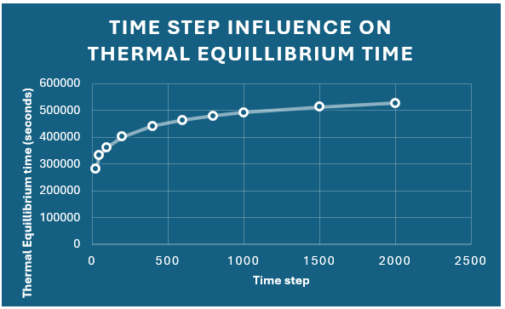
Figure 17 - Time step influence on thermal equilibrium time

7.3 Thermal equilibrium tolerance
Thermal equilibrium tolerance is the threshold used to determine when the solution has reached a steady state. Stricter tolerances result in higher accuracy but also prolong computation time. The data reveals that reducing the tolerance from 0.1 to 0.000001 significantly increases the thermal equilibrium time from 57,500 seconds to 723,500 seconds.
Stricter tolerances improve the precision of equilibrium identification, leading to a more accurate final temperature distribution. However, they also require more computational resources and time. Conversely, looser tolerances reduce computational effort but may compromise accuracy. Selecting an appropriate tolerance is crucial for balancing accuracy and computational efficiency in heat diffusion simulations (Michalcová and Kotrasová, 2020).
Table 3 - Tolerance influence on thermal equilibrium time
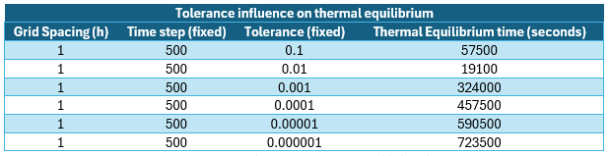
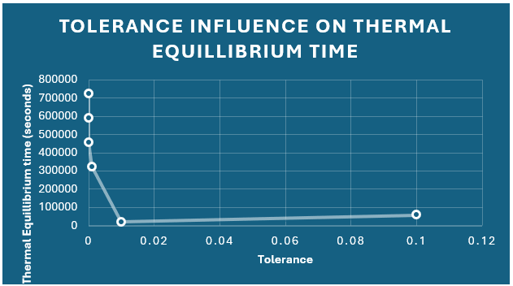
Figure 18 - Tolerance influence on thermal equilibrium time

7.4 Conclusion
In conclusion, the analysis highlights the critical impact of grid spacing, time step, and tolerance on the stability, accuracy, and efficiency of numerical heat diffusion simulations. Finer grid spacings improve accuracy but demand more computational resources, while optimal time steps ensure stability and accuracy without excessive computation time. Stricter tolerances enhance precision but prolong computation. The study validates the effectiveness of the Explicit Finite Difference Method (EFDM) for modelling heat diffusion in two-dimensional domains, provided that numerical parameters are carefully selected. These findings underscore the need for a balanced approach in numerical modelling, aligning with established principles and supporting the method's reliability for accurate thermal analysis. Further research could enhance model accuracy and efficiency through advanced techniques like adaptive grid refinement and implicit methods.

Limitations of the model

8.1 Limitations due to numerical method

8.1.1 Round-off error
Round-off errors occur when numbers are represented with limited digits. Each arithmetic operation introduces a small error, and these errors accumulate over numerous iterations, affecting accuracy. In the EFDM, repeated temperature calculations at each grid point can significantly deviate from true values due to accumulated round-off errors (Kehlet and Logg, 2017).

8.1.2 Truncation error
Truncation errors occur when infinite processes are approximated by finite ones. In numerical simulations, continuous differential equations are discretised into finite algebraic equations, introducing errors because truncated series or differences do not perfectly represent the continuous system. In heat diffusion models, truncation errors arise from finite difference approximations used for spatial and temporal derivatives, potentially leading to less accurate temperature predictions (Zhang et al., 2011).

8.1.3 Complex Geometry
Numerical methods like the Explicit Finite Difference Method (EFDM) struggle to accurately represent complex geometries, as they typically solve Cartesian geometries, leading to errors in capturing boundary conditions and interfaces. This limitation affects overall accuracy, especially in applications like electronic cooling or biomedical heat transfer where precise geometric modelling is crucial (Reddy, 2018). To address this, advanced methods like the Finite Element Method (FEM) or meshless methods offer greater flexibility in representing irregular shapes and boundary conditions, enhancing the accuracy and reliability of thermal analysis by capturing system variations more precisely. These advanced techniques improve the modelling and prediction of complex thermal behaviours, making them valuable tools for engineering and scientific applications.

8.1.4 Stability
The stability of numerical algorithms is crucial for reliable results. An unstable algorithm can produce diverging solutions, leading to significant inaccuracies. In EFDM, stability typically involves adhering to criteria like the Courant-Friedrichs-Lewy (CFL) condition (Caminha, 2024). Failure to meet these criteria can result in unstable solutions and false temperature distributions. Thus, maintaining numerical stability is essential for the accuracy and reliability of the model.

8.2 Limitations due to the coding
The current coding approach in the MATLAB code relies on a predefined minimum difference value between successive temperature maps to determine thermal equilibrium, which may not accurately represent the physical state of thermal equilibrium. This method is computationally efficient but somewhat arbitrary, potentially leading to premature or delayed identification of equilibrium. It doesn't consider the spatial distribution of temperature changes, risking overlooked localised discrepancies that could compromise the model's physical accuracy (Jha and Massa, 2014).

Advanced methods, such as statistical analysis or machine learning techniques, could dynamically adjust the convergence criterion, providing a more refined determination of thermal equilibrium. Implementing physics-based criteria like energy balance or entropy considerations could enhance the model's accuracy. These improvements would ensure the simulated system accurately represents the physical processes, improving the numerical model's robustness and realism for engineering and scientific applications (Zhang and Chen, 2024).

Suggested improvements to the model and future developments

9.1 ADI or Implicit Finite Difference Methods
Adopting Alternating Direction Implicit (ADI) or other implicit finite difference methods can significantly improve stability and efficiency. The current EFDM model is conditionally stable and requires small, computationally intensive time steps. Implicit methods, like the Crank-Nicolson scheme, offer unconditional stability and allow larger time steps while maintaining accuracy. The ADI method enhances stability and efficiency by splitting multidimensional problems into simpler, one-dimensional problems solved alternately (Li et al., 2021).

9.2 Numerical Alternatives to the Finite Difference Method
To handle complex geometries more effectively, alternative numerical methods such as the Finite Element Method (FEM), Finite Volume Method (FVM), and Boundary Element Method (BEM) can be considered:

9.2.1 Finite Element Method (FEM)
FEM divides the domain into smaller, non-uniform elements, providing flexibility in modelling complex geometries and boundary conditions. It is particularly useful in engineering applications where precision is critical (Bielak, 2024).

9.2.2 Finite Volume Method (FVM)
FVM conserves fluxes across control volumes, ensuring accurate and stable solutions, especially in fluid dynamics and heat transfer problems (Moukalled et al., 2016). This method is widely used in computational fluid dynamics (CFD) due to its ability to handle complex geometries and boundary conditions effectively, further enhancing its applicability in engineering and scientific simulations.

9.2.3 Boundary Element Method (BEM)
BEM focuses on the boundaries of the domain, reducing the dimensionality of the problem. This method is advantageous for problems with infinite or semi-infinite domains and complex boundary conditions (Mushtaq, Shah and Muhammad, 2010).

9.3 Robust Thermal Equilibrium Modelling
Improving thermal equilibrium modelling involves developing more robust criteria. Instead of relying solely on a predefined tolerance factor, advanced statistical or machine learning techniques can dynamically adjust the tolerance based on system behaviour. This approach provides a more accurate representation of thermal equilibrium, enhancing the model's reliability (Liu et al., 2024).

Conclusion
This report detailed the development and validation of a 2D heat diffusion model using the Explicit Finite Difference Method (EFDM) for an aluminium plate, achieving accurate simulation and validation of the temperature distribution. Key findings include the successful use of the heat equation and numerical discretisation, validated against the analytical solution through sensitivity analysis of grid spacing, time step, and thermal equilibrium tolerance. Limitations identified include round-off and truncation errors, handling of complex geometries, and stability issues, with suggested improvements involving ADI or implicit methods and alternative numerical approaches like FEM, FVM, and BEM. Overall, the EFDM proved effective for modelling heat diffusion, with recommendations for future enhancements to increase accuracy and efficiency.

References
Bielak, J. (2024). The Finite Element Method. [online] Springer. Available at: https://link.springer.com/book/10.1007/978-3-031-56369-0.
Caminha, G. (2024). The CFL Condition and How to Choose Your Timestep Size. Available at: https://www.simscale.com/blog/cfl-condition/#:~:text=The%20Courant%E2%80%93Friedrichs%E2%80%93Lewy%20or%20CFL%20condition%20is%20a%20condition,an%20important%20role%20in%20computational%20fluid%20dynamics%20%28CFD%29..
Carslaw, H.S. and Jaeger, J.C. (1952). Conduction of Heat in Solids. By H. S. Carslaw and J. C. Jaeger Pp. viii 386. 30s. 1947. (Oxford, at the Clarendon Press). The Mathematical Gazette, [online] 36(316), p.142143. doi:https://doi.org/10.2307/3610347.
Croft, D.R. and Lilley, D.G. (1977). Heat Transfer Calculations Using Finite Difference Equations. Elsevier Science & Technology.
Fadl Hassan Moukalled, L Mangani and Darwish, M. (2016). The finite volume method in computational fluid dynamics : an advanced introduction with OpenFOAM® and Matlab®. [online] Cham: Springer. Available at: https://link.springer.com/book/10.1007/978-3-319-16874-6.
Holleman, R., Fringer, O. and Stacey, M. (2013). Numerical diffusion for flow‐aligned unstructured grids with application to estuarine modeling. International Journal for Numerical Methods in Fluids, [online] 72(11), pp.1117–1145. doi:https://doi.org/10.1002/fld.3774.
Jha, P. and Massa, L. (2014). Teaching thermo-chemical equilibrium using a MATLAB algorithm. The ASEE Computers in Education (CoED) Journal, [online] 5(3), p.93. Available at: https://coed.asee.org/wp-content/uploads/2020/08/11-Teaching-Thermo-Chemical-Equilibrium-Using-a-MATLAB-Algorithm.pdf.
Kehlet, B. and Logg, A. (2017). A posteriori error analysis of roundoff errors in the numerical solution of ordinary differential equations. Numerical Algorithms, [online] 76(1), pp.191–210. doi:https://doi.org/10.1007/s1107501602504.
Kornhaas, M., Sternel, D.C. and Schäfer, M. (2008). Influence of Time Step Size and Convergence Criteria on Large Eddy Simulations with Implicit Time Discretization. In: J. Meyers, B.J. Geurts and P. Sagaut, eds., Quality and Reliability of LargeEddy Simulations. [online] Dordrecht: Springer Netherlands, pp.119–130. doi:https://doi.org/10.1007/9781402085789_10.
Li, C., Long, G., Li, Y. and Zhao, S. (2021). Alternating Direction Implicit (ADI) Methods for Solving TwoDimensional Parabolic Interface Problems with Variable Coefficients. Computation, 9(7). doi:https://doi.org/10.3390/computation9070079.
Liu, H., Deng, H., Feng, X., Liu, Y., Li, Y. and Yao, M. (2024). Datadriven thermal error modeling based on a novel method of temperature measuring point selection. The International Journal of Advanced Manufacturing Technology, [online] 131(3), pp.1823–1848. doi:https://doi.org/10.1007/s00170024131929.
Math is Fun (2017). Taylor Series. [online] Mathsisfun.com. Available at: https://www.mathsisfun.com/algebra/taylor-series.html.
Michalcová, V. and Kotrasová, K. (2020). The Numerical Diffusion Effect on the CFD Simulation Accuracy of Velocity and Temperature Field for the Application of Sustainable Architecture Methodology. Sustainability, 12(23). doi:https://doi.org/10.3390/su122310173.
Mushtaq, M., Shah, A. and Muhammad, G. (2010). Advantages and Disadvantages of Boundary Element Methods Mushtaq, et al Advantages and Disadvantages of Boundary Element Methods For Compressible Fluid Flow Problems. Journal of American Science, [online] 6(1), pp.162–165. Available at: https://www.jofamericanscience.org/journals/am-sci/am0601/21_1158_Mushtaq_am0601.pdf.
Reddy, J.N. (2018). Introduction to the Finite Element method. [online] McGraw-Hill. Available at: https://archive.org/details/introductiontofi0000redd.
Thorsten, B. and Boris, K. (2015). Numerical Modeling of Earth Systems: An introduction to computational methods with focus on solid Earth applications of continuum mechanics. GEOL557. [online] doi:https://doi.org/10.6084/m9.figshare.1555628.v2.
Zhang, H., Liang, S., Song, S. and Wang, H. (2011). Truncation error calculation based on Richardson extrapolation for variablestep collaborative simulation. Science China Information Sciences, [online] 54(6), pp.1238–1250. doi:https://doi.org/10.1007/s114320114274z.
Zhang, Y. and Chen, L. (2024). A modeling method for thermal steady-state simulation of the four-layer printed circuit board. PLOS ONE, [online] 19(9), p.e0310237. doi:https://doi.org/10.1371/journal.pone.0310237.

Appendix

12.1 MATLAB Code

% 1. Workspace management commands
clc
clear
close all

% 2. Define material properties
k = 143; % Thermal conductivity (W/m.C)
rho = 2800; % Density (kg/m³)
c = 795; % Specific heat capacity (J/kg.C)
alpha = k / (rho * c); % Thermal diffusivity (m²/s)

% 3. User inputs for spatial consideration
% Loop to get positive Xdim
while true
Xdim = input('Please enter the Xdimension of the plate in meters: ');
if Xdim > 0
break;
else
disp('Error: Xdimension must be positive.');
end
end

% Loop to get positive Ydim
while true
Ydim = input('Please enter the Ydimension of the plate in meters: ');
if Ydim > 0
break;
else
disp('Error: Ydimension must be positive.');
end
end

% Loop to get positive h that divides both Xdim and Ydim without remainders
while true
h = input('Please enter a value for grid spacing (h): ');
if h > 0 && mod(Xdim, h) == 0 && mod(Ydim, h) == 0
break;
else
if h <= 0
disp('Error: h must be positive.');
elseif mod(Xdim, h) ~= 0 || mod(Ydim, h) ~= 0
disp('Error: h must be a divisor of both Xdim and Ydim without remainders.');
end
end
end

% 4. Compute the number of rows and columns
Nx = Xdim / h + 1; % Number of columns
Ny = Ydim / h + 1; % Number of rows

% 5. Temperature matrix T1
T1 = zeros(Ny, Nx); % Initial temperature matrix
T0 = input('Please enter the boundary temperature T0 in degrees Celsius: ');

% Dirichlet boundary conditions
T1(1, :) = -T0; % Bottom boundary
T1(end, :) = T0; % Top boundary

% 6. User input for temporal consideration
while true
dtmax = (h^2 / (4 * alpha)) - 1; % Maximum permissible time step value
dt = input(sprintf('The maximum permissible time step (dt) value is %.0f. Please enter a time step in seconds: ', dtmax));
Fo = alpha * dt / h^2; % Fourier number

if Fo <= 0.25
break; % Valid dt found, exit loop
else
disp('Error: The time step does not satisfy the stability criterion. Please reduce dt.');
end
end

% 7. Initialise temperature matrix T2
T2 = T1; % Overwrite T1 by T2

% 8. Convergence Criterion threshold
CC = 0.001; % Maximum allowable temperature difference

% 9. Calculation of T2
maxDiff = Inf; % Initialise difference
nSteps = 0; % Count time steps

while maxDiff >= CC
% Update interior points using Explicit Finite Difference Method
for i = 2:Ny-1
for j = 2:Nx-1
T2(i, j) = T1(i, j) + Fo * (T1(i+1, j) + T1(i-1, j) + T1(i, j+1) + T1(i, j-1) - 4 * T1(i, j));
end
end

% Neumann boundary conditions (East and West)
T2(:, 1) = T2(:, 2); % West boundary
T2(:, end) = T2(:, end-1); % East boundary

% Check convergence
maxDiff = max(max(abs(T2 - T1)));
T1 = T2; % Update T1 for the next iteration
nSteps = nSteps + 1;
ntime = nSteps * dt; % Count time in seconds
end

% Analytical solution
TA = zeros(Ny, Nx); % Initialize analytical solution matrix
for i = 1:Ny % I represents the number of rows
for j = 1:Nx % J represents the number of columns
x = (j-1) * h;
y = (i-1) * h;
TA(i, j) = -T0 + (2 * T0 / Ydim) * y;
for k = 1:100 % Sum up to 100 terms
TA(i, j) = TA(i, j) + (1 / (100 * k * pi)^2) * (1 - (-1)^k) * ...
sin(k * pi * y / Ydim) * sinh(k * pi * x / Ydim) / sinh(k * pi * Xdim / Ydim);
end
end
end

% Plot numerical solution
figure;
contourf(linspace(0, Xdim, Nx), linspace(0, Ydim, Ny), T2);
colormap ("jet")
colorbar;
xlabel('x (m)'); ylabel('y (m)'); title('Numerical Thermal Distribution');

% Plot analytical solution
figure;
contourf(linspace(0, Xdim, Nx), linspace(0, Ydim, Ny), TA);
colormap ("jet")
colorbar;
xlabel('x (m)'); ylabel('y (m)'); title('Analytical Thermal Distribution');

% Calculate error map
TD=abs(TA-T2);

% Plot error map
figure;
contourf(TD)
title('Difference Between Numerical and Analytical Solutions')
colormap('jet')
colorbar
clim([0 max(TD,[],'all')])

% Command window information display
fprintf('Thermal equilibrium was reached in %d steps, and %d seconds.\n\n', nSteps, ntime);
disp ('The numerical solution is:')
disp (flip(T2))
disp ('The analytical solution is:')
disp (flip(TA))
disp ('The comparison between numerical and analytical is: ')
disp (TD)

12.2 Sensitivity analysis data
All tests are conduced on a plate with dimension of 12m x 12m, and subjected to a heat of 50°C
Grid spacing influence on thermal equilibrium
Grid Spacing (h) | Time step (fixed) | Tolerance (fixed) | Thermal Equilibrium time (seconds)
4 | 150 | 0.001 | 282600
3 | 150 | 0.001 | 278700
2 | 150 | 0.001 | 255150
1.5 | 150 | 0.001 | 258600
1.2 | 150 | 0.001 | 253200
1 | 150 | 0.001 | 254700
0.75 | 150 | 0.001 | 253350
0.6 | 150 | 0.001 | 252600
0.5 | 150 | 0.001 | 252300
0.4 | 150 | 0.001 | 251700
0.3 | 150 | 0.001 | 251850
0.25 | 150 | 0.001 | 251700
0.2 | 150 | 0.001 | 251700
Time step influence on thermal equilibrium
Grid Spacing (h) | Time step | Tolerance (fixed) | Thermal Equilibrium time (seconds)
0.75 | 2000 | 0.0001 | 528000
0.75 | 1500 | 0.0001 | 513000
0.75 | 1000 | 0.0001 | 492000
0.75 | 800 | 0.0001 | 480000
0.75 | 600 | 0.0001 | 463800
0.75 | 400 | 0.0001 | 441200
0.75 | 200 | 0.0001 | 402000
0.75 | 100 | 0.0001 | 362400
0.75 | 50 | 0.0001 | 332600
0.75 | 25 | 0.0001 | 282775
Tolerance influence on thermal equilibrium
Grid Spacing (h) | Time step (fixed) | Tolerance (fixed) | Thermal Equilibrium time (seconds)
1 | 500 | 0.1 | 57500
1 | 500 | 0.01 | 19100
1 | 500 | 0.001 | 324000
1 | 500 | 0.0001 | 457500
1 | 500 | 0.00001 | 590500
1 | 500 | 0.000001 | 723500

