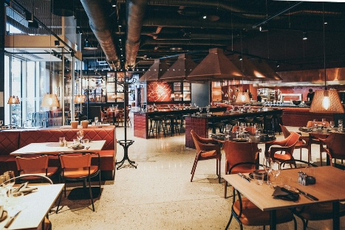
no;2009122
My name is Abdul Mannan and I live in Birmingham, I am married which means I have a wife. I have two children, both of them are boys my older child is fourteen years old and my younger child is eleven years old. I have four siblings one brother and three sisters. I am originally from Bangladesh my religion is Islam. I am self-employed at this moment of time. I am a jewellery designer, means I design and make jewellery and I have been doings this for a long time now.
My journey began when I came to this country (United Kingdom). I was very young then. When I was fourteen years old during my school summer holiday my father’s brother who is my uncle offered me a job at his business which is an Indian restaurant, part time Friday and Saturday night. I took the job because it was a family business. The restaurant was far away from where I was living. It was in a place called Herefordshire; a small town called ross on way. It was a beautiful town. The restaurant called Obilash Indian cuisine. My first job was serving coffee to customers after they had their meal. I was nervous because I didn’t want to drop the hot coffee while I was serving the customers. It was alright for the first night of work and my uncle made everything easy for me. The following weekend I was very excited to go back to work. I continued to work for my uncle for the rest of the school summer holiday. After the school holiday finished my uncle offered me the same job if I wanted to continue work at the restaurant with him every weekend. Happy to yes, because I thoroughly enjoyed working there meeting new people (customers) every Friday and Saturday night. When I finished my secondary school, I wanted to study further, unfortunately my father had health problems which means I had to go get a full-time job because of my father’s earning stopped.
My first full time job was to work with my uncle at his restaurant again. while I was working realized you need to know lots thing about to run a business. Although I enjoying the job, I have realized money wasn’t good (which means salary). I have decided to do something different, if I wanted to earn more money. At that time, there was something called YTS (youth training centre). It is like now days called apprentices.
After joining the program, six month later they put me to placement in the jewellery industry, I have realized could make good salary. here I am making jewellery.

