

Assessment 2

Module name: Data Handling and Business Intelligence
Module code: LCBB5014

Lecturer: Dr Said Usman
Student name: Ventsislava Marinova Peneva
Student ID: 2411180

Table of Contents
1.Introduction 3
2.Data cleaning and Preparation 3
3.Descriptive Statistics and Summary 7
3.1 Overall Descriptive statistics 8
3.2 Descriptive Statistics by Likes, Watches and Average Rating 8
3.3 Trend Analysis 9
4. Statistical analysis using SPSS 12
4.1 Descriptives analysis 12
4.2 Regression Analysis 13
4.3 Correlation Analysis 15
4.4 T-Test 15
5.Insights and Recommendations 16
6.Conclusion 17
References: 17

Data Analysis Report: Letterbox Movie Classification Dataset

1.Introduction
Data is very important in today’s business world. Companies use data to understand customers and make better decisions. In the film and entertainment industry, large amounts of data are created every day through movie ratings, likes, views, and fan activities. Studying this data helps businesses understand what audiences enjoy and what makes a movie successful. The purpose of this report is to analyse movie data and identify viewer behaviour and popularity patterns.
The data used in this report comes from Letterbox Movie Classification Dataset. It includes information such as movie titles, genres, average ratings, runtime, original language, number of watches, likes, and fan counts.
Microsoft Excel and SPSS are used to analyse the data and turn it into useful information. Before analysis, the data is cleaned to remove missing values and fix errors.
After cleaning the data, descriptive statistics are used to summarise the main features of the dataset. Charts and graphs are also created to clearly show trends and patterns across different genres and languages. In addition, statistical tests such as correlation, hypothesis testing, and regression analysis are carried out using SPSS. These tests help examine the relationship between variables and identify factors that influence movie ratings and popularity.
The main aim of this report is to prepare clean data, describe key characteristics of the dataset, find trends, and understand what affects movie success.

2.Data cleaning and Preparation
The data was first checked in Microsoft Excel to make sure it was suitable to use. Filters were applied to key values such as runtime, average rating, and fan count to look for any missing data. The check showed that there were no missing values, so the later analysis would not be affected by incomplete data (Guzman, 2023).
Screenshot 1
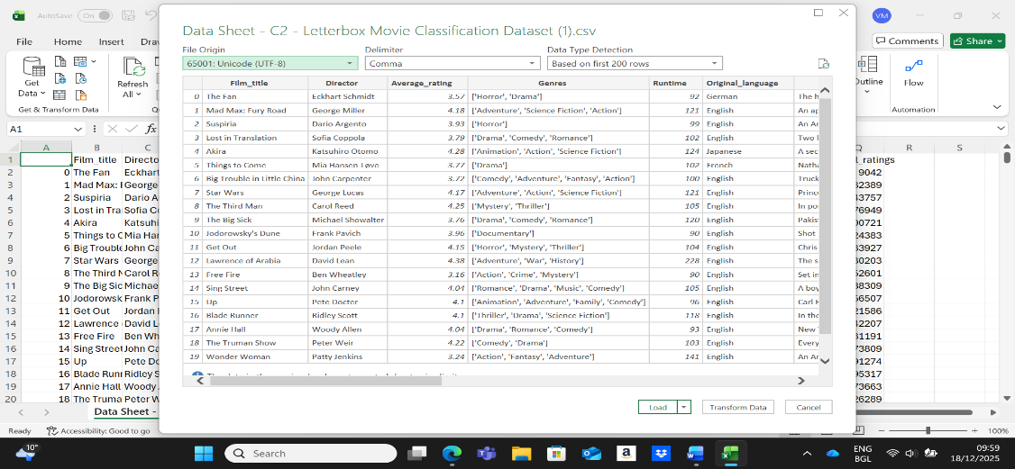
Screenshot 2
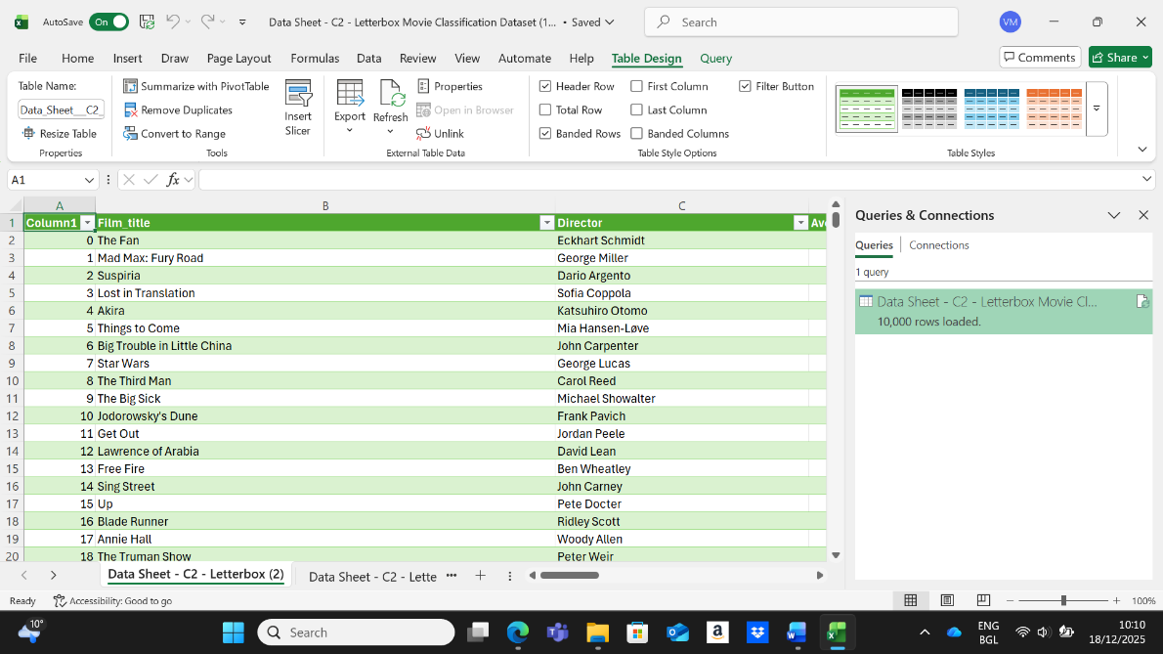

This dataset contains information about movies, such as the film title, director, average rating, genres, runtime, and original language.
The data was saved in a CSV file and opened in Excel. Excel read the file correctly and showed a preview before loading it.
After loading, the data appeared in Excel as a table. The table has 10,000 movies in total. The green header row shows the column names, and the filter arrows allow the data to be sorted or searched.
There is a column called “Column1” that only shows numbers. This column is just for counting rows and is not part of the movie information.
The dataset was loaded successfully and is ready to be used to analysis.
Screenshot 3
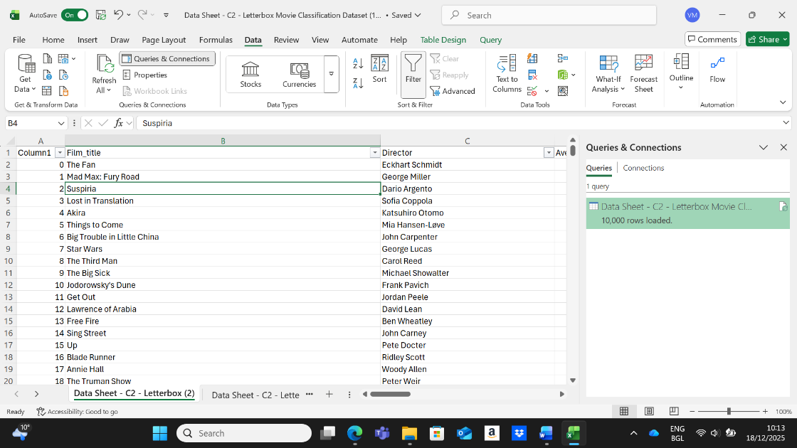
The movie data is opened in Excel as a table. Each row shows one movie, and each column shows details like the movie name and director. The movie “Suspiria” is clicked to select it. This confirms that the data is loaded correctly and can be checked movie by movie.
Screenshot 4
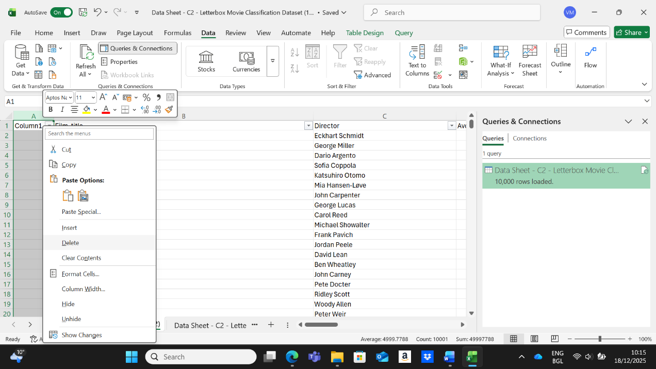

The column named Column1 is right clicked. A menu appears with options to change or remove the column. This column only contains numbers and is not useful movie data, so this step is taken to clean the dataset.
Screenshot 5
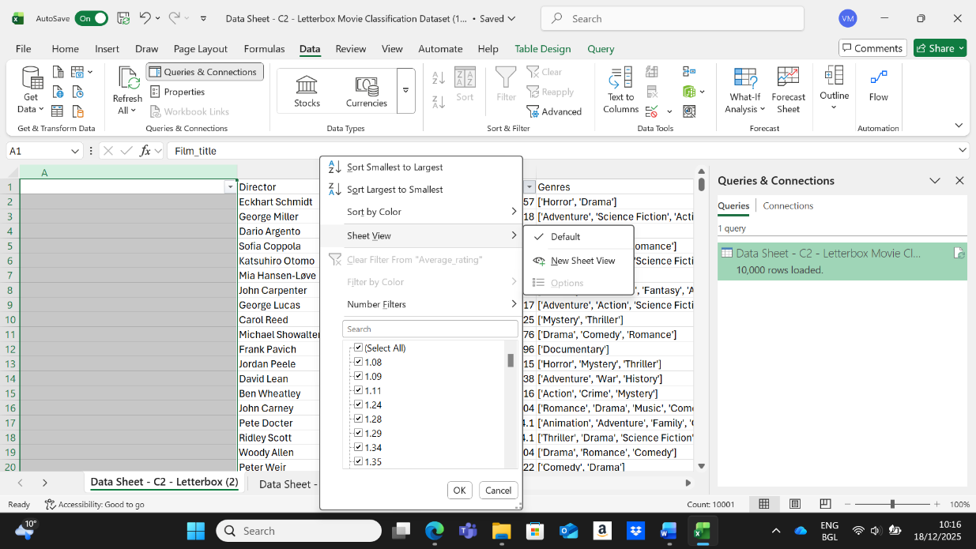
In this step, looked at the movie dataset in Excel. The file had 10,000 movies loaded through Power Query. Opened the Sort-filter menu on the Average rating column to check the rating values. This helping to see the full range or ratings in the data and made sure the numbers were correct and ready for sorting or filtering. This was part of preparing the data so can analyse it later.
Screenshot 6
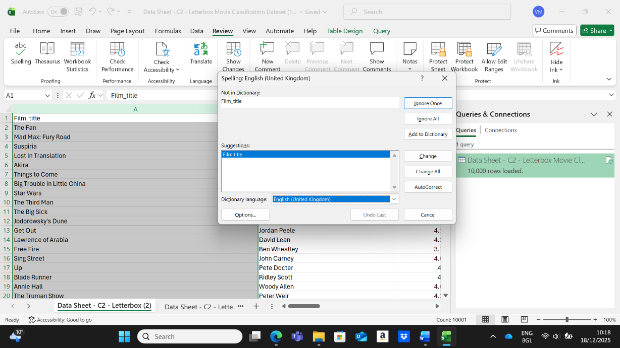

In this step, used Excel’s spell check to review the column names. Excel showed that “Film_title” was not written correctly because of the underscore. It suggested changing it to “Film title” so the name looks cleaner and easier to read. This was part of cleaning the data and making the column names clear before continuing with the analysis.
Screenshot 7
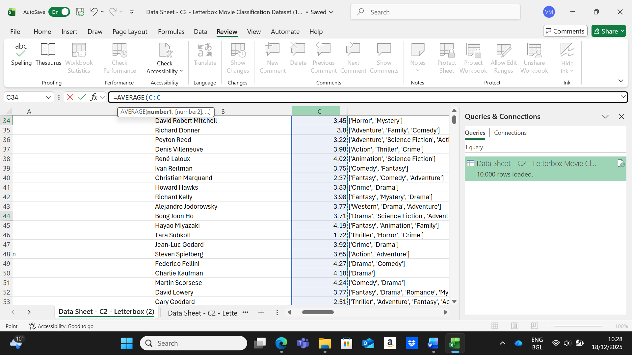
Here I looked at part of the dataset that showed film, directors, the average ratings of their movies, and the genres for each film. To understand the overall rating level, I used the Excel formula =AVERAGE(C:C). This formula finds the average of all the numbers in the ratings column. This helping to see how the movies were rated in general. The data was brought in using Power Query, which made it possible to work with 10,000 rows while keeping everything organised for further analysis.
Screenshot 8
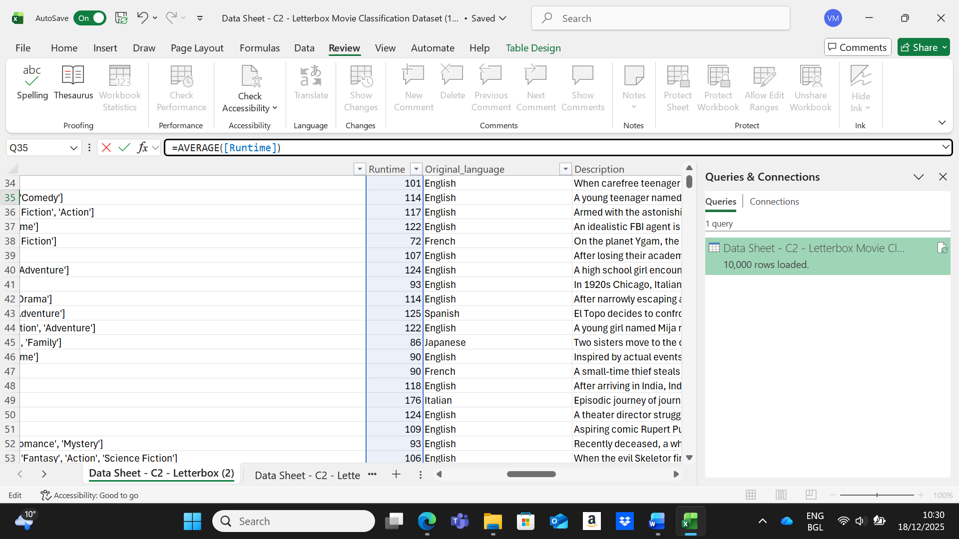
In this step, I worked with data that included movie runtimes, original language, and short plot summaries. To find out the usual length of the movies, used the Excel formula =AVERAGE([Runtime]), which calculates the average runtime of all the films in that column. The dataset also included movies in different languages, like English, French, Spanish, and Italian. This information can be useful later when analysing languages, distribution or other film features.

3.Descriptive Statistics and Summary
Descriptive statistics were create using Microsoft Excel and SPSS to summarise the main features of the dataset. The analysis focused on numerical variables such as average rating, number of watches, number of fans, and runtime, along with important categorical variables. These statistics help to show the typical values, how spread out the data are, and the overall patterns in the dataset (charlotte, 2017).

3.1 Overall Descriptive statistics
This PivotTable shows the average number of likes, movie length, and watches for all movies in the dataset. It appears as one single row because no categories were added to split the data. It was made I a PivotTable, adding likes, runtime, and watches to the values area as averages, and keeping average rating set to all values.
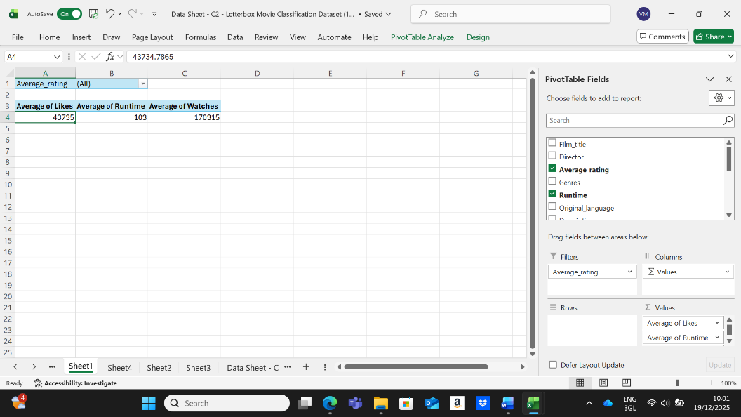

3.2 Descriptive Statistics by Likes, Watches and Average Rating
This PivotTable gives quick summary of the movie data by showing the average numbers. It shows the average likes (43,735), the average watches (170,315), and the average movie rating (about 3). The language filter is set to all, so the table includes movies in every language. Excel then automatically calculated the averages, giving me a simple overview of how popular the movies are and how they are rated.

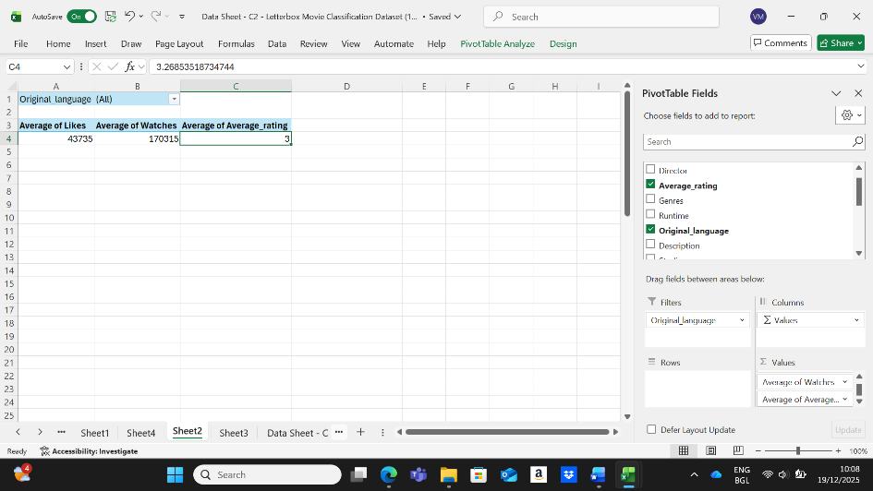

3.3 Trend Analysis
This screenshot shows a PivotTable and a chart that I made in Excel to look at movie data by original language. The table calculates the average number of likes, watches, and the average rating for the movies. The chart then shows these three averages as coloured bars so it’s easy to compare them. I created this by inserting a PivotTable, putting original language in the rows, adding the three metrics to values section (set to Average), and then adding a PivotTable to show the result visually (Cheusheva, 2023).

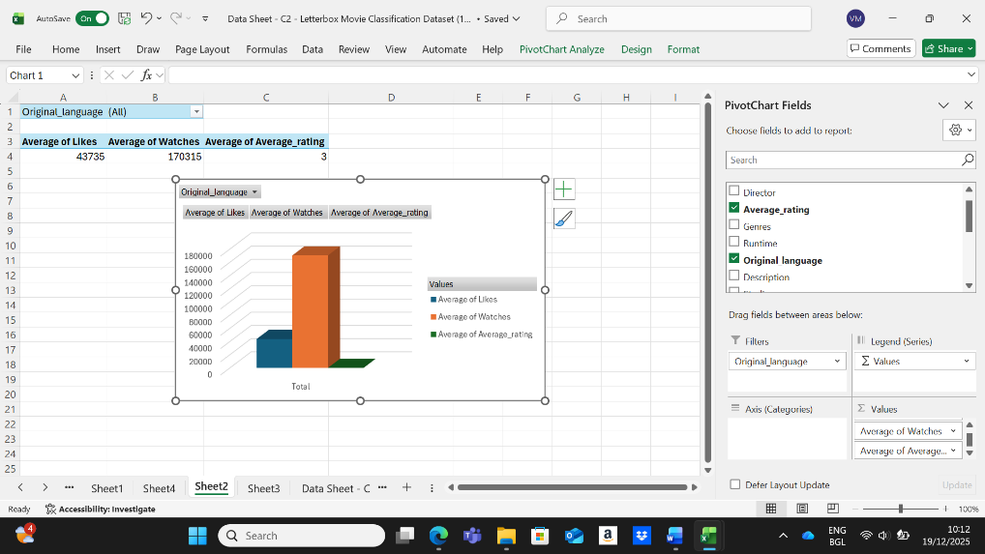

Screenshot 1 Histogram Average Ratings
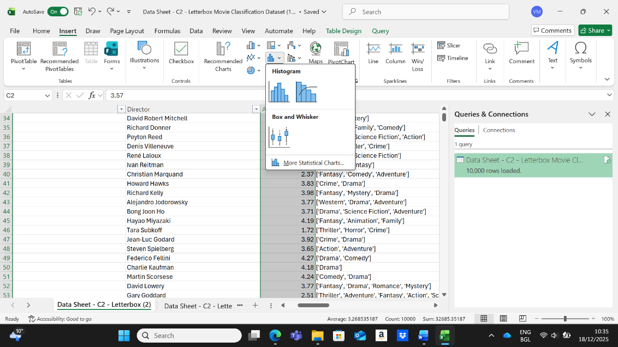
The Excel file displays a big dataset with 10,000 rows of movie information. Each row has a director’s name, their average movie rating, and the genres they work in. At the bottom, Excel shows simple numbers, like the overall average rating of 3.27. I opened the chart menu to make a statistical chart, such as a histogram. This step is mostly about looking over the data and getting ready to show how the ratings are distributed (support.microsoft.com, n.d.).

Screenshot 2 Histogram Average Ratings
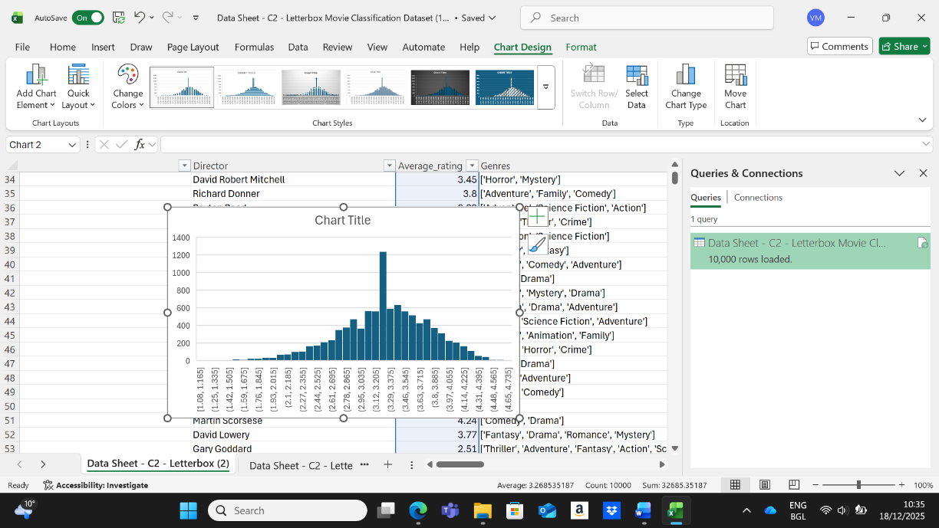
This Excel file has a dataset of 10,000 movies, with information about each movie’s director, average rating, and genres. A histogram was made using the average ratings to show how the ratings are spread out. The horizontal axis shows different rating ranges (for example, 1.08-1.15 or 4.68-4.75), while the vertical axis shows the number of movies or directors in each range. The tallest bar, about 1400, is for ratings between 3.1 and 3.3, showing that most movies and directors have similar ratings. This chart makes it easy to see how the rating are distributed and where most of them fall (Redfern, 2011).
Screenshot 3 Bar Chart: Number of films by Genre
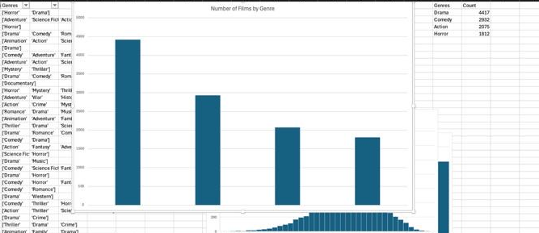
This bar chart shows a clear way to visualise the number of films in four main genres: Drama, Comedy, Action, and Horror. The table lists how many films are in each category: Drama has the most with 4,417 films, followed by Comedy with 2,802, Action with 2,075, and Horror with 1,512.

4. Statistical analysis using SPSS

4.1 Descriptives analysis
Screenshot 1
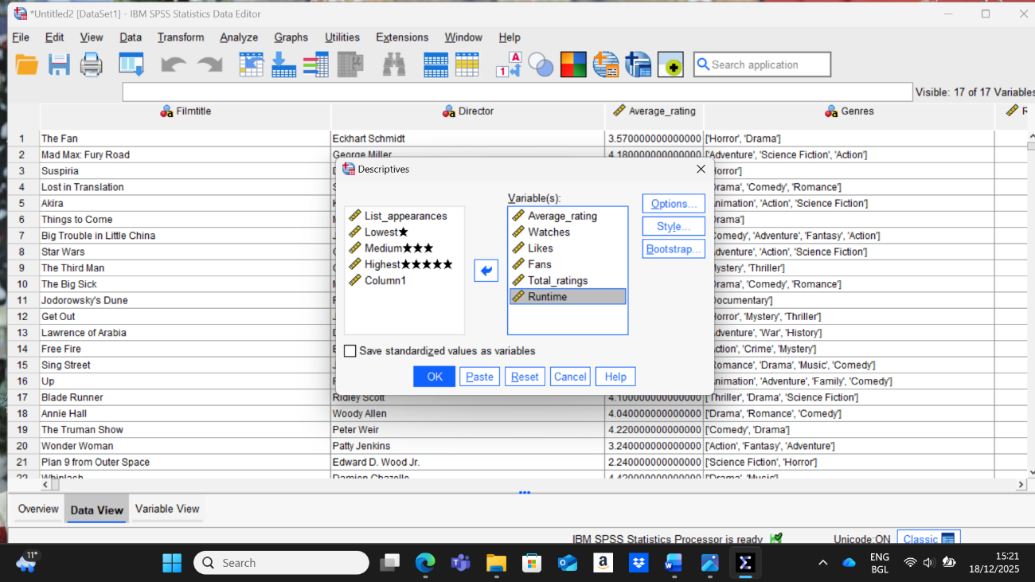
Opened my data in SPSS and used the Descriptives tool to see basic numbers about my variables. I went to Analyse-descriptives and chose the variables I wanted, like ratings, likes, fans, and runtime. Then I clicked OK. SPSS showed simple results such as the average, smallest, and biggest values, which helping to understand my data better (I-cte.org, 2023).
Screenshot 2
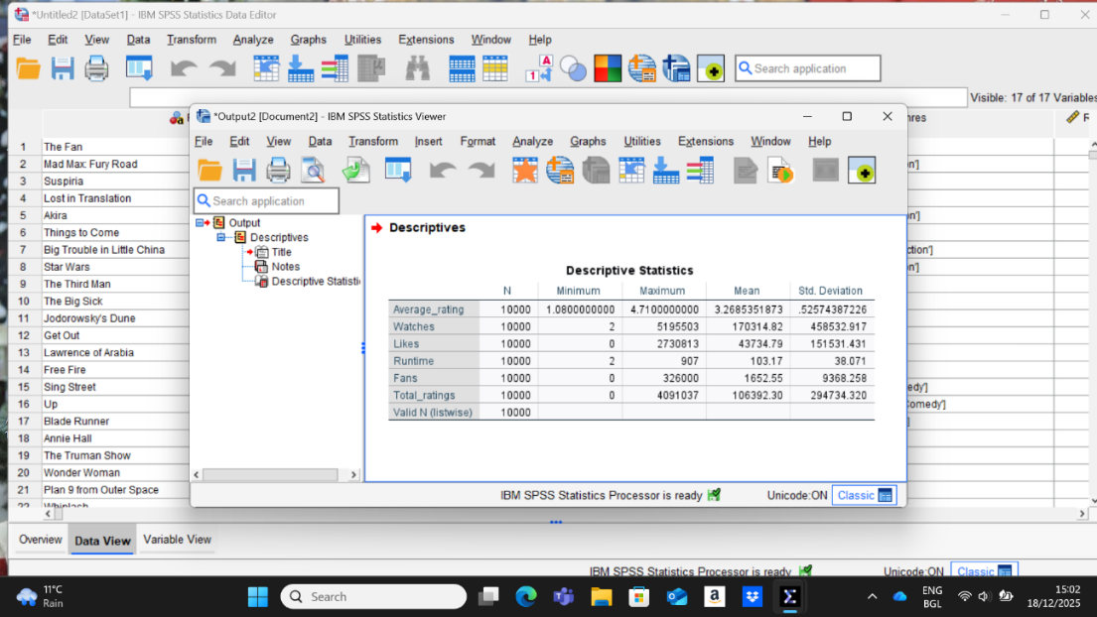
I made this table in SPSS by opening my dataset and then using the Descriptive Statistics option. SPSS then created a table that shows the smallest value, biggest value, average, standard deviation, and how many cases these are for each variable. This gives a quick and clear picture of what the data looks like.

4.2 Regression Analysis
The regression analysis checked if three things-movie length, number of fans, and number of likes- can help explain why movies have different average ratings (Restore.ac.uk, 2011).
Screenshot 1
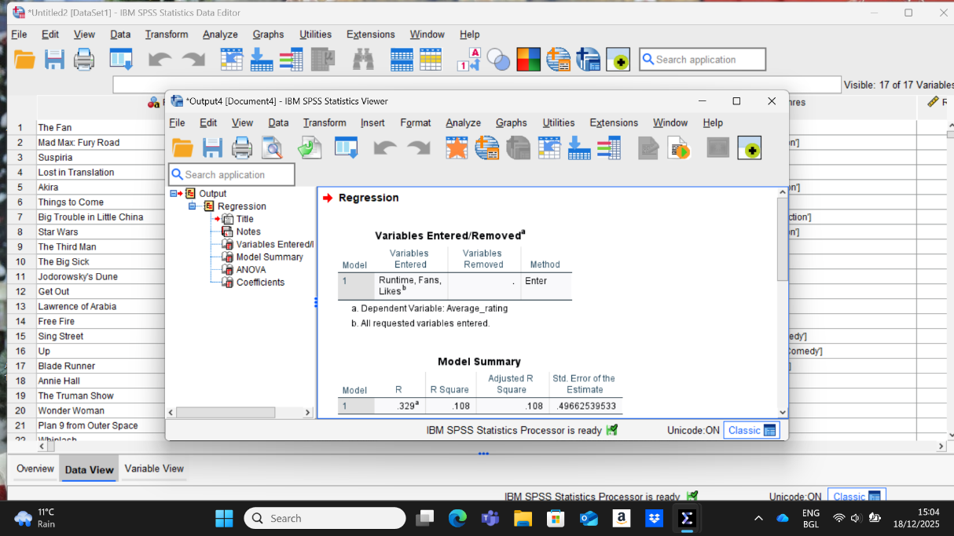
Screenshot 2
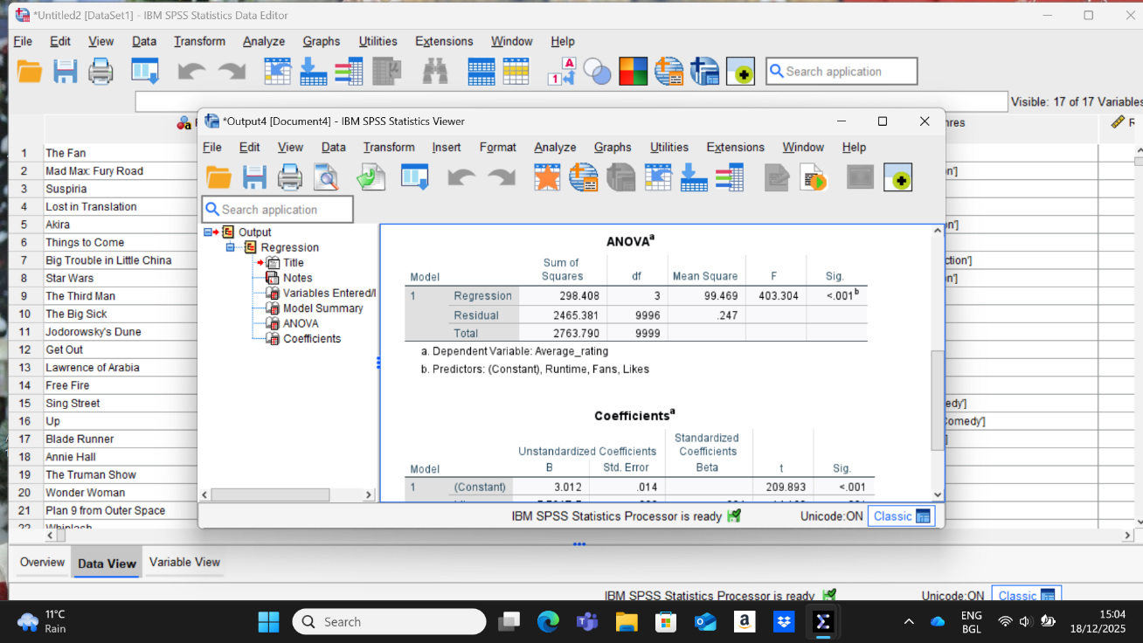
The results show that these factors do affect movie ratings, and this effect is real, not just by chance. But the model explains only about 11% of the differences in ratings, which means many other things also influence how movies are rated.
The constant value of 3.012 means that if movie length, fans, and likes are all zero, the expected movie rating would be around 3. To do this analysis in SPSS, the dataset was opened, and I regression tool was used. Average rating was set as the outcome, and runtime, fans, and likes were added as the factors.
Screenshot 3
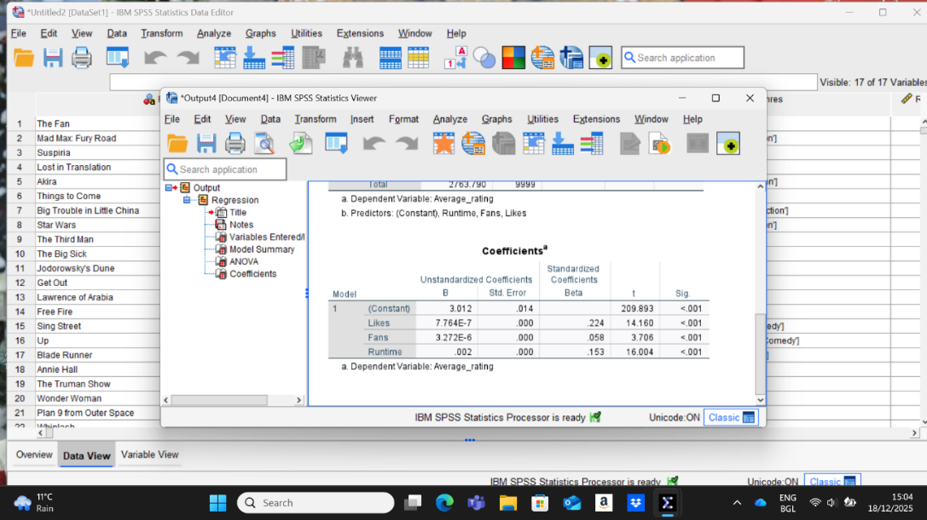
The analysis shows that movie length, number of fans, and number of likes all affect a movie’s average rating. Likes to have the biggest effect, followed by movie length and fans. Even though their effects are small, they are still important. The starting rating is about 3 when all other factors are zero.

4.3 Correlation Analysis
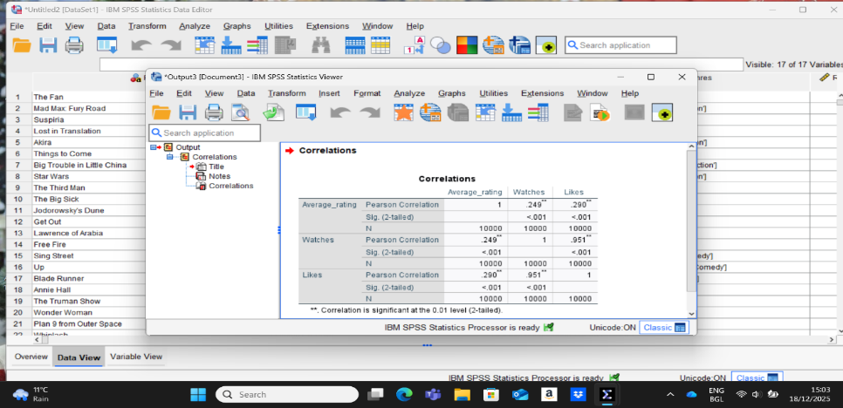
The results show how ratings, watches, and likes are connected. Movies that are watched or liked more usually have a little higher rating. Movies with more watches also have much more likes. All results are meaningful ad not by chance. This I had done in SPSS by going to Analyse-Correlate-Bivariate and choosing Pearson correlation (admin, 2023).

4.4 T-Test
Screenshot 1
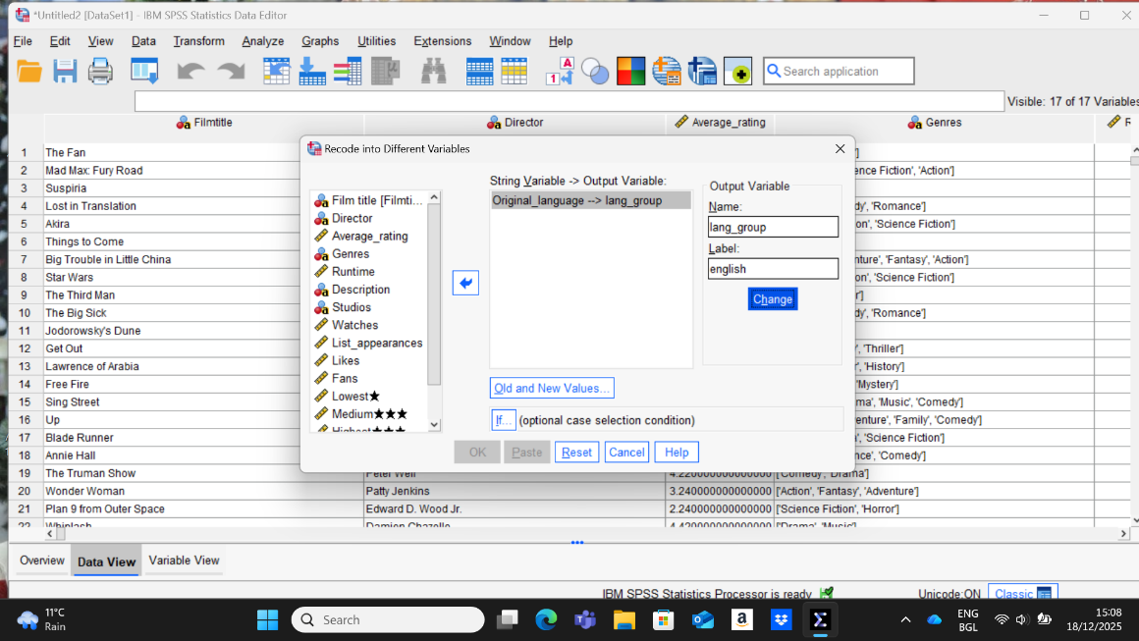
The image shows SPSS with a movie dataset that includes details like titles, directors, ratings, and viewer activity. A window is open to change the original language into a new grouped variable called lang_group for English. This step helps clean and organise the data, so it is easier to analyse (Spss-tutorials.com, 2019).

Screenshot 2
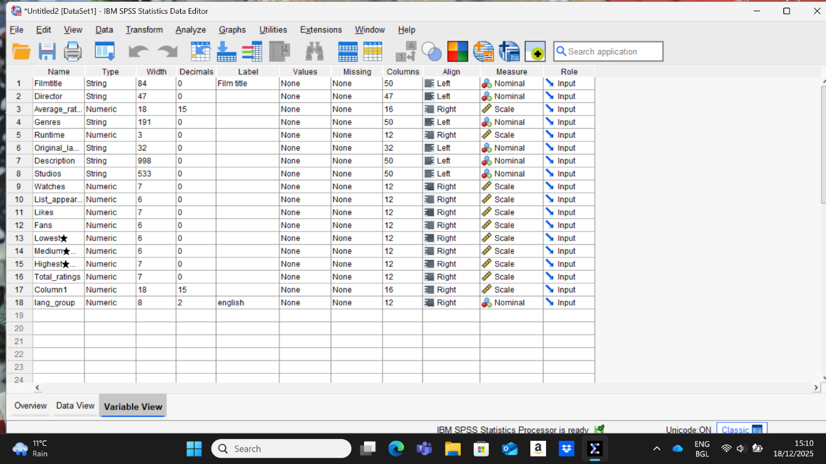
This image shows the “Variable View” in SPSS, where each row is a variable from a movie dataset and each column shows its details, like name, type, label and role. I set this up by entering and adjusting each variable to make sure it is correct and clear. This includes choosing the right measurement type, setting the variable’s role, and decimals, which helps make later analyses accurate and easy to understand.

5.Insights and Recommendations
The Analysis shows a few simple points about what makes films successful on Letterbox. First, popularity and quality are connected, but they are not the same thing. Movies that get many likes and fans often have higher ratings, but genres and language also affect how people feel about them. Second, films that are not in English usually receive higher ratings. This means many viewers enjoy international movies, and platforms could benefit from promoting them more. Third, the length of a movie does not change audience opinion very much. This suggests that the story and overall quality matter more than how long the film is.
Based om these results, we can make a few clear suggestions. Film studios and streaming platforms should continue investing in popular genres like Drama and Action, while also supporting international and non-English films. Making foreign-through good subtitles, better search tools, and targeted marketing-could help more people watch them. It is also helpful to follow audience activity, because likes and fan numbers are strong signs of film’s success.
There are some limits to this analysis. The data comes from users, so it may not aways be complete. Future research could study review sentiment or use time-based data to improve predictions.

6.Conclusion
The report showed how cleaning data, summarising numbers, looking for trends, and using statistical tests can help as understand how movies are rated and how audiences interact with them. After preparing the dataset, we saw that engagement levels were in English. SPSS tests showed strong relationships between views, likes, and fans, and found that likes help predict ratings. Overall, the study shows how business intelligence tools are helping to drive better decisions in film industry.

References:
Guzman, C.D. (2023). Data Cleaning of Movies Dataset. [online] Medium. Available at: https://medium.com/@yosayosa/data-cleaning-of-eda-on-movies-dataset-16afed458b20 [Accessed 18 Dec. 2025].
Redfern, N. (2011). Bar chart or histogram? [online] Research into film. Available at: https://nickredfern.wordpress.com/2011/01/13/bar-chart-or-histogram/ [Accessed 18 Dec. 2025].
I-cte.org. (2023). Descriptive Statistics in SPSS. [online] Available at: https://i-cte.org/academy/descriptive-statistics-in-spss/. [Accessed 18 Dec. 2025].
Restore.ac.uk. (2011). 4.11 Running a Logistic Regression Model on SPSS. [online] Available at: https://www.restore.ac.uk/srme/www/fac/soc/wie/research-new/srme/modules/mod4/11/index.html [Accessed 18 Dec. 2025].
charlotte (2017). Descriptive Statistics. [online] SPC for Excel. Available at: https://www.spcforexcel.com/knowledge/basic-statistics/descriptive_statistics/ [Accessed 19 Dec. 2025].
Cheusheva, S. (2023). Excel TREND function and other ways to do trend analysis. [online] ablebits.com. Available at: https://www.ablebits.com/office-addins-blog/excel-trend-function/. [Accessed 19 Dec. 2025]
support.microsoft.com. (n.d.). Create a histogram. [online] Available at: https://support.microsoft.com/en-us/office/create-a-histogram-85680173-064b-4024-b39d-80f17ff2f4e8. [Accessed 19 Dec. 2025]
admin (2023). Calculate and Interpret Spearman’s Correlation in SPSS. [online] EZ SPSS Tutorials. Available at: https://ezspss.com/calculate-and-interpret-spearmans-correlation-in-spss/. [Accessed 19 Dec. 2025]
Spss-tutorials.com. (2019). SPSS T-Test - Beginners Tutorial. [online] Available at: https://www.spss-tutorials.com/spss-independent-samples-t-test/. [Accessed 19 Dec. 2025]

