Module: Leadership and Management, Theory and Practice
Module code: LCBB6003
Tutor name: Piyumika Gamage
Assignment Title: Component 1: Essay
Student ID: 2119900
Student name: Daniela Jicmon

Table of Contents
TASK 1 3
TASK 2 6
Reference list 9
Appendices 12
Appendix 1: Concept of management or manager 12
Appendix 2: Transactional leadership theory 12
Appendix 3: Situational leadership theory 13
Appendix 4: Contingency theory 13
Appendix 5: Skills in managing to getting people to do what needs to be done 14
Appendix 6: Skills in leading relates to getting people to want to do what needs to be done 15
Appendix 7: Job satisfaction and workforce motivation in Microsoft 15
Appendix 8: Enhancement of organisational performance with leadership and management skills 16

TASK 1
The mentioned statement shows a distinction between the roles of management and leadership, which highlights the managerial responsibilities that can encompass leadership qualities. This answer explores why the statement is problematic.

This debate has been investigated extensively in relation to theory and practice that depicts the nuanced differences and overlap among management and leadership. According to Griffin (2022), management includes planning, organising, controlling and even directing the resources to achieve the goal of the company. The manager's emphasis is on the maintenance of systems, procedures as well as structures that stress efficiency, control and even stability [Refer to Appendix 1]. On the other hand, Kurzhals et al. (2020) argue that leadership focuses on innovation and the personal development of the followers. The manager and leader of these two roles become distinct, and they are not mutually exclusive. The individual can acquire both of these qualities and mix managerial skills with the traits of leadership. Thus, the statement such as a leader cannot be a manager neglects the reality that effective leadership includes managerial competencies including organisational skills, strategic planning along with decision-making. The mentioned statement depicts that the essence of leadership not only needs formal managerial authority to be highly effective but also articulates that the leadership can act at any level within the companies and is not confined to holding managerial titles. The people consider leadership by prioritising initiatives, proposing innovative concepts, or rallying colleagues about causes, regardless of the formal positions.

Concerning the mentioned statement, the transactional leadership theory becomes appropriate [Refer to Appendix 2]. According to Young et al. (2021), this theory talks about the exchange between the followers and the leaders. The managers who stress transactional leadership emphasise the achievement of compliance with the punishments of rewards. This style of leadership is associated with management practice as it highlights the maintenance of order, implementation of policies and even reaching particular targets. For instance, in the corporate world, the CEO of Microsoft, Steve Ballmer, is considered a transactional leader (Baiborodova, 2021). Steve maintains the performance metrics along with the operational efficiency that become vital for the managerial traits. The leadership style of this person highlights the assertion that a manager can be a leader, as Steve effectively managed Microsoft during a period of high growth and changes.
In contrast, the situational leadership theory also becomes vital regarding the mentioned statement. Alvi et al. (2024) overview that this theory highlights that effective leadership depends on the adaptation of styles with maturity as well as the competence of the followers. This theory also suggests that leaders need to possess flexibility to switch between the various styles of leadership including directive, supportive, coaching and even delegation [Refer to Appendix 3]. These all are based on the situational demand on a large scale. For example, the CEO of Starbucks, Howard Schultz, is considered as the situational leader. George (2023) articulates that this person adapts the leadership styles with various contexts including the nurturing of the unique culture of Starbucks and the expansion of this brand in the international market. The capability of Schultz in managing and leading in different situations supports the concept that leaders can also be managers. This includes the mixture of visionary leadership along with practical management skills on a large scale.

Most importantly, the contingency theory becomes appropriate with the leadership and management which is also mixed with the mentioned statement. Shala et al. (2021) depict that the contingency theory shows the effectiveness of the leaders which is contingent upon how well the styles of leadership match with the situations. This also depicts that there is no single possible path to lead, and the qualities of leadership and management become vital to address the complex environment [Refer to Appendix 4]. For instance, the CEO of PepsiCo, Indra Nooyi, is a prime example of contingency leadership which is associated with the strategic vision of this leader which supports the operational needs of PepsiCo. Indra Nooyi balanced visionary leadership with robust managerial practices like the restructuring of the portfolio of this organisation and the implementation of the sustainable model of business (Jdmeier, 2024). These dual practices show how the leadership and management at PepsiCo can coexist and even complement each other.

Most importantly, the practical implication related to this can be given from Elon Musk in Tesla and SpaceX. According to Archwell and Mason (2021), this global leader is well-known for his visionary leadership which encourages innovation and pushes the obstacles in technology to explore new things. Isaacson (2023) overviews that the role of Elon Musk as the manager is proven in the hands-on practices, overseeing the operations of SpaceX and Tesla and the process of decision-making. This mixture of leadership and management become vital for the success of organisations such as Tesla, and SpaceX. On the other hand, the CEO of General Motors, Mary Barra, shows strong leadership which guides GM with the technological transformations regarding sustainable practices (Blanchard, 2021). The managerial skills of Mary Barra become evident in the strategic decision-making along with the operational oversights which highlights that leadership not only prelude the managerial responsibilities. From the perspective of the practical era, it can be said that most effective leaders of companies possess a mixture of managerial and leadership attributes (Armani et al. 2020). They can even manage the tasks well and process them efficiently at the time of encouraging and also motivating the teams. This integration of the skills permits the implementation of the strategic objectives inside the companies that help to foster the positive culture of the organisation.

The distinction between the management and the leadership is a major concern rather than exclusivity. Thus, the mentioned statement oversimplifies the tough relationship between management and leadership. It is real that not all leaders need to be managers and vice versa, but the most effective leaders of companies can embody both of these roles on a large scale. The theoretical framework including transactional, contingency and situational leadership theory shows that leadership and even management become interdependent, and flexibility along with adaptability become the core parts of addressing the various issues in organisations.

TASK 2
The first personal and employability skills such as managing include planning, organising, directing and even controlling the resources which help to achieve particular goals. The core skills regarding effective management highlight communication. According to Winkelmes, et al. (2023), transparent and concise communication becomes vital to set the expectations that present instructions which assures that the team members understand their roles and responsibilities. Effective management utilises verbal and even non-verbal communication to convey the message. Khan (2023) articulates that time management skills highlight that managers value task prioritisation, delegate properly and maintain deadlines. This skill allows one to balance competing values in the workplace. On the other hand, I think managers are required to make fast decisions based on the available information. The skills of good decision-making show critical thinking, analysis of the data and even the potential outcomes. In contrast, Ahmady and Shahbazi (2020) argue that the skill of problem-solving is also important for managers. The managers face issues which need innovative solutions. I think the capability to address the problem, analyse them and implement the solution become vital. Most importantly, the managers need to motivate the team along with delegating the tasks according to the strengths and abilities of the team members [Refer to Appendix 5]. This assures that the work has been distributed effectively and the team members have been valued and even respected.

On the other hand, the second personal and employability skill such as leading or leadership is distinct from the management which stresses the inspiration and motivates the people regarding a common vision. According to Bakker et al. (2023), one of the core skills related to effective leadership is vision and inspiration. The leaders need to articulate a clear vision which motivates as well as inspires the team on a large scale. In my opinion, this vision presents direction along with purpose which encourages people to commit to the goal of the organisation. In contrast, Busu (2020) argue that emotional intelligence is another vital skill which helps make a better leader. This becomes advantageous as it allows one to understand their own and others’ emotions better and creates a strong relationship with the inclusion of a positive working environment. This highlights the skills such as active listening, empathy, resolution of conflict and so on. In contrast, adaptability and resilience become the other vital skills related to leadership. The leaders of an organisation face changing situations and need to be able to adapt quickly. The demonstration of resilience in the era of issues manages the morale of the team and their focus (Degbey and Einola, 2020). On the other hand, the leaders empower the team members with the presentation of the opportunities regarding development and growth. This can highlight the mentoring, presentation of constructive feedback along with support for career development. Most importantly, in my view, influence and negotiation are the other important skills related to leading [Refer to Appendix 6]. Leaders need to influence others and negotiate properly to achieve the targeted outcome. This skill becomes vital and is associated with the team members with the goal of the company.

Impact on the individual and performance of the organisation
The development of leadership skills as well as management skills increases the performance of the individual in various ways. Effective time management along with decision-making skills support the individual to work effectively which boosts productivity. For instance, the project management training of Google emphasises the advancement of these skills that boost the performance of its employees (Grow. google, 2024). In contrast, leadership skills like empowerment, and inspiration create a high level of motivation along with job satisfaction. The employees who feel valued are likely to be more involved in the work. For example, the leadership and development programs in Microsoft nourish these skills which motivate its workforce on a large scale [Refer to Appendix 7]. On the other hand, the advancement of these skills leads to the professional growth of an individual which makes them highly competitive in the global job market. This has been exemplified by Amazon, which makes investments largely in leadership training for its employees (Shrm.org, 2019). This implements the culture of continuous learning as well as development.

Most importantly, the collective impact of skilled managers and even leaders on the performance of the companies is also significant, as it boosts innovation and creativity (Lee et al. 2020). The culture which inspires problem-solving, as well as innovation, supports the advancement of new thoughts and concepts as well as solutions. For instance, the focus of Apple Inc. on innovative thinking along with leadership became the core factor for its high success and market leadership (Hbr.org, 2020). In contrast, companies with strong leadership and management show a low rate of turnover along with high engagement of the employees. This has been exemplified by organisations such as Southwest Airlines which highly prioritises leadership development that leads to high satisfaction and loyalty from its employees. In contrast, effective leaders ensure that the vision and goals of the organisations have been communicated transparently in association with the objectives of the individual [Refer to Appendix 8]. This perspective implements the unified practice to gain the organisational goal. For instance, IBM incorporates its leadership development program with the maintenance of strategic objectives which increases the performance and even growth of IBM (Ibm, 2024). The capability to adapt to changes and to address issues becomes vital for the success of company. Leaders who become resilient and even adaptable can present guidance to the organisation and capitalise on new opportunities. This resilience has been demonstrated by Tesla, the global automotive brand, which addresses the production issues as well as fluctuation of the market with the incorporation of leadership adaptability.

Thus, the development of leadership and management skills becomes important for individual and organisational success. These skills not only advance personal performance but also lead to a positive organisational culture with high innovation, and even strategic alignment.

Word count: 2004

Reference list
Ahmady, S. and Shahbazi, S., 2020. Impact of social problem-solving training on critical thinking and decision making of nursing students. BMC nursing, 19(1), p.94. https://link.springer.com/content/pdf/10.1186/s12912-020-00487-x.pdf
Alvi, L., Nudzulul, F., Arifin, M. and Anshori, M.I., 2024. Situational Leadership: Leader Adaptation Strategies In Various Organizational Contexts. International Journal Business, Management and Innovation Review, 1(2), pp.34-48. https://ekonomi-univetbantara.id/index.php/ijbmir/article/download/15/18
Archwell, D. and Mason, J., 2021. Evaluating corporate leadership in the united states: a review of elon musk leadership. African Journal of Emerging Issues, 3(2), pp.1-10. https://www.ajoeijournals.org/sys/index.php/ajoei/article/download/170/205
Armani, A.B., Petrini, M. and Santos, A.C., 2020. What are the attributes of sustainable leadership?. Revista Brasileira de Gestão de Negócios, 22(04), pp.820-835. https://www.scielo.br/j/rbgn/a/kKJPsznr6RjCGs4dYyJ3bLp/?format=pdf&lang=en
Baiborodova, E., 2021. Bachelor Thesis Evolution of Business strategy and Success Factors of Microsoft Corporation. https://theses.cz/id/2bgw1n/zaverecna_prace.pdf
Bakker, A.B., Hetland, J., Olsen, O.K. and Espevik, R., 2023. Daily transformational leadership: A source of inspiration for follower performance?. European Management Journal, 41(5), pp.700-708. https://www.sciencedirect.com/science/article/pii/S0263237322000603
Blanchard, D., 2021. Supply chain management best practices. John Wiley & Sons. http://dspace.vnbrims.org:13000/xmlui/bitstream/handle/123456789/4488/Supply%20Chain%20Management%20Best%20Practices,%20Second%20Edition..pdf?sequence=1
Bușu, A.F., 2020. Emotional intelligence as a type of cognitive ability. Revista de Științe Politice. Revue des Sciences Politiques, (66), pp.204-215. https://cis01.ucv.ro/revistadestiintepolitice/files/numarul66_2020/18.pdf
By, R.T., 2021. Leadership: In pursuit of purpose. Journal of Change Management, 21(1), pp.30-44. https://www.academia.edu/download/65371120/Leadership_In_Pursuit_of_Purpose.pdf
Degbey, W.Y. and Einola, K., 2020. Resilience in virtual teams: Developing the capacity to bounce back. Applied Psychology, 69(4), pp.1301-1337. https://www.academia.edu/download/91920515/apps.1222020221003-1-sksgsm.pdf
George, A.R., 2023. A Cooperative Business Analysis of Starbucks Corporation & Reflection by Principal Financial Investigator. https://digitalcommons.coastal.edu/cgi/viewcontent.cgi?article=1476&context=honors-theses
Griffin, R.W., 2022. Fundamentals of management. Cengage Learning, Inc. https://thuvienso.hoasen.edu.vn/bitstream/handle/123456789/13211/Contents.pdf
Grow.google, 2024. Learn job-ready skills with Google Career Certificates [Online]. Available at: https://grow.google/intl/en_in/certificates/. [Accessed on: 27.7.2024]
Hbr.org, 2020. How Apple Is Organized for Innovation [Online]. Available at: https://hbr.org/2020/11/how-apple-is-organized-for-innovation. [Accessed on: 27.7.2024]
Ibm.com, 2024. What is talent development? [Online]. Available at: https://www.ibm.com/topics/talent-development. [Accessed on: 27.7.2024]
Isaacson, W., 2023. Elon Musk. Simon and Schuster. https://media-control.de/Leseprobe_Prolog_Walter%20Isaacson_Elon%20Musk.pdf
Jdmeier.com, 2024. Great Lessons from Indra Nooyi [Online]. Available at: https://jdmeier.com/great-lessons-from-indra-nooyi/. [Accessed on: 27.7.2024]
Khan, U.A., 2023. EFFECTIVE TIME MANAGEMENT TECHNIQUES FOR BUSY BUSINESS MANAGERS. Global Journal of Econometrics and Finance, 1(01), pp.49-61. http://gjeaf.com/index.php/Journal/article/download/24/32
Kurzhals, C., Graf‐Vlachy, L. and König, A., 2020. Strategic leadership and technological innovation: A comprehensive review and research agenda. Corporate Governance: An International Review, 28(6), pp.437-464. https://onlinelibrary.wiley.com/doi/pdf/10.1111/corg.12351
Lee, A., Legood, A., Hughes, D., Tian, A.W., Newman, A. and Knight, C., 2020. Leadership, creativity and innovation: A meta-analytic review. European Journal of Work and Organizational Psychology, 29(1), pp.1-35. https://ore.exeter.ac.uk/repository/bitstream/handle/10871/38764/EJWOP%20final%20version%20August%202019.pdf?sequence=2
Shala, B., Prebreza, A. and Ramosaj, B., 2021. The contingency theory of management as a factor of acknowledging the leaders-managers of our time study case: The practice of the contingency theory in the company Avrios. Open Access Library Journal, 8(9), pp.1-20. https://www.scirp.org/journal/paperinformation?paperid=111736
Shrm.org, 2019. Amazon Commits to Investing Millions in Training [Online]. Available at: https://www.shrm.org/in/topics-tools/news/organizational-employee-development/amazon-commits-to-investing-millions-training. [Accessed on: 27.7.2024]
Winkelmes, M.A., Boye, A. and Tapp, S. eds., 2023. Transparent design in higher education teaching and leadership: A guide to implementing the transparency framework institution-wide to improve learning and retention. Taylor & Francis. http://bi-dam-prod.s3.amazonaws.com/5bdc921fd5ef2b744770d6fc/e93dbaf29f8a50db8b5dabd6eb6738d5b1e71681/9781620368237_23_0309c3db01d5156930159e1e3227d2ea.pdf
Young, H.R., Glerum, D.R., Joseph, D.L. and McCord, M.A., 2021. A meta-analysis of transactional leadership and follower performance: Double-edged effects of LMX and empowerment. Journal of Management, 47(5), pp.1255-1280. https://www.davidglerum.com/s/Young-et-al-AAM-Transactional-Leadership-and-Follower-Performance.pdf

Appendices

Appendix 1: Concept of management or manager
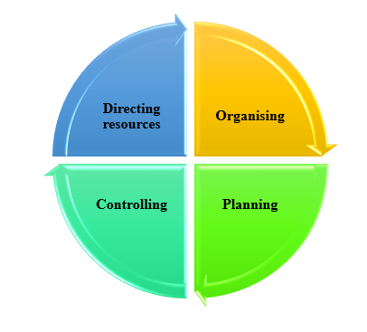

Appendix 2: Transactional leadership theory
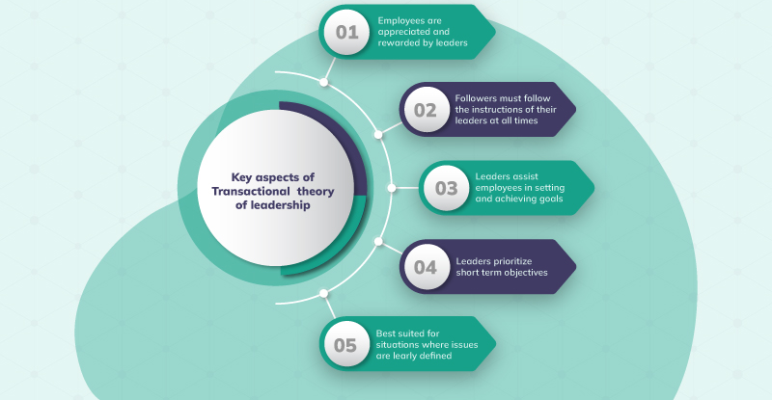

Appendix 3: Situational leadership theory
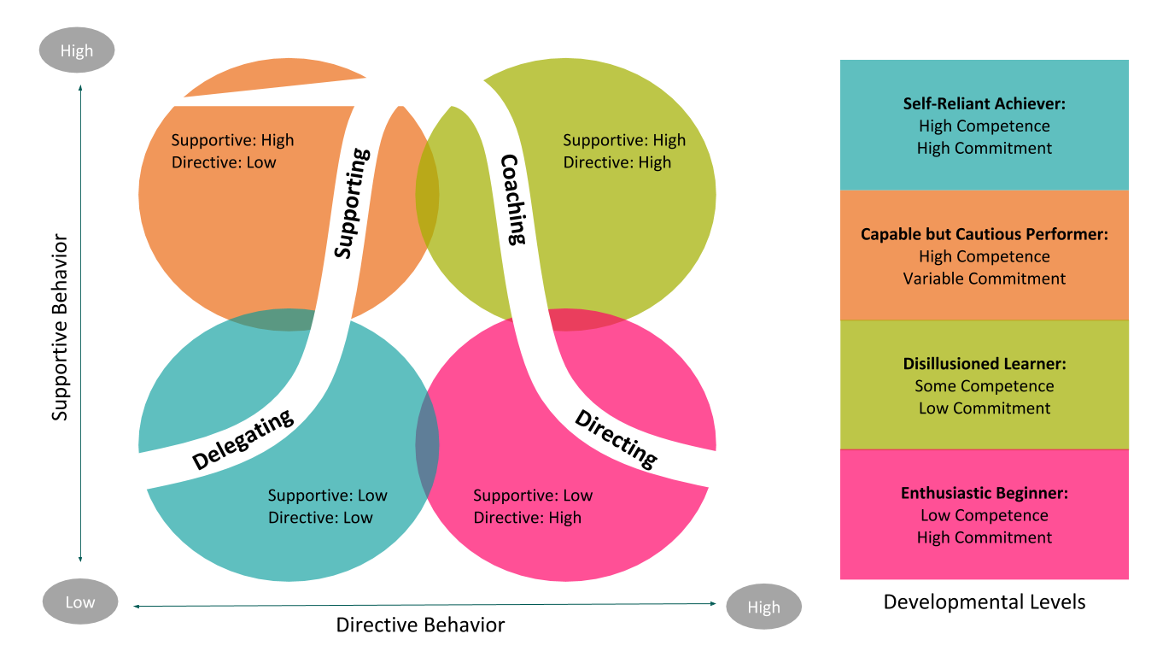

Appendix 4: Contingency theory
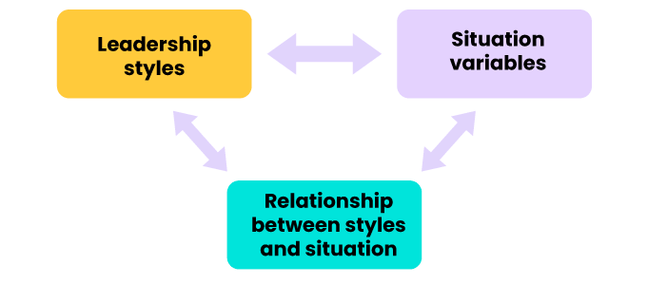

Appendix 5: Skills in managing to getting people to do what needs to be done
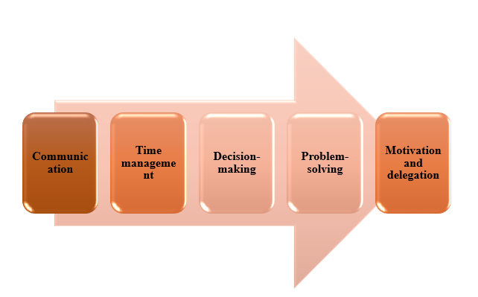

Appendix 6: Skills in leading relates to getting people to want to do what needs to be done
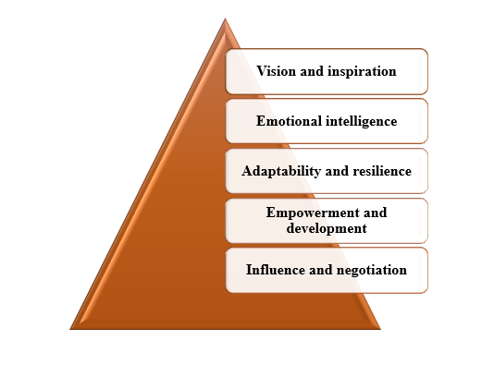

Appendix 7: Job satisfaction and workforce motivation in Microsoft
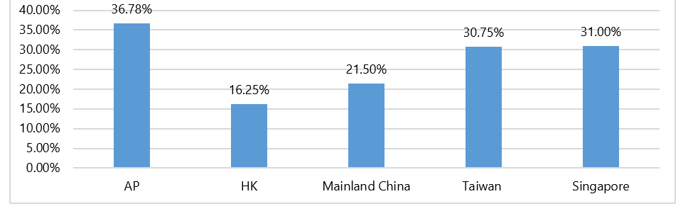

Appendix 8: Enhancement of organisational performance with leadership and management skills


