Trainee Accountant
Posted 4 October by The One Group
Easy Apply
£18,000 - £25,000 per annum
Peterborough, Cambridgeshire
Permanent, full-time
Be one of the first ten applicants
The One Group are recruiting for an enthusiastic Trainee Accountant to join a well established practice in Peterborough on a full time, permanent basis. This role would see you working with a number of clients, small and large, across a variety of different sectors.
This accountancy firm has a great reputation within the area for training and developing new talent, and accelerating your route of progression. No matter where you are with experience or study, you will be given a clear career development path, and be mentored by long standing, experienced members of the business.
The ideal candidate would have some practice experience already, and wanting an opportunity to progress with a firm further through hands on experience and study. You will be offered a fully supported and structured training program to help ensure you have the best opportunity to meet your career ambitions.
Your responsibilities will be varied and include:
- Undertake detailed analysis and reconciliation procedures
- Assist with audit and accounts preparation
- Inputting transactions into the system and preparing reconciliations
- Preparation of VAT returns
- Identify basic tax adjustments
In return for your hard work, motivation and study alongside your dedication to clients on a day to day basis, you will be offered the below brilliant benefits:
- Competitive annual salary £18,000-£25,000 (depending on experience)
- Hybrid working, 3 days from the office, 2 days working from home
- Study support - financial support and leave
- 20 days holiday + bank holidays
- Perkbox - access to a number of discounts
- Auto-enrolment to company pension
If this role sounds like your next step, please apply and speak to Katherine Pearl at The One Group for a confidential chat and for more information on the role.

https://www.reed.co.uk/jobs/trainee-accountant/48406941?source=searchResults&filter=/jobs/jobs-in-hampton-hargate?sortby%3DDisplayDate&utm_campaign=google_jobs_apply&utm_source=google_jobs_apply&utm_medium=organic
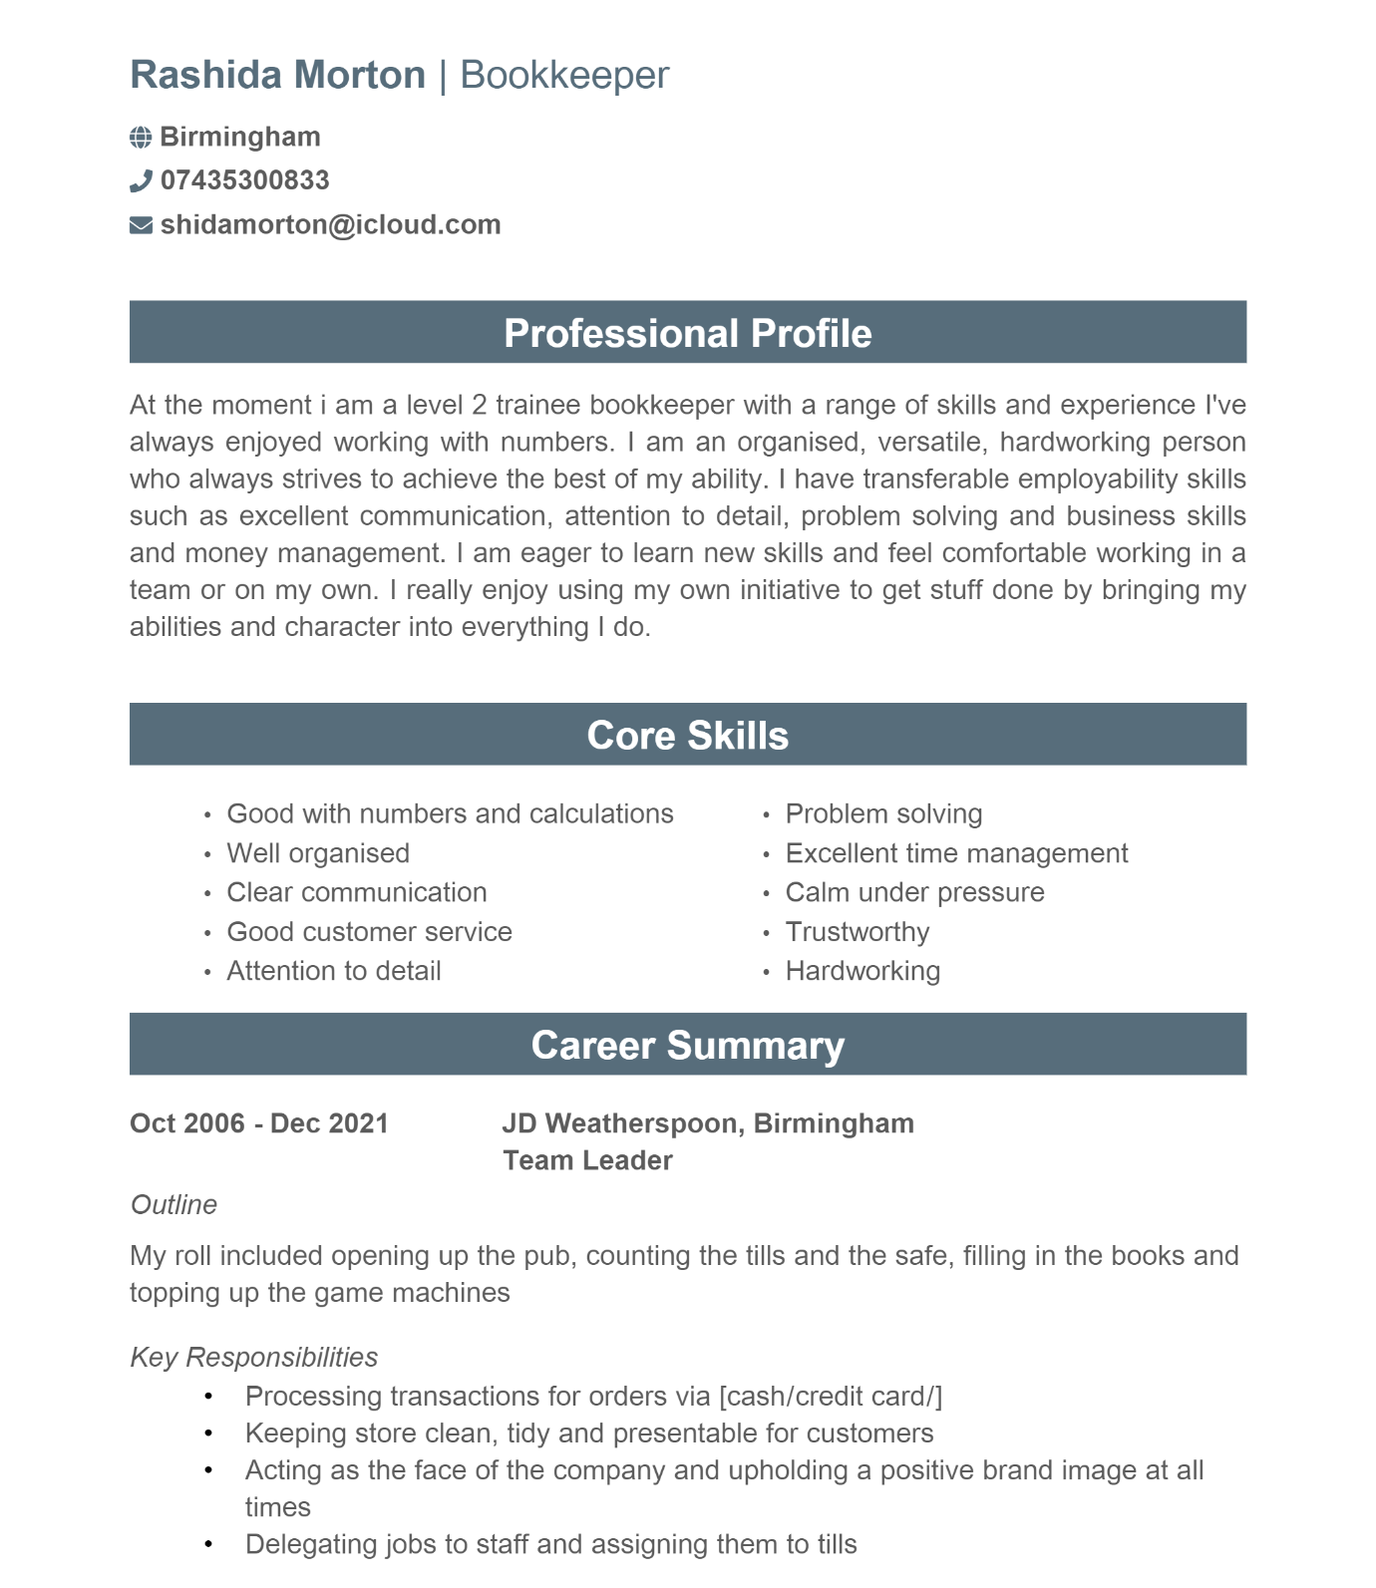

Rashida Morton
19 Over Pool Road Wardend Birmingham B82BY 07435300833 shidamorton@icloud.com

Trainee Accountant
THE ONE GROUP
5 Axon Business Park Commerce Road
Lynchwood Business Park Peterborough
PE2 6LR
01733234000

I am writing to express my sincere interest in the position of Trainee Accountant at your firm I will look forward to learning and developing new skills within your team

I have done many finance related courses at Wolverhampton college ranging from aat payroll/sage aat bookkeeping and aat accounting I hope to put these to use within your company while learning and expanding my experiences. This job seems to be what I am looking for because I am working within the field I love while still being able to study and gain more knowledge

I would like to thank you for taking the time to consider my application and will look forward to meeting with you to discuss my application and qualifications and what I can bring to the team

Yours truly
Rashida Morton

https://www.reed.co.uk/jobs/trainee-accountant/48406941?source=searchResults&filter=/jobs/jobs-in-hampton-hargate?sortby%3DDisplayDate&utm_campaign=google_jobs_apply&utm_source=google_jobs_apply&utm_medium=organic

