Business Plan
GreenLeaf Bistro
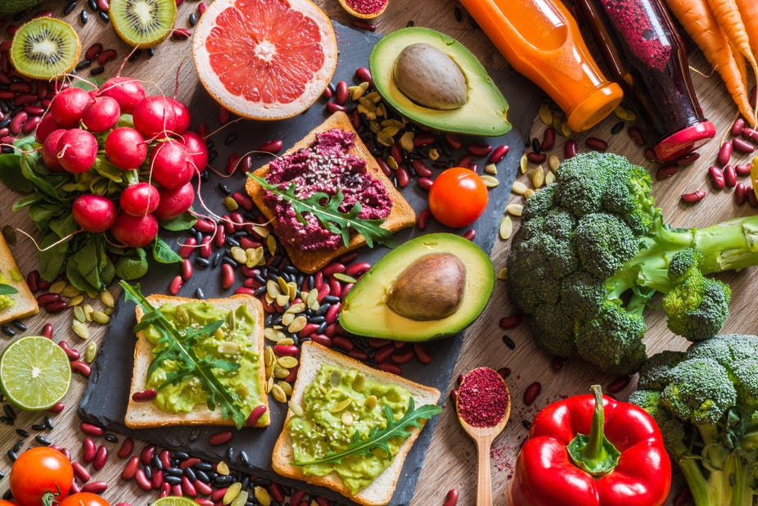
Student's Name: Mariana Ionela Popa
Student's ID: 2122750
Module Name: Entrepreneurship
Assignment: Business Plan
Module Code: LCBB5011
Lecturer Name : Nishi Ramsurrun

- Business Description / Intellectual Property and Legal Considerations
GreenLeaf Bistro, a vegan restaurant that seeks to redifine misconceptions about plant-based diets, introduces the culinary world to a new and inventive culinary endeavour. In addition to enticing taste buds with an array of excellent and aesthetically beautiful vegan cuisine, GreenLeaf Bistro seeks to promote a healthier, more ecologically responsible way of life.
GreenLeaf Bistro combines art, flavour, and sustainability to create excellent plant-based cuisines that appeal to various palates, focusing on obtaining organic, locally-grown items. By presenting vegan food as a gourmet and culinary treat for all food fans, the vast menu at GreenLeaf Bistro attempts to dispel myths about it.
Intellectual Property Considerations
Since GreenLeaf Bistro uses its own recipes and cooking methods, its dishes stand apart. The interior decor and brand emblem of GreenLeaf Bistro will be registered to safeguard its distinct market identity. Additionally, they will look into patenting any cutting-edge cooking methods or technology they develop (Sexton et al., 2022).
Ownership Structure and Legal Considerations
The structure of GreenLeaf Limited Liability Company (LLC) affords them both the benefits of restricted liability and operational freedom. Each co-founder holds a stake in the business and has experience in the culinary arts, sustainable business methods, and business management (Furniss, 2018).
Legally, GreenLeaf Bistro complies with all environmental requirements, health and safety rules, and zoning restrictions. They receive the proper training and certification to guarantee that all staff members meet food safety and quality standards. Additionally, GreenLeaf Bistro acquires the required licenses and permits to operate a restaurant on the preferred site.
GreenLeaf Bistro aspires to pioneer the vegan food sector by providing an unmatched dining experience, embracing sustainability, and advocating a plant-based lifestyle. Their emphasis sets the foundation for long-term success in this cutthroat industry on preserving intellectual property and abiding by the law.
- Industry Analysis
The demand for vegan restaurants is rising swiftly, creating a promising potential for GreenLeaf Bistro to build a significant presence. Consumer tastes for healthier and greener dining options have drastically changed, affecting the industry. The vegan food market in the UK is growing at 9.58%, and 40% of shoppers want plant-based alternatives (The Vegan Business Magazine, 2023).
The market for vegan food restaurants has grown significantly with a varied client base that includes vegetarians, vegans, and other health-conscious people curious about new meals. Sales of organic plant-based food were projected to reach over 305 million US dollars in the UK in 2020. This sum is anticipated to reach 548 million US dollars by 2026.
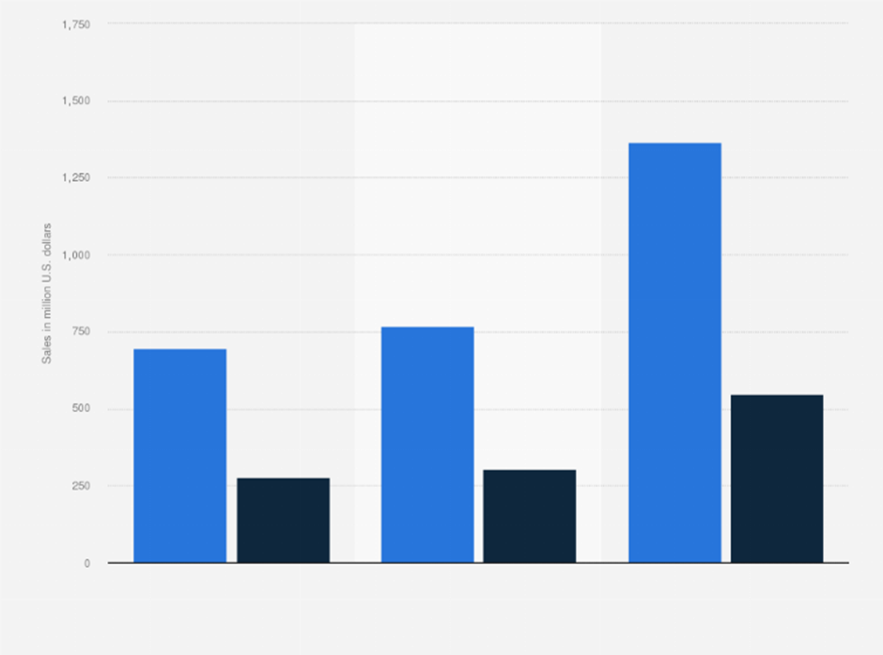
Figure 1: UK: Plant-based food market size by category 2026
Source: (Wunsch, 2022)
VRIO Analysis
Value: GreenLeaf Bistro has a promising future in a market with a growing demand for vegan food due to the company's creative and delicious plant-based cuisines.
Rarity: GreenLeaf Bistro is a distinctive and uncommon offering in the business because of its unique brand identification, patented recipes, and culinary expertise (Alexandru-Ilie et al., 2020).
Imitability: Despite the presence of competing eateries, GreenLeaf Bistro's commitment to intellectual property protection—which includes trademarking their brand and distinctive interior design—ensures that their products will continue to be challenging to imitate.
Organisation: The co-founders' proficiency in culinary arts, sustainability concepts, and business management enhances the organisation's capacity to seize market opportunities.
Porter's Five Forces Analysis
The threat of New Entrants: Due to the demand for skilled chefs, creative cuisine, and a focus on sustainability, the vegan restaurant business has a moderate barrier to entry (Bacon and Krpan, 2018). GreenLeaf Bistro's unique services and solid brand positioning may give it a competitive advantage and discourage new rivals.
Bargaining Power of Suppliers: The accessibility of vegan producs have substantially risen as veganism has grown in popularity, which has reduced suppliers' ability to demand higher pricing. GreenLeaf Bistro may use its network of suppliers to guarantee competitive pricing and quality.
Bargaining Power of Buyers: Due to the availability of vegan eating alternatives, customers have some degree of negotiating power. The emphasis on exceptional service and cutting-edge cuisine at GreenLeaf Bistro may help to distinguish them from competitors and lower buyer power.
The threat of Substitutes: Although other vegan food options are available, GreenLeaf Bistro's focus on elegant, aesthetically beautiful cuisine generates a unique value proposition that lessens the threat of alternatives (Choudhary, 2019).
Competitive Rivalry: New and established rivals compete for market supremacy in the increasingly cutthroat vegan restaurant sector. The emphasis placed by GreenLeaf Bistro on culinary excellence, environmentally friendly methods, and unique brand positioning can help them stand out from competitors.
Due to the market's rapid expansion, unique value offer, and competitive positioning of GreenLeaf Bistro, it is a desirable sector to enter. The VRIO research highlights the company's value and special offers, while Porter's Five Forces analysis suggests that GreenLeaf Bistro may carve out an intriguing position by employing its culinary innovation, sustainability initiatives, and strong brand recognition (Bruijl, 2018).
- Operations and Management Team Plan
Operations Plan
Several different revenue streams will be included in the business plan for GreenLeaf Bistro. The sale of their creative vegan culinary delicacies, which will be provided through a full-service dining experience, will be their primary source of income. The company will also investigate additional revenue opportunities, such as catering, online food ordering, and retail selling vegan products.
GreenLeaf Bistro will develop streamlined procedures for sourcing premium organic products, managing inventories, and adhering to food safety laws to ensure efficient operations. Modern cooking appliances will be in their kitchen, and professional chefs will be working there to provide delectable meals. The restaurant's interior will be thoughtfully constructed to create an engaging atmosphere and welcoming seating, enhancing the overall dining experience.
Management Team Plan
Each GreenLeaf Bistro management team member is a highly qualified professional who brings a unique set of skills and knowledge. Sarah Thompson, the establishment's founder, and a well-known vegan chef, oversees the team. Sarah will be the company's vision and direction-setter thanks to her excellent culinary abilities and passion for sustainable methods.
Mark Johnson, a successful business executive with extensive operations and finance expertise, is helping Sarah. Mark's strategic insight and demonstrated track record of leading successful restaurants will be very beneficial in directing daily operations, financial planning, and company expansion.
A seasoned marketing and branding professional, Lisa Chen completes the management team. In the vegan food sector, Lisa's artistic ability and brand identification expertise will be crucial to the growth of GreenLeaf Bistro as a recognised brand.
GreenLeaf Bistro will be incorporated as a Limited Liability Company (LLC). This decision was chosen because of its flexibility, limited liability protection benefits, and tax requirements' simplicity (Reiser, 2018).
Generating revenue through several channels is given utmost importance in the business plan for GreenLeaf Bistro, with a particular emphasis on offering unique vegan culinary delights and a superb dining experience. Thanks to the qualities and knowledge of the management team and the selected LLC legal structure, the organisation is ready for success in the competitive vegan food industry.
- Marketing Plan
Marketing Strategy
The main goal of GreenLeaf Bistro's marketing plan is to establish a strong brand identity as a top-notch vegan restaurant that appeals to vegans and non-vegans. The restaurant will market itself as an elegant, imaginative plant-based culinary destination that provides food in a welcoming setting. Dispelling the idea that vegan food is unappetising and unimaginative is one of the goals, as is attracting a broad audience looking for a top-notch dining experience.
The 4 Ps Marketing Mix
Product: The broad vegan menu at GreenLeaf Bistro will feature a combination of meals from around the world and locally-sourced organic ingredients. The emphasis will be on developing aesthetically pleasing and delectable dishes that highlight the inventiveness of vegan cuisine.
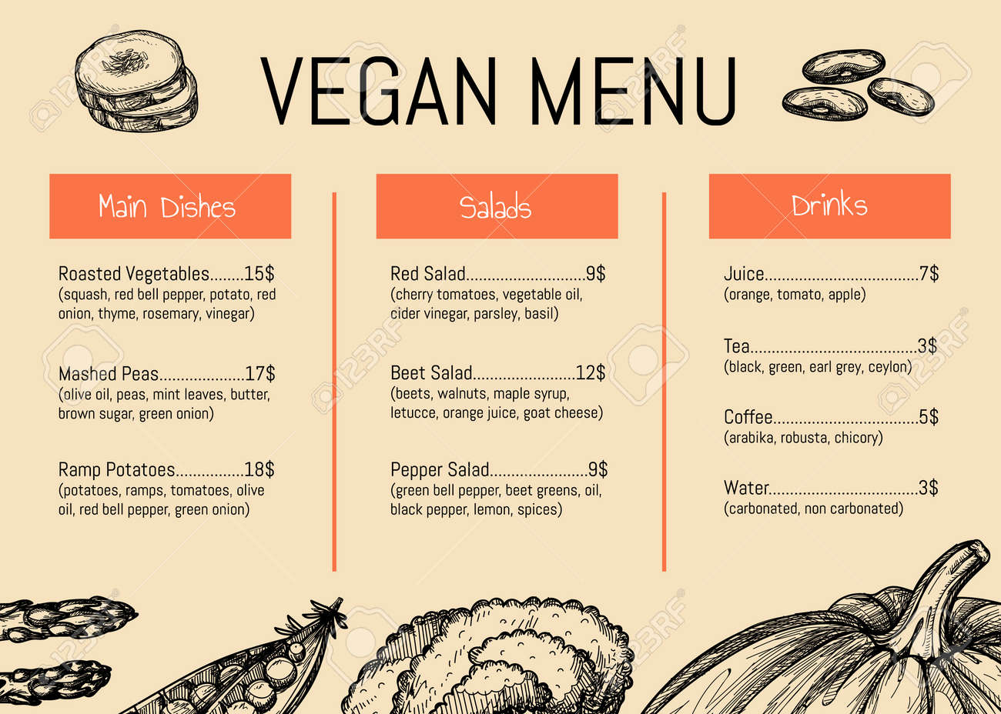
Figure 2: Vegan Menu
Source: (Author)
Price: The menu will be moderately priced, reflecting both the high calibre of the ingredients used and the premium nature of the dining experience. Special incentives and reward programs will be made available to encourage repeat customers and foster brand loyalty.
Promotion: A combination of social media engagement, influencer collaborations, digital marketing, and community outreach will be used. GreenLeaf Bistro will invest money in an aesthetically beautiful website and use social media platforms to highlight its unique menu items, environmentally friendly procedures, and satisfied customers (Ferrell et al., 2021). Collaborations with neighbourhood celebrities and vegan activists can generate interest and attract additional visitors.
Place (Distribution): Thanks to its ideal position in a bustling metropolis close to significant demographics, including health-conscious customers and environmentally sensitive shoppers, the restaurant will have the highest visibility and accessibility (Ginsberg, 2017). GreenLeaf Bistro will look into partnerships with meal delivery providers to diversify its market beyond diners.
Points of Differentiation
Innovative vegan recipes: GreenLeaf Bistro's creative vegan dishes will set them apart from other vegan eateries and give customers a compelling reason to try a plant-based diet.
Sustainable practices: The restaurant is committed to sustainability, as evidenced by waste minimisation efforts, locally sourced food, and eco-friendly packaging. Visitors concerned about the environment will find this appealing (Niederle and Schubert, 2020).
Dining experience: GreenLeaf Bistro will give consumers a unique eating experience and great food.
The positioning of GreenLeaf Bistro as a renowned vegan restaurant with an emphasis on sustainability, culinary innovation, and an unrivalled dining experience is the aim of the restaurant's marketing plan.
- Financial Plan
Source of Funds
A total start-up budget of $200,000 is required for GreenLeaf Bistro to open and operate the Vegan Food Restaurant.
Funding Source | Amount
Equity Investment | $100,000
Bank Loan | $100,000
Total Funding | $200,000

Uses of Funds
Expense | Amount
Equipment and Kitchen Setup | $50,000
Interior and Ambiance | $30,000
Inventory and Ingredients | $40,000
Marketing and Promotion | $20,000
Working Capital | $60,000
Total Uses of Funds | $200,000

Types of Financing Available
GreenLeaf Bistro has explored two primary forms of funding: equity investment and a bank loan. The company's founders invest their funds in the company as equity investors, giving them ownership holdings. A bank loan gives the business access to external money but comes with a long repayment period and interest. Combining debt and equity financing enables the company to raise capital while distributing risk.
Six-Month Cash Budget Forecast
Month | Cash Inflow | Cash Outflow | Net Cash Flow
Month 1 | $15,000 | $10,000 | $5,000
Month 2 | $18,000 | $12,000 | $6,000
Month 3 | $20,000 | $14,000 | $6,000
Month 4 | $22,000 | $15,000 | $7,000
Month 5 | $25,000 | $16,000 | $9,000
Month 6 | $28,000 | $17,000 | $11,000

Sales and Financial Sustainability
The creative vegan menu options and first-rate dining experience at GreenLeaf Bistro will draw a consistent stream of customers, ensuring the restaurant's financial sustainability. They seek to boost sales and revenue growth by actively promoting their special value offer, engaging with the neighbourhood, and implementing digital marketing tactics. Growth in sales will increase the company's capacity to cover operating costs, service debt and provide profits that can be invested in development and expansion. The financial plan paves the way for long-term success by maintaining the company's financial security and capacity to endure market volatility.
- Market Research
Growing customer Demand for Vegan dining: According to market research, there has been a noticeable rise in customer demand for vegan eating options. The number of people following vegetarian and vegan diets is gradually increasing, as is flexitarians' interest in plant-based substitutes. This pattern offers GreenLeaf Bistro a compelling chance to attract various customers (Martinelli and De Canio, 2022).
Consumer Health and Wellness Concerns: Consumers are starting to think more about their health and wellness. Vegan food is healthier because it includes less cholesterol and saturated fat. GreenLeaf Bistro hopes to attract customers looking for wholesome and delicious vegan food by serving it.
Sustainability in the environment is gaining importance. Vegan dining fits in well with this trend because it promotes moral behaviour and lowers carbon footprints. GreenLeaf Bistro should market itself as an environmentally friendly company to attract customers that care about the environment and value sustainable solutions (Twine, 2017).
Culinary Innovation and Special Offerings: Plant-based cuisine is becoming increasingly creative and delicious, and the vegan food sector is driving this trend. GreenLeaf Bistro might take advantage of this trend by providing a varied and intriguing menu that distinguishes itself from other eateries with creative and unique vegan meals (Dedehayir et al., 2017).
Influence on Social Media: Promoting food-related enterprises requires the use of social media platforms. GreenLeaf Bistro can present vegan food that is aesthetically beautiful, engage with potential customers, and have a solid online presence by strategically leveraging websites like Instagram and Facebook. Utilising social media increases brand visibility and broadens the audience.
GreenLeaf Bistro may position itself as a well-known vegan restaurant by using these market research findings to meet the growing demand for vegan food options. The research guarantees that GreenLeaf Bistro knows market trends, client preferences, and the competitive environment, resulting in an engaging and prosperous restaurant business. It serves as a strong base for the business plan as well.

References

ALEXANDRU-ILIE, B., ALEXANDRU, P. D., IULIAN, C. C. & VALENTIN, W. P. 2020. MANAGING ORGANIZATIONS FOR SUSTAINABLE BUSINESS DEVELOPMENT: INTERACTION BETWEEN VRIO FRAMEWORK AND McKINSEY 7S FRAMEWORK.
BACON, L. & KRPAN, D. 2018. (Not) Eating for the environment: The impact of restaurant menu design on vegetarian food choice. Appetite, 125, 190-200.
BRUIJL, D. G. H. T. 2018. The relevance of Porter's five forces in today's innovative and changing business environment. Available at SSRN 3192207.
CHOUDHARY, N. 2019. Strategic analysis of cloud kitchen–a case study. Management Today.
DEDEHAYIR, O., SMIDT, M., RIVEROLA, C. & VELASQUEZ, S. Unlocking the market with vegan food innovations. ISPIM innovation symposium, 2017. The International Society for Professional Innovation Management (ISPIM), 1-13.
FERRELL, O. C., HARTLINE, M. & HOCHSTEIN, B. W. 2021. Marketing strategy, Cengage Learning.
FURNISS, J. L. 2018. PIERCING THE VEIL: TRADITIONAL CORPORATIONS VERSUS LIMITED LIABILITY COMPANIES. International Journal of Business & Public Administration, 15.
GINSBERG, C. 2017. The market for vegetarian foods. age, 8, 18.
MARTINELLI, E. & DE CANIO, F. 2022. Non-vegan consumers buying vegan food: the moderating role of conformity. British Food Journal, 124, 14-30.
NIEDERLE, P. & SCHUBERT, M. N. 2020. How does veganism contribute to shape sustainable food systems? Practices, meanings and identities of vegan restaurants in Porto Alegre, Brazil. Journal of Rural studies, 78, 304-313.
REISER, D. B. 2018. Disruptive philanthropy: Chan-Zuckerberg, the limited liability company, and the millionaire next door. Fla. L. Rev., 70, 921.
SEXTON, A. E., GARNETT, T. & LORIMER, J. 2022. Vegan food geographies and the rise of Big Veganism. Progress in Human Geography, 46, 605-628.
TWINE, R. 2017. A practice theory framework for understanding vegan transition. Animal Studies Journal, 6, 192-224.
UK vegan food market grows 9.58% as 40% of consumers demand plant-based options - vegconomist - The Vegan Business Magazine (2023) vegconomist. Available at: https://vegconomist.com/market-and-trends/uk-vegan-food-market-grows/ (Accessed: 05 July 2023).
Wunsch, N.-G. (2022) UK: Plant-based food market size by category 2026, Statista. Available at: https://www.statista.com/statistics/1284647/plant-based-food-market-in-the-united-kingdom-by-category/ (Accessed: 05 July 2023).

