Digital Skills and Research Methods
Assessment 2

Table of Contents
Introduction 3
Primary Data Collection Research 3
Analysis 13
Secondary Research 13
Analysis 15
Conclusion 15
References 16

Introduction
The main aim of this research report is to analyse the impact of the Virtual Learning Environment (VLE) with respect to using Moodle on the learning experience of the students within the University of Wales Trinity Saint David London Campus. The reported work shall be completed with the help of collecting data using both the secondary and primary research method so that proper analysis of the virtual learning environment process to Moodle can be understood properly. Moreover, with respect to the primary data collection research method questionnaire survey shall be considered and the secondary research process shall be completed with the help of different books and materials following the analysis of both the researches.

Primary Data Collection Research
The following parts shall be conducting a primary data collection in the research process by using the questionnaire survey method so that appropriate understanding of virtual learning experience with the help of modal and how it is helping the students to gain a proper learning experience in the university be understood. The sample respondents considered for the primary data collection is 10 students who are students of the same University.
- Do you use Moodle?
Category | No. of Respondents | Percentage
Yes | 8 | 80
No | 1 | 10
Sometimes | 1 | 10

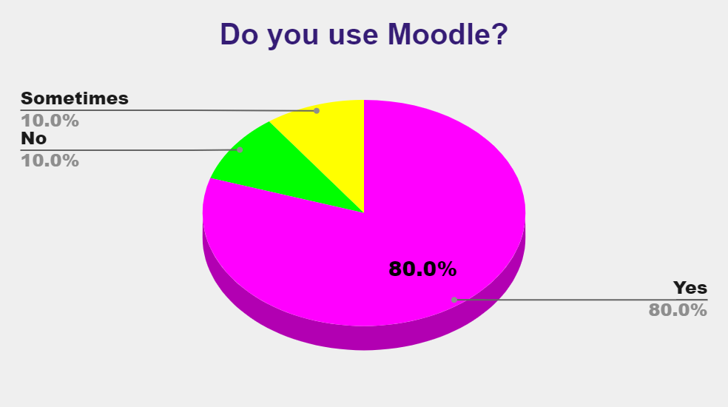
Source: Author
The first question that was asked to the sample respondent did they use the tool Moodle for virtual learning experience in their University for doing that mention classes. In terms of this question, 80% of the respondents had answered with a yes agreeing with the fact that they use this tool of virtual learning. On the other hand, only 10% of the respondents have answered by saying that they do not use this site since they feel it is not very effective and the University has not been able to properly manage how the students will be using the motor and how it will be effective in different learning processes. Also, 10% of the sample has also responded saying they use this tool sometimes whenever it is necessary for them or the teachers are directly trying to contact them through Moodle otherwise, they prefer using the normal method of the learning process which includes physical books and taking notes from the teachers.

Category | No. of Respondents | Percentage
University Login | 9 | 90
Personal Login Credential | 0 | 0
Do not Use | 1 | 10
- How do you get access to Moodle?

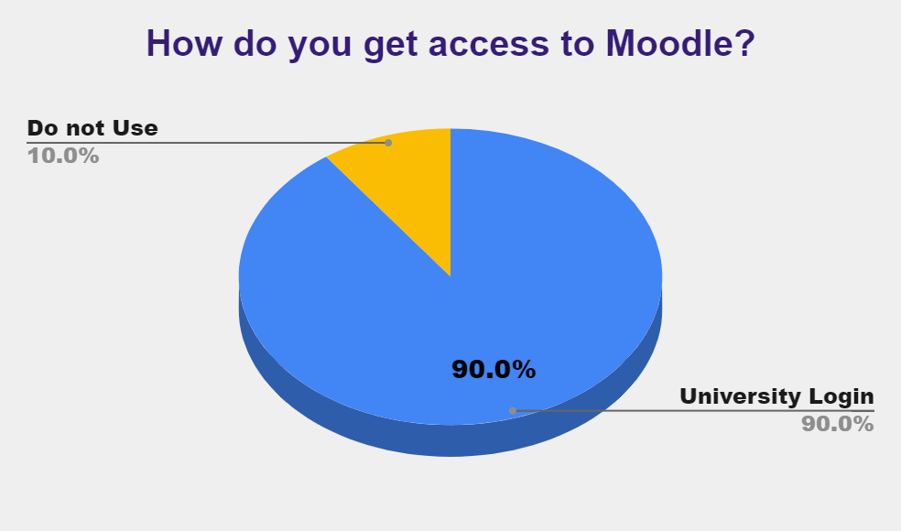
Source: Author
Here, the sample participants were asked as to how they get access to use the Moodle. For this nine of the respondents had answered by saying that they use the university provided login credentials to get access to the Moodle tool and use it according to the learning requirements and processes so that a better learning process can be required for them. on the other hand, only one of the total respondents replied by saying that they do not use the model so there is no way of accessing this tool, the reason being the same as was answered by him in the last question.
- Is Moodle helping to have a great learning experience?
Category | No. of Respondents | Percentage
Strongly Agree | 5 | 50
Agree | 1 | 10
Neutral | 3 | 30
Disagree | 1 | 10
Strongly Disagree | 0 | 0

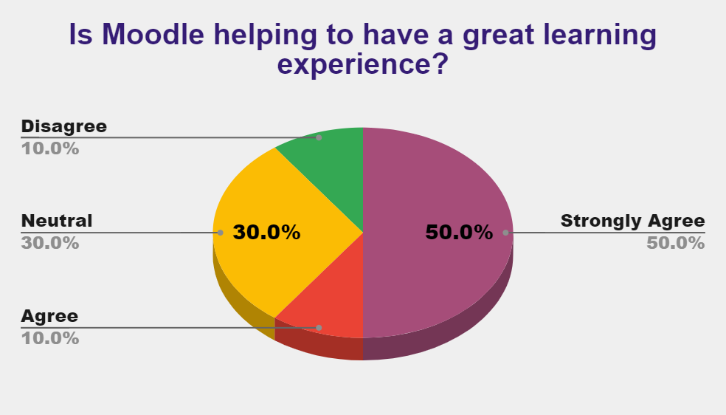
Source: Author
The participants here were asked whether their use of Moodle tools is helping them to have a great and proper experience towards learning in their time in the university. With respect to this aspect, five of the sample participants had strongly agreed and one participant had agreed to the fact that moral is helping them to get a very good learning experience in terms of the virtual process whereas three people had replied in neutral since they are not sure whether it is highly impactful in the learning experience or not. Only one participant replied by saying that they do not feel the model is providing a proper learning experience since according to him without a direct conversation with the teachers they are making a stable communication process which can be reflected in the assessment done during different semesters.
- Do you think the management at the University of Wales Trinity Saint David London Campus is using Moodle at its best?
Category | No. of Respondents | Percentage
Strongly Agree | 3 | 30
Agree | 2 | 20
Neutral | 1 | 10
Disagree | 3 | 30
Strongly Disagree | 1 | 10

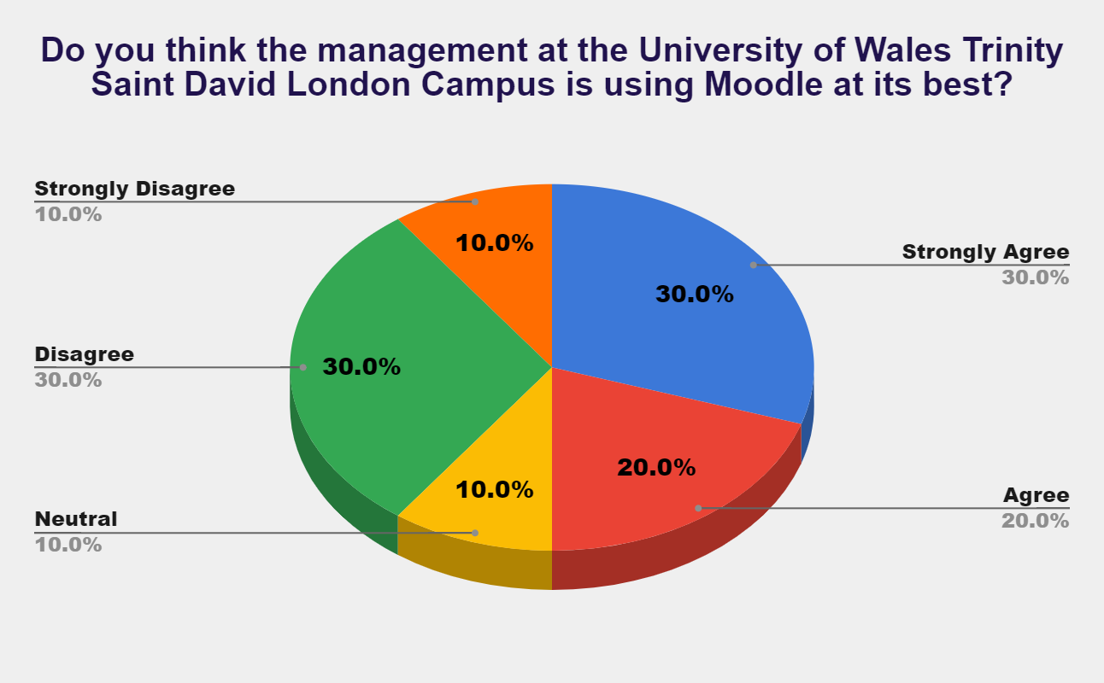
Source: Author
The fourth question asked was whether they think the management at the University of Wales Trinity Saint David London campus is using the model at its best and in this scenario 50% of the respondents had answered that the tool of Moodle is being properly managed by the management of the university and provide the required benefits that it must however as 40% of the respondents had answered by saying that they do not feel the management of the university is Managing the model at the best way possible since they fees different issues of managing their assignments for getting feedback from the teachers which is affecting in their studies as well.

- What you feel is the most beneficial element of Moodle?
Category | No. of Respondents | Percentage
User-Friendly | 2 | 20
Management of Content | 3 | 30
Blended Learning Features | 1 | 10
Testing and Assessment | 1 | 10
Tracking and Reporting | 3 | 30

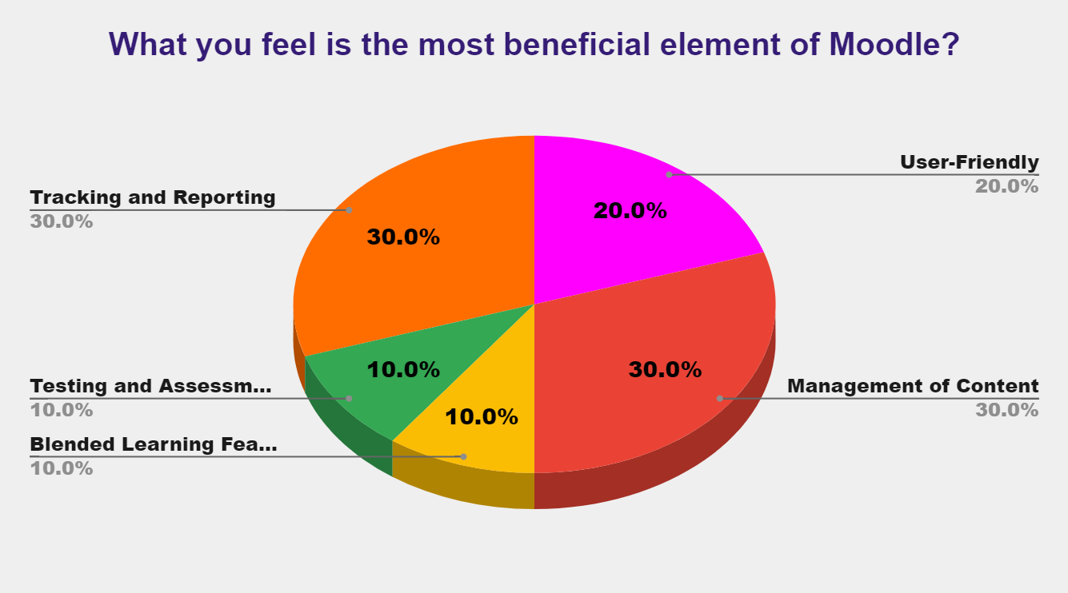
Source: Author
Among all the sample respondents they were asked which aspect or element of the Moodle tool is highly beneficial towards achieving a virtual learning experience. In terms of this question, 20% of the participants responded saying that the tool is user-friendly while 30% of them said that management of the content of different subjects within the university is getting easier by the implementation of this tool. 10% of the participants also answered by saying that the beneficial elements are blended learning teachers and other 10% savings that assessment and testing process is highly helpful. Nonetheless, 30% of the respondents answered by saying that the most beneficial thing at the moment as per them is tracking and reporting about the assignments for the Teachers at the University amidst the lockdown situation.

- Do you think getting feedback from teachers through Moodle is more helpful than a face-to-face discussion of feedback?
Category | No. of Respondents | Percentage
Yes | 7 | 70
No | 3 | 30

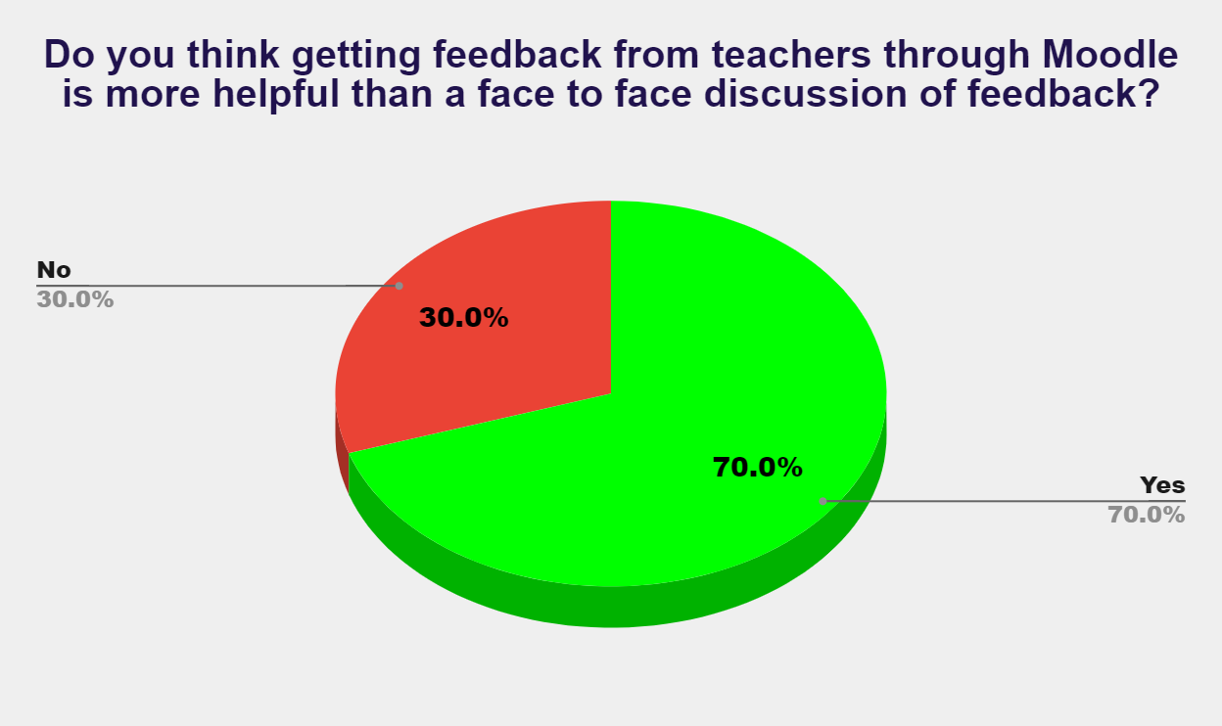
Source: Author
The next question asked to the sample participants was whether they think getting feedback from the teachers with the help of a model tool is helping more than having a face-to-face discussion regarding the feedback on the assignment. In this scenario, 70% of the participants responded by saying yes that they feel the Moodle tool is helpful in feedback as well whereas 30% of them responded negatively saying that it is not as effective as it seems to be.

- What feature of Moodle do you feel is hampering a better learning experience?
Category | No. of Respondents | Percentage
Bulk Creation of Course | 1 | 10
Coping Big Projects | 4 | 40
Lack of Complete Development | 0 | 0
Limited Users | 3 | 30
Lack of Transformational Power | 2 | 20

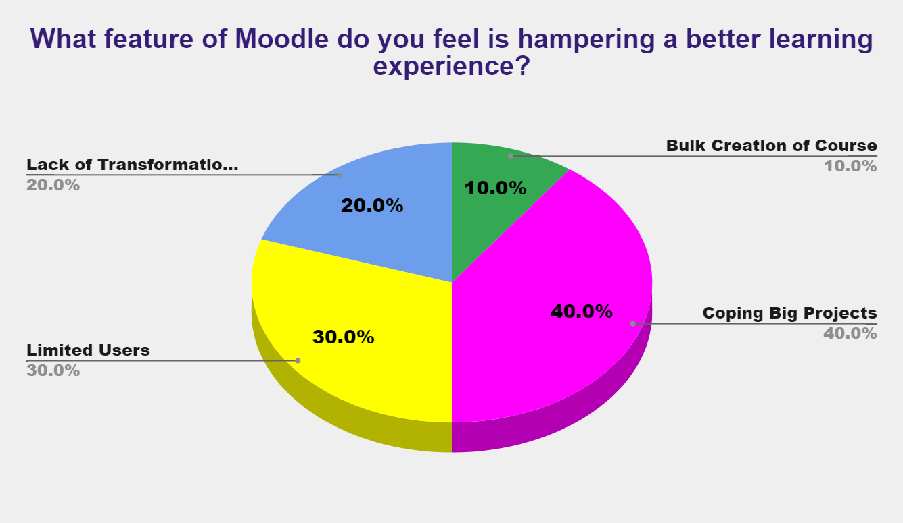
Source: Author
The participants were asked which features of Moodle tool they feel is hampering towards better learning experience in the virtual process. In this scenario, 40% of the respondents answered by saying that coping with a big project is a big disadvantage that is hampering the learning process of the students. also having Limited users in the mood is another limitation following with 20% of people telling the tool having a lack of transformational power and 10% of the people telling issues with bulk creation of the course.

Analysis
The main focus of the research was to understand the implementation and impact of modal on the learning experiences of the sample respondents who are currently pursuing different courses from the university. It is important to understand that most of the questions within the questionnaire survey were asked with the help of email so that social distancing measures can be followed amidst this pandemic outbreak situation.
Therefore, from such analysis of the primary data collection, it can be very well said that most of the sample respondents prefer having a virtual learning experience through Moodle tool in their University so that they can maintain all the rules of social distancing and lockdown in the country as well as perform better with the proper management of the data regarding assignments and subject that must be done and which are left to be completed. even though for some individuals having a face to face or direct contact learning process is much useful rather than the Virtual method keeping in mind the present environmental situation it can be said that the model tool must be developed in a proper way by the University so that the students mixing issues with the tool can get resolved along with making proper amendments regarding how different situations in the virtual learning process can be completed.

Secondary Research
According to Gunawan et.al (2018), the aspect of virtual learning tends to be an incredible inventive activity to give a scope of chances and devices for completing the arrangement of Learning and improvement. Virtual learning is a stage that helps during the time spent completing various types of computerized answers for the upgrade of learning encounters. This framework likewise alluded to the way toward offering instructors for investigating the arrangement of carefully based arrangements through intelligent and dynamic cycles of learning. Then again, it likewise envelops every one of the online conditions that act as enhancements for the course by going through the arrangement of various kinds of independent ability appraisals.
As per Phungsuk et.al (2017), the straightforward cycle of ceaseless instruction and the arrangement of investigating different sorts of interest likewise become conceivable with the arrangement of virtual learning. The availability of this framework additionally assists with doing the way toward going to the homeroom practically. A top-notch arrangement of schooling is additionally accessible in the arrangement of online classes. The help of relentless instructive cycles likewise gets simpler with the constant investigation of virtual learning frameworks.
Various types of programming are carried out in the arrangement of virtual climate learning for completing the framework and start of the functioning experience as was said by Vaganova et.al (2017). The improvement of capability under the stage for supplanting the instructive cycle likewise completes through the interaction of virtual learning. Various kinds of preparation and the board of exercises, the arrangement of promotion to the advanced learning materials, various sorts of gathering conversations and appropriate following of the presentation of the understudies complete through this virtual interaction of learning.
Masoodi et.al (2017) has said that even with having a scope of advantages, absence of inspiration is probably the greatest detriment of virtual learning conditions. The shortfall of Self-discipline inspiration and absence of centralization of study viability is hindering the ceaseless cycle of improvement. There is additionally a chance of doing treacherous exercises during the online tests that decrease the nature of self-restraint and inspiration. Restrictions are likewise there in the arrangement of virtual realizing where it is difficult to direct any sort of any reasonable encounters. The way toward causing understudies to comprehend about the hypotheses and idea of a subject is conceivable.
Nonetheless, students within the University are being instructed by the arrangement of virtual learning climate that prompts the arrangement of higher maintenance than the instructional gathering. The more noteworthy degree of fulfillment and the commitment of the understudy's learning styles are additionally adequately identified with the critical components of virtual learning. The interaction of visual learning, useful space of talking and the nitty gritty cycle of showing help to bring more prominent fulfilment among the understudy.

Analysis
The assortment of auxiliary information has assisted with understanding the general arrangement of virtual learning and its viability. The idea and climate of virtual learning is identified with the arrangement of continuing with online classes for the advancement and improvement of study territories. The cycle is helpful for the current circumstance of pandemic where understudies are getting the arrangement of connecting with the mentors through various types of online stages. Various types of instructing meetings are accessible on the stage for covering every one of the essential zones. Various sorts of advancement and the interaction of virtual learning sway the space of the general learning framework. Both positive and adverse consequences of virtual learning are there and the arrangement of executing various kinds of instruments and exercises are additionally useful for the general turn of events. The auxiliary examination has additionally given the possibility of the difficulties of the framework.

Conclusion
Therefore, it can be concluded by saying that both the secondary and the primary research with respect to the use of virtual learning environment using the Moodle tool within the University has showed that it is a highly beneficial tool in the present scenario which is a necessity to be used but the management of the University must manage the tool in a more effective manner so that it can be user friendly to both the teachers and student using them.

References
Gulbinskienė, D., Masoodi, M. & Šliogerienė, J., 2017. Moodle as virtual learning environment in developing language skills, fostering metacognitive awareness and promoting learner autonomy. Pedagogika, 127(3), pp. 176-185.
Gunawan, W., Kalensun, E. & Fajar, A., 2018. E-Learning through social media in the virtual learning environment. In IOP Conference Series: Materials Science and Engineering, 420(1), p. 012110.
Phungsuk, R., Viriyavejakul, C. & Ratanaolarn, T., 2017. Development of a problem-based learning model via a virtual learning environment. Kasetsart Journal of Social Sciences, 38(3), pp. 297-306.
Vaganova, O. et al., 2017. The organization of the test control of students'knowledge in a virtual learning environment moodle. Journal of Entrepreneurship Education, 20(3), pp. 1-4.

