University of Wales Trinity Saint David
School of Engineering
Evaluating the Effectiveness of Chosen Maintenance Strategies for Dedicated Equipment
Michael Corish
2115171
Advanced Manufacturing Operations
06/04/2025
L6 – Plant and Asset Engineering ACMA6007



Table of Contents

1 Introduction 1
2 Critical Review of Bander Maintenance Practice 2
2.1 Bander Operations 2
2.2 Current Maintenance Practice 4
2.2.1 Breakdown Maintenance 4
2.2.2 Preventive Maintenance 5
2.2.3 Outsourced Maintenance 5
3 Evaluation of Improvements to Current Maintenance Approaches 6
3.1 Predictive Maintenance Strategy for Bander Modules 6
3.2 Developing Skills of Company Employees 7
4 Costs and Resources to Implement Proposed Changes 8
4.1 Costs 8
4.2 Resources 8
5 Conclusion 10
6 References 11

Table of Figures

Figure 1 - Bander machine head in operational environment (Tata Steel, 2018). 2
Figure 2 - Key machine head module components and fixed module frame (Tata Steel, 2018) 3
Figure 3 - 3D model of bander machine head specifying sensor locations (Signode, 2017) 3
Figure 4 - Green table location for bander module maintenance with communication board behind. 4
Figure 5 - Screenshot of HMI data collection screen for sealer module - highlighting cycle count. 6
Figure 6 - Example of information and data communication table between operators and outsourced maintenance team. 7
Figure 7 - Example of bander troubleshooting guide - Alarm Code, Module Location and Fault Description. 7
Figure 8 - Developed preventive maintenance schedule for Tata Steel employees. 8
Figure 9 - Kurt Lewin's 3-stage change model (Hussain, et al., 2018) 9

Introduction

Tata Steel is a world-renowned steelmaking company, gaining much attention in recent news for their decision to transition from blast furnace operations to electric arc furnace steelmaking. During this transition period, heavy end operations have ceased, with downstream processes such as the Hot Mill and Cold Mill currently continuing operations. This report will focus on the maintenance practices of an individual piece of equipment within the Hot Mill. The current Hot Mill annual output stands at approximately two million tonnes. Furthermore, the manufacturing aim of Port Talbot’s Hot Mill is to process imported steel slab into customer defined steel coil through several processing departments. Once processed, coils are banded (packaged) as part of the Coiler process, then transferred to dispatch locations ready for export.
There are currently two banding machines in operation, both identical to each other and in operation depending on which Coiler was used for coil processing. These banding machines have been selected for critical evaluation on presently selected maintenance practices. This report will provide concise information on how the banding machine operates, whilst identifying the advantages and disadvantages of current maintenance practice. Also, suggested improvements to maintenance strategies and investigating the potential opportunities for alternative approaches. Leading to identifying the prospective costs and resources required to fulfil proposed changes to recommended maintenance strategies and the associations of applying change management within a manufacturing organisation. Lastly, concluding the report findings and developing proposed improvements through short and long term recommendations.

Critical Review of Bander Maintenance Practice

Bander Operations

The banding machines currently in operation were first upgraded during a major project in 2018. Although relatively new equipment, it is believed that maintenance strategies have not been developed to the highest standard, causing a detrimental effect to foreseen productivity. Firstly, the equipment can be broken down into three categories: Dispenser, Accumulator and Machine head. This report will focus on maintenance practices for the machine head due to the complexity of the entire process. As an overview of the entire process, the dispenser feeds banding wire material through the accumulator to provide correct strap tension for banding operations. Thus, allowing for feeding and tensioning of banding material, depending on the required processing step of the operating procedure. The key area for banding operations relies on the machine head, this was developed into a modular system, aiming to reduce breakdown maintenance times therefore providing increased process productivity. The main aim of bander equipment is feeding, tensioning, and securing the banding strap around the steel coil for transport to dispatch or additional processing units (Figure 1).
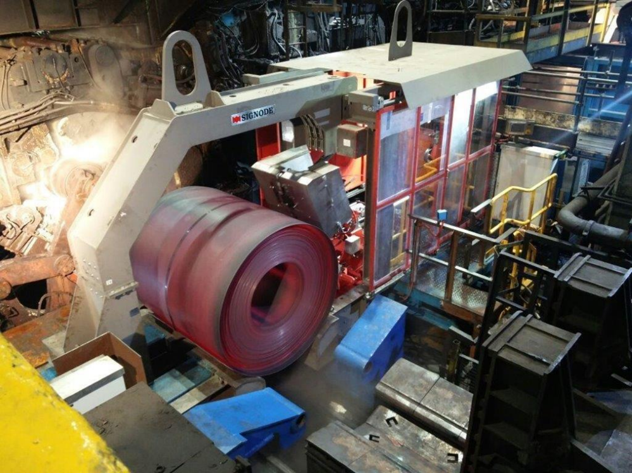
Bander Chute
Bander Strap Travelling Direction

Bander Machine Head

Figure 1 - Bander machine head in operational environment (Tata Steel, 2018).
As previously mentioned, the machine head consists of several modules which are all designed to provide individual functions leading to an overall desired output. (Shaik, et al., 2015) explain that the modular manufacturing operation has benefits in terms of its range of function, product, and service through its ability to be easily reconfigured in the face of changing conditions. Each module has personal locations within the module frame, with quick release functions for ease of manoeuvrability. The following display (Figure 2) identifies the key modules for bander machine head functionality.

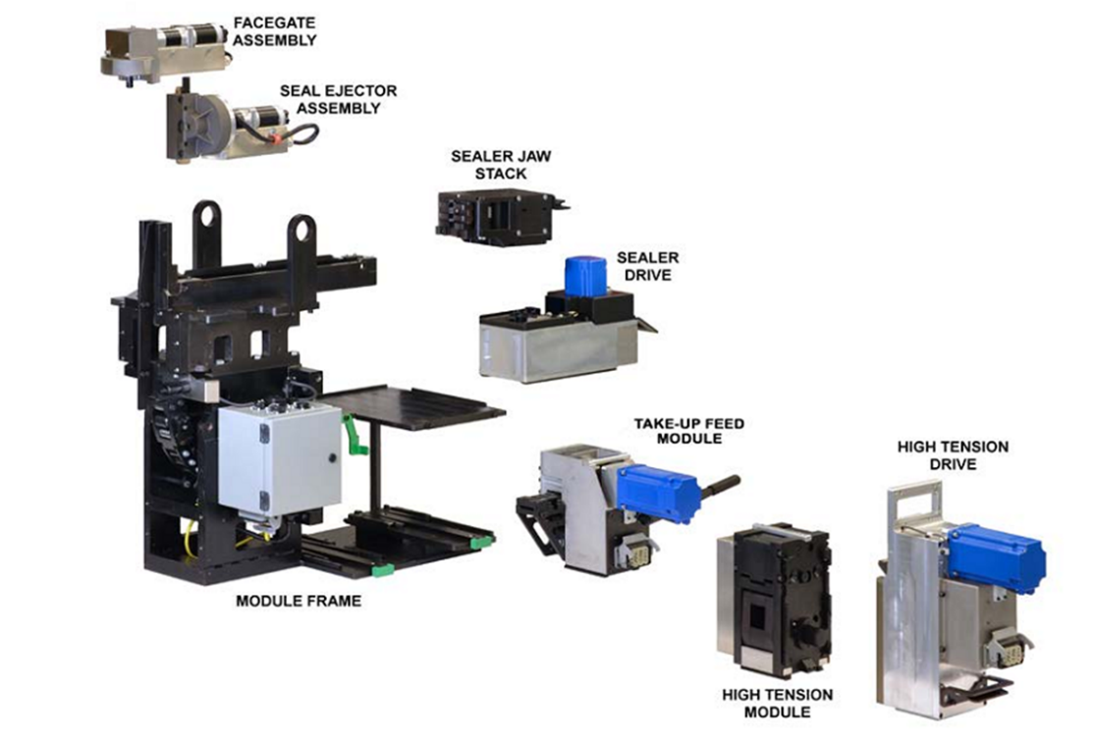

Figure 2 - Key machine head module components and fixed module frame (Tata Steel, 2018)
Bander operations are driven through electrical and pneumatic systems. Modules are electrically driven with plug in points on each. Whereas module frame positions require pneumatics for cylinder movements, due to the additional power required to reposition the entire machine head. The processing steps of bander operations are triggered through sensor indication of strap position. There are three sensors located within the machine head – Head End Sequence (HES), Strap In Transition (SIT) and Feeder Limit Switch (FLS)(Figure 3). These sensors each have their own purpose, HES is used for actioning the banding process, SIT indicates banding strap has exited the machine head and entered the bander chute and FLS completes the process through detecting strap has arrived back at head location, allowing for band tensioning, and securing around coil circumference.
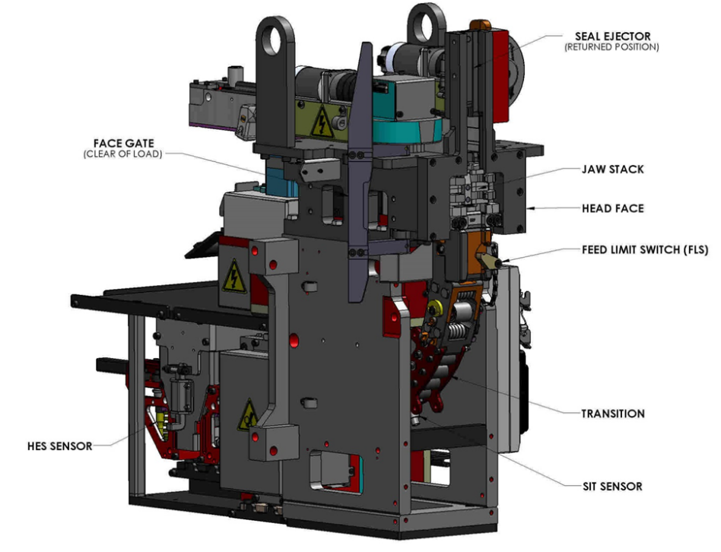

Figure 3 - 3D model of bander machine head specifying sensor locations (Signode, 2017).

Current Maintenance Practice

The following section of this report will review the multiple maintenance practices currently used for maintaining bander operations. The current practices used include breakdown, preventative and outsourced maintenance. These practices will undergo critical review through identifying the advantages and limitations to each, before suggested improvements are made.

Breakdown Maintenance

Breakdown maintenance is a form of maintenance, where repairs are completed only after the breakdown. The aim of it is to put the broken machine back to the regular operational conditions (Poór, et al., 2019). (Gallimore & Penlesky, 1988) summarise that breakdown maintenance crews must react fast to limit the effects on the entire production process, while also identifying loss control as the most critical aspect of breakdown repairs. Bander machine breakdown maintenance relies on production operators for fault finding and module replacement. This has always been maintenance practice, including previous banding machines in operation. The limited engineering department knowledge on bander equipment, reduces the capabilities of carrying out in-house repairs and also, limits the technical knowledge required when encountering complex breakdowns. When breakdowns occur, the whole Hot Mill process must pause operations for safety critical reasons, creating negative impacts on process productivity.
A benefit of current breakdown maintenance practices are the availability of spare bander modules. Therefore, malfunctioning modules are replaced on plant and repaired in a bander compound location outside of processing areas, allowing for shorter periods of production downtime, and eliminating the need for onsite repairs. The current process requires broken modules to be situated on the bander compound ‘red table’ for the outsourced maintenance team to conduct repairs. Once repaired, the module is placed on a ‘green table’ to indicate equipment is operational and ready for use (Figure 4).
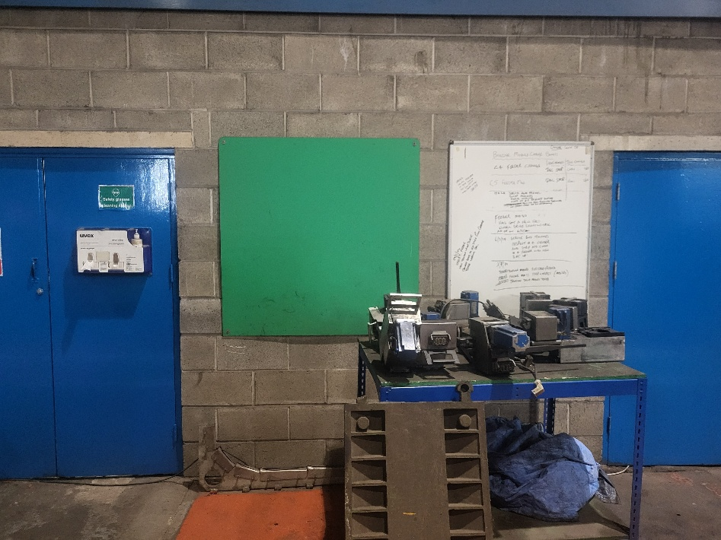

Figure 4 - Green table location for bander module maintenance with communication board behind.
(Abdi & Taghipour, 2019) explain that organisational factors such as the experience and expertise of repair staff, can affect the success probability of repaired equipment. With bander equipment experts conducting repairs on company equipment, increases the probability of operational success. Although, when breakdowns occur, operators must travel outside of the bander location to retrieve spare modules consequently effecting replacement times. Also, due to a lack of machine interface expertise, operator confusion with alarm system notifications increases the potential for unnecessary module replacement. Hence, causing needless outsourced labour on module maintenance leading to increased costs and resources.

Preventive Maintenance

Preventive maintenance is a periodic or time-based maintenance to ensure the reliability of any machine to run on with its original capacity, and to focus primarily on maintaining the machine based on its known condition. Preventive maintenance tasks should be done where failures cannot be detected in advance (Niijjaawan & Niijjaawan, 2010). Also, (Bloch & Geitner, 1999) summarise that in its simplest form, Preventive Maintenance (PM) activity entails periodic lubrication, coating or cleaning of machinery components to increase equipment life spans.
Current preventive measures implemented towards bander maintenance include lubrication, sensor cleaning and re-filling of stock. Firstly, during Hot Mill planned maintenance periods, production personnel ensure lubrication levels are kept at optimum levels therefore increasing the lifespan of moving equipment. Also, utilising compressed air for sensor cleaning, ensuring the removal of debris and dirt from causing potential disruptions to machine operation. Lastly, re-filling the machine head seal magazine, therefore increasing the operational capability of the banding machine. Although, these preventative practices are currently disorganised and are completed at irregular intervals due to reliance on process downtime.

Outsourced Maintenance

Outsourcing is defined as the delegation of business functions totally or partially to another company along with part of the maintenance and operational control (Fernandez, et al., 2010). Currently Tata Steel outsources bander maintenance to an outside company named Signode, supplying expert knowledge on bander operations and maintenance. Furthermore, Signode supplied and fitted the recently developed banding machines, therefore providing outstanding service due to their specialisation in the field. Although, leaning on external company knowledge for specialist maintenance tasks, could potentially damage Tata Steel employee’s familiarity of complex maintenance activities. Signode provide services nationally to a range of companies, signifying that waiting times for availability can vary depending on maintenance staff locations. Ultimately, major breakdowns of banding equipment have the potential to cause increased downtime, due to the proximity of outsourced maintenance teams. This has an adverse effect on Hot Mill productivity and overall costs of maintenance.

Evaluation of Improvements to Current Maintenance Approaches

This area of the report will evaluate suggested improvements towards developing current bander maintenance approaches and the implementation of selected improvements into future maintenance planning and strategies.

Predictive Maintenance Strategy for Bander Modules

Predictive maintenance primarily involves foreseeing breakdown of the system to be maintained by detecting early signs of failure in order to make maintenance work more proactive (Selcuk, 2016). The current approach of replacing modules after failure causes delays to process productivity, due to the limited knowledge of predicting points of failure. If we could understand the lifecycle of these bander modules, then planning and preparation can be undertaken for module changes during planned maintenance periods.
To begin, a measurement system is required to identify the mean number of cycles between failures of each module. However, the Siemens control system used for bander operations displays multiple aspects of module functionality through the Human Machine Interface (HMI). This information (Figure 5), once accessed through the correct procedure, provides each individual modules cycle count.
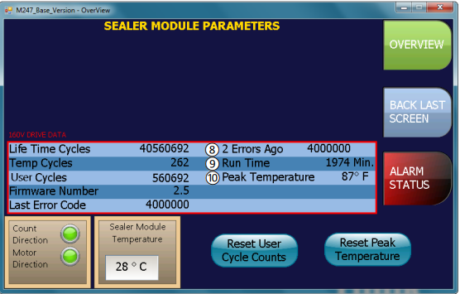

Figure 5 - Screenshot of HMI data collection screen for sealer module - highlighting cycle count.
The suggested approach requires process operators to collect several aspects of module data during module failure replacements. Following the same designated location tables procedure as previously mentioned but also, recording the module serial number, alarm code and cycle count for the arrival of Signode maintenance teams. Furthermore, once maintenance has been completed, Signode would be required to record the type and location of failure (Figure 6).
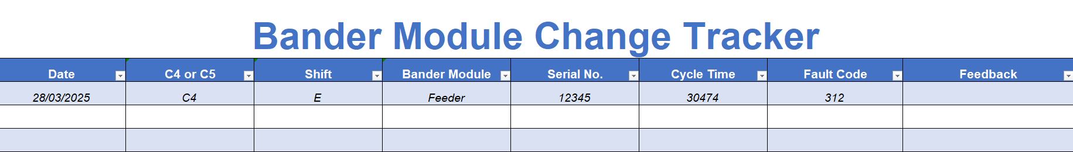
Figure 6 - Example of information and data communication table between operators and outsourced maintenance team.
This suggested change in strategy will take time, due to building enough data to understand the failure rates of modules functional parts. Although on completion, predictions of proximity to failure can be derived from monitoring cycle counts and planning towards alignment with planned maintenance periods. Finally, random failures can always be expected and will not always be predicted, therefore repaired modules should be located within an accessible distance from the breakdown. This will reduce module replacement times and have a positive impact on overall process productivity.

Developing Skills of Company Employees

Developing skills of Tata Steel employees on bander maintenance practices, allows for increased knowledge on faults, faster response times and advancement in communication with the service provider. Firstly, to reduce the risk of unwarranted breakdown maintenance such as multiple module replacements due to the lack of specified alarm feedback, it is suggested to develop a troubleshooting guide for plant operators. The accessibility of this information from the service provider is key to pinpointing the cause of the problem and not only the symptoms. Also, locating the troubleshooting guide to the company website will provide accessibility to all. The suggested improvement provides the alarm code, the specific module requiring replacement and an internal parts check list. An example of the bander trouble shooting guide can be viewed below (Figure 7):
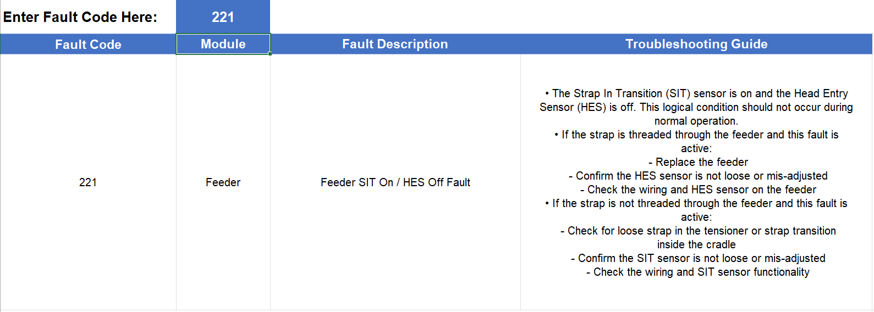
Figure 7 - Example of bander troubleshooting guide - Alarm Code, Module Location and Fault Description.
The benefits this information provides to plant operators on breakdown maintenance are invaluable. However, the engineering department can also benefit from such information when called upon in emergency situations. If service providers are not on-site for catastrophic failures, then engineering personnel have the information required to potentially return the machine to operations without delays of waiting for Signode to repair.

Costs and Resources to Implement Proposed Changes

Costs

The proposed maintenance strategy developments of this report have minimal impact on company maintenance funding. These changes are primarily focused on communication and maintenance organisation, rather than focusing on costly equipment upgrades. Although, implementation of suggested improvements provides potential savings on direct and indirect maintenance costs. Firstly, indirect costs include production downtime, applying the predictive maintenance strategy reduces the risk of breakdown maintenance during production schedules. Also, positioning maintained spares within the machine head location reduces repair times if random breakdowns occur and has a reduced impact on production.
The direct costs of outsourcing maintenance can also be reduced through improving preventive maintenance schedules and developing employee maintenance skills. To begin, the proposed troubleshooting guide provides employees with the information required on breakdowns, therefore reducing the need for outsourced maintenance call-out costs. Additionally, through employing an in-house autonomous preventive maintenance schedule, reduces the regularity of service provider support and potentially increases module lifespans. Although, there is an importance to create a balanced approach between employee and service provider. The outsourced maintenance company provide essential spares and specialised maintenance, so continuing a strong working relationship is crucial towards creating a maintenance excellence environment.

Resources

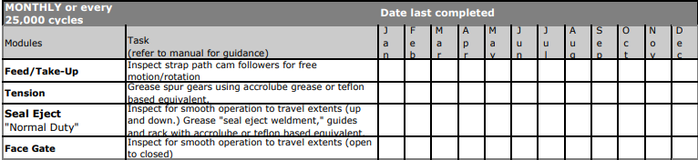
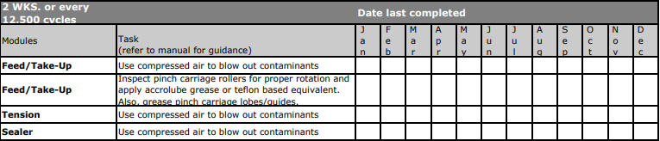
The resources required to implement the proposed changes to maintenance strategy include documentation and training. Firstly, the introduction of digitised documentation will be required to ensure accessibility to all employees. By providing this, employees can input collected data for module failure rate analysis, leading to the development of the future predictive maintenance plan. Also, deploying an alarm fault search engine for employee troubleshooting during breakdowns and the preventive maintenance schedule (Figure 8). All documentation requires storage within the same location for ease of access.
Figure 8 - Developed preventive maintenance schedule for Tata Steel employees.
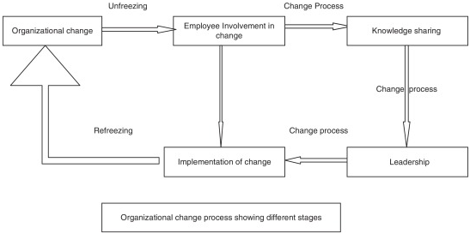
Applying high quality training will be a significant resource required towards the success of the proposed improvements. These changes require increased responsibility for company employees, necessitating the development of a maintenance practice and data recording training plan, towards ensuring the increased efficiency of maintenance strategy implementation. Although, these improvements require organisational change and without the correct management, has the potential to cause disruption and unexpected consequences.
(Phillips & Klein, 2023) stated that organisations must change to survive and there are many approaches to influence change. Lewin’s simple but effective 3-step strategy – Unfreezing, Change and Refreeze is used to aid employee’s adaptation to change (Figure 9). Some of the key elements to each of these stages include employee involvement, knowledge sharing and developing strong leadership to execute change. Change can bring positive and negative impacts to organisational outcomes and because of this, the need to manage the change has become most important (Jalagat, 2015). Therefore, these improvements to current maintenance practices will only be successful if the change is managed in a strategic manner to deliver on projected goals.

Figure 9 - Kurt Lewin's 3-stage change model (Hussain, et al., 2018)

Conclusion

To conclude, the overall findings of this report signify the importance of optimising multiple maintenance strategies to enhance overall productivity. The critical review highlighted the benefits and limitations to current practices used for bander machine maintenance. Although, through reviewing trade offs such as the current strategy of breakdown repairs against the strong availability of spares, underlined the potential for advancements to existing methods. Also, the reliance on service providers against the underdeveloped skills of company employees to perform certain maintenance tasks required attention. After evaluation, the critical areas for improvement included reducing breakdown repairs through predictive maintenance deployment, enhancing communication between company employees and outsourced maintenance teams, and assisting employees towards maintenance skill enhancement.
As previously captured, minimal costs will be required for improvement implementation whereas resources such as training and documentation will prove vital towards strategy optimisation. The utilisation of the module troubleshooting guide and preventive maintenance schedules are improvements that can be developed over a short period of time. Although, the use of predictive maintenance will require longer periods of time until deployment, due to the requirement of mass data collection, recording and fault analysis to identify variables and mean time between failures. Furthermore, these improvements rely on the ability to manage change through strong leadership, communication of knowledge and employee participation. In short, the recently developed banders may not require major developments, however these small advancements in strategy can provide continuous improvement towards maintenance excellence.

References

Abdi, A. & Taghipour, S., 2019. Sustainable asset management: A repair-replacement decision model considering environmental impacts, maintenance quality, and risk. Computers & Industrial Engineering, Volume 136, pp. 117-134.
Bloch, H. P. & Geitner, F. K., 1999. Statistical Approaches in Machinery Problem Solving. In: Practical Machinery Management for Process Plants. s.l.:Gulf Professional Publishing, pp. 477-522.
Fernandez, J. F. G. et al., 2010. Outsourcing maintenance in services providers. Seville, Research Gate.
Gallimore, K. F. & Penlesky, R. J., 1988. A Framework For Developing Maintenance Strategies. Production and Inventory Management Journal, 29(1), pp. 16-21.
Hussain, S. T. et al., 2018. Kurt Lewin's change model: A critical review of the role of leadership and employee involvement in organizational change. Journal of Innovation & Knowledge, 3(3), pp. 123-127.
Jalagat, R., 2015. he Impact of Change and Change Management in Achieving Corporate Goals and Objectives:Organizational Perspective. International Journal of Science and Research (IJSR), 5(11), pp. 1233-1239.
Niijjaawan, N. & Niijjaawan, R., 2010. Role of maintenance. In: Modern Approach to Maintenance in Spinning. s.l.:Woodhead Publishing India, pp. 10-20.
Phillips, J. & Klein, J. D., 2023. Change Management: From Theory to Practice. TechTrends, Volume 67, pp. 189-197.
Poór, P., Ženíšek, D. & Basl, J., 2019. Historical Overview of Maintenance Management Strategies: Development from Breakdown Maintenance to Predictive Maintenance in Accordance with Four Industrial Revolutions. Pilsen, IEOM Society.
Selcuk, S., 2016. Predictive maintenance, its implementation and latest trends. Proceedings of the Institution of Mechanical Engineers, 231(9), pp. 1670-1679.
Shaik, A. M., Rao, V. V. S. K. & Rao, C. S., 2015. Development of modular manufacturing systems—a review. International Journal of Advanced Manufacturing Technology, Volume 76, pp. 789-802.
Signode, 2017. Original Operations, Parts and Safety Manual, Glenview: Signode.
Tata Steel, 2018. Strapping Machine Tata Steel Port Talbot HSM, Port Talbot: Signode Industrial Group .

