Maalikah Amjad
Ambulance service
 | An Ambulance service is an organization that provides emergency medical transportation and care to people who are injured, seriously ill, or experiencing a medical emergency.
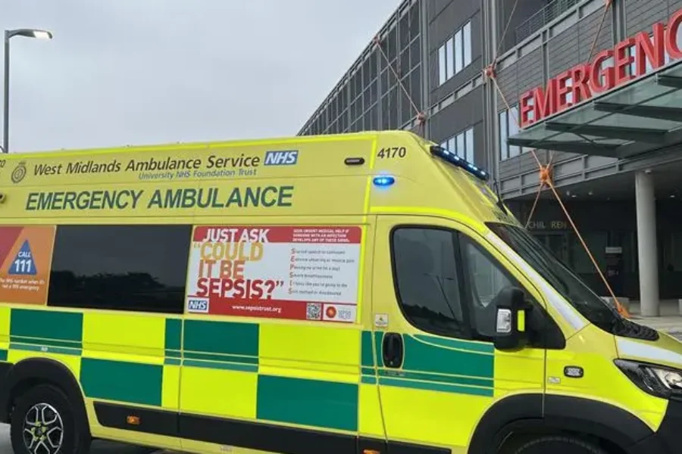 |  |  |  | Ambulance services history:  1800s: Civilian ambulance services began appearing in major cities. Hospitals started using horse-drawn ambulances to transport sick and injured people.  Late 19th century: Ambulances became more organized, with trained attendants providing basic care during transport.  Early 20th century: Motorized ambulances replaced horse-drawn vehicles, making emergency transport faster and more efficient.  1960s-1970s: Modern emergency medical services (EMS) emerged. Paramedics received advanced medical training, allowing treatment to begin before patients reached the hospital.  Today: Ambulances services provide sophisticated pre- hospital emergency care using advanced medical equipment, highly trained paramedics, and communication systems that coordinate with hospitals and any other emergency responders. Modern ambulances are a vital part of healthcare systems worldwide, helping save lives through rapid response, emergency treatment, and safe patient transport.
Ambulance services provide rapid emergency medical care and transportion for sick or injured individuals. When an emergency call is recived, a dispatch centre sends the nearest ambulance. Parmedics assess and treat patients at the scene, provide care during transport, and communicate with hospitals to ensure prompt treatment upon arrival. Modern ambulances are eqipped with advanced medical equipment and also support non-emergency paitent transport services.
Challenges faced by ambulance services
High demand and increased call volume: Ambulance services often receive a large number of emergency and non-emergency calls, This can lead to delays in response times, increased work load for staff, and difficulty in providing timely care to all patients.
Staff shortages:
Ambulance services often face a shortage of qualified parmedics ,emergency medical techniques and support staff. This can result from increasing demend for emergency services,limted recuruitment, and insufficient training capacity.

Both high demand and staff shortages place significant pressure on ambulance services, making it move difficult to provide timely and effective emergency care. As emergency calls continue to rise, limted staffing levels can make it difficult to respond quickly and effective to patients in need. This can lead to longer waiting times, increased pressure on parmedics, staff fatique, and a higher risk of burnout. Overtime, these challenges may affect the quality of patient care, employee wellbeing, and the overall effectiveness of the ambulance service.

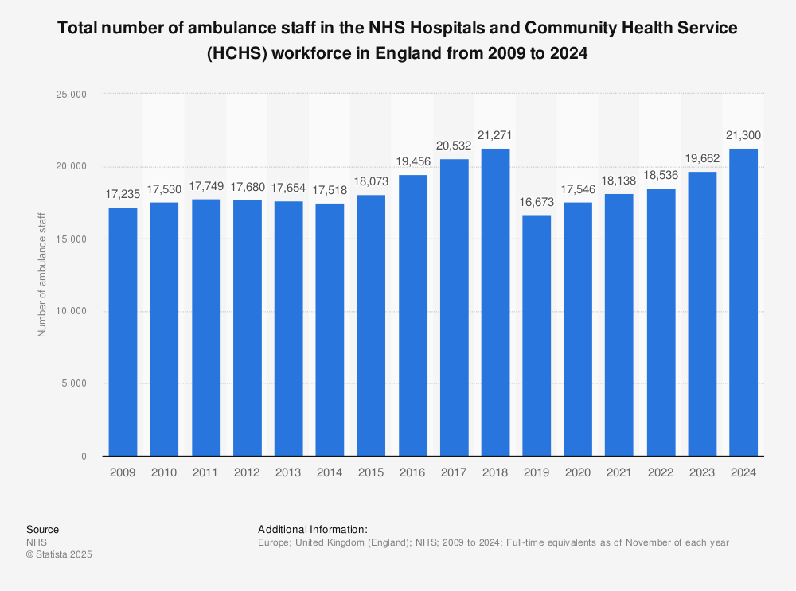

Community Mental Health Services
Maalikah Amjad- 2522378- LCHS4003

Community mental health are mental health care and support services provided within the community rather than in psychiatric hospital. Their goal is to help people manage mental health conditions while living at home, staying connected to family, work, school, and daily life. These services include assessment and diagnosis, therapy and counselling, medication management, crisis support, support workers and case management, rehabilitation and recovery, and peer support groups.
Community mental health services emerged from a major shift in how societies understood mental illness and how they cared for people with mental health conditions. Their origins are closely tied to changes in medicine, social attitudes, human rights, economics, and public policy.
For much of the 18th and 19th centuries, people with severe mental illness were often cared for in large institutions known as asylums or psychiatric hospitals. However, by the late 19th and early 20th centuries many institutions had become overcrowded, underfunded, and custodial rather than therapeutic. Patients could spend decades- or their entire lives- in hospitals, often isolated from their communities.
Community mental health services represent one of the largest transformations in modern healthcare. They reflect a shift from viewing mental illness primarily as a condition requiring segregation in institutions to understanding it as something that can often be manged within society through a combination of medical treatment, psychological support, social care, and community participation.
In historical terms, the rise of community mental health services mirrors broader 20th – century developments in civil rights, welfare policy, public health, and changing attitudes toward disability and citizenship. The service exits today because societies gradually moved away from the model of institutional confinement and toward the principle that people with mental health conditions should, wherever possible, live and participate fully in their communities.
Community mental health services aim to provide accessible, person- centred support within the community, helping individuals maintain independence and avoid unnecessary hospitalization. They are widely valued for promoting recovery, social inclusion, and multidisciplinary care. However, their effectiveness is often limited by underfunding, staff shortages, long waiting times, and fragmented coordination between services. As a result, many people struggle to access timely support and may only receive interventions during a crisis. Therefore, while the community –based model is generally seen as more humane and effective than institutional care, its success is often constrained by resource pressures and inequalities in service provision.
Community mental health services play a significant role in enhancing the quality of life of service users by enabling them to receive support while remaining in their own homes and communities. This helps individuals maintain relationships, participate in education or employment and retain a sense of independence and control over their lives. Access to therapy, medication management, crisis support, and social care can improve mental wellbeing, reduce symptoms, and support recovery. Additionally, community –based services promote social inclusion and reduce the isolation often associated with mental health difficulties. However, the positive impact on quality-of-life depends on timely access to appropriate support, as delays or gaps in services can limit their effectiveness. Overall, these services are important because they support both mental health recovery and broader social, emotional, and practical wellbeing.
Furthermore, the person-centred nature of community care allows service users to be actively involved in decisions about thier treatment and recovery goals. This can empower individuals, increase their sense of control, and improve satisfaction with the care they receive. However, the extent to which these services enhance quality of life depends on the availability and accessibility of support. Long waiting times, staff shortages, and limited resources can reduce their effectiveness and prevent some individuals from receiving timely care.

