University of Wales Trinity Saint David
Date
21/08/20

Lecture:
Magdalena Wronska

Autor:
Ana Rosario (1920819)

Communication

BWSW4002 Effective Team Working & Communication

Communication

BWSW4002 Effective Team Working & Communication

BWSW4002 Effective Team Working & Communication

Communication

BWSW4002 Effective Team Working & Communication

BWSW4002 Effective Team Working & Communication

Communication

BWSW4002 Effective Team Working & Communication

BWSW4002 Effective Team Working & Communication

Communication

BWSW4002 Effective Team Working & Communication
Table of Contents
1. Introduction 3
Definition Communication 3
Importance of communication in workplace 3

2. Models of Communication 4
2.1. Shannon and Weaver (1948) 4
Advantages 5
Disadvantages 6
2.2. Schramm (1954) 6
Advantages 7
Disadvantages 7
2.3. Berlo (1960) 8
Disadvantages 8

3. Communication Skills 9
3.3. Verbal Communication 9
3.2. Non-Verbal 11
3.3. Listening 12
Consequences that may arise from poor communication 14
Suggestion for improvements poor communication: 14
4. Conclusion 15
References 15

Introduction

Definition Communication
Humanity cannot survive without communication, it is what allows sharing information and figuring out from one individual, group or area to another (Differences, 2019). That information can be facts, emotion, values, thoughts, and opinions (Handbook, 2019), the message can also be transferred non-verbally or verbally. (Differences, 2019)
The steps of communication start with the sender (the person who sends the message), next comes encoding (which is the sender converting the feelings and ideas into communication) the followed by the message (which can be verbal or non-verbal), after that the receiver (the individual who receive the message) decodes, then finishing with feedback, which is when the message is send back from receiver to the sender (Differences, 2019, Handbook 2019, Need 2020). This assignment give some understanding of the models of communication, communication skills, example of poor communication and some suggestions to improve it.

Importance of communication in workplace
Communication in the workplace is a fundamental utensil which allows the organisation to be productive and keep a solid relationship between every member of institution (Page, n.d.) (InCorp, 2020). For example: when the employee feels free to expose their ideas without restrictions it is more probable for them to avoid confusion on a given task (Kashyap, 2019). For a project to become successful it depends on solid communication, that means the message must be logical, and when the managers are powerful communicators, they are more capable to instruct their teams successfully. the capacity to give every employee opportunity to talk and to be heard, collective cooperation and transferring information are essential tools in team working. (InCorp, 2020) (Page, n.d.)

Models of Communication

Shannon and Weaver (1948)
The transmission model of communication (Lyon, 2017) is the message shared between sender and receiver through technology which can be sometimes affected by the noise. (Theory, n.d.)
Shannon and Weaver explain that effective communication needs to have: an information source, transmitter, channel, noise, message, receiver, channel, information destination, encode and decode. (Theory, n.d.)
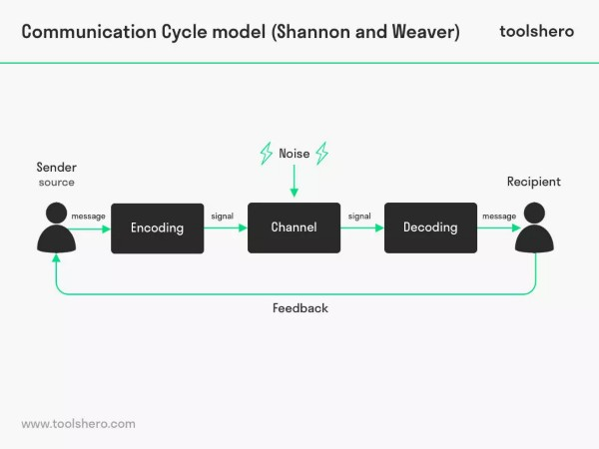
Figure 1 - Shannon and Weaver Communication Model (Toolshero,2020)

with this theory the first factor is the sender, who transmit the message to the receiver by encoding, for example: body language, the pitch and tone of voice or facial expressions; or verbal, for example: meeting from internet, telephone, face to face or using an intermediary; or media, for example: TV, radio, newspaper or cinema. Then this message is passed on, which can be by email, face to face or telephone. Next comes the decoding, which is the interpretation from receiver about the message given. Then this receiver sends feedback, which can be negative or positive, verbal or non-verbal. The feedback is responsible to certify the understanding or access more information to achieve consensus about what has been said between the sender and receiver. It is worth noting that noise, which is anything that can disturb the communication, can occur. (EPM, 2019)

Advantages
The message can be affected by the first barriers based in words which can be language, for example: when a doctor uses medical terminology to explain to the patient his medical condition; or a disjunction message, for example: when the structure of the message given is not succinct and clear; also the excess of information, for example: when the teacher is given too much information for students to take in. (Lyon, 2018)
Second barriers are related to people’s background, for example: some people look disinterested when individuals from other backgrounds are expressing their ideas; or demographic background, for example: people from differing generations can have different behavers and opinions from one another; also triggers and filters, for example: when an individual for breakfast always put cereal first and then the milk, until one day someone says it is more correct to do in the inverse way, this extra information will intrigue and make the person filter this information. (Lyon, 2018)
Third barriers are physical, which can be physical distance, for example: with cov-19 residents in care homes are unable to receive visits from their families, so In this case they have to use the technology to communicate which makes it harder to understand and express themselves properly; or the noise as can be seen on Figure 2, for example: because of the noise where Pedro works (on a building site), during his call with Maria, he understand she said she was in kitchen instead of buy the chicken.
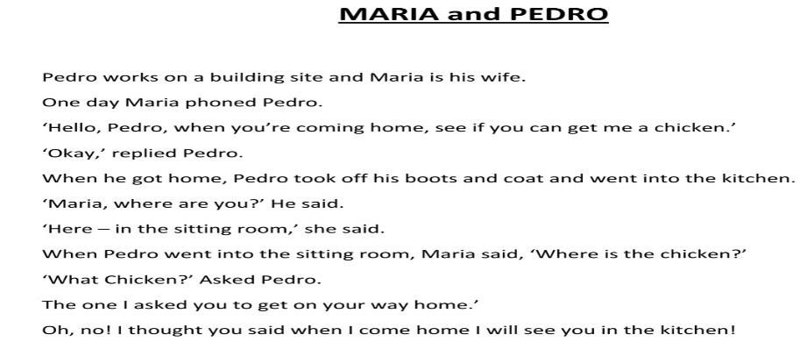
Figure 2 - UWTSD 2020 ("Maria and Predo”, Published literature)

Disadvantages
This model is based on the place and time it was conceived. Shannon and Weaver are from 40s and they use to work from telephone business which allows explain about this time of communication and also permits to see in aspect of sending message but it does not let learn the face to face complex, for example: complicate people, do not have the feedback on original model, non-verbal communication. (Lyon, 2017)

Schramm (1954)
This is a circular model because the communication is a two ways system, so that means the sender, sends and receives a message as much as the receiver, seen in Figure 2 (which is between Maria and Pedro). Schramm’s model works with conception that the most important part of this communication is the decoding. However, those experiences can be moulded according to the people’s social environment, which changes the way of communication, for example: the time (in Figure 2 when Maria called Pedro, he was working so that shows it was the wrong time), reasons (in Figure 9 when Mark starts given many complains to his chief, he is forgetting the propose of is meeting) and place (in Figure 5 the professor is not used to being with people outside is environment, which makes difficult to communicate with other) the person is living in . (EPM, 2019)
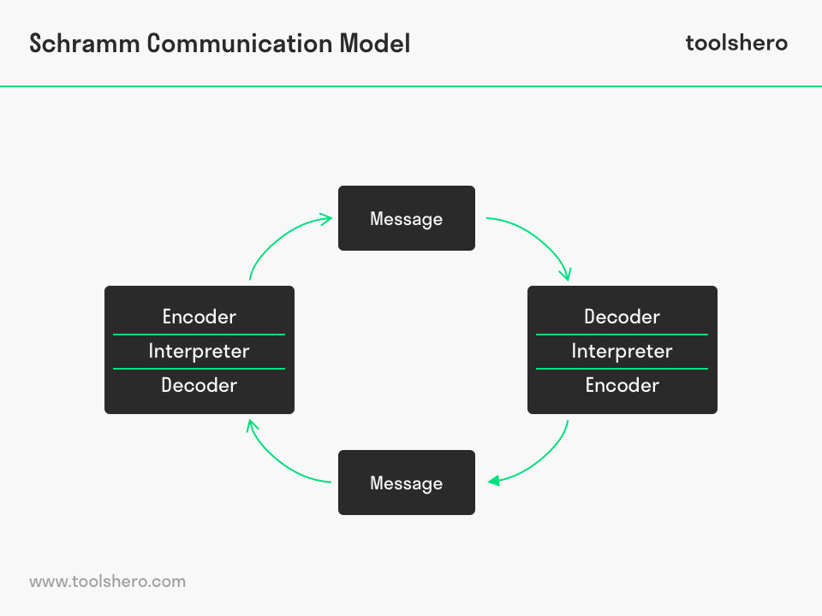
Figure 3 - Schramm Communication Model (Toolshero,2020)

The message only can be transmitted to other individual if it is turned into words (EduMania, 2018), for example: on Figure 7 when Barry put many sign all over the kitchen with big words to transmit the message to the employers.

Advantages
This model gives chance to the sender or receiver to express their ideas and are both equally active, the noise allows comprehension that problems can happen during the analyzation of the message, the feedback permits receiver to analyse if message have been understood, understand the different ways of communication system compared to the usual one. (EduMania, 2018)

Disadvantages
The message received and sent perhaps can be interpreted different than is supposed to, this model does not work with complex and various level of communication process, this model cannot have many sources communicating otherwise it would complicate it. (EduMania, 2018)

Berlo (1960)
This model is called a simple model because it initiates from the sender, afterwards that message is transferred from the sender to the receiver (MSG, 2020), before arriving at the receiver. (Jenkinson, 2013)
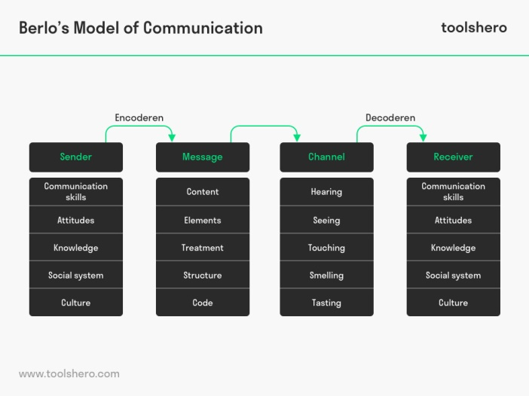
Figure 4 - Berlo’s SMCR Model of Communication (Ben Janse, 2019, Toolshero)

Disadvantages
On this model, the body language is more credible due to the fact that it is performed without thinking, does not mention any noise or barriers of communication, no existence of feedback makes this model linear, sender and receiver have to be in same level of factors mentioned above otherwise they would not be able to understand each other (Theory, n.d.) (Guide, 2020), Figure 5, when the professors house was on fire he used words that people from his village did not understand and for that reason they could not help him.
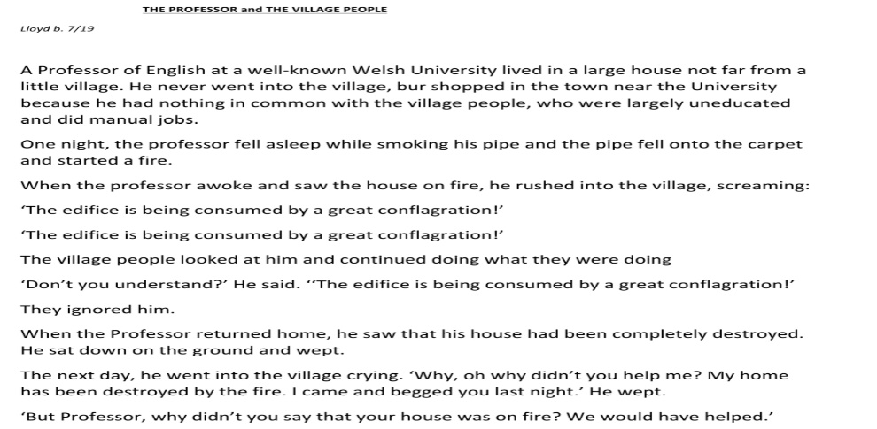
Figure 5 - UWTSD 2020 ("The professor and the village people”, Published literature)

Communication Skills
This skill permits individuals to understand the process of sending and receiving information. Peoples skills are divide in soft skills, which is the skills people need to be successful in work place (Doyle, 2020), for example: capable to work as team or be able to solve problems without other people’s help; and hard skills which are learned abilities gained from carer or life experience (Kagan, 2020), for example: as a career know how to work with different hoists after learning how to use it and repeat it many times. (Indeed, 2020)

Verbal Communication
Difference between written communication and oral communication:
- Written communication allows people to send messages by email (shown in Figure 6), letters, or documents. For example: this method can be very slow, because of the feedback and the transmission there can be many confusions when interpreting the message; literacy is needed and people have a chance to review what have been written. (Surbhi, 2015)
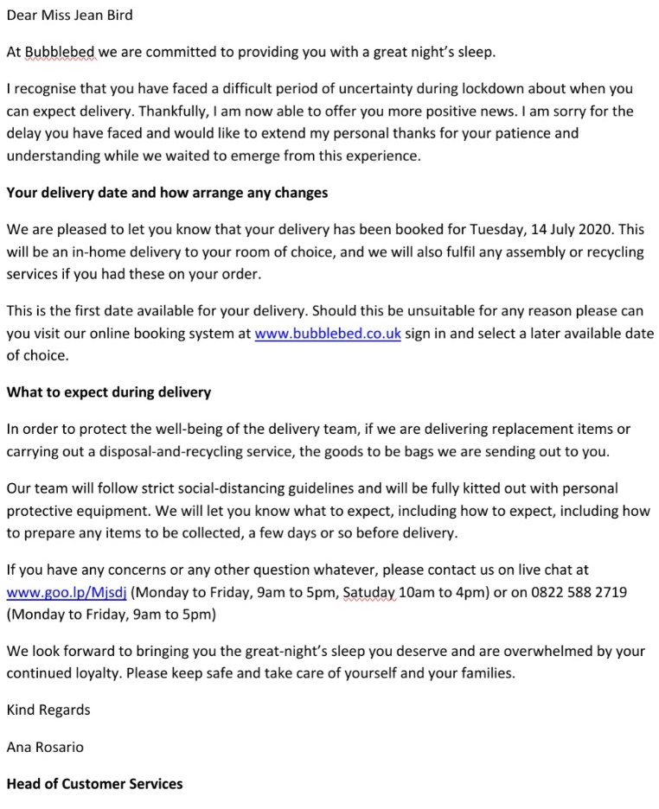
Figure 6 - Class activity

- Oral communication is when people convert ideas into spoken words. This type of communication can also be transmitted by phone, face to face, video call, etc. (Surbhi, 2015) For example, Figure 7, if Max used oral communication, it could be quicker to receive the message, less noise, which can affect the feedback and would help focus on just one task.
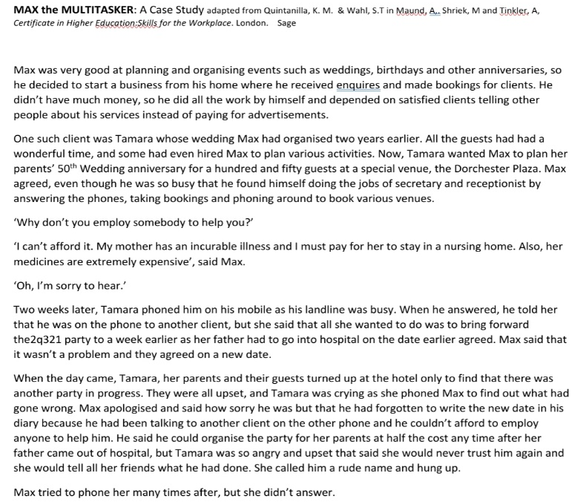
Figure 7 - UWTSD 2020 ("Max the multitasker”, Published literature)

Non-Verbal
Communication can be non-verbal when people communicate without using words (Computers, 2020). This time of communication is divided in different aspects:
- Personal appearance which is how peoples looks can say a lot of their personality, which can see Figure 8, when Barry went to work with a dirty uniform on, his hands and hair were looking unpleasant.
- Kinesics is the body language, which allows people to see other people’s movement without thinking.
- Personal space is the distances between individuals during conversation, which allows to understand our close this people are.
- Time allows to understand how punctual the person is, for example: when an individual get into a work meeting in time is more probable to be seen as a responsible as serious person.
- Vocalic is the tone of voice used, for example: if someone speak to loud could mean angry person or if speak to low could mean shy person.
- Haptics it is when people use touch to express feelings, for example a couple when holding hands. (Nordquist, 2020) (Computers, 2020)
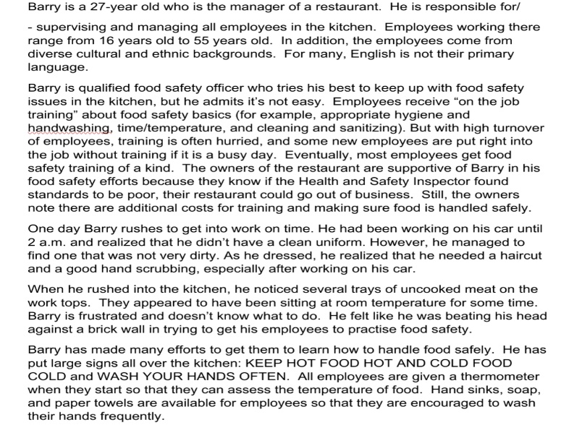
Figure 8 - UWTSD 2020 ("Barry”, Published literature)

Listening
In any effective communication, listening is a key to be successful, without this ability it is easy to people misunderstood the message given which would affect the feedback, Also be a good listener allows people to be more understandable in workplace and private lives because of fact bluing trust with others. (Lyon, 2017)
Listening skills is divided in 2 aspects:
- Active listening which is when people can listen to other individual or group and in same time make those people have been heard. A good listener use a nonverbal communication, which allows people to understand how is the others person emotionally, for example: eye contact or seat in front of the person who is talking, putting all devises distractions away; Also involve verbal communication, which is making good questions, for example: during the conversation make good questions and allows people to answer, show the sender that the other person is following the conversation, which can be seen on Figure 9 when Mark was talking to his chief, she was nodding her head showing understanding; or let the other person talk without interruptions; for example: Mark’s chief let him say all his complaints without interrupting him and let him express all concerns.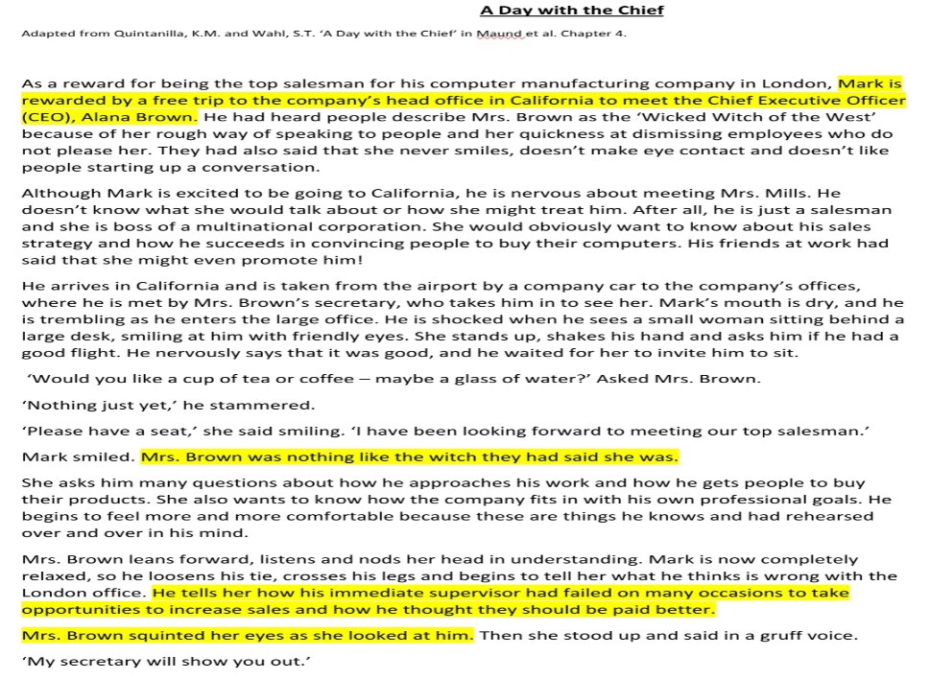
Figure 9 - UWTSD 2020 ("A day with the chief”, Published literature)

- Empathetic listening is when people put themselves in the speakers position so to understand how those people feel, which means be genuine, for example: when a person ask themselves how would it be for them to be in other people’s situation. Being empathetic does not means showing to the speaker fully agreement or solve the problem. Pay attention to the nonverbal and verbal communication, because people normally express quicker by body language than verbally and some people say something but the face expression says another, for example: when someone looks sad but says their happy. (Lyon, 2020)

Consequences that may arise from poor communication
Poor communication can have a huge impact in work place, (Wells, 2017) for example: when the carer given the medication forgets to sign the MAR chart, that unconscious action would make the following carer confused and unable to give the medication, because could cause overdose or miss an important medication, consequently affecting the productivity of work; or when two carers are moving and handling using a poor communication and their messages are not clear enough and consequently harm the resident.

Suggestion for improvements poor communication:
- Appropriate engaged Eye contact
- Be able to respect and accept other people’s ideas is a key to building the trust at any time of a relationship
- Be aware of body language because nonverbal communication often tells more than spoken words
- Being a good listener is important to show the speaker has been heard.
- Do not use devises during conversation with other people
- Do not talk over other people
- Tone of the voice
- Appearance is the first contact before people start to know each other
- Relax so the speaker can feel comfortable to express themselves
- Be clear and objective in expressing ideas (Dose, 2018)

Conclusion
Considering to everything that is present in this article it is clear that communication is complex, but it can be learned, as people can recognize the various aspects that build the communication and looking to the work of those mentioned previously the humanity have discovered how those aspects effect passing on a message, as well as information on how to form successful messages. So in that way this makes communication a skill which can be teachable, so that means people can continue to learn and can carry on developing the ability to be more effective to more people over a life time of relating to others.

References
Computers, W. (2020). “Advantages and Disadvantages of Communication Methods”. Retrieved August 5, 2020, from YouTube: https://www.youtube.com/watch?v=kcWjIDKtaNU
Differences, K. (2019). “What is Communication? Definition, Process, Types and 7 C’s of Communication”. Retrieved July 15, 2020, from YouTube: https://www.youtube.com/watch?reload=9&v=RkebtEk2zU0
Dose, B. (2018). “12 Ways to Improve Communication Skills Instantly”. Retrieved August 8, 2020, from YouTube: https://www.youtube.com/watch?v=HxGq1waX9kw
Doyle, A. (2020). “What are Soft Skills”. Retrieved July 30, 2020, from The Balance Career: https://www.thebalancecareers.com/what-are-soft-skills-2060852
EduMania. (2018). "Schramms Model of Communication". Retrieved July 20, 2020, from YouTube: https://www.youtube.com/watch?time_continue=108&v=vI-RgiVfhjo&feature=emb_title
EPM. (2019). “The Communication Process Explained”. Retrieved July 20, 2020, from EPM: https://www.youtube.com/watch?v=AzBAicGgPws
Guide, M. S. (2020). “Belo’s Model of Communication”. Retrieved July 24, 2020, from Management Study Guide.
Guide, M. S. (2020). “Belo’s Model of Communication”. Retrieved July 24, 2020, from Management Study Guide: https://www.managementstudyguide.com/different-types-of-communication-system.htm
Handbook, E. (2019). “What is Communication?”. Retrieved July 15, 2020, from Entrepreneur Handbook: https://entrepreneurhandbook.co.uk/what-is-communication/
InCorp. (2020). “Importance of Good Communication at the Workplace”. Retrieved July 17, 2020, from InCorp: https://www.incorp.asia/hr/importance-of-good-communication-at-workplace/#:~:text=Communication%20in%20the%20workplace%20is,work%20efficiently%20and%20be%20productive.&text=Employers%20who%20spend%20time%20and,productivity%2C%20performance%20and%20overall
Indeed. (2020). “Communication Skills: Definitions and Examples”. Retrieved July 30, 2020, from Indeed: https://www.indeed.com/career-advice/resumes-cover-letters/communication-skills
Jenkinson, P. (2013). “Communication Models: Basic SMCR Model”. Retrieved July 20, 2020, from YouTube: https://www.youtube.com/watch?v=yUGW2d6nXe0
Kagan, J. (2020). “Hard Skills”. Retrieved July 30, 2020, from Investopedia: https://www.investopedia.com/terms/h/hard-skills.asp#:~:text=Hard%20skills%20are%20learned%20abilities,and%20subsequently%20improve%20employee%20satisfaction.
Kashyap, V. (2019). “Effective Communication in the Workplace: How and Why?”. Retrieved July 17, 2020, from HR Technologist: https://www.hrtechnologist.com/articles/employee-engagement/effective-communication-in-the-workplace-how-and-why/
Lyon, A. (2017). “Efective Listening Skills”. Retrieved August 5, 2020, from YouTube: https://www.youtube.com/watch?v=IwWj_SfDpzg
Lyon, A. (2017). “Transmission Model of Communication: Shannon and Weaver”. Retrieved July 20, 2020, from YouTube: https://www.youtube.com/watch?v=OY1JsGFZprc
Lyon, A. (2018). “Communication Barriers”. Retrieved July 20, 2020, from YouTube: https://www.youtube.com/watch?time_continue=1&v=jsl468Hwr4o&feature=emb_title
Lyon, A. (2020). "Empathetic Listening Skills". Retrieved August 5, 2020, from YouTube: https://www.youtube.com/watch?v=lO1gpzakbik
Lyon, A. (2020). “Active Listening Skills”. Retrieved August 5, 2020, from YouTube: https://www.youtube.com/watch?v=7wUCyjiyXdg
Need, S. Y. (2020). “Listening Skills”. Retrieved August 5, 2020, from Skills You Need: https://www.skillsyouneed.com/ips/listening-skills.html#:~:text=Listening%20is%20the%20ability%20to,effectively%2C%20messages%20are%20easily%20misunderstood.&text=Effective%20listening%20is%20a%20skill%20that%20underpins%20all%20positive%20human%20relatio
Need, S. Y. (2020). “What is Communication?”. Retrieved July 15, 2020, from Skills You Need: https://www.skillsyouneed.com/ips/what-is-communication.html
Nordquist, R. (2020). “What is Nonverbal Communication?”. Retrieved July 24, 2020, from Thoughtco: https://www.thoughtco.com/what-is-nonverbal-communication-1691351
Page, M. (n.d.). “The importance of good communication in the workplace”. Retrieved July 17, 2020, from Michael Page.
S, S. (2015). “Difference Between Oral Communication and Written Communication”. Retrieved July 30, 2020, from Key Differences: https://keydifferences.com/difference-between-oral-communication-and-written-communication.html
Theory, C. (n.d.). “Belo’s SMCR Model of Communication”. Retrieved July 24, 2020, from Communication Theory.
Theory, C. (n.d.). “Shannon and Weaver Model of Communication”. Retrieved July 17, 2020, from Communication Theory: https://www.communicationtheory.org/shannon-and-weaver-model-of-communication/#:~:text=This%20model%20is%20specially%20designed,to%20improve%20the%20Technical%20communication.
Wells, K. (2017). "6 Business Impacts of Poor Communication In the Workplace". Retrieved August 8, 2020, from FSD Service Max: https://fsd.servicemax.com/2017/11/08/6-business-impacts-poor-communication/

