

MODULE CODE: ECAD4015

STUDENT NAME: Rio Galea

STUDENT NUMBER: 2400128

AI Acknowledgement

I confirm that I have not used any AI tools in the research and creation of this assignment.
I confirm that I have not presented any AI generated materials as my own work.
I confirm that I have copies of my drafts, notes, and other resources I used, which I may be asked to provide in evidence.

Targets from my previous assignment

Target | How I have addressed it in this work
Ensure that I engage with suitable academic literature from reliable sources. | I have used reliable journals, articles and government documents. This will decrease the sources in my work bias.
To continue developing my critical engagement with texts. | I have used a variety of sources to with contrasting viewpoints.
To improve my in-text referencing. | This has been addressed by reading through the Havard Referencing Guide and ensuring that I do not make mistakes that I have previously like including page numbers when they were not necessary.

Demonstrate how cross curricular teaching and learning can influence in depth skills and understanding. Underpin this with reference to relevant research, a detailed lesson plan and an enhanced provision material.

Introduction

Cross-curricular teaching is the interweaving of different subjects within a lesson to ensure that teaching is engaging, creative and purposeful (Estyn, 2018). These cross-curricular skills include the obligatory skills of literacy, numeracy, and digital competence (Welsh Government, 2022b). This cross-curriculum teaching approach allows children to develop in the four purposes of the Curriculum for Wales (Welsh Government, 2024). These four purposes involve helping children become ambitious, enterprising, ethical and healthy individuals (Welsh Government, 2024). This essay will demonstrate how cross-curricular learning can impact children’s knowledge and skills. In this essay the advantages of cross-curricular teaching outlined are the introduction of real-life skills, opportunities to incorporate the four purposes into learning and the increase in children’s engagement. In addition, the author will evaluate the suggested advantage that cross-curricular activities are more child focused than other teaching methods, which puts children at the centre of the work. Furthermore, this essay will outline the limitations of cross-curriculum learning, such as, the school’s budget, lack of cross-curricular training and the limited time that is available to teachers. The author will evaluate the viewpoint that this approach creates challenges when assessing children’s subject progression. The possibilities of linking work to too many subjects and ensuring that subjects that are more engaging to the children do not receive higher focus is also consider. Throughout this essay the author will refer to their enhanced provision as Appendix A and the lesson plan to be used alongside will be labelled Appendix B.

Main body

The literacy, numeracy and digital competence framework are the compulsory aspects included within the Curriculum for Wales (Welsh Government, 2024). These skills allow primary school children to receive balanced learning and develop the four purposes of the curriculum (Welsh Government, 2024). The four purposes outline that a school’s curriculum should aim to develop pupils into ambitious, enterprising, ethical, and healthy individuals (Welsh Government, 2022a). According to Payton and Hague (2010) digital competence is vital to providing children with the skills needed to understand the time we live in where technology has a prominent level of importance. In addition, it is portrayed that furthering children’s digital knowledge can allow them to explore their creativity and curiosity when using their resources (Payton and Hague, 2010). Furthermore, technology can help to improve pupils’ knowledge in a variety of subjects through cross-curricular learning (Payton and Hague, 2010). Teaching numeracy in cross-curricular learning includes developing mathematical proficiency, the number system, geometry, statistics, and data understanding (Welsh Government, 2022b). Askew (2012) illustrates the positive benefits that teaching numeracy has on children’s daily lives. Askew (2012) believes that by making lessons engaging and varied, mathematics can be integrated into work instead of singularly teaching a maths lesson. The particular importance of cross-curricular teaching in literacy work is emphasised by highlighting that “any literacy learning students undertake in their English lessons should be consolidated in other subject lessons.” (Harris, 2008, pg. 257). Similarly, Gross (2013) puts forward that literacy in the cross-curricular framework is vital due to an increase in children joining school with a limited level of language skills in the UK. Cooper and Rowley (2009), describe cross-curricular learning as the idea that lessons should include links between AoLEs instead of teaching individual subjects, which they believe to have no advantage for the children’s learning. The importance of cross-curricular teaching is emphasised by suggesting that children’s learning cannot fit into specific subjects (Kerry, 2015). Kelly and Stead (2013), state that cross-curriculum learning is traditionally linked to a child focused learning with the child at the centre of the work. Kelly and Stead (2013) recognise that there are contrasting views when it comes to cross-curricular teaching. The idea is put forward that younger primary school children benefit more from cross-curricular teaching than older children in the primary school (Kelly and Stead, 2013). A positive standpoint is taken when it is suggested that the cross-curricular approach is particularly important as it increases engagement in science and technology (Kelly and Stead, 2013).

Challenges and Opportunities

Kelly and Stead (2013) establish that a challenge when developing cross-curricular teaching is that it requires teachers time to improve their professional development beforehand. This training is necessary due to the lack of information and training provided to teachers on the cross-curricular approach (Kelly and Stead, 2013). According to Agyemang (2010), lack of training and resources can often be an issue of a school with low levels of funding. As a result of this the budget of a school could limit the opportunities available to use a cross-curricular learning approach. Harris (2013) states that there is a limitation in schools of the time available to teachers to understand how subjects link to one another. Furthermore, Kelly and Stead (2013) believe that ensuring that certain subjects that the children find more enjoyable do not gain higher focus compared to other AoLEs might pose some challenges. Barnes (2015) highlights that cross-curriculum lessons provide the teacher with higher opportunities to engage their pupils. In addition, pupils are given experiences that promote real life learning which could suggest that cross-curricular learning creates authentic experiences (Barnes, 2015). A supporting viewpoint is put forward by the Welsh Government (2022a), who state that learners must have the chance to use numeracy and critical thinking skills in real life situations across the curriculum. However, Barnes (2015) explains that a challenge for teachers when creating cross-curricular lessons is including links to too many subjects. It is suggested that this can lead to difficulty when assessing children’s subject progression (Barnes, 2015).

When creating Appendix A, the author has used their PTE1 classes’ subject of life cycles to demonstrate cross-curricular teaching. Appendix A is an accordion butterfly book which opens to show the stages of a butterfly’s life cycle. To do this the children have to use scissors to cut out the stages of the life cycle and stick them into the book in the correct order. They will then have to colour in each half of the butterfly which the Teaching Assistant will help them to stick to the front of their book. When colouring in both halves of their butterfly the TA will remind the children on what they have previously learnt about both their wings being symmetrical. This could link into mathematics as it states, “I have explored reflective symmetry in a range of contexts, and I can discuss it as a property of shapes and images” in Progression Step 2 (PS2) of geometry (Welsh Government, 2020). Similarly, by colouring in the children are using art skills like ‘Creating combines skills and knowledge, drawing on the sense, inspiration and imagination’ in PS2 (Welsh Government, 2020). Another aspect of numeracy that Appendix A links to is Progression Step 1 of Representing Data as the children must be able to sort the pictures into the correct order of the life cycle (Welsh Government, 2022b). When completing Appendix A children will have to use a scissors, glue sticks, paper and colouring pencils. This fits into Progression Step 2 which states “I can safely use a range of tools, materials and equipment to construct for a variety of reasons” (Welsh Government, 2020). Similarly, Progression Step 2 of Design thinking and engineering outlines the ability to identify things that might cause risk, for example, the scissors. According to the Welsh Government (2020), PS2 involves the knowledge that ‘The world around us is full of living things which depend on each other for survival’ which links into the topic of life cycles. By using words in English and Welsh underneath the pictures of the life cycle children are enhancing their literacy skills. According to Welsh Government (2022b), this links to Progression Step 1 which involves being able to use pictures to understand the words that you read. This is particularly important for the words that children are less familiar with in Welsh. After the children have completed their enhanced provision, they will then use the class iPad to take and upload photos of their work onto the Dojo app. This will allow the children to use their digital competency skills as suggested in PS1 which says, “I can save and retrieve my digital work, e.g. clicking icons, within apps, camera roll.” (Welsh Government, 2022c). The author believes that a challenge that might occur with Appendix A is that the children might find the find the sticking of the butterfly to the accordion book challenging. This could be avoided by an adult demonstrating how this should be done to provide children with a visual aid in the task. A supporting viewpoint is put forward by Dunn (2017) who believes it is beneficial to teach children in a variety of ways including visually, kinaesthetically and auditorily. Didau (2014) suggests that asking questions, specifically about new vocabulary is vital to develop children’s critical thinking skills and overall understanding of the topic. According to the Welsh Government (2022b), asking and answering questions is important as it is part of Progression Step 2 of ‘Expressing ourselves through languages is key to communication’. Therefore, Appendix B contains the questions that the teacher could ask when using the book ‘The very Hungry Caterpillar’ as a hook for the lesson and a recap to help children with Appendix A. The author has considered that for EAL children in the class it might be beneficial to include the stages of the life cycle in their first language to make their understanding of the definitions less challenging.

Conclusion

In conclusion, the author has learnt that the literacy, numeracy and digital competence framework is beneficial within the Curriculum for Wales. The Literacy and Numeracy framework provides detailed documents that include the various progression steps in a child’s aspects of learning (Welsh Government, 2022b). This allows teachers to have a clear understanding of the different levels that literacy and numeracy can be taught. Payton and Hague (2010) express the importance of the Digital Competence Framework providing support for children to be competent and confident in increasingly prominent resources. Askew (2012) believes that when numeracy is taught through cross-curricular learning children are more engaged in lessons. Overall, the author has found that the teaching of the literacy, numeracy and digital competence framework allows work to become more engaging and provides more detailed guidelines for teachers to follow. Furthermore, this framework will influence the teachers to use cross-curricular learning in their classes by highlighting the equal importance of subjects for children. In their future career the author will ensure that they use cross-curricular learning to create real-life learning experiences and enhance the outcome of their lessons. The Professional Standards for Teaching and Leadership (PSL) contains information on the behaviour, skills and knowledge that are essential for a teacher to be of a high standard and develop professionally (Welsh Government, 2018). When the author is on their PTE1 they will use the overarching values and dispositions to reflect on their teaching as well as the cross-curricular framework to understand what is important to include in their lesson plans. When the author starts their placement, this framework will be used to create targets to further their professional development. The authors first target will include improving the way that they manage the learning environment. This will be done by using the four purposes to ensure that pupils understand the author clearly and by encouraging positive learning behaviours throughout lessons (Welsh Government, 2018). In addition, the author would like to use the help of the PSL and help from their mentors to understand the different ways to involve parents and carers in the pupil’s learning (Welsh Government, 2018). Finally, the author would like to use a range of methods and approaches in their teaching to provide a “Blended learning experience” (Welsh Government, pg. 31, 2018).

Reference List

Agyemang, G. (2010) Accounting for needs? Formula funding in the UK schools sector. Egham: Royal Holloway University of London.
Available at: https://pure.royalholloway.ac.uk/en/publications/accounting-for-needs-formula-funding-in-the-uk-school-sector (Accessed: 27 February 2025)

Askew, M. (2012) Transforming Primary Mathematics. Oxon: Routledge. Available at: https://doi.org/10.4324/9780203806746 (Accessed: 25 February 2025)

Barnes, J. (2015) Cross-curricular learning 3-14. 3rd Edn. Los Angeles: SAGE. (Available at: https://www.researchgate.net/profile/Jonathan-Barnes-3/publication/274313611_An_Introduction_to_Cross-Curricular_Learning/links/551b2ab60cf251c35b5080db/An-Introduction-to-Cross-Curricular-Learning.pdf (Accessed: 18 February 2025)

Cooper, H. and Rowley, C. (2009) Cross-curricular Approaches to Teaching and Learning. 1st Edn. Los Angeles: SAGE. Available at: https://research-ebsco-com.ezproxy.uwtsd.ac.uk/c/onvpsy/search/details/wunwvidlj5?db=nlebk (Accessed: 18 February 2025)

Cremin, T. and Burnett, C. (2018) Learning to Teach in the Primary School. 4th Edn. Oxon: Routledge. Available at: https://ebookcentral.proquest.com/lib/trinity/detail.action?pq-origsite=primo&docID=5323392 (Accessed: 25 February 2025)

Dunn, D. (2017) How to Be an Outstanding Primary School Teacher. 2nd Edn. London: Bloomsbury Publishing.
Available at: https://ebookcentral.proquest.com/lib/trinity/reader.action?docID=4987833&ppg=1 (Accessed: 2 March 2025)

Didau, D. (2014) The Secret of Literacy: making the implicit, explicit. 1st Edn. Carmarthen: Crown House Publishing. Available at: https://ebookcentral.proquest.com/lib/trinity/reader.action?docID=1584366&ppg=7 (Accessed: 25 February 2025)

Estyn. (2018) Providing enriched experiences to develop skills. Cardiff: Welsh Government.
Available at: https://estyn.gov.wales/improvement-resources/providing-enriched-experiences-to-develop-skills/ (Accessed: 28 February 2025)

Gross, J. (2013) Time to Talk: Implementing outstanding practice in speech, language, and communication. 1st Edn. Oxon: Routledge.
Available at: https://doi.org/10.4324/9780203095102 (Accessed: 25 February 2025)
Pg. 5- EAL children learning English

Harris, V. (2008) A cross-curricular approach to ‘learning to learn’ languages: government policy and school practice. London: BERA. Available at: https://doi.org/10.1080/09585170802509849 (Accessed: 27 February 2025)

Kelly, L. and Stead, D. (2013) Enhancing primary science: developing effective cross-curricular links. Open University Press: Berkshire.
Available at: https://books.google.co.uk/books?hl=en&lr=&id=pJIev0lJYeUC&oi=fnd&pg=PR7&dq=Kelly,+%26+Stead,+D.+(2013).+Enhancing+primary+science:+developing+effective+cross-curricular+links.+Open+University+Press.&ots=8ej-iGhm4u&sig=4CLP7BViEOBZZKsG9OIHmapowqg&redir_esc=y#v=onepage&q&f=false (Accessed: 20 February 2025)

Kerry, T. (2015) Cross- Curricular Teaching in the Primary School. 2nd Edn. London and New York: Routledge. Available at: https://api.taylorfrancis.com/content/books/mono/download?identifierName=doi&identifierValue=10.4324/9781315766010&type=googlepdf (Accessed: 18 February 2025)

Payton, S. and Hague, C. (2010) Digital literacy across the curriculum. Bristol: Futurelab.
Available at: https://www.nfer.ac.uk/publications/digital-literacy-across-the-curriculum/
(Accessed: 25 February 2025)

Welsh Government. (2020) Curriculum for Wales, Areas of Learning and Experience. Welsh Government.
Available at: Curriculum for Wales - Hwb
(Accessed: 23 February 2025)

Welsh Government. (2024) Curriculum for Wales: annual report 2024. Welsh Government.
Available at: https://www.gov.wales/sites/default/files/pdf-versions/2024/10/4/1728576137/curriculum-wales-annual-report-2024.pdf (Accessed: 19 February 2025)

Welsh Government. (2022a) Developing a vision for curriculum design. Welsh Government.
Available at: https://hwb.gov.wales/curriculum-for-wales/designing-your-curriculum/developing-a-vision-for-curriculum-design/ - curriculum-design-and-the-four-purposes
(Accessed: 26 February 2025)

Welsh Government. (2022b) National Literacy and Numeracy Framework. Welsh Government, Cardiff.
Available at: https://hwb.gov.wales/curriculum-for-wales/cross-curricular-skills-frameworks/literacy-and-numeracy-framework/ (Accessed: 20 February 2025)

Welsh Government. (2018) Professional Standards for Teaching and Leadership. Cardiff: Welsh Government.
Available at: professional-standards-for-teaching-and-leadership-interactive-pdf-for-pc.pdf
(Accessed: 2 March 2025)

Welsh Government. (2022c) The Digital Competence Framework. Available at: https://hwb.gov.wales/curriculum-for-wales/cross-curricular-skills-frameworks/digital-competence-framework/
(Accessed: 20 February 2025)

Appendices
Appendix A:
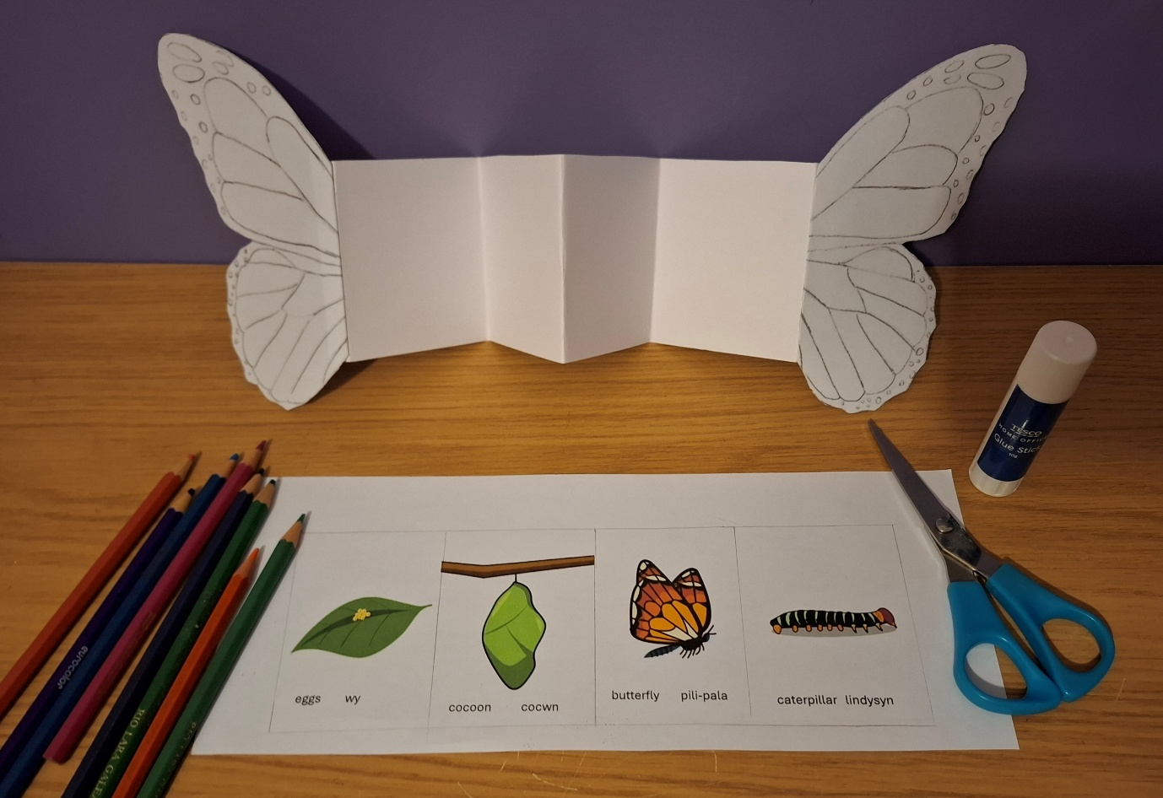

Appendix B:


