Cover page 1
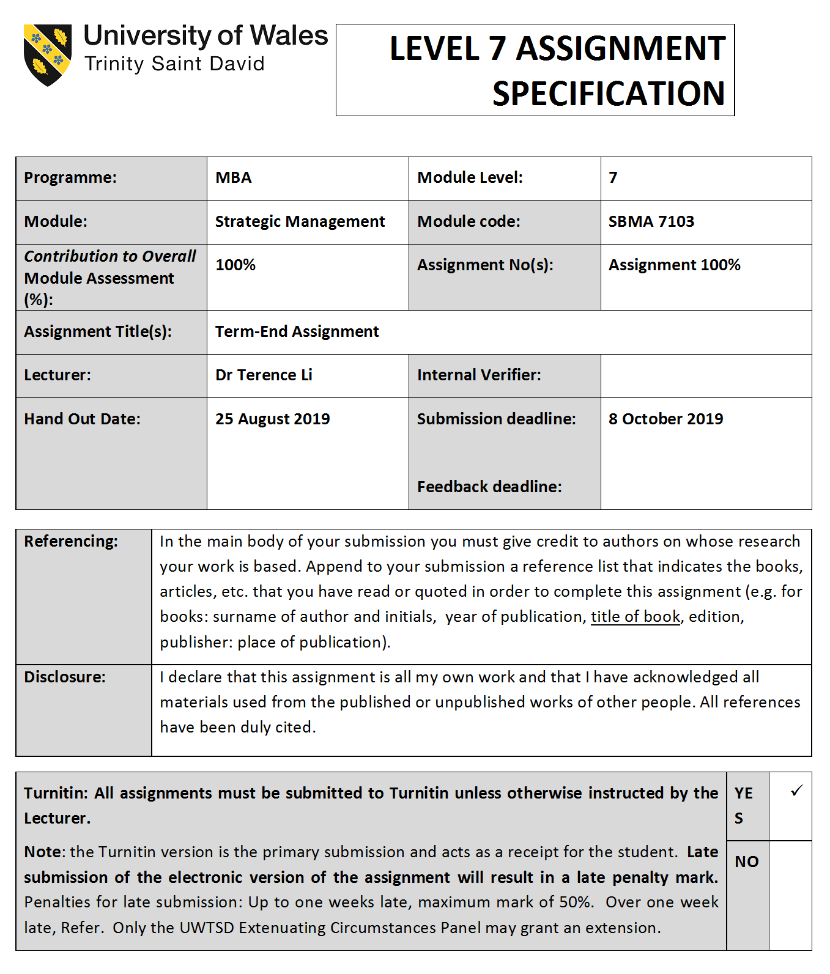

Cover page 2

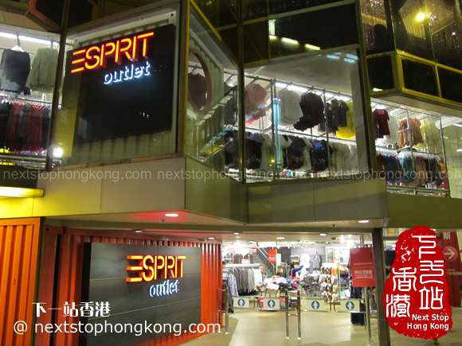
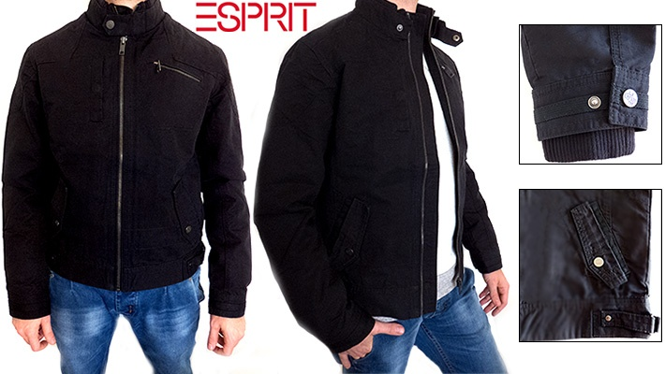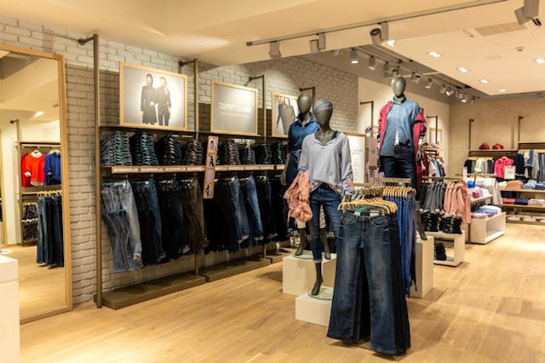

Table of Contents

Cover page 1 i
Cover page 2 ii
Table of Contents iii
Introduction 1
1. Macro and Micro Environmental Analysis of Hong Kong Casual Wear Industry 2
1.1 PESTLE analysis 2
1.1.1 Technological factor 2
1.1.2 Economic factor 3
1.1.3 Social factor 7
1.1.4 Political factor 7
1.1.5 Legal factor 9
1.1.6 Environmental factor 9
1.1.7. External factor evaluation (EFE) matrix: 10
1.2 Porter’s Five Forces Analysis 11
1.2.1 Threat of New Entrants: (High) 12
1.2.2 Threat of Substitutes (High Medium) 12
1.2.3 Bargaining Power of Suppliers (High Medium) 13
1.2.4 Bargaining Power of Buyers (Low Medium) 13
1.2.4 Competitive Rivalry (High) 13
1.2.5. Summary of Competitive power 15
1.2.6. The internal factor evaluation (IFE) matrix 16
2: Recent Corporate and Business Strategy Proposed by Esprit Holdings Limited 17
2.1. Corporate Strategy 17
2.1.1 Closure of Unprofitable Stores 17
2.1.2 Workforce Downsizing 18
2.2 Business Strategy 19
2.2.1. Brand/Image differentiation 19
2.2.2. Product differentiation 19
2.2.3 Wholesale business and e-commerce differentiation 20
2.3. Corporate and business strategy balanced scorecards. 21
3: Recommendations of Strategies to Improve Fiscal Performance of Esprit Holdings 23
3.1. Close Unprofitable Stores and Open Profitable 23
3.2. Decentralization of Management 23
3.3. Products development and international footprint 24
3.4. Brand Positioning and Marketing 25
4: Effectively implementing the Strategies 29
4.1. The Boston Consulting group’s product portfolio matrix (BCG matrix): 29
4.2. Assessment of effectively implement to strategies 31
References 35

Introduction
In Hong Kong (H.K.), the clothing industry is arguably one of the largest industries. Several well-developed Hong Kong clothing manufacturers were entered into the retail business, both within the country and other countries overseas where are included New York, Tokyo, Singapore, Shanghai, London, San Francisco, and Beijing. Some of the notable players in the industry include Bale no, Esprit, Episode, Bossini, JEANSWEST, Moiselle, and Crocodile (HKTDC, 2019). This paper will focus on Esprit Holdings Limited (Esprit) (0330.HK) which is one of the Hong Kong stock listing firms in the sector. By 2018, Esprit ran around 495 retail stores across over 40 countries, 5,264 wholesale point of sales (POS) and 19 eshops. During the 2017-2018 financial year Esprit group recorded total revenue of HK $15,455 million which is a decline of around 11% (Esprit, 2018,p.9). Hong Kong region recorded revenue 173million which decline of 34.4% in 2018 (Esprit, 2018,p.94).The dismal performance has been attributed to the increasingly competitive landscape that is characterized by emerging online stores. The constantly changing business environment makes it necessary for the company to constantly evaluate its external and internal environment so as to formulate strategies that respond to actual market needs. Therefore, this report will present an evaluation of the internal and external environment, current strategies, and propose a number of other strategies that will make Esprit more competitive in the Hong Kong Market.

Macro and Micro Environmental Analysis of Hong Kong Casual Wear Industry
As pointed out above, Esprit has not been performing well as a result of a number of factors operating both within and outside the organization. Therefore, before the formulation of strategy, an evaluation of the external and internal environment is necessary. The PESTLE framework (Political, Economic, Social, Technological, Legal, Environmental) will be employed in the evaluation of the macro environment (CIPD, 2018) while the Porter’s Five Forces framework will focus on the micro environment (Porter, 2008, pp25-40).

1.1 PESTLE analysis

1.1.1 Technological factor
In fashion segment, the revenue of global online shares has reached about 20% in 2018, but will continue to grow in coming years (Stratista, 2019). For instance, Yoo, Jeon and Han, 2016. (2016, pp.87-98) highlights that the popularity of the internet over the world affects the company’s sales. Majority of the consumers of the clothes manufactured by the industry in Hong Kong is the millennial generation. This group of individuals comes from all over the world.
The internet allows them to order and purchase different types of clothing which will then be delivered to their respective countries. The leading trends is integration of shopping functionality with social media directly which allows the rapid speed "inspire and sell" customer conversion (e.g. Facebook or Instagram Checkout). More people is shifting from desktop to mobile, thus mobile apps are improving their checkout experience and mobile browsing becomes crucial (Wang and Reani, 2017, pp.16-35).
Furthermore, the amount of information on the internet will enable consumers to do adequate research before making the final purchase. Despite the increase in automation in the industry, human labour is still required in some of the processes such as hand-making some of the sewing designs and patterns.
Technology has improved the production process of the clothes. The machines used in different industries lead to savings in labour costs. However, the adoption of production technologies at the expense of employment of people is likely to lead to a negative reputation for Esprit in the social sphere. Therefore, a balance has to be struck between automation and employment so that the company enjoys the cost-cutting ability of technology while at the same time maintaining its social reputation as an important employer.

1.1.2 Economic factor
Changing in the economic environment influences H.K. market by both the local and international market. Moreover, shifts in the economy will affect the decision-making process of the customers. The economy of Hong Kong is free trade-oriented of clothing items in the world. In the year 2015, the country was noted to be number in terms of the goods exported to other countries in the world (Huang, 2016, p. 315). The merchandise shipped was close to USD 3 trillion, which represents a total of 14% of exports made that year globally (HKTDC, 2019).
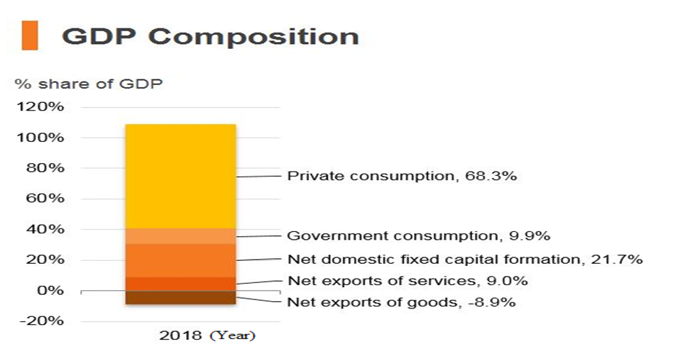
Figure 1: Source from HKTDC, 2019
The Gross Domestic Product (GDP) in Hong Kong was worth 362.99 billion US dollars in 2018 with service sectors accounting 90%+ of GDP (HKTDC, 2019). Clothing retailer is one of service sector.
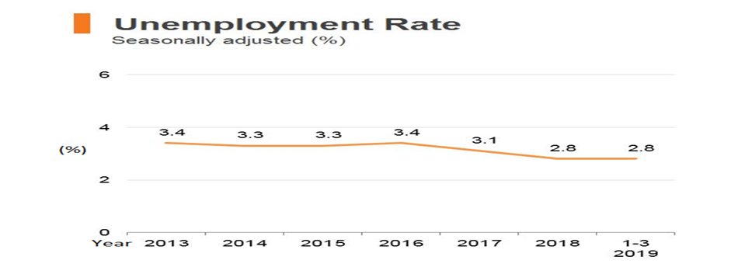
Figure 2: Source from HKTDC, 2019.
The level of unemployment in Hong Kong, as presented in figure 2, has been observed to decline from 3.4% in 2013 to 2.8% in the first quarter of 2019 (HKTDC,2019). The implication of a declining unemployment rate is that people have higher disposable income and are thus more likely to spend on fashion items. The situation thus presents an opportunity for Esprit to expand its revenue.
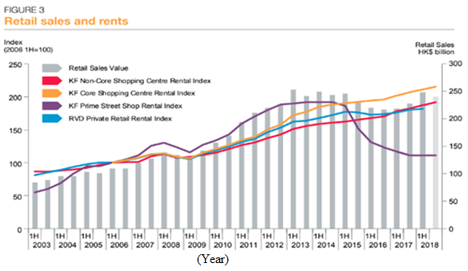
Figure 3: Adapted from Hong Kong business, 2019...
Yet another economic opportunity Esprit can take advantage of is the declining cost of rents in Hong Kong. From figure 3 above, it is evident that the rent prices have been increasing steadily from 2003 to 2014. However, the situation has changed from 2015 where a significant drop has been observed. The prices are expected to drop by a further 5% by the end of 2019 (Hong Kong Business, 2019). Therefore, Esprit will be in a better position to rent low-cost retail premises in prime areas leading to two benefits:
- Esprit will incur less in terms of rent. Two, the prime locations of the cheaper premises will allow Esprit to reach more customers.
- The overall outcome is that Esprit will significantly improve its financial position as a result of making more sales in the new outlets.
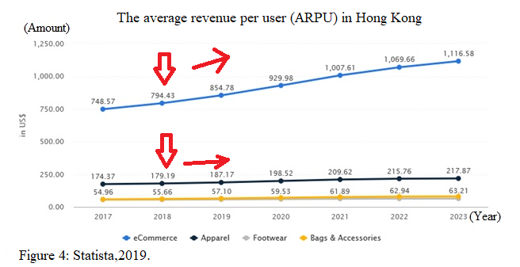
In HK fashion segment, “ARPU” shows online revenues yearly has reached US793.43 and the apparel revenues has reached US 179.19 in 2018 but the growth will continue in coming years (Statista, 2019).

1.1.3 Social factor
In the context of fashion, perhaps the most significant social factor is the general age distribution of the population. Hong Kong is an ageing society whose labour force is declining each year (AVPN, 2019). An ageing population means a decline in the demand for most fashion clothing owing to the fact that most novel designs appeal more to young people than to older people. With this demographic trend in mind, Esprit will need to consider investing more in designing casual wear for older people. Such a move will position it in a better position to take advantage of the demand from older people who will form a significant proportion of the population in future.
Income distribution is another social factor that is likely to have a profound impact on the success of Esprit in the Hong Kong market. It is revealed in AVPN (2019) that in 2017, the city recorded a Gina coefficient of around 0.54. This figure shows that the income gap between the rich and the poor is wider than average. Even more important is the fact that the disparity between the rich and the poor is increasing each year. The uneven distribution of income has resulted in an increasing number of firms in the city investing in philanthropic initiatives so as to improve the social status of the population.

1.1.4 Political factor
The political climate in Hong Kong has been tense since 2014 following a number of political moves by the Chinese government, which put into question the level of political autonomy the city enjoys (SVA, 2019). An example of such actions is the barring of two representatives from the Hong Kong Legislative Council (GovHK,2019) by the Chinese government. Another profound impacts of the political tension between Hong Kong and China is that they threaten to cause social tensions which, in turn, threaten to slow down the Hong Kong economy. Furthermore, the hard stance was taken by Beijing and the emergence of radical localist groups in Hong Kong threatens to lead to riots in the city (SVA, 2019). In the context of retail business, this situation threatens to bring challenges in product distribution within the region and causes the break out of riots. Furthermore, the political tension is likely to result to a decline in the number of people visiting Hong Kong, thus reducing the number of foreigners making clothing purchases in the city.
Despite the challenges mentioned above, it emerges that the Hong Kong government has put in place a number of measures to support the textile and Apparel industry. One of these measures is the creation of free market policies that aim at creating a business-friendly environment for manufacturing companies to be established. Through free-market policies, the government partners with other organizations to support textile and clothing establishments through technology acquisition and subsidizing R&D functions (GovHK, 2019). Furthermore, Bray (2018) points out that the government’s commitment to the textile and clothing industry is evident from its funding of numerous events such as the Hong Kong Fashion Summit. Such events provide an opportunity for companies in the apparel sector to showcase their products to an international audience. Despite this being an opportunity for Esprit, it can also easily be a threat since the funding of such events allows startups to reach a large audience, thus winning market share from established companies.

1.1.5 Legal factor
The main legal issue is in the casual wear industry relates to the labour laws in the` country. These laws will regulate the minimum amount of wages the workforce will be paid. The labour laws will further ensure that the working environments are acceptable to protect the rights of the workers. According to the financial budget read in 2016 February by the financial secretary Tsang John, roughly HK$500 million was directed towards developing the fashion industry (Shen and Mikschovsky, 2019, p. 15). The main course of action included formulating an incubation system for fashion majors, benchmarking from other fashion moguls in fashion-centered cities around the world, supporting and promoting the local fashion brands and encouraging more upcoming fashion designers to produce quality products. Lastly, the program focused on establishing a resource center whereby training and technical support was provided to the young designers.

1.1.6 Environmental factor
Environmental regulations are relevant as they ensure that the situation is protected from harmful emissions from these factories, such as the greenhouse gasses. As the industry is mainly rooted in international trade, there are laws which control the process of exportation of goods to other countries as well. It is pointed out in AVPN (2019) that issues such as environmental sustainability and the prevention of air pollution have, over the recent past, become very important in the textile and clothing industry in Hong Kong. Therefore, Esprit has put in place a number of measures to ensure compliance with environmental protection and sustainability standards. These include wastewater testing before discharge, the real-time mapping of gaseous emissions, and the sustainable sourcing of cotton and wool (Esprit, 2018).

External factor evaluation (EFE) matrix:
Above PESTLE evaluation presents as EFE matrix table, it emerges that a number key factors of opportunities and threats exist for the effect of Esprit in short or long term periods. In long term, the technological environmental aspects present the greatest opportunities to company but it has led to the emergence of purely online retail stores that are winning significant market shares from traditional outlets. Although the greatest threat is that visitors are declined to HK due to 2019 Hong Kong protests (Donny, 2019), Esprit is still in a good position to take advantage of the opportunities presented in these contexts. The formulation of proper strategies will ensure that the company achieves success going forward.

1.2 Porter’s Five Forces Analysis
Aithal (2017, p. 45) explains that this analysis is valuable in understanding the factors which control the profitability of the organization. The Porter five forces are a tool for evaluating industry competitiveness situation and focuses on five factors of supplier power, buyer power, threat of new entry, threat of substation and degree of competitive rivalry as below (Porter, 2008, pp.25-40).
Source: From this research.
· Basic human needs
↑ Unique for money

↓Few in number
↓High switching costs
↑No substitutes
∙Government policies
∙Product differentiation
↓Capital requirement
↓Switch cost
↓More on-line shops and mobile apps
↓ Buyer gets information easily
↓ Low switch costs
∙∙ Undifferentiated products
↓Loss of power for Espirt
↑Gain of power for Espirt

1.2.1 Threat of New Entrants: (High)
The advent of e-commerce has made it significantly easier for new firms to enter different markets. In the casual wear industry, Esprit (2018) reveals that the emergence of online retailers has played a significant role in the decline in Esprit’s revenue. However, it is essential to note that these threats are not posed only by potential new players; existing companies may improve the quality of their products; hence, pose a threat. The newly introduced product will cause the lowering of prices of other products and eventually reduce the profit margins their respective companies. In the clothing industry in Hong Kong, the threat of new entrants increase its start-up capital required for starting a clothing industry is Low. For example: Uniqlo Hong Kong launched “online flagship store” and “mobile app” for everyone shopping easily (Uniqlo,2019).

1.2.2 Threat of Substitutes (High Medium)
The threat of product substitute is a high, medium threat. The main question to ask is, “How easily can a product be traded with another?” In essence, if there are several products in the market which meet the same need, then the profits brought in by those products will be meagre. However, if a product is unique to the type of services it offers, then that product will be profitable for the company. Aithal (2017, p. 46) adds that the price of a product is dependent on whether or not it can be substituted. Therefore, product can be easily substituted and has deficient demand. This product will not cost much. In contrast, a product cannot be easily replaced, has a high demand and thus, a higher price. The threat of Hong Kong clothing industry is minimal. The clothes cannot be replaced by anything else due to basic human needs. Therefore, the clothing industry has a type of security as human beings will continue to wear clothes years to come.

1.2.3 Bargaining Power of Suppliers (High Medium)
The bargaining power of suppliers is a medium-high threat. Research done on sports apparel in China showed that suppliers do not require substantial capital investments or labour. The law of demand and supply is applicable in this setting as well. Therefore, when there are several suppliers available in the market, the clothing company can negotiate a lower price for their resources. Alternatively, when there is only one supplier, the supplier can bargain for a higher price from the textile company. In Hong Kong, there is a lack of diversity in the type of suppliers. As a result, the clothing industry is profitable for suppliers who have access to resources that are in high demand but are not readily available.

1.2.4 Bargaining Power of Buyers (Low Medium)
The negotiating influence of the buyers is a low-medium threat. The buyers of the garments made in Hong Kong are individual consumers. Usually, these people buy clothes on a small scale. Likewise, clothing companies with products that are high in demand can sell them at higher prices. Such products could be clothes sold by famous designers or clothes with high brand loyalty. Nonetheless, consumers are price-sensitive, thus they may or may not comply with this law. Therefore, apparel industries need to do comprehensive research and find out the products and clothes that are in demand. The internet allows consumers to do extensive research on the prices offered by different companies. Naturally, the customers will prefer the company which offers their desired apparel at an affordable price.

1.2.4 Competitive Rivalry (High)
Competition amongst existing textile industries is a high threat. Due to a large number of textile industries in Hong Kong, there is stiff competition amongst the companies, and this consequently affects the price factor of the clothing commodities. This force is the leading industry factor in the consumer market (Ge and Li,, 2019, p. 56). For companies to set themselves apart from the rest, many resources are directed towards advertising. However, as revealed in Esprit (2018) the number of competitors in the market is increasing, especially in the online store format. Therefore, the threat of competitive rivalry can be said to be increasing for casual wear firms in the city. For example: Adidas sport wear group was entered in casual wear market by Y-3 brand (Footasylum, 2019). Zara’s fast fashion produces products about 10 to 14 days to market only (Forbes,2012)

1.2.5. Summary of Competitive power

Overall of 5 forces is high medium and less attractive on profitability to Esprit. It is recommended to choose the differentiated strategy creating competitive advantages and values chains (Tanwar, 2013, pp.11-17).

1.2.6. The internal factor evaluation (IFE) matrix

IFE matrix is used to audit Esprit’s different functional departments internally as below (Frigo,2002):
The total weighted score of Esprit results 2.29 that is considered as weak in its industry in year 2018. It shows all the role of each department for forcing on specific internal factors to improve its performance and creates values to organization, customers and/or stakeholder.

2: Recent Corporate and Business Strategy Proposed by Esprit Holdings Limited

2.1. Corporate Strategy
In essence, a corporate strategy is an incessant course of actively convincing the organization’s donors and investors to trust the company with their finances, thus, causing an increase in the company's equity (Agrawal, 2018, p. 165). The 2019 interim report of Esprit presents some of the corporate-level strategies that should be implemented in order to achieve profitability going forward as below:

2.1.1 Closure of Unprofitable Stores
One of the moves directly targeting the high costs is the reduction of stores that have been posting losses consistently. As pointed out in the 2018/2019 interim report, closure of unprofitable stores will lead to short term costs amounting to HK$1,220 million (Esprit, 2019, p14). However, in the long run, the company will be able to enjoy lower costs and also be able to concentrate more on more profitable stores. According to PESTLE analysis, rent prices in prime areas are declining, and so the elimination of unprofitable stores will free up resources which can be directed to prime areas.
Esprit presents that closure of retail stores will lead to cost reductions that the first phase of eliminating unprofitable stores has resulted in a 13% decrease in occupancy costs and an 18.5% decline in operating costs (Esprit,2019, p16). Despite the fact that the elimination suggestion is seen to actually lead to reduction in costs, one major flaw with the recommendation is that it does not provide recommendations on what should be done with the resources that will be freed up after the closure is completed. Closing outlets without having a plan to continue serving the customers that were being served by the closed outlets means that the company will lose significant market share to other firms that are better positioned in the market.

2.1.2 Workforce Downsizing
The second proposed strategy aims at reducing the organization’s complexity and improving efficiency through the reduction of the number of non-store employees (Esprit, 2019). The overall target, as revealed in Esprit (2019,p14) is to reduce the workers by around 40%. As presented in the financial analysis, the company achieved an 11.4% reduction in staff costs from the downsizing drive. From the figures, it can be said that the firm is on the right track in eliminating the wastage of funds on redundant positions through merging offices in different regions.
While downsizing is presented by Esprit (2019,14) as one of the strategies that will lead to efficiency and profitability from the company, Marques et al. (2011, p. 14) reveal that findings on the specific impact of downsizing are not consistent. While some companies are able to achieve profitability after downsizing, others end up lowering their financial performance. These findings indicate that downsizing alone, as a strategy cannot achieve the desired profitability outcomes. The strategy should be accompanied with a plan on how the remaining personnel will handle all the functions more effectively after the downsizing process is complete. The ‘Headcount reduction’ strategy as presented in Esprit (2019) does not reveal any plan on how the remaining workforce will be organized for better productivity. If no reorganization plan exists, then the organization will most likely suffer from lower revenues as argued by Marques et al. (2011, p.14).
For example, Company merges its “Men’s Esprit and Men’s edc” apparel products under one single head and team; and also merges its “Women’s Esprit” and Women’s edc” apparel products under one single head and team too(Esprit,2018,p19). It is recommended to reduce other overlaps operations for cost efficiency and reduces the number of employees through attrition.

2.2 Business Strategy

Business strategy is concerned with how a firm competes with other firms in the market. Esprit annual report 2018 has proposed to shareholders a number of business strategies which are mainly forced on its brands, product, wholesale business point of sale (POS) and e-commerce. The theoretical framework will be descripted the various differentiation strategies for Esprit’s strategies as below:

Brand/Image differentiation

Designing strong and sustainable brand is the company’s important and most powerful asset (Melin, 1999). The brand can be combination of images, words and images for product or company that provides emotional power and differentiates its product from competing products (Kotler and Keller, 2007). Brand loyalty reduces costs in terms of expenses to attract new customers and creates barriers of entry for competitors. As result, Customers are willing to pay higher price and repurchasing (Easey, 2009). Esprit (2018) is proposed to become a customer-centric organization by result of own unique esprit friend data based analysis. However, Esprit had too slow fashion and less innovation to develop new product, these data based are not able to identify the needs of target customer who likes fast fashion and functional clothing. As result, it may not able to identify the direction of brand differentiation.

Product differentiation

The product differentiation is developed by that the product is distinguished from competitors’ products (Anderson, De Palma and These, 1992). The different may made by little different in product design, packaging, sale promotion or advertising campaign etc. Other major of differentiation for products are differences in quality, the product’s functional aspects and price (Hoyle, 2005). If Esprit can produces items that are different from its competitors’, this unique items will attributes which many buyers feel worth to buy and appealing. These will brings Esprit potential for selling them at premium price, brand loyalty and monopoly profits (Baath and Katsoulacos, 1991).

2.2.3 Wholesale business and e-commerce differentiation

Esprit (2018) reveals that the company provides a wide range of support to partner wholesale outlets including marketing. However, the technology part of the PESTLE evaluation reveals that the emergence of e-commerce platforms poses a major threat to the brick and mortar part of Esprit. Implementation of the wholesale business strategy on physical stores only might lead to the failure of the business owing to the fact that most purchases in future will be made online.
Regarding to online competition, Esprit (2018) is seeking to partner with wholesalers operating online platforms that the products can reach customers both through physical stores and online platforms. Furthermore, for partnering at the online front, the company has invested in its own online capabilities through the ESHOP, which is very successful in Germany (Esprit, 2018). While it is evident that the company is able to reach customers both online and offline, ESHOP should be sufficiently marketed as the best e-commerce platform for casual wear in Hong Kong so that the company can be in a better position to beat new entrants in the online space.
The different of online shopping is that online customers are always need to have a lot of product information before make decision to purchase (Guo, Wang and Wu, 2020, p.101891).
However, More people is shifting from desktop to mobile, thus mobile apps are improving their checkout experience and mobile browsing becomes crucial (Wang and Reani, 2017, pp.16-35).

2.3. Corporate and business strategy balanced scorecards.
`
Table 3: Balanced scorecard for Esprit in 2019.
Source: Gong,2013.
From the evaluation of Esrit proposed strategies are presented by balanced scorecards that links a vision to strategic objectives, goals and meauses. Esprit can balances finanical measures with preformance measures and objectives are relating to all parts of company (Kennerlery and Neely,2002, pp145-155).

3: Recommendations of Strategies to Improve Fiscal Performance of Esprit Holdings

3.1. Close Unprofitable Stores and Open Profitable

The first recommendation provided in Esprit (2019) was to close unprofitable stores. However, one of the main flaws with this recommendation is that it does not provide any suggestions on what should be done with the resources in the closed stores. According to data presented in in the economic part of the PESTLE evaluation by Hong Kong Business (2019), rent prices in prime areas are currently on a downward trend meaning that the prices of shop premises are expected to go even lower. This situation is an opportunity for Esprit since for two reasons. First, Esprit will be able to take advantage of lower rent in prime areas and this will mean that the company will incur lower costs for new locations in Hong Kong. Secondly, since the premises are located in prime business areas, establishing outlets means that more customers will be reached at any given time compared to the unprofitable shops. Therefore, moving will lead to a change in the situation from unprofitability to profitability within a short time. It is thus recommended that Esprit should consider moving resources from the unprofitable shops to the cheap premises in prime areas.

3.2. Decentralization of Management

The financial records presented in Esprit (2018) and Esprit (2019) reveals that the company has been posting losses due to high costs. Furthermore, it is evident that some outlets are performing poorly. For those reasons, the downsizing recommendation is justified. However, the argument by Marques et al. (2011, p. 14) that downsizing does not always lead to positive outcomes is an indication that a sound human resource restructuring strategy is necessary.
It is assumed that despite downsizing, Esprit would like to maintain or even improve its sales volumes. That will mean all the functions will have to be maintained. For that to work with fewer employees, the organization will have to adopt a centralized management approach. Centralized management is a corporate governance approach where all management functions are conducted at one central location (Brandts & Cooper, 2015, pp. 78-83). In the centralized system, the organization will be able to eliminate most management, supervisory and other junior positions without interfering with the ability of the organization to deliver products to customers all over Hong Kong. It is recommended to leverage local cooperatives and colocation design center to provide reliable production efficiencies without the cost of managing labour collectives.

3.3. Products development and international footprint

According to the HK government’s financial budget read roughly HK$500 million was directed towards developing the fashion industry (HKTDC,2018). Esprit may sharing with some of these supporting to promote its fashion brands to worldwide and leverages more upcoming fashion designers to produce quality products. This increasing scale of design production helps Esprit in producing unlimited designs and increasing demand for its products.
Esprit needs keeping taps on local trends by monitoring exiting customer buying pattern and seeks for their interests to provide new products in 14 days or faster. These products can charge at premium price using limited quantity production. It will create product differentiation and value drivers to enhance its competitive advantage.

3.4. Brand Positioning and Marketing
The evaluation of Porter’s Five Forces revealed that the threat of new entrants and competitor firms is significantly high. Customers are aware of diversity in the market, which makes their bargaining power high. The suggestion of giving the company’s brands a customer-centric focus through tailoring them to specific customer categories is a plausible intervention in minimizing the threat of competitors and new entrants and minimizing the bargaining power of customers. Denoue and Saykiewicz (2009, p. 36) point out that brand loyalty is created when a firm is able to show that its brands favour the customer. Furthermore, the brand should actually add value to the customer in order for it to achieve a sustained competitive advantage.
Esprit should invest in marketing campaigns that have been found to give brands a good image. In order to make the brands stand out from ordinary brands, Esprit should invest in getting celebrity endorsements for its different apparel brands. This approach will enable the company to minimize the threat of new entrants since most of them will not afford the cost of partnering with celebrities in marketing. For example: Mobile app member will get best deals for hottest styles without any coupons and rewards points to redeem gift though on line or local purchasing.

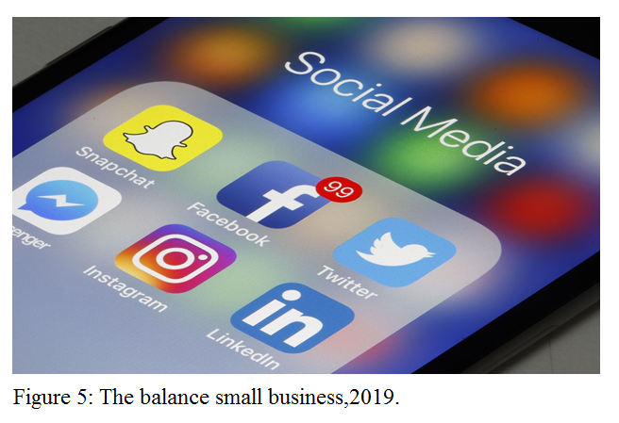

Secondly, the company should assert its online presence by working with online influencers to promote products both on social media such as Facebook, Instagram, YouTube and blogs(See figure 5). It allows social media users to link with eSprit app for making deals and increase engagement with Esprit.
As result, customers will view Esprit brands as being of high quality. This will result in high levels of brand loyalty, thus minimizing all the threats identified in the five forces evaluation.

The Gantt chart below presents a timeline for the recommendations.
Department | Task | Months
Department | Task | 0.5 | 0.5 | 2 | 3 | 4 | 5 | 6 | 7 | 8 | 9 | 10 | 11 | 12
Financial, sales and stakeholder | Review HK stores and department performance for planning
Information technology (IT) | Design and propose new Esprit HK mobile app
Stakeholders | Review plans and proposals for approval
Information technology | Launch new mobile app
Sales and administration | Closing unprofitable Stores
Human resourcing and administration. | Downsizing
Human resourcing | Decentralization of management
Design | Make new designs
Research and Development | Find new material texting and improving
Purchasing | Buying material after approval
Production and Quality Check | Finish new product production
Marketing and IT | Marketing advertise though Social media
Administration, Human resourcing, Training , IT, Sales and logistic | Opening new stores in prime areas and launch new products to all stores.
Information technology, Sales and Logistic | Launching new products to online shops and Wholesalers channels
Communication | Celebrity endorsement
Marketing and  Communication | Influencer marketing
Marketing and Communication. | Fashion show
Information technology ,Marketing and Administration | Monitoring and Controlling
Financial, IT and Communication | Evaluate financial performance and review on line engagement. Report to stakeholder.
Financial, marketing and stakeholder | Renew data, financial report and planning

Table 1: Gantt chart for the implementation of recommendations.
Source: From this research.

4: Effectively implementing the Strategies

4.1. The Boston Consulting group’s product portfolio matrix (BCG matrix):

The BCG matrix is useful in assessing the situation, thus, providing valuable ways in which the plans developed will be implemented. According to Torquati et al. (2018, p. 257), this model is especially useful in providing an outline for evaluating, the company's products with regards to the market share and growth. As presented in Esprit (2019) the company sells its products under two brands. These are “edc” and “Esprit”. However, in order to evaluate the recommended strategies, it is also important to take the stores run by the company as products as the recommended strategies don’t focus on specific brands.
Evaluation of Recommendations
From the recommendation of closing unprofitable stores, it can be seen that these stores have been incurring huge costs while giving very little returns for the company, thus contributing significantly to the overall losses made. This means that in terms of growth and market share, these shops are in a low position. In an evaluation of the BCG matrix, Mohajan (2017, p. 2) it is pointed out that the dog quadrant is the one that scores low in both market share and growth. The recommendation by Mohajan (2017, p. 6) for the dog quadrant is that they should not be invested in due to their characteristic of eating into a firm’s profitability. This is consistent with the recommendation to close the unprofitable stores, as presented in Esprit (2019).
In response to the closure of the unprofitable shops, it is suggested that new shops should be opened in prime areas where the rent is expected to go down. The first consideration, in this recommendation is that costs are expected to be much lower than in the unprofitable shops. Furthermore, since the areas are strategically located, the prospects for growth will be high for Esprit. However, the shops will start with a low market share. Comparing this evaluation with the BCG matrix quadrants presented by Mohajan (2017, p. 5), the recommendation occupies a question mark position. In the case of question marks, the organization makes the decision on whether to invest or not to invest depending on the likelihood for the situation to change to a star (Mohajan, 2017, p. 5). The decisions to invest in the new products under new brand are justified by the fact that marketing will improve the market share of the new units, thus leading them to occupy a star position in future.
With regard to the brand positioning and marketing recommendation, it is evident that at present, the company is losing market share hence the declining revenues. However, generally, since there is a general growth in the fashion industry globally, Esprit can be said to be operating in a fast-growing industry. Since it has a significant market share in the markets it operates in, Esprit brands can be said to be stars. However, the declining market share is an indication that the company is moving towards a question mark. Since the market overall market is growing, it is imperative that Esprit only needs to improve its market share so that its brands can remain in a star position. Therefore, it has been suggested that celebrity endorsements and influencer marketing should be used in order to ensure new entrants and established competitors do not acquire Esprit’s market share. This move is justified by the fact that it aims to improve the company’s market share in a high growth market. Success in this direction will enable the company to maintain its star position.

4.2. Assessment of effectively implement to strategies

Correlated Department | Task | Effective practice to achieve company goals( Response to objectives)
Financial, sales and stakeholder | Review HK stores and department performance for planning | - Company ensures all HK stores are profitable. (Financial)  - It determines to close unprofitable stores or reduce rental fee. (Financial, learning and growth)  - Company plans to rent low-cost retail premises in prime areas for 2 new stores. (learning and growth)  - Any overlap jobs in different department? It merges them into one department. (Operational)
Information technology (IT) | Design and launch new Esprit HK mobile app. | - Apps is linked to HK online and offline stores. ( Learning and growth)  - Customer can earned points for gift redemption for brand royalty and better review rating. (Customer)  - Consumers aware esprit’s new items or promotion though smart phone. ( Learning and growth)
Sales and administration | Closing unprofitable Stores | - Company has all break even or profitable stores. (Financial)
Human resourcing and administration. | Downsizing | - It merges overlap department and reduces the 250 of employees through attrition for cost efficiency. (Operational)  - The company achieves about 430million reduction in OPEX from the downsizing drive.(Financial)  - The company achieves to reduce underlying operation amount down to HK 180 million. (Operational)
Human resourcing | Decentralization of management | - Company leverages local cooperatives and colocation design center to provide reliable production efficiencies without the cost of managing labour collectives.(Learning and growth)  - Company leverages more 8 local cooperatives for new items. (Learning and growth)
Design | Make new designs | - Company add 10 % more of new products that different in product design, packaging or sale promotion.( Learning and growth)
Research and Development | Find new material texting and improving production | - Company are learning market knowledge in HK product innovation to add 12 new products or functional materials. (Learning and growth)  - Shorter production time to market. For example: Zara’s production needs 10 to 14 days to market only (Forbes,2012). ( Learning and growth)
Purchasing | Buying material after approval | - Control proper inventory (Operational)
Production and Quality Check | Finish new product production | - Ensure quality products to market.(Learning and growth)
Marketing and IT | Marketing advertise though Social media | - Company joins fashion shows for international footprints. (learning and growth)  - Company provides products information though social media for sale or aware market.(learning and growth)  - Establish to Esprit friends.(learning and growth)
Administration, Human resourcing, Training , IT, Sales and logistic | Opening new stores in prime areas and launch new products to all stores. | - Company rents low-cost retail premises in prime areas (Financial)  - New products give differentiation advantage to new stores. (learning and growth)  - Aware to markets. (Customers)
Information technology, Sales and Logistic | Launching new products to online shops and Wholesalers channels | - Provide new product information though internet to aware market. (Customers)  - Company achieve higher sales .(Financial)
Communication | Celebrity endorsement | - Company arrange contract well known person who helps promote Esprit products with their social status. It is recommended to use Miss. Hana Kuk Tsz Kiu. She was rewarded a “HK Popular new artiest” in 2017(Coolmusic,2017). (Customers)
Marketing and IT  Communication | Influencer marketing | - Company uses you tuber or Key Opinion Leader(KOL) to introduce product and direct sales.(Customers)
Information technology ,Marketing and Administration | Monitoring and Controlling | - Company monitors the volume customers engagement though analytic and their satisfactions level. (Customers)
Marketing and Communication. | Fashion show | - Company introduces new items and seasonal products at two shows for international footprint. ( Learning and growth)
Financial, IT and Communication | Evaluate financial performance and review on line engagement. | - Company measures profit or loss revenue in recent strategies.(Financial)  - Company measures its online performance though internet analytic. Are customer’s rating at 4 of 5 and 600,000+ engaged? (Financial and customers)
Financial, marketing and stakeholder | Review data, financial report and planning. | - Company reviews each organization performance for next planning and goals. (Financial)  - Review macro and micro environments to compare its primary data, secondary data and balanced scorecard to set target for coming year. (All company’s objectives)
Table 2: Effective practice to achieve company goals
Souce: From this reseach.

References
Agrawal, A., Schaefer, S., and Funke, T., (2018). Incorporating industry 4.0 in corporate strategy. Analyzing the Impacts of Industry 4.0 in Modern Business Environments, 38(4), pp. 161-176.
Aithal, P.S., (2017). ABCD Analysis as research methodology in company case studies. International Journal of Management, Technology, and Social Sciences (IJMTS), 2(2), pp.40-54.
Anderson S., Simon P. P., De Palma A., Thisse J-F. (1992) Discrete choice theory of product differentiation, MIT Press Massachusetts.
AVPN (2019) Social Investment Landscape in Asia, Asian Venture Philanthropy Network. [Online] Available at: https://avpn.asia/si-landscape/country/hong-kong/ [Accessed 27 September 2019]
Beath J., Katsoulacos Y. (1991) The Economic Theory of Product Differentiation, Press Syndicate of the University of Cambridge, Cambridge
Brandts, J. & Cooper, D. J. (2015), ‘Centralized vs. Decentralized Management: An Experimental Study’, Barcelona GSE Working Paper Series, 854(7), pp. 78-83.
Bray, M. (2018) In Hong Kong, Disposable Fashion Gets a Recycled Makeover, Reuters [Online] Available at: https://www.reuters.com/article/us-hongkong-clothing-recycling-idUSKCN1LY1V1 [Accessed: 27 Sept., 2019]
CIPD, (2018) ,PESTLE analysis, CIPD. 17 Dec, 2018. [Online] Available at: https://www.cipd.co.uk/knowledge/strategy/organisational-development/pestle-analysis-factsheet [Accessed: 27 Sept., 2019]
Cool Music, (2017), Chinese Outstanding New Artiest,Cool Music Forum,10 Aug,2017. [Online] Available at: www.cmusichart.com/discuz/viewthread.php?tid=13393
[Accessed: 28 Sept., 2019]
Denoue, M. & Saykiewicz, J. N. (2009), ‘Brand Loyalty as a Tool of Competitive Advantage’, Artykuly, 67(8), pp. 36-45
Donny, Kwok, (2019). "Hong Kong August visitors plunge 40% year-on-year, hotels half-full: finance chief". Reuters. Retrieved 13 September 2019.
Easey, M., (2009) Fashion marketing. Third edition. Blackwell Publishing
Esprit (2018) Annual Report FY 17/18, Esprit Holdings Limited, 19March2019. [Online] Available at: https://www.esprit.com/en/company/investor-relations/publications/annual-interim-reports.[Accessed: 2 Sept., 2019]
Esprit, (2019). Annual interim reports, Esprit Holdings limited, 19 March 2019. [Online] Available at: https://www.esprit.com/en/company/investor-relations/publications/annual-interim-reports.[Accessed: 3 Sept., 2019]
Footasylum, (2019), The brand history of Y3, Footasylum, [Online] Available at: https://www.footasylum.com/y3-history/ [Accessed: 8 Sept., 2019]
Forbes,(2012), The future of fashion retailing the Zara approach, 25 Oct, 2012 [Online] Available at: https://www.forbes.com/sites/gregpetro/2012/10/25/the-future-of-fashion-retailing-the-zara-approach-part-2-of-3/#627b8dce7aa4 .[Accessed: 11 Oct., 2019]
Frigo, L.M., (2002). A Balanced Scorecard Framework for Internal Auditing Department, the Institute of Internal Auditors Research Foundation.
Ge, L., and Li, C., (2019), April. Analysis of competitive power of Chinese sports apparel brand based on Porter's Five Force Model. Proceedings of the 2019 3rd International Conference on Information System and Data Mining, 46(2), pp. 54-58.
Gong Y. (2013) Cross-Function Global Operational Practice. In: Global Operations Strategy. Springer Texts in Business and Economics. Springer, Berlin, Heidelberg
GovHK (2019) LCQ19: Measures to Promote Hong Kong’s Textile and Apparel Industry, The Government of the Hong Kong Special Administrative Region [Online] Available at:<https://www.cedb.gov.hk/citb/en/Legco_Business/Replies_to_Legco_Questions/2012/P201204180383.html [Accessed: 27 Sept., 2019]
Guo, J., Wang, X. and Wu, Y., (2020). Positive emotion bias: Role of emotional content from online customer reviews in purchase decisions. Journal of Retailing and Consumer Services, 52, p.101891.
HKTDC, (2018). Clothing Industry in Hong Kong. Hong Kong trade development council research, 12 Sept 2018. [Online] Available at: http://hong-kong-economy-research.hktdc.com/business-news/article/Hong-Kong-Industry-Profiles/Clothing-Industry-in-Hong-Kong/hkip/en/1/1X000000/1X003DCL.htm [Accessed: 21 Sept., 2019]
HKTDC, (2019).Economic and Trade Information on Hong Kong. Hong Kong trade development council research, 12 Sept 2018. [Online] Available at: http://hong-kong-economy-research.hktdc.com/business-news/article/Market-Environment/Economic-and-Trade-Information-on-Hong-Kong/etihk/en/1/1X000000/1X09OVUL.htm [Accessed: 23 Sept., 2019]
Hong Kong Business,(2019). Prime street shop rents to fall by at least 5% in 2019. Hong Kong Business,19 Dec.,2018. [Online] Available at: https://hongkongbusiness.hk/retail/news/prime-street-shop-rents-fall-least-5-in-2019 [Accessed: 23 Sept., 2019]
Hoyle D., (2005) Automotive quality systems handbook. incorporating ISO/TS 16949:2002 second edition
Huang, B., Zhao, J., Geng, Y., Tian, Y. and Jiang, P., (2017). Energy-related GHG emissions of the textile industry in China. Resources, Conservation and Recycling, 45(4), pp.69-77.
Huang, Y., (2016). Understanding China's Belt and Road initiative: motivation, framework, and assessment. China Economic Review, 40(3), pp.314-321.
Kotler P., Keller K. (2007) A framework for marketing management, third edition, Pearson Education
Marques, T. Gonzalez, I. S. Cruz, P. & Ferreira, M. P. (2011) Downsizing and profitability: an empirical study of Portuguese firms in 1993-2005, International Journal of Business and Economics, 10(1), pp.13-26
Melin, F., (1999) Varumärkesstrategi: Om konsten att utveckla starka varumärken. Liber AB
Mohajan, H. K. (2017) An analysis on BCG growth sharing matrix, Noble International Journal of Business and Management Research, 2(1), pp. 1-6
Play.google,(2019) Esprit – shop fashion & styles. Esprit Global Image GmbH shopping. 8 October, 2019 [Online] Available at: https://play.google.com/store/apps/details?id=com.esprit.espritapp&hl=en [Accessed: 9 Oct., 2019]
Porter, M.E., (2008). The five competitive forces that shape strategy. Harvard business review, 86(1), pp.25-40.
Shen, B., and Mikschovsky, M., (2019). Introduction to fashion supply chain management in Asia. Fashion Supply Chain Management in Asia: Concepts, Models, and Cases, 45(4), pp.1-17.
Statista (2019). Outlook Hong Kong fashion market users, Statista [Online] Available at: https://www.statista.com/outlook/244/118/fashion/hong-kong#market-users [Accessed: 28 Sept., 2019]
SVA (2019) Politics in Hong Kong – Implications for Business and Governance, Steve Vickers & Associates, [Online] Available at: http://stevevicekrsassociates.com/news/politics-in-hong-kong-implications-for-business-and-governance/ [Accessed: 27 Sept., 2019]
Tanwar, R., (2013). Porter’s generic competitive strategies. Journal of business and management, 15(1), pp.11-17.
The balance small business, (2019). What is social media?, The balance small business, 08 May,2019. [Online] Available at: https://www.thebalancesmb.com/what-is-social-media-2890301 [Accessed: 1 Oct., 2019]
Torquati, B., Scarpa, R., Petrosillo, I., Ligonzo, M.G., and Paffarini, C., (2018). How can consumer science help firms transform their dog (BCG Matrix) products into profitable products? Case Studies in the Traditional Food Sector, 34(3), pp.255-279.
Uniqlo,(2019), Uniqlo on line stores. Uniqlo Hong Kong [Online] Available at: https://www.uniqlo.com.hk/pc/en_GB/ [Accessed: 28 Sept., 2019]
Wang, W. and Reani, M., (2017). The rise of mobile computing for Group Decision Support Systems: A comparative evaluation of mobile and desktop. International Journal of Human-Computer Studies, 104, pp.16-35.
Yoo, B., Jeon, S. and Han, T., (2016). An analysis of popularity information effects: field experiments in an online marketplace. Electronic Commerce Research and Applications, 17, pp.87-98.


