STUDENT NAME: Azhda Mustafa
STUDENT NUMBER: 1907558
MODULE : LCBB5004 Managing People
ASSIGNMENT 2: Managing people “Employee engagement”-REPORT 2000 words.
MODULE LECTURER: Dr. Mushfiqur Rahman

Table of contents
1. Introduction. 2
1.1 Module description 2
1.2 Aim of the Report. 2
2. Employee relations 2
2.1 Definition 2
2.2 Employee relations in the time of Covid19 2
3. Employee engagement 3
3.1 Definition 3
3.2 Process of Employee engagement 3
3.3 Elements of Employee engagement 4
3.4 Dimensions of Employee engagement 5
3.5 Drivers of Employee engagement 6
3.6 Drivers in the time of Covid19 8
3.7 ENGAGED employee characteristics. 9
4. Measuring engagement 10
5. Successful Employment engagement strategies 11
6. Employee Value Proposition 12
6.1 Definition 12
6.2 Components and importance of EVP 12
7. Conclusion 14
8. REFERENCES: 15

Introduction.

Module description
“Managing people” is to recognize the role of the Human Resources operate within different areas and within the small, medium, and large organizations. Strategies which companies use to build crucial talent to establish sustainable competitive advantage through people.
Processes to engage staff to achieve high performance at the workplace; approaches to underperformance management.

Aim of the Report.
The Chief executive has recently participated in an online conference, which included an idea that organisational engagement would contribute to better results and employee well-being. Accordingly, the report will pay attention on drivers of employee engagement, measuring engagement, employee value proposition, including strategies to raise the level of engagement.

Employee relations

Definition
Employee relations are related to the management of the employment relationship and the psychological contract in a broader array of employee relations. They involve of employers' methods and approaches to deal either collectively or individually with employees through their unions. This includes voicing and communication between employees and management. (Armstrong and Taylor, 2014) This focus is being placed increasingly on helping line managers to build relations with employees based on trust. (CIPD, 2020)

Employee relations in the time of Covid19
The COVID-19 pandemic has significantly increased organisations' conflict potential and is a significant challenge for the relationship between employees. It will also put considerable pressure on managers and employees to facilitate a return to a safe physical workplace. Specific organisations must be reorganised and even redundancies. Employers must recognise employee conflict potential and ensure managers are equipped to engage with employees sensitively and supportively. It should promote fairness and consistency and make it possible to meet people's particular circumstances. (CIPD, 2020)

Employee engagement

Definition
Work engagement is an optimistic, rewarding, emotional well-being state of the workplace that be an antipode of job burnout. The employee who is engaged have high-level energy and are participating in their work enthusiastically. (Torrington, 2014) This emotional commitment means that committed workers care for themselves and their business. They work on behalf of the company's objectives, not only for a salary or only for the next promotion. (Kruse, 2012)
Employee engagement brings older and more established concepts together and repackages, especially motivation for employment and organisational commitment. (CIPD, 2019)

Process of Employee engagement

Employee engagement is not a one-time process that can bring results quickly; instead, it is a final process that will continue until an organisation exists. (Juneja, 2015)

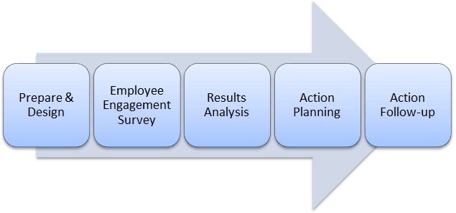

Elements of Employee engagement
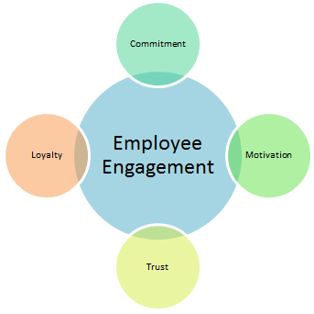
- Commitment: this means the degree to which people are associated with the job, duties, and organisational goals.
- Loyalty: Employees who are active in their work demonstrate greater fidelity to the organisation. Recognition is a necessity for persons to continue their work.
- Trust: Employees must be autonomous to carry out their tasks. They are not limited to specific rules and regulations and should thus be motivated to experiment differently and innovatively to fulfil their duty. (Juneja,2015)
- Motivation: Herzberg theory
Motivation is the energy, the direction, and the maintenance of conduct. Well-motivated people who are willing to exercise discretion, i.e., do more than is expected independently, achieve high performance. (Armstrong and Taylor, 2014)
According to Herzberg theory, two factors affected sentiments of satisfaction or dissatisfaction were recognised. Factors that motivate or satisfy the job content and consist of the requirement for achievement, work interest, responsibility, and advancement opportunities. The intrinsic motivators are these needs. He summarised this in the sentence "motivation by the work itself." (Armstrong and Taylor, 2014)
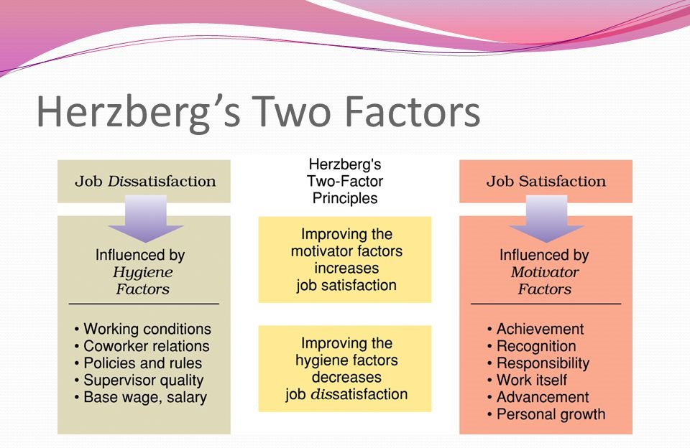
(Future of working, 2014)
Apart from this, corporate culture, a well-established and adequately followed compensation system including reimbursement, benefits, stock exchange options, recognition and personal growth and employee satisfaction are also critical factors in enhancing employee engagement. (Juneja, 2015)

Dimensions of Employee engagement
Psychologist of the United States W. A. Kahn (1990) invented the concept and three dimensions of "employee engagement”:
- Emotional engagement
- Cognitive engagement
- Physical engagement (Torrington, et al., 2017; Terry,2020)

Drivers of Employee engagement
Saks (2006) has specified support, awards and identification, procedural justice, redistributive justice, and corporate aid as the predictors of employee engagement while identifying employee engagement as a multi-dimensional building. Macey and Schneider (2008) indicate leadership is one of the critical drivers of employee perception and employee involvement. Further drivers of employee involvement are employer contributions to decision-making, constructive feedback, formal evaluation receipt, and the implementation of development plans. (Gallup, 2020; Robinson, Perryman and Hayday, 2004)
- Work-life balance – is the core of HRD’s key driver and powerful influence point for promoting employee engagement and organisational efficiency. (Shankar and Bhatnagar, 2010)
“The extent to which an individual is equally engaged in – and equally satisfied with – his or her work role and family role.” (Mushfiqur et al., 2018)
- Managing stress - The management could maintain engagement and monitor stress levels through simple steps, such as prioritising the task of controlling workloads, acknowledging their quality, continued monitoring, and the opportunity to manage the work of employees.
- Leadership - How hard it works and how long it stays because of this engagement are the employees who commit themselves to something or someone in their organisation. (Das and Vijayalakshmi, 2011)

IES’ Diagnostic Tool and its employee engagement drivers
The engagement model of the IES shows the strong relationship between valued feelings and participation and commitment.

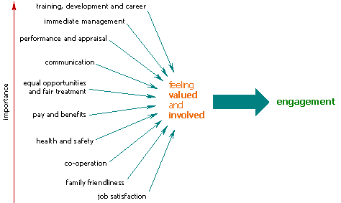(IES, 2014)
- The decision-making involvement
- Good management — managers who care about employees, keep them informed, treat them fairly, encourage them and become interested in their career.
- Two-way, open communication — This allows the employee to express thoughts and suggest better ways of doing things.
- Effective co-operation within the organisation — Between various areas, tasks, management, and syndicates.
- A focus on developing employees — They feel that they have long-term value and offer both the training they need now and fair access to development opportunities.
- A commitment to employee well-being — Health and safety should be taken seriously, and the problems should be minimised by accidents and injuries, violence and harassment and practical action.
- Clear, accessible HR policies - equal opportunities and family friendliness.
- Fairness in salary and benefits — in evaluations within and outside the company.
- A pleasant working environment and Teamwork —encouraging workers to respect and help each other. (IES,2014)

Drivers in the time of Covid19

Taken measures by the organisation are :
- Working from home
- Flexible working time look the 10th edition.
- Job design/restructuring roles
- Making the workplace “Covid-19 safe” on pages
The emphasis on giving flexibility when allowing remote working and maintaining communication and collaboration is on maintaining an appropriate small stack to increase productivity and reduce stress. You should provide the equipment, for instance, a computer, telephone, and video conference facilities if your people are working from home.
Keep contacting them regularly; make sure you talk about their wellbeing. (HSE.Gov.uk, 2020)

Organizations are working to revise their HRM policies, culture of the workplace and the commitment process, to create an environment for work that encourages family-friendly policies such as flexible working time, maternity leave policies, substitute work arrangements, family care enterprises and employee support programmes. (Mushfiqur et.al., 2018)
- Connection – Employees are proud of being part of an organisation and recognise it. This sense of identification could be undermined by furloughs and work from home. It is important to find ways of re-connecting employees and leaders play an essential role in helping employees understand where and how things are happening.
- Support - Anxiety can vary at such a pandemic time from fears that problems like financial welfare will return to work. It can make a positive change only if you take time to discuss and offer some help.
- The employee voice matters much. The employees may be better notified than senior management about customer needs. Where companies need to do extra with less, employees may offer a fresh perspective.
- Scope. This means providing the opportunity for individual development, promoting independence, and helping individuals to discover inherent motivation in their work. Pay rises may well be away from the question when budgets are being squeezed. When times are tough, recognition and acknowledgement matter more. (CMI, 2020)
The negatives with superiors and collaborators of an employee, declining promotion, improved employment opportunities elsewhere, low wages, lack of involvement, health and safety problems, demotivation and reassignment and lack of voice can accelerate the intentions of employee engagement. (Oruh et.al., 2020)

ENGAGED employee characteristics.
(Robinson, Perryman and Hayday, 2004)

Harvard's Service-Profit Chain is a perennially relevant example of this, showing how pleased employees can have a positive effect on the satisfaction of customer and retaining and, ultimately, on business profitability.
- Client contentment leads directly to client loyalty.
- In turn, the nature and quality of the services strongly influence customer satisfaction.
- The best value for customers can be provided by happy, productive, and loyal staff.
- Employees are of value when high-quality education and development are offered, policies that nurture and promote the workplace. (Pedler, 2019)

Measuring engagement

According to the Gallup Organization research to enhance engagement, managers should:
● Instruct the individual strengths of the employees.
● Provide ongoing response on how these forces are applied.
● 'Clear the way' so workers will be able to do their best without needless interruptions.
● Develop confidence by demonstrating a commitment to the success of the worker.
● Challenge individuals in the areas of their specific strengths.
● Concentrate on talent building abilities and knowledge.
● Provide ownership of employees and results.
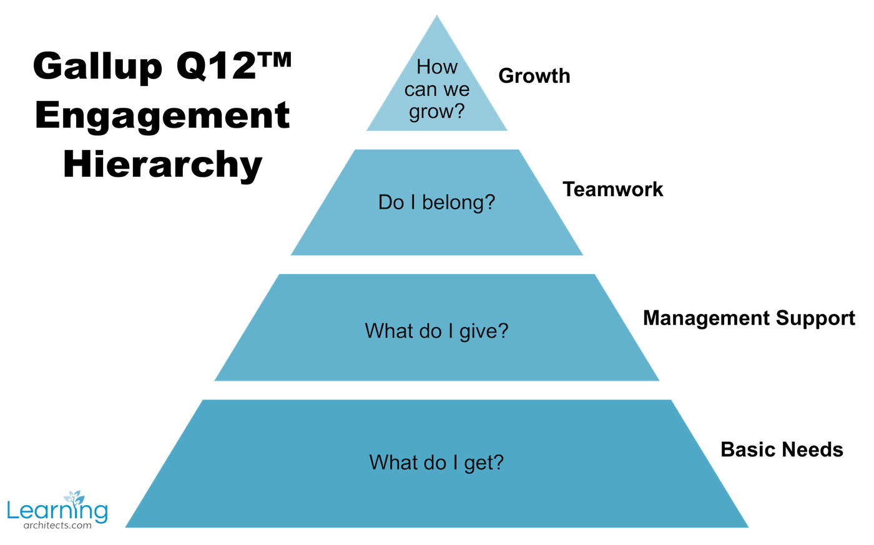
(Gallup, 2019)

Successful Employment engagement strategies
A global issue is low employee engagement. Companies that implement their employee engagement policies outperform rivals in efficiency, productivity, and all the ways that count.

- Pay Attention to Meaning
Connecting to a common goal builds on meaningful work by strengthening the relationship of an employee with the organisation.
- Prioritize
Changing priorities and ambiguity are obstacles to the level of accomplishment needed for full commitment.
- Develop for Today and Tomorrow
Research links career and personal growth opportunities to high job satisfaction. Organizations need skills and to prepare for the future of their work.
- Provide Tools and Resources
What do people want in a digital workplace? Often tools and resources are on top of the list. Before investing a big budget in replacing the systems, knowing precisely what people mean. (Masarech, 2019)

Employee Value Proposition

Definition
The value proposition of an organisation's employees is what it offers future or existing employees. It includes pay that can be exaggerated in comparison to non-financial elements. The goal is to become a preferred employer." The development of EVP is essential in analysing what the companies offer their employees concerning: their reputation, working environment, the position, the career opportunities available and their working term and condition. (Armstrong and Taylor, 2014)

Components and importance of EVP

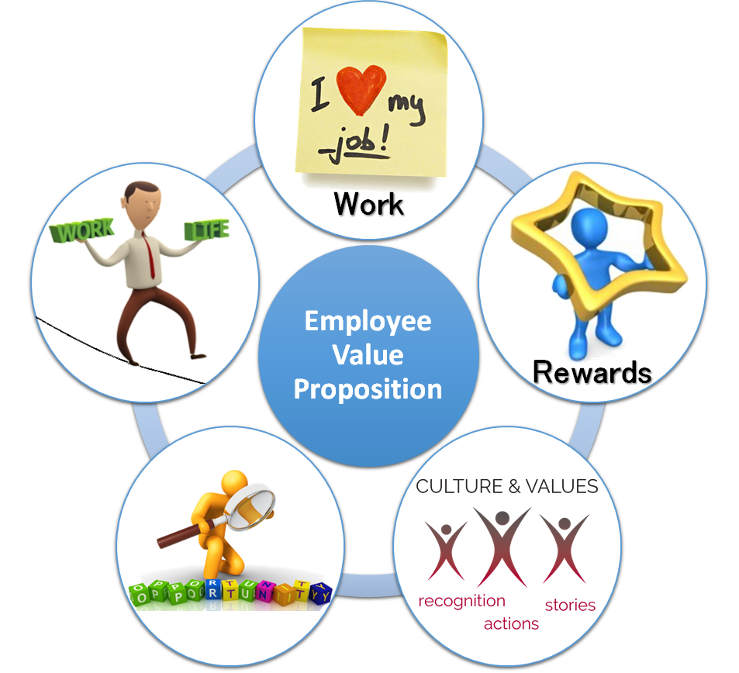

- Opportunuties: The EVP should outline how the organisation offers professional and career development opportunities. Not everyone wants to become a manager or climb the corporate ladder, but different aspirations need to be addressed.

- Job recognition - This area of the EVP is one of the strongest but two of the essential attributes in this example; recognition and autonomy can depend on the manager again. Supported by the Two-Factor Theory of Herzberg (explained in the report), freedom, honour and the significance of the work carried out are said to be critical attributes that correlate with intense job satisfaction, which can provide greater motivation than pay.

- Cultures and Values - It needs to align with the core of the business; its mission, vision and values, in order for an EVP to be successful. There will be ambiguity in expectations, both from the company and from staff, without this alignment, which could cause a lack of clarity in deliverables.

- Rewards - For example, should a company have consistently increased wages during the good times for all its employers, every performance review would lead to disappointment of the work force only to eliminate them and to freeze its salary during the bad times. It is likely to cause increased staff turnover and a dissatisfied workforce with no other reward structures in place, which will ultimately affect performance and business competitiveness. (Foster, 2019)
- A strong EVP is important for two reasons:
- An EVP presents an exhaustive look into each position if it is properly presented, ensuring that the role is attractive to top talent and that the candidate can find out if it is a good fit or not.
- The establishment of a strong EVP can enhance and raise entire job brand and make a desirable destination for top nominees. It is something that the better candidates find appealing to you to have a clear vision. (Murdock, 2018)

Conclusion

Employees are the key asset for any organisation and if they do not have the right space and time to make a perfect combination of work and fun, the employees will feel disengaged. Organization and employees are mutually dependent to achieve their objectives and goals. Therefore, companies should actively look forward to meeting employee expectations and thereby influence employee performance that directly affects the performance of the organisation.

REFERENCES:

Armstrong, M. and Taylor, S. (2014) Armstrong’s handbook of human resource management practice. 13th Edition. Kogan Page. p.169

Armstrong, M. and Taylor, S. (2014) Armstrong’s handbook of human resource management practice. 13th Edition. Kogan Page. p.173

Armstrong, M. and Taylor, S. (2014) Armstrong’s handbook of human resource management practice. 13th Edition. Kogan Page. p. 247

Armstrong, M. and Taylor, S. (2014) Armstrong’s handbook of human resource management practice. 13th Edition. Kogan Page. p.403

Armstrong, M. and Taylor, S. (2014) Armstrong’s handbook of human resource management practice. 13th Edition. Kogan Page. p.406

CIPD, (2019). Employee Engagement & Motivation | Factsheets | CIPD. [online] CIPD. Available at: https://www.cipd.co.uk/knowledge/fundamentals/relations/engagement/factsheet#6227. (Accessed: 10 December 2020)

CIPD. (2020). Employee Relations | Factsheets. Available at: https://www.cipd.co.uk/knowledge/fundamentals/relations/employees/factsheet#6059. (Accessed: 10 December 2020)

CMI. (2020). The four drivers of employee engagement at a time of crisis. [online] Available at: https://www.managers.org.uk/knowledge-and-insights/advice/the-four-drivers-of-employee-engagement-at-a-time-of-crisis/ (Accessed: 13 Dec. 2020)
‌
Das, V.T. and Ch.Vijayalakshmi, Ch.V. (2011). Employee Engagement Strategies For Enhancing Employee Competitiveness To Organizational Success. Indian Journal of Applied Research, 1(12), pp.137–140.

Foster, W. (2019). Employee Value Proposition (EVP)- What it is and why you should have one. [online] Medium. Available at: https://medium.com/@willfsays/employee-value-proposition-evp-what-it-is-and-why-you-should-have-one-4d41db37615b [Accessed 16 Dec. 2020].
‌
FutureofWorking.com. (2014). Herzberg Theory of Motivation in the Workplace. Available at: https://futureofworking.com/herzberg-theory-of-motivation-in-the-workplace/. (Accessed: 14 December 2020)

Gallup (2019). Re-Engineering Performance Management. [online] Gallup.com. Available at: https://www.gallup.com/workplace/238064/re-engineering-performance-management.aspx. (Accessed: 16 Dec. 2020)
‌

HSE.GOV.UK. (2020). Guide to working safely during the coronavirus (COVID-19) outbreak. [online] Available at: https://www.hse.gov.uk/coronavirus/working-safely/index.htm. (Accessed: 16 Dec. 2020)
‌

IES, (2014). Employee engagement | Institute for Employment Studies (IES). [online] Available at: https://www.employment-studies.co.uk/what-we-know/employee-engagement [Accessed 13 Dec. 2020].

Juneja, P (2015). Process of Employee Engagement. [online] Available at: https://www.managementstudyguide.com/employee-engagement-process.htm [Accessed 11 Dec. 2020].

‌Kruse, K. (2012) . What Is Employee Engagement. [online] Forbes. Available at: https://www.forbes.com/sites/kevinkruse/2012/06/22/employee-engagement-what-and-why/?sh=78a707547f37 [Accessed 10 Dec. 2020].

Macey, W.H., Schneider, B. (2008). The meaning of employee engagement. Industrial and Organizational Psychology: Perspectives on Science and Practice, 1(1), 3–30.

Masarech, M. A., (2019) Engagement in the Future Workplace Available at: 5 Successful Employee Engagement Strategies for Today & Tomorrow (gpstrategies.com) (Accessed: 14 Dec. 2020)

Murdock, P.K. (n.d.). Council Post: The Importance Of An Employment Value Proposition For Recruiting In 2018 And Beyond. [online] Forbes. Available at: https://www.forbes.com/sites/forbeshumanresourcescouncil/2018/01/09/the-importance-of-an-employment-value-proposition-for-recruiting-in-2018-and-beyond/?sh=1695ae256690 [Accessed 16 Dec. 2020].
‌

Mushfiqur, R., Mordi, C., Oruh, E.S., Nwagbara, U., Mordi, T. and Turner, I.M. (2018). The impacts of work-life-balance (WLB) challenges on social sustainability. Employee Relations, 40(5), pp.868–888.

Oruh, E.S., Mordi, C., Ajonbadi, A., Mojeed-Sanni, B., Nwagbara, U. and Rahman, M. (2020). Investigating the relationship between managerialist employment relations and employee turnover intention. Employee Relations: The International Journal, 42(1), pp.52–74.
‌

Pedler, T. (2019) Employee engagement – The basics. Available at: 10 employee engagement strategies to create a dream team | HRD Australia (hcamag.com) (Accessed: 14 December 2020)

Robinson, D., Perryman, S. and Hayday, S. (2004). The Drivers of Employee Engagement. [online] Available at: https://www.employment-studies.co.uk/system/files/resources/files/408.pdf. (Accessed: 13 December 2020)
‌Saks, A.M. (2006). Antecedents and consequences of employee engagement. Journal of Managerial Psychology, 21(6), 600–619.

Shankar, T. and Bhatnagar, J. (2010). Work Life Balance, Employee Engagement, Emotional Consonance/Dissonance & Turnover Intention. Indian Journal of Industrial Relations, [online] 46(1), pp.74–87. Available at: https://www.jstor.org/stable/25741098?seq=1 [Accessed 16 Dec. 2020].

Terry, M. (2020). Kahn’s 3 Dimensions of Employee Engagement: Still Good to Go in 2020? [online] www.talkfreely.com. Available at: https://www.talkfreely.com/blog/dimensions-of-employee-engagement. (Accessed: 11 Dec. 2020)

Torrington, D. (2014). Human resource management. 9th Edition. Harlow, England: Pearson. p.155

‌Torrington, D. et al., (2017). Human resource management. 10th Edition. Harlow; New York: Pearson. p.267

