
Managing Projects in The organization
Evaluation of Project Management Plan, BMSW5104

April 21, 2024
University of Wales Trinity Saint David
11 Cranmer Road

PROGRAMME: BA (Hons) Leadership and Management Skills in the workplace
LECTURE NAME: Alfred Mensah
STUDENT NAME: Diego A Torres Betancourt
ID: 2133739

M
Table of Contents

1. Introduction 2
2. Onsite Catering Project: Initiation Phase ………………………………………….3
2.1 Project Description …………………………………………………………………...3
3. Stakeholders Analysis ……………………………………………………………….. 3
3.1 Human Resources …………………………………………………………………… 5
3.2 Health Experts …………………………………………………………………………5
4. Objectives ……………………………………………………………………………… 5
5. Deliverables ……………………………………………………………………..7
6. Work Breakdown Structure (WBS) ………………………………………….8
7. Project Planning ………………………………………………………………10
8. Gantt Chart …………………………………………………………………….12
9. Project Execution ……………………………………………………………..12
10. Conclusion ……………………………………………………………………13
11. References ……………………………………………………………………14
12. Appendix ………………………………………………………………………14

OD
- Introduction
The Project and Programme Office has the responsibility of transforming corporate goals into tangible development initiatives, including stakeholders such as employees, customers, suppliers, and local communities. The involvement of employees is essential for catering services, and local authorities should commence negotiations to address traffic congestion and guarantee adherence to local laws. The Facilities Team will be responsible for the development and management of food facilities, while the HR department will focus on enhancing staff well-being via wellness programs and resolving grievances. The success of this endeavor relies on the cooperation of the local administration, executives, and human resources departments. Health professionals have a vital role in encouraging healthy eating habits in organizations by introducing menu design, wellness programs, and training. The organization's objectives are to minimize staff mobility during lunch hours, encourage a healthy way of life, and tackle worker absenteeism. A detailed project plan is crucial for the successful execution of a catering operation, including specific goals, hierarchical job breakdowns, and resource evaluation. Risk management is identifying possible dangers and devising strategies to minimize their repercussions. The project execution stage include the allocation of resources, execution of tasks, monitoring of progress, communication, and quality control.

- Onsite Catering Project: Initiation Phase
2.1 Project Description
Project management is a methodical procedure for carrying out tasks to accomplish a certain objective, overseen by a team and subject to precise limitations such as scope, time, and budget. It entails the careful allocation of financial resources, acquisition of finances, and vigilant monitoring of expenses. Efficient resource utilization, risk reduction, clear communication, scope control, time management, quality assurance, stakeholder satisfaction, flexibility, cost control, and continual improvement are all essential aspects of project management.
The organization employs around 1,000 individuals, including both factory workers and office personnel. The factory and office premises are spread out across a large area, consisting of multiple buildings. Currently, there are no catering facilities available on-site, and your responsibilities and commitments: as a member of the Project and Programme Office, you must guarantee the successful implementation of the organization's transformation program. To help you get started and progress in your career, your new line manager has assigned you the task of planning and supervising an imaginary internal project. The purpose of this attempt is to offer you practical experience and comprehension of how the organization efficiently transforms corporate objectives into concrete development initiatives. (Good, 2023)
3. Stakeholders Analysis
Tesco's internal stakeholders include a wide range of individuals and entities, including its extensive workforce of 345,000 people, as well as management, the board and executive committee, shareholders, consumers, suppliers, rivals, pressure groups, local communities, and government. The company's success is heavily dependent on the contentment and well-being of its employees. The Tesco Board and Executive Committee wield substantial authority and exert tremendous influence. Significant stakeholders, like BlackRock, Norges Bank, Fidelity International, and Schroders plc, have a substantial influence on Tesco's strategic decisions and overall financial success. External stakeholders include a range of entities including customers, suppliers, rivals, pressure organizations, local communities, and governments. Tesco's success hinges on its unwavering dedication to ensuring customer pleasure, promoting sustainability, and fostering strong connections with suppliers and manufacturers. (Titus, 2023)

Employee input is crucial for catering services, and surveys and focus groups are used to gather information on menu preferences, satisfaction levels, dietary restrictions, and expectations. Online surveys cover various topics like menu choices, meal times, and dietary requirements, while focus groups allow employees to express their opinions on catering services. Feedback channels include suggestion boxes and online platforms, and incentives are provided to encourage active participation. Local authorities should be actively involved in discussions to address traffic congestion and ensure compliance with local laws. Their participation is vital for maintaining smooth traffic flow, ensuring the project benefits the local population, and exerting a reasonable level of influence. To involve local authorities, it is important to communicate project ideas, obtain necessary permissions, address issues, and collaborate on minimizing disruptions during the construction or implementation phase. Including local authorities from the beginning is crucial to ensure compliance and establish a positive relationship with the community. The symbols used represent a utensil set (fork and knife), a building structure, and a traffic signal, respectively. Specialized engagement strategies are employed to focus on specific interests and influence local authorities. (TCPA, 2021)
The Alta and Aval impact ensures that a project is implemented effectively by aligning corporate objectives with operational efficiency. Regular updates, clear communication, and prompt support are important for addressing challenges and marketing the project to stakeholders. The Facilities Team will focus on strategizing and implementing catering facilities, with a focus on logistics, space utilization, and accessibility. They are responsible for enforcing safety regulations, overseeing infrastructure projects, and ensuring compliance with waste disposal and food handling procedures. The kitchen workers will have an ergonomic design. Regular and effective communication and problem-solving are crucial for success. (Bulger, 2013)
3.1 Human Resources: The HR department plays a vital role in assuring the overall well-being and satisfaction of employees. HR may participate in wellness initiatives, including work-life balance, stress management, and nutrition, inside a catering project. Enhancing employee communication may be achieved by informing the personnel about the introduction of the new catering service and highlighting its health-oriented goals. The HR department may provide specialized training programs for catering staff, focusing on areas such as nutritional control, customer service, and hygiene. Feedback channels may be used to assess the level of contentment among staff members about the food service. The HR department is tasked with addressing grievances related to catering services and ensuring seamless integration into the company's overall well-being programs. (Coursera, 2022)
3.2 Health Experts: Health professionals have a vital role in advocating for and encouraging good dietary practices inside organizations. Their expertise guarantees that culinary services are in line with health goals. A participative approach encompasses several components such as menu design, wellness programs, instructional sessions, and the promotion of healthy behaviors. The menu should have alternatives catering to various dietary requirements, prioritize nutrient-dense options, and restrict the inclusion of processed meals and added sugars. Health professionals should further coordinate training on fundamental nutrition, regulating portion sizes, and practicing mindful eating. The feedback loop should include ongoing improvement, diligent monitoring of employee contentment, and flexibility to incorporate expert suggestions.

4. Objectives

4.1 Reducing Staff Movement During Lunch Breaks to promote a healthy lifestyle, and reducing staff absenteeism. To alleviate traffic congestion and improve work-life balance, an onsite cafeteria with a diverse range of nutritious food choices, pleasant eating areas, a pre-order system, frequent coffee marketing, and customer feedback will be built. This will optimize time use and accommodate various food preferences.

4.2 Promoting a Healthy Lifestyle (CSR) To promote a healthy lifestyle, organizations should provide a variety of food options, organize nutrition seminars, establish partnerships with local suppliers, promote physical activity through walking meetings, fitness programs, and corporate sports activities, and offer mental health support through stress management workshops or private counseling services. Regular health checks can help detect potential health problems early, fostering employee accountability and improving overall performance.

4.3 Reducing Staff Absenteeism lets firms implement wellness programs, advocate for health surveillance, support proactive healthcare measures, and provide a supportive work environment. Wellness programs help employees manage stress, enhance mental health, and optimize their overall well-being. Health monitoring applications and wearable devices can help monitor health, while consistent feedback can identify areas for improvement. Proactive healthcare measures, such as regular examinations and immunizations, can detect medical problems and minimize absences.
5. Deliverables
Onsite Cafeteria: The organization intends to create a fully functional café on its facilities. This includes the establishment of a kitchen infrastructure, the recruitment of skilled culinary personnel, servers, and cleaning staff, as well as the implementation of efficient operating procedures for menu development, food sourcing, preparation, service, and trash disposal. The cafeteria will have all the essential facilities and tools to cook meals for about 1,000 staff. The workers will undergo training to uphold stringent food safety and hygiene requirements.
Menu Options: The essay highlights the significance of providing a wide range of meal options that prioritize both health and diversity. This encompasses the process of devising a menu, which offers choices that cater to different dietary requirements, ensuring that the meals are both palatable and nourishing, and periodically altering the menu to sustain workers' engagement and provide diversity. Seeking guidance from a nutritionist or dietitian may enhance this technique.
Seating Areas: The dining space should be constructed to support a substantial workforce, providing enough seats and facilitating effortless mobility. When creating a nice dining atmosphere, it is important to take into account factors such as lighting, acoustics, and design. It is advisable to choose furniture that is both durable and pleasant for simple cleaning and maintenance. Additionally, it is crucial to regularly clean and sanitize the furniture to maintain a sanitary atmosphere.
6. Work Breakdown Structure (WBS)
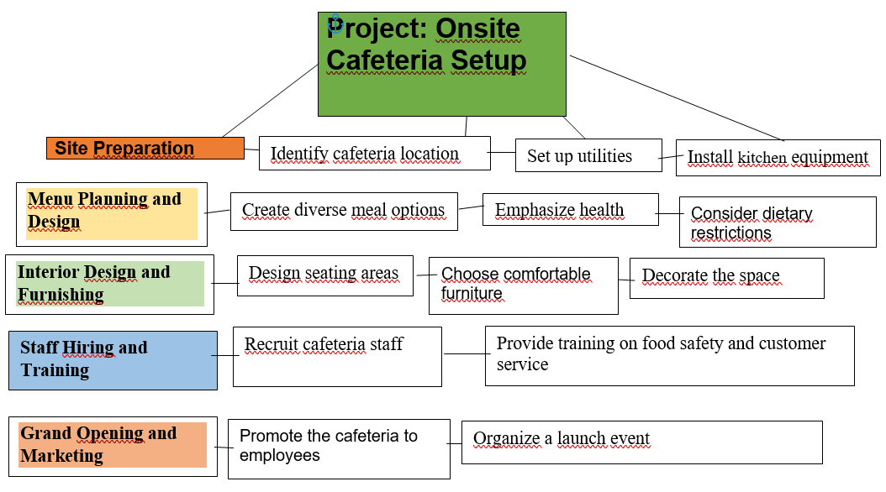
Source: Diego Torres
7. Project Planning
A well-crafted project plan is crucial for allocating resources, controlling expenses, and achieving successful execution. It involves defining the project's specific goals, breaking them down into identifiable outcomes, and creating a Work Breakdown Structure (WBS). The plan evaluates available resources and costs by identifying duties, estimating duration, and computing labor fees. Catering projects require a variety of material resources, including baking and cooking ovens, refrigerators, cooktop cooking techniques, serving counters, culinary equipment, and dining tables and chairs. The selection of fixtures should consider visual appeal, lighting functionality, and overall ambiance. Financial resources should be allocated for procurement, maintenance, and replacement of kitchen equipment, furniture, and food supplies. A schedule should be created to arrange work in a logical order, considering relationships between tasks and assigning dates for start and completion. Risk management involves creating a comprehensive inventory of probable risks and implementing strategies to reduce or eliminate them. Consistent and frequent communication with stakeholders is essential for addressing identified risks and mitigating their consequences.
We'll break down the tasks and subtasks, allocate months, and include estimated costs:
Task | Start Month | End Month | Estimated Cost (£)
Define Project Scope | May | June | £5,000
Identify stakeholders and project boundaries. | May | May
Determine the scope of cafeteria services. | May | June
Set Objectives | June | July | £3,000
Define clear goals for the cafeteria project. | June | June
Align objectives with organizational priorities. | June | July
Menu Planning and Design | July | August | £8,000
Create diverse menus for breakfast, lunch, and snacks. | July | July
Consider dietary preferences (vegetarian, vegan, etc.). | July | August
Cafeteria Layout and Setup | August | September | £12,000
Plan the cafeteria space, seating arrangements, and flow. | August | August
Ensure accessibility, aesthetics, and comfort. | August | September
Kitchen Equipment Procurement | September | October | £20,000
Source kitchen appliances, utensils, and supplies. | September | September
Evaluate quality, durability, and cost-effectiveness. | September | October
Staff Hiring and Training | October | November | £15,000
Recruit chefs, servers, and cleaning staff. | October | October
Provide necessary training on food safety and customer service. | October | November
Ordering System Implementation | November | December | £6,000
Set up an efficient system for ordering meals. | November | November
Include online or mobile options for employee convenience. | November | December
Employee Orientation and Launch | December | April | £4,000
Educate employees about the new cafeteria service. | December | January
Announce the cafeteria opening to employees. | January | February
Monitor initial operations and gather feedback. | March | April
8. Gantt Chart
Source: Diego Torres

9. Project Execution
The implementation stage of an onsite cafeteria catering operation encompasses many crucial elements. The key components included in this list are resource allocation, task execution, progress monitoring, discrepancy resolution, communication, and quality control. Resource allocation entails the distribution of team members based on their specific skills and availability, whereas task execution comprises the completion of tasks per the project's predetermined timeframe. Effective communication is essential for the exchange of information and the comprehension of responsibilities and deadlines. Project progress is tracked using project management tools such as Gantt charts and Kanban boards, and any delays are swiftly addressed. Resource limitations are recognized and alternate choices are explored. Scope creep prevents any deviation from the project's bounds. Effective communication is crucial for delivering stakeholders with up-to-date information, promoting cooperation, and ensuring openness. Quality control entails ensuring that the catering facilities consistently maintain high standards in the cooking sector, as well as in the eating area. Conducting sensory assessments of meals, ensuring the quality of food, and including healthful alternatives are also crucial. To achieve success, it is essential to have efficient coordination, adaptability, and thorough attention to detail. If you want further information or clarification, please feel free to inquire.

10. Conclusion
The project closure process for an onsite cafeteria catering project includes completing responsibilities, documenting expertise, formalizing endorsement, evaluating finished assignments, shifting to operational teams, finalizing contracts with external vendors, and acknowledging achievements. The process includes doing inspections, conducting quality checks, obtaining client approval, and documenting lessons learned. Formalizing acceptance entails securing approval from relevant stakeholders, evaluating finished assignments, and assigning responsibilities to operational teams. Terminating contracts entails engaging in discussions with suppliers, resolving any remaining commitments, and offering feedback. Recognizing success entails expressing appreciation and coordinating a commemorative event.:

11. References
Boin, R., Moller, T., Pokotilo, V., Ricotti, A. and Sandri, N. (2023). Solutions for Smart Mobility in Urban Areas | McKinsey.www.mckinsey.com. Available at: https://www.mckinsey.com/industries/travel-logistics-and-infrastructure/our-insights/infrastructure-technologies-challenges-and-solutions-for-smart-mobility-in-urban-areas [Accessed 20 Apr. 2024].
Bulger, R. (2013). Integrating Project Management and Safety Management. Pmi.org. Available at: https://www.pmi.org/learning/library/integrating-project-management-safety-management-5953 [Accessed 20 Apr. 2024].
Coursera (2022). 4 Phases of the Project Management Lifecycle Explained. Coursera. Available at: https://www.coursera.org/articles/project-management-lifecycle [Accessed 20 Apr. 2024].
Durisinova, M. (2023). What is a Knowledge Management System (KMS)? - Guide. LiveAgent. Available at: https://www.liveagent.com/blog/knowledge-management-system/ [Accessed 7 Apr. 2024].
Espy, L. (2019). Agile Practices: How to Run a Lean Coffee. Project Bliss. Available at: https://projectbliss.net/agile-lean-coffee/ [Accessed 1 Apr. 2024].
Good, L. (2023). What is Project Management? Project-Management.com. Available at: https://project-management.com/what-is-project-management/ [Accessed 20 Apr. 2024].
Haworth, S. and Lockhart Lance, L. (2024). Project Initiation Ultimate Guide: 6 Steps To Start Projects Right. The Digital Project Manager. Available at: https://thedigitalprojectmanager.com/projects/pm-methodology/project-initiation-guide-how-start-projects/ [Accessed 1 Apr. 2024].
Project Manager (2022). Work Breakdown Structure (WBS): The Ultimate Guide (with Examples). ProjectManager. Available at: https://www.projectmanager.com/guides/work-breakdown-structure [Accessed 1 Apr. 2024].
TCPA (2021). Delivering new communities: A Technical Guide to Project and Programme Management for Local Authorities. Town and Country Planning Association. Available at: https://www.tcpa.org.uk/resources/delivering-new-communities-a-technical-guide-to-project-and-programme-management-for-local-authorities/ [Accessed 20 Apr. 2024].
Titus, B.P. (2023). Tesco Stakeholders Analysis - Financial Falconet. www.financialfalconet.com. Available at: https://www.financialfalconet.com/tesco-stakeholders-analysis-examples/?utm_content=cmp-true [Accessed 20 Apr. 2024].

12. Appendix



