Image commentary on Roger II’s coronation by Christ
This image is of a mosaic showing the crowning of Roger II as King of Sicily from Christ (see appendix one). The mosaic is part of the decoration in La Martorana Church, in the Sicilian capital Palermo. The mosaic is believed to have been originally placed at the narthex of the church, although it is no longer in this location. The narthex in this case refers to the courtyard between the entrance hall and nave of the church. This would make the mosaic one of the first things seen upon entering the church and thus be a reminder of who was legitimately in charge of Sicily.
The donor of the mosaic is believed to be George of Antioch. George of Antioch founded La Martorana in 1143, 13 years after Roger II was crowned King of Sicily. Roger was however, crowned by anti-Pope Anacletus in return for support against his rival Innocent II. This crowning by an anti-Pope meant that it was imperative that Roger II’s rule was legitimised so as it would be recognised by the wider Christian world. This need for legitimisation may explain why Roger II is depicted being crowned by Christ and it would show that God was in favour of the coronation thus making Roger II Christ’s deputy on earth, giving him a similar claim to that of the Pope, therefore making it difficult for a rival to claim Roger and his descendants were not the rightful Kings of Sicily.
Furthermore, the mosaic portrays Roger being crowned by a floating Christ suggesting that he is being crowned from above. This is clearly a step up from the crowning of Holy Roman Emperors who were crowned by God’s representative on Earth, the Pope, thus suggesting that their rule was not only legitimate on earth but also that is was of more significance than that of other Christian leaders. This idea of Christ rewarding Roger is furthered given the fact that when his father, Count Roger I, was fighting for control of the Emirate of Sicily, Roger and his followers were fighting under a papal banner against an enemy of the Christian Church, that is to say that they were on effectual crusade. The mosaic is clearly intended as a reminder to the Sicilians and wider world that the Norman line was the legitimate line of rulers in Sicily due to their endorsement by the Pope to take control and coronation as Kings of the Emirate.
The mosaic contains Latin text using the Greek alphabet which translates as Rogerios Rex, which may seem an unusual choice of language to begin with given that Latin was the language of the western Christian world. However, given that Sicily was made up Greek, Latin and Islamic communities who had lived alongside each other before the Normans arrival and conquest, it seems obvious that George of Antioch would make use of the craftsmen already in Sicily who would therefore use their own native language rather than the Norman-French that their new leaders spoke. Furthermore, Roger is portrayed wearing distinctly Byzantine style clothing, yet another link to the Greek craftsmen that may well have had a hand in creating the mosaic. The mosaic therefore, shows how the Normans allowed for the cultural assimilation that already existed in Sicily between the Christians, Greeks and Muslims on the island to continue.
If we compare this mosaic to other art pieces created in Sicily, it becomes clear that the Normans were not only allowing for the cultural assimilation to continue but actively encouraging it. The cathedral in Monreale contains a mosaic depicting the crowning of William II, Roger II’s grandson, as king of Sicily (see appendix two), as in the image of Roger II’s coronation, it is Christ himself crowning William rather than his representative the Pope. This second mosaic was created in around 1180 and is believed to have been commissioned and paid for by William II himself. Again, as in the Roger II mosaic, William II is dressed in Byzantine style robes and Christ’s superiority is displayed through his raised height, although this time he is seated rather than floating. Furthermore, the Cathedral at Monreale goes further in showing the cultural assimilation as it is built in a distinctly Romanesque style, with its typical rounded arches, that had become identifiable as being the typical Norman building style. These striking similarities between the two mosaics show how the Normans not only allowed the cultural assimilation of Sicily but actively encouraged it by building Catholic churches that married all of the cultures together.
Furthermore, this second mosaic shows the continued need for the ruling Normans to legitimise their claim to be the rulers of Sicily. The crowning of William II by Christ, again shows that the Normans were looking for a higher level of legitimisation, rather than just being crowned by God’s representative. Given that Sicily had been won by Count Roger I by military force and the mix of cultures who made up its society, as Wieruszowski points out, the Normans talent for inserting themselves into the leadership, created a sense of Normanness among the leadership and thus made the need for legitimisation even more prevalent. On top of this, the mosaic includes text, although this time using the Latin and Greek alphabets. The text on the book held by Christ translates as ‘with whom my hand shall be established: mine arm also shall strengthen him’, and is a reference to Psalm 89 in which King David is given approval by God, this is clearly intended to suggest that William is the new David and has been chosen by God himself to rule Sicily, thus further legitimising his rule.
From examining the image of Roger II it is a clear example of legitimisation needed by the Normans to show that they were not only conquerors and rulers of Sicily but also that they were rulers by the choice of God. Furthermore, the Normans were in the perfect position to encourage the cultural assimilation of those living in Sicily given their need to fit themselves into not only Sicily as its leaders but also in their homeland of Normandy. The idea of Normanness is, therefore, the leaders of a multicultural society in Sicily as to an extent in Normandy.

Appendices
Appendix One
Crowning of Roger II, c.1150, Santa Maria dell’Ammiraglio, Palermo. Image available at https://www.wga.hu/html_m/zgothic/mosaics/8/2martor4.html [accessed 07/11/2017].
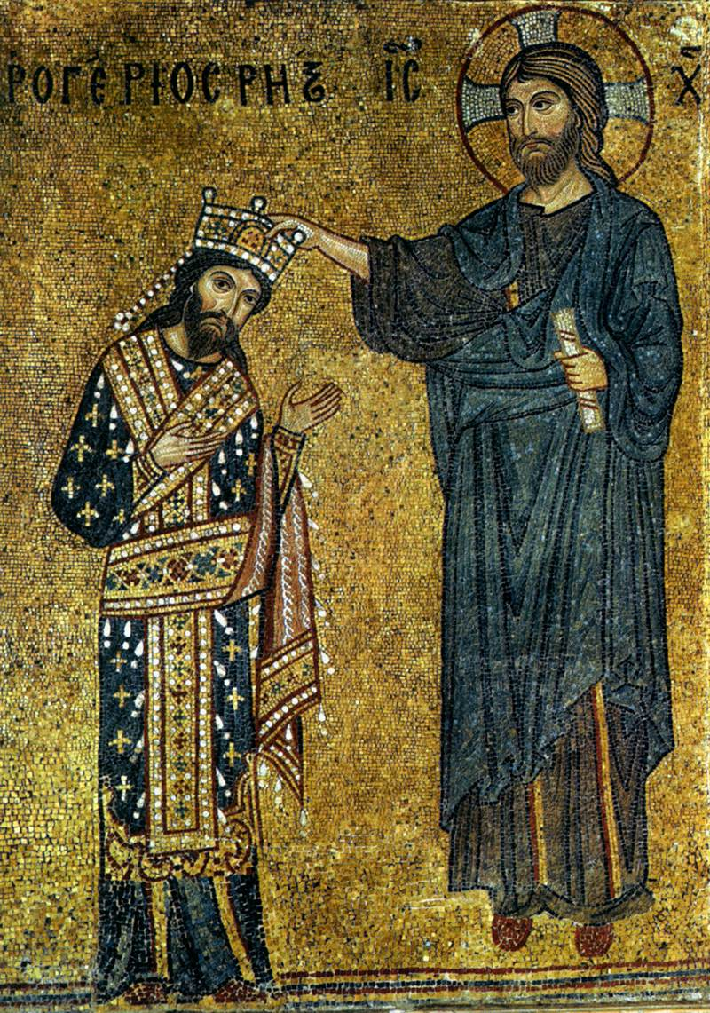

Appendix Two
Crowning of William II, c.1180, Monreale Cathedral, Monreale, Sicily. Image available at https://www.wga.hu/html_m/zgothic/mosaics/5monreal/1sanctu6.html [accessed 07/11/17].
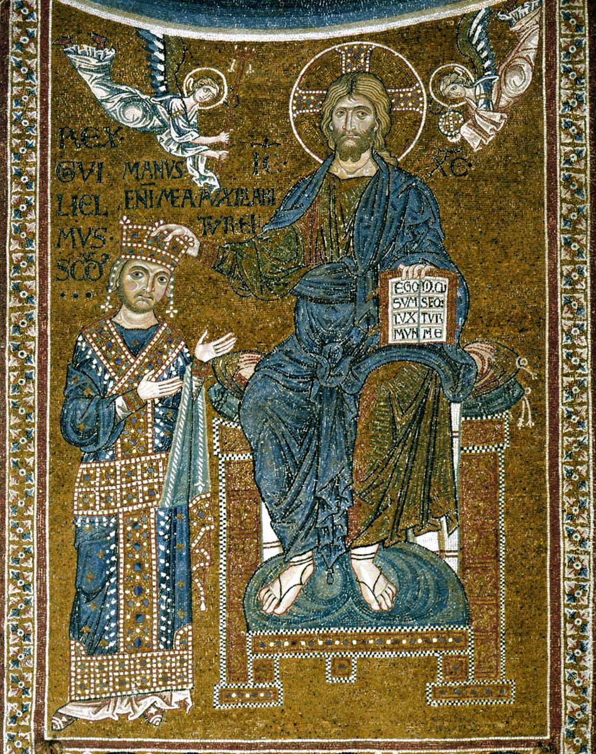

Bibliography
Abulafia, D., Frederick II: A Medieval Emperor (Oxford: Oxford University Press, 1988).
Abulafia, D., ‘The Crown and Economy under Roger II and His Successors’, Dumbarton Oaks Papers, Vol. 37 (1983), (Harvard: Dumbarton Oaks, 1983) pp.1-14.
Collins Staff, Holy Bible: King James Version (Glasgow: Harper Collins2011).
Hayes, D. M., ‘The Political Significance of Roger II of Sicily’s Antiquated Loros in the Mosaic of Santa Maria dell’Ammiragilo, Palermo’, Allegorica, vol.29 (2013) (Saint Louis: Saint Louis University, 2013) pp. 52-69.
Hollingsworth, M., Art in World History (Italy: Giunti, 2003).
Krén, E., and D. Marx, ‘Narthex (detail)’, Web Gallery of Art (Budapest: Web Gallery of Art, 2017). Available at https://www.wga.hu/html_m/zgothic/mosaics/8/2martor4.html [accessed 07/11/2017].
Krén, E., and D. Marx, ‘Sanctuary, north wall (detail)’, Web Gallery of Art (Budapest: Web Gallery of Art, 2017). Available at https://www.wga.hu/html_m/zgothic/mosaics/5monreal/1sanctu6.html [accessed 07/11/2017].
Norwich, J.J., ‘Roger II, King of Sicily’, History Today, Vol. 20, Issue 5, May 1970 (London, History Today, 1970). Available at http://www.historytoday.com/john-julius-norwich/roger-ii-king-sicily [accessed 07/11/2017].
Wieruszowski, H., ‘Roger II of Sicily, Rex-Tyrannus, In Twelfth-Century Political Thought’, Sepculum, Vol. 38, No. 1, Jan 1963 (Chicago: University of Chicago Press, 1963) pp. 46-78.
Williams, A.C., ‘Monreale, The Golden Temple’, Electrum magazine (California, Stanford University, 2011). Available at http://www.electrummagazine.com/2011/07/monreale-the-golden-temple/ [accessed 07/11/2017].

E. Krén and D. Marx, ‘Narthex (detail)’, Web Gallery of Art (Budapest: Web Gallery of Art, 2017). Available at https://www.wga.hu/html_m/zgothic/mosaics/8/2martor4.html [accessed 07/11/2017].
Ibid.
M., Hollingsworth, Art in World History (Italy: Giunti, 2003) p.160.
J. J., Norwich, ‘Roger II, King of Sicily’, History Today, Vol. 20, Issue 5, May 1970 (London, History Today, 1970). Available at http://www.historytoday.com/john-julius-norwich/roger-ii-king-sicily [accessed 07/11/2017].
Ibid.
D., Abulafia, Frederick II: A Medieval Emperor (Oxford: Oxford University Press, 1988) p.34.
H., Wieruszowski, ‘Roger II of Sicily, Rex-Tyrannus, In Twelfth-Century Political Thought’, Sepculum, Vol. 38, No. 1, Jan 1963 (Chicago: University of Chicago Press, 1963) pp. 46-78, p.48.
Wieruszowski, ‘Roger II of Sicily, Rex-Tyrannus, In Twelfth-Century Political Thought’, p.48.
D. M., Hayes, ‘The Political Significance of Roger II of Sicily’s Antiquated Loros in the Mosaic of Santa Maria dell’Ammiragilo, Palermo’, Allegorica, vol.29 (2013) (Saint Louis: Saint Louis University, 2013) pp. 52-69, p.54.
D., Abulafia, ‘The Crown and Economy under Roger II and His Successors’, Dumbarton Oaks Papers, Vol. 37 (1983), (Harvard: Dumbarton Oaks, 1983) pp.1-14, p.11.
Hayes, ‘The Political Significance of Roger II of Sicily’s Antiquated Loros in the Mosaic of Santa Maria dell’Ammiragilo, Palermo’p.54.
A.C. Williams, ‘Monreale, The Golden Temple’, Electrum magazine (California, Stanford University, 2011). Available at http://www.electrummagazine.com/2011/07/monreale-the-golden-temple/ [accessed 07/11/2017].
Wieruszowski, ‘Roger II of Sicily, Rex-Tyrannus, In Twelfth-Century Political Thought’, p.60.
Collins Staff, Holy Bible: King James Version (Glasgow: Harper Collins2011) Psalms 89: 21.

