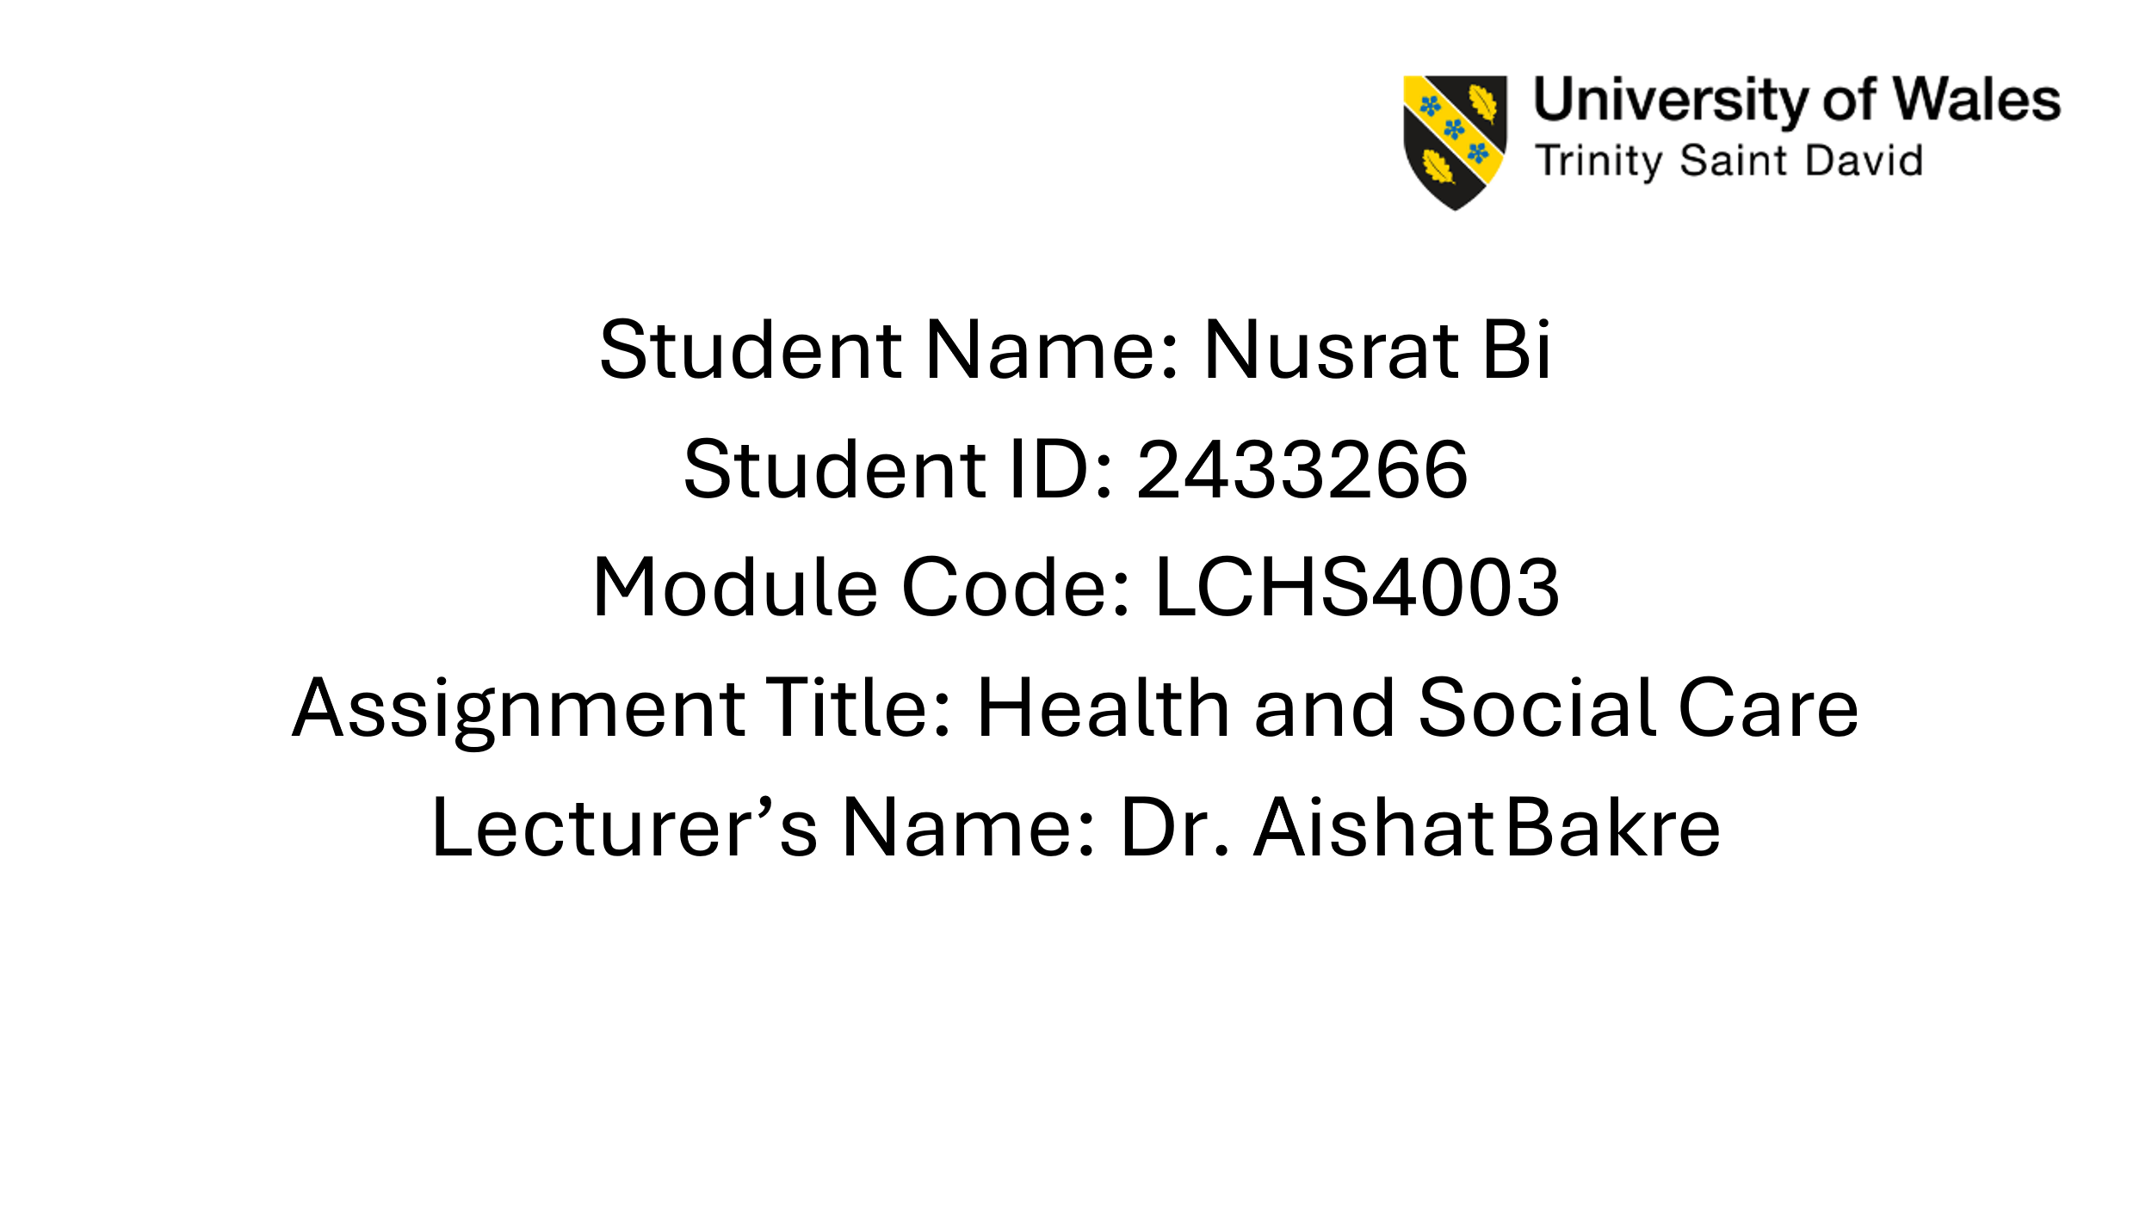

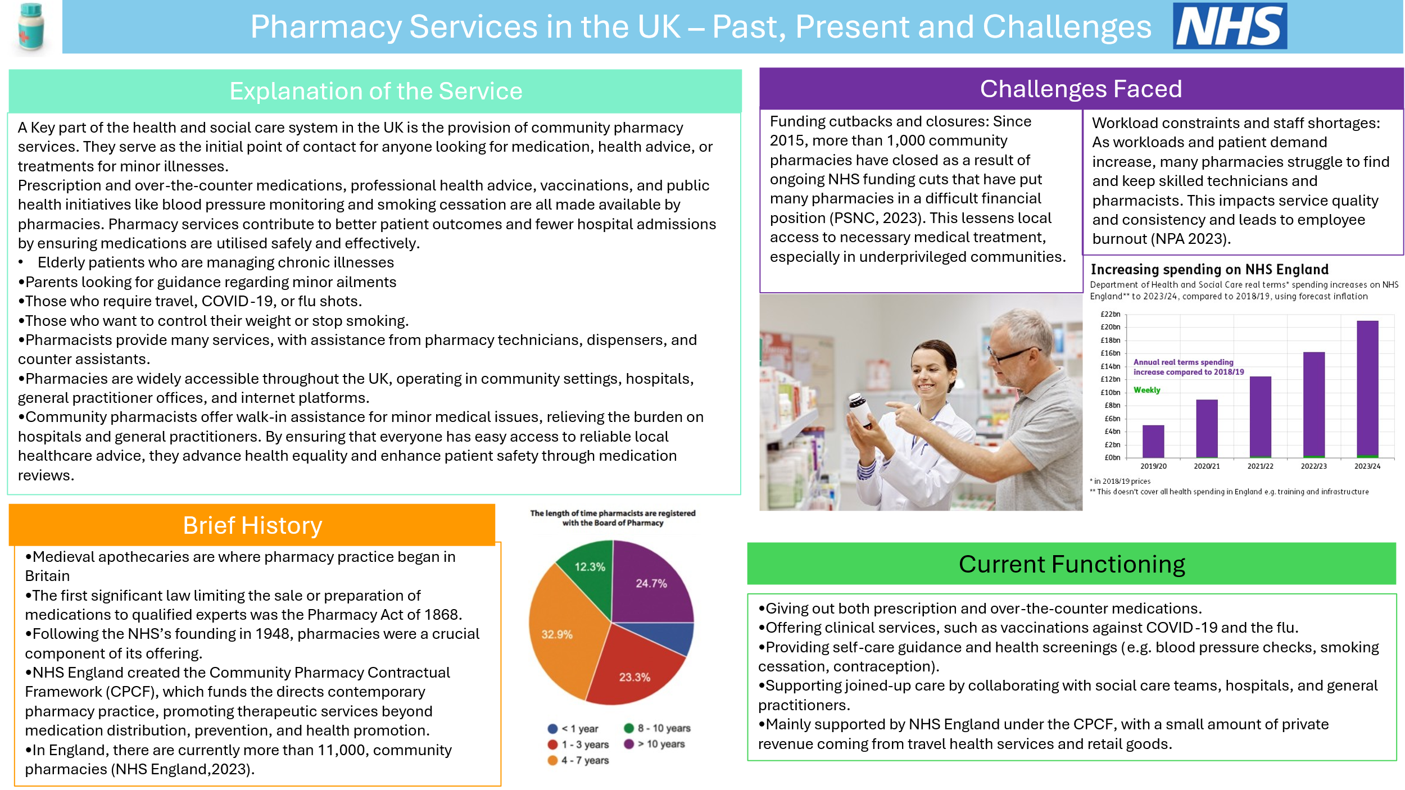
The Origins, Structure, and Functioning of the NHS

Introduction
Many people see the National Health Service (NHS), as one of Britain’s greatest achievements in social policy, offering healthcare that is free to everyone at the point of need and funded through taxation. The NHS was founded in 1948 with the goal of guaranteeing that everyone, regardless of money, could obtain medical care. Before critically assessing the NHS’s current structure, organisation, and issues, this essay will first look at the organisation’s historical roots and guiding principles.
Origins of the NHS
The NHS was established during the post-war reconstruction era, when social injustice and economic suffering were prevalent in Britian. The Beveridge Report of 1942 laid the groundwork for welfare state changes by identifying the “five giants” that need to be conquered: want, disease, ignorance, squalor, and idleness (Beveridge, 1942). Despite resistance from political rivals and medical experts, Aneurin Bevan, the post-war Labour government’s Minister of Health, played a crucial role in putting these concepts into practice (Webster, 2002).
Three guiding principles underpinned the official start of the NHS on July 5th 1948: it should be free at the points of use, satisfy the needs of all people, and be funded by general taxes (Rivett, 1998). Compared to the former system of voluntary and local authority hospitals, where access was restricted based on financial means, this was a revolutionary change. Thus, the NHS’s establishment represented post-war pledges to equality and community well-being making it a significant social and political turning point (Klein, 2019).
Current Structure and Functioning of the NHS
England, Scotland, Wales, and Northern Ireland are all in charge of their own healthcare systems, making the NHS a devolved system today (The king’s Fund. 2023). The largest of the four, NHS England, is in charge of the NHS trusts and clinical commissioning groups, which provides services like community care general practice, and hospitals (NHS England, 2022). With an annual budget of more than £160 billion in England alone, funding is mostly provided by general taxes and National Insurance contributions (The King’s Fund, 2023).
Primary care, secondary care, mental health support, and public health programs are just a few of the many services offered by the NHS, Significant changes have been made to the system. Nevertheless, most notably the Health and Social Care Act of 2012, which expanded the role of private providers in providing care that is supported by the government (Baggott, 2019). The question of whether these measures go against the NHS’s core values has been raised by this restructuring.
Critical Examination
The NHS is under increasing pressure, even though it is still one of the most extensive healthcare systems in the world. Universal access and widespread public support are among its strong points; these have been particularly noticeable during emergencies like the COVID-19 pandemic (BMJ, 2020). However increased demand, a lack of workers, and lengthy wait times are putting a lot of strain on the service. For instance, there ere more than seven million patients on waiting lists in England as of 2023 (The King’s Fund, 2023).
Critics contend that the NHS model’s sustainability is threatened by ongoing underfunding and the slow inclusion of commercial providers (Hunter, 2016). Additionally demographic shifts like elderly people with complicated medical needs put extra strain on operations and finances. The NHS may need both structural changes and more funding to stay viable, but there are ongoing discussions on how to do so without sacrificing its fundamental values (Ham, 2018).

Conclusion
The NHS was founded in 1948 as part of a wider post-war welfare reforms built on the principles of fairness, universal access, and healthcare free at the point of need. While it continues to provide millions of people with vital treatment today, the program is dealing with formerly unseen difficulties such as a lack of financing and an increase in demand. It’s survival as a pillar of social assistance in the UK depends on striking a balance between effectiveness and its guiding principles.

References
Community Pharmacy England (2023) Pharmacy First service. Available at: https://cpe.org.uk/national-pharmacy-services/advanced-services/pharmacy-first-service/ (Accessed: 14 September 2025).
Pharmaceutical Services Negotiating Committee (PSNC) (2023) Community Pharmacy Closures Report.
National Pharmacy Association (NPA) (2023) Workforce and Stress in Pharmacy.
The Pharmacy Act (1868).
NHS (1948) Establishment of the National Health Service.
Department of Health and Social Care (2019) Community Pharmacy Contractual Framework.

Baggott, R. (2019) Understanding Health Policy. 3rd ed. Bristol: Policy Press.
Beveridge, W. (1942) Social Insurance and Allied Services. London: HMSO.
BMJ (2020) ‘COVID-19: Protecting the NHS’, BMJ, 369:m2066.
Ham, C. (2018) ‘Making sense of the NHS’s future’, Health Policy Journal, 122(6), pp. 567–571.
Hunter, D. (2016) The Health Debate. 2nd ed. Bristol: Policy Press.
Klein, R. (2019) The New Politics of the NHS: From Creation to Reinvention. 8th ed. London: Routledge.
NHS England (2022) About the NHS. Available at: https://www.england.nhs.uk/nhs-structure/ (Accessed: 20 September 2025).
Rivett, G. (1998) From Cradle to Grave: Fifty Years of the NHS. London: King’s Fund.
The King’s Fund (2023) The NHS Budget and Funding. Available at: https://www.kingsfund.org.uk (Accessed: 20 September 2025).
Webster, C. (2002) The National Health Service: A Political History. 2nd ed. Oxford: Oxford University Press.

