Module code: BMIH6005
Module name: Organisational Consultancy

Company Name: AZ Consultancy Firm

Enhancing Operational Efficiency and Guest Satisfaction: A Report on Housekeeping Department Challenges at Hilton London Metropole

Name: Marin Marius Enache
Student Id: 2241513

Table of Contents
1. Executive Summary 3
2. Introduction 5
3. Analysis 7
3.1 Identified Issue in the Housekeeping Department 7
3.2 Causes and Impact on Hotel Performance 7
3.3 STEEPLED Analysis 8
3.4 SWOT analysis 10
3.5 TOWS Analysis 12
4. Recommendations and Change Management 14
4.1 Implementation of Digital Housekeeping Management Systems 14
4.2 Comprehensive Staff Training and Development Programme 15
4.3 Review and Restructure of Housekeeping Staffing Model 16
4.4 Enhanced Staff Communication and Feedback Mechanisms 17
4.5 Sustainability and “Green” Housekeeping Practices 18
4.6 Targeted Recruitment and Retention Initiatives 19
4.7 Change Management Strategy 20
5. Action plan 21
6. Conclusion 26
References 28

1. Executive Summary
This executive summary offers a combined picture of the consultancy report generated by AZ Consultancy Firm on behalf of the Hilton London Metropole, namely the issues and strategic opportunities of the improvement of its Housekeeping Department. Being a flagship hotel of the Hilton Hotels and Resorts brand, Hilton London Metropole is a high-profile participant in the hospitality industry of London, and it is well-known by its size, excellent location, and international clientele. The report is a reaction to the evident signs of operational distress within the housekeeping operation which have taken the form of decreasing guest satisfaction, variable service quality, rising staff turnover and threats to the hotel reputation and its financial position.
The consultancy project has been initiated by a thorough evaluation of the operational setting and market environment of the hotel. Hilton London Metropole, 225 Edgware Road, has more than 1,059 rooms and is one of the largest hotels in the city in terms of number of rooms. It has a wide guest base composed of international tourists, business travelers, and conference delegates of large numbers, all of which demand high and standardized levels of services. The complexity of the hotel operations is enhanced by the fact that the hotel is a major events venue and this further puts pressure on the housekeeping department to ensure a quick turnaround of the rooms and a consistent quality. The primary issues of the Housekeeping Department were revealed fast. Inconsistency in the cleanliness of the rooms, poor preparation time, amenities not being prepared and the quality standard being inconsistent have become key issues in the reviews by guests as well as in the internal performance data.
Such problems are even more acute at the times of high occupancy or simultaneous events, which results in reputational risks, guest complaints, and a decrease in rates of repeat bookings. Its underlying causes are complex. The insufficient number of employees working in the busy hours, inconsistent training, lack of communication in multicultural workforce and the partial use of outdated manual operations have all contributed to the reduction of the operational efficiency and the team morale. The findings are supported by major analytical models, such as STEEPLED analysis to investigate external forces i.e. social trends, technology, economic pressures, political and legal requirements, ethical standards, and demographic changes that are shaping up the hotel operations.
As an illustration, the hospitality industry in London is highly competitive, labor costs are increasing as well as regulatory changes affecting labor supply. The demand in environmentally friendly cleaning practice and products is increasing. Innovation provides avenues to improved efficiency, but it involves training and investment of personnel. The SWOT analysis identifies the main strengths of the hotel, which are the brand reputation, central location and access to the training resources of Hilton, and weaknesses, which are the inconsistency of service, high turnover and underutilization of technology.
The TOWS matrix will convert these insights into strategic choices, so that the proposed solutions are not only practical, but also are in line with the unique situation in the hotel. The consultancy report provides a package of evidence-based recommendations that will help deal with the root cause of the housekeeping challenges. Another major concern should be the adoption of an efficient digital housekeeping management system. With such a system, real-time task assignment would be possible, rooms status would be tracked more effectively, and inter-departmental communication would be improved, which is essential to a property of this scale. This digital solution should be introduced in a form of a pilot phase, where any difficulties are solved prior to being implemented hotel-wide.
It is estimated that the change will dramatically cut room turnaround times, service inconsistencies, and will also give the management valuable operational data. In addition to technological modernization, the report proposes a thorough and sustained training and development program of the staff. This program must include service standards, technology use, cultural competence and sustainable housekeeping practices. The hotel can attract a steady supply of skilled labor by collaborating with the local colleges and outside training providers as well as overcome communication obstacles that exist in a multicultural workforce. This should increase consistency of services, boost morale, and minimize turnover, as well as offer staff more definite career advancement and rewards. The second key suggestion is to reorganize the staffing models, based on the thorough analysis of the workload that can be achieved with the help of digital systems.
All the recommended actions depend on change management. The report outlines a systematic way of introducing the change, such as effective communication of the reason and advantages, involvement of the staff in planning and pilot stages of the process, continued support and guidance, and recognition of change leaders among the team members. It is known that resistance to change is a normal reaction, so it is recommended that the management should endeavor to give staff feedback platforms, adopt workable ideas and also celebrate minor achievements to keep the change going.

2. Introduction
The consultancy report reviews the operational issues of the Housekeeping Department of the Hilton London Metropole hotel and looks at the issues that affect the operational efficiency and customer satisfaction. Being one of the landmark properties within the Hilton Hotels and Resorts brand, which is known worldwide, Hilton London Metropole can be regarded as one of the major players within the hospitality industry of London (Zemlina et al., 2023). However, the recent trends and internal feedbacks have raised serious issues in its Housekeeping operations and as such, this report is not only timely, but also critical to the further success and image of the hotel.
Hilton London Metropole is situated in the heart of London, which is at the 225 Edgware Road. The hotel was launched in 1972 and since then it has been refurbished and expanded a number of times to ensure that it retains its competitiveness in the dynamic hospitality environment. It has more than 1,059 guest rooms today, one of the largest hotels in London in terms of the number of rooms (Hilton London Metropole, 2025). The hotel also has a wide range of customers; including international tourists, business travellers who come to attend conferences and events; hence, service excellence is very important to the success of the hotel (Sirirak et al., 2021). The size of the meeting and event facilities of the hotel, which include one of the largest conference facilities in London, leads to the increased requirement of efficient and high-quality housekeeping services to handle the high turnover and satisfaction of the guests (Garg et al., 2025).
With its reputation and central location, the Hilton London Metropole has been struggling with the Housekeeping Department in the recent past. Internal audits and customer feedback show that the score of satisfaction is decreasing concerning the cleanliness of the rooms, the presence of amenities, and the promptness of the rooms preparation, especially at high occupancy rates (Alharbi et al., 2025). Not only do these kinds of problems negatively affect the reputation of the hotel on international review websites, but they also pose a threat to repeat sales and profitability in general (Au-Yong et al., 2024). Housekeeping Department is a fundamental aspect of determining the guest experience in any hotel and any variation can lead to a ripple effect on other departments and the brand itself.
To overcome these challenges in the operations, AZ Consultancy Firm, a specialist firm in enhancing organisational improvement in the hospitality industry, has been contracted to offer an in-depth analysis and customised solutions to solve such operational issues. Having experience with independent hotels as well as large international brands, AZ Consultancy can offer a rich experience in the industry and evidence-based approaches to the assignment. The consultancy focuses on improving the efficiency of operations and the customer satisfaction levels, as these are two aspects that go hand in hand in the hospitality sector. AZ consultancy shall use a practical and participatory approach that will enable it to closely work with the management team at Hilton London Metropole to achieve sustainable changes in the Housekeeping Department.
In order to offer a detailed analysis of the challenges and to develop practical recommendations, this report will be supported by well established theories and analytical frameworks. To start with, the wider external forces that affect the housekeeping operations at Hilton London Metropole will be examined using the STEEPLED analysis. This model allows analyzing such social, technological, economic, environmental, political, legal, ethical, and demographic trends that can impact the performance of departments and the expectations of guests. Secondly, the SWOT analysis will define internal strengths and weaknesses of the department, external opportunities and threats, which will enable the assessment of the current situation in a balanced way. Lastly, the TOWS matrix will be used to translate the learning acquired in the SWOT analysis into actual strategic alternatives by matching the internal resources to the external environment.

3. Analysis

3.1 Identified Issue in the Housekeeping Department
The Housekeeping Department at Hilton London Metropole has fallen under scrutiny owing to various operational issues that have directly affected the satisfaction of guests as well as the overall performance of the hotel (Johnson, 2023). The main problem that is identified is the consistent decrease of the guest satisfaction scores, especially in terms of room cleanliness, turnaround and the accessibility of amenities (Au-Yong et al., 2024). Although the hotel has a high reputation and there are set operational standards, the recent reviews by the customers indicate the variability in the quality of housekeeping services (Singgalen, 2024). Late room preparation, unnoticed facilities, and inconsistent levels of cleanliness are listed as the most common issues, particularly at peak occupancy times or significant conference events (Ali et al., 2021). These factors have led to negative feedback on the Internet and internal polls, which indicate that it is necessary to carry out a detailed examination and intervention (Ollor and Essien, 2022).

3.2 Causes and Impact on Hotel Performance
Root cause analysis suggests that the issues of the Housekeeping Department are complex. Understaffing, especially when occupancy is high, is one of the factors that contribute to it. Although the hotel has a comparatively large housekeeping staff, they may be stretched when the hotel is busy, such as during conferences or the tourist high seasons (Gubhaju et al., 2024). Irregular supervision and failure to check on quality control also add to the variation in service delivery (Gubhaju et al., 2024). Also, communication can be a problem between a diverse workforce due to language barriers, and proper standards and expectations may not be communicated clearly (Gajić et al., 2024). The other important concern is the application of technology in housekeeping. The implications of these housekeeping issues cut across a number of dimensions of the hotel operation (Moreno-Perdigon et al., 2021). The first and foremost reason behind the hotel's success is guest satisfaction. Irregular housekeeping not only results in short-term discontent but also ruins the image of the hotel on authority review websites and booking services (Ghosh, 2023b).
Potential visitors are becoming more dependent on these websites to base their booking choices, and negative reviews may discourage future reservations, thus lowering occupancy levels and income generation (Özdemir et al., 2019). Second, it reduces the efficiency of the operations of the hotel. Slow room turnaround times cause delays to new guests and may lead to logjams, especially when making check-ins and check-outs, especially when coordinating with the front office (Intiar et al., 2024). Team morale is also affected when teams fail to provide services as per the expectation due to lack of resources or lack of clarity in processes, which may further increase rates of turnover and disrupt operations (Semwal et al., 2023).

3.3 STEEPLED Analysis
STEEPLED analysis for the Hilton London Metropole is attached on the following:
Social: In large international hotels, the demands of guests in terms of hygiene and service provision have increased tremendously. This puts extra pressure on housekeeping to achieve high standards that are consistent (Thoriq et al., 2024). Moreover, the multicultural workforce in the department creates challenges for communication and coordination due to language barriers and differences in cultural norms, which may lead to misunderstandings or inconsistent practices (Manoharan and Ashtikar, 2025). To overcome these social factors, it is necessary to conduct staff trainings constantly and use inclusive communication strategies that can promote collaboration within the team and make sure that the needs of all guests are addressed (M’hamed and Idrissi, 2024).
Technological: The current Housekeeping Department does not use the full potential of the developed digital management systems to enhance efficiency and accuracy (Barlan-Espino, 2017). There is a possibility to introduce automation tools to monitor the room status, inventory management, and scheduling (Yadav and Raju, 2025). Technology would improve workflow optimisation, decrease the number of errors, enhance communication among staff and other departments, and facilitate the workflow. Digital solutions are the key to remaining competitive and keeping up with the growing tempo of modern hospitality (Nazari et al., 2020).
Economic: Increasing costs of living and inflation exert pressure on staffing budgets, which impact the recruitment and retention of housekeeping staff. The competitive hotel market in London exacerbates the situation, as hotels must offer attractive pay rates while managing their operating expenses (Mandić et al., 2023). Understaffing or hiring temporary employees due to economic restraints has a detrimental effect on the consistency of services and the satisfaction of the guests.
Environmental: The hospitality industry is witnessing an increasing need to have environmentally friendly cleaning practices and cleaning products. To be in line with the expectations of the guest and the corporate sustainability agenda, housekeeping needs to embrace green procedures like the adoption of biodegradable cleaning agents and the reduction of wastage (Zaman et al., 2016). Adopting a green approach will not only help in improving brand image but will also result in cost reduction and meeting the new green rules.
Factor | Relevance to Housekeeping at Hilton London Metropole
Social | Increased demands of guests in terms of hygiene and service. The issue of multicultural workforce presents a problem of communication.
Technological | There is underutilization of digital housekeeping management systems; possibilities of automation, and workflow optimization.
Economic | The cost-of-living pressure and inflation affect staffing budget and wage expectations. The presence of a high level of competition in London market.
Environmental | Greater attention to environmental friendly cleaning procedures and green facilities. Incentive on reducing wastes and usage of green products.
Political | Housekeeping staff is influenced by the immigration policies. Employment standards local government regulations.
Legal | Adherence to the health and safety legislation; GDPR when it comes to the handling of guest data within the feedback systems.
Ethical | Demand of fair working conditions, equal treatment of employees and open methods of complaints handling.
Demographic | Population ageing of the older members of staff; high turnover of younger staff; growing diversity.

Table 1: STEEPLED analysis (Source: Author)
Political: Immigration policies directly affect the functioning of housekeeping operations since it determines the supply of labour, particularly the diverse workforce in London. Local governments enforce norms of employment and employee protection, which impact the hiring, treatment, and compensation of employees (Cobanoglu et al., 2021). The fluctuations of these political factors can affect the stability of the staff, raise the level of compliance and modify the cost structure of housekeeping services in general.
Legal: In housekeeping, the most important aspect is legal compliance, specifically adherence to health and safety laws that ensure cleanliness for guests and safe working conditions for staff (Widiastini et al., 2024). Moreover, the department should comply with GDPR in terms of managing guests' feedback and personal data, which requires safe data management procedures. The non-observance of these legal conditions may lead to punishment and image loss.
Ethical: The department is under pressure to offer a decent working environment, equal treatment, and proper mechanisms for addressing complaints among all workers. The ethical factors involve avoiding discrimination, safe workloads, and a culture of respect in the workplace. High ethical principles do not only boost the morale and retention of the staff but also better the image of the hotel as a responsible employer (Anwar et al., 2024).
Demographic: The ageing of older housekeeping employees hinders productivity, while high turnover among younger employees disrupts teamwork. The increased diversity in the department needs special training and management strategies to reduce the generational and cultural differences (Kim and Chung, 2022). Adjusting to these demographic trends will be necessary to maintain an effective and steady housekeeping team.

3.4 SWOT analysis
A SWOT analysis for Hilton London Metropole is given on the following:
Strengths: Among the greatest advantages, the high visibility of Hilton London Metropole and its great brand reputation should be mentioned, as they are local and international strengths. This position entails a steady stream of visitors and enables the hotel to charge high prices (Hassan and Eassa, 2025). The hotel is also strategically located in London and has a large number of rooms; this makes it one of the best hotels to be used by tourists and conference organisers, which guarantees high occupancy rates and a wide range of clients (Wilson, 2025). The housekeeping staff has access to the long-established training resources of Hilton and tools that help to operate the facility, which keeps the team up to date with the industry standards and best practices.
Weaknesses: There are also significant internal weaknesses of the department. Due to the variation of housekeeping standards, guest satisfaction has been varying, which means that the uniformity in service delivery is absent (Cesarotti and Spada, 2009). When there are high occupancies, the team experiences some delays in room turnaround which directly affects the experience and efficiency of the operations (Truong et al., 2020). Although Hilton has available resources, a lack of staff training and internal communication can be identified, leading to misunderstandings and inconsistent implementation of responsibilities.
Strengths | Weaknesses
Robust brand reputation and significant visibility. | Erratic housekeeping standards.
Prime location and substantial room capacity. | Prolonged delays in room turnover during high-demand periods.
Access to Hilton's educational resources and operational instruments. | Deficiencies in personnel training and communication.
Favourable guest evaluations regarding staff amiability. | Inadequate utilisation of digital management systems.
Routine enhancements and refurbishments of the facility. | Elevated employee attrition and limited resources.
Opportunities | Threats
Implementation of sophisticated housekeeping technologies. | Fierce rivalry from contemporary or boutique hotels.
Augmented sustainability initiatives. | Increasing labour expenses and workforce deficiencies.
Collaborations for employee training and development. | Adverse online evaluations impacting reputation.
Utilising feedback for ongoing enhancement. | Modifications in immigration policy affecting workforce accessibility.

Table 2: SWOT analysis (Source: Author)
Opportunities: There are a number of opportunities that offer scope for the department's growth and advancement. Using the new technologies of housekeeping, like automated management systems of tasks and online inventory solutions, may improve efficiency and uniformity (Lai et al., 2023). Engaging in sustainability efforts, such as green cleaning, is becoming increasingly feasible and will attract environmentally conscious guests while aligning with the broader corporate responsibility agenda (Zhou et al., 2025). Collaboration with the local training providers or educational institutions will increase the staff's skill level and contribute to their professional development, filling the training gap (Jogarao, 2024). The department can conduct continuous improvement initiatives by actively using the feedback and reviews analytics, which will result in long-term improvements in the quality of services.
Threats: The department faces several external threats that it must address. The very competitive London hospitality industry comprises newer or boutique hotels which can present innovative services or personal experiences (Zhou et al., 2025). An increase in labour costs and a shortage of staff that have been worsened by economic factors and the changes in the policy of immigration pose a threat to the hotel's retention and attraction of qualified housekeeping staff. Without responding to negative online reviews, reputation can be undermined, and bookings will be affected. Alterations in government regulations, particularly those that influence the supply of a diverse workforce, may interfere with the stability of operations and service delivery.

3.5 TOWS Analysis
The TOWS matrix, derived from the SWOT analysis, emphasises actionable strategies by correlating internal strengths and weaknesses with external opportunities and threats.
SO (Strengths-Opportunities) Strategies: The department can utilise Hilton's global training resources to expedite the adoption of new housekeeping technologies and sustainability (Bardukova, 2023). Staff will be fully prepared not only to know but also to be skilled in the use of new digital management systems and green cleaning procedures. These improvements will spur operational performance, meet contemporary guest requirements, and help the hotel achieve its environmental goals (Baquero, 2022). The department will be able to establish a culture of continuous improvement by leveraging positive guest feedback and the intrinsic motivation of employees.
WO (Weaknesses-Opportunities) Strategies: The lack of training and communication can be improved with the help of establishing relationships with the local training providers and educational institutions (Parvez et al., 2025). With a commitment to continuous professional development, the department can train employees, minimise randomness, and create a culture of sharing best practices (Tiwari et al., 2022). Improving technological infrastructure is another opportunity; the introduction of digital task management tools will also contribute to solving the problem of operational inefficiency and a reduction in human error.
SO (Strengths-Opportunities) | WO (Weaknesses-Opportunities)
Utilise Hilton’s worldwide training to improve the implementation of advanced housekeeping technologies and sustainability initiatives. | Train and communicate gaps by collaborating with the local training providers and implementing new staff development programs.
Leverage favourable guest feedback and employee motivation to facilitate ongoing enhancement and trial innovative cleaning technologies. | Make technology upgrades to reduce operation and solve inefficiencies.
ST (Strengths-Threats) | WT (Weaknesses-Threats)
Enhance brand image by being responsive to bad reviews and engaging in facility improvements. | Minimize the use of manual operations by automating housekeeping operations to reduce risk on labor shortage and costs.
Ensure high central location advantage to attract partnerships and resources to recruit staffs in a competitive labor market. | Create an effective feedback system that will ensure that any concerns raised by guests are responded to in time before any damage is caused to the reputation.

Table 3: TOWS Analysis (Source: Author)
ST (Strengths-Threats) Strategies: To protect against the outside menace, the hotel shall undertake an aggressive strategy of promoting its brand image by reacting swiftly to negative feedback and highlighting the recent facility improvements (Zhang et al., 2024). The hotel can utilise proactive communication to protect its market position and maintain the trust of its guests. Additionally, the centralised location can leverage local partnerships, particularly in recruitment and resource sharing (Arceta et al., 2022). This is important in a competitive labour market where staff shortages and cost increases are a threat to the operations. Development of relationships with local colleges or employment agencies will provide a continuous source of talent (Sheoran, 2025).
WT (Weaknesses-Threats) Strategies: Diverting the department away from manual operations by automating housekeeping operations will offset the risks of staffing shortages and increasing labour expenses (Neog, 2021). Data-driven management and automation can help increase consistency and minimise vulnerabilities in operations. It is also crucial to have a strong, real-time feedback loop in place; with the help of it, the department will be able to detect and eliminate the negative effects of the minor lapses in service delivery before they can evolve into a reputation-destroying event (Al-Hyari et al., 2023).

4. Recommendations and Change Management

4.1 Implementation of Digital Housekeeping Management Systems
The most important and, by far, the most revolutionary suggestion is to implement a digital housekeeping management tool in full, i.e., to use Hilton's own OnQ Housekeeping or other popular industry tools like HotSOS or Optii Solutions. At present, the Housekeeping Department has to deal with old or half-baked digital solutions, which causes inefficiencies, miscommunication, and challenges in measuring performance indicators (Putra et al., 2022). A well-developed and comprehensive system will allow the hotel to automate the process of task distribution, offer real-time information about room status, and maintain open communication between housekeeping, front office, and maintenance departments. In the case of a large property with more than 1,000 rooms and a high turnover of events, such a system will be more agile and consistent.
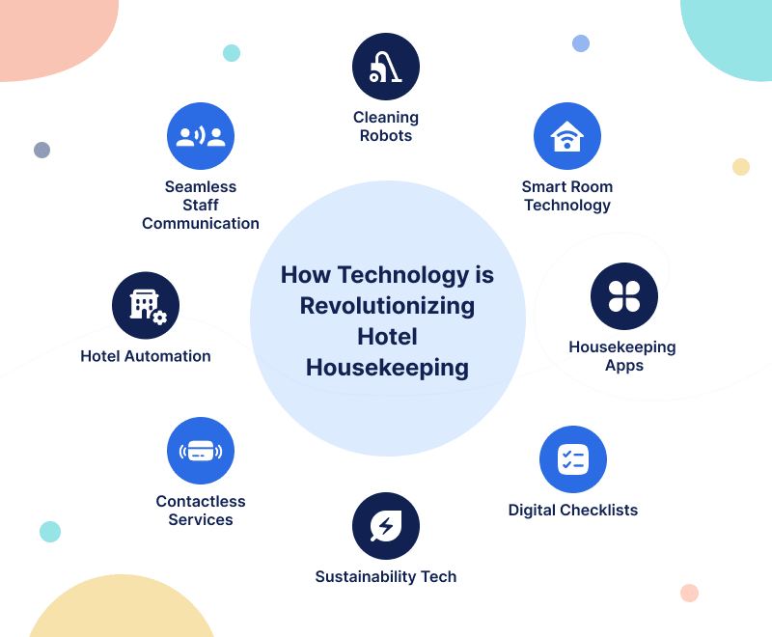
Figure 1: Digital Housekeeping Management Systems (Putra et al., 2022)
The implementation process must start by piloting the change, preferably within a section or a floor of the hotel. This will enable any problems to be resolved prior to the system being scaled up to the whole property. Every employee, including those who are supervisors and managers, will need to be extensively trained, both on using the software and on how new working processes will affect their everyday activities (Chatterjee, 2022). Software licensing, initial training, and IT support are estimated to be about £38,000-£48,000 per annum, which is a reasonable investment considering that the number of labour inefficiencies is expected to reduce and the level of satisfaction for the guests will increase (Ghosh, 2023a). The success should be evaluated with the help of well-monitored key performance indicators, including average turnaround time, the quantity of tasks that were missed, and the satisfaction of guests regarding the cleanliness and general experience of staying in the rooms.

4.2 Comprehensive Staff Training and Development Programme
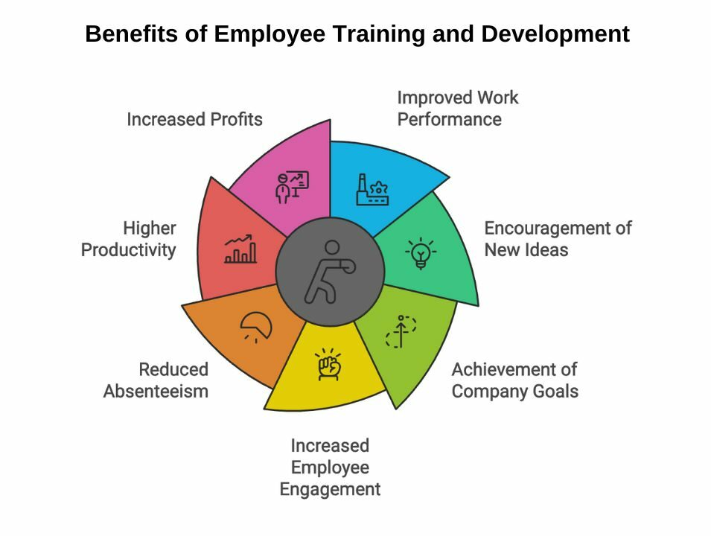
Figure 2: Staff Training and Development Programme (Dodu et al., 2021)
The problem of non-conformance and poor performance needs to be solved by creating an efficient long-term training and development plan for housekeeping employees. The programme must address the service standards, cultural competence, technology usage and sustainability practices (Dodu et al., 2021). The hotel must also provide frequent workshops and language assistance to their staff that are not native English speakers in collaboration with local colleges or professional trainers because communication problems have been shown to be one of the major obstacles to providing consistent (Sharma et al., 2023).
An incentive system must be implemented to support the involvement, appreciation, and continuous development in the event of excellent performance. The cost of this programme, which is expected to be around £20,000 a year, would be spent on professional training, course materials, and rewards of incentives. This forward-looking attitude to employee development will develop a better-skilled, engaged and loyal workforce (Bhatnagar and Nim, 2019). It will lead to a more uniform service delivery, increased staff morale and reduced staff turnover, leading to an increased guest experience (Choy et al., 2021).

4.3 Review and Restructure of Housekeeping Staffing Model
Another vital suggestion is a critical review and consequent restructuring of the existing model of staffing in the Housekeeping Department. The first step in this initiative should be the thorough workload analysis based on the data collected by the new digital management system. The aim is to make sure that staffing is as close as possible to the real-time demand, which depends on occupancy and event schedules and seasonality (Kusuma et al., 2022). The hotel should implement a flexible and shift-based schedule that would enable a stronger alignment of the staff availability with the operation requirements, as well as the accommodating of a wide workforce with varied personal situations (Colaco, 2024).
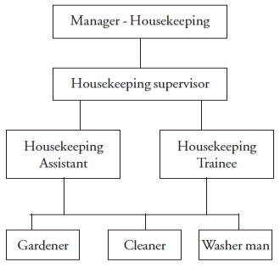
Figure 3: Housekeeping Staffing Model (Colaco, 2024)
The department can also offer flexible schedules such as part-time work or split shifts to make this department more appealing to a wider pool of employees, which will help address the issues of recruitment. Notably, management should always consult the staff before any changes of schedules are made so that new rotas are not only fair but productive (Dar et al., 2021). The financial implication is minimal and mostly administrative and is projected to be approximately £3,000 per annum in shift management software and procedures. The expected advantages are the improvement of staff efficiency, job satisfaction, a quicker preparation of rooms, and reduced overtime expenses.

4.4 Enhanced Staff Communication and Feedback Mechanisms
The hotel needs to set up formal, regular communication channels with staff and allow employees to provide feedback in order to develop a culture of continuous improvement and make sure that operational issues are detected and solved before they become a problem (Thoriq et al., 2024). Team meetings should be established whereby the staff members can express their concerns, give suggestions and be informed of the changes within the department on a monthly basis. Moreover, a digital suggestion box will be introduced, which will help employees to be more open and candid since they can remain anonymous.
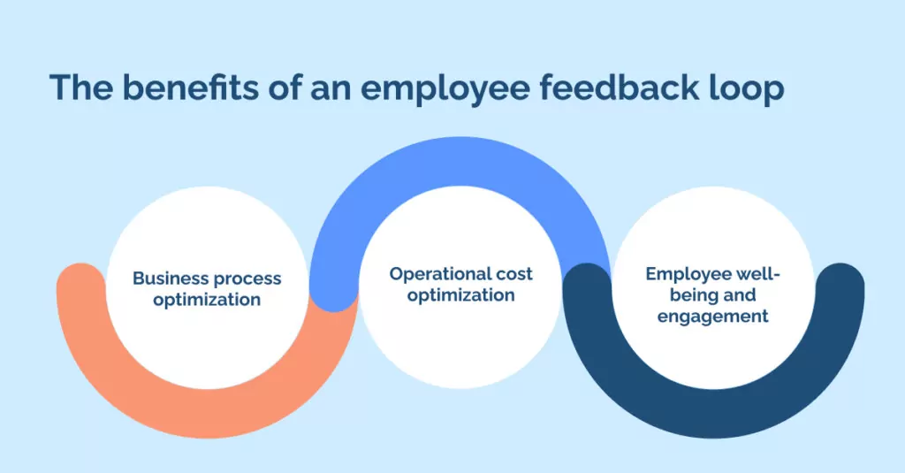
Figure 4: Staff Communication and Feedback Loop (Szende et al., 2021)
The financial investment of these measures is modest, as most of the expenses are based on the time spent during meetings and a relatively small investment in digital tools, which can be estimated at 1,000 a year. The effect of enhanced communication is tremendous. It results in better morale, quicker discovery of possible problems, and a feeling of empowerment on the part of employees (Srivastava and Tyagi, 2024). The management should be responsive, meaning responding to the suggestions and reporting on what has been done. The success of such efforts must be measured by employee surveys, attendance of meetings and the rate at which issues raised are addressed.

4.5 Sustainability and “Green” Housekeeping Practices
The Housekeeping Department ought to speed up the introduction of sustainable and environmentally friendly practices in accordance with the expectations of the guests and corporate responsibility targets of Hilton (Szende et al., 2021). This includes using environmentally friendly cleaning materials, cutting down on single-use plastics, and creating linen and towel reuse programmes in the hotels. The suppliers who provide biodegradable or sustainable products should be given priority by the procurement as staff is trained on green cleaning and waste reduction (Abdel‐Hamid et al., 2022). Although certain environmentally friendly products might be more expensive initially, usually 10-15 per cent more than the traditional products, this is usually countered by the savings in the long run due to less usage of water, energy and disposable items.
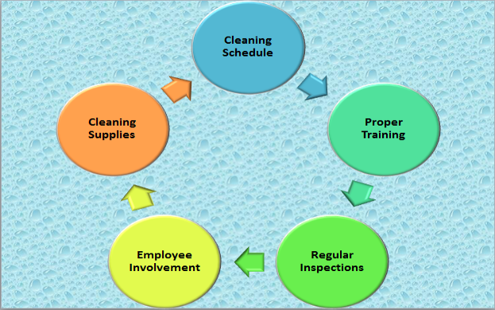
Figure 5: “Green” Housekeeping Practices (Abdel‐Hamid et al., 2022)
The net year-on-year increment is estimated to be between £7,000 and £12,000. The operational and reputational gains of being green are quite high. It not only increases the attraction of the hotel to environmentally conscious customers but also benefits the wellbeing of the staff and the community at large (Srivastava and Tyagi, 2024). The effect of these practices can be quantified by monitoring the resources consumed, the involvement of the guests in linen/towel programmes and evaluating the guest feedback on sustainability through the comments and reviews.

4.6 Targeted Recruitment and Retention Initiatives
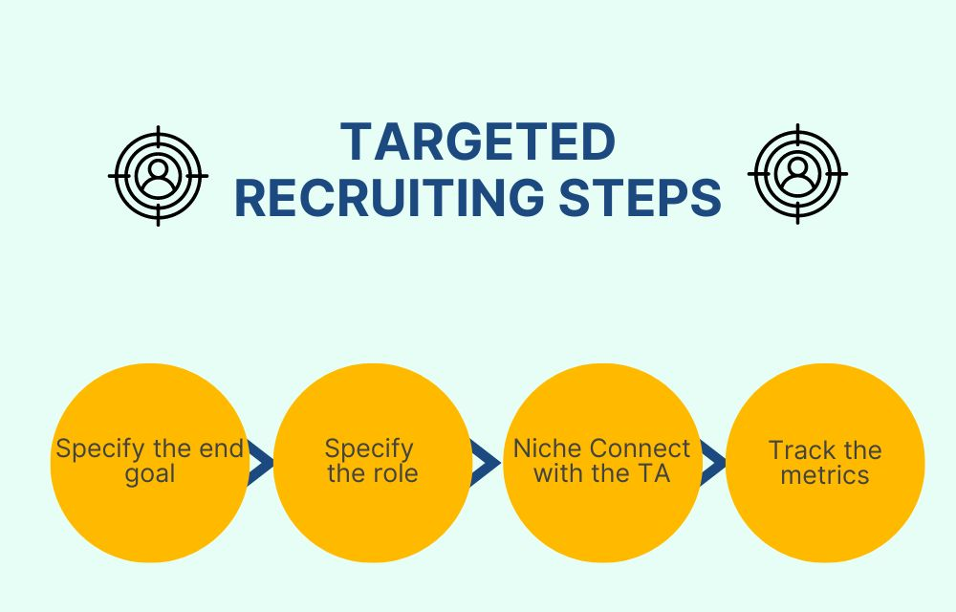
Figure 6: Targeted Recruitment and Retention (Abdel‐Hamid et al., 2022)
With the competitive nature of the London labour market, the hotel needs to take the initiative of attracting and retaining quality housekeeping staff. An increase in recruitment activities must involve participation in local job fairs, online recruitment, and the formation of relationships with the local colleges and training programmes (Abdel‐Hamid et al., 2022). A staff referral bonus will also be introduced to encourage the current employees to refer the right candidates to create a team that is both competent and fits well in the existing culture. There should be an employee recognition and reward system such as that of the employee of the month award, small bonuses or holidays off to reward high performance and dedication.
It is projected that the annual expenditure on such initiatives is between 8000 and 12000 pounds, which includes recruitment activities, referral bonuses, and staff rewards. The improved recruitment and retention shall lead to a more stable, experienced, and motivated housekeeping team that will lead to a decrease in turnover and the recruitment costs (Szende et al., 2021). The decline in vacancy rates, increased staff satisfaction, and a decrease in the overall recruitment costs will be the main success indicators.

4.7 Change Management Strategy
These recommendations will need to be carried out with great attention to change management so that the staff is not only ready but also comfortable with the new modes of work. Change is not always comfortable, and it is natural to resist, so the process should be open and well-organised (Szende et al., 2021). The first one is to explain the causes of the changes in an open and obvious manner. The management is expected to describe how the recommendations will complement the values and strategic goals of the hotel and the direct value to the employees and customers.
This communication must be continuous, and it must make use of staff meetings, electronic communications, and personal communication. The appointment of change champions who are trusted and respected individuals in the team of the Housekeeping Department could help bring the staff closer to the transition and have someone to ask questions and express their concerns to. It is also essential to have active involvement of the staff in the process (Abdel‐Hamid et al., 2022). The management can encourage a feeling of ownership and cooperation by inviting the working force to engage in pilot programmes, comment on the suggested changes, and share their knowledge.
The introduction of new digital systems or processes should be accompanied by special training, which can be held at different levels of knowledge of technology. Continued assistance, such as individual coaching, virtual materials, and peer-to-peer mentoring, must be easily accessible, especially at the transition period. Resistance to change should be handled with a lot of patience and understanding (Szende et al., 2021). The management ought to promote open discussions and anonymous surveys in which the personnel are allowed to air their grievances. As much as possible, valid feedback must be included in the change plan.

5. Action plan
An action plan is attached following:
No | Problem | Solution | Desired Outcome | Time Scale | Completion Date | Planned Budget
1 | Inconsistent housekeeping standards and delays in room turnover. | Establish a digital housekeeping management system and standardise the workflow, incorporating extensive staff training. The introduction of a powerful digital housekeeping management system, the unification of work processes, and the provision of a high level of personnel training are critical steps to maintaining a high level of cleanliness, rapid room turnover, smooth communication within the department, and increasing customer satisfaction Szende et al., 2021). | Enhanced consistency and efficiency in room preparedness, increased guest satisfaction, and a reduction in complaints regarding cleanliness or delays. | 4 months | 31/10/2025 | £38,000 (year 1, including software and training)
2 | Elevated employee turnover and diminished morale. | Initiate continuous training, employee recognition initiatives, and adaptable scheduling; establish staff feedback mechanisms. It is suggested that a constant training program, in addition to staff recognition programs, flexible shift planning, and frequent feedback systems, will reduce turnover, boost morale, increase engagement, and ensure a solid, experienced housekeeping staff (Szende et al., 2021). | Reduced turnover, enhanced morale and engagement, and a more experienced and stable team. | 6 months | 31/12/2025 | £20,000 (annual training, incentives)
3 | Inadequate utilisation of sustainable practices. | Transition to environmentally sustainable cleaning agents and advocate for a linen and towel reuse initiative. The introduction of eco-friendly cleaning products, a guest linen and towel reuse programme and intensive training of the staff in sustainable practices enhance the environmental record of the hotel and save money spent on operations (Abdel‐Hamid et al., 2022). | Improved sustainability reputation, resource cost reductions, favourable guest responses to eco-friendly initiatives. | 2 months (rollout) | 30/09/2025 | £10,000 (initial procurement)
4 | Challenges in recruitment and a deficiency of qualified personnel. | Augment recruitment marketing, initiate referral bonuses, and collaborate with local colleges. Moreover, improved recruitment marketing, referral bonuses for the existing employees, and collaborations with local colleges and training organisations help to attract, hire, and retain talented housekeeping employees, reducing the vacancy rates (Kusuma et al., 2022). | An expanded, more competent applicant pool; diminished vacancy rates and recruitment expenses. | 5 months | 30/11/2025 | £10,000 (recruitment, bonuses)
5 | Inadequate internal communication and restricted feedback. | Implement monthly team meetings, digital suggestion platforms, and transparent feedback mechanisms. Open communication is facilitated by monthly team meetings, the implementation of digital suggestion boxes, and the creation of transparent feedback and follow-up procedures, which raise staff engagement and create a culture of constant improvement in operations (Kusuma et al., 2022). | Enhanced problem-solving, increased employee engagement, and a culture of perpetual improvement. | 1 month (start), ongoing | 31/08/2025 (first review) | £1,000 (digital tools, annual)

6. Conclusion
This consultancy report to the Housekeeping Department of Hilton London Metropole consists of the detailed analysis of the problems which the department experience in its operations, and the possible suggestions on how the operations could be bettered. With the help of the in-depth analysis, it has become obvious that the reputation of the hotel as a place of excellence is now under the threat of a series of interconnected problems, and the most significant ones are the lack of consistency in housekeeping standards, slow room turnover rates, high employee turnover rates, gaps in training, and ineffective use of technological tools. Although not exclusive to a large and busy London hotel, these factors are of special concern to Hilton London Metropole, as it is large, has an international clientele, and has high expectations to meet due to the Hilton brand.
The research showed that operational inefficiencies and discrepancies in the housekeeping department have affected the guest satisfaction scores, particularly the ones that concern cleanliness and room readiness. Feedback systems have existed but have not in all cases turned into actual actions, and employee morale has been low due to high workloads and little appreciation. The report also found that modernisation of work practices by adopting digital management systems and inculcating a culture of sustainability in the day-to-day housekeeping activities was necessary. Competitiveness of the London labour market and continuous demographic changes introduce another level of difficulty, and new approaches to recruitment, training, and retention are required.
The report proposes a definite package of recommendations to overcome these challenges. These are the implementations of a sophisticated digital housekeeping management system to facilitate the ease of task assignment and communication, the installation of a staff training and development programme, and staffing models' re-evaluation and rearrangement to better fit the operational need. Moreover, the efforts to improve the in-house communication, reward and recognise the staff efforts, and implement sustainable housekeeping are given priorities. Active recruitment and retention policies are also given as suggestions to ensure that Hilton London Metropole is competitive in terms of attracting and retaining skilled housekeeping personnel. To every recommendation, a feasible timeframe of implementation, a well-defined result set and a keen pricing issue have been related, making sure that solutions are not only feasible but also reasonable to a property of this magnitude.
In the report, it is stressed that change management will be critical to successful implementation. Employees should be involved, educated, and assisted in the transition and should have clear channels of communication, frequent chances to give feedback and effective training programmes. An organised process for monitoring and evaluating success – based on key performance indicators like guest satisfaction scores, staff retention rates and operation measures – will make sure that progress is monitored and corrections are done where needed.
Lastly, I would also like to take this opportunity to express my sincere gratitude to the management and staff of Hilton London Metropole for their openness, cooperation and commitment in this consultancy project. I have been honoured to work with a highly committed team, and I am sure that the results and suggestions presented in this report will become a great asset for future reference and action. In the event that additional support or follow-up consultancy is needed, AZ Consultancy Firm is at your full disposal, and we are eager to continue working with you in the quest to achieve operational excellence.

References
Abdel‐Hamid, T. A., Ahmed, M. A. E. A. S., Zohry, M. A. F., Elshabrawy, G. A., and Elgohary, E. M. (2022). The role of digital transformation in improving customer satisfaction: An empirical study on Egyptian hotels. The Electronic Journal of Information Systems in Developing Countries, 88(6), e12234.
Alharbi, R., Alshreef, R., Alhashmi, R., Alkhalaf, M., and Elhaj, S. (2025). Improving the Quality of Services and Increasing Customer Satisfaction in the Hotel. In 2025 2nd International Conference on Advanced Innovations in Smart Cities (ICAISC) (pp. 1-6). IEEE.
Al-Hyari, H. S. A., Al-Smadi, H. M., and Weshah, S. R. (2023). The impact of artificial intelligence (AI) on guest satisfaction in hotel management: An empirical study of luxury hotels. Geo Journal of Tourism and Geosites, 48, 810-819.
Ali, B. J., Gardi, B., Othman, B. J., Ahmed, S. A., Ismael, N. B., Hamza, P. A., ... and Anwar, G. (2021). Hotel service quality: The impact of service quality on customer satisfaction in hospitality. International Journal of Engineering, Business and Management, 5(3), 14-28.
Anwar, F. A., Deliana, D., and Suyamto, S. (2024). Digital Transformation in the Hospitality Industry: Improving Efficiency and Guest Experience. International Journal of Management Science and Information Technology, 4(2), 428-437.
Arceta, N. R., Montero, M. C., and Quilitis, J. E. P. (2022). International Journal of Tourism and Hospitality.
Au-Yong, C. P., Hoh, P. K., and Amos, D. (2024). Enhancing the Maintenance Practice to Improve Guests’ Satisfaction in the Hotels Industry. Built Environment Journal, 21(1), 18-29.
Baquero, A. (2022). Customer and employee satisfaction in hotels. Journal of Hospitality and Tourism Issues, 4(2), 69-83.
Bardukova, L. (2023). Navigating the hospitality horizon: current trends and strategies for customer attraction and retention in the hotel industry. Economics and computer science, 2, 88-103.
Barlan-Espino, A. G. (2017). Operational efficiency and customer satisfaction of restaurants: Basis for business operation enhancement. Asia Pacific Journal of Multidisciplinary Research, 5(1), 122-132.
Bhatnagar, E., and Nim, D. (2019). Impact of housekeeping services and practices on customer satisfaction and repeat business. Prabandhan: Indian Journal of Management, 12(8), 46-57.
Burnes, B. (2014) 4th Edition, Managing Change, Great Britain, Prentice Hall.
Buttrick, R. (2009) The Project Workout, London: Prentice Hall
Cesarotti, V., and Spada, C. (2009). A systemic approach to achieve operational excellence in hotel services. International Journal of Quality and Service Sciences, 1(1), 51-66.
Chatterjee, P. (2022). Role of Housekeeping Cleaning Equipment and Agent in the world of Hospitality Industry. International Journal of Research Publication and Reviews, 3(8), 1642-1646.
Choy, M., Cheng, J., and Yu, K. (2021). Evaluating the environmental sustainability strategies of the housekeeping department: the case of an international hotel chain in Hong Kong, China. Tourism Critiques: Practice and Theory, 2(1), 115-132.
Cobanoglu, C., Dogan, S., Berezina, K., Collins, G., Nanu, L., Shahtakhtinskaya, K., and Parvez, O. (2021). Hospitality and tourism information technology. University of South Florida M3 Center Publishing, 17(9781732127593), 2.
Colaco Mr, L. (2024). The Impact of Soft Skills Training on Guest Satisfaction in the Hospitality Industry.
Dar, H., Kamal, M., Tanahy, E., and Salem, D. (2021). Offshore Vessels employees' perception of Housekeeping Service: Impact on Job Satisfaction and Productivity. The Scientific Journal of the Faculty of Tourism and Hotels, Alexandria University, 18(2), 181-201.
Dodu, S. P., Zamfir, M. M. I., and Ile, F. L. (2021). The Fast Forward Reshape Of The Hospitality Industry In Times Of Global Crisis: A Hilton Hotels'perspective. Romanian Economic and Business Review, 16(2), 106-115.
Gajić, T., Petrović, M. D., Pešić, A. M., Conić, M., and Gligorijević, N. (2024). Innovative Approaches in Hotel Management: Integrating Artificial Intelligence (AI) and the Internet of Things (IoT) to Enhance Operational Efficiency and Sustainability. Sustainability, 16(17), 7279.
Garg, S., Srivastava, S. P., Malhotra, R. K., and Sharma, R. (2025). Sustainable Integration of Robotic Services in the Hospitality Industry: Enhancing Operational Efficiency and Employee Satisfaction. In 2025 International Conference on Intelligent Control, Computing and Communications (IC3) (pp. 1377-1381). IEEE.
Ghosh, M. (2023). Analysing IoT automation facilities in hotel rooms: Enhancing guest experience and operational efficiency. Rajasthali Journal, 2(4), 54-60.
Gubhaju, P., Panta, P., and Ahn, J. (2024). AI-driven linen inspection: enhancing efficiency and guest satisfaction in hotel industry. Multimedia Tools and Applications, 1-17.
Gundersen, M. G., Heide, M., and Olsson, U. H. (1996). Hotel guest satisfaction among business travelers: what are the important factors?. Cornell hotel and restaurant administration quarterly, 37(2), 72-81.
Hassan, S. A., and Eassa, A. M. (2025). SHMIS: An integrated IoT context awareness framework for hotel management to enhance guest experience and operational efficiency. Information Technology and Tourism, 1-34.
Hilton London Metropole (2025). About Hilton London Metropole. Available at: https://www.hilton.com/en/hotels/lonmetw-hilton-london-metropole/. [Accessed on: 17th June, 2025].
Intiar, S., Rahayu, E., Prabowo, B. A., and Yuliamir, H. (2024). Maximizing Guest Satisfaction and Financial Benefits: An Integrated Approach in Wimarion Hotel Management. Indonesian Journal of Economics and Management, 5(1), 30-38.
Jogarao, M. (2024). AI in the Hospitality Industry: Revolutionizing Guest Experience. In Technology and Luxury Hospitality (pp. 199-210). Routledge.
Johnson, J. (2023). The Impact of AI-Powered Technologies on Customer Satisfaction and Operational Efficiency in the Hospitality Industry.
Khalil, N., Che Abdullah, S. N., Haron, S. N., and Hamid, M. Y. (2024). A review of green practices and initiatives from stakeholder’s perspectives towards sustainable hotel operations and performance impact. Journal of Facilities Management, 22(4), 653-682.
Kim, C., and Chung, K. (2022). Measuring customer satisfaction and hotel efficiency analysis: An approach based on data envelopment analysis. Cornell Hospitality Quarterly, 63(2), 257-266.
Kumari, M., Kumar, S., and Devi, N. (2025). The Impact of Service Automation and Robotics on Hospitality Business Models. In Metaverse and Sustainable Business Models in SMEs (pp. 317-338). IGI Global Scientific Publishing.
Kusuma, I., Antara, D. M. S., and Murni, N. G. N. S. (2022). The Implementation of Green Housekeeping to Increase Efficiency of Operational Cost of Housekeeping Department at Holiday Resort Lombok.
Lai, T. C., Liu, H. L., Wu, R., and Wu, C. (2023). Examination of Operational Strategy of International Tourist Hotels. International Journal of Social Sciences, 4(2).
M’hamed, E. G., and Idrissi, R. E. (2024, April). Transforming Hospitality: Harnessing Artificial Intelligence for Enhanced Guest Experience and Operational Efficiency. In The International Workshop on Big Data and Business Intelligence (pp. 173-185). Cham: Springer Nature Switzerland.
Mandić, D., Panić, A., and Šain, M. Č. (2023). Automated service delivery in hotels: balancing efficiency and human interaction for optimal guest satisfaction. In International Scientific Conference on Economy, Management and Information Technologies (Vol. 1, No. 1, pp. 167-174).
Manoharan, G., and Ashtikar, S. P. (2025). AI Era in Hospitality: The New Frontier in Guest Satisfaction and Operations. In Digital Disruption in Hospitality, AI, and Emerging Technologies: A Roadmap to Personalized Experiences, Enhanced Operations, and Revenue Growth (pp. 59-77). Emerald Publishing Limited.
Moreno-Perdigon, M. C., Guzman-Perez, B., and Mesa, T. R. (2021). Guest satisfaction in independent and affiliated to chain hotels. International Journal of Hospitality Management, 94, 102812.
Nazari, N., Abd Rahman, A., Ab Aziz, Y. B., and Hashim, H. (2020). The effect of customer satisfaction on the performance of the small an medium-sized hotels. Tourism and hospitality management, 26(1), 69-96.
Neog, R. (2021). New Hotel Cleaning Procedures After COVID-19-A Study of New Housekeeping Practices in Hotels. Atithya: A Journal of Hospitality, 7(2), 1-7.
Noordzife, G. (2014) Project Management of Hotel Opening Processes: Exploring Better Ways to Manage New Hotel Openings, CreateSpace
Ollor, H. Y., and Essien, S. S. (2022). Service Processes and Guest Satisfaction in the Hotel Industry in Uyo, Akwa Ibom State. African Journal of Management and Business Research, 4(1), 19-40.
Özdemir, A. İ., Çolak, A., and Shmilli, J. (2019). Business process management in hotels: with a focus on delivering quality guest service. Quality and Quantity, 53(5), 2305-2322.
Parvez, M. O., Eluwole, K. K., Lasisi, T. T., and Kim, W. G. (2025). GenAI in hotel operations: ChatGPT adoption among front-office employees. Current Issues in Tourism, 1-15.
Putra, R. S., Wendri, I., and Sudiarta, I. (2022). Implementation of Green Practices by Front Office Department Staff in Improving Service Quality at Hilton Bali Resort. Repositori Politeknik Negeri Bali.
Semwal, R., Yadav, S. A., Madhav, R. C., Sharma, S., and Srivastava, P. (2023). Enhancing Guest Experience and Operations Efficiency in Homestays Through Artificial Intelligence: A Conceptual Framework. In 2023 6th International Conference on Contemporary Computing and Informatics (IC3I) (Vol. 6, pp. 2163-2169). IEEE.
Sharma, V., Bideshi, R. K., and Bajpai, S. (2023). Impact of Sustainable Housekeeping Practices on Environmental Stewardship and Operational Efficiency in the Hotel Industry.
Sheoran, M. (2025). Hospitality Industry: Insights and Perspectives. Educohack Press.
Singgalen, Y. A. (2024). Hotel Customer Satisfaction: A Comprehensive Analysis of Perceived Cleanliness, Location, Service, and Value. Journal of Business and Economics Research (JBE), 5(3), 352-369.
Sirirak, S., Islam, N., and Ba Khang, D. (2021). Does ICT adoption enhance hotel performance?. Journal of Hospitality and Tourism Technology, 2(1), 34-49.
Srivastava, P., and Tyagi, P. K. (2024). Implications of AI in Hotel Housekeeping Operations. In Hotel and Travel Management in the AI Era (pp. 337-356). IGI Global.
Szende, P., Dalton, A. N., and Yoo, M. (Eds.). (2021). Operations management in the hospitality industry. Emerald Publishing Limited.
Thoriq, N., Intiar, S., Jabbar, U. A., Aryaningtyas, A. T., and Aswan, M. K. (2024). The Future Of Hotel Housekeeping: New Trends And Modern Approaches. MSJ: Majority Science Journal, 2(3), 61-67.
Thoriq, N., Intiar, S., Jabbar, U. A., Maryani, T., Aryaningtyas, A. T., and Risyanti, Y. D. (2024). Performance Review of Housekeeping Room Attendant in Hotel Puri Garden Semarang. MSJ: Majority Science Journal, 2(3), 78-84.
Tiwari, A., Singh, M., and Dahiya, A. (2022, March). A study on the effect of Technological Innovation on Outsourcing in the Hotel Housekeeping Department. In 2022 International Mobile and Embedded Technology Conference (MECON) (pp. 37-40). IEEE.
Truong, N., Dang-Pham, D., McClelland, R., and Nkhoma, M. (2020). Exploring the impact of innovativeness of hospitality service operation on customer satisfaction. Operations and Supply Chain Management: An International Journal, 13(3), 307-319.
Whittington, R. et al (2020) Exploring Strategy. Harlow: Pearson Education Limited.
Widiastini, N. M. A., Santiara, I. M., and Rahmawati, P. I. (2024). Analysis Operational Efficiency Strategy and Improvement of Hotel Housekeeping Communication System. Jurnal Manajemen Pelayanan Hotel, 8(2), 338-353.
Wilson, O. (2025). Enhancing Operational Efficiency and Guest Satisfaction in Hotel Management: A Strategic Approach. OTS Canadian Journal, 4(5), 72-81.
Yadav, N., and Raju, S. S. (2025). Smart Hotel Technologies Redefining Guest Convenience and Operational Efficiency. In Marketing Technology-Infused Hospitality: Upskilling Frontline Employees for Competitiveness (pp. 25-56). IGI Global Scientific Publishing.
Zaman, M., Botti, L., and Vo Thanh, T. (2016). Does managerial efficiency relate to customer satisfaction? The case of Parisian boutique hotels. International Journal of Culture, Tourism and Hospitality Research, 10(4), 455-470.
Zemlina, Y., Peresichna, S. V. I. T. L. A. N. A., Oliinyk, O. K. S. A. N. A., Krasovskyi, S., and Vasylenko, O. (2023). Ensuring the efficiency of service, technology, and management processes in the hotel and restaurant business. WSEAS Transactions on Environment and Development, 19, 1132-1144.
Zhang, Y. C., Zemke, D. M., Belarmino, A., and Shum, C. (2024). Comparing the antecedents of manager’s and employee’s job satisfaction in the housekeeping department. International Hospitality Review.
Zhou, B., Tian, T., and Hon, A. (2025). The Impact of Intelligent Services on Customer Satisfaction in the China Hotel Industry. Journal of China Tourism Research, 1-26.

