Community Engagement 1
Assessment 1
Part A: Analysing the best practices of community engagement in a project/business environment
Student name: Nicoleta-Claudia Jeculescu
Student ID: 2011088
Lecturer’s Name: Dr Molly Jack
Module code: LCBB4002

Executive Summary
The reports highlighted that Jaguar has been using social media platforms for improving community engagement with the customers. In addition to this, the organisation has also utilised social media platform to communicate its products and services to the customers so that they become aware of the services. In this context, it is essential that the employees of the organisation must be trained such that they became aware of the diverse socio-cultural issues and utilise their skills to resolve the issue.
Table of Contents
1.0 Introduction 4
2.0 Analysis of the project/organisation’s best practices particularly on community engagement and stakeholder’s participation 4
2.1. Identify and establish the sort of relationship they have with the stakeholders and how they engaged with them (social media platforms). 4
2.2 Evaluate the different eras of the Organisation and highlight how their community engagement has evolved, explaining the range of skills, knowledge and strategies employees require to carry out their jobs effectively and efficiently. 6
2.3 Detailed narrative of how they use different social media platforms as an outreach to support the programme/ business 8
2.4 Explain the training and development required to equip employees in dealing with socio-cultural issues within society. 10
3.0 Conclusion 11
4.0 Reference List 12

1.0 Introduction
Community engagement is the process that involves collaborative working with them through groups of people that are affiliated by geographic proximity, a special interest for a similar situation (Kumar and Kumar, 2020). This collaborative working helps in addressing the issues that are affecting the well-being of the involved group of people. Analysing the best practices of community engagement and stakeholder’s participation, an automobile company that is Jaguar will be considered. Jaguar is a luxury vehicle brand having its headquarters at Whitley Coventry England. The origin of the business dates to 1922 and was founded by Swallow Sidecar Company. In addition to this, the way Jaguar has been utilising social media platform for outreaching to support the business will also be discussed. Lastly, address provide based requirements along with the equipment used by Jaguar for dealing with the socio-cultural issues. The business organisation has rendered significant benefits to society by providing them with different vehicles that can be used for transportation. In addition to this, Jaguar has also developed sustainable practices like utilisation of solar energy and energy-efficient vehicles that would have a less negative impact on society.

2.0 Analysis of the project/organisation’s best practices particularly on community engagement and stakeholder’s participation

2.1. Identify and establish the sort of relationship they have with the stakeholders and how they engaged with them (social media platforms).
According to the study carried out by Butt et al. (2016), a stakeholder is a party which has an interest in the organisation and can either affect the operations of the organisation or get affected by the business. The potential stakeholders of Jaguar include their investors, employees’ customers, and suppliers. In addition to this, the government is also an important stakeholder as the organisation needs to abide by the rules and regulations and force by the accounting bodies. The organisation intends to maintain a healthy relationship with all its stakeholders such that a mutualistic relationship could be maintained. In this context, the organisation has developed certain organisational policies concerning the suppliers so that a sustainable operation could be carried out.
According to the study carried out by Hussein and Al-Qaysi (2019), the success of an organisation depends on the supply chain relationship that has been maintained by the organisation. In this context, Jaguar not only conducts a regular meeting with suppliers but also renders support to them during the struggling faces. In this regard, the organisation also helps the suppliers to diagnose the issue so that effective strategies could be implemented for overcoming them. This in turn had led the organisation to develop a healthy relationship with all the suppliers. This has been one of the major reason due to which the organisation had won best supplier relationship management in the CPIS supply management awards (Green, 2017).
On the other hand, the organisation has also maintained a healthy relationship with the employees by implementing various policies such as performance management system and so on that could help in motivating employees. This has been one of the major reasons for the establishment of a healthy relationship with the employees of the organisation. The organisation has carried out both formal and informal meetings with employees for reaching to them are communicating with them.
The study carried out by Perez and del Bosque (2016) revealed that customers are the most important stakeholders of the business as they are affected both by the quality of the products and services along with the value of the organisation. Jaguar had developed various strategies so that it could maintain a good relationship with its customer and engage them throughout the process. In this context, the organisation had utilised social media platforms for engaging with the customers. As per the study conducted by Tripopsakul (2018), digitalisation has led to the development of a social media platform. This platform has let people across the globe to get connected with the organisation. Moreover, Jaguar also updates its messages as well as products on this platform. In addition to this, customers also get the opportunity to leave comments regarding their experiences. Thus, it has turned out to be one of the major platforms that help in augmenting customer engagement for the business organisation like Jaguar. In addition to this, Twitter is another vital social media platform that helps the organisation to maintain real-time communication with the customers.
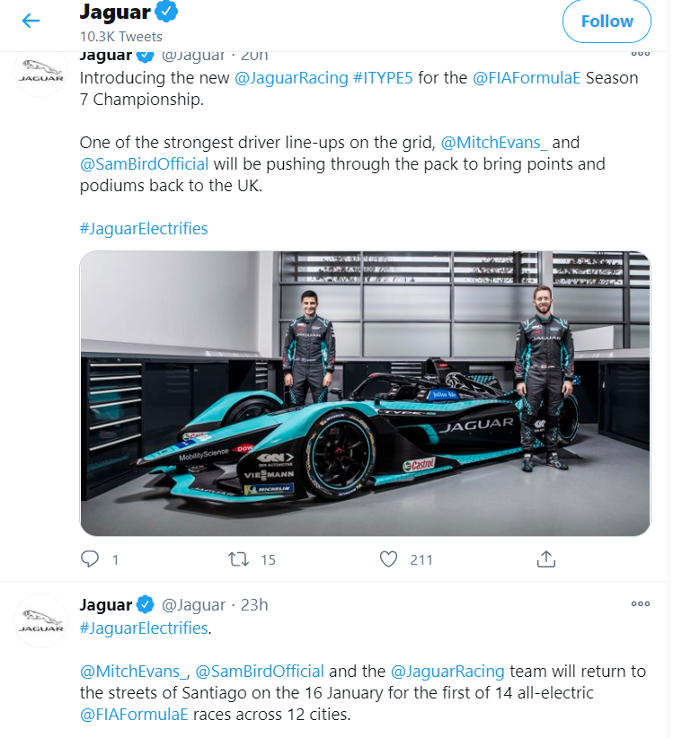
Figure: Twitter page of Jaguar
(Source: Twitter, 2020)

2.2 Evaluate the different eras of the Organisation and highlight how their community engagement has evolved, explaining the range of skills, knowledge and strategies employees require to carry out their jobs effectively and efficiently.
Jaguar has a long history of manufacturing automobiles. In this context, the first car that was developed by the organisation was in 1935 and was named as SS Jaguar 2.51 Saloon. Thereafter, in 1948 Jaguar first car that is William Lyons XK120 became an icon. Followed by this, in 1951 the organisation had developed pure breed Racer referred to as C-type. Thereafter in 1951, the D-type car was produced by the automobile giant Jaguar. Followed by this, the organisation continued nude its journey into the sensational 1960s with E-type, X J and many more (Jaguar, 2020). This course of development of new cars continued throughout the 20th century and in the 21st century, Jaguar had developed XK which is the mark of elegance and redefinition with deft touch. The list of new development did not end in the organisation had continued to redevelop its existing products year after year. This indicated that the employees of the organisation are enriched with innovative and creative skills.
According to the study conducted by Kahn (2018), the success of a business organisation depends on its ability of the employees to innovate its products such that it is able to meet the demand and expectations of the market. With the evolution of the products, a bond between the employees and the employer had also developed by the implementation of diverse strategies and reward systems. Along with this, the organisation has also been able to develop a good engagement with its customer community. This is because with every development the organisation has been able to strengthen its loyal customer base as Expectations of the customers have been met significantly. In addition to this, the employees of the organisation and displayed their analytical and research skills in this respect. Moreover, they have utilised and marketing skills to convey the unique selling proposition of all the models developed by the organisation to the customers in an effective manner.
For instance, in the earlier phase, the organisation utilised different marketing strategies to improve the engagement level with the customers. In this context, the different marketing strategies that had been utilised included print media advertisement, posters on the hoardings, advertisement on the television and many more. With the passage of time, the organisation has further utilised social media marketing strategy so that it could reach to millions of customers across the globe. This indicates that the employees of the organisation Jaguar had utilised both problems solving and analytical skills and has taken advantage of the available market opportunity so that it could strengthen its Bond with its existing customers and render them quality product and services.

2.3 Detailed narrative of how they use different social media platforms as an outreach to support the programme/ business
Social media platforms have become an integral part of all business organisations. These platforms have made a significant and enormous impact on the businesses and their strategies. According to the study conducted by Sivarajah et al. (2020), with the aid of social media platforms like Twitter, Facebook, Instagram, youtube it becomes possible for the business organisation to promote their brand across the globe within a short period of time and in a cost-effective manner. With the aid of social media, it becomes possible for the organisation to reinvent itself on the online platform using social media profiles and sharing of contents.
In addition to this, the study carried out by Baumöl et al. (2016) revealed that social media platforms also play a vital role in providing customer service and in resolving disputes. In this context, Jaguar utilizes platforms like Facebook, Twitter, and YouTube to provide online customer services. This is because on this platform the customers can have a direct conversation with the customer service manager of the organisation. As a result of which, the customers are not only able to state the Complaints but also provide the opportunity to review the products and services that are being provided by the organisation. As a result of which, Jaguar is able to understand the areas of improvements as well as the expectations of the customers that they need to fulfil so that they can further expand their market share. Therefore, the vital skills that are required for the employees to utilise these platforms included interpersonal skills, innovative and creative skills.
Along with this, Jaguar has been utilising these social media platforms for or marketing its products and services so that it can achieve a global reach and improve with sales. In this context, the organisation has been uploading the photos and videos of the vehicle such as New All-Electric Jaguar I-PACE on its social media websites. Along with this, it about out the product and information about the opening of the bookings for the product (Facebook, 2020).
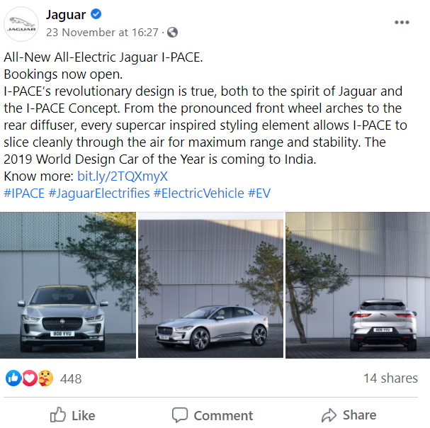
Figure 2: Facebook page of Jaguar
(Source: Jaguar, 2020)
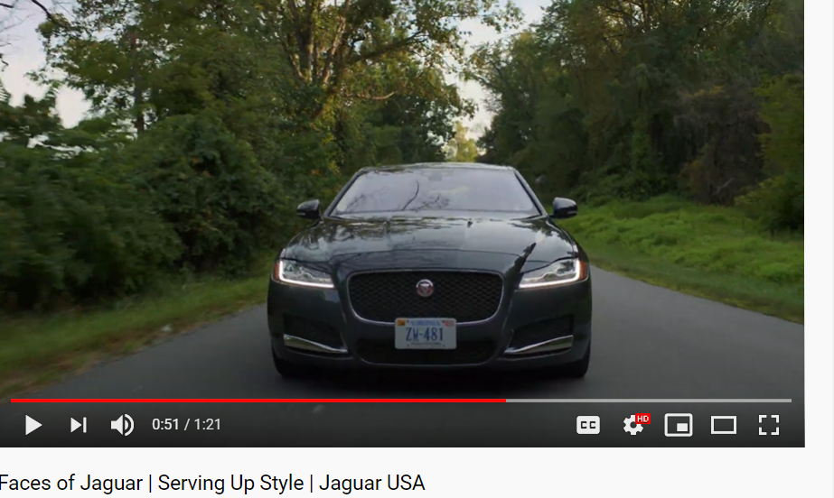
Figure 3: YouTube page of Jaguar
(Source: Jaguar, 2020)

2.4 Explain the training and development required to equip employees in dealing with socio-cultural issues within society.
Every business organisation faces different social-cultural issues. Some of these issues include the difference in the linguistics, discrimination among the employment practices, change in the perceptions of the customers, need for sustainable practices and many more. In this context, it is essential that every organisation like Jaguar must identify these social-cultural issues that would hinder their journey of progress (Nosratabadi et al., 2019). In addition to this, it is also essential that the organisation must provide training to the employees so that they can effectively make strategies that would help in overcoming the issues and let the organisation gain a competitive edge in the market.
In this context, the organisation needs to provide a learning environment for the Employees so that they can develop their skills. These skills are essential for the organisation as with the aid of these skills only it would be possible for Jaguar to overcome the issues utilising them analytical capacities and problem-solving skills of the employees. In addition to this, it is also vital that Jaguar need to adopt a forward-looking approach so that they are able to train those employees on multiculturalism. According to the study conducted by Awang et al. (2020), for a global organisation like Jaguar, it is essential that it should be aware of the different cultures of the different nation so that it could be utilised for developing effective strategies. In addition to this, these cultures are one of the most important external factors that need to be considered by a business organisation for developing a sustainable relationship with the network partners of those cultures. In this respect, the study conducted by Cramer (2017), revealed that globalisation is one of the drivers of territory-less businesses. Therefore, the employees of the organisation not on,y should have effective knowledge about the laws and policies but must also have adequate knowledge about the culture.
According to the theoretical underpinning of Madhani (2017), the forward-looking approach is also referred to as a competency approach to human resource management. This approach is based on identifying, defining along with measuring the individual differences prevailing within the organisation in terms of their abilities which are crucial to accomplish the job successfully. Along with this, it would be possible for the organisation to meet the changes that have occurred in the business environment.

3.0 Conclusion
The success of a business organisation depends on various factors. One such crucial factor that has been identified in the above discussion is community engagement. In this context, it is vital that the organisation must create a learning environment within the organisation so that the employees of the organisations are able to learn the diverse cultures that would help the organisation to improve the community engagement. In addition to this, social media has turned out to be one of the essential platforms that have helped the organisation to reach to the consumers within a short period of time.
Recommendation
- Jaguar needs to conduct frequent training sessions so that the employees of the organisations are able to develop new skills that would help the organisation to effectively assess the market and develop further new Strategies for gaining competitive advantage in the market.
- For teaching about multiculturalism, it would be vital for the organisation to include the employees belonging to different culture so that all the employees become aware of the diversity.

4.0 Reference List
Awang, F., Tabibzadeh, K. and Zhuang, W., 2020, March. Diversity, Multiculturalism, and Inclusivity: The Samurai Way. In ARBS 2020 Proceedings 7th Annual Conference March 26-27, 2020 Eastern Kentucky University Richmond, KY (Vol. 2, p. 6).
Baumöl, U., Hollebeek, L. and Jung, R., 2016. Dynamics of customer interaction on social media platforms. Electronic Markets, 26(3), pp.199-202.
Butt, A., Naaranoja, M. and Savolainen, J., 2016. Project change stakeholder communication. International Journal of Project Management, 34(8), pp.1579-1595.
Cramer, J., 2017. Corporate Social Responsibility and Globalisation: an action plan for business. Routledge.
Facebook, 2020. Jaguar. Available at: https://www.facebook.com/JaguarIndia/?brand_redir=10159835879 (Accessed: 28 November 2020).
Green, W., 2017. Jaguar Land Rover's success is all about collaboration (2020). Available at: https://www.cips.org/supply-management/news/2017/september/jaguar-land-rovers-success-is-all-about-collaboration/ (Accessed: 28 November 2020).
Hussein, H.A. and Al-Qaysi, B.J., 2019. Relationship Marketing and Supply Chain policy in Enhancing the Customer Value in the Telecommunication Sector. Int. J Sup. Chain. Mgt Vol, 8(1), p.840.
Jaguar, 2020. 80 years of Jaguar 1960–1996. Available at: https://www.jaguar.com/about-jaguar/80-years-of-jaguar/80-years-of-jaguar-part-2.html (Accessed: 28 November 2020).
Jaguar, 2020. Faces of Jaguar. Available at: https://www.youtube.com/watch?v=22NS2TkgniU (Accessed: 28 November 2020).
Kahn, K.B., 2018. Understanding innovation. Business Horizons, 61(3), pp.453-460.
Kumar, J. and Kumar, V., 2020. Drivers of brand community engagement. Journal of Retailing and Consumer Services, 54, p.101949.
Madhani, P.M., 2017. A salesperson’s future value and training needs: A model-driven approach. World at Work Journal, 26(1), pp.38-48.
Nosratabadi, S., Mosavi, A., Shamshirband, S., Kazimieras Zavadskas, E., Rakotonirainy, A. and Chau, K.W., 2019. Sustainable business models: A review. Sustainability, 11(6), p.1663.
Perez, A. and del Bosque, I.R., 2016. The stakeholder management theory of CSR. International Journal of Bank Marketing.
Sivarajah, U., Irani, Z., Gupta, S. and Mahroof, K., 2020. Role of big data and social media analytics for business to business sustainability: A participatory web context. Industrial Marketing Management, 86, pp.163-179.
Tripopsakul, S., 2018. Social media adoption as a business platform: an integrated TAM-TOE framework. Polish Journal of Management Studies, 18(2), pp.350-362.

