Ewa Kazimierska

ACDB4011: TITRATION

Table of Contents
1 Introduction 3
2 Results 3
3 Discussion 3
4 Conclusion 3
5 References 5
6 Appendix – Methodology 5
6.1 Chemicals: 5
6.2 Equipment 5
6.3 Methodology 6

Table of Figures
Figure 1: difference in phenolphthalein colour following titration [2] 2

Table of Equations
HCl (aq) + NaOH (aq) NaCl (aq) + $H2$0 (l) Equation 1 1
$Molarity= Moles of solute (mol)Litres of solution (L)$ Equation 2: Molarity 1
Equation 3: Moles Calculation 2

Introduction

The purpose of this experiment was to determine the concentration of Hydrochloric acid (HCl) in an unknown sample required to neutralise standard solution of Sodium hydroxide (NaOH) in the process of titration. This is known as a neutralise reaction because the products which are produced are neutral as displayed in [Equation 1].

HCl (aq) + NaOH (aq) NaCl (aq) + $H_{2}$0 (l) Equation 1

It is hypothesised that by ensuring the equivalence point is reached, the concentration of the hydrochloric acid (HCl) can be determined by a visible colour change due to the indicator which is used to establish the end point of the reaction.
Some of the variables of this reactions include ensuring that there is enough of the standard solution (NaOH) which has a known concentration to allow the accurately. The volume of the acid will be recorded as this will then be used to calculate the moles of the solution. The molarity of the acid can be calculated by using the volume of the base required for neutralisation, which allows the moles of HCl to be determined, based on the stoichiometry of the balanced reaction.[1]

$Molarity= \frac{Moles of solute (mol)}{Litres of solution (L)}$ Equation 2: Molarity

Results
Three titrations were conducted as outlined in the methodology in appendix 1 and have been displayed in table 1. By establishing the volume of NaOH titrated from the burette into the conical flask containing HCl caused the solution to change colour from colourless to pink, indicating the equivalence point [Figure 1].
  - Table one
Flask | 1 rough titration | 2 | 3
V HCL (ML) | 25 | 25 | 25
Initial burette reading | 0 | 16.61 | 26.89
Final burette reading | 16.61 | 33.24 | 43.41
V NaOH (ML) | 16.61 | 16.60 | 16.52
Moles of NaOH | 0.01657 | 0.01656 | 0.01648
Moles of HCL | 0.01657 | 0.01656 | 0.0.1648
Molarity of HCL  Mol/Litre | 0.066 | 0.064 | 0.065

The patterns which were identified in the titration was that when approaching the equivalence point there is a very small volume of NaOH required to neutralise the solution. This could cause you to over titrate the solution giving you a deep pink colour opposed to a faint pink. When the solution was titrated with 16ml of NaOH the colour of the solution began to change however, when this was mixed the colour dissipated thus requiring more NaOH to be added to the solution and depending on the droplet size and how much the tap of the burette was opened meant overshooting the equivalence point of the neutralisation.
The Key finding was establishing the volume of a known concentration of NaOH required to fully neutralise HCl allowing the Molarity and the moles of both chemicals to be determined. To be able to calculate the molarity, the moles used first needs to be determined- this is done by multiplying the concentration of the base solution and the volume:
Concentration x volume = Moles Equation 3: Moles Calculation
- 0.09977 x 0.01661 = 0.00165 mol
- 0.09977 x 0.001660 = 0.001656 mol
- 0.09977 x 0.001652 = 0.001652 mol
The equation for molarity [Equation 2] can be solved for the moles of the solute by writing it as shown below.
$$M_{A}V_{A}= M_{B}V_{B}$$
$$M_{A}=\frac{M_{B}V_{B }}{V_{A}} mol/litre$$
$$M_{A}=concentration of HCl$$
$$V_{A}=Volume of HCl$$
$$M_{B}=Molartiy of base ( NaOH)$$
$$V_{B}=Volume of base \left(NaOH\right)$$

This equation can then be used to determine the molarity is equal to the moles of the solute multiplied by the volume as shown for each titration below. The moles of NaOH which was found from multiplying the concentration and the volume are then used to calculate the molarity of HCl using [Equation 2] as seen from the balance chemical equation there is an number of moles there is a 1:1 ratio.
- $M_{A}= \frac{0.09977 x 0.01661}{0.025}=0.066 mol/litre$
- $M_{A}= \frac{0.09977 x 0.0160}{0.025}=0.064 mol/litre$
- $M_{A}= \frac{0.09977 x 0.01652}{0.025}=0.065 mol/litre$

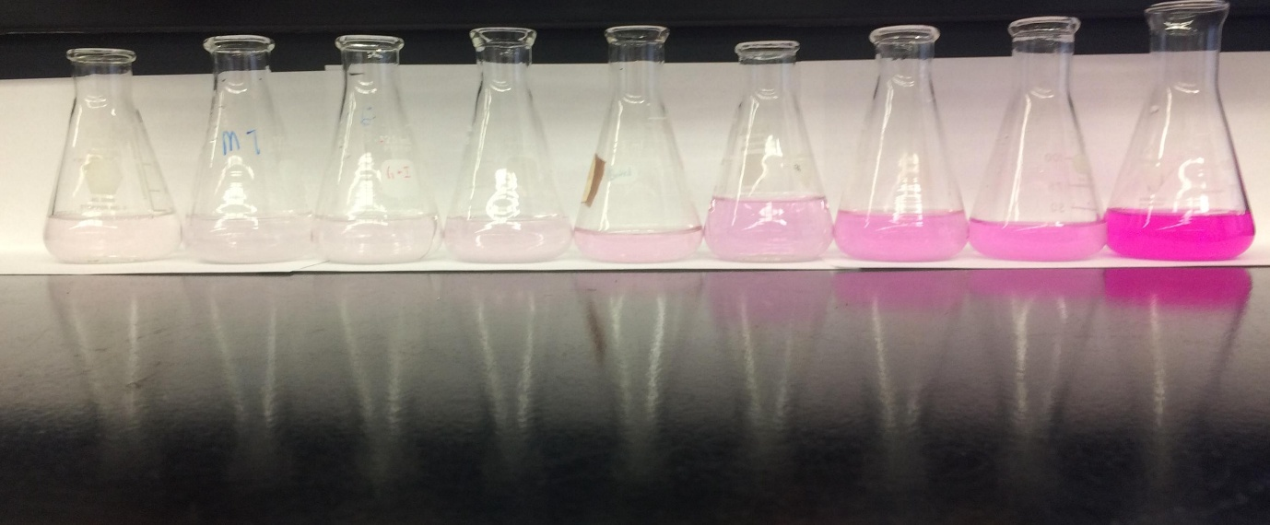

Figure 1: difference in phenolphthalein colour following titration [2]

Discussion

This is experiment is relevant to OME has the method of titration can be used to determine the concentration of nitric acid used for form nitrocellulose. This is a highly flammable substance which is made from cellulose being treated with highly concentrated nitric acid [3]. Gun cotton can be formed by pure nitric acid or from a mixture of sulphuric acid and nitric acid and this was done to increase the weight of the gun cotton [4]. This material was used to replace gun powder as a propellant for munitions a low order explosive, this means that the decomposition is propagated through deflagration.[4] Due to the acids being in a mixture, the process of a titration is important to accurately determine the concentration of the acids, to ensure the formulation of the explosive will possess the desired characteristics for the propellant and also ensure that the explosive will be consistent.
Some of the limitations of this experiment relate to the accuracy of the precision of measurements. Even though the precision of the glassware (burette and pipette) is $±0.05 Ml$ this means that the readings are only accurate to this point. Additionally, inaccuracies in reading the volumes from the glassware due to human error, such as misreading the burette or pipette; could introduce small errors in the volume measurements, leading to slight inaccuracies in the calculated concentration of HCl. Another limitation of this process is effectively determining the end point (equivalence point) of the reaction, as the colour change as shown in figure 1 is very slight and requires the apparatus to be used very carefully to ensure the most accurate volume of NaOH is used. Another area of limitation is identifying and converting the measurements for volume from millilitres to litres to allow for the accurate calculations.

Conclusion

This titration was used to determine the concentration of HCl by following the titration process using a NaOH standard solution. When the equivalence point was reached as indicated by the colour change of the indicator phenolphthalein, and the volume of NaOH required to neutralise the HCl was then recorded. The molarity of the HCl was then calculated by using the known concentration and volume of NaOH- it was calculated that the average molarity of 0.065 mol/L for HCL. This type of experimental technique is effective at determining the concentration of an unknown acid- the limitations of this technique are due to precision inaccuracies due to the glassware and human error. The results gathered supports the hypothesis which suggests the equivalence point can be used to calculate the molarity. When conducting experiments, the use of more precise equipment and techniques to minimise the human error which would allow for more accurate determination of the equivalence point.

References

[1]
A. Raviolo, A. S. Farré, and N. T. Schroh, “Students’ understanding of molar concentration,” Chemistry Education Research and Practice, vol. 22, no. 2, pp. 486–497, Apr. 2021, doi: https://doi.org/10.1039/D0RP00344A.
[2]
S. Schmidt, “Classic acid and base titration in pink,” Chem13 News Magazine, Dec. 03, 2018. https://uwaterloo.ca/chem13-news-magazine/december-2018-january-2019/feature/classic-acid-and-base-titration-pink
[3]
R. Rennie and J. Law, A Dictionary of Chemistry, 8th ed. Oxford University Press, 2016.
[4]
F. A. Abel, “XIV. Researches on gun-cotton.—On the manufacture and composition of gun-cotton,” Philosophical Transactions of the Royal Society of London, vol. 156, pp. 269–308, Dec. 1866, doi: https://doi.org/10.1098/rstl.1866.0014.

Appendix – Methodology

Chemicals:
- 100 mL of standard NaOH solution 0.09977 mol/litre
- 100ml of HCL solution – unknown concentration
- Phenolphthalein indictor

Equipment
- Burette 50ml attached to stand with clamp
- Pipette 10ml
- Conical flask 100ml
- Pipette
- Wash bottle with deionised water
- Graduated cylinder 100ml
- White tile to go under the titration flask
- Beaker for waste

Methodology
- Wash the pipette deionised water and a small amount of HCL before then discard washings
- Wash the burette deionised water and a small amount of NaOH before then discard washings
- Wash the conical flask with small amount of deionised water
- Use the funnel and fill the burette with the standard NaOH solution- run some of the solution through the tap until bottom of meniscus is at zero ensuring there are no bubbles trapped
- Using the pipette place 25mk of HCL into three conical flasks
- Add 3-4 drops of the phenolphthalein indicator to each conical flask and swirl then add 10ml of deionised water using graduated cylinder
- Using tap of burette run the NaOH solution in one of the conical flasks, mixing until the solution changes colour from colourless to pink. This step is used as a rough titration to estimate the volume of NaOH needed to neutralise the measure volume of HCl. Record the final reading.
- Repeat the above step for the next sample of HCl however when the volume is within 2ml of the rough titration rune the base at a slower rate (dripping slowly and shaking the solution in the flask) so you can read the volume of NaOH to neutralise the solution. Record the volume used.
- Repeat the steps until two volumes of NaOH solution differ by no more than 0.10ml for the same volume of HCl.



