

The use of e-learning tools in developing interactive learning experiences
by
Greg Rees

Supervisor: Dr. Nik Whitehead
Second Marker: Beverley Holland

Project submitted as part of the requirements for the award of MSc. Applied Computing

January 2022
DECLARATION

I, Greg Rees, declare that I am the sole author of this Project; that all references cited have been consulted; that I have conducted all work of which this is a record, and that the finished work lies within the prescribed word limits.

This work has not previously been accepted as part of any other degree submission.

Signed : G S Rees

Date : 7th January 2022

FORM OF CONSENT

I, Greg Rees, hereby consent that my Project, submitted in candidature for the M.Sc. Applied Computing degree, if successful, may be made available for inter-library loan or photocopying (subject to the law of copyright), and that the title and abstract may be made available to outside organisations.

Signed : G S Rees

Date : 7th January 2022

Contents
Abstract 8
1. Introduction 9
1.1 Project Objectives 9
2. Literature Review 11
2.1 Background of online and distance learning 11
2.2 Understanding different terms to describe online learning 12
2.3 Types of e-learning platforms and tools 13
2.4 Statistics and trends for e-learning 16
2.5 Advantages and disadvantages of e-learning 18
2.6 Technology that enables facilitation of e-learning 19
2.7 Primary factors affecting choice of authoring tools to use 20
2.8 Additional factors affecting the choice of tools to use 21
2.9 Best practice for delivering e-learning 23
2.10 Barriers of adoption of e-learning 26
2.11 The move to e-learning 27
2.12 Microsoft PowerPoint as an e-learning authoring tool 33
2.13 Proprietary and open-source e-learning authoring tools 35
2.14 Conclusion 38
3. Research Methodology 40
3.1 Philosophy 40
3.2 Strategy 40
3.3 Approaches 41
3.4 Risks & Limitations 42
3.5 Data Evaluation 42
3.6 Deliverables 44
3.7 Resources required 44
3.8 Time plan 45
4. Requirements, Design, and Implementation 46
4.1 Initial research 46
4.2 Project redirection 51
4.3 iSpring Suite 51
4.4 Most common tools used by teachers in PowerPoint 53
4.5 Identifying the requirements using the MoSCoW method 54
4.6 Incorporating quiz tools into the new “E-learning tools” tab 56
4.7 Implementation of the new “E-learning tools” tab 56
4.8 Creating a quiz tool using VBA 59
4.9 Setting up a new quiz 59
4.10 Structure of the default quiz template 61
5. Results and Discussions / Evaluation 67
5.1 System Usability Scale (SUS) results 67
5.2 User Experience Questionnaire (UEQ) results 71
5.3 Reflecting on the literature 76
5.4 Evaluation of Project Objectives 80
6. Conclusions and Recommendations 83
6.2 Suggestions for further work 83
7. Reflection 85
8. References 87
Appendix 1 – Initial questionnaire 95
Appendix 2 – VBA code for new quiz functionality 104
Appendix 3 – Screenshots of the new quiz functionality 108

Figures
Figure 1: Bloom's Taxonomy of Learning [35] 24
Figure 2: Bloom's Digital Taxonomy [36] 25
Figure 3: The Learning Pyramid [38] 26
Figure 4: Summary of responses to software used in traditional classroom-based lessons 47
Figure 5: The iSpring Suite tab on the Microsoft PowerPoint Ribbon 52
Figure 6: The iSpring Suite tab on the Microsoft PowerPoint Ribbon (magnified) 52
Figure 7: Summary of responses regarding commonly used tools in PowerPoint 54
Figure 8: The Customise Ribbon tool 56
Figure 9: The new "E-learning tools" tab on the PowerPoint Ribbon 57
Figure 10: The new "E-learning tools" tab on the PowerPoint Ribbon (magnified) 57
Figure 11: The new quiz creation options on the “E-learning tools” tab 59
Figure 12: Determining the number of questions in the quiz 60
Figure 13: Determining the number of points per question 60
Figure 14: The first quiz slide 61
Figure 15: Users are required to enter their full name and student ID 62
Figure 16: Validation applied to the name and student ID text boxes 62
Figure 17: Users are asked to confirm their details 63
Figure 18: Default slide layout for questions 63
Figure 19: Setting an answer as correct or incorrect 64
Figure 20: Confirmation of a correct answer 64
Figure 21: Confirmation of an incorrect answer 64
Figure 22: Quiz completed slide 65
Figure 23: The results slide 65
Figure 24: Confirmation of results being sent 66
Figure 25: The results worksheet generated in Microsoft Excel 66
Figure 26: The results worksheet generated in Microsoft Excel (magnified) 66
Figure 27: An example of the User Experience Questionnaire (UEQ) [70] 72
Figure 28: Individual responses to the User Experience Questionnaire 73
Figure 29: Distribution of answers using the User Experience Questionnaire 73
Figure 30: Visual representation of answers using the User Experience Questionnaire 74
Figure 31: Consolidation of results by category of the User Experience Questionnaire 74
Figure 32: Evaluation of the new tab against the rubric from Anstey and Gavan 79

Tables
Table 1: Advantage and disadvantages of different types of authoring tool [4] 15
Table 2: E-learning tool evaluation rubric from Anstey and Gavan [26] 32
Table 3: The differences between presentation and e-learning software 34
Table 4: Top-level comparison of existing proprietary and open-source authoring tools 37
Table 5: Most common software used in classroom-based lessons 50
Table 6: MoSCoW method for the new e-learning tab 55
Table 7: The sections of the new "E-learning tools" tab 58
Table 8: An example of the System Usability Scale (SUS) 67
Table 9: Consolidated results of the System Usability Scale 69
Table 10: Evaluating the new tab using the rubric from Anstey and Gavan [26] 78

Abstract
This project was based around the use of e-learning tools in education. The concept of learning away from a traditional classroom environment can be traced back many decades, and the methods of e-learning that exist today are a culmination of advancements and developments in technology. This technology continues to improve, and the number of e-learning tools available to use continues to grow. What remains unclear, is how to select the tool best suited to the task at hand. This is particularly true in education settings, where teachers have been grappling to understand these new ways of delivering lessons electronically and how they can incorporate them into their everyday practice. Ultimately, they need to use the tool that offers a balance of being the best suited to the task and providing the maximum benefit to their students, whilst allowing teachers to work efficiently and effectively.
A top-level comparison of some of the most popular e-learning tools was conducted in order to identify which features were offered. There were many similarities between them, particularly the financial commitment required. This then led to the concept of adapting an existing tool already widely used in UK classrooms – Microsoft PowerPoint. In particular, how PowerPoint could be modified from being a presentation tool to becoming an e-learning authoring tool.
Research was conducted on how this could be achieved, as well establishing the most commonly used tools in PowerPoint by teachers. This then led to the development of a new bespoke “E-learning tools” tab, combining the most popular used tools together. In addition, a bespoke quiz tool was written in VBA code to complement the new tab.
The results of usability testing by using the System Usability Scale and the User Experience Questionnaire were favourable and returned mostly positive results. There were also some valuable improvements identified for the next phase of development.

1. Introduction
This project will focus on the use of e-learning tools in an education context. There are many e-learning tools now available, and they are becoming more widely used in education settings. This is making learning more accessible and flexible for learners; however, it is also causing problems, with teachers not being fully aware of the type of tools available to them or the associated benefits they could bring to their practice. The Covid-19 pandemic has highlighted these issues and effectively driven some teachers to use tools they may not necessarily be familiar with. In addition to this, the tools they are now using may not necessarily be the most suitable.

1.1 Project Objectives
The original aim for this project was to research a variety of online learning tools in order to define a framework for the evaluation of such tools.
To achieve this aim, a number of objectives were identified:
- To investigate the development and current state of online learning tools for developing interactive learning experiences.
- To investigate the current state of teacher engagement with and adoption of tools for online learning.
- To create a framework for online learning tools based on the findings.
- To evaluate the current tools available using the framework and using input from actual users in an education setting.

Upon completion of the project, it was expected that a framework would have been created that will assist educators in deciding which online tools are best suited for their distance learning needs. This required input from school educators, across a number of subjects and phases, who would have used the framework and feedback was to be gathered using interviews and questionnaires. This feedback would then allow for an evaluation of the framework to take place to assess its effectiveness and suitability for the purpose intended [1].
However, after conducting some initial research during the Requirements and Design phase of this project, it was decided that the project would need to pivot, and the aim and objectives were changed to reflect this.
The new aim for this project is to research a variety of online learning tools in order to help create a new “E-learning tools” tab on the Ribbon of Microsoft PowerPoint, which is a widely used piece of software in schools, colleges, and universities. The aim is to consolidate the most frequently used tools together in one place. This will help to “bridge the gap” between Microsoft PowerPoint being presentation software and instead becoming more customised as an e-learning authoring tool. To achieve this aim, a number of objectives were identified:
- To investigate the development and current state of online learning tools for developing e-learning materials.
- To investigate the current state of teacher engagement with and adoption of tools for online learning.
- To create a new “E-learning tools” tab on the Ribbon in Microsoft PowerPoint containing the most commonly used tools.
- To evaluate the new tab using industry standard system usability and user experience tools and consider input from users in an education setting.
These objectives will be met by using a structured approach. The Literature Review section will explore the existing literature around this topic area including the background of e-learning, terminology used, statistics and trends, advantages and disadvantages of e-learning, as well as best practice methods and potential barriers. The Research Methodology section will outline the structure of the research process, including philosophies, strategies, approaches, risks and limitations, as well as the deliverables expected. The Requirements, Design and Implementation section will highlight the research that was undertaken, design ideas for the new “E-learning tools” tab, as well as approaches to implementation. The Results, Discussions and Evaluation section will analyse the results using research questionnaires to determine the success of the new tab. Finally, the Reflection section will evaluate the overall process of conducting this project and outline and future improvements that could be made.

2. Literature Review
This chapter will critically review the existing published literature concerning the chosen project topic and will address areas such as the background of online and distance learning, the types of e-learning platforms and tools used currently and the technology that enables facilitation of e-learning. There will be a discussion around the benefits and drawbacks of e-learning, the factors that affect the choice of tools to use, best practice for delivering e-learning, as well as the potential barriers to adoption. Existing proprietary and open-source e-learning authoring tools will also be identified and discussed.

2.1 Background of online and distance learning
The concept of learning happening away from a traditional classroom-based environment is not a new one. Siemens, Gasevic and Dawson [2] trace the origins of distance learning, or correspondence education as it was previously known, back to America in the early 18th century. Students would be taught how to correctly use shorthand by receiving lessons at home weekly delivered through the United States postal service. Pregowska et al. [3] also identify the origins of correspondence education in the USA but go on to highlight where it has also been used in other countries. Once such example is Australia, which is identified as a country that found significant benefits from correspondence education, mostly due to the remote rural nature of many communities in the country which meant that it was not feasible to deliver lessons in group settings. Pregowska et al. [3] explain that correspondence education in Australia continued until 1967, when other methods began to be explored. Whilst correspondence education enabled learners to receive their lessons directly, a major disadvantage was the lack of feedback from instructors. Despite learners being able to post their work back to their instructors for review, there was often not enough feedback, which could leave learners feeling isolated with no idea of how they were progressing [3]. Siemens, Gasevic and Dawson [2] point out the next significant development in distance learning came about in the late 1960s, where early audioconferencing methods were used to broadcast lessons directly to learners. In this setup, learners would normally dial directly into a central system where they would receive audio instructions for their lessons. However, whilst this was a step up from the early correspondence methods, it remained the fact that communication was mostly one way only, and there were limited opportunities for interaction with instructors or indeed other learners who were on the same course. The first use of videoconferencing techniques to deliver learning followed in the 1970s and 1980s, however it was often regarded as a costly method of delivery and lacked sufficient infrastructure to enable it to be accessible to all [2]. Asgari and Mehrpouyan [4] point out that electronic learning was first manifested in the early 1990s, when emerging technologies such as CD-ROM’s allowed for the distribution of multimedia teaching and training materials. Despite the improvements in the sophistication of learning materials, the lack of two-way communication between learners and instructors remained an issue. Anderson & Dron [5] conclude that the most significant milestone for distance learning has come with the rapid advancement in computing technology over the last two decades. New distance learning pedagogies have had to be established to recognise the new ways of working and several new terms such as online learning and web-based learning, amongst others, have been introduced.

2.2 Understanding different terms to describe online learning
There are several different terms that can be used to describe some form of learning that involves the use of the internet. These terms are used interchangeably which can lead to confusion when trying to understand what is being described. Moore [6] has recognised this and adds that confusion with the terminology is compounded by the fact that there are a number of different environments and a wide variety of different characteristics that can be linked to each type. Cojocariu et al. [7] also recognise this and have opted to focus on the term “e-learning”, short for electronic learning, which they describe as a polysemy in that there are many other terms which can be used to describe it; including online learning, open learning, web-based learning, blended learning and m-learning (mobile learning), amongst others. Ultimately, all of these different terms have in common “the ability to use a computer connected to a network, with the possibility to learn from anywhere, anytime, in any rhythm, with any means” [7]. Haughey [8] goes further and introduces the term “distance learning”, explaining that it mainly refers to education settings where the educator and learner are separated and where the learner can study at a place, pace and time of their choosing. Haughey [8] goes on to explain that distance learning comprises some form of communications technology to link the instructor to the learners either synchronously (at the same time for all) such as via live video link, or asynchronously (in their own time) through online methods such as blogs, wikis and email or downloadable materials such as guided video tutorials. Traxler [9] concurs with this and identifies that distance learning in a university setting, for example, can be used as a method of learning away from a campus location. Traxler [9] also includes a suggestion of similar terms that are used interchangeably alongside distance learning such as online learning, digital learning, e-learning and virtual learning. Traxler [9] goes on to point out that the term “blended learning” may be a better definition to encompass all forms of e-learning as it suggests a combination of digital learning along with other traditional methods.
Almarashdeh [10] acknowledges that the use of distance learning and technology for education purposes has become much more prevalent in recent times. However, Almarashdeh [10] also acknowledges that the popularity and success of such methods is heavily based on the satisfaction level of the educator or instructor using such tools. It is suggested that an educator that is satisfied with the online learning tools they are using and can recognise the value that they add to the learning experience, will promote greater utilisation of these methods by their learners. Whilst there may be truth in this theory, there is not much research and evidence that can prove its validity. For the remainder of this report, the term e-learning will be used as an umbrella term to refer all different types of learning involving the use of the internet.

2.3 Types of e-learning platforms and tools
There are similar issues with describing the different types of e-learning platforms and tools as there are with describing the different types of e-learning terminology. It is important to differentiate the different categories and clarify the terminology that can sometimes be used to describe e-learning environments. Back et al. [11] identify that there are typically three broad categories:
- e-learning platforms. These are mainly used for hosting e-learning materials and allowing collaboration between members through use of chat and video calling facilities. Google Classroom and Microsoft Teams would be examples of e-learning platforms.
- e-learning tools and authoring software. These are used to help create digital content and materials to be used in e-learning. Adobe Captivate and Lectora would be examples of authoring software [12].
- learning management systems (LMS). These are more high-level and complex systems that provide functionality for the administration, documentation, tracking and reporting of users, as well as for automation and delivery of e-learning materials [11].

Asgari and Mehrpouyan [4] point out that the term “authoring tools” may sometimes be misunderstood by most users and can often be regarded as a term that fits better with word processing. Instead, in the context of e-learning, authoring tools should be classified as tools to help educators in adopting “a wide range of media to create professional, interactive, and attractive educational materials” [4]. Asgari and Mehrpouyan [4] go on to identify that e-learning authoring tools can be classified into three categories:
- Web authoring tools – where material is created and presented as a webpage and learners would interact with them through a web-based interface.
- Course authoring tools for a general user – where users are provided with templates or form-based tools requiring minimal technical skill to help them get their materials created in less time.
- Professional course authoring tools – which are designed with advanced features and possibly some requirement for coding specific elements. These are suitable for more technical users as they would require more advanced skills.

The relative advantages and disadvantages of each type of authoring tools is shown in Table 1:

Group | Advantage | Disadvantage
Web authoring tools | Commonly found on the internet, relatively stable and provided with various features | By nature of being a multi-purpose tool they may not always be the most suited for the task at hand
Course authoring tools | Relatively simple to learn and use, suited for rapid development of e-learning materials | Limitations in features available may not allow for fully effective materials to be created
Professional course authoring tools | More flexibility and possibilities for creativity of content, ability to create content for different capabilities of users | Requires more technical skills and/or specific training to be able to use to full potential

Table 1: Advantage and disadvantages of different types of authoring tool [4]

In UK school settings, the Department for Education [13] have introduced the term “Education Technology” or “EdTech” for short. This term is used to encompass the use of technology to support teaching and the management of education settings. It consists of hardware, digital resources, software, and services that aid teaching, meeting of specific needs and tools to help with running education settings such as communication tools or management information systems (MIS). This strategy recognises that technology is increasingly becoming more embedded in society and has altered the way people consume content and engage with services. The resulting change in how society now uses technology will have an effect on teaching and learning. This is supported by Contact North Nord [14], who propose that advancements in digital technology, particularly in the fields of artificial intelligence, augmented and virtual reality, simulations, and gamification of learning will further drive learner motivation and engagement levels in the future.

2.4 Statistics and trends for e-learning
According to research in 2020 by Resalat and Rasheed [15], there are currently 270,000 undergraduate and 108,000 postgraduate students undertaking their studies on an entirely distance learning basis. Distance learning can be used as a tool by universities to offer 100% fully online qualifications. One such example is The Open University, which is a widely established online university which currently makes up 65% of all online learning in higher education, whilst other institutions make up the remaining 35% [16]. In fact, Universities UK [17] state that the number of higher education establishments in the UK offering some sort of distance learning provision increased from 102 in 2010-11 to 117 in 2016-17.
It is important to note that all figures stated in this report were published prior to the Covid-19 pandemic which first emerged in early 2020. This event caused considerable disruption to education and contributed to a major shift to e-learning in all types of education settings. Although there are figures quoted in this report, there are very likely to be substantial changes to the number of learners having to undertake some form of e-learning in the future, as educational institutions reconfigure their ways of working to deliver the best possible experience for learners.
Even before the disruption of the Covid-19 pandemic, Contact North Nord [14] expected that the nature of work in most sectors will change in the future, possibly affecting approximately 30-40% of all jobs, with a more specific focus on technology skills development and continuous “on the job” learning. This will be a driver for the use of increased e-learning methods to enable this to happen. It is therefore important that the future workforce, who are currently in full time school or college education, become adept at engaging with online learning methods from an early age, as it is very likely they will be expected to use it routinely in their future careers. Contact North Nord [14] have identified that there are some common trends predicted to occur in the near future:
- Making learning more accessible and flexible, with a suggestion that classroom-based learning will no longer be the core focus.
- Increasing the levels of student autonomy with less dependence on a teacher. There could be more emphasis on learners supporting each other through methods such as social media, peer assessment, discussion, and online study groups.
- Increasing the use of technology, not only to teach, but also to offer support and assistance to learners, as well as new methods of learner assessment.

However, Contact North Nord [14] are clear that these trends are very much in their infancy and more research and evaluation will be necessary to clarify which factors add lasting value and enable permanent change to existing system.
A study conducted by Ofcom [18] in 2020/21, which looked at media use by children, found that 61% of 5 -15 year olds had their own tablet device and 55% had their own smartphone. These figures are significant and confirm that a large proportion of young people can access the internet through their own devices. Despite the high proportion of young people with their own internet-enabled devices, an issue remains in that there are a significant number of young people in the UK who lack basic digital skills. In 2020, the University of Cambridge [19] estimated this figure to be 22% of the UK population. Bell and Federman [20] concur with the idea of a skills divide and imply that this can affect the confidence of learners, as well as leading to additional differences in learners’ cognitive, psychological and social development. Bell and Federman [20] also put forward the argument that as well as a skills divide, there are also divides between racial, ethnic and socioeconomic backgrounds and their access to technology. A key issue that could potentially be fuelling a skills divide is the lack of sufficient internet infrastructure to UK homes. The UK government has recognised this and has emphasised the importance of a robust and fast internet infrastructure, with an aim to roll out full-fibre connections to all UK households nationwide by 2033 [13].
In response to the Covid-19 pandemic and its associated effect on education, the UK government responded by providing funding for 200,000 laptop devices and 50,000 4G wireless routers to young learners from eligible categories. Such was the necessity of this equipment that more had to be procured to satisfy demand. By January 2021, a combined total of 702,226 laptops, tablets and 4G wireless routers had been distributed to school age children across the UK [21].
Prior to the Covid-19 pandemic, the uptake and deployment of online learning tools in a school-based environment had tended to be sporadic and piecemeal. On further investigation, there seems to be a lack of up-to-date research and sources of information about the use of e-learning tools in schools. This would support the view that online learning in schools is an emerging area worthy of further research and investigation.

2.5 Advantages and disadvantages of e-learning
Whilst e-learning has brought about significant improvements in how educational institutions can improve their learning offer, with factors such as convenience and efficiency often being listed as the main benefits, Dumford and Miller [22] acknowledge that there are a number of unique aspects to e-learning that will have to be considered when making decisions about whether it should be utilised. Dumford and Miller [22] go on to suggest that it is very likely that existing techniques that can result in success for students in a traditional classroom based environment do not always result in the same levels of success when using e-learning methods to deliver the same content. Arkoful and Abaidoo [23] put forward a number of advantages and disadvantages of e-learning as follows:

Advantages
- Increasing learner interest, focus and engagement due to a variety of types of learning materials
- Learners can study in the time and place that suits them, promotes autonomy
- Provides opportunities for relations between learners via forums, blogs, wikis
- Cost effective as learners do not need to travel and courses can be offered without needing to accommodate learners in a building
- Learners can engage in the ways that suit them best e.g., little, and often, self-pacing

Disadvantages
- Feelings of remoteness, isolation, and the lack of interaction with others
- Loss of the ability to offer direct clarifications and explanations of learning materials
- Maintaining integrity of the assessment process and difficulties in assessing learner progress through regulation of online tests or exams
- Issues such as piracy, plagiarism, cheating can be evident
- Not all subject areas are suitable for e-learning. For example, scientific experiments are practical skills that may be better suited to a laboratory

A study by Serhan [24] of learners experiences of e-learning during the Covid-19 pandemic concurs with these advantages and disadvantages and also identifies that the increased use of multimedia to distribute notes and resources rather than a reliance on paper based materials is seen as another advantage. Conversely, Serhan [24] also identifies that the lack of quality interaction and feedback is considered a drawback, as well as the issue of technical difficulties. Technical issues that arise can often cause disruption to learning time and result in a poorer quality experience for learners.

2.6 Technology that enables facilitation of e-learning
Recent years have seen an acceleration in the growth of e-learning tools and platforms. The continuing growth of the Internet and developments in technology such as connectivity and network bandwidth, as well as the sophistication of devices such as tablets, laptops, and smartphones, have provided a solid foundation and backbone to enable this growth. In addition to this, the Department for Education [13] identify that enhancements in the availability and capability of personal digital devices such as smart phones, laptops, tablets have enabled more users to access these e-learning tools in a variety of different settings. This has created opportunities for educators across a variety of different sectors, disciplines, and age ranges, to engage their learners in their e-learning programs in several different ways. A variety of engaging resources can be created and can provide different types of experiences for learners.
JISC [25] identify that there are a number of technologies that have either been specifically designed for e-learning or that can be adapted to use in e-learning activities, specifically:
- Assistive technologies – these help to engage learners who might otherwise be unable to access their learning through existing methods
- Presentation and multimedia technologies – these allow the delivery of lessons, lectures, demonstrations and can allow the instructor to embed test, audio, images, videos, and animation in order to deliver content in a variety of ways
- Social networking tools – these allow instructors to engage, communicate and collaborate with learners. It is also possible for learners to collaborate with each other and increase the levels of interaction
- Mobile technologies – these can include devices such as laptops, smart phones, and tablets which all allow learners to engage with their learning on the move. Mobile technologies can also include mobile and wireless networks which provide the backbone for the connectivity of these devices
- Gaming, simulations, and virtual reality technologies – these allow learners to be a part of an online community and work collaboratively with others to solve problems and to give and receive feedback. The use of immersive technologies, such as virtual reality, is a growing area in e-learning and allows learners to immerse themselves in artificial environments such as simulations to test hypotheses
- Virtual learning environments (VLEs) – these are probably the most established technology in educational settings. They allow for the storage, management and delivery of learning content and can even track the progress of learners [25].

2.7 Primary factors affecting choice of authoring tools to use
There are several proprietary and open-source e-learning authoring tools already in existence and the choice of which tool to use is very much down to the priorities and needs of the educator. If they do not possess a solid understanding of what they are hoping to achieve with an authoring tool, or indeed what each one is capable of, this is likely to lead to an ineffective outcome for learners. Although not an exhaustive list, Anstey and Watson [26] identify some factors that need to be considered by educators when choosing e-learning tools including:
- Features available – such as learner tracking, gamification of learning, reporting on learner progress.
- Scale – how easy is it to scale up the materials that are created. The tools chosen for a school setting may need to be suitable for a number age ranges, phases and subjects.
- Ease of use – the move towards creating and delivering online content will be a big shift for educators. It is essential that the transition process is made as simple as possible.
- Collaboration – they may be a requirement for tools to be included that enable communication between learners. Many courses nowadays have an emphasis on working in teams and e-learning tools will need to consider this.
- Cognitive engagement – it is essential that all learners are taking something from using the tools available and engaging in the content that is provided. It is vital that the e-learning tools assist in moving learning forward.
- Integration with an existing system – many schools use management information systems already e.g., SIMS to store and organise the vast amounts of data and information they are required to keep. Any new system that is introduced may need to have a link to an existing management information system.

Another factor to consider when choosing an authoring tool will be whether it allows the content to be SCORM conformant. SCORM (Sharable Object Content Reference Model) are a set of standards that have been created to ensure compatibility between different types of authoring tools and Learning Management Systems (LMS). Having these standards in place ensures that regardless of the authoring tool that was used to create the content, it will work seamlessly on other systems and in other software without the need for modification [27].

2.8 Additional factors affecting the choice of tools to use
In addition to these factors, there some additional factors that are applicable to all web applications and must be considered:
- Accessibility – the W3C [28] explain that website accessibility helps to ensure that there are no barriers to using the e-learning tools by anybody who may have physical disabilities and also those who may face social inclusion issues e.g. those in rural areas or developing countries.
- Security – any tools that are chosen must be protected from various threats such as malware, viruses, spam, and DDoS attacks If educators are to invest their time and efforts in learning and migrating to an online system, they will want to be assured that security issues have been addressed. In the UK, schools are solely responsible for their own compliance with security and data protection regulations to safeguard their systems and learners. To assist with this, a toolkit is provided by the Department for Education [29].
- Privacy – there is likely to be a requirement for any e-learning tools that are chosen to store data about its users. This could include personal information. In the UK, this process is governed by the Data Protection Act 2018, which is the UK’s version of the General Data Protection Regulations (GDPR). There are six principles which must be followed to comply with the Act [30].

Costinela-Luminiţa and Nicoleta-Magdalena [31] identify that developing areas that depend on the internet for their execution, like e-learning, are exposed to threats and vulnerabilities and these need to be addressed. They go on to suggest that a lot of innovations in the e-learning area have been around course development and delivery, with very little regard given to privacy or security. However, as the use of e-learning increases there is likely to be much more focus on these areas to ensure the security and integrity of content, services, and personal data of users. Specific threats and vulnerabilities that should be considered include:
- Cross Site Scripting (XSS)
- SQL code injection in the web page
- SQL injection in the site address
- Remote injection using a virus or trojan file
- Stack-smashing attacks [31]
Specific security mitigation measures that should be adopted to prevent these types of threats include:
- Authentication methods such as multi-factor, password, or biometric authentication
- Encryption methods such as symmetric or asymmetric encryption
- Robust management of all users and their security permissions
- Access control to restrict access to only those who are authorised to use the system [31]

Another factor to take into consideration, particularly in school settings, is safeguarding. The shift to e-learning has presented new challenges for schools and staff to keep their learners safe and protected from harm. In response to this, the Department for Education [32] revised their guidance on safeguarding to include and account for the increased use of e-learning. It provides clarity on what policies school staff should be aware of, specifically child protection policy, student behaviour policy, staff code of conduct, and the key people involved such as the designated safeguarding leads [33].

2.9 Best practice for delivering e-learning
Although e-learning is becoming more popular in schools and colleges in the UK, there is a distinct lack of guidance for educators and instructors on how to get the best outcomes for their learners. The sudden shift to e-learning in the wake of the Covid-19 pandemic made this more evident and in response to this, Ofsted [34] released guidance in January 2021 into what it found had been working well in remote education since the start of the enforced school closures. The guidance suggests that big changes to the way educators teach is not necessary, as all principles behind cognitive science and learning are still valid. The quality of teaching is seen as more important than how lessons are delivered. There is an emphasis on simplicity and the importance of not over-complicating lessons in order to ensure clarity of explanations and instructions, as misconceptions cannot easily be corrected unlike when in the classroom. The need for increased feedback, retrieval practice and assessment are highlighted to ensure that learners are understanding what they have been taught. Some suggestions are given including the use of chatrooms, interaction tools, and quizzes. Whilst the guidance provided is useful, most of it is quite superficial and lacks detail on the specifics of what educators should actually be doing. Fortunately, there are other tools that can assist with this.
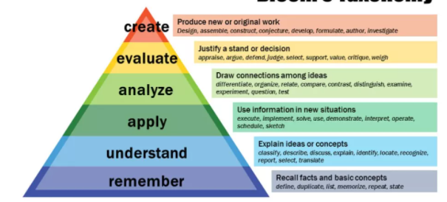
Almost all educators should be familiar with Bloom’s Taxonomy of Learning. It is a hierarchical ordering of cognitive skills represented as a pyramid, as shown in Figure 1:

Figure 1: Bloom's Taxonomy of Learning [35]

This taxonomy allows educators to think about their teaching and can help them to plan learning activities and how they will deliver content to their learners. As you move up through the pyramid, there is an increasing depth and level of cognitive skill, ending with the highest skill where learners use what they have learned to create new and original work or even to teach others what they know.

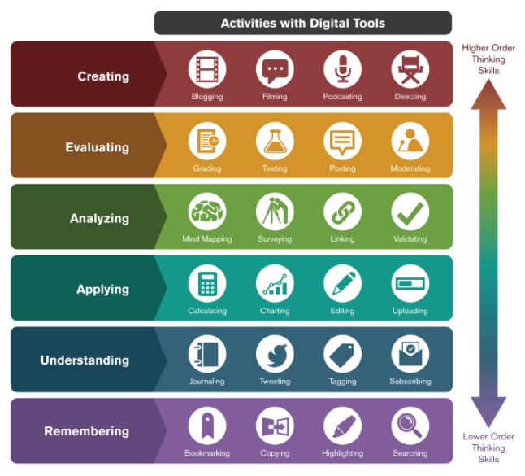
Whilst this continues to be a useful tool, it needed some modifications to make it suitable to be applied to e-learning and the rise of digital tools that are available. Arizona State University [36] introduce Bloom’s Digital Taxonomy to acknowledge the emergence of this new area, as shown in Figure 2:

Figure 2: Bloom's Digital Taxonomy [36]

The aim of Bloom’s Digital Taxonomy is to connect the existing hierarchy of cognitive skills to the digital tools and techniques that are now available. Educators and instructors can now use this to enhance the learning experience and outcomes for their learners.
There are distinct similarities between Bloom’s Taxonomy of Learning and The Learning Pyramid, which was developed by the National Training Laboratory [37]. More geared towards use in education, the idea behind the pyramid is to advise educators on how the different teaching methods they use can have an effect on deepening learning and enhancing the long-term retention of content by learners. The hierarchy of The Learning Pyramid is shown in Figure 3:
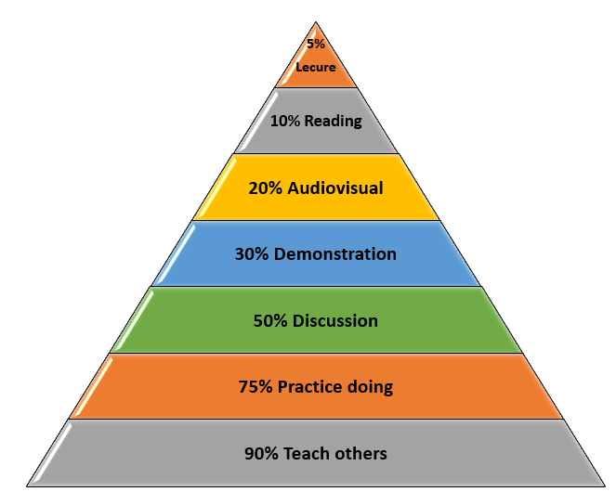
Active
Passive

Figure 3: The Learning Pyramid [38]

Similar to Bloom’s Taxonomy, at the top of the pyramid there are lessons or lectures which require lower order thinking skills. These are typically the more passive teaching methods. At the other end are the more active teaching methods, such as where learners create new material and then teach others what they know.

2.10 Barriers of adoption of e-learning
Despite the advantages that e-learning can bring, some educators are still hesitant to use them as part of their content delivery. Antonis et al. [39] promote the idea of interdisciplinary learning methods but suggest that teachers do not necessarily understand how incorporating new technically complex methods can be relevant to their needs. Antonis et al. [39] go on to state that the usability and levels of support offered by authoring tools are sometimes another barrier. This would suggest that training of staff should be conducted early in the process, as well as regular and ongoing continuing professional development (CPD). This is supported by Cahillane et al. [40] who also identify that limited technical literacy is a potential barrier for staff. Cahillane et al. [40] go on to identify lack of time as another barrier. Schools, colleges, and universities are busy environments and there are many demands on the time of teaching staff. Having to learn new ways of working and developing new content will further erode the limited time that is available. There is also the suggestion of hesitancy and reluctance amongst staff to recreate their existing content, which may already work perfectly well in its current form, so that it can be used on a new platform.
In a report from the Department of Education [13], it was identified that UK schools do not always benefit from the same high standards of internet connectivity that are found in the further and higher education sectors. This may be another factor preventing the move to developing more e-learning content. If staff do not have the assurance and belief that technology will work as required, then they will tend to stick with what has worked best for them in the past.
Another factor to consider is the subject area. Some subjects may not lend themselves well to a move to more e-learning content as the nature of the subject may be more practical, such as practical lessons in physical education or in the sciences, where equipment is often required.

2.11 The move to e-learning
Dhawan [41] points out that the Covid-19 pandemic presented education systems across the world with significant challenges. Educators were no longer able to choose whether they wished to teach aspects of their subjects via e-learning methods, rather that they were forced to shift to e-learning methods literally overnight to ensure continuity of learner progress. Furthermore, Dhawan [41] suggests that resistance to change would not be wise as education institutions would be judged by stakeholders on their pace to adapt to new ways of working and how well they can maintain the quality of the education they provide.
To assist educators in the move to e-learning, Anstey and Gavan [26] have established a comprehensive rubric model to evaluate the strengths and weaknesses of e-learning tools against a set of specific criteria, including functionality, accessibility, technical, mobile design, privacy, data protection & rights, social presence, teaching presence and cognitive presence. A rubric model allows for a comparison between potential e-learning tools and can include features such as criteria, rating scale, indicators, amongst others. However, it is important to note that not all criterion in the rubric is relevant to all e-learning tools. A version of the rubric model from Anstey and Gavan [26] is shown in Table 2:

Category | Criteria | Works Well | Minor Concerns | Serious Concerns | Not applicable
Functionality | Scale | Flexibility to be scaled to any size class and smaller sub-groups | Flexibility to be scaled to any size class but not to smaller sub-groups | Limited to a restrictive number of users and unable to be scaled
Functionality | Ease of Use | User-friendly interface, intuitive, easy for users to become skilful, can be personalised | User interface that may be confusing to users, limited options for personalisation | Not user-friendly, cumbersome, unintuitive, rigid, inflexible
Functionality | Tech Support / Help Availability | Tech support/help documentation readily available and aids in troubleshooting | Tech support/help documentation available but limited, incomplete, not user-friendly | Tech support/help documentation not available
Functionality | Hypermediality | Allows communication through different channels (audio, visual, text), flexible/adaptive engagement with material | Allows communication through different channels (audio, visual, text), limited flexibility with material | Restrictive communication channels, presents information in a rigid, inflexible format
Accessibility | Accessibility standards | Meets accessibility guidelines (e.g., W3C standards) | Limited capacity to meet accessibility guidelines | Fails to meet accessibility guidelines, limited information on compliance
Accessibility | User-focused participation | Addressed needs of diverse users, capabilities and encourages wider participation | Limited capacity to address needs of diverse users and their capabilities | Restrictive in meeting the diversity of needs of users. Limits participation
Accessibility | Required Equipment | No special equipment required beyond what is typically available to users | Some specialised equipment required, possibly requiring purchases at a low cost | Specialised equipment needed requiring moderate financial investment
Accessibility | Cost of Use | All aspects can be used free of charge | Limited aspects available free of charge, other aspects requiring membership or subscription | Most aspects requiring a fee, membership, or subscription. Possible financial burden on users
Technical | Integration / Embedding within a LMS | Can be embedded into an LMS with full functionality of the tool | Can be embedded into an LMS, but with limited functionality | Can only be accessed in an LMS through a link, rather than a functional version
Technical | Desktop/Laptop Operating Systems | Tool can be used with any standard device with recognised operating system | Possible limited functionality depending on operating system used | Limited to one specific operating system
Technical | Browser | Tool can be used with any standard, up to date browser | Possible limited functionality depending on the browser used | Limited to one specific browser
Technical | Additional Downloads | No need to download additional software | Downloads of additional software required | Past version of software required to be downloaded
Mobile Design | Access | Accessed through an app, regardless of the device. Tool takes into account constraints of a smaller screen | Accessed through an app, but on a limited set of operating systems. Constrained by the limitations of the mobile device | Access to the tool is limited or absent on a mobile device
Mobile Design | Functionality | Little or no functional difference between the mobile and desktop version, regardless of the device used | Core features are functional on the mobile app, but some are limited. | Core features are not reliable or non-existent. Differences between operating systems used.
Mobile Design | Offline Access | Offers an offline mode | Offers a limited offline mode | Cannot be used offline
Privacy, Data Protection, and Rights | Sign Up/Sign In | No requirement to create an account or sign in | Teachers are required to create an account; student data is protected by legislation | All users must provide personal information to a third party
Privacy, Data Protection, and Rights | Data Privacy and Ownership | Users maintain ownership/copyright of their intellectual property and data and can be kept private | Users maintain ownership/copyright of their intellectual property and data, but data is shared publicly | Users forfeit ownership and copyright of data; data is shared publicly and cannot be made private
Privacy, Data Protection, and Rights | Archiving, Saving and Exporting Data | Users can archive, save, or  import and export data in a variety of formats | Limitations to archiving,  saving, or importing/exporting data | Data cannot be archived, saved, or imported/exported
Social Presence | Collaboration | Users can communicate and interact both through synchronous and asynchronous methods | Users can communicate and interact through asynchronous but not synchronous methods | Communication, interactivity, and  transfer of meaning between  users is not supported and  limited
Social Presence | User Accountability | Instructors can control learner anonymity; learners are accountable for their actions | Instructors cannot control learner anonymity; learners are accountable for some of their actions | Instructors cannot control learner anonymity, no solution for holding users accountable to their actions
Social Presence | Diffusion | Tool is widely known and popular, most user will have some competence | Tool is mostly known; some users will have competence | Tool is not well known; most users lack competence
Teaching Presence | Facilitation | Good features for active management, monitoring, engagement, and feedback | Limited features for active management, monitoring, engagement, and feedback | Insufficient features for active management, monitoring, engagement, and feedback
Teaching Presence | Customisation | Tool is easily customisable to suit the context | Limited options for customisation | No options for customisation
Teaching Presence | Learning Analytics | Majority of learners performance can be monitored | Limited features to monitor learner performance | Learning analytics are not available
Cognitive Presence | Enhancement of Cognitive Tasks | Enhances engagement to tasks that were otherwise complex | Enables functional improvement to engagement of tasks | No functional engagement in tasks
Cognitive Presence | Higher Order Thinking | Easily facilitates higher order thinking skills | May facilitate higher order thinking skills | Does not engage higher order thinking skills
Cognitive Presence | Metacognitive Engagement | Learners receive regular formative feedback | Limited feedback provided to learners | No opportunities for feedback to learners

Table 2: E-learning tool evaluation rubric from Anstey and Gavan [26]

Unfortunately, time constraints, and the pressing need to ensure continuity of learning at the start of the Covid-19 pandemic, would have meant that educators would have been unable to take all of these factors suggested by Anstey and Gavan [26] into consideration. The time constraint would have also been compounded by a general lack of awareness and understanding of alternative tools that might have been available and the array of features that they offer, most of which would likely have required a significant amount of training to be able to use effectively. Instead, educators were required to improvise and adapt the existing tools that they were already using to deliver classroom-based lessons in order to make them fit for use with e-learning.

2.12 Microsoft PowerPoint as an e-learning authoring tool
A very popular tool used to deliver traditional classroom-based learning in UK schools is Microsoft PowerPoint. This is a piece of presentation software that the vast majority of educators are familiar with using and would likely have built up a bank of resources for their teaching, which they are able to adapt and reuse each year. Microsoft PowerPoint presentations are usually used to provide the main structure or navigation outline of the lesson, and information contained in the presentation slides would then be supplemented by smaller tasks and activities in other software. However, Microsoft PowerPoint is presentation software and not specifically designed for use as an e-learning tool. It is important to understand the main differences between them to assess the suitability of presentation software as an e-learning tool.
According to Learning Revolution [42], there are some key differences between them, as identified in Table 3:

Criteria | Presentation software | E-learning software
Design | Presentations are frequently created in a style chosen by the author. This style may not always be consistent and may not follow best-practice guidelines to ensure accessibility for all learners. | E-learning software usually adheres to formal design principles and may provide pre-set templates for authors to create their content.
Navigation | Presentations are normally designed in a linear manner, with slides structured in a sequential order. There are options to enable hyperlinks and action buttons to encourage interactivity and movement between topics. | E-learning materials will often allow the learner flexibility in how they navigate their way through the material. This could include chapters, topics, lessons, hot spots, as well as dedicated navigation buttons.
Learner engagement | Traditional presentations are often regarded as passive learning. This is not very engaging for the learner. | E-learning materials can include a number of interactive elements such as multimedia (audio/video), animations, simulations, and quizzes.
Learner retention | By their nature, presentations tend to contain predominantly text-based content. The lack of variety may not encourage learner retention. | E-learning content can be presented in a variety of different ways, and this can help learners to retain more information.
Assessment opportunities | Presentations are limited in their assessment opportunities. Quizzes or polls can be added but they tend to be static with limited interactivity. | E-learning materials can offer a variety of interactive games and quizzes which can be adapted by the educator. Marking of these can also be automated.
Table 3: The differences between presentation and e-learning software

2.13 Proprietary and open-source e-learning authoring tools
There are a number of alternative proprietary and open-source e-learning authoring tools already available. In order to assess their suitability, eight tools have been selected and a top-level comparison of the major features provided has been completed. The results can be found in Table 4:
Name | Publisher | Type | Target audience | Major features | Cost ¹
Adobe Captivate [43] | Adobe | Desktop based | Experienced users | - Quick start projects  - Convert PowerPoints to Interactive Videos  - Experiential learning e.g., virtual tours and walkthroughs  - Multi-module branched courses  - Plug-and-play interactions and quizzing tools | £406.40  Student & Teacher edition
Articulate Rise 360 [44] | Articulate Global | Web based | Novice users | - Pre-built customisable templates  - Simple and intuitive interface  - Rapid development of content  - Integrated asset library  - Multiple interactivity options  - Quizzing tools available | £471.90  Teams plan
Articulate Storyline 360 [45] | Articulate Global | Desktop based | Novice and experienced users | - PowerPoint look and feel  - Traditional linear design of content  - Extensive design capabilities  - Integrated asset library  - Multiple interactivity options  - Active and established online community | £471.90  Teams plan
EdApp [46] | EdApp Pty | Web based | Novice users | - Template driven approach  - Rapid development of content  - Editable content library  - PowerPoint conversion tool  - Gamification of learning features | Free -  Basic  Pro -  £1.42 per month
Iseazy [47] | Iseazy | Web based | Novice users | - PowerPoint look and feel  - Pre-built customisable templates  - WYSIWYG editor  - Chapter based organisation of content  - Collaborative working and quizzing tools available | Free – Basic  Pro –  £45.80 per month
iSpring Suite [48] | iSpring Solutions Inc. | Desktop based (works within PowerPoint) | Novice users | - Simple and intuitive design  - Add-In based within PowerPoint  - Creation of HTML5 compatible content  - Substantial built-in content library  - Convert PowerPoints to interactive courses  - Collaborative working and quizzing tools available | £559.81  iSpring Suite
Lectora [49] | Elearning Brothers | Desktop and web based | Experienced users | - Pre-built interaction templates  - PowerPoint import capability  - Assessment and analytics tools  - Adaptive learning features  - Multiple interactivity options | £944.42  Gold Suite
Sleave [50] | BitPupil Technologies Private Limited | Web based | Novice and experienced users | - Creation of responsive templates  - Highly customisable  - Multiple interactivity options  - Creation of HTML5 compatible content  - Coding support for JavaScript/APIs | Free – Basic plan  £54.53 – Standard plan
Table 4: Top-level comparison of existing proprietary and open-source authoring tools

2.14 Conclusion
Following the top-level comparison of major features conducted in this section, it has been decided to reduce the number of authoring tools to take forward for further research from eight to six. The authoring tools which are being removed at this stage are:
- Adobe Captivate. The software is mostly aimed at experienced authors and requires a certain level of proficiency to create content. It is very unlikely that most users in education settings meet this requirement. In addition, Adobe Captivate was an early entrant into the market and allowed the creation of legacy projects using the desktop application. The software still maintains a desktop-first approach, which makes collaboration with others and the sharing of materials difficult. It also puts an extra burden on IT Support teams who would need to install and maintain the software. Furthermore, although Captivate is HTML5 compatible it was traditionally created to be a Flash based authoring tool. As Flash is no longer supported the software has been retrofitted with support for HTML5, although this can lead to a buggy experience for users.
- Lectora. Similar to Adobe Captivate, Lectora is a well-established authoring tool. It also has its roots as a desktop app, although it also now acts as a hybrid model with a web based HTML5 version. However, it remains primarily a desktop application and this limits collaboration with others and the sharing of materials. It also means that many of the newer features are simply ‘bolted on’ to the original version, which increases the complexity of the software. The user interface is also not particularly user friendly or intuitive. This, coupled with the software being aimed at experienced authors and power users, will make it difficult for the majority of users in education settings to use. It is also the most expensive of the tools reviewed, which is a significant factor considering the need for financial resources in education to be targeted carefully.

During this process, it has also become apparent that a major factor to take into consideration, in the later stages of this project, is the cost of e-learning authoring software. A number of them offer a free trial, which would be useful for school leaders to assess their suitability, however once any free trial has ended there is a requirement to purchase monthly or annual licences. These would be a significant investment. These licences come with certain restrictions, such as the number of educators that can use the software or the number of devices the software can be used on at any given time. Budgetary constraints in the UK education system are likely to prevent schools from investing heavily in this software, especially if there is also a significant amount of time needed for staff training and development to be able to use them competently. School leaders would also need assurances that any confidential or sensitive data given to third parties would be kept safe and secure.

3. Research Methodology

3.1 Philosophy
Collis and Hussey [51] identify the two main types of research philosophy as positivism and phenomenology. It is anticipated that the research philosophy more suited to this research project would be phenomenology. The main reasons for this approach include:
- It is likely that the research will generate a significant amount of qualitative data. This will come from sources including the teaching staff asked to use the tools suggested. The data generated will mainly consist of thoughts and opinions.
- The sample, or group, that is needed to conduct this research is relatively small.
- Unlike a quantitative methodology, where measurements form a critical part of the research process, the phenomenological methodology is concerned with data which is of quality and depth regarding the specific problem. The data can also be classed as rich, due to the fact it will be detailed.
- As already mentioned, the data being collected is going to be qualitative. As this cannot be measured statistically, it may be considered to have low reliability.
- On the other hand, the data collected can be regarded as highly valid in the sense that it is an accurate representation of what exactly is happening in the research environment, meaning it should address all the required questions by means of its in-depth knowledge nature.
- Finally, the research will be rather generalised to one specific sector. As such, the characteristics and findings are unlikely to be relative to a wider population.

3.2 Strategy
Saunders et al [52] explain that there are four main strategies of conducting research, namely action research, experiments, surveys and case studies. Upon considering the application of each strategy to this project, it was concluded that the case study approach would be most suitable.
Yin [53] identifies that there are certain characteristics of the case study approach. Firstly, the approach is a phenomenological method aiming to understand certain phenomena within a particular context. This fits with the phenomenology research philosophy selected earlier in this section.
Secondly, Yin [53] outlines that the research does not commence with a set of questions or concerns about the limits within which the research will take place as the boundaries between the phenomenon being studied and the context within which it is being studied are clearly evident.
Finally, this approach involves gathering a significant amount of detailed data regarding how the current methods work and establishing the requirements of the new deliverable from the end users. The process used to gather this data will come from a variety of qualitative methods. In particular, interviews and questionnaires will be implemented.

3.3 Approaches
A research approach needs to be chosen that compliments the research philosophy that will be used. Saunders et al [52] describe the two approaches to consider are inductive and deductive.
It is believed that the approach most suitable for this project is the inductive approach. This has been chosen because:
- There is no specific hypothesis that has been identified from the outset.
- The research will aim to detect patterns and regularities.
- These patterns and regularities will then assist in the formulation of tentative hypotheses that can be explored further.
- There will be an emphasis on the collection of quantitative data from users.
- The data produced could result in a shift in the focus of the research as the project progresses
- The conclusions drawn from the research are likely to be more generalised [54].

3.4 Risks & Limitations
There are a number of risks and limitations that have been identified that could jeopardise the success of this project. These include:
- Users having sufficient time to experiment with the tools – individuals within education will already have their own work to do and may struggle to find the time to assist with this project. It will be important to communicate the timescales to them in advance and give them sufficient time for any tasks they need to undertake.
- Access to end users – as the researcher is not working directly with those users asked to take part in the project, it will be important that adequate communication is maintained e.g., via email.
- Limited only to open source/free solutions – the scope of this project does not enable paid-for solutions to be used which could limit the tools and features that are available for research.
- Poor time management – it will be important to constantly monitor the progress of the project and adjust timescales as appropriate if any issues arise. Project management software is being used and a Gantt chart has been created to assist with this.

3.5 Data Evaluation
The methods of data collection over the duration of this project are anticipated to be:
- Questionnaires - will be distributed to teachers to gather initial research. Questionnaires will also be issued to teachers after the implementation of the deliverable to gather feedback. The design of the questionnaires will need to be carefully considered. It is likely that the questions asked will use a combination of open and closed questions as well as the Likert scale, where teachers will be asked to rate statements on a scale from strong agreement to strong disagreement. Questionnaires are a suitable method because they reduce the risk of bias and are relatively cheap to develop and complete.
- Interviews - with end users/teachers. The main purpose of the interviews will be to understand the current issues and to gauge the expectations of the new deliverable. The use of interviews will be suitable because it will allow interviewees to express their views in their own words, which will allow the interviewer to probe for further information. A rapport can also be built with the interviewee to gain their trust and commitment.
To analyse the results of the research findings, a number of techniques will need to be applied. Like the methods of data collection, it is likely that the data analysis techniques may be a combination of positivistic and phenomenological methods.
It has been suggested by Robson and McCartan [55] that unlike quantitative methods, there are no clear conventions for the analysis of qualitative data.
Further to this Collis and Hussey [51] outline that due to the possible large volume of data which may have been collected, it is important to apply methods that reduce the data, give it some structure and try to use alternative forms of representation other than extended text. To do this, it might be necessary to apply techniques to convert qualitative data into quantitative data. Whilst not universally accepted, Collis and Hussey [51] acknowledge that this method is quite commonplace.
One such way of applying this technique would be to conduct a content analysis. Collis and Hussey [51] describe content analysis as a way of methodically adapting text to numerical value for statistical data analysis. This could be done by analysing the findings from the user observations and interviews to identify themes which could be represented statistically. Another statistical method that could be applied is the use of cross tabulation of findings from user questionnaires. Cross tabulations are relatively simple to produce and easy to understand.
Non-statistical methods which can be applied include the collation and analysing of user interviews. These will require a more general analytical method.
To analyse the results of this project a number of methods will be used:
- Comparison with initial aims and objectives – this will involve comparing and contrasting the initial requirements of the deliverable to what has actually been developed. The result of the project should fulfil the aim and the objectives outlined earlier in this report.
- Evaluation of the deliverable – the new deliverable will be used by teachers to assist them in developing e-learning materials. An evaluation of this process will need to be conducted to gauge the success of the deliverable and to identify any areas that require further improvement.

3.6 Deliverables
The deliverables upon completion of this project are expected to be:
- A new “E-learning tools” tab, created in Microsoft PowerPoint. The contents of the tab will be based upon findings from the literature review and initial interviews with teachers
- The new tab will contain the most commonly used tools by teachers and those that are deemed to be suitable for creating e-learning materials

3.7 Resources required
In order to complete this project successfully, it is anticipated that the following resources will be required at various different stages:
- A desktop/laptop computer system with the Windows 10 operating system installed
- Microsoft Office Suite including Word and PowerPoint
- Web browsers including Google Chrome and Microsoft Edge
- E-learning authoring tool software, specifically Articulate Rise 360, Articulate Storyline 360, EdApp, Iseazy, iSpring Suite and Sleave
- Data analysis tools
- Internet access
- Reference materials on the topic
- End users for feedback and testing of the deliverable, approximately 10 subjects

3.8 Time plan

Task | Expected start date | Expected end date
Background information gathering | March 2021 | March 2021
Investigate existing authoring tools | March 2021 | April 2021
Identify eight initial authoring tools and conduct a top-level comparison on their features | April 2021 | April 2021
Investigate current user engagement with authoring tools | April 2021 | April 2021
Create initial version of the deliverable based on findings | April 2021 | June 2021
Gather end user feedback on the deliverable and usability | July 2021 | August 2021
Create final version of deliverable based on findings | August 2021 | September 2021
Further feedback | September 2021 | October 2021
Evaluate deliverable | October 2021 | November 2021
Project completion | November 2021 | November 2021

4. Requirements, Design, and Implementation

4.1 Initial research
In order to establish the requirements for the new framework, it was important to ask current teachers for their experiences with using e-learning authoring tools. Areas to be considered included the level of experience for teaching staff, common features that were frequently used, any specific successes or failures, as well as issues that have been encountered. A questionnaire was created using Microsoft Forms and distributed electronically to all teachers at a particular sixth-form college via email. The questionnaire consisted of 23 questions, made up of a variety of multiple choice, short, and long answer questions. A copy of the questionnaire can be found in Appendix 1.
Despite an appropriate amount of time being given to complete the initial research questionnaire, and subsequent reminders to complete, there were zero responses. This was very unfortunate and disappointing; it also presented a significant challenge in enabling this project to move forward in its current form. After speaking to several colleagues on a one-to-one basis, it became clear that the most common reason for not completing the questionnaire was linked to issues with their own workloads, which had become particularly excessive due to the new challenges they were facing with the ongoing situation with the Covid-19 pandemic. Unfortunately, this meant that they were unable to find the time to complete the initial questionnaire. However, whilst not necessarily the most ideal method, being able to speak to staff on a one-to-one basis did allow valuable feedback to be gathered and led to a re-focus of the project objectives.
The original concept for this project was to create a framework to assist educators with choosing the correct authoring tool to suit their needs. This idea had proven to be unsuccessful. However, it was important at this stage to ensure continuity of the project, as the review of literature had identified it as an area worthy of further investigation. It was therefore decided that the original project idea would need to pivot and that the original objectives would need to be adapted in order to ensure a successful outcome. As issues with workload and availability of time had proved to be a barrier with completing the initial questionnaire, rather than pursue the original concept of creating a framework and requiring teachers to experiment with using new authoring tools which they had no prior experience of using, it was decided to conduct a series of informal discussions to enable further research. Rather than continue with the initial questionnaire created for the original project idea, it was decided to streamline the research process and adopt a more agile methodology approach by communicating with stakeholders at regular intervals.
From informal discussions with a number of colleagues, it was possible to identify the most common software that is currently used as part of traditional classroom-based lessons. A summary of the results of these discussions is shown in Figure 4:

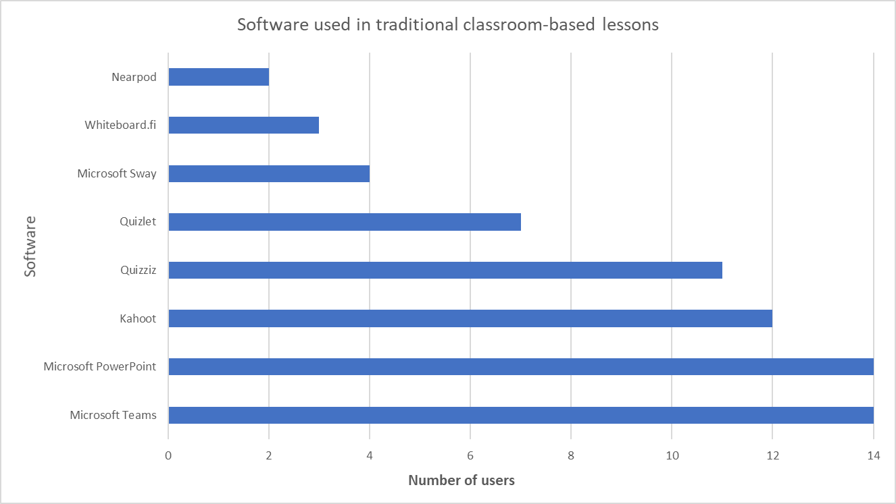
Figure 4: Summary of responses to software used in traditional classroom-based lessons

It was clear that both Microsoft Teams and PowerPoint were used by 100% of respondents, and this was to be expected. Also ranking quite highly is the use of the quizzing tools Kahoot (86%), Quizziz (79%), and Quizlet (50%). Teachers use these tools regularly in their lessons to assess learner understanding. Some teachers begin their lessons with a short quiz as a “starter activity” to prepare learners for the lesson ahead, and others will opt to use a short quiz as a “plenary” activity to check understanding at the end of a lesson. Using these tools allows for the teacher to plan subsequent lessons and shift focus if necessary. Microsoft Sway (29%) is a relative newcomer to most teachers and is sometimes used as an alternative to Microsoft PowerPoint as it provides similar functionality. Whiteboard.fi (21%) is used as a collaboration tool by some teachers, although some still opt to use physical mini whiteboards in their lessons to collect learner responses to questions. Nearpod (14%) is also a relatively new piece of software but has not yet been widely adopted.
A description of the software identified in these results is shown in Table 5:

Software | How it is used in lessons
Microsoft Teams [56] | Microsoft Teams has recently been adopted as the new replacement as the college VLE (Virtual Learning Environment). All course leaders are able to create a “team” to which they add all of the learners studying their subject. Using Teams allows individual teachers to host all course materials, post course updates, communicate will learners, and host online lessons should the need arise.
Microsoft PowerPoint [57] | Microsoft PowerPoint presentations are usually used to provide the main structure or navigation outline of the lesson, and information contained in the presentation slides would then be supplemented by smaller tasks and activities in other software. Presentations, as well as other lesson resources, are often distributed to learners through Microsoft Teams.
Kahoot [58] | Kahoot is an online quiz tool that has become very popular in school settings. Teachers are able to create and customise their own multiple-choice quiz from scratch or build on an existing quiz that is shared in the online library. Learners are then able to join quizzes using any device that can access the Internet and they then “play” against their peers. This provides an element of competition to the learning. Using Kahoot allows the educator to assess learner progress and tailor future lessons based on the feedback received.
Quizziz [59] | Quizziz is similar to Quizlet in that it is a revision resource used by learners. However, Quizziz adopts a more competitive approach which is similar to Kahoot. Quizziz allows learners to complete quizzes to assess their understanding but will offer questions in a random order and allow for a greater element of competitiveness.
Microsoft Sway [60] | Microsoft Sway is a presentation software that is designed to be lightweight, and cloud based. This is in contrast to Microsoft PowerPoint, which is mostly designed to show a number of slides using traditional desktop or laptop devices and in a sequential manner. Sways can be either horizontal or vertical and can be embedded with a variety of multimedia resources such as audio or video files.
Quizlet [61] | Quizlet is predominantly used as a revision resource by learners. Its main feature is the use of virtual flashcards for revision purposes. The idea is that learners use these flashcards as a revision tool, particularly for keywords and their associated definitions. Educators are able to create their own flashcard sets, or direct learners to the many existing sets online.
Whiteboard.fi [62] | Whiteboard.fi is a free online whiteboard tool for learners and teachers. Similar to physical mini whiteboards that can be used in lessons, learners are provided with an individual digital whiteboard on which they can draw and annotate their own answers to questions in lessons. Whiteboard.fi is particularly effective at providing live feedback to the educator on learners’ performance and understanding.
Nearpod [63] | Nearpod allows educators to make a lesson truly interactive and allows learners to interact with resources throughout the lesson. Resources include quizzes, videos, collaboration tools, polls, and more. There are a variety of ready-made resources for educators, or they can choose to create their own materials using the comprehensive tools that are provided.

Table 5: Most common software used in classroom-based lessons

4.2 Project redirection
Earlier in this report, it was established that Microsoft PowerPoint was already widely used in education settings, and this is also the case at the sixth-form college used as the basis for this project, as evidenced by the results of the informal discussions. This means that educators are already familiar with the majority of features that the software offers, and that the software is already widely available as part of the Office 365 packages that many schools, colleges and higher education settings subscribe to.
After analysing the results of the initial research, it was decided that the project would now focus on the use of Microsoft PowerPoint and how it could be suitably adapted to be used as an e-learning tool. It was decided that it would be more feasible to focus on Microsoft PowerPoint to recognise the significant workload burden faced by staff, and the budgetary issues facing education settings. It was also established earlier in this report that there were differences between Microsoft PowerPoint being presentation software, and dedicated authoring tools which are built specifically with e-learning as their core focus. This has now meant there are some key issues that have come out of this pivot to the original project idea, namely:
- What features are most commonly used by teachers in Microsoft PowerPoint?
- How can Microsoft PowerPoint be adapted for use as an e-learning tool?
- How can Microsoft PowerPoint be used more effectively to deliver remote lessons?
- What are the future possibilities of using Microsoft PowerPoint as an e-learning tool?

4.3 iSpring Suite
In the top-level comparison of e-learning authoring tool features conducted in the Literature Review, a piece of software called iSpring Suite [48] stood out as it had the ability to be installed as an “add-in” to PowerPoint. It was decided to explore this software in greater detail, as it had such close links to PowerPoint and would provide an element of familiarity for users. iSpring Suite is designed for novice users and offers features such as:
- A simple and intuitive design
- Ability to record audio/video and narrate slides
- Collaborative working and quizzing tools available
- Ability to embed existing content from other websites such as YouTube
- Ability to manage slide templates and the provision of additional backgrounds, objects, and icons
- Ability to create HTML5 compatible content for distribution on the web
- Access to a substantial built-in content library
- Ability to convert existing PowerPoint presentations to interactive courses

An example of the new tab that is available on the Ribbon for use after installation of iSpring Suite is shown in Figure 5 with a magnified version in Figure 6. This tab is very helpful as it enables all of the core functionality of the software to be found in one place:
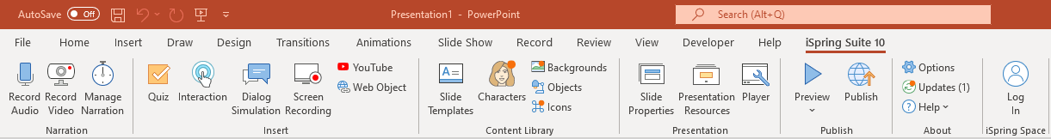
Figure 5: The iSpring Suite tab on the Microsoft PowerPoint Ribbon

Figure 6: The iSpring Suite tab on the Microsoft PowerPoint Ribbon (magnified)
One feature that stands out on the iSpring Suite tab is the quiz maker tool. This allows users to create their own multiple-choice quizzes using a simple drag and drop editor. Once created, these quizzes can be embedded into PowerPoint and distributed to those learners who need to complete it.
Although the additional functionality provided by iSpring Suite would help bridge the gap between PowerPoint being solely presentation software and introduce e-learning authoring tool elements, it does come with its disadvantages. iSpring Suite works on a subscription model and would require payment based on the number of users intending to use the software. In a large education setting with many users, this could be very costly. There is also a requirement to renew subscriptions annually, which would result in the software not being financially viable in the long term.
All Office software, including Microsoft PowerPoint, allows users to customise the Ribbon to suit their needs. New tabs can be created, and all related tools and commands can be grouped together in one place to increase usability. Taking inspiration from iSpring Suite, it was decided to replicate the idea of a dedicated tab on the Ribbon. This will allow the creation of a similar “E-learning tools” tab, which will essentially provide a “one-stop shop” for teachers when creating e-learning materials in PowerPoint in the future. This would help toss consolidate all of the features together in one area and training could then be provided to teachers in how to combine them together. This avoids reliance on a third party and also avoids a potentially costly subscription.

4.4 Most common tools used by teachers in PowerPoint
Before the new “E-learning tools” tab can be created, it was important to speak to the teachers already using PowerPoint to identify the features that are most commonly used. Further informal discussions were held with teachers to identify the features they use regularly. A summary of the results of these discussions is shown in Figure 7:

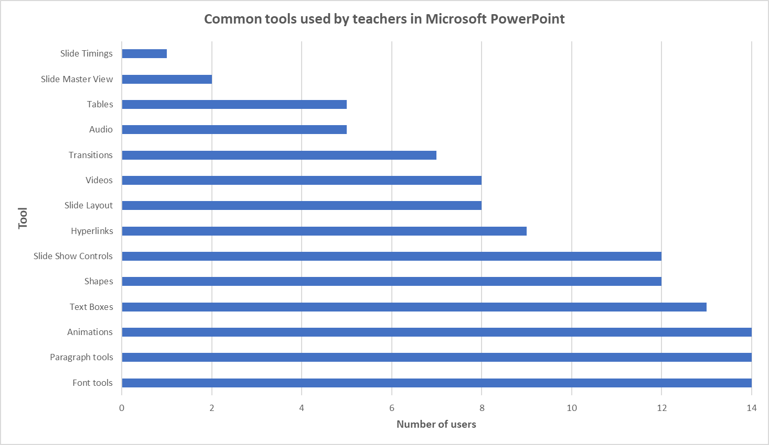
Figure 7: Summary of responses regarding commonly used tools in PowerPoint

It was clear that font, paragraph, and animation tools were the most commonly used by 100% of respondents. Text box tools (93%) featured very highly, as well as the shapes and slide show controls (86%). Hyperlinks were frequently used (64%), whilst slide layout tools and video tools were used by just over half of respondents (57%). Transitions (50%) were not as widely used as animations, and audio and table tools came next (36%). Slide master view (14%) and slide timing tools (7%) were the least used tools identified.
This information was very valuable and fed into the decisions made in the following stages.

4.5 Identifying the requirements using the MoSCoW method
With research now conducted on existing solutions and the core functionality required by users, it was important to prioritise the requirements for the new “E-learning tools” tab in PowerPoint. To achieve this, the MoSCoW method was used. MoSCoW lends itself particularly well to the agile development approach [64]. It consists of a prioritisation technique that focusses on four areas of significance:
- What the new system MUST have - including the minimum viable product.
- What the new system SHOULD have - important but not vital.
- What the new system COULD have - desirable if there is time and resources.
- What the new system WON’T have - not included this time around.

The MoSCoW method applied to the new “E-learning tools” tab, and by using the feedback from teachers, is shown in Table 6:
MoSCoW | Criteria | MoSCoW | Criteria
Must have: | - Font tools  - Paragraph tools  - Animation tools  - Text box controls  - Shape tools  - Slide show controls  - Hyperlinks | Could have: | - Editing tools  - Drawing tools  - Slide Design tools  - Set Up tools  - Language tools  - Comments tools  - Presentation views
Should have: | - Slide layout tools  - Video tools  - Transition tools  - Audio tools  - Table tools  - Slide master tools  - Slide timing tools  - Quiz tools | Won’t have: | - Clipboard tools  - Voice narration tools  - Design idea tools  - Conversion tools (ink to text, etc)  - Caption and subtitles tools  - Colour/Grayscale tools  - Zoom tools  - Window tools

Table 6: MoSCoW method for the new e-learning tab

All of the common tools shown in Figure 7 have either been placed in the “Must have” or “Should have” category, depending on their popularity. These are the tools that were specifically mentioned by teachers. Other tools, which may still be used by teachers but not as frequently, have been categorised as “Could have”. The “Won’t have” category contains any tools that are not used frequently and will therefore not feature on the new tab.

4.6 Incorporating quiz tools into the new “E-learning tools” tab
The use of quizzing software such as Kahoot, Quizziz and Quizlet was identified from the initial informal discussions with teachers. Teachers using these external quiz websites are required to have them open alongside any presentation they are using, often in an internet browser window. All of these different quiz websites require a user account and password. It was decided to try and incorporate some elements of these quiz tools into PowerPoint, which could also be included on the new “E-learning tools” tab. Whilst PowerPoint does not come with any quizzing tools as standard, developers are able to write their own VBA code in order to set up quizzes in the software. Visual Basic for Applications is a powerful programming language built into all Office software and it does not require the installation of any additional software [65]. It allows scripts to be written that can automate tasks. It is not a requirement to be able to understand or write VBA code in order to use the software, and the functionality to write code in PowerPoint is not turned on by default. It is necessary to enable the Developer tab on the Ribbon to access the feature.

4.7 Implementation of the new “E-learning tools” tab
The new “E-learning tools” tab was created in PowerPoint using the “Customise Ribbon” tool, as shown in Figure 8:
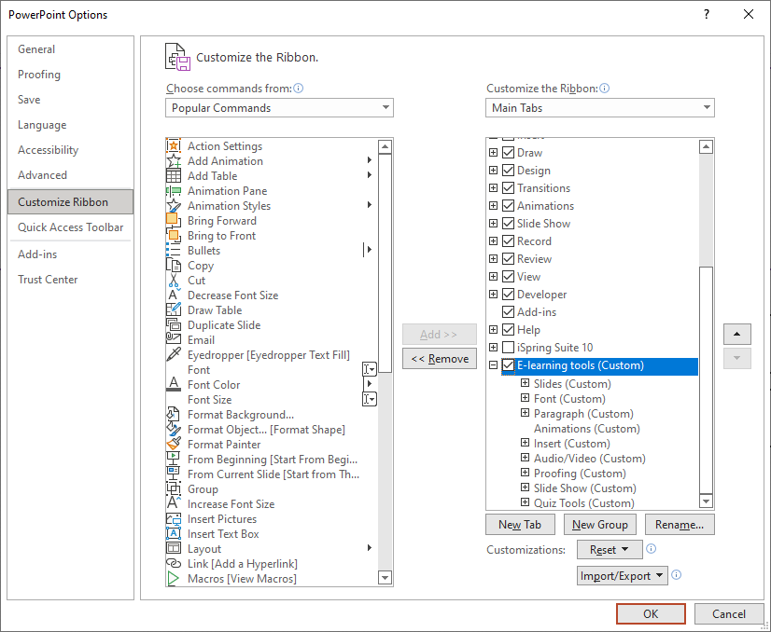
Figure 8: The Customise Ribbon tool
The tools identified from the “Must have” and “Should have” criteria of the MoSCoW process were added. The whole tab is shown in Figure 9 and a magnified version in Figure 10:

Figure 9: The new "E-learning tools" tab on the PowerPoint Ribbon

Figure 10: The new "E-learning tools" tab on the PowerPoint Ribbon (magnified)

The different tools were grouped together logically, with similar tools together, in clearly labelled sections, as explained in Table 7:

Section | Tools | Description
Slides | - New slide  - Slide layout  - Slide master | This section contains the main tools for setting up a slide show and determining the layout and slide template to use.
Font | - Font type  - Font size  - Bold/Italic/Underline  - Font colour  - Text highlight colour | This section contains the most important features identified in the MoSCoW process relating to font type and style.
Paragraph | - Bullets  - Numbering  - Alignment tools | This section is directly next to the font section and contains the most important tools used for organising text on a slide.
Insert | - Text box  - Table tools  - Shapes  - Shape fill  - Links  - Action button  - Pictures  - Screenshot | This section is an amalgamation of a number of different tools, which all come under the umbrella category of “Insert”. These were the tools identified as used most regularly to add to slides.
Audio/Video | - Video  - Audio | The audio and video tools have been kept together to allow users to insert relevant multimedia to the presentation slides.
Proofing | - Spelling  - Thesaurus | Proofing tools were identified as a feature that may not be used as frequently but have been included for their importance in ensuring content is delivered correctly.
Slide Show | - From beginning  - From current slide | The slide show controls were a frequently used feature. Even though some teachers may prefer to use keyboard shortcuts, they have been added for those who prefer to click on the respective button.
Quiz Tools | - Set up quiz  - Set correct answer  - Set incorrect answer | The quiz tools have been added to build this new functionality into PowerPoint. They allow the teacher to set up a new quiz and set correct and incorrect answers. The functionality for these buttons is written in VBA code and stored as subroutines.

Table 7: The sections of the new "E-learning tools" tab
It is important to note that the animation and transition tools, which were identified as “Must have” and “Should have” tools respectively in the MoSCoW process, have not been included on the new tab. This is because of the vast number of options and possibilities available with each tool. Each tool already comes with its own dedicated tab in PowerPoint, and it was felt that each tool would be better kept on its own distinct tab to ensure no functionality was lost by trying to condense the options onto the new “E-learning tools” tab.

4.8 Creating a quiz tool using VBA
A template presentation has been developed to allow teachers to create a multiple-choice quiz which is embedded within PowerPoint. The idea is that teachers will no longer need to depend on using external websites such as Kahoot, Quizziz or Quizlet to assess their learners, and can keep everything in PowerPoint for ease of use and familiarity. They would be able to use the existing resources they may already have which contain topic/unit and lesson content on slides. At the end of a topic, they could then include the multiple-choice quiz to assess their learners.
The new “E-learning tools” tab has been set up to include the tools necessary to create a new quiz. An example of the options available is shown in Figure 11:

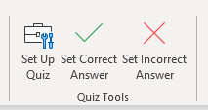
Figure 11: The new quiz creation options on the “E-learning tools” tab

4.9 Setting up a new quiz
The teacher would begin by clicking the “Set Up Quiz” button. Teachers are able to define how many questions are in the quiz, as shown in Figure 12:
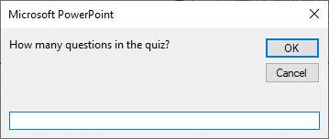
Figure 12: Determining the number of questions in the quiz

The number of questions is stored in a variable. The value of this variable is then used in a loop to determine how many times the master quiz slide should be duplicated. The number of slides added will reflect how many questions there are in the quiz. The final part of the subroutine will allow teachers to define how many points are available per question, as shown in Figure 13. The value is stored in a variable, and this will allow scores to be produced for the results slide when the quiz is completed:

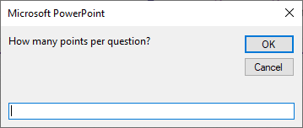
Figure 13: Determining the number of points per question

The full VBA code to create the new quiz functionality can be found in Appendix 2. Screenshots of the new quiz functionality can be found in Appendix 3 [66].

4.10 Structure of the default quiz template
The default version of the quiz comes with 5 slides already created. The first slide is shown in Figure 15:
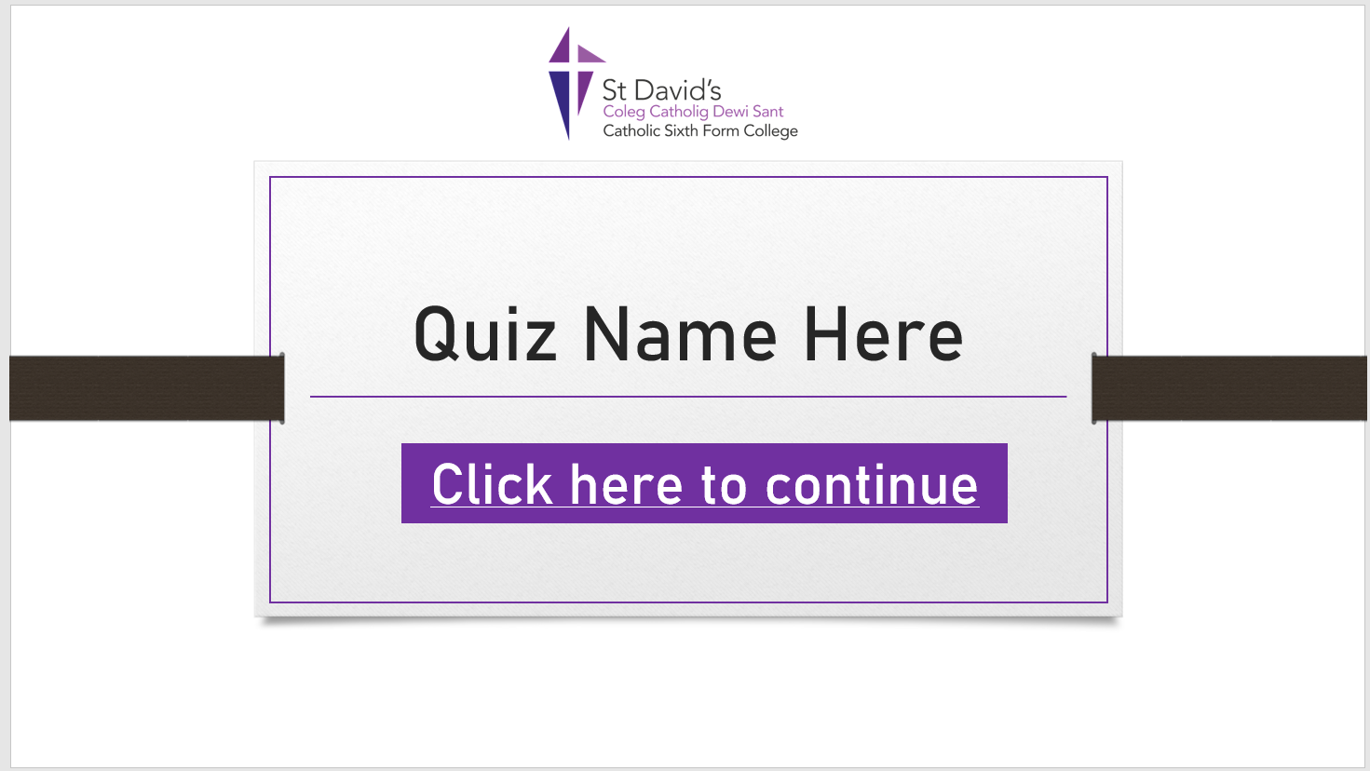
Figure 14: The first quiz slide

This slide allows the teacher to include a name for the quiz which can be changed depending on the topic they are doing at the time. Users will then click on the link to begin the quiz. This will initiate the setup process and prepare the variables in the code for use.

The second slide requires the user to enter their personal details, including their full name and student ID, as show in Figure 15:
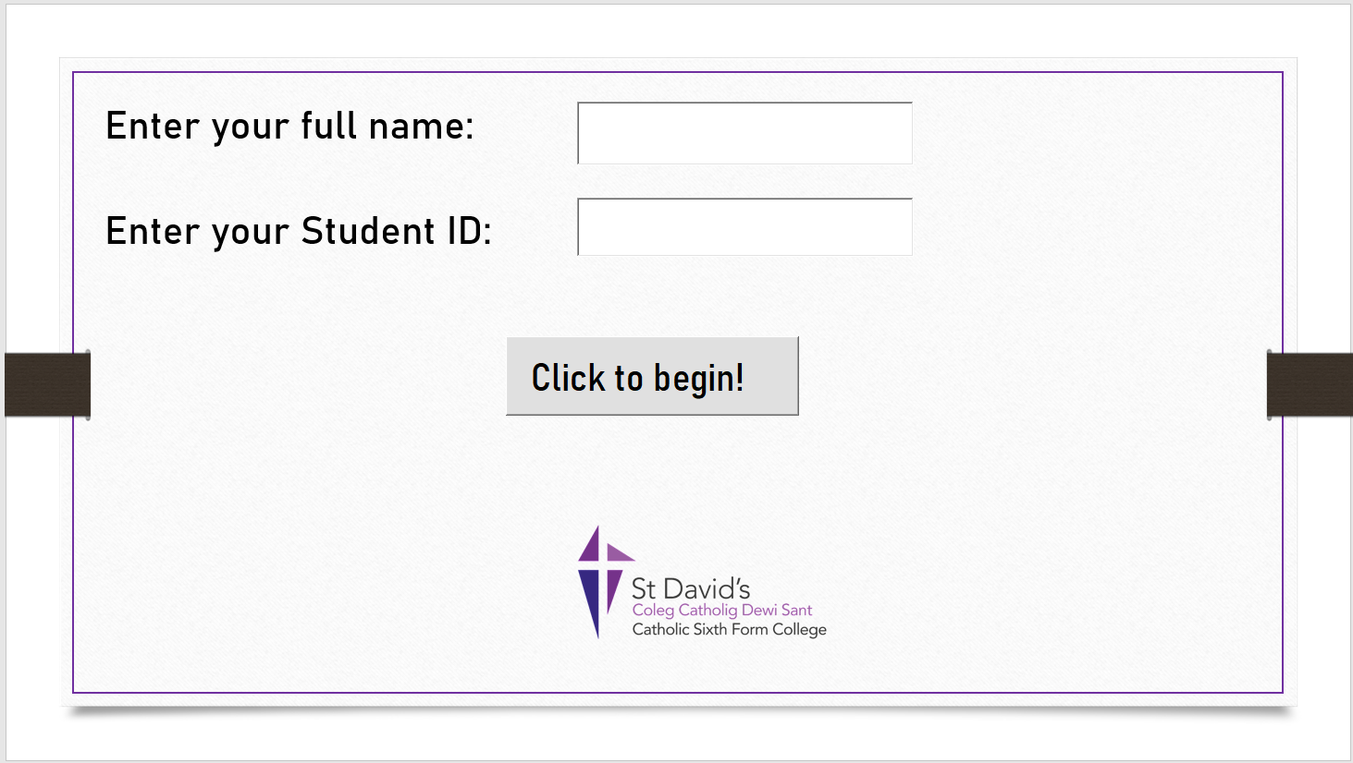
Figure 15: Users are required to enter their full name and student ID

These details are stored in variables which are used later on in the process when the results are emailed back to the teacher. There is validation added to both of the text boxes to ensure that they cannot be left blank before the quiz begins, as shown in Figure 16:

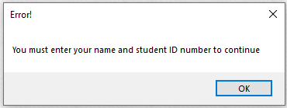
Figure 16: Validation applied to the name and student ID text boxes

Users are also prompted to confirm the details they have entered are correct before the quiz begins, as shown in Figure 17. If the details are incorrect, they are able to select No and re-enter them.
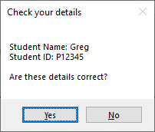
Figure 17: Users are asked to confirm their details

Figure 18 shows the default slide layout for questions. The teacher is able to add the question to the top of the slide and able to reduce the number of answers by removing the answer boxes as necessary. There is also a button on each question slide allowing the user to ‘pass’ on the question. This is also optional, and the teacher can choose to remove it if an answer is required.
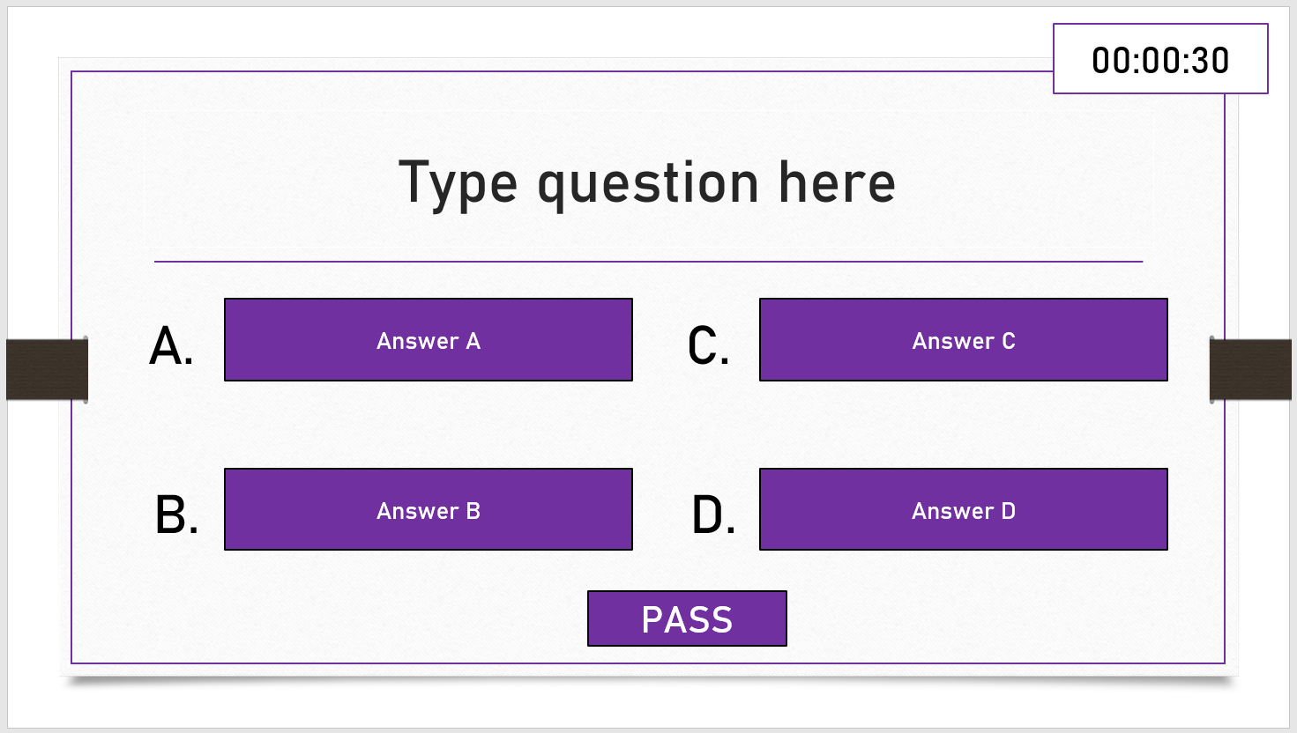
Figure 18: Default slide layout for questions
By default, all of the answer buttons are set to be incorrect. This is to allow the teacher to select which option is the correct one when setting up the quiz. This is achieved by using the buttons on the “E-learning tool” tab, as show in Figure 19:
Figure 19: Setting an answer as correct or incorrect

The teacher can select one of the four answer boxes on each slide and designate them as either the correct or incorrect answer. This is achieved by using two separate sub routines. Confirmation messages are then produced for the teacher, as shown in Figure 20 and Figure 21:

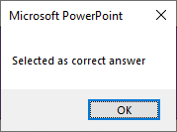
Figure 20: Confirmation of a correct answer

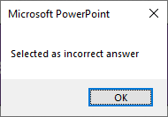
Figure 21: Confirmation of an incorrect answer
Once the quiz is completed, the user is informed and asked to click a button to view their results, as shown in Figure 22:
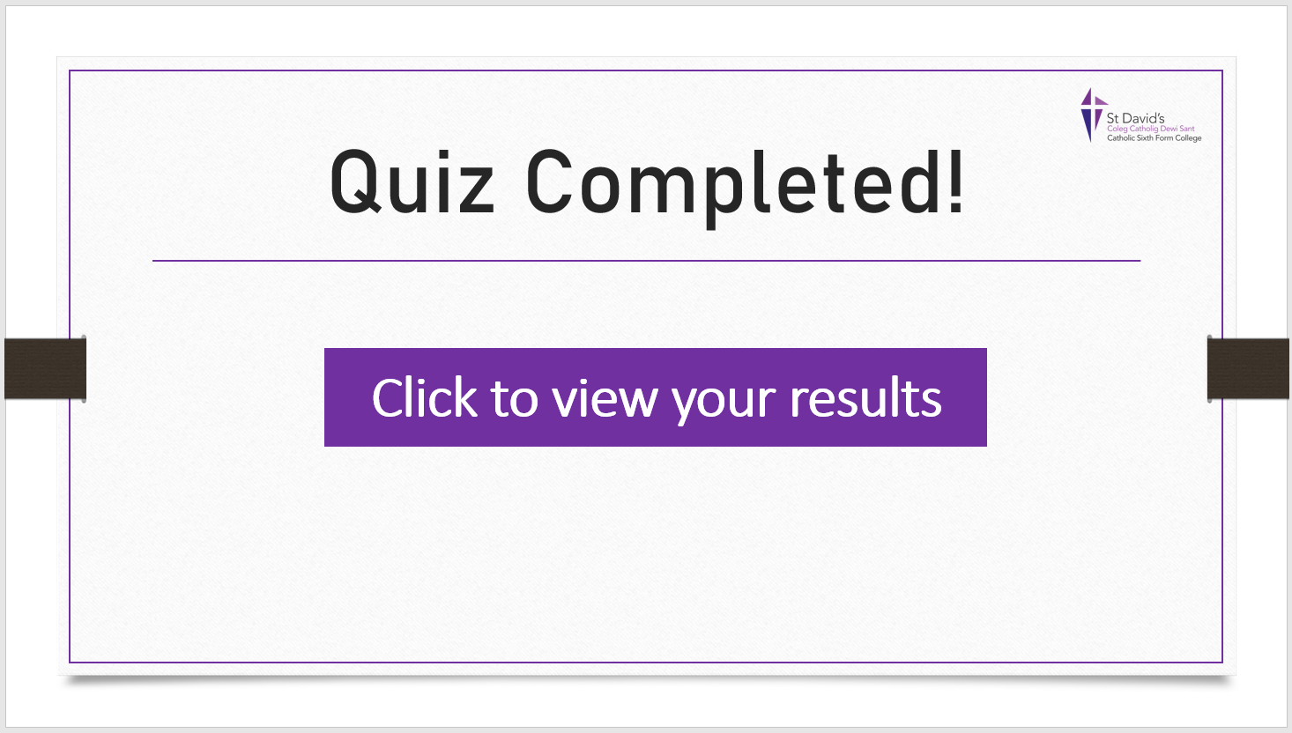
Figure 22: Quiz completed slide
The button click will prepare the statistical results for the results slide. The user will then be taken to the results slide where they can see how they did, as shown in Figure 23:
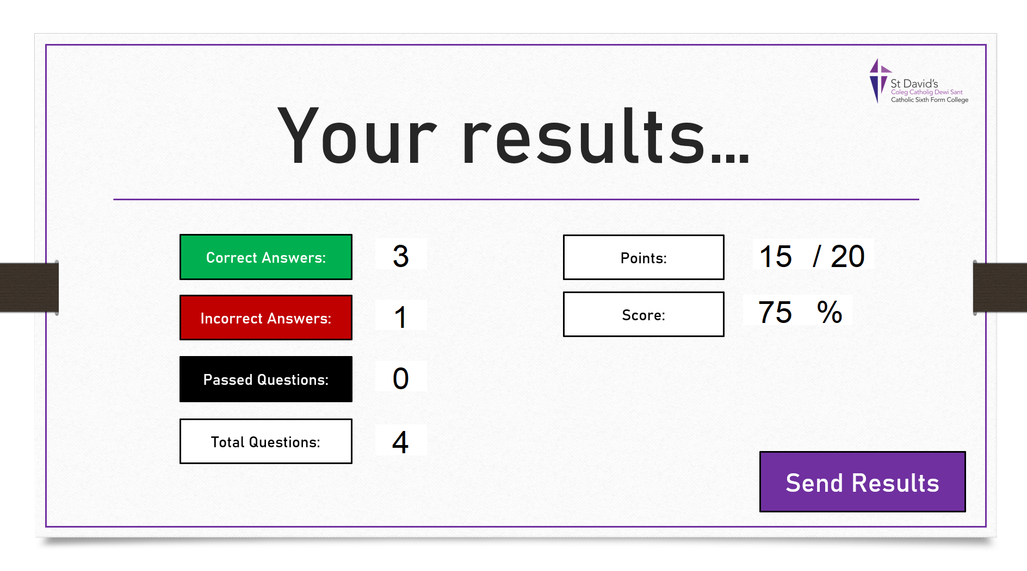
Figure 23: The results slide
The user is then required to click the “Send Results” button to send the results to their teacher. This button runs a subroutine with many processes in the background, however it will also generate a confirmation message for the user, as shown in Figure 24:
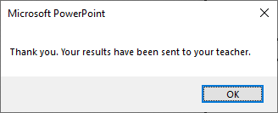
Figure 24: Confirmation of results being sent

The subroutine will also create a new blank Microsoft Excel workbook using the values held in the student name and student ID variables entered at the start of the quiz. It will then set up column headings on a new worksheet and populate the rows underneath with the values stored in the array containing the answer selected for each question. The teacher will then receive a copy of the users results and each filename will be unique as it will be prefixed with the student’s name. An example of the results worksheet is shown in Figure 25, with a magnified version in Figure 26 :
Figure 25: The results worksheet generated in Microsoft Excel

Figure 26: The results worksheet generated in Microsoft Excel (magnified)

5. Results and Discussions / Evaluation
This section is concerned with considering the results after consultation with end users and evaluating the findings. This will take three forms:
- Evaluating the results from the System Usability Scale.
- Evaluating the results from the User Experience Questionnaire.
- Determining how successful the development was in achieving the objectives outlined in Section of this report.

5.1 System Usability Scale (SUS) results
The System Usability Scale (SUS) is described as a relatively quick and efficient way to measure the usability of a new system and gather statical data. There are ten questions for users to answer and the responses are measured using a Likert scale, with responses ranging from Strongly Agree to Strongly Disagree [67]. An example of the System Usability Scale is shown in Table 8:
 | Question | Strongly Disagree  1 | 2 | 3 | 4 | Strongly Agree  5
1 | I think that I would like to use this system frequently.
2 | I found the system unnecessarily complex.
3 | I thought the system was easy to use.
4 | I think that I would need the support of a technical person to be able to use this system.
5 | I found the various functions in this system were well integrated.
6 | I thought there was too much inconsistency in this system.
7 | I would imagine that most people would learn to use this system very quickly.
8 | I found the system very cumbersome to use.
9 | I felt very confident using the system.
10 | I needed to learn a lot of things before I could get going with this system.

Table 8: An example of the System Usability Scale (SUS)
Adobe [68] explain that each response is assigned a point to calculate the overall score as follows:
- (1) Strongly Disagree – 1 point
- (2) Disagree – 2 points
- (3) Neutral) – 3 points
- (4) Agree – 4 points
- (5) Strongly Agree – 5 points

To calculate the score for each respondent:
- For all odd numbered questions (2,4,6,8,10), add together the score and subtract 5
- For all even numbered questions (1,3,5,7,9), add together the score and subtract it from 25
- Calculate the total score by adding both values together and then multiply by 2.5
- This then gives a range of possible values between 0 and 100 [69]

According to UIUX Trend [69], the average score is 68. If the score is under 68 then there may be potential issues that need to be investigated further. Any score over 68 is deemed as good, with anything over 80 moving into the excellent category.

7 members of teaching staff were included in the testing process. They were all invited to review the new “E-learning tools” tab and also experiment with the new quiz functionality. A copy of the System Usability Scale was then distributed to all staff in the sample, and there were 7 responses. The consolidated results of the questionnaires are shown in Table 9:

 | Question | Strongly Disagree  1 | 2 | 3 | 4 | Strongly Agree  5 | Total
1 | I think that I would like to use this system frequently. | 0 | 0 | 3 | 12 | 15 | 30
2 | I found the system unnecessarily complex. | 0 | 4 | 9 | 8 | 0 | 21
3 | I thought the system was easy to use. | 0 | 2 | 3 | 8 | 15 | 28
4 | I think that I would need the support of a technical person to be able to use this system. | 2 | 2 | 6 | 8 | 0 | 18
5 | I found the various functions in this system were well integrated. | 0 | 0 | 6 | 16 | 5 | 27
6 | I thought there was too much inconsistency in this system. | 2 | 4 | 9 | 0 | 0 | 15
7 | I would imagine that most people would learn to use this system very quickly. | 0 | 0 | 3 | 20 | 5 | 28
8 | I found the system very cumbersome to use. | 1 | 6 | 6 | 4 | 0 | 17
9 | I felt very confident using the system. | 0 | 0 | 6 | 16 | 5 | 27
10 | I needed to learn a lot of things before I could get going with this system. | 3 | 6 | 1 | 0 | 0 | 10

Table 9: Consolidated results of the System Usability Scale
NB – all calculations based on 7 responses

Odd total: 140
Even total: 81

Calculating the score:
Odd questions total = 140 - 35 Total: 105
Even questions total = 175 - 81 Total: 94
SUS Score: ((105 + 94) / 7) x 2.5 TOTAL: 71.07

The System Usability Scale results have produced a final score of 71.07. This means that the new tab has scored slightly higher than the average score of 68. This is very pleasing. After analysing the results there were some key findings:
- The majority of the issues around complexity in question 2 were centered around using the new quiz tools. Some respondents felt that they were not well equipped to deal with any errors that occurred, particularly if there were any runtime errors in the VBA code or macros. Although some help for the user has been built into the new system, it is clear that more work needs to be done here to ensure all users feel confident when using it. There will also need to be a strong emphasis on training for users to ensure this is achieved.
- The score for question 4 was mostly based around the same issues identified for question 2. Some respondents felt they would need to contact IT support at some stage to help them with the system.
- There were some comments about useful it was to have all related tools in one location, and this is reflected in the scores for question 1, 3 and 5. Some respondents did not know that the Ribbon could be customised in this way, and it has generated questions around what else could be achieved through this process. There may potentially need to be training around this in the future.
- It was clear that the majority of respondents felt confident in using the system, as reflected in the scores for questions 7 and 9. This is likely to be because of existing familiarity with PowerPoint and Office software.
- Despite the fact that the animation and transition tools were not brought onto the new tab, it was good to see positive scores for consistency and integration in questions 5 and 6.

5.2 User Experience Questionnaire (UEQ) results
The User Experience Questionnaire (UEQ) is described as a fast and reliable method to measure a number of aspects of the user experience [70]. There are 6 categories in total including:
- Attractiveness – users’ overall impression of the system/product
- Perspicuity – the level of familiarity and intuitiveness
- Efficiency – the ability to solve tasks without additional effort
- Dependability – users feeling in control of their interaction
- Stimulation – the level of excitement and motivation experienced by users
- Novelty – the level of innovation and creativity of the system/product
There are 26 different items to be answered and each one consists of a 7-point scale [70]. An example of the User Experience Questionnaire is show in Figure 27:

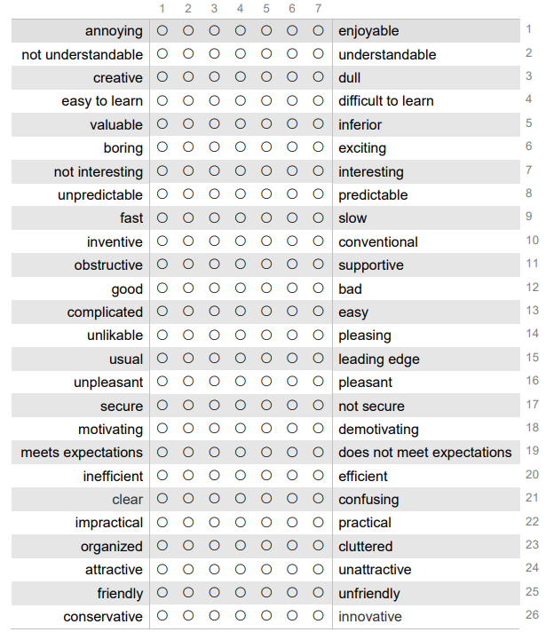
Figure 27: An example of the User Experience Questionnaire (UEQ) [70]

Again, 7 members of teaching staff were included in the testing process. They were all invited to review the new “E-learning tools” tab and also experiment with the new quiz functionality. A copy of the User Experience Questionnaire was then distributed to all staff in the sample, and there were 7 responses, as shown in Figure 28:

Figure 28: Individual responses to the User Experience Questionnaire

The distribution of answers is shown in Figure 29 :
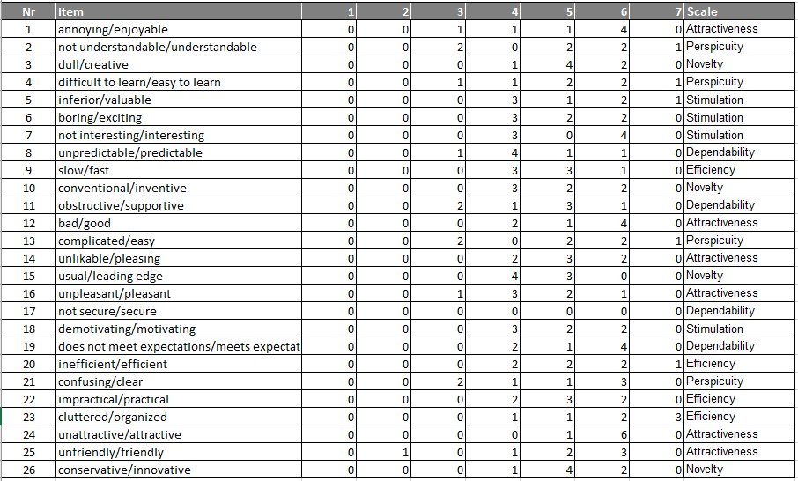
Figure 29: Distribution of answers using the User Experience Questionnaire

A visual representation of the distribution of answers is shown in Figure 30:
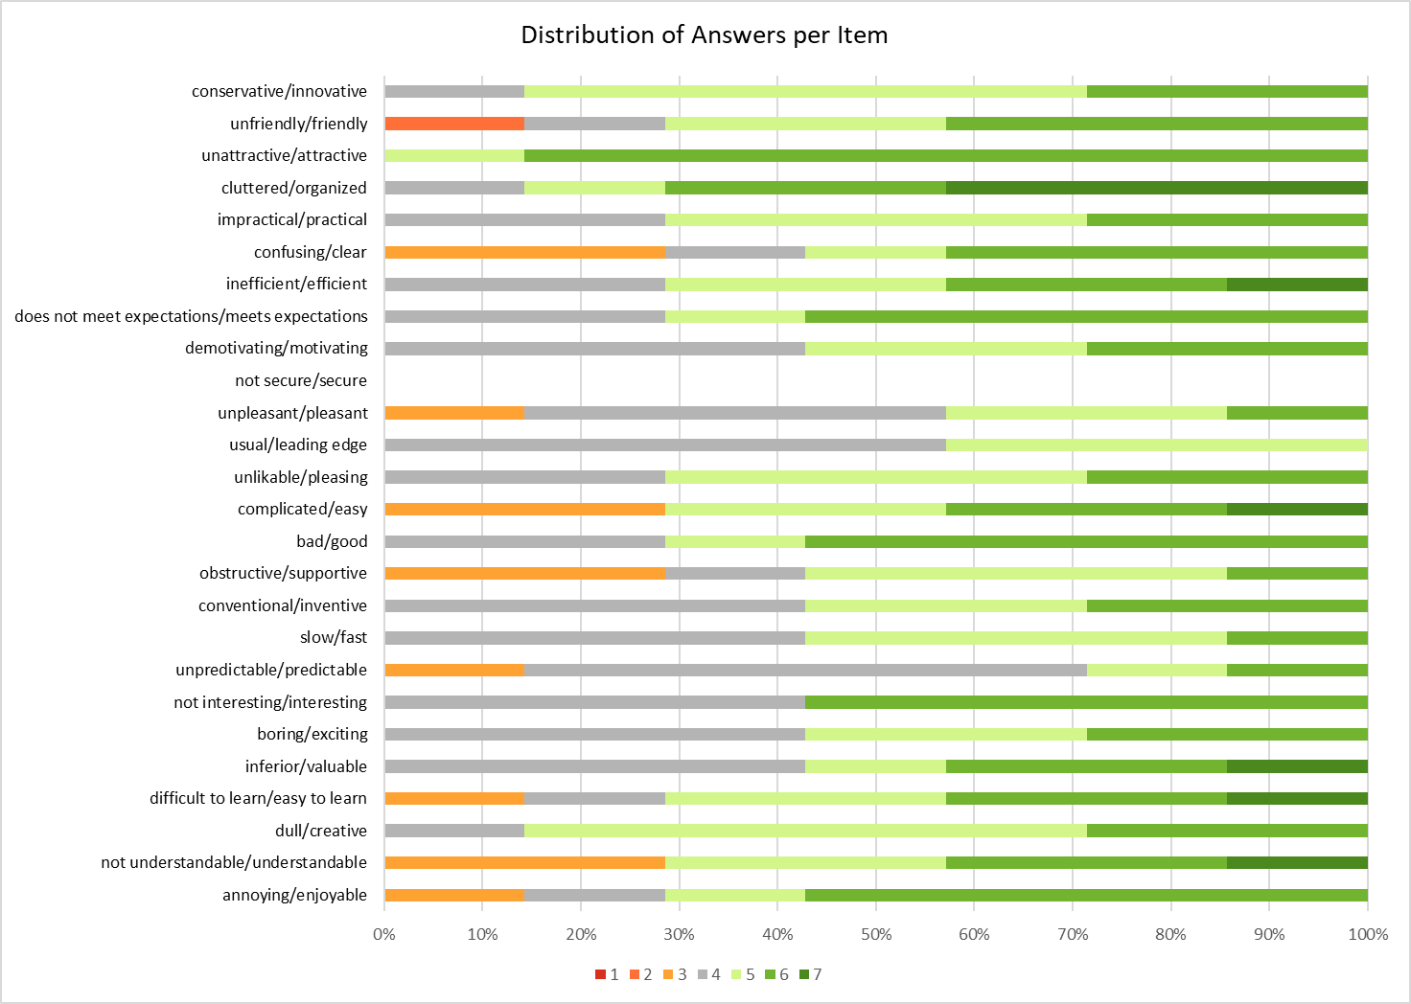
Figure 30: Visual representation of answers using the User Experience Questionnaire

Finally, a consolidation of the results for each category of the UEQ is shown in Figure 31:
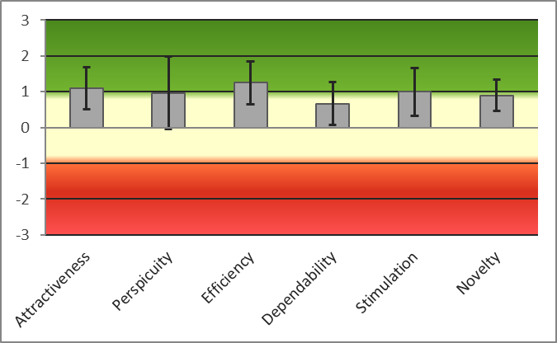
Figure 31: Consolidation of results by category of the User Experience Questionnaire
NB: All users were asked not to score the security question (17) as it was deemed inappropriate in this instance.

Upon analysing the results of the User Experience Questionnaire, it is clear to see that the lowest scoring categories were perspicuity and dependability. This was not unexpected. Perspicuity deals with all of the questions relating to the new tab being easy to understand, simple, clear, and intuitive to use. There were also issues identified in the System Usability Scale relating to these areas of the new tab and this could be an extension of that. Dependability deals with the questions relating to whether the new tab meets the users’ expectations and if it supports them in completing their tasks. Again, there were similar issues identified in the responses to the System Usability Scale. It is very important that these issues are investigated further, and suitable amendments and improvements made to the new tab before it can be issued to all teachers.
The highest scoring categories were those relating to efficiency, attractiveness, stimulation, and novelty. This also reflects the results of the System Usability Questionnaire and suggests that the majority of respondents found the new tab to be attractive, enjoyable, and pleasant to use, as well as being able to allow them to complete their tasks in a more efficient way. They found the interface to be organised, innovative, and in some cases, interesting and motivating to use. These results are very positive and welcomed.
It is important to note a couple of issues that were identified during this process. Firstly, it is possible that some of the teachers asked to respond may have been confused by the terminology used in the questionnaires. Depending on their interpretation of each question, this could possibly have led to them not fully understanding what exactly they were scoring. This issue was also compounded by the fact that the teachers were asked for their feedback on the new “E-learning tools” tab as a whole, which incorporated the new quiz tools. It was already identified from the results in the System Usability Scale that some of the teachers had problems with understanding how to use the new quiz tools, particularly if there were error messages generated by the VBA code. There is a possibility that some of the results may have been skewed by whether or not an individual teacher had a problem with the quiz tools or not.
On reflection, it would have been better to issue two sets of both questionnaires: one for the “E-learning tools” tab, and another for the new quiz tools. This would have helped focus the feedback on specific areas and created a true picture of where any improvements may need to be made in future.

5.3 Reflecting on the literature
In the review of literature in Section 2, a rubric model from Anstey and Gavan [26] that evaluates the suitability of e-learning tools was identified. Having now completed the implementation of the new “E-learning tools” tab in PowerPoint, it would be appropriate to evaluate it using the rubric. The findings of this process are shown in Table 10:

Category | Criteria | Works Well | Minor Concerns | Serious Concerns | Not applicable | Evaluation
Functionality | Scale | X |  |  |  | The new tab can be scaled to many users, and could be tailored for subgroups in the future
Functionality | Ease of Use |  | X |  |  | Some amendments need to be made before the tab is fully user friendly and intuitive
Functionality | Tech Support / Help Availability |  | X |  |  | Technical support is available but help documentation/training materials will need to be created to improve this score
Functionality | Hypermediality |  |  |  | X | Not applicable
Accessibility | Accessibility standards |  | X |  |  | Meeting accessibility guidelines is possible as using an established piece of software; however, the new quiz tools will need to be assessed for accessibility as they are a bespoke program
Accessibility | User-focused participation |  | X |  |  | The tab appeals to users with various degrees of digital literacy, but there are outstanding issues from the testing results to be resolved
Accessibility | Required Equipment | X |  |  |  | No specialised equipment is required
Accessibility | Cost of Use | X |  |  |  | The new tab does not require additional costs beyond the cost of existing software
Technical | Integration / Embedding within a LMS |  |  |  | X | LMS are not anticipated to be used
Technical | Desktop/Laptop Operating Systems | X |  |  |  | Can be used with any up-to-date desktop or laptop operating system
Technical | Browser |  |  |  | X | The tab will function only on the desktop version of Office as there is no option to customise the Ribbon in the online versions
Technical | Additional Downloads | X |  |  |  | Users do not need to download any additional software
Mobile Design | Access |  |  | X |  | Access to the tool is only possible through a desktop or laptop
Mobile Design | Functionality |  |  |  | X | No mobile app available
Mobile Design | Offline Access | X |  |  |  | The tab can be used offline – no requirement for the Internet
Privacy, Data Protection, and Rights | Sign Up/Sign In |  |  |  | X | No requirement to sign up
Privacy, Data Protection, and Rights | Data Privacy and Ownership |  |  |  | X | No data sharing is expected
Privacy, Data Protection, and Rights | Archiving, Saving and Exporting Data |  |  |  | X | Content can be saved but there is no activity data in the system
Social Presence | Collaboration |  |  |  | X | No collaboration tools available
Social Presence | User Accountability | X |  |  |  | Learners can be held accountable for their actions using the tab (quiz tools in particular)
Social Presence | Diffusion | X |  |  |  | As the tab is an extension built into an already familiar piece of software, most users will be familiar with it
Teaching Presence | Facilitation |  |  |  | X | No facility to manage, monitor or engage with learners
Teaching Presence | Customisation | X |  |  |  | The tab is able to be customised further to suit teacher requirements
Teaching Presence | Learning Analytics |  |  |  | X | No learning analytics provided
Cognitive Presence | Enhancement of Cognitive Tasks |  | X |  |  | The new tab could potentially lead to improvements in engagement of tasks
Cognitive Presence | Higher Order Thinking |  | X |  |  | Depending on the content of individual lessons, higher order thinking skills could be assessed
Cognitive Presence | Metacognitive Engagement | X |  |  |  | Learners can have their knowledge tested using the new quiz tools and their performance could be tracked

Table 10: Evaluating the new tab using the rubric from Anstey and Gavan [26]

A visual representation of these results, disregarding those which were not applicable, is shown in Figure 32:

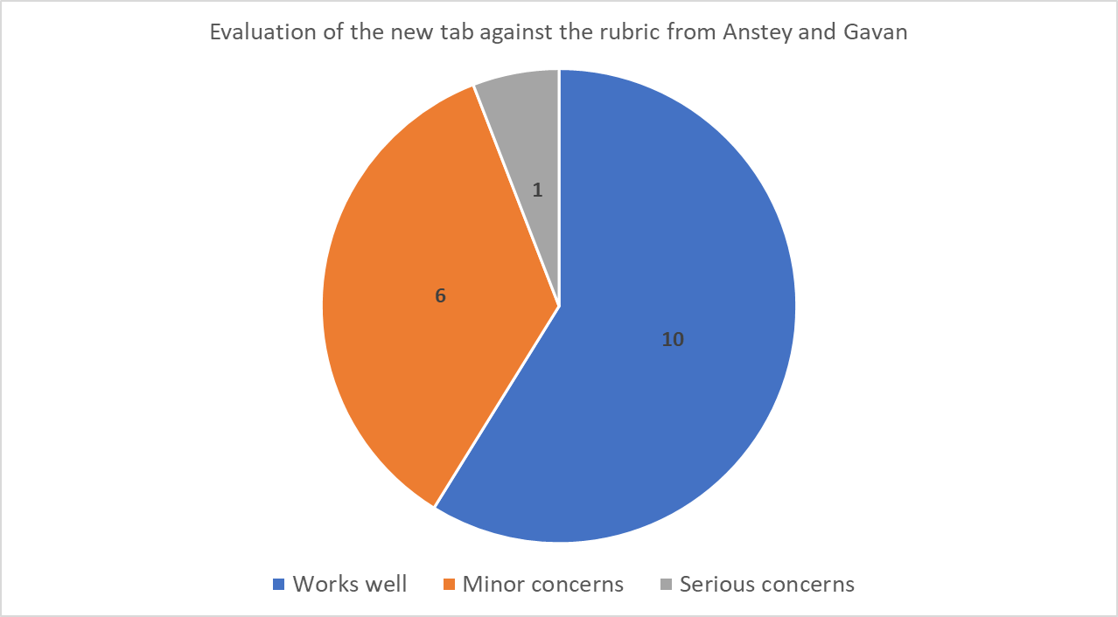

Figure 32: Evaluation of the new tab against the rubric from Anstey and Gavan

It is clear to see from the pie chart, that the majority of the criteria in the rubric were graded as “Works well”, closely followed by “Minor concerns”. This was a very positive outcome and suggests that, on the whole, the new tab would be suitable to use to support e-learning.
There was only 1 criterion that was graded as “Serious concerns”, and that was the inability to use the tab using a mobile device. However, this is not only limited to the new tab. Although there are mobile versions of Microsoft Office available, their functionality is limited, and the size of mobile devices usually limits productivity. It is therefore not deemed to be a serious concern in this context.
There were 10 criteria that were graded as “Not applicable” due to the nature of the new tab.

5.4 Evaluation of Project Objectives
- To investigate the development and current state of online learning tools for developing e-learning materials.
It was found that there is a wide range of terminology used to describe e-learning and that there are three broad categories of e-learning environments including e-learning platforms, e-learning tools, and authoring software, as well as learning management systems (LMS). The focus of the project was narrowed to specifically focus on e-learning authoring tools. However, these can again be broken down into three categories including web authoring tools, course authoring tools and professional course authoring tools. All of these different categories of tools come with their own advantages and disadvantages. It was clear from the research conducted that e-learning is most certainly a growing area, but it was also clear that confusion can arise from the vast range and choice of tools that are available. It can be very confusing for users to know which tool is best suited for their needs. The top-level comparison of professional course authoring tools showed that all of them have strengths in different areas, and they all require a significant financial commitment. It is therefore vital that users are able to assess whether the tool they wish to invest in is the right one for them. The rubric created by Anstey and Gavan [26] for assessing the suitability of e-learning tools goes someway to help with this and was successfully used when evaluating the new “E-learning tools” tab.

- To investigate the current state of teacher engagement with and adoption of tools for online learning.
It was found that there were limited up-to-date statistics available that could help to gauge the use of e-learning tools in education settings. It is certainly true that before the Covid-19 pandemic, the use of e-learning tools in school, colleges and universities was sporadic and piecemeal. The pandemic has caused a shift in the way teachers deliver their lessons and this will have driven them to utilise e-learning tools in some form. It has also acted as a catalyst for upskilling teachers and improving their overall digital literacy.
In some cases, e-learning tools are selected at a top level by the management teams of education settings, whether for financial or other reasons, and teachers are obliged to use them whether or not they are the right tool for the job. The use of e-learning tools in education is certainly an emerging area worthy of further research.

- To create a new “E-learning tools” tab on the Ribbon in Microsoft PowerPoint containing the most commonly used tools.
The new tab was created successfully. It was decided to focus on PowerPoint as it is used by the vast majority of staff. The MoSCoW process was useful and very valuable in determining the most important requirements. These requirements were taken forward and the tab was created accordingly. Tools were grouped together in logical sections on the tab to increase usability for the teachers that would be using it. The process of creating the tab was relatively simple and required the use of the “Customise Ribbon” tool. A new set of quiz tools were also added to the new tab, which allow teachers to create a multiple-choice quiz. Numerous macros were created, and VBA scripts written in order to achieve this functionality. The aim here was to bring the quiz functionality “in-house” and reduce the need for teachers to have to visit external websites.
The feedback from testing the new tab was mostly positive. Indeed, since the testing phase where teaching staff were asked to test the new tab, some staff have been commenting on how they were not aware that the Ribbon could be customised in this way. This has opened up a series of requests for additional training from teaching staff so that they are able to personalise the Ribbon for their own needs. This was an unexpected positive from the project and the ultimate aim is to improve efficiency for all so that staff achieve more in less time.

- To evaluate the new tab using industry standard system usability and user experience tools and consider input from users in an education setting.
The new tab was evaluated by using industry standard tools including the Systems Usability Scale (SUS) and the User Experience Questionnaire (UEQ). Feedback from the System Usability Scale was a score of 71.07, which was above the average score of 68. This was a very positive result and shows that the teachers in the sample are comfortable using the new tab. The creation of the new tab inside PowerPoint has meant that teachers are already familiar with the environment. There were some issues identified with the new quiz tools, which will need to be addressed before a full rollout of the tab can be completed. The majority of teachers are unfamiliar with the concept of VBA code and are not skilled on what action to take in the event of an error. This means that future subroutines need to be created with strong validation methods and robust methods for exception handling. This should help to improve the usability. The User Experience Questionnaire results returned positive scores for efficiency, attractiveness, stimulation, and novelty. It was also identified that respondents found the interface to be organised, innovative, and in some cases, interesting and motivating to use. Similar issues regarding the quiz tools were raised and it was determined that, in future, there should be separate evaluations made for different parts of the system to ensure a clear picture is built of any areas that need further attention.

6. Conclusions and Recommendations
Microsoft Office is widely used across all levels of UK education settings, with schools, colleges and universities all investing heavily in Microsoft Office subscriptions. Microsoft PowerPoint has firmly established itself as a tool of choice for many teachers.
iSpring Suite, as a third-party provider, has already been able to develop software that can be added into PowerPoint in order to give in the necessary functionality to become more of an e-learning authoring tool, rather than just being presentation software. Microsoft should take note of this and be looking at the types of features offered by iSpring Suite. Microsoft does not have any dedicated e-learning software and relies on users manipulating its existing software and tools to get them to do the tasks they require. This is not an easy process, and certainly not one that should be attempted by beginners. There is certainly potential here for Microsoft to improve their e-learning software offer by enhancing the software they already have available. Benefits for existing users would include familiarity and accessibility.

6.2 Suggestions for further work
There is certainly scope for this project idea to be refined and taken further. There are many possibilities with using VBA in Office software. Some things to explore in the future include:
- Creating more robust VBA code that prevents runtime errors as much as possible by using validation techniques and methods for exception handling.
- Teachers receiving student results via email, however with a big class of students this could potentially mean many separate emails arriving. Whilst each email attachment would be named uniquely, it would still add additional workload for teachers to save them separately and open them to extract the results. One improvement here would be for the results for all students to be populated in just one workbook so everything is in one place.
- More time could be spent on developing the timer function for use in the quiz. The timer could be used to limit the time available for each answer, or to provide an overall time limit for the quiz.
- Analytics could be improved, such as recording how much time was spent by each student on each question. This will help to show who has not spent sufficient time on the quiz.
- There will need to be a way to export the new “E-learning tools” toolbar so it can be rolled out to all client machines throughout the college. This will allow for maintenance in the future should there need to be any features added or removed.

Due to the time limit placed on this project, extending into these other areas was not feasible on this occasion. It does however give scope for development in the future.

7. Reflection
The original project idea, to create a framework for educators to evaluate e-learning authoring tools, certainly had scope. There have been significant developments in this technology over recent years and there could potentially be significant benefits to schools, colleges, and universities in adopting such technology. The impact of the Covid-19 pandemic showed how vital this technology was at ensuring continuity of education.
In hindsight, the timing of the project was not ideal. Teachers and other educators were very busy dealing with the new issues and challenges that were being thrown their way and expecting them to be able to find the time to explore new technology at this time was not realistic. When the situation has stabilised and workload demands have eased, there will be a fresh opportunity to revisit this idea again. It may also be a very worthwhile exercise and lead to changes in working practice, as many teachers will have new experiences which they can draw on to shape how technology could be used in the future.
After the original initial interview questionnaire for the first focus of this project had been unsuccessful, I was very fortunate to be able to have direct access to other teachers in order to ask them questions directly. Rather than asking them to complete a questionnaire, I took a more agile approach of asking them for their input, to briefly review a prototype of the new tab, as well as experimenting with the new quiz tools. This method proved successful, and I was able to gather more responses this way. It helped that the teachers could see something tangible and that I was present and able to explain what was going on.
One benefit of working in education myself, was the amount of personal experience I was able to bring to the project. Working in the field, I was already familiar with the extent to which e-learning tools were used in education and the problems and challenges that have come about since the big push to e-learning during the pandemic. It is certainly true that there are a vast number of new tools already available, and more are being released on a regular basis. This is leading to information overload for those in education, as they grapple with having to make decisions about what they should be using, whilst trying to juggle the demands of the job.
Once the project focus had shifted, I found the process of coding with VBA to be quite arduous. Whilst some Office software such as Word and Excel allow the user to record macros to automate tasks, PowerPoint does not offer a similar feature. The only way you can achieve a similar result is to write the code yourself. I have had previous experience of writing programs in Visual Basic and using the Visual Studio Integrated Development Environment before. Whilst there are some links between Visual Basic and VBA, there are also some distinct differences which led to some tasks becoming more time-consuming than necessary. One example of this was when trying to get the code for the slide timer to work correctly. I was able to get the timer to work in a separate presentation file where I had been experimenting with it, but when I tried to replicate the exact same code in the main quiz presentation file it would not work, despite being the same. If I had been using Visual Studio, the software would have alerted me to any errors at run time and directed me to a line number of code which may be incorrect. There would also have been a brief description of the error, as well as alternative options suggested by the onboard Intellisense which works as a code-completion aid. All of these features are a good starting point when trying to find a solution. Unfortunately, VBA does not provide the same level of support and is not as intuitive, leading to longer development times.
Some elements of completing the project were made easier having studied other modules during completion of the MSc. in Applied Computing, particularly the User Experience Design module. This module introduced me to the concept of the MoSCoW process for user and experience requirements, as well as how to analyse a system against both the System Usability Scale (SUS) and the User Experience Questionnaire (UEQ). Having had experience with all of these methods, I was able to adapt them and apply them to the project relatively quickly.
Throughout the project I have strived to be as organised as possible. I have tried to manage my time well and give sufficient time to each section. I have taken steps to back up my work securely at regular intervals and reviewed it regularly to ensure it is completed to the best possible standard. I have attended meetings regularly with my project supervisor and sought feedback at regular intervals so I can refine and improve my work. I am pleased that the project has been completed successfully and that all of the project objectives have been achieved.

8. References
[1] G. Rees (1905774), “Research Proposal,” 2020.
[2] G. Siemens, D. Gasevic, and S. Dawson, “Preparing for the digital university : a review of the history and online learning,” Athabasca Univ. Press, no. January, 2015, [Online]. Available: https://www.researchgate.net/publication/284023691_Preparing_for_the_digital_university_a_review_of_the_history_and_current_state_of_distance_blended_and_online_learning.
[3] A. Pregowska, K. Masztalerz, M. Garlińska, and M. Osial, “A worldwide journey through distance education—from the post office to virtual, augmented and mixed realities, and education during the covid-19 pandemic,” Educ. Sci., vol. 11, no. 3, 2021, doi: 10.3390/educsci11030118.
[4] S. Asgari and A. Mehrpouyan, “A Group Comparison of E-Learning Authoring Tools in Educational Production and Management,” Indian J. Sci. Technol., vol. 11, no. 24, pp. 1–6, 2018, doi: 10.17485/ijst/2018/v11i24/123052.
[5] T. Anderson and J. Dron, “Three generations of distance education pedagogy,” Int. Rev. Res. Open Distance Learn., vol. 12, no. 3, pp. 80–97, 2011, doi: 10.19173/irrodl.v12i3.890.
[6] J. L. Moore, C. Dickson-Deane, and K. Galyen, “e-Learning, online learning, and distance learning environments: Are they the same?,” 2010, doi: 10.1016/j.iheduc.2010.10.001.
[7] V.-M. Cojocariu, I. Lazar, V. Nedeff, and G. Lazar, “SWOT Anlysis of E-learning Educational Services from the Perspective of their Beneficiaries,” Procedia - Soc. Behav. Sci., vol. 116, pp. 1999–2003, 2014, doi: 10.1016/j.sbspro.2014.01.510.
[8] M. Haughey, “Distance learning - the Canadian encyclopedia,” Can. Encycl., 2013, Accessed: Jul. 31, 2021. [Online]. Available: https://www.thecanadianencyclopedia.ca/en/article/distance-learning.
[9] J. Traxler, “Distance learning—Predictions and possibilities,” Educ. Sci., vol. 8, no. 1, 2018, doi: 10.3390/educsci8010035.
[10] I. Almarashdeh, “Sharing instructors experience of learning management system: A technology perspective of user satisfaction in distance learning course,” Comput. Human Behav., vol. 63, pp. 249–255, 2016, doi: 10.1016/j.chb.2016.05.013.
[11] D. A. Back, F. Behringer, N. Haberstroh, J. P. Ehlers, K. Sostmann, and H. Peters, “Learning management system and e-learning tools: An experience of medical students’ usage and expectations,” Int. J. Med. Educ., vol. 7, pp. 267–273, 2016, doi: 10.5116/ijme.57a5.f0f5.
[12] M. Khademi, M. Haghshenas, and H. Kabir, “E-Learning and Authoring Tools: At a Glance E Learning View project data mining View project E-LEARNING AND AUTHORING TOOLS : At a Glance,” vol. 10, no. 2, pp. 259–263, 2012, [Online]. Available: www.arpapress.com/Volumes/Vol10Issue2/IJRRAS_10_2_08.pdf.
[13] UK Department for Education, “Realising the potential of technology in education,” p. 48, 2019, [Online]. Available: https://www.gov.uk/government/publications/realising-the-potential-of-technology-in-education.
[14] “A New Pedagogy Is Emerging... and Online Learning Is a Key Contributing Factor | teachonline.ca.” https://teachonline.ca/tools-trends/how-teach-online-student-success/new-pedagogy-emerging-and-online-learning-key-contributing-factor (accessed Aug. 03, 2021).
[15] R. Resalat, “What’s distance learning?,” Complete University Guide, 2020. https://www.thecompleteuniversityguide.co.uk/student-advice/what-to-study/what-is-distance-learning (accessed Jul. 31, 2021).
[16] “OU50.” http://www2.open.ac.uk/about/annual-report-2018-19/ (accessed Aug. 02, 2021).
[17] Universities UK, “Flexible learning: the current state of play in UK higher education,” 2018. Accessed: Jul. 31, 2021. [Online]. Available: https://www.universitiesuk.ac.uk/policy-and-analysis/reports/Pages/flexible-learning.aspx.
[18] Ofcom, “Children and parents: media use and attitudes report Content consumption and online activities,” no. April, 2021.
[19] “Coronavirus has intensified the UK’s digital divide.” https://www.cam.ac.uk/stories/digitaldivide (accessed Aug. 04, 2021).
[20] B. S. Bell and J. E. Federman, “DigitalCommons @ ILR E-Learning in Postsecondary Education E-Learning in Postsecondary Education,” vol. 23, no. 1, pp. 165–185, 2013.
[21] “Laptops, tablets and 4G wireless routers progress data as of 12 January 2021 - GOV.UK.” https://www.gov.uk/government/publications/laptops-tablets-and-4g-wireless-routers-progress-data (accessed Aug. 09, 2021).
[22] A. D. Dumford and A. L. Miller, “Online learning in higher education: exploring advantages and disadvantages for engagement,” J. Comput. High. Educ., vol. 30, no. 3, pp. 452–465, 2018, doi: 10.1007/s12528-018-9179-z.
[23] V. Arkorful and N. Abaidoo, “The role of e-learning, the advantages and disadvantages of its adoption in Higher Education,” Int. J. Educ. Res., vol. 2, no. 12, pp. 22–34, 2014, doi: 10.5958/2347-7202.2020.00003.1.
[24] D. Serhan, “Transitioning from Face-to-Face to Remote Learning: Students’ Attitudes and Perceptions of using Zoom during COVID-19 Pandemic,” Int. J. Technol. Educ. Sci., vol. 4, no. 4, pp. 335–342, 2020, doi: 10.46328/ijtes.v4i4.148.
[25] “Technology and tools for online learning | Jisc.” https://www.jisc.ac.uk/full-guide/technology-and-tools-for-online-learning (accessed Aug. 21, 2021).
[26] L. M. Anstey and G. P. L. Watson, “Rubric for eLearning tool evaluation,” Cent. Teach. Learn. West. Univ., pp. 1–7, 2018, [Online]. Available: https://teaching.uwo.ca/pdf/elearning/Rubric-for-eLearning-Tool-Evaluation.pdf.
[27] “SCORM Explained: In Depth Review of the SCORM eLearning Standard.” https://scorm.com/scorm-explained/?utm_source=google&utm_medium=natural_search (accessed Aug. 21, 2021).
[28] “Introduction to Web Accessibility | Web Accessibility Initiative (WAI) | W3C.” https://www.w3.org/WAI/fundamentals/accessibility-intro/#context. (accessed Jul. 31, 2021).
[29] GOV.UK, “Data protection: toolkit for schools - GOV.UK,” no. August, 2018, [Online]. Available: https://www.gov.uk/government/publications/data-protection-toolkit-for-schools.
[30] “Data protection - GOV.UK.” https://www.gov.uk/data-protection (accessed Jul. 31, 2021).
[31] C. (Defta) Costinela-Luminiţa and C. (Iacob) Nicoleta-Magdalena, “E-learning Security Vulnerabilities,” Procedia - Soc. Behav. Sci., vol. 46, pp. 2297–2301, 2012, doi: 10.1016/j.sbspro.2012.05.474.
[32] “Keeping children safe in education - GOV.UK.” https://www.gov.uk/government/publications/keeping-children-safe-in-education--2 (accessed Aug. 09, 2021).
[33] “Safeguarding and remote education during coronavirus (COVID-19) - GOV.UK.” https://www.gov.uk/guidance/safeguarding-and-remote-education-during-coronavirus-covid-19#virtual-lessons-and-live-streaming (accessed Aug. 09, 2021).
[34] “What’s working well in remote education - GOV.UK.” https://www.gov.uk/government/publications/whats-working-well-in-remote-education/whats-working-well-in-remote-education (accessed Jul. 31, 2021).
[35] “Bloom’s Digital Taxonomy: An Update | Tech & Learning.” https://www.techlearning.com/news/updating-blooms-taxonomy-for-digital-learning (accessed Aug. 21, 2021).
[36] “Integrating Technology with Bloom’s Taxonomy - Teach Online.” https://teachonline.asu.edu/2016/05/integrating-technology-blooms-taxonomy/ (accessed Aug. 21, 2021).
[37] “The Learning Pyramid.” https://huntsman.usu.edu/learntwice/articles/the-learning-pyramid (accessed Aug. 21, 2021).
[38] “The Learning Pyramid.” https://www.educationcorner.com/the-learning-pyramid.html (accessed Aug. 21, 2021).
[39] K. Antonis, T. Daradoumis, S. Papadakis, and C. Simos, “Evaluation of the effectiveness of a web-based learning design for adult computer science courses,” IEEE Trans. Educ., vol. 54, no. 3, pp. 374–380, 2011, doi: 10.1109/TE.2010.2060263.
[40] “A CASE STUDY OF THE BARRIERS AND ENABLERS AFFECTING TEACHING STAFF E-LEARNING PROVISION Marie Cahillane , Victoria Smy , and Piers MacLean,” pp. 168–176, 2016.
[41] S. Dhawan, “Online Learning: A Panacea in the Time of COVID-19 Crisis,” J. Educ. Technol. Syst., vol. 49, no. 1, pp. 5–22, 2020, doi: 10.1177/0047239520934018.
[42] “Optimizing PowerPoint for E-learning - Learning Revolution.” https://www.learningrevolution.net/powerpoint-for-elearning/ (accessed Jan. 01, 2022).
[43] “Adobe Captivate - All New & Top Features.” https://www.adobe.com/uk/products/captivate/features.html (accessed Oct. 27, 2021).
[44] “Articulate 360 - Mobile Learning Development Done Right - Rise 360.” https://articulate.com/360/rise (accessed Oct. 27, 2021).
[45] “Articulate 360 - Build Highly Interactive E-Learning Courses with Storyline 360.” https://articulate.com/360/storyline (accessed Oct. 27, 2021).
[46] “The Microlearning SCORM Authoring Tool | EdApp Microlearning.” https://www.edapp.com/authoring-tool/ (accessed Oct. 27, 2021).
[47] “Your Cloud-Based E-Learning Authoring Tool | isEazy.” https://iseazy.com/en (accessed Oct. 27, 2021).
[48] “Fast eLearning Authoring Tool | iSpring Suite.” https://www.ispringsolutions.com/ispring-suite?utm_campaign=eLearningIndustrySuitePPC&utm_source=eLearningIndustryDirectory&utm_medium=cpc&ppc_allowed=0 (accessed Oct. 27, 2021).
[49] “Lectora Course Authoring Tool for eLearning Industry.” https://hub.elearningbrothers.com/lectora-course-authoring-elearningindustry-1?utm_source=eLearningIndustryDirectory&utm_medium=cpc&utm_id=eLearningIndustryPPC&ppc_allowed=0 (accessed Oct. 27, 2021).
[50] “Sleave | Free Your Imagination.” https://esleave.com/web/ (accessed Oct. 27, 2021).
[51] Collis.J; Hussey.R, Business Research: A practical guide for undergraduate and postgraduate students. Hampshire: Palgrave Macmillan, 2017.
[52] Saunders.M; Lewis.P; Thornhill.A, Research Methods for Business Students. Essex: Pearson Education, 2015.
[53] Yin.R, Applications of Case Study Research. London: Sage Publications Ltd., 2017.
[54] “Deduction & Induction - Research Methods Knowledge Base.” https://conjointly.com/kb/deduction-and-induction/ (accessed Sep. 18, 2021).
[55] Robson.C; McCartan.K, Real World Research. Oxford: John Wiley & Sons, 2015.
[56] “Group Chat - Team Chat - Collaboration | Microsoft Teams.” https://www.microsoft.com/en-gb/microsoft-teams/group-chat-software (accessed Jan. 01, 2022).
[57] “Microsoft PowerPoint Slide Presentation Software | Microsoft 365.” https://www.microsoft.com/en-us/microsoft-365/powerpoint (accessed Jan. 01, 2022).
[58] “Kahoot! for schools: how it works | Feature overview.” https://kahoot.com/schools/how-it-works/ (accessed Jan. 01, 2022).
[59] “Quizizz – Free Quizzes and Lessons to Engage Every Student.” https://quizizz.com/teachers?ref=header_tab (accessed Jan. 01, 2022).
[60] “Create in Sway.” https://support.microsoft.com/en-us/office/create-in-sway-db30c63b-6548-456d-b0e2-9fcd68bfa7a0?ui=en-us&rs=en-us&ad=us (accessed Jan. 01, 2022).
[61] “Learning tools and flashcards - for free! | Quizlet.” https://quizlet.com/en-gb (accessed Jan. 01, 2022).
[62] “Whiteboard.fi - Free online whiteboard for teachers and classrooms.” https://whiteboard.fi/ (accessed Jan. 01, 2022).
[63] “Nearpod: You’ll wonder how you taught without it.” https://nearpod.com/ (accessed Jan. 01, 2022).
[64] “Software development and the MoSCoW method - Parker Software.” https://www.parkersoftware.com/blog/software-development-and-the-moscow-method/ (accessed Jan. 02, 2022).
[65] “Getting started with VBA in Office | Microsoft Docs.” https://docs.microsoft.com/en-us/office/vba/library-reference/concepts/getting-started-with-vba-in-office (accessed Jan. 03, 2022).
[66] “PowerPoint VBA.” https://pptvba.com/ (accessed Jan. 08, 2022).
[67] “How To Use The System Usability Scale (SUS) To Evaluate The Usability Of Your Website - Usability Geek.” https://usabilitygeek.com/how-to-use-the-system-usability-scale-sus-to-evaluate-the-usability-of-your-website/ (accessed Jan. 02, 2022).
[68] “The System Usability Scale & How it’s Used in UX | Adobe XD Ideas.” https://xd.adobe.com/ideas/process/user-testing/sus-system-usability-scale-ux/ (accessed Jan. 07, 2022).
[69] “Measuring and Interpreting System Usability Scale (SUS) - UIUX Trend.” https://uiuxtrend.com/measuring-system-usability-scale-sus/ (accessed Jan. 07, 2022).
[70] “User Experience Questionnaire (UEQ).” https://www.ueq-online.org/ (accessed Jan. 07, 2022).

Appendix 1 – Initial questionnaire
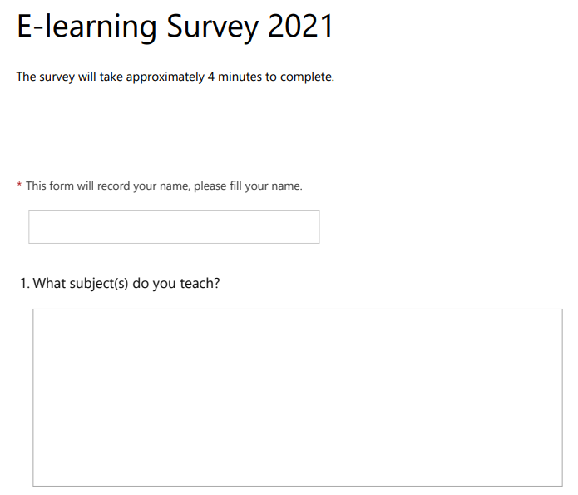
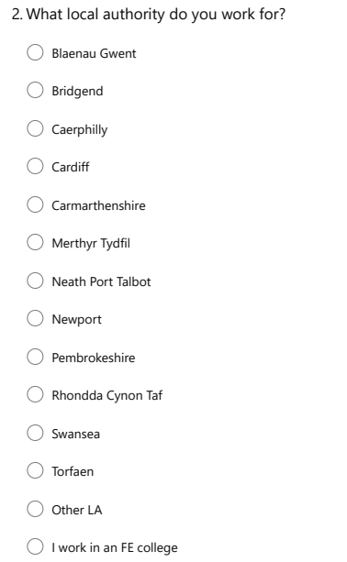

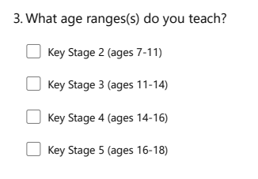
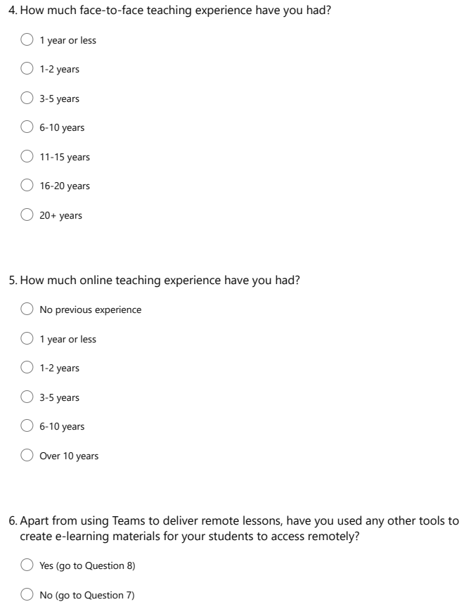

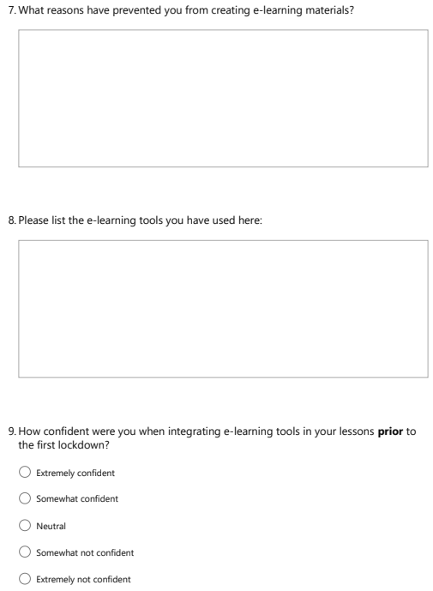

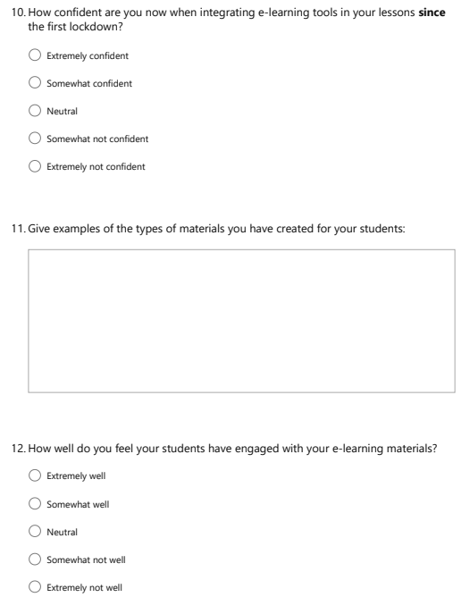

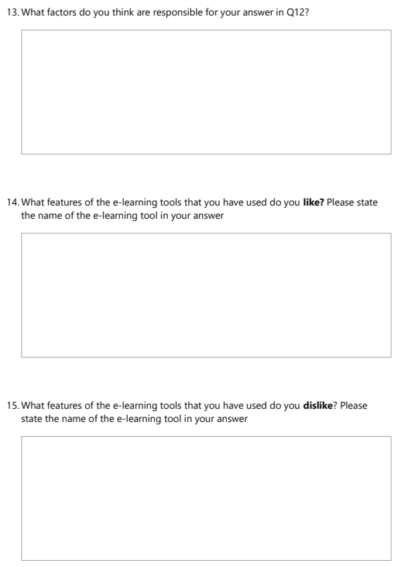

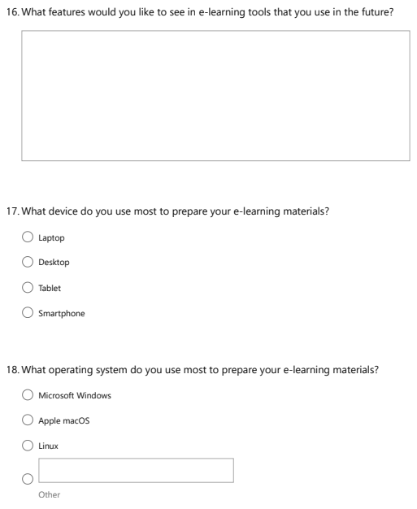

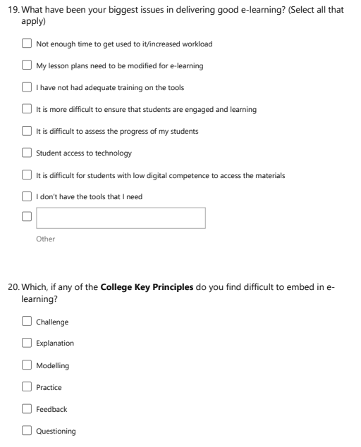

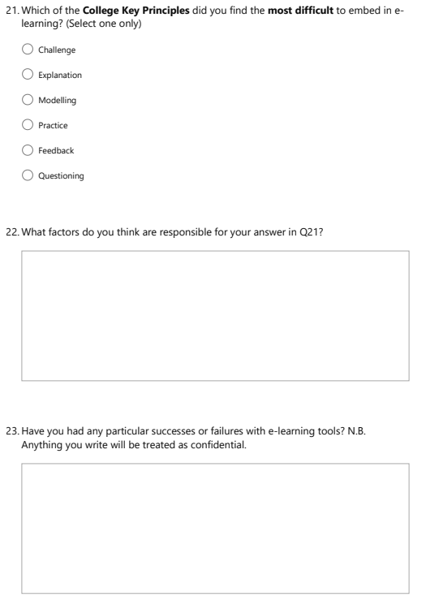

Appendix 2 – VBA code for new quiz functionality
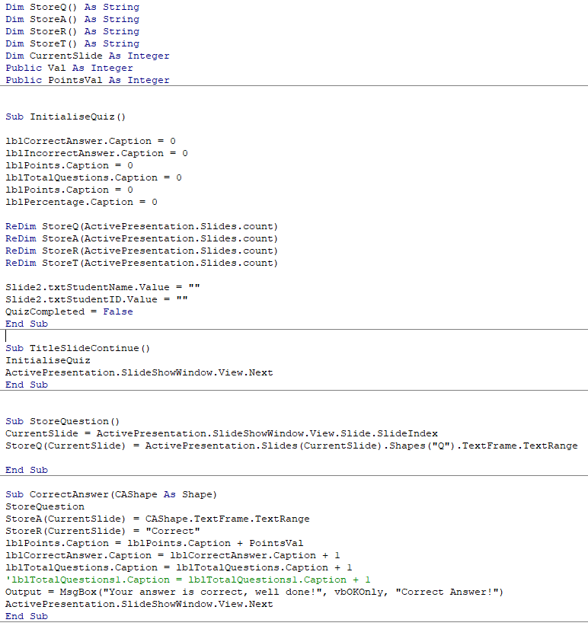
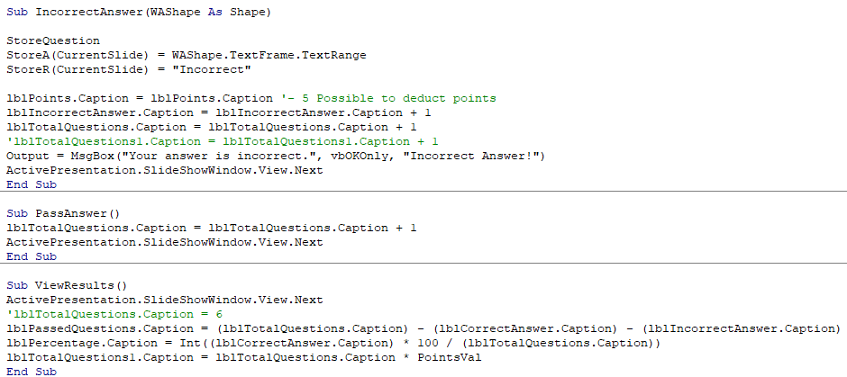

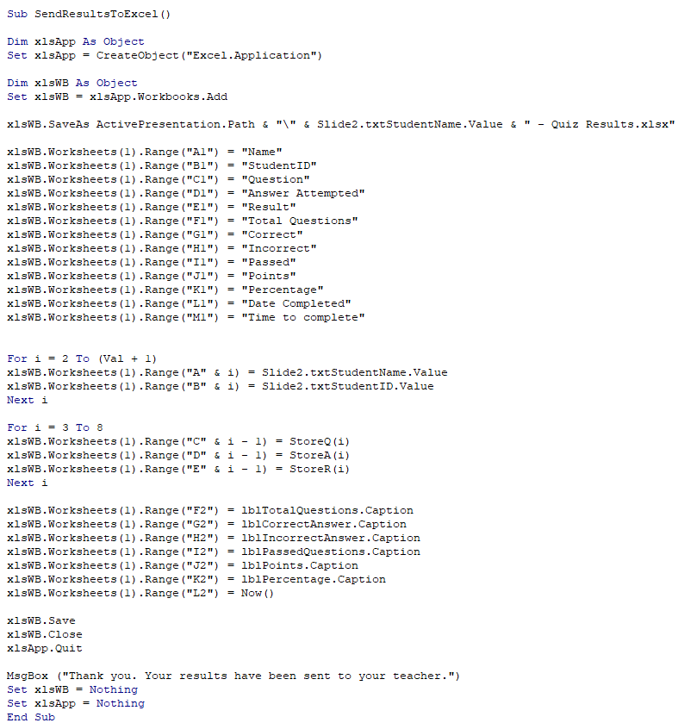

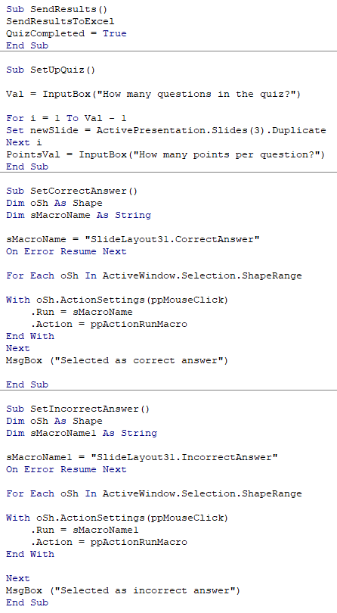

Appendix 3 – Screenshots of the new quiz functionality
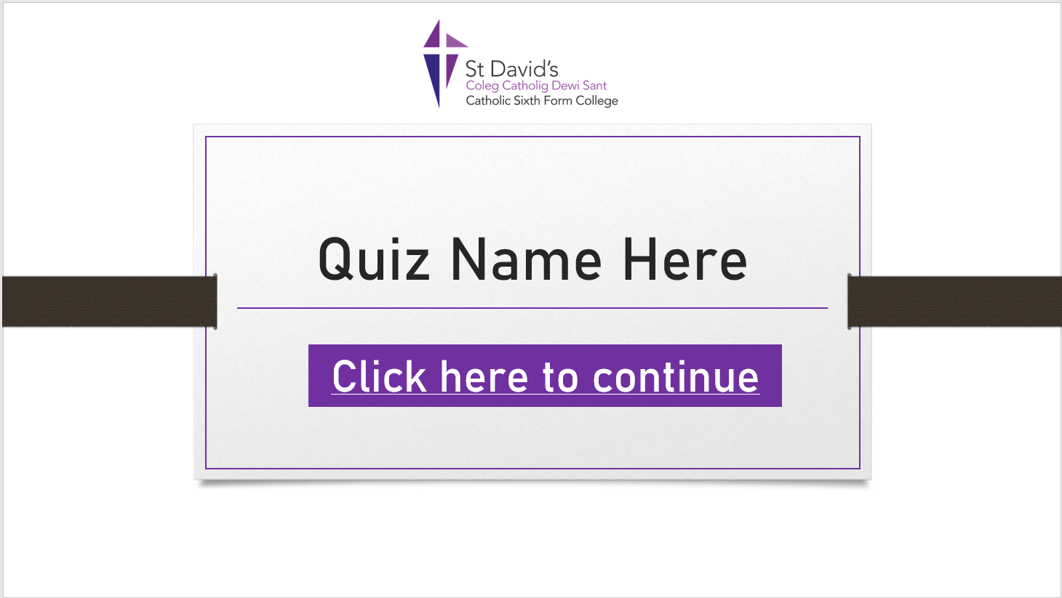

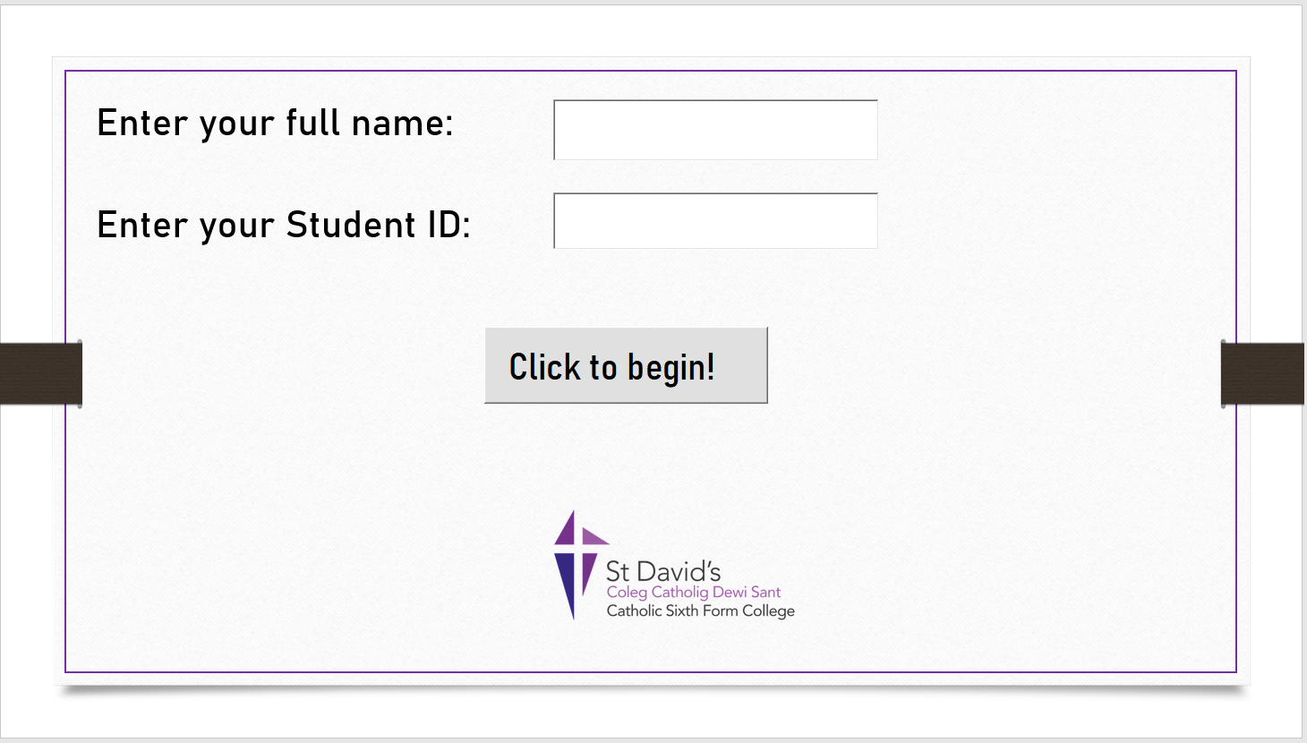

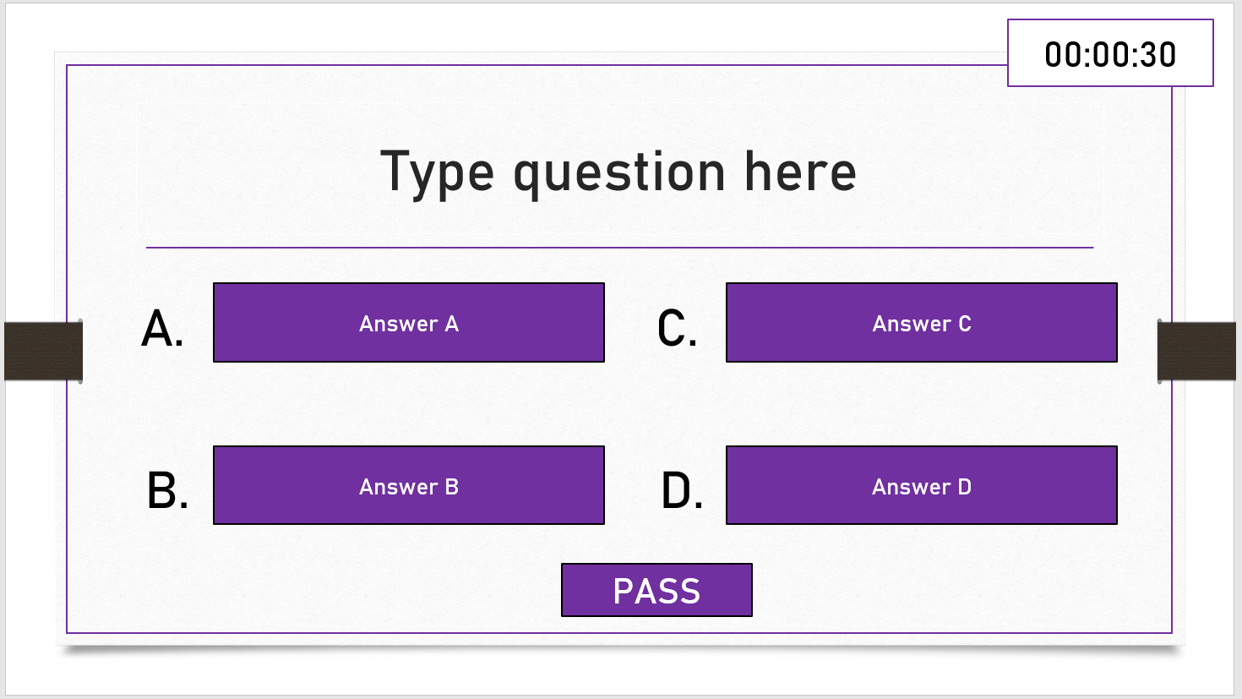

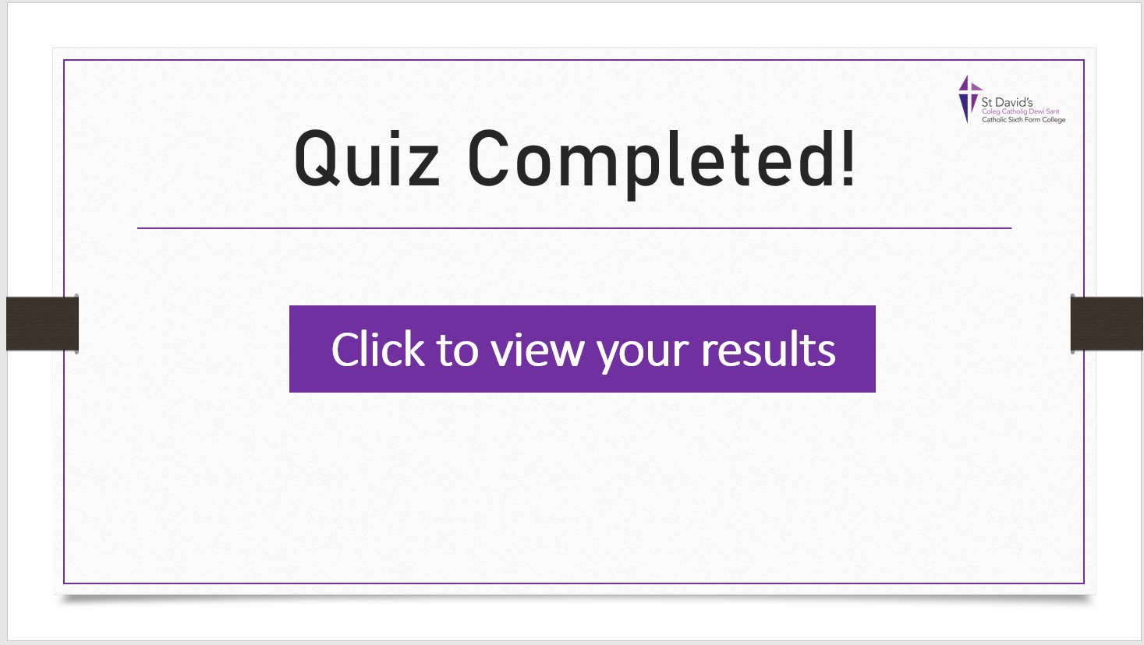

All UK prices have been converted using an exchange rate of $1.35 USD to £1.00 GBP
1 All UK prices have been converted using an exchange rate of $1.35 USD to £1.00 GBP

