University of Wales Trinity Saint David
Wales Institute of Science and Art


Analytical Assessment of Engine Internal Components
Contemporary Powertrains
ACHA6006

Oliver Wilson 2203893
March 2026
Contents
1 Introduction 1
1.1 Aims 1
1.2 Objective 1
2 Connecting Rod Midpoint 2
3 Gudgeon Pin 4
4 Connecting Rod Bolt Fatigue Analysis and Redesign 6
4.1 Wasted Shank Redesign 7
5 Single cylinder Torque 13
6 Engine balancing 15
7 Limitation 18
8 Conclusion 19
9 References 20
10 Appendix 21

Figure 1 Shows the variation of FSF with engine speed at the conrod midpoint. Using the MATLAB extrapolate function the data was extended to 9000 RPM 2
Figure 1 shows a consistent reduction in FSF with increasing RPM. This is supported by Table 1. The reduction in FSF is expected because increasing RPM raises piston acceleration and therefore inertia force, increasing the cyclic stress range in the conrod. Since fatigue resistance falls as alternating stress increases, the midpoint becomes progressively less tolerant to repeated loading as speed rises (Warren and Young, 2001). 2
Table 1 Calculated conrod midpoint stresses and fatigue safety factors at 6000 and 9000 RPM, indicating reduced fatigue margin at higher engine speed. 3
Figure 2 Goodman diagram showing the conrod midpoint operating stress states at 6000 and 9000 rpm relative to the allowable fatigue boundary. 3
Figure 3 Calculated gudgeon pin fatigue safety factor versus engine speed, showing reduced fatigue margin with increasing RPM. 4
Figure 4 Goodman diagram showing the gudgeon pin operating stress states at 6000 and 9000 RPM relative to the allowable fatigue boundary. 5
Figure 8 Original connecting rod bolt fatigue safety factor versus engine speed. 6
Figure 9 Goodman diagram for the original connecting rod bolt at 6000 and 9000 RPM. 7
Figure 10- Conrod Bolt Redesign by Wasted Shank Area 7
Table 2- Threaded bolt specification 8
Figure 11- Connecting Rod Bolt FSF: Original v Redesign 9
Table 3 Material properties used in the connecting rod bolt fatigue assessment, showing the candidate materials considered for improving FSF through changes in strength and stiffness (ARP, 2026). 10
Figure 12- Connecting Rod Bolt FSF for Different Materials 10
Figure 13-Effect of Material Stiffness on Bolt load fraction 11
Figure 5-single-cylinder Torque Component’s 13
Figure 6- Combined 4-Cylinder Engine Torque 13
Figure 7- Calculated power and Torque V calculated (Ford, n.d.) 14
Figure 14- Standard Inline 4 Cylinder Inertial Torques 15
Figure 15- Cross-Plane Inline 4 Cylinder Inertial Torque 16
Figure 16- Standard V Cross-Plane Inertial Torque 17

Introduction
Internal combustion engine components are subjected to high cyclic loads, directional changes, and frictional effects, making fatigue failure a critical design consideration. This report analyses the kinematics of the piston–crank mechanism using provided cylinder pressure data (1000–6000 RPM) to calculate the resulting forces, stresses, and fatigue safety factors for key components including the connecting rod midpoint, gudgeon pin, and connecting rod bolts. The results are extrapolated to 9000 RPM to assess durability beyond the intended operating range. The analysis is based on simplified lecture-based models, and therefore the impact of key assumptions such as idealised loading and neglected losses is considered throughout.

Aims
The aim of this report is to analyse the forces, stresses and fatigue behaviour of key components within an internal combustion engine using lecture-based analytical methods.

Objective
• Analyse piston–crank kinematics to determine displacement, velocity and acceleration
• Calculate inertia and gas forces acting on the piston across 1000–6000 RPM
• Determine resulting stresses in key components (conrod midpoint, gudgeon pin, bolts)
• Evaluate fatigue safety factors (FSF) and extrapolate to 9000 RPM
• Investigate design modifications (geometry and material) to improve fatigue performance
• Assess the effect of crank configuration on engine balance

Connecting Rod Midpoint
The connecting rod (conrod) midpoint was assessed as a nominally axially loaded section using the supplied engine geometry, reciprocating mass and midpoint cross-sectional area of 196.39 mm². The connecting rod force was obtained from the pressure-derived gas and inertia loads from piston kinematics, then converted to stress and assessed using a Goodman fatigue approach based on mean stress, ultimate tensile strength and endurance limit.
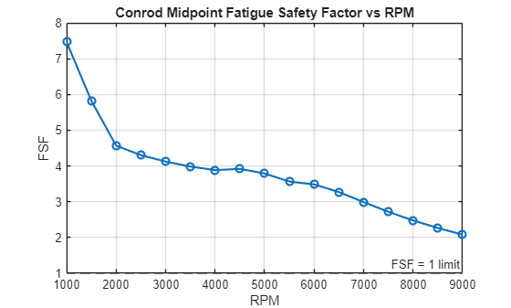
Figure 1 Shows the variation of FSF with engine speed at the conrod midpoint. Using the MATLAB extrapolate function the data was extended to 9000 RPM
Figure 1 shows a consistent reduction in FSF with increasing RPM. This is supported by Table 1. The reduction in FSF is expected because increasing RPM raises piston acceleration and therefore inertia force, increasing the cyclic stress range in the conrod. Since fatigue resistance falls as alternating stress increases, the midpoint becomes progressively less tolerant to repeated loading as speed rises (Warren and Young, 2001).
The midpoint still retains within the margin above failure across the analysed range, so this section is not the limiting feature of the assembly/component. That suggests the beam section is relatively conservative, this indicates that more severe fatigue conditions are usually associated with stress concentrations near geometry transitions rather than the uniform shank region.
The result depends on several assumptions. Stress was treated as uniform axial stress across the midpoint section, which neglects bending, local geometry effects and residual stresses. The MATLAB model is likely to overpredict the true fatigue margin because fatigue behaviour is governed by local peak stress rather than nominal section stress. The extension to 9000 RPM relies on extrapolation, so the higher-speed values are better interpreted as trend indicators than exact design limits. The model is therefore suitable for comparing fatigue sensitivity to rpm, but less reliable for predicting absolute life at the extrapolated limit.
Table 1 Calculated conrod midpoint stresses and fatigue safety factors at 6000 and 9000 RPM, indicating reduced fatigue margin at higher engine speed.
RPM | Min Stress (MPa) | Max Stress (MPa) | Mean Stress (MPa) | Stress Range (MPa) | Allowable Stress (MPa) | FSF
6000 | -32.788 | 203.469 | 85.340 | 236.256 | 823.194 | 3.48
9000 | -66.666 | 313.098 | 123.216 | 379.764 | 789.106 | 2.08

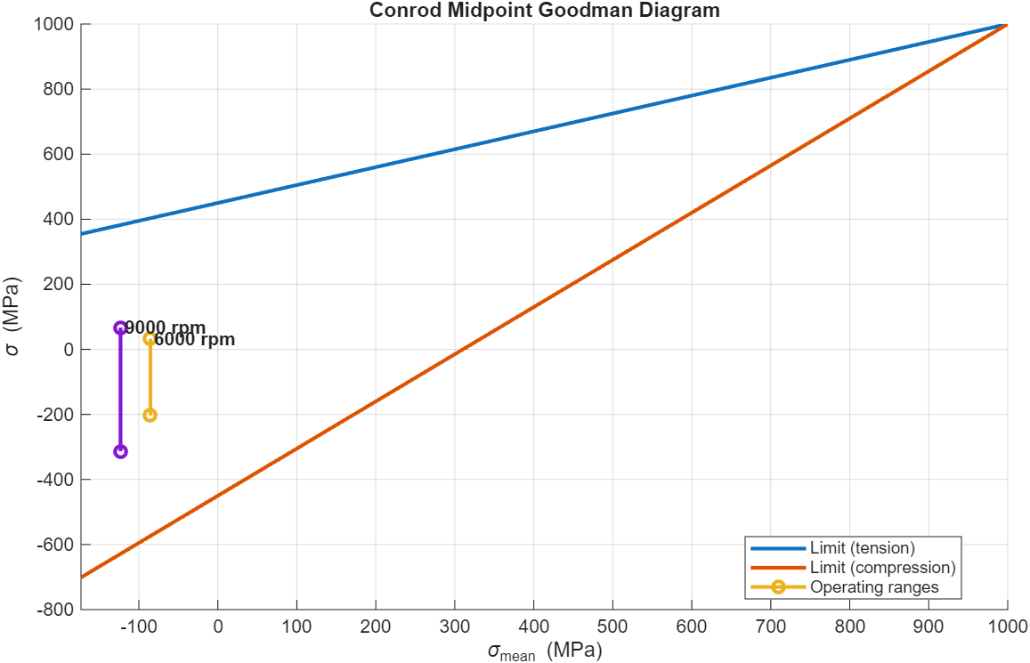
Figure 2 Goodman diagram showing the conrod midpoint operating stress states at 6000 and 9000 rpm relative to the allowable fatigue boundary.
Figure 2 shows that the operating stress ranges at both 6000 and 9000 RPM fall within the Goodman failure boundary, so the conrod midpoint remains safe against fatigue in both cases. The 9000RPM condition lies closer to the boundary, showing that the higher mean stress and stress range reduce fatigue margin. This is consistent with the drop in FSF from 3.48 to 2.08 shown in Table 1. The diagram therefore confirms that increasing RPM makes the midpoint more fatigue-critical, although it is still not the limiting section of the component.

Gudgeon Pin
The gudgeon pin was assessed at the outer surface, where bending stress is highest due to the offset between the applied piston load and the pin supports. Using the supplied pin geometry, exposed pin mass and section properties, the bending stress was calculated from the pin loading and moment arm, then assessed using a Goodman fatigue approach with the given material properties.
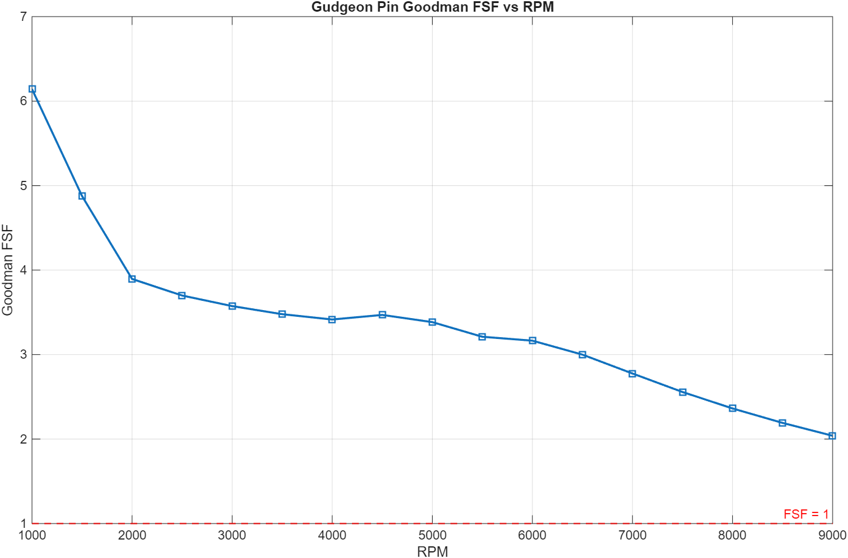
Figure 3 Calculated gudgeon pin fatigue safety factor versus engine speed, showing reduced fatigue margin with increasing RPM.
Figure 3 shows that the gudgeon pin FSF decreases with increasing RPM. This expected increase in piston acceleration increases the alternating bending stress in the pin. However, the FSF remains above 2 at 9000 RPM, indicating that the pin retains a substantial fatigue margin from 1000-9000 RPM (Xin, 2013). Relative to the connecting rod midpoint, this suggests the pin is not operating near its fatigue limit under the loading model used.
The pin was analysed using a simplified bending model with idealised loading and support conditions, so the calculated stress is nominal. Local contact stresses, misalignment and support transition stress concentrations were neglected, making the result more reliable for fatigue trend assessment than exact life prediction.

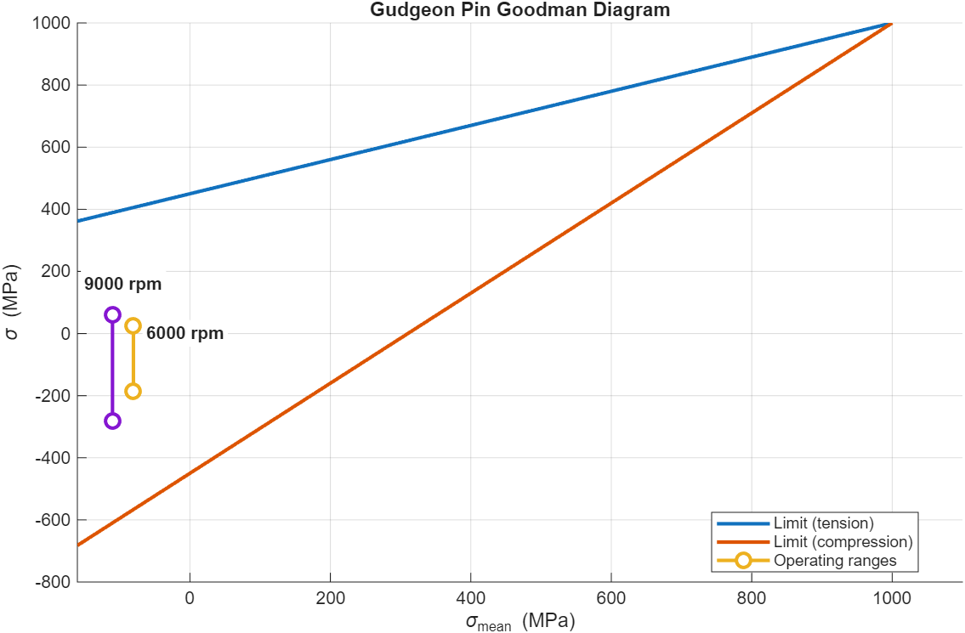
Figure 4 Goodman diagram showing the gudgeon pin operating stress states at 6000 and 9000 RPM relative to the allowable fatigue boundary.
Figure 4 shows that the gudgeon pin operating stress ranges at both 6000 and 9000 RPM remain within the Goodman failure boundary, indicating that fatigue failure is not predicted at either condition. The 9000 RPM stress range lies closer to the boundary, confirming that the increase in mean stress and alternating stress reduces the available fatigue margin. However, both operating ranges remain well inside the allowable region, which suggests that the gudgeon pin retains a comfortable fatigue margin across the analysed speed range.

Connecting Rod Bolt Fatigue Analysis and Redesign
The connecting rod bolts were analysed under cyclic tensile loading caused by the inertia of the reciprocating assembly. At high engine speed, these inertia forces act to separate the rod and cap, while bolt preload maintains joint compression and reduces the alternating stress carried by the bolt. The bolt stress was evaluated using a joint stiffness approach, where the external separating load is shared between the bolt and clamped components according to their relative stiffness, and fatigue safety factor was then assessed using a Goodman relation.
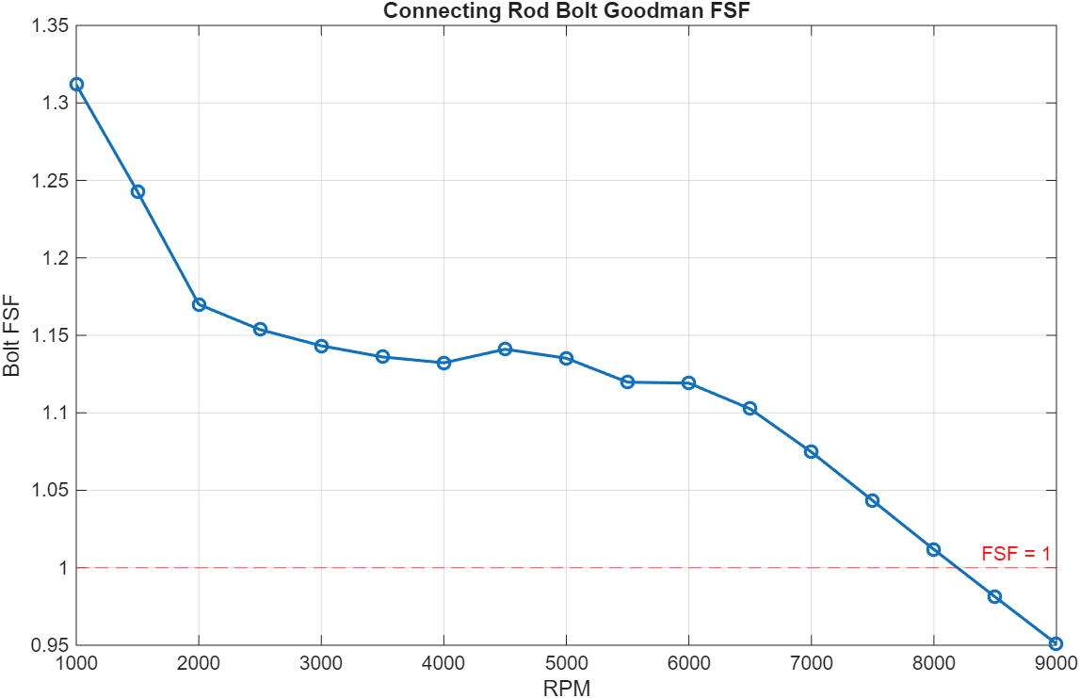
Figure 8 Original connecting rod bolt fatigue safety factor versus engine speed.
The preload force was calculated from the tightening model and used to determine the bolt mean stress. Figure 8 shows that the original M8 connecting rod bolt provides only limited fatigue margin from around 6000 RPM and reduces to an FSF of approximately 1 at 8200 RPM, indicating that the design is not suitable for sustained high-speed operation. The calculated FSF is likely to overpredict performance because it uses nominal stress, while threaded fasteners typically fail from localised thread-root stresses. The achieved preload is also sensitive to friction in the torque–preload relationship, which is known to exhibit substantial scatter, and this changes the mean stress carried by the bolt. Since preload also influences fatigue behaviour directly through mean stress, the true fatigue margin is likely to be lower than predicted (Curtis 2006).

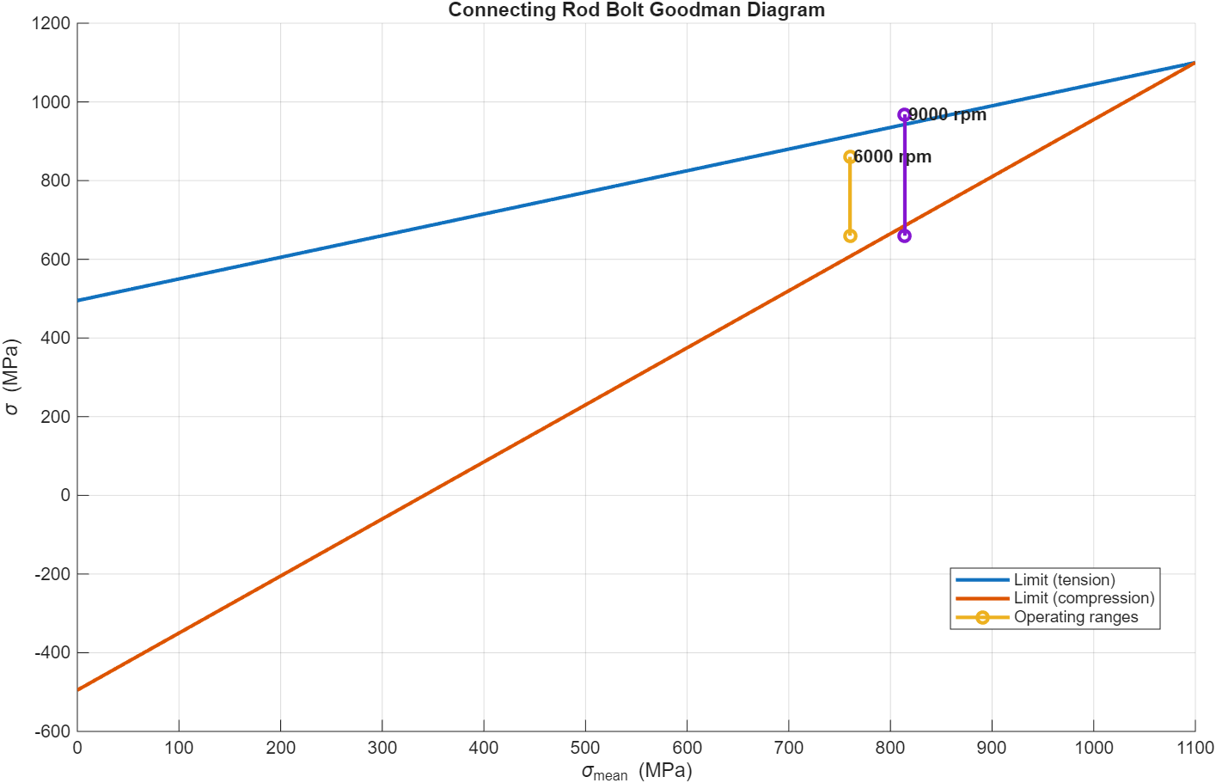
Figure 9 Goodman diagram for the original connecting rod bolt at 6000 and 9000 RPM.
Figure 9 shows that the 9000 RPM operating stress state exceeds the Goodman limit, while the 6000 RPM condition remains within it. This indicates that the original M8 bolt loses sufficient fatigue margin as engine speed increases and is therefore unsuitable for sustained operation at 9000 RPM. A practical way to improve this is to reduce bolt stiffness using a wasted shank.

Wasted Shank Redesign

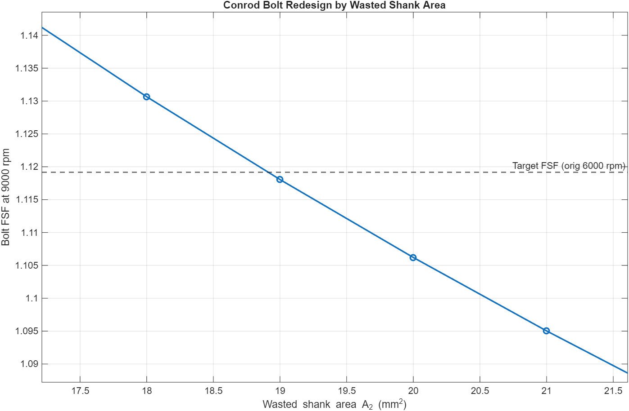
Figure 10- Conrod Bolt Redesign by Wasted Shank Area
Figure 10 indicates that reducing wasted shank area improves the predicted FSF at 9000 RPM by lowering bolt stiffness and therefore reducing the cyclic load carried by the bolt. However, the model suggests an optimum area of about 19 mm² (approximately 5 mm diameter), which is not a realistic final design for a connecting rod bolt. The graph is therefore better interpreted as a trend study showing that reduced shank stiffness is beneficial, rather than a direct design prescription. Final geometry should instead be selected using (ESCUDIER, 2019)fastener fatigue guidance together with checks for local stress concentration, preload retention and practical manufacturability.
This trend is consistent with published conrod bolt research, which found that increasing the compliant length of the bolt and reducing the thin rod diameter lowers stress concentration at the first engaged thread and improves fatigue safety factor in the most failure-prone region.(Jia, Cai et al. 2023), (Dewen Jia, 2025).

Table 2- Threaded bolt specification
Feature | Value | Notes
Thread Type | M8x1.0 | Coarse thread reduces stress concentration factor
Under-head full-width area | 42.43 mm² | Kept unchanged to preserve head seating stiffness and local strength under preload.
Wasted shank area | 28.27 mm² | Reduced to lower bolt stiffness and improve fatigue margin without becoming impractically small.
Thread/root area | 42.43 mm² | Retained to preserve thread strength and compatibility with the original joint.
Under-head full-width diameter | 7.35 mm | Unchanged to maintain bearing area under the bolt head.
Wasted shank diameter | 6.00 mm | Selected as a practical compromise; smaller values improved FSF further but were not considered realistic.
Under-head section length | 5.00 mm | Retained from the model to preserve the original load introduction region.
Wasted shank length | 15.00 mm | Provides the main compliant section needed to reduce bolt stiffness.
Threaded end section length | 7.26 mm | Retained so the effective working length still matches the original bolt model.
Effective working length | 27.26 mm | Kept equal to the original specification for consistency with the stiffness calculation.

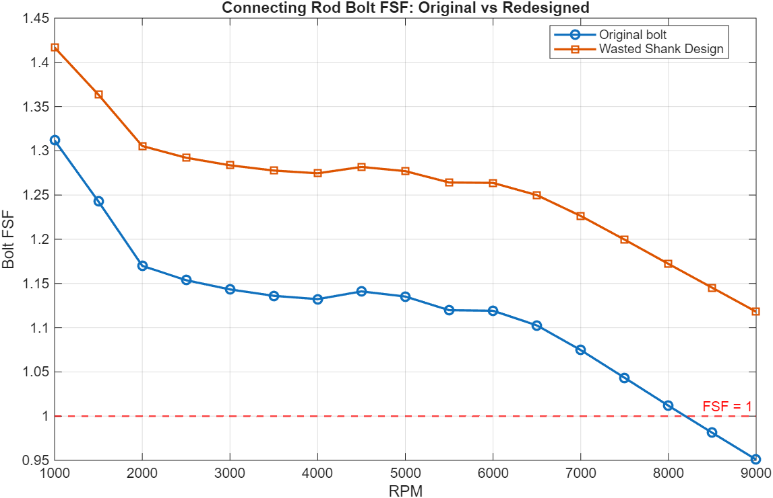
Figure 11- Connecting Rod Bolt FSF: Original v Redesign
Figure 11 compares the original bolt with the redesigned wasted-shank bolt. The original design shows a steady reduction in FSF with increasing engine speed and falls below the critical value of 1 at high RPM, indicating insufficient fatigue margin for extended operation. The redesigned bolt maintains a consistently higher FSF across the full speed range because the reduced shank stiffness lowers the proportion of the separating load transferred into the bolt, reducing the alternating stress responsible for fatigue damage.
A practical redesign was selected using a 6.0 mm wasted shank diameter $\left(A_{2} = 28.27{\text{ mm}}^{2}\right)$, rather than the lower-area optimum suggested by the sensitivity plot. This retains the original M8 thread and effective working length while introducing sufficient compliance to improve fatigue performance without adopting an unrealistically small shank. The redesigned bolt remains above FSF = 1 to 9000 RPM, so the modification provides a usable increase in fatigue margin for higher-speed operation.

Table 3 Material properties used in the connecting rod bolt fatigue assessment, showing the candidate materials considered for improving FSF through changes in strength and stiffness (ARP, 2026).
Material | Young’s Modulus, E (N/mm²) | UTS, Sut (MPa) | Endurance Limit, Se (MPa) | Preload Stress Used (MPa)
10.9 alloy steel | 210000 | 1040.0 | 468.0 | 624.0
12.9 alloy steel | 210000 | 1220.0 | 549.0 | 732.0
ARP 8740 steel | 205000 | 1380.0 | 621.0 | 828.0
ARP 2000 steel | 205000 | 1510.0 | 679.5 | 906.0
Titanium Ti-6Al-4V | 110000 | 900.0 | 405.0 | 540.0

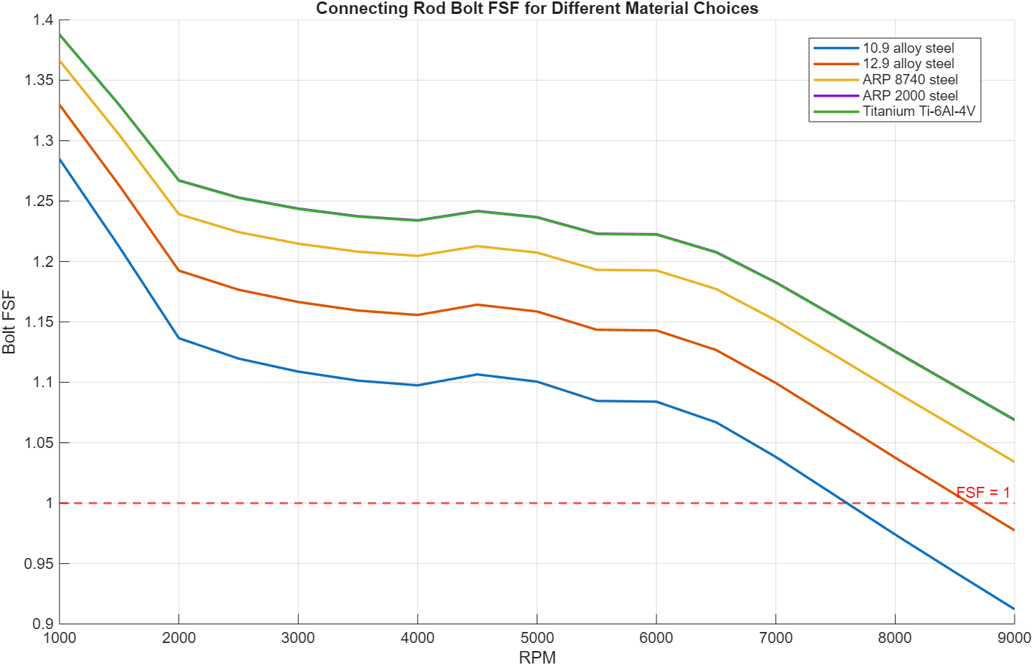
Figure 12- Connecting Rod Bolt FSF for Different Materials
Figure 12 shows the FSF of the connecting rod bolt for several different material choices across the engine speed range. For all materials, the FSF decreases as engine speed increases due to the increasing inertial forces acting on the reciprocating components, which results in higher alternating stresses within the bolt.
Higher strength materials such as ARP 8740 steel and ARP 2000 steel provide improved fatigue safety factors compared to standard 10.9 and 12.9 alloy steels. This is primarily due to their higher ultimate tensile strength and endurance limits, which increase the allowable fatigue stress range. As a result, these materials maintain a higher FSF throughout the operating range.
Although Ti-6Al-4V produced the highest fatigue safety factor due to its reduced stiffness and lower bolt load fraction, this does not automatically make it the best design choice, as the lower stiffness may reduce joint integrity and clamp retention under service loading. High-strength steel remains a more balanced solution for a highly loaded bolted joint, although titanium offers improved fatigue performance, practical considerations such as cost, manufacturability and joint stiffness must also be considered when selecting a suitable bolt material.

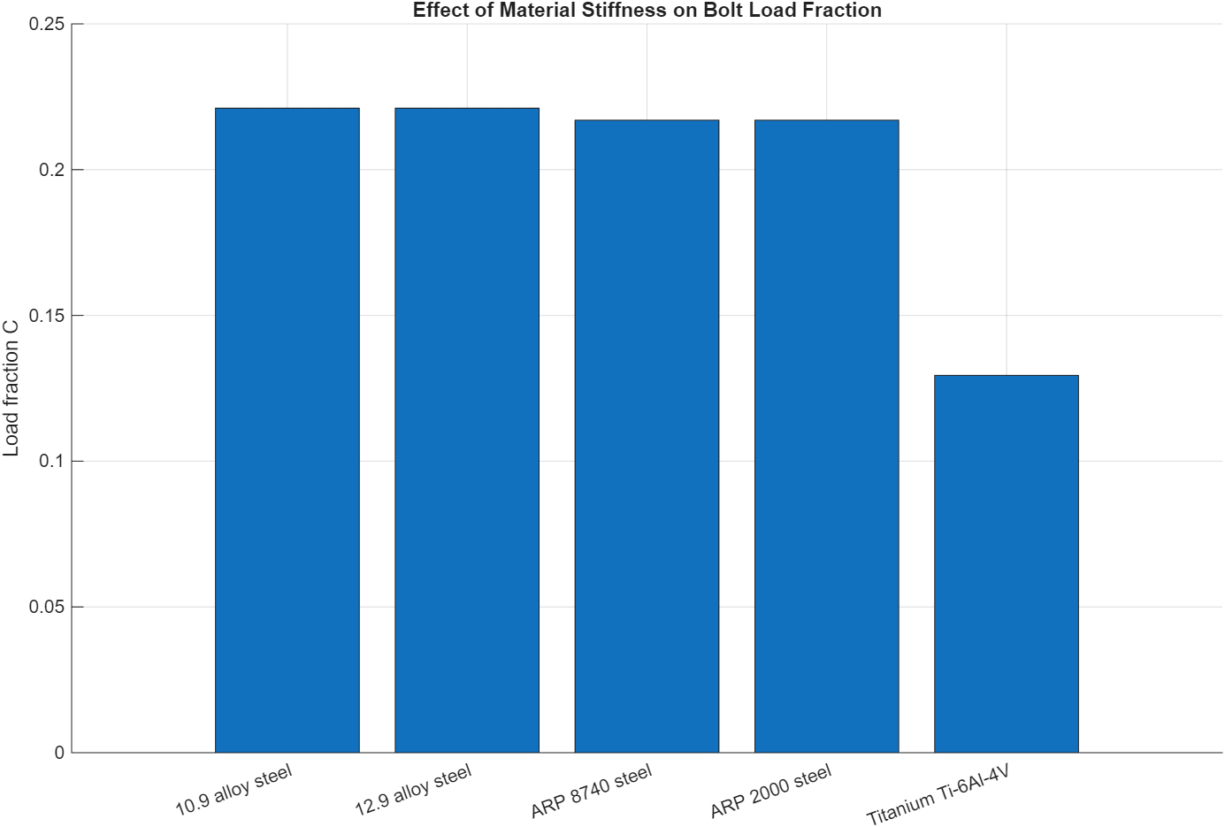
Figure 13-Effect of Material Stiffness on Bolt load fraction
Figure 13 shows the effect of bolt material stiffness on the load fraction carried by the connecting rod bolt. The load fraction represents the proportion of the external separating force that is transmitted through the bolt rather than being absorbed by the clamped components of the joint.
The steel bolts (10.9, 12.9, ARP 8740 and ARP 2000) all show similar load fractions of approximately 0.21–0.22 because their elastic modulus, and therefore their stiffness values, are similar. In contrast, the Ti-6Al-4V bolt shows a much lower load fraction of approximately 0.13 due to its lower modulus of elasticity, which reduces bolt stiffness. As a result, a smaller proportion of the external load is transferred directly through the bolt, while more is absorbed by elastic deformation of the joint. Bolt load transfer is governed by the relative stiffness of the bolt and clamped parts, and that a more elastic bolt experiences a lower additional service load.(Okorn, Nagode et al. 2021)
This reduction in load fraction helps to lower the cyclic stress experienced by the bolt, which contributes to the improved fatigue safety factor observed for the titanium material in the previous analysis.

Single cylinder Torque
The single-cylinder torque plot separates the total crank torque into gas, inertia, and friction components, allowing the contribution of each source to the overall torque output to be identified.
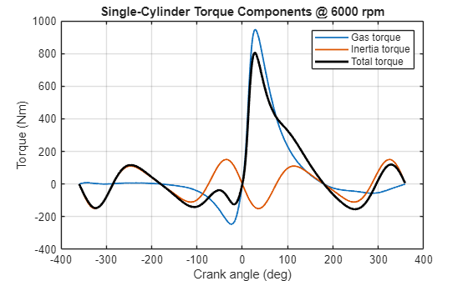
Figure 5-single-cylinder Torque Component’s
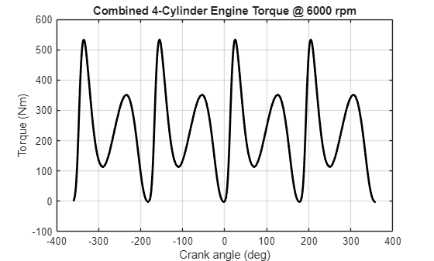
Figure 6- Combined 4-Cylinder Engine Torque
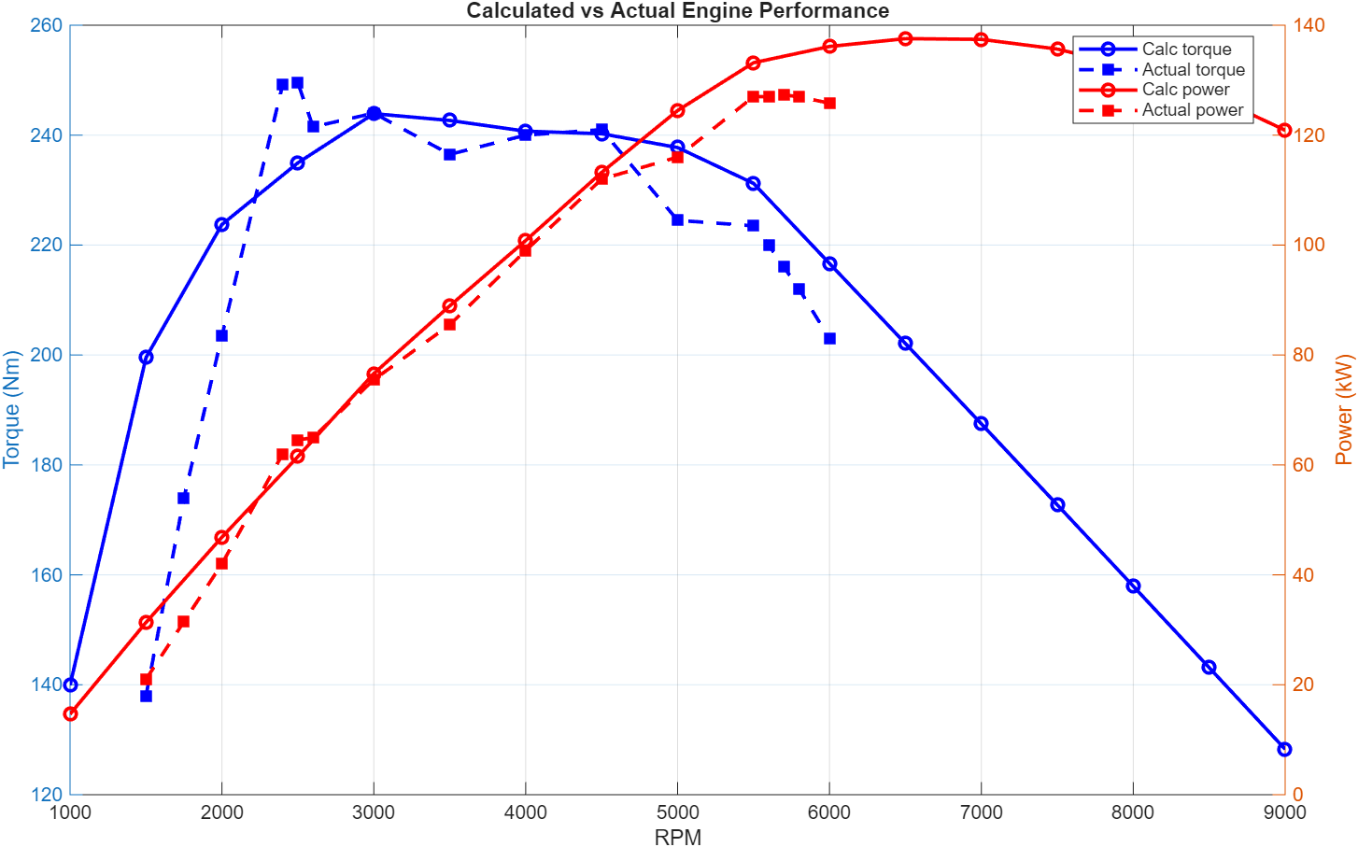
Figure 7- Calculated power and Torque V calculated (Ford, n.d.)
The predicted torque and power shows generally good agreement with the engine specification data. The predicted torque follows the same overall trend, although it is slightly lower around 2500 RPM due to the use of averaged pressure data, which smooths peak combustion effects.
At higher engine speeds, some divergence is observed, likely due to simplified assumptions such as neglecting friction losses and volumetric efficiency changes. The predicted power curve shows similar agreement, as power is directly dependent on torque. Overall, the model captures the main behaviour of the engine but becomes less accurate at higher RPM due to increasing real-world effects not included in the analysis.

Engine balancing
Figure 14 shows the inertia torque produced by each cylinder of a standard inline-4 engine configuration at 6000 RPM, together with the combined resultant torque. The inertia torque arises from the acceleration and deceleration of the reciprocating piston assembly during the engine cycle.

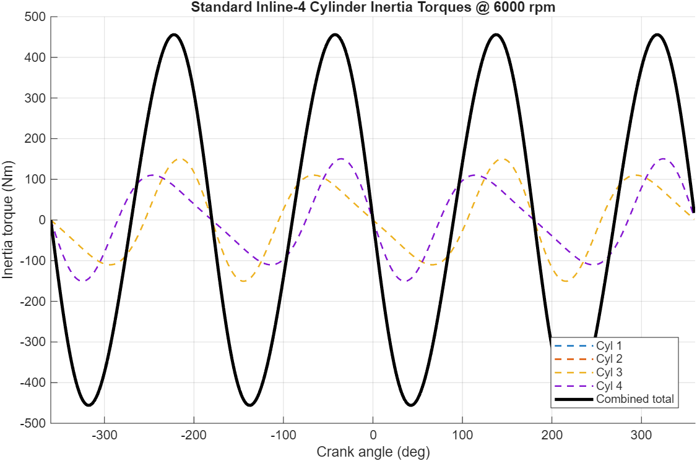
Figure 14- Standard Inline 4 Cylinder Inertial Torques
Each cylinder produces a sinusoidal-type inertia torque due to the changing piston acceleration with crank angle. Because cylinders in a standard inline-4 engine share crank throws that are 180° apart, pairs of pistons move in opposite directions simultaneously. As a result, their inertia torques partially reinforce each other rather than cancelling completely.
This behaviour leads to a large, combined inertia torque fluctuation, as shown by the black curve. The resulting torque variation is significant, reaching large positive and negative values throughout the cycle. This demonstrates that the standard inline-4 configuration produces substantial second-order inertial torque fluctuations that must be absorbed by the crankshaft and flywheel.

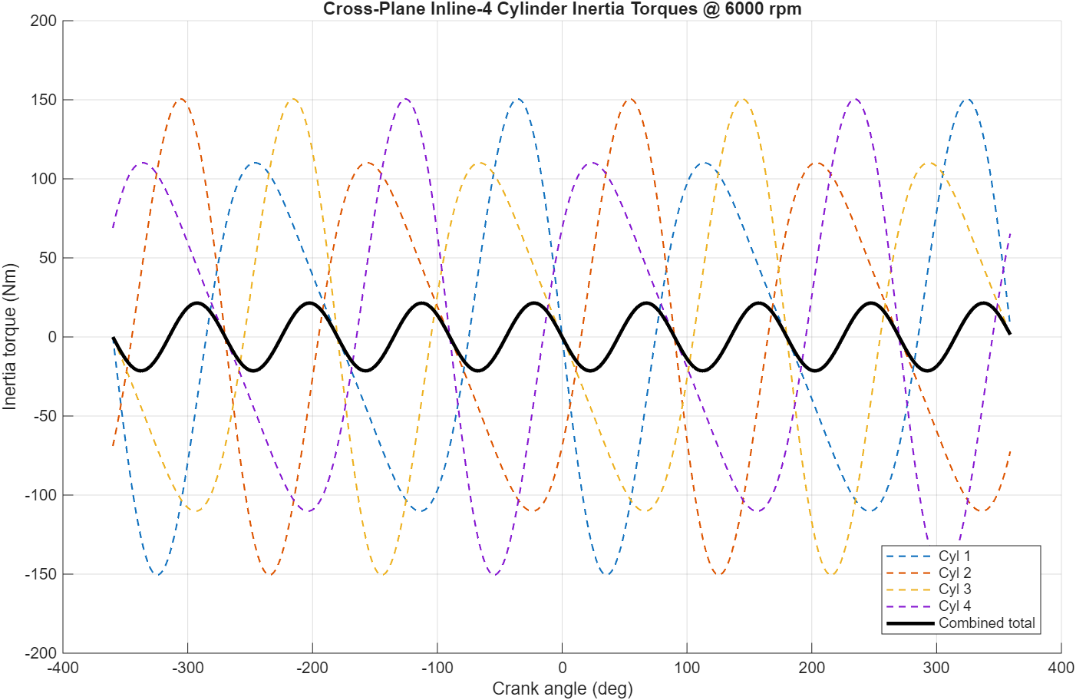
Figure 15- Cross-Plane Inline 4 Cylinder Inertial Torque
Figure 15 shows the inertia torque generated by each cylinder in a cross-plane inline-4 crankshaft configuration. In this design the crank throws are spaced at 90° intervals, which alters the phase relationship between the piston motions.
Because each cylinder now reaches peak acceleration at different crank angles, the inertia torques are distributed more evenly across the engine cycle. When these torques are summed, the combined inertia torque is significantly reduced compared with the standard inline-4 configuration.
The resulting combined torque has a much smaller amplitude and exhibits smoother behaviour throughout the cycle. This demonstrates that the cross-plane crankshaft improves dynamic balance by distributing the inertial forces more evenly, reducing the magnitude of torque fluctuations acting on the crankshaft.

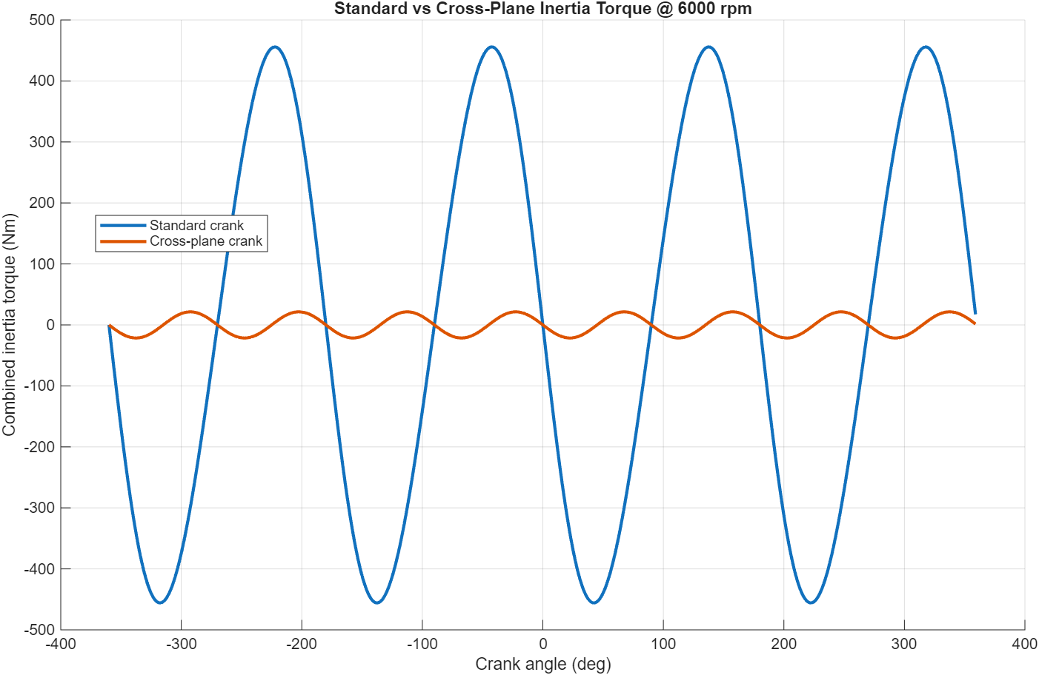
Figure 16- Standard V Cross-Plane Inertial Torque
Figure 16 compares the combined inertia torque for the standard inline-4 crankshaft configuration and the cross-plane crankshaft design. The standard crank configuration produces large torque oscillations due to the synchronised motion of piston pairs, which results in significant second-order inertia effects.
In contrast, the cross-plane configuration significantly reduces the amplitude of the combined inertia torque. By spacing the crank throws at 90°, the peak inertial loads occur at different crank angles, allowing the torque contributions from each cylinder to partially cancel each other.
As a result, the cross-plane crankshaft produces a much smoother inertia torque profile across the engine cycle. This reduction in torque fluctuation can improve engine smoothness, reduce vibration levels, and decrease dynamic loading on the crankshaft and bearings. (Fred Schafer, 2004)

Limitation
A key limitation of this analysis is that pressure and force data beyond 6000 RPM were extrapolated using a linear method, despite inertial forces varying with the square of engine speed (ω²). This may result in inaccuracies in predicted fatigue safety factors at higher RPM.
Additionally, the analysis assumes ideal loading conditions, neglecting factors such as friction losses, thermal effects, and local stress concentrations at interfaces. These simplifications mean that the calculated stresses and fatigue safety factors may differ from real engine behaviour, particularly at high engine speeds.
The equations used give a global fatigue assessment and don’t resolve local stress concentrations which will likely affect the safety factor failure behaviour.

Conclusion
This study investigated the forces and fatigue behaviour of key engine components, with particular focus on the connecting rod bolt. The results showed that inertial forces increase significantly with engine speed and dominate loading at high RPM, leading to a reduction in fatigue safety factor.
The original bolt design was sufficient for operation up to 6000 RPM but failed to maintain a safe fatigue margin beyond approximately 8200 RPM. A redesigned bolt with reduced shank area improved fatigue performance by lowering stiffness and reducing the load fraction carried by the bolt, maintaining an FSF greater than 1 up to 9000 RPM. Material selection was also shown to significantly influence fatigue behaviour, with lower stiffness materials further improving performance.
Overall, the results demonstrate that fatigue performance is strongly influenced by inertia effects, geometry, and material properties. However, the accuracy of the predictions is limited by the simplified assumptions used, particularly at higher engine speeds.

References
ARP, 2026. ARP Material Specifications. [Online]
Available at: https://www.arp-bolts.com/tech/materials
[Accessed 22 march 2026].
Dewen Jia, X. S. W. D. X. D. H. J. &. J. L., 2025. Analysis of the influence of geometric accuracy on the preload and stress of engine connecting rod bolts, s.l.: natureportfolio.
ESCUDIER, M. a. A. T., 2019. A Dictionary of Mechanical Engineering (2 ed.). Oxford: Oxford University Press.
Ford, n.d. ford. [Online]
Available at: https://www.ford.co.uk/content/dam/guxeu/uk/documents/home/experience-ford/about-ford/ford-component-sales/specification-details-data-sheets/16-ecoboost-np.pdf
[Accessed 21 March 2026].
Fred Schafer, R. v. B., 2004. Modern Engine Technology from A to Z. Wiesbaden: SAE.
S. Griza*, F. B. G. Z. A. R. T. S., 2008. Fatigue in engine connecting rod bolt due to forming laps, s.l.: Elsevier.
WARREN C. YOUNG, R. G. B., 2001. Roark’s Formulas, s.l.: McGraw-Hill Professional..
Xin, Q., 2013. Diesel Engine System Design, Cambridge: Woodhead Publishing..
JIA, D., SONG, X., DENG, W., DENG, X., JI, H. and LEI, J., 2025. Analysis of the influence of geometric accuracy on the preload and stress of engine connecting rod bolts. Scientific reports, 15(1), pp. 8606–27.
OKORN, I., NAGODE, M., KLEMENC, J. and OMAN, S., 2021. Analysis of Additional Load and Fatigue Life of Preloaded Bolts in a Flange Joint Considering a Bolt Bending Load. Metals (Basel ), 11(3), pp. 449.

2380 words

Appendix
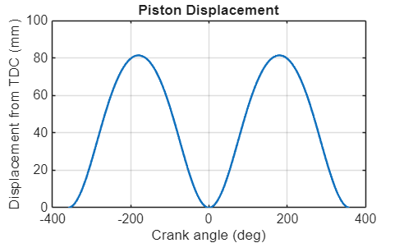

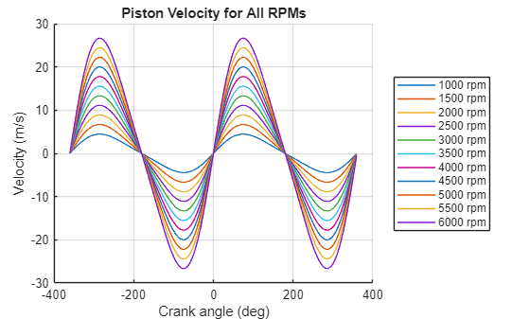

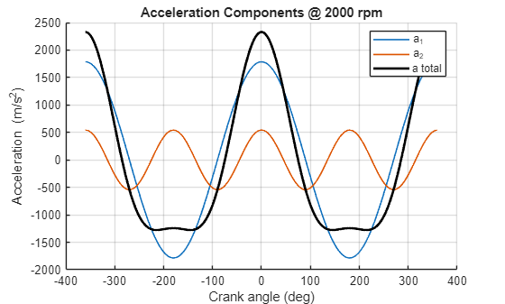

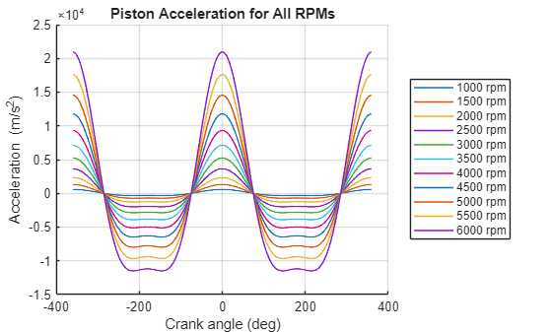
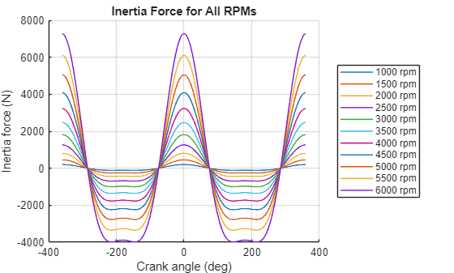 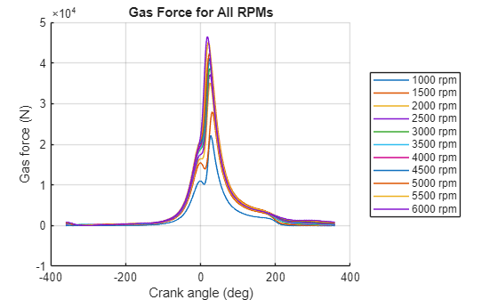 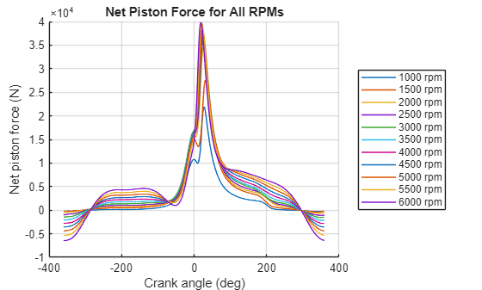 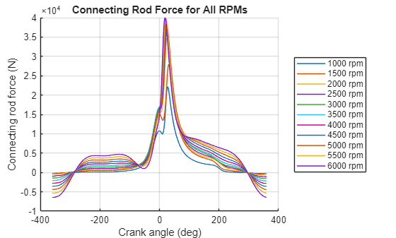 10

